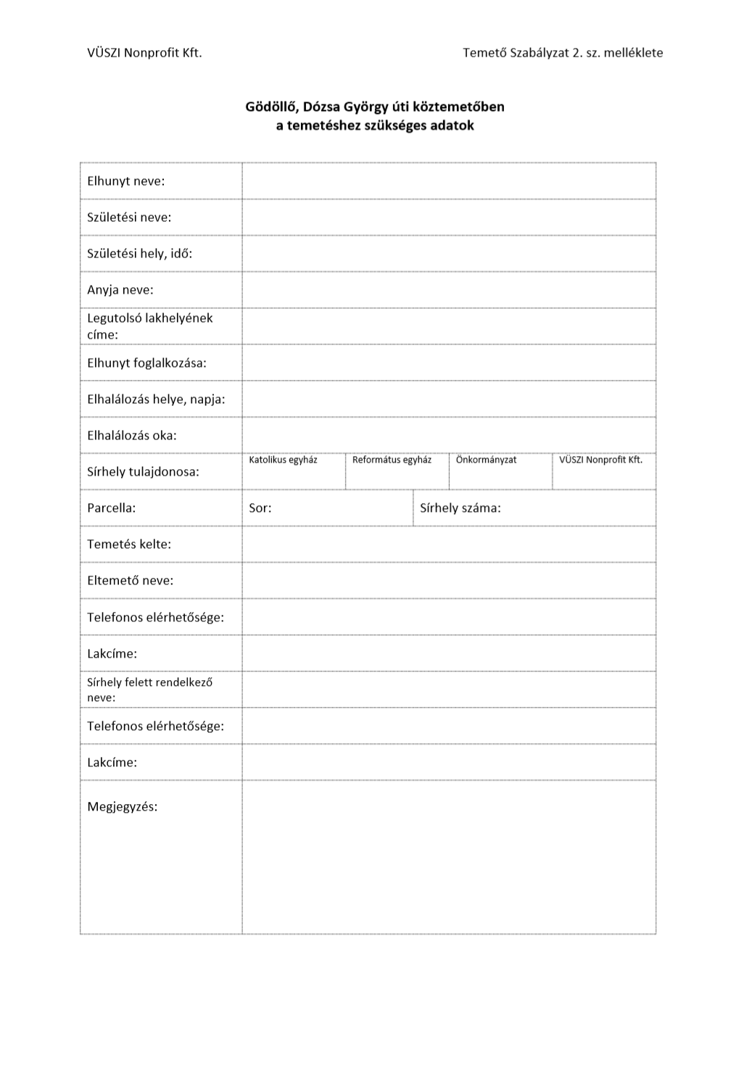

{ClientHome}

{ClientReach}

{ClientName}

{FuneralDate}

{FuneralGrave}

{DeceasedPlaceOfDeath}, {DeceasedDateOfDeath}

{DeceasedProfession}

{DeceasedHome}

{DeceasedMotherBirthName}

{DeceasedPlaceOfBirth}, {DeceasedDateOfBirth}

{DeceasedName}

{DeceasedBirthName}

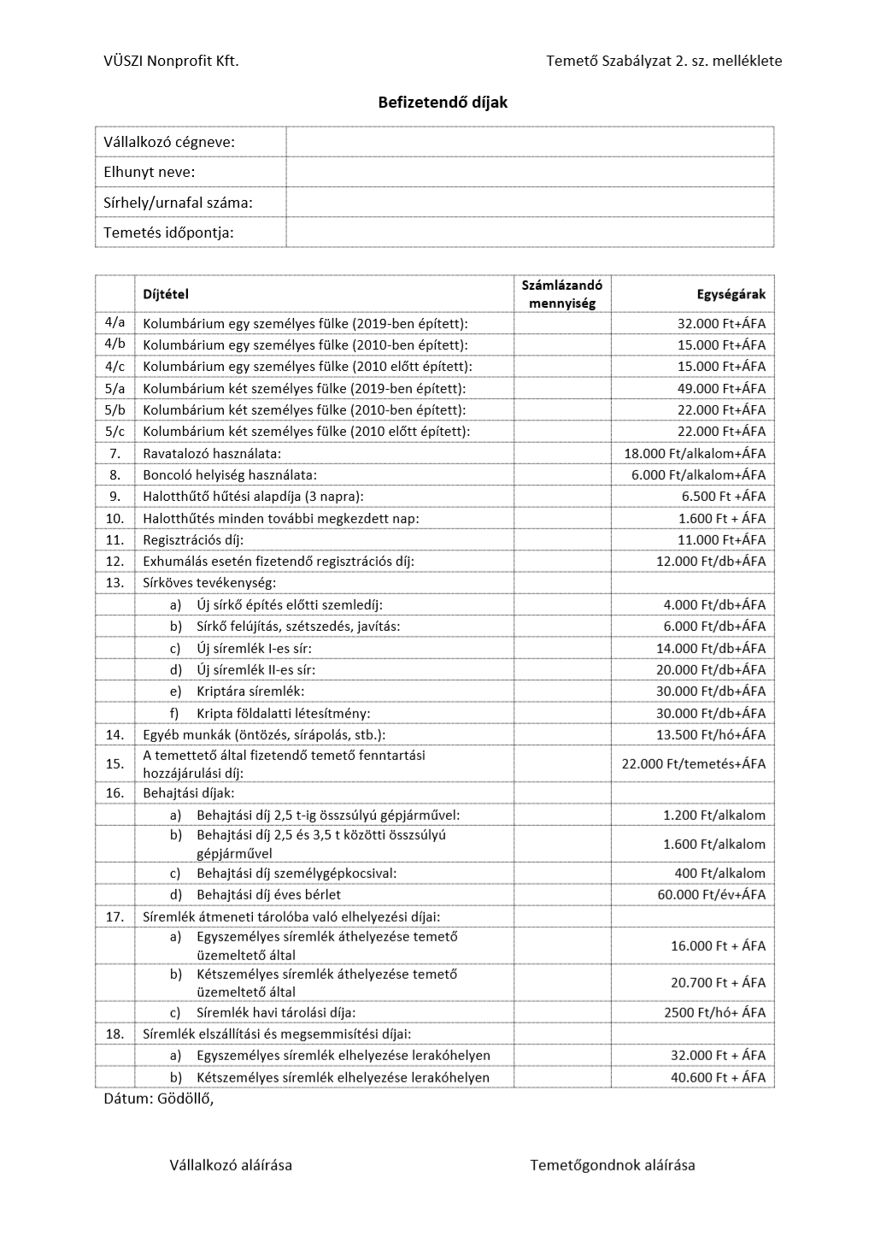

{DateOfIssue}

{FuneralDate}

{FuneralGrave}

{DeceasedName}

Immopax Kft