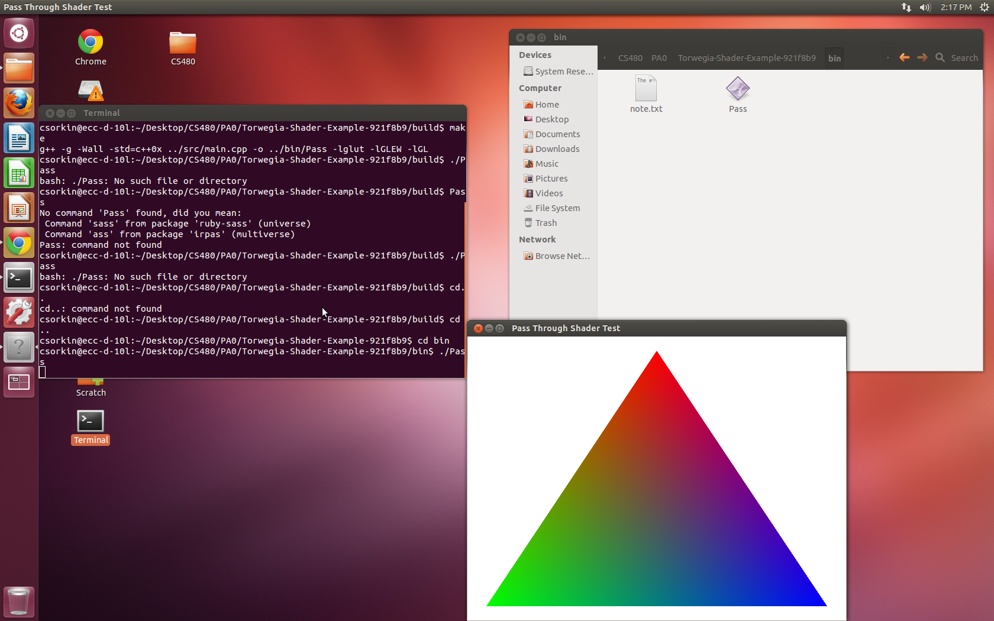
Collin Sorkin
CS480
PA0

