INTRODUCTION
1. PREFACE
2. HOW TO USE THIS MANUAL
3. ON THIS (4th) RELEASE
4. License

1. PREFACE
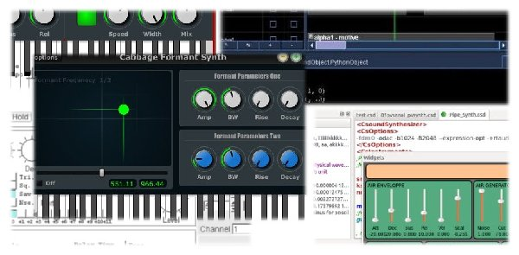
Csound is one of the best known and longest established programs in the field of audio-programming. It was developed in the mid-1980s at the Massachusetts Institute of Technology (MIT) by Barry Vercoe.
Csound's history lies deep in the roots of computer music. It is a direct descendant of the oldest computer-program for sound synthesis, 'MusicN' by Max Mathews. Csound is free and Open Source, distributed under the LGPL licence and is tended and expanded by a core of developers with support from a wider community.
Csound has been growing for more than 25 years. There is rarely anything related to audio you cannot do with Csound. You can work by rendering offline, or in real-time by processing live audio and synthesizing sound on the fly. You can control Csound via MIDI, OSC, or via the Csound API (Application Programming Interface). In Csound, you will find the widest collection of tools for sound synthesis and sound modification, including special filters and tools for spectral processing.
Is Csound difficult to learn? Generally speaking, graphical audio programming languages like Pure Data,1 Max or Reaktor are easier to learn than text-coded audio programming languages like Csound, SuperCollider or ChucK. You cannot make a typo which produces an error which you do not understand. You program without being aware that you are programming. It feels like patching together different units in a studio. This is a fantastic approach. But when you deal with more complex projects, a text-based programming language is often easier to use and debug, and many people prefer to program by typing words and sentences rather than by wiring symbols together using the mouse.
Thanks to the work of Victor Lazzarini and Davis Pyon, it is also very easy to use Csound as a kind of audio engine inside Pd or Max. Have a look into the chapter Csound in Other Applications for further information.
Amongst text-based audio programming languages, Csound is arguably the simplest. You do not need to know any specific programming techniques or be a computer scientist. The basics of the Csound language are a straightforward transfer of the signal flow paradigm to text.
For example, to create a 400 Hz sine oscillator with an amplitude of 0.2, this is the signal flow:
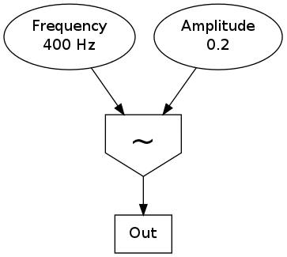
This is a possible transformation of the signal graph into Csound code:
instr Sine
aSig oscils 0.2, 400, 0
out aSig
endin
The oscillator is represented by the opcode oscils and gets its input arguments on the right-hand side. These are amplitude (0.2), frequency (400) and phase (0). It produces an audio signal called aSig at the left side, which is in turn the input of the second opcode out. The first and last lines encase these connections inside an instrument called Sine. That's it.
But it is often difficult to find up to date resources that show and explain what is possible with Csound. Documentation and tutorials produced by developers and experienced users tend to be scattered across many different locations. This was one of the main motivations in producing this manual: to facilitate a flow between the knowledge of contemporary Csound users and those wishing to learn more about Csound.
Ten years after the milestone of Richard Boulanger's Csound Book, the Csound FLOSS Manual is intended to offer an easy-to-understand introduction and to provide a centre of up to date information about the many features of Csound - not as detailed and in depth as the Csound Book, but including new information and sharing this knowledge with the wider Csound community.
Throughout this manual we will attempt a difficult balancing act: we want to provide users with most of the important aspects of Csound, but we also want to stay concise and simple enough to keep you from drowning under the multitude of what can be said about Csound. Frequently this manual will link to other more detailed resources like the Canonical Csound Reference Manual, the primary documentation provided by the Csound developers and associated community over the years, and the Csound Journal (edited by Steven Yi and James Hearon), a quarterly online publication with many great Csound-related articles.
Enjoy and happy Csounding!
- more commonly known as Pd - see the Pure Data FLOSS Manual for further information^

2. HOW TO USE THIS MANUAL
The goal of this manual is to provide a readable introduction to Csound. In no way is it meant as a replacement for the Canonical Csound Reference Manual. It is intended as an introduction-tutorial-reference hybrid, gathering the most important information you need to work with Csound in a variety of situations. In many places, links are provided to other resources, such as the official manual, the Csound Journal, example collections, and more.
It is not necessary to read each chapter in sequence, feel free to jump to any chapter that interests you, although bear in mind that occasionally a chapter will make reference to a previous one.
If you are new to Csound, the QUICK START chapter will be the best place to go to get started. BASICS provides a general introduction to key concepts about digital sound vital to understanding how Csound deals with audio. The CSOUND LANGUAGE chapter provides greater detail about how Csound works and how to work with Csound.
SOUND SYNTHESIS introduces various methods of creating sound from scratch and SOUND MODIFICATION describes various methods of transforming sounds that already exist within Csound. SAMPLES outlines ways in which to record and play audio samples in Csound, an area that might be of particular interest to those intent on using Csound as a real-time performance instrument. The MIDI and OPEN SOUND CONTROL chapters focus on different methods of controlling Csound using external software or hardware. The final chapters introduce various front-ends that can be used to interface with the Csound engine and Csound's communication with other applications.
If you would like to know more about a topic, and in particular about the use of any opcode, refer first to the Canonical Csound Reference Manual.
All files - examples and audio files - can be downloaded at www.csound-tutorial.net . If you use CsoundQt, you can find all the examples in CsoundQt's examples menu under "Floss Manual Examples". When learning Csound (or any other programming language), you may benefit from typing out the examples yourself, as it will help you memorise Csound's syntax as well as how to use the opcodes. The more you get used to typing out Csound code, the more proficient you will be at integrating new techniques, as your concentration will shift from the code to the idea behind the code, and the easier it will be for you to design your own instruments and compositions.
Like other Audio Tools, Csound can produce extreme dynamic range. Be careful when you run the examples! Start with a low volume setting on your amplifier and take special care when using headphones.
You can help to improve this manual, either by reporting bugs or requests, or by joining as a writer. Just contact one of the maintainers (see the list in ON THIS RELEASE).
Thanks to Alex Hofmann, this manual can be ordered as a print-on-demand at www.lulu.com. Just use the search utility there and look for "Csound". Just the links will not work ...

3. ON THIS (4th) RELEASE
Usually we have a one-year-term between releases. But now, Csound6 has brought so many new features that we thought we should provide a new release - half a year after the last one, and shortly before the Csound Conference will take place in Boston. Although the main goal of this "small" release is to cover the most important new features of Csound6 (the usage of arrays, the on-the-fly recompilation, the new API), we have a number of new contributions in addition to them. To summarize:

What's new in this Release
- Chapter 02A Make Csound Run has been supplemented by install instructions for Csound6.
- Chapter 03E Arrays has been completely rewritten to cover the new array functionalities of Csound6.
- Chapter 03F has been renamed to Live Events and has been amended by a description of the new on-the-fly-recompilation feature of Csound6 (and CsoundQt).
- The chapter about Steven Yi's Blue (10 - Frontends) has significantly been enhanced by Jan Jacob Hofmann.
- Chapter 12A about The Csound API has been rewritten by Francois Pinot to be in concordance with the new Csound6 API.
- New chapter 12E Csound in iOS by Nicholas Arner.
- New chapter 12F Csound on Android by Michael Gogins.
- Martin Neukom has contributed a completely new chapter about Random (in the Appendix), as well as material for the chapter about Physical Modelling (04G).
Thanks to all the authors for their valuable contributions. It has been a pleasure to work with them and to read their texts.
If you want to have a look in previous releases, you will find them at http://files.csound-tutorial.net/floss_manual, as well as the csd files and the audio samples.

Hannover and Bruxelles, 30th september 2013
Joachim Heintz and Alexandre Abrioux

4. License
All chapters copyright of the authors (see below). Unless otherwise stated all chapters in this manual licensed with GNU General Public License version 2
This documentation is free documentation; you can redistribute it and/or modify it under the terms of the GNU General Public License as published by the Free Software Foundation; either version 2 of the License, or (at your option) any later version.
This documentation is distributed in the hope that it will be useful, but WITHOUT ANY WARRANTY; without even the implied warranty of MERCHANTABILITY or FITNESS FOR A PARTICULAR PURPOSE. See the GNU General Public License for more details.
You should have received a copy of the GNU General Public License along with this documentation; if not, write to the Free Software Foundation, Inc., 51 Franklin Street, Fifth Floor, Boston, MA 02110-1301, USA.

Authors
Note that this book is a collective effort, so some of the contributors may not have been quoted correctly. If you are one of them, please contact us, or simply put your name at the right place.

INTRODUCTION
PREFACE
Joachim Heintz, Andres Cabrera, Alex Hofmann, Iain McCurdy, Alexandre Abrioux

HOW TO USE THIS MANUAL
Joachim Heintz, Andres Cabrera, Iain McCurdy, Alexandre Abrioux

01 BASICS
A. DIGITAL AUDIO
Alex Hofmann, Rory Walsh, Iain McCurdy, Joachim Heintz

B. PITCH AND FREQUENCY
Rory Walsh, Iain McCurdy, Joachim Heintz

C. INTENSITIES
Joachim Heintz

02 QUICK START
A. MAKE CSOUND RUN
Alex Hofmann, Joachim Heintz, Andres Cabrera, Iain McCurdy, Jim Aikin, Jacques Laplat, Alexandre Abrioux

B. CSOUND SYNTAX
Alex Hofmann, Joachim Heintz, Andres Cabrera, Iain McCurdy

C. CONFIGURING MIDI
Andres Cabrera, Joachim Heintz, Iain McCurdy

D. LIVE AUDIO
Alex Hofmann, Andres Cabrera, Iain McCurdy, Joachim Heintz

E. RENDERING TO FILE
Joachim Heintz, Alex Hofmann, Andres Cabrera, Iain McCurdy

03 CSOUND LANGUAGE
A. INITIALIZATION AND PERFORMANCE PASS
Joachim Heintz

B. LOCAL AND GLOBAL VARIABLES
Joachim Heintz, Andres Cabrera, Iain McCurdy

C. CONTROL STRUCTURES
Joachim Heintz

D. FUNCTION TABLES
Joachim Heintz, Iain McCurdy

E. ARRAYS
Joachim Heintz

F. LIVE CSOUND
Joachim Heintz, Iain McCurdy

G. USER DEFINED OPCODES
Joachim Heintz

H. MACROS
Iain McCurdy

04 SOUND SYNTHESIS
A. ADDITIVE SYNTHESIS
Andres Cabrera, Joachim Heintz, Bjorn Houdorf

B. SUBTRACTIVE SYNTHESIS
Iain McCurdy

C. AMPLITUDE AND RINGMODULATION
Alex Hofman

D. FREQUENCY MODULATION
Alex Hofmann, Bjorn Houdorf

E. WAVESHAPING
Joachim Heintz

F. GRANULAR SYNTHESIS
Iain McCurdy

G. PHYSICAL MODELLING
Joachim Heintz, Iain McCurdy, Martin Neukom

H. SCANNED SYNTHESIS
Christopher Saunders

05 SOUND MODIFICATION
A. ENVELOPES
Iain McCurdy

B. PANNING AND SPATIALIZATION
Iain McCurdy, Joachim Heintz

C. FILTERS
Iain McCurdy

D. DELAY AND FEEDBACK
Iain McCurdy

E. REVERBERATION
Iain McCurdy

F. AM / RM / WAVESHAPING
Alex Hofmann, Joachim Heintz

G. GRANULAR SYNTHESIS
Iain McCurdy, Oeyvind Brandtsegg, Bjorn Houdorf

H. CONVOLUTION
Iain McCurdy

I. FOURIER ANALYSIS / SPECTRAL PROCESSING
Joachim Heintz

06 SAMPLES
A. RECORD AND PLAY SOUNDFILES
Iain McCurdy, Joachim Heintz

B. RECORD AND PLAY BUFFERS
Iain McCurdy, Joachim Heintz, Andres Cabrera

07 MIDI
A. RECEIVING EVENTS BY MIDIIN
Iain McCurdy

B. TRIGGERING INSTRUMENT INSTANCES
Joachim Heintz, Iain McCurdy

C. WORKING WITH CONTROLLERS
Iain McCurdy

D. READING MIDI FILES
Iain McCurdy

E. MIDI OUTPUT
Iain McCurdy

08 OTHER COMMUNICATION
A. OPEN SOUND CONTROL
Alex Hofmann

B. CSOUND AND ARDUINO
Iain McCurdy

09 CSOUND IN OTHER APPLICATIONS
A. CSOUND IN PD
Joachim Heintz, Jim Aikin

B. CSOUND IN MAXMSP
Davis Pyon

C. CSOUND IN ABLETON LIVE
Rory Walsh

D. CSOUND AS A VST PLUGIN
Rory Walsh

10 CSOUND FRONTENDS
CSOUNDQT
Andrés Cabrera, Peiman Khosravi, Joachim Heintz

WINXOUND
Stefano Bonetti

BLUE
Steven Yi, Jan Jacob Hofmann

CABBAGE
Rory Walsh

CSOUND VIA TERMINAL
Iain McCurdy

11 CSOUND UTILITIES
CSOUND UTILITIES
Iain McCurdy

12 CSOUND AND OTHER PROGRAMMING LANGUAGES
A. THE CSOUND API
François Pinot, Rory Walsh

B. PYTHON INSIDE CSOUND
Andrés Cabrera, Joachim Heintz

C. PYTHON IN CSOUNDQT
Tarmo Johannes, Joachim Heintz

D. LUA IN CSOUND

E. CSOUND IN IOS
Nicholas Arner

F. CSOUND ON ANDROID
Michael Gogins

13 EXTENDING CSOUND
EXTENDING CSOUND

OPCODE GUIDE
OVERVIEW
Joachim Heintz, Iain McCurdy

SIGNAL PROCESSING I
Joachim Heintz, Iain McCurdy

SIGNAL PROCESSING II
Joachim Heintz, Iain McCurdy

DATA
Joachim Heintz, Iain McCurdy

REALTIME INTERACTION
Joachim Heintz, Iain McCurdy

INSTRUMENT CONTROL
Joachim Heintz, Iain McCurdy

MATH, PYTHON/SYSTEM, PLUGINS
Joachim Heintz, Iain McCurdy

APPENDIX
GLOSSARY
Joachim Heintz, Iain McCurdy

LINKS
Joachim Heintz, Stefano Bonetti

BUILDING CSOUND
Ernesto Illescas, Menno Knevel, Joachim Heintz

METHODS OF WRITING CSOUND SCORES
Iain McCurdy, Joachim Heintz, Jacob Joaquin

RANDOM
Martin Neukom

V.1 - Final Editing Team in March 2011:
Joachim Heintz, Alex Hofmann, Iain McCurdy
V.2 - Final Editing Team in March 2012:
Joachim Heintz, Iain McCurdy
V.3 - Final Editing Team in March 2013:
Joachim Heintz, Iain McCurdy
V.4 - Final Editing Team in September 2013:
Joachim Heintz, Alexandre Abrioux

Free manuals for free software
01 BASICS
5. DIGITAL AUDIO
6. FREQUENCIES
7. INTENSITIES

5. DIGITAL AUDIO
At a purely physical level, sound is simply a mechanical disturbance of a medium. The medium in question may be air, solid, liquid, gas or a mixture of several of these. This disturbance to the medium causes molecules to move to and fro in a spring-like manner. As one molecule hits the next, the disturbance moves through the medium causing sound to travel. These so called compressions and rarefactions in the medium can be described as sound waves. The simplest type of waveform, describing what is referred to as 'simple harmonic motion', is a sine wave.
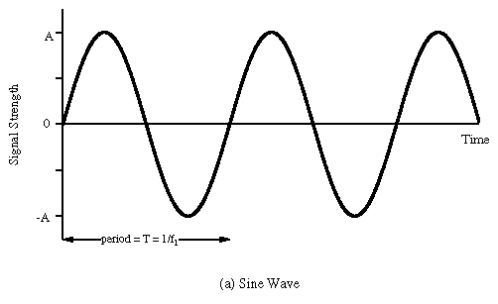
Each time the waveform signal goes above 0 the molecules are in a state of compression meaning they are pushing towards each other. Every time the waveform signal drops below 0 the molecules are in a state of rarefaction meaning they are pulling away from each other. When a waveform shows a clear repeating pattern, as in the case above, it is said to be periodic. Periodic sounds give rise to the sensation of pitch.

Elements of a Sound Wave
Periodic waves have four common parameters, and each of the four parameters affects the way we perceive sound.
- Period: This is the length of time it takes for a waveform to complete one cycle. This amount of time is referred to as t
- Wavelength(): the distance it takes for a wave to complete one full period. This is usually measured in meters.
- Frequency: the number of cycles or periods per second. Frequency is measured in Hertz. If a sound has a frequency of 440Hz it completes 440 cycles every second. Given a frequency, one can easily calculate the period of any sound. Mathematically, the period is the reciprocal of the frequency (and vice versa). In equation form, this is expressed as follows.
Frequency = 1/Period Period = 1/Frequency
Therefore the frequency is the inverse of the period, so a wave of 100 Hz frequency has a period of 1/100 or 0.01 secs, likewise a frequency of 256Hz has a period of 1/256, or 0.004 secs. To calculate the wavelength of a sound in any given medium we can use the following equation:
Wavelength = Velocity/Frequency
Humans can hear frequencies from 20Hz to 20000Hz (although this can differ dramatically from individual to individual). You can read more about frequency in the next chapter.
- Phase: This is the starting point of a waveform. The starting point along the Y-axis of our plotted waveform is not always 0. This can be expressed in degrees or in radians. A complete cycle of a waveform will cover 360 degrees or (2 x pi) radians.
- Amplitude: Amplitude is represented by the y-axis of a plotted pressure wave. The strength at which the molecules pull or push away from each other will determine how far above and below 0 the wave fluctuates. The greater the y-value the greater the amplitude of our wave. The greater the compressions and rarefactions the greater the amplitude.

Transduction
The analogue sound waves we hear in the world around us need to be converted into an electrical signal in order to be amplified or sent to a soundcard for recording. The process of converting acoustical energy in the form of pressure waves into an electrical signal is carried out by a device known as a a transducer.
A transducer, which is usually found in microphones, produces a changing electrical voltage that mirrors the changing compression and rarefaction of the air molecules caused by the sound wave. The continuous variation of pressure is therefore 'transduced' into continuous variation of voltage. The greater the variation of pressure the greater the variation of voltage that is sent to the computer.
Ideally, the transduction process should be as transparent and clean as possible: i.e., whatever goes in comes out as a perfect voltage representation. In the real world however this is never the case. Noise and distortion are always incorporated into the signal. Every time sound passes through a transducer or is transmitted electrically a change in signal quality will result. When we talk of 'noise' we are talking specifically about any unwanted signal captured during the transduction process. This normally manifests itself as an unwanted 'hiss'.

Sampling
The analogue voltage that corresponds to an acoustic signal changes continuously so that at each instant in time it will have a different value. It is not possible for a computer to receive the value of the voltage for every instant because of the physical limitations of both the computer and the data converters (remember also that there are an infinite number of instances between every two instances!).
What the soundcard can do however is to measure the power of the analogue voltage at intervals of equal duration. This is how all digital recording works and is known as 'sampling'. The result of this sampling process is a discrete or digital signal which is no more than a sequence of numbers corresponding to the voltage at each successive sample time.
Below left is a diagram showing a sinusoidal waveform. The vertical lines that run through the diagram represents the points in time when a snapshot is taken of the signal. After the sampling has taken place we are left with what is known as a discrete signal consisting of a collection of audio samples, as illustrated in the diagram on the right hand side below. If one is recording using a typical audio editor the incoming samples will be stored in the computer RAM (Random Access Memory). In Csound one can process the incoming audio samples in real time and output a new stream of samples, or write them to disk in the form of a sound file.
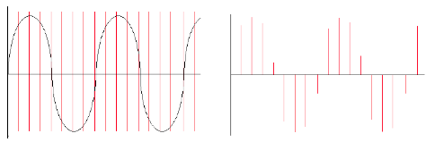
It is important to remember that each sample represents the amount of voltage, positive or negative, that was present in the signal at the point in time the sample or snapshot was taken.
The same principle applies to recording of live video. A video camera takes a sequence of pictures of something in motion for example. Most video cameras will take between 30 and 60 still pictures a second. Each picture is called a frame. When these frames are played we no longer perceive them as individual pictures. We perceive them instead as a continuous moving image.

Analogue versus Digital
In general, analogue systems can be quite unreliable when it comes to noise and distortion. Each time something is copied or transmitted, some noise and distortion is introduced into the process. If this is done many times, the cumulative effect can deteriorate a signal quite considerably. It is because of this, the music industry has turned to digital technology, which so far offers the best solution to this problem. As we saw above, in digital systems sound is stored as numbers, so a signal can be effectively "cloned". Mathematical routines can be applied to prevent errors in transmission, which could otherwise introduce noise into the signal.

Sample Rate and the Sampling Theorem
The sample rate describes the number of samples (pictures/snapshots) taken each second. To sample an audio signal correctly it is important to pay attention to the sampling theorem:
"To represent digitally a signal containing frequencies up to X Hz, it is necessary to use a sampling rate of at least 2X samples per second"
According to this theorem, a soundcard or any other digital recording device will not be able to represent any frequency above 1/2 the sampling rate. Half the sampling rate is also referred to as the Nyquist frequency, after the Swedish physicist Harry Nyquist who formalized the theory in the 1920s. What it all means is that any signal with frequencies above the Nyquist frequency will be misrepresented. Furthermore it will result in a frequency lower than the one being sampled. When this happens it results in what is known as aliasing or foldover.

Aliasing
Here is a graphical representation of aliasing.
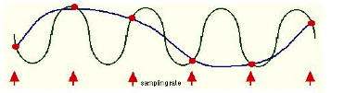
The sinusoidal wave form in blue is being sampled at each arrow. The line that joins the red circles together is the captured waveform. As you can see the captured wave form and the original waveform have different frequencies. Here is another example:
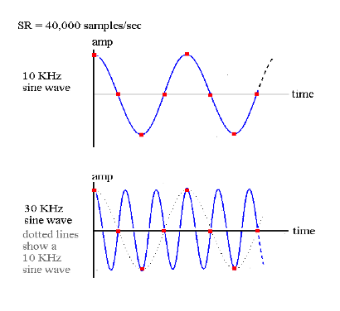
We can see that if the sample rate is 40,000 there is no problem sampling a signal that is 10KHz. On the other hand, in the second example it can be seen that a 30kHz waveform is not going to be correctly sampled. In fact we end up with a waveform that is 10kHz, rather than 30kHz.
The following Csound instrument plays a 1000 Hz tone first directly, and then because the frequency is 1000 Hz lower than the sample rate of 44100 Hz:
EXAMPLE 01A01_Aliasing.csd
<CsoundSynthesizer>
<CsOptions>
-odac
</CsOptions>
<CsInstruments>
;example by Joachim Heintz
sr = 44100
ksmps = 32
nchnls = 2
0dbfs = 1

instr 1
asig oscils .2, p4, 0
outs asig, asig
endin

</CsInstruments>
<CsScore>
i 1 0 2 1000 ;1000 Hz tone
i 1 3 2 43100 ;43100 Hz tone sounds like 1000 Hz because of aliasing
</CsScore>
</CsoundSynthesizer>
The same phenomenon takes places in film and video too. You may recall having seen wagon wheels apparently move backwards in old Westerns. Let us say for example that a camera is taking 60 frames per second of a wheel moving. If the wheel is completing one rotation in exactly 1/60th of a second, then every picture looks the same. - as a result the wheel appears to stand still. If the wheel speeds up, i.e., increases frequency, it will appear as if the wheel is slowly turning backwards. This is because the wheel will complete more than a full rotation between each snapshot. This is the most ugly side-effect of aliasing - wrong information.
As an aside, it is worth observing that a lot of modern 'glitch' music intentionally makes a feature of the spectral distortion that aliasing induces in digital audio.
Audio-CD Quality uses a sample rate of 44100Kz (44.1 kHz). This means that CD quality can only represent frequencies up to 22050Hz. Humans typically have an absolute upper limit of hearing of about 20Khz thus making 44.1KHz a reasonable standard sampling rate.

Bits, Bytes and Words. Understanding Binary.
All digital computers represent data as a collection of bits (short for binary digit). A bit is the smallest possible unit of information. One bit can only be one of two states - off or on, 0 or 1. The meaning of the bit, which can represent almost anything, is unimportant at this point. The thing to remember is that all computer data - a text file on disk, a program in memory, a packet on a network - is ultimately a collection of bits.
Bits in groups of eight are called bytes, and one byte usually represents a single character of data in the computer. It's a little used term, but you might be interested in knowing that a nibble is half a byte (usually 4 bits).

The Binary System
All digital computers work in a environment that has only two variables, 0 and 1. All numbers in our decimal system therefore must be translated into 0's and 1's in the binary system. If you think of
binary numbers in terms of switches. With one switch you can represent up to two different numbers.
0 (OFF) = Decimal 0
1 (ON) = Decimal 1
Thus, a single bit represents 2 numbers, two bits can represent 4 numbers, three bits represent 8 numbers, four bits represent 16 numbers, and so on up to a byte, or eight bits, which represents 256 numbers. Therefore each added bit doubles the amount of possible numbers that can be represented. Put simply, the more bits you have at your disposal the more information you can store.

Bit-depth Resolution
Apart from the sample rate, another important parameter which can affect the fidelity of a digital signal is the accuracy with which each sample is known, in other words knowing how strong each voltage is. Every sample obtained is set to a specific amplitude (the measure of strength for each voltage) level. The number of levels depends on the precision of the measurement in bits, i.e., how many binary digits are used to store the samples. The number of bits that a system can use is normally referred to as the bit-depth resolution.
If the bit-depth resolution is 3 then there are 8 possible levels of amplitude that we can use for each sample. We can see this in the diagram below. At each sampling period the soundcard plots an amplitude. As we are only using a 3-bit system the resolution is not good enough to plot the correct amplitude of each sample. We can see in the diagram that some vertical lines stop above or below the real signal. This is because our bit-depth is not high enough to plot the amplitude levels with sufficient accuracy at each sampling period.
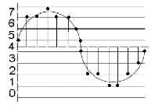
example here for 4, 6, 8, 12, 16 bit of a sine signal ...
... coming in the next release
The standard resolution for CDs is 16 bit, which allows for 65536 different possible amplitude levels, 32767 either side of the zero axis. Using bit rates lower than 16 is not a good idea as it will result in noise being added to the signal. This is referred to as quantization noise and is a result of amplitude values being excessively rounded up or down when being digitized. Quantization noise becomes most apparent when trying to represent low amplitude (quiet) sounds. Frequently a tiny amount of noise, known as a dither signal, will be added to digital audio before conversion back into an analogue signal. Adding this dither signal will actually reduce the more noticeable noise created by quantization. As higher bit depth resolutions are employed in the digitizing process the need for dithering is reduced. A general rule is to use the highest bit rate available.
Many electronic musicians make use of deliberately low bit depth quantization in order to add noise to a signal. The effect is commonly known as 'bit-crunching' and is relatively easy to do in Csound.

ADC / DAC
The entire process, as described above, of taking an analogue signal and converting it into a digital signal is referred to as analogue to digital conversion or ADC. Of course digital to analogue conversion, DAC, is also possible. This is how we get to hear our music through our PC's headphones or speakers. For example, if one plays a sound from Media Player or iTunes the software will send a series of numbers to the computer soundcard. In fact it will most likely send 44100 numbers a second. If the audio that is playing is 16 bit then these numbers will range from -32768 to +32767.
When the sound card receives these numbers from the audio stream it will output corresponding voltages to a loudspeaker. When the voltages reach the loudspeaker they cause the loudspeakers magnet to move inwards and outwards. This causes a disturbance in the air around the speaker resulting in what we perceive as sound.

6. FREQUENCIES
As mentioned in the previous section frequency is defined as the number of cycles or periods per second. Frequency is measured in Hertz. If a tone has a frequency of 440Hz it completes 440 cycles every second. Given a tone's frequency, one can easily calculate the period of any sound. Mathematically, the period is the reciprocal of the frequency and vice versa. In equation form, this is expressed as follows.
Frequency = 1/Period Period = 1/Frequency
Therefore the frequency is the inverse of the period, so a wave of 100 Hz frequency has a period of 1/100 or 0.01 seconds, likewise a frequency of 256Hz has a period of 1/256, or 0.004 seconds. To calculate the wavelength of a sound in any given medium we can use the following equation:
λ = Velocity/Frequency
For instance, a wave of 1000 Hz in air (velocity of diffusion about 340 m/s) has a length of approximately 340/1000 m = 34 cm.

Lower and Higher Borders for Hearing
The human ear can generally hear sounds in the range 20 Hz to 20,000 Hz (20 kHz). This upper limit tends to decrease with age due to a condition known as presbyacusis, or age related hearing loss. Most adults can hear to about 16 kHz while most children can hear beyond this. At the lower end of the spectrum the human ear does not respond to frequencies below 20 Hz, with 40 of 50 Hz being the lowest most people can perceive.
So, in the following example, you will not hear the first (10 Hz) tone, and probably not the last (20 kHz) one, but hopefully the other ones (100 Hz, 1000 Hz, 10000 Hz):
EXAMPLE 01B01_BordersForHearing.csd
<CsoundSynthesizer>
<CsOptions>
-odac -m0
</CsOptions>
<CsInstruments>
;example by joachim heintz
sr = 44100
ksmps = 32
nchnls = 2
0dbfs = 1

instr 1
prints "Playing %d Hertz!\n", p4
asig oscils .2, p4, 0
outs asig, asig
endin

</CsInstruments>
<CsScore>
i 1 0 2 10
i . + . 100
i . + . 1000
i . + . 10000
i . + . 20000
</CsScore>
</CsoundSynthesizer>

Logarithms, Frequency Ratios and Intervals
A lot of basic maths is about simplification of complex equations. Shortcuts are taken all the time to make things easier to read and equate. Multiplication can be seen as a shorthand of addition, for example, 5x10 = 5+5+5+5+5+5+5+5+5+5. Exponents are shorthand for multiplication, 35 = 3x3x3x3x3. Logarithms are shorthand for exponents and are used in many areas of science and engineering in which quantities vary over a large range. Examples of logarithmic scales include the decibel scale, the Richter scale for measuring earthquake magnitudes and the astronomical scale of stellar brightnesses. Musical frequencies also work on a logarithmic scale, more on this later.
Intervals in music describe the distance between two notes. When dealing with standard musical notation it is easy to determine an interval between two adjacent notes. For example a perfect 5th is always made up of 7 semitones. When dealing with Hz values things are different. A difference of say 100Hz does not always equate to the same musical interval. This is because musical intervals as we hear them are represented in Hz as frequency ratios. An octave for example is always 2:1. That is to say every time you double a Hz value you will jump up by a musical interval of an octave.
Consider the following. A flute can play the note A at 440 Hz. If the player plays another A an octave above it at 880 Hz the difference in Hz is 440. Now consider the piccolo, the highest pitched instrument of the orchestra. It can play a frequency of 2000 Hz but it can also play an octave above this at 4000 Hz (2 x 2000 Hz). While the difference in Hertz between the two notes on the flute is only 440 Hz, the difference between the two high pitched notes on a piccolo is 1000 Hz yet they are both only playing notes one octave apart.
What all this demonstrates is that the higher two pitches become the greater the difference in Hertz needs to be for us to recognize the difference as the same musical interval. The most common ratios found in the equal temperament scale are the unison: (1:1), the octave: (2:1), the perfect fifth (3:2), the perfect fourth (4:3), the major third (5:4) and the minor third (6:5).
The following example shows the difference between adding a certain frequency and applying a ratio. First, the frequencies of 100, 400 and 800 Hz all get an addition of 100 Hz. This sounds very different, though the added frequency is the same. Second, the ratio 3/2 (perfect fifth) is applied to the same frequencies. This sounds always the same, though the frequency displacement is different each time.
EXAMPLE 01B02_Adding_vs_ratio.csd
<CsoundSynthesizer>
<CsOptions>
-odac -m0
</CsOptions>
<CsInstruments>
;example by joachim heintz
sr = 44100
ksmps = 32
nchnls = 2
0dbfs = 1

instr 1
prints "Playing %d Hertz!\n", p4
asig oscils .2, p4, 0
outs asig, asig
endin

instr 2
prints "Adding %d Hertz to %d Hertz!\n", p5, p4
asig oscils .2, p4+p5, 0
outs asig, asig
endin

instr 3
prints "Applying the ratio of %f (adding %d Hertz)
to %d Hertz!\n", p5, p4*p5, p4
asig oscils .2, p4*p5, 0
outs asig, asig
endin

</CsInstruments>
<CsScore>
;adding a certain frequency (instr 2)
i 1 0 1 100
i 2 1 1 100 100
i 1 3 1 400
i 2 4 1 400 100
i 1 6 1 800
i 2 7 1 800 100
;applying a certain ratio (instr 3)
i 1 10 1 100
i 3 11 1 100 [3/2]
i 1 13 1 400
i 3 14 1 400 [3/2]
i 1 16 1 800
i 3 17 1 800 [3/2]
</CsScore>
</CsoundSynthesizer>
So what of the algorithms mentioned above. As some readers will know the current preferred method of tuning western instruments is based on equal temperament. Essentially this means that all octaves are split into 12 equal intervals. Therefore a semitone has a ratio of 2(1/12), which is approximately 1.059463.
So what about the reference to logarithms in the heading above? As stated previously, logarithms are shorthand for exponents. 2(1/12)= 1.059463 can also be written as log2(1.059463)= 1/12. Therefore musical frequency works on a logarithmic scale.

MIDI Notes
Csound can easily deal with MIDI notes and comes with functions that will convert MIDI notes to Hertz values and back again. In MIDI speak A440 is equal to A4 and is MIDI note 69. You can think of A4 as being the fourth A from the lowest A we can hear, well almost hear.
Caution: like many 'standards' there is occasional disagreement about the mapping between frequency and octave number. You may occasionally encounter A440 being described as A3.

7. INTENSITIES

Real World Intensities and Amplitudes
There are many ways to describe a sound physically. One of the most common is the Sound Intensity Level (SIL). It describes the amount of power on a certain surface, so its unit is Watt per square meter (). The range of human hearing is about at the threshold of hearing to at the threshold of pain. For ordering this immense range, and to facilitate the measurement of one sound intensity based upon its ratio with another, a logarithmic scale is used. The unit Bel describes the relation of one intensity I to a reference intensity I0 as follows:
Sound Intensity Level in Bel
If, for instance, the ratio is 10, this is 1 Bel. If the ratio is 100, this is 2 Bel.
For real world sounds, it makes sense to set the reference value to the threshold of hearing which has been fixed as at 1000 Hertz. So the range of hearing covers about 12 Bel. Usually 1 Bel is divided into 10 deci Bel, so the common formula for measuring a sound intensity is:

Sound Intensity Level (SIL) in Decibel (dB) with

While the sound intensity level is useful to describe the way in which the human hearing works, the measurement of sound is more closely related to the sound pressure deviations. Sound waves compress and expand the air particles and by this they increase and decrease the localized air pressure. These deviations are measured and transformed by a microphone. So the question arises: what is the relationship between the sound pressure deviations and the sound intensity? The answer is: sound intensity changes are proportional to the square of the sound pressure changes . As a formula:
Relation between Sound Intensity and Sound Pressure
Let us take an example to see what this means. The sound pressure at the threshold of hearing can be fixed at . This value is the reference value of the Sound Pressure Level (SPL). If we have now a value of , the corresponding sound intensity relation can be calculated as:
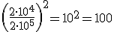
So, a factor of 10 at the pressure relation yields a factor of 100 at the intensity relation. In general, the dB scale for the pressure P related to the pressure P0 is:

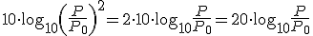
Sound Pressure Level (SPL) in Decibel (dB) with

Working with Digital Audio basically means working with amplitudes. What we are dealing with microphones are amplitudes. Any audio file is a sequence of amplitudes. What you generate in Csound and write either to the DAC in realtime or to a sound file, are again nothing but a sequence of amplitudes. As amplitudes are directly related to the sound pressure deviations, all the relations between sound intensity and sound pressure can be transferred to relations between sound intensity and amplitudes:

Relation between Intensity and Ampltitudes
Decibel (dB) Scale of Amplitudes with any amplitude related to an other amplitude

If you drive an oscillator with the amplitude 1, and another oscillator with the amplitude 0.5, and you want to know the difference in dB, you calculate:
So, the most useful thing to keep in mind is: when you double the amplitude, you get +6 dB; when you have half of the amplitude as before, you get -6 dB.

What is 0 dB?
As described in the last section, any dB scale - for intensities, pressures or amplitudes - is just a way to describe a relationship. To have any sort of quantitative measurement you will need to know the reference value referred to as "0 dB". For real world sounds, it makes sense to set this level to the threshold of hearing. This is done, as we saw, by setting the SIL to and the SPL to .
But for working with digital sound in the computer, this does not make any sense. What you will hear from the sound you produce in the computer, just depends on the amplification, the speakers, and so on. It has nothing, per se, to do with the level in your audio editor or in Csound. Nevertheless, there is a rational reference level for the amplitudes. In a digital system, there is a strict limit for the maximum number you can store as amplitude. This maximum possible level is called 0 dB.
Each program connects this maximum possible amplitude with a number. Usually it is '1' which is a good choice, because you know that everything above 1 is clipping, and you have a handy relation for lower values. But actually this value is nothing but a setting, and in Csound you are free to set it to any value you like via the 0dbfs opcode. Usually you should use this statement in the orchestra header:
0dbfs = 1
This means: "Set the level for zero dB as full scale to 1 as reference value." Note that because of historical reasons the default value in Csound is not 1 but 32768. So you must have this 0dbfs=1 statement in your header if you want to set Csound to the value probably all other audio applications have.

dB Scale Versus Linear Amplitude
Let's see some practical consequences now of what we have discussed so far. One major point is: for getting smooth transitions between intensity levels you must not use a simple linear transition of the amplitudes, but a linear transition of the dB equivalent. The following example shows a linear rise of the amplitudes from 0 to 1, and then a linear rise of the dB's from -80 to 0 dB, both over 10 seconds.
EXAMPLE 01C01_db_vs_linear.csd
<CsoundSynthesizer>
<CsOptions>
-odac
</CsOptions>
<CsInstruments>
;example by joachim heintz
sr = 44100
ksmps = 32
nchnls = 2
0dbfs = 1

instr 1 ;linear amplitude rise
kamp line 0, p3, 1 ;amp rise 0->1
asig oscils 1, 1000, 0 ;1000 Hz sine
aout = asig * kamp
outs aout, aout
endin

instr 2 ;linear rise of dB
kdb line -80, p3, 0 ;dB rise -60 -> 0
asig oscils 1, 1000, 0 ;1000 Hz sine
kamp = ampdb(kdb) ;transformation db -> amp
aout = asig * kamp
outs aout, aout
endin

</CsInstruments>
<CsScore>
i 1 0 10
i 2 11 10
</CsScore>
</CsoundSynthesizer>
You will hear how fast the sound intensity increases at the first note with direct amplitude rise, and then stays nearly constant. At the second note you should hear a very smooth and constant increment of intensity.

RMS Measurement
Sound intensity depends on many factors. One of the most important is the effective mean of the amplitudes in a certain time span. This is called the Root Mean Square (RMS) value. To calculate it, you have (1) to calculate the squared amplitudes of number N samples. Then you (2) divide the result by N to calculate the mean of it. Finally (3) take the square root.
Let's see a simple example, and then have a look how getting the rms value works in Csound. Assumeing we have a sine wave which consists of 16 samples, we get these amplitudes:
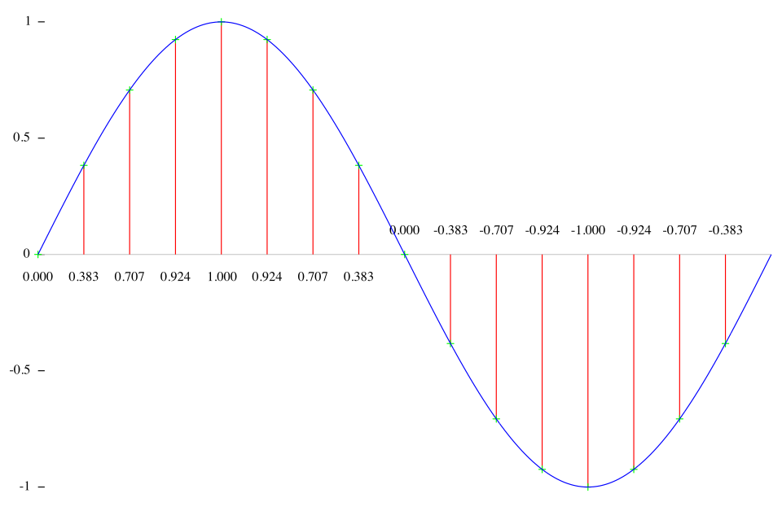
These are the squared amplitudes:
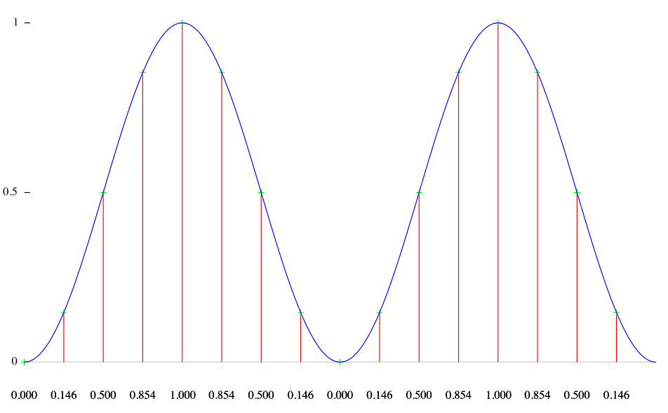
The mean of these values is:
(0+0.146+0.5+0.854+1+0.854+0.5+0.146+0+0.146+0.5+0.854+1+0.854+0.5+0.146)/16=8/16=0.5
And the resulting RMS value is 0.5=0.707 .
The rms opcode in Csound calculates the RMS power in a certain time span, and smoothes the values in time according to the ihp parameter: the higher this value (the default is 10 Hz), the snappier the measurement, and vice versa. This opcode can be used to implement a self-regulating system, in which the rms opcode prevents the system from exploding. Each time the rms value exceeds a certain value, the amount of feedback is reduced. This is an example1 :
EXAMPLE 01C02_rms_feedback_system.csd
<CsoundSynthesizer>
<CsOptions>
-odac
</CsOptions>
<CsInstruments>
;example by Martin Neukom, adapted by Joachim Heintz
sr = 44100
ksmps = 32
nchnls = 2
0dbfs = 1

giSine ftgen 0, 0, 2^10, 10, 1 ;table with a sine wave

instr 1
a3 init 0
kamp linseg 0, 1.5, 0.2, 1.5, 0 ;envelope for initial input
asnd poscil kamp, 440, giSine ;initial input
if p4 == 1 then ;choose between two sines ...
adel1 poscil 0.0523, 0.023, giSine
adel2 poscil 0.073, 0.023, giSine,.5
else ;or a random movement for the delay lines
adel1 randi 0.05, 0.1, 2
adel2 randi 0.08, 0.2, 2
endif
a0 delayr 1 ;delay line of 1 second
a1 deltapi adel1 + 0.1 ;first reading
a2 deltapi adel2 + 0.1 ;second reading
krms rms a3 ;rms measurement
delayw asnd + exp(-krms) * a3 ;feedback depending on rms
a3 reson -(a1+a2), 3000, 7000, 2 ;calculate a3
aout linen a1/3, 1, p3, 1 ;apply fade in and fade out
outs aout, aout
endin
</CsInstruments>
<CsScore>
i 1 0 60 1 ;two sine movements of delay with feedback
i 1 61 . 2 ;two random movements of delay with feedback
</CsScore>
</CsoundSynthesizer>

Fletcher-Munson Curves
Human hearing is roughly in a range between 20 and 20000 Hz. But inside this range, the hearing is not equally sensitive. The most sensitive region is around 3000 Hz. If you come to the upper or lower border of the range, you need more intensity to perceive a sound as "equally loud".
These curves of equal loudness are mostly called "Fletcher-Munson Curves" because of the paper of H. Fletcher and W. A. Munson in 1933. They look like this:
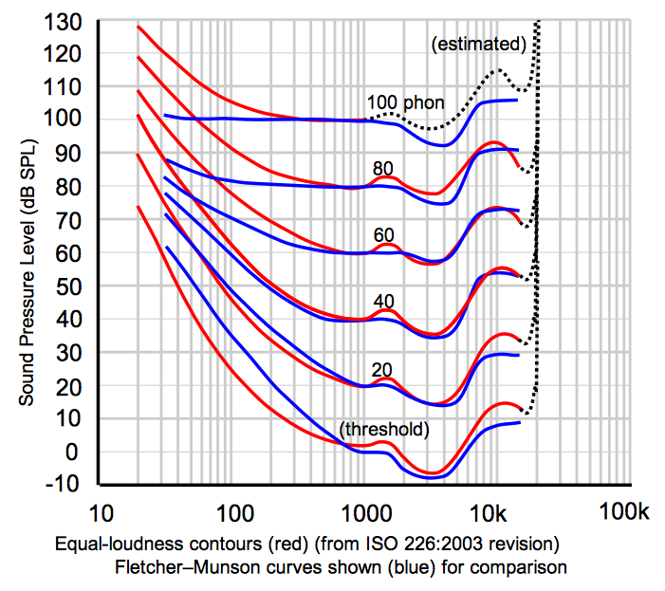
Try the following test. In the first 5 seconds you will hear a tone of 3000 Hz. Adjust the level of your amplifier to the lowest possible point at which you still can hear the tone. - Then you hear a tone whose frequency starts at 20 Hertz and ends at 20000 Hertz, over 20 seconds. Try to move the fader or knob of your amplification exactly in a way that you still can hear anything, but as soft as possible. The movement of your fader should roughly be similar to the lowest Fletcher-Munson-Curve: starting relatively high, going down and down until 3000 Hertz, and then up again. (As always, this test depends on your speaker hardware. If your speaker do not provide proper lower frequencies, you will not hear anything in the bass region.)
EXAMPLE 01C03_FletcherMunson.csd
<CsoundSynthesizer>
<CsOptions>
-odac
</CsOptions>
<CsInstruments>
sr = 44100
ksmps = 32
nchnls = 2
0dbfs = 1

giSine ftgen 0, 0, 2^10, 10, 1 ;table with a sine wave

instr 1
kfreq expseg p4, p3, p5
printk 1, kfreq ;prints the frequencies once a second
asin poscil .2, kfreq, giSine
aout linen asin, .01, p3, .01
outs aout, aout
endin
</CsInstruments>
<CsScore>
i 1 0 5 1000 1000
i 1 6 20 20 20000
</CsScore>
</CsoundSynthesizer>
It is very important to bear in mind that the perceived loudness depends much on the frequencies. You must know that putting out a sine of 30 Hz with a certain amplitude is totally different from a sine of 3000 Hz with the same amplitude - the latter will sound much louder.

- cf Martin Neukom, Signale Systeme Klangsynthese, Zürich 2003, p. 383^
02 QUICK START
8. MAKE CSOUND RUN
9. CSOUND SYNTAX
10. CONFIGURING MIDI
11. LIVE AUDIO
12. RENDERING TO FILE

8. MAKE CSOUND RUN

Csound and Frontends
The core element of Csound is an audio engine for the Csound language. It has no graphical interface and it is designed to take Csound text files (called ".csd" files) and produce audio, either in realtime, or by writing to a file. It can still be used in this way, but most users nowadays prefer to use Csound via a frontend. A frontend is an application which assists you in writing code and running Csound. Beyond the functions of a simple text editor, a frontend environment will offer colour coded highlighting of language specific keywords and quick access to an integrated help system. A frontend can also expand possibilities by providing tools to build interactive interfaces as well, sometimes, as advanced compositional tools.
In 2009 the Csound developers decided to include CsoundQt as the standard frontend to be included with the Csound distribution, so you will already have this frontend if you have installed any of the recent pre-built versions of Csound. Conversely if you install a frontend you will require a separate installation of Csound in order for it to function. If you experience any problems with CsoundQt, or simply prefer another frontend design, try WinXound, Cabbage or Blue as alternative.

Which version of Csound should I choose?
Spring 2013 has been an exciting time for Csound users with the release of Csound6. Csound6 has a lot of new features like on-the-fly recompilation of Csound code (enabling forms of live-coding), arrays, new syntax for using opcodes, a redesigned C/C++ API, better threading for usage with multi-core processors, better real-time performance, etc... but one must bear in mind that Csound6 is still a work-in-progress and may have stability issues.
If you are proficient with compiling software for your computer, know how to use git, are already a programmer wanting to learn an audio-specific language, then Csound6 might be for you as it offers a few features that resemble general purpose languages like functional-style syntax, increment/decrement operators, better means of data abstraction (arrays), etc...
On the other hand, if you are new to Csound or to programming in general, your best bet would be to install Csound5, as most documentation still refers to that version. Everything you will learn about Csound5 will work in Csound6, but you will benefit from the added stability and better documentation (including this manual) that Csound5 still provides over Csound6.
Of course, it is possible to have Csound5 installed as the main package and still install a local copy of Csound6 for testing purposes, but then again, certain skills are required pertaining to compiling software from source code1 so beginners should really consider learning Csound5 and then move to Csound6 once it has become the official version.

How to Download and Install Csound
To get Csound you first need to download the package for your system from the SourceForge page: http://sourceforge.net/projects/csound/files/csound5 (or http://sourceforge.net/projects/csound/files/csound6 if you have decided to use Csound6).
There are many files here, so here are some guidelines to help you choose the appropriate version.

Windows
Windows installers are the ones ending in .exe. Look for the latest version of Csound, and find a file which should be called something like: Csound5.17-gnu-win32-d.exe. The important thing to note is the final letter of the installer name, which can be "d" or "f". This specifies the computation precision of the Csound engine. Float precision (32-bit float) is marked with "f" and double precision (64-bit float) is marked "d". This is important to bear in mind, as a frontend which works with the "floats" version will not run if you have the "doubles" version installed. More recent versions of the pre-built Windows installer have only been released in the "doubles" version.
After you have downloaded the installer, you might find it easiest just to launch the executable installer and follow the instructions accepting the defaults. You can, however, modify the components that will be installed during the installation process (utilities, front-ends, documentation etc.) creating either a fully-featured installation or a super-light installation with just the bare bones.
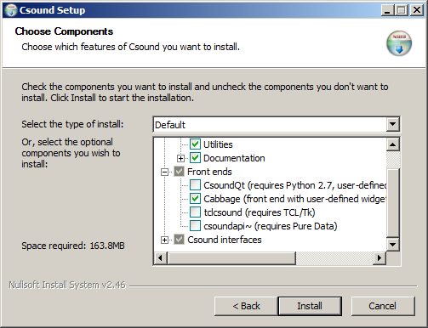
You may also find it useful to install the Python opcodes at the this stage - selected under "Csound interfaces". If you choose to do this however you will have to separately install Python itself. You will need to install Python in any case if you plan to use the CsoundQt front end, as the current version of CsoundQt requires Python. (As of March 2013, Version 2.7 of Python is the correct choice.)
Csound will, by default, install into your Program Files folder, but you may prefer to install directly into a folder in the root directory of your C: drive.
Once installation has completed, you can find a Csound folder in your Start Menu containing short-cuts to various items of documentation and Csound front-ends.
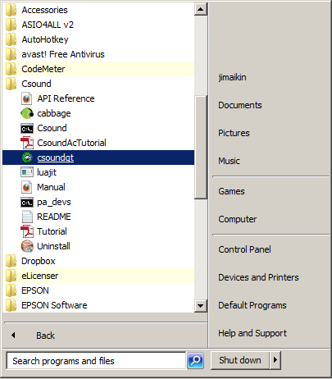
The Windows installer will not create any desktop shortcuts but you can easily do this yourself by right-clicking the CsoundQt executable (for example) and selecting "create shortcut". Drag the newly created shortcut onto your desktop.

Mac OS X
The Mac OS X installers are the files ending in .dmg. Look for the latest version of Csound for your particular system, for example a Universal binary for 10.8 will be called something like: csound5.19.02-OSX10.8-universal.dmg. When you double click the downloaded file, you will have a disk image on your desktop, with the Csound installer, CsoundQt and a readme file. Double-click the installer and follow the instructions. Csound and the basic Csound utilities will be installed. To install the CsoundQt frontend, you only need to move it to your Applications folder.

Linux and others
Csound is available from the official package repositories for many distributions like OpenSuse, Debian, Ubuntu, Fedora, Archlinux and Gentoo. If there are no binary packages for your platform, or you need a more recent version, you can get the source package from the SourceForge page and build from source. You will find the most recent build instructions in the Csound MediaWiki on Sourceforge (Csound5) and in the new Sourceforge Wiki (Csound6). Detailed (but perhaps outdated) information can also be found in the Building Csound Manual Page.
Note that the Csound repository has moved from cvs to git. After installing git, you can use this command to clone the Csound6 repository, if you like to have access to the latest (perhaps unstable) sources:
git clone git://git.code.sf.net/p/csound/csound6-git
You will find the last release on the master branch, and the latest sources on the develop branch.

iOS
Thanks to Steven Yi and Victor Lazzarini, Csound has been ported to Android and iOS.2
The iOS files for Csound are found in a subfolder of the Csound files on SourceForge. The location is http://sourceforge.net/projects/csound/files/csound5/iOS/ for Csound5. For Csound6, you will find the iOS files in the version folder in http://sourceforge.net/projects/csound/files/csound6/.
The file of interest (in the Csound5 folder) is csound-iOS-X.XX.XX.X.zip where (X.XX.XX.X is the version number). The archive file contains the CSound programming library, sample code, and a PDF introduction to programming CSound for iOS devices, written by Victor Lazzarini and Steven Yi.
This distribution is aimed at iOS programmers, there are no apps that can be installed directly: this is due to the fact that iOS apps cannot be installed directly. iOS apps have to be downloaded and installed from Apple's app store.
On Apple's app store, there are some examples of apps that use Csound. Below, is a a small sample of apps that make use of Csound:

- csGrain, developed by the Boulanger Labs (http://www.boulangerlabs.com), is a complex audio effects app that works with audio files or live audio input.
- Portable Dandy, an innovative sampler synthesiser for iOS (see http://www.barefoot-coders.com).
- iPulsaret, an impressive synthesizer app (see http://www.densitytigs.com).
This is an on-going situation, and we can expect to see more apps made available as time goes by.

Android
The Android files for Csound are found in a subfolder of the Csound files on SourceForge. At the time of writing the location is http://sourceforge.net/projects/csound/files/csound5/Android/ for Csound5. For Csound6, you will find the Android files in the version folder in http://sourceforge.net/projects/csound/files/csound6/.
Two files are of interest here (in the Csound5 folder). One is a CSD player which executes Csound files on an Android device (the CSD player app is called CsoundApp-XXX.apk where XXX is the version number of the app).
The other file of possible interest to is csound-android-X.XX.XX.zip (where X.XX.XX is the version number), this file contains an Android port of the Csound programming library and sample Android projects. The source code for the CSD player mentioned above, is one of the sample projects. This file should not be installed on an Android device.
To install the CsoundApp-XXX.apk on an Android device the following steps are taken:
- The CsoundApp-XXX.apk file is copied onto the Android device, for example /mnt/sdcard/download or something similar.
- One or more CSD files (not included in the distribution) should be copied to the device's shared storage location: this is usually anywhere in or below /mnt/sdcard
- Launch a file explorer app on the device and navigate to the folder containing the file CsoundApp-XXX.apk (copied in step 1). Select the apk file and when prompted, select to install it. The app is installed as "CSD Player".
- In the device's app browser (the screen which is used to launch all the apps on the device) run the "CSD Player" app.
- CSD Player displays its initial screen. Tap the "Browse" button to find a CSD file to play on your device: CSD Player displays a file browser starting at the device's shared storage location (usually /mnt/sdcard). Select a csd file that you have copied to the device (step 2).
- Tap the play toggle to play the selected CSD.
If you want to use Csound6 on Android, have a look at chapter 12F in this manual, which describes everything in detail.
On Google's Play Store there are some apps that use Csound. Below is a small sample of such apps:
- DIY Sound Salad, developed by Zatchu (http://zatchu.com/category/story/), is a multi sample record and playback app. Quite enjoyable to use.
- Chime Pad, developed by Arthur B. Hunkins (http://www.arthunkins.com), is a soothing chime player app.
- Mono Dot Micro, developed by Acoustic Orchard (http://acousticorchard.com/microsynth/market), this app is a 2 oscillator synthesiser, with effects.
- Psycho Flute developed by Brian Redfern (source code available at http://github.com/bredfern/PsychoFlute), it is a "physical modelling flute synth". Both fun and interesting.

Install Problems?
If, for any reason, you can't find the CsoundQt (formerly QuteCsound) frontend on your system after install, or if you want to install the most recent version of CsoundQt, or if you prefer another frontend altogether: see the CSOUND FRONTENDS section of this manual for further information. If you have any install problems, consider joining the Csound Mailing List to report your issues, or write a mail to one of the maintainers (see ON THIS RELEASE).

The Csound Reference Manual
The Csound Reference Manual is an indispensable companion to Csound. It is available in various formats from the same place as the Csound installers, and it is installed with the packages for OS X and Windows. It can also be browsed online at The Csound Manual Section at Csounds.com. Many frontends will provide you with direct and easy access to it.

How to Execute a Simple Example

Using CsoundQt
Run CsoundQt. Go into the CsoundQt menubar and choose: Examples->Getting started...-> Basics-> HelloWorld
You will see a very basic Csound file (.csd) with a lot of comments in green.
Click on the "RUN" icon in the CsoundQt control bar to start the realtime Csound engine. You should hear a 440 Hz sine wave.
You can also run the Csound engine in the terminal from within QuteCsound. Just click on "Run in Term". A console will pop up and Csound will be executed as an independent process. The result should be the same - the 440 Hz "beep".

Using the Terminal / Console
1. Save the following code in any plain text editor as HelloWorld.csd.
EXAMPLE 02A01_HelloWorld.csd
<CsoundSynthesizer>
<CsOptions>
-odac
</CsOptions>
<CsInstruments>
;Example by Alex Hofmann
instr 1
aSin oscils 0dbfs/4, 440, 0
out aSin
endin
</CsInstruments>
<CsScore>
i 1 0 1
</CsScore>
</CsoundSynthesizer>
2. Open the Terminal / Prompt / Console
3. Type: csound /full/path/HelloWorld.csd
where /full/path/HelloWorld.csd is the complete path to your file. You also execute this file by just typing csound then dragging the file into the terminal window and then hitting return.
You should hear a 440 Hz tone.
- for Windows users in particular, compiling Csound can be tedious. On linux systems it may be easier to do, but one would still need to learn how to use cmake to configure Csound6.^
- Steven Yi and Victor Lazzarini: Csound on Android (Paper at the Linux Audio Conference 2012); Brian Redfern: Introducing the Android CSD Player (Csound Journal Issue 17 - Fall 2012) ^

9. CSOUND SYNTAX

Orchestra and Score
In Csound, you must define "instruments", which are units which "do things", for instance playing a sine wave. These instruments must be called or "turned on" by a "score". The Csound "score" is a list of events which describe how the instruments are to be played in time. It can be thought of as a timeline in text.
A Csound instrument is contained within an Instrument Block, which starts with the keyword instr and ends with the keyword endin. All instruments are given a number (or a name) to identify them.
instr 1
... instrument instructions come here...
endin
Score events in Csound are individual text lines, which can turn on instruments for a certain time. For example, to turn on instrument 1, at time 0, for 2 seconds you will use:
i 1 0 2

The Csound Document Structure
A Csound document is structured into three main sections:
- CsOptions: Contains the configuration options for Csound. For example using "-o dac" in this section will make Csound run in real-time instead of writing a sound file.1
- CsInstruments: Contains the instrument definitions and optionally some global settings and definitions like sample rate, etc. 2
- CsScore: Contains the score events which trigger the instruments.
Each of these sections is opened with a <xyz> tag and closed with a </xyz> tag. Every Csound file starts with the <CsoundSynthesizer> tag, and ends with </CsoundSynthesizer>. Only the text in-between will be used by Csound.
EXAMPLE 02B01_DocStruct.csd
<CsoundSynthesizer>; START OF A CSOUND FILE

<CsOptions> ; CSOUND CONFIGURATION
-odac
</CsOptions>

<CsInstruments> ; INSTRUMENT DEFINITIONS GO HERE

; Set the audio sample rate to 44100 Hz
sr = 44100

instr 1
; a 440 Hz Sine Wave
aSin oscils 0dbfs/4, 440, 0
out aSin
endin
</CsInstruments>

<CsScore> ; SCORE EVENTS GO HERE
i 1 0 1
</CsScore>

</CsoundSynthesizer> ; END OF THE CSOUND FILE
; Anything after is ignored by Csound
Comments, which are lines of text that Csound will ignore, are started with the ";" character. Multi-line comments can be made by encasing them between "/*" and "*/".

Opcodes
"Opcodes" or "Unit generators" are the basic building blocks of Csound. Opcodes can do many things like produce oscillating signals, filter signals, perform mathematical functions or even turn on and off instruments. Opcodes, depending on their function, will take inputs and outputs. Each input or output is called, in programming terms, an "argument". Opcodes always take input arguments on the right and output their results on the left, like this:
output OPCODE input1, input2, input3, .., inputN
For example the oscils opcode has three inputs: amplitude, frequency and phase, and produces a sine wave signal:
aSin oscils 0dbfs/4, 440, 0
In this case, a 440 Hertz oscillation starting at phase 0 radians, with an amplitude of 0dbfs/4 (a quarter of 0 dB as full scale) will be created and its output will be stored in a container called aSin. The order of the arguments is important: the first input to oscils will always be amplitude, the second, frequency and the third, phase.
Many opcodes include optional input arguments and occasionally optional output arguments. These will always be placed after the essential arguments. In the Csound Manual documentation they are indicated using square brackets "[]". If optional input arguments are omitted they are replaced with the default values indicated in the Csound Manual. The addition of optional output arguments normally initiates a different mode of that opcode: for example, a stereo as opposed to mono version of the opcode.

Variables
A "variable" is a named container. It is a place to store things like signals or values from where they can be recalled by using their name. In Csound there are various types of variables. The easiest way to deal with variables when getting to know Csound is to imagine them as cables.
If you want to patch this together: Oscillator->Filter->Output,
you need two cables, one going out from the oscillator into the filter and one from the filter to the output. The cables carry audio signals, which are variables beginning with the letter "a".
aSource buzz 0.8, 200, 10, 1
aFiltered moogladder aSource, 400, 0.8
out aFiltered
In the example above, the buzz opcode produces a complex waveform as signal aSource. This signal is fed into the moogladder opcode, which in turn produces the signal aFiltered. The out opcode takes this signal, and sends it to the output whether that be to the speakers or to a rendered file.
Other common variable types are "k" variables which store control signals, which are updated less frequently than audio signals, and "i" variables which are constants within each instrument note.
You can find more information about variable types here in this manual, or here in the Csound Journal.

Using the Manual
The Csound Reference Manual is a comprehensive source regarding Csound's syntax and opcodes. All opcodes have their own manual entry describing their syntax and behavior, and the manual contains a detailed reference on the Csound language and options.
In CsoundQt you can find the Csound Manual in the Help Menu. You can quickly go to a particular opcode entry in the manual by putting the cursor on the opcode and pressing Shift+F1. WinXsound , Cabbage and Blue also provide easy access to the manual.
- Find all options ("flags") in alphabetical order at www.csounds.com/manual/html/CommandFlags.html or sorted by category at www.csounds.com/manual/html/CommandFlagsCategory.html .^
- It is not obligatory to include Orchestra Header Statements (sr, kr, ksmps, nchnls, etc.) in the section. If they are omitted, then the default value will be used:
sr (audio sampling rate, default value is 44100)
kr (control rate, default value is 4410, but overwritten if ksmps is specified, as kr=sr/ksmps)
ksmps (number of samples in a control period, default value is 10)
nchnls (number of channels of audio output, default value is 1 (mono))
0dbfs (value of 0 decibels using full scale amplitude, default is 32767)
Modern audio software normal uses 0dbfs = 1
Read chapter 01 to know more about these terms from a general perspective. Read chapter 03A to know more in detail about ksmps and friends. ^

10. CONFIGURING MIDI
Csound can receive MIDI events (like MIDI notes and MIDI control changes) from an external MIDI interface or from another program via a virtual MIDI cable. This information can be used to control any aspect of synthesis or performance.
Csound receives MIDI data through MIDI Realtime Modules. These are special Csound plugins which enable MIDI input using different methods according to platform. They are enabled using the -+rtmidi command line flag in the <CsOptions> section of your .csd file, but can also be set interactively on some front-ends via the configure dialog setups.
There is the universal "portmidi" module. PortMidi is a cross-platform module for MIDI I/O and should be available on all platforms. To enable the "portmidi" module, you can use the flag:
-+rtmidi=portmidi
After selecting the RT MIDI module from a front-end or the command line, you need to select the MIDI devices for input and output. These are set using the flags -M and -Q respectively followed by the number of the interface. You can usually use:
-M999
To get a performance error with a listing of available interfaces.
For the PortMidi module (and others like ALSA), you can specify no number to use the default MIDI interface or the 'a' character to use all devices. This will even work when no MIDI devices are present.
-Ma
So if you want MIDI input using the portmidi module, using device 2 for input and device 1 for output, your <CsOptions> section should contain:
-+rtmidi=portmidi -M2 -Q1
There is a special "virtual" RT MIDI module which enables MIDI input from a virtual keyboard. To enable it, you can use:
-+rtmidi=virtual -M0

Platform Specific Modules
If the "portmidi" module is not working properly for some reason, you can try other platform specific modules.

Linux
On Linux systems, you might also have an "alsa" module to use the alsa raw MIDI interface. This is different from the more common alsa sequencer interface and will typically require the snd-virmidi module to be loaded.

OS X
On OS X you may have a "coremidi" module available.

Windows
On Windows, you may have a "winmme" MIDI module.

MIDI I/O in CsoundQt
As with Audio I/O, you can set the MIDI preferences in the configuration dialog. In it you will find a selection box for the RT MIDI module, and text boxes for MIDI input and output devices.
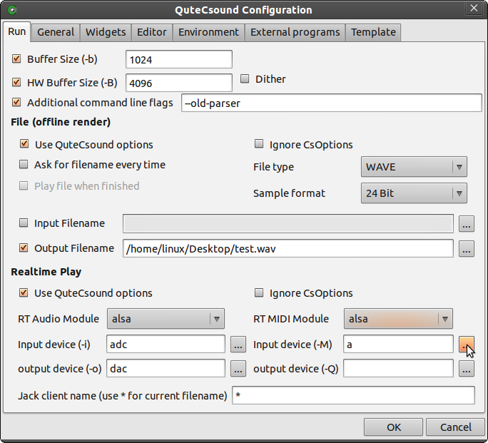

How to Use a MIDI Keyboard
Once you've set up the hardware, you are ready to receive MIDI information and interpret it in Csound. By default, when a MIDI note is received, it turns on the Csound instrument corresponding to its channel number, so if a note is received on channel 3, it will turn on instrument 3, if it is received on channel 10, it will turn on instrument 10 and so on.
If you want to change this routing of MIDI channels to instruments, you can use the massign opcode. For instance, this statement lets you route your MIDI channel 1 to instrument 10:
massign 1, 10
On the following example, a simple instrument, which plays a sine wave, is defined in instrument 1. There are no score note events, so no sound will be produced unless a MIDI note is received on channel 1.
EXAMPLE 02C01_Midi_Keybd_in.csd
<CsoundSynthesizer>
<CsOptions>
-+rtmidi=portmidi -Ma -odac
</CsOptions>
<CsInstruments>
;Example by Andrés Cabrera

sr = 44100
ksmps = 32
nchnls = 2
0dbfs = 1

massign 0, 1 ;assign all MIDI channels to instrument 1
giSine ftgen 0,0,2^10,10,1 ;a function table with a sine wave

instr 1
iCps cpsmidi ;get the frequency from the key pressed
iAmp ampmidi 0dbfs * 0.3 ;get the amplitude
aOut poscil iAmp, iCps, giSine ;generate a sine tone
outs aOut, aOut ;write it to the output
endin

</CsInstruments>
<CsScore>
e 3600
</CsScore>
</CsoundSynthesizer>
Note that Csound has an unlimited polyphony in this way: each key pressed starts a new instance of instrument 1, and you can have any number of instrument instances at the same time.

How to Use a MIDI Controller
To receive MIDI controller events, opcodes like ctrl7 can be used. In the following example instrument 1 is turned on for 60 seconds. It will receive controller #1 (modulation wheel) on channel 1 and convert MIDI range (0-127) to a range between 220 and 440. This value is used to set the frequency of a simple sine oscillator.
EXAMPLE 02C02_Midi_Ctl_in.csd
<CsoundSynthesizer>
<CsOptions>
-+rtmidi=virtual -M1 -odac
</CsOptions>
<CsInstruments>
;Example by Andrés Cabrera

sr = 44100
ksmps = 32
nchnls = 2
0dbfs = 1

giSine ftgen 0,0,2^10,10,1

instr 1
; --- receive controller number 1 on channel 1 and scale from 220 to 440
kFreq ctrl7 1, 1, 220, 440
; --- use this value as varying frequency for a sine wave
aOut poscil 0.2, kFreq, giSine
outs aOut, aOut
endin
</CsInstruments>
<CsScore>
i 1 0 60
e
</CsScore>
</CsoundSynthesizer>

Other Type of MIDI Data
Csound can receive other type of MIDI, like pitch bend, and aftertouch through the usage of specific opcodes. Generic MIDI Data can be received using the midiin opcode. The example below prints to the console the data received via MIDI.
EXAMPLE 02C03_Midi_all_in.csd
<CsoundSynthesizer>
<CsOptions>
-+rtmidi=portmidi -Ma -odac
</CsOptions>
<CsInstruments>
;Example by Andrés Cabrera

sr = 44100
ksmps = 32
nchnls = 2
0dbfs = 1

instr 1
kStatus, kChan, kData1, kData2 midiin

if kStatus != 0 then ;print if any new MIDI message has been received
printk 0, kStatus
printk 0, kChan
printk 0, kData1
printk 0, kData2
endif

endin

</CsInstruments>
<CsScore>
i1 0 3600
e
</CsScore>
</CsoundSynthesizer>

11. LIVE AUDIO

Configuring Audio & Tuning Audio Performance

Selecting Audio Devices and Drivers
Csound relates to the various inputs and outputs of sound devices installed on your computer as a numbered list. If you wish to send or receive audio to or from a specific audio connection you will need to know the number by which Csound knows it. If you are not sure of what that is you can trick Csound into providing you with a list of available devices by trying to run Csound using an obviously out of range device number, like this:
EXAMPLE 02D01_GetDeviceList.csd
<CsoundSynthesizer>
<CsOptions>
-iadc999 -odac999
</CsOptions>
<CsInstruments>
;Example by Andrés Cabrera
instr 1
endin
</CsInstruments>
<CsScore>
e
</CsScore>
</CsoundSynthesizer>
The input and output devices will be listed seperately.1 Specify your input device with the -iadc flag and the number of your input device, and your output device with the -odac flag and the number of your output device. For instance, if you select one of the devices from the list above both, for input and output, you may include something like
-iadc2 -odac3
in the <CsOptions> section of you .csd file.
The RT (= real-time) output module can be set with the -+rtaudio flag. If you don't use this flag, the PortAudio driver will be used. Other possible drivers are jack and alsa (Linux), mme (Windows) or CoreAudio (Mac). So, this sets your audio driver to mme instead of Port Audio:
-+rtaudio=mme

Tuning Performance and Latency
Live performance and latency depend mainly on the sizes of the software and the hardware buffers. They can be set in the <CsOptions> using the -B flag for the hardware buffer, and the -b flag for the software buffer.2 For instance, this statement sets the hardware buffer size to 512 samples and the software buffer size to 128 sample:
-B512 -b128
The other factor which affects Csound's live performance is the ksmps value which is set in the header of the <CsInstruments> section. By this value, you define how many samples are processed every Csound control cycle.
Try your realtime performance with -B512, -b128 and ksmps=32.3 With a software buffer of 128 samples, a hardware buffer of 512 and a sample rate of 44100 you will have around 12ms latency, which is usable for live keyboard playing. If you have problems with either the latency or the performance, tweak the values as described here.

CsoundQt
To define the audio hardware used for realtime performance, open the configuration dialog. In the "Run" Tab, you can choose your audio interface, and the preferred driver. You can select input and output devices from a list if you press the buttons to the right of the text boxes for input and output names. Software and hardware buffer sizes can be set at the top of this dialogue box.
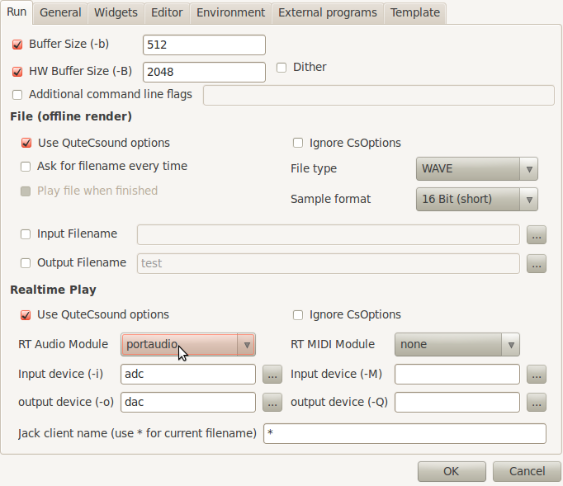

Csound Can Produce Extreme Dynamic Range!
Csound can produce extreme dynamic range, so keep an eye on the level you are sending to your output. The number which describes the level of 0 dB, can be set in Csound by the 0dbfs assignment in the <CsInstruments> header. There is no limitation, if you set 0dbfs = 1 and send a value of 32000, this can damage your ears and speakers!

Using Live Audio Input and Output
To process audio from an external source (for example a microphone), use the inch opcode to access any of the inputs of your audio input device. For the output, outch gives you all necessary flexibility. The following example takes a live audio input and transforms its sound using ring modulation. The Csound Console should output five times per second the input amplitude level.
EXAMPLE 02D02_LiveInput.csd
<CsoundSynthesizer>
<CsOptions>
;CHANGE YOUR INPUT AND OUTPUT DEVICE NUMBER HERE IF NECESSARY!
-iadc0 -odac0 -B512 -b128
</CsOptions>
<CsInstruments>
;Example by Joachim Heintz
sr = 44100 ;set sample rate to 44100 Hz
ksmps = 32 ;number of samples per control cycle
nchnls = 2 ;use two audio channels
0dbfs = 1 ;set maximum level as 1

giSine ftgen 0, 0, 2^10, 10, 1 ;table with sine wave

instr 1
aIn inch 1 ;take input from channel 1
kInLev downsamp aIn ;convert audio input to control signal
printk .2, abs(kInLev)
;make modulator frequency oscillate 200 to 1000 Hz
kModFreq poscil 400, 1/2, giSine
kModFreq = kModFreq+600
aMod poscil 1, kModFreq, giSine ;modulator signal
aRM = aIn * aMod ;ring modulation
outch 1, aRM, 2, aRM ;output to channel 1 and 2
endin
</CsInstruments>
<CsScore>
i 1 0 3600
</CsScore>
</CsoundSynthesizer>
Live Audio is frequently used with live devices like widgets or MIDI. In CsoundQt, you can find several examples in Examples -> Getting Started -> Realtime Interaction.
- You may have to run -iadc999 and -odac999 seperately.^
- As Victor Lazzarini explains (mail to Joachim Heintz, 19 march 2013), the role of -b and -B varies between the Audio Modules:
"1. For portaudio, -B is only used to suggest a latency to the backend, whereas -b is used to set the actual buffersize.
2. For coreaudio, -B is used as the size of the internal circular buffer, and -b is used for the actual IO buffer size.
3. For jack, -B is used to determine the number of buffers used in conjunction with -b , num = (N + M + 1) / M. -b is the size of each buffer.
4. For alsa, -B is the size of the buffer size, -b is the period size (a buffer is divided into periods).
5. For pulse, -b is the actual buffersize passed to the device, -B is not used.
In other words, -B is not too significant in 1), not used in 5), but has a part to play in 2), 3) and 4), which is functionally similar." ^
- It is always preferable to use power-of-two values for ksmps (which is the same as "block size" in PureData or "vector size" in Max). Just with ksmps = 1, 2, 4, 8, 16 ... you will take advantage of the "full duplex" audio, which provides best real time audio. Make sure your ksmps divides your buffer size with no remainder. So, for -b 128, you can use ksmps = 128, 64, 32, 16, 8, 4, 2 or 1.^

12. RENDERING TO FILE

When to Render to File
Csound can also render audio straight to a sound file stored on your hard drive instead of as live audio sent to the audio hardware. This gives you the possibility to hear the results of very complex processes which your computer can't produce in realtime. Or you want to render something in Csound to import it in an audio editor, or as the final result of a 'tape' piece.1
Csound can render to formats like wav, aiff or ogg (and other less popular ones), but not mp3 due to its patent and licencing problems.

Rendering to File
Save the following code as Render.csd:
EXAMPLE 02E01_Render.csd
<CsoundSynthesizer>
<CsOptions>
-o Render.wav
</CsOptions>
<CsInstruments>
;Example by Alex Hofmann
instr 1
aSin oscils 0dbfs/4, 440, 0
out aSin
endin
</CsInstruments>
<CsScore>
i 1 0 1
e
</CsScore>
</CsoundSynthesizer>
Open the Terminal / Prompt / Console and type:
csound /path/to/Render.csd
Now, because you changed the -o flag in the <CsOptions> from "-o dac" to "-o filename", the audio output is no longer written in realtime to your audio device, but instead to a file. The file will be rendered to the default directory (usually the user home directory). This file can be opened and played in any audio player or editor, e.g. Audacity. (By default, csound is a non-realtime program. So if no command line options are given, it will always render the csd to a file called test.wav, and you will hear nothing in realtime.)
The -o flag can also be used to write the output file to a certain directory. Something like this for Windows ...
<CsOptions>
-o c:/music/samples/Render.wav
</CsOptions>
... and this for Linux or Mac OSX:
<CsOptions>
-o /Users/JSB/organ/tatata.wav
</CsOptions>

Rendering Options
The internal rendering of audio data in Csound is done with 64-bit floating point numbers. Depending on your needs, you should decide the precision of your rendered output file:
- If you want to render 32-bit floats, use the option flag -f.
- If you want to render 24-bit, use the flag -3.
- If you want to render 16-bit, use the flag -s (or nothing, because this is also the default in Csound).
For making sure that the header of your soundfile will be written correctly, you should use the -W flag for a WAV file, or the -A flag for a AIFF file. So these options will render the file "Wow.wav" as WAV file with 24-bit accuracy:
<CsOptions>
-o Wow.wav -W -3
</CsOptions>

Realtime and Render-To-File at the Same Time
Sometimes you may want to simultaneously have realtime output and file rendering to disk, like recording your live performance. This can be achieved by using the fout opcode. You just have to specify your output file name. File type and format are given by a number, for instance 18 specifies "wav 24 bit" (see the manual page for more information). The following example creates a random frequency and panning movement of a sine wave, and writes it to the file "live_record.wav" (in the same directory as your .csd file):
EXAMPLE 02E02_RecordRT.csd
<CsoundSynthesizer>
<CsOptions>
-odac
</CsOptions>
<CsInstruments>
;Example by Joachim Heintz
sr = 44100
ksmps = 32
nchnls = 2
0dbfs = 1

seed 0 ;each time different seed for random
giSine ftgen 0, 0, 2^10, 10, 1 ;a sine wave

instr 1
kFreq randomi 400, 800, 1 ;random sliding frequency
aSig poscil .2, kFreq, giSine ;sine with this frequency
kPan randomi 0, 1, 1 ;random panning
aL, aR pan2 aSig, kPan ;stereo output signal
outs aL, aR ;live output
fout "live_record.wav", 18, aL, aR ;write to soundfile
endin

</CsInstruments>
<CsScore>
i 1 0 10
e
</CsScore>
</CsoundSynthesizer>

CsoundQt
All the options which are described in this chapter can be handled very easily in CsoundQt:
- Rendering to file is simply done by clicking the "Render" button, or choosing "Control->Render to File" in the Menu.
- To set file-destination and file-type, you can make your own settings in "CsoundQt Configuration" under the tab "Run -> File (offline render)". The default is a 16-Bit .wav-file.
- To record a live performance, just click the "Record" button. You will find a file with the same name as your .csd file, and a number appended for each record task, in the same folder as your .csd file.
- or bit-depth, see the section about Bit-depth Resolution in chapter 01A (Digital Audio)^
03 CSOUND LANGUAGE
13. INITIALIZATION AND PERFORMANCE PASS
14. LOCAL AND GLOBAL VARIABLES
15. CONTROL STRUCTURES
16. FUNCTION TABLES
17. E. ARRAYS
18. LIVE EVENTS
19. USER DEFINED OPCODES
20. MACROS

13. INITIALIZATION AND PERFORMANCE PASS
Not only for beginners, but also for experienced Csound users, many problems result from the misunderstanding of the so-called i-rate and k-rate. You want Csound to do something just once, but Csound does it continuously. You want Csound to do something continuously, but Csound does it just once. If you experience such a case, you will most probably have confused i- and k-rate-variables.
The concept behind this is actually not complicated. But it is something which is more implicitly mentioned when we think of a program flow, whereas Csound wants to know it explicitely. So we tend to forget it when we use Csound, and we do not notice that we ordered a stone to become a wave, and a wave to become a stone. This chapter tries to explicate very carefully the difference between stones and waves, and how you can profit from them, after you understood and accepted both qualities.

The Init Pass
Whenever a Csound instrument is called, all variables are set to initial values. This is called the initialization pass.
There are certain variables, which stay in the state in which they have been put by the init-pass. These variables start with an i if they are local (= only considered inside an instrument), or with a gi if they are global (= considered overall in the orchestra). This is a simple example:
EXAMPLE 03A01_Init-pass.csd
<CsoundSynthesizer>
<CsInstruments>

giGlobal = 1/2

instr 1
iLocal = 1/4
print giGlobal, iLocal
endin

instr 2
iLocal = 1/5
print giGlobal, iLocal
endin

</CsInstruments>
<CsScore>
i 1 0 0
i 2 0 0
</CsScore>
</CsoundSynthesizer>
;example by joachim heintz
The output should include these lines:
SECTION 1:
new alloc for instr 1:
instr 1: giGlobal = 0.500 iLocal = 0.250
new alloc for instr 2:
instr 2: giGlobal = 0.500 iLocal = 0.200
As you see, the local variables iLocal do have different meanings in the context of their instrument, whereas giGlobal is known everywhere and in the same way. It is also worth mentioning that the performance time of the instruments (p3) is zero. This makes sense, as the instruments are called, but only the init-pass is performed.1

The Performance Pass
After having assigned initial values to all variables, Csound starts the actual performance. As music is a variation of values in time,2 audio signals are producing values which vary in time. In all digital audio, the time unit is given by the sample rate, and one sample is the smallest possible time atom. For a sample rate of 44100 Hz,3 one sample comes up to the duration of 1/44100 = 0.0000227 seconds.
So, performance for an audio application means basically: calculate all the samples which are finally being written to the output. You can imagine this as the cooperation of a clock and a calculator. For each sample, the clock ticks, and for each tick, the next sample is calculated.
Most audio applications do not perform this calculation sample by sample. It is much more efficient to collect some amount of samples in a "block" or "vector", and calculate them all together. This means in fact, to introduce another internal clock in your application; a clock which ticks less frequently than the sample clock. For instance, if (always assumed your sample rate is 44100 Hz) your block size consists of 10 samples, your internal calculation time clock ticks every 1/4410 (0.000227) seconds. If your block size consists of 441 samples, the clock ticks every 1/100 (0.01) seconds.
The following illustration shows an example for a block size of 10 samples. The samples are shown at the bottom line. Above are the control ticks, one for each ten samples. The top two lines show the times for both clocks in seconds. In the upmost line you see that the first control cycle has been finished at 0.000227 seconds, the second one at 0.000454 seconds, and so on.4
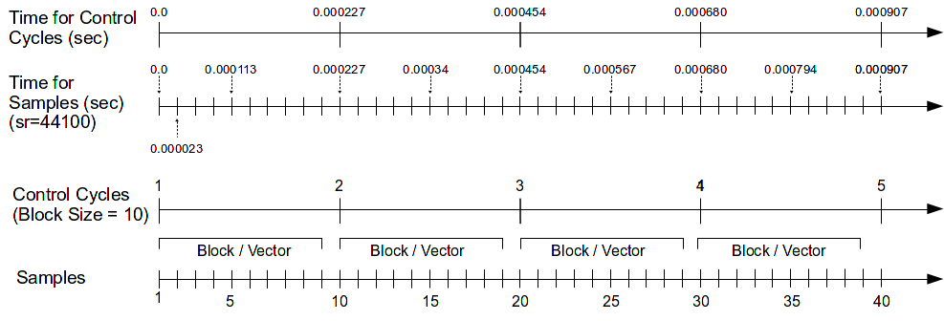
The rate (frequency) of these ticks is called the control rate in Csound. By historical reason,5 it is called "kontrol rate" instead of control rate, and abbreviated as "kr" instead of cr. Each of the calculation cycles is called a "k-cycle". The block size or vector size is given by the ksmps parameter, which means: how many samples (smps) are collected for one k-cycle.6
Let us see some code examples to illustrate these basic contexts.

Implicit Incrementation
EXAMPLE 03A02_Perf-pass_incr.csd
<CsoundSynthesizer>
<CsInstruments>
sr = 44100
ksmps = 4410

instr 1
kCount init 0; set kcount to 0 first
kCount = kCount + 1; increase at each k-pass
printk 0, kCount; print the value
endin

</CsInstruments>
<CsScore>
i 1 0 1
</CsScore>
</CsoundSynthesizer>
;example by joachim heintz
Your output should contain the lines:
i 1 time 0.10000: 1.00000
i 1 time 0.20000: 2.00000
i 1 time 0.30000: 3.00000
i 1 time 0.40000: 4.00000
i 1 time 0.50000: 5.00000
i 1 time 0.60000: 6.00000
i 1 time 0.70000: 7.00000
i 1 time 0.80000: 8.00000
i 1 time 0.90000: 9.00000
i 1 time 1.00000: 10.00000
A counter (kCount) is set here to zero as initial value. Then, in each control cycle, the counter is increased by one. What we see here, is the typical behaviour of a loop. The loop has not been set explicitely, but works implicitely because of the continuous recalculation of all k-variables. So we can also speak about the k-cycles as an implicit (and time-triggered) k-loop.7 Try changing the ksmps value from 4410 to 8820 and to 2205 and observe the difference.
The next example reads the incrementation of kCount as rising frequency. The first instrument, called Rise, sets the k-rate frequency kFreq to the initial value of 100 Hz, and then adds 10 Hz in every new k-cycle. As ksmps=441, one k-cycle takes 1/100 second to perform. So in 3 seconds, the frequency rises from 100 to 3100 Hz. At the last k-cycle, the final frequency value is printed out.8 - The second instrument, Partials, increments the counter by one for each k-cycle, but only sets this as new frequency for every 100 steps. So the frequency stays at 100 Hz for one second, then at 200 Hz for one second, and so on. As the resulting frequencies are in the ratio 1 : 2 : 3 ..., we hear partials based on a 100 Hz fundamental, from the first partial up to the 31st. The opcode printk2 prints out the frequency value whenever it has changed.
EXAMPLE 03A03_Perf-pass_incr_listen.csd
<CsoundSynthesizer>
<CsOptions>
-o dac
</CsOptions>
<CsInstruments>
sr = 44100
ksmps = 441
0dbfs = 1
nchnls = 2

;build a table containing a sine wave
giSine ftgen 0, 0, 2^10, 10, 1

instr Rise
kFreq init 100
aSine poscil .2, kFreq, giSine
outs aSine, aSine
;increment frequency by 10 Hz for each k-cycle
kFreq = kFreq + 10
;print out the frequency for the last k-cycle
kLast release
if kLast == 1 then
printk 0, kFreq
endif
endin

instr Partials
;initialize kCount
kCount init 100
;get new frequency if kCount equals 100, 200, ...
if kCount % 100 == 0 then
kFreq = kCount
endif
aSine poscil .2, kFreq, giSine
outs aSine, aSine
;increment kCount
kCount = kCount + 1
;print out kFreq whenever it has changed
printk2 kFreq
endin
</CsInstruments>
<CsScore>
i "Rise" 0 3
i "Partials" 4 31
</CsScore>
</CsoundSynthesizer>
;example by joachim heintz

Init versus Equals
A frequently occuring error is that instead of setting the k-variable as kCount init 0, it is set as kCount = 0. The meaning of both statements has one significant difference. kCount init 0 sets the value for kCount to zero only in the init pass, without affecting it during the performance pass. kCount = 1 sets the value for kCount to zero again and again, in each performance cycle. So the increment always starts from the same point, and nothing really happens:
EXAMPLE 03A04_Perf-pass_no_incr.csd
<CsoundSynthesizer>
<CsInstruments>
sr = 44100
ksmps = 4410

instr 1
kcount = 0; sets kcount to 0 at each k-cycle
kcount = kcount + 1; does not really increase ...
printk 0, kcount; print the value
endin

</CsInstruments>
<CsScore>
i 1 0 1
</CsScore>
</CsoundSynthesizer>
;example by joachim heintz
Outputs:
i 1 time 0.10000: 1.00000
i 1 time 0.20000: 1.00000
i 1 time 0.30000: 1.00000
i 1 time 0.40000: 1.00000
i 1 time 0.50000: 1.00000
i 1 time 0.60000: 1.00000
i 1 time 0.70000: 1.00000
i 1 time 0.80000: 1.00000
i 1 time 0.90000: 1.00000
i 1 time 1.00000: 1.00000

A Look at the Audio Vector
There are different opcodes to print out k-variables.9 There is no opcode in Csound to print out the audio vector directly, but you can use the vaget opcode to see what is happening inside one control cycle with the audio samples.
EXAMPLE 03A05_Audio_vector.csd
<CsoundSynthesizer>
<CsInstruments>
sr = 44100
ksmps = 5
0dbfs = 1

instr 1
aSine oscils 1, 2205, 0
kVec1 vaget 0, aSine
kVec2 vaget 1, aSine
kVec3 vaget 2, aSine
kVec4 vaget 3, aSine
kVec5 vaget 4, aSine
printks "kVec1 = % f, kVec2 = % f, kVec3 = % f, kVec4 = % f, kVec5 = % f\n",\
0, kVec1, kVec2, kVec3, kVec4, kVec5
endin
</CsInstruments>
<CsScore>
i 1 0 [1/2205]
</CsScore>
</CsoundSynthesizer>
;example by joachim heintz
The output shows these lines:
kVec1 = 0.000000, kVec2 = 0.309017, kVec3 = 0.587785, kVec4 = 0.809017, kVec5 = 0.951057
kVec1 = 1.000000, kVec2 = 0.951057, kVec3 = 0.809017, kVec4 = 0.587785, kVec5 = 0.309017
kVec1 = -0.000000, kVec2 = -0.309017, kVec3 = -0.587785, kVec4 = -0.809017, kVec5 = -0.951057
kVec1 = -1.000000, kVec2 = -0.951057, kVec3 = -0.809017, kVec4 = -0.587785, kVec5 = -0.309017
In this example, the number of audio samples in one k-cycle is set to five by the statement ksmps=5. The first argument to vaget specifies which sample of the block you get. For instance,
kVec1 vaget 0, aSine
gets the first value of the audio vector and writes it into the variable kVec1. For a frequency of 2205 Hz at a sample rate of 44100 Hz, you need 20 samples to write one complete cycle of the sine. So we call the instrument for 1/2205 seconds, and we get 4 k-cycles. The printout shows exactly one period of the sine wave.

A Summarizing Example
After having put so much attention to the different single aspects of initialization, performance and audio vectors, the next example tries to summarize and illustrate all the aspects in their practical mixture.
EXAMPLE 03A06_Init_perf_audio.csd
<CsoundSynthesizer>
<CsOptions>
-o dac
</CsOptions>
<CsInstruments>
sr = 44100
ksmps = 441
nchnls = 2
0dbfs = 1
instr 1
iAmp = p4 ;amplitude taken from the 4th parameter of the score line
iFreq = p5 ;frequency taken from the 5th parameter
; --- move from 0 to 1 in the duration of this instrument call (p3)
kPan line 0, p3, 1
aNote oscils iAmp, iFreq, 0 ;create an audio signal
aL, aR pan2 aNote, kPan ;let the signal move from left to right
outs aL, aR ;write it to the output
endin
</CsInstruments>
<CsScore>
i 1 0 3 0.2 443
</CsScore>
</CsoundSynthesizer>
;example by joachim heintz
As ksmps=441, each control cycle is 0.01 seconds long (441/44100). So this happens when the instrument call is performed:

Accessing the Initialization Value of a k-Variable
It has been said that the init pass sets initial values to all variables. It must be emphasized that this indeed concerns all variables, not only the i-variables. It is only the matter that i-variables are not affected by anything which happens later, in the performance. But also k- and a-variables get their initial values.
As we saw, the init opcode is used to set initial values for k- or a-variables explicitely. On the other hand, you can get the initial value of a k-variable which has not been set explicitely, by the i() facility. This is a simple example:
EXAMPLE 03A07_Init-values_of_k-variables.csd
<CsoundSynthesizer>
<CsOptions>
-o dac
</CsOptions>
<CsInstruments>
instr 1
gkLine line 0, p3, 1
endin
instr 2
iInstr2LineValue = i(gkLine)
print iInstr2LineValue
endin
instr 3
iInstr3LineValue = i(gkLine)
print iInstr3LineValue
endin
</CsInstruments>
<CsScore>
i 1 0 5
i 2 2 0
i 3 4 0
</CsScore>
</CsoundSynthesizer>
;example by joachim heintz
Outputs:
new alloc for instr 1:
B 0.000 .. 2.000 T 2.000 TT 2.000 M: 0.0
new alloc for instr 2:
instr 2: iInstr2LineValue = 0.400
B 2.000 .. 4.000 T 4.000 TT 4.000 M: 0.0
new alloc for instr 3:
instr 3: iInstr3LineValue = 0.800
B 4.000 .. 5.000 T 5.000 TT 5.000 M: 0.0
Instrument 1 produces a rising k-signal, starting at zero and ending at one, over a time of five seconds. The values of this line rise are written to the global variable gkLine. After two seconds, instrument 2 is called, and examines the value of gkLine at its init-pass via i(gkLine). The value at this time (0.4), is printed out at init-time as iInstr2LineValue. The same happens for instrument 3, which prints out iInstr3LineValue = 0.800, as it has been started at 4 seconds.
The i() feature is particularily useful if you need to examine the value of any control signal from a widget or from midi, at the time when an instrument starts.

Reinitialization
As we saw above, an i-value is not affected by the performance loop. So you cannot expect this to work as an incrementation:
EXAMPLE 03A08_Init_no_incr.csd
<CsoundSynthesizer>
<CsInstruments>
sr = 44100
ksmps = 4410

instr 1
iCount init 0 ;set iCount to 0 first
iCount = iCount + 1 ;increase
print iCount ;print the value
endin

</CsInstruments>
<CsScore>
i 1 0 1
</CsScore>
</CsoundSynthesizer>
;example by joachim heintz
The output is nothing but:
instr 1: iCount = 1.000
But you can advise Csound to repeat the initialization of an i-variable. This is done with the reinit opcode. You must mark a section by a label (any name followed by a colon). Then the reinit statement will cause the i-variable to refresh. Use rireturn to end the reinit section.
EXAMPLE 03A09_Re-init.csd
<CsoundSynthesizer>
<CsInstruments>
sr = 44100
ksmps = 4410

instr 1
iCount init 0 ; set icount to 0 first
reinit new ; reinit the section each k-pass
new:
iCount = iCount + 1 ; increase
print iCount ; print the value
rireturn
endin

</CsInstruments>
<CsScore>
i 1 0 1
</CsScore>
</CsoundSynthesizer>
;example by joachim heintz
Outputs:
instr 1: iCount = 1.000
instr 1: iCount = 2.000
instr 1: iCount = 3.000
instr 1: iCount = 4.000
instr 1: iCount = 5.000
instr 1: iCount = 6.000
instr 1: iCount = 7.000
instr 1: iCount = 8.000
instr 1: iCount = 9.000
instr 1: iCount = 10.000
instr 1: iCount = 11.000
What happens here more in detail, is the following. In the actual init-pass, iCount is set to zero via iCount init 0. Still in this init-pass, it is incremented by one (iCount = iCount+1) and the value is printed out as iCount = 1.000. Now starts the first performance pass. The statement reinit new advices Csound to initialise again the section labeled as "new". So the statement iCount = iCount + 1 is executed again. As the current value of iCount at this time is 1, the result is 2. So the printout at this first performance pass is iCount = 2.000. The same happens in the next nine performance cycles, so the final count is 11.

Order Of Calculation
In this context, it can be very important to observe the order in which the instruments of a Csound orchestra are evaluated. This order is determined by the instrument numbers. So, if you want to use during the same performance pass a value in instrument 10 which is generated by another instrument, you must not give this instrument the number 11 or higher. In the following example, first instrument 10 uses a value of instrument 1, then a value of instrument 100.
EXAMPLE 03A10_Order_of_calc.csd
<CsoundSynthesizer>
<CsInstruments>
sr = 44100
ksmps = 4410

instr 1
gkcount init 0 ;set gkcount to 0 first
gkcount = gkcount + 1 ;increase
endin

instr 10
printk 0, gkcount ;print the value
endin

instr 100
gkcount init 0 ;set gkcount to 0 first
gkcount = gkcount + 1 ;increase
endin

</CsInstruments>
<CsScore>
;first i1 and i10
i 1 0 1
i 10 0 1
;then i100 and i10
i 100 1 1
i 10 1 1
</CsScore>
</CsoundSynthesizer>
;Example by Joachim Heintz
The output shows the difference:
new alloc for instr 1:
new alloc for instr 10:
i 10 time 0.10000: 1.00000
i 10 time 0.20000: 2.00000
i 10 time 0.30000: 3.00000
i 10 time 0.40000: 4.00000
i 10 time 0.50000: 5.00000
i 10 time 0.60000: 6.00000
i 10 time 0.70000: 7.00000
i 10 time 0.80000: 8.00000
i 10 time 0.90000: 9.00000
i 10 time 1.00000: 10.00000
B 0.000 .. 1.000 T 1.000 TT 1.000 M: 0.0
new alloc for instr 100:
i 10 time 1.10000: 0.00000
i 10 time 1.20000: 1.00000
i 10 time 1.30000: 2.00000
i 10 time 1.50000: 4.00000
i 10 time 1.60000: 5.00000
i 10 time 1.70000: 6.00000
i 10 time 1.80000: 7.00000
i 10 time 1.90000: 8.00000
i 10 time 2.00000: 9.00000
B 1.000 .. 2.000 T 2.000 TT 2.000 M: 0.0
Instrument 10 can use the values which instrument 1 has produced in the same control cycle, but it can only refer to values of instrument 100 which are produced in the previous control cycle. By this reason, the printout shows values which are one less in the latter case.

Named Instruments
It has been said in chapter 02B (Quick Start) that instead of a number you can also use a name for an instrument. This is mostly preferable, because you can give meaningful names, leading to a better readable code. But what about the order of calculation in named instruments?
The answer is simple: Csound calculates them in the same order as they are written in the orchestra. So if your instrument collection is like this ...
EXAMPLE 03A11_Order_of_calc_named.csd
<CsoundSynthesizer>
<CsOptions>
-nd
</CsOptions>
<CsInstruments>

instr Grain_machine
prints " Grain_machine\n"
endin

instr Fantastic_FM
prints " Fantastic_FM\n"
endin

instr Random_Filter
prints " Random_Filter\n"
endin

instr Final_Reverb
prints " Final_Reverb\n"
endin

</CsInstruments>
<CsScore>
i "Final_Reverb" 0 1
i "Random_Filter" 0 1
i "Grain_machine" 0 1
i "Fantastic_FM" 0 1
</CsScore>
</CsoundSynthesizer>
;example by joachim heintz
... you can count on this output:
new alloc for instr Grain_machine:
Grain_machine
new alloc for instr Fantastic_FM:
Fantastic_FM
new alloc for instr Random_Filter:
Random_Filter
new alloc for instr Final_Reverb:
Final_Reverb
Note that the score has not the same order. But internally, Csound transforms all names to numbers, in the order they are written from top to bottom. The numbers are reported on the top of Csound's output:10
instr Grain_machine uses instrument number 1
instr Fantastic_FM uses instrument number 2
instr Random_Filter uses instrument number 3
instr Final_Reverb uses instrument number 4

About "i-time" And "k-rate" Opcodes
It is often confusing for the beginner that there are some opcodes which only work at "i-time" or "i-rate", and others which only work at "k-rate" or "k-time". For instance, if the user wants to print the value of any variable, (s)he thinks: "OK - print it out." But Csound replies: "Please, tell me first if you want to print an i- or a k-variable".11
The print opcode just prints variables which are updated at each initialization pass ("i-time" or "i-rate"). If you want to print a variable which is updated at each control cycle ("k-rate" or "k-time"), you need its counterpart printk. (As the performance pass is usually updated some thousands times per second, you have an additional parameter in printk, telling Csound how often you want to print out the k-values.)
So, some opcodes are just for i-rate variables, like filelen or ftgen. Others are just for k-rate variables like metro or max_k. Many opcodes have variants for either i-rate-variables or k-rate-variables, like printf_i and printf, sprintf and sprintfk, strindex and strindexk.
Most of the Csound opcodes are able to work either at i-time or at k-time or at audio-rate, but you have to think carefully what you need, as the behaviour will be very different if you choose the i-, k- or a-variante of an opcode. For example, the random opcode can work at all three rates:
ires random imin, imax : works at "i-time"
kres random kmin, kmax : works at "k-rate"
ares random kmin, kmax : works at "audio-rate"
If you use the i-rate random generator, you will get one value for each note. For instance, if you want to have a different pitch for each note you are generating, you will use this one.
If you use the k-rate random generator, you will get one new value on every control cycle. If your sample rate is 44100 and your ksmps=10, you will get 4410 new values per second! If you take this as pitch value for a note, you will hear nothing but a noisy jumping. If you want to have a moving pitch, you can use the randomi variant of the k-rate random generator, which can reduce the number of new values per second, and interpolate between them.
If you use the a-rate random generator, you will get as many new values per second as your sample rate is. If you use it in the range of your 0 dB amplitude, you produce white noise.
EXAMPLE 03A12_Random_at_ika.csd
<CsoundSynthesizer>
<CsOptions>
-odac
</CsOptions>
<CsInstruments>
sr = 44100
ksmps = 32
0dbfs = 1
nchnls = 2

seed 0 ;each time different seed
giSine ftgen 0, 0, 2^10, 10, 1 ;sine table

instr 1 ;i-rate random
iPch random 300, 600
aAmp linseg .5, p3, 0
aSine poscil aAmp, iPch, giSine
outs aSine, aSine
endin

instr 2 ;k-rate random: noisy
kPch random 300, 600
aAmp linseg .5, p3, 0
aSine poscil aAmp, kPch, giSine
outs aSine, aSine
endin

instr 3 ;k-rate random with interpolation: sliding pitch
kPch randomi 300, 600, 3
aAmp linseg .5, p3, 0
aSine poscil aAmp, kPch, giSine
outs aSine, aSine
endin

instr 4 ;a-rate random: white noise
aNoise random -.1, .1
outs aNoise, aNoise
endin

</CsInstruments>
<CsScore>
i 1 0 .5
i 1 .25 .5
i 1 .5 .5
i 1 .75 .5
i 2 2 1
i 3 4 2
i 3 5 2
i 3 6 2
i 4 9 1
</CsScore>
</CsoundSynthesizer>
;example by joachim heintz

Possible Problems with k-Rate Tick Size
It has been said that usually the k-rate clock ticks much slower than the sample (a-rate) clock. For a common size of ksmps=32, one k-value remains the same for 32 samples. This can lead to problems, for instance if you use k-rate envelopes. Let us assume that you want to produce a very short fade-in of 3 milliseconds, and you do it with the following line of code:
kFadeIn linseg 0, .003, 1
Your envelope will look like this:
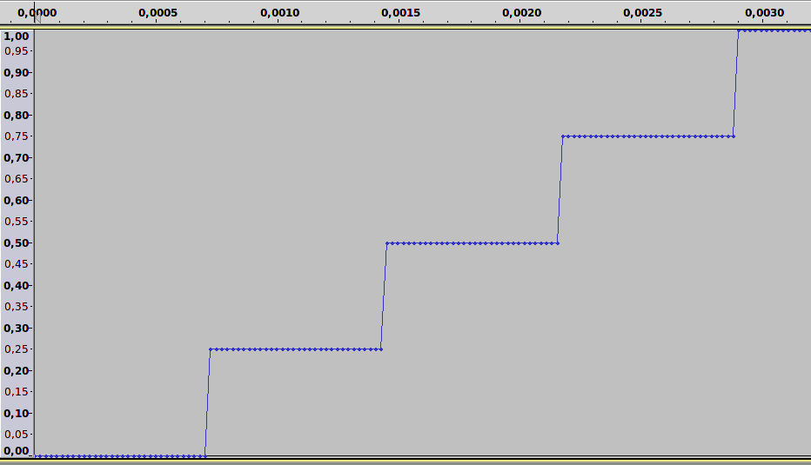
Such a "staircase-envelope" is what you hear in the next example as zipper noise. The transeg opcode produces a non-linear envelope with a sharp peak:
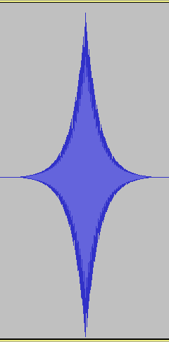
The rise and the decay are each 1/100 seconds long. If this envelope is produced at k-rate with a blocksize of 128 (instr 1), the noise is clearly audible. Try changing ksmps to 64, 32 or 16 and compare the amount of zipper noise. - Instrument 2 uses an envelope at audio-rate instead. Regardless the blocksize, each sample is calculated seperately, so the envelope will always be smooth.
EXAMPLE 03A13_Zipper.csd
<CsoundSynthesizer>
<CsOptions>
-o dac
</CsOptions>
<CsInstruments>
sr = 44100
;--- increase or decrease to hear the difference more or less evident
ksmps = 128
nchnls = 2
0dbfs = 1

instr 1 ;envelope at k-time
aSine oscils .5, 800, 0
kEnv transeg 0, .1, 5, 1, .1, -5, 0
aOut = aSine * kEnv
outs aOut, aOut
endin

instr 2 ;envelope at a-time
aSine oscils .5, 800, 0
aEnv transeg 0, .1, 5, 1, .1, -5, 0
aOut = aSine * aEnv
outs aOut, aOut
endin

</CsInstruments>
<CsScore>
r 5 ;repeat the following line 5 times
i 1 0 1
s ;end of section
r 5
i 2 0 1
e
</CsScore>
</CsoundSynthesizer>
;example by joachim heintz

Time Impossible
There are two internal clocks in Csound. The sample rate (sr) determines the audio-rate, whereas the control rate (kr) determines the rate, in which a new control cycle can be started and a new block of samples can be performed. In general, Csound can not start any event in between two control cycles, nor end.12 The next example chooses an extreme small control rate (only 10 k-cycles per second) to illustrate this.
EXAMPLE 03A14_Time_Impossible.csd
<CsoundSynthesizer>
<CsOptions>
-o test.wav -d
</CsOptions>
<CsInstruments>
sr = 44100
ksmps = 4410
nchnls = 1
0dbfs = 1

instr 1
aPink oscils .5, 430, 0
out aPink
endin
</CsInstruments>
<CsScore>
i 1 0.05 0.1
i 1 0.4 0.15
</CsScore>
</CsoundSynthesizer>
The first call advices instrument 1 to start performance at time 0.05. But this is impossible as it lies between two control cycles. The second call starts at a possible time, but the duration of 0.15 again does not coincident with the control rate. So the result starts the first call at time 0.1 and extends the second call to 0.2 seconds:
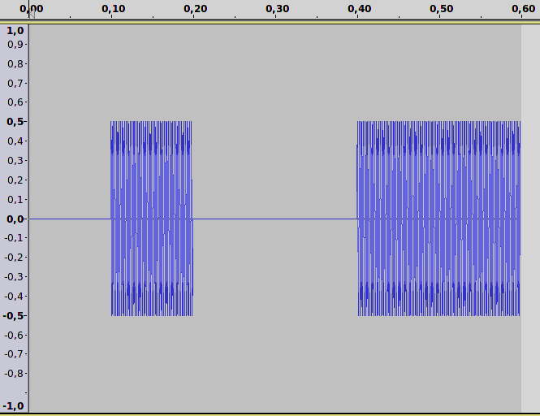

When to Use i- or k- Rate
When you code on your Csound instrument, you may sometimes wonder whether you shall use an i-rate or a k-rate opcode. From what is said, the general answer is clear: Use i-rate if something has to be done only once, or in a somehow punctual manner. Use k-rate if something has to be done continuously, or if you must regard what happens during the performance.

- You would not get any other result if you set p3 to 1 or any other value, as nothing is done here except initialization.^
- For the physical result which comes out of the loudspeakers or headphones, the variation is the variation of air pressure.^
- 44100 samples per second^
- These are by the way the times which Csound reports if you ask for the control cycles. The first control cycle in this example (sr=44100, ksmps=10) would be reported as 0.00027 seconds, not as 0.00000 seconds.^
- As Richard Boulanger explains, in early Csound a line starting with 'c' was a comment line. So it was not possible to abbreviate control variables as cAnything (http://csound.1045644.n5.nabble.com/OT-why-is-control-rate-called-kontrol-rate-td5720858.html#a5720866). ^
- As the k-rate is directly depending on sample rate (sr) and ksmps (kr = sr/ksmps), it is probably the best style to specify sr and ksmps in the header, but not kr. ^
- This must not be confused with a 'real' k-loop where inside one single k-cycle a loop is performed. See chapter 03C (section Loops) for examples.^
- The value is 3110 instead of 3100 because it has already been incremented by 10.^
- See the manual page for printk, printk2, printks, printf to know more about the differences.^
- If you want to know the number in an instrument, use the nstrnum opcode. ^
- See the following section 03B about the variable types for more on this subject.^
- In csound 6, the possibilities of these "in between" will be enlarged via the --sample-accurate option.^

14. LOCAL AND GLOBAL VARIABLES

Variable Types
In Csound, there are several types of variables. It is important to understand the differences between these types. There are
- initialization variables, which are updated at each initialization pass, i.e. at the beginning of each note or score event. They start with the character i. To this group count also the score parameter fields, which always starts with a p, followed by any number: p1 refers to the first parameter field in the score, p2 to the second one, and so on.
- control variables, which are updated at each control cycle during the performance of an instrument. They start with the character k.
- audio variables, which are also updated at each control cycle, but instead of a single number (like control variables) they consist of a vector (a collection of numbers), having in this way one number for each sample. They start with the character a.
- string variables, which are updated either at i-time or at k-time (depending on the opcode which produces a string). They start with the character S.
Except these four standard types, there are two other variable types which are used for spectral processing:
- f-variables are used for the streaming phase vocoder opcodes (all starting with the characters pvs), which are very important for doing realtime FFT (Fast Fourier Transform) in Csound. They are updated at k-time, but their values depend also on the FFT parameters like frame size and overlap.
- w-variables are used in some older spectral processing opcodes.
The following example exemplifies all the variable types (except the w-type):
EXAMPLE 03B01_Variable_types.csd
<CsoundSynthesizer>
<CsOptions>
-o dac
</CsOptions>
<CsInstruments>
;Example by Joachim Heintz
sr = 44100
ksmps = 32
0dbfs = 1
nchnls = 2

seed 0; random seed each time different

instr 1; i-time variables
iVar1 = p2; second parameter in the score
iVar2 random 0, 10; random value between 0 and 10
iVar = iVar1 + iVar2; do any math at i-rate
print iVar1, iVar2, iVar
endin

instr 2; k-time variables
kVar1 line 0, p3, 10; moves from 0 to 10 in p3
kVar2 random 0, 10; new random value each control-cycle
kVar = kVar1 + kVar2; do any math at k-rate
; --- print each 0.1 seconds
printks "kVar1 = %.3f, kVar2 = %.3f, kVar = %.3f%n", 0.1, kVar1, kVar2, kVar
endin

instr 3; a-variables
aVar1 oscils .2, 400, 0; first audio signal: sine
aVar2 rand 1; second audio signal: noise
aVar3 butbp aVar2, 1200, 12; third audio signal: noise filtered
aVar = aVar1 + aVar3; audio variables can also be added
outs aVar, aVar; write to sound card
endin

instr 4; S-variables
iMyVar random 0, 10; one random value per note
kMyVar random 0, 10; one random value per each control-cycle
;S-variable updated just at init-time
SMyVar1 sprintf "This string is updated just at init-time:
kMyVar = %d\n", iMyVar
printf_i "%s", 1, SMyVar1
;S-variable updates at each control-cycle
printks "This string is updated at k-time:
kMyVar = %.3f\n", .1, kMyVar
endin

instr 5; f-variables
aSig rand .2; audio signal (noise)
; f-signal by FFT-analyzing the audio-signal
fSig1 pvsanal aSig, 1024, 256, 1024, 1
; second f-signal (spectral bandpass filter)
fSig2 pvsbandp fSig1, 350, 400, 400, 450
aOut pvsynth fSig2; change back to audio signal
outs aOut*20, aOut*20
endin

</CsInstruments>
<CsScore>
; p1 p2 p3
i 1 0 0.1
i 1 0.1 0.1
i 2 1 1
i 3 2 1
i 4 3 1
i 5 4 1
</CsScore>
</CsoundSynthesizer>
You can think of variables as named connectors between opcodes. You can connect the output from an opcode to the input of another. The type of connector (audio, control, etc.) is determined by the first letter of its name.
For a more detailed discussion, see the article An overview Of Csound Variable Types by Andrés Cabrera in the Csound Journal, and the page about Types, Constants and Variables in the Canonical Csound Manual.

Local Scope
The scope of these variables is usually the instrument in which they are defined. They are local variables. In the following example, the variables in instrument 1 and instrument 2 have the same names, but different values.
EXAMPLE 03B02_Local_scope.csd
<CsoundSynthesizer>
<CsOptions>
-odac
</CsOptions>
<CsInstruments>
;Example by Joachim Heintz
sr = 44100
ksmps = 4410; very high because of printing
nchnls = 2
0dbfs = 1

instr 1
;i-variable
iMyVar init 0
iMyVar = iMyVar + 1
print iMyVar
;k-variable
kMyVar init 0
kMyVar = kMyVar + 1
printk 0, kMyVar
;a-variable
aMyVar oscils .2, 400, 0
outs aMyVar, aMyVar
;S-variable updated just at init-time
SMyVar1 sprintf "This string is updated just at init-time:
kMyVar = %d\n", i(kMyVar)
printf "%s", kMyVar, SMyVar1
;S-variable updated at each control-cycle
SMyVar2 sprintfk "This string is updated at k-time:
kMyVar = %d\n", kMyVar
printf "%s", kMyVar, SMyVar2
endin

instr 2
;i-variable
iMyVar init 100
iMyVar = iMyVar + 1
print iMyVar
;k-variable
kMyVar init 100
kMyVar = kMyVar + 1
printk 0, kMyVar
;a-variable
aMyVar oscils .3, 600, 0
outs aMyVar, aMyVar
;S-variable updated just at init-time
SMyVar1 sprintf "This string is updated just at init-time:
kMyVar = %d\n", i(kMyVar)
printf "%s", kMyVar, SMyVar1
;S-variable updated at each control-cycle
SMyVar2 sprintfk "This string is updated at k-time:
kMyVar = %d\n", kMyVar
printf "%s", kMyVar, SMyVar2
endin

</CsInstruments>
<CsScore>
i 1 0 .3
i 2 1 .3
</CsScore>
</CsoundSynthesizer>
This is the output (first the output at init-time by the print opcode, then at each k-cycle the output of printk and the two printf opcodes):
new alloc for instr 1:
instr 1: iMyVar = 1.000
i 1 time 0.10000: 1.00000
This string is updated just at init-time: kMyVar = 0
This string is updated at k-time: kMyVar = 1
i 1 time 0.20000: 2.00000
This string is updated just at init-time: kMyVar = 0
This string is updated at k-time: kMyVar = 2
i 1 time 0.30000: 3.00000
This string is updated just at init-time: kMyVar = 0
This string is updated at k-time: kMyVar = 3
B 0.000 .. 1.000 T 1.000 TT 1.000 M: 0.20000 0.20000
new alloc for instr 2:
instr 2: iMyVar = 101.000
i 2 time 1.10000: 101.00000
This string is updated just at init-time: kMyVar = 100
This string is updated at k-time: kMyVar = 101
i 2 time 1.20000: 102.00000
This string is updated just at init-time: kMyVar = 100
This string is updated at k-time: kMyVar = 102
i 2 time 1.30000: 103.00000
This string is updated just at init-time: kMyVar = 100
This string is updated at k-time: kMyVar = 103
B 1.000 .. 1.300 T 1.300 TT 1.300 M: 0.29998 0.29998

Global Scope
If you need variables which are recognized beyond the scope of an instrument, you must define them as global. This is done by prefixing the character g before the types i, k, a or S. See the following example:
EXAMPLE 03B03_Global_scope.csd
<CsoundSynthesizer>
<CsInstruments>
;Example by Joachim Heintz
sr = 44100
ksmps = 4410; very high because of printing
nchnls = 2
0dbfs = 1

;global scalar variables should be inititalized in the header
giMyVar init 0
gkMyVar init 0

instr 1
;global i-variable
giMyVar = giMyVar + 1
print giMyVar
;global k-variable
gkMyVar = gkMyVar + 1
printk 0, gkMyVar
;global S-variable updated just at init-time
gSMyVar1 sprintf "This string is updated just at init-time:
gkMyVar = %d\n", i(gkMyVar)
printf "%s", gkMyVar, gSMyVar1
;global S-variable updated at each control-cycle
gSMyVar2 sprintfk "This string is updated at k-time:
gkMyVar = %d\n", gkMyVar
printf "%s", gkMyVar, gSMyVar2
endin

instr 2
;global i-variable, gets value from instr 1
giMyVar = giMyVar + 1
print giMyVar
;global k-variable, gets value from instr 1
gkMyVar = gkMyVar + 1
printk 0, gkMyVar
;global S-variable updated just at init-time, gets value from instr 1
printf "Instr 1 tells: '%s'\n", gkMyVar, gSMyVar1
;global S-variable updated at each control-cycle, gets value from instr 1
printf "Instr 1 tells: '%s'\n\n", gkMyVar, gSMyVar2
endin

</CsInstruments>
<CsScore>
i 1 0 .3
i 2 0 .3
</CsScore>
</CsoundSynthesizer>
The output shows the global scope, as instrument 2 uses the values which have been changed by instrument 1 in the same control cycle:new alloc for instr 1:
instr 1: giMyVar = 1.000
new alloc for instr 2:
instr 2: giMyVar = 2.000
i 1 time 0.10000: 1.00000
This string is updated just at init-time: gkMyVar = 0
This string is updated at k-time: gkMyVar = 1
i 2 time 0.10000: 2.00000
Instr 1 tells: 'This string is updated just at init-time: gkMyVar = 0'
Instr 1 tells: 'This string is updated at k-time: gkMyVar = 1'
i 1 time 0.20000: 3.00000
This string is updated just at init-time: gkMyVar = 0
This string is updated at k-time: gkMyVar = 3
i 2 time 0.20000: 4.00000
Instr 1 tells: 'This string is updated just at init-time: gkMyVar = 0'
Instr 1 tells: 'This string is updated at k-time: gkMyVar = 3'
i 1 time 0.30000: 5.00000
This string is updated just at init-time: gkMyVar = 0
This string is updated at k-time: gkMyVar = 5
i 2 time 0.30000: 6.00000
Instr 1 tells: 'This string is updated just at init-time: gkMyVar = 0'
Instr 1 tells: 'This string is updated at k-time: gkMyVar = 5'

How To Work With Global Audio Variables
Some special considerations must be taken if you work with global audio variables. Actually, Csound behaves basically the same whether you work with a local or a global audio variable. But usually you work with global audio variables if you want to add several audio signals to a global signal, and that makes a difference.
The next few examples are going into a bit more detail. If you just want to see the result (= global audio usually must be cleared), you can skip the next examples and just go to the last one of this section.
It should be understood first that a global audio variable is treated the same by Csound if it is applied like a local audio signal:
EXAMPLE 03B04_Global_audio_intro.csd
<CsoundSynthesizer>
<CsOptions>
-odac
</CsOptions>
<CsInstruments>
;Example by Joachim Heintz
sr = 44100
ksmps = 32
nchnls = 2
0dbfs = 1

instr 1; produces a 400 Hz sine
gaSig oscils .1, 400, 0
endin

instr 2; outputs gaSig
outs gaSig, gaSig
endin

</CsInstruments>
<CsScore>
i 1 0 3
i 2 0 3
</CsScore>
</CsoundSynthesizer>
Of course there is no need to use a global variable in this case. If you do it, you risk your audio will be overwritten by an instrument with a higher number using the same variable name. In the following example, you will just hear a 600 Hz sine tone, because the 400 Hz sine of instrument 1 is overwritten by the 600 Hz sine of instrument 2:
EXAMPLE 03B05_Global_audio_overwritten.csd
<CsoundSynthesizer>
<CsOptions>
-o dac
</CsOptions>
<CsInstruments>
;Example by Joachim Heintz
sr = 44100
ksmps = 32
nchnls = 2
0dbfs = 1

instr 1; produces a 400 Hz sine
gaSig oscils .1, 400, 0
endin

instr 2; overwrites gaSig with 600 Hz sine
gaSig oscils .1, 600, 0
endin

instr 3; outputs gaSig
outs gaSig, gaSig
endin

</CsInstruments>
<CsScore>
i 1 0 3
i 2 0 3
i 3 0 3
</CsScore>
</CsoundSynthesizer>
In general, you will use a global audio variable like a bus to which several local audio signal can be added. It's this addition of a global audio signal to its previous state which can cause some trouble. Let's first see a simple example of a control signal to understand what is happening:
EXAMPLE 03B06_Global_audio_added.csd
<CsoundSynthesizer>
<CsInstruments>
;Example by Joachim Heintz
sr = 44100
ksmps = 4410; very high because of printing
nchnls = 2
0dbfs = 1

instr 1
kSum init 0; sum is zero at init pass
kAdd = 1; control signal to add
kSum = kSum + kAdd; new sum in each k-cycle
printk 0, kSum; print the sum
endin

</CsInstruments>
<CsScore>
i 1 0 1
</CsScore>
</CsoundSynthesizer>
In this case, the "sum bus" kSum increases at each control cycle by 1, because it adds the kAdd signal (which is always 1) in each k-pass to its previous state. It is no different if this is done by a local k-signal, like here, or by a global k-signal, like in the next example:
EXAMPLE 03B07_Global_control_added.csd
<CsoundSynthesizer>
<CsInstruments>
;Example by Joachim Heintz
sr = 44100
ksmps = 4410; very high because of printing
nchnls = 2
0dbfs = 1

gkSum init 0; sum is zero at init

instr 1
gkAdd = 1; control signal to add
endin

instr 2
gkSum = gkSum + gkAdd; new sum in each k-cycle
printk 0, gkSum; print the sum
endin

</CsInstruments>
<CsScore>
i 1 0 1
i 2 0 1
</CsScore>
</CsoundSynthesizer>
What happens when working with audio signals instead of control signals in this way, repeatedly adding a signal to its previous state? Audio signals in Csound are a collection of numbers (a vector). The size of this vector is given by the ksmps constant. If your sample rate is 44100, and ksmps=100, you will calculate 441 times in one second a vector which consists of 100 numbers, indicating the amplitude of each sample.
So, if you add an audio signal to its previous state, different things can happen, depending on the vector's present and previous states. If both previous and present states (with ksmps=9) are [0 0.1 0.2 0.1 0 -0.1 -0.2 -0.1 0] you will get a signal which is twice as strong: [0 0.2 0.4 0.2 0 -0.2 -0.4 -0.2 0]. But if the present state is opposite [0 -0.1 -0.2 -0.1 0 0.1 0.2 0.1 0], you will only get zeros when you add them. This is shown in the next example with a local audio variable, and then in the following example with a global audio variable.
EXAMPLE 03B08_Local_audio_add.csd
<CsoundSynthesizer>
<CsOptions>
-o dac
</CsOptions>
<CsInstruments>
;Example by Joachim Heintz
sr = 44100
ksmps = 4410; very high because of printing
;(change to 441 to see the difference)
nchnls = 2
0dbfs = 1

instr 1
;initialize a general audio variable
aSum init 0
;produce a sine signal (change frequency to 401 to see the difference)
aAdd oscils .1, 400, 0
;add it to the general audio (= the previous vector)
aSum = aSum + aAdd
kmax max_k aSum, 1, 1; calculate maximum
printk 0, kmax; print it out
outs aSum, aSum
endin

</CsInstruments>
<CsScore>
i 1 0 1
</CsScore>
</CsoundSynthesizer>
prints:
i 1 time 0.10000: 0.10000
i 1 time 0.20000: 0.20000
i 1 time 0.30000: 0.30000
i 1 time 0.40000: 0.40000
i 1 time 0.50000: 0.50000
i 1 time 0.60000: 0.60000
i 1 time 0.70000: 0.70000
i 1 time 0.80000: 0.79999
i 1 time 0.90000: 0.89999
i 1 time 1.00000: 0.99999
EXAMPLE 03B09_Global_audio_add.csd
<CsoundSynthesizer>
<CsOptions>
-o dac
</CsOptions>
<CsInstruments>
;Example by Joachim Heintz
sr = 44100
ksmps = 4410; very high because of printing
;(change to 441 to see the difference)
nchnls = 2
0dbfs = 1

;initialize a general audio variable
gaSum init 0

instr 1
;produce a sine signal (change frequency to 401 to see the difference)
aAdd oscils .1, 400, 0
;add it to the general audio (= the previous vector)
gaSum = gaSum + aAdd
endin

instr 2
kmax max_k gaSum, 1, 1; calculate maximum
printk 0, kmax; print it out
outs gaSum, gaSum
endin

</CsInstruments>
<CsScore>
i 1 0 1
i 2 0 1
</CsScore>
</CsoundSynthesizer>
In both cases, you get a signal which increases each 1/10 second, because you have 10 control cycles per second (ksmps=4410), and the frequency of 400 Hz can be evenly divided by this. If you change the ksmps value to 441, you will get a signal which increases much faster and is out of range after 1/10 second. If you change the frequency to 401 Hz, you will get a signal which increases first, and then decreases, because each audio vector has 40.1 cycles of the sine wave. So the phases are shifting; first getting stronger and then weaker. If you change the frequency to 10 Hz, and then to 15 Hz (at ksmps=44100), you cannot hear anything, but if you render to file, you can see the whole process of either enforcing or erasing quite clear:
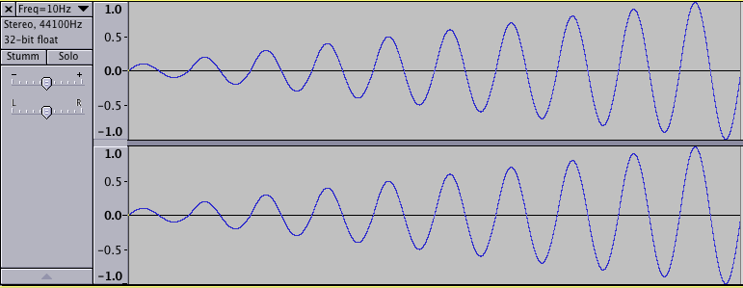
Self-reinforcing global audio signal on account of its state in one control cycle being the same as in the previous one
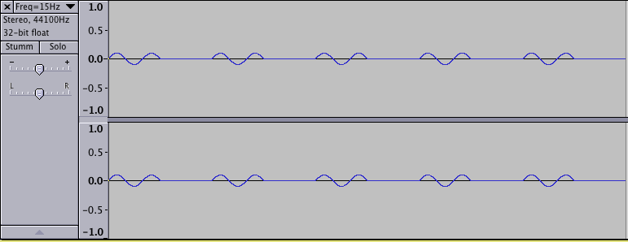
Partly self-erasing global audio signal because of phase inversions in two subsequent control cycles
So the result of all is: If you work with global audio variables in a way that you add several local audio signals to a global audio variable (which works like a bus), you must clear this global bus at each control cycle. As in Csound all the instruments are calculated in ascending order, it should be done either at the beginning of the first, or at the end of the last instrument. Perhaps it is the best idea to declare all global audio variables in the orchestra header first, and then clear them in an "always on" instrument with the highest number of all the instruments used. This is an example of a typical situation:
EXAMPLE 03B10_Global_with_clear.csd
<CsoundSynthesizer>
<CsOptions>
-o dac
</CsOptions>
<CsInstruments>
;Example by Joachim Heintz
sr = 44100
ksmps = 32
nchnls = 2
0dbfs = 1

;initialize the global audio variables
gaBusL init 0
gaBusR init 0
;make the seed for random values each time different
seed 0

instr 1; produces short signals
loop:
iDur random .3, 1.5
timout 0, iDur, makenote
reinit loop
makenote:
iFreq random 300, 1000
iVol random -12, -3; dB
iPan random 0, 1; random panning for each signal
aSin oscil3 ampdb(iVol), iFreq, 1
aEnv transeg 1, iDur, -10, 0; env in a-rate is cleaner
aAdd = aSin * aEnv
aL, aR pan2 aAdd, iPan
gaBusL = gaBusL + aL; add to the global audio signals
gaBusR = gaBusR + aR
endin

instr 2; produces short filtered noise signals (4 partials)
loop:
iDur random .1, .7
timout 0, iDur, makenote
reinit loop
makenote:
iFreq random 100, 500
iVol random -24, -12; dB
iPan random 0, 1
aNois rand ampdb(iVol)
aFilt reson aNois, iFreq, iFreq/10
aRes balance aFilt, aNois
aEnv transeg 1, iDur, -10, 0
aAdd = aRes * aEnv
aL, aR pan2 aAdd, iPan
gaBusL = gaBusL + aL; add to the global audio signals
gaBusR = gaBusR + aR
endin

instr 3; reverb of gaBus and output
aL, aR freeverb gaBusL, gaBusR, .8, .5
outs aL, aR
endin

instr 100; clear global audios at the end
clear gaBusL, gaBusR
endin

</CsInstruments>
<CsScore>
f 1 0 1024 10 1 .5 .3 .1
i 1 0 20
i 2 0 20
i 3 0 20
i 100 0 20
</CsScore>
</CsoundSynthesizer>

The chn Opcodes For Global Variables
Instead of using the traditional g-variables for any values or signals which are to transfer between several instruments, it is also possible to use the chn opcodes. An i-, k-, a- or S-value or signal can be set by chnset and received by chnget. One advantage is to have strings as names, so that you can choose intuitive names.
For audio variables, instead of performing an addition, you can use the chnmix opcode. For clearing an audio variable, the chnclear opcode can be used.
EXAMPLE 03B11_Chn_demo.csd
<CsoundSynthesizer>
<CsOptions>
-o dac
</CsOptions>
<CsInstruments>
;Example by Joachim Heintz
sr = 44100
ksmps = 32
nchnls = 2
0dbfs = 1

instr 1; send i-values
chnset 1, "sio"
chnset -1, "non"
endin

instr 2; send k-values
kfreq randomi 100, 300, 1
chnset kfreq, "cntrfreq"
kbw = kfreq/10
chnset kbw, "bandw"
endin

instr 3; send a-values
anois rand .1
chnset anois, "noise"
loop:
idur random .3, 1.5
timout 0, idur, do
reinit loop
do:
ifreq random 400, 1200
iamp random .1, .3
asig oscils iamp, ifreq, 0
aenv transeg 1, idur, -10, 0
asine = asig * aenv
chnset asine, "sine"
endin

instr 11; receive some chn values and send again
ival1 chnget "sio"
ival2 chnget "non"
print ival1, ival2
kcntfreq chnget "cntrfreq"
kbandw chnget "bandw"
anoise chnget "noise"
afilt reson anoise, kcntfreq, kbandw
afilt balance afilt, anoise
chnset afilt, "filtered"
endin

instr 12; mix the two audio signals
amix1 chnget "sine"
amix2 chnget "filtered"
chnmix amix1, "mix"
chnmix amix2, "mix"
endin

instr 20; receive and reverb
amix chnget "mix"
aL, aR freeverb amix, amix, .8, .5
outs aL, aR
endin

instr 100; clear
chnclear "mix"
endin

</CsInstruments>
<CsScore>
i 1 0 20
i 2 0 20
i 3 0 20
i 11 0 20
i 12 0 20
i 20 0 20
i 100 0 20
</CsScore>
</CsoundSynthesizer>

15. CONTROL STRUCTURES
In a way, control structures are the core of a programming language. The fundamental element in each language is the conditional if branch. Actually all other control structures like for-, until- or while-loops can be traced back to if-statements.1
So, Csound provides mainly the if-statement; either in the usual if-then-else form, or in the older way of an if-goto statement. These will be covered first. Though all necessary loops can be built just by if-statements, Csound's loop facility offers a more comfortable way of performing loops. They will be introduced later, in the Loop section of this chapter. Finally, time loops are shown, which are particulary important in audio programming languages.

If i-Time Then Not k-Time!
The fundamental difference in Csound between i-time and k-time which has been explained in chapter 03A, must be regarded very carefully when you work with control structures. If you make a conditional branch at i-time, the condition will be tested just once for each note, at the initialization pass. If you make a conditional branch at k-time, the condition will be tested again and again in each control-cycle.
For instance, if you test a soundfile whether it is mono or stereo, this is done at init-time. If you test an amplitude value to be below a certain threshold, it is done at performance time (k-time). If you get user-input by a scroll number, this is also a k-value, so you need a k-condition.
Thus, all if and loop opcodes have an "i" and a "k" descendant. In the next few sections, a general introduction into the different control tools is given, followed by examples both at i-time and at k-time for each tool.

If - then - [elseif - then -] else
The use of the if-then-else statement is very similar to other programming languages. Note that in Csound, "then" must be written in the same line as "if" and the expression to be tested, and that you must close the if-block with an "endif" statement on a new line:
if <condition> then
...
else
...
endif
It is also possible to have no "else" statement:
if <condition> then
...
endif
Or you can have one or more "elseif-then" statements in between:
if <condition1> then
...
elseif <condition2> then
...
else
...
endif
If statements can also be nested. Each level must be closed with an "endif". This is an example with three levels:
if <condition1> then; first condition opened
if <condition2> then; second condition openend
if <condition3> then; third condition openend
...
else
...
endif; third condition closed
elseif <condition2a> then
...
endif; second condition closed
else
...
endif; first condition closed

i-Rate Examples
A typical problem in Csound: You have either mono or stereo files, and want to read both with a stereo output. For the real stereo ones that means: use soundin (diskin / diskin2) with two output arguments. For the mono ones it means: use soundin / diskin / diskin2 with one output argument, and throw it to both output channels:
EXAMPLE 03C01_IfThen_i.csd
<CsoundSynthesizer>
<CsOptions>
-o dac
</CsOptions>
<CsInstruments>
;Example by Joachim Heintz
sr = 44100
ksmps = 32
nchnls = 2
0dbfs = 1

instr 1
Sfile = "/my/file.wav" ;your soundfile path here
ifilchnls filenchnls Sfile
if ifilchnls == 1 then ;mono
aL soundin Sfile
aR = aL
else ;stereo
aL, aR soundin Sfile
endif
outs aL, aR
endin

</CsInstruments>
<CsScore>
i 1 0 5
</CsScore>
</CsoundSynthesizer>
If you use CsoundQt, you can browse in the widget panel for the soundfile. See the corresponding example in the CsoundQt Example menu.

k-Rate Examples
The following example establishes a moving gate between 0 and 1. If the gate is above 0.5, the gate opens and you hear a tone. If the gate is equal or below 0.5, the gate closes, and you hear nothing.
EXAMPLE 03C02_IfThen_k.csd
<CsoundSynthesizer>
<CsOptions>
-odac
</CsOptions>
<CsInstruments>
;Example by Joachim Heintz
sr = 44100
ksmps = 32
nchnls = 2
0dbfs = 1

seed 0; random values each time different
giTone ftgen 0, 0, 2^10, 10, 1, .5, .3, .1

instr 1

; move between 0 and 1 (3 new values per second)
kGate randomi 0, 1, 3
; move between 300 and 800 hz (1 new value per sec)
kFreq randomi 300, 800, 1
; move between -12 and 0 dB (5 new values per sec)
kdB randomi -12, 0, 5
aSig oscil3 1, kFreq, giTone
kVol init 0
if kGate > 0.5 then; if kGate is larger than 0.5
kVol = ampdb(kdB); open gate
else
kVol = 0; otherwise close gate
endif
kVol port kVol, .02; smooth volume curve to avoid clicks
aOut = aSig * kVol
outs aOut, aOut
endin

</CsInstruments>
<CsScore>
i 1 0 30
</CsScore>
</CsoundSynthesizer>

Short Form: (a v b ? x : y)
If you need an if-statement to give a value to an (i- or k-) variable, you can also use a traditional short form in parentheses: (a v b ? x : y).2 It asks whether the condition a or b is true. If a, the value is set to x; if b, to y. For instance, the last example could be written in this way:
EXAMPLE 03C03_IfThen_short_form.csd
<CsoundSynthesizer>
<CsOptions>
-odac
</CsOptions>
<CsInstruments>
;Example by Joachim Heintz
sr = 44100
ksmps = 32
nchnls = 2
0dbfs = 1

seed 0
giTone ftgen 0, 0, 2^10, 10, 1, .5, .3, .1

instr 1
kGate randomi 0, 1, 3; moves between 0 and 1 (3 new values per second)
kFreq randomi 300, 800, 1; moves between 300 and 800 hz
;(1 new value per sec)
kdB randomi -12, 0, 5; moves between -12 and 0 dB
;(5 new values per sec)
aSig oscil3 1, kFreq, giTone
kVol init 0
kVol = (kGate > 0.5 ? ampdb(kdB) : 0); short form of condition
kVol port kVol, .02; smooth volume curve to avoid clicks
aOut = aSig * kVol
outs aOut, aOut
endin

</CsInstruments>
<CsScore>
i 1 0 20
</CsScore>
</CsoundSynthesizer>

If - goto
An older way of performing a conditional branch - but still useful in certain cases - is an "if" statement which is not followed by a "then", but by a label name. The "else" construction follows (or doesn't follow) in the next line. Like the if-then-else statement, the if-goto works either at i-time or at k-time. You should declare the type by either using igoto or kgoto. Usually you need an additional igoto/kgoto statement for omitting the "else" block if the first condition is true. This is the general syntax:
i-time
if <condition> igoto this; same as if-then
igoto that; same as else
this: ;the label "this" ...
...
igoto continue ;skip the "that" block
that: ; ... and the label "that" must be found
...
continue: ;go on after the conditional branch
...
k-time
if <condition> kgoto this; same as if-then
kgoto that; same as else
this: ;the label "this" ...
...
kgoto continue ;skip the "that" block
that: ; ... and the label "that" must be found
...
continue: ;go on after the conditional branch
...

i-Rate Examples
This is the same example as above in the if-then-else syntax for a branch depending on a mono or stereo file. If you just want to know whether a file is mono or stereo, you can use the "pure" if-igoto statement:
EXAMPLE 03C04_IfGoto_i.csd
<CsoundSynthesizer>
<CsInstruments>
;Example by Joachim Heintz
sr = 44100
ksmps = 32
nchnls = 2
0dbfs = 1

instr 1
Sfile = "/Joachim/Materialien/SamplesKlangbearbeitung/Kontrabass.aif"
ifilchnls filenchnls Sfile
if ifilchnls == 1 igoto mono; condition if true
igoto stereo; else condition
mono:
prints "The file is mono!%n"
igoto continue
stereo:
prints "The file is stereo!%n"
continue:
endin

</CsInstruments>
<CsScore>
i 1 0 0
</CsScore>
</CsoundSynthesizer>
But if you want to play the file, you must also use a k-rate if-kgoto, because, not only do you have an event at i-time (initializing the soundin opcode) but also at k-time (producing an audio signal). So the code in this case is much more cumbersome, or obfuscated, than the previous if-then-else example.
EXAMPLE 03C05_IfGoto_ik.csd
<CsoundSynthesizer>
<CsOptions>
-odac
</CsOptions>
<CsInstruments>
;Example by Joachim Heintz
sr = 44100
ksmps = 32
nchnls = 2
0dbfs = 1

instr 1
Sfile = "my/file.wav"
ifilchnls filenchnls Sfile
if ifilchnls == 1 kgoto mono
kgoto stereo
if ifilchnls == 1 igoto mono; condition if true
igoto stereo; else condition
mono:
aL soundin Sfile
aR = aL
igoto continue
kgoto continue
stereo:
aL, aR soundin Sfile
continue:
outs aL, aR
endin

</CsInstruments>
<CsScore>
i 1 0 5
</CsScore>
</CsoundSynthesizer>

k-Rate Examples
This is the same example as above (03C02) in the if-then-else syntax for a moving gate between 0 and 1:
EXAMPLE 03C06_IfGoto_k.csd
<CsoundSynthesizer>
<CsOptions>
-odac
</CsOptions>
<CsInstruments>
;Example by Joachim Heintz
sr = 44100
ksmps = 32
nchnls = 2
0dbfs = 1

seed 0
giTone ftgen 0, 0, 2^10, 10, 1, .5, .3, .1

instr 1
kGate randomi 0, 1, 3; moves between 0 and 1 (3 new values per second)
kFreq randomi 300, 800, 1; moves between 300 and 800 hz
;(1 new value per sec)
kdB randomi -12, 0, 5; moves between -12 and 0 dB
;(5 new values per sec)
aSig oscil3 1, kFreq, giTone
kVol init 0
if kGate > 0.5 kgoto open; if condition is true
kgoto close; "else" condition
open:
kVol = ampdb(kdB)
kgoto continue
close:
kVol = 0
continue:
kVol port kVol, .02; smooth volume curve to avoid clicks
aOut = aSig * kVol
outs aOut, aOut
endin

</CsInstruments>
<CsScore>
i 1 0 30
</CsScore>
</CsoundSynthesizer>

Loops
Loops can be built either at i-time or at k-time just with the "if" facility. The following example shows an i-rate and a k-rate loop created using the if-i/kgoto facility:
EXAMPLE 03C07_Loops_with_if.csd
<CsoundSynthesizer>
<CsInstruments>
;Example by Joachim Heintz

instr 1 ;i-time loop: counts from 1 until 10 has been reached
icount = 1
count:
print icount
icount = icount + 1
if icount < 11 igoto count
prints "i-END!%n"
endin

instr 2 ;k-rate loop: counts in the 100th k-cycle from 1 to 11
kcount init 0
ktimek timeinstk ;counts k-cycle from the start of this instrument
if ktimek == 100 kgoto loop
kgoto noloop
loop:
printks "k-cycle %d reached!%n", 0, ktimek
kcount = kcount + 1
printk2 kcount
if kcount < 11 kgoto loop
printks "k-END!%n", 0
noloop:
endin

</CsInstruments>
<CsScore>
i 1 0 0
i 2 0 1
</CsScore>
</CsoundSynthesizer>
But Csound offers a slightly simpler syntax for this kind of i-rate or k-rate loops. There are four variants of the loop opcode. All four refer to a label as the starting point of the loop, an index variable as a counter, an increment or decrement, and finally a reference value (maximum or minimum) as comparision:
- loop_lt counts upwards and looks if the index variable is lower than the reference value;
- loop_le also counts upwards and looks if the index is lower than or equal to the reference value;
- loop_gt counts downwards and looks if the index is greater than the reference value;
- loop_ge also counts downwards and looks if the index is greater than or equal to the reference value.
As always, all four opcodes can be applied either at i-time or at k-time. Here are some examples, first for i-time loops, and then for k-time loops.

i-Rate Examples
The following .csd provides a simple example for all four loop opcodes:
EXAMPLE 03C08_Loop_opcodes_i.csd
<CsoundSynthesizer>
<CsInstruments>
;Example by Joachim Heintz

instr 1 ;loop_lt: counts from 1 upwards and checks if < 10
icount = 1
loop:
print icount
loop_lt icount, 1, 10, loop
prints "Instr 1 terminated!%n"
endin

instr 2 ;loop_le: counts from 1 upwards and checks if <= 10
icount = 1
loop:
print icount
loop_le icount, 1, 10, loop
prints "Instr 2 terminated!%n"
endin

instr 3 ;loop_gt: counts from 10 downwards and checks if > 0
icount = 10
loop:
print icount
loop_gt icount, 1, 0, loop
prints "Instr 3 terminated!%n"
endin

instr 4 ;loop_ge: counts from 10 downwards and checks if >= 0
icount = 10
loop:
print icount
loop_ge icount, 1, 0, loop
prints "Instr 4 terminated!%n"
endin

</CsInstruments>
<CsScore>
i 1 0 0
i 2 0 0
i 3 0 0
i 4 0 0
</CsScore>
</CsoundSynthesizer>
The next example produces a random string of 10 characters and prints it out:
EXAMPLE 03C09_Random_string.csd
<CsoundSynthesizer>
<CsInstruments>
;Example by Joachim Heintz

instr 1
icount = 0
Sname = ""; starts with an empty string
loop:
ichar random 65, 90.999
Schar sprintf "%c", int(ichar); new character
Sname strcat Sname, Schar; append to Sname
loop_lt icount, 1, 10, loop; loop construction
printf_i "My name is '%s'!\n", 1, Sname; print result
endin

</CsInstruments>
<CsScore>
; call instr 1 ten times
r 10
i 1 0 0
</CsScore>
</CsoundSynthesizer>
You can also use an i-rate loop to fill a function table (= buffer) with any kind of values. This table can then be read, or manipulated and then be read again. In the next example, a function table with 20 positions (indices) is filled with random integers between 0 and 10 by instrument 1. Nearly the same loop construction is used afterwards to read these values by instrument 2.
EXAMPLE 03C10_Random_ftable_fill.csd
<CsoundSynthesizer>
<CsInstruments>
;Example by Joachim Heintz

giTable ftgen 0, 0, -20, -2, 0; empty function table with 20 points
seed 0; each time different seed

instr 1 ; writes in the table
icount = 0
loop:
ival random 0, 10.999 ;random value
; --- write in giTable at first, second, third ... position
tableiw int(ival), icount, giTable
loop_lt icount, 1, 20, loop; loop construction
endin

instr 2; reads from the table
icount = 0
loop:
; --- read from giTable at first, second, third ... position
ival tablei icount, giTable
print ival; prints the content
loop_lt icount, 1, 20, loop; loop construction
endin

</CsInstruments>
<CsScore>
i 1 0 0
i 2 0 0
</CsScore>
</CsoundSynthesizer>

k-Rate Examples
The next example performs a loop at k-time. Once per second, every value of an existing function table is changed by a random deviation of 10%. Though there are some vectorial opcodes for this task (and in Csound 6 probably array), it can also be done by a k-rate loop like the one shown here:
EXAMPLE 03C11_Table_random_dev.csd
<CsoundSynthesizer>
<CsOptions>
-odac
</CsOptions>
<CsInstruments>
;Example by Joachim Heintz
sr = 44100
ksmps = 441
nchnls = 2
0dbfs = 1

giSine ftgen 0, 0, 256, 10, 1; sine wave
seed 0; each time different seed

instr 1
ktiminstk timeinstk ;time in control-cycles
kcount init 1
if ktiminstk == kcount * kr then; once per second table values manipulation:
kndx = 0
loop:
krand random -.1, .1;random factor for deviations
kval table kndx, giSine; read old value
knewval = kval + (kval * krand); calculate new value
tablew knewval, kndx, giSine; write new value
loop_lt kndx, 1, 256, loop; loop construction
kcount = kcount + 1; increase counter
endif
asig poscil .2, 400, giSine
outs asig, asig
endin

</CsInstruments>
<CsScore>
i 1 0 10
</CsScore>
</CsoundSynthesizer>

Time Loops
Until now, we have just discussed loops which are executed "as fast as possible", either at i-time or at k-time. But, in an audio programming language, time loops are of particular interest and importance. A time loop means, repeating any action after a certain amount of time. This amount of time can be equal to or different to the previous time loop. The action can be, for instance: playing a tone, or triggering an instrument, or calculating a new value for the movement of an envelope.
In Csound, the usual way of performing time loops, is the timout facility. The use of timout is a bit intricate, so some examples are given, starting from very simple to more complex ones.
Another way of performing time loops is by using a measurement of time or k-cycles. This method is also discussed and similar examples to those used for the timout opcode are given so that both methods can be compared.

timout Basics
The timout opcode refers to the fact that in the traditional way of working with Csound, each "note" (an "i" score event) has its own time. This is the duration of the note, given in the score by the duration parameter, abbreviated as "p3". A timout statement says: "I am now jumping out of this p3 duration and establishing my own time." This time will be repeated as long as the duration of the note allows it.
Let's see an example. This is a sine tone with a moving frequency, starting at 400 Hz and ending at 600 Hz. The duration of this movement is 3 seconds for the first note, and 5 seconds for the second note:
EXAMPLE 03C12_Timout_pre.csd
<CsoundSynthesizer>
<CsOptions>
-odac
</CsOptions>
<CsInstruments>
;Example by Joachim Heintz
sr = 44100
ksmps = 32
nchnls = 2
0dbfs = 1

giSine ftgen 0, 0, 2^10, 10, 1

instr 1
kFreq expseg 400, p3, 600
aTone poscil .2, kFreq, giSine
outs aTone, aTone
endin

</CsInstruments>
<CsScore>
i 1 0 3
i 1 4 5
</CsScore>
</CsoundSynthesizer>
Now we perform a time loop with timout which is 1 second long. So, for the first note, it will be repeated three times, and five times for the second note:
EXAMPLE 03C13_Timout_basics.csd
<CsoundSynthesizer>
<CsOptions>
-odac
</CsOptions>
<CsInstruments>
;Example by Joachim Heintz
sr = 44100
ksmps = 32
nchnls = 2
0dbfs = 1

giSine ftgen 0, 0, 2^10, 10, 1

instr 1
loop:
timout 0, 1, play
reinit loop
play:
kFreq expseg 400, 1, 600
aTone poscil .2, kFreq, giSine
outs aTone, aTone
endin

</CsInstruments>
<CsScore>
i 1 0 3
i 1 4 5
</CsScore>
</CsoundSynthesizer>
This is the general syntax of timout:
first_label:
timout istart, idur, second_label
reinit first_label
second_label:
... <any action you want to have here>
The first_label is an arbitrary word (followed by a colon) to mark the beginning of the time loop section. The istart argument for timout tells Csound, when the second_label section is to be executed. Usually istart is zero, telling Csound: execute the second_label section immediately, without any delay. The idur argument for timout defines for how many seconds the second_label section is to be executed before the time loop begins again. Note that the reinit first_label is necessary to start the second loop after idur seconds with a resetting of all the values. (See the explanations about reinitialization in the chapter Initilalization And Performance Pass.)
As usual when you work with the reinit opcode, you can use a rireturn statement to constrain the reinit-pass. In this way you can have both, the timeloop section and the non-timeloop section in the body of an instrument:
EXAMPLE 03C14_Timeloop_and_not.csd
<CsoundSynthesizer>
<CsOptions>
-odac
</CsOptions>
<CsInstruments>
;Example by Joachim Heintz
sr = 44100
ksmps = 32
nchnls = 2
0dbfs = 1

giSine ftgen 0, 0, 2^10, 10, 1

instr 1
loop:
timout 0, 1, play
reinit loop
play:
kFreq1 expseg 400, 1, 600
aTone1 oscil3 .2, kFreq1, giSine
rireturn ;end of the time loop
kFreq2 expseg 400, p3, 600
aTone2 poscil .2, kFreq2, giSine

outs aTone1+aTone2, aTone1+aTone2
endin

</CsInstruments>
<CsScore>
i 1 0 3
i 1 4 5
</CsScore>
</CsoundSynthesizer>

timout Applications
In a time loop, it is very important to change the duration of the loop. This can be done either by referring to the duration of this note (p3) ...
EXAMPLE 03C15_Timout_different_durations.csd
<CsoundSynthesizer>
<CsOptions>
-odac
</CsOptions>
<CsInstruments>
;Example by Joachim Heintz
sr = 44100
ksmps = 32
nchnls = 2
0dbfs = 1

giSine ftgen 0, 0, 2^10, 10, 1

instr 1
loop:
timout 0, p3/5, play
reinit loop
play:
kFreq expseg 400, p3/5, 600
aTone poscil .2, kFreq, giSine
outs aTone, aTone
endin

</CsInstruments>
<CsScore>
i 1 0 3
i 1 4 5
</CsScore>
</CsoundSynthesizer>
... or by calculating new values for the loop duration on each reinit pass, for instance by random values:
EXAMPLE 03C16_Timout_random_durations.csd
<CsoundSynthesizer>
<CsOptions>
-odac
</CsOptions>
<CsInstruments>
;Example by Joachim Heintz
sr = 44100
ksmps = 32
nchnls = 2
0dbfs = 1

giSine ftgen 0, 0, 2^10, 10, 1

instr 1
loop:
idur random .5, 3 ;new value between 0.5 and 3 seconds each time
timout 0, idur, play
reinit loop
play:
kFreq expseg 400, idur, 600
aTone poscil .2, kFreq, giSine
outs aTone, aTone
endin

</CsInstruments>
<CsScore>
i 1 0 20
</CsScore>
</CsoundSynthesizer>
The applications discussed so far have the disadvantage that all the signals inside the time loop must definitely be finished or interrupted, when the next loop begins. In this way it is not possible to have any overlapping of events. To achieve this, the time loop can be used to simply trigger an event. This can be done with event_i or scoreline_i. In the following example, the time loop in instrument 1 triggers a new instance of instrument 2 with a duration of 1 to 5 seconds, every 0.5 to 2 seconds. So in most cases, the previous instance of instrument 2 will still be playing when the new instance is triggered. Random calculations are executed in instrument 2 so that each note will have a different pitch,creating a glissando effect:
EXAMPLE 03C17_Timout_trigger_events.csd
<CsoundSynthesizer>
<CsOptions>
-odac
</CsOptions>
<CsInstruments>
;Example by Joachim Heintz
sr = 44100
ksmps = 32
nchnls = 2
0dbfs = 1

giSine ftgen 0, 0, 2^10, 10, 1

instr 1
loop:
idurloop random .5, 2 ;duration of each loop
timout 0, idurloop, play
reinit loop
play:
idurins random 1, 5 ;duration of the triggered instrument
event_i "i", 2, 0, idurins ;triggers instrument 2
endin

instr 2
ifreq1 random 600, 1000 ;starting frequency
idiff random 100, 300 ;difference to final frequency
ifreq2 = ifreq1 - idiff ;final frequency
kFreq expseg ifreq1, p3, ifreq2 ;glissando
iMaxdb random -12, 0 ;peak randomly between -12 and 0 dB
kAmp transeg ampdb(iMaxdb), p3, -10, 0 ;envelope
aTone poscil kAmp, kFreq, giSine
outs aTone, aTone
endin

</CsInstruments>
<CsScore>
i 1 0 30
</CsScore>
</CsoundSynthesizer>
The last application of a time loop with the timout opcode which is shown here, is a randomly moving envelope. If you want to create an envelope in Csound which moves between a lower and an upper limit, and has one new random value in a certain time span (for instance, once a second), the time loop with timout is one way to achieve it. A line movement must be performed in each time loop, from a given starting value to a new evaluated final value. Then, in the next loop, the previous final value must be set as the new starting value, and so on. Here is a possible solution:
EXAMPLE 03C18_Timout_random_envelope.csd
<CsoundSynthesizer>
<CsOptions>
-odac
</CsOptions>
<CsInstruments>
;Example by Joachim Heintz
sr = 44100
ksmps = 32
nchnls = 2
0dbfs = 1

giSine ftgen 0, 0, 2^10, 10, 1
seed 0

instr 1
iupper = 0; upper and ...
ilower = -24; ... lower limit in dB
ival1 random ilower, iupper; starting value
loop:
idurloop random .5, 2; duration of each loop
timout 0, idurloop, play
reinit loop
play:
ival2 random ilower, iupper; final value
kdb linseg ival1, idurloop, ival2
ival1 = ival2; let ival2 be ival1 for next loop
rireturn ;end reinit section
aTone poscil ampdb(kdb), 400, giSine
outs aTone, aTone
endin

</CsInstruments>
<CsScore>
i 1 0 30
</CsScore>
</CsoundSynthesizer>
Note that in this case the oscillator has been put after the time loop section (which is terminated by the rireturn statement. Otherwise the oscillator would start afresh with zero phase in each time loop, thus producing clicks.

Time Loops by using the metro Opcode
The metro opcode outputs a "1" at distinct times, otherwise it outputs a "0". The frequency of this "banging" (which is in some way similar to the metro objects in PD or Max) is given by the kfreq input argument. So the output of metro offers a simple and intuitive method for controlling time loops, if you use it to trigger a separate instrument which then carries out another job. Below is a simple example for calling a subinstrument twice per second:
EXAMPLE 03C19_Timeloop_metro.csd
<CsoundSynthesizer>
<CsOptions>
-odac
</CsOptions>
<CsInstruments>
;Example by Joachim Heintz
sr = 44100
ksmps = 32
nchnls = 2
0dbfs = 1

instr 1; triggering instrument
kTrig metro 2; outputs "1" twice a second
if kTrig == 1 then
event "i", 2, 0, 1
endif
endin

instr 2; triggered instrument
aSig oscils .2, 400, 0
aEnv transeg 1, p3, -10, 0
outs aSig*aEnv, aSig*aEnv
endin

</CsInstruments>
<CsScore>
i 1 0 10
</CsScore>
</CsoundSynthesizer>
The example which is given above (03C17_Timout_trigger_events.csd) as a flexible time loop by timout, can be done with the metro opcode in this way:
EXAMPLE 03C20_Metro_trigger_events.csd
<CsoundSynthesizer>
<CsOptions>
-odac
</CsOptions>
<CsInstruments>
;Example by Joachim Heintz
sr = 44100
ksmps = 32
nchnls = 2
0dbfs = 1

giSine ftgen 0, 0, 2^10, 10, 1
seed 0

instr 1
kfreq init 1; give a start value for the trigger frequency
kTrig metro kfreq
if kTrig == 1 then ;if trigger impulse:
kdur random 1, 5; random duration for instr 2
event "i", 2, 0, kdur; call instr 2
kfreq random .5, 2; set new value for trigger frequency
endif
endin

instr 2
ifreq1 random 600, 1000; starting frequency
idiff random 100, 300; difference to final frequency
ifreq2 = ifreq1 - idiff; final frequency
kFreq expseg ifreq1, p3, ifreq2; glissando
iMaxdb random -12, 0; peak randomly between -12 and 0 dB
kAmp transeg ampdb(iMaxdb), p3, -10, 0; envelope
aTone poscil kAmp, kFreq, giSine
outs aTone, aTone
endin

</CsInstruments>
<CsScore>
i 1 0 30
</CsScore>
</CsoundSynthesizer>
Note the differences in working with the metro opcode compared to the timout feature:
- As metro works at k-time, you must use the k-variants of event or scoreline to call the subinstrument. With timout you must use the i-variants of event or scoreline (event_i and scoreline_i), because it uses reinitialization for performing the time loops.
- You must select the one k-cycle where the metro opcode sends a "1". This is done with an if-statement. The rest of the instrument is not affected. If you use timout, you usually must seperate the reinitialized from the not reinitialized section by a rireturn statement.

Links
Steven Yi: Control Flow (Part I = Csound Journal Spring 2006, Part 2 = Csound Journal Summer 2006)

- While writing on this release (spring 2013) we are in a period of including new control structures in Csound. As a first test, the until loop has been introduced in Csound 5.14. See the example in http://www.csounds.com/manual/html/until.html^
- Since the new parser (Csound 5.14) you can also write without parentheses.^

16. FUNCTION TABLES
A function table is essentially the same as what other audio programming languages call a buffer, a table, a list or an array. It is a place where data can be stored in an ordered way. Each function table has a size: how much data (in Csound just numbers) can be stored in it. Each value in the table can be accessed by an index, counting from 0 to size-1. For instance, if you have a function table with a size of 10, and the numbers [1.1 2.2 3.3 5.5 8.8 13.13 21.21 34.34 55.55 89.89] in it, this is the relation of value and index:
VALUE | 1.1 | 2.2 | 3.3 | 5.5 | 8.8 | 13.13 | 21.21 | 34.34 | 55.55 | 89.89
INDEX | 0 | 1 | 2 | 3 | 4 | 5 | 6 | 7 | 8 | 9
So, if you want to retrieve the value 13.13, you must point to the value stored under index 5.
The use of function tables is manifold. A function table can contain pitch values to which you may refer using the input of a MIDI keyboard. A function table can contain a model of a waveform which is read periodically by an oscillator. You can record live audio input in a function table, and then play it back. There are many more applications, all using the fast access (because function tables are stored in RAM) and flexible use of function tables.

How to Generate a Function Table
Each function table must be created before it can be used. Even if you want to write values later, you must first create an empty table, because you must initially reserve some space in memory for it.
Each creation of a function table in Csound is performed by one of the GEN Routines. Each GEN Routine generates a function table in a particular way: GEN01 transfers audio samples from a soundfile into a table, with GEN02 we can write values in "by hand" one by one, GEN10 calculates a waveform using information determining a sum of sinusoids, GEN20 generates window functions typically used for granular synthesis, and so on. There is a good overview in the Csound Manual of all existing GEN Routines. Here we will explain the general use and give simple examples for some frequent cases.

GEN02 And General Parameters For GEN Routines
Let's start with our example above and write the 10 numbers into a function table of the same size. For this, use of a GEN02 function table is required. A short description of GEN02 from the manual reads as follows:
f # time size 2 v1 v2 v3 ...
This is the traditional way of creating a function table by an "f statement" or an "f score event" (in relation for instance to "i score events" which call instrument instances). The input parameters after the "f" are the following:
- #: a number (as positive integer) for this function table;
- time: at which time the function table is made available (usually 0 = from the beginning);
- size: the size of the function table. This is a bit tricky, because in the early days of Csound just power-of-two sizes for function tables were possible (2, 4, 8, 16, ...). Nowadays nearly every GEN Routine accepts other sizes, but these non-power-of-two sizes must be declared as a negative number!
- 2: the number of the GEN Routine which is used to generate the table. And here is another important point which must be regarded. By default, Csound normalizes the table values. This means that the maximum is scaled to +1 if positive, and to -1 if negative. To prevent Csound from normalizing, a negative number must be given as GEN number (here -2 instead of 2).
- v1 v2 v3 ...: the values which are written into the function table.
So this is the way to put the values [1.1 2.2 3.3 5.5 8.8 13.13 21.21 34.34 55.55 89.89] in a function table with the number 1:
EXAMPLE 03D01_Table_norm_notNorm.csd
<CsoundSynthesizer>
<CsInstruments>
;Example by Joachim Heintz
instr 1 ;prints the values of table 1 or 2
prints "%nFunction Table %d:%n", p4
indx init 0
loop:
ival table indx, p4
prints "Index %d = %f%n", indx, ival
loop_lt indx, 1, 10, loop
endin
</CsInstruments>
<CsScore>
f 1 0 -10 -2 1.1 2.2 3.3 5.5 8.8 13.13 21.21 34.34 55.55 89.89; not normalized
f 2 0 -10 2 1.1 2.2 3.3 5.5 8.8 13.13 21.21 34.34 55.55 89.89; normalized
i 1 0 0 1; prints function table 1
i 1 0 0 2; prints function table 2
</CsScore>
</CsoundSynthesizer>
Instrument 1 just serves to print the values of the table (the tablei opcode will be explained later). See the difference whether the table is normalized (positive GEN number) or not normalized (negative GEN number).
Using the ftgen opcode is a more modern way of creating a function table, which is usually preferable to the old way of writing an f-statement in the score.1 The syntax is explained below:
giVar ftgen ifn, itime, isize, igen, iarg1 [, iarg2 [, ...]]
- giVar: a variable name. Each function is stored in an i-variable. Usually you want to have access to it from every instrument, so a gi-variable (global initialization variable) is given.
- ifn: a number for the function table. If you type in 0, you give Csound the job to choose a number, which is mostly preferable.
The other parameters (size, GEN number, individual arguments) are the same as in the f-statement in the score. As this GEN call is now a part of the orchestra, each argument is separated from the next by a comma (not by a space or tab like in the score).
So this is the same example as above, but now with the function tables being generated in the orchestra header:
EXAMPLE 03D02_Table_ftgen.csd
<CsoundSynthesizer>
<CsInstruments>
;Example by Joachim Heintz

giFt1 ftgen 1, 0, -10, -2, 1.1, 2.2, 3.3, 5.5, 8.8, 13.13, 21.21, 34.34, 55.55, 89.89
giFt2 ftgen 2, 0, -10, 2, 1.1, 2.2, 3.3, 5.5, 8.8, 13.13, 21.21, 34.34, 55.55, 89.89

instr 1; prints the values of table 1 or 2
prints "%nFunction Table %d:%n", p4
indx init 0
loop:
ival table indx, p4
prints "Index %d = %f%n", indx, ival
loop_lt indx, 1, 10, loop
endin

</CsInstruments>
<CsScore>
i 1 0 0 1; prints function table 1
i 1 0 0 2; prints function table 2
</CsScore>
</CsoundSynthesizer>

GEN01: Importing a Soundfile
GEN01 is used for importing soundfiles stored on disk into the computer's RAM, ready for for use by a number of Csound's opcodes in the orchestra. A typical ftgen statement for this import might be the following:
varname ifn itime isize igen Sfilnam iskip iformat ichn
giFile ftgen 0, 0, 0, 1, "myfile.wav", 0, 0, 0
- varname, ifn, itime: These arguments have the same meaning as explained above in reference to GEN02.
- isize: Usually you won't know the length of your soundfile in samples, and want to have a table length which includes exactly all the samples. This is done by setting isize=0. (Note that some opcodes may need a power-of-two table. In this case you can not use this option, but must calculate the next larger power-of-two value as size for the function table.)
- igen: As explained in the previous subchapter, this is always the place for indicating the number of the GEN Routine which must be used. As always, a positive number means normalizing, which is usually convenient for audio samples.
- Sfilnam: The name of the soundfile in double quotes. Similar to other audio programming languages, Csound recognizes just the name if your .csd and the soundfile are in the same folder. Otherwise, give the full path. (You can also include the folder via the "SSDIR" variable, or add the folder via the "--env:NAME+=VALUE" option.)
- iskip: The time in seconds you want to skip at the beginning of the soundfile. 0 means reading from the beginning of the file.
- iformat: Usually 0, which means: read the sample format from the soundfile header.
- ichn: 1 = read the first channel of the soundfile into the table, 2 = read the second channel, etc. 0 means that all channels are read.
The next example plays a short sample. You can download it here. Copy the text below, save it to the same location as the "fox.wav" soundfile (or add the folder via the "--env:NAME+=VALUE" option),2 and it should work. Reading the function table is done here with the poscil3 opcode which can deal with non-power-of-two tables.
EXAMPLE 03D03_Sample_to_table.csd
<CsoundSynthesizer>
<CsOptions>
-odac
</CsOptions>
<CsInstruments>
;Example by Joachim Heintz
sr = 44100
ksmps = 32
nchnls = 2
0dbfs = 1

giSample ftgen 0, 0, 0, 1, "fox.wav", 0, 0, 1

instr 1
itablen = ftlen(giSample) ;length of the table
idur = itablen / sr ;duration
aSamp poscil3 .5, 1/idur, giSample
outs aSamp, aSamp
endin

</CsInstruments>
<CsScore>
i 1 0 2.757
</CsScore>
</CsoundSynthesizer>

GEN10: Creating a Waveform
The third example for generating a function table covers a classic case: building a function table which stores one cycle of a waveform. This waveform is then read by an oscillator to produce a sound.
There are many GEN Routines to achieve this. The simplest one is GEN10. It produces a waveform by adding sine waves which have the "harmonic" frequency relations 1 : 2 : 3 : 4 ... After the usual arguments for function table number, start, size and gen routine number, which are the first four arguments in ftgen for all GEN Routines, you must specify for GEN10 the relative strengths of the harmonics. So, if you just provide one argument, you will end up with a sine wave (1st harmonic). The next argument is the strength of the 2nd harmonic, then the 3rd, and so on. In this way, you can build the standard harmonic waveforms by sums of sinoids. This is done in the next example by instruments 1-5. Instrument 6 uses the sine wavetable twice: for generating both the sound and the envelope.
EXAMPLE 03D04_Standard_waveforms_with_GEN10.csd
<CsoundSynthesizer>
<CsOptions>
-odac
</CsOptions>
<CsInstruments>
;Example by Joachim Heintz
sr = 44100
ksmps = 32
nchnls = 2
0dbfs = 1

giSine ftgen 0, 0, 2^10, 10, 1
giSaw ftgen 0, 0, 2^10, 10, 1, 1/2, 1/3, 1/4, 1/5, 1/6, 1/7, 1/8, 1/9
giSquare ftgen 0, 0, 2^10, 10, 1, 0, 1/3, 0, 1/5, 0, 1/7, 0, 1/9
giTri ftgen 0, 0, 2^10, 10, 1, 0, -1/9, 0, 1/25, 0, -1/49, 0, 1/81
giImp ftgen 0, 0, 2^10, 10, 1, 1, 1, 1, 1, 1, 1, 1, 1

instr 1 ;plays the sine wavetable
aSine poscil .2, 400, giSine
aEnv linen aSine, .01, p3, .05
outs aEnv, aEnv
endin

instr 2 ;plays the saw wavetable
aSaw poscil .2, 400, giSaw
aEnv linen aSaw, .01, p3, .05
outs aEnv, aEnv
endin

instr 3 ;plays the square wavetable
aSqu poscil .2, 400, giSquare
aEnv linen aSqu, .01, p3, .05
outs aEnv, aEnv
endin

instr 4 ;plays the triangular wavetable
aTri poscil .2, 400, giTri
aEnv linen aTri, .01, p3, .05
outs aEnv, aEnv
endin

instr 5 ;plays the impulse wavetable
aImp poscil .2, 400, giImp
aEnv linen aImp, .01, p3, .05
outs aEnv, aEnv
endin

instr 6 ;plays a sine and uses the first half of its shape as envelope
aEnv poscil .2, 1/6, giSine
aSine poscil aEnv, 400, giSine
outs aSine, aSine
endin

</CsInstruments>
<CsScore>
i 1 0 3
i 2 4 3
i 3 8 3
i 4 12 3
i 5 16 3
i 6 20 3
</CsScore>
</CsoundSynthesizer>

How to Write Values to a Function Table
As we saw, each GEN Routine generates a function table, and by doing this, it writes values into it. But in certain cases you might first want to create an empty table, and then write the values into it later. This section is about how to do this.
Actually it is not correct to speak of an "empty table". If Csound creates an "empty" table, in fact it writes zeros to the indices which are not specified. This is perhaps the easiest method of creating an "empty" table for 100 values:
giEmpty ftgen 0, 0, -100, 2, 0
The basic opcode which writes values to existing function tables is tablew and its i-time descendant tableiw. Note that you may have problems with some features if your table is not a power-of-two size. In this case, you can also use tabw / tabw_i, but they don't have the offset- and the wraparound-feature. As usual, you must differentiate if your signal (variable) is i-rate, k-rate or a-rate. The usage is simple and differs just in the class of values you want to write to the table (i-, k- or a-variables):
tableiw isig, indx, ifn [, ixmode] [, ixoff] [, iwgmode]
tablew ksig, kndx, ifn [, ixmode] [, ixoff] [, iwgmode]
tablew asig, andx, ifn [, ixmode] [, ixoff] [, iwgmode]
- isig, ksig, asig is the value (variable) you want to write into specified locations of the table;
- indx, kndx, andx is the location (index) where you write the value;
- ifn is the function table you want to write in;
- ixmode gives the choice to write by raw indices (counting from 0 to size-1), or by a normalized writing mode in which the start and end of each table are always referred as 0 and 1 (not depending on the length of the table). The default is ixmode=0 which means the raw index mode. A value not equal to zero for ixmode changes to the normalized index mode.
- ixoff (default=0) gives an index offset. So, if indx=0 and ixoff=5, you will write at index 5.
- iwgmode tells what you want to do if your index is larger than the size of the table. If iwgmode=0 (default), any index larger than possible is written at the last possible index. If iwgmode=1, the indices are wrapped around. For instance, if your table size is 8, and your index is 10, in the wraparound mode the value will be written at index 2.
Here are some examples for i-, k- and a-rate values.

i-Rate Example
The following example calculates the first 12 values of a Fibonacci series and writes it to a table. This table has been created first in the header (filled with zeros). Then instrument 1 calculates the values in an i-time loop and writes them to the table with tableiw. Instrument 2 just serves to print the values.
EXAMPLE 03D05_Write_Fibo_to_table.csd
<CsoundSynthesizer>
<CsInstruments>
;Example by Joachim Heintz

giFt ftgen 0, 0, -12, -2, 0

instr 1; calculates first 12 fibonacci values and writes them to giFt
istart = 1
inext = 2
indx = 0
loop:
tableiw istart, indx, giFt ;writes istart to table
istartold = istart ;keep previous value of istart
istart = inext ;reset istart for next loop
inext = istartold + inext ;reset inext for next loop
loop_lt indx, 1, 12, loop
endin

instr 2; prints the values of the table
prints "%nContent of Function Table:%n"
indx init 0
loop:
ival table indx, giFt
prints "Index %d = %f%n", indx, ival
loop_lt indx, 1, ftlen(giFt), loop
endin

</CsInstruments>
<CsScore>
i 1 0 0
i 2 0 0
</CsScore>
</CsoundSynthesizer>

k-Rate Example
The next example writes a k-signal continuously into a table. This can be used to record any kind of user input, for instance by MIDI or widgets. It can also be used to record random movements of k-signals, like here:
EXAMPLE 03D06_Record_ksig_to_table.csd
<CsoundSynthesizer>
<CsOptions>
-odac
</CsOptions>
<CsInstruments>
;Example by Joachim Heintz
sr = 44100
ksmps = 32
nchnls = 2
0dbfs = 1

giFt ftgen 0, 0, -5*kr, 2, 0; size for 5 seconds of recording
giWave ftgen 0, 0, 2^10, 10, 1, .5, .3, .1; waveform for oscillator
seed 0

; - recording of a random frequency movement for 5 seconds, and playing it
instr 1
kFreq randomi 400, 1000, 1 ;random frequency
aSnd poscil .2, kFreq, giWave ;play it
outs aSnd, aSnd
;;record the k-signal
prints "RECORDING!%n"
;create a writing pointer in the table,
;moving in 5 seconds from index 0 to the end
kindx linseg 0, 5, ftlen(giFt)
;write the k-signal
tablew kFreq, kindx, giFt
endin

instr 2; read the values of the table and play it again
;;read the k-signal
prints "PLAYING!%n"
;create a reading pointer in the table,
;moving in 5 seconds from index 0 to the end
kindx linseg 0, 5, ftlen(giFt)
;read the k-signal
kFreq table kindx, giFt
aSnd oscil3 .2, kFreq, giWave; play it
outs aSnd, aSnd
endin

</CsInstruments>
<CsScore>
i 1 0 5
i 2 6 5
</CsScore>
</CsoundSynthesizer>
As you see, in this typical case of writing k-values to a table you need a moving signal for the index. This can be done using the line or linseg opcode like here, or by using a phasor. The phasor always moves from 0 to 1 in a certain frequency. So, if you want the phasor to move from 0 to 1 in 5 seconds, you must set the frequency to 1/5. By setting the ixmode argument of tablew to 1, you can use the phasor output directly as writing pointer. So this is an alternative version of instrument 1 taken from the previous example:
instr 1; recording of a random frequency movement for 5 seconds, and playing it
kFreq randomi 400, 1000, 1; random frequency
aSnd oscil3 .2, kFreq, giWave; play it
outs aSnd, aSnd
;;record the k-signal with a phasor as index
prints "RECORDING!%n"
;create a writing pointer in the table,
;moving in 5 seconds from index 0 to the end
kindx phasor 1/5
;write the k-signal
tablew kFreq, kindx, giFt, 1
endin

a-Rate Example
Recording an audio signal is quite similar to recording a control signal. You just need an a-signal as input and also as index. The first example shows first the recording of a random audio signal. If you have live audio input, you can then record your input for 5 seconds.
EXAMPLE 03D07_Record_audio_to_table.csd
<CsoundSynthesizer>
<CsOptions>
-iadc -odac
</CsOptions>
<CsInstruments>
;Example by Joachim Heintz
sr = 44100
ksmps = 32
nchnls = 2
0dbfs = 1

giFt ftgen 0, 0, -5*sr, 2, 0; size for 5 seconds of recording audio
seed 0

instr 1 ;generating a band filtered noise for 5 seconds, and recording it
aNois rand .2
kCfreq randomi 200, 2000, 3; random center frequency
aFilt butbp aNois, kCfreq, kCfreq/10; filtered noise
aBal balance aFilt, aNois, 1; balance amplitude
outs aBal, aBal
;;record the audiosignal with a phasor as index
prints "RECORDING FILTERED NOISE!%n"
;create a writing pointer in the table,
;moving in 5 seconds from index 0 to the end
aindx phasor 1/5
;write the k-signal
tablew aBal, aindx, giFt, 1
endin

instr 2 ;read the values of the table and play it
prints "PLAYING FILTERED NOISE!%n"
aindx phasor 1/5
aSnd table3 aindx, giFt, 1
outs aSnd, aSnd
endin

instr 3 ;record live input
ktim timeinsts ; playing time of the instrument in seconds
prints "PLEASE GIVE YOUR LIVE INPUT AFTER THE BEEP!%n"
kBeepEnv linseg 0, 1, 0, .01, 1, .5, 1, .01, 0
aBeep oscils .2, 600, 0
outs aBeep*kBeepEnv, aBeep*kBeepEnv
;;record the audiosignal after 2 seconds
if ktim > 2 then
ain inch 1
printks "RECORDING LIVE INPUT!%n", 10
;create a writing pointer in the table,
;moving in 5 seconds from index 0 to the end
aindx phasor 1/5
;write the k-signal
tablew ain, aindx, giFt, 1
endif
endin

instr 4 ;read the values from the table and play it
prints "PLAYING LIVE INPUT!%n"
aindx phasor 1/5
aSnd table3 aindx, giFt, 1
outs aSnd, aSnd
endin

</CsInstruments>
<CsScore>
i 1 0 5
i 2 6 5
i 3 12 7
i 4 20 5
</CsScore>
</CsoundSynthesizer>

How to Retreive Values from a Function Table
There are two methods of reading table values. You can either use the table / tab opcodes, which are universally usable, but need an index; or you can use an oscillator for reading a table at k-rate or a-rate.

The table Opcode
The table opcode is quite similar in syntax to the tableiw/tablew opcodes (which are explained above). It's just its counterpart in reading values from a function table instead of writing values to it. So its output is either an i-, k- or a-signal. The main input is an index of the appropriate rate (i-index for i-output, k-index for k-output, a-index for a-output). The other arguments are as explained above for tableiw/tablew:
ires table indx, ifn [, ixmode] [, ixoff] [, iwrap]
kres table kndx, ifn [, ixmode] [, ixoff] [, iwrap]
ares table andx, ifn [, ixmode] [, ixoff] [, iwrap]
As table reading often requires interpolation between the table values - for instance if you read k- or a-values faster or slower than they have been written in the table - Csound offers two descendants of table for interpolation: tablei interpolates linearly, whilst table3 performs cubic interpolation (which is generally preferable but is computationally slightly more expensive).3
Another variant is the tab_i / tab opcode which misses some features but may be preferable in some situations. If you have any problems in reading non-power-of-two tables, give them a try. They should also be faster than the table opcode, but you must take care: they include fewer built-in protection measures than table, tablei and table3 and if they are given index values that exceed the table size Csound will stop and report a performance error.
Examples of the use of the table opcodes can be found in the earlier examples in the How-To-Write-Values... section.

Oscillators
To read table values using an oscillator is standard when reading tables which contain one cycle of a waveform at audio-rate. But actually you can read any table using an oscillator, either at a- or at k-rate. The advantage is that you needn't create an index signal. You can simply specify the frequency of the oscillator.
You should bear in mind that many of the oscillators in Csound will work only with power-of-two table sizes. The poscil/poscil3 opcodes do not have this restriction and offer a high precision, because they work with floating point indices, so in general it is recommended to use them. Below is an example that demonstrates both reading a k-rate and an a-rate signal from a buffer with poscil3 (an oscillator with a cubic interpolation):
EXAMPLE 03D08_RecPlay_ak_signals.csd
<CsoundSynthesizer>
<CsOptions>
-iadc -odac
</CsOptions>
<CsInstruments>
;Example by Joachim Heintz
sr = 44100
ksmps = 32
nchnls = 2
0dbfs = 1
; -- size for 5 seconds of recording control data
giControl ftgen 0, 0, -5*kr, 2, 0
; -- size for 5 seconds of recording audio data
giAudio ftgen 0, 0, -5*sr, 2, 0
giWave ftgen 0, 0, 2^10, 10, 1, .5, .3, .1; waveform for oscillator
seed 0

; -- ;recording of a random frequency movement for 5 seconds, and playing it
instr 1
kFreq randomi 400, 1000, 1; random frequency
aSnd poscil .2, kFreq, giWave; play it
outs aSnd, aSnd
;;record the k-signal with a phasor as index
prints "RECORDING RANDOM CONTROL SIGNAL!%n"
;create a writing pointer in the table,
;moving in 5 seconds from index 0 to the end
kindx phasor 1/5
;write the k-signal
tablew kFreq, kindx, giControl, 1
endin

instr 2; read the values of the table and play it with poscil
prints "PLAYING CONTROL SIGNAL!%n"
kFreq poscil 1, 1/5, giControl
aSnd poscil .2, kFreq, giWave; play it
outs aSnd, aSnd
endin

instr 3; record live input
ktim timeinsts ; playing time of the instrument in seconds
prints "PLEASE GIVE YOUR LIVE INPUT AFTER THE BEEP!%n"
kBeepEnv linseg 0, 1, 0, .01, 1, .5, 1, .01, 0
aBeep oscils .2, 600, 0
outs aBeep*kBeepEnv, aBeep*kBeepEnv
;;record the audiosignal after 2 seconds
if ktim > 2 then
ain inch 1
printks "RECORDING LIVE INPUT!%n", 10
;create a writing pointer in the table,
;moving in 5 seconds from index 0 to the end
aindx phasor 1/5
;write the k-signal
tablew ain, aindx, giAudio, 1
endif
endin

instr 4; read the values from the table and play it with poscil
prints "PLAYING LIVE INPUT!%n"
aSnd poscil .5, 1/5, giAudio
outs aSnd, aSnd
endin

</CsInstruments>
<CsScore>
i 1 0 5
i 2 6 5
i 3 12 7
i 4 20 5
</CsScore>
</CsoundSynthesizer>

Saving the Contents of a Function Table to a File
A function table exists only as long as you run the Csound instance which has created it. If Csound terminates, all the data is lost. If you want to save the data for later use, you must write them to a file. There are several cases, depending firstly on whether you write at i-time or at k-time and secondly on what kind of file you want to write to.

Writing a File in Csound's ftsave Format at i-Time or k-Time
Any function table in Csound can easily be written to a file by the ftsave (i-time) or ftsavek (k-time) opcode. Their use is very simple. The first argument specifies the filename (in double quotes), the second argument chooses between a text format (non zero) or a binary format (zero) to write, then you just give the number of the function table(s) to save.
With the following example, you should end up with two textfiles in the same folder as your .csd: "i-time_save.txt" saves function table 1 (a sine wave) at i-time; "k-time_save.txt" saves function table 2 (a linear increment produced during the performance) at k-time.
EXAMPLE 03D09_ftsave.csd
<CsoundSynthesizer>
<CsInstruments>
;Example by Joachim Heintz
sr = 44100
ksmps = 32
nchnls = 2
0dbfs = 1

giWave ftgen 1, 0, 2^7, 10, 1; sine with 128 points
giControl ftgen 2, 0, -kr, 2, 0; size for 1 second of recording control data
seed 0

instr 1; saving giWave at i-time
ftsave "i-time_save.txt", 1, 1
endin

instr 2; recording of a line transition between 0 and 1 for one second
kline linseg 0, 1, 1
tabw kline, kline, giControl, 1
endin

instr 3; saving giWave at k-time
ftsave "k-time_save.txt", 1, 2
endin

</CsInstruments>
<CsScore>
i 1 0 0
i 2 0 1
i 3 1 .1
</CsScore>
</CsoundSynthesizer>
The counterpart to ftsave/ftsavek are the ftload/ftloadk opcodes. Using them, you can load the saved files into function tables.

Writing a Soundfile from a Recorded Function Table
If you have recorded your live-input to a buffer, you may want to save your buffer as a soundfile. There is no opcode in Csound which does that, but it can be done by using a k-rate loop and the fout opcode. This is shown in the next example, in instrument 2. First instrument 1 records your live input. Then instrument 2 writes the "testwrite.wav" file into the same folder as your .csd. This is done at the first k-cycle of instrument 2, by repeatedly reading the table values and writing them as an audio signal to disk. After this is done, the instrument is turned off by executing the turnoff statement.
EXAMPLE 03D10_Table_to_soundfile.csd
<CsoundSynthesizer>
<CsOptions>
-i adc
</CsOptions>
<CsInstruments>
;Example by Joachim Heintz
sr = 44100
ksmps = 32
nchnls = 2
0dbfs = 1
; -- size for 5 seconds of recording audio data
giAudio ftgen 0, 0, -5*sr, 2, 0

instr 1 ;record live input
ktim timeinsts ; playing time of the instrument in seconds
prints "PLEASE GIVE YOUR LIVE INPUT AFTER THE BEEP!%n"
kBeepEnv linseg 0, 1, 0, .01, 1, .5, 1, .01, 0
aBeep oscils .2, 600, 0
outs aBeep*kBeepEnv, aBeep*kBeepEnv
;;record the audiosignal after 2 seconds
if ktim > 2 then
ain inch 1
printks "RECORDING LIVE INPUT!%n", 10
;create a writing pointer in the table,
;moving in 5 seconds from index 0 to the end
aindx phasor 1/5
;write the k-signal
tablew ain, aindx, giAudio, 1
endif
endin

instr 2; write the giAudio table to a soundfile
Soutname = "testwrite.wav"; name of the output file
iformat = 14; write as 16 bit wav file
itablen = ftlen(giAudio); length of the table in samples

kcnt init 0; set the counter to 0 at start
loop:
kcnt = kcnt+ksmps; next value (e.g. 10 if ksmps=10)
andx interp kcnt-1; calculate audio index (e.g. from 0 to 9)
asig tab andx, giAudio; read the table values as audio signal
fout Soutname, iformat, asig; write asig to a file
if kcnt <= itablen-ksmps kgoto loop; go back as long there is something to do
turnoff ; terminate the instrument
endin

</CsInstruments>
<CsScore>
i 1 0 7
i 2 7 .1
</CsScore>
</CsoundSynthesizer>
This code can also be transformed in a User Defined Opcode. It can be found here.

Related Opcodes
ftgen: Creates a function table in the orchestra using any GEN Routine.
table / tablei / table3: Read values from a function table at any rate, either by direct indexing (table), or by linear (tablei) or cubic (table3) interpolation. These opcodes provide many options and are safe because of boundary check, but you may have problems with non-power-of-two tables.
tab_i / tab: Read values from a function table at i-rate (tab_i), k-rate or a-rate (tab). Offer no interpolation and less options than the table opcodes, but they work also for non-power-of-two tables. They do not provide a boundary check, which makes them fast but also give the user the resposability not reading any value off the table boundaries.
tableiw / tablew: Write values to a function table at i-rate (tableiw), k-rate and a-rate (tablew). These opcodes provide many options and are safe because of boundary check, but you may have problems with non-power-of-two tables.
tabw_i / tabw: Write values to a function table at i-rate (tabw_i), k-rate or a-rate (tabw). Offer less options than the tableiw/tablew opcodes, but work also for non-power-of-two tables. They do not provide a boundary check, which makes them fast but also give the user the resposability not writing any value off the table boundaries.
poscil / poscil3: Precise oscillators for reading function tables at k- or a-rate, with linear (poscil) or cubic (poscil3) interpolation. They support also non-power-of-two tables, so it's usually recommended to use them instead of the older oscili/oscil3 opcodes. Poscil has also a-rate input for amplitude and frequency, while poscil3 has just k-rate input.
oscili / oscil3: The standard oscillators in Csound for reading function tables at k- or a-rate, with linear (oscili) or cubic (oscil3) interpolation. They support all rates for the amplitude and frequency input, but are restricted to power-of-two tables. Particularily for long tables and low frequencies they are not as precise as the poscil/poscil3 oscillators.
ftsave / ftsavek: Save a function table as a file, at i-time (ftsave) or k-time (ftsavek). This can be a text file or a binary file, but not a soundfile. If you want to save a soundfile, use the User Defined Opcode TableToSF.
ftload / ftloadk: Load a function table which has been written by ftsave/ftsavek.
line / linseg / phasor: Can be used to create index values which are needed to read/write k- or a-signals with the table/tablew or tab/tabw opcodes.

- Mainly because you can refer to the function table by a variable name and most not deal with tables numbers.^
- If youŕ .csd file is, for instance, in the directory /home/jh/csound, and your sound file in the directory /home/jh/samples, you should add this inside the <CsOptions> tag:
--env:SSDIR+=/home/jh/samples. This means: 'Look also in /home/jh/sample as Sound Sample Directory (SSDIR)'
^
- For a general introduction about interpolation, see for instance http://en.wikipedia.org/wiki/Interpolation^

ARRAYS
One of the principal new features of Csound 6 is the support of arrays. This chapter wants to describe how to use arrays with the methods which are implemented right now (september 2013). More methds will come, and we will try to add some more musically interesting examples in future releases.
This is the outline of this chapter:
- Types of Arrays
  - Dimensions
  - i- or k-rate
  - Local or Global
  - Arrays of Strings
  - Arrays of Audio Signals
- Naming Conventions
- Creating an Array
  - init
  - array / fillarray
  - genarray
- Basic Operations: len / slice
- Copy Arrays from/to Tables
- Copy Arrays from/to FFT Data
- Math Operations
  - +, -, *, / on a Number
  - +, -, *, / on a Second Array
  - min / max / sum / scale
  - Function Mapping on an Array: maparray
- Arrays in UDOs

Types of Arrays

Dimensions
One-dimensional arrays - also called vectors - are the most commonly used sort of arrays. But you can also use arrays with two or more dimensions in Csound 6. The way to designate the number of dimensions is very similar to other programming languages.
This denotes the second element of a one-dimensional array (as usual, indexing an element starts at zero, so kArr[0] would be the first element):
kArr[1]
This denotes the second column in the third row of a two-dimensional array:
kArr[2][1]
Note that the square brackets are not used everywhere. This is explained more in detail below under Naming Conventions.

i- or k-Rate
Like most other variables in Csound, arrays can be either i-rate or k-rate. An i-array can only be modified at init-time, and any operation on it is only performed once, at init-time. A k-array can be modified during the performance, and any (k-) operation on it will be performed in every k-cycle (!). This is a very simple example:
EXAMPLE 03E01_i_k_arrays.csd
<CsoundSynthesizer>
<CsOptions>
-nm128 ;no sound and reduced messages
</CsOptions>
<CsInstruments>
sr = 44100
ksmps = 4410 ;10 k-cycles per second

instr 1
iArr[] array 1, 2, 3
iArr[0] = iArr[0] + 10
prints " iArr[0] = %d\n\n", iArr[0]
endin

instr 2
kArr[] array 1, 2, 3
kArr[0] = kArr[0] + 10
printks " kArr[0] = %d\n", 0, kArr[0]
endin

</CsInstruments>
<CsScore>
i 1 0 1
i 2 1 1
</CsScore>
</CsoundSynthesizer>
;example by joachim heintz
The output shows this:
iArr[0] = 11
kArr[0] = 11
kArr[0] = 21
kArr[0] = 31
kArr[0] = 41
kArr[0] = 51
kArr[0] = 61
kArr[0] = 71
kArr[0] = 81
kArr[0] = 91
kArr[0] = 101
Although both instruments run for one second, the operation to increment the first array value by ten is executed only once in the i-rate version of the array. But in the k-rate version, the incrementation is repeated in each k-cycle - in this case every 1/10 second, but usually something around every 1/1000 second. A good opportunity to throw off rendering power for useless repetations, or to produce errors if you intentionally wanted to operate something only once ...
Currently most of the operations on arrays are k-rate only. So we will discuss mostly k-arrays in this chapter. The examples show how you can to work with k-rate arrays but avoid to senselessly repeat an operation in every k-cycle.

Local or Global
Like any other variable in Csound, an array has usually a local scope. This means that it is only recognized in the scope of the instrument in which it has been defined. If you want to use arrays in a global meaning, you have to start the variable name with the character g, as usual in Csound. The next example shows local and global arrays both for i- and k-rate.
EXAMPLE 03E02_Local_vs_global_arrays.csd
<CsoundSynthesizer>
<CsOptions>
-nm128 ;no sound and reduced messages
</CsOptions>
<CsInstruments>

instr i_local
iArr[] array 1, 2, 3
prints " iArr[0] = %d iArr[1] = %d iArr[2] = %d\n",
iArr[0], iArr[1], iArr[2]
endin

instr i_local_diff ;same name, different content
iArr[] array 4, 5, 6
prints " iArr[0] = %d iArr[1] = %d iArr[2] = %d\n",
iArr[0], iArr[1], iArr[2]
endin

instr i_global
giArr[] array 11, 12, 13
endin

instr i_global_read ;understands giArr though not defined here
prints " giArr[0] = %d giArr[1] = %d giArr[2] = %d\n",
giArr[0], giArr[1], giArr[2]
endin

instr k_local
kArr[] array -1, -2, -3
printks " kArr[0] = %d kArr[1] = %d kArr[2] = %d\n",
0, kArr[0], kArr[1], kArr[2]
turnoff
endin

instr k_local_diff
kArr[] array -4, -5, -6
printks " kArr[0] = %d kArr[1] = %d kArr[2] = %d\n",
0, kArr[0], kArr[1], kArr[2]
turnoff
endin

instr k_global
gkArr[] array -11, -12, -13
turnoff
endin

instr k_global_read
printks " gkArr[0] = %d gkArr[1] = %d gkArr[2] = %d\n",
0, gkArr[0], gkArr[1], gkArr[2]
turnoff
endin
</CsInstruments>
<CsScore>
i "i_local" 0 0
i "i_local_diff" 0 0
i "i_global" 0 0
i "i_global_read" 0 0
i "k_local" 0 1
i "k_local_diff" 0 1
i "k_global" 0 1
i "k_global_read" 0 1
</CsScore>
</CsoundSynthesizer>
;example by joachim heintz

Arrays of Strings
So far we have discussed only arrays of numbers. It is also possible to have arrays of strings, which can be very useful in many situations, for instance while working with file paths.1 Here comes a very simple example first, followed by a more extended one.
EXAMPLE 03E03_String_arrays.csd
<CsoundSynthesizer>
<CsOptions>
-nm128 ;no sound and reduced messages
</CsOptions>
<CsInstruments>

instr 1
String = "onetwothree"
S_Arr[] init 3
S_Arr[0] strsub String, 0, 3
S_Arr[1] strsub String, 3, 6
S_Arr[2] strsub String, 6
printf_i "S_Arr[0] = '%s'\nS_Arr[1] = '%s'\nS_Arr[2] = '%s'\n", 1,
S_Arr[0], S_Arr[1], S_Arr[2]
endin

</CsInstruments>
<CsScore>
i 1 0 1
</CsScore>
</CsoundSynthesizer>
;example by joachim heintz
EXAMPLE 03E04_Anagram.csd
<CsoundSynthesizer>
<CsOptions>
-dnm0
</CsOptions>
<CsInstruments>

giArrLen = 5
gSArr[] init giArrLen

opcode StrAgrm, S, Sj
;changes the elements in Sin randomly, like in an anagram
Sin, iLen xin
if iLen == -1 then
iLen strlen Sin
endif
Sout = ""
;for all elements in Sin
iCnt = 0
iRange = iLen
loop:
;get one randomly
iRnd rnd31 iRange-.0001, 0
iRnd = int(abs(iRnd))
Sel strsub Sin, iRnd, iRnd+1
Sout strcat Sout, Sel
;take it out from Sin
Ssub1 strsub Sin, 0, iRnd
Ssub2 strsub Sin, iRnd+1
Sin strcat Ssub1, Ssub2
;adapt range (new length)
iRange = iRange-1
loop_lt iCnt, 1, iLen, loop
xout Sout
endop

instr 1
prints "Filling gSArr[] in instr %d at init-time!\n", p1
iCounter = 0
until (iCounter == giArrLen) do
S_new StrAgrm "csound"
gSArr[iCounter] = S_new
iCounter += 1
od
endin

instr 2
prints "Printing gSArr[] in instr %d at init-time:\n [", p1
iCounter = 0
until (iCounter == giArrLen) do
printf_i "%s ", iCounter+1, gSArr[iCounter]
iCounter += 1
od
prints "]\n"
endin

instr 3
printks "Printing gSArr[] in instr %d at perf-time:\n [", 0, p1
kcounter = 0
until (kcounter == giArrLen) do
printf "%s ", kcounter+1, gSArr[kcounter]
kcounter += 1
od
printks "]\n", 0
turnoff
endin

instr 4
prints "Modifying gSArr[] in instr %d at init-time!\n", p1
iCounter = 0
until (iCounter == giArrLen) do
S_new StrAgrm "csound"
gSArr[iCounter] = S_new
iCounter += 1
od
endin

instr 5
prints "Printing gSArr[] in instr %d at init-time:\n [", p1
iCounter = 0
until (iCounter == giArrLen) do
printf_i "%s ", iCounter+1, gSArr[iCounter]
iCounter += 1
od
prints "]\n"
endin

instr 6
kCycle timeinstk
printks "Modifying gSArr[] in instr %d at k-cycle %d!\n", 0,
p1, kCycle
kCounter = 0
until (kCounter == giArrLen) do
kChar random 33, 127
S_new sprintfk "%c ", int(kChar)
gSArr[kCounter] strcpyk S_new ;'=' should work but does not
kCounter += 1
od
if kCycle == 3 then
turnoff
endif
endin

instr 7
kCycle timeinstk
printks "Printing gSArr[] in instr %d at k-cycle %d:\n [",
0, p1, kCycle
kCounter = 0
until (kCounter == giArrLen) do
printf "%s ", kCounter+1, gSArr[kCounter]
kCounter += 1
od
printks "]\n", 0
if kCycle == 3 then
turnoff
endif
endin

</CsInstruments>
<CsScore>
i 1 0 1
i 2 0 1
i 3 0 1
i 4 1 1
i 5 1 1
i 6 1 1
i 7 1 1
</CsScore>
</CsoundSynthesizer>
;example by joachim heintz
Prints:
Filling gSArr[] in instr 1 at init-time!
Printing gSArr[] in instr 2 at init-time:
[nudosc coudns dsocun ocsund osncdu ]
Printing gSArr[] in instr 3 at perf-time:
[nudosc coudns dsocun ocsund osncdu ]
Modifying gSArr[] in instr 4 at init-time!
Printing gSArr[] in instr 5 at init-time:
[ousndc uocdns sudocn usnocd ouncds ]
Modifying gSArr[] in instr 6 at k-cycle 1!
Printing gSArr[] in instr 7 at k-cycle 1:
[s < x + ! ]
Modifying gSArr[] in instr 6 at k-cycle 2!
Printing gSArr[] in instr 7 at k-cycle 2:
[P Z r u U ]
Modifying gSArr[] in instr 6 at k-cycle 3!
Printing gSArr[] in instr 7 at k-cycle 3:
[b K c " h ]

Arrays of Audio Signals
Collecting audio signals in an array simplifies working with multiple channels, as one of many possible use cases. Here are two simple examples, one for local and the other for global audio.
EXAMPLE 03E05_Local_audio_array.csd
<CsoundSynthesizer>
<CsOptions>
-odac -d
</CsOptions>
<CsInstruments>

sr = 44100
ksmps = 32
nchnls = 2
0dbfs = 1

instr 1
aArr[] init 2
a1 oscils .2, 400, 0
a2 oscils .2, 500, 0
kEnv transeg 1, p3, -3, 0
aArr[0] = a1 * kEnv
aArr[1] = a2 * kEnv
outch 1, aArr[0], 2, aArr[1]
endin

instr 2 ;to test identical names
aArr[] init 2
a1 oscils .2, 600, 0
a2 oscils .2, 700, 0
kEnv transeg 0, p3-p3/10, 3, 1, p3/10, -6, 0
aArr[0] = a1 * kEnv
aArr[1] = a2 * kEnv
outch 1, aArr[0], 2, aArr[1]
endin
</CsInstruments>
<CsScore>
i 1 0 3
i 2 0 3
</CsScore>
</CsoundSynthesizer>
;example by joachim heintz
EXAMPLE 03E06_Global_audio_array.csd
<CsoundSynthesizer>
<CsOptions>
-odac -d
</CsOptions>
<CsInstruments>

sr = 44100
ksmps = 32
nchnls = 2
0dbfs = 1

gaArr[] init 2

instr 1 ; left channel
kEnv loopseg 0.5, 0, 0, 1,0.003, 1,0.0001, 0,0.9969
aSig pinkish kEnv
gaArr[0] = aSig
endin

instr 2 ; right channel
kEnv loopseg 0.5, 0, 0.5, 1,0.003, 1,0.0001, 0,0.9969
aSig pinkish kEnv
gaArr[1] = aSig
endin

instr 3 ; reverb
aInSigL = gaArr[0] / 3
aInSigR = gaArr[1] / 2
aRvbL,aRvbR reverbsc aInSigL, aInSigR, 0.88, 8000
gaArr[0] = gaArr[0] + aRvbL
gaArr[1] = gaArr[1] + aRvbR
outs gaArr[0]/4, gaArr[1]/4
gaArr[0] = 0
gaArr[1] = 0
endin
</CsInstruments>
<CsScore>
i 1 0 10
i 2 0 10
i 3 0 12
</CsScore>
</CsoundSynthesizer>
;example by joachim heintz, using code by iain mccurdy

Naming Conventions
An array must be created (via init or array / fillarray2) as kMyArrayName plus ending brackets. The brackets determine the dimensions of the array. So
kArr[] init 10
creates a one-dimensional array of length 10, whereas
kArr[][] init 10, 10
creates a two-dimensional array with 10 rows and 10 columns.
After the initialization of the array, referring to the array as a whole is done without any brackets. Brackets are only used if an element is indexed:
kArr[] init 10 ;with brackets because of initialization
kLen = lenarray(kArr) ;without brackets
kFirstEl = kArr[0] ;with brackets because of indexing
The same syntax is used for a simple copy via the '=' operator:
kArr1[] array 1, 2, 3, 4, 5 ;creates kArr1
kArr2[] = kArr1 ;creates kArr2 as copy of kArr1

Creating an Array
An array can currently be created by four methods: with the init opcode, with array/fillarray, with genarray, or as a copy of an already existing array with the '=' operator.

init
The most general method, which works for arrays of any number of dimensions, is to use the init opcode. Here you require a certain space for the array:
kArr[] init 10 ;creates a one-dimensional array with length 10
kArr[][] init 10, 10 ;creates a two-dimensional array

array / fillarray
If you want to fill an array with any distinct values, you can use the (fill)array opcode. This line creates a vector with length 4 and puts in the numbers [1, 2, 3, 4]:
kArr[] array 1, 2, 3, 4
You can also use this opcode for filling multi-dimensional arrays:
EXAMPLE 03E07_Fill_multidim_array.csd
<CsoundSynthesizer>
<CsOptions>
-nm0
</CsOptions>
<CsInstruments>

instr 1
iArr[][] init 2,3
iArr array 1,2,3,7,6,5
iRow = 0
until iRow == 2 do
iColumn = 0
until iColumn == 3 do
prints "iArr[%d][%d] = %d\n", iRow, iColumn, iArr[iRow][iColumn]
iColumn += 1
od
iRow += 1
od
endin

</CsInstruments>
<CsScore>
i 1 0 0
</CsScore>
</CsoundSynthesizer>
;example by joachim heintz

genarray
This opcode creates an array which is filled by a series of numbers from a starting value to an (included) ending value. Here are some examples:
iArr[] genarray 1, 5 ; creates i-array with [1, 2, 3, 4, 5]
kArr[] genarray_i 1, 5 ; creates k-array at init-time with [1, 2, 3, 4, 5]
iArr[] genarray -1, 1, 0.5 ; i-array with [-1, -0.5, 0, 0.5, 1]
iArr[] genarray 1, -1, -0.5 ; [1, 0.5, 0, -0.5, -1]
iArr[] genarray -1, 1, 0.6 ; [-1, -0.4, 0.2, 0.8]

Basic Operations: len, slice
The opcode lenarray reports the length of an i- or k-array. As many opcodes now in Csound 6, it can be used either in the traditional way (Left-hand-side <- Opcode <- Right-hand-side), or as a function. The next example shows both usages, for i- and k-arrays.
EXAMPLE 03E08_lenarray.csd
<CsoundSynthesizer>
<CsOptions>
-nm0
</CsOptions>
<CsInstruments>

instr 1 ;simple i-rate example
iArr[] array 1, 3, 5, 7, 9
iLen lenarray iArr
prints "Length of iArr = %d\n", iLen
endin

instr 2 ;simple k-rate example
kArr[] array 2, 4, 6, 8
kLen lenarray kArr
printks "Length of kArr = %d\n", 0, kLen
turnoff
endin

instr 3 ;i-rate with functional syntax
iArr[] genarray 1, 9, 2
iIndx = 0
until iIndx == lenarray(iArr) do
prints "iArr[%d] = %d\n", iIndx, iArr[iIndx]
iIndx += 1
od
endin

instr 4 ;k-rate with functional syntax
kArr[] genarray_i -2, -8, -2
kIndx = 0
until kIndx == lenarray(kArr) do
printf "kArr[%d] = %d\n", kIndx+1, kIndx, kArr[kIndx]
kIndx += 1
od
turnoff
endin

</CsInstruments>
<CsScore>
i 1 0 0
i 2 0 .1
i 3 0 0
i 4 0 .1
</CsScore>
</CsoundSynthesizer>
;example by joachim heintz
The opcode slicearray takes a slice of a (one-dimensional) array:
slicearray kArr, iStart, iEnd
returns a slice of kArr from index iStart to index iEnd (included).
The array for receiving the slice must have been created in advance:
kArr[] fillarray 1, 2, 3, 4, 5, 6, 7, 8, 9
kArr1[] init 5
kArr2[] init 4
kArr1 slicearray kArr, 0, 4 ;[1, 2, 3, 4, 5]
kArr2 slicearray kArr, 5, 8 ;[6, 7, 8, 9]
EXAMPLE 03E09_slicearray.csd
<CsoundSynthesizer>
<CsOptions>
-n
</CsOptions>
<CsInstruments>

instr 1

;create and fill an array
kArr[] genarray_i 1, 9

;print the content
printf "%s", 1, "kArr = whole array\n"
kndx = 0
until kndx == lenarray(kArr) do
printf "kArr[%d] = %f\n", kndx+1, kndx, kArr[kndx]
kndx += 1
od

;build new arrays for the slices
kArr1[] init 5
kArr2[] init 4

;put in first five and last four elements
kArr1 slicearray kArr, 0, 4
kArr2 slicearray kArr, 5, 8

;print the content
printf "%s", 1, "\nkArr1 = slice from index 0 to index 4\n"
kndx = 0
until kndx == lenarray(kArr1) do
printf "kArr1[%d] = %f\n", kndx+1, kndx, kArr1[kndx]
kndx += 1
od
printf "%s", 1, "\nkArr2 = slice from index 5 to index 8\n"
kndx = 0
until kndx == lenarray(kArr2) do
printf "kArr2[%d] = %f\n", kndx+1, kndx, kArr2[kndx]
kndx += 1
od

turnoff
endin

</CsInstruments>
<CsScore>
i 1 0 1
</CsScore>
</CsoundSynthesizer>
;example by joachim heintz

Copy Arrays from/to Tables
As function tables have been the classical way of working with arrays in Csound, switching between them and the new array facility in Csound is a basic operation. Copying data from a function table to a vector is done by copyf2array, whereas copya2ftab copies data from a vector to a function table:
copyf2array kArr, kfn ;from a function table to an array
copya2ftab kArr, kfn ;from an array to a function table
Following now one simple example for each operation.
EXAMPLE 03E10_copyf2array.csd
<CsoundSynthesizer>
<CsOptions>
-nm0
</CsOptions>
<CsInstruments>

;8 points sine wave function table
giSine ftgen 0, 0, 8, 10, 1

instr 1
;create array
kArr[] init 8

;copy table values in it
copyf2array kArr, giSine

;print values
kndx = 0
until kndx == lenarray(kArr) do
printf "kArr[%d] = %f\n", kndx+1, kndx, kArr[kndx]
kndx += 1
od

;turn instrument off
turnoff
endin

</CsInstruments>
<CsScore>
i 1 0 0.1
</CsScore>
</CsoundSynthesizer>
;example by joachim heintz
EXAMPLE 03E11_copya2ftab.csd
<CsoundSynthesizer>
<CsOptions>
-nm0
</CsOptions>
<CsInstruments>

;an 'empty' function table with 10 points
giTable ftgen 0, 0, -10, 2, 0

instr 1

;print inital values of giTable
puts "\nInitial table content:", 1
indx = 0
until indx == ftlen(giTable) do
iVal table indx, giTable
printf_i "Table index %d = %f\n", 1, indx, iVal
indx += 1
od

;create array with values 1..10
kArr[] genarray_i 1, 10

;print array values
printf "%s", 1, "\nArray content:\n"
kndx = 0
until kndx == lenarray(kArr) do
printf "kArr[%d] = %f\n", kndx+1, kndx, kArr[kndx]
kndx += 1
od

;copy array values to table
copya2ftab kArr, giTable

;print modified values of giTable
printf "%s", 1, "\nModified table content after copya2ftab:\n"
kndx = 0
until kndx == ftlen(giTable) do
kVal table kndx, giTable
printf "Table index %d = %f\n", kndx+1, kndx, kVal
kndx += 1
od

;turn instrument off
turnoff
endin

</CsInstruments>
<CsScore>
i 1 0 0.1
</CsScore>
</CsoundSynthesizer>
;example by joachim heintz

Copy Arrays from/to FFT Data
You can copy the data of an f-signal - which contains the results of a Fast Fourier Transform - into an array with the opcode pvs2array. The counterpart pvsfromarray copies then back the content of an array to a f-signal.
kFrame pvs2array kArr, fSigIn ;from f-signal fSig to array kArr
fSigOut pvsfromarray kArr [,ihopsize, iwinsize, iwintype]
Some care is needed to use these opcodes correctly:
- The array kArr must be declared in advance to its usage in these opcodes, usually with init.
- The size of this array depends on the FFT size of the f-signal fSigIn. If the FFT size is N, the f-signal will contain N/2+1 amplitude-frequency pairs. For instance, if the FFT size is 1024, the FFT will write out 513 bins, each bin containing one value for amplitude and one value for frequency. So to store all these values, the array must have a size of 1026. In general, the size of kArr equals FFT-size plus two.
- The indices 0, 2, 4, ... of kArr will contain the amplitudes; the indices 1, 3, 5, ... will contain the frequencies of the bins of a specific frame.
- The number of this frame is reported in the kFrame output of pvs2array. By this parameter you know when pvs2array writes new values to the array kArr.
- On the way back, the FFT size of fSigOut, which is written by pvsfromarray, depends on the size of kArr. If the size of kArr is 1026, the FFT size will be 1024.
- The default value for ihopsize is 4 (= fftsize/4); the default value for inwinsize is the fftsize; and the default value for iwintype is 1, which means a hanning window.
This is an example which implements a spectral high-pass filter. The f-signal is written in an array. The amplitudes of the first 40 bins are then zeroed.3 This is only done when a new frame writes its values to the array, not to waste rendering power.
EXAMPLE 03E12_pvs_to_from_array.csd
<CsoundSynthesizer>
<CsOptions>
-o dac
</CsOptions>
<CsInstruments>

sr = 44100
ksmps = 32
nchnls = 2
0dbfs = 1

gifil ftgen 0, 0, 0, 1, "fox.wav", 0, 0, 1

instr 1
ifftsize = 2048 ;fft size set to pvstanal default
fsrc pvstanal 1, 1, 1, gifil ;create fsig stream from function table
kArr[] init ifftsize+2 ;create array for bin data
kflag pvs2array kArr, fsrc ;export data to array

;if kflag has reported a new write action ...
knewflag changed kflag
if knewflag == 1 then
; ... set amplitude of first 40 bins to zero:
kndx = 0 ;even array index = bin amplitude
kstep = 2 ;change only even indices
kmax = 80
loop:
kArr[kndx] = 0
loop_le kndx, kstep, kmax, loop
endif

fres pvsfromarray kArr ;read modified data back to fres
aout pvsynth fres ;and resynth
outs aout, aout

endin
</CsInstruments>
<CsScore>
i 1 0 2.7
</CsScore>
</CsoundSynthesizer>
;example by joachim heintz
Basically, with the opcodes pvs2array and pvsfromarray, you have complete access to every operation in the spectral domain. You could re-write the existing pvs transformations, you could change them, but you can also simply use the spectral data to do anything else. The next example looks for the most prominent amplitudes in a frame, and triggers then another instrument.
EXAMPLE 03E13_fft_peaks_arpegg.csd
<CsoundSynthesizer>
<CsOptions>
-odac -d -m128
; Example by Tarmo Johannes
</CsOptions>
<CsInstruments>

sr = 44100
ksmps = 32
nchnls = 2
0dbfs = 1

giSine ftgen 0, 0, 4096, 10, 1

instr getPeaks

;generate signal to analyze
kfrcoef jspline 60, 0.1, 1 ; change the signal in time a bit for better testing
kharmcoef jspline 4, 0.1, 1
kmodcoef jspline 1, 0.1, 1
kenv linen 0.5, 0.05, p3, 0.05
asig foscil kenv, 300+kfrcoef, 1, 1+kmodcoef, 10, giSine
outs asig*0.05, asig*0.05 ; original sound in backround

;FFT analysis
ifftsize = 1024
ioverlap = ifftsize / 4
iwinsize = ifftsize
iwinshape = 1
fsig pvsanal asig, ifftsize, ioverlap, iwinsize, iwinshape
ithresh = 0.001 ; detect only peaks over this value

;FFT values to array
kFrames[] init iwinsize+2 ; declare array
kframe pvs2array kFrames, fsig ; even member = amp of one bin, odd = frequency

;detect peaks
kindex = 2 ; start checking from second bin
kcounter = 0
iMaxPeaks = 13 ; track up to iMaxPeaks peaks
ktrigger metro 1/2 ; check after every 2 seconds
if ktrigger == 1 then
loop:
; check with neigbouring amps - if higher or equal than previous amp
; and more than the coming one, must be peak.
if (kFrames[kindex-2]<=kFrames[kindex] &&
kFrames[kindex]>kFrames[kindex+2] &&
kFrames[kindex]>ithresh &&
kcounter<iMaxPeaks) then
kamp = kFrames[kindex]
kfreq = kFrames[kindex+1]
; play sounds with the amplitude and frequency of the peak as in arpeggio
event "i", "sound", kcounter*0.1, 1, kamp, kfreq
kcounter = kcounter+1
endif
loop_lt kindex, 2, ifftsize, loop
endif
endin

instr sound
iamp = p4
ifreq = p5
kenv adsr 0.1,0.1,0.5,p3/2
kndx line 5,p3,1
asig foscil iamp*kenv, ifreq,1,0.75,kndx,giSine
outs asig, asig
endin

</CsInstruments>
<CsScore>
i "getPeaks" 0 60
</CsScore>
</CsoundSynthesizer>

Math Operations

+, -, *, / on a Number
If the four basic math operators are used between an array and a scalar (number), the operation is applied to each element. The safest way to do this is to store the result in a new array:
kArr1[] fillarray 1, 2, 3
kArr2[] = kArr1 + 10 ;(kArr2 is now [11, 12, 13])
Here is an example of array-scalar operations.
EXAMPLE 03E14_array_scalar_math.csd
<CsoundSynthesizer>
<CsOptions>
-n -m128
</CsOptions>
<CsInstruments>

instr 1

;create array and fill with numbers 1..10
kArr1[] fillarray 1, 2, 3, 4, 5, 6, 7, 8, 9, 10

;print content
printf "%s", 1, "\nInitial content:\n"
kndx = 0
until kndx == lenarray(kArr1) do
printf "kArr[%d] = %f\n", kndx+1, kndx, kArr1[kndx]
kndx += 1
od

;add 10
kArr2[] = kArr1 + 10

;print content
printf "%s", 1, "\nAfter adding 10:\n"
kndx = 0
until kndx == lenarray(kArr2) do
printf "kArr[%d] = %f\n", kndx+1, kndx, kArr2[kndx]
kndx += 1
od

;subtract 5
kArr3[] = kArr2 - 5

;print content
printf "%s", 1, "\nAfter subtracting 5:\n"
kndx = 0
until kndx == lenarray(kArr3) do
printf "kArr[%d] = %f\n", kndx+1, kndx, kArr3[kndx]
kndx += 1
od

;multiply by -1.5
kArr4[] = kArr3 * -1.5

;print content
printf "%s", 1, "\nAfter multiplying by -1.5:\n"
kndx = 0
until kndx == lenarray(kArr4) do
printf "kArr[%d] = %f\n", kndx+1, kndx, kArr4[kndx]
kndx += 1
od

;divide by -3/2
kArr5[] = kArr4 / -(3/2)

;print content
printf "%s", 1, "\nAfter dividing by -3/2:\n"
kndx = 0
until kndx == lenarray(kArr5) do
printf "kArr[%d] = %f\n", kndx+1, kndx, kArr5[kndx]
kndx += 1
od

;turnoff
turnoff
endin

</CsInstruments>
<CsScore>
i 1 0 .1
</CsScore>
</CsoundSynthesizer>
;example by joachim heintz

+, -, *, / on a Second Array
If the four basic math operators are used between two arrays, the operation is applied element by element. The result can be straightforward stored in a new array:
kArr1[] fillarray 1, 2, 3
kArr2[] fillarray 10, 20, 30
kArr3[] = kArr1 + kArr2 ;(kArr3 is now [11, 22, 33])
Here is an example of array-array operations.
EXAMPLE 03E15_array_array_math.csd
<CsoundSynthesizer>
<CsOptions>
-n -m128
</CsOptions>
<CsInstruments>

instr 1

;create array and fill with numbers 1..10 resp .1..1
kArr1[] fillarray 1, 2, 3, 4, 5, 6, 7, 8, 9, 10
kArr2[] fillarray 1, 2, 3, 5, 8, 13, 21, 34, 55, 89

;print contents
printf "%s", 1, "\nkArr1:\n"
kndx = 0
until kndx == lenarray(kArr1) do
printf "kArr1[%d] = %f\n", kndx+1, kndx, kArr1[kndx]
kndx += 1
od
printf "%s", 1, "\nkArr2:\n"
kndx = 0
until kndx == lenarray(kArr2) do
printf "kArr2[%d] = %f\n", kndx+1, kndx, kArr2[kndx]
kndx += 1
od

;add arrays
kArr3[] = kArr1 + kArr2

;print content
printf "%s", 1, "\nkArr1 + kArr2:\n"
kndx = 0
until kndx == lenarray(kArr3) do
printf "kArr3[%d] = %f\n", kndx+1, kndx, kArr3[kndx]
kndx += 1
od

;subtract arrays
kArr4[] = kArr1 - kArr2

;print content
printf "%s", 1, "\nkArr1 - kArr2:\n"
kndx = 0
until kndx == lenarray(kArr4) do
printf "kArr4[%d] = %f\n", kndx+1, kndx, kArr4[kndx]
kndx += 1
od

;multiply arrays
kArr5[] = kArr1 * kArr2

;print content
printf "%s", 1, "\nkArr1 * kArr2:\n"
kndx = 0
until kndx == lenarray(kArr5) do
printf "kArr5[%d] = %f\n", kndx+1, kndx, kArr5[kndx]
kndx += 1
od

;divide arrays
kArr6[] = kArr1 / kArr2

;print content
printf "%s", 1, "\nkArr1 / kArr2:\n"
kndx = 0
until kndx == lenarray(kArr6) do
printf "kArr5[%d] = %f\n", kndx+1, kndx, kArr6[kndx]
kndx += 1
od

;turnoff
turnoff

endin

</CsInstruments>
<CsScore>
i 1 0 .1
</CsScore>
</CsoundSynthesizer>
;example by joachim heintz

min, max, sum, scale
minarray and maxarray return the smallest / largest value in an array, and optionally its index:
kMin [,kMinIndx] minarray kArr
kMax [,kMaxIndx] maxarray kArr
This is a simple example for these operations:
EXAMPLE 03E16_min_max_array.csd
<CsoundSynthesizer>
<CsOptions>
-nm0
</CsOptions>
<CsInstruments>

seed 0

instr 1
;create an array with 10 elements
kArr[] init 10
;fill in random numbers and print them out
kIndx = 0
until kIndx == 10 do
kNum random -100, 100
kArr[kIndx] = kNum
printf "kArr[%d] = %10f\n", kIndx+1, kIndx, kNum
kIndx += 1
od
;investigate minimum and maximum number and print them out
kMin, kMinIndx minarray kArr
kMax, kMaxIndx maxarray kArr
printf "Minimum of kArr = %f at index %d\n", kIndx+1, kMin, kMinIndx
printf "Maximum of kArr = %f at index %d\n\n", kIndx+1, kMax, kMaxIndx
turnoff
endin
</CsInstruments>
<CsScore>
i1 0 0.1
</CsScore>
</CsoundSynthesizer>
;example by joachim heintz
This would create a different output each time you run it; for instance:
kArr[0] = -2.071383
kArr[1] = 97.150272
kArr[2] = 21.187835
kArr[3] = 72.199983
kArr[4] = -64.908241
kArr[5] = -7.276434
kArr[6] = -51.368650
kArr[7] = 41.324552
kArr[8] = -8.483235
kArr[9] = 77.560219
Minimum of kArr = -64.908241 at index 4
Maximum of kArr = 97.150272 at index 1
sumarray simply returns the sum of all values in an (numerical) array. This is a simple example:
EXAMPLE 03E17_sumarray.csd
<CsoundSynthesizer>
<CsOptions>
-nm0
</CsOptions>
<CsInstruments>

seed 0

instr 1
;create an array with 10 elements
kArr[] init 10
;fill in random numbers and print them out
kIndx = 0
until kIndx == 10 do
kNum random 0, 10
kArr[kIndx] = kNum
printf "kArr[%d] = %10f\n", kIndx+1, kIndx, kNum
kIndx += 1
od
;calculate sum of all values and print it out
kSum sumarray kArr
printf "Sum of all values in kArr = %f\n", kIndx+1, kSum
turnoff
endin
</CsInstruments>
<CsScore>
i1 0 0.1
</CsScore>
</CsoundSynthesizer>
;example by joachim heintz
Finally, scalearray scales the values of a given numerical array between a minimum and a maximum value. These lines ...
kArr[] fillarray 1, 3, 9, 5, 6
scalearray kArr, 1, 3
... change kArr from [1, 3, 9, 5, 6] to [1, 1.5, 3, 2, 2.25]. This is a simple example:
EXAMPLE 03E18_scalearray.csd
<CsoundSynthesizer>
<CsOptions>
-nm0
</CsOptions>
<CsInstruments>

seed 0

instr 1
;create an array with 10 elements
kArr[] init 10
;fill in random numbers and print them out
printks "kArr in maximum range 0..100:\n", 0
kIndx = 0
until kIndx == 10 do
kNum random 0, 100
kArr[kIndx] = kNum
printf "kArr[%d] = %10f\n", kIndx+1, kIndx, kNum
kIndx += 1
od
;scale numbers 0...1 and print them out again
scalearray kArr, 0, 1
kIndx = 0
printks "kArr in range 0..1\n", 0
until kIndx == 10 do
printf "kArr[%d] = %10f\n", kIndx+1, kIndx, kArr[kIndx]
kIndx += 1
od
turnoff
endin
</CsInstruments>
<CsScore>
i1 0 0.1
</CsScore>
</CsoundSynthesizer>
;example by joachim heintz
One possible output:
kArr in maximum range 0..100:
kArr[0] = 93.898027
kArr[1] = 98.554934
kArr[2] = 37.244273
kArr[3] = 58.581820
kArr[4] = 71.195263
kArr[5] = 11.948356
kArr[6] = 3.493777
kArr[7] = 13.688537
kArr[8] = 24.875835
kArr[9] = 52.205258
kArr in range 0..1
kArr[0] = 0.951011
kArr[1] = 1.000000
kArr[2] = 0.355040
kArr[3] = 0.579501
kArr[4] = 0.712189
kArr[5] = 0.088938
kArr[6] = 0.000000
kArr[7] = 0.107244
kArr[8] = 0.224929
kArr[9] = 0.512423

Function Mapping on an Array: maparray
maparray applies the function "fun" (which must have one input and one output argument) to each element of the vector kArrSrc and stores the result in kArrRes (which must have been created before):
kArrRes maparray kArrSrc, "fun"
Possible functions are for instance abs, ceil, exp, floor, frac, int, log, log10, round, sqrt. The following example applies different functions sequentially to the source array:
EXAMPLE 03E19_maparray.csd
<CsoundSynthesizer>
<CsOptions>
-nm0
</CsOptions>
<CsInstruments>

instr 1

;create an array and fill with numbers
kArrSrc[] array 1.01, 2.02, 3.03, 4.05, 5.08, 6.13, 7.21

;print source array
printf "%s", 1, "\nSource array:\n"
kndx = 0
until kndx == lenarray(kArrSrc) do
printf "kArrSrc[%d] = %f\n", kndx+1, kndx, kArrSrc[kndx]
kndx += 1
od

;create an empty array for the results
kArrRes[] init 7

;apply the sqrt() function to each element
kArrRes maparray kArrSrc, "sqrt"

;print the result
printf "%s", 1, "\nResult after applying sqrt() to source array\n"
kndx = 0
until kndx == lenarray(kArrRes) do
printf "kArrRes[%d] = %f\n", kndx+1, kndx, kArrRes[kndx]
kndx += 1
od

;apply the log() function to each element
kArrRes maparray kArrSrc, "log"

;print the result
printf "%s", 1, "\nResult after applying log() to source array\n"
kndx = 0
until kndx == lenarray(kArrRes) do
printf "kArrRes[%d] = %f\n", kndx+1, kndx, kArrRes[kndx]
kndx += 1
od

;apply the int() function to each element
kArrRes maparray kArrSrc, "int"

;print the result
printf "%s", 1, "\nResult after applying int() to source array\n"
kndx = 0
until kndx == lenarray(kArrRes) do
printf "kArrRes[%d] = %f\n", kndx+1, kndx, kArrRes[kndx]
kndx += 1
od

;apply the frac() function to each element
kArrRes maparray kArrSrc, "frac"

;print the result
printf "%s", 1, "\nResult after applying frac() to source array\n"
kndx = 0
until kndx == lenarray(kArrRes) do
printf "kArrRes[%d] = %f\n", kndx+1, kndx, kArrRes[kndx]
kndx += 1
od

;turn instrument instance off
turnoff

endin

</CsInstruments>
<CsScore>
i 1 0 0.1
</CsScore>
</CsoundSynthesizer>
;example by joachim heintz
Prints:
Source array:
kArrSrc[0] = 1.010000
kArrSrc[1] = 2.020000
kArrSrc[2] = 3.030000
kArrSrc[3] = 4.050000
kArrSrc[4] = 5.080000
kArrSrc[5] = 6.130000
kArrSrc[6] = 7.210000
Result after applying sqrt() to source array
kArrRes[0] = 1.004988
kArrRes[1] = 1.421267
kArrRes[2] = 1.740690
kArrRes[3] = 2.012461
kArrRes[4] = 2.253886
kArrRes[5] = 2.475884
kArrRes[6] = 2.685144
Result after applying log() to source array
kArrRes[0] = 0.009950
kArrRes[1] = 0.703098
kArrRes[2] = 1.108563
kArrRes[3] = 1.398717
kArrRes[4] = 1.625311
kArrRes[5] = 1.813195
kArrRes[6] = 1.975469
Result after applying int() to source array
kArrRes[0] = 1.000000
kArrRes[1] = 2.000000
kArrRes[2] = 3.000000
kArrRes[3] = 4.000000
kArrRes[4] = 5.000000
kArrRes[5] = 6.000000
kArrRes[6] = 7.000000
Result after applying frac() to source array
kArrRes[0] = 0.010000
kArrRes[1] = 0.020000
kArrRes[2] = 0.030000
kArrRes[3] = 0.050000
kArrRes[4] = 0.080000
kArrRes[5] = 0.130000
kArrRes[6] = 0.210000

Arrays in UDOs
The dimension of an input array must be declared in two places:
- as k[] or k[][] in the type input list
- as kName[], kName[][] etc in the xin list.
For Instance:
opcode FirstEl, k, k[]
;returns the first element of vector kArr
kArr[] xin
xout kArr[0]
endop
This is a simple example using this code:
EXAMPLE 03E20_array_UDO.csd
<CsoundSynthesizer>
<CsOptions>
-nm128
</CsOptions>
<CsInstruments>

opcode FirstEl, k, k[]
;returns the first element of vector kArr
kArr[] xin
xout kArr[0]
endop

instr 1
kArr[] array 6, 3, 9, 5, 1
kFirst FirstEl kArr
printf "kFirst = %d\n", 1, kFirst
turnoff
endin

</CsInstruments>
<CsScore>
i 1 0 .1
</CsScore>
</CsoundSynthesizer>
;example by joachim heintz
As there is no built-in opcode for printing the content of an array, it is a good task for an array. Let us finish with this example:
EXAMPLE 03E21_print_array.csd
<CsoundSynthesizer>
<CsOptions>
-n -m0
</CsOptions>
<CsInstruments>

seed 0

opcode PrtArr1k, 0, k[]POVVO
kArr[], ktrig, kstart, kend, kprec, kppr xin
kprint init 0
if ktrig > 0 then
kppr = (kppr == 0 ? 10 : kppr)
kend = (kend == -1 || kend == .5 ? lenarray(kArr) : kend)
kprec = (kprec == -1 || kprec == .5 ? 3 : kprec)
kndx = kstart
Sformat sprintfk "%%%d.%df, ", kprec+3, kprec
Sdump sprintfk "%s", "["
loop:
Snew sprintfk Sformat, kArr[kndx]
Sdump strcatk Sdump, Snew
kmod = (kndx+1-kstart) % kppr
if kmod == 0 && kndx != kend-1 then
printf "%s\n", kprint+1, Sdump
Sdump strcpyk " "
endif
kprint = kprint + 1
loop_lt kndx, 1, kend, loop
klen strlenk Sdump
Slast strsubk Sdump, 0, klen-2
printf "%s]\n", kprint+1, Slast
endif
endop

instr SimplePrinting
kArr[] fillarray 1, 2, 3, 4, 5, 6, 7
kPrint metro 1
prints "\nSimple Printing with defaults, once a second:\n"
PrtArr1k kArr, kPrint
endin

instr EatTheHead
kArr[] fillarray 1, 2, 3, 4, 5, 6, 7
kPrint metro 1
kStart init 0
prints "\nChanging the start index:\n"
if kPrint == 1 then
PrtArr1k kArr, 1, kStart
kStart += 1
endif
endin

instr EatTheTail
kArr[] fillarray 1, 2, 3, 4, 5, 6, 7
kPrint metro 1
kEnd init 7
prints "\nChanging the end index:\n"
if kPrint == 1 then
PrtArr1k kArr, 1, 0, kEnd
kEnd -= 1
endif
endin

instr PrintFormatted
;create an array with 24 elements
kArr[] init 24

;fill with random values
kndx = 0
until kndx == lenarray(kArr) do
kArr[kndx] rnd31 10, 0
kndx += 1
od

;print
prints "\nPrinting with precision=5 and 4 elements per row:\n"
PrtArr1k kArr, 1, 0, -1, 5, 4
printks "\n", 0

;turnoff after first k-cycle
turnoff
endin

</CsInstruments>
<CsScore>
i "SimplePrinting" 0 5
i "EatTheHead" 6 5
i "EatTheTail" 12 5
i "PrintFormatted" 18 1
</CsScore>
</CsoundSynthesizer>
;example by joachim heintz
Prints:
Simple Printing with defaults, once a second:
[ 1.000, 2.000, 3.000, 4.000, 5.000, 6.000, 7.000]
[ 1.000, 2.000, 3.000, 4.000, 5.000, 6.000, 7.000]
[ 1.000, 2.000, 3.000, 4.000, 5.000, 6.000, 7.000]
[ 1.000, 2.000, 3.000, 4.000, 5.000, 6.000, 7.000]
[ 1.000, 2.000, 3.000, 4.000, 5.000, 6.000, 7.000]
Changing the start index:
[ 1.000, 2.000, 3.000, 4.000, 5.000, 6.000, 7.000]
[ 2.000, 3.000, 4.000, 5.000, 6.000, 7.000]
[ 3.000, 4.000, 5.000, 6.000, 7.000]
[ 4.000, 5.000, 6.000, 7.000]
[ 5.000, 6.000, 7.000]
Changing the end index:
[ 1.000, 2.000, 3.000, 4.000, 5.000, 6.000, 7.000]
[ 1.000, 2.000, 3.000, 4.000, 5.000, 6.000]
[ 1.000, 2.000, 3.000, 4.000, 5.000]
[ 1.000, 2.000, 3.000, 4.000]
[ 1.000, 2.000, 3.000]
Printing with precision=5 and 4 elements per row:
[-6.02002, 1.55606, -7.25789, -3.43802,
-2.86539, 1.35237, 9.26686, 8.13951,
0.68799, 3.02332, -7.03470, 7.87381,
-4.86597, -2.42907, -5.44999, 2.07420,
1.00121, 7.33340, -7.53952, 3.23020,
9.93770, 2.84713, -8.23949, -1.12326]
- You cannot have currently a mixture of numbers and strings in an array, but you can convert a string to a number with the strtod opcode.^
- array and fillarray are only different names for the same opcode.^
- As sample rate is here 44100, and fftsize is 2048, each bin has a frequency range of 44100 / 2048 = 21.533 Hz. Bin 0 looks for frequencies around 0 Hz, bin 1 for frequencies around 21.533 Hz, bin 2 around 43.066 Hz, and so on. So setting the first 40 bin amplitudes to 0 means that no frequencies will be resynthesized which are lower than bin 40 which is centered at 40 * 21.533 = 861.328 Hz. ^

18. LIVE EVENTS
The basic concept of Csound from the early days of the program is still valent and fertile because it is a familiar musical one. You create a set of instruments and instruct them to play at various times. These calls of instrument instances, and their execution, are called "instrument events".
Whenever any Csound code is executed, it has to be compiled first. Since Csound6, you can change the code of any running Csound instance, and recompile it on the fly. There are basically two opcodes for this "live coding": compileorc re-compiles any existing orc file, whereas compilestr compiles any string. At the end of this chapter, we will present some simple examples for both methods, followed by a description how to re-compile code on the fly in CsoundQt.
The scheme of instruments and events can be instigated in a number of ways. In the classical approach you think of an "orchestra" with a number of musicians playing from a "score", but you can also trigger instruments using any kind of live input: from MIDI, from OSC, from the command line, from a GUI (such as Csound's FLTK widgets or CsoundQt's widgets), from the API (also used in CsoundQt's Live Event Sheet). Or you can create a kind of "master instrument", which is always on, and triggers other instruments using opcodes designed for this task, perhaps under certain conditions: if the live audio input from a singer has been detected to have a base frequency greater than 1043 Hz, then start an instrument which plays a soundfile of broken glass...

Order of Execution Revisited
Whatever you do in Csound with instrument events, you must bear in mind the order of execution that has been explained in the first chapter of this section about the Initialization and Performance Pass: instruments are executed one by one, both in the initialization pass and in each control cycle, and the order is determined by the instrument number.
It is worth to have a closer look to what is happening exactly in time if you trigger an instrument from inside another instrument. The first example shows the result when instrument 2 triggers instrument 1 and instrument 3 at init-time.
EXAMPLE 03F01_OrderOfExc_event_i.csd
<CsoundSynthesizer>
<CsOptions>
-nm0
</CsOptions>
<CsInstruments>
sr = 44100
ksmps = 441

instr 1
kCycle timek
prints "Instrument 1 is here at initialization.\n"
printks "Instrument 1: kCycle = %d\n", 0, kCycle
endin

instr 2
kCycle timek
prints " Instrument 2 is here at initialization.\n"
printks " Instrument 2: kCycle = %d\n", 0, kCycle
event_i "i", 3, 0, .02
event_i "i", 1, 0, .02
endin

instr 3
kCycle timek
prints " Instrument 3 is here at initialization.\n"
printks " Instrument 3: kCycle = %d\n", 0, kCycle
endin

</CsInstruments>
<CsScore>
i 2 0 .02
</CsScore>
</CsoundSynthesizer>
;example by joachim heintz
This is the output:
Instrument 2 is here at initialization.
Instrument 3 is here at initialization.
Instrument 1 is here at initialization.
Instrument 1: kCycle = 1
Instrument 2: kCycle = 1
Instrument 3: kCycle = 1
Instrument 1: kCycle = 2
Instrument 2: kCycle = 2
Instrument 3: kCycle = 2
Instrument 2 is the first one to initialize, because it is the only one which is called by the score. Then instrument 3 is initialized, because it is called first by instrument 2. The last one is instrument 1. All this is done before the actual performance begins. In the performance itself, starting from the first control cycle, all instruments are executed by their order.
Let us compare now what is happening when instrument 2 calls instrument 1 and 3 during the performance (= at k-time):
EXAMPLE 03F02_OrderOfExc_event_k.csd
<CsoundSynthesizer>
<CsOptions>
-nm0
</CsOptions>
<CsInstruments>
sr = 44100
ksmps = 441
0dbfs = 1
nchnls = 1

instr 1
kCycle timek
prints "Instrument 1 is here at initialization.\n"
printks "Instrument 1: kCycle = %d\n", 0, kCycle
endin

instr 2
kCycle timek
prints " Instrument 2 is here at initialization.\n"
printks " Instrument 2: kCycle = %d\n", 0, kCycle
if kCycle == 1 then
event "i", 3, 0, .02
event "i", 1, 0, .02
endif
printks " Instrument 2: still in kCycle = %d\n", 0, kCycle
endin

instr 3
kCycle timek
prints " Instrument 3 is here at initialization.\n"
printks " Instrument 3: kCycle = %d\n", 0, kCycle
endin

instr 4
kCycle timek
prints " Instrument 4 is here at initialization.\n"
printks " Instrument 4: kCycle = %d\n", 0, kCycle
endin

</CsInstruments>
<CsScore>
i 4 0 .02
i 2 0 .02
</CsScore>
</CsoundSynthesizer>
;example by joachim heintz
This is the output:
Instrument 2 is here at initialization.
Instrument 4 is here at initialization.
Instrument 2: kCycle = 1
Instrument 2: still in kCycle = 1
Instrument 4: kCycle = 1
Instrument 3 is here at initialization.
Instrument 1 is here at initialization.
Instrument 1: kCycle = 2
Instrument 2: kCycle = 2
Instrument 2: still in kCycle = 2
Instrument 3: kCycle = 2
Instrument 4: kCycle = 2
Instrument 2 starts with its init-pass, and then instrument 4 is initialized. As you see, the reverse order of the scorelines has no effect; the instruments which start at the same time are executed in ascending order, depending on their numbers.
In this first cycle, instrument 2 calls instrument 3 and 1. As you see by the output of instrument 4, the whole control cycle is finished first, before instrument 3 and 1 (in this order) are initialized.1 These both instruments start their performance in cycle number two, where they find themselves in the usual order: instrument 1 before instrument 2, then instrument 3 before instrument 4.
Usually you will not need to know this in such a precise timing. But in case you experience any problems, the knowledge about these proceedings may help.

Instrument Events From The Score
This is the classical way of triggering instrument events: you write a list in the score section of a .csd file. Each line which begins with an "i", is an instrument event. As this is very simple, and examples can be found easily, let us focus instead on some additional features which can be useful when you work in this way. Documentation for these features can be found in the Score Statements section of the Canonical Csound Reference Manual. Here are some examples:
EXAMPLE 03F03_Score_tricks.csd
<CsoundSynthesizer>
<CsOptions>
-odac
</CsOptions>
<CsInstruments>
;Example by Joachim Heintz
sr = 44100
ksmps = 32
nchnls = 2
0dbfs = 1

giWav ftgen 0, 0, 2^10, 10, 1, .5, .3, .1

instr 1
kFadout init 1
krel release ;returns "1" if last k-cycle
if krel == 1 && p3 < 0 then ;if so, and negative p3:
xtratim .5 ;give 0.5 extra seconds
kFadout linseg 1, .5, 0 ;and make fade out
endif
kEnv linseg 0, .01, p4, abs(p3)-.1, p4, .09, 0; normal fade out
aSig poscil kEnv*kFadout, p5, giWav
outs aSig, aSig
endin

</CsInstruments>
<CsScore>
t 0 120 ;set tempo to 120 beats per minute
i 1 0 1 .2 400 ;play instr 1 for one second
i 1 2 -10 .5 500 ;play instr 1 indefinetely (negative p3)
i -1 5 0 ;turn it off (negative p1)
; -- turn on instance 1 of instr 1 one sec after the previous start
i 1.1 ^+1 -10 .2 600
i 1.2 ^+2 -10 .2 700 ;another instance of instr 1
i -1.2 ^+2 0 ;turn off 1.2
; -- turn off 1.1 (dot = same as the same p-field above)
i -1.1 ^+1 .
s ;end of a section, so time begins from new at zero
i 1 1 1 .2 800
r 5 ;repeats the following line (until the next "s")
i 1 .25 .25 .2 900
s
v 2 ;lets time be double as long
i 1 0 2 .2 1000
i 1 1 1 .2 1100
s
v 0.5 ;lets time be half as long
i 1 0 2 .2 1200
i 1 1 1 .2 1300
s ;time is normal now again
i 1 0 2 .2 1000
i 1 1 1 .2 900
s
; -- make a score loop (4 times) with the variable "LOOP"
{4 LOOP
i 1 [0 + 4 * $LOOP.] 3 .2 [1200 - $LOOP. * 100]
i 1 [1 + 4 * $LOOP.] 2 . [1200 - $LOOP. * 200]
i 1 [2 + 4 * $LOOP.] 1 . [1200 - $LOOP. * 300]
}
e
</CsScore>
</CsoundSynthesizer>
Triggering an instrument with an indefinite duration by setting p3 to any negative value, and stopping it by a negative p1 value, can be an important feature for live events. If you turn instruments off in this way you may have to add a fade out segment. One method of doing this is shown in the instrument above with a combination of the release and the xtratim opcodes. Also note that you can start and stop certain instances of an instrument with a floating point number as p1.

Using MIDI Note-On Events
Csound has a particular feature which makes it very simple to trigger instrument events from a MIDI keyboard. Each MIDI Note-On event can trigger an instrument, and the related Note-Off event of the same key stops the related instrument instance. This is explained more in detail in the chapter Triggering Instrument Instances in the MIDI section of this manual. Here, just a small example is shown. Simply connect your MIDI keyboard and it should work.
EXAMPLE 03F04_Midi_triggered_events.csd
<CsoundSynthesizer>
<CsOptions>
-Ma -odac
</CsOptions>
<CsInstruments>
;Example by Joachim Heintz
sr = 44100
ksmps = 32
nchnls = 2
0dbfs = 1

giSine ftgen 0, 0, 2^10, 10, 1
massign 0, 1; assigns all midi channels to instr 1

instr 1
iFreq cpsmidi ;gets frequency of a pressed key
iAmp ampmidi 8 ;gets amplitude and scales 0-8
iRatio random .9, 1.1 ;ratio randomly between 0.9 and 1.1
aTone foscili .1, iFreq, 1, iRatio/5, iAmp+1, giSine ;fm
aEnv linenr aTone, 0, .01, .01 ; avoiding clicks at the note-end
outs aEnv, aEnv
endin

</CsInstruments>
<CsScore>
f 0 36000; play for 10 hours
e
</CsScore>
</CsoundSynthesizer>

Using Widgets
If you want to trigger an instrument event in realtime with a Graphical User Interface, it is usually a "Button" widget which will do this job. We will see here a simple example; first implemented using Csound's FLTK widgets, and then using CsoundQt's widgets.

FLTK Button
This is a very simple example demonstrating how to trigger an instrument using an FLTK button. A more extended example can be found here.
EXAMPLE 03F05_FLTK_triggered_events.csd
<CsoundSynthesizer>
<CsOptions>
-odac
</CsOptions>
<CsInstruments>
;Example by Joachim Heintz
sr = 44100
ksmps = 32
nchnls = 2
0dbfs = 1

; -- create a FLTK panel --
FLpanel "Trigger By FLTK Button", 300, 100, 100, 100
; -- trigger instr 1 (equivalent to the score line "i 1 0 1")k1, ih1 FLbutton "Push me!", 0, 0, 1, 150, 40, 10, 25, 0, 1, 0, 1
; -- trigger instr 2
k2, ih2 FLbutton "Quit", 0, 0, 1, 80, 40, 200, 25, 0, 2, 0, 1
FLpanelEnd; end of the FLTK panel section
FLrun ; run FLTK
seed 0; random seed different each time

instr 1
idur random .5, 3; recalculate instrument duration
p3 = idur; reset instrument duration
ioct random 8, 11; random values between 8th and 11th octave
idb random -18, -6; random values between -6 and -18 dB
aSig oscils ampdb(idb), cpsoct(ioct), 0
aEnv transeg 1, p3, -10, 0
outs aSig*aEnv, aSig*aEnv
endin

instr 2
exitnow
endin

</CsInstruments>
<CsScore>
f 0 36000
e
</CsScore>
</CsoundSynthesizer>
Note that in this example the duration of an instrument event is recalculated when the instrument is inititalized. This is done using the statement "p3 = i...". This can be a useful technique if you want the duration that an instrument plays for to be different each time it is called. In this example duration is the result of a random function'. The duration defined by the FLTK button will be overwriten by any other calculation within the instrument itself at i-time.

CsoundQt Button
In CsoundQt, a button can be created easily from the submenu in a widget panel:
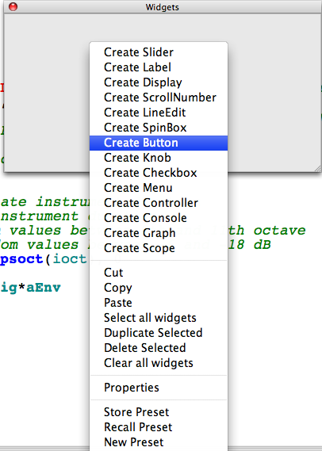
In the Properties Dialog of the button widget, make sure you have selected "event" as Type. Insert a Channel name, and at the bottom type in the event you want to trigger - as you would if writing a line in the score.
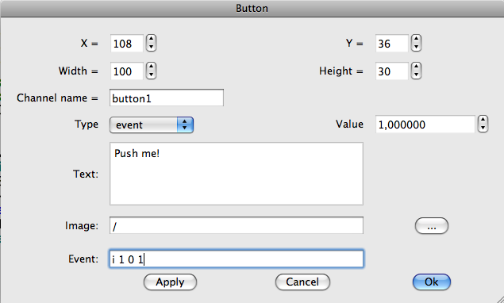
In your Csound code, you need nothing more than the instrument you want to trigger:
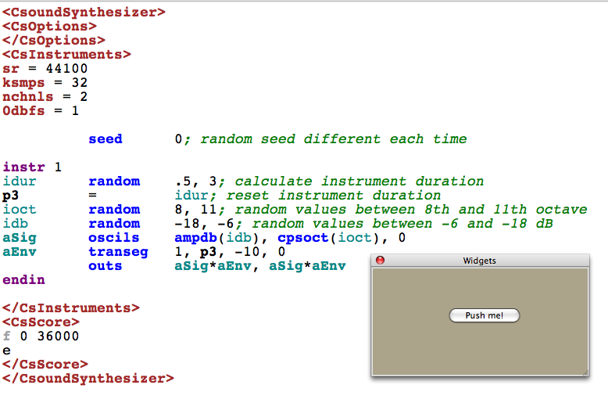
For more information about CsoundQt, read the CsoundQt chapter in the 'Frontends' section of this manual.

Using A Realtime Score (Live Event Sheet)

Command Line With The -L stdin Option
If you use any .csd with the option "-L stdin" (and the -odac option for realtime output), you can type any score line in realtime (sorry, this does not work for Windows). For instance, save this .csd anywhere and run it from the command line:
EXAMPLE 03F06_Commandline_rt_events.csd
<CsoundSynthesizer>
<CsOptions>
-L stdin -odac
</CsOptions>
<CsInstruments>
;Example by Joachim Heintz
sr = 44100
ksmps = 32
nchnls = 2
0dbfs = 1

seed 0; random seed different each time

instr 1
idur random .5, 3; calculate instrument duration
p3 = idur; reset instrument duration
ioct random 8, 11; random values between 8th and 11th octave
idb random -18, -6; random values between -6 and -18 dB
aSig oscils ampdb(idb), cpsoct(ioct), 0
aEnv transeg 1, p3, -10, 0
outs aSig*aEnv, aSig*aEnv
endin

</CsInstruments>
<CsScore>
f 0 36000
e
</CsScore>
</CsoundSynthesizer>
If you run it by typing and returning a commandline like this ...
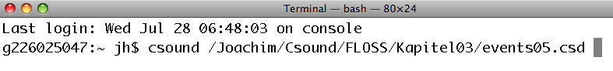
... you should get a prompt at the end of the Csound messages:
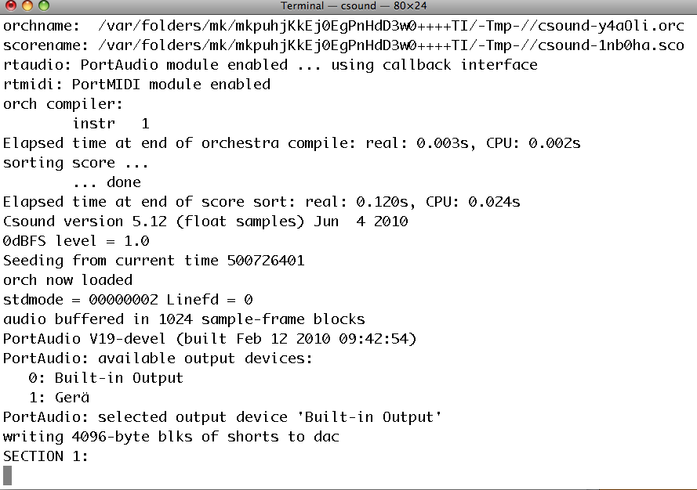
If you now type the line "i 1 0 1" and press return, you should hear that instrument 1 has been executed. After three times your messages may look like this:
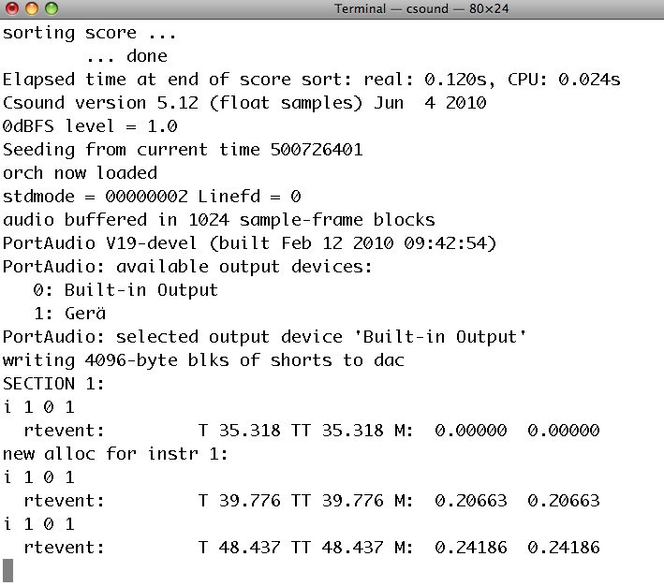

CsoundQt's Live Event Sheet
In general, this is the method that CsoundQt uses and it is made available to the user in a flexible environment called the Live Event Sheet. Have a look in the CsoundQt frontend to see more of the possibilities of "firing" live instrument events using the Live Event Sheet.2
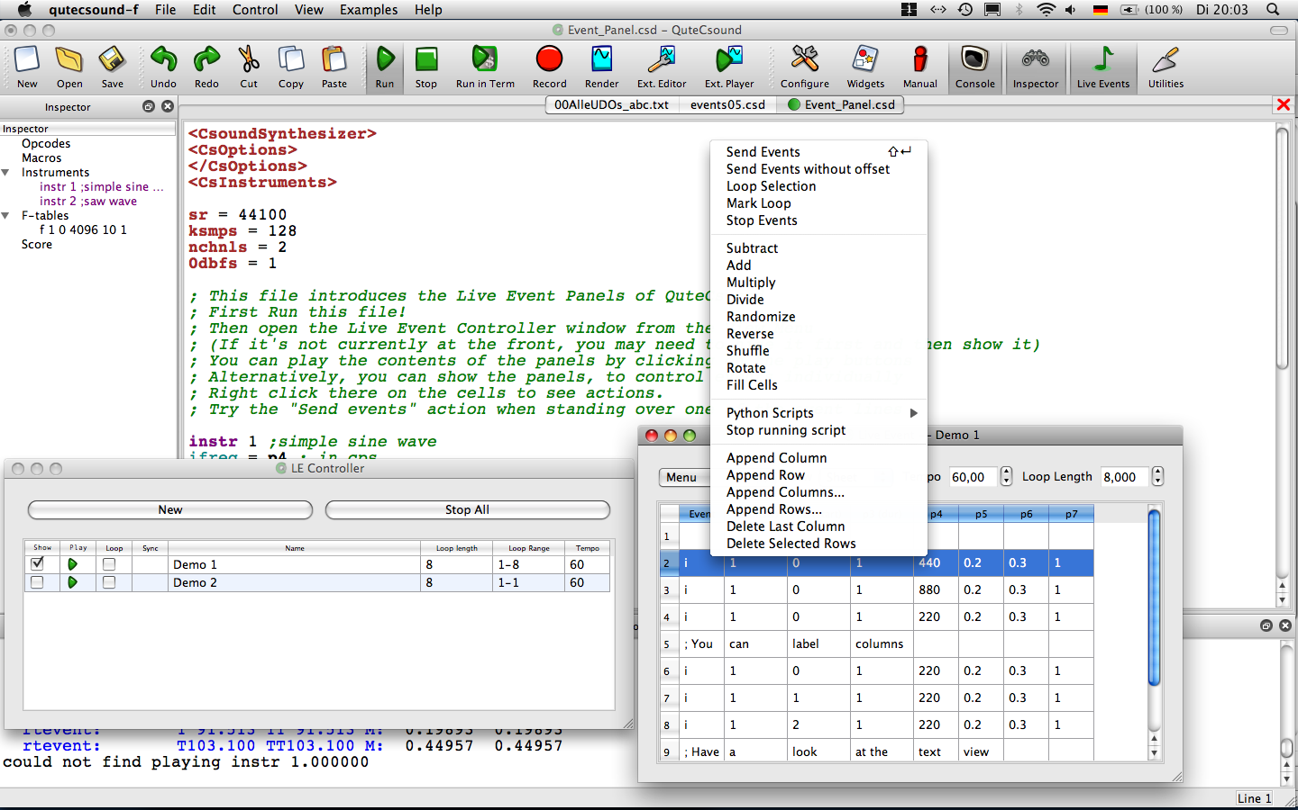

By Conditions
We have discussed first the classical method of triggering instrument events from the score section of a .csd file, then we went on to look at different methods of triggering real time events using MIDI, by using widgets, and by using score lines inserted live. We will now look at the Csound orchestra itself and to some methods by which an instrument can internally trigger another instrument. The pattern of triggering could be governed by conditionals, or by different kinds of loops. As this "master" instrument can itself be triggered by a realtime event, you have unlimited options available for combining the different methods.
Let's start with conditionals. If we have a realtime input, we may want to define a threshold, and trigger an event
- if we cross the threshold from below to above;
- if we cross the threshold from above to below.
In Csound, this could be implemented using an orchestra of three instruments. The first instrument is the master instrument. It receives the input signal and investigates whether that signal is crossing the threshold and if it does whether it is crossing from low to high or from high to low. If it crosses the threshold from low ot high the second instrument is triggered, if it crosses from high to low the third instrument is triggered.
EXAMPLE 03F07_Event_by_condition.csd
<CsoundSynthesizer>
<CsOptions>
-iadc -odac
</CsOptions>
<CsInstruments>
;Example by Joachim Heintz
sr = 44100
ksmps = 32
nchnls = 2
0dbfs = 1

seed 0; random seed different each time

instr 1; master instrument
ichoose = p4; 1 = real time audio, 2 = random amplitude movement
ithresh = -12; threshold in dB
kstat init 1; 1 = under the threshold, 2 = over the threshold
;;CHOOSE INPUT SIGNAL
if ichoose == 1 then
ain inch 1
else
kdB randomi -18, -6, 1
ain pinkish ampdb(kdB)
endif
;;MEASURE AMPLITUDE AND TRIGGER SUBINSTRUMENTS IF THRESHOLD IS CROSSED
afoll follow ain, .1; measure mean amplitude each 1/10 second
kfoll downsamp afoll
if kstat == 1 && dbamp(kfoll) > ithresh then; transition down->up
event "i", 2, 0, 1; call instr 2
printks "Amplitude = %.3f dB%n", 0, dbamp(kfoll)
kstat = 2; change status to "up"
elseif kstat == 2 && dbamp(kfoll) < ithresh then; transition up->down
event "i", 3, 0, 1; call instr 3
printks "Amplitude = %.3f dB%n", 0, dbamp(kfoll)
kstat = 1; change status to "down"
endif
endin

instr 2; triggered if threshold has been crossed from down to up
asig oscils .2, 500, 0
aenv transeg 1, p3, -10, 0
outs asig*aenv, asig*aenv
endin

instr 3; triggered if threshold has been crossed from up to down
asig oscils .2, 400, 0
aenv transeg 1, p3, -10, 0
outs asig*aenv, asig*aenv
endin

</CsInstruments>
<CsScore>
i 1 0 1000 2 ;change p4 to "1" for live input
e
</CsScore>
</CsoundSynthesizer>

Using i-Rate Loops For Calculating A Pool Of Instrument Events
You can perform a number of calculations at init-time which lead to a list of instrument events. In this way you are producing a score, but inside an instrument. The score events are then executed later.
Using this opportunity we can introduce the scoreline / scoreline_i opcode. It is quite similar to the event / event_i opcode but has two major benefits:
- You can write more than one scoreline by using "{{" at the beginning and "}}" at the end.
- You can send a string to the subinstrument (which is not possible with the event opcode).
Let's look at a simple example for executing score events from an instrument using the scoreline opcode:
EXAMPLE 03F08_Generate_event_pool.csd
<CsoundSynthesizer>
<CsOptions>
-odac
</CsOptions>
<CsInstruments>
;Example by Joachim Heintz
sr = 44100
ksmps = 32
nchnls = 2
0dbfs = 1

seed 0; random seed different each time

instr 1 ;master instrument with event pool
scoreline_i {{i 2 0 2 7.09
i 2 2 2 8.04
i 2 4 2 8.03
i 2 6 1 8.04}}
endin

instr 2 ;plays the notes
asig pluck .2, cpspch(p4), cpspch(p4), 0, 1
aenv transeg 1, p3, 0, 0
outs asig*aenv, asig*aenv
endin

</CsInstruments>
<CsScore>
i 1 0 7
e
</CsScore>
</CsoundSynthesizer>
With good right, you might say: "OK, that's nice, but I can also write scorelines in the score itself!" That's right, but the advantage with the scoreline_i method is that you can render the score events in an instrument, and then send them out to one or more instruments to execute them. This can be done with the sprintf opcode, which produces the string for scoreline in an i-time loop (see the chapter about control structures).
EXAMPLE 03F09_Events_sprintf.csd
<CsoundSynthesizer>
<CsOptions>
-odac
</CsOptions>
<CsInstruments>
;Example by Joachim Heintz
sr = 44100
ksmps = 32
nchnls = 2
0dbfs = 1

giPch ftgen 0, 0, 4, -2, 7.09, 8.04, 8.03, 8.04
seed 0; random seed different each time

instr 1 ; master instrument with event pool
itimes = 7 ;number of events to produce
icnt = 0 ;counter
istart = 0
Slines = ""
loop: ;start of the i-time loop
idur random 1, 2.9999 ;duration of each note:
idur = int(idur) ;either 1 or 2
itabndx random 0, 3.9999 ;index for the giPch table:
itabndx = int(itabndx) ;0-3
ipch table itabndx, giPch ;random pitch value from the table
Sline sprintf "i 2 %d %d %.2f\n", istart, idur, ipch ;new scoreline
Slines strcat Slines, Sline ;append to previous scorelines
istart = istart + idur ;recalculate start for next scoreline
loop_lt icnt, 1, itimes, loop ;end of the i-time loop
puts Slines, 1 ;print the scorelines
scoreline_i Slines ;execute them
iend = istart + idur ;calculate the total duration
p3 = iend ;set p3 to the sum of all durations
print p3 ;print it
endin

instr 2 ;plays the notes
asig pluck .2, cpspch(p4), cpspch(p4), 0, 1
aenv transeg 1, p3, 0, 0
outs asig*aenv, asig*aenv
endin

</CsInstruments>
<CsScore>
i 1 0 1 ;p3 is automatically set to the total duration
e
</CsScore>
</CsoundSynthesizer>
In this example, seven events have been rendered in an i-time loop in instrument 1. The result is stored in the string variable Slines. This string is given at i-time to scoreline_i, which executes them then one by one according to their starting times (p2), durations (p3) and other parameters.
If you have many scorelines which are added in this way, you may run to Csound's maximal string length. By default, it is 255 characters. It can be extended by adding the option "-+max_str_len=10000" to Csound's maximum string length of 9999 characters. Instead of collecting all score lines in a single string, you can also execute them inside the i-time loop. Also in this way all the single score lines are added to Csound's event pool. The next example shows an alternative version of the previous one by adding the instrument events one by one in the i-time loop, either with event_i (instr 1) or with scoreline_i (instr 2):
EXAMPLE 03F10_Events_collected.csd
<CsoundSynthesizer>
<CsOptions>
-odac
</CsOptions>
<CsInstruments>
;Example by Joachim Heintz
sr = 44100
ksmps = 32
nchnls = 2
0dbfs = 1

giPch ftgen 0, 0, 4, -2, 7.09, 8.04, 8.03, 8.04
seed 0; random seed different each time

instr 1; master instrument with event_i
itimes = 7; number of events to produce
icnt = 0; counter
istart = 0
loop: ;start of the i-time loop
idur random 1, 2.9999; duration of each note:
idur = int(idur); either 1 or 2
itabndx random 0, 3.9999; index for the giPch table:
itabndx = int(itabndx); 0-3
ipch table itabndx, giPch; random pitch value from the table
event_i "i", 3, istart, idur, ipch; new instrument event
istart = istart + idur; recalculate start for next scoreline
loop_lt icnt, 1, itimes, loop; end of the i-time loop
iend = istart + idur; calculate the total duration
p3 = iend; set p3 to the sum of all durations
print p3; print it
endin

instr 2; master instrument with scoreline_i
itimes = 7; number of events to produce
icnt = 0; counter
istart = 0
loop: ;start of the i-time loop
idur random 1, 2.9999; duration of each note:
idur = int(idur); either 1 or 2
itabndx random 0, 3.9999; index for the giPch table:
itabndx = int(itabndx); 0-3
ipch table itabndx, giPch; random pitch value from the table
Sline sprintf "i 3 %d %d %.2f", istart, idur, ipch; new scoreline
scoreline_i Sline; execute it
puts Sline, 1; print it
istart = istart + idur; recalculate start for next scoreline
loop_lt icnt, 1, itimes, loop; end of the i-time loop
iend = istart + idur; calculate the total duration
p3 = iend; set p3 to the sum of all durations
print p3; print it
endin

instr 3; plays the notes
asig pluck .2, cpspch(p4), cpspch(p4), 0, 1
aenv transeg 1, p3, 0, 0
outs asig*aenv, asig*aenv
endin

</CsInstruments>
<CsScore>
i 1 0 1
i 2 14 1
e
</CsScore>
</CsoundSynthesizer>

Using Time Loops
As discussed above in the chapter about control structures, a time loop can be built in Csound either with the timout opcode or with the metro opcode. There were also simple examples for triggering instrument events using both methods. Here, a more complex example is given: A master instrument performs a time loop (choose either instr 1 for the timout method or instr 2 for the metro method) and triggers once in a loop a subinstrument. The subinstrument itself (instr 10) performs an i-time loop and triggers several instances of a sub-subinstrument (instr 100). Each instance performs a partial with an independent envelope for a bell-like additive synthesis.
EXAMPLE 03F11_Events_time_loop.csd
<CsoundSynthesizer>
<CsOptions>
-odac
</CsOptions>
<CsInstruments>
;Example by Joachim Heintz
sr = 44100
ksmps = 32
nchnls = 2
0dbfs = 1

giSine ftgen 0, 0, 2^10, 10, 1
seed 0

instr 1; time loop with timout. events are triggered by event_i (i-rate)
loop:
idurloop random 1, 4; duration of each loop
timout 0, idurloop, play
reinit loop
play:
idurins random 1, 5; duration of the triggered instrument
event_i "i", 10, 0, idurins; triggers instrument 10
endin

instr 2; time loop with metro. events are triggered by event (k-rate)
kfreq init 1; give a start value for the trigger frequency
kTrig metro kfreq
if kTrig == 1 then ;if trigger impulse:
kdur random 1, 5; random duration for instr 10
event "i", 10, 0, kdur; call instr 10
kfreq random .25, 1; set new value for trigger frequency
endif
endin

instr 10; triggers 8-13 partials
inumparts random 8, 14
inumparts = int(inumparts); 8-13 as integer
ibasoct random 5, 10; base pitch in octave values
ibasfreq = cpsoct(ibasoct)
ipan random .2, .8; random panning between left (0) and right (1)
icnt = 0; counter
loop:
event_i "i", 100, 0, p3, ibasfreq, icnt+1, inumparts, ipan
loop_lt icnt, 1, inumparts, loop
endin

instr 100; plays one partial
ibasfreq = p4; base frequency of sound mixture
ipartnum = p5; which partial is this (1 - N)
inumparts = p6; total number of partials
ipan = p7; panning
ifreqgen = ibasfreq * ipartnum; general frequency of this partial
ifreqdev random -10, 10; frequency deviation between -10% and +10%
; -- real frequency regarding deviation
ifreq = ifreqgen + (ifreqdev*ifreqgen)/100
ixtratim random 0, p3; calculate additional time for this partial
p3 = p3 + ixtratim; new duration of this partial
imaxamp = 1/inumparts; maximum amplitude
idbdev random -6, 0; random deviation in dB for this partial
iamp = imaxamp * ampdb(idbdev-ipartnum); higher partials are softer
ipandev random -.1, .1; panning deviation
ipan = ipan + ipandev
aEnv transeg 0, .005, 0, iamp, p3-.005, -10, 0
aSine poscil aEnv, ifreq, giSine
aL, aR pan2 aSine, ipan
outs aL, aR
prints "ibasfreq = %d, ipartial = %d, ifreq = %d%n",\
ibasfreq, ipartnum, ifreq
endin

</CsInstruments>
<CsScore>
i 1 0 300 ;try this, or the next line (or both)
;i 2 0 300
</CsScore>
</CsoundSynthesizer>

Recompilation
As it has been mentioned at the start of this chapter, since Csound6 you can re-compile any code in an already running Csound instance. Let us first see some simple examples for the general use, and then a more practical approach in CsoundQt.

compileorc / compilestr
The opcode compileorc refers to a definition of instruments which has been saved as an .orc ("orchestra") file. To see how it works, save this text in a simple text (ASCII) format as "to_recompile.orc":
instr 1
iAmp = .2
iFreq = 465
aSig oscils iAmp, iFreq, 0
outs aSig, aSig
endin
Then save this csd in the same directory:
EXAMPLE 03F12_compileorc.csd
<CsoundSynthesizer>
<CsOptions>
-o dac -d -L stdin -Ma
</CsOptions>
<CsInstruments>
sr = 44100
nchnls = 2
ksmps = 32
0dbfs = 1

massign 0, 9999

instr 9999
ires compileorc "to_recompile.orc"
print ires ; 0 if compiled successfully
event_i "i", 1, 0, 3 ;send event
endin

</CsInstruments>
<CsScore>
i 9999 0 1
</CsScore>
</CsoundSynthesizer>
If you run this csd in the terminal, you should hear a three seconds beep, and the output should be like this:
SECTION 1:
new alloc for instr 9999:
instr 9999: ires = 0.000
new alloc for instr 1:
B 0.000 .. 1.000 T 1.000 TT 1.000 M: 0.20000 0.20000
B 1.000 .. 3.000 T 3.000 TT 3.000 M: 0.20000 0.20000
Score finished in csoundPerform().
inactive allocs returned to freespace
end of score. overall amps: 0.20000 0.20000
overall samples out of range: 0 0
0 errors in performance
Having understood this, it is easy to do the next step. Remove (or comment out) the score line "i 9999 0 1" so that the score is empty. If you start the csd now, Csound will run indefinitely. Now call instr 9999 by typing "i 9999 0 1" in the terminal window (if the option -L stdin works for your setup), or by pressing any MIDI key (if you have connected a keyboard). You should hear the same beep as before. But as the recompile.csd keeps running, you can change now the to_recompile.orc instrument. Try, for instance, another value for kFreq. Whenever this is done (do not forget to save the file) and you call again instr 9999 in recompile.csd, the new version of this instrument is compiled and then called immediately.
The other possibility to recompile code by using an opcode is compilestr. It will compile any instrument definition which is contained in a string. As this will be a string with several lines, you will usually use the '{{' delimiter for the start and '}}' for the end of the string. This is a basic example:
EXAMPLE 03F13_compilestr.csd
<CsoundSynthesizer>
<CsOptions>
-o dac -d
</CsOptions>
<CsInstruments>
sr = 44100
nchnls = 1
ksmps = 32
0dbfs = 1

instr 1

;will fail because of wrong code
ires compilestr {{
instr 2
a1 oscilb p4, p5, 0
out a1
endin
}}
print ires ; returns -1 because not successfull

;will compile ...
ires compilestr {{
instr 2
a1 oscils p4, p5, 0
out a1
endin
}}
print ires ; ... and returns 0

;call the new instrument
;(note that the overall performance is extended)
scoreline_i "i 2 0 3 .2 415"

endin

</CsInstruments>
<CsScore>
i1 0 1
</CsScore>
</CsoundSynthesizer>
As you see, instrument 2 is defined inside instrument 1, and compiled via compilestr. in case you can change this string in real-time (for instance in receiving it via OSC), you can add any new definition of instruments on the fly. But much more elegant is to use the related method of the Csound API, as CsoundQt does.

Re-Compilation in CsoundQt
(The following description is only valid if you have CsoundQt with PythonQt support. If so, your CsoundQt application should be called CsoundQt-d-py-cs6 or similar. If the "-py" is missing, you will probably not have PythonQt support.)
To see how easy it is to re-compile code of a running Csound instance, load this csd in CsoundQt:
EXAMPLE 03F14_Recompile_in_CsoundQt.csd
<CsoundSynthesizer>
<CsInstruments>
sr = 44100
nchnls = 1
ksmps = 32
0dbfs = 1

instr 1
a1 oscils .2, 500, 0
out a1
endin

</CsInstruments>
<CsScore>
r 1000
i 1 0 1
</CsScore>
</CsoundSynthesizer>
The r-statement repeats the call to instr 1 for 1000 times. Now change the frequency of 500 in instr 1 to say 800. You will hear no change, because this has not been compiled yet. But when you now select the instrument definition (including the instr ... endin) and then choose Edit -> Evaluate selection, you will hear that in the next call of instrument 1 the frequency has changed. (Instead of selecting code and evaluation the selection, you can also place the cursor inside an instrument and then choose Edit -> Evaluate section.)
You can also insert new instrument definitions, and then call it with CsoundQt's Live event sheet. You even need not save it - instead you can save several results of your live coding without stopping Csound. Have fun ...

Links And Related Opcodes

Links
A great collection of interactive examples with FLTK widgets by Iain McCurdy can be found here. See particularily the "Realtime Score Generation" section. Recently, the collection has been ported to QuteCsound by René Jopi, and is part of QuteCsound's example menu.
An extended example for calculating score events at i-time can be found in the Re-Generation of Stockhausen's "Studie II" by Joachim Heintz (also included in the QuteCsound Examples menu).

Related Opcodes
event_i / event: Generate an instrument event at i-time (event_i) or at k-time (event). Easy to use, but you cannot send a string to the subinstrument.
scoreline_i / scoreline: Generate an instrument at i-time (scoreline_i) or at k-time (scoreline). Like event_i/event, but you can send to more than one instrument but unlike event_i/event you can send strings. On the other hand, you must usually preformat your scoreline-string using sprintf.
sprintf / sprintfk: Generate a formatted string at i-time (sprintf) or k-time (sprintfk), and store it as a string-variable.
-+max_str_len=10000: Option in the "CsOptions" tag of a .csd file which extend the maximum string length to 9999 characters.
massign: Assigns the incoming MIDI events to a particular instrument. It is also possible to prevent any assigment by this opcode.
cpsmidi / ampmidi: Returns the frequency / velocity of a pressed MIDI key.
release: Returns "1" if the last k-cycle of an instrument has begun.
xtratim: Adds an additional time to the duration (p3) of an instrument.
turnoff / turnoff2: Turns an instrument off; either by the instrument itself (turnoff), or from another instrument and with several options (turnoff2).
-p3 / -p1: A negative duration (p3) turns an instrument on "indefinitely"; a negative instrument number (p1) turns this instrument off. See the examples at the beginning of this chapter.
-L stdin: Option in the "CsOptions" tag of a .csd file which lets you type in realtime score events.
timout: Allows you to perform time loops at i-time with reinitalization passes.
metro: Outputs momentary 1s with a definable (and variable) frequency. Can be used to perform a time loop at k-rate.
follow: Envelope follower.
- This has been described incorrectly in the first two issues of this manual.^
- There are also some video tutorials: http://www.youtube.com/watch?v=O9WU7DzdUmE http://www.youtube.com/watch?v=Hs3eO7o349k http://www.youtube.com/watch?v=yUMzp6556Kw^

19. USER DEFINED OPCODES
Opcodes are the core units of everything that Csound does. They are like little machines that do a job, and programming is akin to connecting these little machines to perform a larger job. An opcode usually has something which goes into it: the inputs or arguments, and usually it has something which comes out of it: the output which is stored in one or more variables. Opcodes are written in the programming language C (that is where the name "Csound" comes from). If you want to create a new opcode in Csound, you must write it in C. How to do this is described in the Extending Csound chapter of this manual, and is also described in the relevant chapter of the Canonical Csound Reference Manual.
There is, however, a way of writing your own opcodes in the Csound Language itself. The opcodes which are written in this way, are called User Defined Opcodes or "UDO"s. A UDO behaves in the same way as a standard opcode: it has input arguments, and usually one or more output variables. They run at i-time or at k-time. You use them as part of the Csound Language after you have defined and loaded them.
User Defined Opcodes have many valuable properties. They make your instrument code clearer because they allow you to create abstractions of blocks of code. Once a UDO has been defined it can be recalled and repeated many times within an orchestra, each repetition requiring only a single line of code. UDOs allow you to build up your own library of functions you need and return to frequently in your work. In this way, you build your own Csound dialect within the Csound Language. UDOs also represent a convenient format with which to share your work in Csound with other users.
This chapter explains, initially with a very basic example, how you can build your own UDOs, and what options they offer. Following this, the practice of loading UDOs in your .csd file is shown, followed by some tips in regard to some unique capabilities of UDOs. Before the "Links And Related Opcodes" section at the end, some examples are shown for different User Defined Opcode definitions and applications.
If you want to write a User Defined Opcode in Csound6 which uses arrays, have a look at the end of chapter 03E to see their usage and naming conventions.

Transforming Csound Instrument Code To A User Defined Opcode
Writing a User Defined Opcode is actually very easy and straightforward. It mainly means to extract a portion of usual Csound instrument code, and put it in the frame of a UDO. Let's start with the instrument code:
EXAMPLE 03G01_Pre_UDO.csd
<CsoundSynthesizer>
<CsOptions>
-odac
</CsOptions>
<CsInstruments>
;Example by Joachim Heintz
sr = 44100
ksmps = 32
nchnls = 2
0dbfs = 1

giSine ftgen 0, 0, 2^10, 10, 1
seed 0

instr 1
aDel init 0; initialize delay signal
iFb = .7; feedback multiplier
aSnd rand .2; white noise
kdB randomi -18, -6, .4; random movement between -18 and -6
aSnd = aSnd * ampdb(kdB); applied as dB to noise
kFiltFq randomi 100, 1000, 1; random movement between 100 and 1000
aFilt reson aSnd, kFiltFq, kFiltFq/5; applied as filter center frequency
aFilt balance aFilt, aSnd; bring aFilt to the volume of aSnd
aDelTm randomi .1, .8, .2; random movement between .1 and .8 as delay time
aDel vdelayx aFilt + iFb*aDel, aDelTm, 1, 128; variable delay
kdbFilt randomi -12, 0, 1; two random movements between -12 and 0 (dB) ...
kdbDel randomi -12, 0, 1; ... for the filtered and the delayed signal
aOut = aFilt*ampdb(kdbFilt) + aDel*ampdb(kdbDel); mix it
outs aOut, aOut
endin

</CsInstruments>
<CsScore>
i 1 0 60
</CsScore>
</CsoundSynthesizer>
This is a filtered noise, and its delay, which is fed back again into the delay line at a certain ratio iFb. The filter is moving as kFiltFq randomly between 100 and 1000 Hz. The volume of the filtered noise is moving as kdB randomly between -18 dB and -6 dB. The delay time moves between 0.1 and 0.8 seconds, and then both signals are mixed together.

Basic Example
If this signal processing unit is to be transformed into a User Defined Opcode, the first question is about the extend of the code that will be encapsulated: where the UDO code will begin and end? The first solution could be a radical, and possibly bad, approach: to transform the whole instrument into a UDO.
EXAMPLE 03G02_All_to_UDO.csd
<CsoundSynthesizer>
<CsOptions>
</CsOptions>
<CsInstruments>
;Example by Joachim Heintz
sr = 44100
ksmps = 32
nchnls = 2
0dbfs = 1

giSine ftgen 0, 0, 2^10, 10, 1
seed 0

opcode FiltFb, 0, 0
aDel init 0; initialize delay signal
iFb = .7; feedback multiplier
aSnd rand .2; white noise
kdB randomi -18, -6, .4; random movement between -18 and -6
aSnd = aSnd * ampdb(kdB); applied as dB to noise
kFiltFq randomi 100, 1000, 1; random movement between 100 and 1000
aFilt reson aSnd, kFiltFq, kFiltFq/5; applied as filter center frequency
aFilt balance aFilt, aSnd; bring aFilt to the volume of aSnd
aDelTm randomi .1, .8, .2; random movement between .1 and .8 as delay time
aDel vdelayx aFilt + iFb*aDel, aDelTm, 1, 128; variable delay
kdbFilt randomi -12, 0, 1; two random movements between -12 and 0 (dB) ...
kdbDel randomi -12, 0, 1; ... for the filtered and the delayed signal
aOut = aFilt*ampdb(kdbFilt) + aDel*ampdb(kdbDel); mix it
outs aOut, aOut
endop

instr 1
FiltFb
endin

</CsInstruments>
<CsScore>
i 1 0 60
</CsScore>
</CsoundSynthesizer>
Before we continue the discussion about the quality of this transormation, we should have a look at the syntax first. The general syntax for a User Defined Opcode is:
opcode name, outtypes, intypes
...
endop
Here, the name of the UDO is FiltFb. You are free to use any name, but it is suggested that you begin the name with a capital letter. By doing this, you avoid duplicating the name of most of the pre-existing opcodes1 which normally start with a lower case letter. As we have no input arguments and no output arguments for this first version of FiltFb, both outtypes and intypes are set to zero. Similar to the instr ... endin block of a normal instrument definition, for a UDO the opcode ... endop keywords begin and end the UDO definition block. In the instrument, the UDO is called like a normal opcode by using its name, and in the same line the input arguments are listed on the right and the output arguments on the left. In the previous a example, 'FiltFb' has no input and output arguments so it is called by just using its name:
instr 1
FiltFb
endin
Now - why is this UDO more or less useless? It achieves nothing, when compared to the original non UDO version, and in fact looses some of the advantages of the instrument defined version. Firstly, it is not advisable to include this line in the UDO:
outs aOut, aOut
This statement writes the audio signal aOut from inside the UDO to the output device. Imagine you want to change the output channels, or you want to add any signal modifier after the opcode. This would be impossible with this statement. So instead of including the 'outs' opcode, we give the FiltFb UDO an audio output:
xout aOut
The xout statement of a UDO definition works like the "outlets" in PD or Max, sending the result(s) of an opcode back to the caller instrument.
Now let us consider the UDO's input arguments, choose which processes should be carried out within the FiltFb unit, and what aspects would offer greater flexibility if controllable from outside the UDO. First, the aSnd parameter should not be restricted to a white noise with amplitude 0.2, but should be an input (like a "signal inlet" in PD/Max). This is implemented using the line:
aSnd xin
Both the output and the input type must be declared in the first line of the UDO definition, whether they are i-, k- or a-variables. So instead of "opcode FiltFb, 0, 0" the statement has changed now to "opcode FiltFb, a, a", because we have both input and output as a-variable.
The UDO is now much more flexible and logical: it takes any audio input, it performs the filtered delay and feedback processing, and returns the result as another audio signal. In the next example, instrument 1 does exactly the same as before. Instrument 2 has live input instead.
EXAMPLE 03G03_UDO_more_flex.csd
<CsoundSynthesizer>
<CsOptions>
</CsOptions>
<CsInstruments>
;Example by Joachim Heintz
sr = 44100
ksmps = 32
nchnls = 2
0dbfs = 1

giSine ftgen 0, 0, 2^10, 10, 1
seed 0

opcode FiltFb, a, a
aSnd xin
aDel init 0; initialize delay signal
iFb = .7; feedback multiplier
kdB randomi -18, -6, .4; random movement between -18 and -6
aSnd = aSnd * ampdb(kdB); applied as dB to noise
kFiltFq randomi 100, 1000, 1; random movement between 100 and 1000
aFilt reson aSnd, kFiltFq, kFiltFq/5; applied as filter center frequency
aFilt balance aFilt, aSnd; bring aFilt to the volume of aSnd
aDelTm randomi .1, .8, .2; random movement between .1 and .8 as delay time
aDel vdelayx aFilt + iFb*aDel, aDelTm, 1, 128; variable delay
kdbFilt randomi -12, 0, 1; two random movements between -12 and 0 (dB) ...
kdbDel randomi -12, 0, 1; ... for the filtered and the delayed signal
aOut = aFilt*ampdb(kdbFilt) + aDel*ampdb(kdbDel); mix it
xout aOut
endop

instr 1; white noise input
aSnd rand .2
aOut FiltFb aSnd
outs aOut, aOut
endin

instr 2; live audio input
aSnd inch 1; input from channel 1
aOut FiltFb aSnd
outs aOut, aOut
endin

</CsInstruments>
<CsScore>
i 1 0 60 ;change to i 2 for live audio input
</CsScore>
</CsoundSynthesizer>

Is There an Optimal Design for a User Defined Opcode?
Is this now the optimal version of the FiltFb User Defined Opcode? Obviously there are other parts of the opcode definiton which could be controllable from outside: the feedback multiplier iFb, the random movement of the input signal kdB, the random movement of the filter frequency kFiltFq, and the random movements of the output mix kdbSnd and kdbDel. Is it better to put them outside of the opcode definition, or is it better to leave them inside?
There is no general answer. It depends on the degree of abstraction you desire or you prefer to relinquish. If you are working on a piece for which all of the parameters settings are already defined as required in the UDO, then control from the caller instrument may not be necessary . The advantage of minimizing the number of input and output arguments is the simplification in using the UDO. The more flexibility you require from your UDO however, the greater the number of input arguments that will be required. Providing more control is better for a later reusability, but may be unnecessarily complicated.
Perhaps it is the best solution to have one abstract definition which performs one task, and to create a derivative - also as UDO - fine tuned for the particular project you are working on. The final example demonstrates the definition of a general and more abstract UDO FiltFb, and its various applications: instrument 1 defines the specifications in the instrument itself; instrument 2 uses a second UDO Opus123_FiltFb for this purpose; instrument 3 sets the general FiltFb in a new context of two varying delay lines with a buzz sound as input signal.
EXAMPLE 03G04_UDO_calls_UDO.csd
<CsoundSynthesizer>
<CsOptions>
-odac
</CsOptions>
<CsInstruments>
;Example by Joachim Heintz
sr = 44100
ksmps = 32
nchnls = 2
0dbfs = 1

giSine ftgen 0, 0, 2^10, 10, 1
seed 0

opcode FiltFb, aa, akkkia
; -- DELAY AND FEEDBACK OF A BAND FILTERED INPUT SIGNAL --
;input: aSnd = input sound
; kFb = feedback multiplier (0-1)
; kFiltFq: center frequency for the reson band filter (Hz)
; kQ = band width of reson filter as kFiltFq/kQ
; iMaxDel = maximum delay time in seconds
; aDelTm = delay time
;output: aFilt = filtered and balanced aSnd
; aDel = delay and feedback of aFilt

aSnd, kFb, kFiltFq, kQ, iMaxDel, aDelTm xin
aDel init 0
aFilt reson aSnd, kFiltFq, kFiltFq/kQ
aFilt balance aFilt, aSnd
aDel vdelayx aFilt + kFb*aDel, aDelTm, iMaxDel, 128; variable delay
xout aFilt, aDel
endop

opcode Opus123_FiltFb, a, a
;;the udo FiltFb here in my opus 123 :)
;input = aSnd
;output = filtered and delayed aSnd in different mixtures
aSnd xin
kdB randomi -18, -6, .4; random movement between -18 and -6
aSnd = aSnd * ampdb(kdB); applied as dB to noise
kFiltFq randomi 100, 1000, 1; random movement between 100 and 1000
iQ = 5
iFb = .7; feedback multiplier
aDelTm randomi .1, .8, .2; random movement between .1 and .8 as delay time
aFilt, aDel FiltFb aSnd, iFb, kFiltFq, iQ, 1, aDelTm
kdbFilt randomi -12, 0, 1; two random movements between -12 and 0 (dB) ...
kdbDel randomi -12, 0, 1; ... for the noise and the delay signal
aOut = aFilt*ampdb(kdbFilt) + aDel*ampdb(kdbDel); mix it
xout aOut
endop

instr 1; well known context as instrument
aSnd rand .2
kdB randomi -18, -6, .4; random movement between -18 and -6
aSnd = aSnd * ampdb(kdB); applied as dB to noise
kFiltFq randomi 100, 1000, 1; random movement between 100 and 1000
iQ = 5
iFb = .7; feedback multiplier
aDelTm randomi .1, .8, .2; random movement between .1 and .8 as delay time
aFilt, aDel FiltFb aSnd, iFb, kFiltFq, iQ, 1, aDelTm
kdbFilt randomi -12, 0, 1; two random movements between -12 and 0 (dB) ...
kdbDel randomi -12, 0, 1; ... for the noise and the delay signal
aOut = aFilt*ampdb(kdbFilt) + aDel*ampdb(kdbDel); mix it
aOut linen aOut, .1, p3, 3
outs aOut, aOut
endin

instr 2; well known context UDO which embeds another UDO
aSnd rand .2
aOut Opus123_FiltFb aSnd
aOut linen aOut, .1, p3, 3
outs aOut, aOut
endin

instr 3; other context: two delay lines with buzz
kFreq randomh 200, 400, .08; frequency for buzzer
aSnd buzz .2, kFreq, 100, giSine; buzzer as aSnd
kFiltFq randomi 100, 1000, .2; center frequency
aDelTm1 randomi .1, .8, .2; time for first delay line
aDelTm2 randomi .1, .8, .2; time for second delay line
kFb1 randomi .8, 1, .1; feedback for first delay line
kFb2 randomi .8, 1, .1; feedback for second delay line
a0, aDel1 FiltFb aSnd, kFb1, kFiltFq, 1, 1, aDelTm1; delay signal 1
a0, aDel2 FiltFb aSnd, kFb2, kFiltFq, 1, 1, aDelTm2; delay signal 2
aDel1 linen aDel1, .1, p3, 3
aDel2 linen aDel2, .1, p3, 3
outs aDel1, aDel2
endin

</CsInstruments>
<CsScore>
i 1 0 30
i 2 31 30
i 3 62 120
</CsScore>
</CsoundSynthesizer>
The good thing about the different possibilities of writing a more specified UDO, or a more generalized: You needn't decide this at the beginning of your work. Just start with any formulation you find useful in a certain situation. If you continue and see that you should have some more parameters accessible, it should be easy to rewrite the UDO. Just be careful not to confuse the different versions you create. Use names like Faulty1, Faulty2 etc. instead of overwriting Faulty. Making use of extensive commenting when you initially create the UDO will make it easier to adapt the UDO at a later time. What are the inputs (including the measurement units they use such as Hertz or seconds)? What are the outputs? - How you do this, is up to you and depends on your style and your preference.

How to Use the User Defined Opcode Facility in Practice
In this section, we will address the main points of using UDOs: what you must bear in mind when loading them, what special features they offer, what restrictions you must be aware of and how you can build your own language with them.

Loading User Defined Opcodes in the Orchestra Header
As can be seen from the examples above, User Defined Opcodes must be defined in the orchestra header (which is sometimes called "instrument 0").
You can load as many User Defined Opcodes into a Csound orchestra as you wish. As long as they do not depend on each other, their order is arbitrarily. If UDO Opus123_FiltFb uses the UDO FiltFb for its definition (see the example above), you must first load FiltFb, and then Opus123_FiltFb. If not, you will get an error like this:
orch compiler:
opcode Opus123_FiltFb a a
error: no legal opcode, line 25:
aFilt, aDel FiltFb aSnd, iFb, kFiltFq, iQ, 1, aDelTm

Loading By An #include File
Definitions of User Defined Opcodes can also be loaded into a .csd file by an "#include" statement. What you must do is the following:
- Save your opcode definitions in a plain text file, for instance "MyOpcodes.txt".
- If this file is in the same directory as your .csd file, you can just call it by the statement:
#include "MyOpcodes.txt"
- If "MyOpcodes.txt" is in a different directory, you must call it by the full path name, for instance:
#include "/Users/me/Documents/Csound/UDO/MyOpcodes.txt"
As always, make sure that the "#include" statement is the last one in the orchestra header, and that the logical order is accepted if one opcode depends on another.
If you work with User Defined Opcodes a lot, and build up a collection of them, the #include feature allows you easily import several or all of them to your .csd file.

The setksmps Feature
The ksmps assignment in the orchestra header cannot be changed during the performance of a .csd file. But in a User Defined Opcode you have the unique possibility of changing this value by a local assignment. If you use a setksmps statement in your UDO, you can have a locally smaller value for the number of samples per control cycle in the UDO. In the following example, the print statement in the UDO prints ten times compared to one time in the instrument, because ksmps in the UDO is 10 times smaller:
EXAMPLE 03G06_UDO_setksmps.csd
<CsoundSynthesizer>
<CsInstruments>
;Example by Joachim Heintz
sr = 44100
ksmps = 44100 ;very high because of printing

opcode Faster, 0, 0
setksmps 4410 ;local ksmps is 1/10 of global ksmps
printks "UDO print!%n", 0
endop

instr 1
printks "Instr print!%n", 0 ;print each control period (once per second)
Faster ;print 10 times per second because of local ksmps
endin

</CsInstruments>
<CsScore>
i 1 0 2
</CsScore>
</CsoundSynthesizer>

Default Arguments
For i-time arguments, you can use a simple feature to set default values:
- "o" (instead of "i") defaults to 0
- "p" (instead of "i") defaults to 1
- "j" (instead of "i") defaults to -1
For k-time arguments, you can use since Csound 5.18 these default values:
- "O" (instead of "k") defaults to 0
- "P" (instead of "k") defaults to 1
- "V" (instead of "k") defaults to 0.5
So you can omit these arguments - in this case the default values will be used. If you give an input argument instead, the default value will be overwritten:
EXAMPLE 03G07_UDO_default_args.csd
<CsoundSynthesizer>
<CsInstruments>
;Example by Joachim Heintz

opcode Defaults, iii, opj
ia, ib, ic xin
xout ia, ib, ic
endop

instr 1
ia, ib, ic Defaults
print ia, ib, ic
ia, ib, ic Defaults 10
print ia, ib, ic
ia, ib, ic Defaults 10, 100
print ia, ib, ic
ia, ib, ic Defaults 10, 100, 1000
print ia, ib, ic
endin

</CsInstruments>
<CsScore>
i 1 0 0
</CsScore>
</CsoundSynthesizer>

Recursive User Defined Opcodes
Recursion means that a function can call itself. This is a feature which can be useful in many situations. Also User Defined Opcodes can be recursive. You can do many things with a recursive UDO which you cannot do in any other way; at least not in a simliarly simple way. This is an example of generating eight partials by a recursive UDO. See the last example in the next section for a more musical application of a recursive UDO.
EXAMPLE 03G08_Recursive_UDO.csd
<CsoundSynthesizer>
<CsOptions>
</CsOptions>
<CsInstruments>
;Example by Joachim Heintz
sr = 44100
ksmps = 32
nchnls = 2
0dbfs = 1

opcode Recursion, a, iip
;input: frequency, number of partials, first partial (default=1)
ifreq, inparts, istart xin
iamp = 1/inparts/istart ;decreasing amplitudes for higher partials
if istart < inparts then ;if inparts have not yet reached
acall Recursion ifreq, inparts, istart+1 ;call another instance of this UDO
endif
aout oscils iamp, ifreq*istart, 0 ;execute this partial
aout = aout + acall ;add the audio signals
xout aout
endop

instr 1
amix Recursion 400, 8 ;8 partials with a base frequency of 400 Hz
aout linen amix, .01, p3, .1
outs aout, aout
endin

</CsInstruments>
<CsScore>
i 1 0 1
</CsScore>
</CsoundSynthesizer>

Examples
We will focus here on some examples which will hopefully show the wide range of User Defined Opcodes. Some of them are adaptions of examples from previous chapters about the Csound Syntax. Much more examples can be found in the User-Defined Opcode Database, editied by Steven Yi.

Play A Mono Or Stereo Soundfile
Csound is often very strict and gives errors where other applications might 'turn a blind eye'. This is also the case if you read a soundfile using one of Csound's opcodes: soundin, diskin or diskin2. If your soundfile is mono, you must use the mono version, which has one audio signal as output. If your soundfile is stereo, you must use the stereo version, which outputs two audio signals. If you want a stereo output, but you happen to have a mono soundfile as input, you will get the error message:
INIT ERROR in ...: number of output args inconsistent with number
of file channels
It may be more useful to have an opcode which works for both, mono and stereo files as input. This is a ideal job for a UDO. Two versions are possible: FilePlay1 returns always one audio signal (if the file is stereo it uses just the first channel), FilePlay2 returns always two audio signals (if the file is mono it duplicates this to both channels). We can use the default arguments to make this opcode behave exactly as diskin2:
EXAMPLE 03G09_UDO_FilePlay.csd
<CsoundSynthesizer>
<CsOptions>
-odac
</CsOptions>
<CsInstruments>
;Example by Joachim Heintz
sr = 44100
ksmps = 32
nchnls = 2
0dbfs = 1

opcode FilePlay1, a, Skoooooo
;gives mono output regardless your soundfile is mono or stereo
;(if stereo, just the first channel is used)
;see diskin2 page of the csound manual for information about the input arguments
Sfil, kspeed, iskip, iloop, iformat, iwsize, ibufsize, iskipinit xin
ichn filenchnls Sfil
if ichn == 1 then
aout diskin2 Sfil, kspeed, iskip, iloop, iformat, iwsize,\
ibufsize, iskipinit
else
aout, a0 diskin2 Sfil, kspeed, iskip, iloop, iformat, iwsize,\
ibufsize, iskipinit
endif
xout aout
endop

opcode FilePlay2, aa, Skoooooo
;gives stereo output regardless your soundfile is mono or stereo
;see diskin2 page of the csound manual for information about the input arguments
Sfil, kspeed, iskip, iloop, iformat, iwsize, ibufsize, iskipinit xin
ichn filenchnls Sfil
if ichn == 1 then
aL diskin2 Sfil, kspeed, iskip, iloop, iformat, iwsize,\
ibufsize, iskipinit
aR = aL
else
aL, aR diskin2 Sfil, kspeed, iskip, iloop, iformat, iwsize,\
ibufsize, iskipinit
endif
xout aL, aR
endop

instr 1
aMono FilePlay1 "fox.wav", 1
outs aMono, aMono
endin

instr 2
aL, aR FilePlay2 "fox.wav", 1
outs aL, aR
endin

</CsInstruments>
<CsScore>
i 1 0 4
i 2 4 4
</CsScore>
</CsoundSynthesizer>

Change the Content of a Function Table
In example 03C11_Table_random_dev.csd, a function table has been changed at performance time, once a second, by random deviations. This can be easily transformed to a User Defined Opcode. It takes the function table variable, a trigger signal, and the random deviation in percent as input. In each control cycle where the trigger signal is "1", the table values are read. The random deviation is applied, and the changed values are written again into the table. Here, the tab/tabw opcodes are used to make sure that also non-power-of-two tables can be used.
EXAMPLE 03G10_UDO_rand_dev.csd
<CsoundSynthesizer>
<CsOptions>
-odac
</CsOptions>
<CsInstruments>
;Example by Joachim Heintz
sr = 44100
ksmps = 441
nchnls = 2
0dbfs = 1

giSine ftgen 0, 0, 256, 10, 1; sine wave
seed 0; each time different seed

opcode TabDirtk, 0, ikk
;"dirties" a function table by applying random deviations at a k-rate trigger
;input: function table, trigger (1 = perform manipulation),
;deviation as percentage
ift, ktrig, kperc xin
if ktrig == 1 then ;just work if you get a trigger signal
kndx = 0
loop:
krand random -kperc/100, kperc/100
kval tab kndx, ift; read old value
knewval = kval + (kval * krand); calculate new value
tabw knewval, kndx, giSine; write new value
loop_lt kndx, 1, ftlen(ift), loop; loop construction
endif
endop

instr 1
kTrig metro 1, .00001 ;trigger signal once per second
TabDirtk giSine, kTrig, 10
aSig poscil .2, 400, giSine
outs aSig, aSig
endin

</CsInstruments>
<CsScore>
i 1 0 10
</CsScore>
</CsoundSynthesizer>
Of course you can also change the content of a function table at init-time. The next example permutes a series of numbers randomly each time it is called. For this purpose, first the input function table iTabin is copied as iCopy. This is necessary because we do not want to change iTabin in any way. Next a random index in iCopy is created and the value at this location in iTabin is written at the beginning of iTabout, which contains the permuted results. At the end of this cycle, each value in iCopy which has a larger index than the one which has just been read, is shifted one position to the left. So now iCopy has become one position smaller - not in table size but in the number of values to read. This procedure is continued until all values from iCopy are reflected in iTabout:
EXAMPLE 03G11_TabPermRnd.csd
<CsoundSynthesizer>
<CsInstruments>
;Example by Joachim Heintz

giVals ftgen 0, 0, -12, -2, 1, 2, 3, 4, 5, 6, 7, 8, 9, 10, 11, 12
seed 0; each time different seed

opcode TabPermRand_i, i, i
;permuts randomly the values of the input table
;and creates an output table for the result
iTabin xin
itablen = ftlen(iTabin)
iTabout ftgen 0, 0, -itablen, 2, 0 ;create empty output table
iCopy ftgen 0, 0, -itablen, 2, 0 ;create empty copy of input table
tableicopy iCopy, iTabin ;write values of iTabin into iCopy
icplen init itablen ;number of values in iCopy
indxwt init 0 ;index of writing in iTabout
loop:
indxrd random 0, icplen - .0001; random read index in iCopy
indxrd = int(indxrd)
ival tab_i indxrd, iCopy; read the value
tabw_i ival, indxwt, iTabout; write it to iTabout
; -- shift values in iCopy larger than indxrd one position to the left
shift:
if indxrd < icplen-1 then ;if indxrd has not been the last table value
ivalshft tab_i indxrd+1, iCopy ;take the value to the right ...
tabw_i ivalshft, indxrd, iCopy ;...and write it to indxrd position
indxrd = indxrd + 1 ;then go to the next position
igoto shift ;return to shift and see if there is anything left to do
endif
indxwt = indxwt + 1 ;increase the index of writing in iTabout
loop_gt icplen, 1, 0, loop ;loop as long as there is ;
;a value in iCopy
ftfree iCopy, 0 ;delete the copy table
xout iTabout ;return the number of iTabout
endop

instr 1
iPerm TabPermRand_i giVals ;perform permutation
;print the result
indx = 0
Sres = "Result:"
print:
ival tab_i indx, iPerm
Sprint sprintf "%s %d", Sres, ival
Sres = Sprint
loop_lt indx, 1, 12, print
puts Sres, 1
endin

instr 2; the same but performed ten times
icnt = 0
loop:
iPerm TabPermRand_i giVals ;perform permutation
;print the result
indx = 0
Sres = "Result:"
print:
ival tab_i indx, iPerm
Sprint sprintf "%s %d", Sres, ival
Sres = Sprint
loop_lt indx, 1, 12, print
puts Sres, 1
loop_lt icnt, 1, 10, loop
endin

</CsInstruments>
<CsScore>
i 1 0 0
i 2 0 0
</CsScore>
</CsoundSynthesizer>

Print the Content of a Function Table
There is no opcode in Csound for printing the contents of a function table, but one can be created as a UDO.2 Again a loop is needed for checking the values and putting them into a string which can then be printed. In addition, some options can be given for the print precision and for the number of elements in a line.
EXAMPLE 03G12_TableDumpSimp.csd
<CsoundSynthesizer>
<CsOptions>
-ndm0 -+max_str_len=10000
</CsOptions>
<CsInstruments>
;Example by Joachim Heintz

gitab ftgen 1, 0, -7, -2, 0, 1, 2, 3, 4, 5, 6
gisin ftgen 2, 0, 128, 10, 1

opcode TableDumpSimp, 0, ijo
;prints the content of a table in a simple way
;input: function table, float precision while printing (default = 3),
;parameters per row (default = 10, maximum = 32)
ifn, iprec, ippr xin
iprec = (iprec == -1 ? 3 : iprec)
ippr = (ippr == 0 ? 10 : ippr)
iend = ftlen(ifn)
indx = 0
Sformat sprintf "%%.%df\t", iprec
Sdump = ""
loop:
ival tab_i indx, ifn
Snew sprintf Sformat, ival
Sdump strcat Sdump, Snew
indx = indx + 1
imod = indx % ippr
if imod == 0 then
puts Sdump, 1
Sdump = ""
endif
if indx < iend igoto loop
puts Sdump, 1
endop

instr 1
TableDumpSimp p4, p5, p6
prints "%n"
endin

</CsInstruments>
<CsScore>
;i1 st dur ftab prec ppr
i1 0 0 1 -1
i1 . . 1 0
i1 . . 2 3 10
i1 . . 2 6 32
</CsScore>
</CsoundSynthesizer>

A Recursive User Defined Opcode for Additive Synthesis
In the last example of the chapter about Triggering Instrument Events a number of partials were synthesized, each with a random frequency deviation of up to 10% compared to precise harmonic spectrum frequencies and a unique duration for each partial. This can also be written as a recursive UDO. Each UDO generates one partial, and calls the UDO again until the last partial is generated. Now the code can be reduced to two instruments: instrument 1 performs the time loop, calculates the basic values for one note, and triggers the event. Then instrument 11 is called which feeds the UDO with the values and passes the audio signals to the output.
EXAMPLE 03G13_UDO_Recursive_AddSynth.csd
<CsoundSynthesizer>
<CsOptions>
-odac
</CsOptions>
<CsInstruments>
;Example by Joachim Heintz
sr = 44100
ksmps = 32
nchnls = 2
0dbfs = 1

giSine ftgen 0, 0, 2^10, 10, 1
seed 0

opcode PlayPartials, aa, iiipo
;plays inumparts partials with frequency deviation and own envelopes and
;durations for each partial
;ibasfreq: base frequency of sound mixture
;inumparts: total number of partials
;ipan: panning
;ipartnum: which partial is this (1 - N, default=1)
;ixtratim: extra time in addition to p3 needed for this partial (default=0)

ibasfreq, inumparts, ipan, ipartnum, ixtratim xin
ifreqgen = ibasfreq * ipartnum; general frequency of this partial
ifreqdev random -10, 10; frequency deviation between -10% and +10%
ifreq = ifreqgen + (ifreqdev*ifreqgen)/100; real frequency
ixtratim1 random 0, p3; calculate additional time for this partial
imaxamp = 1/inumparts; maximum amplitude
idbdev random -6, 0; random deviation in dB for this partial
iamp = imaxamp * ampdb(idbdev-ipartnum); higher partials are softer
ipandev random -.1, .1; panning deviation
ipan = ipan + ipandev
aEnv transeg 0, .005, 0, iamp, p3+ixtratim1-.005, -10, 0; envelope
aSine poscil aEnv, ifreq, giSine
aL1, aR1 pan2 aSine, ipan
if ixtratim1 > ixtratim then
ixtratim = ixtratim1 ;set ixtratim to the ixtratim1 if the latter is larger
endif
if ipartnum < inumparts then ;if this is not the last partial
; -- call the next one
aL2, aR2 PlayPartials ibasfreq, inumparts, ipan, ipartnum+1, ixtratim
else ;if this is the last partial
p3 = p3 + ixtratim; reset p3 to the longest ixtratim value
endif
xout aL1+aL2, aR1+aR2
endop

instr 1; time loop with metro
kfreq init 1; give a start value for the trigger frequency
kTrig metro kfreq
if kTrig == 1 then ;if trigger impulse:
kdur random 1, 5; random duration for instr 10
knumparts random 8, 14
knumparts = int(knumparts); 8-13 partials
kbasoct random 5, 10; base pitch in octave values
kbasfreq = cpsoct(kbasoct) ;base frequency
kpan random .2, .8; random panning between left (0) and right (1)
event "i", 11, 0, kdur, kbasfreq, knumparts, kpan; call instr 11
kfreq random .25, 1; set new value for trigger frequency
endif
endin

instr 11; plays one mixture with 8-13 partials
aL, aR PlayPartials p4, p5, p6
outs aL, aR
endin

</CsInstruments>
<CsScore>
i 1 0 300
</CsScore>
</CsoundSynthesizer>

Using Strings as Arrays
For some situations it can be very useful to use strings in Csound as a collection of single strings or numbers. This is what programming languages call a list or an array. Csound does not provide opcodes for this purpose, but you can define these opcodes as UDOs. A set of these UDOs can then be used like this:
ilen StrayLen "a b c d e"
ilen -> 5
Sel StrayGetEl "a b c d e", 0
Sel -> "a"
inum StrayGetNum "1 2 3 4 5", 0
inum -> 1
ipos StrayElMem "a b c d e", "c"
ipos -> 2
ipos StrayNumMem "1 2 3 4 5", 3
ipos -> 2
Sres StraySetEl "a b c d e", "go", 0
Sres -> "go a b c d e"
Sres StraySetNum "1 2 3 4 5", 0, 0
Sres -> "0 1 2 3 4 5"
Srev StrayRev "a b c d e"
Srev -> "e d c b a"
Sub StraySub "a b c d e", 1, 3
Sub -> "b c"
Sout StrayRmv "a b c d e", "b d"
Sout -> "a c e"
Srem StrayRemDup "a b a c c d e e"
Srem -> "a b c d e"
ift,iftlen StrayNumToFt "1 2 3 4 5", 1
ift -> 1 (same as f 1 0 -5 -2 1 2 3 4 5)
iftlen -> 5
You can find an article about defining such a sub-language here, and the up to date UDO code here (or at the UDO repository).

Links And Related Opcodes

Links
This is the page in the Canonical Csound Reference Manual about the definition of UDOs.
The most important resource of User Defined Opcodes is the User-Defined Opcode Database, editied by Steven Yi.
Also by Steven Yi, read the second part of his article about control flow in Csound in the Csound Journal (summer 2006).

Related Opcodes
opcode: The opcode used to begin a User Defined Opcode definition.
#include: Useful to include any loadable Csound code, in this case definitions of User Defined Opcodes.
setksmps: Lets you set a smaller ksmps value locally in a User Defined Opcode.

- Only the FLTK and STK opcodes begin with capital letters.^
- See https://github.com/joachimheintz/judo for more and more recent versions.^

20. MACROS
Macros within Csound is a mechanism whereby a line or a block of text can be referenced using a macro codeword. Whenever the codeword is subsequently encountered in a Csound orchestra or score it will be replaced by the code text contained within the macro. This mechanism can be useful in situations where a line or a block of code will be repeated many times - if a change is required in the code that will be repeated, it need only be altered once in the macro definition rather than having to be edited in each of the repetitions.
Csound utilises a subtly different mechanism for orchestra and score macros so each will be considered in turn. There are also additional features offered by the macro system such as the ability to create a macro that accepts arguments - a little like the main macro containing sub-macros that can be repeated several times within the main macro - the inclusion of a block of text contained within a completely separate file and other macro refinements.
It is important to realise that a macro can contain any text, including carriage returns, and that Csound will be ignorant to its use of syntax until the macro is actually used and expanded elsewhere in the orchestra or score.

Orchestra Macros
Macros are defined using the syntax:
#define NAME # replacement text #
'NAME' is the user-defined name that will be used to call the macro at some point later in the orchestra; it must begin with a letter but can then contain any combination of numbers and letters. 'replacement text', bounded by hash symbols will be the text that will replace the macro name when later called. Remember that the replacement text can stretch over several lines. One syntactical aspect to note is that '#define' needs to be right at the beginning of a line, i.e. the Csound parser will be intolerant toward the initial '#' being preceded by any white space, whether that be spaces or tabs. A macro can be defined anywhere within the <CsInstruments> </CsInstruments> sections of a .csd file.
When it is desired to use and expand the macro later in the orchestra the macro name needs to be preceded with a '$' symbol thus:
$NAME
The following example illustrates the basic syntax needed to employ macros. The name of a sound file is referenced twice in the score so it is defined as a macro just after the header statements. Instrument 1 derives the duration of the sound file and instructs instrument 2 to play a note for this duration. instrument 2 plays the sound file. The score as defined in the <CsScore> </CsScore> section only lasts for 0.01 seconds but the event_i statement in instrument 1 will extend this for the required duration. The sound file is a mono file so you can replace it with any other mono file or use the original one.

EXAMPLE 03H01_Macros_basic.csd
<CsoundSynthesizer>

<CsOptions>
-odac
</CsOptions>

<CsInstruments>
sr = 44100
ksmps = 16
nchnls = 1
0dbfs = 1

; define the macro
#define SOUNDFILE # "loop.wav" #

instr 1
; use an expansion of the macro in deriving the duration of the sound file
idur filelen $SOUNDFILE
event_i "i",2,0,idur
endin

instr 2
; use another expansion of the macro in playing the sound file
a1 diskin2 $SOUNDFILE,1
out a1
endin

</CsInstruments>

<CsScore>
i 1 0 0.01
e
</CsScore>
</CsoundSynthesizer>
; example written by Iain McCurdy
In more complex situations where we require slight variations, such as different constant values or different sound files in each reuse of the macro, we can use a macro with arguments. A macro's argument are defined as a list of sub-macro names within brackets after the name of the primary macro and each macro argument is separated by an apostrophe as shown below.
#define NAME(Arg1'Arg2'Arg3...) # replacement text #
Arguments can be any text string permitted as Csound code, they should not be likened to opcode arguments where each must conform to a certain type such as i, k, a etc. Macro arguments are subsequently referenced in the macro text using their names preceded by a '$' symbol. When the main macro is called later in the orchestra its arguments are then replaced with the values or strings required. The Csound Reference Manual states that up to five arguments are permitted but this still refers to an earlier implementation and in fact many more are actually permitted.
In the following example a 6 partial additive synthesis engine with a percussive character is defined within a macro. Its fundamental frequency and the ratios of its six partials to this fundamental frequency are prescribed as macro arguments. The macro is reused within the orchestra twice to create two different timbres, it could be reused many more times however. The fundamental frequency argument is passed to the macro as p4 from the score.

EXAMPLE 03H02_Macro_6partials.csd
<CsoundSynthesizer>

<CsOptions>
-odac
</CsOptions>

<CsInstruments>
sr = 44100
ksmps = 16
nchnls = 1
0dbfs = 1

gisine ftgen 0,0,2^10,10,1

; define the macro
#define ADDITIVE_TONE(Frq'Ratio1'Ratio2'Ratio3'Ratio4'Ratio5'Ratio6) #
iamp = 0.1
aenv expseg 1,p3*(1/$Ratio1),0.001,1,0.001
a1 poscil iamp*aenv,$Frq*$Ratio1,gisine
aenv expseg 1,p3*(1/$Ratio2),0.001,1,0.001
a2 poscil iamp*aenv,$Frq*$Ratio2,gisine
aenv expseg 1,p3*(1/$Ratio3),0.001,1,0.001
a3 poscil iamp*aenv,$Frq*$Ratio3,gisine
aenv expseg 1,p3*(1/$Ratio4),0.001,1,0.001
a4 poscil iamp*aenv,$Frq*$Ratio4,gisine
aenv expseg 1,p3*(1/$Ratio5),0.001,1,0.001
a5 poscil iamp*aenv,$Frq*$Ratio5,gisine
aenv expseg 1,p3*(1/$Ratio6),0.001,1,0.001
a6 poscil iamp*aenv,$Frq*$Ratio6,gisine
a7 sum a1,a2,a3,a4,a5,a6
out a7
#

instr 1 ; xylophone
; expand the macro with partial ratios that reflect those of a xylophone
; the fundemental frequency macro argument (the first argument -
; - is passed as p4 from the score
$ADDITIVE_TONE(p4'1'3.932'9.538'16.688'24.566'31.147)
endin

instr 2 ; vibraphone
$ADDITIVE_TONE(p4'1'3.997'9.469'15.566'20.863'29.440)
endin

</CsInstruments>

<CsScore>
i 1 0 1 200
i 1 1 2 150
i 1 2 4 100
i 2 3 7 800
i 2 4 4 700
i 2 5 7 600
e
</CsScore>
</CsoundSynthesizer>
; example written by Iain McCurdy

Score Macros
Score macros employ a similar syntax. Macros in the score can be used in situations where a long string of p-fields are likely to be repeated or, as in the next example, to define a palette of score patterns than repeat but with some variation such as transposition. In this example two 'riffs' are defined which each employ two macro arguments: the first to define when the riff will begin and the second to define a transposition factor in semitones. These riffs are played back using a bass guitar-like instrument using the wgpluck2 opcode. Remember that mathematical expressions within the Csound score must be bound within square brackets [].

EXAMPLE 03H03_Score_macro.csd
<CsoundSynthesizer>

<CsOptions>
-odac
</CsOptions>

<CsInstruments>
sr = 44100
ksmps = 16
nchnls = 1
0dbfs = 1

instr 1 ; bass guitar
a1 wgpluck2 0.98, 0.4, cpsmidinn(p4), 0.1, 0.6
aenv linseg 1,p3-0.1,1,0.1,0
out a1*aenv
endin

</CsInstruments>

<CsScore>
; p4 = pitch as a midi note number
#define RIFF_1(Start'Trans)
#
i 1 [$Start ] 1 [36+$Trans]
i 1 [$Start+1 ] 0.25 [43+$Trans]
i 1 [$Start+1.25] 0.25 [43+$Trans]
i 1 [$Start+1.75] 0.25 [41+$Trans]
i 1 [$Start+2.5 ] 1 [46+$Trans]
i 1 [$Start+3.25] 1 [48+$Trans]
#
#define RIFF_2(Start'Trans)
#
i 1 [$Start ] 1 [34+$Trans]
i 1 [$Start+1.25] 0.25 [41+$Trans]
i 1 [$Start+1.5 ] 0.25 [43+$Trans]
i 1 [$Start+1.75] 0.25 [46+$Trans]
i 1 [$Start+2.25] 0.25 [43+$Trans]
i 1 [$Start+2.75] 0.25 [41+$Trans]
i 1 [$Start+3 ] 0.5 [43+$Trans]
i 1 [$Start+3.5 ] 0.25 [46+$Trans]
#
t 0 90
$RIFF_1(0 ' 0)
$RIFF_1(4 ' 0)
$RIFF_2(8 ' 0)
$RIFF_2(12'-5)
$RIFF_1(16'-5)
$RIFF_2(20'-7)
$RIFF_2(24' 0)
$RIFF_2(28' 5)
e
</CsScore>
</CsoundSynthesizer>
; example written by Iain McCurdy
Score macros can themselves contain macros so that, for example, the above example could be further expanded so that a verse, chorus structure could be employed where verses and choruses, defined using macros, were themselves constructed from a series of riff macros.
UDOs and macros can both be used to reduce code repetition and there are many situations where either could be used but each offers its own strengths. UDOs strengths lies in their ability to be used just like an opcode with inputs and output, the ease with which they can be shared - between Csound projects and between Csound users - their ability to operate at a different k-rate to the rest of the orchestra and in how they facilitate recursion. The fact that macro arguments are merely blocks of text, however, offers up new possibilities and unlike UDOs, macros can span several instruments. Of course UDOs have no use in the Csound score unlike macros. Macros can also be used to simplify the creation of complex FLTK GUI where panel sections might be repeated with variations of output variable names and location.
Csound's orchestra and score macro system offers many additional refinements and this chapter serves merely as an introduction to their basic use. To learn more it is recommended to refer to the relevant sections of the Csound Reference Manual.

04 SOUND SYNTHESIS
21. ADDITIVE SYNTHESIS
22. SUBTRACTIVE SYNTHESIS
23. AMPLITUDE AND RING MODULATION
24. FREQUENCY MODULATION
25. WAVESHAPING
26. GRANULAR SYNTHESIS
27. PHYSICAL MODELLING
28. SCANNED SYNTHESIS

21. ADDITIVE SYNTHESIS
Jean Baptiste Joseph Fourier demonstrated around 1800 that any continuous function can be perfectly described as a sum of sine waves. This in fact means that you can create any sound, no matter how complex, if you know which sine waves to add together.
This concept really excited the early pioneers of electronic music, who imagined that sine waves would give them the power to create any sound imaginable and previously unimagined. Unfortunately, they soon realized that while adding sine waves is easy, interesting sounds must have a large number of sine waves which are constantly varying in frequency and amplitude, which turns out to be a hugely impractical task.
However, additive synthesis can provide unusual and interesting sounds. Moreover both, the power of modern computers, and the ability of managing data in a programming language offer new dimensions of working with this old tool. As with most things in Csound there are several ways to go about it. We will try to show some of them, and see how they are connected with different programming paradigms.

What are the main parameters of Additive Synthesis?
Before going into different ways of implementing additive synthesis in Csound, we shall think about the parameters to consider. As additive synthesis is the addition of several sine generators, the parameters are on two different levels:
- For each sine, there is a frequency and an amplitude with an envelope.
  - The frequency is usually a constant value. But it can be varied, though. Natural sounds usually have very slight changes of partial frequencies.
  - The amplitude must at least have a simple envelope like the well-known ADSR. But more complex ways of continuously altering the amplitude will make the sound much more lively.
- For the sound as a whole, these are the relevant parameters:
  - The total number of sinusoids. A sound which consists of just three sinusoids is of course "poorer" than a sound which consists of 100 sinusoids.
  - The frequency ratios of the sine generators. For a classical harmonic spectrum, the multipliers of the sinusoids are 1, 2, 3, ... (If your first sine is 100 Hz, the others are 200, 300, 400, ... Hz.) For an inharmonic or noisy spectrum, there are probably no simple integer ratios. This frequency ratio is mainly responsible for our perception of timbre.
  - The base frequency is the frequency of the first partial. If the partials are showing an harmonic ratio, this frequency (in the example given 100 Hz) is also the overall perceived pitch.
  - The amplitude ratios of the sinusoids. This is also very important for the resulting timbre of a sound. If the higher partials are relatively strong, the sound appears more brilliant; if the higher partials are soft, the sound appears dark and soft.
  - The duration ratios of the sinusoids. In simple additive synthesis, all single sines have the same duration, but they may also differ. This usually relates to the envelopes: if the envelopes of different partials vary, some partials may die away faster than others.
It is not always the aim of additive synthesis to imitate natural sounds, but it can definitely be learned a lot through the task of first analyzing and then attempting to imitate a sound using additive synthesis techniques. This is what a guitar note looks like when spectrally analyzed:
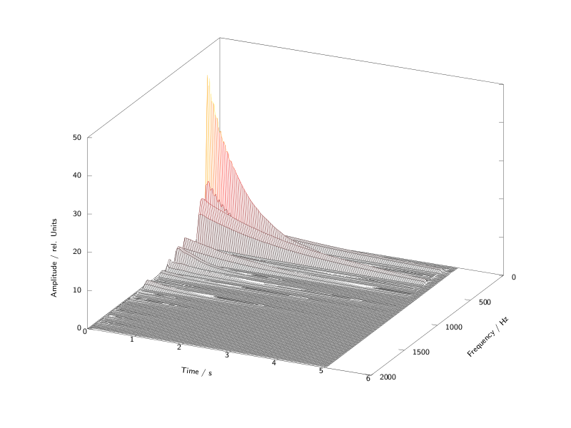
Spectral analysis of a guitar tone in time (courtesy of W. Fohl, Hamburg)
Each partial has its own movement and duration. We may or may not be able to achieve this successfully in additive synthesis. Let us begin with some simple sounds and consider ways of programming this with Csound; later we will look at some more complex sounds and advanced ways of programming this.

Simple Additions of Sinusoids inside an Instrument
If additive synthesis amounts to the adding sine generators, it is straightforward to create multiple oscillators in a single instrument and to add the resulting audio signals together. In the following example, instrument 1 shows a harmonic spectrum, and instrument 2 an inharmonic one. Both instruments share the same amplitude multipliers: 1, 1/2, 1/3, 1/4, ... and receive the base frequency in Csound's pitch notation (octave.semitone) and the main amplitude in dB.
EXAMPLE 04A01_AddSynth_simple.csd
<CsoundSynthesizer>
<CsOptions>
-o dac
</CsOptions>
<CsInstruments>
;example by Andrés Cabrera
sr = 44100
ksmps = 32
nchnls = 2
0dbfs = 1

giSine ftgen 0, 0, 2^10, 10, 1

instr 1 ;harmonic additive synthesis
;receive general pitch and volume from the score
ibasefrq = cpspch(p4) ;convert pitch values to frequency
ibaseamp = ampdbfs(p5) ;convert dB to amplitude
;create 8 harmonic partials
aOsc1 poscil ibaseamp, ibasefrq, giSine
aOsc2 poscil ibaseamp/2, ibasefrq*2, giSine
aOsc3 poscil ibaseamp/3, ibasefrq*3, giSine
aOsc4 poscil ibaseamp/4, ibasefrq*4, giSine
aOsc5 poscil ibaseamp/5, ibasefrq*5, giSine
aOsc6 poscil ibaseamp/6, ibasefrq*6, giSine
aOsc7 poscil ibaseamp/7, ibasefrq*7, giSine
aOsc8 poscil ibaseamp/8, ibasefrq*8, giSine
;apply simple envelope
kenv linen 1, p3/4, p3, p3/4
;add partials and write to output
aOut = aOsc1 + aOsc2 + aOsc3 + aOsc4 + aOsc5 + aOsc6 + aOsc7 + aOsc8
outs aOut*kenv, aOut*kenv
endin

instr 2 ;inharmonic additive synthesis
ibasefrq = cpspch(p4)
ibaseamp = ampdbfs(p5)
;create 8 inharmonic partials
aOsc1 poscil ibaseamp, ibasefrq, giSine
aOsc2 poscil ibaseamp/2, ibasefrq*1.02, giSine
aOsc3 poscil ibaseamp/3, ibasefrq*1.1, giSine
aOsc4 poscil ibaseamp/4, ibasefrq*1.23, giSine
aOsc5 poscil ibaseamp/5, ibasefrq*1.26, giSine
aOsc6 poscil ibaseamp/6, ibasefrq*1.31, giSine
aOsc7 poscil ibaseamp/7, ibasefrq*1.39, giSine
aOsc8 poscil ibaseamp/8, ibasefrq*1.41, giSine
kenv linen 1, p3/4, p3, p3/4
aOut = aOsc1 + aOsc2 + aOsc3 + aOsc4 + aOsc5 + aOsc6 + aOsc7 + aOsc8
outs aOut*kenv, aOut*kenv
endin

</CsInstruments>
<CsScore>
; pch amp
i 1 0 5 8.00 -10
i 1 3 5 9.00 -14
i 1 5 8 9.02 -12
i 1 6 9 7.01 -12
i 1 7 10 6.00 -10
s
i 2 0 5 8.00 -10
i 2 3 5 9.00 -14
i 2 5 8 9.02 -12
i 2 6 9 7.01 -12
i 2 7 10 6.00 -10
</CsScore>
</CsoundSynthesizer>

Simple Additions of Sinusoids via the Score
A typical paradigm in programming: If you find some almost identical lines in your code, consider to abstract it. For the Csound Language this can mean, to move parameter control to the score. In our case, the lines
aOsc1 poscil ibaseamp, ibasefrq, giSine
aOsc2 poscil ibaseamp/2, ibasefrq*2, giSine
aOsc3 poscil ibaseamp/3, ibasefrq*3, giSine
aOsc4 poscil ibaseamp/4, ibasefrq*4, giSine
aOsc5 poscil ibaseamp/5, ibasefrq*5, giSine
aOsc6 poscil ibaseamp/6, ibasefrq*6, giSine
aOsc7 poscil ibaseamp/7, ibasefrq*7, giSine
aOsc8 poscil ibaseamp/8, ibasefrq*8, giSine
can be abstracted to the form
aOsc poscil ibaseamp*iampfactor, ibasefrq*ifreqfactor, giSine
with the parameters iampfactor (the relative amplitude of a partial) and ifreqfactor (the frequency multiplier) transferred to the score.
The next version simplifies the instrument code and defines the variable values as score parameters:
EXAMPLE 04A02_AddSynth_score.csd
<CsoundSynthesizer>
<CsOptions>
-o dac
</CsOptions>
<CsInstruments>
;example by Andrés Cabrera and Joachim Heintz
sr = 44100
ksmps = 32
nchnls = 2
0dbfs = 1

giSine ftgen 0, 0, 2^10, 10, 1

instr 1
iBaseFreq = cpspch(p4)
iFreqMult = p5 ;frequency multiplier
iBaseAmp = ampdbfs(p6)
iAmpMult = p7 ;amplitude multiplier
iFreq = iBaseFreq * iFreqMult
iAmp = iBaseAmp * iAmpMult
kEnv linen iAmp, p3/4, p3, p3/4
aOsc poscil kEnv, iFreq, giSine
outs aOsc, aOsc
endin

</CsInstruments>
<CsScore>
; freq freqmult amp ampmult
i 1 0 7 8.09 1 -10 1
i . . 6 . 2 . [1/2]
i . . 5 . 3 . [1/3]
i . . 4 . 4 . [1/4]
i . . 3 . 5 . [1/5]
i . . 3 . 6 . [1/6]
i . . 3 . 7 . [1/7]
s
i 1 0 6 8.09 1.5 -10 1
i . . 4 . 3.1 . [1/3]
i . . 3 . 3.4 . [1/6]
i . . 4 . 4.2 . [1/9]
i . . 5 . 6.1 . [1/12]
i . . 6 . 6.3 . [1/15]
</CsScore>
</CsoundSynthesizer>
You might say: Okay, where is the simplification? There are even more lines than before! - This is true, and this is certainly just a step on the way to a better code. The main benefit now is flexibility. Now our code is capable of realizing any number of partials, with any amplitude, frequency and duration ratios. Using the Csound score abbreviations (for instance a dot for repeating the previous value in the same p-field), you can do a lot of copy-and-paste, and focus on what is changing from line to line.
Note also that you are now calling one instrument in multiple instances at the same time for performing additive synthesis. In fact, each instance of the instrument contributes just one partial for the additive synthesis. This call of multiple and simultaneous instances of one instrument is also a typical procedure for situations like this, and for writing clean and effective Csound code. We will discuss later how this can be done in a more elegant way than in the last example.

Creating Function Tables for Additive Synthesis
Before we continue on this road, let us go back to the first example and discuss a classical and abbreviated method of playing a number of partials. As we mentioned at the beginning, Fourier stated that any periodic oscillation can be described as a sum of simple sinusoids. If the single sinusoids are static (no individual envelope or duration), the resulting waveform will always be the same.

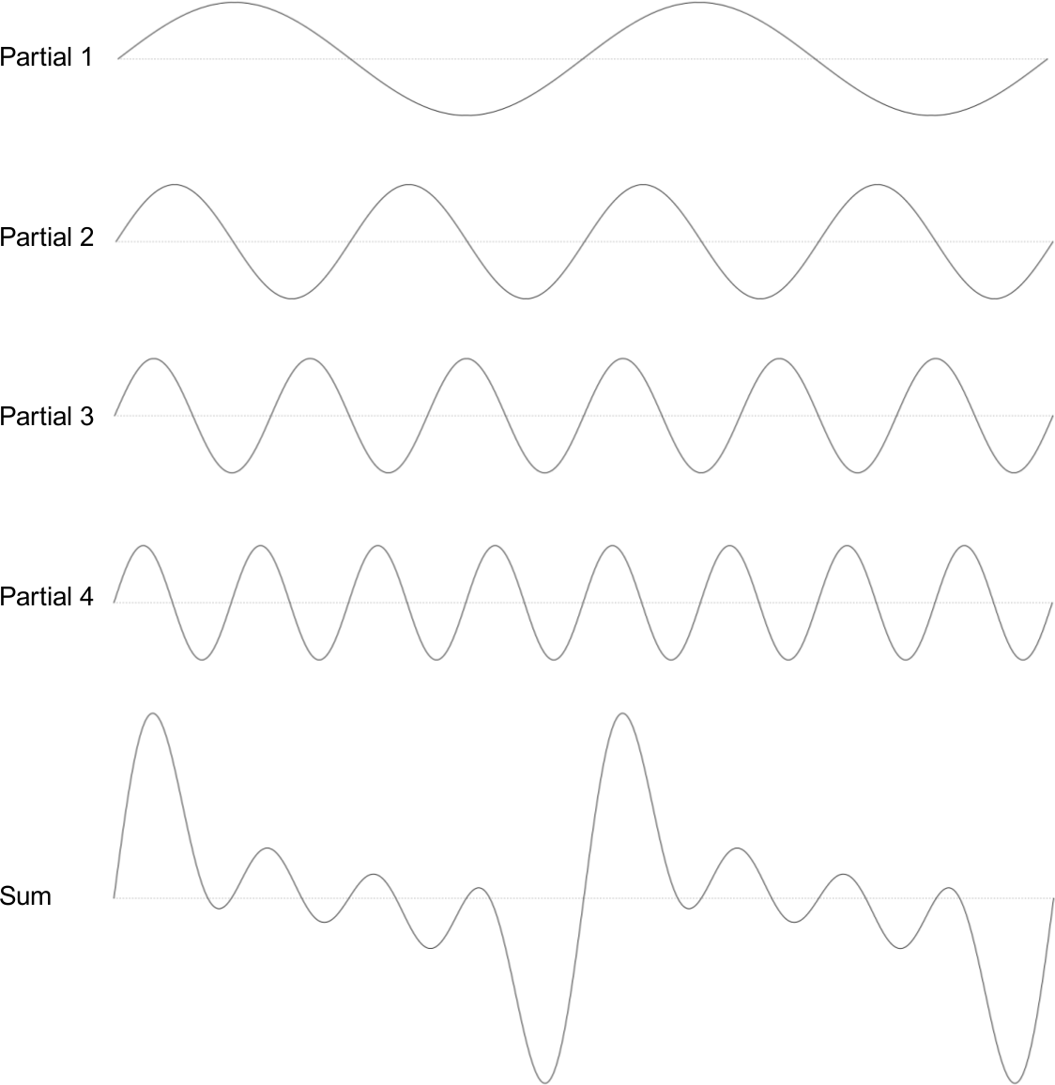

You see four sine generators, each with fixed frequency and amplitude relations, and mixed together. At the bottom of the illustration you see the composite waveform which repeats itself at each period. So - why not just calculate this composite waveform first, and then read it with just one oscillator?
This is what some Csound GEN routines do. They compose the resulting shape of the periodic wave, and store the values in a function table. GEN10 can be used for creating a waveform consisting of harmonically related partials. After the common GEN routine p-fields
<table number>, <creation time>, <size in points>, <GEN number>
you have just to determine the relative strength of the harmonics. GEN09 is more complex and allows you to also control the frequency multiplier and the phase (0-360°) of each partial. We are able to reproduce the first example in a shorter (and computational faster) form:
EXAMPLE 04A03_AddSynth_GEN.csd
<CsoundSynthesizer>
<CsOptions>
-o dac
</CsOptions>
<CsInstruments>
;example by Andrés Cabrera and Joachim Heintz
sr = 44100
ksmps = 32
nchnls = 2
0dbfs = 1

giSine ftgen 0, 0, 2^10, 10, 1
giHarm ftgen 1, 0, 2^12, 10, 1, 1/2, 1/3, 1/4, 1/5, 1/6, 1/7, 1/8
giNois ftgen 2, 0, 2^12, 9, 100,1,0, 102,1/2,0, 110,1/3,0, \
123,1/4,0, 126,1/5,0, 131,1/6,0, 139,1/7,0, 141,1/8,0

instr 1
iBasFreq = cpspch(p4)
iTabFreq = p7 ;base frequency of the table
iBasFreq = iBasFreq / iTabFreq
iBaseAmp = ampdb(p5)
iFtNum = p6
aOsc poscil iBaseAmp, iBasFreq, iFtNum
aEnv linen aOsc, p3/4, p3, p3/4
outs aEnv, aEnv
endin

</CsInstruments>
<CsScore>
; pch amp table table base (Hz)
i 1 0 5 8.00 -10 1 1
i . 3 5 9.00 -14 . .
i . 5 8 9.02 -12 . .
i . 6 9 7.01 -12 . .
i . 7 10 6.00 -10 . .
s
i 1 0 5 8.00 -10 2 100
i . 3 5 9.00 -14 . .
i . 5 8 9.02 -12 . .
i . 6 9 7.01 -12 . .
i . 7 10 6.00 -10 . .
</CsScore>
</CsoundSynthesizer>
As you can see, for non-harmonically related partials, the construction of a table must be done with a special care. If the frequency multipliers in our first example started with 1 and 1.02, the resulting period is acually very long. For a base frequency of 100 Hz, you will have the frequencies of 100 Hz and 102 Hz overlapping each other. So you need 100 cycles from the 1.00 multiplier and 102 cycles from the 1.02 multiplier to complete one period and to start again both together from zero. In other words, we have to create a table which contains 100 respectively 102 periods, instead of 1 and 1.02. Then the table values are not related to 1 - as usual - but to 100. That is the reason we have to introduce a new parameter iTabFreq for this purpose.
This method of composing waveforms can also be used for generating the four standard historical shapes used in a synthesizer. An impulse wave can be created by adding a number of harmonics of the same strength. A sawtooth has the amplitude multipliers 1, 1/2, 1/3, ... for the harmonics. A square has the same multipliers, but just for the odd harmonics. A triangle can be calculated as 1 divided by the square of the odd partials, with swaping positive and negative values. The next example creates function tables with just ten partials for each standard form.
EXAMPLE 04A04_Standard_waveforms.csd
<CsoundSynthesizer>
<CsOptions>
-o dac
</CsOptions>
<CsInstruments>
;example by Joachim Heintz
sr = 44100
ksmps = 32
nchnls = 2
0dbfs = 1

giImp ftgen 1, 0, 4096, 10, 1, 1, 1, 1, 1, 1, 1, 1, 1, 1
giSaw ftgen 2, 0, 4096, 10, 1,1/2,1/3,1/4,1/5,1/6,1/7,1/8,1/9,1/10
giSqu ftgen 3, 0, 4096, 10, 1, 0, 1/3, 0, 1/5, 0, 1/7, 0, 1/9, 0
giTri ftgen 4, 0, 4096, 10, 1, 0, -1/9, 0, 1/25, 0, -1/49, 0, 1/81, 0

instr 1
asig poscil .2, 457, p4
outs asig, asig
endin

</CsInstruments>
<CsScore>
i 1 0 3 1
i 1 4 3 2
i 1 8 3 3
i 1 12 3 4
</CsScore>
</CsoundSynthesizer>

Triggering Sub-instruments for the Partials
Performing additive synthesis by designing partial strengths into function tables has the disadvantage that once a note has begun there is no way of varying the relative strengths of individual partials. There are various methods to circumvent the inflexibility of table-based additive synthesis such as morphing between several tables (using for example the ftmorf opcode). Next we will consider another approach: triggering one instance of a sub-instrument for each partial, and exploring the possibilities of creating a spectrally dynamic sound using this technique.
Let us return to the second instrument (05A02.csd) which already made some abstractions and triggered one instrument instance for each partial. This was done in the score; but now we will trigger one complete note in one score line, not just one partial. The first step is to assign the desired number of partials via a score parameter. The next example triggers any number of partials using this one value:
EXAMPLE 04A05_Flexible_number_of_partials.csd
<CsoundSynthesizer>
<CsOptions>
-o dac
</CsOptions>
<CsInstruments>
;Example by Joachim Heintz
sr = 44100
ksmps = 32
nchnls = 2
0dbfs = 1

giSine ftgen 0, 0, 2^10, 10, 1

instr 1 ;master instrument
inumparts = p4 ;number of partials
ibasfreq = 200 ;base frequency
ipart = 1 ;count variable for loop
;loop for inumparts over the ipart variable
;and trigger inumpartss instanes of the subinstrument
loop:
ifreq = ibasfreq * ipart
iamp = 1/ipart/inumparts
event_i "i", 10, 0, p3, ifreq, iamp
loop_le ipart, 1, inumparts, loop
endin

instr 10 ;subinstrument for playing one partial
ifreq = p4 ;frequency of this partial
iamp = p5 ;amplitude of this partial
aenv transeg 0, .01, 0, iamp, p3-0.1, -10, 0
apart poscil aenv, ifreq, giSine
outs apart, apart
endin

</CsInstruments>
<CsScore>
; number of partials
i 1 0 3 10
i 1 3 3 20
i 1 6 3 2
</CsScore>
</CsoundSynthesizer>
This instrument can easily be transformed to be played via a midi keyboard. The next example connects the number of synthesized partials with the midi velocity. So if you play softly, the sound will have fewer partials than if a key is struck with force.
EXAMPLE 04A06_Play_it_with_Midi.csd
<CsoundSynthesizer>
<CsOptions>
-o dac -Ma
</CsOptions>
<CsInstruments>
;Example by Joachim Heintz
sr = 44100
ksmps = 32
nchnls = 2
0dbfs = 1

giSine ftgen 0, 0, 2^10, 10, 1
massign 0, 1 ;all midi channels to instr 1

instr 1 ;master instrument
ibasfreq cpsmidi ;base frequency
iampmid ampmidi 20 ;receive midi-velocity and scale 0-20
inparts = int(iampmid)+1 ;exclude zero
ipart = 1 ;count variable for loop
;loop for inparts over the ipart variable
;and trigger inparts instances of the sub-instrument
loop:
ifreq = ibasfreq * ipart
iamp = 1/ipart/inparts
event_i "i", 10, 0, 1, ifreq, iamp
loop_le ipart, 1, inparts, loop
endin

instr 10 ;subinstrument for playing one partial
ifreq = p4 ;frequency of this partial
iamp = p5 ;amplitude of this partial
aenv transeg 0, .01, 0, iamp, p3-.01, -3, 0
apart poscil aenv, ifreq, giSine
outs apart/3, apart/3
endin

</CsInstruments>
<CsScore>
f 0 3600
</CsScore>
</CsoundSynthesizer>
Although this instrument is rather primitive it is useful to be able to control the timbre in this way using key velocity. Let us continue to explore some other methods of creating parameter variation in additive synthesis.

User-controlled Random Variations in Additive Synthesis
In natural sounds, there is movement and change all the time. Even the best player or singer will not be able to play a note in the exact same way twice. And within a tone, the partials have some unsteadiness all the time: slight excitations in the amplitudes, uneven durations, slight frequency fluctuations. In an audio programming environment like Csound, we can achieve these movements with random deviations. It is not so important whether we use randomness or not, rather in which way. The boundaries of random deviations must be adjusted as carefully as with any other parameter in electronic composition. If sounds using random deviations begin to sound like mistakes then it is probably less to do with actually using random functions but instead more to do with some poorly chosen boundaries.
Let us start with some random deviations in our subinstrument. These parameters can be affected:
- The frequency of each partial can be slightly detuned. The range of this possible maximum detuning can be set in cents (100 cent = 1 semitone).
- The amplitude of each partial can be altered, compared to its standard value. The alteration can be measured in Decibel (dB).
- The duration of each partial can be shorter or longer than the standard value. Let us define this deviation as a percentage. If the expected duration is five seconds, a maximum deviation of 100% means getting a value between half the duration (2.5 sec) and the double duration (10 sec).
The following example shows the effect of these variations. As a base - and as a reference to its author - we take the "bell-like sound" which Jean-Claude Risset created in his Sound Catalogue.1
EXAMPLE 04A07_Risset_variations.csd
<CsoundSynthesizer>
<CsOptions>
-o dac
</CsOptions>
<CsInstruments>
;Example by Joachim Heintz
sr = 44100
ksmps = 32
nchnls = 2
0dbfs = 1

;frequency and amplitude multipliers for 11 partials of Risset's bell
giFqs ftgen 0, 0, -11,-2,.56,.563,.92, .923,1.19,1.7,2,2.74, \
3,3.74,4.07
giAmps ftgen 0, 0, -11, -2, 1, 2/3, 1, 1.8, 8/3, 1.46, 4/3, 4/3, 1, 4/3
giSine ftgen 0, 0, 2^10, 10, 1
seed 0

instr 1 ;master instrument
ibasfreq = 400
ifqdev = p4 ;maximum freq deviation in cents
iampdev = p5 ;maximum amp deviation in dB
idurdev = p6 ;maximum duration deviation in %
indx = 0 ;count variable for loop
loop:
ifqmult tab_i indx, giFqs ;get frequency multiplier from table
ifreq = ibasfreq * ifqmult
iampmult tab_i indx, giAmps ;get amp multiplier
iamp = iampmult / 20 ;scale
event_i "i", 10, 0, p3, ifreq, iamp, ifqdev, iampdev, idurdev
loop_lt indx, 1, 11, loop
endin

instr 10 ;subinstrument for playing one partial
;receive the parameters from the master instrument
ifreqnorm = p4 ;standard frequency of this partial
iampnorm = p5 ;standard amplitude of this partial
ifqdev = p6 ;maximum freq deviation in cents
iampdev = p7 ;maximum amp deviation in dB
idurdev = p8 ;maximum duration deviation in %
;calculate frequency
icent random -ifqdev, ifqdev ;cent deviation
ifreq = ifreqnorm * cent(icent)
;calculate amplitude
idb random -iampdev, iampdev ;dB deviation
iamp = iampnorm * ampdb(idb)
;calculate duration
idurperc random -idurdev, idurdev ;duration deviation (%)
iptdur = p3 * 2^(idurperc/100)
p3 = iptdur ;set p3 to the calculated value
;play partial
aenv transeg 0, .01, 0, iamp, p3-.01, -10, 0
apart poscil aenv, ifreq, giSine
outs apart, apart
endin

</CsInstruments>
<CsScore>
; frequency amplitude duration
; deviation deviation deviation
; in cent in dB in %
;;unchanged sound (twice)
r 2
i 1 0 5 0 0 0
s
;;slight variations in frequency
r 4
i 1 0 5 25 0 0
;;slight variations in amplitude
r 4
i 1 0 5 0 6 0
;;slight variations in duration
r 4
i 1 0 5 0 0 30
;;slight variations combined
r 6
i 1 0 5 25 6 30
;;heavy variations
r 6
i 1 0 5 50 9 100
</CsScore>
</CsoundSynthesizer>
For a midi-triggered descendant of the instrument, we can - as one of many possible choices - vary the amount of possible random variation on the key velocity. So a key pressed softly plays the bell-like sound as described by Risset but as a key is struck with increasing force the sound produced will be increasingly altered.
EXAMPLE 04A08_Risset_played_by_Midi.csd
<CsoundSynthesizer>
<CsOptions>
-o dac -Ma
</CsOptions>
<CsInstruments>
;Example by Joachim Heintz
sr = 44100
ksmps = 32
nchnls = 2
0dbfs = 1

;frequency and amplitude multipliers for 11 partials of Risset's bell
giFqs ftgen 0, 0, -11, -2, .56,.563,.92,.923,1.19,1.7,2,2.74,3,\
3.74,4.07
giAmps ftgen 0, 0, -11, -2, 1, 2/3, 1, 1.8, 8/3, 1.46, 4/3, 4/3, 1,\
4/3
giSine ftgen 0, 0, 2^10, 10, 1
seed 0
massign 0, 1 ;all midi channels to instr 1

instr 1 ;master instrument
;;scale desired deviations for maximum velocity
;frequency (cent)
imxfqdv = 100
;amplitude (dB)
imxampdv = 12
;duration (%)
imxdurdv = 100
;;get midi values
ibasfreq cpsmidi ;base frequency
iampmid ampmidi 1 ;receive midi-velocity and scale 0-1
;;calculate maximum deviations depending on midi-velocity
ifqdev = imxfqdv * iampmid
iampdev = imxampdv * iampmid
idurdev = imxdurdv * iampmid
;;trigger subinstruments
indx = 0 ;count variable for loop
loop:
ifqmult tab_i indx, giFqs ;get frequency multiplier from table
ifreq = ibasfreq * ifqmult
iampmult tab_i indx, giAmps ;get amp multiplier
iamp = iampmult / 20 ;scale
event_i "i", 10, 0, 3, ifreq, iamp, ifqdev, iampdev, idurdev
loop_lt indx, 1, 11, loop
endin

instr 10 ;subinstrument for playing one partial
;receive the parameters from the master instrument
ifreqnorm = p4 ;standard frequency of this partial
iampnorm = p5 ;standard amplitude of this partial
ifqdev = p6 ;maximum freq deviation in cents
iampdev = p7 ;maximum amp deviation in dB
idurdev = p8 ;maximum duration deviation in %
;calculate frequency
icent random -ifqdev, ifqdev ;cent deviation
ifreq = ifreqnorm * cent(icent)
;calculate amplitude
idb random -iampdev, iampdev ;dB deviation
iamp = iampnorm * ampdb(idb)
;calculate duration
idurperc random -idurdev, idurdev ;duration deviation (%)
iptdur = p3 * 2^(idurperc/100)
p3 = iptdur ;set p3 to the calculated value
;play partial
aenv transeg 0, .01, 0, iamp, p3-.01, -10, 0
apart poscil aenv, ifreq, giSine
outs apart, apart
endin

</CsInstruments>
<CsScore>
f 0 3600
</CsScore>
</CsoundSynthesizer>
It will depend on the power of your computer whether you can play examples like this in realtime. Have a look at chapter 2D (Live Audio) for tips on getting the best possible performance from your Csound orchestra.
In the next example we will use additive synthesis to make a kind of a wobble bass. It starts as a bass, then evolve to something else, and then ends as a bass again. We will first generate all the inharmonic partials with a loop. Ordinary partials are arithmetic, we add the same value to one partial to get to the next. In this example we will instead use geometric partials, we will multiplicate one partial with a certain number (kfreqmult) to get the next partial frequency. This number is not constant, but is generated by a sine oscilator. This is frequency modulation. Then some randomness is added to make a more interesting sound, and chorus effect to make the sound more "fat". The exponential function, exp, is used because if we move upwards in common musical scales, then the frequencies grow exponentially.
EXAMPLE 04A09_Wobble_bass.csd
<CsoundSynthesizer> ; Wobble bass made with additive synthesis

<CsOptions> ; and frequency modulation
-odac
</CsOptions>

<CsInstruments>
; Example by Bjørn Houdorf, March 2013
sr = 44100
ksmps = 1
nchnls = 2
0dbfs = 1

instr 1
kamp = 24 ; Amplitude
kfreq expseg p4, p3/2, 50*p4, p3/2, p4 ; Base frequency
iloopnum = p5 ; Number of all partials generated
alyd1 init 0
alyd2 init 0
seed 0
kfreqmult oscili 1, 2, 1
kosc oscili 1, 2.1, 1
ktone randomh 0.5, 2, 0.2 ; A random input
icount = 1

loop: ; Loop to generate partials to additive synthesis
kfreq = kfreqmult * kfreq
atal oscili 1, 0.5, 1
apart oscili 1, icount*exp(atal*ktone) , 1 ; Modulate each partials
anum = apart*kfreq*kosc
asig1 oscili kamp, anum, 1
asig2 oscili kamp, 1.5*anum, 1 ; Chorus effect to make the sound more "fat"
asig3 oscili kamp, 2*anum, 1
asig4 oscili kamp, 2.5*anum, 1
alyd1 = (alyd1 + asig1+asig4)/icount ;Sum of partials
alyd2 = (alyd2 + asig2+asig3)/icount
loop_lt icount, 1, iloopnum, loop ; End of loop

outs alyd1, alyd2 ; Output generated sound
endin
</CsInstruments>

<CsScore>
f1 0 128 10 1
i1 0 60 110 50
e
</CsScore>

</CsoundSynthesizer>

gbuzz, buzz and GEN11
gbuzz is useful for creating additive tones made of of harmonically related cosine waves. Rather than define attributes for every partial individually gbuzz allows us to define global aspects for the additive tone, specifically, the number of partials in the tone, the partial number of the lowest partial present and an amplitude coefficient multipler which shifts the peak of spectral energy in the tone. Number of harmonics (knh) and lowest hamonic (klh) although k-rate arguments are only interpreted as integers by the opcode therefore changes from integer to integer will result in discontinuities in the output signal. The amplitude coefficient multiplier allows smooth modulations.
In the following example a 100Hz tone is created in which the number of partials it contains rises from 1 to 20 across its 8 second duration. A spectrogram/sonogram displays how this manifests spectrally. A linear frequency scale is employed so that partials appear equally spaced.
EXAMPLE 04A10_gbuzz.csd
<CsoundSynthesizer>

<CsOptions>
-o dac
</CsOptions>

<CsInstruments>
sr = 44100
ksmps = 32
nchnls = 2
0dbfs = 1

; a cosine wave
gicos ftgen 0, 0, 2^10, 11, 1

instr 1
knh line 1, p3, 20 ; number of harmonics
klh = 1 ; lowest harmonic
kmul = 1 ; amplitude coefficient multiplier
asig gbuzz 1, 100, knh, klh, kmul, gicos
outs asig, asig
endin

</CsInstruments>

<CsScore>
i 1 0 8
e
</CsScore>

</CsoundSynthesizer>
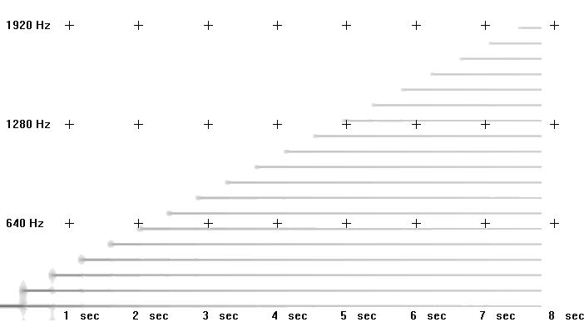
The total number of partials only reaches 19 because the line function only reaches 20 at the very conclusion of the note.
In the next example the number of partials contained within the tone remains constant but the partial number of the lowest partial rises from 1 to 20.
EXAMPLE 04A11_gbuzz_partials_rise.csd
<CsoundSynthesizer>

<CsOptions>
-o dac
</CsOptions>

<CsInstruments>
sr = 44100
ksmps = 32
nchnls = 2
0dbfs = 1

; a cosine wave
gicos ftgen 0, 0, 2^10, 11, 1

instr 1
knh = 20
klh line 1, p3, 20
kmul = 1
asig gbuzz 1, 100, knh, klh, kmul, gicos
outs asig, asig
endin

</CsInstruments>

<CsScore>
i 1 0 8
e
</CsScore>

</CsoundSynthesizer>
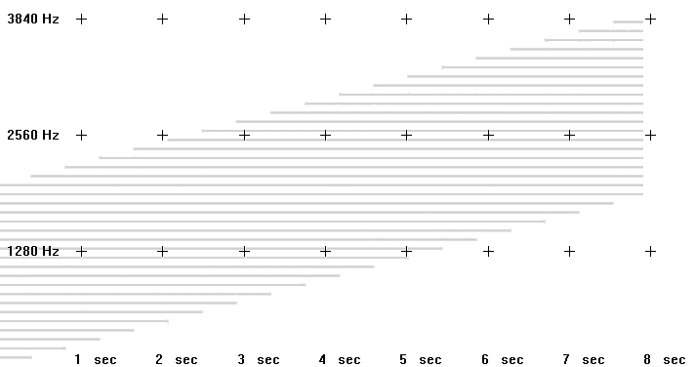
In the sonogram it can be seen how, as lowermost partials are removed, additional partials are added at the top ot the spectrum. This is because the total number of partials remains constant at 20.
In the final gbuzz example the amplitude coefficient multiplier rises from 0 to 2. It can be heard (and seen in the sonogram) how, when this value is zero greatest emphasis is placed on the lowermost partial and when this value is 2 the uppermost partial has the greatest emphasis.
EXAMPLE 04A12_gbuzz_amp_coeff_rise.csd
<CsoundSynthesizer>

<CsOptions>
-o dac
</CsOptions>

<CsInstruments>
sr = 44100
ksmps = 32
nchnls = 2
0dbfs = 1

; a cosine wave
gicos ftgen 0, 0, 2^10, 11, 1

instr 1
knh = 20
klh = 1
kmul line 0, p3, 2
asig gbuzz 1, 100, knh, klh, kmul, gicos
fout "gbuzz3.wav",4,asig
endin

</CsInstruments>

<CsScore>
i 1 0 8
e
</CsScore>

</CsoundSynthesizer>
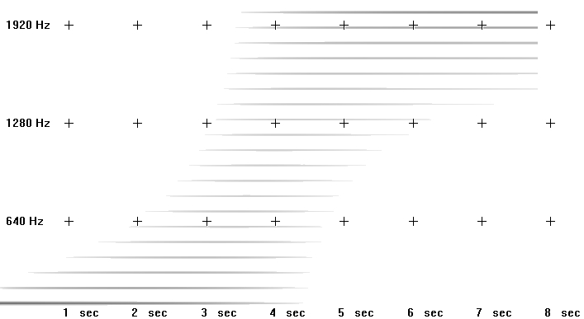
buzz is a simplified version of gbuzz with fewer parameters – it does not provide for modulation of the lowest partial number and amplitude coefficient multiplier.
GEN11 creates a function table waveform using the same parameters as gbuzz. When a gbuzz tone is required but no performance time modulation of its parameters is needed GEN11 may provide a more efficient option. GEN11 also opens the possibility of using its waveforms in a variety of other opcodes. gbuzz, buzz and GEN11 may prove useful as a source in subtractive synthesis.
Additive synthesis can still be an exciting way of producing sounds. The nowadays computational power and programming structures open the way for new discoveries and ideas. The later examples were intended to show some of these potentials of additive synthesis in Csound.
- Jean-Claude Risset, Introductory Catalogue of Computer Synthesized Sounds (1969), cited after Dodge/Jerse, Computer Music, New York / London 1985, p.94^

22. SUBTRACTIVE SYNTHESIS

Introduction
Subtractive synthesis is, at least conceptually, the inverse of additive synthesis in that instead of building complex sound through the addition of simple cellular materials such as sine waves, subtractive synthesis begins with a complex sound source, such as white noise or a recorded sample, or a rich waveform, such as a sawtooth or pulse, and proceeds to refine that sound by removing partials or entire sections of the frequency spectrum through the use of audio filters.
The creation of dynamic spectra (an arduous task in additive synthesis) is relatively simple in subtractive synthesis as all that will be required will be to modulate a few parameters pertaining to any filters being used. Working with the intricate precision that is possible with additive synthesis may not be as easy with subtractive synthesis but sounds can be created much more instinctively than is possible with additive or FM synthesis.

A Csound Two-Oscillator Synthesizer
The first example represents perhaps the classic idea of subtractive synthesis: a simple two oscillator synth filtered using a single resonant lowpass filter. Many of the ideas used in this example have been inspired by the design of the Minimoog synthesizer (1970) and other similar instruments.
Each oscillator can describe either a sawtooth, PWM waveform (i.e. square - pulse etc.) or white noise and each oscillator can be transposed in octaves or in cents with respect to a fundamental pitch. The two oscillators are mixed and then passed through a 4-pole / 24dB per octave resonant lowpass filter. The opcode 'moogladder' is chosen on account of its authentic vintage character. The cutoff frequency of the filter is modulated using an ADSR-style (attack-decay-sustain-release) envelope facilitating the creation of dynamic, evolving spectra. Finally the sound output of the filter is shaped by an ADSR amplitude envelope.
As this instrument is suggestive of a performance instrument controlled via MIDI, this has been partially implemented. Through the use of Csound's MIDI interoperability opcode, mididefault, the instrument can be operated from the score or from a MIDI keyboard. If a MIDI note is received, suitable default p-field values are substituted for the missing p-fields. MIDI controller 1 can be used to control the global cutoff frequency for the filter.
A schematic for this instrument is shown below:
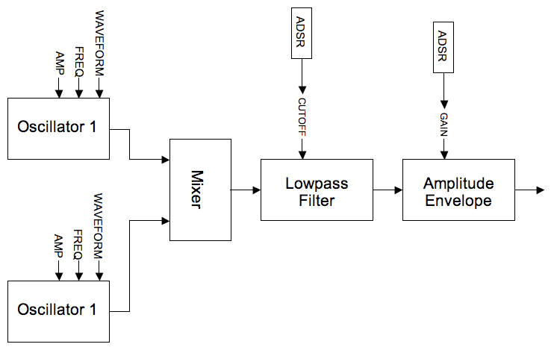

EXAMPLE 04B01_Subtractive_Midi.csd
<CsoundSynthesizer>

<CsOptions>
-odac -Ma
</CsOptions>

<CsInstruments>
sr = 44100
ksmps = 4
nchnls = 2
0dbfs = 1

initc7 1,1,0.8 ;set initial controller position

prealloc 1, 10

instr 1
iNum notnum ;read in midi note number
iCF ctrl7 1,1,0.1,14 ;read in midi controller 1

; set up default p-field values for midi activated notes
mididefault iNum, p4 ;pitch (note number)
mididefault 0.3, p5 ;amplitude 1
mididefault 2, p6 ;type 1
mididefault 0.5, p7 ;pulse width 1
mididefault 0, p8 ;octave disp. 1
mididefault 0, p9 ;tuning disp. 1
mididefault 0.3, p10 ;amplitude 2
mididefault 1, p11 ;type 2
mididefault 0.5, p12 ;pulse width 2
mididefault -1, p13 ;octave displacement 2
mididefault 20, p14 ;tuning disp. 2
mididefault iCF, p15 ;filter cutoff freq
mididefault 0.01, p16 ;filter env. attack time
mididefault 1, p17 ;filter env. decay time
mididefault 0.01, p18 ;filter env. sustain level
mididefault 0.1, p19 ;filter release time
mididefault 0.3, p20 ;filter resonance
mididefault 0.01, p21 ;amp. env. attack
mididefault 0.1, p22 ;amp. env. decay.
mididefault 1, p23 ;amp. env. sustain
mididefault 0.01, p24 ;amp. env. release

; asign p-fields to variables
iCPS = cpsmidinn(p4) ;convert from note number to cps
kAmp1 = p5
iType1 = p6
kPW1 = p7
kOct1 = octave(p8) ;convert from octave displacement to multiplier
kTune1 = cent(p9) ;convert from cents displacement to multiplier
kAmp2 = p10
iType2 = p11
kPW2 = p12
kOct2 = octave(p13)
kTune2 = cent(p14)
iCF = p15
iFAtt = p16
iFDec = p17
iFSus = p18
iFRel = p19
kRes = p20
iAAtt = p21
iADec = p22
iASus = p23
iARel = p24

;oscillator 1
;if type is sawtooth or square...
if iType1==1||iType1==2 then
;...derive vco2 'mode' from waveform type
iMode1 = (iType1=1?0:2)
aSig1 vco2 kAmp1,iCPS*kOct1*kTune1,iMode1,kPW1;VCO audio oscillator
else ;otherwise...
aSig1 noise kAmp1, 0.5 ;...generate white noise
endif

;oscillator 2 (identical in design to oscillator 1)
if iType2==1||iType2==2 then
iMode2 = (iType2=1?0:2)
aSig2 vco2 kAmp2,iCPS*kOct2*kTune2,iMode2,kPW2
else
aSig2 noise kAmp2,0.5
endif

;mix oscillators
aMix sum aSig1,aSig2
;lowpass filter
kFiltEnv expsegr 0.0001,iFAtt,iCPS*iCF,iFDec,iCPS*iCF*iFSus,iFRel,0.0001
aOut moogladder aMix, kFiltEnv, kRes

;amplitude envelope
aAmpEnv expsegr 0.0001,iAAtt,1,iADec,iASus,iARel,0.0001
aOut = aOut*aAmpEnv
outs aOut,aOut
endin
</CsInstruments>

<CsScore>
;p4 = oscillator frequency
;oscillator 1
;p5 = amplitude
;p6 = type (1=sawtooth,2=square-PWM,3=noise)
;p7 = PWM (square wave only)
;p8 = octave displacement
;p9 = tuning displacement (cents)
;oscillator 2
;p10 = amplitude
;p11 = type (1=sawtooth,2=square-PWM,3=noise)
;p12 = pwm (square wave only)
;p13 = octave displacement
;p14 = tuning displacement (cents)
;global filter envelope
;p15 = cutoff
;p16 = attack time
;p17 = decay time
;p18 = sustain level (fraction of cutoff)
;p19 = release time
;p20 = resonance
;global amplitude envelope
;p21 = attack time
;p22 = decay time
;p23 = sustain level
;p24 = release time
; p1 p2 p3 p4 p5 p6 p7 p8 p9 p10 p11 p12 p13
;p14 p15 p16 p17 p18 p19 p20 p21 p22 p23 p24
i 1 0 1 50 0 2 .5 0 -5 0 2 0.5 0 \
5 12 .01 2 .01 .1 0 .005 .01 1 .05
i 1 + 1 50 .2 2 .5 0 -5 .2 2 0.5 0 \
5 1 .01 1 .1 .1 .5 .005 .01 1 .05
i 1 + 1 50 .2 2 .5 0 -8 .2 2 0.5 0 \
8 3 .01 1 .1 .1 .5 .005 .01 1 .05
i 1 + 1 50 .2 2 .5 0 -8 .2 2 0.5 -1 \
8 7 .01 1 .1 .1 .5 .005 .01 1 .05
i 1 + 3 50 .2 1 .5 0 -10 .2 1 0.5 -2 \
10 40 .01 3 .001 .1 .5 .005 .01 1 .05
i 1 + 10 50 1 2 .01 -2 0 .2 3 0.5 0 \
0 40 5 5 .001 1.5 .1 .005 .01 1 .05

f 0 3600
e
</CsScore>

</CsoundSynthesizer>

Simulation of Timbres from a Noise Source
The next example makes extensive use of bandpass filters arranged in parallel to filter white noise. The bandpass filter bandwidths are narrowed to the point where almost pure tones are audible. The crucial difference is that the noise source always induces instability in the amplitude and frequency of tones produced - it is this quality that makes this sort of subtractive synthesis sound much more organic than an additive synthesis equivalent. If the bandwidths are widened then more of the characteristic of the noise source comes through and the tone becomes 'airier' and less distinct; if the bandwidths are narrowed the resonating tones become clearer and steadier. By varying the bandwidths interesting metamorphoses of the resultant sound are possible.
22 reson filters are used for the bandpass filters on account of their ability to ring and resonate as their bandwidth narrows. Another reason for this choice is the relative CPU economy of the reson filter, a not inconsiderable concern as so many of them are used. The frequency ratios between the 22 parallel filters are derived from analysis of a hand bell, the data was found in the appendix of the Csound manual here.
In addition to the white noise as a source, noise impulses are also used as a sound source (via the 'mpulse' opcode). The instrument will automatically and randomly slowly crossfade between these two sound sources.
A lowpass and highpass filter are inserted in series before the parallel bandpass filters to shape the frequency spectrum of the source sound. Csound's butterworth filters butlp and buthp are chosen for this task on account of their steep cutoff slopes and lack of ripple at the cutoff point.
The outputs of the reson filters are sent alternately to the left and right outputs in order to create a broad stereo effect.
This example makes extensive use of the 'rspline' opcode, a generator of random spline functions, to slowly undulate the many input parameters. The orchestra is self generative in that instrument 1 repeatedly triggers note events in instrument 2 and the extensive use of random functions means that the results will continually evolve as the orchestra is allowed to perform.
A flow diagram for this instrument is shown below:
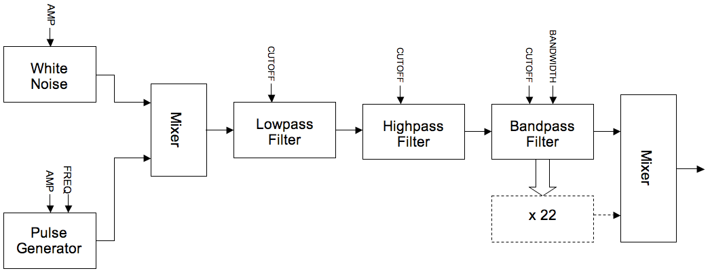

EXAMPLE 04B02_Subtractive_timbres.csd
<CsoundSynthesizer>

<CsOptions>
-odac
</CsOptions>

<CsInstruments>
;Example written by Iain McCurdy

sr = 44100
ksmps = 16
nchnls = 2
0dbfs = 1

instr 1 ; triggers notes in instrument 2 with randomised p-fields
krate randomi 0.2,0.4,0.1 ;rate of note generation
ktrig metro krate ;triggers used by schedkwhen
koct random 5,12 ;fundemental pitch of synth note
kdur random 15,30 ;duration of note
schedkwhen ktrig,0,0,2,0,kdur,cpsoct(koct) ;trigger a note in instrument 2
endin

instr 2 ; subtractive synthesis instrument
aNoise pinkish 1 ;a noise source sound: pink noise
kGap rspline 0.3,0.05,0.2,2 ;time gap between impulses
aPulse mpulse 15, kGap ;a train of impulses
kCFade rspline 0,1,0.1,1 ;crossfade point between noise and impulses
aInput ntrpol aPulse,aNoise,kCFade;implement crossfade

; cutoff frequencies for low and highpass filters
kLPF_CF rspline 13,8,0.1,0.4
kHPF_CF rspline 5,10,0.1,0.4
; filter input sound with low and highpass filters in series -
; - done twice per filter in order to sharpen cutoff slopes
aInput butlp aInput, cpsoct(kLPF_CF)
aInput butlp aInput, cpsoct(kLPF_CF)
aInput buthp aInput, cpsoct(kHPF_CF)
aInput buthp aInput, cpsoct(kHPF_CF)

kcf rspline p4*1.05,p4*0.95,0.01,0.1 ; fundemental
; bandwidth for each filter is created individually as a random spline function
kbw1 rspline 0.00001,10,0.2,1
kbw2 rspline 0.00001,10,0.2,1
kbw3 rspline 0.00001,10,0.2,1
kbw4 rspline 0.00001,10,0.2,1
kbw5 rspline 0.00001,10,0.2,1
kbw6 rspline 0.00001,10,0.2,1
kbw7 rspline 0.00001,10,0.2,1
kbw8 rspline 0.00001,10,0.2,1
kbw9 rspline 0.00001,10,0.2,1
kbw10 rspline 0.00001,10,0.2,1
kbw11 rspline 0.00001,10,0.2,1
kbw12 rspline 0.00001,10,0.2,1
kbw13 rspline 0.00001,10,0.2,1
kbw14 rspline 0.00001,10,0.2,1
kbw15 rspline 0.00001,10,0.2,1
kbw16 rspline 0.00001,10,0.2,1
kbw17 rspline 0.00001,10,0.2,1
kbw18 rspline 0.00001,10,0.2,1
kbw19 rspline 0.00001,10,0.2,1
kbw20 rspline 0.00001,10,0.2,1
kbw21 rspline 0.00001,10,0.2,1
kbw22 rspline 0.00001,10,0.2,1

imode = 0 ; amplitude balancing method used by the reson filters
a1 reson aInput, kcf*1, kbw1, imode
a2 reson aInput, kcf*1.0019054878049, kbw2, imode
a3 reson aInput, kcf*1.7936737804878, kbw3, imode
a4 reson aInput, kcf*1.8009908536585, kbw4, imode
a5 reson aInput, kcf*2.5201981707317, kbw5, imode
a6 reson aInput, kcf*2.5224085365854, kbw6, imode
a7 reson aInput, kcf*2.9907012195122, kbw7, imode
a8 reson aInput, kcf*2.9940548780488, kbw8, imode
a9 reson aInput, kcf*3.7855182926829, kbw9, imode
a10 reson aInput, kcf*3.8061737804878, kbw10,imode
a11 reson aInput, kcf*4.5689024390244, kbw11,imode
a12 reson aInput, kcf*4.5754573170732, kbw12,imode
a13 reson aInput, kcf*5.0296493902439, kbw13,imode
a14 reson aInput, kcf*5.0455030487805, kbw14,imode
a15 reson aInput, kcf*6.0759908536585, kbw15,imode
a16 reson aInput, kcf*5.9094512195122, kbw16,imode
a17 reson aInput, kcf*6.4124237804878, kbw17,imode
a18 reson aInput, kcf*6.4430640243902, kbw18,imode
a19 reson aInput, kcf*7.0826219512195, kbw19,imode
a20 reson aInput, kcf*7.0923780487805, kbw20,imode
a21 reson aInput, kcf*7.3188262195122, kbw21,imode
a22 reson aInput, kcf*7.5551829268293, kbw22,imode

; amplitude control for each filter output
kAmp1 rspline 0, 1, 0.3, 1
kAmp2 rspline 0, 1, 0.3, 1
kAmp3 rspline 0, 1, 0.3, 1
kAmp4 rspline 0, 1, 0.3, 1
kAmp5 rspline 0, 1, 0.3, 1
kAmp6 rspline 0, 1, 0.3, 1
kAmp7 rspline 0, 1, 0.3, 1
kAmp8 rspline 0, 1, 0.3, 1
kAmp9 rspline 0, 1, 0.3, 1
kAmp10 rspline 0, 1, 0.3, 1
kAmp11 rspline 0, 1, 0.3, 1
kAmp12 rspline 0, 1, 0.3, 1
kAmp13 rspline 0, 1, 0.3, 1
kAmp14 rspline 0, 1, 0.3, 1
kAmp15 rspline 0, 1, 0.3, 1
kAmp16 rspline 0, 1, 0.3, 1
kAmp17 rspline 0, 1, 0.3, 1
kAmp18 rspline 0, 1, 0.3, 1
kAmp19 rspline 0, 1, 0.3, 1
kAmp20 rspline 0, 1, 0.3, 1
kAmp21 rspline 0, 1, 0.3, 1
kAmp22 rspline 0, 1, 0.3, 1

; left and right channel mixes are created using alternate filter outputs.
; This shall create a stereo effect.
aMixL sum a1*kAmp1,a3*kAmp3,a5*kAmp5,a7*kAmp7,a9*kAmp9,a11*kAmp11,\
a13*kAmp13,a15*kAmp15,a17*kAmp17,a19*kAmp19,a21*kAmp21
aMixR sum a2*kAmp2,a4*kAmp4,a6*kAmp6,a8*kAmp8,a10*kAmp10,a12*kAmp12,\
a14*kAmp14,a16*kAmp16,a18*kAmp18,a20*kAmp20,a22*kAmp22

kEnv linseg 0, p3*0.5, 1,p3*0.5,0,1,0 ; global amplitude envelope
outs (aMixL*kEnv*0.00008), (aMixR*kEnv*0.00008) ; audio sent to outputs
endin

</CsInstruments>

<CsScore>
i 1 0 3600 ; instrument 1 (note generator) plays for 1 hour
e
</CsScore>

</CsoundSynthesizer>

Vowel-Sound Emulation Using Bandpass Filtering
The final example in this section uses precisely tuned bandpass filters, to simulate the sound of the human voice expressing vowel sounds. Spectral resonances in this context are often referred to as 'formants'. Five formants are used to simulate the effect of the human mouth and head as a resonating (and therefore filtering) body. The filter data for simulating the vowel sounds A,E,I,O and U as expressed by a bass, tenor, counter-tenor, alto and soprano voice were found in the appendix of the Csound manual here. Bandwidth and intensity (dB) information is also needed to accurately simulate the various vowel sounds.
reson filters are again used but butbp and others could be equally valid choices.
Data is stored in GEN07 linear break point function tables, as this data is read by k-rate line functions we can interpolate and therefore morph between different vowel sounds during a note.
The source sound for the filters comes from either a pink noise generator or a pulse waveform. The pink noise source could be used if the emulation is to be that of just the breath whereas the pulse waveform provides a decent approximation of the human vocal chords buzzing. This instrument can however morph continuously between these two sources.
A flow diagram for this instrument is shown below:
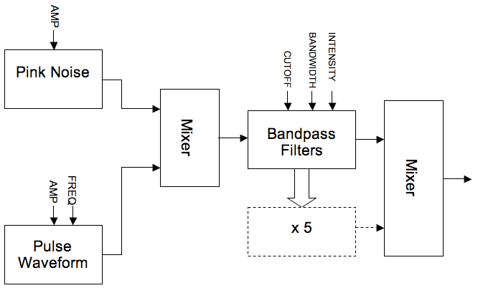

EXAMPLE 04B03_Subtractive_vowels.csd
<CsoundSynthesizer>

<CsOptions>
-odac
</CsOptions>

<CsInstruments>
;example by Iain McCurdy

sr = 44100
ksmps = 16
nchnls = 2
0dbfs = 1

;FUNCTION TABLES STORING DATA FOR VARIOUS VOICE FORMANTS

;BASS
giBF1 ftgen 0, 0, -5, -2, 600, 400, 250, 400, 350
giBF2 ftgen 0, 0, -5, -2, 1040, 1620, 1750, 750, 600
giBF3 ftgen 0, 0, -5, -2, 2250, 2400, 2600, 2400, 2400
giBF4 ftgen 0, 0, -5, -2, 2450, 2800, 3050, 2600, 2675
giBF5 ftgen 0, 0, -5, -2, 2750, 3100, 3340, 2900, 2950

giBDb1 ftgen 0, 0, -5, -2, 0, 0, 0, 0, 0
giBDb2 ftgen 0, 0, -5, -2, -7, -12, -30, -11, -20
giBDb3 ftgen 0, 0, -5, -2, -9, -9, -16, -21, -32
giBDb4 ftgen 0, 0, -5, -2, -9, -12, -22, -20, -28
giBDb5 ftgen 0, 0, -5, -2, -20, -18, -28, -40, -36

giBBW1 ftgen 0, 0, -5, -2, 60, 40, 60, 40, 40
giBBW2 ftgen 0, 0, -5, -2, 70, 80, 90, 80, 80
giBBW3 ftgen 0, 0, -5, -2, 110, 100, 100, 100, 100
giBBW4 ftgen 0, 0, -5, -2, 120, 120, 120, 120, 120
giBBW5 ftgen 0, 0, -5, -2, 130, 120, 120, 120, 120

;TENOR
giTF1 ftgen 0, 0, -5, -2, 650, 400, 290, 400, 350
giTF2 ftgen 0, 0, -5, -2, 1080, 1700, 1870, 800, 600
giTF3 ftgen 0, 0, -5, -2, 2650, 2600, 2800, 2600, 2700
giTF4 ftgen 0, 0, -5, -2, 2900, 3200, 3250, 2800, 2900
giTF5 ftgen 0, 0, -5, -2, 3250, 3580, 3540, 3000, 3300

giTDb1 ftgen 0, 0, -5, -2, 0, 0, 0, 0, 0
giTDb2 ftgen 0, 0, -5, -2, -6, -14, -15, -10, -20
giTDb3 ftgen 0, 0, -5, -2, -7, -12, -18, -12, -17
giTDb4 ftgen 0, 0, -5, -2, -8, -14, -20, -12, -14
giTDb5 ftgen 0, 0, -5, -2, -22, -20, -30, -26, -26

giTBW1 ftgen 0, 0, -5, -2, 80, 70, 40, 40, 40
giTBW2 ftgen 0, 0, -5, -2, 90, 80, 90, 80, 60
giTBW3 ftgen 0, 0, -5, -2, 120, 100, 100, 100, 100
giTBW4 ftgen 0, 0, -5, -2, 130, 120, 120, 120, 120
giTBW5 ftgen 0, 0, -5, -2, 140, 120, 120, 120, 120

;COUNTER TENOR
giCTF1 ftgen 0, 0, -5, -2, 660, 440, 270, 430, 370
giCTF2 ftgen 0, 0, -5, -2, 1120, 1800, 1850, 820, 630
giCTF3 ftgen 0, 0, -5, -2, 2750, 2700, 2900, 2700, 2750
giCTF4 ftgen 0, 0, -5, -2, 3000, 3000, 3350, 3000, 3000
giCTF5 ftgen 0, 0, -5, -2, 3350, 3300, 3590, 3300, 3400

giTBDb1 ftgen 0, 0, -5, -2, 0, 0, 0, 0, 0
giTBDb2 ftgen 0, 0, -5, -2, -6, -14, -24, -10, -20
giTBDb3 ftgen 0, 0, -5, -2, -23, -18, -24, -26, -23
giTBDb4 ftgen 0, 0, -5, -2, -24, -20, -36, -22, -30
giTBDb5 ftgen 0, 0, -5, -2, -38, -20, -36, -34, -30

giTBW1 ftgen 0, 0, -5, -2, 80, 70, 40, 40, 40
giTBW2 ftgen 0, 0, -5, -2, 90, 80, 90, 80, 60
giTBW3 ftgen 0, 0, -5, -2, 120, 100, 100, 100, 100
giTBW4 ftgen 0, 0, -5, -2, 130, 120, 120, 120, 120
giTBW5 ftgen 0, 0, -5, -2, 140, 120, 120, 120, 120

;ALTO
giAF1 ftgen 0, 0, -5, -2, 800, 400, 350, 450, 325
giAF2 ftgen 0, 0, -5, -2, 1150, 1600, 1700, 800, 700
giAF3 ftgen 0, 0, -5, -2, 2800, 2700, 2700, 2830, 2530
giAF4 ftgen 0, 0, -5, -2, 3500, 3300, 3700, 3500, 2500
giAF5 ftgen 0, 0, -5, -2, 4950, 4950, 4950, 4950, 4950

giADb1 ftgen 0, 0, -5, -2, 0, 0, 0, 0, 0
giADb2 ftgen 0, 0, -5, -2, -4, -24, -20, -9, -12
giADb3 ftgen 0, 0, -5, -2, -20, -30, -30, -16, -30
giADb4 ftgen 0, 0, -5, -2, -36, -35, -36, -28, -40
giADb5 ftgen 0, 0, -5, -2, -60, -60, -60, -55, -64

giABW1 ftgen 0, 0, -5, -2, 50, 60, 50, 70, 50
giABW2 ftgen 0, 0, -5, -2, 60, 80, 100, 80, 60
giABW3 ftgen 0, 0, -5, -2, 170, 120, 120, 100, 170
giABW4 ftgen 0, 0, -5, -2, 180, 150, 150, 130, 180
giABW5 ftgen 0, 0, -5, -2, 200, 200, 200, 135, 200

;SOPRANO
giSF1 ftgen 0, 0, -5, -2, 800, 350, 270, 450, 325
giSF2 ftgen 0, 0, -5, -2, 1150, 2000, 2140, 800, 700
giSF3 ftgen 0, 0, -5, -2, 2900, 2800, 2950, 2830, 2700
giSF4 ftgen 0, 0, -5, -2, 3900, 3600, 3900, 3800, 3800
giSF5 ftgen 0, 0, -5, -2, 4950, 4950, 4950, 4950, 4950

giSDb1 ftgen 0, 0, -5, -2, 0, 0, 0, 0, 0
giSDb2 ftgen 0, 0, -5, -2, -6, -20, -12, -11, -16
giSDb3 ftgen 0, 0, -5, -2, -32, -15, -26, -22, -35
giSDb4 ftgen 0, 0, -5, -2, -20, -40, -26, -22, -40
giSDb5 ftgen 0, 0, -5, -2, -50, -56, -44, -50, -60

giSBW1 ftgen 0, 0, -5, -2, 80, 60, 60, 70, 50
giSBW2 ftgen 0, 0, -5, -2, 90, 90, 90, 80, 60
giSBW3 ftgen 0, 0, -5, -2, 120, 100, 100, 100, 170
giSBW4 ftgen 0, 0, -5, -2, 130, 150, 120, 130, 180
giSBW5 ftgen 0, 0, -5, -2, 140, 200, 120, 135, 200

instr 1
kFund expon p4,p3,p5 ; fundamental
kVow line p6,p3,p7 ; vowel select
kBW line p8,p3,p9 ; bandwidth factor
iVoice = p10 ; voice select
kSrc line p11,p3,p12 ; source mix

aNoise pinkish 3 ; pink noise
aVCO vco2 1.2,kFund,2,0.02 ; pulse tone
aInput ntrpol aVCO,aNoise,kSrc ; input mix

; read formant cutoff frequenies from tables
kCF1 tablei kVow*5,giBF1+(iVoice*15)
kCF2 tablei kVow*5,giBF1+(iVoice*15)+1
kCF3 tablei kVow*5,giBF1+(iVoice*15)+2
kCF4 tablei kVow*5,giBF1+(iVoice*15)+3
kCF5 tablei kVow*5,giBF1+(iVoice*15)+4
; read formant intensity values from tables
kDB1 tablei kVow*5,giBF1+(iVoice*15)+5
kDB2 tablei kVow*5,giBF1+(iVoice*15)+6
kDB3 tablei kVow*5,giBF1+(iVoice*15)+7
kDB4 tablei kVow*5,giBF1+(iVoice*15)+8
kDB5 tablei kVow*5,giBF1+(iVoice*15)+9
; read formant bandwidths from tables
kBW1 tablei kVow*5,giBF1+(iVoice*15)+10
kBW2 tablei kVow*5,giBF1+(iVoice*15)+11
kBW3 tablei kVow*5,giBF1+(iVoice*15)+12
kBW4 tablei kVow*5,giBF1+(iVoice*15)+13
kBW5 tablei kVow*5,giBF1+(iVoice*15)+14
; create resonant formants byt filtering source sound
aForm1 reson aInput, kCF1, kBW1*kBW, 1 ; formant 1
aForm2 reson aInput, kCF2, kBW2*kBW, 1 ; formant 2
aForm3 reson aInput, kCF3, kBW3*kBW, 1 ; formant 3
aForm4 reson aInput, kCF4, kBW4*kBW, 1 ; formant 4
aForm5 reson aInput, kCF5, kBW5*kBW, 1 ; formant 5

; formants are mixed and multiplied both by intensity values derived from tables and by the on-screen gain controls for each formant
aMix sum aForm1*ampdbfs(kDB1),aForm2*ampdbfs(kDB2),aForm3*ampdbfs(kDB3),aForm4*ampdbfs(kDB4),aForm5*ampdbfs(kDB5)
kEnv linseg 0,3,1,p3-6,1,3,0 ; an amplitude envelope
outs aMix*kEnv, aMix*kEnv ; send audio to outputs
endin

</CsInstruments>

<CsScore>
; p4 = fundemental begin value (c.p.s.)
; p5 = fundemental end value
; p6 = vowel begin value (0 - 1 : a e i o u)
; p7 = vowel end value
; p8 = bandwidth factor begin (suggested range 0 - 2)
; p9 = bandwidth factor end
; p10 = voice (0=bass; 1=tenor; 2=counter_tenor; 3=alto; 4=soprano)
; p11 = input source begin (0 - 1 : VCO - noise)
; p12 = input source end

; p4 p5 p6 p7 p8 p9 p10 p11 p12
i 1 0 10 50 100 0 1 2 0 0 0 0
i 1 8 . 78 77 1 0 1 0 1 0 0
i 1 16 . 150 118 0 1 1 0 2 1 1
i 1 24 . 200 220 1 0 0.2 0 3 1 0
i 1 32 . 400 800 0 1 0.2 0 4 0 1
e
</CsScore>

</CsoundSynthesizer>

Conclusion
These examples have hopefully demonstrated the strengths of subtractive synthesis in its simplicity, intuitive operation and its ability to create organic sounding timbres. Further research could explore Csound's other filter opcodes including vcomb, wguide1, wguide2 and the more esoteric phaser1, phaser2 and resony.

23. AMPLITUDE AND RING MODULATION

Introduction
Amplitude-modulation (AM) means, that one oscillator varies the volume/amplitude of an other. If this modulation is done very slowly (1 Hz to 10 Hz) it is recognised as tremolo. Volume-modulation above 10 Hz leads to the effect, that the sound changes its timbre. So called side-bands appear.
Example 04C01_Simple_AM.csd
<CsoundSynthesizer>
<CsOptions>
-o dac
</CsOptions>
<CsInstruments>

sr = 48000
ksmps = 32
nchnls = 1
0dbfs = 1

instr 1
aRaise expseg 2, 20, 100
aModSine poscil 0.5, aRaise, 1
aDCOffset = 0.5 ; we want amplitude-modulation
aCarSine poscil 0.3, 440, 1
out aCarSine*(aModSine + aDCOffset)
endin

</CsInstruments>
<CsScore>
f 1 0 1024 10 1
i 1 0 25
e
</CsScore>
</CsoundSynthesizer>
; written by Alex Hofmann (Mar. 2011)

Theory, Mathematics and Sidebands
The side-bands appear on both sides of the main frequency. This means (freq1-freq2) and (freq1+freq2) appear.
The sounding result of the following example can be calculated as this: freq1 = 440Hz, freq2 = 40 Hz -> The result is a sound with [400, 440, 480] Hz.
The amount of the sidebands can be controlled by a DC-offset of the modulator.
Example 04C02_Sidebands.csd
<CsoundSynthesizer>
<CsOptions>
-o dac
</CsOptions>
<CsInstruments>

sr = 48000
ksmps = 32
nchnls = 1
0dbfs = 1

instr 1
aOffset linseg 0, 1, 0, 5, 0.6, 3, 0
aSine1 poscil 0.3, 40 , 1
aSine2 poscil 0.3, 440, 1
out (aSine1+aOffset)*aSine2
endin

</CsInstruments>
<CsScore>
f 1 0 1024 10 1
i 1 0 10
e
</CsScore>
</CsoundSynthesizer>
; written by Alex Hofmann (Mar. 2011)
Ring-modulation is a special-case of AM, without DC-offset (DC-Offset = 0). That means the modulator varies between -1 and +1 like the carrier. The sounding difference to AM is, that RM doesn't contain the carrier frequency.
(If the modulator is unipolar (oscillates between 0 and +1) the effect is called AM.)

More Complex Synthesis using Ring Modulation and Amplitude Modulation
If the modulator itself contains more harmonics, the resulting ring modulated sound becomes more complex.
Carrier freq: 600 Hz
Modulator freqs: 200Hz with 3 harmonics = [200, 400, 600] Hz
Resulting freqs: [0, 200, 400, <-600->, 800, 1000, 1200]
Example 04C03_RingMod.csd
<CsoundSynthesizer>
<CsOptions>
-o dac
</CsOptions>
<CsInstruments>

sr = 48000
ksmps = 32
nchnls = 1
0dbfs = 1

instr 1 ; Ring-Modulation (no DC-Offset)
aSine1 poscil 0.3, 200, 2 ; -> [200, 400, 600] Hz
aSine2 poscil 0.3, 600, 1
out aSine1*aSine2
endin

</CsInstruments>
<CsScore>
f 1 0 1024 10 1 ; sine
f 2 0 1024 10 1 1 1; 3 harmonics
i 1 0 5
e
</CsScore>
</CsoundSynthesizer>
; written by Alex Hofmann (Mar. 2011)
Using an inharmonic modulator frequency also makes the result sound inharmonic. Varying the DC-offset makes the sound-spectrum evolve over time.
Modulator freqs: [230, 460, 690]
Resulting freqs: [ (-)90, 140, 370, <-600->, 830, 1060, 1290]
(negative frequencies become mirrored, but phase inverted)
Example 04C04_Evolving_AM.csd
<CsoundSynthesizer>
<CsOptions>
-o dac
</CsOptions>
<CsInstruments>

sr = 48000
ksmps = 32
nchnls = 1
0dbfs = 1

instr 1 ; Amplitude-Modulation
aOffset linseg 0, 1, 0, 5, 1, 3, 0
aSine1 poscil 0.3, 230, 2 ; -> [230, 460, 690] Hz
aSine2 poscil 0.3, 600, 1
out (aSine1+aOffset)*aSine2
endin

</CsInstruments>
<CsScore>
f 1 0 1024 10 1 ; sine
f 2 0 1024 10 1 1 1; 3 harmonics
i 1 0 10
e
</CsScore>
</CsoundSynthesizer>

24. FREQUENCY MODULATION

From Vibrato to the Emergence of Sidebands
A vibrato is a periodical change of pitch, normally less than a halftone and with a slow changing-rate (around 5Hz). Frequency modulation is usually implemented using sine-wave oscillators.
Example 04D01_Vibrato.csd
<CsoundSynthesizer>
<CsOptions>
-o dac
</CsOptions>
<CsInstruments>
sr = 48000
ksmps = 32
nchnls = 2
0dbfs = 1

instr 1
aMod poscil 10, 5 , 1 ; 5 Hz vibrato with 10 Hz modulation-width
aCar poscil 0.3, 440+aMod, 1 ; -> vibrato between 430-450 Hz
outs aCar, aCar
endin

</CsInstruments>
<CsScore>
f 1 0 1024 10 1 ;Sine wave for table 1
i 1 0 2
</CsScore>
</CsoundSynthesizer>
; written by Alex Hofmann (Mar. 2011)
As the depth of modulation is increased, it becomes harder to perceive the base-frequency, but it is still vibrato.
Example 04D02_Vibrato_deep.csd
<CsoundSynthesizer>
<CsOptions>
-o dac
</CsOptions>
<CsInstruments>
sr = 48000
ksmps = 32
nchnls = 2
0dbfs = 1

instr 1
aMod poscil 90, 5 , 1 ; modulate 90Hz ->vibrato from 350 to 530 hz
aCar poscil 0.3, 440+aMod, 1
outs aCar, aCar
endin

</CsInstruments>
<CsScore>
f 1 0 1024 10 1 ;Sine wave for table 1
i 1 0 2
</CsScore>
</CsoundSynthesizer>
; written by Alex Hofmann (Mar. 2011)

The Simple Modulator->Carrier Pairing
Increasing the modulation-rate leads to a different effect. Frequency-modulation with more than 20Hz is no longer recognized as vibrato. The main-oscillator frequency lays in the middle of the sound and sidebands appear above and below. The number of sidebands is related to the modulation amplitude, later this is controlled by the so called modulation-index.
Example 04D03_FM_index.csd
<CsoundSynthesizer>
<CsOptions>
-o dac
</CsOptions>
<CsInstruments>
sr = 48000
ksmps = 32
nchnls = 2
0dbfs = 1

instr 1
aRaise linseg 2, 10, 100 ;increase modulation from 2Hz to 100Hz
aMod poscil 10, aRaise , 1
aCar poscil 0.3, 440+aMod, 1
outs aCar, aCar
endin

</CsInstruments>
<CsScore>
f 1 0 1024 10 1 ;Sine wave for table 1
i 1 0 12
</CsScore>
</CsoundSynthesizer>
; written by Alex Hofmann (Mar. 2011)
Hereby the main-oscillator is called carrier and the one changing the carriers frequency is the modulator. The modulation-index: I = mod-amp/mod-freq. Making changes to the modulation-index, changes the amount of overtones, but not the overall volume. That gives the possibility produce drastic timbre-changes without the risk of distortion.
When carrier and modulator frequency have integer ratios like 1:1, 2:1, 3:2, 5:4.. the sidebands build a harmonic series, which leads to a sound with clear fundamental pitch.
Example 04D04_Harmonic_FM.csd
<CsoundSynthesizer>
<CsOptions>
-o dac
</CsOptions>
<CsInstruments>
sr = 48000
ksmps = 32
nchnls = 2
0dbfs = 1

instr 1
kCarFreq = 660 ; 660:440 = 3:2 -> harmonic spectrum
kModFreq = 440
kIndex = 15 ; high Index.. try lower values like 1, 2, 3..
kIndexM = 0
kMaxDev = kIndex*kModFreq
kMinDev = kIndexM*kModFreq
kVarDev = kMaxDev-kMinDev
kModAmp = kMinDev+kVarDev
aModulator poscil kModAmp, kModFreq, 1
aCarrier poscil 0.3, kCarFreq+aModulator, 1
outs aCarrier, aCarrier
endin

</CsInstruments>
<CsScore>
f 1 0 1024 10 1 ;Sine wave for table 1
i 1 0 15
</CsScore>
</CsoundSynthesizer>
; written by Alex Hofmann (Mar. 2011)
Otherwise the spectrum of the sound is inharmonic, which makes it metallic or noisy.
Raising the modulation-index, shifts the energy into the side-bands. The side-bands distance is: Distance in Hz = (carrierFreq)-(k*modFreq) | k = {1, 2, 3, 4 ..}
This calculation can result in negative frequencies. Those become reflected at zero, but with inverted phase! So negative frequencies can erase existing ones. Frequencies over Nyquist-frequency (half of samplingrate) "fold over" (aliasing).

The John Chowning FM Model of a Trumpet
Composer and researcher Jown Chowning worked on the first digital implementation of FM in the 1970's.
Using envelopes to control the modulation index and the overall amplitude gives you the possibility to create evolving sounds with enormous spectral variations. Chowning showed these possibilities in his pieces, where he let the sounds transform. In the piece Sabelithe a drum sound morphes over the time into a trumpet tone.
Example 04D05_Trumpet_FM.csd
<CsoundSynthesizer>
<CsOptions>
-o dac
</CsOptions>
<CsInstruments>
sr = 48000
ksmps = 32
nchnls = 2
0dbfs = 1

instr 1 ; simple way to generate a trumpet-like sound
kCarFreq = 440
kModFreq = 440
kIndex = 5
kIndexM = 0
kMaxDev = kIndex*kModFreq
kMinDev = kIndexM * kModFreq
kVarDev = kMaxDev-kMinDev
aEnv expseg .001, 0.2, 1, p3-0.3, 1, 0.2, 0.001
aModAmp = kMinDev+kVarDev*aEnv
aModulator poscil aModAmp, kModFreq, 1
aCarrier poscil 0.3*aEnv, kCarFreq+aModulator, 1
outs aCarrier, aCarrier
endin

</CsInstruments>
<CsScore>
f 1 0 1024 10 1 ;Sine wave for table 1
i 1 0 2
</CsScore>
</CsoundSynthesizer>
; written by Alex Hofmann (Mar. 2011)
The following example uses the same instrument, with different settings to generate a bell-like sound:
Example 04D06_Bell_FM.csd
<CsoundSynthesizer>
<CsOptions>
-o dac
</CsOptions>
<CsInstruments>
sr = 48000
ksmps = 32
nchnls = 2
0dbfs = 1

instr 1 ; bell-like sound
kCarFreq = 200 ; 200/280 = 5:7 -> inharmonic spectrum
kModFreq = 280
kIndex = 12
kIndexM = 0
kMaxDev = kIndex*kModFreq
kMinDev = kIndexM * kModFreq
kVarDev = kMaxDev-kMinDev
aEnv expseg .001, 0.001, 1, 0.3, 0.5, 8.5, .001
aModAmp = kMinDev+kVarDev*aEnv
aModulator poscil aModAmp, kModFreq, 1
aCarrier poscil 0.3*aEnv, kCarFreq+aModulator, 1
outs aCarrier, aCarrier
endin

</CsInstruments>
<CsScore>
f 1 0 1024 10 1 ;Sine wave for table 1
i 1 0 9
</CsScore>
</CsoundSynthesizer>
; written by Alex Hofmann (Mar. 2011)

More Complex FM Algorithms
Combining more than two oscillators (operators) is called complex FM synthesis. Operators can be connected in different combinations often 4-6 operators are used. The carrier is always the last operator in the row. Changing it's pitch, shifts the whole sound. All other operators are modulators, changing their pitch alters the sound-spectrum.

Two into One: M1+M2 -> C
The principle here is, that (M1:C) and (M2:C) will be separate modulations and later added together.
Example 04D07_Added_FM.csd
<CsoundSynthesizer>
<CsOptions>
-o dac
</CsOptions>
<CsInstruments>
sr = 48000
ksmps = 32
nchnls = 2
0dbfs = 1

instr 1
aMod1 poscil 200, 700, 1
aMod2 poscil 1800, 290, 1
aSig poscil 0.3, 440+aMod1+aMod2, 1
outs aSig, aSig
endin

</CsInstruments>
<CsScore>
f 1 0 1024 10 1 ;Sine wave for table 1
i 1 0 3
</CsScore>
</CsoundSynthesizer>
; written by Alex Hofmann (Mar. 2011)

In series: M1->M2->C
This is much more complicated to calculate and sound-timbre becomes harder to predict, because M1:M2 produces a complex spectrum (W), which then modulates the carrier (W:C).
Example 04D08_Serial_FM.csd
<CsoundSynthesizer>
<CsOptions>
-o dac
</CsOptions>
<CsInstruments>
sr = 48000
ksmps = 32
nchnls = 2
0dbfs = 1

instr 1
aMod1 poscil 200, 700, 1
aMod2 poscil 1800, 290+aMod1, 1
aSig poscil 0.3, 440+aMod2, 1
outs aSig, aSig
endin

</CsInstruments>
<CsScore>
f 1 0 1024 10 1 ;Sine wave for table 1
i 1 0 3
</CsScore>
</CsoundSynthesizer>
; written by Alex Hofmann (Mar. 2011)

Phase Modulation - the Yamaha DX7 and Feedback FM
There is a strong relation between frequency modulation and phase modulation, as both techniques influence the oscillator's pitch, and the resulting timbre modifications are the same.
If you'd like to build a feedbacking FM system, it will happen that the self-modulation comes to a zero point, which stops the oscillator forever. To avoid this, it is more practical to modulate the carriers table-lookup phase, instead of its pitch.
Even the most famous FM-synthesizer Yamaha DX7 is based on the phase-modulation (PM) technique, because this allows feedback. The DX7 provides 7 operators, and offers 32 routing combinations of these. (http://yala.freeservers.com/t2synths.htm#DX7)
To build a PM-synth in Csound tablei opcode needs to be used as oscillator. In order to step through the f-table, a phasor will output the necessary steps.
Example 04D09_PhaseMod.csd
<CsoundSynthesizer>
<CsOptions>
-o dac
</CsOptions>
<CsInstruments>
sr = 48000
ksmps = 32
nchnls = 2
0dbfs = 1

instr 1 ; simple PM-Synth
kCarFreq = 200
kModFreq = 280
kModFactor = kCarFreq/kModFreq
kIndex = 12/6.28 ; 12/2pi to convert from radians to norm. table index
aEnv expseg .001, 0.001, 1, 0.3, 0.5, 8.5, .001
aModulator poscil kIndex*aEnv, kModFreq, 1
aPhase phasor kCarFreq
aCarrier tablei aPhase+aModulator, 1, 1, 0, 1
outs (aCarrier*aEnv), (aCarrier*aEnv)
endin

</CsInstruments>
<CsScore>
f 1 0 1024 10 1 ;Sine wave for table 1
i 1 0 9
</CsScore>
</CsoundSynthesizer>
; written by Alex Hofmann (Mar. 2011)
Let's use the possibilities of self-modulation (feedback-modulation) of the oscillator. So in the following example, the oscillator is both modulator and carrier. To control the amount of modulation, an envelope scales the feedback.
Example 04D10_Feedback_modulation.csd
<CsoundSynthesizer>
<CsOptions>
-o dac
</CsOptions>
<CsInstruments>
sr = 48000
ksmps = 32
nchnls = 2
0dbfs = 1

instr 1 ; feedback PM
kCarFreq = 200
kFeedbackAmountEnv linseg 0, 2, 0.2, 0.1, 0.3, 0.8, 0.2, 1.5, 0
aAmpEnv expseg .001, 0.001, 1, 0.3, 0.5, 8.5, .001
aPhase phasor kCarFreq
aCarrier init 0 ; init for feedback
aCarrier tablei aPhase+(aCarrier*kFeedbackAmountEnv), 1, 1, 0, 1
outs aCarrier*aAmpEnv, aCarrier*aAmpEnv
endin

</CsInstruments>
<CsScore>
f 1 0 1024 10 1 ;Sine wave for table 1
i 1 0 9
</CsScore>
</CsoundSynthesizer>
; written by Alex Hofmann (Mar. 2011)

25. WAVESHAPING
Waveshaping can in some ways be thought of as a relation to modulation techniques such as frequency or phase modulation. Waveshaping can achieve quite dramatic sound tranformations through the application of a very simple process. In FM (frequency modulation) synthesis modulation occurs between two oscillators, waveshaping is implemented using a single oscillator (usually a simple sine oscillator) and a so-called 'transfer function'. The transfer function transforms and shapes the incoming amplitude values using a simple lookup process: if the incoming value is x, the outgoing value becomes y. This can be written as a table with two columns. Here is a simple example:
Incoming (x) Value | Outgoing (y) Value
-0.5 or lower | -1
between -0.5 and 0.5 | remain unchanged
0.5 or higher | 1

Illustrating this in an x/y coordinate system results in the following image:
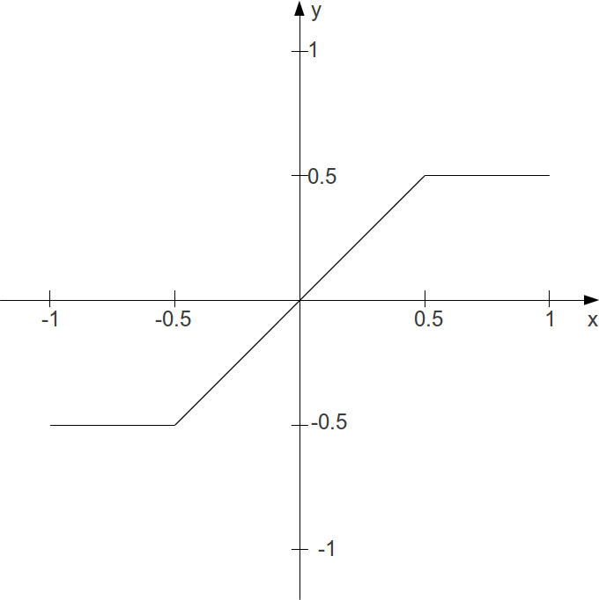

Basic Implementation Model
Implementing this as Csound code is pretty straightforward. The x-axis is the amplitude of every single sample, which is in the range of -1 to +1.1 This number has to be used as index to a table which stores the transfer function. To create a table like the one above, you can use Csound's sub-routine GEN072 . This statement will create a table of 4096 points in the desired shape:
giTrnsFnc ftgen 0, 0, 4096, -7, -0.5, 1024, -0.5, 2048, 0.5, 1024, 0.5
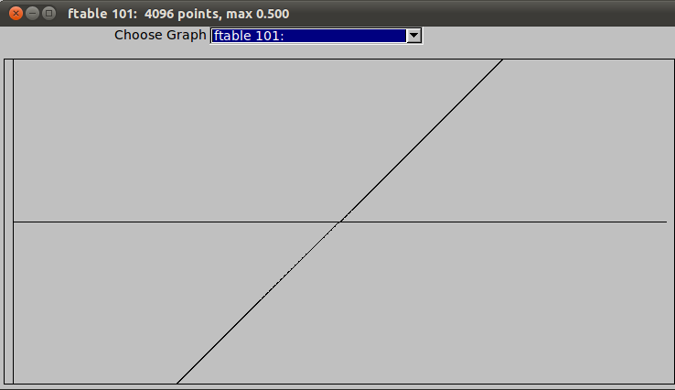
Now, two problems must be solved. First, the index of the function table is not -1 to +1. Rather, it is either 0 to 4095 in the raw index mode, or 0 to 1 in the normalized mode. The simplest solution is to use the normalized index and scale the incoming amplitudes, so that an amplitude of -1 becomes an index of 0, and an amplitude of 1 becomes an index of 1:
aIndx = (aAmp + 1) / 2
The other problem stems from the difference in the accuracy of possible values in a sample and in a function table. Every single sample is encoded in a 32-bit floating point number in standard audio applications - or even in a 64-bit float in recent Csound.3 A table with 4096 points results in a 12-bit number, so you will have a serious loss of accuracy (= sound quality) if you use the table values directly.4 Here, the solution is to use an interpolating table reader. The opcode tablei (instead of table) does this job. This opcode then needs an extra point in the table for interpolating, so it is wise to use 4097 as size instead of 4096.5
This is the code for the simple waveshaping with the transfer function which has been discussed so far:
EXAMPLE 04E01_Simple_waveshaping.csd
<CsoundSynthesizer>
<CsOptions>
-odac
</CsOptions>
<CsInstruments>
sr = 44100
ksmps = 32
nchnls = 2
0dbfs = 1

giTrnsFnc ftgen 0, 0, 4097, -7, -0.5, 1024, -0.5, 2048, 0.5, 1024, 0.5
giSine ftgen 0, 0, 1024, 10, 1

instr 1
aAmp poscil 1, 400, giSine
aIndx = (aAmp + 1) / 2
aWavShp tablei aIndx, giTrnsFnc, 1
outs aWavShp, aWavShp
endin

</CsInstruments>
<CsScore>
i 1 0 10
</CsScore>
</CsoundSynthesizer>
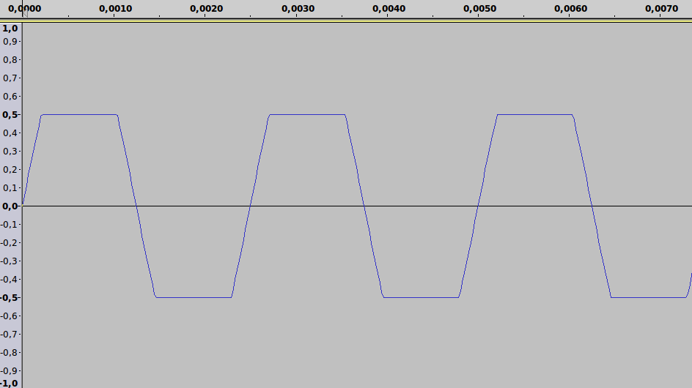

Chebychev Polynomials as Transfer Functions
Coming in a future release of this manual...

- Use the statement 0dbfs=1 in the orchestra header to ensure this.^
- See chapter 03D:FUNCTION TABLES to find more information about creating tables.^
- This is the 'd' in some abbreviations like Csound5.17-gnu-win32-d.exe (d = double precision floats).^
- Of course you can use an even smaller table if your goal is the degradation of the incoming sound ("distortion"). See chapter 05F for some examples.^
- A table size of a power-of-two plus one inserts the "extended guard point" as an extension of the last table value, instead of copying the first index to this location. See http://www.csounds.com/manual/html/f.html for more information.^

26. GRANULAR SYNTHESIS

Concept Behind Granular Synthesis
Granular synthesis is a technique in which a source sound or waveform is broken into many fragments, often of very short duration, which are then restructured and rearranged according to various patterning and indeterminacy functions.
If we imagine the simplest possible granular synthesis algorithm in which a precise fragment of sound is repeated with regularity, there are two principle attributes of this process that we are most concerned with. Firstly the duration of each sound grain is significant: if the grain duration if very small, typically less than 0.02 seconds, then less of the characteristics of the source sound will be evident. If the grain duration is greater than 0.02 then more of the character of the source sound or waveform will be evident. Secondly the rate at which grains are generated will be significant: if grain generation is below 20 hertz, i.e. less than 20 grains per second, then the stream of grains will be perceived as a rhythmic pulsation; if rate of grain generation increases beyond 20 Hz then individual grains will be harder to distinguish and instead we will begin to perceive a buzzing tone, the fundamental of which will correspond to the frequency of grain generation. Any pitch contained within the source material is not normally perceived as the fundamental of the tone whenever grain generation is periodic, instead the pitch of the source material or waveform will be perceived as a resonance peak (sometimes referred to as a formant); therefore transposition of the source material will result in the shifting of this resonance peak.

Granular Synthesis Demonstrated Using First Principles
The following example exemplifies the concepts discussed above. None of Csound's built-in granular synthesis opcodes are used, instead schedkwhen in instrument 1 is used to precisely control the triggering of grains in instrument 2. Three notes in instrument 1 are called from the score one after the other which in turn generate three streams of grains in instrument 2. The first note demonstrates the transition from pulsation to the perception of a tone as the rate of grain generation extends beyond 20 Hz. The second note demonstrates the loss of influence of the source material as the grain duration is reduced below 0.02 seconds. The third note demonstrates how shifting the pitch of the source material for the grains results in the shifting of a resonance peak in the output tone. In each case information regarding rate of grain generation, duration and fundamental (source material pitch) is output to the terminal every 1/2 second so that the user can observe the changing parameters.
It should also be noted how the amplitude of each grain is enveloped in instrument 2. If grains were left unenveloped they would likely produce clicks on account of discontinuities in the waveform produced at the beginning and ending of each grain.
Granular synthesis in which grain generation occurs with perceivable periodicity is referred to as synchronous granular synthesis. granular synthesis in which this periodicity is not evident is referred to as asynchronous granular synthesis.

EXAMPLE 04F01_GranSynth_basic.csd
<CsoundSynthesizer>

<CsOptions>
-odac -m0
</CsOptions>

<CsInstruments>
;Example by Iain McCurdy

sr = 44100
ksmps = 1
nchnls = 1
0dbfs = 1

giSine ftgen 0,0,4096,10,1

instr 1
kRate expon p4,p3,p5 ; rate of grain generation
kTrig metro kRate ; a trigger to generate grains
kDur expon p6,p3,p7 ; grain duration
kForm expon p8,p3,p9 ; formant (spectral centroid)
; p1 p2 p3 p4
schedkwhen kTrig,0,0,2, 0, kDur,kForm ;trigger a note(grain) in instr 2
;print data to terminal every 1/2 second
printks "Rate:%5.2F Dur:%5.2F Formant:%5.2F%n", 0.5, kRate , kDur, kForm
endin

instr 2
iForm = p4
aEnv linseg 0,0.005,0.2,p3-0.01,0.2,0.005,0
aSig poscil aEnv, iForm, giSine
out aSig
endin

</CsInstruments>

<CsScore>
;p4 = rate begin
;p5 = rate end
;p6 = duration begin
;p7 = duration end
;p8 = formant begin
;p9 = formant end
; p1 p2 p3 p4 p5 p6 p7 p8 p9
i 1 0 30 1 100 0.02 0.02 400 400 ;demo of grain generation rate
i 1 31 10 10 10 0.4 0.01 400 400 ;demo of grain size
i 1 42 20 50 50 0.02 0.02 100 5000 ;demo of changing formant
e
</CsScore>

</CsoundSynthesizer>

Granular Synthesis of Vowels: FOF
The principles outlined in the previous example can be extended to imitate vowel sounds produced by the human voice. This type of granular synthesis is referred to as FOF (fonction d'onde formatique) synthesis and is based on work by Xavier Rodet on his CHANT program at IRCAM. Typically five synchronous granular synthesis streams will be used to create five different resonant peaks in a fundamental tone in order to imitate different vowel sounds expressible by the human voice. The most crucial element in defining a vowel imitation is the degree to which the source material within each of the five grain streams is transposed. Bandwidth (essentially grain duration) and intensity (loudness) of each grain stream are also important indicators in defining the resultant sound.
Csound has a number of opcodes that make working with FOF synthesis easier. We will be using fof.
Information regarding frequency, bandwidth and intensity values that will produce various vowel sounds for different voice types can be found in the appendix of the Csound manual here. These values are stored in function tables in the FOF synthesis example. GEN07, which produces linear break point envelopes, is chosen as we will then be able to morph continuously between vowels.

EXAMPLE 04F02_Fof_vowels.csd
<CsoundSynthesizer>

<CsOptions>
-odac
</CsOptions>

<CsInstruments>
;example by Iain McCurdy

sr = 44100
ksmps = 16
nchnls = 2
0dbfs = 1

;FUNCTION TABLES STORING DATA FOR VARIOUS VOICE FORMANTS
;BASS
giBF1 ftgen 0, 0, -5, -2, 600, 400, 250, 400, 350
giBF2 ftgen 0, 0, -5, -2, 1040, 1620, 1750, 750, 600
giBF3 ftgen 0, 0, -5, -2, 2250, 2400, 2600, 2400, 2400
giBF4 ftgen 0, 0, -5, -2, 2450, 2800, 3050, 2600, 2675
giBF5 ftgen 0, 0, -5, -2, 2750, 3100, 3340, 2900, 2950

giBDb1 ftgen 0, 0, -5, -2, 0, 0, 0, 0, 0
giBDb2 ftgen 0, 0, -5, -2, -7, -12, -30, -11, -20
giBDb3 ftgen 0, 0, -5, -2, -9, -9, -16, -21, -32
giBDb4 ftgen 0, 0, -5, -2, -9, -12, -22, -20, -28
giBDb5 ftgen 0, 0, -5, -2, -20, -18, -28, -40, -36

giBBW1 ftgen 0, 0, -5, -2, 60, 40, 60, 40, 40
giBBW2 ftgen 0, 0, -5, -2, 70, 80, 90, 80, 80
giBBW3 ftgen 0, 0, -5, -2, 110, 100, 100, 100, 100
giBBW4 ftgen 0, 0, -5, -2, 120, 120, 120, 120, 120
giBBW5 ftgen 0, 0, -5, -2, 130, 120, 120, 120, 120

;TENOR
giTF1 ftgen 0, 0, -5, -2, 650, 400, 290, 400, 350
giTF2 ftgen 0, 0, -5, -2, 1080, 1700, 1870, 800, 600
giTF3 ftgen 0, 0, -5, -2, 2650, 2600, 2800, 2600, 2700
giTF4 ftgen 0, 0, -5, -2, 2900, 3200, 3250, 2800, 2900
giTF5 ftgen 0, 0, -5, -2, 3250, 3580, 3540, 3000, 3300

giTDb1 ftgen 0, 0, -5, -2, 0, 0, 0, 0, 0
giTDb2 ftgen 0, 0, -5, -2, -6, -14, -15, -10, -20
giTDb3 ftgen 0, 0, -5, -2, -7, -12, -18, -12, -17
giTDb4 ftgen 0, 0, -5, -2, -8, -14, -20, -12, -14
giTDb5 ftgen 0, 0, -5, -2, -22, -20, -30, -26, -26

giTBW1 ftgen 0, 0, -5, -2, 80, 70, 40, 40, 40
giTBW2 ftgen 0, 0, -5, -2, 90, 80, 90, 80, 60
giTBW3 ftgen 0, 0, -5, -2, 120, 100, 100, 100, 100
giTBW4 ftgen 0, 0, -5, -2, 130, 120, 120, 120, 120
giTBW5 ftgen 0, 0, -5, -2, 140, 120, 120, 120, 120

;COUNTER TENOR
giCTF1 ftgen 0, 0, -5, -2, 660, 440, 270, 430, 370
giCTF2 ftgen 0, 0, -5, -2, 1120, 1800, 1850, 820, 630
giCTF3 ftgen 0, 0, -5, -2, 2750, 2700, 2900, 2700, 2750
giCTF4 ftgen 0, 0, -5, -2, 3000, 3000, 3350, 3000, 3000
giCTF5 ftgen 0, 0, -5, -2, 3350, 3300, 3590, 3300, 3400

giTBDb1 ftgen 0, 0, -5, -2, 0, 0, 0, 0, 0
giTBDb2 ftgen 0, 0, -5, -2, -6, -14, -24, -10, -20
giTBDb3 ftgen 0, 0, -5, -2, -23, -18, -24, -26, -23
giTBDb4 ftgen 0, 0, -5, -2, -24, -20, -36, -22, -30
giTBDb5 ftgen 0, 0, -5, -2, -38, -20, -36, -34, -30

giTBW1 ftgen 0, 0, -5, -2, 80, 70, 40, 40, 40
giTBW2 ftgen 0, 0, -5, -2, 90, 80, 90, 80, 60
giTBW3 ftgen 0, 0, -5, -2, 120, 100, 100, 100, 100
giTBW4 ftgen 0, 0, -5, -2, 130, 120, 120, 120, 120
giTBW5 ftgen 0, 0, -5, -2, 140, 120, 120, 120, 120

;ALTO
giAF1 ftgen 0, 0, -5, -2, 800, 400, 350, 450, 325
giAF2 ftgen 0, 0, -5, -2, 1150, 1600, 1700, 800, 700
giAF3 ftgen 0, 0, -5, -2, 2800, 2700, 2700, 2830, 2530
giAF4 ftgen 0, 0, -5, -2, 3500, 3300, 3700, 3500, 2500
giAF5 ftgen 0, 0, -5, -2, 4950, 4950, 4950, 4950, 4950

giADb1 ftgen 0, 0, -5, -2, 0, 0, 0, 0, 0
giADb2 ftgen 0, 0, -5, -2, -4, -24, -20, -9, -12
giADb3 ftgen 0, 0, -5, -2, -20, -30, -30, -16, -30
giADb4 ftgen 0, 0, -5, -2, -36, -35, -36, -28, -40
giADb5 ftgen 0, 0, -5, -2, -60, -60, -60, -55, -64

giABW1 ftgen 0, 0, -5, -2, 50, 60, 50, 70, 50
giABW2 ftgen 0, 0, -5, -2, 60, 80, 100, 80, 60
giABW3 ftgen 0, 0, -5, -2, 170, 120, 120, 100, 170
giABW4 ftgen 0, 0, -5, -2, 180, 150, 150, 130, 180
giABW5 ftgen 0, 0, -5, -2, 200, 200, 200, 135, 200

;SOPRANO
giSF1 ftgen 0, 0, -5, -2, 800, 350, 270, 450, 325
giSF2 ftgen 0, 0, -5, -2, 1150, 2000, 2140, 800, 700
giSF3 ftgen 0, 0, -5, -2, 2900, 2800, 2950, 2830, 2700
giSF4 ftgen 0, 0, -5, -2, 3900, 3600, 3900, 3800, 3800
giSF5 ftgen 0, 0, -5, -2, 4950, 4950, 4950, 4950, 4950

giSDb1 ftgen 0, 0, -5, -2, 0, 0, 0, 0, 0
giSDb2 ftgen 0, 0, -5, -2, -6, -20, -12, -11, -16
giSDb3 ftgen 0, 0, -5, -2, -32, -15, -26, -22, -35
giSDb4 ftgen 0, 0, -5, -2, -20, -40, -26, -22, -40
giSDb5 ftgen 0, 0, -5, -2, -50, -56, -44, -50, -60

giSBW1 ftgen 0, 0, -5, -2, 80, 60, 60, 70, 50
giSBW2 ftgen 0, 0, -5, -2, 90, 90, 90, 80, 60
giSBW3 ftgen 0, 0, -5, -2, 120, 100, 100, 100, 170
giSBW4 ftgen 0, 0, -5, -2, 130, 150, 120, 130, 180
giSBW5 ftgen 0, 0, -5, -2, 140, 200, 120, 135, 200

gisine ftgen 0, 0, 4096, 10, 1
giexp ftgen 0, 0, 1024, 19, 0.5, 0.5, 270, 0.5

instr 1
kFund expon p4,p3,p5 ; fundemental
kVow line p6,p3,p7 ; vowel select
kBW line p8,p3,p9 ; bandwidth factor
iVoice = p10 ; voice select

; read formant cutoff frequenies from tables
kForm1 tablei kVow*5,giBF1+(iVoice*15)
kForm2 tablei kVow*5,giBF1+(iVoice*15)+1
kForm3 tablei kVow*5,giBF1+(iVoice*15)+2
kForm4 tablei kVow*5,giBF1+(iVoice*15)+3
kForm5 tablei kVow*5,giBF1+(iVoice*15)+4
; read formant intensity values from tables
kDB1 tablei kVow*5,giBF1+(iVoice*15)+5
kDB2 tablei kVow*5,giBF1+(iVoice*15)+6
kDB3 tablei kVow*5,giBF1+(iVoice*15)+7
kDB4 tablei kVow*5,giBF1+(iVoice*15)+8
kDB5 tablei kVow*5,giBF1+(iVoice*15)+9
; read formant bandwidths from tables
kBW1 tablei kVow*5,giBF1+(iVoice*15)+10
kBW2 tablei kVow*5,giBF1+(iVoice*15)+11
kBW3 tablei kVow*5,giBF1+(iVoice*15)+12
kBW4 tablei kVow*5,giBF1+(iVoice*15)+13
kBW5 tablei kVow*5,giBF1+(iVoice*15)+14
; create resonant formants using fof opcode
koct = 1
aForm1 fof ampdb(kDB1),kFund,kForm1,0,kBW1,0.003,0.02,0.007,\
1000,gisine,giexp,3600
aForm2 fof ampdb(kDB2),kFund,kForm2,0,kBW2,0.003,0.02,0.007,\
1000,gisine,giexp,3600
aForm3 fof ampdb(kDB3),kFund,kForm3,0,kBW3,0.003,0.02,0.007,\
1000,gisine,giexp,3600
aForm4 fof ampdb(kDB4),kFund,kForm4,0,kBW4,0.003,0.02,0.007,\
1000,gisine,giexp,3600
aForm5 fof ampdb(kDB5),kFund,kForm5,0,kBW5,0.003,0.02,0.007,\
1000,gisine,giexp,3600

; formants are mixed
aMix sum aForm1,aForm2,aForm3,aForm4,aForm5
kEnv linseg 0,3,1,p3-6,1,3,0 ; an amplitude envelope
outs aMix*kEnv*0.3, aMix*kEnv*0.3 ; send audio to outputs
endin

</CsInstruments>

<CsScore>
; p4 = fundamental begin value (c.p.s.)
; p5 = fundamental end value
; p6 = vowel begin value (0 - 1 : a e i o u)
; p7 = vowel end value
; p8 = bandwidth factor begin (suggested range 0 - 2)
; p9 = bandwidth factor end
; p10 = voice (0=bass; 1=tenor; 2=counter_tenor; 3=alto; 4=soprano)

; p1 p2 p3 p4 p5 p6 p7 p8 p9 p10
i 1 0 10 50 100 0 1 2 0 0
i 1 8 . 78 77 1 0 1 0 1
i 1 16 . 150 118 0 1 1 0 2
i 1 24 . 200 220 1 0 0.2 0 3
i 1 32 . 400 800 0 1 0.2 0 4
e
</CsScore>
</CsoundSynthesizer>

Asynchronous Granular Synthesis
The previous two examples have played psychoacoustic phenomena associated with the perception of granular textures that exhibit periodicity and patterns. If we introduce indeterminacy into some of the parameters of granular synthesis we begin to lose the coherence of some of these harmonic structures.
The next example is based on the design of example 04F01.csd. Two streams of grains are generated. The first stream begins as a synchronous stream but as the note progresses the periodicity of grain generation is eroded through the addition of an increasing degree of gaussian noise. It will be heard how the tone metamorphosizes from one characterized by steady purity to one of fuzzy airiness. The second the applies a similar process of increasing indeterminacy to the formant parameter (frequency of material within each grain).
Other parameters of granular synthesis such as the amplitude of each grain, grain duration, spatial location etc. can be similarly modulated with random functions to offset the psychoacoustic effects of synchronicity when using constant values.

EXAMPLE 04F03_Asynchronous_GS.csd
<CsoundSynthesizer>

<CsOptions>
-odac
</CsOptions>

<CsInstruments>
;Example by Iain McCurdy

sr = 44100
ksmps = 1
nchnls = 1
0dbfs = 1

giWave ftgen 0,0,2^10,10,1,1/2,1/4,1/8,1/16,1/32,1/64

instr 1 ;grain generating instrument 1
kRate = p4
kTrig metro kRate ; a trigger to generate grains
kDur = p5
kForm = p6
;note delay time (p2) is defined using a random function -
;- beginning with no randomization but then gradually increasing
kDelayRange transeg 0,1,0,0, p3-1,4,0.03
kDelay gauss kDelayRange
; p1 p2 p3 p4
schedkwhen kTrig,0,0,3, abs(kDelay), kDur,kForm ;trigger a note (grain) in instr 3
endin

instr 2 ;grain generating instrument 2
kRate = p4
kTrig metro kRate ; a trigger to generate grains
kDur = p5
;formant frequency (p4) is multiplied by a random function -
;- beginning with no randomization but then gradually increasing
kForm = p6
kFormOSRange transeg 0,1,0,0, p3-1,2,12 ;range defined in semitones
kFormOS gauss kFormOSRange
; p1 p2 p3 p4
schedkwhen kTrig,0,0,3, 0, kDur,kForm*semitone(kFormOS)
endin

instr 3 ;grain sounding instrument
iForm = p4
aEnv linseg 0,0.005,0.2,p3-0.01,0.2,0.005,0
aSig poscil aEnv, iForm, giWave
out aSig
endin

</CsInstruments>

<CsScore>
;p4 = rate
;p5 = duration
;p6 = formant
; p1 p2 p3 p4 p5 p6
i 1 0 12 200 0.02 400
i 2 12.5 12 200 0.02 400
e
</CsScore>

</CsoundSynthesizer>

Synthesis of Dynamic Sound Spectra: grain3
The next example introduces another of Csound's built-in granular synthesis opcodes to demonstrate the range of dynamic sound spectra that are possible with granular synthesis.
Several parameters are modulated slowly using Csound's random spline generator rspline. These parameters are formant frequency, grain duration and grain density (rate of grain generation). The waveform used in generating the content for each grain is randomly chosen using a slow sample and hold random function - a new waveform will be selected every 10 seconds. Five waveforms are provided: a sawtooth, a square wave, a triangle wave, a pulse wave and a band limited buzz-like waveform. Some of these waveforms, particularly the sawtooth, square and pulse waveforms, can generate very high overtones, for this reason a high sample rate is recommended to reduce the risk of aliasing (see chapter 01A).
Current values for formant (cps), grain duration, density and waveform are printed to the terminal every second. The key for waveforms is: 1:sawtooth; 2:square; 3:triangle; 4:pulse; 5:buzz.

EXAMPLE 04F04_grain3.csd
<CsoundSynthesizer>

<CsOptions>
-odac
</CsOptions>

<CsInstruments>
;example by Iain McCurdy

sr = 96000
ksmps = 16
nchnls = 1
0dbfs = 1

;waveforms used for granulation
giSaw ftgen 1,0,4096,7,0,4096,1
giSq ftgen 2,0,4096,7,0,2046,0,0,1,2046,1
giTri ftgen 3,0,4096,7,0,2046,1,2046,0
giPls ftgen 4,0,4096,7,1,200,1,0,0,4096-200,0
giBuzz ftgen 5,0,4096,11,20,1,1

;window function - used as an amplitude envelope for each grain
;(hanning window)
giWFn ftgen 7,0,16384,20,2,1

instr 1
;random spline generates formant values in oct format
kOct rspline 4,8,0.1,0.5
;oct format values converted to cps format
kCPS = cpsoct(kOct)
;phase location is left at 0 (the beginning of the waveform)
kPhs = 0
;frequency (formant) randomization and phase randomization are not used
kFmd = 0
kPmd = 0
;grain duration and density (rate of grain generation)
kGDur rspline 0.01,0.2,0.05,0.2
kDens rspline 10,200,0.05,0.5
;maximum number of grain overlaps allowed. This is used as a CPU brake
iMaxOvr = 1000
;function table for source waveform for content of the grain
;a different waveform chosen once every 10 seconds
kFn randomh 1,5.99,0.1
;print info. to the terminal
printks "CPS:%5.2F%TDur:%5.2F%TDensity:%5.2F%TWaveform:%1.0F%n",1,\
kCPS,kGDur,kDens,kFn
aSig grain3 kCPS, kPhs, kFmd, kPmd, kGDur, kDens, iMaxOvr, kFn, giWFn, \
0, 0
out aSig*0.06
endin

</CsInstruments>

<CsScore>
i 1 0 300
e
</CsScore>

</CsoundSynthesizer>

The final example introduces grain3's two built-in randomizing functions for phase and pitch. Phase refers to the location in the source waveform from which a grain will be read, pitch refers to the pitch of the material within grains. In this example a long note is played, initially no randomization is employed but gradually phase randomization is increased and then reduced back to zero. The same process is applied to the pitch randomization amount parameter. This time grain size is relatively large:0.8 seconds and density correspondingly low: 20 Hz.

EXAMPLE 04F05_grain3_random.csd
<CsoundSynthesizer>

<CsOptions>
-odac
</CsOptions>

<CsInstruments>
;example by Iain McCurdy

sr = 44100
ksmps = 16
nchnls = 1
0dbfs = 1

;waveforms used for granulation
giBuzz ftgen 1,0,4096,11,40,1,0.9

;window function - used as an amplitude envelope for each grain
;(bartlett window)
giWFn ftgen 2,0,16384,20,3,1

instr 1
kCPS = 100
kPhs = 0
kFmd transeg 0,21,0,0, 10,4,15, 10,-4,0
kPmd transeg 0,1,0,0, 10,4,1, 10,-4,0
kGDur = 0.8
kDens = 20
iMaxOvr = 1000
kFn = 1
;print info. to the terminal
printks "Random Phase:%5.2F%TPitch Random:%5.2F%n",1,kPmd,kFmd
aSig grain3 kCPS, kPhs, kFmd, kPmd, kGDur, kDens, iMaxOvr, kFn, giWFn, 0, 0
out aSig*0.06
endin

</CsInstruments>

<CsScore>
i 1 0 51
e
</CsScore>

</CsoundSynthesizer>

Conclusion
This chapter has introduced some of the concepts behind the synthesis of new sounds based on simple waveforms by using granular synthesis techniques. Only two of Csound's built-in opcodes for granular synthesis, fof and grain3, have been used; it is beyond the scope of this work to cover all of the many opcodes for granulation that Csound provides. This chapter has focused mainly on synchronous granular synthesis; chapter 05G, which introduces granulation of recorded sound files, makes greater use of asynchronous granular synthesis for time-stretching and pitch shifting. This chapter will also introduce some of Csound's other opcodes for granular synthesis.

27. PHYSICAL MODELLING
With physical modelling we employ a completely different approach to synthesis than we do with all other standard techniques. Unusually the focus is not primarily to produce a sound, but to model a physical process and if this process exhibits certain features such as periodic oscillation within a frequency range of 20 to 20000 Hz, it will produce sound.
Physical modelling synthesis techniques do not build sound using wave tables, oscillators and audio signal generators, instead they attempt to establish a model, as a system in itself, which which can then produce sound because of how the function it producers time varies with time. A physical model usually derives from the real physical world, but could be any time-varying system. Physical modelling is an exciting area for the production of new sounds.
Compared with the complexity of a real-world physically dynamic system a physical model will most likely represent a brutal simplification. Nevertheless, using this technique will demand a lot of formulae, because physical models are described in terms of mathematics. Although designing a model may require some considerable work, once established the results commonly exhibit a lively tone with time-varying partials and a "natural" difference between attack and release by their very design - features that other synthesis techniques will demand more from the end user in order to establish.
Csound already contains many ready-made physical models as opcodes but you can still build your own from scratch. This chapter will look at how to implement two classical models from first principles and then introduce a number of Csound's ready made physical modelling opcodes.

The Mass-Spring Model1
Many oscillating processes in nature can be modelled as connections of masses and springs. Imagine one mass-spring unit which has been set into motion. This system can be described as a sequence of states, where every new state results from the two preceding ones. Assumed the first state a0 is 0 and the second state a1 is 0.5. Without the restricting force of the spring, the mass would continue moving unimpeded following a constant velocity:
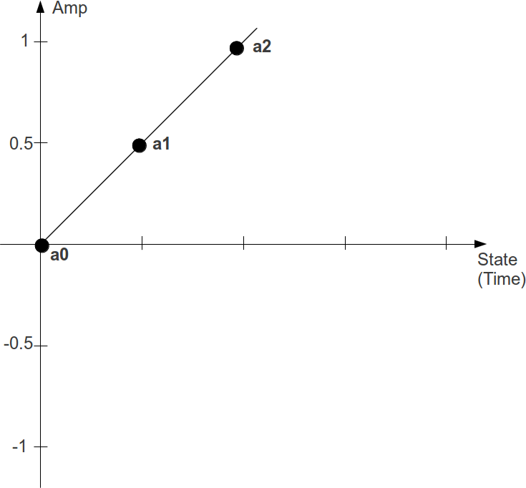
As the velocity between the first two states can be described as a1-a0, the value of the third state a2 will be:
a2 = a1 + (a1 - a0) = 0.5 + 0.5 = 1
But, the spring pulls the mass back with a force which increases the further the mass moves away from the point of equilibrium. Therefore the masses movement can be described as the product of a constant factor c and the last position a1. This damps the continuous movement of the mass so that for a factor of c=0.4 the next position will be:
a2 = (a1 + (a1 - a0)) - c * a1 = 1 - 0.2 = 0.8
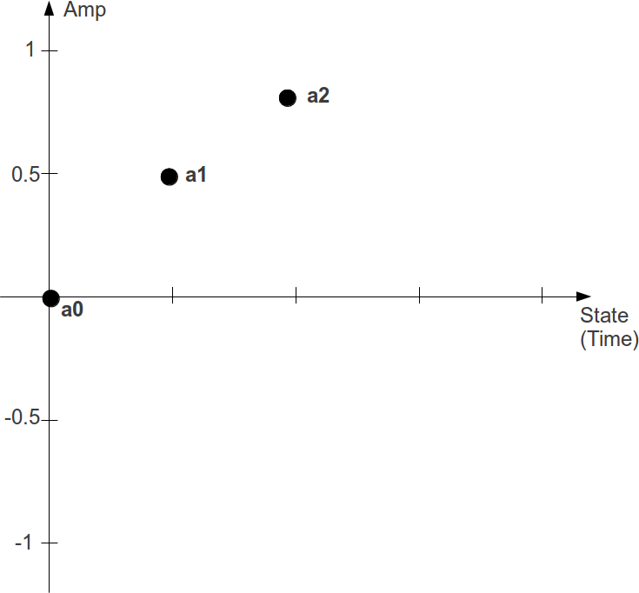
Csound can easily calculate the values by simply applying the formulae. For the first k-cycle2 , they are set via the init opcode. After calculating the new state, a1 becomes a0 and a2 becomes a1 for the next k-cycle. This is a csd which prints the new values five times per second. (The states are named here as k0/k1/k2 instead of a0/a1/a2, because k-rate values are needed here for printing instead of audio samples.)
EXAMPLE 04G01_Mass_spring_sine.csd
<CsoundSynthesizer>
<CsOptions>
-n ;no sound
</CsOptions>
<CsInstruments>
sr = 44100
ksmps = 8820 ;5 steps per second

instr PrintVals
;initial values
kstep init 0
k0 init 0
k1 init 0.5
kc init 0.4
;calculation of the next value
k2 = k1 + (k1 - k0) - kc * k1
printks "Sample=%d: k0 = %.3f, k1 = %.3f, k2 = %.3f\n", 0, kstep, k0, k1, k2
;actualize values for the next step
kstep = kstep+1
k0 = k1
k1 = k2
endin

</CsInstruments>
<CsScore>
i "PrintVals" 0 10
</CsScore>
</CsoundSynthesizer>
;example by joachim heintz
The output starts with:
State=0: k0 = 0.000, k1 = 0.500, k2 = 0.800
State=1: k0 = 0.500, k1 = 0.800, k2 = 0.780
State=2: k0 = 0.800, k1 = 0.780, k2 = 0.448
State=3: k0 = 0.780, k1 = 0.448, k2 = -0.063
State=4: k0 = 0.448, k1 = -0.063, k2 = -0.549
State=5: k0 = -0.063, k1 = -0.549, k2 = -0.815
State=6: k0 = -0.549, k1 = -0.815, k2 = -0.756
State=7: k0 = -0.815, k1 = -0.756, k2 = -0.393
State=8: k0 = -0.756, k1 = -0.393, k2 = 0.126
State=9: k0 = -0.393, k1 = 0.126, k2 = 0.595
State=10: k0 = 0.126, k1 = 0.595, k2 = 0.826
State=11: k0 = 0.595, k1 = 0.826, k2 = 0.727
State=12: k0 = 0.826, k1 = 0.727, k2 = 0.337
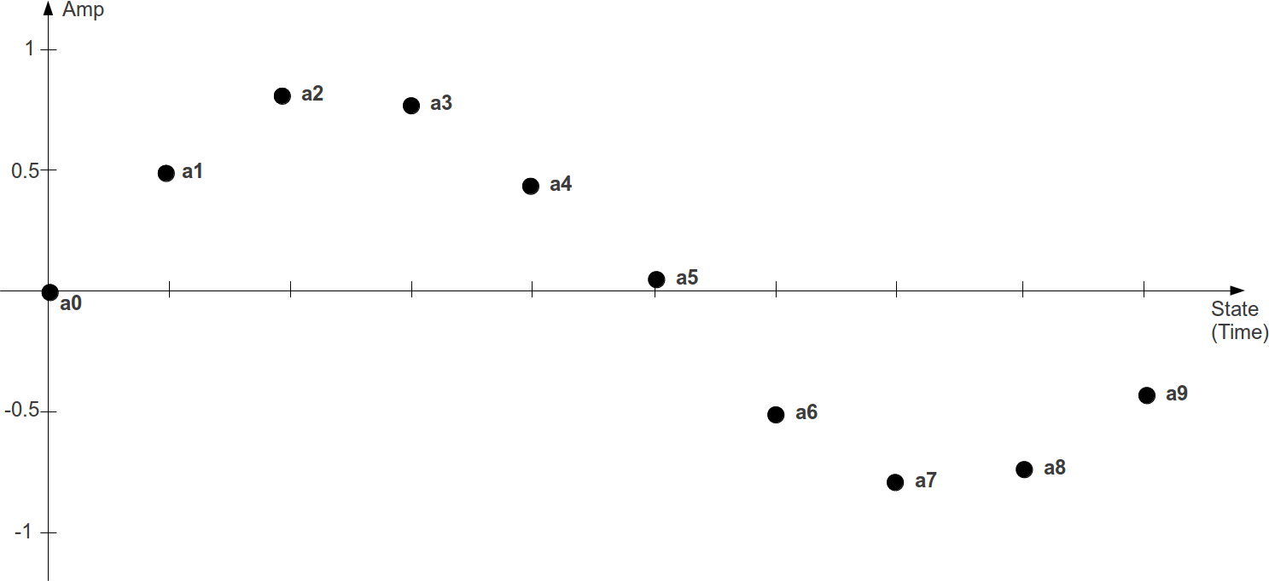
So, a sine wave has been created, without the use of any of Csound's oscillators...
Here is the audible proof:
EXAMPLE 04G02_MS_sine_audible.csd
<CsoundSynthesizer>
<CsOptions>
-odac
</CsOptions>
<CsInstruments>
sr = 44100
ksmps = 1
nchnls = 2
0dbfs = 1

instr MassSpring
;initial values
a0 init 0
a1 init 0.05
ic = 0.01 ;spring constant
;calculation of the next value
a2 = a1+(a1-a0) - ic*a1
outs a0, a0
;actualize values for the next step
a0 = a1
a1 = a2
endin
</CsInstruments>
<CsScore>
i "MassSpring" 0 10
</CsScore>
</CsoundSynthesizer>
;example by joachim heintz, after martin neukom
As the next sample is calculated in the next control cycle, ksmps has to be set to 1.3 The resulting frequency depends on the spring constant: the higher the constant, the higher the frequency. The resulting amplitude depends on both, the starting value and the spring constant.
This simple model shows the basic principle of a physical modelling synthesis: creating a system which produces sound because it varies in time. Certainly it is not the goal of physical modelling synthesis to reinvent the wheel of a sine wave. But modulating the parameters of a model may lead to interesting results. The next example varies the spring constant, which is now no longer a constant:
EXAMPLE 04G03_MS_variable_constant.csd
<CsoundSynthesizer>
<CsOptions>
-odac
</CsOptions>
<CsInstruments>
sr = 44100
ksmps = 1
nchnls = 2
0dbfs = 1

instr MassSpring
;initial values
a0 init 0
a1 init 0.05
kc randomi .001, .05, 8, 3
;calculation of the next value
a2 = a1+(a1-a0) - kc*a1
outs a0, a0
;actualize values for the next step
a0 = a1
a1 = a2
endin
</CsInstruments>
<CsScore>
i "MassSpring" 0 10
</CsScore>
</CsoundSynthesizer>
;example by joachim heintz
Working with physical modelling demands thought in more physical or mathematical terms: examples of this might be if you were to change the formula when a certain value of c had been reached, or combine more than one spring.

Implementing Simple Physical Systems
This text shows how to get oscillators and filters from simple physical models by recording the position of a point (mass) of a physical system. The behavior of a particle (mass on a spring, mass of a pendulum, etc.) is described by its position, velocity and acceleration. The mathematical equations which describe the movement of such a point are differential equations. In what follows, we describe how to derive time discrete system equations (also called difference equations) from physical models (described by differential equations). At every time step we first calculate the acceleration of a mass and then its new velocity and position. This procedure is called Euler's method and yields good results for low frequencies compared to the sampling rate. (Better approximations are achieved with the improved Euler's method or the Runge–Kutta methods.)
(The figures below have been realized with Mathematica)

Integrating the Trajectory of a Point
Velocity v is the difference of positions x per time unit T, acceleration a the difference of velocities v per time unit T:

vt = (xt – xt-1)/T, at = (vt – vt-1)/T.
Putting T = 1 we get

vt = xt – xt-1, at = vt – vt-1.
If we know the position and velocity of a point at time t – 1 and are able to calculate its acceleration at time t we can calculate the velocity vt and the position xt at time t:

vt = vt-1 + at and xt = xt-1 + vt
With the following algorithm we calculate a sequence of successive positions x:
1. init x and v
2. calculate a
3. v += a ; v = v + a
4. x += v ; x = x + v
Example 1: The acceleration of gravity is constant (g = –9.81ms-2). For a mass with initial position x = 300m (above ground) and velocity v = 70ms-1 (upwards) we get the following trajectory (path)
g = -9.81; x = 300; v = 70; Table[v += g; x += v, {16}];
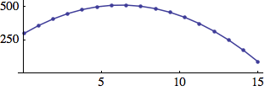
Example 2: The acceleration a of a mass on a spring is proportional (with factor –c) to its position (deflection) x.
x = 0; v = 1; c = .3; Table[a = -c*x; v += a; x += v, {22}];
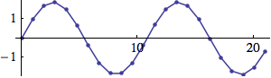

Introducing damping:
Since damping is proportional to the velocity we reduce velocity at every time step by a certain amount d:
v *= (1 - d)
Example 3: Spring with damping (see lin_reson.csd below):
d = 0.2; c = .3; x = 0; v = 1;
Table[a = -c*x; v += a; v *= (1 - d); x += v, {22}];
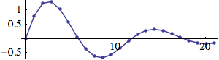

The factor c can be calculated from the frequency f:
c = 2 – sqrt(4 – d2) cos(2π f/sr)

Introducing excitation:

In the examples 2 and 3 the systems oscillate because of their initial velocity v = 1. The resultant oscillation is the impulse response of the systems. We can excite the systems continuously by adding a value exc to the velocity at every time step.
v += exc;
Example 4: Damped spring with random excitation (resonator with noise as input)
d = .01; s = 0; v = 0; Table[a = -.3*s; v += a; v += RandomReal[{-1, 1}]; v *= (1 - d); s += v, {61}];
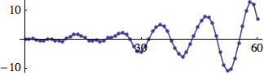
EXAMPLE 04G04_lin_reson.csd
<CsoundSynthesizer>
<CsInstruments>
sr = 44100
ksmps = 100
nchnls = 1
0dbfs = 1

opcode lin_reson, a, akk
setksmps 1
avel init 0 ;velocity
ax init 0 ;deflection x
ain,kf,kdamp xin
kc = 2-sqrt(4-kdamp^2)*cos(kf*2*$M_PI/sr)
aacel = -kc*ax
avel = avel+aacel+ain
avel = avel*(1-kdamp)
ax = ax+avel
xout ax
endop

instr 1
aexc rand p4
aout lin_reson aexc,p5,p6
out aout
endin

</CsInstruments>
<CsScore>
; p4 p5 p6
; excitaion freq damping
i1 0 5 .0001 440 .0001
</CsScore>
</CsoundSynthesizer>
;example by martin neukom

Introducing nonlinear acceleration:
Example 5: The acceleration of a pendulum depends on its deflection (angle x).
a = c*sin(x)
This figure shows the function –.3sin(x)
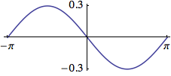
The following trajectory shows that the frequency decreases with encreasing amplitude and that the pendulum can turn around.
d = .003; s = 0; v = 0;
Table[a = f[s]; v += a; v += RandomReal[{-.09, .1}]; v *= (1 - d);
s += v, {400}];
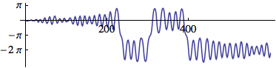

We can implement systems with accelerations that are arbitrary functions of position x.

Example 6: a = f(x) = – c1x + c2sin(c3x)
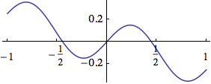
d = .03; x = 0; v = 0; Table[a = f[x]; v += a; v += RandomReal[{-.1, .1}]; v *= (1 - d); x += v, {400}];
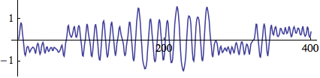
EXAMPLE 04G05_nonlin_reson.csd
<CsoundSynthesizer>
<CsInstruments>

sr = 44100
ksmps = 100
nchnls = 1
0dbfs = 1

; simple damped nonlinear resonator
opcode nonlin_reson, a, akki
setksmps 1
avel init 0 ;velocity
adef init 0 ;deflection
ain,kc,kdamp,ifn xin
aacel tablei adef, ifn, 1, .5 ;acceleration = -c1*f1(def)
aacel = -kc*aacel
avel = avel+aacel+ain ;vel += acel + excitation
avel = avel*(1-kdamp)
adef = adef+avel
xout adef
endop

instr 1
kenv oscil p4,.5,1
aexc rand kenv
aout nonlin_reson aexc,p5,p6,p7
out aout
endin

</CsInstruments>
<CsScore>
f1 0 1024 10 1
f2 0 1024 7 -1 510 .15 4 -.15 510 1
f3 0 1024 7 -1 350 .1 100 -.3 100 .2 100 -.1 354 1
; p4 p5 p6 p7
; excitation c1 damping ifn
i1 0 20 .0001 .01 .00001 3
;i1 0 20 .0001 .01 .00001 2
</CsScore>
</CsoundSynthesizer>
;example by martin neukom

The Van der Pol Oscillator:

While attempting to explain the nonlinear dynamics of vacuum tube circuits, the Dutch electrical engineer Balthasar van der Pol derived the differential equation

d2x/dt2 = –ω2x + μ(1 – x2)dx/dt. (where d2x/dt2 = acelleration and dx/dt = velocity)

The equation describes a linear oscillator d2x/dt2 = –ω2x with an additional nonlinear term μ(1 – x2)dx/dt. When |x| > 1, the nonlinear term results in damping, but when |x| < 1, negative damping results, which means that energy is introduced into the system.
Such oscillators compensating for energy loss by an inner energy source are called self-sustained oscillators.
v = 0; x = .001; ω = 0.1; μ = 0.25;
snd = Table[v += (-ω^2*x + μ*(1 - x^2)*v); x += v, {200}];
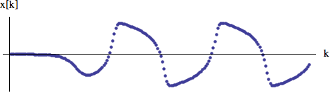
The constant ω is the angular frequency of the linear oscillator (μ = 0). For a simulation with sampling rate sr we calculate the frequency f in Hz as

f = ω·sr/2π.

Since the simulation is only an approximation of the oscillation this formula gives good results only for low frequencies. The exact frequency of the simulation is

f = arccos(1 – ω2/2)sr·/2π.
We get ω2 from frequency f as
2 – 2cos(f·2π/sr).
With increasing μ the oscillations nonlinearity becomes stronger and more overtones arise (and at the same time the frequency becomes lower). The following figure shows the spectrum of the oscillation for various values of μ.
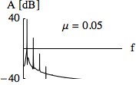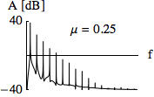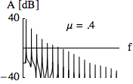
Certain oscillators can be synchronized either by an external force or by mutual influence. Examples of synchronization by an external force are the control of cardiac activity by a pace maker and the adjusting of a clock by radio signals. An example for the mutual synchronization of oscillating systems is the coordinated clapping of an audience. These systems have in common that they are not linear and that they oscillate without external excitation (self-sustained oscillators).

The UDO v_d_p represents a Van der Pol oscillator with a natural frequency kfr and a nonlinearity factor kmu. It can be excited by a sine wave of frequency kfex and amplitude kaex. The range of frequency within which the oscillator is synchronized to the exciting frequency increases as kmu and kaex increase.
EXAMPLE 04G06_van_der_pol.csd
<CsoundSynthesizer>
<CsInstruments>
sr = 44100
ksmps = 100
nchnls = 2
0dbfs = 1

;Van der Pol Oscillator ;outputs a nonliniear oscillation
;inputs: a_excitation, k_frequency in Hz (of the linear part), nonlinearity (0 < mu < ca. 0.7)
opcode v_d_p, a, akk
setksmps 1
av init 0
ax init 0
ain,kfr,kmu xin
kc = 2-2*cos(kfr*2*$M_PI/sr)
aa = -kc*ax + kmu*(1-ax*ax)*av
av = av + aa
ax = ax + av + ain
xout ax
endop
instr 1
kaex invalue "aex"
kfex invalue "fex"
kamp invalue "amp"
kf invalue "freq"
kmu invalue "mu"
a1 oscil kaex,kfex,1
aout v_d_p a1,kf,kmu
out kamp*aout,a1*100
endin
</CsInstruments>
<CsScore>
f1 0 32768 10 1
i1 0 95
</CsScore>
</CsoundSynthesizer>
The variation of the phase difference between excitation and oscillation, as well as the transitions between synchronous, beating and asynchronous behaviors, can be visualized by showing the sum of the excitation and the oscillation signals in a phase diagram. The following figures show to the upper left the waveform of the Van der Pol oscillator, to the lower left that of the excitation (normalized) and to the right the phase diagram of their sum. For these figures, the same values were always used for kfr, kmu and kaex. Comparing the first two figures, one sees that the oscillator adopts the exciting frequency kfex within a large frequency range. When the frequency is low (figure a), the phases of the two waves are nearly the same. Hence there is a large deflection along the x-axis in the phase diagram showing the sum of the waveforms. When the frequency is high, the phases are nearly inverted (figure b) and the phase diagram shows only a small deflection. The figure c shows the transition to asynchronous behavior. If the proportion between the natural frequency of the oscillator kfr and the excitation frequency kfex is approximately simple (kfex/kfr ≅ m/n), then within a certain range the frequency of the Van der Pol oscillator is synchronized so that kfex/kfr = m/n. Here one speaks of higher order synchronization (figure d).
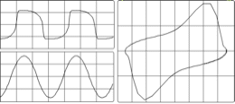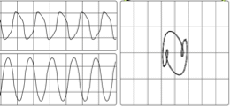
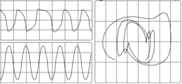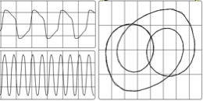

The Karplus-Strong Algorithm: Plucked String
The Karplus-Strong algorithm provides another simple yet interesting example of how physical modelling can be used to synthesized sound. A buffer is filled with random values of either +1 or -1. At the end of the buffer, the mean of the first and the second value to come out of the buffer is calculated. This value is then put back at the beginning of the buffer, and all the values in the buffer are shifted by one position.
This is what happens for a buffer of five values, for the first five steps:
initial state | 1 | -1 | 1 | 1 | -1
step 1 | 0 | 1 | -1 | 1 | 1
step 2 | 1 | 0 | 1 | -1 | 1
step 3 | 0 | 1 | 0 | 1 | -1
step 4 | 0 | 0 | 1 | 0 | 1
step 5 | 0.5 | 0 | 0 | 1 | 0

The next Csound example represents the content of the buffer in a function table, implements and executes the algorithm, and prints the result after each five steps which here is referred to as one cycle:
EXAMPLE 04G07_KarplusStrong.csd
<CsoundSynthesizer>
<CsOptions>
-n
</CsOptions>
<CsInstruments>
sr = 44100
ksmps = 32
nchnls = 1
0dbfs = 1

opcode KS, 0, ii
;performs the karplus-strong algorithm
iTab, iTbSiz xin
;calculate the mean of the last two values
iUlt tab_i iTbSiz-1, iTab
iPenUlt tab_i iTbSiz-2, iTab
iNewVal = (iUlt + iPenUlt) / 2
;shift values one position to the right
indx = iTbSiz-2
loop:
iVal tab_i indx, iTab
tabw_i iVal, indx+1, iTab
loop_ge indx, 1, 0, loop
;fill the new value at the beginning of the table
tabw_i iNewVal, 0, iTab
endop

opcode PrintTab, 0, iiS
;prints table content, with a starting string
iTab, iTbSiz, Sout xin
indx = 0
loop:
iVal tab_i indx, iTab
Snew sprintf "%8.3f", iVal
Sout strcat Sout, Snew
loop_lt indx, 1, iTbSiz, loop
puts Sout, 1
endop

instr ShowBuffer
;fill the function table
iTab ftgen 0, 0, -5, -2, 1, -1, 1, 1, -1
iTbLen tableng iTab
;loop cycles (five states)
iCycle = 0
cycle:
Scycle sprintf "Cycle %d:", iCycle
PrintTab iTab, iTbLen, Scycle
;loop states
iState = 0
state:
KS iTab, iTbLen
loop_lt iState, 1, iTbLen, state
loop_lt iCycle, 1, 10, cycle
endin

</CsInstruments>
<CsScore>
i "ShowBuffer" 0 1
</CsScore>
</CsoundSynthesizer>
This is the output:
Cycle 0: 1.000 -1.000 1.000 1.000 -1.000
Cycle 1: 0.500 0.000 0.000 1.000 0.000
Cycle 2: 0.500 0.250 0.000 0.500 0.500
Cycle 3: 0.500 0.375 0.125 0.250 0.500
Cycle 4: 0.438 0.438 0.250 0.188 0.375
Cycle 5: 0.359 0.438 0.344 0.219 0.281
Cycle 6: 0.305 0.398 0.391 0.281 0.250
Cycle 7: 0.285 0.352 0.395 0.336 0.266
Cycle 8: 0.293 0.318 0.373 0.365 0.301
Cycle 9: 0.313 0.306 0.346 0.369 0.333
It can be seen clearly that the values get smoothed more and more from cycle to cycle. As the buffer size is very small here, the values tend to come to a constant level; in this case 0.333. But for larger buffer sizes, after some cycles the buffer content has the effect of a period which is repeated with a slight loss of amplitude. This is how it sounds, if the buffer size is 1/100 second (or 441 samples at sr=44100):
EXAMPLE 04G08_Plucked.csd
<CsoundSynthesizer>
<CsOptions>
-odac
</CsOptions>
<CsInstruments>
sr = 44100
ksmps = 1
nchnls = 2
0dbfs = 1

instr 1
;delay time
iDelTm = 0.01
;fill the delay line with either -1 or 1 randomly
kDur timeinsts
if kDur < iDelTm then
aFill rand 1, 2, 1, 1 ;values 0-2
aFill = floor(aFill)*2 - 1 ;just -1 or +1
else
aFill = 0
endif
;delay and feedback
aUlt init 0 ;last sample in the delay line
aUlt1 init 0 ;delayed by one sample
aMean = (aUlt+aUlt1)/2 ;mean of these two
aUlt delay aFill+aMean, iDelTm
aUlt1 delay1 aUlt
outs aUlt, aUlt
endin

</CsInstruments>
<CsScore>
i 1 0 60
</CsScore>
</CsoundSynthesizer>
;example by joachim heintz, after martin neukom
This sound resembles a plucked string: at the beginning the sound is noisy but after a short period of time it exhibits periodicity. As can be heard, unless a natural string, the steady state is virtually endless, so for practical use it needs some fade-out. The frequency the listener perceives is related to the length of the delay line. If the delay line is 1/100 of a second, the perceived frequency is 100 Hz. Compared with a sine wave of similar frequency, the inherent periodicity can be seen, and also the rich overtone structure:
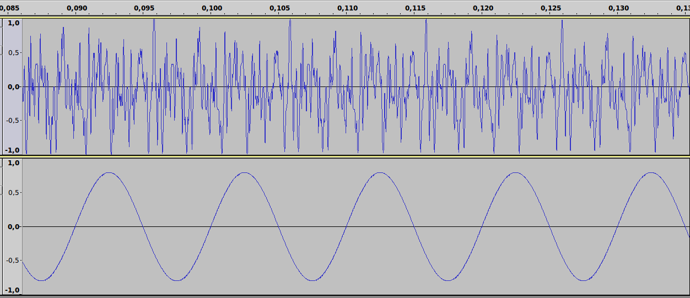
Csound also contains over forty opcodes which provide a wide variety of ready-made physical models and emulations. A small number of them will be introduced here to give a brief overview of the sort of things available.

wgbow - A Waveguide Emulation of a Bowed String by Perry Cook
Perry Cook is a prolific author of physical models and a lot of his work has been converted into Csound opcodes. A number of these models wgbow, wgflute, wgclar wgbowedbar and wgbrass are based on waveguides. A waveguide, in its broadest sense, is some sort of mechanism that limits the extend of oscillations, such as a vibrating string fixed at both ends or a pipe. In these sorts of physical model a delay is used to emulate these limits. One of these, wgbow, implements an emulation of a bowed string. Perhaps the most interesting aspect of many physical models in not specifically whether they emulate the target instrument played in a conventional way accurately but the facilities they provide for extending the physical limits of the instrument and how it is played - there are already vast sample libraries and software samplers for emulating conventional instruments played conventionally. wgbow offers several interesting options for experimentation including the ability to modulate the bow pressure and the bowing position at k-rate. Varying bow pressure will change the tone of the sound produced by changing the harmonic emphasis. As bow pressure reduces, the fundamental of the tone becomes weaker and overtones become more prominent. If the bow pressure is reduced further the abilty of the system to produce a resonance at all collapse. This boundary between tone production and the inability to produce a tone can provide some interesting new sound effect. The following example explores this sound area by modulating the bow pressure parameter around this threshold. Some additional features to enhance the example are that 7 different notes are played simultaneously, the bow pressure modulations in the right channel are delayed by a varying amount with respect top the left channel in order to create a stereo effect and a reverb has been added.
EXAMPLE 04G09_wgbow.csd
<CsoundSynthesizer>

<CsOptions>
-odac
</CsOptions>

<CsInstruments>

sr = 44100
ksmps = 32
nchnls = 2
0dbfs = 1
seed 0

gisine ftgen 0,0,4096,10,1

gaSendL,gaSendR init 0

instr 1 ; wgbow instrument
kamp = 0.3
kfreq = p4
ipres1 = p5
ipres2 = p6
; kpres (bow pressure) defined using a random spline
kpres rspline p5,p6,0.5,2
krat = 0.127236
kvibf = 4.5
kvibamp = 0
iminfreq = 20
; call the wgbow opcode
aSigL wgbow kamp,kfreq,kpres,krat,kvibf,kvibamp,gisine,iminfreq
; modulating delay time
kdel rspline 0.01,0.1,0.1,0.5
; bow pressure parameter delayed by a varying time in the right channel
kpres vdel_k kpres,kdel,0.2,2
aSigR wgbow kamp,kfreq,kpres,krat,kvibf,kvibamp,gisine,iminfreq
outs aSigL,aSigR
; send some audio to the reverb
gaSendL = gaSendL + aSigL/3
gaSendR = gaSendR + aSigR/3
endin

instr 2 ; reverb
aRvbL,aRvbR reverbsc gaSendL,gaSendR,0.9,7000
outs aRvbL,aRvbR
clear gaSendL,gaSendR
endin

</CsInstruments>

<CsScore>
; instr. 1
; p4 = pitch (hz.)
; p5 = minimum bow pressure
; p6 = maximum bow pressure
; 7 notes played by the wgbow instrument
i 1 0 480 70 0.03 0.1
i 1 0 480 85 0.03 0.1
i 1 0 480 100 0.03 0.09
i 1 0 480 135 0.03 0.09
i 1 0 480 170 0.02 0.09
i 1 0 480 202 0.04 0.1
i 1 0 480 233 0.05 0.11
; reverb instrument
i 2 0 480
</CsScore>

</CsoundSynthesizer>
This time a stack of eight sustaining notes, each separated by an octave, vary their 'bowing position' randomly and independently. You will hear how different bowing positions accentuates and attenuates different partials of the bowing tone. To enhance the sound produced some filtering with tone and pareq is employed and some reverb is added.
EXAMPLE 04G010_wgbow_enhanced.csd
<CsoundSynthesizer>

<CsOptions>
-odac
</CsOptions>

<CsInstruments>

sr = 44100
ksmps = 32
nchnls = 2
0dbfs = 1
seed 0

gisine ftgen 0,0,4096,10,1

gaSend init 0

instr 1 ; wgbow instrument
kamp = 0.1
kfreq = p4
kpres = 0.2
krat rspline 0.006,0.988,0.1,0.4
kvibf = 4.5
kvibamp = 0
iminfreq = 20
aSig wgbow kamp,kfreq,kpres,krat,kvibf,kvibamp,gisine,iminfreq
aSig butlp aSig,2000
aSig pareq aSig,80,6,0.707
outs aSig,aSig
gaSend = gaSend + aSig/3
endin

instr 2 ; reverb
aRvbL,aRvbR reverbsc gaSend,gaSend,0.9,7000
outs aRvbL,aRvbR
clear gaSend
endin

</CsInstruments>

<CsScore>
; instr. 1 (wgbow instrument)
; p4 = pitch (hertz)
; wgbow instrument
i 1 0 480 20
i 1 0 480 40
i 1 0 480 80
i 1 0 480 160
i 1 0 480 320
i 1 0 480 640
i 1 0 480 1280
i 1 0 480 2460
; reverb instrument
i 2 0 480
</CsScore>

</CsoundSynthesizer>
All of the wg- family of opcodes are worth exploring and often the approach taken here - exploring each input parameter in isolation whilst the others retain constant values - sets the path to understanding the model better. Tone production with wgbrass is very much dependent upon the relationship between intended pitch and lip tension, random experimentation with this opcode is as likely to result in silence as it is in sound and in this way is perhaps a reflection of the experience of learning a brass instrument when the student spends most time push air silently through the instrument. With patience it is capable of some interesting sounds however. In its case, I would recommend building a realtime GUI and exploring the interaction of its input arguments that way. wgbowedbar, like a number of physical modelling algorithms, is rather unstable. This is not necessary a design flaw in the algorithm but instead perhaps an indication that the algorithm has been left quite open for out experimentation - or abuse. In these situation caution is advised in order to protect ears and loudspeakers. Positive feedback within the model can result in signals of enormous amplitude very quickly. Employment of the clip opcode as a means of some protection is recommended when experimenting in realtime.

barmodel - a Model of a Struck Metal Bar by Stefan Bilbao
barmodel can also imitate wooden bars, tubular bells, chimes and other resonant inharmonic objects. barmodel is a model that can easily be abused to produce ear shreddingly loud sounds therefore precautions are advised when experimenting with it in realtime. We are presented with a wealth of input arguments such as 'stiffness', 'strike position' and 'strike velocity', which relate in an easily understandable way to the physical process we are emulating. Some parameters will evidently have more of a dramatic effect on the sound produced than other and again it is recommended to create a realtime GUI for exploration. Nonetheless, a fixed example is provided below that should offer some insight into the kinds of sounds possible.
Probably the most important parameter for us is the stiffness of the bar. This actually provides us with our pitch control and is not in cycle-per-second so some experimentation will be required to find a desired pitch. There is a relationship between stiffness and the parameter used to define the width of the strike - when the stiffness coefficient is higher a wider strike may be required in order for the note to sound. Strike width also impacts upon the tone produced, narrower strikes generating emphasis upon upper partials (provided a tone is still produced) whilst wider strikes tend to emphasize the fundamental).
The parameter for strike position also has some impact upon the spectral balance. This effect may be more subtle and may be dependent upon some other parameter settings, for example, when strike width is particularly wide, its effect may be imperceptible. A general rule of thumb here is that is that in order to achieve the greatest effect from strike position, strike width should be as low as will still produce a tone. This kind of interdependency between input parameters is the essence of working with a physical model that can be both intriguing and frustrating.
An important parameter that will vary the impression of the bar from metal to wood is
An interesting feature incorporated into the model in the ability to modulate the point along the bar at which vibrations are read. This could also be described as pick-up position. Moving this scanning location results in tonal and amplitude variations. We just have control over the frequency at which the scanning location is modulated.
EXAMPLE 04G011_barmodel.csd
<CsoundSynthesizer>
<CsOptions>
-odac
</CsOptions>
<CsInstruments>
sr = 44100
ksmps = 32
nchnls = 2
0dbfs = 1

instr 1
; boundary conditions 1=fixed 2=pivot 3=free
kbcL = 1
kbcR = 1
; stiffness
iK = p4
; high freq. loss (damping)
ib = p5
; scanning frequency
kscan rspline p6,p7,0.2,0.8
; time to reach 30db decay
iT30 = p3
; strike position
ipos random 0,1
; strike velocity
ivel = 1000
; width of strike
iwid = 0.1156
aSig barmodel kbcL,kbcR,iK,ib,kscan,iT30,ipos,ivel,iwid
kPan rspline 0.1,0.9,0.5,2
aL,aR pan2 aSig,kPan
outs aL,aR
endin

</CsInstruments>

<CsScore>
;t 0 90 1 30 2 60 5 90 7 30
; p4 = stiffness (pitch)

#define gliss(dur'Kstrt'Kend'b'scan1'scan2)
#
i 1 0 20 $Kstrt $b $scan1 $scan2
i 1 ^+0.05 $dur > $b $scan1 $scan2
i 1 ^+0.05 $dur > $b $scan1 $scan2
i 1 ^+0.05 $dur > $b $scan1 $scan2
i 1 ^+0.05 $dur > $b $scan1 $scan2
i 1 ^+0.05 $dur > $b $scan1 $scan2
i 1 ^+0.05 $dur > $b $scan1 $scan2
i 1 ^+0.05 $dur > $b $scan1 $scan2
i 1 ^+0.05 $dur > $b $scan1 $scan2
i 1 ^+0.05 $dur > $b $scan1 $scan2
i 1 ^+0.05 $dur > $b $scan1 $scan2
i 1 ^+0.05 $dur > $b $scan1 $scan2
i 1 ^+0.05 $dur > $b $scan1 $scan2
i 1 ^+0.05 $dur > $b $scan1 $scan2
i 1 ^+0.05 $dur > $b $scan1 $scan2
i 1 ^+0.05 $dur > $b $scan1 $scan2
i 1 ^+0.05 $dur > $b $scan1 $scan2
i 1 ^+0.05 $dur $Kend $b $scan1 $scan2
#
$gliss(15'40'400'0.0755'0.1'2)
b 5
$gliss(2'80'800'0.755'0'0.1)
b 10
$gliss(3'10'100'0.1'0'0)
b 15
$gliss(40'40'433'0'0.2'5)
e
</CsScore>
</CsoundSynthesizer>
; example written by Iain McCurdy

PhISEM - Physically Inspired Stochastic Event Modeling
The PhiSEM set of models in Csound, again based on the work of Perry Cook, imitate instruments that rely on collisions between smaller sound producing object to produce their sounds. These models include a tambourine, a set of bamboo windchimes and sleighbells. These models algorithmically mimic these multiple collisions internally so that we only need to define elements such as the number of internal elements (timbrels, beans, bells etc.) internal damping and resonances. Once again the most interesting aspect of working with a model is to stretch the physical limits so that we can hear the results from, for example, a maraca with an impossible number of beans, a tambourine with so little internal damping that it never decays. In the following example I explore tambourine, bamboo and sleighbells each in turn, first in a state that mimics the source instrument and then with some more extreme conditions.
EXAMPLE 04G12_PhiSEM.csd
<CsoundSynthesizer>

<CsOptions>
-odac
</CsOptions>

<CsInstruments>

sr = 44100
ksmps = 32
nchnls = 1
0dbfs = 1

instr 1 ; tambourine
iAmp = p4
iDettack = 0.01
iNum = p5
iDamp = p6
iMaxShake = 0
iFreq = p7
iFreq1 = p8
iFreq2 = p9
aSig tambourine iAmp,iDettack,iNum,iDamp,iMaxShake,iFreq,iFreq1,iFreq2
out aSig
endin

instr 2 ; bamboo
iAmp = p4
iDettack = 0.01
iNum = p5
iDamp = p6
iMaxShake = 0
iFreq = p7
iFreq1 = p8
iFreq2 = p9
aSig bamboo iAmp,iDettack,iNum,iDamp,iMaxShake,iFreq,iFreq1,iFreq2
out aSig
endin

instr 3 ; sleighbells
iAmp = p4
iDettack = 0.01
iNum = p5
iDamp = p6
iMaxShake = 0
iFreq = p7
iFreq1 = p8
iFreq2 = p9
aSig sleighbells iAmp,iDettack,iNum,iDamp,iMaxShake,iFreq,iFreq1,iFreq2
out aSig
endin

</CsInstruments>

<CsScore>
; p4 = amp.
; p5 = number of timbrels
; p6 = damping
; p7 = freq (main)
; p8 = freq 1
; p9 = freq 2

; tambourine
i 1 0 1 0.1 32 0.47 2300 5600 8100
i 1 + 1 0.1 32 0.47 2300 5600 8100
i 1 + 2 0.1 32 0.75 2300 5600 8100
i 1 + 2 0.05 2 0.75 2300 5600 8100
i 1 + 1 0.1 16 0.65 2000 4000 8000
i 1 + 1 0.1 16 0.65 1000 2000 3000
i 1 8 2 0.01 1 0.75 1257 2653 6245
i 1 8 2 0.01 1 0.75 673 3256 9102
i 1 8 2 0.01 1 0.75 314 1629 4756

b 10

; bamboo
i 2 0 1 0.4 1.25 0.0 2800 2240 3360
i 2 + 1 0.4 1.25 0.0 2800 2240 3360
i 2 + 2 0.4 1.25 0.05 2800 2240 3360
i 2 + 2 0.2 10 0.05 2800 2240 3360
i 2 + 1 0.3 16 0.01 2000 4000 8000
i 2 + 1 0.3 16 0.01 1000 2000 3000
i 2 8 2 0.1 1 0.05 1257 2653 6245
i 2 8 2 0.1 1 0.05 1073 3256 8102
i 2 8 2 0.1 1 0.05 514 6629 9756

b 20

; sleighbells
i 3 0 1 0.7 1.25 0.17 2500 5300 6500
i 3 + 1 0.7 1.25 0.17 2500 5300 6500
i 3 + 2 0.7 1.25 0.3 2500 5300 6500
i 3 + 2 0.4 10 0.3 2500 5300 6500
i 3 + 1 0.5 16 0.2 2000 4000 8000
i 3 + 1 0.5 16 0.2 1000 2000 3000
i 3 8 2 0.3 1 0.3 1257 2653 6245
i 3 8 2 0.3 1 0.3 1073 3256 8102
i 3 8 2 0.3 1 0.3 514 6629 9756
e
</CsScore>

</CsoundSynthesizer>
; example written by Iain McCurdy
Physical modelling can produce rich, spectrally dynamic sounds with user manipulation usually abstracted to a small number of descriptive parameters. Csound offers a wealth of other opcodes for physical modelling which cannot all be introduced here so the user is encouraged to explore based on the approaches exemplified here. You can find lists in the chapters Models and Emulations, Scanned Synthesis and Waveguide Physical Modeling of the Csound Manual.
- The explanation here follows chapter 8.1.1 of Martin Neukom's Signale Systeme Klangsynthese (Bern 2003)^
- See chapter 03A INITIALIZATION AND PERFORMANCE PASS for more information about Csound's performance loops.^
- If defining this as a UDO, a local ksmps=1 could be set without affecting the general ksmps. See chapter 03F USER DEFINED OPCODES and the Csound Manual for setksmps for more information.^

28. SCANNED SYNTHESIS
Scanned Synthesis is a relatively new synthesis technique invented by Max Mathews, Rob Shaw and Bill Verplank at Interval Research in 2000. This algorithm uses a combination of a table-lookup oscillator and Sir Issac Newton's mechanical model (equation) of a mass and spring system to dynamically change the values stored in an f-table. The sonic result is a timbral spectrum that changes with time.
Csound has a couple opcodes dedicated to scanned synthesis, and these opcodes can be used not only to make sounds, but also to generate dynamic f-tables for use with other Csound opcodes.

A QUICK SCANNED SYNTH
The quickest way to start using scanned synthesis is Matt Ingalls' opcode scantable.
a1 scantable iamp, kfrq, ipos, imass, istiff, idamp, ivel
The arguments iamp and kfrq should be familiar, amplitude and frequency respectively. The other arguments are f-table numbers containing data known in the scanned synthesis world as profiles.

PROFILES
Profiles refer to variables in the mass and spring equation. Newton's model describes a string as a finite series of marbles connected to each other with springs.
In this example we will use 128 marbles in our system. To the Csound user, profiles are a series of f-tables that set up the scantable opcode. To the opcode, these f-tables influence the dynamic behavior of the table read by a table-lookup oscillator.

gipos ftgen 1, 0, 128, 10, 1 ;Initial Shape ;Sine wave range -1 to 1
gimass ftgen 2, 0, 128, -7, 1, 1 ;Masses ;Constant value 1
gistiff ftgen 3, 0, 128, -7, 50, 64, 100, 0 ;Stiffness ;Unipolar triangle range to 100
gidamp ftgen 4, 0, 128, -7, 1, 128, 1 ;Damping ;Constant value 1
givel ftgen 5, 0, 128, -7, 0, 128, 0 ;Initial Velocity;Constant value 1
These tables need to be the same size as each other or Csound will return an error.
Run the following .csd. Notice that the sound starts off sounding like our intial shape (a sine wave) but evolves as if there are filters or distortions or LFO's.
EXAMPLE 04H01_scantable.csd
<CsoundSynthesizer>
<CsOptions>
-o dac
</CsOptions>
<CsInstruments>
nchnls = 2
sr=44100
ksmps = 32
0dbfs = 1
gipos ftgen 1, 0, 128, 10, 1 ;Initial Shape, sine wave range -1 to 1
gimass ftgen 2, 0, 128, -7, 1, 128, 1 ;Masses(adj.), constant value 1
gistiff ftgen 3, 0, 128, -7, 50, 64, 100, 64, 0 ;Stiffness; unipolar triangle range 0 to 100
gidamp ftgen 4, 0, 128, -7, 1, 128, 1 ;Damping; constant value 1
givel ftgen 5, 0, 128, -7, 0, 128, 0 ;Initial Velocity; constant value 1
instr 1
iamp = .7
kfrq = 440
a1 scantable iamp, kfrq, gipos, gimass, gistiff, gidamp, givel
a1 dcblock2 a1
outs a1, a1
endin
</CsInstruments>
<CsScore>
i 1 0 10
e
</CsScore>
</CsoundSynthesizer>
;Example by Christopher Saunders
But as you see no effects or controls signals in the .csd, just a synth!
This is the power of scanned synthesis. It produces a dynamic spectrum with "just" an oscillator. Imagine now applying a scanned synthesis oscillator to all your favorite synth techniques - Subtractive, Waveshaping, FM, Granular and more.
Recall from the subtractive synthesis technique, that the "shape" of the waveform of your oscillator has a huge effect on the way the oscillator sounds. In scanned synthesis, the shape is in motion and these f-tables control how the shape moves.

DYNAMIC TABLES
The scantable opcode makes it easy to use dynamic f-tables in other csound opcodes. The example below sounds exactly like the above .csd, but it demonstrates how the f-table set into motion by scantable can be used by other csound opcodes.
EXAMPLE 04H02_Dynamic_tables.csd

<CsoundSynthesizer>
<CsOptions>
-o dac
</CsOptions>
<CsInstruments>
nchnls = 2
sr=44100
ksmps = 32
0dbfs = 1

gipos ftgen 1, 0, 128, 10, 1 ;Initial Shape, sine wave range -1 to 1;
gimass ftgen 2, 0, 128, -7, 1, 128, 1 ;Masses(adj.), constant value 1
gistiff ftgen 3, 0, 128, -7, 50, 64, 100, 64, 0 ;Stiffness; unipolar triangle range 0 to 100
gidamp ftgen 4, 0, 128, -7, 1, 128, 1 ;Damping; constant value 1
givel ftgen 5, 0, 128, -7, 0, 128, 0 ;Initial Velocity; constant value 1
instr 1
iamp = .7
kfrq = 440
a0 scantable iamp, kfrq, gipos, gimass, gistiff, gidamp, givel ;
a1 oscil3 iamp, kfrq, gipos
a1 dcblock2 a1
outs a1, a1
endin
</CsInstruments>
<CsScore>
i 1 0 10
e
</CsScore>
</CsoundSynthesizer>
;Example by Christopher Saunders
Above we use a table-lookup oscillator to periodically read a dynamic table.
Below is an example of using the values of an f-table generated by scantable, to modify the amplitudes of an fsig, a signal type in csound which represents a spectral signal.
EXAMPLE 04H03_Scantable_pvsmaska.csd

<CsoundSynthesizer>
<CsOptions>
-o dac
</CsOptions>
<CsInstruments>
nchnls = 2
sr=44100
ksmps = 32
0dbfs = 1

gipos ftgen 1, 0, 128, 10, 1 ;Initial Shape, sine wave range -1 to 1;
gimass ftgen 2, 0, 128, -7, 1, 128, 1 ;Masses(adj.), constant value 1
gistiff ftgen 3, 0, 128, -7, 50, 64, 100, 64, 0 ;Stiffness; unipolar triangle range 0 to 100
gidamp ftgen 4, 0, 128, -7, 1, 128, 1 ;Damping; constant value 1
givel ftgen 5, 0, 128, -7, 0, 128, 0 ;Initial Velocity; constant value 1
gisin ftgen 6, 0,8192, 10, 1 ;Sine wave for buzz opcode

instr 1
iamp = .7
kfrq = 110
a1 buzz iamp, kfrq, 32, gisin
outs a1, a1
endin
instr 2
iamp = .7
kfrq = 110
a0 scantable 1, 10, gipos, gimass, gistiff, gidamp, givel ;
ifftsize = 128
ioverlap = ifftsize / 4
iwinsize = ifftsize
iwinshape = 1; von-Hann window
a1 buzz iamp, kfrq, 32, gisin
fftin pvsanal a1, ifftsize, ioverlap, iwinsize, iwinshape; fft-analysis of file
fmask pvsmaska fftin, 1, 1
a2 pvsynth fmask; resynthesize
outs a2, a2
endin
</CsInstruments>
<CsScore>
i 1 0 3
i 2 5 10
e
</CsScore>
</CsoundSynthesizer>
;Example by Christopher Saunders
In this .csd, the score plays instrument 1, a normal buzz sound, and then the score plays instrument 2 -- the same buzz sound re-synthesized with amplitudes of each of the 128 frequency bands, controlled by a dynamic f-table.

A MORE FLEXIBLE SCANNED SYNTH
Scantable can do a lot for us, it can synthesize an interesting, time-varying timbre using a table lookup oscillator, or animate an f-table for use in other Csound opcodes. However, there are other scanned synthesis opcodes that can take our expressive use of the algorithm even further.
The opcodes scans and scanu by Paris Smaragdis give the Csound user one of the most robust and flexible scanned synthesis environments. These opcodes work in tandem to first set up the dynamic wavetable, and then to "scan" the dynamic table in ways a table-lookup oscillator cannot.
The opcode scanu takes 18 arguments and sets a table into motion.
scanu ipos, irate, ifnvel, ifnmass, ifnstif, ifncentr, ifndamp, kmass, kstif, kcentr, kdamp, ileft, iright, kpos, kstrngth, ain, idisp, id
For a detailed description of what each argument does, see the Csound Reference Manual (link); I will discuss the various types of arguments in the opcode.
The first set of arguments - ipos, irate, ifnvel, ifnmass, ifnstiff, ifncenter, and ifndamp, are f-tables describing the profiles, similar to the profile arguments for scantable. Scanu takes 6 f-tables instead of scantable's 5. Like scantable, these need to be f-tables of the same size or Csound will return an error.
An exception to this size requirement is the ifnstiff table. This table is the size of the other profiles squared. If the other f-tables are size 128, then ifnstiff should be of size16384 (or 128 x 128). To discuss what this table does, I must first introduce the concept of a scanned matrix.

THE SCANNED MATRIX
The scanned matrix is a convention designed to describe the shape of the connections of masses(n.) in the mass(n.) and spring model.
Going back to our discussion on Newton's mechanical model, the mass(n.) and spring model describes the behavior of a string as a finite number of masses connected by springs. As you can imagine, the masses are connected sequentially, one to another, like beads on a string. Mass(n.) #1 is connected to #2, #2 connected to #3 and so on. However, the pioneers of scanned synthesis had the idea to connect the masses in a non-linear way. It's hard to imagine, because as musicians, we have experience with piano or violin strings (one dimensional strings), but not with multi-dimensional strings. Fortunately, the computer has no problem working with this this idea, and the flexibility of Newton's equation allows us to use the CPU to model mass(n.) #1 being connected with springs not only to #2 but also to #3 and any other mass(n.) in the model.
The most direct and useful implementation of this concept is to connect mass #1 to mass #2 and mass #128 -- forming a string without endpoints, a circular string. Like tying our string with beads to make a necklace. The pioneers of scanned synthesis discovered that this circular string model is more useful than a conventional one-dimensionalstring model with endpoints. In fact, scantable uses a circular string.
The matrix is described in a simple ASCII file, imported into Csound via a GEN23 generated f-table.
f3 0 16384 -23 "string-128"
This text file must be located in the same directory as your .csd or csound will give you this error
ftable 3: error opening ASCII file
f 3 0.00 16384.00 -23.00 "circularstring-128"
You can construct your own matrix using Stephen Yi's Scanned Matrix editor included in the Blue frontend for Csound, and as a standalone Java application Scanned Synthesis Matrix Editor.
To swap out matrices, simply type the name of a different matrix file into the double quotes.
f3 0 16384 -23 "circularstring-128";
Different matrices have unique effects on the behavior of the system. Some matrices can make the synth extremely loud, others extremely quiet. Experiment with using different matrices.
Now would be a good time to point out that Csound has other scanned synthesis opcodes preceded with an "x", xscans, xscanu, that use a different matrix format than the one used by scans, scanu, and Stephen Yi's Scanned Matrix Editor. The Csound Reference Manual has more information on this.

THE HAMMER
If the initial shape, an f-table specified by the ipos argument determines the shape of the initial contents in our dynamic table. If you use autocomplete in CsoundQT, the scanu opcode line highlights the first p-field of scanu as the "init" opcode. In my examples I use "ipos" to avoid p1 of scanu being syntax-highlighted. But what if we want to "reset" or "pluck" the table, perhaps with a shape of a square wave instead of a sine wave, while the instrument is playing?
With scantable, there is an easy way to to this, send a score event changing the contents of the dynamic f-table. You can do this with the Csound score by adjusting the start time of the f-events in the score.
EXAMPLE 04H04_Hammer.csd

<CsoundSynthesizer>
<CsOptions>
-o dac
</CsOptions>
<CsInstruments>
sr=44100
kr=4410
ksmps=10
nchnls=2
0dbfs=1

instr 1
ipos ftgen 1, 0, 128, 10, 1 ; Initial Shape, sine wave range -1 to 1;
imass ftgen 2, 0, 128, -7, 1, 128, 1 ;Masses(adj.), constant value 1
istiff ftgen 3, 0, 128, -7, 50, 64, 100, 64, 0 ;Stiffness; unipolar triangle range 0 to 100
idamp ftgen 4, 0, 128, -7, 1, 128, 1; ;Damping; constant value 1
ivel ftgen 5, 0, 128, -7, 0, 128, 0 ;Initial Velocity; constant value 0
iamp = 0.5
a1 scantable iamp, 60, ipos, imass, istiff, idamp, ivel
outs a1, a1
endin
</CsInstruments>
<CsScore>
i 1 0 14
f 1 1 128 10 1 1 1 1 1 1 1 1 1 1 1
f 1 2 128 10 1 1 0 0 0 0 0 0 0 1 1
f 1 3 128 10 1 1 1 1 1
f 1 4 128 10 1 0 0 0 0 0 0 0 0 0 0 0 0 0 0 1
f 1 5 128 10 1 1
f 1 6 128 13 1 1 0 0 0 -.1 0 .3 0 -.5 0 .7 0 -.9 0 1 0 -1 0
f 1 7 128 21 6 5.745
</CsScore>
</CsoundSynthesizer>
;Example by Christopher Saunders
You'll get the warning
WARNING: replacing previous ftable 1
This is not a bad thing, it means this method of hammering the string is working. In fact you could use this method to explore and hammer every possible GEN routine in Csound. GEN10 (sines), GEN 21 (noise) and GEN 27 (breakpoint functions) could keep you occupied for a while.
Unipolar waves have a different sound but a loss in volume can occur.
There is a way to do this with scanu. But I do not use this feature and just use these values instead.

ileft = 0.
iright = 1.
kpos = 0.
kstrngth = 0.

MORE ON PROFILES
One of the biggest challenges in understanding scanned synthesis is the concept of profiles.
Setting up the opcode scanu requires 3 profiles - Centering, Mass, Damping. The pioneers of scanned synthesis discovered early on that the resultant timbre is far more interesting if marble #1 had a different centering force than mass #64.
The farther our model gets away from a physical real-world string that we know and pluck on our guitars and pianos, the more interesting the sounds for synthesis. Therefore, instead of one mass, and damping, and centering value for all 128 of the marbles each marble should have its own conditions. How the centering, mass, and damping profiles make the system behave is up to the user to discover through experimentation. (More on how to experiment safely later in this chapter.)

CONTROL RATE PROFILE SCALARS
Profiles are a detailed way to control the behavior of the string, but what if we want to influence the mass or centering or damping of every marble after a note has been activated and while its playing?
Scanu gives us 4 k-rate arguments kmass, kstif, kcentr, kdamp, to scale these forces. One could scale mass to volume, or have an envelope controlling centering.
Caution! These parameters can make the scanned system unstable in ways that could make extremely loud sounds come out of your computer. It is best to experiment with small changes in range and keep your headphones off. A good place to start experimenting is with different values for kcentr while keeping kmass, kstiff, and kdamp constant.
You could also scale mass and stiffness to MIDI velocity.

AUDIO INJECTION
Instead of using the hammer method to move the marbles around, we could use audio to add motion to the mass and spring model. Scanu lets us do this with a simple audio rate argument. When the Reference manual says "amplitude should not be too great" it means it.
A good place to start is by scaling down the audio in the opcode line.

ain/2000
It is always a good idea to take into account the 0dbfs statement in the header. Simply put if 0dbfs =1 and you send scans an audio signal with a value of 1, you and your immediate neighbors are in for a very loud ugly sound. "amplitude should not be too great"
to bypass audio injection all together, simply assign 0 to an a-rate variable.

ain = 0
and use this variable as the argument.

CONNECTING TO SCANS
The p-field id, is an arbitrary integer label that tells the scans opcode which scanu to read. By making the value of id negative, the arbitrary numerical label becomes the number of an f-table that can be used by any other opcode in Csound, like we did with scantable earlier in this chapter.
We could then use oscil to perform a table lookup algorithm to make sound out of scanu (as long as id is negative), but scanu has a companion opcode, scans which has 1 more argument than oscil. This argument is the number of an f-table containing the scan trajectory.

SCAN TRAJECTORIES
One thing we have take for granted so far with oscil is that the wave table is read front to back If you regard oscil as a phasor and table pair, the first index of the table is always read first and the last index is always read last as in the example below
EXAMPLE 04H05_Scan_trajectories.csd
<CsoundSynthesizer>
<CsOptions>
-o dac
</CsOptions>
<CsInstruments>

sr=44100
kr=4410
ksmps=10
nchnls=2
0dbfs=1

instr 1
andx phasor 440
a1 table andx*8192, 1
outs a1*.2, a1*.2
endin
</CsInstruments>
<CsScore>

f1 0 8192 10 1
i 1 0 4
</CsScore>
</CsoundSynthesizer>
;Example by Christopher Saunders
But what if we wanted to read the table indices back to front, or even "out of order"? Well we could do something like this-
EXAMPLE 04H06_Scan_trajectories2.csd
<CsoundSynthesizer>
<CsOptions>
-o dac
</CsOptions>
<CsInstruments>
sr=44100
kr=4410
ksmps=10
nchnls=2 ; STEREO
0dbfs=1
instr 1
andx phasor 440
andx table andx*8192, 1 ; read the table out of order!
a1 table andx*8192, 1
outs a1*.2, a1*.2
endin
</CsInstruments>
<CsScore>

f1 0 8192 10 1
f2 0 8192 -5 .001 8192 1;
i 1 0 4
</CsScore>
</CsoundSynthesizer>
;Example by Christopher Saunders
We are still dealing with 2 dimensional arrays, or f-tables as we know them. But if we remember back to the our conversation about the scanned matrix, matrices are multi-dimensional, it would be a shame to only read them in "2D".
The opcode scans gives us the flexibility of specifying a scan trajectory, analogous to the telling the phasor/table combination to read values non-consecutively. We could read these values, not left to right, but in a spiral order, by specifying a table to be the ifntraj argument of scans.
a3 scans iamp, kpch, ifntraj ,id , interp
An f-table for the spiral method can generated by reading the ASCII file "spiral-8,16,128,2,1over2" by GEN23
f2 0 128 -23 "spiral-8,16,128,2,1over2"
The following .csd requires that the files "circularstring-128" and "spiral-8,16, 128,2,1over2" be located in the same directory as the .csd.
EXAMPLE 04H07_Scan_matrices.csd
<CsoundSynthesizer>
<CsOptions>
-o dac
</CsOptions>
<CsInstruments>
nchnls = 2
sr = 44100
ksmps = 10
0dbfs = 1
instr 1
ipos ftgen 1, 0, 128, 10, 1
irate = .005
ifnvel ftgen 6, 0, 128, -7, 0, 128, 0
ifnmass ftgen 2, 0, 128, -7, 1, 128, 1
ifnstif ftgen 3, 0, 16384,-23,"circularstring-128"
ifncentr ftgen 4, 0, 128, -7, 0, 128, 2
ifndamp ftgen 5, 0, 128, -7, 1, 128, 1
imass = 2
istif = 1.1
icentr = .1
idamp = -0.01
ileft = 0.
iright = .5
ipos = 0.
istrngth = 0.
ain = 0
idisp = 0
id = 8
scanu 1, irate, ifnvel, ifnmass, ifnstif, ifncentr, ifndamp, imass, istif, icentr, idamp, ileft, iright, ipos, istrngth, ain, idisp, id
scanu 1,.007,6,2,3,4,5, 2, 1.10 ,.10 ,0 ,.1 ,.5, 0, 0,ain,1,2;
iamp = .2
ifreq = 200
a1 scans iamp, ifreq, 7, id
a1 dcblock a1
outs a1, a1
endin
</CsInstruments>
<CsScore>
f7 0 128 -7 0 128 128
i 1 0 5
f7 5 128 -23 "spiral-8,16,128,2,1over2"
i 1 5 5
f7 10 128 -7 127 64 1 63 127
i 1 10 5
</CsScore>
</CsoundSynthesizer>
;Example by Christopher Saunders
Notice that the scan trajectory has an FM-like effect on the sound.

TABLE SIZE AND INTERPOLATION
Tables used for scan trajectory must be the same size (have the same number of indices) as the mass, centering, damping tables. and must also have the same range as the size of these tables. For example, in our .csd's we've been using 128 point tables for initial position, mass centering, damping;(our stiffness tables have been 128 squared). So our trajectory tables must be of size 128, and contain values from 0 to 127.
One can use larger or smaller tables, but their sizes must agree in this way or Csound will give you an error. Larger tables, of course significantly increase CPU usage and slow down real-time performance.
If all the sizes are multiples of a number (128), we can use Csound's Macro language extension to define the table size as a macro, and then change the definition twice (once for the orc and once for the score) instead of 10 times.
EXAMPLE 04H08_Scan_tablesize.csd
<CsoundSynthesizer>
<CsOptions>
-o dac
</CsOptions>
<CsInstruments>
nchnls = 2
sr = 44100
ksmps = 10
0dbfs = 1
#define SIZE #128#
instr 1
ipos ftgen 1, 0, $SIZE., 10, 1
irate = .005
ifnvel ftgen 6, 0, $SIZE., -7, 0, $SIZE., 0
ifnmass ftgen 2, 0, $SIZE., -7, 1, $SIZE., 1
ifnstif ftgen 3, 0, $SIZE.*$SIZE.,-23, "circularstring-$SIZE."
ifncentr ftgen 4, 0, $SIZE., -7, 0, $SIZE., 2
ifndamp ftgen 5, 0, $SIZE., -7, 1, $SIZE., 1
imass = 2
istif = 1.1
icentr = .1
idamp = -0.01
ileft = 0.
iright = .5
ipos = 0.
istrngth = 0.
ain = 0
idisp = 0
id = 8

scanu 1, irate, ifnvel, ifnmass, ifnstif, ifncentr, ifndamp, imass, istif, icentr, idamp, ileft, iright, ipos, istrngth, ain, idisp, id
scanu 1,.007,6,2,3,4,5, 2, 1.10 ,.10 ,0 ,.1 ,.5, 0, 0,ain,1,2;
iamp = .2
ifreq = 200
a1 scans iamp, ifreq, 7, id, 4
a1 dcblock a1
outs a1, a1
endin
</CsInstruments>
<CsScore>
#define SIZE #128#
f7 0 $SIZE. -7 0 $SIZE. $SIZE.
i 1 0 5
f7 5 $SIZE. -7 0 63 [$SIZE.-1] 63 0
i 1 5 5
f7 10 $SIZE. -7 [$SIZE.-1] 64 1 63 [$SIZE.-1]
i 1 10 5
</CsScore>
</CsoundSynthesizer>
;Example by Christopher Saunders
Macros even work in our string literal in our GEN 23 f-table! But if you define size as 64 and there isn't a file in your directory named "circularstring-64" Csound will not run your score and give you an error. Here is a link to download power-of-two size ASCII files that create circular matrices for use in this way, and of course, you can design your own stiffness matrix files with Steven Yi's scanned matrix editor.
When using smaller size tables it may be necessary to use interpolation to avoid the artifacts of a small table. scans gives us this option as a fifth optional argument, iorder, detailed in the reference manual and worth experimenting with.
Using the opcodes scanu and scans require that we fill in 22 arguments and create at least 7 f-tables, including at least one external ASCII file (because no one wants to fill in 16,384 arguments to an f-statement). This a very challenging pair of opcodes. The beauty of scanned synthesis is that there is no one scanned synthesis "sound".

USING BALANCE TO TAME AMPLITUDES
However, like this frontier can be a lawless, dangerous place. When experimenting with scanned synthesis parameters, one can illicit extraordinarily loud sounds out of Csound, often by something as simple as a misplaced decimal point.
Warning the following .csd is hot, it produces massively loud amplitude values. Be very cautious about rendering this .csd, I highly recommend rendering to a file instead of real-time, if you must run it.
EXAMPLE 04H09_Scan_extreme_amplitude.csd
<CsoundSynthesizer>
<CsOptions>
-o dac
</CsOptions>
<CsInstruments>

nchnls = 2
sr = 44100
ksmps = 256
0dbfs = 1
;NOTE THIS CSD WILL NOT RUN UNLESS
;IT IS IN THE SAME FOLDER AS THE FILE "STRING-128"
instr 1
ipos ftgen 1, 0, 128 , 10, 1
irate = .007
ifnvel ftgen 6, 0, 128 , -7, 0, 128, 0.1
ifnmass ftgen 2, 0, 128 , -7, 1, 128, 1
ifnstif ftgen 3, 0, 16384, -23, "string-128"
ifncentr ftgen 4, 0, 128 , -7, 1, 128, 2
ifndamp ftgen 5, 0, 128 , -7, 1, 128, 1
kmass = 1
kstif = 0.1
kcentr = .01
kdamp = 1
ileft = 0
iright = 1
kpos = 0
kstrngth = 0.
ain = 0
idisp = 1
id = 22
scanu ipos, irate, ifnvel, ifnmass, \
ifnstif, ifncentr, ifndamp, kmass, \
kstif, kcentr, kdamp, ileft, iright,\
kpos, kstrngth, ain, idisp, id
kamp = 0dbfs*.2
kfreq = 200
ifn ftgen 7, 0, 128, -5, .001, 128, 128.
a1 scans kamp, kfreq, ifn, id
a1 dcblock2 a1
iatt = .005
idec = 1
islev = 1
irel = 2
aenv adsr iatt, idec, islev, irel
;outs a1*aenv,a1*aenv; Uncomment for speaker destruction;
endin
</CsInstruments>
<CsScore>
f8 0 8192 10 1;
i 1 0 5
</CsScore>
</CsoundSynthesizer>
;Example by Christopher Saunders
The extreme volume of this .csd comes from from a value given to scanu
kdamp = .1
.1 is not exactly a safe value for this argument, in fact, any value above 0 for this argument can cause chaos.
It would take a skilled mathematician to map out safe possible ranges for all the arguments of scanu. I figured out these values through a mix of trial and error and studying other .csd's.
We can use the opcode balance to listen to sine wave (a signal with consistent, safe amplitude) and squash down our extremely loud scanned synth output (which is loud only because of our intentional carelessness.)
EXAMPLE 04H10_Scan_balanced_amplitudes.csd
<CsoundSynthesizer>
<CsOptions>
-o dac
</CsOptions>
<CsInstruments>

nchnls = 2
sr = 44100
ksmps = 256
0dbfs = 1
;NOTE THIS CSD WILL NOT RUN UNLESS
;IT IS IN THE SAME FOLDER AS THE FILE "STRING-128"

instr 1
ipos ftgen 1, 0, 128 , 10, 1
irate = .007
ifnvel ftgen 6, 0, 128 , -7, 0, 128, 0.1
ifnmass ftgen 2, 0, 128 , -7, 1, 128, 1
ifnstif ftgen 3, 0, 16384, -23, "string-128"
ifncentr ftgen 4, 0, 128 , -7, 1, 128, 2
ifndamp ftgen 5, 0, 128 , -7, 1, 128, 1
kmass = 1
kstif = 0.1
kcentr = .01
kdamp = -0.01
ileft = 0
iright = 1
kpos = 0
kstrngth = 0.
ain = 0
idisp = 1
id = 22
scanu ipos, irate, ifnvel, ifnmass, \
ifnstif, ifncentr, ifndamp, kmass, \
kstif, kcentr, kdamp, ileft, iright,\
kpos, kstrngth, ain, idisp, id
kamp = 0dbfs*.2
kfreq = 200
ifn ftgen 7, 0, 128, -5, .001, 128, 128.
a1 scans kamp, kfreq, ifn, id
a1 dcblock2 a1
ifnsine ftgen 8, 0, 8192, 10, 1
a2 oscil kamp, kfreq, ifnsine
a1 balance a1, a2
iatt = .005
idec = 1
islev = 1
irel = 2
aenv adsr iatt, idec, islev, irel
outs a1*aenv,a1*aenv
endin
</CsInstruments>
<CsScore>
f8 0 8192 10 1;
i 1 0 5
</CsScore>
</CsoundSynthesizer>
;Example by Christopher Saunders
It must be emphasized that this is merely a safeguard. We still get samples out of range when we run this .csd, but many less than if we had not used balance. It is recommended to use balance if you are doing real-time mapping of k-rate profile scalar arguments for scans; mass stiffness, damping, and centering.

REFERENCES AND FURTHER READING
Max Matthews, Bill Verplank, Rob Shaw, Paris Smaragdis, Richard Boulanger, John ffitch, Matthew Gilliard, Matt Ingalls, and Steven Yi all worked to make scanned synthesis usable, stable and openly available to the open-source Csound community. Their contributions are in the reference manual, several academic papers on scanned synthesis and journal articles, and the software that supports the Csound community.
Csounds.com page on Scanned Synthesis
http://www.csounds.com/scanned/
Dr. Richard Boulanger's tutorial on Scanned Synthesis
http://www.csounds.com/scanned/toot/index.html
Steven Yi's Page on experimenting with Scanned Synthesis
http://www.csounds.com/stevenyi/scanned/yi_scannedSynthesis.html
05 SOUND MODIFICATION
29. ENVELOPES
30. PANNING AND SPATIALIZATION
31. FILTERS
32. DELAY AND FEEDBACK
33. REVERBERATION
34. AM / RM / WAVESHAPING
35. GRANULAR SYNTHESIS
36. CONVOLUTION
37. FOURIER TRANSFORMATION / SPECTRAL PROCESSING

29. ENVELOPES
Envelopes are used to define how a value changes over time. In early synthesizers, envelopes were used to define the changes in amplitude in a sound across its duration thereby imbuing sounds characteristics such as 'percussive', or 'sustaining'. Of course envelopes can be applied to any parameter and not just amplitude.
Csound offers a wide array of opcodes for generating envelopes including ones which emulate the classic ADSR (attack-decay-sustain-release) envelopes found on hardware and commercial software synthesizers. A selection of these opcodes, which represent the basic types, shall be introduced here
The simplest opcode for defining an envelope is line. line describes a single envelope segment as a straight line between a start value and an end value which has a given duration.
ares line ia, idur, ib
kres line ia, idur, ib
In the following example line is used to create a simple envelope which is then used as the amplitude control of a poscil oscillator. This envelope starts with a value of 0.5 then over the course of 2 seconds descends in linear fashion to zero.
EXAMPLE 05A01_line.csd
<CsoundSynthesizer>

<CsOptions>
-odac ; activates real time sound output
</CsOptions>

<CsInstruments>
; Example by Iain McCurdy
sr = 44100
ksmps = 32
nchnls = 1
0dbfs = 1

giSine ftgen 0, 0, 2^12, 10, 1 ; a sine wave

instr 1
aEnv line 0.5, 2, 0 ; amplitude envelope
aSig poscil aEnv, 500, giSine ; audio oscillator
out aSig ; audio sent to output
endin

</CsInstruments>
<CsScore>
i 1 0 2 ; instrument 1 plays a note for 2 seconds
e
</CsScore>
</CsoundSynthesizer>
The envelope in the above example assumes that all notes played by this instrument will be 2 seconds long. In practice it is often beneficial to relate the duration of the envelope to the duration of the note (p3) in some way. In the next example the duration of the envelope is replaced with the value of p3 retrieved from the score, whatever that may be. The envelope will be stretched or contracted accordingly.
EXAMPLE 05A02_line_p3.csd
<CsoundSynthesizer>

<CsOptions>
-odac ;activates real time sound output
</CsOptions>

<CsInstruments>
;Example by Iain McCurdy
sr = 44100
ksmps = 32
nchnls = 1
0dbfs = 1

giSine ftgen 0, 0, 2^12, 10, 1 ; a sine wave

instr 1
; A single segment envelope. Time value defined by note duration.
aEnv line 0.5, p3, 0
aSig poscil aEnv, 500, giSine ; an audio oscillator
out aSig ; audio sent to output
endin

</CsInstruments>
<CsScore>
; p1 p2 p3
i 1 0 1
i 1 2 0.2
i 1 3 4
e
</CsScore>
</CsoundSynthesizer>
It may not be disastrous if a envelope's duration does not match p3 and indeed there are many occasions when we want an envelope duration to be independent of p3 but we need to remain aware that if p3 is shorter than an envelope's duration then that envelope will be truncated before it is allowed to complete and if p3 is longer than an envelope's duration then the envelope will complete before the note ends (the consequences of this latter situation will be looked at in more detail later on in this section).
line (and most of Csound's envelope generators) can output either k or a-rate variables. k-rate envelopes are computationally cheaper than a-rate envelopes but in envelopes with fast moving segments quantization can occur if they output a k-rate variable, particularly when the control rate is low, which in the case of amplitude envelopes can lead to clicking artefacts or distortion.
linseg is an elaboration of line and allows us to add an arbitrary number of segments by adding further pairs of time durations followed envelope values. Provided we always end with a value and not a duration we can make this envelope as long as we like.
In the next example a more complex amplitude envelope is employed by using the linseg opcode. This envelope is also note duration (p3) dependent but in a more elaborate way. A attack-decay stage is defined using explicitly declared time durations. A release stage is also defined with an explicitly declared duration. The sustain stage is the p3 dependent stage but to ensure that the duration of the entire envelope still adds up to p3, the explicitly defined durations of the attack, decay and release stages are subtracted from the p3 dependent sustain stage duration. For this envelope to function correctly it is important that p3 is not less than the sum of all explicitly defined envelope segment durations. If necessary, additional code could be employed to circumvent this from happening.
EXAMPLE 05A03_linseg.csd
<CsoundSynthesizer>

<CsOptions>
-odac ; activates real time sound output
</CsOptions>

<CsInstruments>
; Example by Iain McCurdy

sr = 44100
ksmps = 32
nchnls = 1
0dbfs = 1

giSine ftgen 0, 0, 2^12, 10, 1 ; a sine wave

instr 1
; a more complex amplitude envelope:
; |-attack-|-decay--|---sustain---|-release-|
aEnv linseg 0, 0.01, 1, 0.1, 0.1, p3-0.21, 0.1, 0.1, 0
aSig poscil aEnv, 500, giSine
out aSig
endin

</CsInstruments>

<CsScore>
i 1 0 1
i 1 2 5
e
</CsScore>

</CsoundSynthesizer>
The next example illustrates an approach that can be taken whenever it is required that more than one envelope segment duration be p3 dependent. This time each segment is a fraction of p3. The sum of all segments still adds up to p3 so the envelope will complete across the duration of each each note regardless of duration.
EXAMPLE 05A04_linseg_p3_fractions.csd
<CsoundSynthesizer>

<CsOptions>
-odac ;activates real time sound output
</CsOptions>

<CsInstruments>
;Example by Iain McCurdy

sr = 44100
ksmps = 32
nchnls = 1
0dbfs = 1

giSine ftgen 0, 0, 2^12, 10, 1; a sine wave

instr 1
aEnv linseg 0, p3*0.5, 1, p3*0.5, 0 ; rising then falling envelope
aSig poscil aEnv, 500, giSine
out aSig
endin

</CsInstruments>

<CsScore>
; 3 notes of different durations are played
i 1 0 1
i 1 2 0.1
i 1 3 5
e
</CsScore>

</CsoundSynthesizer>
The next example highlights an important difference in the behaviours of line and linseg when p3 exceeds the duration of an envelope.
When a note continues beyond the end of the final value of a linseg defined envelope the final value of that envelope is held. A line defined envelope behaves differently in that instead of holding its final value it continues in a trajectory defined by the last segment.
This difference is illustrated in the following example. The linseg and line envelopes of instruments 1 and 2 appear to be the same but the difference in their behaviour as described above when they continue beyond the end of their final segment is clear when listening to the example.
Note that information given in the Csound Manual in regard to this matter is incorrect at the time of writing.
EXAMPLE 05A05_line_vs_linseg.csd
<CsoundSynthesizer>

<CsOptions>
-odac ; activates real time sound output
</CsOptions>

<CsInstruments>
; Example by Iain McCurdy
sr = 44100
ksmps = 32
nchnls = 1
0dbfs = 1

giSine ftgen 0, 0, 2^12, 10, 1 ; a sine wave

instr 1 ; linseg envelope
aCps linseg 300, 1, 600 ; linseg holds its last value
aSig poscil 0.2, aCps, giSine
out aSig
endin

instr 2 ; line envelope
aCps line 300, 1, 600 ; line continues its trajectory
aSig poscil 0.2, aCps, giSine
out aSig
endin

</CsInstruments>

<CsScore>
i 1 0 5 ; linseg envelope
i 2 6 5 ; line envelope
e
</CsScore>

</CsoundSynthesizer>
expon and expseg are versions of line and linseg that instead produce envelope segments with concave exponential rather than linear shapes. expon and expseg can often be more musically useful for envelopes that define amplitude or frequency as they will reflect the logarithmic nature of how these parameters are perceived. On account of the mathematics that is used to define these curves, we cannot define a value of zero at any node in the envelope and an envelope cannot cross the zero axis. If we require a value of zero we can instead provide a value very close to zero. If we still really need zero we can always subtract the offset value from the entire envelope in a subsequent line of code.
The following example illustrates the difference between line and expon when applied as amplitude envelopes.
EXAMPLE 05A06_line_vs_expon.csd
<CsoundSynthesizer>

<CsOptions>
-odac ; activates real time sound output
</CsOptions>

<CsInstruments>
; Example by Iain McCurdy

sr = 44100
ksmps = 32
nchnls = 1
0dbfs = 1

giSine ftgen 0, 0, 2^12, 10, 1 ; a sine wave

instr 1 ; line envelope
aEnv line 1, p3, 0
aSig poscil aEnv, 500, giSine
out aSig
endin

instr 2 ; expon envelope
aEnv expon 1, p3, 0.0001
aSig poscil aEnv, 500, giSine
out aSig
endin

</CsInstruments>

<CsScore>
i 1 0 2 ; line envelope
i 2 2 1 ; expon envelope
e
</CsScore>

</CsoundSynthesizer>
The nearer our 'near-zero' values are to zero the quicker the curve will appear to reach 'zero'. In the next example smaller and smaller envelope end values are passed to the expon opcode using p4 values in the score. The percussive 'ping' sounds are perceived to be increasingly short.
EXAMPLE 05A07_expon_pings.csd
<CsoundSynthesizer>

<CsOptions>
-odac ; activates real time sound output
</CsOptions>

<CsInstruments>
; Example by Iain McCurdy

sr = 44100
ksmps = 32
nchnls = 1
0dbfs = 1

giSine ftgen 0, 0, 2^12, 10, 1 ; a sine wave

instr 1; expon envelope
iEndVal = p4 ; variable 'iEndVal' retrieved from score
aEnv expon 1, p3, iEndVal
aSig poscil aEnv, 500, giSine
out aSig
endin

</CsInstruments>

<CsScore>
;p1 p2 p3 p4
i 1 0 1 0.001
i 1 1 1 0.000001
i 1 2 1 0.000000000000001
e
</CsScore>

</CsoundSynthesizer>
Note that expseg does not behave like linseg in that it will not hold its last final value if p3 exceeds its entire duration, instead it continues its curving trajectory in a manner similar to line (and expon). This could have dangerous results if used as an amplitude envelope.
When dealing with notes with an indefinite duration at the time of initiation (such as midi activated notes or score activated notes with a negative p3 value), we do not have the option of using p3 in a meaningful way. Instead we can use one of Csound's envelopes that sense the ending of a note when it arrives and adjust their behaviour according to this. The opcodes in question are linenr, linsegr, expsegr, madsr, mxadsr and envlpxr. These opcodes wait until a held note is turned off before executing their final envelope segment. To facilitate this mechanism they extend the duration of the note so that this final envelope segment can complete.
The following example uses midi input (either hardware or virtual) to activate notes. The use of the linsegr envelope means that after the short attack stage lasting 0.1 seconds, the penultimate value of 1 will be held as long as the note is sustained but as soon as the note is released the note will be extended by 0.5 seconds in order to allow the final envelope segment to decay to zero.
EXAMPLE 05A08_linsegr.csd
<CsoundSynthesizer>

<CsOptions>
-odac -+rtmidi=virtual -M0
; activate real time audio and MIDI (virtual midi device)
</CsOptions>

<CsInstruments>
; Example by Iain McCurdy

sr = 44100
ksmps = 32
nchnls = 1
0dbfs = 1

giSine ftgen 0, 0, 2^12, 10, 1 ; a sine wave

instr 1
icps cpsmidi
; attack-|sustain-|-release
aEnv linsegr 0, 0.01, 0.1, 0.5,0 ; envelope that senses note releases
aSig poscil aEnv, icps, giSine ; audio oscillator
out aSig ; audio sent to output
endin

</CsInstruments>

<CsScore>
f 0 240 ; csound performance for 4 minutes
e
</CsScore>

</CsoundSynthesizer>
Sometimes designing our envelope shape in a function table can provide us with shapes that are not possible using Csound's envelope generating opcodes. In this case the envelope can be read from the function table using an oscillator and if the oscillator is given a frequency of 1/p3 then it will read though the envelope just once across the duration of the note.
The following example generates an amplitude envelope which is the shape of the first half of a sine wave.
EXAMPLE 05A09_sine_env.csd
<CsoundSynthesizer>

<CsOptions>
-odac ; activate real time sound output
</CsOptions>

<CsInstruments>
; Example by Iain McCurdy

sr = 44100
ksmps = 32
nchnls = 1
0dbfs = 1

giSine ftgen 0, 0, 2^12, 10, 1 ; a sine wave
giEnv ftgen 0, 0, 2^12, 9, 0.5, 1, 0 ; envelope shape: a half sine

instr 1
; read the envelope once during the note's duration:
aEnv poscil 1, 1/p3, giEnv
aSig poscil aEnv, 500, giSine ; audio oscillator
out aSig ; audio sent to output
endin

</CsInstruments>

<CsScore>
; 7 notes, increasingly short
i 1 0 2
i 1 2 1
i 1 3 0.5
i 1 4 0.25
i 1 5 0.125
i 1 6 0.0625
i 1 7 0.03125
f 0 7.1
e
</CsScore>

</CsoundSynthesizer>

lpshold, loopseg and looptseg - A Csound TB303
The next example introduces three of Csound's looping opcodes, lpshold, loopseg and looptseg.
These opcodes generate envelopes which are looped at a rate corresponding to a defined frequency. What they each do could also be accomplished using the 'envelope from table' technique outlined in an earlier example but these opcodes provides the added convenience of encapsulating all the required code in one line without the need of any function tables. Furthermore all of the input arguments for these opcodes can be modulated at k-rate.
lpshold generates an envelope with in which each break point is held constant until a new break point is encountered. The resulting envelope will contain horizontal line segments. In our example this opcode will be used to generate a looping bassline in the fashion of a Roland TB303. Because the duration of the entire envelope is wholly dependent upon the frequency with which the envelope repeats - in fact it is the reciprocal – values for the durations of individual envelope segments are defining times in seconds but represent proportions of the entire envelope duration. The values given for all these segments do not need to add up to any specific value as Csound rescales the proportionality according to the sum of all segment durations. You might find it convenient to contrive to have them all add up to 1, or to 100 – either is equally valid. The other looping envelope opcodes discussed here use the same method for defining segment durations.
loopseg allows us to define a looping envelope with linear segements. In this example it is used to define the amplitude envelope of each individual note. Take note that whereas the lpshold envelope used to define the pitches of the melody repeats once per phrase the amplitude envelope repeats once for each note of the melody therefore its frequency is 16 times that of the melody envelope (there are 16 notes in our melodic phrase).
looptseg is an elaboration of loopseg in that is allows us to define the shape of each segment individually whether that be convex, linear of concave. This aspect is defined using the 'type' parameters. A 'type' value of 0 denotes a linear segement, a positive value denotes a convex segment with higher positive values resulting in increasingly convex curves. Negative values denote concave segments with increasing negative values resulting in increasingly concave curves. In this example looptseg is used to define a filter envelope which, like the amplitude envelope, repeats for every note. The addition of the 'type' parameter allows us to modulate the sharpness of the decay of the filter envelope. This is a crucial element of the TB303 design. Note that looptseg is only available in Csound 5.12 or later.
Other crucial features of this instrument such as 'note on/off' and 'hold' for each step are also implemented using lpshold.
A number of the input parameters of this example are modulated automatically using the randomi opcodes in order to keep it interesting. It is suggested that these modulations could be replaced by linkages to other controls such as CsoundQt widgets, FLTK widgets or MIDI controllers. Suggested ranges for each of these values are given in the .csd.
[Note that corrections were made to the implementations of the loopseg and lpshold opcodes in Csound version 5.13; therefore the following example will not run on earlier versions.]
EXAMPLE 05A10_lpshold_loopseg.csd
<CsoundSynthesizer>
<CsOptions>
-odac ;activates real time sound output
</CsOptions>
<CsInstruments>
; Example by Iain McCurdy

sr = 44100
ksmps = 4
nchnls = 1
0dbfs = 1

seed 0; seed random number generators from system clock

instr 1; Bassline instrument
kTempo = 90 ; tempo in beats per minute
kCfBase randomi 1,4, 0.2 ; base filter frequency (oct format)
kCfEnv randomi 0,4,0.2 ; filter envelope depth
kRes randomi 0.5,0.9,0.2 ; filter resonance
kVol = 0.5 ; volume control
kDecay randomi -10,10,0.2 ; decay shape of the filter.
kWaveform = 0 ; oscillator waveform. 0=sawtooth 2=square
kDist randomi 0,1,0.1 ; amount of distortion
kPhFreq = kTempo/240 ; freq. to repeat the entire phrase
kBtFreq = (kTempo)/15 ; frequency of each 1/16th note
; -- Envelopes with held segments --
; The first value of each pair defines the relative duration of that segment,
; the second, the value itself.
; Note numbers (kNum) are defined as MIDI note numbers.
; Note On/Off (kOn) and hold (kHold) are defined as on/off switches, 1 or zero
; note:1 2 3 4 5 6 7 8
; 9 10 11 12 13 14 15 16 0
kNum lpshold kPhFreq, 0, 0,40, 1,42, 1,50, 1,49, 1,60, 1,54, 1,39, 1,40, \
1,46, 1,36, 1,40, 1,46, 1,50, 1,56, 1,44, 1,47,1
kOn lpshold kPhFreq, 0, 0,1, 1,1, 1,1, 1,1, 1,1, 1,1, 1,0, 1,1, \
1,1, 1,1, 1,1, 1,1, 1,1, 1,1, 1,0, 1,1, 1
kHold lpshold kPhFreq, 0, 0,0, 1,1, 1,1, 1,0, 1,0, 1,0, 1,0, 1,1, \
1,0, 1,0, 1,1, 1,1, 1,1, 1,1, 1,0, 1,0, 1
kHold vdel_k kHold, 1/kBtFreq, 1 ; offset hold by 1/2 note duration
kNum portk kNum, (0.01*kHold) ; apply portamento to pitch changes
; if note is not held: no portamento
kCps = cpsmidinn(kNum) ; convert note number to cps
kOct = octcps(kCps) ; convert cps to oct format
; amplitude envelope attack sustain decay gap
kAmpEnv loopseg kBtFreq, 0, 0, 0,0.1, 1, 55/kTempo, 1, 0.1,0, 5/kTempo,0,0
kAmpEnv = (kHold=0?kAmpEnv:1) ; if a held note, ignore envelope
kAmpEnv port kAmpEnv,0.001

; filter envelope
kCfOct looptseg kBtFreq,0,0,kCfBase+kCfEnv+kOct,kDecay,1,kCfBase+kOct
; if hold is off, use filter envelope, otherwise use steady state value:
kCfOct = (kHold=0?kCfOct:kCfBase+kOct)
kCfOct limit kCfOct, 4, 14 ; limit the cutoff frequency (oct format)
aSig vco2 0.4, kCps, i(kWaveform)*2, 0.5 ; VCO-style oscillator
aFilt lpf18 aSig, cpsoct(kCfOct), kRes, (kDist^2)*10 ; filter audio
aSig balance aFilt,aSig ; balance levels
kOn port kOn, 0.006 ; smooth on/off switching
; audio sent to output, apply amp. envelope,
; volume control and note On/Off status
aAmpEnv interp kAmpEnv*kOn*kVol
out aSig * aAmpEnv
endin

</CsInstruments>
<CsScore>
i 1 0 3600 ; instr 1 plays for 1 hour
e
</CsScore>
</CsoundSynthesizer>

30. PANNING AND SPATIALIZATION

Simple Stereo Panning
Csound provides a large number of opcodes designed to assist in the distribution of sound amongst two or more speakers. These range from opcodes that merely balance a sound between two channel to ones that include algorithms to simulate the doppler shift that occurs when sound moves, algorithms that simulate the filtering and inter-aural delay that occurs as sound reaches both our ears and algorithms that simulate distance in an acoustic space.
First we will look at some 'first principles' methods of panning a sound between two speakers.
The simplest method that is typically encountered is to multiply one channel of audio (aSig) by a panning variable (kPan) and to multiply the other side by 1 minus the same variable like this:
aSigL = aSig * kPan
aSigR = aSig * (1 – kPan)
outs aSigL, aSigR
where kPan is within the range zero to 1. If kPan is 1 all the signal will be in the left channel, if it is zero all the signal will be in the right channel and if it is 0.5 there will be signal of equal amplitide in both the left and the right channels. This way the signal can be continuously panned between the left and right channels.
The problem with this method is that the overall power drops as the sound is panned to the middle.
One possible solution to this problem is to take the square root of the panning variable for each channel before multiplying it to the audio signal like this:
aSigL = aSig * sqrt(kPan)
aSigR = aSig * sqrt((1 – kPan))
outs aSigL, aSigR
By doing this, the straight line function of the input panning variable becomes a convex curve so that less power is lost as the sound is panned centrally.
Using 90º sections of a sine wave for the mapping produces a more convex curve and a less immediate drop in power as the sound is panned away from the extremities. This can be implemented using the code shown below.
aSigL = aSig * sin(kPan*$M_PI_2)
aSigR = aSig * cos(kPan*$M_PI_2)
outs aSigL, aSigR
(Note that '$M_PI_2' is one of Csound's built in macros and is equivalent to pi/2.)
A fourth method, devised by Michael Gogins, places the point of maximum power for each channel slightly before the panning variable reaches its extremity. The result of this is that when the sound is panned dynamically it appears to move beyond the point of the speaker it is addressing. This method is an elaboration of the previous one and makes use of a different 90 degree section of a sine wave. It is implemented using the following code:
aSigL = aSig * sin((kPan + 0.5) * $M_PI_2)
aSigR = aSig * cos((kPan + 0.5) * $M_PI_2)
outs aSigL, aSigR

The following example demonstrates all three methods one after the other for comparison. Panning movement is controlled by a slow moving LFO. The input sound is filtered pink noise.
EXAMPLE 05B01_Pan_stereo.csd
<CsoundSynthesizer>

<CsOptions>
-odac ; activates real time sound output
</CsOptions>

<CsInstruments>
; Example by Iain McCurdy

sr = 44100
ksmps = 10
nchnls = 2
0dbfs = 1

instr 1
imethod = p4; read panning method variable from score (p4)

;---------------- generate a source sound -------------------
a1 pinkish 0.3; pink noise
a1 reson a1, 500, 30, 1; bandpass filtered
aPan lfo 0.5, 1, 1; panning controlled by an lfo
aPan = aPan + 0.5; offset shifted +0.5
;------------------------------------------------------------

if imethod=1 then
;------------------------ method 1 --------------------------
aPanL = aPan
aPanR = 1 - aPan
;------------------------------------------------------------
endif

if imethod=2 then
;------------------------ method 2 --------------------------
aPanL = sqrt(aPan)
aPanR = sqrt(1 - aPan)
;------------------------------------------------------------
endif

if imethod=3 then
;------------------------ method 3 --------------------------
aPanL = sin(aPan*$M_PI_2)
aPanR = cos(aPan*$M_PI_2)
;------------------------------------------------------------
endif

if imethod=4 then
;------------------------ method 4 --------------------------
aPanL = sin((aPan + 0.5) * $M_PI_2)
aPanR = cos((aPan + 0.5) * $M_PI_2)
;------------------------------------------------------------
endif

outs a1*aPanL, a1*aPanR ; audio sent to outputs
endin

</CsInstruments>

<CsScore>
; 4 notes one after the other to demonstrate 4 different methods of panning
;p1 p2 p3 p4(method)
i 1 0 4.5 1
i 1 5 4.5 2
i 1 10 4.5 3
i 1 15 4.5 4
e
</CsScore>

</CsoundSynthesizer>
An opcode called pan2 exist which makes panning slightly easier for us to implement simple panning employing various methods. The following example demonstrates the three methods that this opcode offers one after the other. The first is the 'equal power' method, the second 'square root' and the third is simple linear. The Csound Manual alludes to fourth method but this does not seem to function currently.
EXAMPLE 05B02_pan2.csd
<CsoundSynthesizer>

<CsOptions>
-odac ; activates real time sound output
</CsOptions>

<CsInstruments>
; Example by Iain McCurdy

sr = 44100
ksmps = 10
nchnls = 2
0dbfs = 1

instr 1
imethod = p4 ; read panning method variable from score (p4)
;----------------------- generate a source sound ------------------------
aSig pinkish 0.5 ; pink noise
aSig reson aSig, 500, 30, 1 ; bandpass filtered
;------------------------------------------------------------------------

;---------------------------- pan the signal ----------------------------
aPan lfo 0.5, 1, 1 ; panning controlled by an lfo
aPan = aPan + 0.5 ; DC shifted + 0.5
aSigL, aSigR pan2 aSig, aPan, imethod; create stereo panned output
;------------------------------------------------------------------------

outs aSigL, aSigR ; audio sent to outputs
endin

</CsInstruments>

<CsScore>
; 3 notes one after the other to demonstrate 3 methods used by pan2
;p1 p2 p3 p4
i 1 0 4.5 0 ; equal power (harmonic)
i 1 5 4.5 1 ; square root method
i 1 10 4.5 2 ; linear
e
</CsScore>

</CsoundSynthesizer>
In the next example we will generate some sounds as the primary signal. We apply some delay and reverb to this signal to produce a secondary signal. A random function will pan the primary signal between the channels, but the secondary signal remains panned in the middle all the time.
EXAMPLE 05B03_Different_pan_layers.csd
<CsoundSynthesizer>

<CsOptions>
-o dac -d
</CsOptions>

<CsInstruments>
; Example by Bjorn Houdorf, March 2013

sr = 44100
ksmps = 32
nchnls = 2
0dbfs = 1
seed 0

instr 1
ktrig metro 0.8; Trigger frequency, instr. 2
scoreline "i 2 0 4", ktrig
endin

instr 2
ital random 60, 72; random notes
ifrq = cpsmidinn(ital)
knumpart1 oscili 4, 0.1, 1
knumpart2 oscili 5, 0.11, 1
; Generate primary signal.....
asig buzz 0.1, ifrq, knumpart1*knumpart2+1, 1
ipan random 0, 1; ....make random function...
asigL, asigR pan2 asig, ipan, 1; ...pan it...
outs asigL, asigR ;.... and output it..
kran1 randomi 0,4,3
kran2 randomi 0,4,3
asigdel1 delay asig, 0.1+i(kran1)
asigdel2 delay asig, 0.1+i(kran2)
; Make secondary signal...
aL, aR reverbsc asig+asigdel1, asig+asigdel2, 0.9, 15000
outs aL, aR; ...and output it
endin
</CsInstruments>

<CsScore>
f1 0 8192 10 1
i1 0 60
</CsScore>

</CsoundSynthesizer>

3-d Binaural Encoding
3-D binaural simulation is availalable in a number of opcodes that make use of spectral data files that provide information about the filtering and inter-aural delay effects of the human head. The older one of these is hrtfer. The newer ones are hrtfmove, hrtfmove2 and hrftstat. The main parameters for control of the opcodes are azimuth (the direction of the source expressed as an angle formed from the direction in which we are facing) and elevation (the angle by which the sound deviates from this horizontal plane, either above or below). Both these parameters are defined in degrees. 'Binaural' infers that the stereo output of this opcode should be listened to using headphones so that no mixing in the air of the two channels occurs before they reach our ears.
The following example take a monophonic source sound of noise impulses and processes it using the hrtfmove2 opcode. First of all the sound is rotated around us in the horizontal plane then it is raised above our head then dropped below us and finally returned to be straight and level in front of us.For this example to work you will need to download the files hrtf-44100-left.dat and hrtf-44100-right.dat and place them in your SADIR (see setting environment variables) or in the same directory as the .csd.
EXAMPLE 05B04_hrtfmove.csd
<CsoundSynthesizer>

<CsOptions>
-odac ; activates real time sound output
</CsOptions>

<CsInstruments>
; Example by Iain McCurdy

sr = 44100
ksmps = 10
nchnls = 2
0dbfs = 1

giSine ftgen 0, 0, 2^12, 10, 1 ; sine wave
giLFOShape ftgen 0, 0, 131072, 19, 0.5,1,180,1 ; U-shape parabola

instr 1
; create an audio signal (noise impulses)
krate oscil 30,0.2,giLFOShape ; rate of impulses
; amplitude envelope: a repeating pulse
kEnv loopseg krate+3,0, 0,1, 0.05,0, 0.95,0,0
aSig pinkish kEnv ; noise pulses

; -- apply binaural 3d processing --
; azimuth (direction in the horizontal plane)
kAz linseg 0, 8, 360
; elevation (held horizontal for 8 seconds then up, then down, then horizontal
kElev linseg 0, 8, 0, 4, 90, 8, -40, 4, 0
; apply hrtfmove2 opcode to audio source - create stereo ouput
aLeft, aRight hrtfmove2 aSig, kAz, kElev, \
"hrtf-44100-left.dat","hrtf-44100-right.dat"
outs aLeft, aRight ; audio to outputs
endin

</CsInstruments>

<CsScore>
i 1 0 24 ; instr 1 plays a note for 24 seconds
e
</CsScore>

</CsoundSynthesizer>

Going Multichannel
So far we have only considered working in 2-channels/stereo but Csound is extremely flexible at working in more that 2 channels. By changing nchnls in the orchestra header we can specify any number of channels but we also need to ensure that we choose an audio hardware device using -odac that can handle multichannel audio. Audio channels send from Csound that do not address hardware channels will simply not be reproduced. There may be some need to make adjustments to the software settings of your soundcard using its own software or the operating system's software but due to the variety of sound hardware options available it would be impossible to offer further specific advice here.

Sending Multichannel Sound to the Loudspeakers
In order to send multichannel audio we must use opcodes designed for that task. So far we have used outs to send stereo sound to a pair of loudspeakers. (The 's' actually stands for 'stereo'.) Correspondingly there exist opcodes for quadophonic (outq), hexaphonic (outh), octophonic (outo), 16-channel sound (outx) and 32-channel sound (out32).
For example
outq a1, a2, a3, a4
sends four independent audio streams to four hardware channels. Any unneeded channels still have to be given an audio signal. A typical workaround would be to give them 'silence'. For example if only 5 channels were required:
nchnls = 6

; --snip--

aSilence = 0
outh a1, a2, a3, a4, a5, aSilence
These opcodes only address very specific loudspeaker arrangements (although workarounds are possible) and have been superseded to a large extent by newer opcodes that allow greater flexibility in the number and routing of audio to a multichannel output.
outc allows us to address any number of output audio channels, but they still need to be addressed sequentially. For example our 5-channel audio could be design as follows:
nchnls = 5

; --snip--

outc a1, a2, a3, a4, a5
outch allows us to direct audio to a specific channel or list of channels and takes the form:
outch kchan1, asig1 [, kchan2] [, asig2] [...]
For example, our 5-channel audio system could be designed using outch as follows:
nchnls = 5

; --snip--

outch 1,a1, 2,a2, 3,a3, 4,a4, 5,a5
Note that channel numbers can be changed at k-rate thereby opening the possibility of changing the speaker configuration dynamically during performance. Channel numbers do not need to be sequential and unneeded channels can be left out completely. This can make life much easier when working with complex systems employing many channels.

Rendering Multichannel Audio Streams as Sound Files
So far we have referred to outs, outo etc. as a means to send audio to the speakers but strictly speaking they are only sending audio to Csound's output (as specified by nchnls) and the final destination will be defined using a command line flag in <CsOptions>. -odac will indeed instruct Csound to send audio to the audio hardware and then onto the speakers but we can alternatively send audio to a sound file using -oSoundFile.wav. Provided a file type that supports multichannel interleaved data is chosen (wav will work), a multichannel file will be created that can be used in some other audio applications or can be re-read by Csound later on by using, for example diskin2. This method is useful for rendering audio that is too complex to be monitored in real-time. Only single interleaved sound files can be created , separate mono files cannot be created using this method. Simultaneously monitoring the audio generated by Csound whilst rendering will not be possible when using this method; we must choose one or the other.
An alternative method of rendering audio in Csound, and one that will allow simulatenous monitoring in real-time is to use the fout opcode. For example:
fout "FileName.wav", 8, a1, a2, a3, a4
outq a1, a2, a3, a4
will render an interleaved, 24-bit, 4-channel sound file whilst simultaneously sending the quadrophonic audio to the loudspeakers.
If we wanted to de-interleave an interleaved sound file into multiple mono sound files we could use the code:
a1, a2, a3, a4 soundin "4ChannelSoundFile.wav"
fout "Channel1.wav", 8, a1
fout "Channel2.wav", 8, a2
fout "Channel3.wav", 8, a3
fout "Channel4.wav", 8, a4

VBAP
Vector Base Amplitude Panning1 can be described as a method which extends stereo panning to more than two speakers. The number of speakers is, in general, arbitrary. You can configure for standard layouts such as quadrophonic, octophonic or 5.1 configuration, but in fact any number of speakers can be positioned even in irregular distances from each other. If you are fortunate enough to have speakers arranged at different heights, you can even configure VBAP for three dimensions.

Basic Steps
First you must tell VBAP where your loudspeakers are positioned. Let us assume you have seven speakers in the positions and numberings outlined below (M = middle/centre):
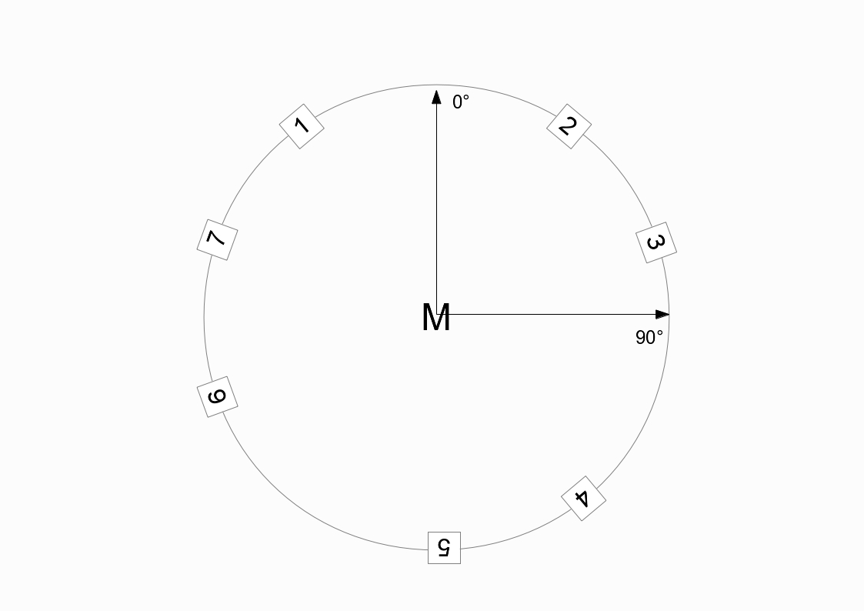
The opcode vbaplsinit, which is usually placed in the header of a Csound orchestra, defines these positions as follows:
vbaplsinit 2, 7, -40, 40, 70, 140, 180, -110, -70
The first number determines the number of dimensions (here 2). The second number states the overall number of speakers, then followed by the positions in degrees (clockwise).
All that is required now is to provide vbap with a monophonic sound source to be distributed amongst the speakers according to information given about the position. Horizontal position (azimuth) is expressed in degrees clockwise just as the initial locations of the speakers were. The following would be the Csound code to play the sound file "ClassGuit.wav" once while moving it counterclockwise:
EXAMPLE 05B05_VBAP_circle.csd
<CsoundSynthesizer>
<CsOptions>
-odac -d ;for the next line, change to your folder
--env:SSDIR+=/home/jh/Joachim/Csound/FLOSS/audio
</CsOptions>
<CsInstruments>
sr = 44100
ksmps = 32
0dbfs = 1
nchnls = 7

vbaplsinit 2, 7, -40, 40, 70, 140, 180, -110, -70

instr 1
Sfile = "ClassGuit.wav"
iFilLen filelen Sfile
p3 = iFilLen
aSnd, a0 soundin Sfile
kAzim line 0, p3, -360 ;counterclockwise
a1, a2, a3, a4, a5, a6, a7, a8 vbap8 aSnd, kAzim
outch 1, a1, 2, a2, 3, a3, 4, a4, 5, a5, 6, a6, 7, a7
endin
</CsInstruments>
<CsScore>
i 1 0 1
</CsScore>
</CsoundSynthesizer>
;example by joachim heintz
In the CsOptions tag, you see the option --env:SSDIR+= ... as a possibility to add a folder to the path in which Csound usually looks for your samples (SSDIR = Sound Sample Directory) if you call them only by name, without the full path. To play the full length of the sound file (without prior knowledge of its duration) the filelen opcode is used to derive this duration, and then the duration of this instrument (p3) is set to this value. The p3 given in the score section (here 1) is overwritten by this value.
The circular movement is a simple k-rate line signal, from 0 to -360 across the duration of the sound file (in this case the same as p3). Note that we have to use the opcode vbap8 here, as there is no vbap7. Just give the eighth channel a variable name (a8) and thereafter ignore it.

The Spread Parameter
As VBAP derives from a panning paradigm, it has one problem which becomes more serious as the number of speakers increases. Panning between two speakers in a stereo configuration means that all speakers are active. Panning between two speakers in a quadro configuration means that half of the speakers are active. Panning between two speakers in an octo configuration means that only a quarter of the speakers are active. And so on --- so that the actual perceived extend of the sound source becomes unintentionally smaller and smaller.
To alleviate this tendency, Ville Pulkki has introduced an additional parameter, called "spread", in a range from zero to hundred percent.2 The 'ascetic' form of VBAP we have seen in the previous example, means: no spread (0%). A spread of 100% means that all speakers are active, and the information about where the sound comes from is nearly lost.
As the kspread input to the vbap8 opcode is the second of two optional parameters, we first have to provide the first one. kelev defines the elevation of the sound - it is always zero for two dimensions, as in the speaker configuration in our example. The next example adds a spread movement to the previous one. The spread starts at zero percent, then increases up to hundred percent, and then decreases back down again to zero.
EXAMPLE 05B06_VBAP_spread.csd
<CsoundSynthesizer>
<CsOptions>
-odac -d ;for the next line, change to your folder
--env:SSDIR+=/home/jh/Joachim/Csound/FLOSS/audio
</CsOptions>
<CsInstruments>
sr = 44100
ksmps = 32
0dbfs = 1
nchnls = 7

vbaplsinit 2, 7, -40, 40, 70, 140, 180, -110, -70

instr 1
Sfile = "ClassGuit.wav"
iFilLen filelen Sfile
p3 = iFilLen
aSnd, a0 soundin Sfile
kAzim line 0, p3, -360
kSpread linseg 0, p3/2, 100, p3/2, 0
a1, a2, a3, a4, a5, a6, a7, a8 vbap8 aSnd, kAzim, 0, kSpread
outch 1, a1, 2, a2, 3, a3, 4, a4, 5, a5, 6, a6, 7, a7
endin
</CsInstruments>
<CsScore>
i 1 0 1
</CsScore>
</CsoundSynthesizer>
;example by joachim heintz

New VBAP Opcodes
As a reaction to a number of requests, John fFitch has written new VBAP opcodes in 2012. Their main goal is to allow more than one loudspeaker configuration within a single orchestra (so that you can "switch" between them) and to give more flexibility to the number of output channels. This is an example for three different configurations which are called in three instruments:
EXAMPLE 05B07_VBAP_new.csd
<CsoundSynthesizer>
<CsOptions>
-odac -d ;for the next line, change to your folder
--env:SSDIR+=/home/jh/Joachim/Csound/FLOSS/audio
</CsOptions>
<CsInstruments>
sr = 44100
ksmps = 32
0dbfs = 1
nchnls = 7

vbaplsinit 2.01, 7, -40, 40, 70, 140, 180, -110, -70
vbaplsinit 2.02, 2, -40, 40
vbaplsinit 2.03, 3, -70, 180, 70

instr 1
aSnd, a0 soundin "ClassGuit.wav"
kAzim line 0, p3, -360
a1, a2, a3, a4, a5, a6, a7 vbap aSnd, kAzim, 0, 0, 1
outch 1, a1, 2, a2, 3, a3, 4, a4, 5, a5, 6, a6, 7, a7
endin

instr 2
aSnd, a0 soundin "ClassGuit.wav"
kAzim line 0, p3, -360
a1, a2 vbap aSnd, kAzim, 0, 0, 2
outch 1, a1, 2, a2
endin

instr 3
aSnd, a0 soundin "ClassGuit.wav"
kAzim line 0, p3, -360
a1, a2, a3 vbap aSnd, kAzim, 0, 0, 3
outch 7, a1, 3, a2, 5, a3
endin

</CsInstruments>
<CsScore>
i 1 0 6
i 2 6 6
i 3 12 6
</CsScore>
</CsoundSynthesizer>
;example by joachim heintz
Instead of just one loudspeaker configuration as in the previous examples, there are now three configurations:
vbaplsinit 2.01, 7, -40, 40, 70, 140, 180, -110, -70
vbaplsinit 2.02, 2, -40, 40
vbaplsinit 2.03, 3, -70, 180, 70
The first parameter (the number of dimensions) now has an additional fractional part, with a range from .01 to .99, specifying the number of the speaker layout. So 2.01 means: two dimensions, layout number one, 2.02 is layout number two, and 2.03 is layout number three. The new vbap opcode has now these parameters:
ar1[, ar2...] vbap asig, kazim [, kelev] [, kspread] [, ilayout]
The last parameter ilayout refers to the speaker layout number. In the example above, instrument 1 uses layout 1, instrument 2 uses layout 2, and instrument 3 uses layout 3. Even if you do not have more than two speakers you should see in Csound's output that instrument 1 goes to all seven speakers, instrument 2 only to the first two, and instrument 3 goes to speaker 3, 5, and 7.
In addition to the new vbap opcode, vbapg has been written. The idea is to have an opcode which returns the gains (amplitudes) of the speakers instead of the audio signal:
k1[, k2...] vbapg kazim [,kelev] [, kspread] [, ilayout]

Ambisonics
Ambisonics is another technique to distribute a virtual sound source in space. Although the practical use has some similarities to VBAP, Ambisonics follows a rather different approach. It has nothing to do with amplitude panning but establishs a sound field. So by default all speakers are active, and localisation results from effects other than just amplitude.
There are excellent sources for the discussion of Ambisonics online.3 We will focus here just on the basic practicalities of using Ambisonics in Csound, without going into too much detail of the concepts behind them.
Ambisonics works in two basic steps. In the first step you encode the spacial information of a virtual sound source (its localisation) in a so-called B-format. In the second step you decode the B-format to match your loudspeaker setup.
It is possible to save the B-format as its own audio file, to conserve the spacial information or you can immediately do the decoding after the encoding thereby dealing directly only with audio signals instead of Ambisonic files. The next example takes the latter approach by implementing a transformation of the VBAP circle example to Ambisonics.
EXAMPLE 05B08_Ambi_circle.csd
<CsoundSynthesizer>
<CsOptions>
-odac -d ;for the next line, change to your folder
--env:SSDIR+=/home/jh/Joachim/Csound/FLOSS/Release01/Csound_Floss_Release01/audio
</CsOptions>
<CsInstruments>
sr = 44100
ksmps = 32
0dbfs = 1
nchnls = 8

instr 1
Sfile = "ClassGuit.wav"
iFilLen filelen Sfile
p3 = iFilLen
aSnd, a0 soundin Sfile
kAzim line 0, p3, 360 ;counterclockwise (!)
iSetup = 4 ;octogon
aw, ax, ay, az bformenc1 aSnd, kAzim, 0
a1, a2, a3, a4, a5, a6, a7, a8 bformdec1 iSetup, aw, ax, ay, az
outch 1, a1, 2, a2, 3, a3, 4, a4, 5, a5, 6, a6, 7, a7, 8, a8
endin
</CsInstruments>
<CsScore>
i 1 0 1
</CsScore>
</CsoundSynthesizer>
;example by joachim heintz
First to note is that for a counterclockwise circle, the azimuth now has the line 0 -> 360, instead of 0 -> -360 as was in the VBAP example. This is because Ambisonics usually reads the angle in the mathematical way: a positive angle is counterclockwise. Next, the encoding process is carried out in the line:
aw, ax, ay, az bformenc1 aSnd, kAzim, 0
Input arguments are the monophonic sound source aSnd, the xy-angle kAzim, and the elevation angle which is set to zero. Output signals are the spacial informations in x-, y- and z- direction (ax, ay, az), and also an omnidirectional signal called aw.
Decoding is performed by the line
a1, a2, a3, a4, a5, a6, a7, a8 bformdec1 iSetup, aw, ax, ay, az
The inputs for the decoder are the same aw, ax, ay, az, which were the results of the encoding process, and an additional iSetup parameter. Currently the Csound decoder only works with some standard setups for the speaker: iSetup = 4 refers to an octogon.4 So the final eight audio signals a1, ..., a8 are being produced using this decoder, and are then sent to the speakers in the same way using the outch opcode.

Different Orders
What we have seen in this example is called "first order" ambisonics. This means that the encoding process leads to the four basic dimensions w, x, y, z as described above.5 In "second order" ambisonics, there are additional directions called r, s, t, u, v. And in "third order" ambisonics again the additional k, l, m, n, o, p, q. The final example in this section shows the three orders, each of them in one instrument. If you have eight speakers in octo setup, you can compare the results.
EXAMPLE 05B09_Ambi_orders.csd
<CsoundSynthesizer>
<CsOptions>
-odac -d ;for the next line, change to your folder
--env:SSDIR+=/home/jh/Joachim/Csound/FLOSS/Release01/Csound_Floss_Release01/audio
</CsOptions>
<CsInstruments>
sr = 44100
ksmps = 32
0dbfs = 1
nchnls = 8

instr 1 ;first order
aSnd, a0 soundin "ClassGuit.wav"
kAzim line 0, p3, 360
iSetup = 4 ;octogon
aw, ax, ay, az bformenc1 aSnd, kAzim, 0
a1, a2, a3, a4, a5, a6, a7, a8 bformdec1 iSetup, aw, ax, ay, az
outch 1, a1, 2, a2, 3, a3, 4, a4, 5, a5, 6, a6, 7, a7, 8, a8
endin

instr 2 ;second order
aSnd, a0 soundin "ClassGuit.wav"
kAzim line 0, p3, 360
iSetup = 4 ;octogon
aw, ax, ay, az, ar, as, at, au, av bformenc1 aSnd, kAzim, 0
a1, a2, a3, a4, a5, a6, a7, a8 bformdec1 iSetup, aw, ax, ay, az, ar, as, at, au, av
outch 1, a1, 2, a2, 3, a3, 4, a4, 5, a5, 6, a6, 7, a7, 8, a8
endin

instr 3 ;third order
aSnd, a0 soundin "ClassGuit.wav"
kAzim line 0, p3, 360
iSetup = 4 ;octogon
aw, ax, ay, az, ar, as, at, au, av, ak, al, am, an, ao, ap, aq bformenc1 aSnd, kAzim, 0
a1, a2, a3, a4, a5, a6, a7, a8 bformdec1 iSetup, aw, ax, ay, az, ar, as, at, au, av, ak, al, am, an, ao, ap, aq
outch 1, a1, 2, a2, 3, a3, 4, a4, 5, a5, 6, a6, 7, a7, 8, a8
endin
</CsInstruments>
<CsScore>
i 1 0 6
i 2 6 6
i 3 12 6
</CsScore>
</CsoundSynthesizer>
;example by joachim heintz
In theory, first-order ambisonics needs at least 4 speakers to be projected correctly. Second-order ambisonics needs at least 6 speakers (9, if 3 dimensions are employed). Third-order ambisonics needs at least 8 speakers (or 16 for 3d). So, although higher order should in general lead to a better result in space, you cannot expect it to work unless you have a sufficient number of speakers. Of course practice may prove a preferable means of judgement to theory in many cases.

VBAP or Ambisonics?
Csound offers a simple and reliable way to access two standard methods for multi-channel spatialisation. Both have different qualities and follow different aesthetics. VBAP can perhaps be described as clear, rational, direct. It combines simplicity with flexibility. It gives a reliable sound projection even for rather asymmetric speaker setups. Ambisonics on the other hand offers a very soft sound image, in which the single speaker becomes part of a coherent sound field. The B-format offers the possibility to store the spatial information independently from any particular speaker configuration.
The composer, or spatial interpreter, can choose one or the other technique depending on the music and the context. Or (s)he can design a personal appraoch to spatialisation by combining the different techniques described in this chapter.

- First described by Ville Pulkki in 1997: Ville Pulkki, Virtual source positioning using vector base amplitude panning, in: Journal of the Audio Engeneering Society, 45(6), 456-466^
- Ville Pulkki, Uniform spreading of amplitude panned virtual sources, in: Proceedings of the 1999 IEEE Workshop on Applications of Signal Processing to Audio and Acoustics, Mohonk Montain House, New Paltz^
- For instance www.ambisonic.net or www.icst.net/research/projects/ambisonics-theory^
- See www.csounds.com/manual/html/bformdec1.html for more details.^
- Which in turn then are taken by the decoder as input.^

31. FILTERS
Audio filters can range from devices that subtly shape the tonal characteristics of a sound to ones that dramatically remove whole portions of a sound spectrum to create new sounds. Csound includes several versions of each of the commonest types of filters and some more esoteric ones also. The full list of Csound's standard filters can be found here. A list of the more specialised filters can be found here.

Lowpass Filters
The first type of filter encountered is normally the lowpass filter. As its name suggests it allows lower frequencies to pass through unimpeded and therefore filters higher frequencies. The crossover frequency is normally referred to as the 'cutoff' frequency. Filters of this type do not really cut frequencies off at the cutoff point like a brick wall but instead attenuate increasingly according to a cutoff slope. Different filters offer cutoff slopes of different of steepness. Another aspect of a lowpass filter that we may be concerned with is a ripple that might emerge at the cutoff point. If this is exaggerated intentionally it is referred to as resonance or 'Q'.
In the following example, three lowpass filters filters are demonstrated: tone, butlp and moogladder. tone offers a quite gentle cutoff slope and therefore is better suited to subtle spectral enhancement tasks. butlp is based on the Butterworth filter design and produces a much sharper cutoff slope at the expense of a slightly greater CPU overhead. moogladder is an interpretation of an analogue filter found in a moog synthesizer – it includes a resonance control.
In the example a sawtooth waveform is played in turn through each filter. Each time the cutoff frequency is modulated using an envelope, starting high and descending low so that more and more of the spectral content of the sound is removed as the note progresses. A sawtooth waveform has been chosen as it contains strong higher frequencies and therefore demonstrates the filters characteristics well; a sine wave would be a poor choice of source sound on account of its lack of spectral richness.
EXAMPLE 05C01_tone_butlp_moogladder.csd
<CsoundSynthesizer>

<CsOptions>
-odac ; activates real time sound output
</CsOptions>

<CsInstruments>
; Example by Iain McCurdy

sr = 44100
ksmps = 32
nchnls = 1
0dbfs = 1

instr 1
prints "tone%n" ; indicate filter type in console
aSig vco2 0.5, 150 ; input signal is a sawtooth waveform
kcf expon 10000,p3,20 ; descending cutoff frequency
aSig tone aSig, kcf ; filter audio signal
out aSig ; filtered audio sent to output
endin

instr 2
prints "butlp%n" ; indicate filter type in console
aSig vco2 0.5, 150 ; input signal is a sawtooth waveform
kcf expon 10000,p3,20 ; descending cutoff frequency
aSig butlp aSig, kcf ; filter audio signal
out aSig ; filtered audio sent to output
endin

instr 3
prints "moogladder%n" ; indicate filter type in console
aSig vco2 0.5, 150 ; input signal is a sawtooth waveform
kcf expon 10000,p3,20 ; descending cutoff frequency
aSig moogladder aSig, kcf, 0.9 ; filter audio signal
out aSig ; filtered audio sent to output
endin

</CsInstruments>

<CsScore>
; 3 notes to demonstrate each filter in turn
i 1 0 3; tone
i 2 4 3; butlp
i 3 8 3; moogladder
e
</CsScore>

</CsoundSynthesizer>

Highpass Filters
A highpass filter is the converse of a lowpass filter; frequencies higher than the cutoff point are allowed to pass whilst those lower are attenuated. atone and buthp are the analogues of tone and butlp. Resonant highpass filters are harder to find but Csound has one in bqrez. bqrez is actually a multi-mode filter and could also be used as a resonant lowpass filter amongst other things. We can choose which mode we want by setting one of its input arguments appropriately. Resonant highpass is mode 1. In this example a sawtooth waveform is again played through each of the filters in turn but this time the cutoff frequency moves from low to high. Spectral content is increasingly removed but from the opposite spectral direction.
EXAMPLE 05C02_atone_buthp_bqrez.csd
<CsoundSynthesizer>

<CsOptions>
-odac ; activates real time sound output
</CsOptions>

<CsInstruments>
; Example by Iain McCurdy

sr = 44100
ksmps = 32
nchnls = 1
0dbfs = 1

instr 1
prints "atone%n" ; indicate filter type in console
aSig vco2 0.2, 150 ; input signal is a sawtooth waveform
kcf expon 20, p3, 20000 ; define envelope for cutoff frequency
aSig atone aSig, kcf ; filter audio signal
out aSig ; filtered audio sent to output
endin

instr 2
prints "buthp%n" ; indicate filter type in console
aSig vco2 0.2, 150 ; input signal is a sawtooth waveform
kcf expon 20, p3, 20000 ; define envelope for cutoff frequency
aSig buthp aSig, kcf ; filter audio signal
out aSig ; filtered audio sent to output
endin

instr 3
prints "bqrez(mode:1)%n" ; indicate filter type in console
aSig vco2 0.03, 150 ; input signal is a sawtooth waveform
kcf expon 20, p3, 20000 ; define envelope for cutoff frequency
aSig bqrez aSig, kcf, 30, 1 ; filter audio signal
out aSig ; filtered audio sent to output
endin

</CsInstruments>

<CsScore>
; 3 notes to demonstrate each filter in turn
i 1 0 3 ; atone
i 2 5 3 ; buthp
i 3 10 3 ; bqrez(mode 1)
e
</CsScore>

</CsoundSynthesizer>

Bandpass Filters
A bandpass filter allows just a narrow band of sound to pass through unimpeded and as such is a little bit like a combination of a lowpass and highpass filter connected in series. We normally expect at least one additional parameter of control: control over the width of the band of frequencies allowed to pass through, or 'bandwidth'.
In the next example cutoff frequency and bandwidth are demonstrated independently for two different bandpass filters offered by Csound. First of all a sawtooth waveform is passed through a reson filter and a butbp filter in turn while the cutoff frequency rises (bandwidth remains static). Then pink noise is passed through reson and butbp in turn again but this time the cutoff frequency remains static at 5000Hz while the bandwidth expands from 8 to 5000Hz. In the latter two notes it will be heard how the resultant sound moves from almost a pure sine tone to unpitched noise. butbp is obviously the Butterworth based bandpass filter. reson can produce dramatic variations in amplitude depending on the bandwidth value and therefore some balancing of amplitude in the output signal may be necessary if out of range samples and distortion are to be avoided. Fortunately the opcode itself includes two modes of amplitude balancing built in but by default neither of these methods are active and in this case the use of the balance opcode may be required. Mode 1 seems to work well with spectrally sparse sounds like harmonic tones while mode 2 works well with spectrally dense sounds such as white or pink noise.
EXAMPLE 05C03_reson_butbp.csd
<CsoundSynthesizer>

<CsOptions>
-odac ; activates real time sound output
</CsOptions>

<CsInstruments>
; Example by Iain McCurdy

sr = 44100
ksmps = 32
nchnls = 1
0dbfs = 1

instr 1
prints "reson%n" ; indicate filter type in console
aSig vco2 0.5, 150 ; input signal: sawtooth waveform
kcf expon 20,p3,10000 ; rising cutoff frequency
aSig reson aSig,kcf,kcf*0.1,1 ; filter audio signal
out aSig ; send filtered audio to output
endin

instr 2
prints "butbp%n" ; indicate filter type in console
aSig vco2 0.5, 150 ; input signal: sawtooth waveform
kcf expon 20,p3,10000 ; rising cutoff frequency
aSig butbp aSig, kcf, kcf*0.1 ; filter audio signal
out aSig ; send filtered audio to output
endin

instr 3
prints "reson%n" ; indicate filter type in console
aSig pinkish 0.5 ; input signal: pink noise
kbw expon 10000,p3,8 ; contracting bandwidth
aSig reson aSig, 5000, kbw, 2 ; filter audio signal
out aSig ; send filtered audio to output
endin

instr 4
prints "butbp%n" ; indicate filter type in console
aSig pinkish 0.5 ; input signal: pink noise
kbw expon 10000,p3,8 ; contracting bandwidth
aSig butbp aSig, 5000, kbw ; filter audio signal
out aSig ; send filtered audio to output
endin

</CsInstruments>

<CsScore>
i 1 0 3 ; reson - cutoff frequency rising
i 2 4 3 ; butbp - cutoff frequency rising
i 3 8 6 ; reson - bandwidth increasing
i 4 15 6 ; butbp - bandwidth increasing
e
</CsScore>

</CsoundSynthesizer>

Comb Filtering
A comb filter is a special type of filter that creates a harmonically related stack of resonance peaks on an input sound file. A comb filter is really just a very short delay effect with feedback. Typically the delay times involved would be less than 0.05 seconds. Many of the comb filters documented in the Csound Manual term this delay time, 'loop time'. The fundamental of the harmonic stack of resonances produced will be 1/loop time. Loop time and the frequencies of the resonance peaks will be inversely proportionsl – as loop time get smaller, the frequencies rise. For a loop time of 0.02 seconds the fundamental resonance peak will be 50Hz, the next peak 100Hz, the next 150Hz and so on. Feedback is normally implemented as reverb time – the time taken for amplitude to drop to 1/1000 of its original level or by 60dB. This use of reverb time as opposed to feedback alludes to the use of comb filters in the design of reverb algorithms. Negative reverb times will result in only the odd numbered partials of the harmonic stack being present.
The following example demonstrates a comb filter using the vcomb opcode. This opcode allows for performance time modulation of the loop time parameter. For the first 5 seconds of the demonstration the reverb time increases from 0.1 seconds to 2 while the loop time remains constant at 0.005 seconds. Then the loop time decreases to 0.0005 seconds over 6 seconds (the resonant peaks rise in frequency), finally over the course of 10 seconds the loop time rises to 0.1 seconds (the resonant peaks fall in frequency). A repeating noise impulse is used as a source sound to best demonstrate the qualities of a comb filter.
EXAMPLE 05C04_comb.csd
<CsoundSynthesizer>

<CsOptions>
-odac ;activates real time sound output
</CsOptions>

<CsInstruments>
;Example by Iain McCurdy

sr = 44100
ksmps = 32
nchnls = 1
0dbfs = 1

instr 1
; -- generate an input audio signal (noise impulses) --
; repeating amplitude envelope:
kEnv loopseg 1,0, 0,1,0.005,1,0.0001,0,0.9949,0
aSig pinkish kEnv*0.6 ; pink noise pulses

; apply comb filter to input signal
krvt linseg 0.1, 5, 2 ; reverb time
alpt expseg 0.005,5,0.005,6,0.0005,10,0.1,1,0.1 ; loop time
aRes vcomb aSig, krvt, alpt, 0.1 ; comb filter
out aRes ; audio to output
endin

</CsInstruments>

<CsScore>
i 1 0 25
e
</CsScore>

</CsoundSynthesizer>

Other Filters Worth Investigating
In addition to a wealth of low and highpass filters Csound several more unique filters. Multimode such as bqrez provide several different filter types within a single opcode. Filter type is normally chosen using an i-rate input argument that functions like a switch. Another multimode filter, clfilt, offers addition filter controls such as 'filter design' and 'number of poles' to create unusual sound filters. unfortunately some parts of this opcode are not implemented yet.
eqfil is essentially a parametric equaliser but multiple iterations could be used as modules in a graphic equaliser bank. In addition to the capabilities of eqfil, pareq adds the possibility of creating low and high shelving filtering which might prove useful in mastering or in spectral adjustment of more developed sounds.
rbjeq offers a quite comprehensive multimode filter including highpass, lowpass, bandpass, bandreject, peaking, low-shelving and high-shelving, all in a single opcode
statevar offers the outputs from four filter types - highpass, lowpass, bandpass and bandreject - simultaneously so that the user can morph between them smoothly. svfilter does a similar thing but with just highpass, lowpass and bandpass filter types.
phaser1 and phaser2 offer algorithms containing chains of first order and second order allpass filters respectively. These algorithms could conceivably be built from individual allpass filters but these ready-made versions provide convenience and added efficiency
hilbert is a specialist IIR filter that implements the Hilbert transformer.
For those wishing to devise their own filter using coefficients Csound offers filter2 and zfilter2.

32. DELAY AND FEEDBACK
A delay in DSP is a special kind of buffer sometimes called a circular buffer. The length of this buffer is finite and must be declared upon initialization as it is stored in RAM. One way to think of the circular buffer is that as new items are added at the beginning of the buffer the oldest items at the end of the buffer are being 'shoved' out.
Besides their typical application for creating echo effects, delays can also be used to implement chorus, flanging, pitch shifting and filtering effects.
Csound offers many opcodes for implementing delays. Some of these offer varying degrees of quality - often balanced against varying degrees of efficiency whilst some are for quite specialized purposes.
To begin with this section is going to focus upon a pair of opcodes, delayr and delayw. Whilst not the most efficient to use in terms of the number of lines of code required, the use of delayr and delayw helps to clearly illustrate how a delay buffer works. Besides this, delayr and delayw actually offer a lot more flexibility and versatility than many of the other delay opcodes.
When using delayr and delayw the establishement of a delay buffer is broken down into two steps: reading from the end of the buffer using delayr (and by doing this defining the length or duration of the buffer) and then writing into the beginning of the buffer using delayw.
The code employed might look like this:
aSigOut delayr 1
delayw aSigIn
where 'aSigIn' is the input signal written into the beginning of the buffer and 'aSigOut' is the output signal read from the end of the buffer. The fact that we declare reading from the buffer before writing to it is sometimes initially confusing but, as alluded to before, one reason this is done is to declare the length of the buffer. The buffer length in this case is 1 second and this will be the apparent time delay between the input audio signal and audio read from the end of the buffer.
The following example implements the delay described above in a .csd file. An input sound of sparse sine tone pulses is created. This is written into the delay buffer from which a new audio signal is created by read from the end of this buffer. The input signal (sometimes referred to as the dry signal) and the delay output signal (sometimes referred to as the wet signal) are mixed and set to the output. The delayed signal is attenuated with respect to the input signal.
EXAMPLE 05D01_delay.csd
<CsoundSynthesizer>

<CsOptions>
-odac ; activates real time sound output
</CsOptions>

<CsInstruments>
; Example by Iain McCurdy

sr = 44100
ksmps = 32
nchnls = 1
0dbfs = 1
giSine ftgen 0, 0, 2^12, 10, 1 ; a sine wave

instr 1
; -- create an input signal: short 'blip' sounds --
kEnv loopseg 0.5, 0, 0, 0,0.0005, 1 , 0.1, 0, 1.9, 0, 0
kCps randomh 400, 600, 0.5
aEnv interp kEnv
aSig poscil aEnv, kCps, giSine

; -- create a delay buffer --
aBufOut delayr 0.3
delayw aSig

; -- send audio to output (input and output to the buffer are mixed)
out aSig + (aBufOut*0.4)
endin

</CsInstruments>

<CsScore>
i 1 0 25
e
</CsScore>
</CsoundSynthesizer>
If we mix some of the delayed signal into the input signal that is written into the buffer then we will delay some of the delayed signal thus creating more than a single echo from each input sound. Typically the sound that is fed back into the delay input is attenuated so that sound cycle through the buffer indefinitely but instead will eventually die away. We can attenuate the feedback signal by multiplying it by a value in the range zero to 1. The rapidity with which echoes will die away is defined by how close the zero this value is. The following example implements a simple delay with feedback.
EXAMPLE 05D02_delay_feedback.csd
<CsoundSynthesizer>

<CsOptions>
-odac ;activates real time sound output
</CsOptions>

<CsInstruments>
;Example by Iain McCurdy

sr = 44100
ksmps = 32
nchnls = 1
0dbfs = 1

giSine ftgen 0, 0, 2^12, 10, 1 ; a sine wave

instr 1
; -- create an input signal: short 'blip' sounds --
kEnv loopseg 0.5,0,0,0,0.0005,1,0.1,0,1.9,0,0 ; repeating envelope
kCps randomh 400, 600, 0.5 ; 'held' random values
aEnv interp kEnv ; a-rate envelope
aSig poscil aEnv, kCps, giSine ; generate audio

; -- create a delay buffer --
iFdback = 0.7 ; feedback ratio
aBufOut delayr 0.3 ; read audio from end of buffer
; write audio into buffer (mix in feedback signal)
delayw aSig+(aBufOut*iFdback)

; send audio to output (mix the input signal with the delayed signal)
out aSig + (aBufOut*0.4)
endin

</CsInstruments>

<CsScore>
i 1 0 25
e
</CsScore>

</CsoundSynthesizer>
Constructing a delay effect in this way is rather limited as the delay time is static. If we want to change the delay time we need to reinitialise the code that implements the delay buffer. A more flexible approach is to read audio from within the buffer using one of Csounds opcodes for 'tapping' a delay buffer, deltap, deltapi, deltap3 or deltapx. The opcodes are listed in order of increasing quality which also reflects an increase in computational expense. In the next example a delay tap is inserted within the delay buffer (between the delayr and the delayw) opcodes. As our delay time is modulating quite quickly we will use deltapi which uses linear interpolation as it rebuilds the audio signal whenever the delay time is moving. Note that this time we are not using the audio output from the delayr opcode as we are using the audio output from deltapi instead. The delay time used by deltapi is created by randomi which creates a random function of straight line segments. A-rate is used for the delay time to improve the accuracy of its values, use of k-rate would result in a noticeably poorer sound quality. You will notice that as well as modulating the time gap between echoes, this example also modulates the pitch of the echoes – if the delay tap is static within the buffer there would be no change in pitch, if is moving towards the beginning of the buffer then pitch will rise and if it is moving towards the end of the buffer then pitch will drop. This side effect has led to digital delay buffers being used in the design of many pitch shifting effects.
The user must take care that the delay time demanded from the delay tap does not exceed the length of the buffer as defined in the delayr line. If it does it will attempt to read data beyond the end of the RAM buffer – the results of this are unpredictable. The user must also take care that the delay time does not go below zero, in fact the minumum delay time that will be permissible will be the duration of one k cycle (ksmps/sr).
EXAMPLE 05D03_deltapi.csd
<CsoundSynthesizer>

<CsOptions>
-odac ; activates real time sound output
</CsOptions>

<CsInstruments>
; Example by Iain McCurdy

sr = 44100
ksmps = 32
nchnls = 1
0dbfs = 1

giSine ftgen 0, 0, 2^12, 10, 1 ; a sine wave

instr 1
; -- create an input signal: short 'blip' sounds --
kEnv loopseg 0.5,0,0,0,0.0005,1,0.1,0,1.9,0,0
aEnv interp kEnv
aSig poscil aEnv, 500, giSine

aDelayTime randomi 0.05, 0.2, 1 ; modulating delay time
; -- create a delay buffer --
aBufOut delayr 0.2 ; read audio from end of buffer
aTap deltapi aDelayTime ; 'tap' the delay buffer
delayw aSig + (aTap*0.9) ; write audio into buffer

; send audio to the output (mix the input signal with the delayed signal)
out aSig + (aTap*0.4)
endin

</CsInstruments>

<CsScore>
i 1 0 30
e
</CsScore>

</CsoundSynthesizer>
We are not limited to inserting only a single delay tap within the buffer. If we add further taps we create what is known as a multi-tap delay. The following example implements a multi-tap delay with three delay taps. Note that only the final delay (the one closest to the end of the buffer) is fed back into the input in order to create feedback but all three taps are mixed and sent to the output. There is no reason not to experiment with arrangements other than this but this one is most typical.
EXAMPLE 05D04_multi-tap_delay.csd
<CsoundSynthesizer>

<CsOptions>
-odac ; activates real time sound output
</CsOptions>

<CsInstruments>
; Example by Iain McCurdy

sr = 44100
ksmps = 32
nchnls = 1
0dbfs = 1

giSine ftgen 0, 0, 2^12, 10, 1 ; a sine wave

instr 1
; -- create an input signal: short 'blip' sounds --
kEnv loopseg 0.5,0,0,0,0.0005,1,0.1,0,1.9,0,0; repeating envelope
kCps randomh 400, 1000, 0.5 ; 'held' random values
aEnv interp kEnv ; a-rate envelope
aSig poscil aEnv, kCps, giSine ; generate audio

; -- create a delay buffer --
aBufOut delayr 0.5 ; read audio end buffer
aTap1 deltap 0.1373 ; delay tap 1
aTap2 deltap 0.2197 ; delay tap 2
aTap3 deltap 0.4139 ; delay tap 3
delayw aSig + (aTap3*0.4) ; write audio into buffer

; send audio to the output (mix the input signal with the delayed signals)
out aSig + ((aTap1+aTap2+aTap3)*0.4)
endin

</CsInstruments>

<CsScore>
i 1 0 25
e
</CsScore>

</CsoundSynthesizer>
As mentioned at the top of this section many familiar effects are actually created from using delay buffers in various ways. We will briefly look at one of these effects: the flanger. Flanging derives from a phenomenon which occurs when the delay time becomes so short that we begin to no longer perceive individual echoes but instead a stack of harmonically related resonances are perceived the frequencies of which are in simple ratio with 1/delay_time. This effect is known as a comb filter. When the delay time is slowly modulated and the resonances shifting up and down in sympathy the effect becomes known as a flanger. In this example the delay time of the flanger is modulated using an LFO that employs a U-shaped parabola as its waveform as this seems to provide the smoothest comb filter modulations.
EXAMPLE 05D05_flanger.csd
<CsoundSynthesizer>

<CsOptions>
-odac ; activates real time sound output
</CsOptions>

<CsInstruments>
;Example by Iain McCurdy

sr = 44100
ksmps = 32
nchnls = 1
0dbfs = 1

giSine ftgen 0, 0, 2^12, 10, 1 ; a sine wave
giLFOShape ftgen 0, 0, 2^12, 19, 0.5, 1, 180, 1 ; u-shaped parabola

instr 1
aSig pinkish 0.1 ; pink noise

aMod poscil 0.005, 0.05, giLFOShape ; delay time LFO
iOffset = ksmps/sr ; minimum delay time
kFdback linseg 0.8,(p3/2)-0.5,0.95,1,-0.95 ; feedback

; -- create a delay buffer --
aBufOut delayr 0.5 ; read audio from end buffer
aTap deltap3 aMod + iOffset ; tap audio from within buffer
delayw aSig + (aTap*kFdback) ; write audio into buffer

; send audio to the output (mix the input signal with the delayed signal)
out aSig + aTap
endin

</CsInstruments>

<CsScore>
i 1 0 25
e
</CsScore>

</CsoundSynthesizer>

Delay buffers can be used to implement a wide variety of signal processing effects beyond simple echo effects. This chapter has introduced the basics of working with Csound's delay opcodes and also hinted at some of the further possibilities available.

33. REVERBERATION
Reverb is the effect a room or space has on a sound where the sound we perceive is a mixture of the direct sound and the dense overlapping echoes of that sound reflecting off walls and objects within the space.
Csound's earliest reverb opcodes are reverb and nreverb. By today's standards these sound rather crude and as a consequence modern Csound users tend to prefer the more recent opcodes freeverb and reverbsc.
The typical way to use a reverb is to run as a effect throughout the entire Csound performance and to send it audio from other instruments to which it adds reverb. This is more efficient than initiating a new reverb effect for every note that is played. This arrangement is a reflection of how a reverb effect would be used with a mixing desk in a conventional studio. There are several methods of sending audio from sound producing instruments to the reverb instrument, three of which will be introduced in the coming examples
The first method uses Csound's global variables so that an audio variable created in one instrument and be read in another instrument. There are several points to highlight here. First the global audio variable that is use to send audio the reverb instrument is initialized to zero (silence) in the header area of the orchestra.
This is done so that if no sound generating instruments are playing at the beginning of the performance this variable still exists and has a value. An error would result otherwise and Csound would not run. When audio is written into this variable in the sound generating instrument it is added to the current value of the global variable.
This is done in order to permit polyphony and so that the state of this variable created by other sound producing instruments is not overwritten. Finally it is important that the global variable is cleared (assigned a value of zero) when it is finished with at the end of the reverb instrument. If this were not done then the variable would quickly 'explode' (get astronomically high) as all previous instruments are merely adding values to it rather that redeclaring it. Clearing could be done simply by setting to zero but the clear opcode might prove useful in the future as it provides us with the opportunity to clear many variables simultaneously.
This example uses the freeverb opcode and is based on a plugin of the same name. Freeverb has a smooth reverberant tail and is perhaps similar in sound to a plate reverb. It provides us with two main parameters of control: 'room size' which is essentially a control of the amount of internal feedback and therefore reverb time, and 'high frequency damping' which controls the amount of attenuation of high frequencies. Both there parameters should be set within the range 0 to 1. For room size a value of zero results in a very short reverb and a value of 1 results in a very long reverb. For high frequency damping a value of zero provides minimum damping of higher frequencies giving the impression of a space with hard walls, a value of 1 provides maximum high frequency damping thereby giving the impression of a space with soft surfaces such as thick carpets and heavy curtains.
EXAMPLE 05E01_freeverb.csd
<CsoundSynthesizer>

<CsOptions>
-odac ; activates real time sound output
</CsOptions>

<CsInstruments>
;Example by Iain McCurdy

sr = 44100
ksmps = 32
nchnls = 2
0dbfs = 1

gaRvbSend init 0 ; global audio variable initialized to zero

instr 1 ; sound generating instrument (sparse noise bursts)
kEnv loopseg 0.5,0,0,1,0.003,1,0.0001,0,0.9969,0,0; amp. env.
aSig pinkish kEnv ; noise pulses
outs aSig, aSig ; audio to outs
iRvbSendAmt = 0.8 ; reverb send amount (0 - 1)
; add some of the audio from this instrument to the global reverb send variable
gaRvbSend = gaRvbSend + (aSig * iRvbSendAmt)
endin

instr 5 ; reverb - always on
kroomsize init 0.85 ; room size (range 0 to 1)
kHFDamp init 0.5 ; high freq. damping (range 0 to 1)
; create reverberated version of input signal (note stereo input and output)
aRvbL,aRvbR freeverb gaRvbSend, gaRvbSend,kroomsize,kHFDamp
outs aRvbL, aRvbR ; send audio to outputs
clear gaRvbSend ; clear global audio variable
endin

</CsInstruments>

<CsScore>
i 1 0 300 ; noise pulses (input sound)
i 5 0 300 ; start reverb
e
</CsScore>

</CsoundSynthesizer>
The next example uses Csound's zak patching system to send audio from one instrument to another. The zak system is a little like a patch bay you might find in a recording studio. Zak channels can be a, k or i-rate. These channels will be addressed using numbers so it will be important to keep track of what each numbered channel is used for. Our example will be very simple in that we will only be using one zak audio channel. Before using any of the zak opcodes for reading and writing data we must initialize zak storage space. This is done in the orchestra header area using the zakinit opcode. This opcode initializes both a and k rate channels; we must intialize at least one of each even if we don't require both.
zakinit 1, 1
The audio from the sound generating instrument is mixed into a zak audio channel the zawm opcode like this:
zawm aSig * iRvbSendAmt, 1
This channel is read from in the reverb instrument using the zar opcode like this:
aInSig zar 1
Because audio is begin mixed into our zak channel but it is never redefined (only mixed into) it needs to be cleared after we have finished with it. This is accomplished at the bottom of the reverb instrument using the zacl opcode like this:
zacl 0, 1
This example uses the reverbsc opcode. It too has a stereo input and output. The arguments that define its character are feedback level and cutoff frequency. Feedback level should be in the range zero to 1 and controls reverb time. Cutoff frequency should be within the range of human hearing (20Hz -20kHz) and less than the Nyqvist frequency (sr/2) - it controls the cutoff frequencies of low pass filters within the algorithm.
EXAMPLE 05E02_reverbsc.csd
<CsoundSynthesizer>

<CsOptions>
-odac ; activates real time sound output
</CsOptions>

<CsInstruments>
; Example by Iain McCurdy

sr = 44100
ksmps = 32
nchnls = 2
0dbfs = 1

; initialize zak space - one a-rate and one k-rate variable.
; We will only be using the a-rate variable.
zakinit 1, 1

instr 1 ; sound generating instrument - sparse noise bursts
kEnv loopseg 0.5,0, 0,1,0.003,1,0.0001,0,0.9969,0,0; amp. env.
aSig pinkish kEnv ; pink noise pulses
outs aSig, aSig ; send audio to outputs
iRvbSendAmt = 0.8 ; reverb send amount (0 - 1)
; write to zak audio channel 1 with mixing
zawm aSig*iRvbSendAmt, 1
endin

instr 5 ; reverb - always on
aInSig zar 1 ; read first zak audio channel
kFblvl init 0.88 ; feedback level - i.e. reverb time
kFco init 8000 ; cutoff freq. of a filter within the reverb
; create reverberated version of input signal (note stereo input and output)
aRvbL,aRvbR reverbsc aInSig, aInSig, kFblvl, kFco
outs aRvbL, aRvbR ; send audio to outputs
zacl 0, 1 ; clear zak audio channels
endin

</CsInstruments>

<CsScore>
i 1 0 10 ; noise pulses (input sound)
i 5 0 12 ; start reverb
e
</CsScore>

</CsoundSynthesizer>
reverbsc contains a mechanism to modulate delay times internally which has the effect of harmonically blurring sounds the longer they are reverberated. This contrasts with freeverb's rather static reverberant tail. On the other hand screverb's tail is not as smooth as that of freeverb, inidividual echoes are sometimes discernible so it may not be as well suited to the reverberation of percussive sounds. Also be aware that as well as reducing the reverb time, the feedback level parameter reduces the overall amplitude of the effect to the point where a setting of 1 will result in silence from the opcode.
A more recent option for sending sound from instrument to instrument in Csound is to use the chn... opcodes. These opcodes can also be used to allow Csound to interface with external programs using the software bus and the Csound API.
EXAMPLE 05E03_reverb_with_chn.csd
<CsoundSynthesizer>

<CsOptions>
-odac ; activates real time sound output
</CsOptions>

<CsInstruments>
; Example by Iain McCurdy

sr = 44100
ksmps = 32
nchnls = 2
0dbfs = 1

instr 1 ; sound generating instrument - sparse noise bursts
kEnv loopseg 0.5,0, 0,1,0.003,1,0.0001,0,0.9969,0,0 ; amp. envelope
aSig pinkish kEnv ; noise pulses
outs aSig, aSig ; audio to outs
iRvbSendAmt = 0.4 ; reverb send amount (0 - 1)
;write audio into the named software channel:
chnmix aSig*iRvbSendAmt, "ReverbSend"
endin

instr 5 ; reverb (always on)
aInSig chnget "ReverbSend" ; read audio from the named channel
kTime init 4 ; reverb time
kHDif init 0.5 ; 'high frequency diffusion' (0 - 1)
aRvb nreverb aInSig, kTime, kHDif ; create reverb signal
outs aRvb, aRvb ; send audio to outputs
chnclear "ReverbSend" ; clear the named channel
endin

</CsInstruments>

<CsScore>
i 1 0 10 ; noise pulses (input sound)
i 5 0 12 ; start reverb
e
</CsScore>

</CsoundSynthesizer>

The Schroeder Reverb Design
Many reverb algorithms including Csound's freeverb, reverb and reverbn are based on what is known as the Schroeder reverb design. This was a design proposed in the early 1960s by the physicist Manfred Schroeder. In the Schroeder reverb a signal is passed into four parallel comb filters the outputs of which are summed and then passed through two allpass filters as shown in the diagram below. Essentially the comb filters provide the body of the reverb effect and the allpass filters smear their resultant sound to reduce ringing artefacts the comb filters might produce. More modern designs might extent the number of filters used in an attempt to create smoother results. The freeverb opcode employs eight parallel comb filters followed by four series allpass filters on each channel. The two main indicators of poor implementations of the Schoeder reverb are individual echoes being excessively apparent and ringing artefacts. The results produced by the freeverb opcode are very smooth but a criticism might be that it is lacking in character and is more suggestive of a plate reverb than of a real room.
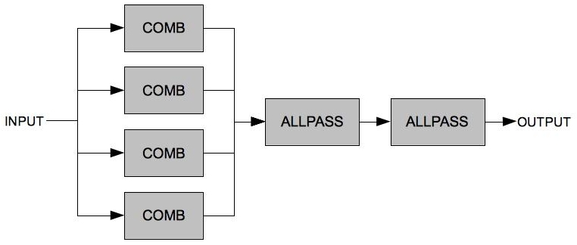
The next example implements the basic Schroeder reverb with four parallel comb filters followed by three series allpass filters. This also proves a useful exercise in routing audio signals within Csound. Perhaps the most crucial element of the Schroeder reverb is the choice of loop times for the comb and allpass filters – careful choices here should obviate the undesirable artefacts mentioned in the previous paragraph. If loop times are too long individual echoes will become apparent, if they are too short the characteristic ringing of comb filters will become apparent. If loop times between filters differ too much the outputs from the various filters will not fuse. It is also important that the loop times are prime numbers so that echoes between different filters do not reinforce each other. It may also be necessary to adjust loop times when implementing very short reverbs or very long reverbs. The duration of the reverb is effectively determined by the reverb times for the comb filters. There is certainly scope for experimentation with the design of this example and exploration of settings other than the ones suggested here.
This example consists of five instruments. The fifth instrument implements the reverb algorithm described above. The first four instruments act as a kind of generative drum machine to provide source material for the reverb. Generally sharp percussive sounds provide the sternest test of a reverb effect. Instrument 1 triggers the various synthesized drum sounds (bass drum, snare and closed hi-hat) produced by instruments 2 to 4.
EXAMPLE 05E04_schroeder_reverb.csd
<CsoundSynthesizer>

<CsOptions>
-odac -m0
; activate real time sound output and suppress note printing
</CsOptions>

<CsInstruments>
;Example by Iain McCurdy

sr = 44100
ksmps = 1
nchnls = 2
0dbfs = 1

giSine ftgen 0, 0, 2^12, 10, 1 ; a sine wave
gaRvbSend init 0 ; global audio variable initialized
giRvbSendAmt init 0.4 ; reverb send amount (range 0 - 1)

instr 1 ; trigger drum hits
ktrigger metro 5 ; rate of drum strikes
kdrum random 2, 4.999 ; randomly choose which drum to hit
schedkwhen ktrigger, 0, 0, kdrum, 0, 0.1 ; strike a drum
endin

instr 2 ; sound 1 - bass drum
iamp random 0, 0.5 ; amplitude randomly chosen
p3 = 0.2 ; define duration for this sound
aenv line 1,p3,0.001 ; amplitude envelope (percussive)
icps exprand 30 ; cycles-per-second offset
kcps expon icps+120,p3,20 ; pitch glissando
aSig oscil aenv*0.5*iamp,kcps,giSine ; oscillator
outs aSig, aSig ; send audio to outputs
gaRvbSend = gaRvbSend + (aSig * giRvbSendAmt) ; add to send
endin

instr 3 ; sound 3 - snare
iAmp random 0, 0.5 ; amplitude randomly chosen
p3 = 0.3 ; define duration
aEnv expon 1, p3, 0.001 ; amp. envelope (percussive)
aNse noise 1, 0 ; create noise component
iCps exprand 20 ; cps offset
kCps expon 250 + iCps, p3, 200+iCps ; create tone component gliss.
aJit randomi 0.2, 1.8, 10000 ; jitter on freq.
aTne oscil aEnv, kCps*aJit, giSine ; create tone component
aSig sum aNse*0.1, aTne ; mix noise and tone components
aRes comb aSig, 0.02, 0.0035 ; comb creates a 'ring'
aSig = aRes * aEnv * iAmp ; apply env. and amp. factor
outs aSig, aSig ; send audio to outputs
gaRvbSend = gaRvbSend + (aSig * giRvbSendAmt); add to send
endin

instr 4 ; sound 4 - closed hi-hat
iAmp random 0, 1.5 ; amplitude randomly chosen
p3 = 0.1 ; define duration for this sound
aEnv expon 1,p3,0.001 ; amplitude envelope (percussive)
aSig noise aEnv, 0 ; create sound for closed hi-hat
aSig buthp aSig*0.5*iAmp, 12000 ; highpass filter sound
aSig buthp aSig, 12000 ; -and again to sharpen cutoff
outs aSig, aSig ; send audio to outputs
gaRvbSend = gaRvbSend + (aSig * giRvbSendAmt) ; add to send
endin

instr 5 ; schroeder reverb - always on
; read in variables from the score
kRvt = p4
kMix = p5

; print some information about current settings gleaned from the score
prints "Type:"
prints p6
prints "\\nReverb Time:%2.1f\\nDry/Wet Mix:%2.1f\\n\\n",p4,p5

; four parallel comb filters
a1 comb gaRvbSend, kRvt, 0.0297; comb filter 1
a2 comb gaRvbSend, kRvt, 0.0371; comb filter 2
a3 comb gaRvbSend, kRvt, 0.0411; comb filter 3
a4 comb gaRvbSend, kRvt, 0.0437; comb filter 4
asum sum a1,a2,a3,a4 ; sum (mix) the outputs of all comb filters

; two allpass filters in series
a5 alpass asum, 0.1, 0.005 ; send mix through first allpass filter
aOut alpass a5, 0.1, 0.02291 ; send 1st allpass through 2nd allpass

amix ntrpol gaRvbSend, aOut, kMix ; create a dry/wet mix
outs amix, amix ; send audio to outputs
clear gaRvbSend ; clear global audio variable
endin

</CsInstruments>

<CsScore>
; room reverb
i 1 0 10 ; start drum machine trigger instr
i 5 0 11 1 0.5 "Room Reverb" ; start reverb

; tight ambience
i 1 11 10 ; start drum machine trigger instr
i 5 11 11 0.3 0.9 "Tight Ambience" ; start reverb

; long reverb (low in the mix)
i 1 22 10 ; start drum machine
i 5 22 15 5 0.1 "Long Reverb (Low In the Mix)" ; start reverb

; very long reverb (high in the mix)
i 1 37 10 ; start drum machine
i 5 37 25 8 0.9 "Very Long Reverb (High in the Mix)" ; start reverb
e
</CsScore>

</CsoundSynthesizer>
This chapter has introduced some of the more recent Csound opcodes for delay-line based reverb algorithms which in most situations can be used to provide high quality and efficient reverberation. Convolution offers a whole new approach for the creation of realistic reverbs that imitate actual spaces - this technique is demonstrated in the Convolution chapter.

34. AM / RM / WAVESHAPING
An introduction as well as some background theory of amplitude modulation, ring modulation and waveshaping is given in the fourth chapter entitled "sound-synthesis". As all of these techniques merely modulate the amplitude of a signal in a variety of ways, they can also be used for the modification of non-synthesized sound. In this chapter we will explore amplitude modulation, ring modulation and waveshaping as applied to non-synthesized sound.1

AMPLITUDE MODULATION
With "sound-synthesis", the principle of AM was shown as a amplitude multiplication of two sine oscillators. Later we've used a more complex modulators, to generate more complex spectrums. The principle also works very well with sound-files (samples) or live-audio-input.
Karlheinz Stockhausens "Mixtur für Orchester, vier Sinusgeneratoren und vier Ringmodulatoren” (1964) was the first piece which used analog ringmodulation (AM without DC-offset) to alter the acoustic instruments pitch in realtime during a live-performance. The word ringmodulation inherites from the analog four-diode circuit which was arranged in a "ring".
In the following example shows how this can be done digitally in Csound. In this case a sound-file works as the carrier which is modulated by a sine-wave-osc. The result sounds like old 'Harald Bode' pitch-shifters from the 1960's.
Example: 05F01_RM_modification.csd
<CsoundSynthesizer>
<CsOptions>
-o dac
</CsOptions>
<CsInstruments>

sr = 48000
ksmps = 32
nchnls = 1
0dbfs = 1

instr 1 ; Ringmodulation
aSine1 poscil 0.8, p4, 1
aSample diskin2 "fox.wav", 1, 0, 1, 0, 32
out aSine1*aSample
endin

</CsInstruments>
<CsScore>
f 1 0 1024 10 1 ; sine

i 1 0 2 400
i 1 2 2 800
i 1 4 2 1600
i 1 6 2 200
i 1 8 2 2400
e
</CsScore>
</CsoundSynthesizer>
; written by Alex Hofmann (Mar. 2011)

WAVESHAPING
In chapter 04E waveshaping has been described as a method of applying a transfer function to an incoming signal. It has been discussed that the table which stores the transfer function must be read with an interpolating table reader to avoid degradation of the signal. On the other hand, degradation can be a nice thing for sound modification. So let us start with this branch here.

Bit Depth Reduction
If the transfer function itself is linear, but the table of the function is small, and no interpolation is applied to the amplitude as index to the table, in effect the bit depth is reduced. For a function table of size 4, a line becomes a staircase:
Bit Depth = high
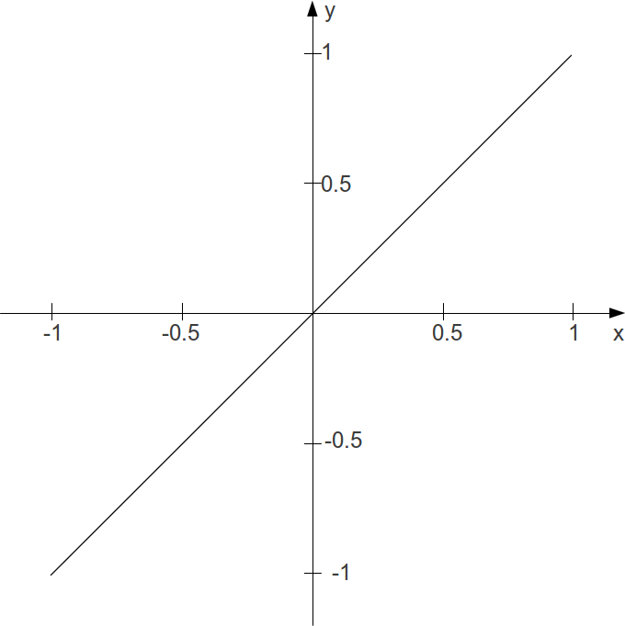
Bit Depth = 2
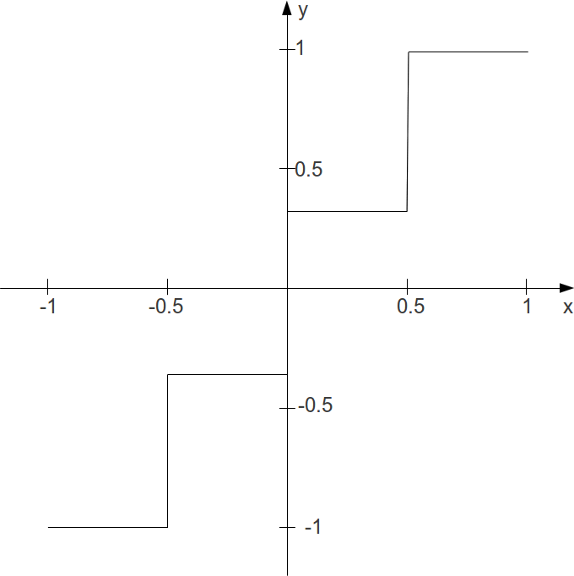
This is the sounding result:
EXAMPLE 05F02_Wvshp_bit_crunch.csd
<CsoundSynthesizer>
<CsOptions>
-odac
</CsOptions>
<CsInstruments>
sr = 44100
ksmps = 32
nchnls = 2
0dbfs = 1

giTrnsFnc ftgen 0, 0, 4, -7, -1, 3, 1

instr 1
aAmp soundin "fox.wav"
aIndx = (aAmp + 1) / 2
aWavShp table aIndx, giTrnsFnc, 1
outs aWavShp, aWavShp
endin

</CsInstruments>
<CsScore>
i 1 0 2.767
</CsScore>
</CsoundSynthesizer>
;example by joachim heintz

Transformation and Distortion
In general, the transformation of sound in applying waveshaping depends on the transfer function. The following example applies at first a table which does not change the sound at all, because the function just says y = x. The second one leads aready to a heavy distortion, though "just" the samples between an amplitude of -0.1 and +0.1 are erased. Tables 3 to 7 apply some chebychev functions which are well known from waveshaping synthesis. Finally, tables 8 and 9 approve that even a meaningful sentence and a nice music can regarded as noise ...
EXAMPLE 05F03_Wvshp_different_transfer_funs.csd
<CsoundSynthesizer>
<CsOptions>
-odac
</CsOptions>
<CsInstruments>
sr = 44100
ksmps = 32
nchnls = 2
0dbfs = 1

giNat ftgen 1, 0, 2049, -7, -1, 2048, 1
giDist ftgen 2, 0, 2049, -7, -1, 1024, -.1, 0, .1, 1024, 1
giCheb1 ftgen 3, 0, 513, 3, -1, 1, 0, 1
giCheb2 ftgen 4, 0, 513, 3, -1, 1, -1, 0, 2
giCheb3 ftgen 5, 0, 513, 3, -1, 1, 0, 3, 0, 4
giCheb4 ftgen 6, 0, 513, 3, -1, 1, 1, 0, 8, 0, 4
giCheb5 ftgen 7, 0, 513, 3, -1, 1, 3, 20, -30, -60, 32, 48
giFox ftgen 8, 0, -121569, 1, "fox.wav", 0, 0, 1
giGuit ftgen 9, 0, -235612, 1, "ClassGuit.wav", 0, 0, 1

instr 1
iTrnsFnc = p4
kEnv linseg 0, .01, 1, p3-.2, 1, .01, 0
aL, aR soundin "ClassGuit.wav"
aIndxL = (aL + 1) / 2
aWavShpL tablei aIndxL, iTrnsFnc, 1
aIndxR = (aR + 1) / 2
aWavShpR tablei aIndxR, iTrnsFnc, 1
outs aWavShpL*kEnv, aWavShpR*kEnv
endin

</CsInstruments>
<CsScore>
i 1 0 7 1 ;natural though waveshaping
i 1 + . 2 ;rather heavy distortion
i 1 + . 3 ;chebychev for 1st partial
i 1 + . 4 ;chebychev for 2nd partial
i 1 + . 5 ;chebychev for 3rd partial
i 1 + . 6 ;chebychev for 4th partial
i 1 + . 7 ;after dodge/jerse p.136
i 1 + . 8 ;fox
i 1 + . 9 ;guitar
</CsScore>
</CsoundSynthesizer>
;example by joachim heintz
Instead of using the "self-built" method which has been described here, you can use the Csound opcode distort. It performs the actual waveshaping process and gives a nice control about the amount of distortion in the kdist parameter. Here is a simple example:2
EXAMPLE 05F04_distort.csd
<CsoundSynthesizer>
<CsOptions>
-odac
</CsOptions>
<CsInstruments>
sr = 44100
ksmps = 32
nchnls = 2
0dbfs = 1

gi1 ftgen 1,0,257,9,.5,1,270 ;sinoid (also the next)
gi2 ftgen 2,0,257,9,.5,1,270,1.5,.33,90,2.5,.2,270,3.5,.143,90
gi3 ftgen 3,0,129,7,-1,128,1 ;actually natural
gi4 ftgen 4,0,129,10,1 ;sine
gi5 ftgen 5,0,129,10,1,0,1,0,1,0,1,0,1 ;odd partials
gi6 ftgen 6,0,129,21,1 ;white noise
gi7 ftgen 7,0,129,9,.5,1,0 ;half sine
gi8 ftgen 8,0,129,7,1,64,1,0,-1,64,-1 ;square wave

instr 1
ifn = p4
ivol = p5
kdist line 0, p3, 1 ;increase the distortion over p3
aL, aR soundin "ClassGuit.wav"
aout1 distort aL, kdist, ifn
aout2 distort aR, kdist, ifn
outs aout1*ivol, aout2*ivol
endin
</CsInstruments>
<CsScore>
i 1 0 7 1 1
i . + . 2 .3
i . + . 3 1
i . + . 4 .5
i . + . 5 .15
i . + . 6 .04
i . + . 7 .02
i . + . 8 .02
</CsScore>
</CsoundSynthesizer>
;example by joachim heintz

- This is the same for Granular Synthesis which can either be "pure" synthesis or applied so sampled sound.^
- Have a look at Iain McCurdy's Realtime example (which has also been ported to CsoundQt by René Jopi) for 'distort' for a more interactive exploration of the opcode.^

35. GRANULAR SYNTHESIS
This chapter will focus upon granular synthesis used as a DSP technique upon recorded sound files and will introduce techniques including time stretching, time compressing and pitch shifting. The emphasis will be upon asynchronous granulation. For an introduction to synchronous granular synthesis using simple waveforms please refer to chapter 04F.
Csound offers a wide range of opcodes for sound granulation. Each has its own strengths and weaknesses and suitability for a particular task. Some are easier to use than others, some, such as granule and partikkel, are extremely complex and are, at least in terms of the number of input arguments they demand, amongst Csound's most complex opcodes.

sndwarp - Time Stretching and Pitch Shifting
sndwarp may not be Csound's newest or most advanced opcode for sound granulation but it is quite easy to use and is certainly up to the task of time stretching and pitch shifting. sndwarp has two modes by which we can modulate time stretching characteristics, one in which we define a 'stretch factor', a value of 2 defining a stretch to twice the normal length, and the other in which we directly control a pointer into the file. The following example uses sndwarp's first mode to produce a sequence of time stretches and pitch shifts. An overview of each procedure will be printed to the terminal as it occurs. sndwarp does not allow for k-rate modulation of grain size or density so for this level we need to look elsewhere.
You will need to make sure that a sound file is available to sndwarp via a GEN01 function table. You can replace the one used in this example with one of your own by replacing the reference to 'ClassicalGuitar.wav'. This sound file is stereo therefore instrument 1 uses the stereo version of sndwarp. 'sndwarpst'. A mismatch between the number of channels in the sound file and the version of sndwarp used will result in playback at an unexpected pitch. You will also need to give GEN01 an appropriate size that will be able to contain your chosen sound file. You can calculate the table size you will need by multiplying the duration of the sound file (in seconds) by the sample rate - for stereo files this value should be doubled - and then choose the next power of 2 above this value. You can download the sample used in the example at http://www.iainmccurdy.org/csoundrealtimeexamples/sourcematerials/ClassicalGuitar.wav.
sndwarp describes grain size as 'window size' and it is defined in samples so therefore a window size of 44100 means that grains will last for 1s each (when sample rate is set at 44100). Window size randomization (irandw) adds a random number within that range to the duration of each grain. As these two parameters are closely related it is sometime useful to set irandw to be a fraction of window size. If irandw is set to zero we will get artefacts associated with synchronous granular synthesis.
sndwarp (along with many of Csound's other granular synthesis opcodes) requires us to supply it with a window function in the form of a function table according to which it will apply an amplitude envelope to each grain. By using different function tables we can alternatively create softer grains with gradual attacks and decays (as in this example), with more of a percussive character (short attack, long decay) or 'gate'-like (short attack, long sustain, short decay).
EXAMPLE 05G01_sndwarp.csd
<CsoundSynthesizer>

<CsOptions>
-odac -m0
; activate real-time audio output and suppress printing
</CsOptions>

<CsInstruments>
; example written by Iain McCurdy

sr = 44100
ksmps = 16
nchnls = 2
0dbfs = 1

; waveform used for granulation
giSound ftgen 1,0,2097152,1,"ClassGuit.wav",0,0,0

; window function - used as an amplitude envelope for each grain
; (first half of a sine wave)
giWFn ftgen 2,0,16384,9,0.5,1,0

instr 1
kamp = 0.1
ktimewarp expon p4,p3,p5 ; amount of time stretch, 1=none 2=double
kresample line p6,p3,p7 ; pitch change 1=none 2=+1oct
ifn1 = giSound ; sound file to be granulated
ifn2 = giWFn ; window shaped used to envelope every grain
ibeg = 0
iwsize = 3000 ; grain size (in sample)
irandw = 3000 ; randomization of grain size range
ioverlap = 50 ; density
itimemode = 0 ; 0=stretch factor 1=pointer
prints p8 ; print a description
aSigL,aSigR sndwarpst kamp,ktimewarp,kresample,ifn1,ibeg, \
iwsize,irandw,ioverlap,ifn2,itimemode
outs aSigL,aSigR
endin

</CsInstruments>

<CsScore>
;p3 = stretch factor begin / pointer location begin
;p4 = stretch factor end / pointer location end
;p5 = resample begin (transposition)
;p6 = resample end (transposition)
;p7 = procedure description
;p8 = description string
; p1 p2 p3 p4 p5 p6 p7 p8
i 1 0 10 1 1 1 1 "No time stretch. No pitch shift."
i 1 10.5 10 2 2 1 1 "%nTime stretch x 2."
i 1 21 20 1 20 1 1 \
"%nGradually increasing time stretch factor from x 1 to x 20."
i 1 41.5 10 1 1 2 2 "%nPitch shift x 2 (up 1 octave)."
i 1 52 10 1 1 0.5 0.5 "%nPitch shift x 0.5 (down 1 octave)."
i 1 62.5 10 1 1 4 0.25 \
"%nPitch shift glides smoothly from 4 (up 2 octaves) to 0.25 (down 2 octaves)."
i 1 73 15 4 4 1 1 \
"%nA chord containing three transpositions: unison, +5th, +10th. (x4 time stretch.)"
i 1 73 15 4 4 [3/2] [3/2] ""
i 1 73 15 4 4 3 3 ""
e
</CsScore>

</CsoundSynthesizer>
The next example uses sndwarp's other timestretch mode with which we explicitly define a pointer position from where in the source file grains shall begin. This method allows us much greater freedom with how a sound will be time warped; we can even freeze movement an go backwards in time - something that is not possible with timestretching mode.
This example is self generative in that instrument 2, the instrument that actually creates the granular synthesis textures, is repeatedly triggered by instrument 1. Instrument 2 is triggered once every 12.5s and these notes then last for 40s each so will overlap. Instrument 1 is played from the score for 1 hour so this entire process will last that length of time. Many of the parameters of granulation are chosen randomly when a note begins so that each note will have unique characteristics. The timestretch is created by a line function: the start and end points of which are defined randomly when the note begins. Grain/window size and window size randomization are defined randomly when a note begins - notes with smaller window sizes will have a fuzzy airy quality wheres notes with a larger window size will produce a clearer tone. Each note will be randomly transposed (within a range of +/- 2 octaves) but that transposition will be quantized to a rounded number of semitones - this is done as a response to the equally tempered nature of source sound material used.
Each entire note is enveloped by an amplitude envelope and a resonant lowpass filter in each case encasing each note under a smooth arc. Finally a small amount of reverb is added to smooth the overall texture slightly
EXAMPLE 05G02_selfmade_grain.csd
<CsoundSynthesizer>

<CsOptions>
-odac
</CsOptions>

<CsInstruments>
;example written by Iain McCurdy

sr = 44100
ksmps = 32
nchnls = 2
0dbfs = 1

; the name of the sound file used is defined as a string variable -
; - as it will be used twice in the code.
; This simplifies adapting the orchestra to use a different sound file
gSfile = "ClassGuit.wav"

; waveform used for granulation
giSound ftgen 1,0,2097152,1,gSfile,0,0,0

; window function - used as an amplitude envelope for each grain
giWFn ftgen 2,0,16384,9,0.5,1,0

seed 0 ; seed the random generators from the system clock
gaSendL init 0 ; initialize global audio variables
gaSendR init 0

instr 1 ; triggers instrument 2
ktrigger metro 0.08 ;metronome of triggers. One every 12.5s
schedkwhen ktrigger,0,0,2,0,40 ;trigger instr. 2 for 40s
endin

instr 2 ; generates granular synthesis textures
;define the input variables
ifn1 = giSound
ilen = nsamp(ifn1)/sr
iPtrStart random 1,ilen-1
iPtrTrav random -1,1
ktimewarp line iPtrStart,p3,iPtrStart+iPtrTrav
kamp linseg 0,p3/2,0.2,p3/2,0
iresample random -24,24.99
iresample = semitone(int(iresample))
ifn2 = giWFn
ibeg = 0
iwsize random 400,10000
irandw = iwsize/3
ioverlap = 50
itimemode = 1
; create a stereo granular synthesis texture using sndwarp
aSigL,aSigR sndwarpst kamp,ktimewarp,iresample,ifn1,ibeg,\
iwsize,irandw,ioverlap,ifn2,itimemode
; envelope the signal with a lowpass filter
kcf expseg 50,p3/2,12000,p3/2,50
aSigL moogvcf2 aSigL, kcf, 0.5
aSigR moogvcf2 aSigR, kcf, 0.5
; add a little of our audio signals to the global send variables -
; - these will be sent to the reverb instrument (2)
gaSendL = gaSendL+(aSigL*0.4)
gaSendR = gaSendR+(aSigR*0.4)
outs aSigL,aSigR
endin

instr 3 ; reverb (always on)
aRvbL,aRvbR reverbsc gaSendL,gaSendR,0.85,8000
outs aRvbL,aRvbR
;clear variables to prevent out of control accumulation
clear gaSendL,gaSendR
endin

</CsInstruments>

<CsScore>
; p1 p2 p3
i 1 0 3600 ; triggers instr 2
i 3 0 3600 ; reverb instrument
e
</CsScore>

</CsoundSynthesizer>

granule - Clouds of Sound
The granule opcode is one of Csound's most complex opcodes requiring up to 22 input arguments in order to function. Only a few of these arguments are available during performance (k-rate) so it is less well suited for real-time modulation, for real-time a more nimble implementation such as syncgrain, fog, or grain3 would be recommended. For more complex realtime granular techniques, the partikkel opcode can be used. The granule opcode as used here, proves itself ideally suited at the production of massive clouds of granulated sound in which individual grains are often completed indistinguishable. There are still two important k-rate variables that have a powerful effect on the texture created when they are modulated during a note, they are: grain gap - effectively density - and grain size which will affect the clarity of the texture - textures with smaller grains will sound fuzzier and airier, textures with larger grains will sound clearer. In the following example transeg envelopes move the grain gap and grain size parameters through a variety of different states across the duration of each note.
With granule we define a number a grain streams for the opcode using its 'ivoice' input argument. This will also have an effect on the density of the texture produced. Like sndwarp's first timestretching mode, granule also has a stretch ratio parameter. Confusingly it works the other way around though, a value of 0.5 will slow movement through the file by 1/2, 2 will double is and so on. Increasing grain gap will also slow progress through the sound file. granule also provides up to four pitch shift voices so that we can create chord-like structures without having to use more than one iteration of the opcode. We define the number of pitch shifting voices we would like to use using the 'ipshift' parameter. If this is given a value of zero, all pitch shifting intervals will be ignored and grain-by-grain transpositions will be chosen randomly within the range +/-1 octave. granule contains built-in randomizing for several of it parameters in order to easier facilitate asynchronous granular synthesis. In the case of grain gap and grain size randomization these are defined as percentages by which to randomize the fixed values.
Unlike Csound's other granular synthesis opcodes, granule does not use a function table to define the amplitude envelope for each grain, instead attack and decay times are defined as percentages of the total grain duration using input arguments. The sum of these two values should total less than 100.
Five notes are played by this example. While each note explores grain gap and grain size in the same way each time, different permutations for the four pitch transpositions are explored in each note. Information about what these transpositions are, are printed to the terminal as each note begins.
EXAMPLE 05G03_granule.csd
<CsoundSynthesizer>

<CsOptions>
-odac -m0
; activate real-time audio output and suppress note printing
</CsOptions>

<CsInstruments>
; example written by Iain McCurdy

sr = 44100
ksmps = 32
nchnls = 2
0dbfs = 1

;waveforms used for granulation
giSoundL ftgen 1,0,1048576,1,"ClassGuit.wav",0,0,1
giSoundR ftgen 2,0,1048576,1,"ClassGuit.wav",0,0,2

seed 0; seed the random generators from the system clock
gaSendL init 0
gaSendR init 0

instr 1 ; generates granular synthesis textures
prints p9
;define the input variables
kamp linseg 0,1,0.1,p3-1.2,0.1,0.2,0
ivoice = 64
iratio = 0.5
imode = 1
ithd = 0
ipshift = p8
igskip = 0.1
igskip_os = 0.5
ilength = nsamp(giSoundL)/sr
kgap transeg 0,20,14,4, 5,8,8, 8,-10,0, 15,0,0.1
igap_os = 50
kgsize transeg 0.04,20,0,0.04, 5,-4,0.01, 8,0,0.01, 15,5,0.4
igsize_os = 50
iatt = 30
idec = 30
iseedL = 0
iseedR = 0.21768
ipitch1 = p4
ipitch2 = p5
ipitch3 = p6
ipitch4 = p7
;create the granular synthesis textures; one for each channel
aSigL granule kamp,ivoice,iratio,imode,ithd,giSoundL,ipshift,igskip,\
igskip_os,ilength,kgap,igap_os,kgsize,igsize_os,iatt,idec,iseedL,\
ipitch1,ipitch2,ipitch3,ipitch4
aSigR granule kamp,ivoice,iratio,imode,ithd,giSoundR,ipshift,igskip,\
igskip_os,ilength,kgap,igap_os,kgsize,igsize_os,iatt,idec,iseedR,\
ipitch1,ipitch2,ipitch3,ipitch4
;send a little to the reverb effect
gaSendL = gaSendL+(aSigL*0.3)
gaSendR = gaSendR+(aSigR*0.3)
outs aSigL,aSigR
endin

instr 2 ; global reverb instrument (always on)
; use reverbsc opcode for creating reverb signal
aRvbL,aRvbR reverbsc gaSendL,gaSendR,0.85,8000
outs aRvbL,aRvbR
;clear variables to prevent out of control accumulation
clear gaSendL,gaSendR
endin

</CsInstruments>

<CsScore>
; p4 = pitch 1
; p5 = pitch 2
; p6 = pitch 3
; p7 = pitch 4
; p8 = number of pitch shift voices (0=random pitch)
; p1 p2 p3 p4 p5 p6 p7 p8 p9
i 1 0 48 1 1 1 1 4 "pitches: all unison"
i 1 + . 1 0.5 0.25 2 4 \
"%npitches: 1(unison) 0.5(down 1 octave) 0.25(down 2 octaves) 2(up 1 octave)"
i 1 + . 1 2 4 8 4 "%npitches: 1 2 4 8"
i 1 + . 1 [3/4] [5/6] [4/3] 4 "%npitches: 1 3/4 5/6 4/3"
i 1 + . 1 1 1 1 0 "%npitches: all random"

i 2 0 [48*5+2]; reverb instrument
e
</CsScore>

</CsoundSynthesizer>

Grain delay effect
Granular techniques can be used to implement a flexible delay effect, where we can do transposition, time modification and disintegration of the sound into small particles, all within the delay effect itself. To implement this effect, we record live audio into a buffer (Csound table), and let the granular synthesizer/generator read sound for the grains from this buffer. We need a granular synthesizer that allows manual control over the read start point for each grain, since the relationship between the write position and the read position in the buffer determines the delay time. We've used the fof2 opcode for this purpose here.
EXAMPLE 05G04_grain_delay.csd
<CsoundSynthesizer>
<CsOptions>
; activate real-time audio output and suppress note printing
-odac -d -m128
</CsOptions>

<CsInstruments>
;example by Oeyvind Brandtsegg

sr = 44100
ksmps = 512
nchnls = 2
0dbfs = 1

; empty table, live audio input buffer used for granulation
giTablen = 131072
giLive ftgen 0,0,giTablen,2,0

; sigmoid rise/decay shape for fof2, half cycle from bottom to top
giSigRise ftgen 0,0,8192,19,0.5,1,270,1

; test sound
giSample ftgen 0,0,524288,1,"fox.wav", 0,0,0

instr 1
; test sound, replace with live input
a1 loscil 1, 1, giSample, 1
outch 1, a1
chnmix a1, "liveAudio"
endin

instr 2
; write live input to buffer (table)
a1 chnget "liveAudio"
gkstart tablewa giLive, a1, 0
if gkstart < giTablen goto end
gkstart = 0
end:
a0 = 0
chnset a0, "liveAudio"
endin

instr 3
; delay parameters
kDelTim = 0.5 ; delay time in seconds (max 2.8 seconds)
kFeed = 0.8
; delay time random dev
kTmod = 0.2
kTmod rnd31 kTmod, 1
kDelTim = kDelTim+kTmod
; delay pitch random dev
kFmod linseg 0, 1, 0, 1, 0.1, 2, 0, 1, 0
kFmod rnd31 kFmod, 1
; grain delay processing
kamp = ampdbfs(-8)
kfund = 25 ; grain rate
kform = (1+kFmod)*(sr/giTablen) ; grain pitch transposition
koct = 0
kband = 0
kdur = 2.5 / kfund ; duration relative to grain rate
kris = 0.5*kdur
kdec = 0.5*kdur
kphs = (gkstart/giTablen)-(kDelTim/(giTablen/sr)) ; calculate grain phase based on delay time
kgliss = 0
a1 fof2 1, kfund, kform, koct, kband, kris, kdur, kdec, 100, \
giLive, giSigRise, 86400, kphs, kgliss
outch 2, a1*kamp
chnset a1*kFeed, "liveAudio"
endin

</CsInstruments>
<CsScore>
i 1 0 20
i 2 0 20
i 3 0 20
e
</CsScore>
</CsoundSynthesizer>
In the last example we will use the grain opcode. This opcode is part of a little group of opcodes which also includes grain2 and grain3. Grain is the oldest opcode, Grain2 is a more easy-to-use opcode, while Grain3 offers more control.
EXAMPLE 05G05_grain.csd
<CsoundSynthesizer>
<CsOptions>
-o dac -d
</CsOptions>
<CsInstruments>
; Example by Bjørn Houdorf, february 2013

sr = 44100
ksmps = 128
nchnls = 2
0dbfs = 1

; First we hear each grain, but later on it sounds more like a drum roll.
; If your computer have problems with running this CSD-file in real-time,
; you can render to a soundfile. Just write "-o filename" in the <CsOptions>,
; instead of "-o dac"
gareverbL init 0
gareverbR init 0
giFt1 ftgen 0, 0, 1025, 20, 2, 1 ; GEN20, Hanning window for grain envelope
; The soundfile(s) you use should be in the same folder as your csd-file
; The soundfile "fox.wav" can be downloaded at http://csound-tutorial.net/node/1/58
giFt2 ftgen 0, 0, 524288, 1, "fox.wav", 0, 0, 0
; Instead you can use your own soundfile(s)

instr 1 ; Granular synthesis of soundfile
ipitch = sr/ftlen(giFt2) ; Original frequency of the input sound
kdens1 expon 3, p3, 500
kdens2 expon 4, p3, 400
kdens3 expon 5, p3, 300
kamp line 1, p3, 0.05
a1 grain 1, ipitch, kdens1, 0, 0, 1, giFt2, giFt1, 1
a2 grain 1, ipitch, kdens2, 0, 0, 1, giFt2, giFt1, 1
a3 grain 1, ipitch, kdens3, 0, 0, 1, giFt2, giFt1, 1
aleft = kamp*(a1+a2)
aright = kamp*(a2+a3)
outs aleft, aright ; Output granulation
gareverbL = gareverbL + a1+a2 ; send granulation to Instr 2 (Reverb)
gareverbR = gareverbR + a2+a3
endin

instr 2 ; Reverb
kkamp line 0, p3, 0.08
aL reverb gareverbL, 10*kkamp ; reverberate what is in gareverbL
aR reverb gareverbR, 10*kkamp ; and garaverbR
outs kkamp*aL, kkamp*aR ; and output the result
gareverbL = 0 ; empty the receivers for the next loop
gareverbR = 0
endin
</CsInstruments>
<CsScore>
i1 0 20 ; Granulation
i2 0 21 ; Reverb
</CsScore>
</CsoundSynthesizer>

Conclusion
Several opcodes for granular synthesis have been considered in this chapter but this is in no way meant to suggest that these are the best, in fact it is strongly recommended to explore all of Csound's other opcodes as they each have their own unique character. The syncgrain family of opcodes (including also syncloop and diskgrain) are deceptively simple as their k-rate controls encourages further abstractions of grain manipulation, fog is designed for FOF synthesis type synchronous granulation but with sound files and partikkel offers a comprehensive control of grain characteristics on a grain-by-grain basis inspired by Curtis Roads' encyclopedic book on granular synthesis 'Microsound'.

36. CONVOLUTION
Convolution is a mathematical procedure whereby one function is modified by another. Applied to audio, one of these functions might be a sound file or a stream of live audio whilst the other will be, what is referred to as, an impulse response file; this could actually just be another shorter sound file. The longer sound file or live audio stream will be modified by the impulse response so that the sound file will be imbued with certain qualities of the impulse response. It is important to be aware that convolution is a far from trivial process and that realtime performance may be a frequent consideration. Effectively every sample in the sound file to be processed will be multiplied in turn by every sample contained within the impulse response file. Therefore, for a 1 second impulse response at a sampling frequency of 44100 hertz, each and every sample of the input sound file or sound stream will undergo 44100 multiplication operations. Expanding upon this even further, for 1 second's worth of a convolution procedure this will result in 44100 x 44100 (or 1,944,810,000) multiplications. This should provide some insight into the processing demands of a convolution procedure and also draw attention to the efficiency cost of using longer impulse response files.
The most common application of convolution in audio processing is reverberation but convolution is equally adept at, for example, imitating the filtering and time smearing characteristics of vintage microphones, valve amplifiers and speakers. It is also used sometimes to create more unusual special effects. The strength of convolution based reverbs is that they implement acoustic imitations of actual spaces based upon 'recordings' of those spaces. All the quirks and nuances of the original space will be retained. Reverberation algorithms based upon networks of comb and allpass filters create only idealised reverb responses imitating spaces that don't actually exist. The impulse response is a little like a 'fingerprint' of the space. It is perhaps easier to manipulate characteristics such as reverb time and high frequency diffusion (i.e. lowpass filtering) of the reverb effect when using a Schroeder derived algorithm using comb and allpass filters but most of these modification are still possible, if not immediately apparent, when implementing reverb using convolution. The quality of a convolution reverb is largely dependent upon the quality of the impulse response used. An impulse response recording is typically achieved by recording the reverberant tail that follows a burst of white noise. People often employ techniques such as bursting balloons to achieve something approaching a short burst of noise. Crucially the impulse sound should not excessively favour any particular frequency or exhibit any sort of resonance. More modern techniques employ a sine wave sweep through all the audible frequencies when recording an impulse response. Recorded results using this technique will normally require further processing in order to provide a usable impulse response file and this approach will normally be beyond the means of a beginner.
Many commercial, often expensive, implementations of convolution exist both in the form of software and hardware but fortunately Csound provides easy access to convolution for free. Csound currently lists six different opcodes for convolution, convolve (convle), cross2, dconv, ftconv, ftmorf and pconvolve. convolve (convle) and dconv are earlier implementations and are less suited to realtime operation, cross2 relates to FFT-based cross synthesis and ftmorf is used to morph between similar sized function table and is less related to what has been discussed so far, therefore in this chapter we shall focus upon just two opcodes, pconvolve and ftconv.

pconvolve
pconvolve is perhaps the easiest of Csound's convolution opcodes to use and the most useful in a realtime application. It uses the uniformly partitioned (hence the 'p') overlap-save algorithm which permits convolution with very little delay (latency) in the output signal. The impulse response file that it uses is referenced directly, i.e. it does not have to be previously loaded into a function table, and multichannel files are permitted. The impulse response file can be any standard sound file acceptable to Csound and does not need to be pre-analysed as is required by convolve. Convolution procedures through their very nature introduce a delay in the output signal but pconvolve minimises this using the algorithm mentioned above. It will still introduce some delay but we can control this using the opcode's 'ipartitionsize' input argument. What value we give this will require some consideration and perhaps some experimentation as choosing a high partition size will result in excessively long delays (only an issue in realtime work) whereas very low partition sizes demand more from the CPU and too low a size may result in buffer under-runs and interrupted realtime audio. Bear in mind still that realtime CPU performance will depend heavily on the length of the impulse file. The partition size argument is actually an optional argument and if omitted it will default to whatever the software buffer size is as defined by the -b command line flag. If we specify the partition size explicitly however, we can use this information to delay the input audio (after it has been used by pconvolve) so that it can be realigned in time with the latency affected audio output from pconvolve - this will be essential in creating a 'wet/dry' mix in a reverb effect. Partition size is defined in sample frames therefore if we specify a partition size of 512, the delay resulting from the convolution procedure will be 512/sr (sample rate).
In the following example a monophonic drum loop sample undergoes processing through a convolution reverb implemented using pconvolve which in turn uses two different impulse files. The first file is a more conventional reverb impulse file taken in a stairwell whereas the second is a recording of the resonance created by striking a terracota bowl sharply. If you wish to use the three sound files I have used in creating this example the mono input sound file is here and the two stereo sound files used as impulse responses are here and here. You can, of course, replace them with ones of your own but remain mindful of mono/stereo/multichannel integrity.

EXAMPLE 05H01_pconvolve.csd
<CsoundSynthesizer>

<CsOptions>
-odac
</CsOptions>

<CsInstruments>

sr = 44100
ksmps = 512
nchnls = 2
0dbfs = 1

gasig init 0

instr 1 ; sound file player
gasig diskin2 p4,1,0,1
endin

instr 2 ; convolution reverb
; Define partion size.
; Larger values require less CPU but result in more latency.
; Smaller values produce lower latency but may cause -
; - realtime performance issues
ipartitionsize = 256
ar1,ar2 pconvolve gasig, p4,ipartitionsize
; create a delayed version of the input signal that will sync -
; - with convolution output
adel delay gasig,ipartitionsize/sr
; create a dry/wet mix
aMixL ntrpol adel,ar1*0.1,p5
aMixR ntrpol adel,ar2*0.1,p5
outs aMixL,aMixR
gasig = 0
endin

</CsInstruments>

<CsScore>
; instr 1. sound file player
; p4=input soundfile
; instr 2. convolution reverb
; p4=impulse response file
; p5=dry/wet mix (0 - 1)

i 1 0 8.6 "loop.wav"
i 2 0 10 "Stairwell.wav" 0.3

i 1 10 8.6 "loop.wav"
i 2 10 10 "Dish.wav" 0.8
e
</CsScore>

</CsoundSynthesizer>

ftconv
ftconv (abbreviated from 'function table convolution) is perhaps slightly more complicated to use than pconvolve but offers additional options. The fact that ftconv utilises an impulse response that we must first store in a function table rather than directly referencing a sound file stored on disk means that we have the option of performing transformations upon the audio stored in the function table before it is employed by ftconv for convolution. This example begins just as the previous example: a mono drum loop sample is convolved first with a typical reverb impulse response and then with an impulse response derived from a terracotta bowl. After twenty seconds the contents of the function tables containing the two impulse responses are reversed by calling a UDO (instrument 3) and the convolution procedure is repeated, this time with a 'backwards reverb' effect. When the reversed version is performed the dry signal is delayed further before being sent to the speakers so that it appears that the reverb impulse sound occurs at the culmination of the reverb build-up. This additional delay is switched on or off via p6 from the score. As with pconvolve, ftconv performs the convolution process in overlapping partitions to minimise latency. Again we can minimise the size of these partitions and therefore the latency but at the cost of CPU efficiency. ftconv's documentation refers to this partition size as 'iplen' (partition length). ftconv offers further facilities to work with multichannel files beyond stereo. When doing this it is suggested that you use GEN52 which is designed for this purpose. GEN01 seems to work fine, at least up to stereo, provided that you do not defer the table size definition (size=0). With ftconv we can specify the actual length of the impulse response - it will probably be shorter than the power-of-2 sized function table used to store it - and this action will improve realtime efficiency. This optional argument is defined in sample frames and defaults to the size of the impulse response function table.

EXAMPLE 05H02_ftconv.csd
<CsoundSynthesizer>

<CsOptions>
-odac
</CsOptions>

<CsInstruments>

sr = 44100
ksmps = 512
nchnls = 2
0dbfs = 1

; impulse responses stored as stereo GEN01 function tables
giStairwell ftgen 1,0,131072,1,"Stairwell.wav",0,0,0
giDish ftgen 2,0,131072,1,"Dish.wav",0,0,0

gasig init 0

; reverse function table UDO
opcode tab_reverse,0,i
ifn xin
iTabLen = ftlen(ifn)
iTableBuffer ftgentmp 0,0,-iTabLen,-2, 0
icount = 0
loop:
ival table iTabLen-icount-1, ifn
tableiw ival,icount,iTableBuffer
loop_lt icount,1,iTabLen,loop
icount = 0
loop2:
ival table icount,iTableBuffer
tableiw ival,icount,ifn
loop_lt icount,1,iTabLen,loop2
endop

instr 3 ; reverse the contents of a function table
tab_reverse p4
endin

instr 1 ; sound file player
gasig diskin2 p4,1,0,1
endin

instr 2 ; convolution reverb
; buffer length
iplen = 1024
; derive the length of the impulse response
iirlen = nsamp(p4)
ar1,ar2 ftconv gasig, p4, iplen,0, iirlen
; delay compensation. Add extra delay if reverse reverb is used.
adel delay gasig,(iplen/sr) + ((iirlen/sr)*p6)
; create a dry/wet mix
aMixL ntrpol adel,ar1*0.1,p5
aMixR ntrpol adel,ar2*0.1,p5
outs aMixL,aMixR
gasig = 0
endin

</CsInstruments>

<CsScore>
; instr 1. sound file player
; p4=input soundfile
; instr 2. convolution reverb
; p4=impulse response file
; p5=dry/wet mix (0 - 1)
; p6=reverse reverb switch (0=off,1=on)
; instr 3. reverse table contents
; p4=function table number

; 'stairwell' impulse response
i 1 0 8.5 "loop.wav"
i 2 0 10 1 0.3 0

; 'dish' impulse response
i 1 10 8.5 "loop.wav"
i 2 10 10 2 0.8 0

; reverse the impulse responses
i 3 20 0 1
i 3 20 0 2

; 'stairwell' impulse response (reversed)
i 1 21 8.5 "loop.wav"
i 2 21 10 1 0.5 1

; 'dish' impulse response (reversed)
i 1 31 8.5 "loop.wav"
i 2 31 10 2 0.5 1

e
</CsScore>

</CsoundSynthesizer
Suggested avenues for further exploration with ftconv could be applying envelopes to, filtering and time stretching and compressing the function table stored impulse files before use in convolution.
The impulse responses I have used here are admittedly of rather low quality and whilst it is always recommended to maintain as high standards of sound quality as possible the user should not feel restricted from exploring the sound transformation possibilities possible form whatever source material they may have lying around. Many commercial convolution algorithms demand a proprietary impulse response format inevitably limiting the user to using the impulse responses provided by the software manufacturers but with Csound we have the freedom to use any sound we like.

37. FOURIER TRANSFORMATION / SPECTRAL PROCESSING
A fourier transformation (FT) is used to transfer an audio-signal from time-domain to the frequency-domain. This can, for instance, be used to analyze and visualize the spectrum of the signal appearing in a certain time span. Fourier transform and subsequent manipulations in the frequency domain open a wide area of interesting sound transformations, like time stretching, pitch shifting and much more.

How does it work?
The mathematician J.B. Fourier (1768-1830) developed a method to approximate unknown functions by using trigonometric functions. The advantage of this was, that the properties of the trigonometric functions (sin & cos) were well-known and helped to describe the properties of the unknown function.
In music, a fourier transformed signal is decomposed into its sum of sinoids. In easy words: Fourier transform is the opposite of additive synthesis. Ideally, a sound can be splitted by Fourier transformation into its partial components, and resynthesized again by adding these components.
Because of sound beeing represented as discrete samples in the computer, the computer implementation calculates a discrete Fourier transform (DFT). As each transformation needs a certain number of samples, one main decision in performing DFT is about the number of samples used. The analysis of the frequency components is better the more samples are used for it. But as samples are progression in time, a caveat must be found for each FT in music between either better time resolution (fewer samples) or better frequency resolution (more samples). A typical value for FT in music is to have about 20-100 "snapshots" per second (which can be compared to the single frames in a film or video).
At a sample rate of 48000 samples per second, these are about 500-2500 samples for one frame or window. The standard method for DFT in computer music works with window sizes which are power-of-two samples long, for instance 512, 1024 or 2048 samples. The reason for this restriction is that DFT for these power-of-two sized frames can be calculated much faster. So it is called Fast Fourier Transform (FFT), and this is the standard implementation of the Fourier transform in audio applications.

How to do it in Csound?
As usual, there is not just one way to work with FFT and spectral processing in Csound. There are several families of opcodes. Each family can be very useful for a specific approach of working in the frequency domain. Have a look at the Spectral Processing overview in the Csound Manual. This introduction will focus on the so-called "Phase Vocoder Streaming" opcodes (all these opcodes begin with the charcters "pvs") which came into Csound by the work of Richard Dobson, Victor Lazzarini and others. They are designed to work in realtime in the frequency domain in Csound; and indeed they are not just very fast but also easier to use than FFT implementations in some other applications.

Changing from Time-domain to Frequency-domain
For dealing with signals in the frequency domain, the pvs opcodes implement a new signal type, the f-signals. Csound shows the type of a variable in the first letter of its name. Each audio signal starts with an a, each control signal with a k, and so each signal in the frequency domain used by the pvs-opcodes starts with an f.
There are several ways to create an f-signal. The most common way is to convert an audio signal to a frequency signal. The first example covers two typical situations:
- the audio signal derives from playing back a soundfile from the hard disc (instr 1)
- the audio signal is the live input (instr 2)
(Be careful - the example can produce a feedback three seconds after the start. Best results are with headphones.)
EXAMPLE 05I01_pvsanal.csd 1
<CsoundSynthesizer>
<CsOptions>
-i adc -o dac
</CsOptions>
<CsInstruments>
;Example by Joachim Heintz
;uses the file "fox.wav" (distributed with the Csound Manual)
sr = 44100
ksmps = 32
nchnls = 2
0dbfs = 1

;general values for fourier transform
gifftsiz = 1024
gioverlap = 256
giwintyp = 1 ;von hann window

instr 1 ;soundfile to fsig
asig soundin "fox.wav"
fsig pvsanal asig, gifftsiz, gioverlap, gifftsiz*2, giwintyp
aback pvsynth fsig
outs aback, aback
endin

instr 2 ;live input to fsig
prints "LIVE INPUT NOW!%n"
ain inch 1 ;live input from channel 1
fsig pvsanal ain, gifftsiz, gioverlap, gifftsiz, giwintyp
alisten pvsynth fsig
outs alisten, alisten
endin

</CsInstruments>
<CsScore>
i 1 0 3
i 2 3 10
</CsScore>
</CsoundSynthesizer>
You should hear first the "fox.wav" sample, and then, the slightly delayed live input signal. The delay depends first on the general settings for realtime input (ksmps, -b and -B: see chapter 2D). But second, there is also a delay added by the FFT. The window size here is 1024 samples, so the additional delay is 1024/44100 = 0.023 seconds. If you change the window size gifftsiz to 2048 or to 512 samples, you should get a larger or shorter delay. - So for realtime applications, the decision about the FFT size is not only a question "better time resolution versus better frequency resolution", but it is also a question of tolerable latency.
What happens in the example above? At first, the audio signal (asig, ain) is being analyzed and transformed in an f-signal. This is done via the opcode pvsanal. Then nothing happens but transforming the frequency domain signal back into an audio signal. This is called inverse Fourier transformation (IFT or IFFT) and is done by the opcode pvsynth.2 In this case, it is just a test: to see if everything works, to hear the results of different window sizes, to check the latency. But potentially you can insert any other pvs opcode(s) in between this entrance and exit:

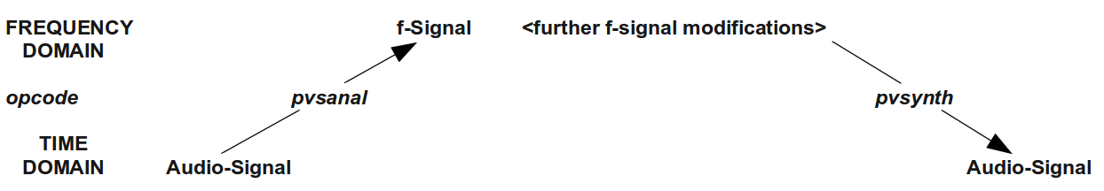

Pitch shifting
Simple pitch shifting can be done by the opcode pvscale. All the frequency data in the f-signal are scaled by a certain value. Multiplying by 2 results in transposing an octave upwards; multiplying by 0.5 in transposing an octave downwards. For accepting cent values instead of ratios as input, the cent opcode can be used.
EXAMPLE 05I02_pvscale.csd
<CsoundSynthesizer>
<CsOptions>
-odac
</CsOptions>
<CsInstruments>
;example by joachim heintz
sr = 44100
ksmps = 32
nchnls = 1
0dbfs = 1

gifftsize = 1024
gioverlap = gifftsize / 4
giwinsize = gifftsize
giwinshape = 1; von-Hann window

instr 1 ;scaling by a factor
ain soundin "fox.wav"
fftin pvsanal ain, gifftsize, gioverlap, giwinsize, giwinshape
fftscal pvscale fftin, p4
aout pvsynth fftscal
out aout
endin

instr 2 ;scaling by a cent value
ain soundin "fox.wav"
fftin pvsanal ain, gifftsize, gioverlap, giwinsize, giwinshape
fftscal pvscale fftin, cent(p4)
aout pvsynth fftscal
out aout/3
endin

</CsInstruments>
<CsScore>
i 1 0 3 1; original pitch
i 1 3 3 .5; octave lower
i 1 6 3 2 ;octave higher
i 2 9 3 0
i 2 9 3 400 ;major third
i 2 9 3 700 ;fifth
e
</CsScore>
</CsoundSynthesizer>
Pitch shifting via FFT resynthesis is very simple in general, but more or less complicated in detail. With speech for instance, there is a problem because of the formants. If you simply scale the frequencies, the formants are shifted, too, and the sound gets the typical "Mickey-Mousing" effect. There are some parameters in the pvscale opcode, and some other pvs-opcodes which can help to avoid this, but the result always depends on the individual sounds and on your ideas.

Time stretch/compress
As the Fourier transformation seperates the spectral information from the progression in time, both elements can be varied independently. Pitch shifting via the pvscale opcode, as in the previous example, is independent from the speed of reading the audio data. The complement is changing the time without changing the pitch: time stretching or time compression.
The simplest way to alter the speed of a sampled sound is using pvstanal (which is new in Csound 5.13). This opcode transforms a sound which is stored in a function table, in an f-signal, and time manipulations are simply done by altering the ktimescal parameter.
Example 05I03_pvstanal.csd
<CsoundSynthesizer>
<CsOptions>
-odac
</CsOptions>
<CsInstruments>
;example by joachim heintz
sr = 44100
ksmps = 32
nchnls = 1
0dbfs = 1

;store the sample "fox.wav" in a function table (buffer)
gifil ftgen 0, 0, 0, 1, "fox.wav", 0, 0, 1

;general values for the pvstanal opcode
giamp = 1 ;amplitude scaling
gipitch = 1 ;pitch scaling
gidet = 0 ;onset detection
giwrap = 0 ;no loop reading
giskip = 0 ;start at the beginning
gifftsiz = 1024 ;fft size
giovlp = gifftsiz/8 ;overlap size
githresh = 0 ;threshold

instr 1 ;simple time stretching / compressing
fsig pvstanal p4, giamp, gipitch, gifil, gidet, giwrap, giskip,
gifftsiz, giovlp, githresh
aout pvsynth fsig
out aout
endin

instr 2 ;automatic scratching
kspeed randi 2, 2, 2 ;speed randomly between -2 and 2
kpitch randi p4, 2, 2 ;pitch between 2 octaves lower or higher
fsig pvstanal kspeed, 1, octave(kpitch), gifil
aout pvsynth fsig
aenv linen aout, .003, p3, .1
out aout
endin

</CsInstruments>
<CsScore>
; speed
i 1 0 3 1
i . + 10 .33
i . + 2 3
s
i 2 0 10 0;random scratching without ...
i . 11 10 2 ;... and with pitch changes
</CsScore>
</CsoundSynthesizer>

Cross Synthesis
Working in the frequency domain makes it possible to combine or "cross" the spectra of two sounds. As the Fourier transform of an analysis frame results in a frequency and an amplitude value for each frequency "bin", there are many different ways of performing cross synthesis. The most common methods are:
- Combine the amplitudes of sound A with the frequencies of sound B. This is the classical phase vocoder approach. If the frequencies are not completely from sound B, but can be scaled between A and B, the crossing is more flexible and adjustable to the sounds being used. This is what pvsvoc does.
- Combine the frequencies of sound A with the amplitudes of sound B. Give more flexibility by scaling the amplitudes between A and B: pvscross.
- Get the frequencies from sound A. Multiply the amplitudes of A and B. This can be described as spectral filtering. pvsfilter gives a flexible portion of this filtering effect.
This is an example for phase vocoding. It is nice to have speech as sound A, and a rich sound, like classical music, as sound B. Here the "fox" sample is being played at half speed and "sings" through the music of sound B:
EXAMPLE 05I04_phase_vocoder.csd
<CsoundSynthesizer>
<CsOptions>
-odac
</CsOptions>
<CsInstruments>
;example by joachim heintz
sr = 44100
ksmps = 32
nchnls = 1
0dbfs = 1

;store the samples in function tables (buffers)
gifilA ftgen 0, 0, 0, 1, "fox.wav", 0, 0, 1
gifilB ftgen 0, 0, 0, 1, "ClassGuit.wav", 0, 0, 1

;general values for the pvstanal opcode
giamp = 1 ;amplitude scaling
gipitch = 1 ;pitch scaling
gidet = 0 ;onset detection
giwrap = 1 ;loop reading
giskip = 0 ;start at the beginning
gifftsiz = 1024 ;fft size
giovlp = gifftsiz/8 ;overlap size
githresh = 0 ;threshold

instr 1
;read "fox.wav" in half speed and cross with classical guitar sample
fsigA pvstanal .5, giamp, gipitch, gifilA, gidet, giwrap, giskip,\
gifftsiz, giovlp, githresh
fsigB pvstanal 1, giamp, gipitch, gifilB, gidet, giwrap, giskip,\
gifftsiz, giovlp, githresh
fvoc pvsvoc fsigA, fsigB, 1, 1
aout pvsynth fvoc
aenv linen aout, .1, p3, .5
out aout
endin

</CsInstruments>
<CsScore>
i 1 0 11
</CsScore>
</CsoundSynthesizer>
The next example introduces pvscross:
EXAMPLE 05I05_pvscross.csd
<CsoundSynthesizer>
<CsOptions>
-odac
</CsOptions>
<CsInstruments>
;example by joachim heintz
sr = 44100
ksmps = 32
nchnls = 1
0dbfs = 1

;store the samples in function tables (buffers)
gifilA ftgen 0, 0, 0, 1, "BratscheMono.wav", 0, 0, 1
gifilB ftgen 0, 0, 0, 1, "fox.wav", 0, 0, 1

;general values for the pvstanal opcode
giamp = 1 ;amplitude scaling
gipitch = 1 ;pitch scaling
gidet = 0 ;onset detection
giwrap = 1 ;loop reading
giskip = 0 ;start at the beginning
gifftsiz = 1024 ;fft size
giovlp = gifftsiz/8 ;overlap size
githresh = 0 ;threshold

instr 1
;cross viola with "fox.wav" in half speed
fsigA pvstanal 1, giamp, gipitch, gifilA, gidet, giwrap, giskip,\
gifftsiz, giovlp, githresh
fsigB pvstanal .5, giamp, gipitch, gifilB, gidet, giwrap, giskip,\
gifftsiz, giovlp, githresh
fcross pvscross fsigA, fsigB, 0, 1
aout pvsynth fcross
aenv linen aout, .1, p3, .5
out aout
endin

</CsInstruments>
<CsScore>
i 1 0 11
</CsScore>
</CsoundSynthesizer>
The last example shows spectral filtering via pvsfilter. The well-known "fox" (sound A) is now filtered by the viola (sound B). Its resulting intensity depends on the amplitudes of sound B, and if the amplitudes are strong enough, you hear a resonating effect:
EXAMPLE 05I06_pvsfilter.csd
<CsoundSynthesizer>
<CsOptions>
-odac
</CsOptions>
<CsInstruments>
;example by joachim heintz
sr = 44100
ksmps = 32
nchnls = 1
0dbfs = 1

;store the samples in function tables (buffers)
gifilA ftgen 0, 0, 0, 1, "fox.wav", 0, 0, 1
gifilB ftgen 0, 0, 0, 1, "BratscheMono.wav", 0, 0, 1

;general values for the pvstanal opcode
giamp = 1 ;amplitude scaling
gipitch = 1 ;pitch scaling
gidet = 0 ;onset detection
giwrap = 1 ;loop reading
giskip = 0 ;start at the beginning
gifftsiz = 1024 ;fft size
giovlp = gifftsiz/4 ;overlap size
githresh = 0 ;threshold

instr 1
;filters "fox.wav" (half speed) by the spectrum of the viola (double speed)
fsigA pvstanal .5, giamp, gipitch, gifilA, gidet, giwrap, giskip,\
gifftsiz, giovlp, githresh
fsigB pvstanal 2, 5, gipitch, gifilB, gidet, giwrap, giskip,\
gifftsiz, giovlp, githresh
ffilt pvsfilter fsigA, fsigB, 1
aout pvsynth ffilt
aenv linen aout, .1, p3, .5
out aout
endin

</CsInstruments>
<CsScore>
i 1 0 11
</CsScore>
</CsoundSynthesizer>
There are much more ways of working with the pvs opcodes. Have a look at the Signal Processing II section of the Opcodes Overview to find some hints.
- All soundfiles used in this manual are free and can be downloaded at www.csound-tutorial.net^
- For some cases it is good to have pvsadsyn as an alternative, which is using a bank of oscillators for resynthesis.^
06 SAMPLES
38. RECORD AND PLAY SOUNDFILES
39. RECORD AND PLAY BUFFERS

38. RECORD AND PLAY SOUNDFILES

Playing Soundfiles From Disk - diskin21
The simplest way of playing a sound file from Csound is to use the diskin2 opcode. This opcode reads audio directly from the hard drive location where it is stored, i.e. it does not pre-load the sound file at initialisation time. This method of sound file playback is therefore good for playing back very long, or parts of very long, sound files. It is perhaps less well suited to playing back sound files where dense polyphony, multiple iterations and rapid random access to the file is required. In these situations reading from a function table or buffer is preferable.
diskin2 has additional parameters for speed of playback, and interpolation.
EXAMPLE 06A01_Play_soundfile.csd
<CsoundSynthesizer>

<CsOptions>
-odac ; activate real-time audio output
</CsOptions>

<CsInstruments>
; example written by Iain McCurdy

sr = 44100
ksmps = 32
nchnls = 1

instr 1 ; play audio from disk
kSpeed init 1 ; playback speed
iSkip init 0 ; inskip into file (in seconds)
iLoop init 0 ; looping switch (0=off 1=on)
; read audio from disk using diskin2 opcode
a1 diskin2 "loop.wav", kSpeed, iSkip, iLoop
out a1 ; send audio to outputs
endin

</CsInstruments>

<CsScore>
i 1 0 6
e
</CsScore>

</CsoundSynthesizer>

Writing Audio to Disk
The traditional method of rendering Csound's audio to disk is to specify a sound file as the audio destination in the Csound command or under <CsOptions>, in fact before real-time performance became a possibility this was the only way in which Csound was used. With this method, all audio that is piped to the output using out, outs etc. will be written to this file. The number of channels that the file will conatain will be determined by the number of channels specified in the orchestra header using 'nchnls'. The disadvantage of this method is that we cannot simultaneously listen to the audio in real-time.
EXAMPLE 06A02_Write_soundfile.csd
<CsoundSynthesizer>

<CsOptions>
; audio output destination is given as a sound file (wav format specified)
; this method is for deferred time performance,
; simultaneous real-time audio will not be possible
-oWriteToDisk1.wav -W
</CsOptions>

<CsInstruments>
; example written by Iain McCurdy

sr = 44100
ksmps = 32
nchnls = 1
0dbfs = 1

giSine ftgen 0, 0, 4096, 10, 1 ; a sine wave

instr 1 ; a simple tone generator
aEnv expon 0.2, p3, 0.001 ; a percussive envelope
aSig poscil aEnv, cpsmidinn(p4), giSine ; audio oscillator
out aSig ; send audio to output
endin

</CsInstruments>

<CsScore>
; two chords
i 1 0 5 60
i 1 0.1 5 65
i 1 0.2 5 67
i 1 0.3 5 71

i 1 3 5 65
i 1 3.1 5 67
i 1 3.2 5 73
i 1 3.3 5 78
e
</CsScore>

</CsoundSynthesizer>

Writing Audio to Disk with Simultaneous Real-time Audio Output - fout and monitor
Recording audio output to disk whilst simultaneously monitoring in real-time is best achieved through combining the opcodes monitor and fout. 'monitor' can be used to create an audio signal that consists of a mix of all audio output from all instruments. This audio signal can then be rendered to a sound file on disk using 'fout'. 'monitor' can read multi-channel outputs but its number of outputs should correspond to the number of channels defined in the header using 'nchnls'. In this example it is reading just in mono. 'fout' can write audio in a number of formats and bit depths and it can also write multi-channel sound files.
EXAMPLE 06A03_Write_RT.csd
<CsoundSynthesizer>

<CsOptions>
-odac ; activate real-time audio output
</CsOptions>

<CsInstruments>
;example written by Iain McCurdy

sr = 44100
ksmps = 32
nchnls = 1
0dbfs = 1

giSine ftgen 0, 0, 4096, 10, 1 ; a sine wave
gaSig init 0; set initial value for global audio variable (silence)

instr 1 ; a simple tone generator
aEnv expon 0.2, p3, 0.001 ; percussive amplitude envelope
aSig poscil aEnv, cpsmidinn(p4), giSine ; audio oscillator
out aSig
endin

instr 2 ; write to a file (always on in order to record everything)
aSig monitor ; read audio from output bus
fout "WriteToDisk2.wav",4,aSig ; write audio to file (16bit mono)
endin

</CsInstruments>

<CsScore>
; activate recording instrument to encapsulate the entire performance
i 2 0 8.3

; two chords
i 1 0 5 60
i 1 0.1 5 65
i 1 0.2 5 67
i 1 0.3 5 71

i 1 3 5 65
i 1 3.1 5 67
i 1 3.2 5 73
i 1 3.3 5 78
e
</CsScore>

</CsoundSynthesizer
- diskin2 is an improved version of diskin. In Csound 6, both will use the same code, so it should make no difference whether you use diskin or diskin2.^

39. RECORD AND PLAY BUFFERS

Playing Audio From RAM - flooper2
Csound offers many opcodes for playing back sound files that have first been loaded into a function table (and therefore are loaded into RAM). Some of these offer higher quality at the expense of computation speed some are simpler and less fully featured.
One of the newer and easier to use opcodes for this task is flooper2. As its name might suggest it is intended for the playback of files with looping. 'flooper2' can also apply a cross-fade between the end and the beginning of the loop in order to smooth the transition where looping takes place.
In the following example a sound file that has been loaded into a GEN01 function table is played back using 'flooper2'. 'flooper2' also includes a parameter for modulating playback speed/pitch. There is also the option of modulating the loop points at k-rate. In this example the entire file is simply played and looped. You can replace the sound file with one of your own or you can download the one used in the example from here:

Some notes about GEN01 and function table sizes:
When storing sound files in GEN01 function tables we must ensure that we define a table of sufficient size to store our sound file. Normally function table sizes should be powers of 2 (2, 4, 8, 16, 32 etc.). If we know the duration of our sound file we can derive the required table size by multiplying this duration by the sample rate and then choosing the next power of 2 larger than this. For example when the sampling rate is 44100, we will require 44100 table locations to store 1 second of audio; but 44100 is not a power of 2 so we must choose the next power of 2 larger than this which is 65536. (Hint: you can discover a sound file's duration by using Csound's 'sndinfo' utility.)
There are some 'lazy' options however: if we underestimate the table size, when we then run Csound it will warn us that this table size is too small and conveniently inform us via the terminal what the minimum size required to store the entire file would be - we can then substitute this value in our GEN01 table. We can also overestimate the table size in which case Csound won't complain at all, but this is a rather inefficient approach.
If we give table size a value of zero we have what is referred to as 'deferred table size'. This means that Csound will calculate the exact table size needed to store our sound file and use this as the table size but this will probably not be a power of 2. Many of Csound's opcodes will work quite happily with non-power of 2 function table sizes, but not all! It is a good idea to know how to deal with power of 2 table sizes. We can also explicitly define non-power of 2 table sizes by prefacing the table size with a minus sign '-'.
All of the above discussion about required table sizes assumed that the sound file was mono, to store a stereo sound file will naturally require twice the storage space, for example, 1 second of stereo audio will require 88200 storage locations. GEN01 will indeed store stereo sound files and many of Csound's opcodes will read from stereo GEN01 function tables, but again not all! We must be prepared to split stereo sound files, either to two sound files on disk or into two function tables using GEN01's 'channel' parameter (p8), depending on the opcodes we are using.
Storing audio in GEN01 tables as mono channels with non-deferred and power of 2 table sizes will ensure maximum compatibility.
EXAMPLE 06B01_flooper2.csd
<CsoundSynthesizer>

<CsOptions>
-odac ; activate real-time audio
</CsOptions>

<CsInstruments>
; example written by Iain McCurdy

sr = 44100
ksmps = 32
nchnls = 1
0dbfs = 1

; STORE AUDIO IN RAM USING GEN01 FUNCTION TABLE
giSoundFile ftgen 0, 0, 262144, 1, "loop.wav", 0, 0, 0

instr 1 ; play audio from function table using flooper2 opcode
kAmp = 1 ; amplitude
kPitch = p4 ; pitch/speed
kLoopStart = 0 ; point where looping begins (in seconds)
kLoopEnd = nsamp(giSoundFile)/sr; loop end (end of file)
kCrossFade = 0 ; cross-fade time
; read audio from the function table using the flooper2 opcode
aSig flooper2 kAmp,kPitch,kLoopStart,kLoopEnd,kCrossFade,giSoundFile
out aSig ; send audio to output
endin

</CsInstruments>

<CsScore>
; p4 = pitch
; (sound file duration is 4.224)
i 1 0 [4.224*2] 1
i 1 + [4.224*2] 0.5
i 1 + [4.224*1] 2
e
</CsScore>

</CsoundSynthesizer>

Csound's Built-in Record-Play Buffer - sndloop
Csound has an opcode called sndloop which provides a simple method of recording some audio into a buffer and then playing it back immediately. The duration of audio storage required is defined when the opcode is initialized. In the following example two seconds is provided. Once activated, as soon as two seconds of live audio has been recorded by 'sndloop', it immediately begins playing it back in a loop. 'sndloop' allows us to modulate the speed/pitch of the played back audio as well as providing the option of defining a crossfade time between the end and the beginning of the loop. In the example pressing 'r' on the computer keyboard activates record followed by looped playback, pressing 's' stops record or playback, pressing '+' increases the speed and therefore the pitch of playback and pressing '-' decreases the speed/pitch of playback. If playback speed is reduced below zero it enters the negative domain in which case playback will be reversed.
You will need to have a microphone connected to your computer in order to use this example.
EXAMPLE 06B02_sndloop.csd
<CsoundSynthesizer>

<CsOptions>
; real-time audio in and out are both activated
-iadc -odac
</CsOptions>

<CsInstruments>
;example written by Iain McCurdy

sr = 44100
ksmps = 32
nchnls = 1

instr 1
; PRINT INSTRUCTIONS
prints "Press 'r' to record, 's' to stop playback, "
prints "'+' to increase pitch, '-' to decrease pitch.\\n"
; SENSE KEYBOARD ACTIVITY
kKey sensekey; sense activity on the computer keyboard
aIn inch 1 ; read audio from first input channel
kPitch init 1 ; initialize pitch parameter
iDur init 2 ; inititialize duration of loop parameter
iFade init 0.05 ; initialize crossfade time parameter
if kKey = 114 then ; if 'r' has been pressed...
kTrig = 1 ; set trigger to begin record-playback
elseif kKey = 115 then ; if 's' has been pressed...
kTrig = 0 ; set trigger to turn off record-playback
elseif kKey = 43 then ; if '+' has been pressed...
kPitch = kPitch + 0.02 ; increment pitch parameter
elseif kKey = 95 then ; if '-' has been pressed
kPitch = kPitch - 0.02 ; decrement pitch parameter
endif ; end of conditional branches
; CREATE SNDLOOP INSTANCE
aOut, kRec sndloop aIn, kPitch, kTrig, iDur, iFade ; (kRec output is not used)
out aOut ; send audio to output
endin

</CsInstruments>

<CsScore>
i 1 0 3600 ; instr 1 plays for 1 hour
</CsScore>

</CsoundSynthesizer>

Recording to and Playback from a Function Table
Writing to and reading from buffers can also be achieved through the use of Csound's opcodes for table reading and writing operations. Although the procedure is a little more complicated than that required for 'sndloop' it is ultimately more flexible. In the next example separate instruments are used for recording to the table and for playing back from the table. Another instrument which runs constantly scans for activity on the computer keyboard and activates the record or playback instruments accordingly. For writing to the table we will use the tablew opcode and for reading from the table we will use the table opcode (if we were to modulate the playback speed it would be better to use one of Csound's interpolating variations of 'table' such as tablei or table3. Csound writes individual values to table locations, the exact table locations being defined by an 'index'. For writing continuous audio to a table this index will need to be continuously moving 1 location for every sample. This moving index (or 'pointer') can be created with an a-rate line or a phasor. The next example uses 'line'. When using Csound's table operation opcodes we first need to create that table, either in the orchestra header or in the score. The duration of the audio buffer can be calculated from the size of the table. In this example the table is 2^17 points long, that is 131072 points. The duration in seconds is this number divided by the sample rate which in our example is 44100Hz. Therefore maximum storage duration for this example is 131072/44100 which is around 2.9 seconds.
EXAMPLE 06B03_RecPlayToTable.csd
<CsoundSynthesizer>

<CsOptions>
; real-time audio in and out are both activated
-iadc -odac -d -m0
</CsOptions>

<CsInstruments>
; example written by Iain McCurdy

sr = 44100
ksmps = 32
nchnls = 1

giBuffer ftgen 0, 0, 2^17, 7, 0; table for audio data storage
maxalloc 2,1 ; allow only one instance of the recording instrument at a time!

instr 1 ; Sense keyboard activity. Trigger record or playback accordingly.
prints "Press 'r' to record, 'p' for playback.\\n"
iTableLen = ftlen(giBuffer) ; derive buffer function table length
idur = iTableLen / sr ; derive storage time in seconds
kKey sensekey ; sense activity on the computer keyboard
if kKey=114 then ; if ASCCI value of 114 ('r') is output
event "i", 2, 0, idur, iTableLen ; activate recording instrument (2)
endif
if kKey=112 then ; if ASCCI value of 112 ('p) is output
event "i", 3, 0, idur, iTableLen ; activate playback instrument
endif
endin

instr 2 ; record to buffer
iTableLen = p4 ; table/recording length in samples
; -- print progress information to terminal --
prints "recording"
printks ".", 0.25 ; print '.' every quarter of a second
krelease release ; sense when note is in final k-rate pass...
if krelease=1 then ; then ..
printks "\\ndone\\n", 0 ; ... print a message
endif
; -- write audio to table --
ain inch 1 ; read audio from live input channel 1
andx line 0,p3,iTableLen ; create an index for writing to table
tablew ain,andx,giBuffer ; write audio to function table
endin

instr 3 ; playback from buffer
iTableLen = p4 ; table/recording length in samples
; -- print progress information to terminal --
prints "playback"
printks ".", 0.25 ; print '.' every quarter of a second
krelease release ; sense when note is in final k-rate pass
if krelease=1 then ; then ...
printks "\\ndone\\n", 0 ; ... print a message
endif; end of conditional branch
; -- read audio from table --
aNdx line 0, p3, iTableLen; create an index for reading from table
a1 table aNdx, giBuffer ; read audio to audio storage table
out a1 ; send audio to output
endin

</CsInstruments>

<CsScore>
i 1 0 3600 ; Sense keyboard activity. Start recording - playback.
</CsScore>

</CsoundSynthesizer>

Encapsulating Record and Play Buffer Functionality to a UDO
Recording and playing of buffers can also be encapsulated into a User Defined Opcode. For being flexible in the size of the buffer, the tabw opcode will be used for writing audio data to a buffer. tabw writes to a table of any size and does not need a power-of-two table size like tablew.
An empty table (buffer) of any size can be created with a negative number as size. A table for recording 10 seconds of audio data can be created in this way:
giBuf1 ftgen 0, 0, -(10*sr), 2, 0
The used can decide whether he wants to assign a certain number to the table, or whether he lets Csound do this job, calling the table via its variable, in this case giBuf1. This is a UDO for creating a mono buffer, and another UDO for creating a stereo buffer:
opcode BufCrt1, i, io
ilen, inum xin
ift ftgen inum, 0, -(ilen*sr), 2, 0
xout ift
endop

opcode BufCrt2, ii, io
ilen, inum xin
iftL ftgen inum, 0, -(ilen*sr), 2, 0
iftR ftgen inum, 0, -(ilen*sr), 2, 0
xout iftL, iftR
endop
This simplifies the procedure of creating a record/play buffer, because the user is just asked for the length of the buffer. A number can be given, but by default Csound will assign this number. This statement will create an empty stereo table for 5 seconds of recording:
iBufL,iBufR BufCrt2 5
A first, simple version of a UDO for recording will just write the incoming audio to sequential locations of the table. This can be done by setting the ksmps value to 1 inside this UDO (setksmps 1), so that each audio sample has its own discrete k-value. In this way the write index for the table can be assigned via the statement andx=kndx, and increased by one for the next k-cycle. An additional k-input turns recording on and of:
opcode BufRec1, 0, aik
ain, ift, krec xin
setksmps 1
if krec == 1 then ;record as long as krec=1
kndx init 0
andx = kndx
tabw ain, andx, ift
kndx = kndx+1
endif
endop
The reading procedure is simple, too. Actually the same code can be used; it is sufficient just to replace the opcode for writing (tabw) with the opcode for reading (tab):
opcode BufPlay1, a, ik
ift, kplay xin
setksmps 1
if kplay == 1 then ;play as long as kplay=1
kndx init 0
andx = kndx
aout tab andx, ift
kndx = kndx+1
endif
endop
So - let's use these first simple UDOs in a Csound instrument. Press the "r" key as long as you want to record, and the "p" key for playing back. Note that you must disable the key repeats on your computer keyboard for this example (in QuteCsound, disable "Allow key repeats" in Configuration -> General).
EXAMPLE 06B04_BufRecPlay_UDO.csd
<CsoundSynthesizer>
<CsOptions>
-i adc -o dac -d -m0
</CsOptions>
<CsInstruments>
;example written by Joachim Heintz
sr = 44100
ksmps = 32
nchnls = 1
0dbfs = 1

opcode BufCrt1, i, io
ilen, inum xin
ift ftgen inum, 0, -(ilen*sr), 2, 0
xout ift
endop

opcode BufRec1, 0, aik
ain, ift, krec xin
setksmps 1
imaxindx = ftlen(ift)-1 ;max index to write
knew changed krec
if krec == 1 then ;record as long as krec=1
if knew == 1 then ;reset index if restarted
kndx = 0
endif
kndx = (kndx > imaxindx ? imaxindx : kndx)
andx = kndx
tabw ain, andx, ift
kndx = kndx+1
endif
endop

opcode BufPlay1, a, ik
ift, kplay xin
setksmps 1
imaxindx = ftlen(ift)-1 ;max index to read
knew changed kplay
if kplay == 1 then ;play as long as kplay=1
if knew == 1 then ;reset index if restarted
kndx = 0
endif
kndx = (kndx > imaxindx ? imaxindx : kndx)
andx = kndx
aout tab andx, ift
kndx = kndx+1
endif
xout aout
endop

opcode KeyStay, k, kkk
;returns 1 as long as a certain key is pressed
key, k0, kascii xin ;ascii code of the key (e.g. 32 for space)
kprev init 0 ;previous key value
kout = (key == kascii || (key == -1 && kprev == kascii) ? 1 : 0)
kprev = (key > 0 ? key : kprev)
kprev = (kprev == key && k0 == 0 ? 0 : kprev)
xout kout
endop

opcode KeyStay2, kk, kk
;combines two KeyStay UDO's (this way is necessary
;because just one sensekey opcode is possible in an orchestra)
kasci1, kasci2 xin ;two ascii codes as input
key,k0 sensekey
kout1 KeyStay key, k0, kasci1
kout2 KeyStay key, k0, kasci2
xout kout1, kout2
endop

instr 1
ain inch 1 ;audio input on channel 1
iBuf BufCrt1 3 ;buffer for 3 seconds of recording
kRec,kPlay KeyStay2 114, 112 ;define keys for record and play
BufRec1 ain, iBuf, kRec ;record if kRec=1
aout BufPlay1 iBuf, kPlay ;play if kPlay=1
out aout ;send out
endin

</CsInstruments>
<CsScore>
i 1 0 1000
</CsScore>
</CsoundSynthesizer>
Let's realize now a more extended and easy to operate version of these two UDO's for recording and playing a buffer. The wishes of a user might be the following:
Recording:
- allow recording not just from the beginning of the buffer, but also from any arbitrary starting point kstart
- allow circular recording (wrap around) if the end of the buffer has been reached: kwrap=1
Playing:
- play back with different speed kspeed (negaitve speed means playing backwards)
- start playback at any point of the buffer kstart
- end playback at any point of the buffer kend
- allow certain modes of wraparound kwrap while playing:
  - kwrap=0 stops at the defined end point of the buffer
  - kwrap=1 repeats playback between defined end and start points
  - kwrap=2 starts at a the defined starting point but wraps between end point and beginning of the buffer
  - kwrap=3 wraps between kstart and the end of the table
The following example provides versions of BufRec and BufPlay which do this job. We will use the table3 opcode instead of the simple tab or table opcodes in this case, because we want to translate any number of samples in the table to any number of output samples by different speed values:

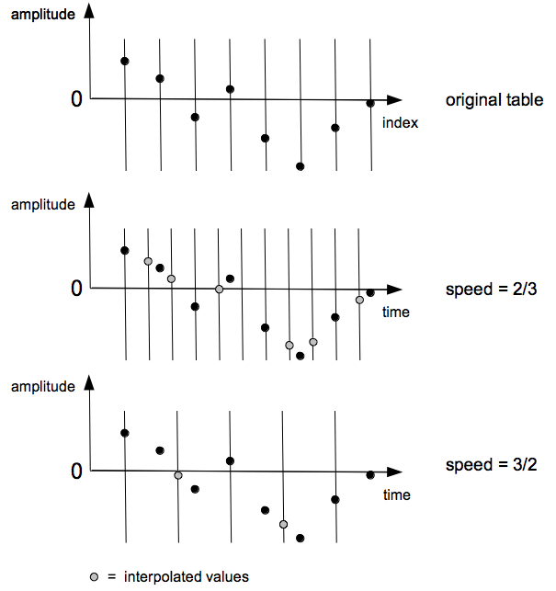
For higher or lower speed values than the original record speed, interpolation must be used in between certain sample values if the original shape of the wave is to be reproduced as accurately as possible. This job is performed with high quality by table3 which employs cubic interpolation.
In a typical application of recording and playing buffer buffers, the ability to interact with the process will be paramount. We can benefit from having interactive access to the following:
- starting and stopping record
- adjusting the start and end points of recording
- use or prevent wraparound while recording
- starting and stopping playback
- adjusting the start and end points of playback
- adjusting wraparound in playback at one of the specified modes (1 - 4)
- applying volume at playback
These interactions could be carried out via widgets, MIDI, OSC or something else. As we want to provide examples which can be used with any Csound frontend here, we are restricted to triggering the record and play events by hitting the space bar of the computer keyboard. (See the CsoundQt version of this example for a more interactive version.)
EXAMPLE 06B05_BufRecPlay_complex.csd
<CsoundSynthesizer>
<CsOptions>
-i adc -o dac -d
</CsOptions>
<CsInstruments>
;example written by joachim heintz
sr = 44100
ksmps = 32
nchnls = 2
0dbfs = 1

opcode BufCrt2, ii, io ;creates a stereo buffer
ilen, inum xin ;ilen = length of the buffer (table) in seconds
iftL ftgen inum, 0, -(ilen*sr), 2, 0
iftR ftgen inum, 0, -(ilen*sr), 2, 0
xout iftL, iftR
endop

opcode BufRec1, k, aikkkk ;records to a buffer
ain, ift, krec, kstart, kend, kwrap xin
setksmps 1
kendsmps = kend*sr ;end point in samples
kendsmps = (kendsmps == 0 || kendsmps > ftlen(ift) ? ftlen(ift) : kendsmps)
kfinished = 0
knew changed krec ;1 if record just started
if krec == 1 then
if knew == 1 then
kndx = kstart * sr - 1 ;first index to write
endif
if kndx >= kendsmps-1 && kwrap == 1 then
kndx = -1
endif
if kndx < kendsmps-1 then
kndx = kndx + 1
andx = kndx
tabw ain, andx, ift
else
kfinished = 1
endif
endif
xout kfinished
endop

opcode BufRec2, k, aaiikkkk ;records to a stereo buffer
ainL, ainR, iftL, iftR, krec, kstart, kend, kwrap xin
kfin BufRec1 ainL, iftL, krec, kstart, kend, kwrap
kfin BufRec1 ainR, iftR, krec, kstart, kend, kwrap
xout kfin
endop

opcode BufPlay1, ak, ikkkkkk
ift, kplay, kspeed, kvol, kstart, kend, kwrap xin
;kstart = begin of playing the buffer in seconds
;kend = end of playing in seconds. 0 means the end of the table
;kwrap = 0: no wrapping. stops at kend (positive speed) or kstart
; (negative speed).this makes just sense if the direction does not
; change and you just want to play the table once
;kwrap = 1: wraps between kstart and kend
;kwrap = 2: wraps between 0 and kend
;kwrap = 3: wraps between kstart and end of table
;CALCULATE BASIC VALUES
kfin init 0
iftlen = ftlen(ift)/sr ;ftlength in seconds
kend = (kend == 0 ? iftlen : kend) ;kend=0 means end of table
kstart01 = kstart/iftlen ;start in 0-1 range
kend01 = kend/iftlen ;end in 0-1 range
kfqbas = (1/iftlen) * kspeed ;basic phasor frequency
;DIFFERENT BEHAVIOUR DEPENDING ON WRAP:
if kplay == 1 && kfin == 0 then
;1. STOP AT START- OR ENDPOINT IF NO WRAPPING REQUIRED (kwrap=0)
if kwrap == 0 then
; -- phasor freq so that 0-1 values match distance start-end
kfqrel = kfqbas / (kend01-kstart01)
andxrel phasor kfqrel ;index 0-1 for distance start-end
; -- final index for reading the table (0-1)
andx = andxrel * (kend01-kstart01) + (kstart01)
kfirst init 1 ;don't check condition below at the first k-cycle (always true)
kndx downsamp andx
kprevndx init 0
;end of table check:
;for positive speed, check if this index is lower than the previous one
if kfirst == 0 && kspeed > 0 && kndx < kprevndx then
kfin = 1
;for negative speed, check if this index is higher than the previous one
else
kprevndx = (kprevndx == kstart01 ? kend01 : kprevndx)
if kfirst == 0 && kspeed < 0 && kndx > kprevndx then
kfin = 1
endif
kfirst = 0 ;end of first cycle in wrap = 0
endif
;sound out if end of table has not yet reached
asig table3 andx, ift, 1
kprevndx = kndx ;next previous is this index
;2. WRAP BETWEEN START AND END (kwrap=1)
elseif kwrap == 1 then
kfqrel = kfqbas / (kend01-kstart01) ;same as for kwarp=0
andxrel phasor kfqrel
andx = andxrel * (kend01-kstart01) + (kstart01)
asig table3 andx, ift, 1 ;sound out
;3. START AT kstart BUT WRAP BETWEEN 0 AND END (kwrap=2)
elseif kwrap == 2 then
kw2first init 1
if kw2first == 1 then ;at first k-cycle:
reinit wrap3phs ;reinitialize for getting the correct start phase
kw2first = 0
endif
kfqrel = kfqbas / kend01 ;phasor freq so that 0-1 values match distance start-end
wrap3phs:
andxrel phasor kfqrel, i(kstart01) ;index 0-1 for distance start-end
rireturn ;end of reinitialization
andx = andxrel * kend01 ;final index for reading the table
asig table3 andx, ift, 1 ;sound out
;4. WRAP BETWEEN kstart AND END OF TABLE(kwrap=3)
elseif kwrap == 3 then
kfqrel = kfqbas / (1-kstart01) ;phasor freq so that 0-1 values match distance start-end
andxrel phasor kfqrel ;index 0-1 for distance start-end
andx = andxrel * (1-kstart01) + kstart01 ;final index for reading the table
asig table3 andx, ift, 1
endif
else ;if either not started or finished at wrap=0
asig = 0 ;don't produce any sound
endif
xout asig*kvol, kfin
endop

opcode BufPlay2, aak, iikkkkkk ;plays a stereo buffer
iftL, iftR, kplay, kspeed, kvol, kstart, kend, kwrap xin
aL,kfin BufPlay1 iftL, kplay, kspeed, kvol, kstart, kend, kwrap
aR,kfin BufPlay1 iftR, kplay, kspeed, kvol, kstart, kend, kwrap
xout aL, aR, kfin
endop

opcode In2, aa, kk ;stereo audio input
kchn1, kchn2 xin
ain1 inch kchn1
ain2 inch kchn2
xout ain1, ain2
endop

opcode Key, kk, k
;returns '1' just in the k-cycle a certain key has been pressed (kdown)
; or released (kup)
kascii xin ;ascii code of the key (e.g. 32 for space)
key,k0 sensekey
knew changed key
kdown = (key == kascii && knew == 1 && k0 == 1 ? 1 : 0)
kup = (key == kascii && knew == 1 && k0 == 0 ? 1 : 0)
xout kdown, kup
endop

instr 1
giftL,giftR BufCrt2 3 ;creates a stereo buffer for 3 seconds
gainL,gainR In2 1,2 ;read input channels 1 and 2 and write as global audio
prints "PLEASE PRESS THE SPACE BAR ONCE AND GIVE AUDIO INPUT
ON CHANNELS 1 AND 2.\n"
prints "AUDIO WILL BE RECORDED AND THEN AUTOMATICALLY PLAYED
BACK IN SEVERAL MANNERS.\n"
krec,k0 Key 32
if krec == 1 then
event "i", 2, 0, 10
endif
endin

instr 2
; -- records the whole buffer and returns 1 at the end
kfin BufRec2 gainL, gainR, giftL, giftR, 1, 0, 0, 0
if kfin == 0 then
printks "Recording!\n", 1
endif
if kfin == 1 then
ispeed random -2, 2
istart random 0, 1
iend random 2, 3
iwrap random 0, 1.999
iwrap = int(iwrap)
printks "Playing back with speed = %.3f, start = %.3f, end = %.3f,
wrap = %d\n", p3, ispeed, istart, iend, iwrap
aL,aR,kf BufPlay2 giftL, giftR, 1, ispeed, 1, istart, iend, iwrap
if kf == 0 then
printks "Playing!\n", 1
endif
endif
krel release
if kfin == 1 && kf == 1 || krel == 1 then
printks "PRESS SPACE BAR AGAIN!\n", p3
turnoff
endif
outs aL, aR
endin

</CsInstruments>
<CsScore>
i 1 0 1000
e
</CsScore>
</CsoundSynthesizer>

07 MIDI
40. RECEIVING EVENTS BY MIDIIN
41. TRIGGERING INSTRUMENT INSTANCES
42. WORKING WITH CONTROLLERS
43. READING MIDI FILES
44. MIDI OUTPUT

40. RECEIVING EVENTS BY MIDIIN
Csound provides a variety of opcodes, such as cpsmidi, ampmidi and ctrl7 which allow for transparent interpretation of incoming midi data. These opcodes allow us to read in midi information without us having to worry about parsing status bytes and so on. Occasionally when we are involved in more complex midi interaction, it might be advantageous for us to scan all raw midi information that is coming into Csound. The midiin opcode allows us to do this.
In the next example a simple midi monitor is constructed. Incoming midi events are printed to the terminal with some formatting to make them readable. We can disable Csound's default instrument triggering mechanism (which in this example we don't want) by giving the line:
massign 0,0
just after the header statement (sometimes referred to as instrument 0).
For this example to work you will need to ensure that you have activated live midi input within Csound, either by using the -M flag or from within the QuteCsound configuration menu, and that you have a midi keyboard or controller connected. You may also want to include the -m0 flag which will disable some of Csound's additional messaging output and therefore allow our midi printout to be presented more clearly.
The status byte tells us what sort of midi information has been received. For example, a value of 144 tells us that a midi note event has been received, a value of 176 tells us that a midi controller event has been received, a value of 224 tells us that pitch bend has been received and so on.
The meaning of the two data bytes depends on what sort of status byte has been received. For example if a midi note event has been received then data byte 1 gives us the note velocity and data byte 2 gives us the note number, if a midi controller event has been received then data byte 1 gives us the controller number and data byte 2 gives us the controller value.
EXAMPLE 07A01_midiin_print.csd
<CsoundSynthesizer>

<CsOptions>
-Ma -m0
; activates all midi devices, suppress note printings
</CsOptions>

<CsInstruments>
; Example by Iain McCurdy

; no audio so 'sr' or 'nchnls' aren't relevant
ksmps = 32

; using massign with these arguments disables default instrument triggering
massign 0,0

instr 1
kstatus, kchan, kdata1, kdata2 midiin ;read in midi
ktrigger changed kstatus, kchan, kdata1, kdata2 ;trigger if midi data changes
if ktrigger=1 && kstatus!=0 then ;if status byte is non-zero...
; -- print midi data to the terminal with formatting --
printks "status:%d%tchannel:%d%tdata1:%d%tdata2:%d%n"\
,0,kstatus,kchan,kdata1,kdata2
endif
endin

</CsInstruments>

<CsScore>
i 1 0 3600 ; instr 1 plays for 1 hour
</CsScore>

</CsoundSynthesizer>
The principle advantage of the midiin opcode is that, unlike opcodes such as cpsmidi, ampmidi and ctrl7 which only receive specific midi data types on a specific channel, midiin 'listens' to all incoming data including system exclusive. In situations where elaborate Csound instrument triggering mappings that are beyond the default triggering mechanism's capabilities, are required then the use for midiin might be beneficial.

41. TRIGGERING INSTRUMENT INSTANCES

Csound's Default System of Instrument Triggering Via Midi
Csound has a default system for instrument triggering via midi. Provided a midi keyboard has been connected and the appropriate commmand line flags for midi input have been set (see configuring midi for further information) or the appropriate settings have been made in QuteCsound's configuration menu, then midi notes received on midi channel 1 will trigger instrument 1, notes on channel 2 will trigger instrument 2 and so on. Instruments will turn on and off in sympathy with notes being pressed and released on the midi keyboard and Csound will correctly unravel polyphonic layering and turn on and off only the correct layer of the same instrument begin played. Midi activated notes can be thought of as 'held' notes, similar to notes activated in the score with a negative duration (p3). Midi activated notes will sustain indefinitely as long as the performance time will allow until a corresponding note off has been received - this is unless this infinite p3 duration is overwritten within the instrument itself by p3 begin explicitly defined.
The following example confirms this default mapping of midi channels to instruments. You will need a midi keyboard that allows you to change the midi channel on which it is transmmitting. Besides a written confirmation to the console of which instrument is begin triggered, there is an audible confirmation in that instrument 1 plays single pulses, instrument 2 plays sets of two pulses and instrument 3 plays sets of three pulses. The example does not go beyond three instruments. If notes are received on midi channel 4 and above, because corresonding instruments do not exist, notes on any of these channels will be directed to instrument 1.
EXAMPLE 07B01_MidiInstrTrigger.csd
<CsoundSynthesizer>

<CsOptions>
-Ma -odac -m0
;activates all midi devices, real time sound output, and suppress note printings
</CsOptions>

<CsInstruments>
; Example by Iain McCurdy

sr = 44100
ksmps = 32
nchnls = 1
0dbfs = 1

gisine ftgen 0,0,2^12,10,1

instr 1 ; 1 impulse (midi channel 1)
prints "instrument/midi channel: %d%n",p1 ; print instrument number to terminal
reset: ; label 'reset'
timout 0, 1, impulse ; jump to 'impulse' for 1 second
reinit reset ; reninitialize pass from 'reset'
impulse: ; label 'impulse'
aenv expon 1, 0.3, 0.0001 ; a short percussive envelope
aSig poscil aenv, 500, gisine ; audio oscillator
out aSig ; audio to output
endin

instr 2 ; 2 impulses (midi channel 2)
prints "instrument/midi channel: %d%n",p1
reset:
timout 0, 1, impulse
reinit reset
impulse:
aenv expon 1, 0.3, 0.0001
aSig poscil aenv, 500, gisine
a2 delay aSig, 0.15 ; short delay adds another impulse
out aSig+a2 ; mix two impulses at output
endin

instr 3 ; 3 impulses (midi channel 3)
prints "instrument/midi channel: %d%n",p1
reset:
timout 0, 1, impulse
reinit reset
impulse:
aenv expon 1, 0.3, 0.0001
aSig poscil aenv, 500, gisine
a2 delay aSig, 0.15 ; delay adds a 2nd impulse
a3 delay a2, 0.15 ; delay adds a 3rd impulse
out aSig+a2+a3 ; mix the three impulses at output
endin

</CsInstruments>
<CsScore>
f 0 300
e
</CsScore>
<CsoundSynthesizer>

Using massign to Map MIDI Channels to Instruments
We can use the massign opcode, which is used just after the header statement, to explicitly map midi channels to specific instruments and thereby overrule Csound's default mappings. massign takes two input arguments, the first defines the midi channel to be redirected and the second stipulates which instrument it should be directed to. The following example is identical to the previous one except that the massign statements near the top of the orchestra jumble up the default mappings. Midi notes on channel 1 will be mapped to instrument 3, notes on channel 2 to instrument 1 and notes on channel 3 to instrument 2. Undefined channel mappings will be mapped according to the default arrangement and once again midi notes on channels for which an instrument does not exist will be mapped to instrument 1.
EXAMPLE 07B02_massign.csd
<CsoundSynthesizer>

<CsOptions>
-Ma -odac -m0
; activate all midi devices, real time sound output, and suppress note printing
</CsOptions>

<CsInstruments>
; Example by Iain McCurdy

sr = 44100
ksmps = 32
nchnls = 1
0dbfs = 1

gisine ftgen 0,0,2^12,10,1

massign 1,3 ; channel 1 notes directed to instr 3
massign 2,1 ; channel 2 notes directed to instr 1
massign 3,2 ; channel 3 notes directed to instr 2

instr 1 ; 1 impulse (midi channel 1)
iChn midichn ; discern what midi channel
prints "channel:%d%tinstrument: %d%n",iChn,p1 ; print instr num and midi channel
reset: ; label 'reset'
timout 0, 1, impulse ; jump to 'impulse' for 1 second
reinit reset ; reninitialize pass from 'reset'
impulse: ; label 'impulse'
aenv expon 1, 0.3, 0.0001 ; a short percussive envelope
aSig poscil aenv, 500, gisine ; audio oscillator
out aSig ; send audio to output
endin

instr 2 ; 2 impulses (midi channel 2)
iChn midichn
prints "channel:%d%tinstrument: %d%n",iChn,p1
reset:
timout 0, 1, impulse
reinit reset
impulse:
aenv expon 1, 0.3, 0.0001
aSig poscil aenv, 500, gisine
a2 delay aSig, 0.15 ; delay generates a 2nd impulse
out aSig+a2 ; mix two impulses at the output
endin

instr 3 ; 3 impulses (midi channel 3)
iChn midichn
prints "channel:%d%tinstrument: %d%n",iChn,p1
reset:
timout 0, 1, impulse
reinit reset
impulse:
aenv expon 1, 0.3, 0.0001
aSig poscil aenv, 500, gisine
a2 delay aSig, 0.15 ; delay generates a 2nd impulse
a3 delay a2, 0.15 ; delay generates a 3rd impulse
out aSig+a2+a3 ; mix three impulses at output
endin

</CsInstruments>

<CsScore>
f 0 300
e
</CsScore>

<CsoundSynthesizer>
massign also has a couple of additional functions that may come in useful. A channel number of zero is interpreted as meaning 'any'. The following instruction will map notes on any and all channels to instrument 1.
massign 0,1
An instrument number of zero is interpreted as meaning 'none' so the following instruction will instruct Csound to ignore triggering for notes received on any and all channels.
massign 0,0
The above feature is useful when we want to scan midi data from an already active instrument using the midiin opcode, as we did in EXAMPLE 0701.csd.

Using Multiple Triggering
Csound's event/event_i opcode (see the Triggering Instrument Events chapter) makes it possible to trigger any other instrument from a midi-triggered one. As you can assign a fractional number to an instrument, you can distinguish the single instances from each other. This is an example for using fractional instrument numbers.
EXAMPLE 07B03_MidiTriggerChain.csd
<CsoundSynthesizer>
<CsOptions>
-Ma
</CsOptions>
<CsInstruments>
;Example by Joachim Heintz, using code of Victor Lazzarini
sr = 44100
ksmps = 32
nchnls = 1
0dbfs = 1

massign 0, 1 ;assign all incoming midi to instr 1

instr 1 ;global midi instrument, calling instr 2.cc.nnn (c=channel, n=note number)
inote notnum ;get midi note number
ichn midichn ;get midi channel
instrnum = 2 + ichn/100 + inote/100000 ;make fractional instr number
; -- call with indefinite duration
event_i "i", instrnum, 0, -1, ichn, inote
kend release ;get a "1" if instrument is turned off
if kend == 1 then
event "i", -instrnum, 0, 1 ;then turn this instance off
endif
endin

instr 2
ichn = int(frac(p1)*100)
inote = round(frac(frac(p1)*100)*1000)
prints "instr %f: ichn = %f, inote = %f%n", p1, ichn, inote
printks "instr %f playing!%n", 1, p1
endin

</CsInstruments>
<CsScore>
f 0 36000
e
</CsScore>
</CsoundSynthesizer>
This example merely demonstrates a technique for passing information about MIDI channel and note number from the directly triggered instrument to a sub-instrument. A practical application for this would be in creating keygroups - triggering different instruments by playing in different regions of the keyboard. In this case you could change just the line:
instrnum = 2 + ichn/100 + inote/100000
to this:
if inote < 48 then
instrnum = 2
elseif inote < 72 then
instrnum = 3
else
instrnum = 4
endif
instrnum = instrnum + ichn/100 + inote/100000
In this case you will call for any key below C3 instrument 2, for any key between C3 and B4 instrument 3, and for any higher key instrument 4.
By this multiple triggering you are also able to trigger more than one instrument at the same time (which is not possible by the massign opcode). This is an example using a User Defined Opcode (see the UDO chapter of this manual):
EXAMPLE 07B04_MidiMultiTrigg.csd
<CsoundSynthesizer>
<CsOptions>
-Ma
</CsOptions>
<CsInstruments>
;Example by Joachim Heintz, using code of Victor Lazzarini
sr = 44100
ksmps = 32
nchnls = 1
0dbfs = 1

massign 0, 1 ;assign all incoming midi to instr 1
giInstrs ftgen 0, 0, -5, -2, 2, 3, 4, 10, 100 ;instruments to be triggered

opcode MidiTrig, 0, io
;triggers the first inum instruments in the function table ifn by a midi event,
; with fractional numbers containing channel and note number information

; -- if inum=0 or not given, all instrument numbers in ifn are triggered
ifn, inum xin
inum = (inum == 0 ? ftlen(ifn) : inum)
inote notnum
ichn midichn
iturnon = 0
turnon:
iinstrnum tab_i iturnon, ifn
if iinstrnum > 0 then
ifracnum = iinstrnum + ichn/100 + inote/100000
event_i "i", ifracnum, 0, -1
endif
loop_lt iturnon, 1, inum, turnon
kend release
if kend == 1 then
kturnoff = 0
turnoff:
kinstrnum tab kturnoff, ifn
if kinstrnum > 0 then
kfracnum = kinstrnum + ichn/100 + inote/100000
event "i", -kfracnum, 0, 1
loop_lt kturnoff, 1, inum, turnoff
endif
endif
endop

instr 1 ;global midi instrument
; -- trigger the first two instruments in the giInstrs table
MidiTrig giInstrs, 2
endin

instr 2
ichn = int(frac(p1)*100)
inote = round(frac(frac(p1)*100)*1000)
prints "instr %f: ichn = %f, inote = %f%n", p1, ichn, inote
printks "instr %f playing!%n", 1, p1
endin

instr 3
ichn = int(frac(p1)*100)
inote = round(frac(frac(p1)*100)*1000)
prints "instr %f: ichn = %f, inote = %f%n", p1, ichn, inote
printks "instr %f playing!%n", 1, p1
endin

</CsInstruments>
<CsScore>
f 0 36000
e
</CsScore>
</CsoundSynthesizer>

42. WORKING WITH CONTROLLERS

Scanning MIDI Continuous Controllers
The most useful opcode for reading in midi continuous controllers is ctrl7. 'ctrl7's input arguments allow us to specify midi channel and controller number of the controller to be scanned in addition to giving us the option to rescale the received midi values between a new minimum and maximum value as defined by the 3rd and 4th input arguments. Further possibilities for modifying the data output are provided by the 5th (optional) argument which is used to point to a function table that reshapes the controllers output response to something other than linear. This can be useful when working with parameters which are normally expressed on a logarithmic scale such as frequency.
The following example scans midi controller 1 on channel 1 and prints values received to the console. The minimum and maximum values are given as 0 and 127 therefore they are not rescaled at all. (Controller 1 is also the modulation wheel on a midi keyboard.)
EXAMPLE 07C01_ctrl7_print.csd
<CsoundSynthesizer>

<CsOptions>
-Ma -odac
; activate all MIDI devices
</CsOptions>

<CsInstruments>
; Example by Iain McCurdy

; 'sr' and 'nchnls' are irrelevant so are omitted
ksmps = 32

instr 1
kCtrl ctrl7 1,1,0,127 ; read in controller 1 on channel 1
kTrigger changed kCtrl ; if 'kCtrl' changes generate a trigger ('bang')
if kTrigger=1 then
; Print kCtrl to console with formatting, but only when its value changes.
printks "Controller Value: %d%n", 0, kCtrl
endif
endin

</CsInstruments>

<CsScore>
i 1 0 3600
e
</CsScore>

<CsoundSynthesizer>
There are also 14 bit and 21 bit versions of ctrl7 (ctrl14 and ctrl21) which improve upon the 7 bit resolution of 'ctrl7' but hardware that outputs 14 or 21 bit controller information is rare so these opcodes are seldom used.

Scanning Pitch Bend and Aftertouch
We can scan pitch bend and aftertouch in a similar way using the opcodes pchbend and aftouch. Once again we can specify minimum and maximum values with which to re-range the output. In the case of 'pchbend' we specify the value it outputs when the pitch bend wheel is at rest followed by a value which defines the entire range from when it is pulled to its minimum to when it is pushed to its maximum. In this example playing a key on the keyboard will play a note, the pitch of which can be bent up or down two semitones using the pitch bend wheel. Aftertouch can be used to modify the amplitude of the note while it is playing. Pitch bend and aftertouch data is also printed at the terminal whenever it changes. One thing to bear in mind is that for 'pchbend' to function the Csound instrument that contains it needs to have been activated by a MIDI event: you will need to play a midi note on your keyboard and then move the pitch bend wheel.
EXAMPLE 07C02_pchbend_aftouch.csd
<CsoundSynthesizer>

<CsOptions>
-odac -Ma
</CsOptions>

<CsInstruments>
;Example by Iain McCurdy

sr = 44100
ksmps = 32
nchnls = 1
0dbfs = 1

giSine ftgen 0,0,2^10,10,1 ; a sine wave

instr 1
; -- pitch bend --
kPchBnd pchbend 0,4 ; read in pitch bend (range -2 to 2)
kTrig1 changed kPchBnd ; if 'kPchBnd' changes generate a trigger
if kTrig1=1 then
printks "Pitch Bend:%f%n",0,kPchBnd ; print kPchBnd to console when it changes
endif

; -- aftertouch --
kAfttch aftouch 0,0.9 ; read in aftertouch (range 0 to 0.9)
kTrig2 changed kAfttch ; if 'kAfttch' changes generate a trigger
if kTrig2=1 then
printks "Aftertouch:%d%n",0,kAfttch ; print kAfttch to console when it changes
endif

; -- create a sound --
iNum notnum ; read in MIDI note number
; MIDI note number + pitch bend are converted to cycles per seconds
aSig poscil 0.1,cpsmidinn(iNum+kPchBnd),giSine
out aSig ; audio to output
endin

</CsInstruments>

<CsScore>
f 0 300
e
</CsScore>

<CsoundSynthesizer>

Initializing MIDI Controllers
It may be useful to be able to define the beginning value of a midi controller that will be used in an orchestra - that is, the value it will adopt until its corresponding hardware control has been moved. Until a controller has been moved its value in Csound defaults to its minimum setting unless additional initialization has been carried out. It is important to be aware that midi controllers only send out information when they are moved, when lying idle they send out no information. As an example, if we imagine we have an Csound instrument in which the output volume is controlled by a midi controller it might prove to be slightly frustrating that each time the orchestra is launched, this instrument will remain silent until the volume control is moved. This frustration might become greater when many midi controllers are begin utilized. It would be more useful to be able to define the starting value for each of these controllers. The initc7 opcode allows us to define the starting value of a midi controller until its hardware control has been moved. If 'initc7' is placed within the instrument itself it will be re-initialized each time the instrument is called, if it is placed in instrument 0 (just after the header statements) then it will only be initialized when the orchestra is first launched. The latter case is probably most useful.
In the following example a simple synthesizer is implemented. Midi controller 1 controls the output volume of this instrument but the 'initc7' statement near the top of the orchestra ensures that this control does not default to its minimum setting. The arguments that 'initc7' takes are for midi channel, controller number and initial value. Initial value is defined within the range 0-1, therefore a value of 1 set this controller to its maximum value (midi value 127), and a value of 0.5 sets it to its halfway value (midi value 64) and so on.
Additionally this example uses the cpsmidi opcode to scan in midi pitch and the ampmidi opcode to scan in note velocity.
EXAMPLE 07C03_cpsmidi_ampmidi.csd
<CsoundSynthesizer>

<CsOptions>
-Ma -odac
; activate all midi inputs and real-time audio output
</CsOptions>

<CsInstruments>
; Example by Iain McCurdy

sr = 44100
ksmps = 32
nchnls = 1
0dbfs = 1

giSine ftgen 0,0,2^12,10,1 ; a sine wave
initc7 1,1,1 ; initialize CC 1 on chan. 1 to its max level

instr 1
iCps cpsmidi ; read in midi pitch in cycles-per-second
iAmp ampmidi 1 ; read in note velocity - re-range to be from 0 to 1
kVol ctrl7 1,1,0,1 ; read in CC 1, chan. 1. Re-range to be from 0 to 1
aSig poscil iAmp*kVol, iCps, giSine ; an audio oscillator
out aSig ; send audio to output
endin

</CsInstruments>

<CsScore>
f 0 3600
e
</CsScore>

<CsoundSynthesizer>
You will maybe hear that this instrument produces 'clicks' as notes begin and end. To find out how to prevent this please see the section on envelopes with release sensing in the chapter Sound Modification: Envelopes.

Smoothing 7-bit Quantization in MIDI Controllers
A problem we encounter with 7 bit midi controllers is the poor resolution that they offer us. 7 bit means that we have 2 to the power of 7 possible values; therefore 128 possible values, which is rather inadequate for defining the frequency of an oscillator over a number of octaves, the cutoff frequency of a filter or a volume control. We quickly become aware of the parameter that is being controlled moving up in steps - not so much of a 'continuous' control. We may also experience clicking artefacts, sometimes called 'zipper noise', as the value changes. There are some things we can do to address this problem. We can filter the controller signal within Csound so that the sudden changes that occur between steps along the controller's travel are smoothed using additional interpolating values - we must be careful not to smooth excessively otherwise the response of the controller will become sluggish. Any k-rate compatible lowpass filter can be used for this task but the portk opcode is particularly useful as it allows us to define the amount of smoothing as a time taken to glide to half the required value rather than having to specify a cutoff frequency. Additionally this 'half time' value can be varied as a k-rate value which provides an advantage availed of in the following example.
This example takes the simple synthesizer of the previous example as its starting point. The volume control which is controlled by midi controller 1 on channel 1 is passed through a 'portk' filter. The 'half time' for 'portk' ramps quickly up to its required value of 0.01 through the use of a linseg statement in the previous line. This is done so that when a new note begins the volume control jumps immediately to its required value rather than gliding up from zero on account of the effect of the 'portk' filter. Try this example with the 'portk' half time defined as a constant to hear the difference. To further smooth the volume control, it is converted to an a-rate variable through the use of the interp opcode which, as well as performing this conversion, interpolates values in the gaps between k-cycles.
EXAMPLE 07C04_smoothing.csd
<CsoundSynthesizer>
<CsOptions>
-Ma -odac
</CsOptions>
<CsInstruments>
;Example by Iain McCurdy

sr = 44100
ksmps = 32
nchnls = 1
0dbfs = 1

giSine ftgen 0,0,2^12,10,1
initc7 1,1,1 ; initialize CC 1 to its max. level

instr 1
iCps cpsmidi ; read in midi pitch in cycles-per-second
iAmp ampmidi 1 ; read in note velocity - re-range 0 to 1
kVol ctrl7 1,1,0,1 ; read in CC 1, chan. 1. Re-range from 0 to 1
kPortTime linseg 0,0.001,0.01 ; create a value that quickly ramps up to 0.01
kVol portk kVol,kPortTime ; create a filtered version of kVol
aVol interp kVol ; create an a-rate version of kVol
aSig poscil iAmp*aVol,iCps,giSine
out aSig
endin

</CsInstruments>
<CsScore>
f 0 300
e
</CsScore>
<CsoundSynthesizer>
All of the techniques introduced in this section are combined in the final example which includes a 2-semitone pitch bend and tone control which is controlled by aftertouch. For tone generation this example uses the gbuzz opcode.
EXAMPLE 07C05_MidiControlComplex.csd
<CsoundSynthesizer>

<CsOptions>
-Ma -odac
</CsOptions>

<CsInstruments>
;Example by Iain McCurdy

sr = 44100
ksmps = 32
nchnls = 1
0dbfs = 1

giCos ftgen 0,0,2^12,11,1 ; a cosine wave
initc7 1,1,1 ; initialize controller to its maximum level

instr 1
iNum notnum ; read in midi note number
iAmp ampmidi 0.1 ; read in note velocity - range 0 to 0.2
kVol ctrl7 1,1,0,1 ; read in CC 1, chan. 1. Re-range from 0 to 1
kPortTime linseg 0,0.001,0.01 ; create a value that quickly ramps up to 0.01
kVol portk kVol, kPortTime ; create filtered version of kVol
aVol interp kVol ; create an a-rate version of kVol.
iRange = 2 ; pitch bend range in semitones
iMin = 0 ; equilibrium position
kPchBnd pchbend iMin, 2*iRange ; pitch bend in semitones (range -2 to 2)
kPchBnd portk kPchBnd,kPortTime; create a filtered version of kPchBnd
aEnv linsegr 0,0.005,1,0.1,0 ; amplitude envelope with release stage
kMul aftouch 0.4,0.85 ; read in aftertouch
kMul portk kMul,kPortTime ; create a filtered version of kMul
; create an audio signal using the 'gbuzz' additive synthesis opcode
aSig gbuzz iAmp*aVol*aEnv,cpsmidinn(iNum+kPchBnd),70,0,kMul,giCos
out aSig ; audio to output
endin

</CsInstruments>

<CsScore>
f 0 300
e
</CsScore>

<CsoundSynthesizer>

43. READING MIDI FILES
Instead of using either the standard Csound score or live midi events as input for a orchestra Csound can read a midi file and use the data contained within it as if it were a live midi input.
The command line flag to instigate reading from a midi file is '-F' followed by the name of the file or the complete path to the file if it is not in the same directory as the .csd file. Midi channels will be mapped to instrument according to the rules and options discussed in Triggering Instrument Instances and all controllers can be interpretted as desired using the techniques discussed in Working with Controllers. One thing we need to be concerned with is that without any events in our standard Csound score our performance will terminate immedately. To circumvent this problem we need some sort of dummy event in our score to fool Csound into keeping going until our midi file has completed. Something like the following, placed in the score, is often used.
f 0 3600
This dummy 'f' event will force Csound to wait for 3600 second (1 hour) before terminating performance. It doesn't really matter what number of seconds we put in here, as long as it is more than the number of seconds duration of the midi file. Alternatively a conventional 'i' score event can also keep performance going; sometimes we will have, for example, a reverb effect running throughout the performance which can also prevent Csound from terminating. Performance can be interrupted at any time by typing ctrl+c in the terminal window.
The following example plays back a midi file using Csound's 'fluidsynth' family of opcodes to facilitate playing soundfonts (sample libraries). For more information on these opcodes please consult the Csound Reference Manual. In order to run the example you will need to download a midi file and two (ideally contrasting) soundfonts. Adjust the references to these files in the example accordingly. Free midi files and soundfonts are readily available on the internet. I am suggesting that you use contrasting soundfonts, such as a marimba and a trumpet, so that you can easily hear the parsing of midi channels in the midi file to different Csound instruments. In the example channels 1,3,5,7,9,11,13 and 15 play back using soundfont 1 and channels 2,4,6,8,10,12,14 and 16 play back using soundfont 2. When using fluidsynth in Csound we normally use an 'always on' instrument to gather all the audio from the various soundfonts (in this example instrument 99) which also conveniently keeps performance going while our midi file plays back.
EXAMPLE 07D01_ReadMidiFile.csd
<CsoundSynthesizer>

<CsOptions>
;'-F' flag reads in a midi file
-F AnyMIDIfile.mid
</CsOptions>

<CsInstruments>
;Example by Iain McCurdy

sr = 44100
ksmps = 32
nchnls = 1
0dbfs = 1

sr = 44100
ksmps = 32
nchnls = 2

giEngine fluidEngine; start fluidsynth engine
; load a soundfont
iSfNum1 fluidLoad "ASoundfont.sf2", giEngine, 1
; load a different soundfont
iSfNum2 fluidLoad "ADifferentSoundfont.sf2", giEngine, 1
; direct each midi channels to a particular soundfonts
fluidProgramSelect giEngine, 1, iSfNum1, 0, 0
fluidProgramSelect giEngine, 3, iSfNum1, 0, 0
fluidProgramSelect giEngine, 5, iSfNum1, 0, 0
fluidProgramSelect giEngine, 7, iSfNum1, 0, 0
fluidProgramSelect giEngine, 9, iSfNum1, 0, 0
fluidProgramSelect giEngine, 11, iSfNum1, 0, 0
fluidProgramSelect giEngine, 13, iSfNum1, 0, 0
fluidProgramSelect giEngine, 15, iSfNum1, 0, 0
fluidProgramSelect giEngine, 2, iSfNum2, 0, 0
fluidProgramSelect giEngine, 4, iSfNum2, 0, 0
fluidProgramSelect giEngine, 6, iSfNum2, 0, 0
fluidProgramSelect giEngine, 8, iSfNum2, 0, 0
fluidProgramSelect giEngine, 10, iSfNum2, 0, 0
fluidProgramSelect giEngine, 12, iSfNum2, 0, 0
fluidProgramSelect giEngine, 14, iSfNum2, 0, 0
fluidProgramSelect giEngine, 16, iSfNum2, 0, 0

instr 1,2,3,4,5,6,7,8,9,10,11,12,13,14,15,16 ; fluid synths for channels 1-16
iKey notnum ; read in midi note number
iVel ampmidi 127 ; read in key velocity
; create a note played by the soundfont for this instrument
fluidNote giEngine, p1, iKey, iVel
endin

instr 99 ; gathering of fluidsynth audio and audio output
aSigL, aSigR fluidOut giEngine ; read all audio from soundfont
outs aSigL, aSigR ; send audio to outputs
endin
</CsInstruments>

<CsScore>
i 99 0 3600 ; audio output instrument also keeps performance going
e
</CsScore>

<CsoundSynthesizer>
Midi file input can be combined with other Csound inputs from the score or from live midi and also bear in mind that a midi file doesn't need to contain midi note events, it could instead contain, for example, a sequence of controller data used to automate parameters of effects during a live performance.
Rather than to directly play back a midi file using Csound instruments it might be useful to import midi note events as a standard Csound score. This way events could be edited within the Csound editor or several scores could be combined. The following example takes a midi file as input and outputs standard Csound .sco files of the events contained therein. For convenience each midi channel is output to a separate .sco file, therefore up to 16 .sco files will be created. Multiple .sco files can be later recombined by using #include... statements or simply by using copy and paste.
The only tricky aspect of this example is that note-ons followed by note-offs need to be sensed and calculated as p3 duration values. This is implemented by sensing the note-off by using the release opcode and at that moment triggering a note in another instrument with the required score data. It is this second instrument that is responsible for writing this data to a score file. Midi channels are rendered as p1 values, midi note numbers as p4 and velocity values as p5.
EXAMPLE 07D02_MidiToScore.csd
<CsoundSynthesizer>

<CsOptions>
; enter name of input midi file
-F InputMidiFile.mid
</CsOptions>

<CsInstruments>
; Example by Iain McCurdy

;ksmps needs to be 10 to ensure accurate rendering of timings
ksmps = 10

massign 0,1

instr 1
iChan midichn
iCps cpsmidi ; read pitch in frequency from midi notes
iVel veloc 0, 127 ; read in velocity from midi notes
kDur timeinsts ; running total of duration of this note
kRelease release ; sense when note is ending
if kRelease=1 then ; if note is about to end
; p1 p2 p3 p4 p5 p6
event "i", 2, 0, kDur, iChan, iCps, iVel ; send full note data to instr 2
endif
endin

instr 2
iDur = p3
iChan = p4
iCps = p5
iVel = p6
iStartTime times ; read current time since the start of performance
; form file name for this channel (1-16) as a string variable
SFileName sprintf "Channel%d.sco",iChan
; write a line to the score for this channel's .sco file
fprints SFileName, "i%d\\t%f\\t%f\\t%f\\t%d\\n",\
iChan,iStartTime-iDur,iDur,iCps,iVel
endin

</CsInstruments>

<CsScore>
f 0 480 ; ensure this duration is as long or longer that duration of midi file
e
</CsScore>

</CsoundSynthesizer>
The example above ignores continuous controller data, pitch bend and aftertouch. The second example on the page in the Csound Manual for the opcode fprintks renders all midi data to a score file.

44. MIDI OUTPUT
Csound's ability to output midi data in real-time can open up many possibilities. We can relay the Csound score to a hardware synthesizer so that it plays the notes in our score instead of a Csound instrument. We can algorithmically generate streams of notes within the orchestra and have these played by the external device. We could even route midi data internally to another piece of software. Csound could be used as a device to transform incoming midi data, transforming, transposing or arpeggiating incoming notes before they are output again. Midi output could also be used to preset faders on a motorized fader box (such as the Behringer BCF 2000) to their correct initial locations.

Initiating Realtime MIDI Output
The command line flag for realtime midi output is -Q. Just as when setting up an audio input or output device or a midi input device we must define the desired device number after the flag. When in doubt what midi output devices we have on our system we can always specify an 'out of range' device number (e.g. -Q999) in which case Csound will not run but will instead give an error and provide us with a list of available devices and their corresponding numbers. We can then insert an appropriate device number.

midiout - Outputting Raw MIDI Data
The analog of the opcode for the input of raw midi data, midiin, is midiout. midiout will output a midi message with its given input arguments once every k period - this could very quickly lead to clogging of incoming midi data in the device to which midi is begin sent unless measures are taken to prevent the midiout code from begin executed on every k pass. In the following example this is dealt with by turning off the instrument as soon as the midiout line has been executed just once by using the turnoff opcode. Alternative approaches would be to set the status byte to zero after the first k pass or to embed the midiout within a conditional (if... then...) so that its rate of execution can be controlled in some way.
Another thing we need to be aware of is that midi notes do not contain any information about note duration; instead the device playing the note waits until it receives a corresponding note-off instruction on the same midi channel and with the same note number before stopping the note. When working with midiout we must also be aware of this. The status byte for a midi note-off is 128 but it is more common for note-offs to be expressed as a note-on (status byte 144) with zero velocity. In the following example two notes (and corresponding note offs) are send to the midi output - the first note-off makes use of the zero velocity convention whereas the second makes use of the note-off status byte. Hardware and software synths should respond similarly to both. One advantage of the note-off message using status byte 128 is that we can also send a note-off velocity, i.e. how forcefully we release the key. Only more expensive midi keyboards actually sense and send note-off velocity and it is even rarer for hardware to respond to received note-off velocities in a meaningful way. Using Csound as a sound engine we could respond to this data in a creative way however.
In order for the following example to work you must connect a midi sound module or keyboard receiving on channel 1 to the midi output of your computer. You will also need to set the appropriate device number after the '-Q' flag.
No use is made of audio so sample rate (sr), and number of channels (nchnls) are left undefined - nonetheless they will assume default values.
EXAMPLE 07E01_midiout.csd
<CsoundSynthesizer>

<CsOptions>
; amend device number accordingly
-Q999
</CsOptions>

<CsInstruments>
;Example by Iain McCurdy

ksmps = 32 ;no audio so sr and nchnls irrelevant

instr 1
; arguments for midiout are read from p-fields
istatus init p4
ichan init p5
idata1 init p6
idata2 init p7
midiout istatus, ichan, idata1, idata2; send raw midi data
turnoff ; turn instrument off to prevent reiterations of midiout
endin

</CsInstruments>

<CsScore>
;p1 p2 p3 p4 p5 p6 p7
i 1 0 0.01 144 1 60 100 ; note on
i 1 2 0.01 144 1 60 0 ; note off (using velocity zero)

i 1 3 0.01 144 1 60 100 ; note on
i 1 5 0.01 128 1 60 100 ; note off (using 'note off' status byte)
</CsScore>

</CsoundSynthesizer>
The use of separate score events for note-ons and note-offs is rather cumbersome. It would be more sensible to use the Csound note duration (p3) to define when the midi note-off is sent. The next example does this by utilizing a release flag generated by the release opcode whenever a note ends and sending the note-off then.
EXAMPLE 07E02_score_to_midiout.csd
<CsoundSynthesizer>

<CsOptions>
; amend device number accordingly
-Q999
</CsOptions>

<CsInstruments>
;Example by Iain McCurdy

ksmps = 32 ;no audio so sr and nchnls omitted

instr 1
;arguments for midiout are read from p-fields
istatus init p4
ichan init p5
idata1 init p6
idata2 init p7
kskip init 0
if kskip=0 then
midiout istatus, ichan, idata1, idata2; send raw midi data (note on)
kskip = 1; ensure that the note on will only be executed once
endif
krelease release; normally output is zero, on final k pass output is 1
if krelease=1 then; i.e. if we are on the final k pass...
midiout istatus, ichan, idata1, 0; send raw midi data (note off)
endif
endin

</CsInstruments>

<CsScore>
;p1 p2 p3 p4 p5 p6 p7
i 1 0 4 144 1 60 100
i 1 1 3 144 1 64 100
i 1 2 2 144 1 67 100
f 0 5; extending performance time prevents note-offs from being lost
</CsScore>

</CsoundSynthesizer>
Obviously midiout is not limited to only sending only midi note information but instead this information could include continuous controller information, pitch bend, system exclusive data and so on. The next example, as well as playing a note, sends controller 1 (modulation) data which rises from zero to maximum (127) across the duration of the note. To ensure that unnessessary midi data is not sent out, the output of the line function is first converted into integers, and midiout for the continuous controller data is only executed whenever this integer value changes. The function that creates this stream of data goes slightly above this maximum value (it finishes at a value of 127.1) to ensure that a rounded value of 127 is actually achieved.
In practice it may be necessary to start sending the continuous controller data slightly before the note-on to allow the hardware time to respond.
EXAMPLE 07E03_midiout_cc.csd
<CsoundSynthesizer>

<CsOptions>
; amend device number accordingly
-Q999
</CsOptions>

<CsInstruments>
; Example by Iain McCurdy

ksmps = 32 ; no audio so sr and nchnls irrelevant

instr 1
; play a midi note
; read in values from p-fields
ichan init p4
inote init p5
iveloc init p6
kskip init 0 ; 'skip' flag ensures that note-on is executed just once
if kskip=0 then
midiout 144, ichan, inote, iveloc; send raw midi data (note on)
kskip = 1 ; flip flag to prevent repeating the above line
endif
krelease release ; normally zero, on final k pass this will output 1
if krelease=1 then ; if we are on the final k pass...
midiout 144, ichan, inote, 0 ; send a note off
endif

; send continuous controller data
iCCnum = p7
kCCval line 0, p3, 127.1 ; continuous controller data function
kCCval = int(kCCval) ; convert data function to integers
ktrig changed kCCval ; generate a trigger each time kCCval changes
if ktrig=1 then ; if kCCval has changed...
midiout 176, ichan, iCCnum, kCCval ; ...send a controller message
endif
endin

</CsInstruments>

<CsScore>
;p1 p2 p3 p4 p5 p6 p7
i 1 0 5 1 60 100 1
f 0 7 ; extending performance time prevents note-offs from being lost
</CsScore>

</CsoundSynthesizer>

midion - Outputting MIDI Notes Made Easier
midiout is the most powerful opcode for midi output but if we are only interested in sending out midi notes from an instrument then the midion opcode simplifies the procedure as the following example demonstrates by playing a simple major arpeggio.
EXAMPLE 07E04_midion.csd
<CsoundSynthesizer>

<CsOptions>
; amend device number accordingly
-Q999
</CsOptions>

<CsInstruments>
; Example by Iain McCurdy

ksmps = 32 ;no audio so sr and nchnls irrelevant

instr 1
; read values in from p-fields
kchn = p4
knum = p5
kvel = p6
midion kchn, knum, kvel ; send a midi note
endin

</CsInstruments>

<CsScore>
;p1 p2 p3 p4 p5 p6
i 1 0 2.5 1 60 100
i 1 0.5 2 1 64 100
i 1 1 1.5 1 67 100
i 1 1.5 1 1 72 100
f 0 30 ; extending performance time prevents note-offs from being missed
</CsScore>

</CsoundSynthesizer>
Changing any of 'midion's k-rate input arguments in realtime will force it to stop the current midi note and send out a new one with the new parameters.
midion2 allows us to control when new notes are sent (and the current note is stopped) through the use of a trigger input. The next example uses 'midion2' to algorithmically generate a melodic line. New note generation is controlled by a metro, the rate of which undulates slowly through the use of a randomi function.
EXAMPLE 07E05_midion2.csd
<CsoundSynthesizer>

<CsOptions>
; amend device number accordingly
-Q999
</CsOptions>

<CsInstruments>
; Example by Iain McCurdy

ksmps = 32 ; no audio so sr and nchnls irrelevant

instr 1
; read values in from p-fields
kchn = p4
knum random 48,72.99 ; note numbers chosen randomly across a 2 octaves
kvel random 40, 115 ; velocities are chosen randomly
krate randomi 1,2,1 ; rate at which new notes will be output
ktrig metro krate^2 ; 'new note' trigger
midion2 kchn, int(knum), int(kvel), ktrig ; send midi note if ktrig=1
endin

</CsInstruments>

<CsScore>
i 1 0 20 1
f 0 21 ; extending performance time prevents the final note-off being lost
</CsScore>

</CsoundSynthesizer>
'midion' and 'midion2' generate monophonic melody lines with no gaps between notes.
moscil works in a slightly different way and allows us to explicitly define note durations as well as the pauses between notes thereby permitting the generation of more staccato melodic lines. Like 'midion' and 'midion2', 'moscil' will not generate overlapping notes (unless two or more instances of it are concurrent). The next example algorithmically generates a melodic line using 'moscil'.
EXAMPLE 07E06_moscil.csd
<CsoundSynthesizer>

<CsOptions>
; amend device number accordingly
-Q999
</CsOptions>

<CsInstruments>
; Example by Iain McCurdy

ksmps = 32 ;no audio so sr and nchnls omitted

seed 0; random number generators seeded by system clock

instr 1
; read value in from p-field
kchn = p4
knum random 48,72.99 ; note numbers chosen randomly across a 2 octaves
kvel random 40, 115 ; velocities are chosen randomly
kdur random 0.2, 1 ; note durations chosen randomly from 0.2 to 1
kpause random 0, 0.4 ; pauses betw. notes chosen randomly from 0 to 0.4
moscil kchn, knum, kvel, kdur, kpause ; send a stream of midi notes
endin

</CsInstruments>

<CsScore>
;p1 p2 p3 p4
i 1 0 20 1
f 0 21 ; extending performance time prevents final note-off from being lost
</CsScore>

</CsoundSynthesizer>

MIDI File Output
As well as (or instead of) outputting midi in realtime, Csound can render data from all of its midi output opcodes to a midi file. To do this we use the '--midioutfile=' flag followed by the desired name for our file. For example:
<CsOptions>
-Q2 --midioutfile=midiout.mid
</CsOptions>
will simultaneously stream realtime midi to midi output device number 2 and render to a file named 'midiout.mid' which will be saved in our home directory.
08 OTHER COMMUNICATION
45. OPEN SOUND CONTROL - NETWORK COMMUNICATION
46. CSOUND AND ARDUINO

45. OPEN SOUND CONTROL - NETWORK COMMUNICATION
Open Sound Control (OSC) is a network protocol format for musical control data communication. A few of its advantages compared to MIDI are, that it's more accurate, quicker and much more flexible. With OSC you can easily send messages to other software independent if it's running on the same machine or over network. There is OSC support in software like PD, Max/Msp, Chuck or SuperCollider. A nice screencast of Andrés Cabrera shows communication between PD and Csound via OSC.1
OSC messages contain an IP adress with port information and the data-package which will be send over network. In Csound, there are two opcodes, which provide access to network communication called OSCsend, OSClisten.
Example 08A01_osc.csd
<CsoundSynthesizer>
<CsOptions>
-o dac
</CsOptions>
<CsInstruments>
sr = 48000
ksmps = 32
nchnls = 2
0dbfs = 1

; localhost means communication on the same machine, otherwise you need
; an IP adress
#define IPADDRESS # "localhost" #
#define S_PORT # 47120 #
#define R_PORT # 47120 #

turnon 1000 ; starts instrument 1000 immediately
turnon 1001 ; starts instrument 1001 immediately

instr 1000 ; this instrument sends OSC-values
kValue1 randomh 0, 0.8, 4
kNum randomh 0, 8, 8
kMidiKey tab (int(kNum)), 2
kOctave randomh 0, 7, 4
kValue2 = cpsmidinn (kMidiKey*kOctave+33)
kValue3 randomh 0.4, 1, 4
Stext sprintf "%i", $S_PORT
OSCsend kValue1+kValue2, $IPADDRESS, $S_PORT, "/QuteCsound",
"fff", kValue1, kValue2, kValue3
endin

instr 1001 ; this instrument receives OSC-values
kValue1Received init 0.0
kValue2Received init 0.0
kValue3Received init 0.0
Stext sprintf "%i", $R_PORT
ihandle OSCinit $R_PORT
kAction OSClisten ihandle, "/QuteCsound", "fff",
kValue1Received, kValue2Received, kValue3Received
if (kAction == 1) then
printk2 kValue2Received
printk2 kValue1Received

endif
aSine poscil3 kValue1Received, kValue2Received, 1
; a bit reverbration
aInVerb = aSine*kValue3Received
aWetL, aWetR freeverb aInVerb, aInVerb, 0.4, 0.8
outs aWetL+aSine, aWetR+aSine
endin

</CsInstruments>
<CsScore>
f 1 0 1024 10 1
f 2 0 8 -2 0 2 4 7 9 11 0 2
e 3600
</CsScore>
</CsoundSynthesizer>
; example by Alex Hofmann (Mar. 2011)
- As another example you can communicate via OSC between Csound and Grame's Inscore. Find the code at https://github.com/joachimheintz/cs_inscore and video tutorials at
http://vimeo.com/54160283 (installation)
http://vimeo.com/54160405 (examples) ^

46. CSOUND AND ARDUINO
It is the intention of this chapter to suggests a number of ways in which Csound can be paired with an Arduino prototyping circuit board. It is not the intention of this chapter to go into any detail about how to use an Arduino, there is already a wealth of information available elsewhere online about this. It is common to use an Arduino and Csound with another program functioning as an interpreter so therefore some time is spent discussing these other programs.
An Arduino is a simple microcontroller circuit board that has become enormously popular as a component in multidisciplinary and interactive projects for musicians and artists since its introduction in 2005. An Arduino board can be programmed to do many things and to send and receive data to and from a wide variety of other components and devices. As such it is impossible to specifically define its function here. An Arduino is normally programmed using its own development environment (IDE). A program is written on a computer which is then uploaded to the Arduino; the Arduino then runs this program, independent of the computer if necessary. Arduino's IDE is based on that used by Processing and Wiring. Arduino programs are often referred to as "sketches". There now exists a plethora of Arduino variants and even a number of derivatives and clones but all function in more or less the same way.
Interaction between an Arduino and Csound is essentially a question of communication and as such a number of possible solutions exist. This chapter will suggest several possibilities and it will then be up to the user to choose the one most suitable for their requirements. Most Arduino boards communicate using serial communication (normally via a USB cable). A number of Arduino programs, called "Firmata", exist that are intended to simplify and standardise communication between Arduinos and software. Through the use of a Firmata the complexity of Arduino's serial communication is shielded from the user and a number of simpler objects, ugens or opcodes (depending on what the secondary software is) can instead be used to establish communication. Unfortunately Csound is rather poorly served with facilities to communicate using the Firmata (although this will hopefully improve in the future) so it might prove easiest to use another program (such as Pd or Processing) as an intermediary between the Arduino and Csound.

Arduino - Pd - Csound
First we will consider communication between an Arduino (running a Standard Firmata) and Pd. Later we can consider the options for further communication from Pd to Csound.
Assuming that the Arduino IDE (integrated development environment) has been installed and that the Arduino has been connected, we should then open and upload a Firmata sketch. One can normally be found by going to File -> Examples -> Firmata -> ... There will be a variety of flavours from which to choose but "StandardFirmata" should be a good place to start. Choose the appropriate Arduino board type under Tools -> Board -> ... and then choose the relevant serial port under Tools -> Serial Port -> ... Choosing the appropriate serial port may require some trial and error but if you have chosen the wrong one this will become apparent when you attempt to upload the sketch. Once you have established the correct serial port to use, it is worth taking a note of which number on the list (counting from zero) this corresponds to as this number will be used by Pd to communicate with the Arduino. Finally upload the sketch by clicking on the right-pointing arrow button.
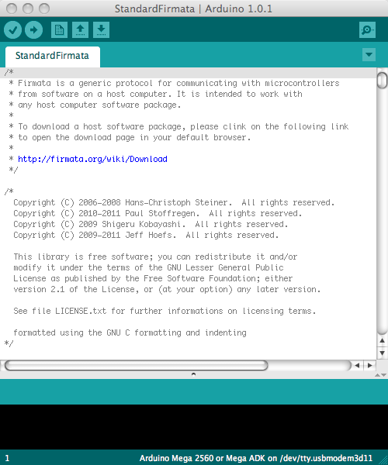
Assuming that Pd is already installed, it will also be necessary to install an add-on library for Pd called Pduino. Follow its included instructions about where to place this library on your platform and then reopen Pd. You will now have access to a set of Pd objects for communicating with your Arduino. The Pduino download will also have included a number of examples Pd. "arduino-test.pd" will probably be the best patch to start. First set the appropriate serial port number to establish communication and then set Arduino pins as "input", "output" etc. as you desire. It is beyond the scope of this chapter to go into further detail regarding setting up an Arduino with sensors and auxiliary components, suffice to say that communication to an Arduino is normally tested by 'blinking' digital pin 13 and communication from an Arduino is normally tested by connecting a 10 kilo-ohm (10k) potentiometer to analog pin zero. For the sake of argument, we shall assume in this tutorial that we are setting the Arduino as a hardware controller and have a potentiometer connected to pin 0.
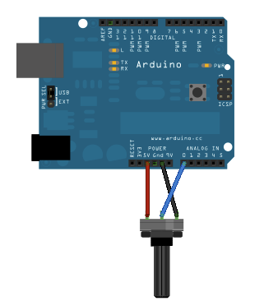
This picture below demonstrates a simple Pd patch that uses Pduino's objects to receive communication from Arduino's analog and digital inputs. (Note that digital pins 0 and 1 are normally reserved for serial communication if the USB serial communication is unavailable.) In this example serial port '5' has been chosen. Once the analogIns enable box for pin 0 is checked, moving the potentiometer will change the values in the left-most number box (and move the slider connected to it). Arduino's analog inputs output integers with 10-bit resolution (0 - 1023) but these values will often be rescaled as floats within the range 0 - 1 in the host program for convenience.
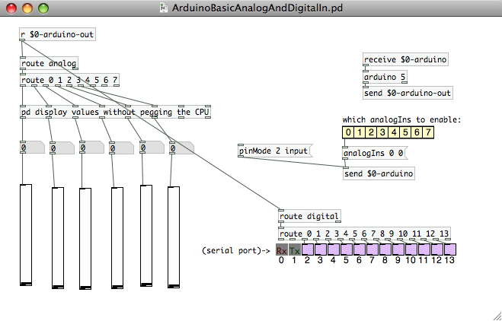
Having established communication between the Arduino and Pd we can now consider the options available to us for communicating between Pd and Csound. The most obvious (but not necessarily the best or most flexible) method is to use Pd's csoundapi~ object. The above example could be modified to employ csoundapi~ as shown below.
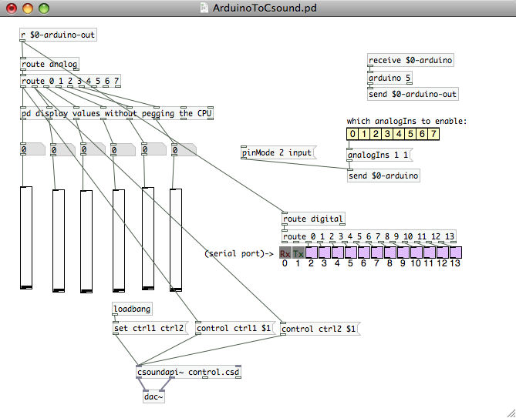
The outputs from the first two Arduino analog controls are passed into Csound using its API. Note that we should use the unpegged (not quantised in time) values directly from the 'route' object. The Csound .csd file "control.csd" is called upon by Pd and it should reside in the same directory as the Pd patch. Establishing communication to and from Pd could employ code such as that shown below. Data from controller one (Arduino analog 0) is used to modulate the amplitude of an oscillator and data from controller two (Arduino analog 1) varies its pitch across a four octave range.
EXAMPLE 08B01_Pd_to_Csound.csd
<CsoundSynthesizer>

<CsOptions>
</CsOptions>

<CsInstruments>

sr = 44100
nchnls = 2
0dbfs = 1
ksmps = 32

instr 1
; read in controller data from Pd via the API using 'invalue'
kctrl1 invalue "ctrl1"
kctrl2 invalue "ctrl2"
; re-range controller values from 0 - 1 to 7 - 11
koct = (kctrl2*4)+7
; create an oscillator
a1 vco2 kctrl1,cpsoct(koct),4,0.1
outs a1,a1
endin
</CsInstruments>

<CsScore>
i 1 0 10000
e
</CsScore>

</CsoundSynthesizer>
Communication from Pd into Csound is established using the invalue opcodes and audio is passed back to Pd from Csound using outs. Note that Csound does not address the computer's audio hardware itself but merely passes audio signals back to Pd. Greater detail about using Csound within Pd can be found in the chapter Csound in Pd.
A disadvantage to using the method outlined above is that in order to modify the Csound patch it will need to be edited in an external editor, re-saved and then the Pd patch will need to be reloaded to reflect the changes. This workflow might be considered rather inefficient.
Another method of data communication between PD and Csound could be to use MIDI. In this case some sort of MIDI connection node or virtual patchbay will need to be employed. On Mac this could be the IAC driver, on Windows this could be MIDI Yoke and on Linux this could be Jack. This method will have the disadvantage that the Arduino's signal might have to be quantised in order to match the 7-bit MIDI controller format but the advantage is that Csound's audio engine will be used (not Pd's; in fact audio can be disabled in Pd) so that making modifications to the Csound .csd and hearing the changes should require fewer steps.
A final method for communication between Pd and Csound is to use OSC. This method would have the advantage that analog 10 bit signal would not have to be quantised. Again workflow should be good with this method as Pd's interaction will effectively be transparent to the user and once started it can reside in the background during working. Communication using OSC is also used between Processing and Csound so is described in greater detail below.

Arduino - Processing - Csound
It is easy to communicate with an Arduino using a Processing sketch and any data within Processing can be passed to Csound using OSC.
The following method makes use of the Arduino and P5 (glove) libraries for processing. Again these need to be copied into the appropriate directory for your chosen platform in order for Processing to be able to use them. Once again there is no requirement to actually know very much about Processing beyond installing it and running a patch (sketch). The following sketch will read all Arduino inputs and output them as OSC.
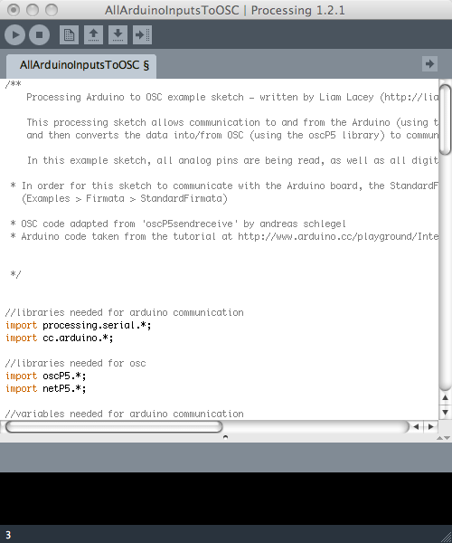
Start the Processing sketch by simply clicking the triangle button at the top-left of the GUI. Processing is now reading serial data from the Arduino and transmitting this as OSC data within the computer.
The OSC data sent by Processing can be read by Csound using its own OSC opcodes. The following example simply reads in data transmitted by Arduino's analog pin 0 and prints changed values to the terminal. To read in data from all analog and digital inputs you can use this example .csd.
EXAMPLE 08B02_Processing_to_Csound.csd
<CsoundSynthesizer>

<CsOptions>
-o dac
</CsOptions>

<CsInstruments>

sr = 44100
ksmps = 8
nchnls = 1
0dbfs = 1

; handle used to reference osc stream
gihandle OSCinit 12001

instr 1
; initialise variable used for analog values
gkana0 init 0
; read in OSC channel '/analog/0'
gktrigana0 OSClisten gihandle, "/analog/0", "i", gkana0
; print changed values to terminal
printk2 gkana0
endin

</CsInstruments>

<CsScore>
i 1 0 3600
e
</CsScore>

</CsoundSynthesizer>
Also worth in investigating is Jacob Joaquin's Csoundo - a Csound library for Processing. This library will allow closer interaction between Processing and Csound in the manner of the csoundapi~ object in Pd. This project has more recently been developed by Rory Walsh.

Arduino as a MIDI Device
Some users might find it most useful to simply set the Arduino up as a MIDI device and to use that protocol for communication. In order to do this all that is required is to connect MIDI pin 4 to the Arduino's 5v via a 200k resistor, to connect MIDI pin 5 to the Arduino's TX (serial transmit) pin/pin 1 and to connect MIDI pin 2 to ground, as shown below. In order to program the Arduino it will be necessary to install Arduino's MIDI library.
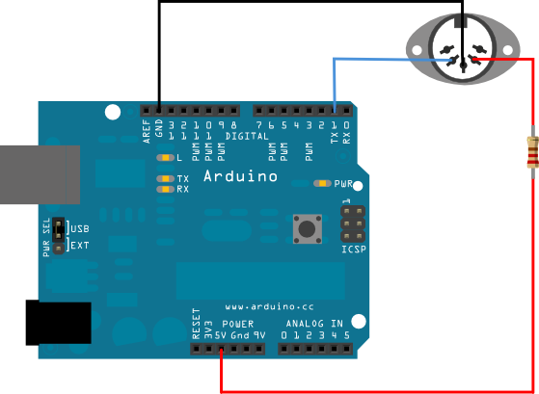
Programming an Arduino to generate a MIDI controller signal from analog pin 0 could be done using the following code:
// example written by Iain McCurdy
// import midi library
#include <MIDI.h>

const int analogInPin = A0; // choose analog input pin
int sensorValue = 0; // sensor value variable
int oldSensorValue = 0; // sensor value from previous pass
int midiChannel = 1; // set MIDI channel

void setup()
{
MIDI.begin(1);
}

void loop()
{
sensorValue = analogRead(analogInPin);

// only send out a MIDI message if controller has changed
if (sensorValue!=oldSensorValue)
{
// controller 1, rescale value from 0-1023 (Arduino) to 0-127 (MIDI)
MIDI.sendControlChange(1,sensorValue/8,midiChannel);
oldSensorValue = sensorValue; // set old sensor value to current
}
}

delay(10);
}
Data from the Arduino can now be read using Csound's ctrl7 opcodes for reading MIDI controller data.

The Serial Opcodes
Serial data can also be read directly from the Arduino by Csound by using Matt Ingalls' opcodes for serial communication: serialBegin and serialRead.
An example Arduino sketch for serial communication could be as simple as this:
// Example written by Matt Ingalls
// ARDUINO CODE:

void setup() {
// enable serial communication
Serial.begin(9600);

// declare pin 9 to be an output:
pinMode(9, OUTPUT);
}

void loop()
{
// only do something if we received something (this should be at csound's k-rate)
if (Serial.available())
{

// set the brightness of LED (connected to pin 9) to our input value
int brightness = Serial.read();
analogWrite(9, brightness);

// while we are here, get our knob value and send it to csound
int sensorValue = analogRead(A0);
Serial.write(sensorValue/4); // scale to 1-byte range (0-255)
}
}
It will be necessary to provide the correct address of the serial port to which the Arduino is connected (in the given example the Windows platform was being used and the port address was /COM4).
It will be necessary to scale the value to correspond to the range provided by a single byte (0-255) so therefore the Arduino's 10 bit analog input range (0-1023) will have to be divided by four.
EXAMPLE 08B03_Serial_Read.csd
; Example written by Matt Ingalls
; CSOUND CODE:
; run with a commandline something like:
; csound --opcode-lib=serialOpcodes.dylib serialdemo.csd -odac -iadc

<CsoundSynthesizer>

<CsOptions>

</CsOptions>
;--opcode-lib=serialOpcodes.dylib -odac
<CsInstruments>

ksmps = 500 ; the default krate can be too fast for the arduino to handle
0dbfs = 1

instr 1
iPort serialBegin "/COM4", 9600
kVal serialRead iPort
printk2 kVal
endin

</CsInstruments>
<CsScore>
i 1 0 3600
e
</CsScore>
</CsoundSynthesizer>
This example will read serial data from the Arduino and print it to the terminal. Reading output streams from several of Arduino's sensor inputs simultaneously will require more complex parsing of data within Csound as well as more complex packaging of data from the Arduino. Examples for this will follow in the next update of this chapter.

HID
A final option for communication has been made available by a new Arduino board called "Leonardo". It pairs with a computer as if it were an HID (Human Interface Device) such as a mouse, keyboard or a gamepad. Sensor data can therefore be used to imitate the actions of a mouse connected to the computer or keystrokes on a keyboard. Csound is already equipped with opcodes to make use of this data. Gamepad-like data is perhaps the most useful option though and there exist opcodes (a least in the Linux version) for reading gamepad data. It is also possible to read in data from a gamepad using pygame and Csound's python opcodes.
09 CSOUND IN OTHER APPLICATIONS
47. CSOUND IN PD
48. B. CSOUND IN MAXMSP
49. CSOUND IN ABLETON LIVE
50. D. CSOUND AS A VST PLUGIN

47. CSOUND IN PD

INSTALLING1
You can embed Csound in PD via the external csoundapi~,2 which has been written by Victor Lazzarini. This external is part of the Csound distribution.
On Ubuntu Linux, you can install the csoundapi~ via the Synaptic package manager. Just look for "csoundapi~" or "pd-csound", check "install", and your system will install the library at the appropriate location. If you build Csound from sources, you should also be able to get the csoundapi~ via the scons option buildPDClass=1. It will be put as csoundapi~.pd_linux in /usr/lib/pd/extra, so that PD should be able to find it. If not, add it to PD's search path (File->Path...).
On Mac OSX, you find the csoundapi~ in the following path:
/Library/Frameworks/CsoundLib.framework/Versions/5.2/Resources/PD/csoundapi~.pd_darwin
Put this file in a folder which is in PD's search path. For PD-extended, it's by default ~/Library/Pd. But you can put it anywhere. Just make sure that the location is specified in PD's Preferences > Path... menu.
On Windows, while installing Csound, open up the "Front ends" component in the Installer box and make sure the item "csoundapi~" is checked:
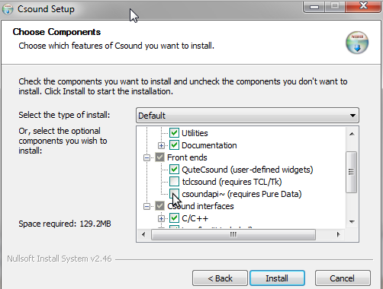
After having finished the installation, you will find csoundapi~.dll in the csound/bin folder. Copy this file into the pd/extra folder, or in any other location in PD's search path.
When you have installed the "csoundapi~" extension on any platform, and included the file in PD's search path if necessary, you should be able to call the csoundapi~ object in PD. Just open a PD window, put a new object, and type in "csoundapi~":
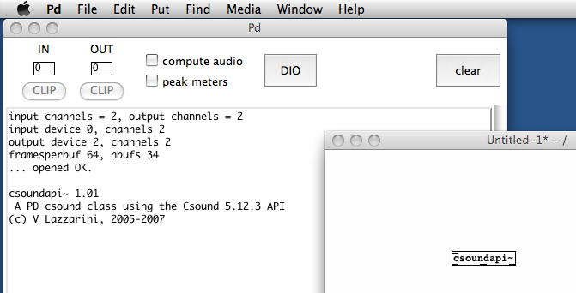

CONTROL DATA
You can send control data from PD to your Csound instrument via the keyword "control" in a message box. In your Csound code, you must receive the data via invalue or chnget. This is a simple example:
EXAMPLE 09A01_pdcs_control_in.csd
<CsoundSynthesizer>
<CsOptions>
</CsOptions>
<CsInstruments>
;Example by Joachim Heintz

sr = 44100
nchnls = 2
0dbfs = 1
ksmps = 8

giSine ftgen 0, 0, 2^10, 10, 1

instr 1
kFreq invalue "freq"
kAmp invalue "amp"
aSin oscili kAmp, kFreq, giSine
outs aSin, aSin
endin

</CsInstruments>
<CsScore>
i 1 0 10000
</CsScore>
</CsoundSynthesizer>
Save this file under the name "control.csd". Save a PD window in the same folder and create the following patch:
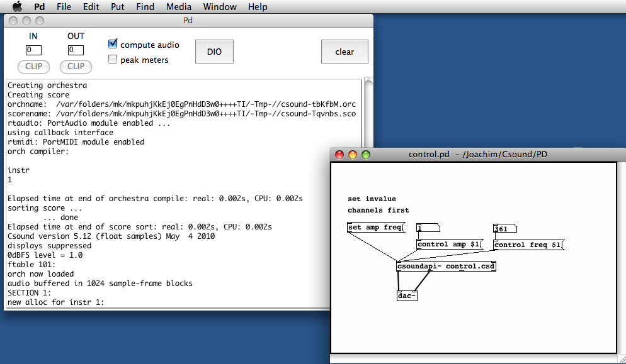
Note that for invalue channels, you first must register these channels by a "set" message.
As you see, the first two outlets of the csoundapi~ object are the signal outlets for the audio channels 1 and 2. The third outlet is an outlet for control data (not used here, see below). The rightmost outlet sends a bang when the score has been finished.

LIVE INPUT
Audio streams from PD can be received in Csound via the inch opcode. As many input channels there are, as many audio inlets are created in the csoundapi~ object. The following CSD uses two audio inputs:
EXAMPLE 09A02_pdcs_live_in.csd
<CsoundSynthesizer>
<CsOptions>
</CsOptions>
<CsInstruments>
;Example by Joachim Heintz
sr = 44100
0dbfs = 1
ksmps = 8
nchnls = 2

instr 1
aL inch 1
aR inch 2
kcfL randomi 100, 1000, 1; center frequency
kcfR randomi 100, 1000, 1; for band pass filter
aFiltL butterbp aL, kcfL, kcfL/10
aoutL balance aFiltL, aL
aFiltR butterbp aR, kcfR, kcfR/10
aoutR balance aFiltR, aR
outch 1, aoutL
outch 2, aoutR
endin

</CsInstruments>
<CsScore>
i 1 0 10000
</CsScore>
</CsoundSynthesizer>
The corresponding PD patch is extremely simple:
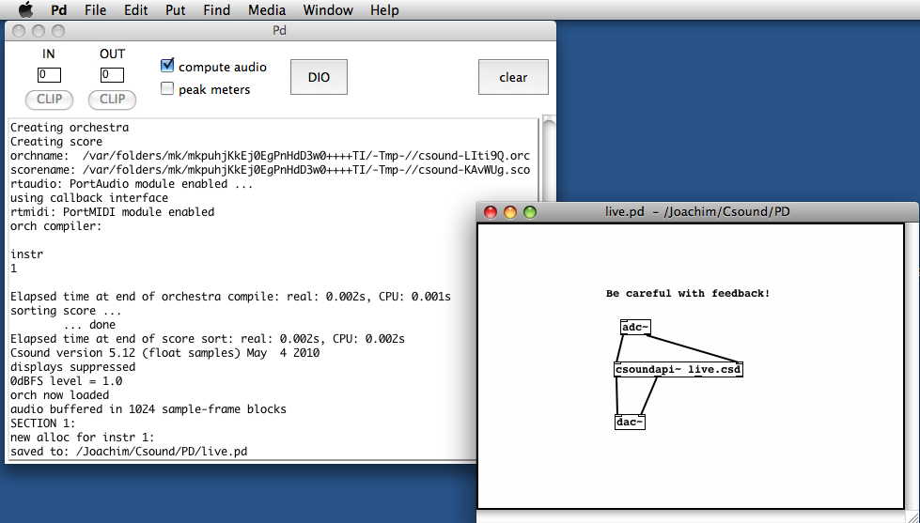

MIDI
The csoundapi~ object receives MIDI data via the keyword "midi". Csound is able to trigger instrument instances in receiving a "note on" message, and turning them off in receiving a "note off" message (or a note-on message with velocity=0). So this is a very simple way to build a synthesizer with arbitrary polyphonic output:
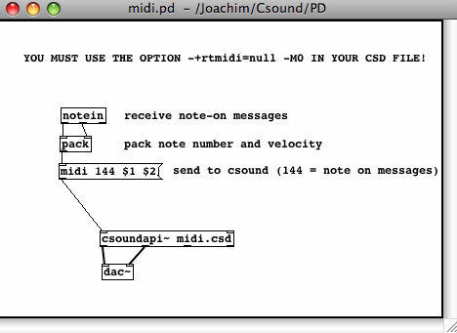
This is the corresponding midi.csd. It must contain the options -+rtmidi=null -M0 in the <CsOptions> tag. It's an FM synth which changes the modulation index according to the verlocity: the more you press a key, the higher the index, and the more partials you get. The ratio is calculated randomly between two limits which can be adjusted.
EXAMPLE 09A03_pdcs_midi.csd
<CsOptions>
-+rtmidi=null -M0
</CsOptions>
<CsoundSynthesizer>
<CsInstruments>
;Example by Joachim Heintz
sr = 44100
ksmps = 8
nchnls = 2
0dbfs = 1

giSine ftgen 0, 0, 2^10, 10, 1

instr 1
iFreq cpsmidi ;gets frequency of a pressed key
iAmp ampmidi 8;gets amplitude and scales 0-8
iRatio random .9, 1.1; ratio randomly between 0.9 and 1.1
aTone foscili .1, iFreq, 1, iRatio/5, iAmp+1, giSine; fm
aEnv linenr aTone, 0, .01, .01; avoiding clicks at the end of a note
outs aEnv, aEnv
endin

</CsInstruments>
<CsScore>
f 0 36000; play for 10 hours
e
</CsScore>
</CsoundSynthesizer>

SCORE EVENTS
Score events can be sent from PD to Csound by a message with the keyword event. You can send any kind of score events, like instrument calls or function table statements. The following example triggers Csound's instrument 1 whenever you press the message box on the top. Different sounds can be selected by sending f events (building/replacing a function table) to Csound.
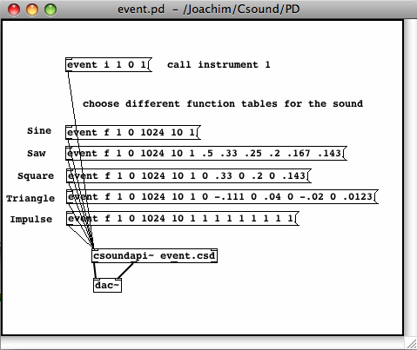
EXAMPLE 09A04_pdcs_events.csd
<CsoundSynthesizer>
<CsOptions>
</CsOptions>
<CsInstruments>
;Example by Joachim Heintz
sr = 44100
ksmps = 8
nchnls = 2
0dbfs = 1

seed 0; each time different seed
giSine ftgen 1, 0, 2^10, 10, 1; function table 1

instr 1
iDur random 0.5, 3
p3 = iDur
iFreq1 random 400, 1200
iFreq2 random 400, 1200
idB random -18, -6
kFreq linseg iFreq1, iDur, iFreq2
kEnv transeg ampdb(idB), p3, -10, 0
aTone oscili kEnv, kFreq, 1
outs aTone, aTone
endin

</CsInstruments>
<CsScore>
f 0 36000; play for 10 hours
e
</CsScore>
</CsoundSynthesizer>

CONTROL OUTPUT
If you want Csound to give any sort of control data to PD, you can use the opcodes outvalue or chnset. You will receive this data at the second outlet from the right of the csoundapi~ object. The data are sent as a list with two elements. The name of the control channel is the first element, and the value is the second element. You can get the values by a route object or by a send/receive chain. This is a simple example:
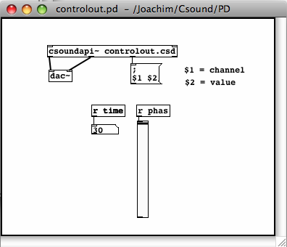
EXAMPLE 09A05_pdcs_control_out.csd
<CsoundSynthesizer>
<CsOptions>
</CsOptions>
<CsInstruments>
;Example by Joachim Heintz

sr = 44100
nchnls = 2
0dbfs = 1
ksmps = 8

instr 1
ktim times
kphas phasor 1
outvalue "time", ktim
outvalue "phas", kphas*127
endin

</CsInstruments>
<CsScore>
i 1 0 30
</CsScore>
</CsoundSynthesizer>

SEND/RECEIVE BUFFERS FROM PD TO CSOUND AND BACK
A PD array can be sent directly to Csound, and a Csound function table to PD. The message tabset [tabset array-name ftable-number] copies a PD array into a Csound function table. The message tabget [tabget array-name ftable-number] copies a Csound function table into a PD array. The example below should explain everything. Just choose another soundfile instead of "stimme.wav".
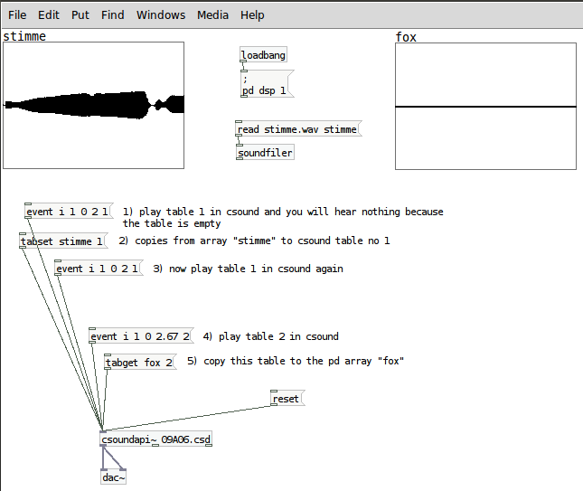
EXAMPLE 06A06_pdcs_tabset_tabget.csd
<CsoundSynthesizer>
<CsOptions>
-odac
</CsOptions>
<CsInstruments>
sr = 44100
ksmps = 8
nchnls = 1
0dbfs = 1

giCopy ftgen 1, 0, -88200, 2, 0 ;"empty" table
giFox ftgen 2, 0, 0, 1, "fox.wav", 0, 0, 1

opcode BufPlay1, a, ipop
ifn, ispeed, iskip, ivol xin
icps = ispeed / (ftlen(ifn) / sr)
iphs = iskip / (ftlen(ifn) / sr)
asig poscil3 ivol, icps, ifn, iphs
xout asig
endop

instr 1
itable = p4
aout BufPlay1 itable
out aout
endin

</CsInstruments>
<CsScore>
f 0 99999
</CsScore>
</CsoundSynthesizer>
;example by joachim heintz

SETTINGS
Make sure that the Csound vector size given by the ksmps value, is not larger than the internal PD vector size. It should be a power of 2. I'd recommend to start with ksmps=8. If there are performance problems, try to increase this value to 16, 32, or 64.
The csoundapi~ object runs by default if you turn on audio in PD. You can stop it by sending a "run 0" message, and start it again with a "run 1" message.
You can recompile the .csd file of a csoundapi~ object by sending a "reset" message.
By default, you see all the messages of Csound in the PD window. If you don't want to see them, send a "message 0" message. "message 1" prints the output again.
If you want to open a new .csd file in the csoundapi~ object, send the message "open", followed by the path of the .csd file you want to load.
A "rewind" message rewinds the score without recompilation. The message "offset", followed by a number, offsets the score playback by an amount of seconds.
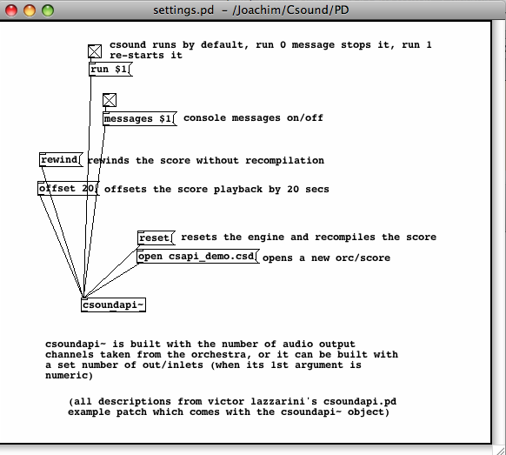
- This chapter still sticks to Csound5. For Csound6, the external is now called csound6~.^
- The new name for Csound 6 will be csound6~.^

CSOUND IN MAXMSP
The information contained within this document pertains to csound~ v1.0.7.

INTRODUCTION
Csound can be embedded in a Max patch using the csound~ object. This allows you to synthesize and process audio, MIDI, or control data with Csound.

INSTALLING
Before installing csound~, install Csound5. csound~ needs a normal Csound5 installation in order to work. You can download Csound5 from here.
Once Csound5 is installed, download the csound~ zip file from here.

INSTALLING ON MAC OS X
- Expand the zip file and navigate to binaries/MacOSX/.
- Choose an mxo file based on what kind of CPU you have (intel or ppc) and which type of floating point numbers are used in your Csound5 version (double or float). The name of the Csound5 installer may give a hint with the letters "f" or "d" or explicitly with the words "double" or "float". However, if you do not see a hint, then that means the installer contains both, in which case you only have to match your CPU type.
- Copy the mxo file to:
  - Max 4.5: /Library/Application Support/Cycling '74/externals/
  - Max 4.6: /Applications/MaxMSP 4.6/Cycling'74/externals/
  - Max 5: /Applications/Max5/Cycling '74/msp-externals/
- Rename the mxo file to "csound~.mxo".
- If you would like to install the help patches, navigate to the help_files folder and copy all files to:
  - Max 4.5: /Applications/MaxMSP 4.5/max-help/
  - Max 4.6: /Applications/MaxMSP 4.6/max-help/
  - Max 5: /Applications/Max5/Cycling '74/msp-help/

INSTALLING ON WINDOWS
- Expand the zip file and navigate to binaries\Windows\.
- Choose an mxe file based on the type of floating point numbers used in your Csound5 version (double or float). The name of the Csound5 installer may give a hint with the letters "f" or "d" or explicitly with the words "double" or "float".
- Copy the mxe file to:
  - Max 4.5: C:\Program Files\Common Files\Cycling '74\externals\
  - Max 4.6: C:\Program Files\Cycling '74\MaxMSP 4.6\Cycling '74\externals\
  - Max 5: C:\Program Files\Cycling '74\Max 5.0\Cycling '74\msp-externals\
- Rename the mxe file to "csound~.mxe".
- If you would like to install the help patches, navigate to the help_files folder and copy all files to:
  - Max 4.5: C:\Program Files\Cycling '74\MaxMSP 4.5\max-help\
  - Max 4.6: C:\Program Files\Cycling '74\MaxMSP 4.6\max-help\
  - Max 5: C:\Program Files\Cycling '74\Max 5.0\Cycling '74\msp-help\

KNOWN ISSUES
On Windows (only), various versions of Csound5 have a known incompatibility with csound~ that has to do with the fluid opcodes. How can you tell if you're affected? Here's how: if you stop a Csound performance (or it stops by itself) and you click on a non-MaxMSP or non-Live window and it crashes, then you are affected. Until this is fixed, an easy solution is to remove/delete fluidOpcodes.dll from your plugins or plugins64 folder. Here are some common locations for that folder:
- C:\Program Files\Csound\plugins
- C:\Program Files\Csound\plugins64

CREATING A CSOUND~ PATCH
- Create the following patch:
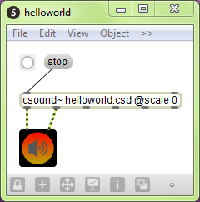
- Save as "helloworld.maxpat" and close it.
- Create a text file called "helloworld.csd" within the same folder as your patch.
- Add the following to the text file:
EXAMPLE 09B01_maxcs_helloworld.csd
<CsoundSynthesizer>
<CsInstruments>
;Example by Davis Pyon
sr = 44100
ksmps = 32
nchnls = 2
0dbfs = 1

instr 1
aNoise noise .1, 0
outch 1, aNoise, 2, aNoise
endin

</CsInstruments>
<CsScore>
f0 86400
i1 0 86400
e
</CsScore>
</CsoundSynthesizer>

- Open the patch, press the bang button, then press the speaker icon.
At this point, you should hear some noise. Congratulations! You created your first csound~ patch.
You may be wondering why we had to save, close, and reopen the patch. This is needed in order for csound~ to find the csd file. In effect, saving and opening the patch allows csound~ to "know" where the patch is. Using this information, csound~ can then find csd files specified using a relative pathname (e.g. "helloworld.csd"). Keep in mind that this is only necessary for newly created patches that have not been saved yet. By the way, had we specified an absolute pathname (e.g. "C:/Mystuff/helloworld.csd"), the process of saving and reopening would have been unnecessary.
The "@scale 0" argument tells csound~ not to scale audio data between Max and Csound. By default, csound~ will scale audio to match 0dB levels. Max uses a 0dB level equal to one, while Csound uses a 0dB level equal to 32768. Using "@scale 0" and adding the statement "0dbfs = 1" within the csd file allows you to work with a 0dB level equal to one everywhere. This is highly recommended.

AUDIO I/O
All csound~ inlets accept an audio signal and some outlets send an audio signal. The number of audio outlets is determined by the arguments to the csound~ object. Here are four ways to specify the number of inlets and outlets:
- [csound~ @io 3]
- [csound~ @i 4 @o 7]
- [csound~ 3]
- [csound~ 4 7]
"@io 3" creates 3 audio inlets and 3 audio outlets. "@i 4 @o 7" creates 4 audio inlets and 7 audio outlets. The third and fourth lines accomplish the same thing as the first two. If you don't specify the number of audio inlets or outlets, then csound~ will have two audio inlets and two audio oulets. By the way, audio outlets always appear to the left of non-audio outlets. Let's create a patch called audio_io.maxpat that demonstrates audio i/o:
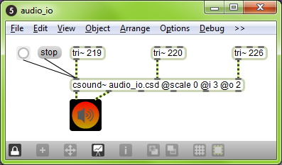
Here is the corresponding text file (let's call it audio_io.csd):
EXAMPLE 09B02_maxcs_audio_io.csd
<CsoundSynthesizer>
<CsInstruments>
;Example by Davis Pyon
sr = 44100
ksmps = 32
nchnls = 3
0dbfs = 1

instr 1
aTri1 inch 1
aTri2 inch 2
aTri3 inch 3
aMix = (aTri1 + aTri2 + aTri3) * .2
outch 1, aMix, 2, aMix
endin

</CsInstruments>
<CsScore>
f0 86400
i1 0 86400
e
</CsScore>
</CsoundSynthesizer>
In audio_io.maxpat, we are mixing three triangle waves into a stereo pair of outlets. In audio_io.csd, we use inch and outch to receive and send audio from and to csound~. inch and outch both use a numbering system that starts with one (the left-most inlet or outlet).
Notice the statement "nchnls = 3" in the orchestra header. This tells the Csound compiler to create three audio input channels and three audio output channels. Naturally, this means that our csound~ object should have no more than three audio inlets or outlets.

CONTROL MESSAGES
Control messages allow you to send numbers to Csound. It is the primary way to control Csound parameters at i-rate or k-rate. To control a-rate (audio) parameters, you must use and audio inlet. Here are two examples:
- control frequency 2000
- c resonance .8
Notice that you can use either "control" or "c" to indicate a control message. The second argument specifies the name of the channel you want to control and the third argument specifies the value.
The following patch and text file demonstrates control messages:
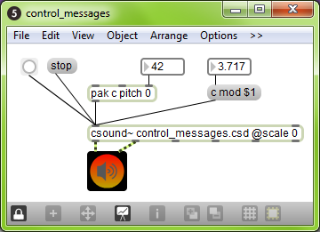
EXAMPLE 09B03_maxcs_control_in.csd
<CsoundSynthesizer>
<CsInstruments>
;Example by Davis Pyon
sr = 44100
ksmps = 32
nchnls = 2
0dbfs = 1

giSine ftgen 1, 0, 16384, 10, 1 ; Generate a sine wave table.

instr 1
kPitch chnget "pitch"
kMod invalue "mod"
aFM foscil .2, cpsmidinn(kPitch), 2, kMod, 1.5, giSine
outch 1, aFM, 2, aFM
endin
</CsInstruments>
<CsScore>
f0 86400
i1 0 86400
e
</CsScore>
</CsoundSynthesizer>
In the patch, notice that we use two different methods to construct control messages. The "pak" method is a little faster than the message box method, but do whatever looks best to you. You may be wondering how we can send messages to an audio inlet (remember, all inlets are audio inlets). Don't worry about it. In fact, we can send a message to any inlet and it will work.
In the text file, notice that we use two different opcodes to receive the values sent in the control messages: chnget and invalue. chnget is more versatile (it works at i-rate and k-rate, and it accepts strings) and is a tiny bit faster than invalue. On the other hand, the limited nature of invalue (only works at k-rate, never requires any declarations in the header section of the orchestra) may be easier for newcomers to Csound.

MIDI
csound~ accepts raw MIDI numbers in it's first inlet. This allows you to create Csound instrument instances with MIDI notes and also control parameters using MIDI Control Change. csound~ accepts all types of MIDI messages, except for: sysex, time code, and sync. Let's look at a patch and text file that uses MIDI:
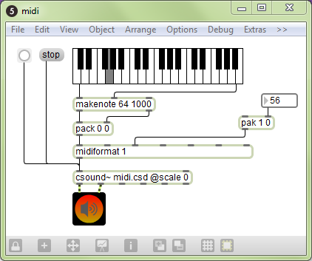

EXAMPLE 09B04_maxcs_midi.csd
<CsoundSynthesizer>
<CsInstruments>
;Example by Davis Pyon
sr = 44100
ksmps = 32
nchnls = 2
0dbfs = 1

massign 0, 0 ; Disable default MIDI assignments.
massign 1, 1 ; Assign MIDI channel 1 to instr 1.

giSine ftgen 1, 0, 16384, 10, 1 ; Generate a sine wave table.

instr 1
iPitch cpsmidi
kMod midic7 1, 0, 10
aFM foscil .2, iPitch, 2, kMod, 1.5, giSine
outch 1, aFM, 2, aFM
endin
</CsInstruments>
<CsScore>
f0 86400
e
</CsScore>
</CsoundSynthesizer>
In the patch, notice how we're using midiformat to format note and control change lists into raw MIDI bytes. The "1" argument for midiformat specifies that all MIDI messages will be on channel one.
In the text file, notice the massign statements in the header of the orchestra. "massign 0,0" tells Csound to clear all mappings between MIDI channels and Csound instrument numbers. This is highly recommended because forgetting to add this statement may cause confusion somewhere down the road. The next statement "massign 1,1" tells Csound to map MIDI channel one to instrument one.
To get the MIDI pitch, we use the opcode cpsmidi. To get the FM modulation factor, we use midic7 in order to read the last known value of MIDI CC number one (mapped to the range [0,10]).
Notice that in the score section of the text file, we no longer have the statement "i1 0 86400" as we had in earlier examples. This is a good thing as you should never instantiate an instrument via both MIDI and score events (at least that has been this writer's experience).

Events
To send Csound events (i.e. score statements), use the "event" or "e" message. You can send any type of event that Csound understands. The following patch and text file demonstrates how to send events:
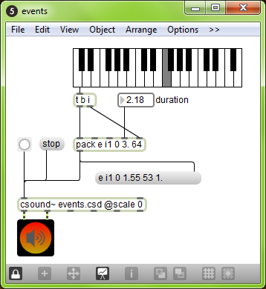
EXAMPLE 09B05_maxcs_events.csd
<CsoundSynthesizer>
<CsInstruments>
;Example by Davis Pyon
sr = 44100
ksmps = 32
nchnls = 2
0dbfs = 1

instr 1
iDur = p3
iCps = cpsmidinn(p4)
iMeth = 1
print iDur, iCps, iMeth
aPluck pluck .2, iCps, iCps, 0, iMeth
outch 1, aPluck, 2, aPluck
endin
</CsInstruments>
<CsScore>
f0 86400
e
</CsScore>
</CsoundSynthesizer>
In the patch, notice how the arguments to the pack object are declared. The "i1" statement tells Csound that we want to create an instance of instrument one. There is no space between "i" and "1" because pack considers "i" as a special symbol signifying an integer. The next number specifies the start time. Here, we use "0" because we want the event to start right now. The duration "3." is specified as a floating point number so that we can have non-integer durations. Finally, the number "64" determines the MIDI pitch. You might be wondering why the pack object output is being sent to a message box. This is good practice as it will reveal any mistakes you made in constructing an event message.
In the text file, we access the event parameters using p-statements. We never access p1 (instrument number) or p2 (start time) because they are not important within the context of our instrument. Although p3 (duration) is not used for anything here, it is often used to create audio envelopes. Finally, p4 (MIDI pitch) is converted to cycles-per-second. The print statement is there so that we can verify the parameter values.

49. CSOUND IN ABLETON LIVE
Csound can be used in Ableton Live through Max4Live. Max4Live is a toolkit which allows users to build devices for Live using Max/MSP. Please see the previous section on using Csound in Max/MSP for more details on how to use Csound in Live.
Cabbage can also be used to run Csound in Live, or any other audio plugin host. Please refer to the section titled 'Cabbage' in chapter 10.

50. D. CSOUND AS A VST PLUGIN
Csound can be built into a VST or AU plugin through the use of the Csound host API. Refer to the section on using the Csound API for more details.
If you are not well versed in low level computer programming you can just use Cabbage to create Csound based plugins. See the section titled 'Cabbage' in Chapter 10.
10 CSOUND FRONTENDS
51. CsoundQt
52.
53. BLUE
54. WinXound
55. CSOUND VIA TERMINAL

51. CsoundQt
CsoundQt is a free, cross-platform graphical frontend to Csound. It features syntax highlighting, code completion and a graphical widget editor for realtime control of Csound. It comes with many useful code examples, from basic tutorials to complex synthesizers and pieces written in Csound. It also features an integrated Csound language help display.
CsoundQt (named QuteCsound until automn 2011) can be used as a code editor tailored for Csound, as it facilitates running and rendering Csound files without the need of typing on the command line using the Run and Render buttons.
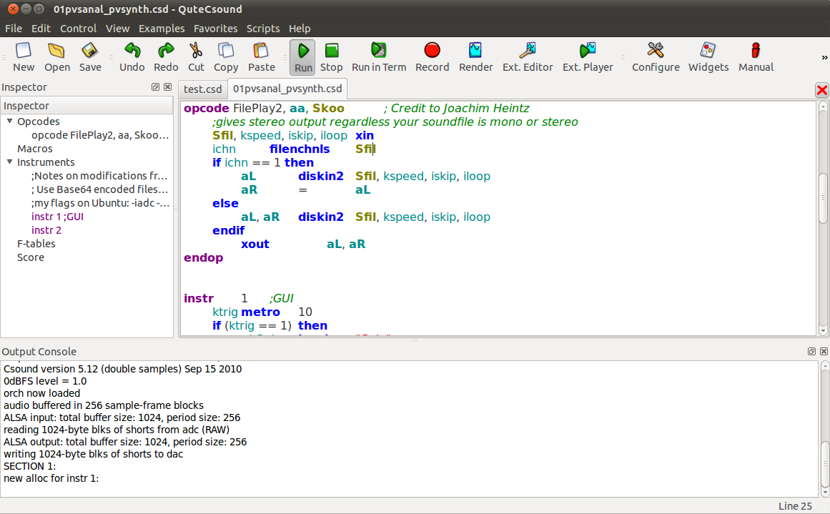
In the widget editor panel, you can create a variety of widgets to control Csound. To link the value from a widget, you first need to set its channel, and then use the Csound opcodes invalue or chnget. To send values to widgets, e.g. for data display, you need to use the outvalue or chnset opcode.
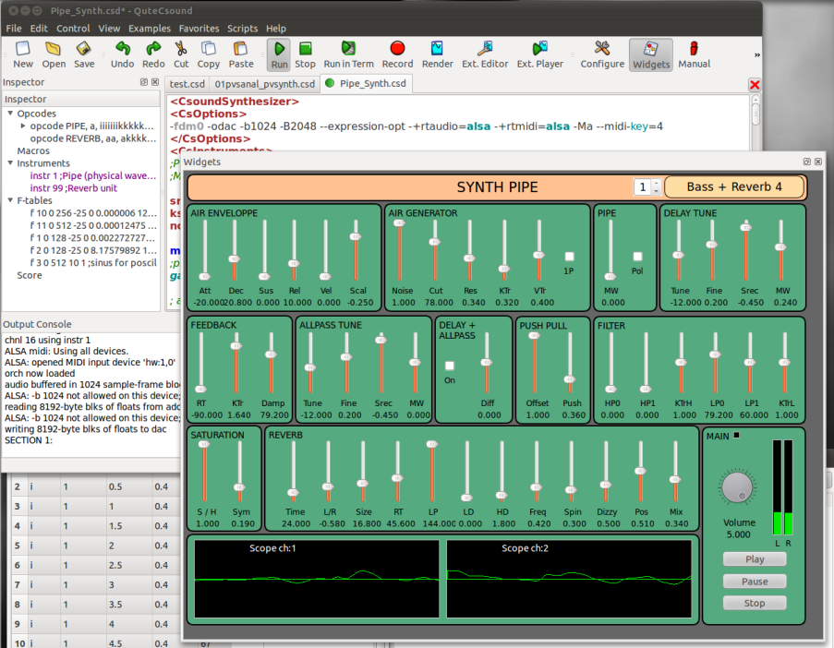
CsoundQt also offers convenient facilities for score editing in a spreadsheet like environment which can be transformed using Python scripting (see also chapter 12C).
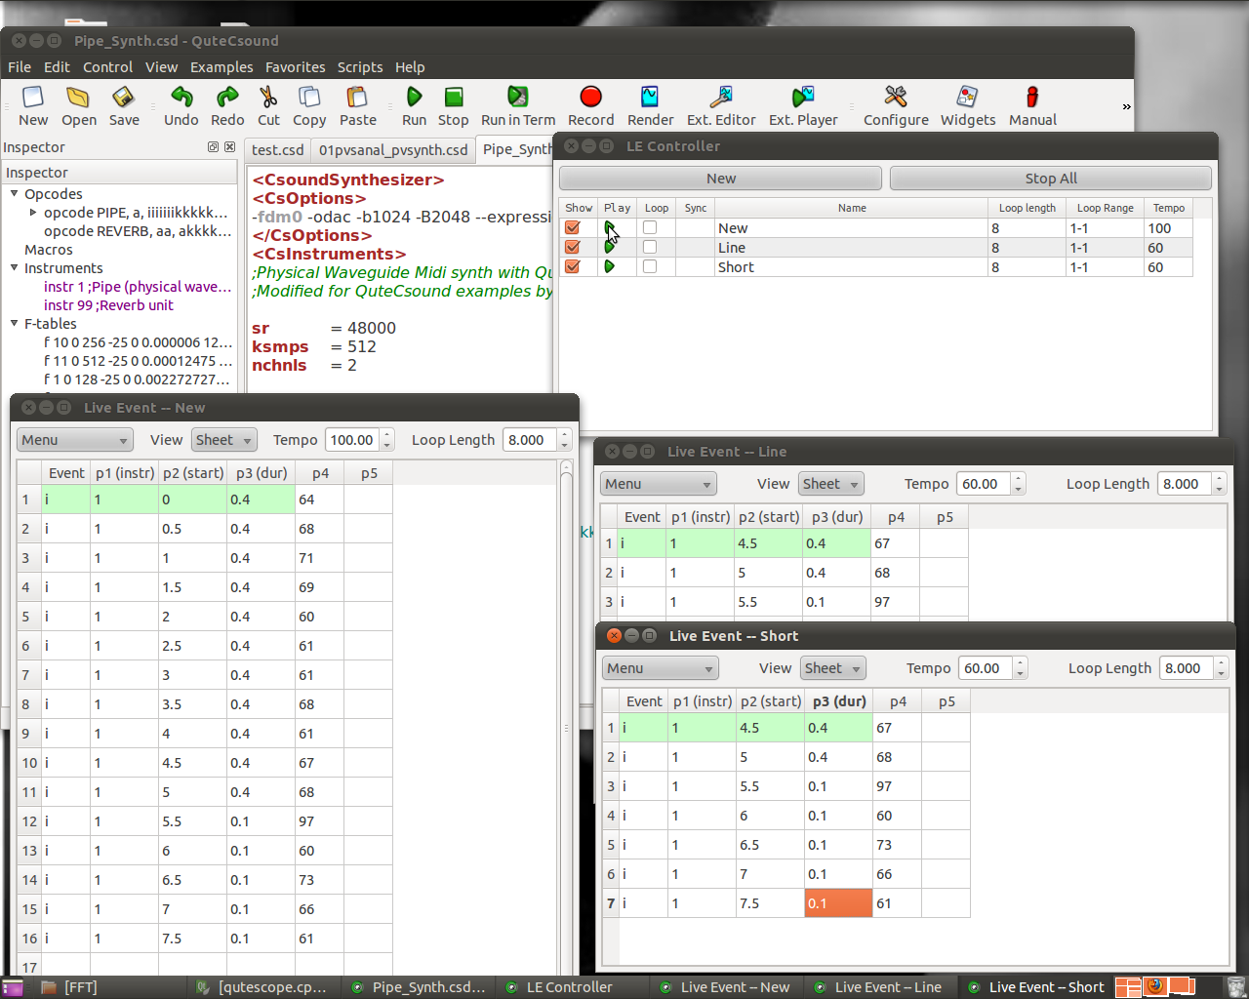
You will find more detailed information and video tutorials in the CsoundQt home page at http://qutecsound.sourceforge.net.

Configuring CsoundQt
CsoundQt gives easy access to the most important Csound options and to many specific CsoundQt settings via its Configuration Panel. In particular the 'Run' tab offers many choices which have to be understood and set carefully.
To open the configuration panel simply push the 'Configure' button. The configuration panel comprises 7 tabs. The available configurable parameters in each tab are described below for each tab.

Run
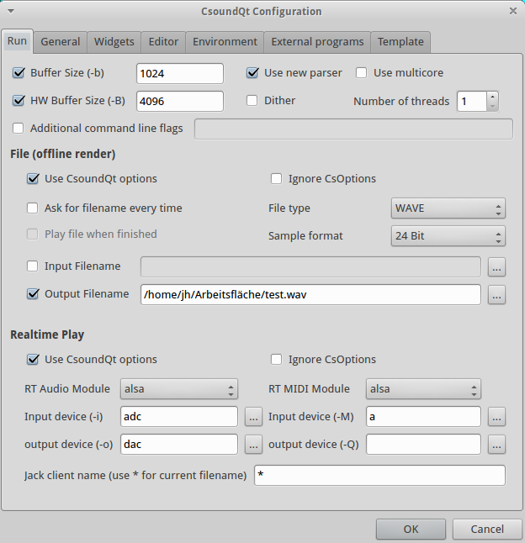
The settings at the top of the “Run” tab allow the user to define the command-line flags with which Csound is invoked.
Buffer Size (-b)
This defines the software buffer size (corresponding with the -b flag).
If you do not tick, CsoundQt will use the defaults.1
If you tick to enter an own value, these are some hints:
- Always use power-of-two values.
- Usually the ksmps block size is 1/4 or 1/2 of the software buffer size. If you use live input and output, it is most effective to set the software buffer size to an integer multiple of ksmps ("full duplex audio").
- Use smaller values (e.g. 128) for live performance (in particular with live input), as it will reduce the latency. Use larger values (e.g. 1024) for other cases, for instance playing sound files.
HW Buffer Size (-B)
This defines the hardware buffer size (corresponding with the -B flag).
If you do not tick, CsoundQt will use the defaults.2
If you tick to enter an own value, these are some hints:
- Always use a multiple integer of the software buffer size. A common relation is: Hardware Buffer Size = 4 * Software Buffer Size.
- The relation between software buffer size and hardware buffer size depends on the audio module.3
Use new parser
Tick this if you use Csound 5.14 or higher. This option has been introduced during the transition between the old and the new parser, and will disappear in future.
Use multicore /Number of threads
This option is only available when the new parser is enabled, and corresponds with the -j flag. For instance, ‘-j 2‘ will tell Csound to use 2 parallel processors when possible.
You should use this option with care. It may be also worth to state that using multiple threads will not in each case improve the performance. Whether it does or not depends on the structure of the csd file you run.
Dither
Switches on dithering (the --dither flag) for the conversion of audio from the internal resolution (now mostly 64 bit double precision float) to the output sample format (see below).
Additional command line flags
This enables the user to add any additional options not listed here. Only use if you know what you are doing!

File (offline render)
These options determine CsoundQt's behaviour if you render to file (by pushing the Render button or selecting the menu item Control -> Render to file).
Use CsoundQt options
Tick this to activate the CsoundQT options configured here.
Ignore CsOptions
Use this to ignore the option embedded in the <CsOptions> section of the csd files you are rendering.
NOTE that care must be taken to avoid inconsistencies between CsOptions and CsoundQt options. For beginners, it is recommended to tick "Ignore CsOptions" when the CsoundQT options are enabled. If you are a more experienced user, you can leave this unchecked to allow some additional options like -m128 to reduce Csound's printout.
NOTE that if you have checked "Use CsoundQt options" and have not checked "Ignore CsOptions", in the case of a conflict between both the CsoundQt options set in the configure panel will have the priority.
Ask for filename every time
Ask for a filename to render the performance to.
File type / Sample format
Use this to set the output file format.
Input Filename
Corresponds with the -i flag (Input soundfile name).
Output Filename
Corresponds with the -o flag for defining the output file name to which the sound is written.

Realtime Play
These options determine CsoundQt's behaviour if you push the Run button (or select the menu item Control -> Run Csound).
Use CsoundQt options
Tick this to activate the CsoundQT options configured here.
Ignore CsOptions
Use this to ignore the option embedded in the <CsOptions> section of the csd files you are running.
NOTE that care must be taken to avoid inconsistencies between CsOptions and CsoundQt options. For beginners, it is recommended to disable CsOptions when the CsoundQT options are enabled. If you are a more experienced user, you can leave this unchecked to allow some additional options like -m128 to reduce Csound's printout.
NOTE that if you have checked "Use CsoundQt options" and have not checked "Ignore CsOptions", in the case of a conflict between both the CsoundQt options set in the configure panel will have the priority.
RT Audio Module
This option is very much dependent on your operating system.
In case you experience crashes or have problems with the real time performance, it is worth to try another module.
The most common choices on the different operating systems are probably:
- For Linux, use alsa or jack.
- For OSX, use coreaudio or portaudio.
- For Windows, use portaudio.
Input device
This option selects the device you are using for real-time input, for instance from a microphone. (Note that you must have ticked "Use CsoundQt options" if you want Csound to use your selection.)
The usual (and most stable) choice here is adc. In this case Csound will use the device which has been selected as standard by your operating system.
If you want to use another device instead, click on the button at the right side. You will find a list of available devices and can choose one of them.
Output device
This option selects the device you are using for real-time output. (Note that you must have ticked "Use CsoundQt options" if you want Csound to use your selection.)
The usual (and most stable) choice here is dac. In this case Csound will use the device which has been selected as standard by your operating system.
If you want to use another device instead, click on the button at the right side. You will find a list of available devices and can choose one of them.
RT MIDI Module
This option is very much dependent on your operating system.
In case you experience problems with MIDI, it is worth to try another module. In case you do not use any MIDI at all, select none to get rid of one possible source of trouble.
The most common choices on the different operating systems are probably:
- For Linux, use alsa or portmidi.
- For OSX, use coremidi4 or portmidi.
- For Windows, use portmidi.
Input device
This option selects the device you are using for real-time MIDI input. (Note that you must have ticked "Use CsoundQt options" if you want Csound to use your selection.)
The usual choice here is a. In this case Csound will use all MIDI devices.
In case your RT MIDI Module does not support this option, click on the button at the right side. You will find a list of available devices and can choose one of them.
Output device
This option selects the device you are using for real-time MIDI output. (Note that you must have ticked "Use CsoundQt options" if you want Csound to use your selection.)
Jack client name
This option specifies the name for communicating with a Jack audio client. The default '*' means 'all' clients.

General
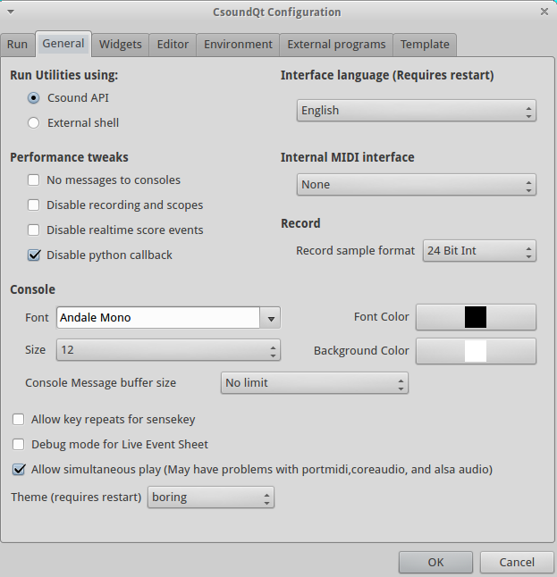

Run Utilities using:
This should be self-explanatory and is only meaningful if you run any of the Csound Utilities like sndinfo or the FFT analysis tool pvanal.

Interface language
Self-explanatory.

Performance tweaks
These are very important options in case you use CsoundQt for real-time usage and experience performance problems.
No messages to consoles
Tick this to disable any printout.
Disable recording and scopes
This refers to CsoundQt's internal Record facility and to the Scope widget.
Disable realtime score events
If you check this, you will not be able to send any live score event, for instance from a Button widget or the Live Event Sheet.
Disable python callback
If you do not use CsoundQt's internal Python scripting facility in real-time, you should check this to improve the overall performance.

Internal MIDI interface
The "Internal MIDI interface" is the MIDI device from which MIDI control messages are sent directly to the CsoundQt widgets. Have a look, for instance, in the properties of a Slider widget to see the MIDI CC number and the MIDI Channel to be specified.
Note that this does not set the input MIDI device for Csound itself (which has be explained above in Run -> RT MIDI Module -> Input device).

Record sample format
Defines the bit depth of the audio file to which CsoundQt records its real-time output, when using the Record button (or the 'record' option from the Control menu). For most cases 32bit float or 24bit formats are recommended. The former is particularly useful as it can hold ‘clipped‘ sample values, which can be later normalised.

Console
You can choose here how the Csound output console looks like.
Control message buffer size
If you do not not want to prevent CsoundQt from printing anything to the console at all (see above) but want to reduce this output for performance's sake, you can set here a limit.
There are some mixed options at the bottom of this tab:
Allow key repeats for sensekey
If you press a key on your computer for a long time, the key is repeated. This may or may not be useful for the sensekey opcode and can be decided here.
Debug mode for Live Event Sheet
Self-explanatory.
Allow simultaneous play
If checked, it allows you to play more than one csd tab simultansously.
Theme
Allows you to choose between the traditional ("fun") CsoundQt look, and a more serious ("boring") one.

Widgets
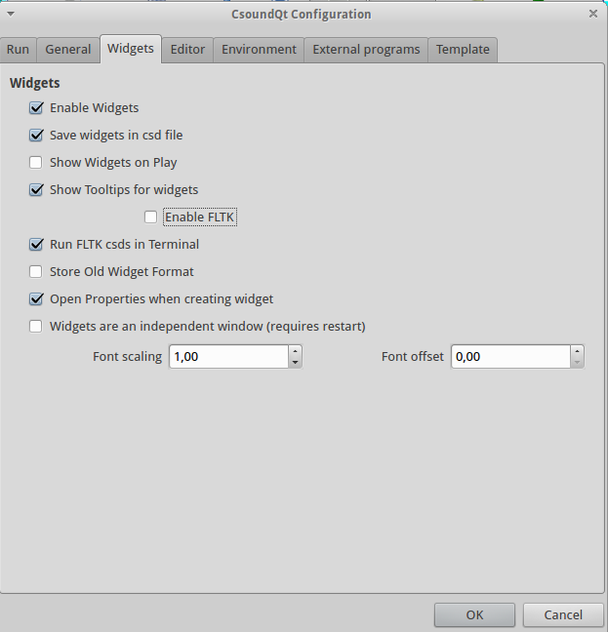
Enable Widgets
If not checked, you cannot use any of CsoundQt's widgets.
Save Widgets in csd file
Each csd file has a section for widgets and presets. These sections are hidden when you open your csd file in CsoundQt, but are visible in any text editor. So if you do not have checked this option, you will not see any of your widgets the next time you open your csd. So, only useful if you want to export a csd without the widget tags.
Show Widgets on play
If checked, the widget panel will pop up each time you push the Play button.
Show tooltips for widgets
Enables a useful feature which lets you see the channel name of a widget if you stay a moment on it with the computer mouse.
Enable FLTK
FLTK means a built-in (and somehow outdated) method of using widgets in Csound. As these widgets could conflict with CsoundQt's own widgets, you will usually uncheck this.
Run FLTK csds in Terminal
This lets you execute csd files which contain FLTK widgets without conflicting with CsoundQt.
Store Old Widget Format
CsoundQt started in using the file format for widgets from Matt Ingall's 'Mac Csound' for the sake of compatibility. Later it decided to use an own format; mainly for the build-in presets facility. When you check this option, CsoundQt will save the old Mac Csound widgets format in addition to the new proper CsoundQt widget format.
Open properties when creating widgets
Usually you will this have ticked, to enter your channel name and other properties when you create a widget.
Widgets are an independent window
CsoundQt consists of many subwindows except the main Editor panel: the Console, the Help (Manual), the Inspector, and so on. If you check this option, the widget panel will not be considered as one of them, but as independent window. This means that you cannot dock it by double-clicking on the top, like all the other subwindows, but it may have advantages anyhow, depending on your operating system and your configuration.
Font scaling / Font offset
Affects the way the fonts are shown for instance in a Label widget.

Editor
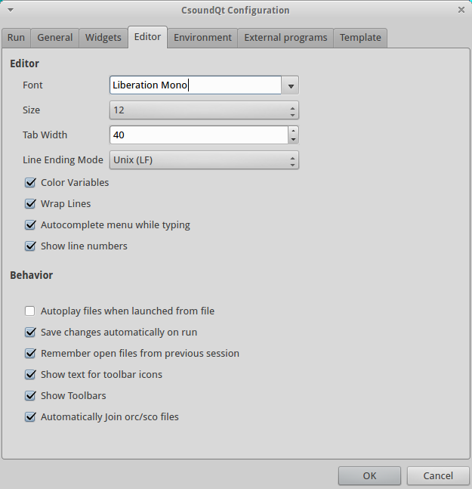
Only one option needs some explanation:
Autoplay files when launched from file
If ticked, a csd file will play immediately when opened.

Environment
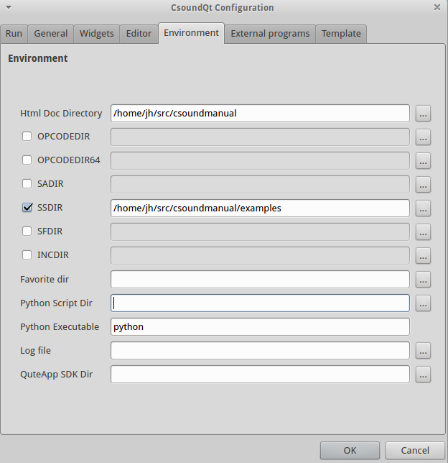
There are some important settings here, along with some only for developers. We will focus on the options which can be important for all users.
Html doc directory
This refers to the folder containing the Canonical Csound Manual. If you choose View -> Help Panel, and see nothing but a message like "not found!", you will have to set here the directory for the manual. Click on the browse button on the right side, and choose the folder where it is on your computer.5
SADIR (Sound Analysis Directory)
You can set here the directory in which Csound will seek for analysis files like .pvx files.
SSDIR (Sound Sample Directory)
This is very useful to set a folder for sound samples, for instance used by diskin. You can then refer to the sample only by name.
SFDIR (Sound File Directory)
To specify a directory for output files. This is usually be done in the 'Run' tab, as explained above (Output Filename).
INCDIR (Include Directory)
Specifies a directory for files which all called by the #include statement.
Favorite dir
Specifies a directory which will then appear under the menu as 'Favorites'.
Python script dir
Usually you will leave this empty so that CsoundQt links to the Python Scripts it comes with. Only specify if you build CsoundQt or want to change the scipts folder.

External Programs
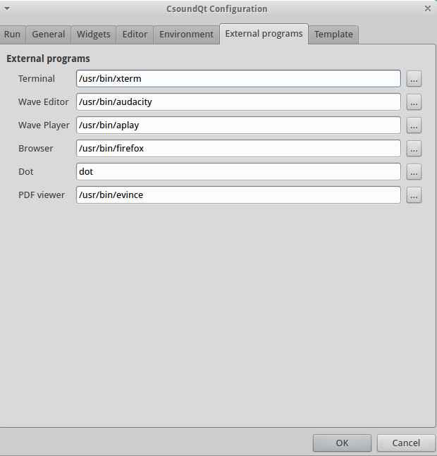
Should be self-explanatory. 'Dot' is the executable from www.graphviz.org. It is used in CsoundQt for the Code Graph Viewer (View -> View Code Graph).

Template
This tab is useful as it allows the user to define a default template for new CSDs. Something like this can be a great timesaver:
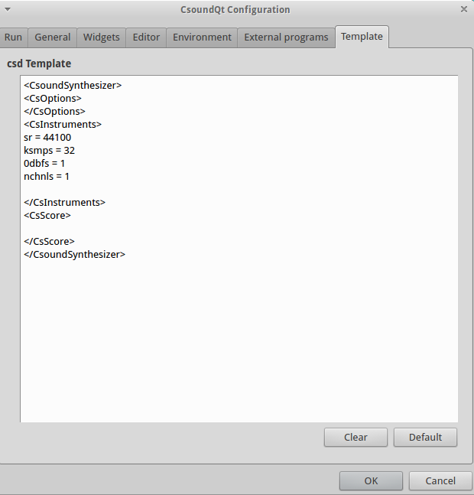

- According to the relevant manual page, the defaults are 256 for Linux, 1024 for OSX and 4096 for Windows.^
- According to the manual, 1024 for Linux, 4096 for OSX and 16384 for Windows.^
- In the explanation of Victor Lazzarini (mail to Joachim Heintz, 19 march 2013):
"1. For portaudio, -B is only used to suggest a latency to the backend, whereas -b is used to set the actual buffersize.
2. For coreaudio, -B is used as the size of the internal circular buffer, and -b is used for the actual IO buffer size.
3. For jack, -B is used to determine the number of buffers used in conjunction with -b , num = (N + M + 1) / M. -b is the size of each buffer.
4. For alsa, -B is the size of the buffer size, -b is the period size (a buffer is divided into periods).
5. For pulse, -b is the actual buffersize passed to the device, -B is not used.
In other words, -B is not too significant in 1), not used in 5), but has a part to play in 2), 3) and 4), which is functionally similar." ^
- This options is only available in CsoundQt 0.7.3 or higher. For older versions, you must use the command line flag -+rtmidi=coremidi.^
- Or download the manual, if necessary, from sourceforge (currently http://sourceforge.net/projects/csound/files/csound5/csound5.19/manual/).^

52.


Cabbage is a software for prototyping and developing audio plugins with the Csound audio synthesis language. It provides Csound programmers with a simple albeit powerful toolkit for the development of cross-platform audio software. Pre-built binaries for Microsoft Windows and Apple OSX(Built on OSX 10.6) are available from the Cabbage google code homepage.
This document will take you through the basics of using Cabbage. It starts with a look at features provided by the host and then moves on to some simple examples. The text concludes with a reference section for the various GUI controls available in Cabbage. It’s assumed that the reader has some prior knowledge of Csound.
In order to use Cabbage you MUST have Csound installed. Cabbage is only available for the doubles version of Csound. This is the version that comes with the various platform installers so there shouldn't be any problems. If however you build your own version of Csound don't forget to use the 'useDouble=1' option or Cabbage will not work properly.
The Cabbage standalone player
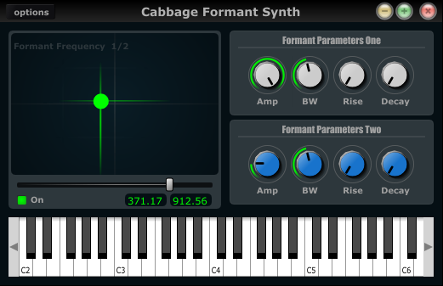
Most prototyping will be done in the Cabbage standalone host. This host lets you load and run Cabbage instruments, as seen in the screenshot above. Clicking on the options button will give you access to the following commands:

Open Cabbage Instrument
Use this command to open a cabbage instrument(Unified Csound file with a dedicated <Cabbage></Cabbage> section). You may open any .csd file you wish and add a Cabbage section yourself once it’s open. If opening existing Csound instrument you will need to use the-n command line options to tell Csound not to open any audio devices, as these are handled directly by Cabbage. On OSX users can open .csd files contained within plugins. Just select a .vst file instaed of a .csd file when opening. See the sections on exporting plugins for more information.

New Cabbage…
This command will help you create a new Cabbage instrument/effect. Cabbage instruments are synthesisers capable of creating sounds from scratch while effects process incoming audio. Effects can access the incoming audio by using the inch or ins opcodes. All effects have stereo inputs and stereo outputs. Instruments can access the incoming MIDI data in a host of different ways but the easiest is to pipe the MIDI data directly to instrument p-fields using the MIDI inter-op command line flags. Examples can be found in the examples folder.

View Source Editor
This command will launch the integrated text editor. The text editor will always contain the text which corresponds to the instrument that is currently open. Each time a file is saved in the editor(Ctrl+S), Cabbage will automatically recompile the underlying Csound instrument and update any changes that have been made to the instruments GUI. The editor also features a Csound message console that can prove useful when debugging instruments.

Audio Settings
Clicking on the audio settings command will open the audio settings window. Here you can choose your audio/MIDI input/output devices. You can also select the sampling rate and audio buffer sizes. Small buffer sizes will reduce latency but might cause some clicks in the audio. Keep testing buffer sizes until you find a setting that works best for your PC.
Cabbage hosts Csound instruments. It uses its own audio IO callbacks which will override any IO settings specified in the <CsOptions> sections of your Csound file.

Export…
This command will export your Cabbage instrument as a plugin. Clicking synth or plugin will cause Cabbage to create a plugin file(with a .dll file extension) into teh same directory as teh csd file you are using. When exporting as Cabbage will prompt you to save your plugin in a set location, under a specific name. Once Cabbage has created the plugin it will make a copy of the current .csd file and locate it in the same folder as the plugin. This new .csd file will have the same name as the plugin and should ALWAYS be in the same directory as the plugin.
You do not need to keep exporting instruments as plugins every time you modify them. You need only modify the associated source code. To simplify this task, Cabbage will automatically load the associated .csd file whenever you export as a plugin. On OSX Cabbage can open a plugin’s .csd file directly by selecting the plugin when prompted to select a file to open.

Always on Top
This command lets you toggle Always on top mode. By default it is turned on. This means your Cabbage instrument will always appear on top of any other applications that are currently open.

Update Instrument
This command updates Cabbage. This is useful if you decide to use another editor rather the one provided. Just remember to save any changes made to your Cabbage instrument before hitting update.

Auto-update

Checking this will cause Cabbage to continuously check whether changes have been made to the file it has open. If you wish to use a different source code editor with Cabbage than the one provided, you can check this option. Whenever you save changes to the .csd file that Cabbage currently has open, it will automatically update according to the changes made. Although it’s not as quick as the integrated editor, it does give you scope to use some feature rich source code editors with Cabbage.

Use Cabbage IO

This will turn on or off Cabbage audio and MIDI input/output and is only applicable to standalone instruments. When Cabbage IO is turned off Cabbage will let Csound take control of the audio and MIDI IO. This means that users will need to use standard Csound IO flags in the <CsOptions> section of their .csd file.

Batch Convert
This command will let you convert a selection of Cabbage .csd files into plugins so you don’t have to manually open and export each one.
This feature is currently only available on Windows.

Your first Cabbage instruments
The following section describes the steps involved in building a simple Cabbage instrument. It’s assumed that the user has some prior knowledge of Csound. When creating a Cabbage patch users must provide special xml-style tags at the top of a unified Csound file. The Cabbage specific code should be placed between an opening <Cabbage> and a closing </Cabbage> tag. You can create a new instrument by using the New Cabbage Instrument menu command. Select either a synth or an effect and Cabbage will automatically generate a basic template for you to work with.
Each line of Cabbage specific code relates to one graphical user interface(GUI) control only. Lines must start with the type of GUI control you wish to use, i.e, vslider, button, xypad, etc. Users then add identifiers to indicate how the control will look and behave. All parameters passed to identifiers are either strings denoted with double quotes or numerical values. Information on different identifiers and their parameters is given below in the reference section. Long lines can be broken up with a \ placed at the end of a line.
This section does not go into details about each Cabbage control, nor does it show all available identifiers. Details about the various Cabbage controls can be found in reference section below.

A basic Cabbage synthesiser
Code to create the most basic of Cabbage synthesisers is presented below. This instrument uses the MIDI interop command line flags to pipe MIDI data directly to p-fields in instrument 1. In this case all MIDI pitch data is sent directly to p4, and all MIDI amplitude data is sent to p5. MIDI data been sent on channel 1 will cause instrument 1 to play. Data being sent on channel 2 will cause instrument 2 to play. It has been reported that the massign opcode does not work as expected with Cabbage. This is currently under investigation.
<Cabbage>
form size(400, 120), caption("Simple Synth"), pluginID("plu1")
keyboard bounds(0, 0, 380, 100)
</Cabbage>
<CsoundSynthesizer>
<CsOptions>
-n -d -+rtmidi=NULL -M0 --midi-key-cps=4 --midi-velocity-amp=5
</CsOptions>
<CsInstruments>
sr = 44100
ksmps = 64
nchnls = 2
0dbfs=1

instr 1
kenv linenr p5, 0.1, .25, 0.01
a1 oscil kenv*k1, p4, 1
outs a1, a1
endin

</CsInstruments>
<CsScore>
f1 0 1024 10 1
f0 3600
</CsScore>

</CsoundSynthesizer>

You’ll notice that a -n and -d are passed to Csound in the CsOptions section. -n stops Csound from writing audio to disk. This must be used as Cabbage manages its own audio IO callbacks. The -d prevents any FLTK widgets from displaying. You will also notice that our instrument is stereo. ALL Cabbage instruments operate in stereo.

Controlling your Cabbage patch
The most obvious limitation to the above instrument is that users cannot interact directly with Csound. In order to do this one can use a Csound channel opcode and a Cabbage control such as a slider. Any control that is to interact with Csound must have a channel identifier.
When one supplies a channel name to the channel() identifier Csound will listen for data being sent on that channel through the use of the named channel opcodes. There are a few ways of retrieving data from the named channel bus in Csound, the most straightforward one being the chnget opcode. It’s defined in the Csound reference manual as:
kval chnget Sname
Sname is the name of the channel. This same name must be passed to the channel() identifier in the corresponding <Cabbage> section.
At present Cabbage only works with the chnget/chnset method of sending and receiving channel data. invalue and outvalue won't work.
Our previous example can be modified so that a slider now controls the volume of our oscillator.

<Cabbage>
form size(400, 170), caption("Simple Synth"), pluginID("plu1")
hslider bounds(0, 110, 380, 50), channel("gain"), range(0, 1, .5), textBox(1)
keyboard bounds(0, 0, 380, 100)
</Cabbage>
<CsoundSynthesizer>
<CsOptions>
-n -d -+rtmidi=NULL -M0 --midi-key-cps=4 --midi-velocity-amp=5
</CsOptions>
<CsInstruments>
sr = 44100
ksmps = 64
nchnls = 2
0dbfs=1

instr 1
k1 chnget "gain"
kenv linenr p5, 0.1, 1, 0.1
a1 oscil kenv*k1, p4, 1
outs a1, a1
endin

</CsInstruments>
<CsScore>
f1 0 1024 10 1
f0 3600
</CsScore>
</CsoundSynthesizer>
In the example above we use a hslider control which is a horizontal slider. The bounds() identifier sets up the position and size of the widget. The most important identifier is channel("gain"). It is passed a string called gain. This is the same string we pass to chnget in our Csound code. When a user moves the slider, the current position of the slider is sent to Csound on a channel named "gain". Without the channel() identifier no communication would take place between the Cabbage control and Csound. The above example also uses a MIDI keyboard that can be used en lieu of a real MIDI keyboard when testing plugins.
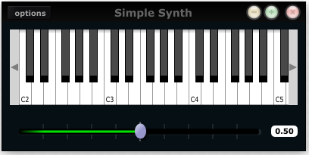

A basic Cabbage effect
Cabbage effects are used to process incoming audio. To do so one must make sure they can access the incoming audio stream. Any of Csound's signal input opcodes can be used for this. The examples that come with Cabbage use both the ins and inch opcodes to retreive the incoming audio signal. The following code is for a simple reverb unit. It accepts a stereo input and outputs a stereo signal.
<Cabbage>
form caption("Reverb") size(230, 130)
groupbox text("Stereo Reverb"), bounds(0, 0, 200, 100)
rslider channel("size"), bounds(10, 25, 70, 70), text("Size"), range(0, 2, 0.2)
rslider channel("fco"), bounds(70, 25, 70, 70), text("Cut-off"), range(0, 22000, 10000)
rslider channel("gain"), bounds(130, 25, 70, 70), text("Gain"), range(0, 1, 0.5)
</Cabbage>
<CsoundSynthesizer>
<CsOptions>
-d -n
</CsOptions>
<CsInstruments>
; Initialize the global variables.
sr = 44100
ksmps = 32
nchnls = 2

instr 1
kfdback chnget "size"
kfco chnget "fco"
kgain chnget "gain"
ainL inch 1
ainR inch 2
aoutL, aoutR reverbsc ainL, ainR, kfdback, kfco
outs aoutL*kgain, aoutR*kgain
endin

</CsInstruments>
<CsScore>
f1 0 4096 10 1
i1 0 1000
</CsScore>
</CsoundSynthesizer>
The above instrument uses 3 sliders to control
- the reverb size
- the cut-off frequency for the internal low-pass filters set up on the different delay lines
- overall gain.
The range() identifier is used with each slider to specify the min, max and starting value of the sliders.
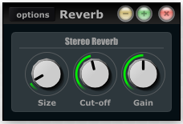
If you compare the two score sections in the above instruments you’ll notice that the synth instrument doesn't use any i-statement. Instead it uses an f0 3600. This tells Csound to wait for 3600 seconds before exiting. Because the instrument is to be controlled via MIDI we don’t need to use an i-statement in the score. In the other example we use an i-statement with a long duration so that the effect runs without stopping for a long time.

Exporting your instruments as plugins
Once you have created your instruments you will need to export them as plugins if you want them to be seen by other host applications. When you export in Cabbage it will create a plugin file that will have the same name as the csd file you are currently working on. In your plugin host you will need to add the directory that contains your Cabbage plugins and csd files.
In order to make future changes to the instrument you only need to edit the associated .csd file. For instance, if you have a plugin called "SavageCabbage.dll" and you wish to make some changes, you only have to edit the corresponding "SavageCabbage.csd" file. In order to see the changes in your plugin host you will need to delete and re-instantiate the plugin from the track. Your changes will be seen once you re-instantiate the plugin.

Cabbage Reference
Each and every Cabbage control has a numbers of possible identifiers that can be used to tell Cabbage how it will look and behave. Identifiers with parameters enclosed in quote marks must be passed a quoted string. Identifiers containing parameters without quotes must be passed numerical values. All parameters except pos() have default values and are therefore optional. In the reference tables below any identifiers enclosed in square brackets are optional.
As pos() and size() are used so often they can be set in one go using the bounds() identifier:
bounds(x, y, width, height): bounds takes integer values that set position and size on screen(in pixels)
Below is a list of the different GUI controls currently available in Cabbage. Controls can be split into two groups, interactive controls and non-interactive controls. The non-interactive controls such as group boxes and images don’t interact in any way with either Csound or plugin hosts. The interactive controls such as sliders and buttons do interact with Csound. Each interactive control that one inserts into a Cabbage instrument will be accessible in a plugin host if the instrument has been exported as a plugin. The name that appears beside each native slider in the plugin host will be the assigned channel name for that control.
In order to save space in the following reference section bounds() will be used instead of pos() and size() wherever applicable.

Form

form caption("title"), size(Width, Height), pluginID("plug")
Form creates the main application window. pluginID() is the only required identifier. The default values for size are 600x300.
caption: The string passed to caption will be the string that appears on the main application window.
size(Width, Height): integer values denoted the width and height of the form.
pluginID("plug"): this unique string must be four characters long. It is the ID given to your plugin when loaded by plugin hosts.
Every plugin must have a unique pluginID. If two plugins share the same ID there will be conflicts when trying to load them into a plugin host.

Example:
form caption("Simple Synth"), pluginID("plu1")

GroupBox

groupbox bounds(x, y, width, height), text("Caption")

Groupbox creates a container for other GUI controls. They do not communicate with Csound but can be useful for organising widgets into panels.
bounds(x, y, width, height): integer values that set position and size on screen(in pixels)
text("caption"): "caption" will be the string to appear on the group box

Example:
groupbox bounds(0, 0, 200, 100), text("Group box")
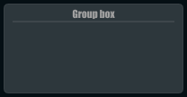

Keyboard

keyboard bounds(x, y, width, height)

Keyboard create a piano keyboard that will send MIDI information to your Csound instrument. This component can be used together with a hardware controller. Pressing keys on the actual MIDI keyboard will cause the on-screen keys to light up.
bounds(x, y, width, height): integer values that set position and size on screen(in pixels)
You can only use one MIDI keyboard component with each Cabbage instrument. Also note that the keyboard can be played at different velocities depending on where you click on the key with your mouse. Clicking at the top of the key will cause a smaller velocity while clicking on the bottom will cause the note to sound with full velocity. The keyboard control is only provided as a quick and easy means of testing plugins in Cabbage. Treating it as anything more than that could result in severe disappointment!

Example:
keyboard bounds(0, 0, 200, 100)
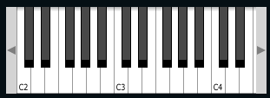

CsoundOutput

csoundoutput bounds(x, y, width, height), text("name")
csoundoutput will let you view the Csound output console within your instrument’s GUI, useful when 'de-slugging'(debugging in Cabbage is known as de-slugging!) Cabbage instruments.
bounds(x, y, width, height): integer values that set position and size on screen(in pixels)
text("name"): "name" will be the text that appears on the top of the check box.

Example:
csoundoutput bounds(210, 00, 340, 145), text("Csound Output")
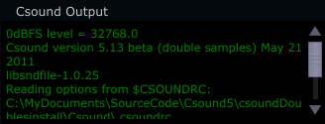

Image

image bounds(x, y, width, height), file("file name"), shape("type"), colour("colour")\ outline("colour"), line(thickness)
Image creates a static shape or graphic. It can be used to show pictures or it can be used to draw simple shapes. If you wish to display a picture you must pass the file name to the file() identifier. The file MUST be in the same directory as your Cabbage instrument. If you simply wish to draw a shape you can choose a background colour with colour() and an outline colour with outline(). line() will let you determine the thickness of the outline.
bounds(x, y, width, height): integer values that set position and size on screen(in pixels)
file("filename"): "filename" is the name of the image to be displayed on the control
shape("type");: "shape" must be either "round"(with rounded corners, default), "sharp"(with sharp corners), or "ellipse"(an elliptical shape)
colour("colour"): This sets the colour of the image if no file name is given with the file identifier. Any CSS or HTML colour string can be passed to this identifier.
outline("colour"): This sets the outline colour of the image/shape. Any CSS or HTML colour string can be passed to this identifier.
line(thickness): This sets the line thickness in pixels.

Example:
image bounds(0, 10, 260, 190), colour("white") image bounds(5, 15, 250, 180),\
colour("brown") image bounds(30, 30, 200, 150), \ file("logo_cabbage_sw_no_text.png")


Sliders

hslider bounds(x, y, width, height), channel("chanName")[, caption("caption"), \
text("name"), textBox(on/off), range(min, max, value, skew, incr), \
midCtrl(Channel, Ctrlnum), colour("colour")]
Slider can be used to create an on-screen slider. Data can be sent to Csound on the channel specified through the chanName string. Presented above is the syntax for a horizontal slider, i.e., hslider. In order to change it to another slider type simple substitute hslider with the appropriate identifier as outlined below.
bounds(x, y, width, height): integer values that set position and size on screen(in pixels)
channel("chanName"): "chanName" is the name of the channel upon which to communicate with Csound(see examples above).
caption("caption"): This identifier lets you place your control within a groupbox. "caption" is the text that will appear on groupbox. This identifier is useful for naming and containing controls.
range(min, max, value, skew, incr): the first 2 parameters are required. The rest are optional. The first two parameters let you set the minimum value and the maximum value. The next parameter determines the initial value of the slider. The next allows you to adjust the skew factor. Tweaking the skew factor can cause the slider to output values in a non linear fashion. A skew of 0.5 will cause the slider to output values in an exponential fashion. A skew of 1 is the default value, which causes the slider to behave is a typical linear form.
For the moment min must be less than max. In other words you can’t invert the slider. Also note that skew defaults to 1 when the slider is being controlled by MIDI.
text("name"): The string passed in for "name" will appear on a label beside the slider. This is useful for naming sliders.
textBox(on/off): textbox takes a 0 or a 1. 1 will cause a text box to appear with the sliders values. Leaving this out will result in the numbers appearing automatically when you hover over the sliders with your mouse.
midCtrl(channel, Ctrlnum) : channel must be a valid midi channel, while controller num should be the number of the controller you wish to use. This identifier only works when running your instruments within the Cabbage standalone player.
colour("colour"): This sets the colour of the image if a file name is not passed to file. Any CSS or HTML colour string can be passed to this identifier.
Slider types:
hslider: horizontal slider
vslider: vertical slider
rslider: rotary slider

Example:
rslider bounds(0, 110, 90, 90), caption("Freq1"), channel("freq2"), \
colour("cornflowerblue"), range(0, 1, .5), midictrl(0, 1)
rslider bounds(100, 120, 70, 70), text("Freq2"), channel("freq2"), \
colour("red"), range(0, 1, .5), midictrl(0, 1) rslider bounds(190, 120, 70, 70), \ text("Freq3"), channel("freq2"), colour("green"), text("Freq3"), textbox(1)
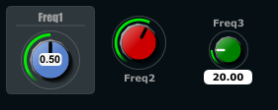

Button

button bounds(x, y, width, height), channel("chanName")[,text("offCaption","onCaption")\ caption("caption"), value(val)]
Button creates a button that can be used for a whole range of different tasks. The "channel" string identifies the channel on which the host will communicate with Csound. "OnCaption" and "OffCaption" determine the strings that will appear on the button as users toggle between two states, i.e., 0 or 1. By default these captions are set to "On" and "Off" but the user can specify any strings they wish. Button will constantly toggle between 0 and 1.
bounds(x, y, width, height): integer values that set position and size on screen(in pixels)
channel("chanName"): "chanName" is the name of the channel upon which to communicate with Csound(see examples above).
caption("caption"): This identifier lets you place your control within a groupbox. "caption" is the text that will appear on group box. This identifier is useful for naming and containing controls.
text("offCaption", "onCaption"): The text identifier must be passed at least one string argument. This string will be the one that will appear on the button. If you pass two strings to text() the button will toggle between the two string each time it is pushed.
value(val): val sets the initial state of the control

Example:
button bounds(0, 110, 120, 70), caption("Freq1"), text("On", "Off"), channel("freq2"),\ value(1)
button bounds(150, 110, 120, 70), text("On", "Off"), channel("freq2"), value(0)
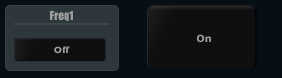

CheckBox

checkbox bounds(x, y, width, height), channel("chanName")[, text("name"), value(val), caption("Caption")]
Checkbox creates a checkbox which functions like a button only the associated caption will not change when the user checks it. As with all controls capable of sending data to an instance of Csound the channel string is the channel on which the control will communicate with Csound.
channel("chanName"): "chanName" is the name of the channel upon which to communicate with Csound(see examples above).
caption("caption"): This identifier lets you place your control within a groupbox. "caption" is the text that will appear on groupbox. This identifier is useful for naming and containing controls.
text("name"): "name" will be the text that appears beside the checkbox.
value(val): val sets the initial state of the control

Example:
checkbox bounds(0, 110, 120, 70), caption("Freq1"), text("On"), channel("freq2")
checkbox bounds(130, 110, 120, 70), text("Mute"), channel("freq2"), value(1)
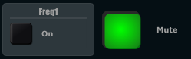

ComboBox

combobox bounds(x, y, width, height), channel("chanName")[, value(val), items("item1",\ "item2", ...), caption("caption")]
Combobox creates a drop-down list of items which users can choose from. Once the user selects an item, the index of their selection will be sent to Csound on a channel named by the channel string. The default value is 0.
bounds(x, y, width, height): integer values that set position and size on screen(in pixels)
channel("chanName"): "chanName" is the name of the channel upon which to communicate with Csound(see examples above).
items("item1", "item2", etc): list of items that will populate the combobox. Each item has a corresponding index value. The first item when selected will send a 1, the second item a 2, the third a 3 etc.
value(val): val sets the initial state of the control
caption("caption"): This identifier lets you place your control within a groupbox. "caption" is the text that will appear on groupbox. This identifier is useful for naming and containing controls.

Example:
combobox bounds(0, 110, 120, 70), channel"freq"), caption("Freq"), items("200Hz", "400Hz", "800Hz"), value(2)
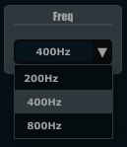

XYPad

xypad bounds(x, y, width, height), channel("chanName")[, rangex(min, max, val)\ rangey(min, max, val), text("name")]
xypad is an x/y controller that sends data to Csound on two named channels. The first channel transmits the current position of the ball on the X axis, while the second transmits the position of the ball on the Y axis. If you turn on automation via the checkbox located on the bottom left of the xypad you can throw the ball from edge to edge. Once the ball is in full flight you can control the speed of the ball using the XYpad slider.
bounds(x, y, width, height): integer values that set position and size on screen(in pixels)
channel("chanName"): "chanName" is the name of the channel in which to communicate with Csound(see examples above).
text("name"): "name" will be the text that appears on the top right hand side of the XYpad surface.
rangex(min, max, value): sets the range of the X axis. The first 2 parameters are required. The third is optional. The first two parameters let you set the minimum value and the maximum value. The next parameter determines the initial value.
rangey(min, max, value): sets the range of the Y axis. The first 2 parameters are required. The third is optional. The first two parameters let you set the minimum value and the maximum value. The next parameter determines the initial value.

Example:
xypad bounds(0, 0, 300, 300), text("X/Y PAD"), rangex(0, 500, 250), rangey(0, 100, 25)
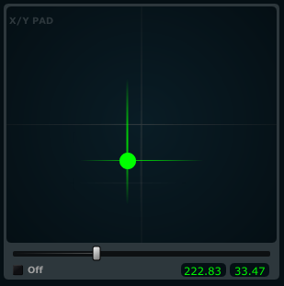

Quick Reference
The table below lists all the various Cabbage controls that are currently available.
Available GUI Controls | Description
form | Main window.
groupbox | A container for placing control on.
image | Used to display an image from file.
keyboard | MIDI keyboard.
label | Used to display text.
csoundoutput | Will show a window with the output from Csound in it.
snapshot | Can be used to record presets.
infobutton | When pressed will display a web browser with a user defined file. Can be useful for displaying plugin help in HTML. (Only available on OSX and Windows)
line | Used to display a line. Useful when designing GUIs.
table | For displaying Csound function tables. Tables are notified to update from Csound.
rslider, hslider, vslider | Rotary, Horizontal and Vertical sliders. Range can be set, along with an increment value. A skew factor can be set in order for it to behave non-linearly.
button | Button. Toggles between 1 and 0 when clicked.
combobox | Pressing a combo box causes an indexed drop-down list to appear. The item index is sent to Csound.
checkbox | A toggle/check box. Will show when it's on and off. Sends a 0 or 1 to Csound.
xypad | A xyPad which can be used to controls two parameters at the same time. Animation can also be enabled to throw the ball around. It's also possible to draw a path for the ball.
The next table contains all the available identifiers for Cabbage widgets. Note that not all controls support the same identifiers. For example, a groupbox will never need to have a channel assigned to it because it's a static control. Likewise buttons don't need to use the range() identifier as they always toggle between 0 and 1. Parameters within quotation marks represent string values, while those without represent floating point decimals, or integer values.
GUI Control | Supported identifiers
pos(x, y) | Sets the position of the control within it's parent.
size(width, height) | Sets the size of the control.
bounds(x, y, width, height) | Sets a controls position on screen and size.
channel(“channel”) | Sets up a software channel for Csound and Cabbage to communicate over. Channels should only contain valid ascii characters.
caption(“caption”) | Used to set the name of the instrument and also used to automatically place a control within a group box.
min(min) | Set minimum value for a slider.
max(max) | Set maximum value for a slider.
value(val) | Set initial value for sliders, combo boxes, check boxes and buttons. When used with a keyboard controls it can be used to set the lowest note seen on screen.
range(min, max, val, skew, incr) | Sets range of slider with and initialises it to val. Users can get the slider to a have in a non-linear fashion by selecting a skew value less than 1, while incr can be used to control how big each step is when the slider is moved.
rangex(min, max, val) rangey(min, max, val) | Set the ranges of the xyPad's X and Y axis.
colour(“colour”)  colour(red, green, blue)  colour(red, green, blue, alpha) | Sets the colour of the control. Any CSS or HTML colour string can be passed to this identifier. The colour identifier can also be passed an RBG, or RGBA value. All channel values must be between 0 and 255. For instance colour(0, 0, 255) will create blue, while colour(0, 255, 0, 255) will create green with an alpha channel set to full.
fontcolour(“colour”)  fontcolour(red, green, blue)  fontcolour(red, green, blue, alpha) | Sets the colour of the font. Please see the colour identifier for details on the parameters.
tracker(“colour”) | Set the colour of a sliders tracker. See the colour identifier for details on the parameters.
outline(“colour”) | Set the outline colour of an image. See the colour identifier for details on the parameters.
textbox(val) | Used with slider to turn on or off the default textbox that appears beside them. By default this is set to 1 for on, if you pass a 0 to it, the textbox will no longer be displayed.
text(“string”) | Used to set the text on any components that displays text.
file(“filename”) | Used to select the file that is to be displayed with the image control.
populate(“file type”, “dir”) | Used to add all files of a set type, located in specific directory to a combo boxes list of items.
author(“author's name”) | Used to add the author's name, or any other message to the bottom of the instrument.
items(“one”, “two”, “three”, …)  items(“on”, “off”) | Used to populate buttons, combo boxes and snapshots. When used with a button the first two parameters represent the captions the button will display when clicked. When used with a snapshot each item represents a saved preset.
preset(“preset”) | Used to tie a snapshot control to a particular control
plant(“name”) | Used to turn an image or group box into a container for controls. Each plant must be given a unique name and must be followed by a pair of curly brackets. Any widget declared within these bracket swill belong to the plant. Coordinates for children are relative to the top left position of its parent control. Resizing the parent will automatically cause all children to resize accordingly.
shape(“shape”) | Used to set the shape of an image, can be set to rounded, ellipse or sharp for rectangles and squares.
pluginID(“plug”) | Used to set the plugin identifier. Each plugin should have a unique identifier, otherwise hosts may not be able to load them correctly.
tablenumbers(1, 2, 3, 4, ...) | Tells table controls which function tables to load. If more than one table is passed function table will be stocked on top of each other with an layer of transparency.
midictrl(channel, controller) | Can be used with sliders and button to enable the use of a MIDI hardware controller. Channel and controller set the channel and controller numbers.
line(val) | This identifier will stop the group box line from appearing if passed a 0.

Troubleshooting, FAQs, tips and tricks
- Why doesn’t my VST host see my Cabbage plugins? The most likely reason is that you have not added the directory containing your plugins to your host’s preferences. Most hosts will allow you to choose the folders that contain plugins. If you don’t set the Cabbage plugin directory then the host has no idea where your Cabbage plugins are located.
- Why doesn’t my Cabbage plugin load? The most likely reason a plugin will not load is because there are errors in the Csound code. Cabbage plugins will load regardless of errors in the Cabbage code, but errors in the Csound code will stop Csound from compiling successfully and prevent the plugin from loading. Always make sure that the Csound code is error free before exporting.
- One mega plugin or several smaller ones? It’s a good idea to split multi-effects instruments into separate plugins. This allows greater modularity within you plugin host and can often lead to less demand on your PC’s CPU.
- Mixing effects and instruments? Adding an effect processor to a plugin instrument might seem like a good idea. For instance you might add some reverb to the output of your FM synth to create some nice presence. In general however it is best to keep them separate. Plugin instruments demand a whole lot more CPU than their effects siblings. Performance will be a lot smoother if you split the two processes up and simply send the output of your synthesiser into an instance of a Cabbage reverb effect plugin.
- What’s up? My plugin makes a load of noise? If you have nchnls set to 1 there will be noise sent to the second, or right channel. Make sure that nchnls is ALWAYS set to 2! Also be careful when dealing with stereo input. If you try to access the incoming signal on the right channel but you don't have any audio going to the right channel you may experience some noise.
- I can’t tell whether my sliders are controlling anything?! There will be times when moving sliders or other interactive controls just doesn’t do what you might expect. The best way to de-slug Cabbage instruments is to use the printk2 opcode in Csound. For instance if a slider is not behaving as expected make sure that Csound is receiving data from the slider on the correct channel. Using the code below should print the values of the slider to the Csound output console each time you move it. If not, then you most likely have the wrong channel name set.
(...) k1 chnget "slider1" printk2 k1 (...)
- What gives? I’ve checked my channels and they are consistent, yet moving my sliders does nothing? Believe it or not I have come across some cases of this happening! In all cases it was due to the fact that the chosen channel name contained a /. Please try to use plain old letters for your channel names. Avoid using any kind of mathematical operators or fancy symbols and everything should be Ok.
- Can I use nchnls to determine the number of output channels in my plugin? Currently all Cabbage plugins are stereo by default, but Cabbage can be built for any number of channels.
- Can I use Csound MACROs in the <Cabbage> section of my csd file? I’m afraid not. The Cabbage section of your csd file is parsed by Cabbage’s own parser therefore it will not understand any Csound syntax whatsoever.
- I’ve built some amazing instruments, how do I share them with the world?! Easy. Upload them to the Cabbage recipes section of Cabbage forum, available through http://www.thecabbagefoundation.org

Last updated 2012-03-30 17:19:47 GMT Daylight Time

BLUE

General Overview
Blue is a graphical computer music environment for composition, a versatile front-end to Csound. It is written in Java, platform-independent, and uses Csound as its audio engine. It provides higher level abstractions such as a graphical timeline for composition, GUI-based instruments, score generating SoundObjects like PianoRolls, python scripting, Cmask, Jmask and more. It is available for free (donation appreciated) at:
http://blue.kunstmusik.com

Organization of tabs and windows
Blue organizes all tasks that may arise while working with Csound within a single environment. Each task, be it score generation, instrument design, or composition is done in its own window. All the different windows are organized in tabs so that you can flip through easily and access them quickly.
In several places you will find lists and trees: All of your instruments used in a composition are numbered, named and listed in the Orchestra-window.
You will find the same for UDOs (User Defined Opcodes).
From this list you may export or import Instruments and UDOs from a library to the piece and vice versa. You may also bind several UDOs to a particular Instrument and export this instrument along with the UDOs it needs.

Editor
Blue holds several windows where you can enter code in an editor-like window. The editor-like windows are found for example in the Orchestra-window, the window to enter global score or the Tables-window to collect all the functions. There you may type in, import or paste text-based information. It gets displayed with syntax highlighting of Csound code.
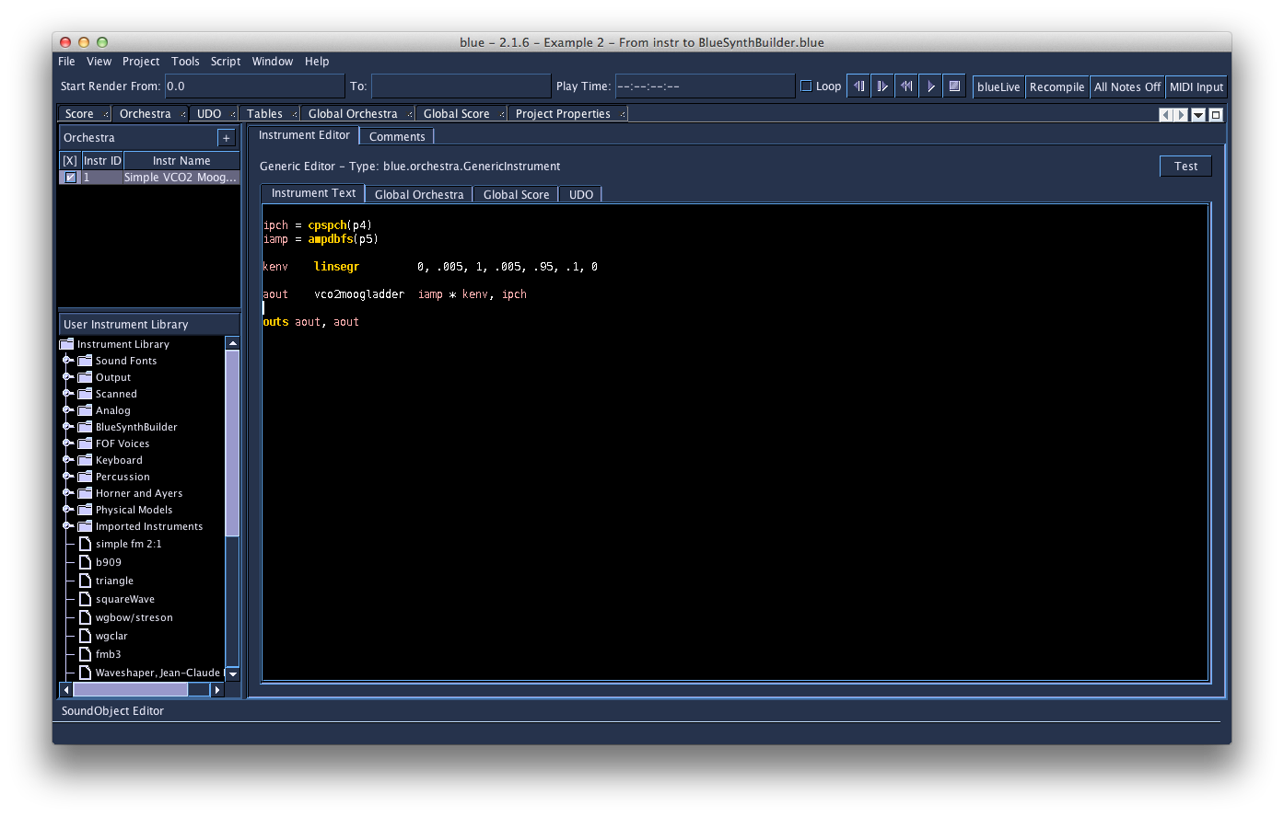
Image: The Orchestra-window

The Score timeline as a graphical representation of the composition
The Score timeline allows for visual organization of all the used SoundObjects in a composition.
In the Score-window, which is the main graphical window that represents the composition, you may arrange the composition by arranging the various SoundObjects in the timeline. A SoundObject is an object that holds or even generates a certain amount of score-events. SoundObjects are the building blocks within blue's score timeline. SoundObjects can be lists of notes, algorithmic generators, python script code, Csound instrument definitions, PianoRolls, Pattern Editors, Tracker interfaces, and more. These SoundObjects may be text based or GUI-based as well, depending on their facilities and purposes.
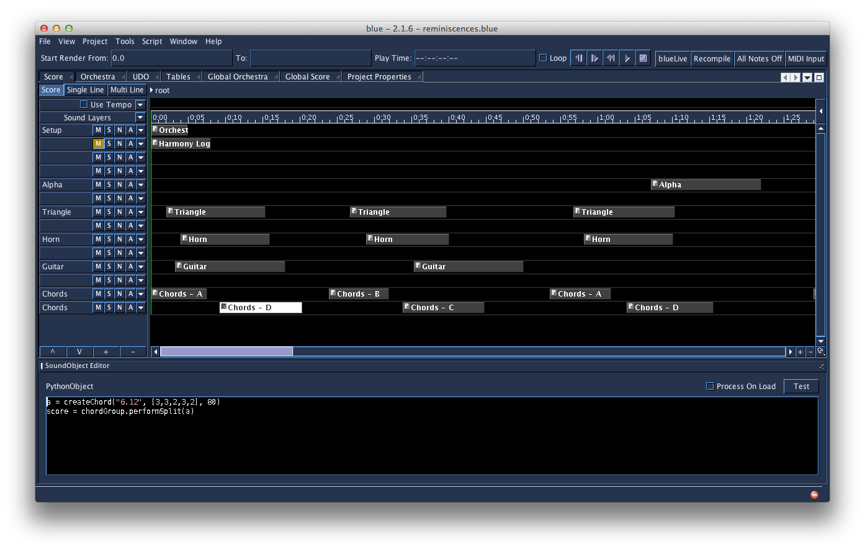
Image: The timeline holding several Sound Objects. One SoundObject is selected and opened in the SoundObject-Editor-window

SoundObjects
To enable every kind of music production style and thus every kind of electronic music, blue holds a set of different SoundObjects. SoundObjects in blue can represent many things, whether it is a single sound, a melody, a rhythm, a phrase, a section involving phrases and multiple lines, a gesture, or anything else that is a perceived sound idea.
Just as there are many ways to think about music, each with their own model for describing sound and vocabulary for explaining music, there are a number of different SoundObjects in blue. Each SoundObject in blue is useful for different purposes, with some being more appropriate for expressing certain musical ideas than others. For example, using a scripting object like the PythonObject or RhinoObject would serve a user who is trying to express a musical idea that may require an algorithmic basis, while the PianoRoll would be useful for those interested in notating melodic and harmonic ideas. The variety of different SoundObjects allows for users to choose what tool will be the most appropriate to express their musical ideas.
Since there are many ways to express musical ideas, to fully allow the range of expression that Csound offers, blue's SoundObjects are capable of generating different things that Csound will use. Although most often they are used for generating Csound SCO text, SoundObjects may also generate ftables, instruments, user-defined opcodes, and everything else that would be needed to express a musical idea in Csound.

Means of modification of a SoundObject
First, you may set the start time and duration of every SoundObject "by hand" by typing in precise numbers or drag it more intuitively back and fourth on the timeline. This modifies and the position in time of a SoundObject, while stretching it modifies the outer boundaries of it and may even change the density of events it generates inside.
If you want to enter information into a SoundObject, you can open and edit it in a SoundObject editor-window.
But there is also a way to modify the “output” of a SoundObject, without having to change its content. The way to do this is using NoteProcessors.
By using NoteProcessors, several operations may be applied onto the parameters of a SoundObject. NoteProcessors allow for modifying the SoundObjects score results, i.e. adding 2 to all p4 values, multiplying all p5 values by 6, etc. These NoteProcessors can be chained together to manipulate and modify objects to achieve things like transposition, serial processing of scores, and more.
Finally the SoundObjects may be grouped together and organized in larger-scale hierarchy by combining them to PolyObjects.
Polyobject are objects, which hold other SoundObjects, and have timelines in themselves. Working within them on their timelines and outside of them on the parent timeline helps organize and understand the concepts of objective time and relative time between different objects.

Instruments with a graphical interface
Instruments and effects with a graphical interface may help to increase musical workflow. Among the instruments with a graphical user interface there are BlueSynthBuilder (BSB)-Instruments, BlueEffects and the blue Mixer.

BlueSynthBuilder (BSB)-Instruments
The BlueSynthBuilder (BSB)-Instruments and the BlueEffects work like conventional Csound instruments, but there is an additional opportunity to add and design a GUI that may contain sliders, knobs, textfields, pull-down menus and more. You may convert any conventional Csound Instrument automatically to a BSB-Instrument and then add and design a GUI.
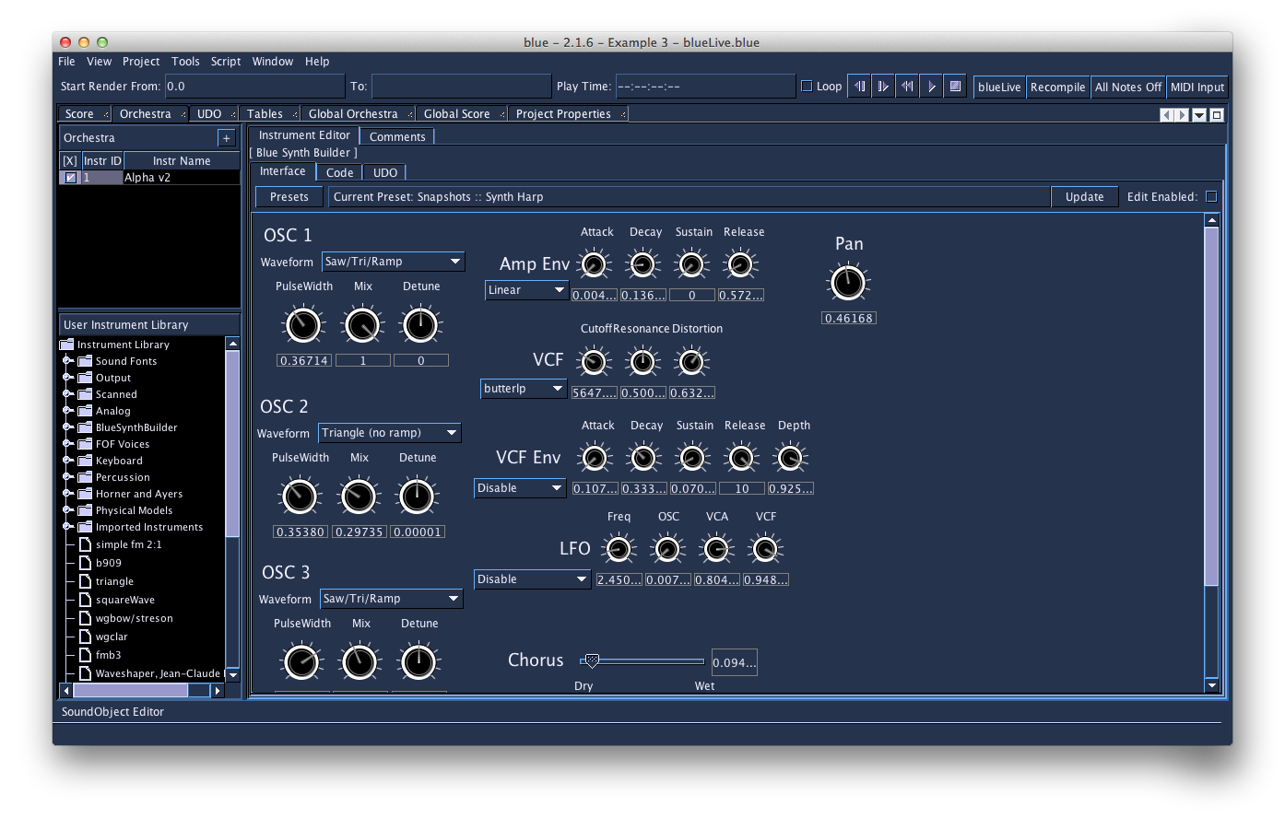
Image: The interface of a BSB-Instrument.

blue Mixer
Blue's graphical mixer system allows signals generated by instruments to be mixed together and further processed by Blue Effects. The GUI follows a paradigm commonly found in music sequencers and digital audio workstations.
The mixer UI is divided into channels, sub-channels, and the master channel. Each channel has a fader for applying level adjustments to the channel's signal, as well as bins pre- and post-fader for adding effects. Effects can be created on the mixer, or added from the Effects Library.
Users can modify the values of widgets by manipulating them in real-time, but they can also draw automation curves to compose value changes over time.
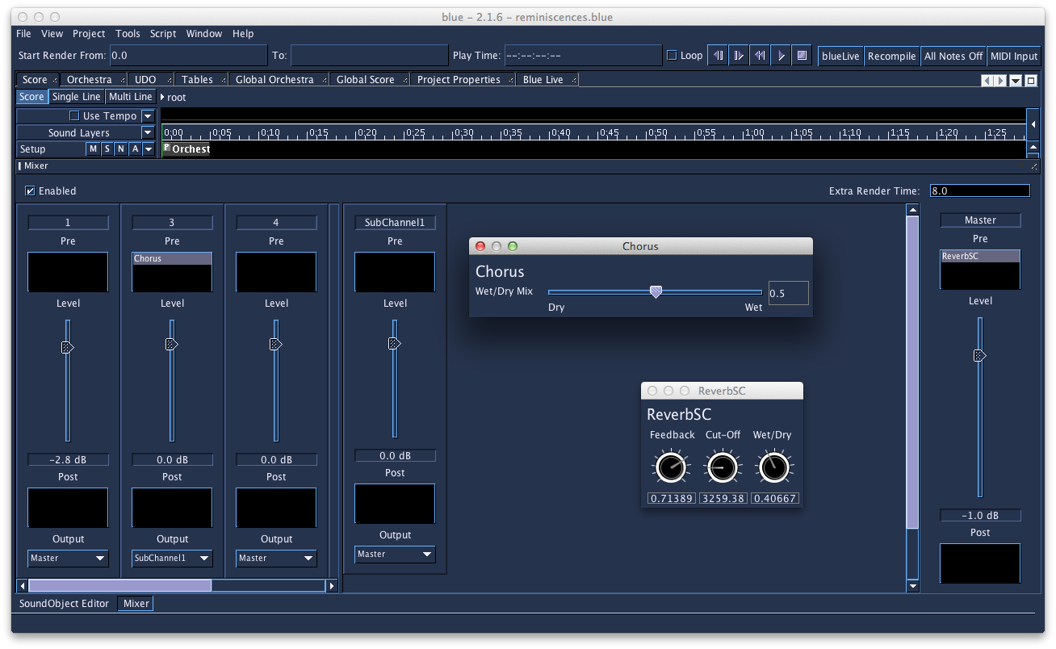
Image: The BlueMixer

Automation
For BSB-Instruments, blueMixer and blueEffects it is possible to use Lines and Graphs within the score timeline to enter and edit parameters via a line. In Blue, most widgets in BlueSynthBuilder and Effects can have automation enabled. Faders in the Mixer can also be automated.
Editing automation is done in the Score timeline. This is done by first selecting a parameter for automation from the SoundLayer's “A” button's popup menu, then selecting the Single Line mode in the Score for editing individual line values.
Using Multi-Line mode in the score allows the user to select blocks of SoundObjects and automations and move them as a whole to other parts of the Score.
Thus the parameters of these instruments with a GUI may be automatized and controlled via an editable graph in the Score-window.

Libraries
blue features also libraries for instruments, SoundObjects, UDOs, Effects (for the blueMixer) and the CodeRepository for code snippets. All these libraries are organized as lists or trees. Items of the library may be imported to the current composition or exported from it to be used later in other pieces.
The SoundObject library allows for instantiating multiple copies of a SoundObject, which allows for editing the original object and updating all copies. If NoteProcessors are applied to the instances in the composition representing the general structure of the composition you may edit the content of a SoundObject in the library while the structure of the composition remains unchanged. That way you may work on a SoundObject while all the occurrences in the composition of that very SoundObject are updated automatically according the changes done in the library.
The Orchestra manager organizes instruments and functions as an instrument librarian.
There is also an Effects Library and a Library for the UDOs

Other Features
- blueLive - work with SoundObjects in realtime to experiment with musical ideas or performance.
- SoundObject freezing - frees up CPU cycles by pre-rendering SoundObjects
- Microtonal support using scales defined in the Scala scale format, including a microtonal PianoRoll, Tracker, NoteProcessors, and more.

54. WinXound
WinXound Description:
WinXound is a free and open-source Front-End GUI Editor for CSound 5, CSoundAV,
CSoundAC, with Python and Lua support, developed by Stefano Bonetti.
It runs on Microsoft Windows, Apple Mac OsX and Linux.
WinXound is optimized to work with the new CSound 5 compiler.
WinXound Features:
- Edit CSound, Python and Lua files (csd, orc, sco, py, lua) with Syntax Highlight and Rectangular Selection;
- Run CSound, CSoundAV, CSoundAC, Python and Lua compilers;
- Run external language tools (QuteCsound, Idle, or other GUI Editors);
- CSound analysis user friendly GUI;
- Integrated CSound manual help;
- Possibilities to set personal colors for the syntax highlighter;
- Convert orc/sco to csd or csd to orc/sco;
- Split code into two windows horizontally or vertically;
- CSound csd explorer (File structure for Tags and Instruments);
- CSound Opcodes autocompletion menu;
- Line numbers;
- Bookmarks;
- ...and much more ... (Download it!)
Web Site and Contacts:
- Web: winxound.codeplex.com
- Email: stefano_bonetti@tin.it (or stefano_bonetti@alice.it)

REQUIREMENTS
System requirements for Microsoft Windows:
- Supported: Xp, Vista, Seven (32/64 bit versions);
- (Note: For Windows Xp you also need the Microsoft Framework .Net version 2.0 or major. You can download it from www.microsoft.com site);
- CSound 5: http://sourceforge.net/projects/csound - (needed for CSound and LuaJit compilers);
- Not requested but suggested: CSoundAV by Gabriel Maldonado (http://www.csounds.com/maldonado/);
- Requested to work with Python: Python compiler (http://www.python.org/download/)
System requirements for Apple Mac OsX:
- Osx 10.5 or major;
- CSound 5: http://sourceforge.net/projects/csound - (needed for CSound compiler);
System requirements for Linux:
- Gnome environment or libraries;
- Please, read carefully the "ReadMe" file in the source code.

INSTALLATION AND USAGE
Microsoft Windows Installation and Usage:
- Download and install the Microsoft Framework .Net version 2.0 or major (only for Windows Xp);
- Download and install the latest version of CSound 5 (http://sourceforge.net/projects/csound);
- Download the WinXound zipped file, decompress it where you want (see the (*)note below), and double-click on "WinXound_Net" executable;
- (*)note: THE WINXOUND FOLDER MUST BE LOCATED IN A PATH WHERE YOU HAVE FULL READ AND WRITE PERMISSION (for example in your User Personal folder).
Apple Mac OsX Installation and Usage:
- Download and install the latest version of CSound 5 (http://sourceforge.net/projects/csound);
- Download the WinXound zipped file, decompress it and drag WinXound.app to your Applications folder (or where you want). Launch it from there.
Linux Installation and Usage:
- Download and install the latest version of CSound 5 for your distribution;
- Ubuntu (32/64 bit): Download the WinXound zipped file, decompress it in a location where you have the full read and write permissions;
- To compile the source code:
1) Before to compile WinXound you need to install:
- gtkmm-2.4 (libgtkmm-2.4-dev) >= 2.12
- vte (libvte-dev)
- webkit-1.0 (libwebkit-dev)
2) To compile WinXound open the terminal window, go into the uncompressed "winxound_gtkmm" directory and type:
./configure
make
3) To use WinXound without installing it:
make standalone
./bin/winxound
[Note: WinXound folder must be located in a path where you have full read and write permission.]
4) To install WinXound:
make install

Source Code:
- Windows: The source code is written in C# using Microsoft Visual Studio C# Express Edition 2008.
- OsX: The source code is written in Cocoa and Objective-C using XCode 3.2 version.
- Linux: The source code is written in C++ (Gtkmm) using Anjuta.
Note: The TextEditor is entirely based on the wonderful SCINTILLA text control by Neil Hodgson (http://www.scintilla.org).

Screenshots:
Look at: winxound.codeplex.com

Credits:
Many thanks for suggestions and debugging help to Roberto Doati, Gabriel Maldonado, Mark Jamerson, Andreas Bergsland, Oeyvind Brandtsegg, Francesco Biasiol, Giorgio Klauer, Paolo Girol, Francesco Porta, Eric Dexter, Menno Knevel, Joseph Alford, Panos Katergiathis, James Mobberley, Fabio Macelloni, Giuseppe Silvi, Maurizio Goina, Andrés Cabrera, Peiman Khosravi, Rory Walsh and Luis Jure.

55. CSOUND VIA TERMINAL
Whilst many of us now interact with Csound through one of its many front-ends which provide us with an experience more akin the that of mainstream software, new-comers to Csound should bear in mind that there was a time when the only way running Csound was from the command line using the Csound command. In fact we must still run Csound in this way but front-ends do this for us usually via some toolbar button or widget. Many people still prefer to interact with Csound from a terminal window and feel this provides a more 'naked' and honest interfacing with the program. Very often these people come from the group of users who have been using Csound for many years, form the time before front-ends. It is still important for all users to be aware of how to run Csound from the terminal as it provides a useful backup if problems develop with a preferred front-end.

The Csound Command
The Csound command follows the format:
csound [performance_flags] [input_orc/sco/csd]
Executing 'csound' with no additional arguments will run the program but after a variety of configuration information is printed to the terminal we will be informed that we provided "insufficient arguments" for Csound to do anything useful. This action can still be valid for first testing if Csound is installed and configured for terminal use, for checking what version is installed and for finding out what performance flags are available without having to refer to the manual.
Performance flags are controls that can be used to define how Csound will run. All of these flags have defaults but we can make explicitly use flags and change these defaults to do useful things like controlling the amount of information that Csound displays for us while running, activating a MIDI device for input, or altering buffer sizes for fine tuning realtime audio performance. Even if you are using a front-end, command line flags can be manipulated in a familiar format usually in 'settings' or 'preferences' menu. Adding flags here will have the same effect as adding them as part of the Csound command. To learn more about Csound's command line flags it is best to start on the page in the reference manual where they are listed and described by category.
Command line flags can also be defined within the <CsOptions> </CsOptions> part of a .csd file and also in a file called .csoundrc which can be located in the Csound home program directory and/or in the current working directory. Having all these different options for where esentially the same information is stored might seem excessive but it is really just to allow flexibiliy in how users can make changes to how Csound runs, depending on the situation and in the most efficient way possible. This does however bring up one one issue in that if a particular command line flag has been set in two different places, how does Csound know which one to choose? There is an order of precedence that allows us to find out.
Beginning from its own defaults the first place Csound looks for additional flag options is in the .csoundrc file in Csound's home directory, the next is in a .csoundrc file in the current working directory (if it exists), the next is in the <CsOptions> of the .csd and finally the Csound command itself. Flags that are read later in this list will overwrite earlier ones. Where flags have been set within a front-end's options, these will normally overwrite any previous instructions for that flag as they form part of the Csound command. Often a front-end will incorporate a check-box for disabling its own inclusion of flag (without actually having to delete them from the dialogue window).
After the command line flags (if any) have been declared in the Csound command, we provide the name(s) of out input file(s) - originally this would have been the orchestra (.orc) and score (.sco) file but this arrangement has now all but been replaced by the more recently introduced .csd (unified orchestra and score) file. The facility to use a separate orchestra and score file remains however.
For example:
Csound -d -W -osoundoutput.wav inputfile.csd
will run Csound and render the input .csd 'inputfile.csd' as a wav file ('-W' flag) to the file 'soundoutput.wav' ('-o' flag). Additionally displays will be suppressed as dictated by the '-d' flag. The input .csd file will need to be in the current working directory as no full path has been provided. the output file will be written to the current working directory of SFDIR if specified.

11 CSOUND UTILITIES
56. CSOUND UTILITIES

56. CSOUND UTILITIES
Csound comes bundled with a variety of additional utility applications. These are small programs that perform a single function, very often with a sound file, that might be useful just before or just after working with the main Csound program. Originally these were programs that were run from the command line but many of Csound front-ends now offer direct access to many of these utilities through their own utilities menus. It is useful to still have access to these programs via the command line though, if all else fails.
The standard syntax for using these programs from the command line is to type the name of the utility followed optionally by one or more command line flags which control various performance options of the program - all of these will have useable defaults anyway - and finally the name of the sound file upon which the utility will operate.
utility_name [flag(s)] [file_name(s)]
If we require some help or information about a utility and don't want to be bothered hunting through the Csound Manual we can just type the the utility's name with no additional arguments, hit enter and the commmand line response will give us some information about that utility and what command line flags it offers. We can also run the utility through Csound - perhaps useful if there are problems running the utility directly - by calling Csound with the -U flag. The -U flag will instruct Csound to run the utility and to interpret subsequent flags as those of the utility and not its own.
Csound -U utility_name [flag(s)] [file_name(s)]

sndinfo
As an example of invoking one of these utilities form the command line we shall look at the utility 'sndinfo' (sound information) which provides the user with some information about one or more sound files. 'sndinfo' is invoked and provided with a file name thus:
sndinfo /Users/iainmccurdy/sounds/mysound.wav
If you are unsure of the file address of your sound file you can always just drag and drop it into the terminal window. The output should be something like:
util sndinfo:
/Users/iainmccurdy/sounds/mysound.wav:
srate 44100, stereo, 24 bit WAV, 3.335 seconds
(147078 sample frames)
'sndinfo' will accept a list of file names and provide information on all of them in one go so it may prove more efficient gleaning the same information from a GUI based sample editor. We also have the advantage of begin able to copy and paste from the terminal window into a .csd file.

Analysis Utilities
Although many of Csound's opcodes already operate upon commonly encountered sound file formats such as 'wav' and 'aiff', a number of them require sound information in more specialised and pre-analysed formats and for this Csound provides the sound analysis utilities atsa, cvanal, hetro, lpanal and pvanal. By far the most commonly used of these is pvanal which, although originally written to provide analysis files for pvoc and its generation of opcodes, has now been extended to be able to generate files in the pvoc-ex (.pvx) format for use with the newer 'pvs' streaming pvoc opcodes.
This time as well as requiring an input sound file for analysis we will need to provide a name (and optionally the full address) for the output file. Using pvanal's command flags we can have full control over typical FFT conversion parameters such as FFT size, overlap, window type etc. as well as additional options that may prove useful such as the ability to select a fragment of a larger sound file for the analysis. In the following illustration we shall make use of just one flag, -s, for selecting which channel of the input sound file to analyse, all other flag values shall assume their default values which should work fine in most situations.
pvanal -s1 mysound.wav myanalysis.pvx
pvanal will analyse the first (left if stereo) channel of the input sound file 'mysound.wav' (and in this case as no full address has been provided it will need to be in either the current working directory or SSDIR), and a name has been provided for the output file 'myanalysis.pvx', which, as no full address has been given, will be placed in the current working directory. While pvanal is running it will print a running momentary and finally inform us once the process is complete.
If you use CsoundQT you can have direct access to pvanal with all its options through the 'utilities' button in the toolbar. Once opened it will reveal a dialogue window looking something like this:
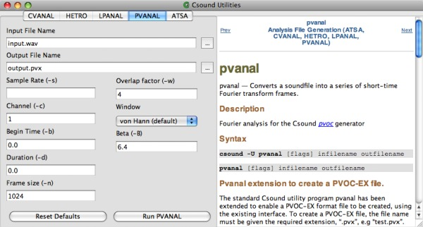
Especially helpful is the fact that we are also automatically provided with pvanal's manual page.

File Conversion Utilities
The next group of utilities, het_import, het_export, pvlook, pv_export, pv_import, sdif2ad and srconv facilitate file conversions between various types. Perhaps the most interesting of these are pvlook, which prints to the terminal a formatted text version of a pvanal file - useful to finding out exactly what is going on inside individual analysis bins, something that may be of use when working with the more advanced resynthesis opcodes such as pvadd or pvsbin. srconv can be used to convert the sample rate of a sound file.

Miscellaneous Utilities
A final grouping gathers together various unsorted utilities: cs, csb64enc, envext, extractor, makecsd, mixer, scale and mkdb. Most interesting of these are perhaps extractor which will extract a user defined fragment of a sound file which it will then write to a new file, mixer which mixes together any number of sound files and with gain control over each file and scale which will scale the amplitude of an individual sound file.

Conclusion
It has been seen that the Csound utilities offer a wealth of useful, but often overlooked, tools to augment our work with Csound. Whilst some of these utilities may seem redundant now that most of us have access to fully featured 3rd-party sound editing software, it should be borne in mind that many of these utilities were written in the 1980s and early 90s when such tools were less readily available.
12 CSOUND AND OTHER PROGRAMMING LANGUAGES
57. THE CSOUND API
58. PYTHON INSIDE CSOUND
59. C. PYTHON IN CSOUNDQT1
60. D. LUA IN CSOUND
61. E. CSOUND IN iOS
62. F. CSOUND ON ANDROID

57. THE CSOUND API
An application programming interface (API) is an interface provided by a computer system, library or application that allows users to access functions and routines for a particular task. It gives developers a way to harness the functionality of existing software within a host application. The Csound API can be used to control an instance of Csound through a series of different functions thus making it possible to harness all the power of Csound in one’s own applications. In other words, almost anything that can be done within Csound can be done with the API. The API is written in C, but there are interfaces to other languages as well, such as Python, C++ and Java.
To use the Csound C API, you have to include csound.h in your source file and to link your code with libcsound. Here is an example of the csound command line application written using the Csound C API:
#include <csound/csound.h>

int main(int argc, char **argv)
{
CSOUND *csound = csoundCreate(NULL);
int result = csoundCompile(csound, argc, argv);
if (result == 0) {
result = csoundPerform(csound);
}
csoundDestroy(csound);
return (result >= 0 ? 0 : result);
}
First we create an instance of Csound. To do this we call csoundCreate() which returns an opaque pointer that will be passed to most Csound API functions. Then we compile the orc/sco files or the csd file given as input arguments through the argv parameter of the main function. If the compilation is successful (result == 0), we call the csoundPerform() function. csoundPerform() will cause Csound to perform until the end of the score is reached. When this happens csoundPerform() returns a non-zero value and we destroy our instance before ending the program.
On a linux system, with libcsound named libcsound64 (double version of the csound library), supposing that all include and library paths are set correctly, we would build the above example with the following command (notice the use of the -DUSE_DOUBLE flag to signify that we compile against the 64 bit version of the csound library):
gcc -DUSE_DOUBLE -o csoundCommand csoundCommand.c -lcsound64
The command for building with a 32 bit version of the library would be:
gcc -o csoundCommand csoundCommand.c -lcsound
Within the C or C++ examples of this chapter, we will use the MYFLT type for the audio samples. Doing so, the same source files can be used for both development (32 bit or 64 bit), the compiler knowing how to interpret MYFLT as double if the macro USE_DOUBLE is defined, or as float if the macro is not defined.
The C API has been wrapped in a C++ class for convenience. This gives the Csound basic C++ API. With this API, the above example would become:
#include <csound/csound.hpp>

int main(int argc, char **argv)
{
Csound *cs = new Csound();
int result = cs->Compile(argc, argv);
if (result == 0) {
result = cs->Perform();
}
return (result >= 0 ? 0 : result);
}
Here, we get a pointer to a Csound object instead of the csound opaque pointer. We call methods of this object instead of C functions, and we don't need to call csoundDestroy in the end of the program, because the C++ object destruction mechanism takes care of this. On our linux system, the example would be built with the following command:
g++ -DUSE_DOUBLE -o csoundCommandCpp csoundCommand.cpp -lcsound64
The Csound API has also been wrapped to other languages. The Csound Python API wraps the Csound API to the Python language. To use this API, you have to import the csnd module. The csnd module is normally installed in the site-packages or dist-packages directory of your python distribution as a csnd.py file. Our csound command example becomes:
import sys
import csnd

def csoundCommand(args):
csound = csnd.Csound()
arguments = csnd.CsoundArgVList()
for s in args:
arguments.Append(s)
result = csound.Compile(arguments.argc(), arguments.argv())
if result == 0:
result = csound.Perform()
return result

def main():
csoundCommand(sys.argv)

if __name__ =='__main__':
main()
We use a Csound object (remember Python has OOp features). Note the use of the CsoundArgVList helper class to wrap the program input arguments into a C++ manageable object. In fact, the Csound class has syntactic sugar (thanks to method overloading) for the Compile method. If you have less than six string arguments to pass to this method, you can pass them directly. But here, as we don't know the number of arguments to our csound command, we use the more general mechanism of the CsoundArgVList helper class.
The Csound Java API wraps the Csound API to the Java language. To use this API, you have to import the csnd package. The csnd package is located in the csnd.jar archive which has to be known from your Java path. Our csound command example becomes:
import csnd.*;

public class CsoundCommand
{
private Csound csound = null;
private CsoundArgVList arguments = null;

public CsoundCommand(String[] args) {
csound = new Csound();
arguments = new CsoundArgVList();
arguments.Append("dummy");
for (int i = 0; i < args.length; i++) {
arguments.Append(args[i]);
}
int result = csound.Compile(arguments.argc(), arguments.argv());
if (result == 0) {
result = csound.Perform();
}
System.out.println(result);
}

public static void main(String[] args) {
CsoundCommand csCmd = new CsoundCommand(args);
}
}
Note the "dummy" string as first argument in the arguments list. C, C++ and Python expect that the first argument in a program argv input array is implicitly the name of the calling program. This is not the case in Java: the first location in the program argv input array contains the first command line argument if any. So we have to had this "dummy" string value in the first location of the arguments array so that the C API function called by our csound.Compile method is happy.
This illustrates a fundamental point about the Csound API. Whichever API wrapper is used (C++, Python, Java, etc), it is the C API which is working under the hood. So a thorough knowledge of the Csound C API is highly recommended if you plan to use the Csound API in any of its different flavours. The main source of information about the Csound C API is the csound.h header file which is fully commented.
On our linux system, with csnd.jar located in /usr/local/lib/csound/java, our Java Program would be compiled and run with the following commands:
javac -cp /usr/local/lib/csound/java/csnd.jar CsoundCommand.java
java -cp /usr/local/lib/csound/java/csnd.jar:. CsoundCommand
There also exists an extended Csound C++ API, which adds to the Csound C++ API a CsoundFile class, the CsoundAC C++ API, which provides a class hierarchy for doing algorithmic composition using Michael Gogins' concept of music graphs, and API wrappers for the LISP, LUA and HASKELL languages.
For now, in this chapter we will focus on the basic C/C++ API, and the Python and Java API.

Threading
Before we begin to look at how to control Csound in real time we need to look at threads. Threads are used so that a program can split itself into two or more simultaneously running tasks. Multiple threads can be executed in parallel on many computer systems. The advantage of running threads is that you do not have to wait for one part of your software to finish executing before you start another.
In order to control aspects of your instruments in real time your will need to employ the use of threads. If you run the first example found on this page you will see that the host will run for as long as csoundPerform() returns 0. As soon as it returns non-zero it will exit the loop and cause the application to quit. Once called, csoundPerform() will cause the program to hang until it is finished. In order to interact with Csound while it is performing you will need to call csoundPerform() in a separate unique thread.
When implementing threads using the Csound API, we must define a special performance function thread. We then pass the name of this performance function to csoundCreateThread(), thus registering our performance-thread function with Csound. When defining a Csound performance-thread routine you must declare it to have a return type uintptr_t, hence it will need to return a value when called. The thread function will take only one parameter, a pointer to void. This pointer to void is quite important as it allows us to pass important data from the main thread to the performance thread. As several variables are needed in our thread function the best approach is to create a user defined data structure that will hold all the information your performance thread will need. For example:
typedef struct {
int result; /* result of csoundCompile() */
CSOUND *csound; /* instance of csound */
bool PERF_STATUS; /* performance status */
} userData;
Below is a basic performance-thread routine. *data is cast as a userData data type so that we can access its members.
uintptr_t csThread(void *data)
{
userData *udata = (userData *)data;
if (!udata->result) {
while ((csoundPerformKsmps(udata->csound) == 0) &&
(udata->PERF_STATUS == 1));
csoundDestroy(udata->csound);
}
udata->PERF_STATUS = 0;
return 1;
}
In order to start this thread we must call the csoundCreateThread() API function which is declared in csound.h as:
void *csoundCreateThread(uintptr_t (*threadRoutine (void *),
void *userdata);
If you are building a command line program you will need to use some kind of mechanism to prevent int main() from returning until after the performance has taken place. A simple while loop will suffice.
The first example presented above can now be rewritten to include a unique performance thread:

#include <stdio.h>
#include <csound/csound.h>

uintptr_t csThread(void *clientData);

typedef struct {
int result;
CSOUND *csound;
int PERF_STATUS;
} userData;

int main(int argc, char *argv[])
{
int finish;
void *ThreadID;
userData *ud;
ud = (userData *)malloc(sizeof(userData));
MYFLT *pvalue;
ud->csound = csoundCreate(NULL);
ud->result = csoundCompile(ud->csound, argc, argv);

if (!ud->result) {
ud->PERF_STATUS = 1;
ThreadID = csoundCreateThread(csThread, (void *)ud);
}
else {
return 1;
}

/* keep performing until user types a number and presses enter */
scanf("%d", &finish);
ud->PERF_STATUS = 0;
csoundDestroy(ud->csound);
free(ud);
return 0;
}

/* performance thread function */
uintptr_t csThread(void *data)
{
userData *udata = (userData *)data;
if (!udata->result) {
while ((csoundPerformKsmps(udata->csound) == 0) &&
(udata->PERF_STATUS == 1));
csoundDestroy(udata->csound);
}
udata->PERF_STATUS = 0;
return 1;
}
The application above might not appear all that interesting. In fact it's almost the exact same as the first example presented except that users can now stop Csound by hitting 'enter'. The real worth of threads can only be appreciated when you start to control your instrument in real time.

Channel I/O
The big advantage to using the API is that it allows a host to control your Csound instruments in real time. There are several mechanisms provided by the API that allow us to do this. The simplest mechanism makes use of a 'software bus'.
The term bus is usually used to describe a means of communication between hardware components. Buses are used in mixing consoles to route signals out of the mixing desk into external devices. Signals get sent through the sends and are taken back into the console through the returns. The same thing happens in a software bus, only instead of sending analog signals to different hardware devices we send data to and from different software.
Using one of the software bus opcodes in Csound we can provide an interface for communication with a host application. An example of one such opcode is chnget. The chnget opcode reads data that is being sent from a host Csound API application on a particular named channel, and assigns it to an output variable. In the following example instrument 1 retrieves any data the host may be sending on a channel named "pitch":
instr 1
kfreq chnget "pitch"
asig oscil 10000, kfreq, 1
out asig
endin
One way in which data can be sent from a host application to an instance of Csound is through the use of the csoundGetChannelPtr() API function which is defined in csound.h as:
int csoundGetChannelPtr(CSOUND *, MYFLT **p, const char *name, int type);
CsoundGetChannelPtr() stores a pointer to the specified channel of the bus in p. The channel pointer p is of type MYFLT *. The argument name is the name of the channel and the argument type is a bitwise OR of exactly one of the following values:
CSOUND_CONTROL_CHANNEL - control data (one MYFLT value)
CSOUND_AUDIO_CHANNEL - audio data (ksmps MYFLT values)
CSOUND_STRING_CHANNEL - string data (MYFLT values with enough space to store csoundGetStrVarMaxLen(CSOUND*) characters, including the NULL character at the end of the string)
and at least one of these:
CSOUND_INPUT_CHANNEL - when you need Csound to accept incoming values from a host
CSOUND_OUTPUT_CHANNEL - when you need Csound to send outgoing values to a host
If the call to csoundGetChannelPtr() is successful the function will return zero. If not, it will return a negative error code. We can now modify our previous code in order to send data from our application on a named software bus to an instance of Csound using csoundGetChannelPtr().
#include <stdio.h>
#include <csound/csound.h>

/* performance thread function prototype */
uintptr_t csThread(void *clientData);

/* userData structure declaration */
typedef struct {
int result;
CSOUND *csound;
int PERF_STATUS;
} userData;

/*-----------------------------------------------------------
* main function
*-----------------------------------------------------------*/
int main(int argc, char *argv[])
{
int userInput = 200;
void *ThreadID;
userData *ud;
ud = (userData *)malloc(sizeof(userData));
MYFLT *pvalue;
ud->csound = csoundCreate(NULL);
ud->result = csoundCompile(ud->csound, argc, argv);
if (csoundGetChannelPtr(ud->csound, &pvalue, "pitch",
CSOUND_INPUT_CHANNEL | CSOUND_CONTROL_CHANNEL) != 0) {
printf("csoundGetChannelPtr could not get the \"pitch\" channel");
return 1;
}
if (!ud->result) {
ud->PERF_STATUS = 1;
ThreadID = csoundCreateThread(csThread, (void*)ud);
}
else {
printf("csoundCompiled returned an error");
return 1;
}
printf("\nEnter a pitch in Hz(0 to Exit) and type return\n");
while (userInput != 0) {
*pvalue = (MYFLT)userInput;
scanf("%d", &userInput);
}
ud->PERF_STATUS = 0;
csoundDestroy(ud->csound);
free(ud);
return 0;
}

/*-----------------------------------------------------------
* definition of our performance thread function
*-----------------------------------------------------------*/
uintptr_t csThread(void *data)
{
userData *udata = (userData *)data;
if (!udata->result) {
while ((csoundPerformKsmps(udata->csound) == 0) &&
(udata->PERF_STATUS == 1));
csoundDestroy(udata->csound);
}
udata->PERF_STATUS = 0;
return 1;
}

Score Events
Adding score events to the csound instance is easy to do. It requires that csound has its threading done, see the paragraph above on threading. To enter a score event into csound, one calls the following function:
void myInputMessageFunction(void *data, const char *message)
{
userData *udata = (userData *)data;
csoundInputMessage(udata->csound, message );
}
Now we can call that function to insert Score events into a running csound instance. The formatting of the message should be the same as one would normally have in the Score part of the .csd file. The example shows the format for the message. Note that if you're allowing csound to print its error messages, if you send a malformed message, it will warn you. Good for debugging. There's an example with the csound source code that allows you to type in a message, and then it will send it.
/* instrNum start duration p4 p5 p6 ... pN */
const char *message = "i1 0 1 0.5 0.3 0.1";
myInputMessageFunction((void*)udata, message);

Callbacks
Csound can call subroutines declared in the host program when some special events occur. This is done through the callback mechanism. One has to declare to Csound the existence of a callback routine using an API setter function. Then when a corresponding event occurs during performance, Csound will call the host callback routine, eventually passing some arguments to it.
The example below shows a very simple command line application allowing the user to rewind the score or to abort the performance. This is achieved by reading characters from the keyboard: 'r' for rewind and 'q' for quit. During performance, Csound executes a loop. Each pass in the loop yields ksmps audio frames. Using the API csoundSetYieldCallback function, we can tell to Csound to call our own routine after each pass in its internal loop.
The yieldCallback routine must be non-blocking. That's why it is a bit tricky to force the C getc function to be non-blocking. To enter a character, you have to type the character and then hit the return key.
#include <csound/csound.h>

int yieldCallback(CSOUND *csound)
{
int fd, oldstat, dummy;
char ch;

fd = fileno(stdin);
oldstat = fcntl(fd, F_GETFL, dummy);
fcntl(fd, F_SETFL, oldstat | O_NDELAY);
ch = getc(stdin);
fcntl(fd, F_SETFL, oldstat);
if (ch == -1)
return 1;
switch (ch) {
case 'r':
csoundRewindScore(csound);
break;
case 'q':
csoundStop(csound);
break;
}
return 1;
}

int main(int argc, char **argv)
{
CSOUND *csound = csoundCreate(NULL);
csoundSetYieldCallback(csound, yieldCallback);
int result = csoundCompile(csound, argc, argv);
if (result == 0) {
result = csoundPerform(csound);
}
csoundDestroy(csound);
return (result >= 0 ? 0 : result);
}
The user can also set callback routines for file open events, real-time audio events, real-time MIDI events, message events, keyboards events, graph events, and channel invalue and outvalue events.

CsoundPerformanceThread: a Swiss Knife for the API
Beside the API, Csound provides a helper C++ class to facilitate threading issues: CsoundPerformanceThread. This class performs a score in a separate thread, allowing the host program to do its own processing in its main thread during the score performance. The host program will communicate with the CsoundPerformanceThread class by sending messages to it, calling CsoundPerformanceThread methods. Those messages are queued inside CsoundPerformanceThread and are treated in a first in first out (FIFO) manner.
The example below is equivalent to the example in the callback section. But this time, as the characters are read in a different thread, there is no need to have a non-blocking character reading routine.
#include <csound/csound.hpp>
#include <csound/csPerfThread.hpp>

#include <iostream>
using namespace std;

int main(int argc, char **argv)
{
Csound *cs = new Csound();
int result = cs->Compile(argc, argv);
if (result == 0) {
CsoundPerformanceThread *pt = new CsoundPerformanceThread(cs);
pt->Play();
while (pt->GetStatus() == 0) {
char c = cin.get();
switch (c) {
case 'r':
cs->RewindScore();
break;
case 'q':
pt->Stop();
pt->Join();
break;
}
}
}
return (result >= 0 ? 0 : result);
}
Because CsoundPerformanceThread is not part of the API, we have to link to libcsnd to get it working:
g++ -DUSE_DOUBLE -o threadPerf threadPerf.cpp -lcsound64 -lcsnd
When using this class from Python or Java, this is not an issue because the csnd.py module and the csnd.jar package include the API functions and classes, and the CsoundPerformanceThread class as well.
Here is a more complete example which could be the base of a frontal application to run Csound. The host application is modeled through the CsoundSession class which has its own event loop (mainLoop). CsoundSession inherits from the API Csound class and it embeds an object of type CsoundPerformanceThread. Most of the CsoundPerformanceThread class methods are used.
#include <csound/csound.hpp>
#include <csound/csPerfThread.hpp>

#include <iostream>
#include <string>
using namespace std;

class CsoundSession : public Csound
{
public:
CsoundSession(string const &csdFileName = "") : Csound() {
m_pt = NULL;
m_csd = "";
if (!csdFileName.empty()) {
m_csd = csdFileName;
startThread();
}
};

void startThread() {
if (Compile((char *)m_csd.c_str()) == 0 ) {
m_pt = new CsoundPerformanceThread(this);
m_pt->Play();
}
};

void resetSession(string const &csdFileName) {
if (!csdFileName.empty())
m_csd = csdFileName;
if (!m_csd.empty()) {
stopPerformance();
startThread();
}
};

void stopPerformance() {
if (m_pt) {
if (m_pt->GetStatus() == 0)
m_pt->Stop();
m_pt->Join();
m_pt = NULL;
}
Reset();
};

void mainLoop() {
string s;
bool loop = true;
while (loop) {
cout << endl << "l)oad csd; e(vent; r(ewind; t(oggle pause; s(top; p(lay; q(uit: ";
char c = cin.get();
switch (c) {
case 'l':
cout << "Enter the name of csd file:";
cin >> s;
resetSession(s);
break;
case 'e':
cout << "Enter a score event:";
cin.ignore(1000, '\n'); //a bit tricky, but well, this is C++!
getline(cin, s);
m_pt->InputMessage(s.c_str());
break;
case 'r':
RewindScore();
break;
case 't':
if (m_pt)
m_pt->TogglePause();
break;
case 's':
stopPerformance();
break;
case 'p':
resetSession("");
break;
case 'q':
if (m_pt) {
m_pt->Stop();
m_pt->Join();
}
loop = false;
break;
}
cout << endl;
}
};

private:
string m_csd;
CsoundPerformanceThread *m_pt;
};

int main(int argc, char **argv)
{
string csdName = "";
if (argc > 1)
csdName = argv[1];
CsoundSession *session = new CsoundSession(csdName);
session->mainLoop();
}
There are also methods in CsoundPerformanceThread for sending score events (ScoreEvent), for moving the time pointer (SetScoreOffsetSeconds), for setting a callback function (SetProcessCallback) to be called at the end of each pass in the process loop, and for flushing the message queue (FlushMessageQueue).
As an exercise, the user should complete this example using the methods above and then try to rewrite the example in Python and/or in Java.

Csound6
With Csound6, the API changed a lot, breaking backward compatibility.
The Python module for the API is called now csnd6 instead of csnd and the corresponding Java package is called now csnd6.jar instead of csnd.jar. To use the CsoundPerformanceThread class from C++, one have to link to libcsnd6 instead of libcsnd.
As usual the best source of information is the csound.h header file. Comparing the Csound6 version of this file with the Csound5 version we see that it has been highly refactored, that many new functions have been added and that some functions have been renamed, or got new signatures, or have been removed.
Let us review this by sections:

Instantiation
csoundInitialize() has a new signature: (int flags) instead of (int *argc, char ***argv, int flags). The first two arguments were never used. The flags argument can be a bitwise or of the two values CSOUNDINIT_NO_SIGNAL_HANDLER and CSOUNDINIT_NO_ATEXIT. With the first value, Csound will react to an operating system interrupt signal in a custom way instead of the classical "Csound tidy up". The second value is for Windows systems only and tells Csound to destroy all instances when exiting. csoundCreate() calls csoundInitialize() with no flags. So if none of the above options are needed, csoundCreate() is enough to create an instance of Csound.
csoundPreCompile() has been removed.

Performance
Seven new functions:
TREE *csoundParseOrc(CSOUND *csound, const char *str)
int csoundCompileTree(CSOUND *csound, TREE *root)
void csoundDeleteTree(CSOUND *csound, TREE *tree)
int csoundCompileOrc(CSOUND *csound, const char *str)
MYFLT csoundEvalCode(CSOUND *csound, const char *str)
int csoundCompileArgs(CSOUND *, int argc, char **argv)
int csoundStart(CSOUND *csound)

csoundCompileFromStrings() has been removed.

Score Handling
One new function: int csoundReadScore(CSOUND *csound, char *str)

Attributes
Five new configuration/parameter getting and setting functions:
uint32_t csoundGetNchnlsInput(CSOUND *csound)
int64_t csoundGetCurrentTimeSamples(CSOUND *csound)
int csoundSetOption(CSOUND *csound, char *option)
void csoundSetParams(CSOUND *csound, CSOUND_PARAMS *p)
void csoundGetParams(CSOUND *csound, CSOUND_PARAMS *p)

General Input/Ouput
Seven new getting and setting functions for managing audio and/or midi input and output device names:
const char *csoundGetOutputName(CSOUND *)
void csoundSetOutput(CSOUND *csound, char *name, char *type, char *format)
void csoundSetInput(CSOUND *csound, char *name)
void csoundSetMIDIInput(CSOUND *csound, char *name)
void csoundSetMIDIFileInput(CSOUND *csound, char *name)
void csoundSetMIDIOutput(CSOUND *csound, char *name)
void csoundSetMIDIFileOutput(CSOUND *csound, char *name)
Here is a C++ example illustrating the new API functions presented in the above sections:
#include <csound/csound.hpp>
#include <csound/csPerfThread.hpp>

#include <iostream>
#include <string>
#include <vector>
using namespace std;

string orc1 =
"instr 1 \n"
"idur = p3 \n"
"iamp = p4 \n"
"ipch = cpspch(p5) \n"
"kenv linen iamp, 0.05, idur, 0.1 \n"
"a1 poscil kenv, ipch \n"
" out a1 \n"
"endin";

string orc2 =
"instr 1 \n"
"idur = p3 \n"
"iamp = p4 \n"
"ipch = cpspch(p5) \n"
"a1 foscili iamp, ipch, 1, 1.5, 1.25 \n"
" out a1 \n"
"endin\n";

string orc3 =
"instr 1 \n"
"idur = p3 \n"
"iamp = p4 \n"
"ipch = cpspch(p5-1) \n"
"kenv linen iamp, 0.05, idur, 0.1 \n"
"asig rand 0.45 \n"
"afilt moogvcf2 asig, ipch*4, ipch/(ipch * 1.085) \n"
"asig balance afilt, asig \n"
" out kenv*asig \n"
"endin\n";

string sco1 =
"i 1 0 1 0.5 8.00\n"
"i 1 + 1 0.5 8.04\n"
"i 1 + 1.5 0.5 8.07\n"
"i 1 + 0.25 0.5 8.09\n"
"i 1 + 0.25 0.5 8.11\n"
"i 1 + 0.5 0.8 9.00\n";

string sco2 =
"i 1 0 1 0.5 9.00\n"
"i 1 + 1 0.5 8.07\n"
"i 1 + 1 0.5 8.04\n"
"i 1 + 1 0.5 8.02\n"
"i 1 + 1 0.5 8.00\n";

string sco3 =
"i 1 0 0.5 0.5 8.00\n"
"i 1 + 0.5 0.5 8.04\n"
"i 1 + 0.5 0.5 8.00\n"
"i 1 + 0.5 0.5 8.04\n"
"i 1 + 0.5 0.5 8.00\n"
"i 1 + 0.5 0.5 8.04\n"
"i 1 + 1.0 0.8 8.00\n";

void noMessageCallback(CSOUND* cs, int attr, const char *format, va_list valist)
{
// Do nothing so that Csound will not print any message,
// leaving a clean console for our app
return;
}

class CsoundSession : public Csound
{
public:
CsoundSession(vector<string> & orc, vector<string> & sco) : Csound() {
m_orc = orc;
m_sco = sco;
m_pt = NULL;
};

void mainLoop() {
SetMessageCallback(noMessageCallback);
SetOutput((char *)"dac", NULL, NULL);
GetParams(&m_csParams);
m_csParams.sample_rate_override = 48000;
m_csParams.control_rate_override = 480;
m_csParams.e0dbfs_override = 1.0;
// Note that setParams is called before first compilation
SetParams(&m_csParams);
if (CompileOrc(orc1.c_str()) == 0) {
Start(this->GetCsound());
// Just to be sure...
cout << GetSr() << ", " << GetKr() << ", ";
cout << GetNchnls() << ", " << Get0dBFS() << endl;
m_pt = new CsoundPerformanceThread(this);
m_pt->Play();
}
else {
return;
}

string s;
TREE *tree;
bool loop = true;
while (loop) {
cout << endl << "1) 2) 3): orchestras, 4) 5) 6): scores; q(uit: ";
char c = cin.get();
cin.ignore(1, '\n');
switch (c) {
case '1':
tree = ParseOrc(m_orc[0].c_str());
CompileTree(tree);
DeleteTree(tree);
break;
case '2':
CompileOrc(m_orc[1].c_str());
break;
case '3':
EvalCode(m_orc[2].c_str());
break;
case '4':
ReadScore((char *)m_sco[0].c_str());
break;
case '5':
ReadScore((char *)m_sco[1].c_str());
break;
case '6':
ReadScore((char *)m_sco[2].c_str());
break;
case 'q':
if (m_pt) {
m_pt->Stop();
m_pt->Join();
}
loop = false;
break;
}
}
};

private:
CsoundPerformanceThread *m_pt;
CSOUND_PARAMS m_csParams;
vector<string> m_orc;
vector<string> m_sco;
};

int main(int argc, char **argv)
{
vector<string> orc;
orc.push_back(orc1);
orc.push_back(orc2);
orc.push_back(orc3);
vector<string> sco;
sco.push_back(sco1);
sco.push_back(sco2);
sco.push_back(sco3);
CsoundSession *session = new CsoundSession(orc, sco);
session->mainLoop();
}

Realtime Audio I/O
Four new functions for dealing with realtime audio modules:
void csoundSetRTAudioModule(CSOUND *csound, char *module)
int csoundGetModule(CSOUND *csound, int number, char **name, char **type)
int csoundGetAudioDevList(CSOUND *csound, CS_AUDIODEVICE *list, int isOutput)
void csoundSetAudioDeviceListCallback(CSOUND *csound,
int (*audiodevlist__)(CSOUND *, CS_AUDIODEVICE *list, int isOutput))

Realtime Midi I/O
Four new functions for dealing with realtime Midi modules:
void csoundSetMIDIModule(CSOUND *csound, char *module)
void csoundSetHostImplementedMIDIIO(CSOUND *csound, int state)
int csoundGetMIDIDevList(CSOUND *csound, CS_MIDIDEVICE *list, int isOutput)
void csoundSetMIDIDeviceListCallback(CSOUND *csound,
int (*mididevlist__)(CSOUND *, CS_MIDIDEVICE *list, int isOutput))

Message and Text
One new message function:
void csoundSetDefaultMessageCallback(
void (*csoundMessageCallback_)(CSOUND *, int attr,
const char *format,
va_list valist))

void csoundCreateMessageBuffer(CSOUND *csound, int toStdOut) replaces csoundEnableMessageBuffer().

Channels, Control and Events
Historically there were several ways of sending data to and from Csound through software buses:
- numbered channels with no callback (opcodes chani and chano with API functions csoundChanOKGet(), etc)
- named channels with no callback (opcodes chnget and chnset with API function csoundGetChannelPtr())
- named channels with callback (opcodes chnrecv and chnsend) with API function csoundSetChannelIOCallback())
- named channels with callback (opcodes invalue and outvalue with API functions csoundSetOutputValueCallback(), etc)
A bit confusing!
This has been simplified in two categories:

Named Channels with no Callback
This category uses csoundGetChannelPtr() as in Csound5 to get a pointer to the data of the named channel. There are also six new functions to send data to and from a named channel in a thread safe way:
MYFLT csoundGetControlChannel(CSOUND *csound, const char *name, int *err)
void csoundSetControlChannel(CSOUND *csound, const char *name, MYFLT val)
void csoundGetAudioChannel(CSOUND *csound, const char *name, MYFLT *samples)
void csoundSetAudioChannel(CSOUND *csound, const char *name, MYFLT *samples)
void csoundGetStringChannel(CSOUND *csound, const char *name, char *string)
void csoundSetStringChannel(CSOUND *csound, const char *name, char *string)
The opcodes concerned are chani, chano, chnget and chnset. When using numbered channels with chani and chano, the API sees those channels as named channels, the name being derived from the channel number (i.e. 1 gives "1", 17 gives "17", etc).
There is also a new helper function returning the data size of a named channel:
int csoundGetChannelDatasize(CSOUND *csound, const char *name)
It is particularly useful when dealing with string channels.
The following functions have been removed: csoundChanIKSet(), csoundChanOKGet(), csoundChanIASet(), csoundChanOAGet(), csoundChanIKSetValue(), csoundChanOKGetValue(), csoundChanIASetSample(), and csoundChanOAGetSample().

Named Channels with Callback
Each time a named channel with callback is used (opcodes invalue, outvalue, chnrecv, and chnsend), the corresponding callback registered by one of those functions will be called:
void csoundSetInputChannelCallback(CSOUND *csound,
channelCallback_t inputChannelCalback)
void csoundSetOutputChannelCallback(CSOUND *csound,
channelCallback_t outputChannelCalback)

These functions replace csoundSetInputValueCallback() and csoundSetOutputValueCallback(), which are still in the header file but are now deprecated.

Other Channel Functions
replace csoundPvsinSet() and csoundPvsoutGet().
int csoundSetPvsChannel(CSOUND *, const PVSDATEXT *fin, const char *name), and
int csoundGetPvsChannel(CSOUND *csound, PVSDATEXT *fout, const char *name)
replace csoundSetControlChannelParams() and csoundGetControlChannelParams().
int csoundSetControlChannelHints(CSOUND *, const char *name,
controlChannelHints_t hints), and
int csoundGetControlChannelHints(CSOUND *, const char *name,
controlChannelHints_t *hints)
int *csoundGetChannelLock(CSOUND *, const char *name) has a new signature: the third argument has been removed.
kills off one or more running instances of an instrument.
int csoundKillInstance(CSOUND *csound, MYFLT instr,
char *instrName, int mode, int allow_release)
replace csoundSetCallback() and csoundRemoveCallback().
int csoundRegisterKeyboardCallback(CSOUND *,
int (*func)(void *userData, void *p, unsigned int type),
void *userData, unsigned int type), and
void csoundRemoveKeyboardCallback(CSOUND *csound,
int (*func)(void *, void *, unsigned int))

Tables
Two new functions to copy data from a table to a host array, or from a host array to a table in a thread safe way:
void csoundTableCopyOut(CSOUND *csound, int table, MYFLT *dest), and
void csoundTableCopyIn(CSOUND *csound, int table, MYFLT *src)

Miscellaneous Functions
One can now create a circular buffer with elements of any type. Thus the existing functions csoundCreateCircularBuffer(), csoundReadCircularBuffer(), and csoundWriteCircularBuffer() have a new signature:
void *csoundCreateCircularBuffer(CSOUND *csound, int numelem, int elemsize)
int csoundReadCircularBuffer(CSOUND *csound, void *circular_buffer,
void *out, int items)
int csoundWriteCircularBuffer(CSOUND *csound, void *p,
const void *inp, int items)
There are also two new functions:
int csoundPeekCircularBuffer(CSOUND *csound, void *circular_buffer,
void *out, int items), and
void csoundFlushCircularBuffer(CSOUND *csound, void *p)
The function void csoundDestroyCircularBuffer(CSOUND *csound, void *circularbuffer) replaces csoundFreeCircularBuffer().
Finally the new function CSOUND *csoundGetInstance(long obj) is reserved for the Swig generated Python wrapper.

Deprecated and Removed Functions
csoundQueryInterface(), csoundSetChannelIOCallback(), and csoundPerformKsmpsAbsolute() are deprecated.
csoundGetStrVarMaxLen(), csoundGetSampleFormat(), csoundGetSampleSize(), csoundGetOutputFileName(), csoundSetMakeXYinCallback(), csoundSetReadXYinCallback(), csoundSetKillXYinCallback(), and csoundLocalizeString() have been removed.

References & Links
Michael Gogins 2006, "Csound and CsoundVST API Reference Manual", http://csound.sourceforge.net/refman.pdf
Rory Walsh 2006, "Developing standalone applications using the Csound Host API and wxWidgets", Csound Journal Volume 1 Issue 4 - Summer 2006, http://www.csounds.com/journal/2006summer/wxCsound.html
Rory Walsh 2010, "Developing Audio Software with the Csound Host API", The Audio Programming Book, DVD Chapter 35, The MIT Press
François Pinot 2011, "Real-time Coding Using the Python API: Score Events", Csound Journal Issue 14 - Winter 2011, http://www.csounds.com/journal/issue14/realtimeCsoundPython.html

58. PYTHON INSIDE CSOUND
This chapter is based on Andrés Cabrera's article Using Python inside Csound, An introduction to the Python opcodes, Csound Journal Issue 6, Spring 2007: http://www.csounds.com/journal/issue6/pythonOpcodes.html. Some basic knowledge of Python is required. For using Csound's Python opcodes, you must have Python installed (currently version 2.7). This should be the case on OSX1 and Linux. For Windows there should be an option in the installer which lets you choose to install Python (www.python.org) and build Csound's Python opcodes.

Starting the Python Interpreter and Running Python Code at i-Time: pyinit and pyruni
To use the Python opcodes inside Csound, you must first start the Python interpreter. This is done using the pyinit opcode. The pyinit opcode must be put in the header before any other Python opcode is used, otherwise, since the interpreter is not running, all Python opcodes will return an error. You can run any Python code by placing it within quotes as argument to the opcode pyruni. This opcode executes the Python code at init time and can be put in the heade. The example below, shows a simple csd file which prints the text "Hello Csound world!" to the terminal.2 Note that a dummy instrument must be declared to satisfy the Csound parser.
EXAMPLE 12B01_pyinit.csd
<CsoundSynthesizer>
<CsOptions>
-ndm0
</CsOptions>
<CsInstruments>

;start python interpreter
pyinit

;run python code at init-time
pyruni "print '*********************'"
pyruni "print '*Hello Csound world!*'"
pyruni "print '*********************'"

instr 1
endin

</CsInstruments>
<CsScore>
i 1 0 0
</CsScore>
</CsoundSynthesizer>
;Example by Andrés Cabrera and Joachim Heintz
Prints:
*********************
*Hello Csound world!*
*********************

Python Variables Are Usually Global
The Python interpreter maintains its state for the length of the Csound run. This means that any variables declared will be available on all calls to the Python interpreter. In other words, they are global. The code below shows variables "c" and "d" being calculated both in the header ("c") and in instrument 2 ("d"), and that they are available in all instruments (here printed out in instrument 1 and 3). A multi-line string can be written in Csound with the {{...}} delimiters. This can be useful for longer Python code snippets.
EXAMPLE 12B02_python_global.csd
<CsoundSynthesizer>
<CsOptions>
-ndm0
</CsOptions>
<CsInstruments>

pyinit

;Execute a python script in the header
pyruni {{
a = 2
b = 3
c = a + b
}}

instr 1 ;print the value of c
prints "Instrument %d reports:\n", p1
pyruni "print 'a + b = c = %d' % c"
endin

instr 2 ;calculate d
prints "Instrument %d calculates the value of d!\n", p1
pyruni "d = c**2"
endin

instr 3 ;print the value of d
prints "Instrument %d reports:\n", p1
pyruni "print 'c squared = d = %d' % d"
endin

</CsInstruments>
<CsScore>
i 1 1 0
i 2 3 0
i 3 5 0
</CsScore>
</CsoundSynthesizer>
;Example by Andrés Cabrera and Joachim Heintz
Prints:
Instrument 1 reports:
a + b = c = 5
Instrument 2 calculates the value of d!
Instrument 3 reports:
c squared = d = 25

Running Python Code at k-Time
Python scripts can also be executed at k-rate using pyrun. When pyrun is used, the script will be executed again on every k-pass for the instrument, which means it will be executed kr times per second. The example below shows a simple example of pyrun. The number of control cycles per second is set here to 100 via the statement kr=100. After setting the value of variable "a" in the header to zero, instrument 1 runs for one second, thus incrementing the value of "a" to 100 by the Python statement a = a + 1. Instrument 2, starting after the first second, prints the value. Instrument 1 is then called again for another two seconds, so the value of variable "a" is 300 afterwards. Then instrument 3 is called which performs both, incrementing (in the '+=' short form) and printing, for the first two k-cycles.
EXAMPLE 12B03_pyrun.csd
<CsoundSynthesizer>
<CsOptions>
-ndm0
</CsOptions>
<CsInstruments>

kr=100

;start the python interpreter
pyinit
;set variable a to zero at init-time
pyruni "a = 0"

instr 1
;increment variable a by one in each k-cycle
pyrun "a = a + 1"
endin

instr 2
;print out the state of a at this instrument's initialization
pyruni "print 'instr 2: a = %d' % a"
endin

instr 3
;perform two more increments and print out immediately
kCount timeinstk
pyrun "a += 1"
pyrun "print 'instr 3: a = %d' % a"
;;turnoff after k-cycle number two
if kCount == 2 then
turnoff
endif
endin
</CsInstruments>
<CsScore>
i 1 0 1 ;Adds to a for 1 second
i 2 1 0 ;Prints a
i 1 2 2 ;Adds to a for another two seconds
i 3 4 1 ;Prints a again
</CsScore>
</CsoundSynthesizer>
;Example by Andrés Cabrera and Joachim Heintz
Prints:
instr 2: a = 100
instr 3: a = 301
instr 3: a = 302

Running External Python Scripts: pyexec
Csound allows you to run Python script files that exist outside your csd file. This is done using pyexec. The pyexec opcode will run the script indicated, like this:
pyexec "/home/python/myscript.py"
In this case, the script "myscript.py" will be executed at k-rate. You can give full or relative path names.
There are other versions of the pyexec opcode, which run at initialization only (pyexeci) and others that include an additional trigger argument (pyexect).

Passing values from Python to Csound: pyeval(i)
The opcode pyeval and its relatives, allow you to pass to Csound the value of a Python expression. As usual, the expression is given as a string. So we expect this to work:
Not Working Example!
<CsoundSynthesizer>
<CsOptions>
-ndm0
</CsOptions>
<CsInstruments>

pyinit
pyruni "a = 1"
pyruni "b = 2"

instr 1
ival pyevali "a + b"
prints "a + b = %d\n", ival
endin

</CsInstruments>
<CsScore>
i 1 0 0
</CsScore>
</CsoundSynthesizer>
Running this code results in an error with this message:
INIT ERROR in instr 1: pyevali: expression must evaluate in a float
What happens is that Python has delivered an integer to Csound, which expects a floating-point number. Csound always works with numbers which are not integers (to represent a 1, Csound actually uses 1.0). This is equivalent mathematically, but in computer memory these two numbers are stored in a different way. So what you need to do is tell Python to deliver a floating-point number to Csound. This can be done by Python's float() facility. So this code should work:
EXAMPLE 12B04_pyevali.csd
<CsoundSynthesizer>
<CsOptions>
-ndm0
</CsOptions>
<CsInstruments>

pyinit
pyruni "a = 1"
pyruni "b = 2"

instr 1
ival pyevali "float(a + b)"
prints "a + b = %d\n", ival
endin

</CsInstruments>
<CsScore>
i 1 0 0
</CsScore>
</CsoundSynthesizer>
;Example by Andrés Cabrera and Joachim Heintz
Prints:
a + b = 3

Passing Values from Csound to Python: pyassign(i)
You can pass values from Csound to Python via the pyassign opcodes. This is a very simple example which calculates the cent distance of the proportion 3/2:
EXAMPLE 12B05_pyassigni.csd
<CsoundSynthesizer>
<CsOptions>
-ndm0
</CsOptions>
<CsInstruments>

pyinit

instr 1 ;assign 3/2 to the python variable "x"
pyassigni "x", 3/2
endin

instr 2 ;calculate cent distance of this proportion
pyruni {{
from math import log
cent = log(x,2)*1200
print cent
}}
endin

</CsInstruments>
<CsScore>
i 1 0 0
i 2 0 0
</CsScore>
</CsoundSynthesizer>
;example by joachim heintz
Unfortunately, you can neither pass strings from Csound to Python via pyassign, nor from Python to Csound via pyeval. So the interchange between both worlds is actually limited to numbers.

Calling Python Functions with Csound Variables
Apart from reading and setting variables directly with an opcode, you can also call Python functions from Csound and have the function return values directly to Csound. This is the purpose of the pycall opcodes. With these opcodes you specify the function to call and the function arguments as arguments to the opcode. You can have the function return values (up to 8 return values are allowed) directly to Csound i- or k-rate variables. You must choose the appropriate opcode depending on the number of return values from the function, and the Csound rate (i- or k-rate) at which you want to run the Python function. Just add a number from 1 to 8 after to pycall, to select the number of outputs for the opcode. If you just want to execute a function without return value simply use pycall. For example, the function "average" defined above, can be called directly from Csound using:
kave pycall1 "average", ka, kb
The output variable kave, will calculate the average of the variable ka and kb at k-rate.
As you may have noticed, the Python opcodes run at k-rate, but also have i-rate versions if an "i" is added to the opcode name. This is also true for pycall. You can use pycall1i, pycall2i, etc. if you want the function to be evaluated at instrument initialization, or in the header. The following csd shows a simple usage of the pycall opcodes:
EXAMPLE 12B06_pycall.csd
<CsoundSynthesizer>
<CsOptions>
-dnm0
</CsOptions>
<CsInstruments>

pyinit

pyruni {{
def average(a,b):
ave = (a + b)/2
return ave
}} ;Define function "average"

instr 1 ;call it
iave pycall1i "average", p4, p5
prints "a = %i\n", iave
endin

</CsInstruments>
<CsScore>
i 1 0 1 100 200
i 1 1 1 1000 2000
</CsScore>
</CsoundSynthesizer>
;example by andrés cabrera and joachim heintz
This csd will print the following output:
a = 150
a = 1500

Local Instrument Scope
Sometimes you want Python variables to be global, and sometimes you may want Python variables to be local to the instrument instance. This is possible using the local Python opcodes. These opcodes are the same as the ones shown above, but have the prefix pyl instead of py. There are opcodes like pylruni, pylcall1t and pylassigni, which will behave just like their global counterparts, but they will affect local Python variables only. It is important to have in mind that this locality applies to instrument instances, not instrument numbers. The next example shows both, local and global behaviour.
EXAMPLE 12B07_local_vs_global.csd
<CsoundSynthesizer>
<CsOptions>
-dnm0
</CsOptions>
<CsInstruments>

pyinit
giInstanceLocal = 0
giInstanceGlobal = 0

instr 1 ;local python variable 'value'
kTime timeinsts
pylassigni "value", p4
giInstanceLocal = giInstanceLocal+1
if kTime == 0.5 then
kvalue pyleval "value"
printks "Python variable 'value' in instr %d, instance %d = %d\n", 0, p1, giInstanceLocal, kvalue
turnoff
endif
endin

instr 2 ;global python variable 'value'
kTime timeinsts
pyassigni "value", p4
giInstanceGlobal = giInstanceGlobal+1
if kTime == 0.5 then
kvalue pyleval "value"
printks "Python variable 'value' in instr %d, instance %d = %d\n", 0, p1, giInstanceGlobal, kvalue
turnoff
endif
endin

</CsInstruments>
<CsScore>
; p4
i 1 0 1 100
i 1 0 1 200
i 1 0 1 300
i 1 0 1 400

i 2 2 1 1000
i 2 2 1 2000
i 2 2 1 3000
i 2 2 1 4000
</CsScore>
</CsoundSynthesizer>
;Example by Andrés Cabrera and Joachim Heintz
Prints:
Python variable 'value' in instr 1, instance 4 = 100
Python variable 'value' in instr 1, instance 4 = 200
Python variable 'value' in instr 1, instance 4 = 300
Python variable 'value' in instr 1, instance 4 = 400
Python variable 'value' in instr 2, instance 4 = 4000
Python variable 'value' in instr 2, instance 4 = 4000
Python variable 'value' in instr 2, instance 4 = 4000
Python variable 'value' in instr 2, instance 4 = 4000
Both instruments pass the value of the score parameter field p4 to the python variable "value". The only difference is that instrument 1 does this local (with pylassign and pyleval) and instrument 2 does it global (with pyassign and pyeval). Four instances of instrument 1 are called at the same time, for the same duration. Thanks to the local variables, each assignment to the variable "value" stays independent from each other. This is shown when all instances are adviced to print out "value" after 0.5 seconds.
When the four instances of instrument 2 are called, each new instance overwrites the "value" of all previous instances with its own p4. So the second instance sets "value" to 2000 for itself but only for the first instance. The third instance sets "value" to 3000 also for instance one and two. And the fourth instance sets "value" to 4000 for all previous instances, too, and that is shown in the printout, again after 0.5 seconds.

Triggered Versions of Python Opcodes
All of the python opcodes have a "triggered" version, which will only execute when its trigger value is different to 0. The names of these opcodes have a "t" added at the end of them (e.g. pycallt or pylassignt), and all have an additional parameter called ktrig for triggering purposes. See the example in the next chapter for usage.

Simple Markov Chains Using the Python Opcodes
Python opcodes can simplify the creation of complex data structures for algorithmic composition. Below you'll find a simple example of using the Python opcodes to generate Markov chains for a pentatonic scale. Markov chains require in practice building matrices, which start becoming unwieldy in Csound, especially for more than two dimensions. In Python multi-dimensional matrices can be handled as nested lists very easily. Another advange is that the size of matrices (or lists) need not be known in advance, since it is not necessary in python to declare the sizes of lists.
EXAMPLE 12B08_markov.csd
<CsoundSynthesizer>
<CsOptions>
-odac -dm0
</CsOptions>
<CsInstruments>

sr = 44100
ksmps = 32
nchnls = 2
0dbfs = 1

pyinit

; Python script to define probabilities for each note as lists within a list
; Definition of the get_new_note function which randomly generates a new
; note based on the probabilities of each note occuring.
; Each note list must total 1, or there will be problems!

pyruni {{
c = [0.1, 0.2, 0.05, 0.4, 0.25]
d = [0.4, 0.1, 0.1, 0.2, 0.2]
e = [0.2, 0.35, 0.05, 0.4, 0]
g = [0.7, 0.1, 0.2, 0, 0]
a = [0.1, 0.2, 0.05, 0.4, 0.25]

markov = [c, d, e, g, a]

from random import random, seed

seed()

def get_new_note(previous_note):
number = random()
accum = 0
i = 0
while accum < number:
accum = accum + markov[int(previous_note)] [int(i)]
i = i + 1
return i - 1.0
}}

giSine ftgen 0, 0, 2048, 10, 1 ;sine wave
giPenta ftgen 0, 0, -6, -2, 0, 2, 4, 7, 9 ;Pitch classes for pentatonic scale

instr 1 ;Markov chain reader and note spawner
;p4 = frequency of note generation
;p5 = octave
ioct init p5
klastnote init 0 ;Used to remember last note played (start at first note of scale)
ktrig metro p4 ;generate a trigger with frequency p4
knewnote pycall1t ktrig, "get_new_note", klastnote ;get new note from chain
schedkwhen ktrig, 0, 10, 2, 0, 0.2, knewnote, ioct ;launch note on instrument 2
klastnote = knewnote ;New note is now the old note
endin

instr 2 ;A simple sine wave instrument
;p4 = note to be played
;p5 = octave
ioct init p5
ipclass table p4, giPenta
ipclass = ioct + (ipclass / 100) ; Pitch class of the note
ifreq = cpspch(ipclass) ;Note frequency in Hertz
aenv linen .2, 0.05, p3, 0.1 ;Amplitude envelope
aout poscil aenv, ifreq , giSine ;Simple oscillator
outs aout, aout
endin

</CsInstruments>
<CsScore>
; frequency of Octave of
; note generation melody
i 1 0 30 3 7
i 1 5 25 6 9
i 1 10 20 7.5 10
i 1 15 15 1 8
</CsScore>
</CsoundSynthesizer>
;Example by Andrés Cabrera

- Open a Terminal and type "python". If your python version is not 2.7, download and install the proper version from www.python.org.^
- This printing does not work in CsoundQt. You should run all the examples here in the Terminal.^

59. C. PYTHON IN CSOUNDQT1
If CsoundQt is built with PythonQt support,2 it enables a lot of new possibilities, mostly in three main fields: interaction with the CsoundQt interface, interaction with widgets and using classes from Qt libraries to build custom interfaces in python.
If you start CsoundQt and can open the panels "Python Console" and "Python Scratch Pad", you are ready to go.
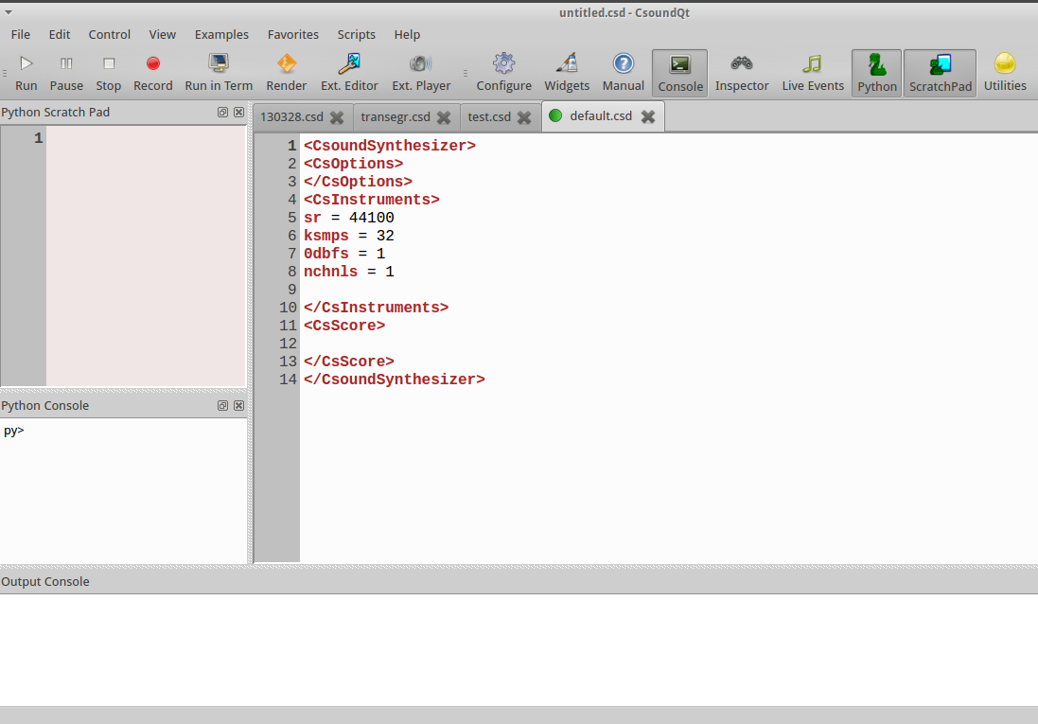

The CsoundQt Python Object
As CsoundQt has formerly been called QuteCsound, this name can still be found in the sources. The QuteCsound object (called PyQcsObject in the sources) is the interface for scripting CsoundQt. All declarations of the class can be found in the file pyqcsobject.h in the sources.
It enables the control of a large part of CsoundQt's possibilities from the python interpreter, the python scratchpad, from scripts or from inside of a running Csound file via Csound's python opcodes.3
By default, a PyQcsObject is already available in the python interpreter of CsoundQt called “q”. To use any of its methods, use form like
q.stopAll()
The methods can be divided into four groups:
- access CsoundQt's interface (open or close files, start or stop performance etc)
- edit Csound files which has already been opened as tabs in CsoundQt
- manage CsoundQt's widgets
- interface with the running Csound engine

File and Control Access
If you have CsoundQt running on your computer, you should type the following code examples in the Python Console (if only one line) or the Python Scratch Pad (if more than one line of code).4

Create or Load a csd File
Type q.newDocument('cs_floss_1.csd') in your Python Console and hit the Return key. This will create a new csd file named "cs_floss_1.csd" in your working directory. And it also returns an integer (in the screenshot below: 3) as index for this file.
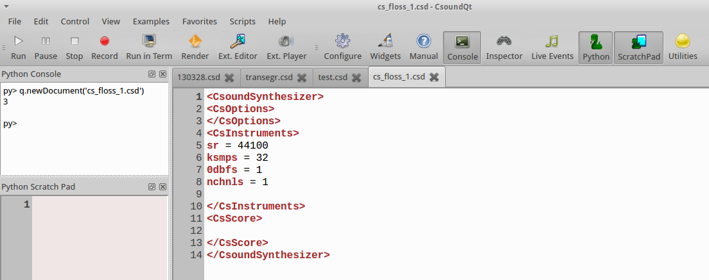
If you close this file and then execute the line q.loadDocument('cs_floss_1.csd'), you should see the file again as tab in CsoundQt.
Let us have a look how these two methods newDocument and loadDocument are described in the sources:
int newDocument(QString name)
int loadDocument(QString name, bool runNow = false)
The method newDocument needs a name as string ("QString") as argument, and returns an integer. The method loadDocument also takes a name as input string and returns an integer as index for this csd. The additional argument runNow is optional. It expects a boolean value (True/False or 1/0). The default is "false" which means "do not run immediately after loading". So if you type instead q.loadDocument('cs_floss_1.csd', True) or q.loadDocument('cs_floss_1.csd', 1), the csd file should start immediately.

Run, Pause or Stop a csd File
For the next methods, we first need some more code in our csd. So let your "cs_floss_1.csd" look like this:
EXAMPLE 12C01_run_pause_stop.csd
<CsoundSynthesizer>
<CsOptions>
</CsOptions>
<CsInstruments>
sr = 44100
ksmps = 32
0dbfs = 1
nchnls = 1

giSine ftgen 0, 0, 1024, 10, 1

instr 1
kPitch expseg 500, p3, 1000
aSine poscil .2, kPitch, giSine
out aSine
endin
</CsInstruments>
<CsScore>
i 1 0 10
</CsScore>
</CsoundSynthesizer>
This instrument performs a simple pitch glissando from 500 to 1000 Hz in ten seconds. Now make sure that this csd is the currently active tab in CsoundQt, and execute this:
q.play()
This starts the performance. If you do nothing, the performance will stop after ten seconds. If you type instead after some seconds
q.pause()
the performance will pause. The same task q.pause() will resume the performance. Note that this is different from executing q.play() after q.pause() ; this will start a new performance. With
q.stop()
you can stop the current performance.

Access to Different csd Tabs via Indices
The play(), pause() and stop() method, as well as other methods in CsoundQt's integrated Python, allow also to access csd file tabs which are not currently active. As we saw in the creation of a new csd file by q.newDocument('cs_floss_1.csd'), each of them gets an index. This index allows universal access to all csd files in a running CsoundQt instance.
First, create a new file "cs_floss_2.csd", for instance with this code:
<CsoundSynthesizer>
<CsOptions>
</CsOptions>
<CsInstruments>
sr = 44100
ksmps = 32
0dbfs = 1
nchnls = 1

giSine ftgen 0, 0, 1024, 10, 1

instr 1
kPitch expseg 500, p3, 1000
aSine poscil .2, kPitch, giSine
out aSine
endin
</CsInstruments>
<CsScore>
i 1 0 10
</CsScore>
</CsoundSynthesizer>
Now get the index of these two tabs in executing q.getDocument('cs_floss_1.csd') resp. q.getDocument('cs_floss_2.csd') . This will show something like this:
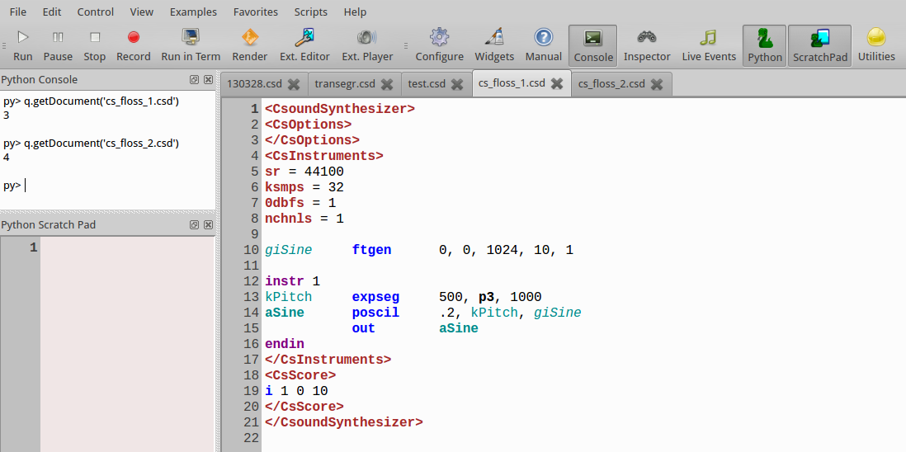
So in my case the indices are 3 and 4.5 Now you can start, pause and stop any of these files with tasks like these:
q.play(3)
q.play(4)
q.stop(3)
q.stop(4)
If you have checked "Allow simultaneous play" in CsoundQt's Configure->General ...
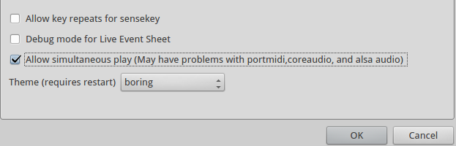
.. you should be able to run both csds simultaneously. To stop all running files, use:
q.stopAll()
To set a csd as active, use setDocument(index). This will have the same effect as clicking on the tab.

Send Score Events
Now comment out the score line in the file "cs_floss_2.csd", or simply remove it. When you now start Csound, this tab should run.6 Now execute this command:
q.sendEvent('i 1 0 2')
This should trigger instrument 1 for two seconds.

Query File Name or Path
In case you need to know the name7 or the path of a csd file, you have these functions:
getFileName()
getFilePath()
Calling the method without any arguments, it refers to the currently active csd. An index as argument links to a specific tab. Here is a Python code snippet which returns indices, file names and file paths of all tabs in CsoundQt:
index = 0
while q.getFileName(index):
print 'index = %d' % index
print ' File Name = %s' % q.getFileName(index)
print ' File Path = %s' % q.getFilePath(index)
index += 1
Which returns for instance:
index = 0
File Name = /home/jh/Joachim/Stuecke/30Carin/csound/130328.csd
File Path = /home/jh/Joachim/Stuecke/30Carin/csound
index = 1
File Name = /home/jh/src/csoundmanual/examples/transegr.csd
File Path = /home/jh/src/csoundmanual/examples
index = 2
File Name = /home/jh/Arbeitsfläche/test.csd
File Path = /home/jh/Arbeitsfläche
index = 3
File Name = /home/jh/Joachim/Csound/FLOSS/Release03/Chapter_12C_PythonInCsoundQt/cs_floss_1.csd
File Path = /home/jh/Joachim/Csound/FLOSS/Release03/Chapter_12C_PythonInCsoundQt
index = 4
File Name = /home/jh/Joachim/Csound/FLOSS/Release03/Chapter_12C_PythonInCsoundQt/cs_floss_2.csd
File Path = /home/jh/Joachim/Csound/FLOSS/Release03/Chapter_12C_PythonInCsoundQt

Get and Set csd Text
One of the main features of Python scripting in CsoundQt is the ability to edit any section of a csd file. There are several "get" functions, to query text, and also "set" functions to change or insert text.

Get Text from a csd File
Make sure your "cs_floss_2.csd" is the active tab, and execute the following python code lines:
q.getCsd()
q.getOrc()
q.getSco()
The q.getOrc() task should return this:
u'\nsr = 44100\nksmps = 32\n0dbfs = 1\nnchnls = 1\n\ngiSine ftgen 0, 0, 1024, 10, 1\n\ninstr 1\nkPitch expseg 1000, p3, 500\naSine poscil .2, kPitch, giSine\n out aSine\nendin\n'
The u'...' indicates that a unicode string is returned. As usual in format expressions, newlines are indicated with the '\n' formatter.
You can also get the text for the <CsOptions>, the text for CsoundQt's widgets and presets, or the full text of this csd:
getOptionsText()
getWidgetsText()
getPresetsText()getCsd()
getFullText()
If you select some text or some widgets, you will get the selection with these commands:
getSelectedText()
getSelectedWidgetsText()
As usual, you can specify any of the loaded csds via its index. So calling q.getOrc(3) instead of q.getOrc()will return the orc text of the csd with index 3, instead of the orc text of the currently active csd.

Set Text in a csd File
Set the cursor anywhere in your active csd, and execute the following line in the Python Console:
q.insertText('my nice insertion')
You will see your nice insertion in the csd file. In case you do not like it, you can choose Edit->Undo. It does not make a difference for the CsoundQt editor whether the text has been typed by hand, or by the internal Python script facility.
Text can also be inserted to individual sections using the functions:
setCsd(text)
setFullText(text)
setOrc(text)
setSco(text)
setWidgetsText(text)
setPresetsText(text)
setOptionsText(text)
Note that the whole section will be overwritten with the string text.

Opcode Exists
You can ask whether a string is an opcode name, or not, with the function opcodeExtists, for instance:
py> q.opcodeExists('line')
True
py> q.opcodeExists('OSCsend')
True
py> q.opcodeExists('Line')
False
py> q.opcodeExists('Joe')
NotYet

Example: Score Generation
A typical application for setting text in a csd is to generate a score. There have been numerous tools and programs to do this, and it can be very pleasant to use CsoundQt's Python scripting for this task. Let us modify our previous instrument first to make it more flexible:
EXAMPLE 12C02_score_generated.csd
<CsoundSynthesizer>
<CsOptions>
</CsOptions>
<CsInstruments>
sr = 44100
ksmps = 32
0dbfs = 1
nchnls = 1

giSine ftgen 0, 0, 1024, 10, 1

instr 1
iOctStart = p4 ;pitch in octave notation at start
iOctEnd = p5 ;and end
iDbStart = p6 ;dB at start
iDbEnd = p7 ;and end
kPitch expseg cpsoct(iOctStart), p3, cpsoct(iOctEnd)
kEnv linseg iDbStart, p3, iDbEnd
aSine poscil ampdb(kEnv), kPitch, giSine
iFad random p3/20, p3/5
aOut linen aSine, iFad, p3, iFad
out aOut
endin
</CsInstruments>
<CsScore>
i 1 0 10 ;will be overwritten by the python score generator
</CsScore>
</CsoundSynthesizer>
The following code will now insert 30 score events in the score section:
from random import uniform
numScoEvents = 30
sco = ''
for ScoEvent in range(numScoEvents):
start = uniform(0, 40)
dur = 2**uniform(-5, 3)
db1, db2 = [uniform(-36, -12) for x in range(2)]
oct1, oct2 = [uniform(6, 10) for x in range(2)]
scoLine = 'i 1 %f %f %f %f %d %d\n' % (start, dur, oct1, oct2, db1, db2)
sco = sco + scoLine
q.setSco(sco)
This generates a texture with either falling or rising gliding pitches. The durations are set in a way that shorter durations are more frequently than larger ones. The volume and pitch ranges allow many variations in the simple shape.

Widgets

Creating a Label
Click on the "Widgets" button to see the widgets panel. Then execute this command in the Python Console:
q.createNewLabel()
The properties dialog of the label pops up. Type "Hello Label!" or something like this as text.
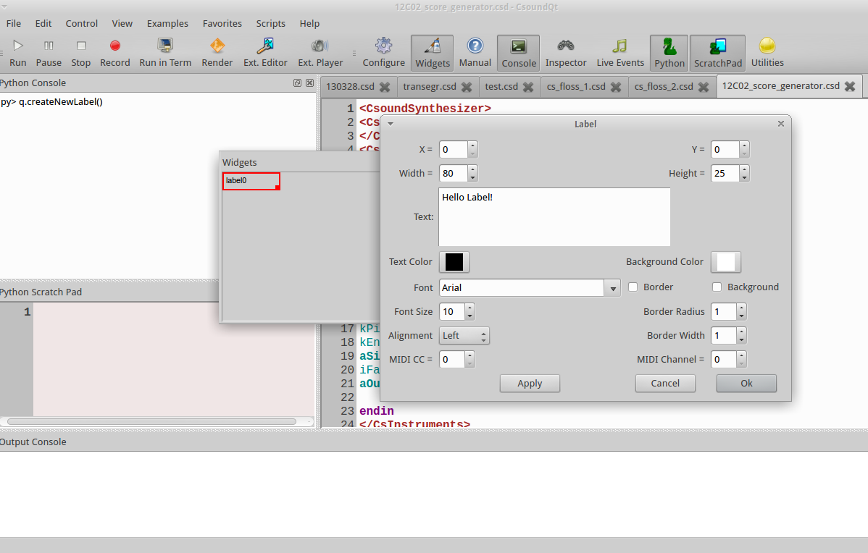
When you click "Ok", you will see the label widget in the panel, and a strange unicode string as return value in the Python Console:
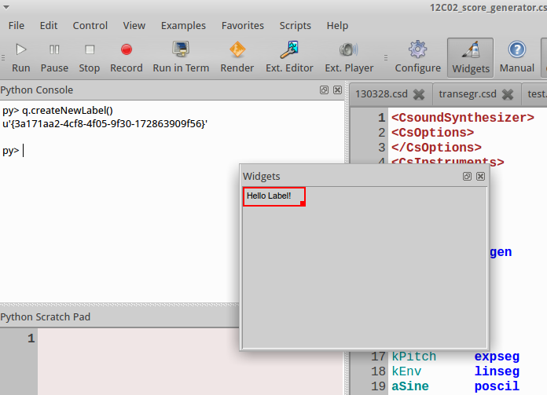
The string u'{3a171aa2-4cf8-4f05-9f30-172863909f56}' is a "universally unique identifier" (uuid). Each widget can be accessed by this ID.

Specifying the Common Properties as Arguments
Instead of having a live talk with the properties dialog, we can specify all properties as arguments for the createNewLabel method:
q.createNewLabel(200, 100, "second_label")
This should be the result:
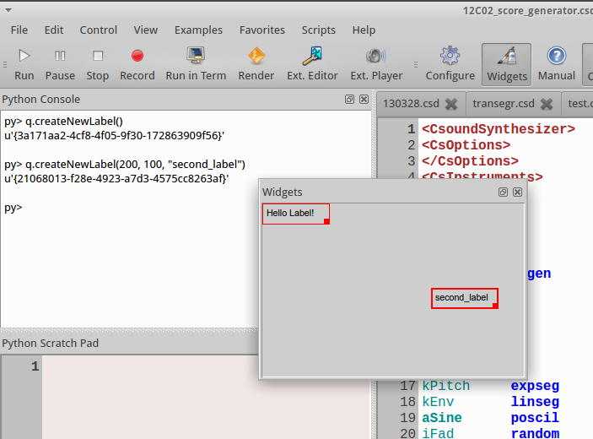
A new label has been created—without opening the properties dialog—at position x=200 y=1008 with the name "second_label". If you want to create a widget not in the active document, but in another tab, you can also specify the tab index. This command will create a widget at the same position and with the same name in the first tab:
q.createNewLabel(200, 100, "second_label", 0)

Setting the Specific Properties
Each widget has a xy position and a channel name.9 But the other properties depend on the type of widget. A Display has name, width and height, but no resolution like a SpinBox. The function setWidgetProperty refers to a widget via its ID and sets a property. Let us try this for a Display widget. This command creates a Display widget with channel name "disp_chan_01" at position x=50 y=150:
q.createNewDisplay(50, 150, "disp_chan_01")
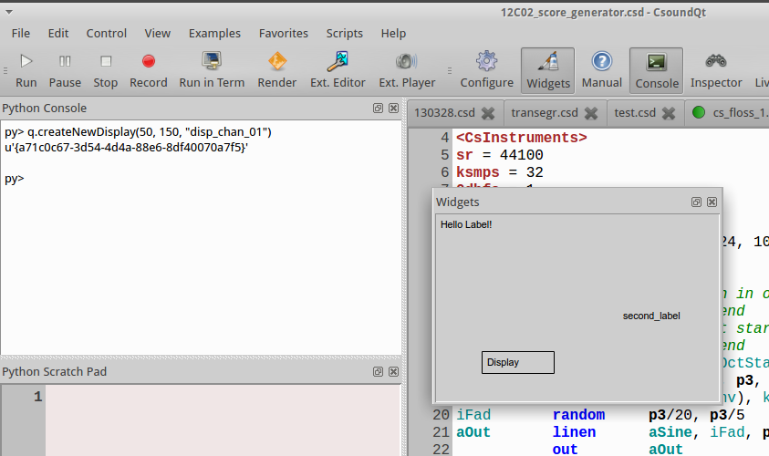
And this sets the text to a new string:10
q.setWidgetProperty("disp_chan_01", "QCS_label", "Hey Joe!")
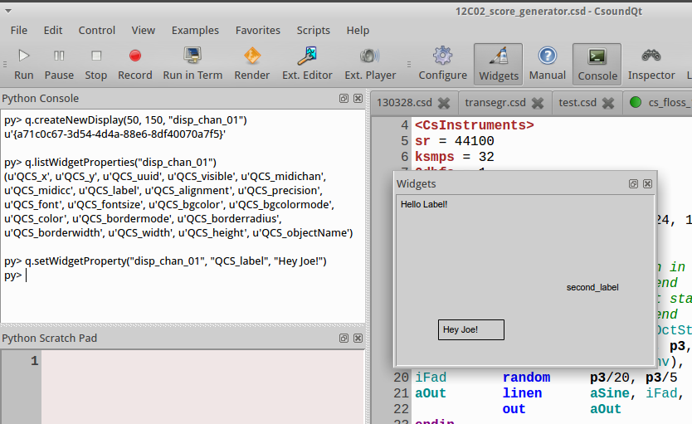
The setWidgetProperty method needs the ID of a widget first. This can be expressed either as channel name ("disp_chan_01") as in the command above, or as uuid. As I got the string u'{a71c0c67-3d54-4d4a-88e6-8df40070a7f5}' as uuid, I can also write:
q.setWidgetProperty(u'{a71c0c67-3d54-4d4a-88e6-8df40070a7f5}', "QCS_label", "Hey Joeboe!")
For humans, referring to the channel name as ID is probably preferable ...11 - But as the createNew... method returns the uuid, you can use it implicitely, for instance in this command:
q.setWidgetProperty(q.createNewLabel(70, 70, "WOW"), "QCS_fontsize", 18)
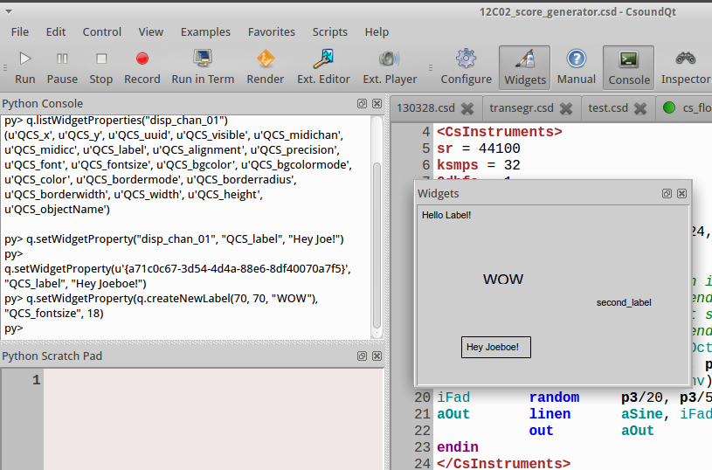

Getting the Property Names and Values
You may have asked how to know that the visible text of a Display widget is called "QCS_label" and the fontsize "QCS_fontsize". If you do not know the name of a property, ask CsoundQt for it via the function listWidgetProperties:
py> q.listWidgetProperties("disp_chan_01")
(u'QCS_x', u'QCS_y', u'QCS_uuid', u'QCS_visible', u'QCS_midichan', u'QCS_midicc', u'QCS_label', u'QCS_alignment', u'QCS_precision', u'QCS_font', u'QCS_fontsize', u'QCS_bgcolor', u'QCS_bgcolormode', u'QCS_color', u'QCS_bordermode', u'QCS_borderradius', u'QCS_borderwidth', u'QCS_width', u'QCS_height', u'QCS_objectName')
As you see, listWidgetProperties returns all properties in a tuple. You can query the value of a single property with the function getWidgetProperty, which takes the uuid and the property as inputs, and returns the property value. So this code snippet asks for all property values of our Display widget:
widgetID = "disp_chan_01"
properties = q.listWidgetProperties(widgetID)
for property in properties:
propVal = q.getWidgetProperty(widgetID, property)
print property + ' = ' + str(propVal)
Returns:
QCS_x = 50
QCS_y = 150
QCS_uuid = {a71c0c67-3d54-4d4a-88e6-8df40070a7f5}
QCS_visible = True
QCS_midichan = 0
QCS_midicc = -3
QCS_label = Hey Joeboe!
QCS_alignment = left
QCS_precision = 3
QCS_font = Arial
QCS_fontsize = 10
QCS_bgcolor = #ffffff
QCS_bgcolormode = False
QCS_color = #000000
QCS_bordermode = border
QCS_borderradius = 1
QCS_borderwidth = 1
QCS_width = 80
QCS_height = 25
QCS_objectName = disp_chan_01

Get the UUIDs of all Widgets
For getting the uuid strings of all widgets in the active csd tab, type
q.getWidgetUuids()

As always, the uuid strings of other csd tabs can be accessed via the index.

Some Examples for Creating and Modifying Widgets
Create a new slider with the channel name "level" at position 10,10 in the (already open but not necessarily active) document "test.csd":
q.createNewSlider(10, 10, "level", q.getDocument("test.csd"))
Create ten knobs with the channel names "partial_1", "partial_2" etc, and the according labels "amp_part_1", "amp_part_2" etc in the currently active document:
for no in range(10):
q.createNewKnob(100*no, 5, "partial_"+str(no+1))
q.createNewLabel(100*no+5, 90, "amp_part_"+str(no+1))
Alternatively, you can store the uuid strings while creating:
knobs, labels = [], []
for no in range(10):
knobs.append(q.createNewKnob(100*no, 5, "partial_"+str(no+1)))
labels.append(q.createNewLabel(100*no+5, 90, "amp_part_"+str(no+1)))
The variables knobs and labels now contain the IDs:
py> knobs
[u'{8d10f9e3-70ce-4953-94b5-24cf8d6f6adb}', u'{d1c98b52-a0a1-4f48-9bca-bac55dad0de7}', u'{b7bf4b76-baff-493f-bc1f-43d61c4318ac}', u'{1332208d-e479-4152-85a8-0f4e6e589d9d}', u'{428cc329-df4a-4d04-9cea-9be3e3c2a41c}', u'{1e691299-3e24-46cc-a3b6-85fdd40eac15}', u'{a93c2b27-89a8-41b2-befb-6768cae6f645}', u'{26931ed6-4c28-4819-9b31-4b9e0d9d0a68}', u'{874beb70-b619-4706-a465-12421c6c8a85}', u'{3da687a9-2794-4519-880b-53c2f3b67b1f}']
py> labels
[u'{9715ee01-57d5-407d-b89a-bae2fc6acecf}', u'{71295982-b5e7-4d64-9ac5-b8fbcffbd254}', u'{09e924fa-2a7c-47c6-9e17-e710c94bd2d1}', u'{2e31dbfb-f3c2-43ab-ab6a-f47abb4875a3}', u'{adfe3aef-4499-4c29-b94a-a9543e54e8a3}', u'{b5760819-f750-411d-884c-0bad16d68d09}', u'{c3884e9e-f0d8-4718-8fcb-66e82456f0b5}', u'{c1401878-e7f7-4e71-a097-e92ada42e653}', u'{a7d14879-1601-4789-9877-f636105b552c}', u'{ec5526c4-0fda-4963-8f18-1c7490b0a667}'
Move the first knob 200 pixels downwards:
q.setWidgetProperty( knobs[0], "QCS_y", q.getWidgetProperty(knobs[0], "QCS_y")+200)
Modify the maximum of each knob so that the higher partials have less amplitude range (set maximum to 1, 0.9, 0.8, ..., 0.1):
for knob in range(10):
q.setWidgetProperty(knobs[knob], "QCS_maximum", 1-knob/10.0)

Deleting widgets
You can delete a widget using the method destroyWidget. You have to pass the widget's ID, again either as channel name or (better) as uuid string. This will remove the first knob in the example above:
q.destroyWidget("partial_1")
This will delete all knobs:
for w in knobs:
q.destroyWidget(w)
And this will delete all widgets of the active document:
for w in q.getWidgetUuids():
q.destroyWidget(w)

Getting and Setting Channel Names and Values
After this cruel act of destruction, let us again create a slider and a display:
py> q.createNewSlider(10, 10, "level")
u'{b0294b09-5c87-4607-afda-2e55a8c7526e}'
py> q.createNewDisplay(50, 10, "message")
u'{a51b438f-f671-4108-8cdb-982387074e4d}'
Now we will ask for the values of these widgets12 with the methods getChannelValue and getChannelString:
py> q.getChannelValue('level')
0.0
py> q.getChannelString("level")
u''
py> q.getChannelValue('message')
0.0
py> q.getChannelString('message')
u'Display'
As you see, it depends on the type of the widget whether to query its value by getChannelValue or getChannelString. Although CsoundQt will not return an error, it makes no sense to ask a slider for its string (as its value is a number), and a display for its number (as its value is a string).
With the methods setChannelValue and setChannelString we can change the main content of a widget very easily:
py> q.setChannelValue("level", 0.5)
py> q.setChannelString("message", "Hey Joe again!")
This is much more handy than the general method using setWidgetProperty:
py> q.setWidgetProperty("level", "QCS_value", 1)
py> q.setWidgetProperty("message", "QCS_label", "Nono")

Presets
Now right-click in the widget panel and choose Store Preset -> New Preset:
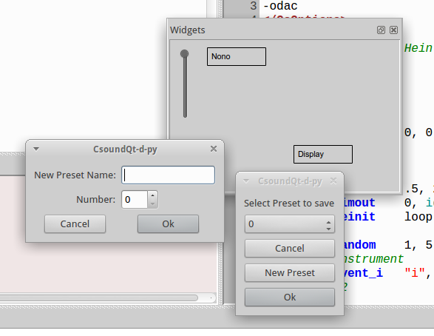
You can (but need not) enter a name for the preset. The important thing here is the number of the preset (here 0). - Now change the value of the slider and the text of the display widget. Save again as preset, now being preset 1. - Now execute this:
q.loadPreset(0)
You will see the content of the widgets reloaded to the first preset. Again, with
q.loadPreset(1)
you can switch to the second one.
Like all python scripting functions in CsoundQt, you can not only use these methods from the Python Console or the Python Cratch Pad, but also from inside any csd. This is an example how to switch all the widgets to other predefined states, in this case controlled by the score. You will see the widgets for the first three seconds in Preset 0, then for the next three seconds in Preset 1, and finally again in Preset 0:
EXAMPLE 12C03_presets.csd
<CsoundSynthesizer>
<CsOptions>
-odac
</CsOptions>
<CsInstruments>

pyinit

instr loadPreset
index = p4
pycalli "q.loadPreset", index
endin

</CsInstruments>
<CsScore>
i "loadPreset" 0 3 0
i "loadPreset" + . 1
i "loadPreset" + . 0
</CsScore>
</CsoundSynthesizer>
;example by tarmo johannes and joachim heintz

Csound Functions
Several functions can interact with the Csound engine, for example to query information about it. Note that the functions getSampleRate, getKsmps, getNumChannels and getCurrentCsound refer to a running instance of Csound.
py> q.getVersion() # CsoundQt API version
u'1.0'
py> q.getSampleRate()
44100.0
py> q.getKsmps()
32
py> q.getNumChannels()
1
py> q.getCurrentCsound()
CSOUND (C++ object at: 0x2fb5670)
With getCsChannel, getCsStringChannel and setCsChannel you can access csound channels directly, independently from widgets. They are useful when testing a csd for use with the Csound API (in another application, a csLapdsa or Cabbage plugin, Android application) or similar. These are some examples, executed on a running csd instance:
py> q.getCsChannel('my_num_chn')
0.0
py> q.getCsStringChannel('my_str_chn')
u''

py> q.setCsChannel('my_num_chn', 1.1)
py> q.setCsChannel('my_str_chn', 'Hey Csound')

py> q.getCsChannel('my_num_chn')
1.1
py> q.getCsStringChannel('my_str_chn')
u'Hey Csound'
If you have a function table in your running Csound instance which has for instance been created with the line giSine ftgen 1, 0, 1024, 10, 1, you can query getTableArray like this:
py> q.getTableArray(1)
MYFLT (C++ object at: 0x35d1c58)
Finally, you can register a Python function as a callback to be executed in between processing blocks for Csound. The first argument should be the text that should be called on every pass. It can include arguments or variables which will be evaluated every time. You can also set a number of periods to skip to avoid.
registerProcessCallback(QString func, int skipPeriods = 0)
You can register the python text to be executed on every Csound control block callback, so you can execute a block of code, or call any function which is already defined.

Creating Own GUIs with PythonQt
One of the very powerful features of using Python inside CsoundQt is the ability to build own GUIs. This is done via the PythonQt library which gives you access to the Qt toolkit via Python. We will show some examples here. Have a look in the "Scripts" menu in CsoundQt to find much more (you will find the code in the "Editor" submenu).

Dialog Box
Sometimes it is practical to ask from user just one question - number or name of something and then execute the rest of the code (it can be done also inside a csd with python opcodes). In Qt, the class to create a dialog for one question is called QInputDialog.
To use this or any other Qt classes, it is necessary to import the PythonQt and its Qt submodules. In most cases it is enough to add this line:
from PythonQt.Qt import *
or
from PythonQt.QtGui import *
At first an object of QInputDialog must be defined, then you can use its methods getInt, getDouble, getItem or getText to read the input in the form you need. This is a basic example:
from PythonQt.Qt import *

inpdia = QInputDialog()
myInt = inpdia.getInt(inpdia,"Example 1","How many?")
print myInt
# example by tarmo johannes
Note that the variable myInt is now set to a value which remains in your Python interpreter. Your Python Console may look like this when executing the code above, and then ask for the value of myInt:
py>
12
Evaluated 5 lines.
py> myInt
12
Depending on the value of myInt, you can do funny or serious things. This code re-creates the Dialog Box whenever the user enters the number 1:
from PythonQt.Qt import *

def again():
inpdia = QInputDialog()
myInt = inpdia.getInt(inpdia,"Example 1","How many?")
if myInt == 1:
print "If you continue to enter '1' I will come back again and again."
again()
else:
print "Thanks - Leaving now."
again()
# example by joachim heintz
This is a simple example showing how you can embed an own GUI in your Csound code. Here, Csound waits for the user input, and the prints out the entered value as the Csound variable giNumber:
EXAMPLE 12C04_dialog.csd
<CsoundSynthesizer>
<CsOptions>
-n
</CsOptions>
<CsInstruments>

pyinit
pyruni {{
from PythonQt.Qt import *
dia = QInputDialog()
dia.setDoubleDecimals(4)
}}

giNumber pyevali {{
dia.getDouble(dia,"CS question","Enter number: ")
}} ; get the number from Qt dialog

instr 1
print giNumber
endin

</CsInstruments>
<CsScore>
i 1 0 0
</CsScore>
</CsoundSynthesizer>
;example by tarmo johannes

Simple GUI with Buttons
The next example takes the user input (as a string) and transforms it to a sounding sequence of notes. First, make sure that the following csd is your active tab in CsoundQt:
EXAMPLE 12C05_string_sound.csd
<CsoundSynthesizer>
<CsInstruments>

sr = 44100
nchnls = 2
0dbfs = 1
ksmps = 32

giSine ftgen 1, 0, 4096, 10, 1 ; sine

#define MAINJOB(INSTNO) #
Sstr strget p4
ilen strlen Sstr
ipos = 0
marker: ; convert every character in the string to pitch
ichr strchar Sstr, ipos
icps = cpsmidinn(ichr)-$INSTNO*8
;print icps
event_i "i", "sound", 0+ipos/8, p3, ichr,icps, $INSTNO ; chord with arpeggio
loop_lt ipos, 1, ilen, marker
#

instr 1
$MAINJOB(1)
endin

instr 2
$MAINJOB(2)
endin

instr 3
$MAINJOB(3)
endin

instr sound
ichar = p4
ifreq = p5
itype = p6
kenv linen 0.1,0.1, p3,0.5
if itype== 1 then
asig pluck kenv,ifreq,ifreq,0, 3, 0
elseif itype==2 then
kenv adsr 0.05,0.1,0.5,1
asig poscil kenv*0.1,ifreq,giSine
else
asig buzz kenv,ifreq,10, giSine
endif
outs asig,asig
endin

</CsInstruments>
<CsScore>
f0 3600
i 1 0 4 "huhuu"
</CsScore>
</CsoundSynthesizer>
;example by tarmo johannes
Now copy this Python code into your Python Scratch Pad and evaluate it. Then type anything in the "type here" box and push the "insert" button. After pushing "play", the string will be played. You can also send the string as real-time event, to different instruments, in different durations.
from PythonQt.Qt import *

# FUNCTIONS==============================

def insert(): # read input from UI and insert a line to score of csd file, open in CsoundQt with index csdIndex
scoreLine = "f0 3600\n" + "i " + instrSpinBox.text + " 0 " + durSpinBox.text + ' "' + par1LineEdit.text + "\""
print scoreLine
q.setSco(scoreLine, csdIndex)

def play(): # play file with index csdIndex
print "PLAY"
q.play(csdIndex)

def send(): # read input from UI send live event
scoreLine = "i " + instrSpinBox.text + " 0 " + durSpinBox.text + ' "' + par1LineEdit.text + "\""
print scoreLine
q.sendEvent(csdIndex, scoreLine)

def stopAndClose(): #stop csdIndex, close UI
print "STOP"
q.stop(csdIndex)
window.delete()

# MAIN ====================================

window = QWidget() # window as main widget
layout = QGridLayout(window) # use gridLayout - the most flexible one - to place the widgets in a table-like structure
window.setLayout(layout)
window.setWindowTitle("PythonQt inteface example")

instrLabel = QLabel("Select instrument")
layout.addWidget(instrLabel,0,0) # first row, first column

instrSpinBox = QSpinBox(window)
instrSpinBox.setMinimum(1)
instrSpinBox.setMaximum(3)
layout.addWidget(instrSpinBox, 0, 1) # first row, second column

durLabel = QLabel("Duration: ")
layout.addWidget(durLabel,1,0) # etc

durSpinBox = QSpinBox(window)
durSpinBox.setMinimum(1)
durSpinBox.setMaximum(20)
durSpinBox.setValue(3)
layout.addWidget(durSpinBox, 1, 1)

par1Label = QLabel("Enter string for parameter 1: ")
layout.addWidget(par1Label,2,0)

par1LineEdit = QLineEdit(window)
par1LineEdit.setMaxLength(30) # don't allow too long strings
par1LineEdit.setText("type here")
layout.addWidget(par1LineEdit,2,1)

insertButton = QPushButton("Insert",window)
layout.addWidget(insertButton, 3,0)

playButton = QPushButton("Play",window)
layout.addWidget(playButton, 3,1)

sendButton = QPushButton("Send event",window)
layout.addWidget(sendButton, 4,0)

closeButton = QPushButton("Close",window)
layout.addWidget(closeButton, 4,1)

# connect buttons and functions ================
#NB! function names must be without parenthesis!
# number and type of arguments of the signal and slot (called function) must match

insertButton.connect(SIGNAL("clicked()"),insert ) # when clicked, run function insert()
playButton.connect(SIGNAL("clicked()"),play) #etc
sendButton.connect(SIGNAL("clicked()"),send)
closeButton.connect(SIGNAL("clicked()"),stopAndClose)

window.show() # show the window and wait for clicks on buttons

A Color Controller
To illustrate how to use power of Qt together with CsoundQt, the following example uses the color picking dialog of Qt. When user moves the cursor around in the RGB palette frame, the current red-green-blue values are forwarded to CsoundQt as floats in 0..1, visualized as colored meters and used as controlling parameters for sound.
Qt's object QColorDialog emits the signal currentColorChanged(QColor) every time when any of the RGB values in the colorbox has changed. The script connects the signal to a function that forwards the color values to Csound. So with one mouse movement, three parameters can be controlled instantly.
In the Csound implementation of this example I used - thinking on the colors - three instruments from Richard Boulanger's "Trapped in convert" - red, green and blue. The RGB values of the dialog box control the mix between these three instruments.
As usual, let the following csd be your active tab in CsoundQt, then run the Python code in the Python Scratch Pad.13
EXAMPLE 12C06_color_controller.csd
<CsoundSynthesizer>
<CsInstruments>
sr = 44100
ksmps = 32
nchnls = 2

garvb init 0
alwayson "_reverb"

;============================================================================;
;==================================== RED ===================================;
;============================================================================;
; parameters from original score
;i 8 15.5 3.1 3 50 4000 129 8 2.6 0.3
instr red
ifuncl = 16

p4 = 2.2 ; amp
p5 = 50 ; FilterSweep StartFreq
p6 = 4000 ; FilterSweep EndFreq
p7= 129 ; bandwidth
p8 = 8 ; cps of rand1
p9 = 2.6 ; cps of rand2
p10 = 0.3 ; reverb send factor

k1 expon p5, p3, p6
k2 line p8, p3, p8 * .93
k3 phasor k2
k4 table k3 * ifuncl, 20
anoise rand 8000
aflt1 reson anoise, k1, 20 + (k4 * k1 / p7), 1

k5 linseg p6 * .9, p3 * .8, p5 * 1.4, p3 * .2, p5 * 1.4
k6 expon p9 * .97, p3, p9
k7 phasor k6
k8 tablei k7 * ifuncl, 21
aflt2 reson anoise, k5, 30 + (k8 * k5 / p7 * .9), 1

abal oscil 1000, 1000, 1
a3 balance aflt1, abal
a5 balance aflt2, abal

k11 linen p4, .15, p3, .5
a3 = a3 * k11
a5 = a5 * k11

k9 randh 1, k2
aleft = ((a3 * k9) * .7) + ((a5 * k9) * .3)
k10 randh 1, k6
aright = ((a3 * k10) * .3)+((a5 * k10) * .7)
klevel invalue "red"
klevel port klevel,0.05
outs aleft*klevel, aright*klevel
garvb = garvb + (a3 * p10)*klevel
endin

;============================================================================;
;==================================== BLUE ==================================;
;============================================================================;
;i 2 80.7 8 0 8.077 830 0.7 24 19 0.13
instr blue ; p6 = amp

p5 = 8.077 ; pitch
p6 = 830 ; amp
p7 = 0.7 ; reverb send factor
p8 = 24 ; lfo freq
p9 = 19 ; number of harmonic
p10 = 0.1+rnd(0.2) ;0.5 ; sweep rate

ifreq random 500,1000;cpspch(p5)
k1 randi 1, 30
k2 linseg 0, p3 * .5, 1, p3 * .5, 0
k3 linseg .005, p3 * .71, .015, p3 * .29, .01
k4 oscil k2, p8, 1,.2
k5 = k4 + 2

ksweep linseg p9, p3 * p10, 1, p3 * (p3 - (p3 * p10)), 1

kenv expseg .001, p3 * .01, p6, p3 * .99, .001
asig gbuzz kenv, ifreq + k3, k5, ksweep, k1, 15

klevel invalue "blue"
klevel port klevel,0.05
asig = asig*klevel
outs asig, asig
garvb = garvb + (asig * p7)
endin

;============================================================================;
;==================================== GREEN =================================;
;============================================================================;
; i 5 43 1.1 9.6 3.106 2500 0.4 1.0 8 3 17 34

instr green ; p6 = amp
p5 = 3.106 ; pitch
p6 = 2500 ; amp
p7 = 0.4 ; reverb send
p8 = 0.5 ; pan direction
p9 = 8 ; carrier freq
p10 = 3 ; modulator freq
p11 = 17 ; modulation index
p12 = 34 ; rand freq

ifreq = cpspch(p5) ; p7 = reverb send factor
; p8 = pan direction
k1 line p9, p3, 1 ; ... (1.0 = L -> R, 0.1 = R -> L)
k2 line 1, p3, p10 ; p9 = carrier freq
k4 expon 2, p3, p12 ; p10 = modulator freq
k5 linseg 0, p3 * .8, 8, p3 * .2, 8 ; p11 = modulation index
k7 randh p11, k4 ; p12 = rand freq
k6 oscil k4, k5, 1, .3

kenv1 linen p6, .03, p3, .2
a1 foscil kenv1, ifreq + k6, k1, k2, k7, 1

kenv2 linen p6, .1, p3, .1
a2 oscil kenv2, ifreq * 1.001, 1

amix = a1 + a2
kpan linseg int(p8), p3 * .7, frac(p8), p3 * .3, int(p8)
klevel invalue "green"
klevel port klevel,0.05
amix = amix*klevel
outs amix * kpan, amix * (1 - kpan)
garvb = garvb + (amix * p7)
endin

instr _reverb
p4 = 1/10 ; p4 = panrate
k1 oscil .5, p4, 1
k2 = .5 + k1
k3 = 1 - k2
asig reverb garvb, 2.1
outs asig * k2, (asig * k3) * (-1)
garvb = 0
endin

</CsInstruments>
<CsScore>
;============================================================================;
;========================= FUNCTIONS ========================================;
;============================================================================;
f1 0 8192 10 1
; 15 - vaja
f15 0 8192 9 1 1 90
;kasutusel red
f16 0 2048 9 1 3 0 3 1 0 6 1 0
f20 0 16 -2 0 30 40 45 50 40 30 20 10 5 4 3 2 1 0 0 0
f21 0 16 -2 0 20 15 10 9 8 7 6 5 4 3 2 1 0 0

r 3 COUNT
i "red" 0 20
i "green" 0 20
i "blue" 0 6
i . + 3
i . + 4
i . + 7
s

f 0 1800

</CsScore>
</CsoundSynthesizer>
;example by tarmo johannes, after richard boulanger
from PythonQt.Qt import *

# write the current RGB values as floats 0..1 to according channels of "rgb-widgets.csd"
def getColors(currentColor):
q.setChannelValue("red",currentColor.redF(),csd)
q.setChannelValue("green",currentColor.greenF(),csd)
q.setChannelValue("blue",currentColor.blueF(),csd)

# main-----------
cdia = QColorDialog() #create QColorDiaog object
cdia.connect(SIGNAL("currentColorChanged(QColor)"),getColors) # create connection between color changes in the dialog window and function getColors
cdia.show() # show the dialog window,
q.play(csd) # and play the csd

List of PyQcsObject Methods in CsoundQt

Load/Create/Activate a csd File
int loadDocument(QString name, bool runNow = false)
int getDocument(QString name = "")
int newDocument(QString name)
void setDocument(int index)

Play/Pause/Stop a csd File
void play(int index = -1, bool realtime = true)
void pause(int index = -1)
void stop(int index = -1)
void stopAll()

Send Score Events
void sendEvent(int index, QString events)
void sendEvent(QString events)
void schedule(QVariant time, QVariant event)

Query File Name/Path
QString getFileName(int index = -1)
QString getFilePath(int index = -1)

Get csd Text
QString getSelectedText(int index = -1, int section = -1)
QString getCsd(int index = -1)
QString getFullText(int index = -1)
QString getOrc(int index = -1)
QString getSco(int index = -1)
QString getWidgetsText(int index = -1)
QString getSelectedWidgetsText(int index = -1)
QString getPresetsText(int index = -1)
QString getOptionsText(int index = -1)

Set csd Text
void insertText(QString text, int index = -1, int section = -1)
void setCsd(QString text, int index = -1)
void setFullText(QString text, int index = -1)
void setOrc(QString text, int index = -1)
void setSco(QString text, int index = -1)
void setWidgetsText(QString text, int index = -1)
void setPresetsText(QString text, int index = -1)
void setOptionsText(QString text, int index = -1)

Opcode Exists
bool opcodeExists(QString opcodeName)

Create Widgets
QString createNewLabel(int x = 0, int y = 0, QString channel = QString(), int index = -1)
QString createNewDisplay(int x = 0, int y = 0, QString channel = QString(), int index = -1)
QString createNewScrollNumber(int x = 0, int y = 0, QString channel = QString(), int index = -1)
QString createNewLineEdit(int x = 0, int y = 0, QString channel = QString(), int index = -1)
QString createNewSpinBox(int x = 0, int y = 0, QString channel = QString(), int index = -1)
QString createNewSlider(QString channel, int index = -1)
QString createNewSlider(int x = 0, int y = 0, QString channel = QString(), int index = -1)
QString createNewButton(int x = 0, int y = 0, QString channel = QString(), int index = -1)
QString createNewKnob(int x = 0, int y = 0, QString channel = QString(), int index = -1)
QString createNewCheckBox(int x = 0, int y = 0, QString channel = QString(), int index = -1)
QString createNewMenu(int x = 0, int y = 0, QString channel = QString(), int index = -1)
QString createNewMeter(int x = 0, int y = 0, QString channel = QString(), int index = -1)
QString createNewConsole(int x = 0, int y = 0, QString channel = QString(), int index = -1)
QString createNewGraph(int x = 0, int y = 0, QString channel = QString(), int index = -1)
QString createNewScope(int x = 0, int y = 0, QString channel = QString(), int index = -1)

Query Widgets
QVariant getWidgetProperty(QString widgetid, QString property, int index= -1)
double getChannelValue(QString channel, int index = -1)
QString getChannelString(QString channel, int index = -1)
QStringList listWidgetProperties(QString widgetid, int index = -1)
QStringList getWidgetUuids(int index = -1)

Modify Widgets
void setWidgetProperty(QString widgetid, QString property, QVariant value, int index= -1)
void setChannelValue(QString channel, double value, int index = -1)
void setChannelString(QString channel, QString value, int index = -1)

Delete Widgets
bool destroyWidget(QString widgetid)

Presets
void loadPreset(int presetIndex, int index = -1)

Live Event Sheet
QuteSheet* getSheet(int index = -1, int sheetIndex = -1)
QuteSheet* getSheet(int index, QString sheetName)

Csound / API
QString getVersion()
void refresh()
void setCsChannel(QString channel, double value, int index = -1)
void setCsChannel(QString channel, QString value, int index = -1)
double getCsChannel(QString channel, int index = -1)
QString getCsStringChannel(QString channel, int index = -1)
CSOUND* getCurrentCsound()
double getSampleRate(int index = -1)
int getKsmps(int index = -1)
int getNumChannels(int index = -1)
MYFLT *getTableArray(int ftable, int index = -1)
void registerProcessCallback(QString func, int skipPeriods = 0, int index = -1)

- This chapter is based on Andrés Cabrera's paper Python Scripting in QuteCsound at the Csound Conference in Hannover (2011).^
- This should be the case for CsoundQt 0.7 or higher on OSX. On Windows, the corrent version 0.7.0 is built with PythonQt support. You must have installed Python 2.7, too. For building CsoundQt with Python support, have a look at the descriptions in http://sourceforge.net/apps/mediawiki/qutecsound.^
- See chapter 12B for more information on these.^
- To evaluate multiple lines of Python code in the Scratch Pad, choose either Edit->Evaluate Section (Alt+E), or select and choose Edit->Evaluate Selection (Alt+Shift+E).^
- If you have less or more csd tabs already while creating the new files, the index will be lower or higher.^
- If not, you are probably using an older version of Csound. In this case, insert the scoreline "f 0 99999", and this csd will run and wait for your real-time score events for 99999 seconds.^
- Different to most usages, 'name' means here the full path including the file name.^
- Pixels from left resp. from top.^
- Only a label does not have a channel name. So as we saw, in case of a label the name is its displayed text.^
- For the main property of a widget (text for a Display, number for Sliders, SpinBoxes etc) you can also use the setChannelString and setChannelValue method. See below at "Getting and Setting Channel Values" ^
- Note that two widgets can share the same channel name (for instance a slider and a spinbox). In this case, referring to a widget via its channel name is not possible at all.^
- Here again accessed by the channel name. Of course accessing by uuid would also be possible (and more safe, as explained above).^
- The example should also be availiable in CsoundQt's Scripts menu.^

60. D. LUA IN CSOUND
Have a look at Michael Gogins' paper Writing Csound Opcodes in Lua at the Csound Conference in Hannover (there is also a video from the workshop at www.youtube.com/user/csconf2011).

61. E. CSOUND IN iOS

The text from this chapter is taken from "Csound for iOS: A Beginner's Guide" written by Timothy Neate, Nicholas Arner, and Abigail Richardson. The original tutorial document can be found here: http://www-users.york.ac.uk/~adh2/iOS-CsoundABeginnersGuide.pdf
The authors are Masters students at the University of York Audio Lab. Each one is working on a separate interactive audio app for the iPad, and has each been incorporating the Mobile Csound API for that purpose. They came together to write this tutorial to make other developers aware of the Mobile Csound API, and how to utilize it.

The motivation behind this tutorial was to create a step by step guide to using the Mobile Csound API. When the authors originally started to develop with the API, they found it difficult to emulate the results of the examples that were provided with the API download. As a result, the authors created a simple example using the API, and wanted others to learn from our methods and mistakes. The authors hope that this tutorial provides clarity in the use of the Mobile Csound API.

Introduction
The traditional way of working with audio on both Apple computers and mobile devices is through the use of Core Audio. Core Audio is a low-level API which Apple provides to developers for writing applications utilizing digital audio. The downside of Core Audio being low-level is that it is often considered to be rather cryptic and difficult to implement, making audio one of the more difficult aspects of writing an iOS app.
In an apparent response to the difficulties of implementing Core Audio, there have been a number of tools released to make audio development on the iOS platform easier to work with. One of these is libpd, an open-source library released in 2010. libpd allows developers to run Pure Data on both iOS and Android mobile devices. Pure Data is a visual programming language whose primary application is sound processing.
The recent release of the Mobile Csound Platform provides an alternative to the use of PD for mobile audio applications. Csound is a synthesis program which utilizes a toolkit of over 1200 signal processing modules, called opcodes. The release of the Mobile Csound Platform now allows Csound to run on mobile devices, providing new opportunities in audio programming for developers. Developers unfamiliar with Pure Data’s visual language paradigm may be more comfortable with Csound’s ‘C’-programming based environment.
For those who are unfamiliar, or need to refresh themselves on Csound, the rest of the chapters in the FLOSS manual are a good resource to look at.
For more advanced topics in Csound programming, the Csound Book (Boulanger ed., 2000) will provide an in-depth coverage.
In order to make use of the material in this tutorial, the reader is assumed to have basic knowledge of Objective-C and iOS development. Apple’s Xcode 4.6.1 IDE (integrated development environment) will be used for the provided example project.
Although the Mobile Csound API is provided with an excellent example project, it was felt that this tutorial will be a helpful supplement in setting up a basic Csound for iOS project for the first time, by including screenshots from the project set-up, and a section on common errors the user may encounter when working with the API.
The example project provided by the authors of the API includes a number of files illustrating various aspects of the API, including audio input/output, recording, interaction with GUI widgets, and multi-touch. More information on the example project can be found in the API manual, which is included in the example projects folder.

1.1 The Csound for iOS API
The Mobile Csound Platform allows programmers to embed the Csound audio engine inside of their iOS project. The API provides methods for sending static program information from iOS to the instance of Csound, as well as sending dynamic value changes based on user interaction with standard UI interface elements, including multi-touch interaction.

2.0 Example Walkthrough
This section discusses why the example was made, and what can be learned from it; giving an overview of its functionality, then going into a more detailed description of its code. A copy of the example project can be found at the following link.
https://sourceforge.net/projects/csoundiosguide/

2.1 Running the Example Project
Run the provided Xcode project, CsoundTutorial.xcodeproj, and the example app should launch (either on a simulator or a hardware device). A screenshot of the app is shown in Figure 2.1 below. The app consists of two sliders, each controlling a parameter of a Csound oscillator. The top slider controls the amplitude, and the bottom slider controls the frequency.

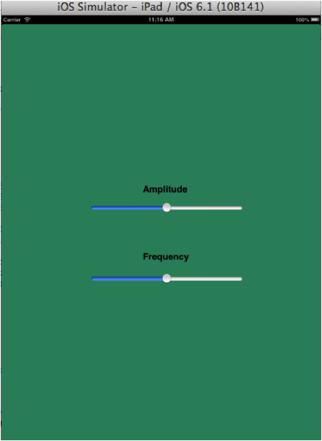
Figure 2.1

2.2 Oscillator Example Walkthrough
This example outlines how to use the methods in the Csound-iOS API to send values from iOS into Csound. This example was made purposefully simple, with the intent of making its functionality as obvious as possible to the reader. This section begins by giving an overview of both the iOS and Csound implementation, then describes how this achieved by breaking down the example code. The code to create this oscillator example was done in the ViewController.h and the ViewController.m files, which are discussed below in sections 2.2.3.1 and 2.2.3.2. The project is split into Objective-C code, Storyboards for the user interface elements, and a Csound file for the audio engine.

2.2.1 iOS Example Outline
In the Xcode project user interface sliders are used to allow a user to control the Csound audio engine through iOS. Communication begins with iOS requesting some memory within Csound; setting a pointer to this location. It updates this pointer with values from the user interface sliders. Csound references the same memory location by naming it with a string, this named communication link is called a channel. When sending this information, iOS uses methods within the iOS-Csound API to setup this channel name, and update it dependant on the control rate.

2.2.2. Csound Example Outline
In this example, Csound is not aware of iOS. All it knows is that there is a piece of memory assigned for it, and it must retrieve information from here dependent on its control rate. Csound uses the chnget opcode to do this. chnget searches for some channel with a specific name and retrieves values from it.

2.2.3. The iOS File
This example is implemented across two main files:
The .h file is used to include all the necessary classes, declare properties, and allow for user interaction by connecting the interface to the implementation.
The .m file is used to implement communication between the interface methods declared in the .h file, and the Csound file. These will now be discussed in more depth, with code examples.

2.2.3.1 The .h File

The imports (discussed in detail in section 3.2.1) are declared:
#import <UIKit/UIKit.h>
#import "CsoundObj.h"
#import "CsoundValueCacheable.h"
Apart from the standard UIKit.h (which gives access to iOS interface widgets) these ensure that the code written can access the information in the other files in the Csound API.
Next comes the class definition:
@interface ViewController : UIViewController
<CsoundObjCompletionListener, CsoundValueCacheable>
Every iOS class definition begins with the @interface keyword, followed by the name of the class. So our class is called ViewController, and the colon indicates that our class inherits all the functionality of the UIViewController.
Following this are two Protocol definitions which are listed between the triangular brackets < >. In Objective-C a Protocol is a list of required functionality (i.e., methods) that a class needs to implement. In this case there are two Protocols that are defined by the Csound API, that we want our class to conform to: CsoundObjCompletionListener and CsoundValueCacheable. This will allow us to send data between iOS and Csound, and so is essential for what we are about to do. The required functions that we have to implement are described in the section following this one (2.2.3.2).
The Csound object needs to be declared as a property in the .h file, which is what this next line of code does:
//Declare a Csound object
@property (nonatomic, retain) CsoundObj* csound;
The next section of code allows for the interface objects (sliders) to communicate with the .m file:
- (IBAction)amplitudeSlider:(UISlider *)sender;
- (IBAction)frequencySlider:(UISlider *)sender;
Just to the left of each of these IBAction methods, you should see a little circle. If the storyboard is open (MainStoryboard.storyboard) you will see the appropriate slider being highlighted if you hover over one of the little circles.

2.2.3.2. The .m File
The .m file imports the .h file so that it can access the information within it, and the information that it accesses.
At the beginning of the implementation of the ViewController, the csound variable which was declared in the .h file is instantiated with @synthesize thus:
@implementation ViewController
@synthesize csound = mCsound;
Note that the Csound object must be released later in the dealloc method as shown below:
- (void)dealloc
{
[mCsound release];
[super dealloc];
}
For each parameter you have in iOS that you wish to send to Csound, you need to do the things outlined in this tutorial. In our simple example we have an iOS slider for Frequency, and one for Amplitude, both of which are values we want to send to Csound.
Some global variables are then declared, as shown in Table 2.1, a holder for each iOS parameter’s current value, and a pointer for each which is going to point to a memory location within Csound.
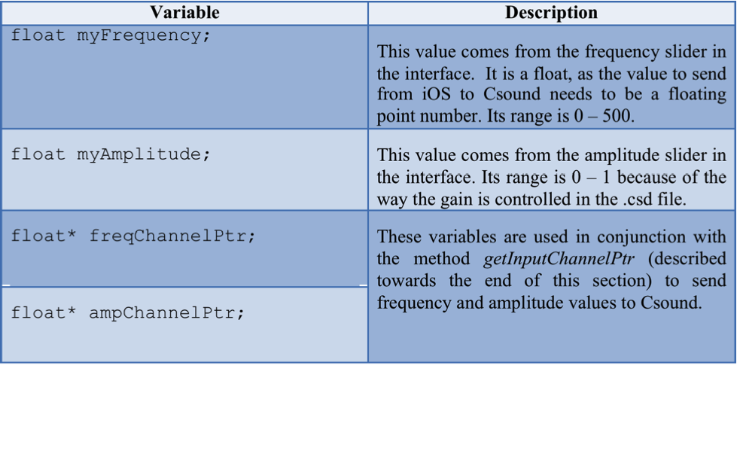
The next significant part of the .m file is the viewDidAppear method. When the view loads, and appears in iOS, this iOS SDK method is called. In the example, the following code is used to locate the Csound file:
//Locate .csd and assign create a string with its file path
NSString *tempFile = [[NSBundle mainBundle] pathForResource:@"aSimpleOscillator" ofType:@"csd"];
This code searches the main bundle for a file called aSimpleOscillator of the type csd (which you will be able to see in Xcode’s left-hand File List, under the folder Supporting Files). It then assigns it to an NSString named tempFile. The name of the string tempFile is then printed out to confirm which file is running.
The methods shown in Table 2.2 are then called:
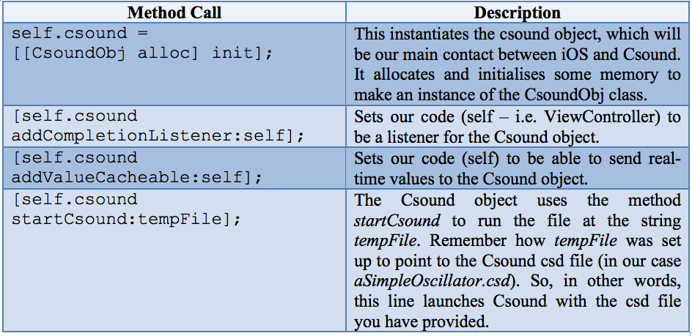
The methods that allow the value of the slider to be assigned to a variable are then implemented. This is done with both frequency, and amplitude. As shown below for the amplitude slider:
//Make myAmplitude value of slider
- (IBAction)amplitudeSlider:(UISlider *)sender
{
UISlider *ampSlider = (UISlider *)sender;
myAmplitude = ampSlider.value;
}
This method is called by iOS every time the slider is moved (because it is denoted as an IBAction, i.e. an Interface Builder Action call). The code shows that the ampSlider variable is of type UISlider, and because of that the current (new) value of the slider is held in ampSlider.value. This is allocated to the variable myAmplitude. Similar code exists for the frequency slider.

The protocol methods are then implemented. The previous section showed how we set up our class (ViewController) to conform to two Protocols that the Csound API provides: CsoundObjCompletionListener and CsoundValueCacheable.
Take a look at the place where these Protocols are defined, because a Protocol definition lists clearly what methods are required to be implemented to use their functionality.
For CsoundValueCacheable you need to look in the file CsoundValueCacheable.h (in the folder valueCacheable). In that file it’s possible to see the protocol definition, as shown below, and its four required methods.
#import <Foundation/Foundation.h>
@class CsoundObj;
@protocol CsoundValueCacheable <NSObject>
-(void)setup:(CsoundObj*)csoundObj;
-(void)updateValuesToCsound;
-(void)updateValuesFromCsound;
-(void)cleanup;
@end

Every method needs at least an empty function shell. Some methods, such as updateValuesFromCsound are left empty, because – for the tutorial example – there is no need to get values from Csound. Other protocol methods have functionality added. These are discussed below.
The setup method is used to prepare the updateValuesToCsound method for communication with Csound:
//Sets up communication with Csound
-(void)setup:(CsoundObj* )csoundObj
{
NSString *freqString = @"freqVal";
freqChannelPtr = [csoundObj getInputChannelPtr:freqString];

NSString *ampString = @"ampVal";
ampChannelPtr = [csoundObj getInputChannelPtr:ampString];

}
The first line of the method body creates a string; freqString, to name the communication channel that Csound will be sending values to. The next line uses the getInputChannelPtr method to create the channel pointer for Csound to transfer information to. Effectively, iOS has sent a message to Csound, asking it to open a communication channel with the name “freqVal”. The Csound object allocates memory that iOS can write to, and returns a pointer to that memory address. From this point onwards iOS could send data values to this address, and Csound can retrieve that data by quoting the channel name “freqVal”. This is described in more detail in the next section (2.2.4).

The next two lines of the code do the same thing, but for amplitude. This process creates two named channels for Csound to communicate through.

The protocol method updateValuesToCsound uses variables in the .m file and assigns them to the newly allocated memory address used for communication. This ensures that when Csound looks at this specific memory location, it will find the most up to date value of the variable. This is shown below:
-(void)updateValuesToCsound
{
*freqChannelPtr = myFrequency;
*ampChannelPtr = myAmplitude;

}
The first line assigns the variable myFrequency (the value coming from the iOS slider for Frequency) to the channel freqChannelPtr which, as discussed earlier, is of type float*. The second line does a similar thing, but for amplitude.
For the other Protocol CsoundObjCompletionListener it is possible to look for the file CsoundObj.h (which is found in Xcode’s left-hand file list, in the folder called classes). In there is definition of the protocol.
@protocol CsoundObjCompletionListener
-(void)csoundObjDidStart:(CsoundObj*)csoundObj;
-(void)csoundObjComplete:(CsoundObj*)csoundObj;
In this example there is nothing special that needs to be done when Csound starts running, or when it completes, so the two methods (csoundObjDidStart: and csoundObjComplete:) are left as empty function shells. In the example, the protocol is left included, along with the empty methods, in case you wish to use them in your App.

2.2.4 The Csound File
This Csound file contains all the code to allow iOS to control its values and output a sinusoid at some frequency and amplitude taken from the on-screen sliders. There are three main sections: The Options, the Instruments, and the Score. These are all discussed in more detail in section 4. Each of these constituent parts of the .csd file will now be broken down to determine how iOS and Csound work together.

2.2.4.1 The Options
There’s only one feature in the options section of the .csd that needs to be considered here; the flags. Each flag and its properties are summarised in Table 2.3.
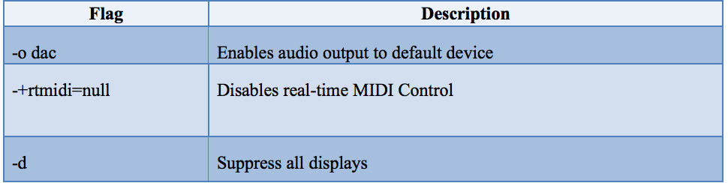

2.2.4.2 The Instrument

The first lines of code in the instrument set up some important values for the .csd to use when processing audio. These are described in Table 2.4, and are discussed in more detail in the Reference section of the Csound Manual
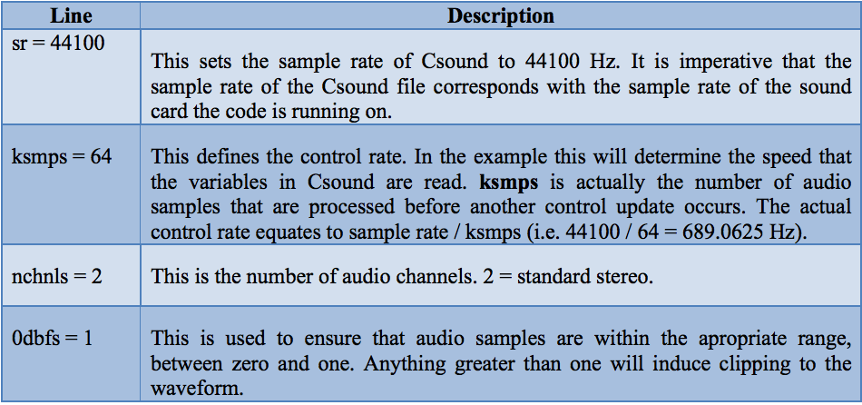

The instrument then takes values from Csound using the chnget opcode:
kfreq chnget "freqVal"
kamp chnget "ampVal"
Here, the chnget command uses the “freqVal” and “ampVal” channels previously created in iOS to assign a new control variable. The variables kfreq and kamp are control-rate variables because they begin with the letter ‘k’. They will be updated 689.0625 times per second. This may be faster or slower than iOS updates the agreed memory addresses, but it doesn’t matter. Csound will just take the value that is there when it accesses the address via the named channel.
These control-rate variables are used to control the amplitude and frequency fields of the opcode poscil; a Csound opcode for generating sinusoidal waves. This is then output in stereo using the next line.
asig oscil kamp,kfreq,1
outs asig,asig
endin

The third parameter of the poscil opcode in this case is 1. This means ‘use f-table 1’. Section 3.3 explains f-tables in more depth.

2.2.4.3 The Score
The score is used to store the f-tables the instrument is using to generate sounds, and it allows for the playing of an instrument. This instrument is then played, as shown below:
i1 0 10000
This line plays instrument 1 from 0 seconds, to 10000 seconds. This means that the instrument continues to play until it is stopped, or a great amount of time passes.
It is possible to send score events from iOS using the method sendScore. This is discussed in more depth in section 6.1.

3 Using the Mobile Csound API in an Xcode Project
Section 3 provides an overview of how to set up your Xcode project to utilize the Mobile Csound API, as well as how to download the API and include it into your project.

3.1 Setting up an Xcode Project with the Mobile Csound API
This section describes the steps required to set up an Xcode project for use with the Mobile Csound API. Explanations include where to find the Mobile Csound API, how to include it into an Xcode project and what settings are needed.

3.1.2 Creating an Xcode Project
This section briefly describes the settings which are needed to set up an Xcode project for use with the Mobile Csound API. Choose the appropriate template to suit the needs of the project being created. When choosing the options for the project, it is important that Use Automatic Reference Counting is not checked (Figure. 3.1). It is also unnecessary to include unit tests.
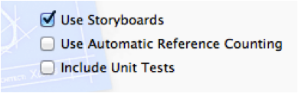
Note: When including this API into a pre-existing project, it is possible to turn off ARC on specific files by entering the compiler sources, and changing the compiler flag to: ‘-fno-objc-arc’

3.1.3 Adding the Mobile Csound API to an Xcode Project
Once an Xcode project has been created, the API needs to be added to the Xcode project. To add the Mobile Csound API to the project, right click on the Xcode project and select Add files to <myProject>. This will bring up a navigation window to search for the files to be added to the project. Navigate to the Csound-iOS folder, which is located as shown in Figure 3.2 below.

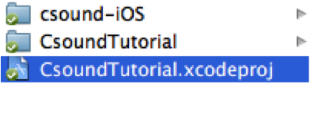
Select the whole folder as shown and click add. Once this has been done, Xcode will provide an options box as shown in Figure 3.3. Check Copy items into destination group’s folder (if needed).
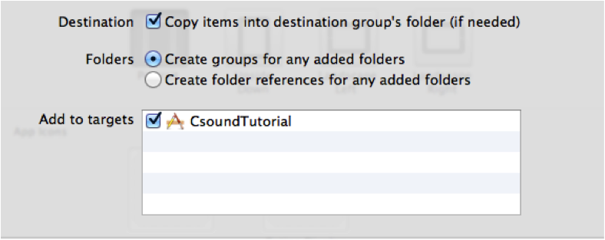
The options in Figure 3.3 are selected so that the files which are necessary to run the project are copied into the project folder. This is done to make sure that there are no problems when the project folder is moved to another location - ensuring all the file-paths for the project files remain the same.

Once this addition from this section has been made, the project structure displayed in Xcode should look similar to that in Figure 3.4.
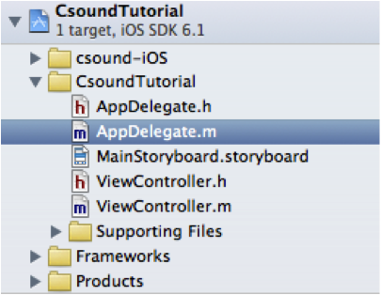

3.1.4 Compiling Sources
A list of compile sources is found by clicking on the blue project file in Xcode, navigating to the Build Phases tab and opening Compile Sources. Check that the required sources for the project are present in the Compile Sources in Xcode. All the files displayed in Figure 3.5 should be present, but not necessarily in the same order as shown.
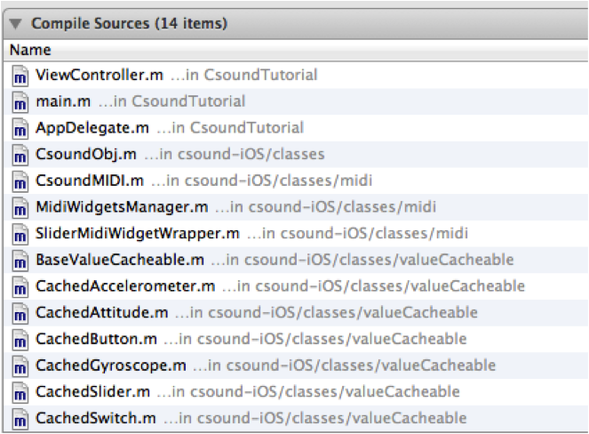

3.1.5 Including the Necessary Frameworks
There are some additional frameworks which are required to allow the project to run. These frameworks are:

- AudioToolbox.framework
- CoreGraphics.framework
- CoreMotion.framework
- CoreMIDI.framework
To add these frameworks to the project, navigate to the ‘Link Binary With Libraries’ section of Xcode. This is found by clicking on the blue project folder and navigating to the ‘Build Phases’ tab, followed by opening ‘Link Binary With Libraries’. To add a framework, click on the plus sign and search for the framework required. Once all the necessary frameworks are added, the ‘Link Binary With Libraries’ should look similar to Figure 3.6 below.

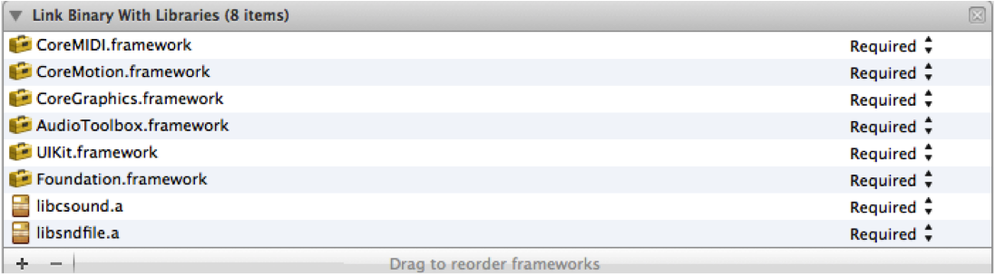

3.1.6 The .csd File
The project is now set up for use with the Mobile Csound API. The final file which will be required by the project is a .csd file which will describe the Csound instruments to be used by the application. A description of what the .csd file is and how to include one into the project is found in Section 3.3. This file will additionally need to be referenced appropriately in the Xcode project. A description of where and how this reference is made is available in Section 2.2.3.2.

3.2 Setting up the View Controller
This section describes how the ViewController.h and the ViewController.m should be set up to ensure that they are able to use the API. It will discuss what imports are needed; conforming to the protocols defined by the API; giving a brief overview. This section can be viewed in conjunction with the example project provided.

3.2.1 Importing
So that the code is able to access other code in the API, it is important to include the following imports, along with imports for any additional files required. The three imports shown in Table 3.1 are used in the header file of the view controller to access the necessary files to get Csound-iOS working:

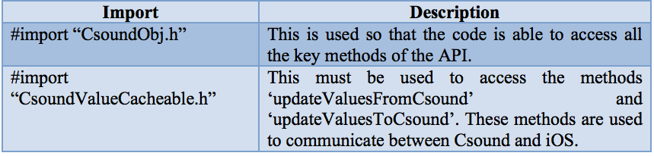
In our example you can see these at the top of ViewController.h

3.2.2 Conforming to Protocols
It is imperative that the view controller conforms to the protocols outlined the CsoundObj.h file; the file in the API that allows for communication between iOS and Csound. This must then be declared in the ViewController.h file:
@property (nonatomic, retain) CsoundObj* csound;
The API authors chose to use protocols so that there is a defined set of methods that must be used in the code. This ensures that a consistent design is adhered to. They are defined in the CsoundValueCacheable.h file thus:
@class CsoundObj;
@protocol CsoundValueCacheable <NSObject>
-(void)setup:(CsoundObj*)csoundObj;
-(void)updateValuesToCsound;
-(void)updateValuesFromCsound;
-(void)cleanup;
Each of these must then be implemented in the ViewController.m file. If it is unnecessary to implement one of these methods, it still must appear but the method body can be left blank, thus:
-(void)updateValuesFromCsound
{
//No values coming from Csound to iOS
}

3.2.3 Overview of Protocols
When writing the code which allows us to send values from iOS to Csound, it is important that the code conforms to the following protocol methods (Table 3.2):

3.3 Looking at the Csound '.csd' File
The following section provides an overview of the Csound editing environment, the structure of the .csd file, and how to include the .csd file into your Xcode project.

3.3.1 Downloading Csound
A Csound front-end editor, CsoundQt, can be used for editing the .csd file in the provided example project. It is advised to use CsoundQt with iOS because it is an ideal environment for developing and testing the Csound audio engine – error reports for debugging, the ability to run the Csound audio code on its own, and listen to its results. However, using CsoundQt is not essential to use Csound as an audio engine as Csound is a standalone language. CsoundQt is included in the Csound package download.
In order to use Csound in iOS, the latest version of Csound (Version 5.19) will need to be installed.
Csound 5.19 can be downloaded from the following link:
http://sourceforge.net/projects/Csound/files/Csound5/Csound5.19
For more information on downloading Csound, please consult Chapter 2A of this Manual, "MAKE CSOUND RUN".
In order for Xcode to see the .csd file, it must be imported it into the Xcode project. This is done by right-clicking on the ‘Supporting Files’ folder in the project, and clicking on ‘Add files to (project name)’ (Figure 3.7).

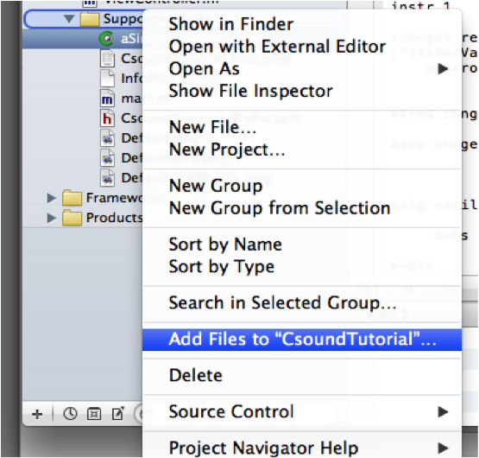

It is possible to edit the .csd file while also working in Xcode. This is done by right-clicking on the .csd file in Xcode, and clicking on ‘Open With External Editor’ (Figure 3.8).
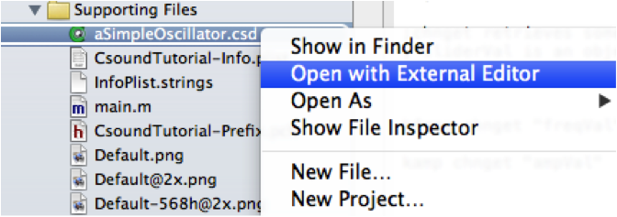
However, it is important to remember to save any changes to the .csd file before the Xcode project is recompiled.

3.3.2 The .csd File
When setting up a Csound project, it is important that various audio and performance settings configured correctly in the header section of the .csd file. These settings are described in Table 3.3, and are discussed in more detail in the Csound Manual. The reader is also encouraged to review Chapter 2B, "CSOUND SYNTAX", in this manual.

It is important that the sample rate for the Csound project be set to the same sample rate as the hardware it will be run on. For this project, make sure the sample rate set to 44100, as depicted in Figure 3.9. This is done by opening the Audio MIDI Setup, which is easily found on all Mac computers by searching in Spotlight.
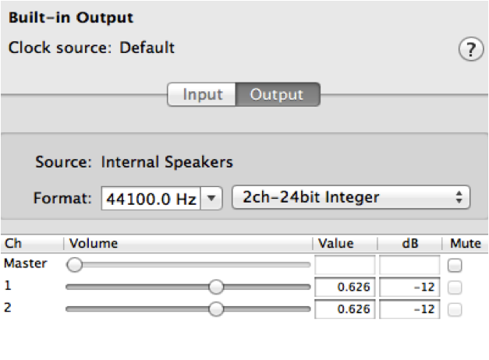

3.3.3 Instruments

As mentioned previously, Csound instruments are defined in the orchestra section of the .csd file. The example project provided by the authors uses a simple oscillator that has two parameters: amplitude and frequency, both of which are controlled by UI sliders.

Figure 3.10 shows a block diagram of the synthesizer we are using in the example project.
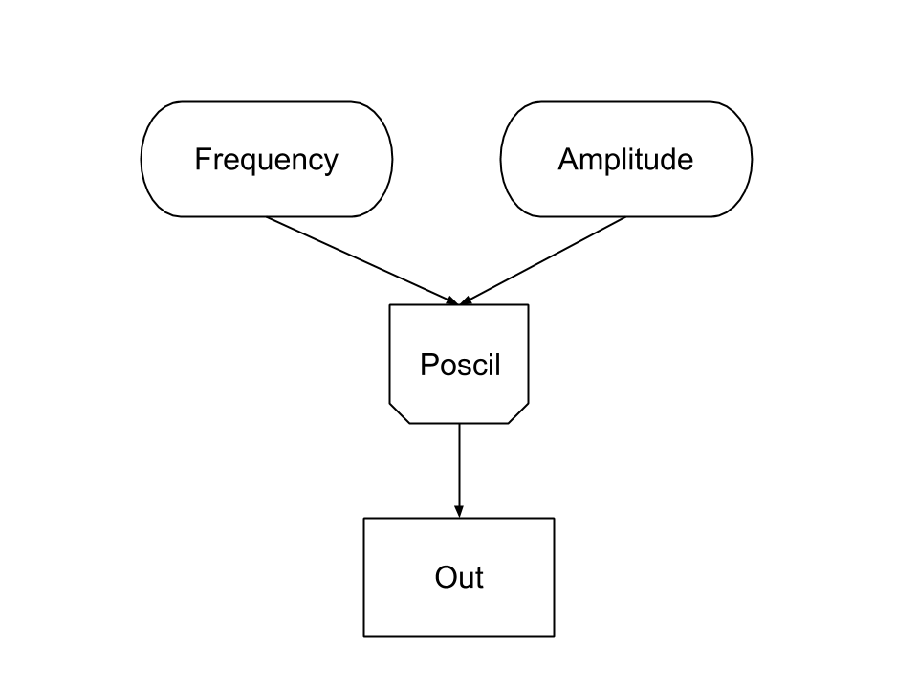

3.3.4 Score
The score is the section of the .csd file which provides instruments with control instruction, for example pitch, volume, and duration. However, as the goal here is for users to be able to interact with the Csound audio engine in real-time, developers will most likely opt instead to send score information to Csound that is generated by UI elements in the Xcode project. Details of the instrument and score can be found in the comments of the aSimpleOscillator.csd file.
Csound uses GEN (f-table generator) routines for a variety of functions. This project uses GEN10, which create composite waveforms by adding partials. At the start of the score section, a GEN routine is specified by function statements (also known as f-statements). The parameters are shown below in Table 3.4:
In a Csound score, the first three parameter fields (also known as p-fields) are reserved for the instrument number, the start time, and duration amount. P-fields 4 and 5 are conventionally reserved for amplitude and frequency, however, P-fields beyond 3 can be programmed as desired.
The p-fields used in the example project are shown in Table 3.5.
In this project, the first three p-fields are used: the instrument number (i1), the start time (time = 0 seconds), and the duration (time = 1000 seconds). Amplitude and frequency are controlled by UI sliders in iOS.
The reader is encouraged to review Chapter 3D of this Manual, "FUNCTION TABLES" for more detailed information.
4 Common Problems
This section is designed to document some common problems faced during the creation of this tutorial. It is hoped that by outlining these common errors, readers can debug some common errors they are likely to come across when creating applications using this API. It discusses each error, describes the cause and outlines a possible solution.

4.1 UIKnob.h is Not Found
This is a problem related to the API. The older versions of the API import a file in the examples that sketches a UIKnob in Core Graphics. This is not a part of the API, and should not be included in the project.
The file in question is a part of the examples library provided with the SDK. It is used in the file ‘AudioIn test’ and is used to sketch a radial knob on the screen. It gives a good insight into how the user can generate an interface to interact with the API.
Solution: Comment the line out, or download the latest version of the API.

4.2 Feedback from Microphone
This is generally caused by the sample rate of a .csd file being wrong.
Solution: Ensure that the system’s sample rate is the same as in the .csd file. Going to the audio and MIDI set-up and checking the current output can find the computer’s sample rate. See section 3.3.2 for more information.

4.3 Crackling Audio
There are numerous possible issues here, but the main cause of this happening is a CPU overload.
Solution: The best way to debug this problem is to look through the code and ensure that there are no memory intensive processes, especially in code that is getting used a lot. Problem areas include fast iterations (loops), and code where Csound is calling a variable. Functions such as updateValuesToCsound and updateValuesFromCsound are examples of frequently called functions.
An example: an NSLog in the updateValuesToCsound method can cause a problem. Say, the ksmps in the .csd is set to 64. This means that the Csound is calling for iOS to run the method updateValuesToCsound every 64 samples. Assuming the sample rate is 44.1k this means that this CPU intensive NSLog is being called ~689 times a second; very computationally expensive.

4.4 Crackling from amplitude slider
When manipulating the amplitude slider in iOS, a small amount of clicking is noticeable. This is due to the fact that there is no envelope-smoothing function applied to the amplitude changes. While this would be an improvement on the current implementation, however; it was felt that the current implementation would be more conducive to learning for the novice Csound user. This would be implemented by using a port opcode.

5 Csound Library Methods
This section will present and briefly describe the methods which are available in the Mobile Csound API.

5.1 Csound Basics

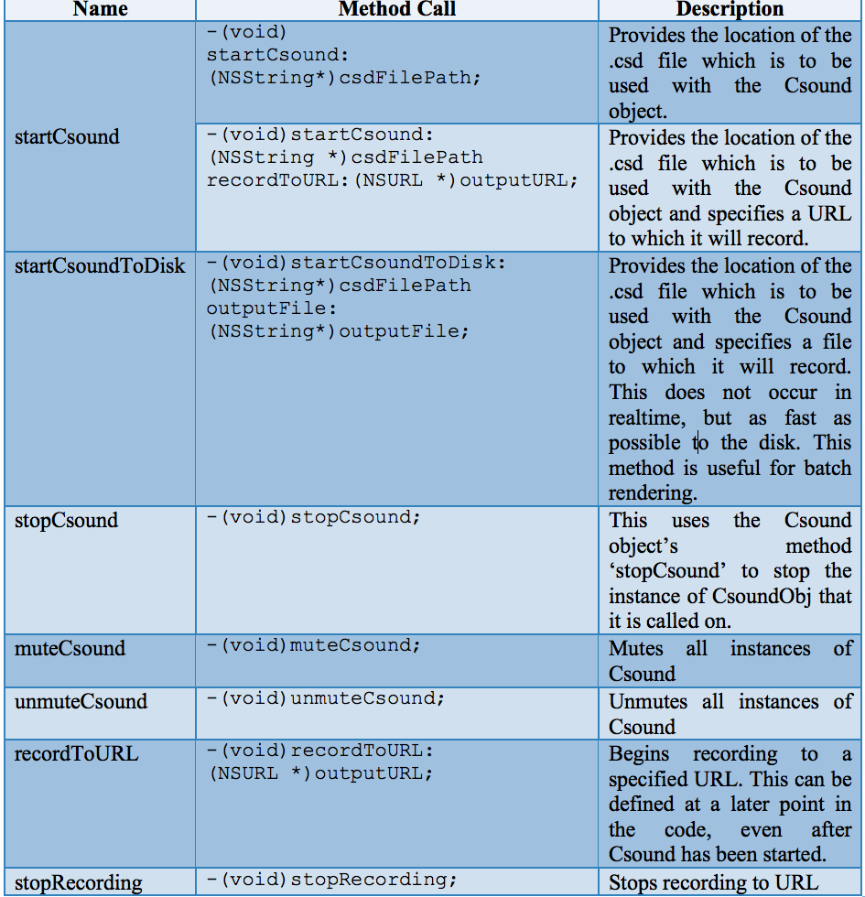

5.2 UI and Hardware Methods
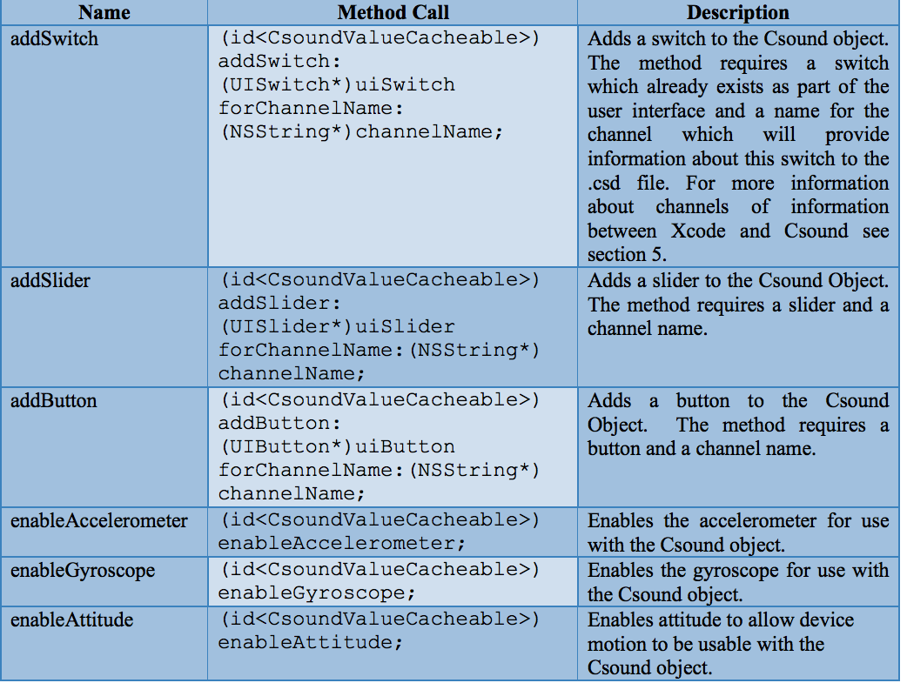

5.3 Communicating between Xcode and Csound
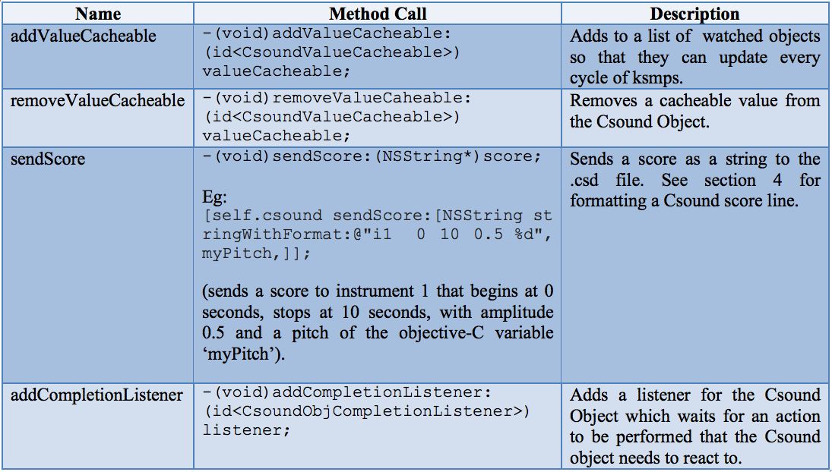

5.4 Retreive Csound-iOS Information
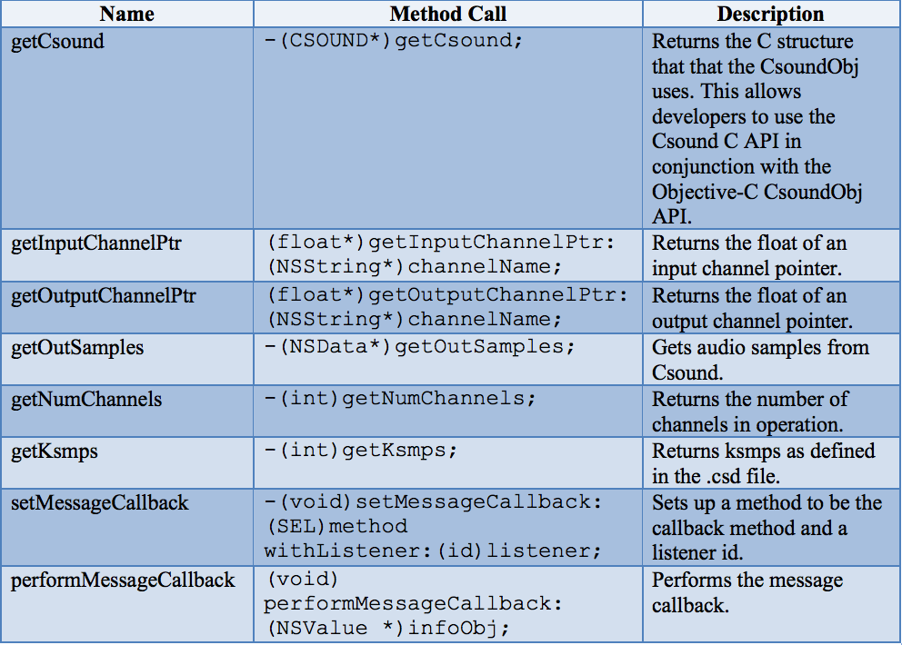

6 Conclusions
This tutorial provided an overview of the Csound-iOS API, outlining its benefits, and describing its functionality by means of an example project. It provided the basic tools for using the API, equipping iOS developers to explore the potential of this API in their own time.

APIs such as this one, as well as others including libpd and The Amazing Audio Engine provide developers with the ability to integrate interactive audio into their apps, without having to deal with the low-level complexities of Core Audio.

6.1 Additional Resources
Upon completion of this tutorial, the authors suggest that the reader look at the original Csound for iOS example project, written by Steven Yi and Victor Lazzarini.
This is available for download from http://sourceforge.net/projects/csound/files/csound5/iOS/

62. F. CSOUND ON ANDROID

Introduction
Now that we have spent some time with Csound on Android, we have come to realize that a high end smartphone, not to mention a tablet, is in every sense of the word a real computer. The limits to what can be programmed on it are indefinable. On a high-end personal computer, it is easier to type, and Csound runs quite a bit faster; but there is no essential difference between running Csound on a computer and running it on a smartphone.
Csound has been available on the Android platform since 2012 (Csound 5.19), thanks to the work of Victor Lazzarini and Steven Yi. Csound 6 was ported to Android, and enhanced, by Michael Gogins and Steven Yi in the summer of 2013. This chapter is about Csound 6 for Android.
The following packages are available for Android:
- The CsoundAndroid library, which is intended to be used by developers for creating apps based on Csound.
- The CsoundAndroidExamples app, which demonstrates various uses of CsoundAndroid.
- The Csound6 app, which is a self-contained environment for creating, editing, debugging, and performing Csound pieces on Android.
All of these packages are available for download from the SourceForge site's file pages at http://sourceforge.net/projects/csound/files/csound6/.
For more information about the AndroidCsound or AndroidCsoundExamples packages, download them and consult the documentation contained therein.

The Csound6 app
The Csound6 app permits the user, on any Android device that is powerful enough, including most tablets and the most powerful smartphones, to do most things that can be done with Csound on any other platform such as OS X, Windows, or Linux. This includes creating Csound pieces, editing them, debugging them, and performing them, either in real time to audio output or to a soundfile for later playback.
The app has a built-in, pre-configured user interface with five sliders, five push buttons, one trackpad, and a 3 dimensional accelerometer that are pre-assigned to control channels which can be read using Csound's chnget opcode.
The app also has some limitations and missing features compared with the longer-established platforms. These include:
- There is no real-time MIDI input or output.
- Audio input is not accurately synchronized with audio output.
- Many plugin opcodes are missing, including the OSC opcodes and most opcodes involved with using other plugin formats or inter-process communications.
However, some of the more useful plugins are indeed available on Android:
- The signal flow graph opcodes for routing audio from instruments to effects, etc.
- The FluidSynth opcodes for playing SoundFonts.
- The Lua opcodes for running Lua code in Csound and even defining new Csound opcodes in Lua.
- The libstdutil library, which enables Csound to be used for various time/frequency analysis and resynthesis tasks, and for other purposes.

Installing the App
There are two ways to install the Csound6 app. You can download it using your device, or you can download it to a computer and transfer it to your device. These methods are presented below.

Preparing Your Device
Using the Csound6 app is similar to using an application on a regular computer. You need to be able to browse the file system, and you need to be able to edit csd files.
There are a number of free and paid apps that give users the ability to browse the Linux file system that exists on all Android devices. If you don't already have such a utility, you should install a file browser that provides access to as much as possible of the file system on your device, including system storage and external store such as an SD card. I have found that the free AndroZip app can do this.
There also is an increasing number of free and paid text editors for Android. The one that I chose to use for developing, testing, and using the Csound6 app is the free version of the Jota text editor. There are also various enhanced paid versions of this app, and of course you may find some other editor more suitable to your purposes. Other editors should also be able to work with Csound, although they have only very lightly been tested.
When you use Csound, the command for editing csd files will transparently invoke the editor, as though it was an integral part of the app. This kind of integration is an appealing feature of the Android operating system.
If you render soundfiles, they take up a lot of space. For example, CD-quality stereo soundfiles (44.1 KHz, 16 bit) take up about 10 megabytes per minute of sound. Higher quality or more channels take up even more room. But even without extra storage, a modern smartphone should have gigabytes, thousands of megabytes, of free storage. This is actually enough to make an entire album of pieces.
On most devices, installing extra storage is easy and not very expensive. I recommend obtaining the largest possible SD card, if your device supports them. This will vastly expand the amount of available space, up to 32 or 64 gigabytes or even more.
Download to Device
To download the Csound6 app to your device, go online using Google Search or a Web browser. You can find the application package file, Csound6.apk, on SourceForge, on the Csound project site, on the File page (you may first have to allow your android to install an app which is not in Google Play). The app will be on one of the more recent releases of Csound 6. For example, you can find it at Csound6.apk. But you should look for the latest release and use that.
Click on the filename to download the package. The download will happen in the background. You can then go to the notifications bar of your device and click on the downloaded file. You will be presented with one or more options for how to install it. The installer will ask for certain permissions, which you need to grant.

Transfer from a Computer
It's also easy to download the Csound6.apk file to a personal computer. Once you have downloaded the file from SourceForge, connect your device to the computer with a USB cable. The file system of the device should then automatically be mounted on the file system of the computer. Find the Csound6.apk in the computer's download directory, and copy the Csound6.apk file. Find your device's download directory, and paste the Csound.apk file there.
Then you will need to use a file browser that is actually on your device, such as AndropZip. Browse to your Download directory, select the Csound6.apk file, and you should be presented with a choice of actions. Select the Install action. The installer will ask for certain permissions, which you should give.

User Interface
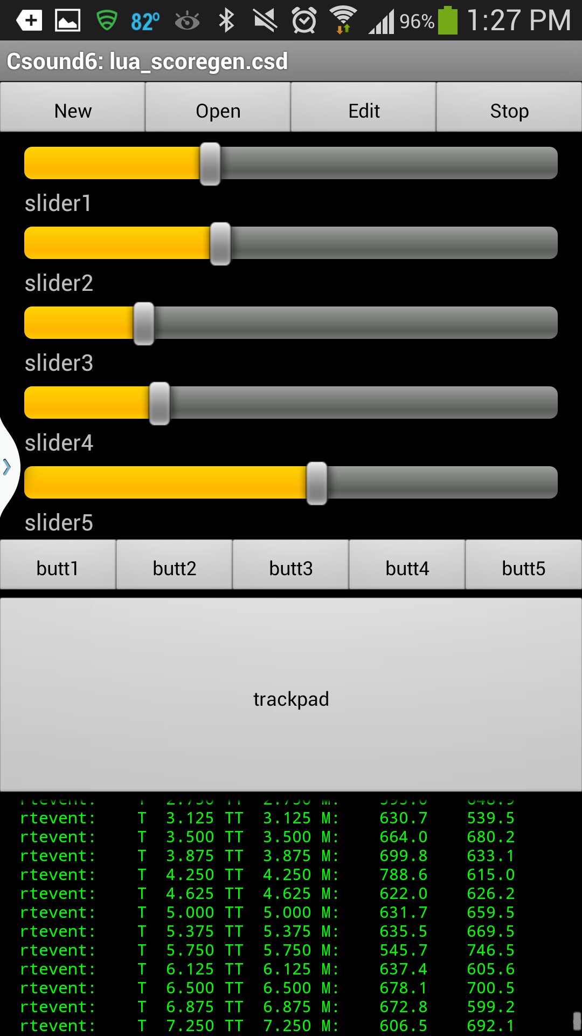

- New – creates a blank template CSD file in the root directory of the user's storage for the user to edit. The CSD file will be remembered and performed by Csound.
- Open – opens an existing CSD file in the root directory of the user's storage. The user's storage filesystem can be navigated to find other files.
- Edit – opens a text editor to edit the current CSD file. Be sure to save the file before you perform it! I recommend the free, open source Jota text editor on smartphones and, though I haven't tried Jota on tablets, it probably works well there as well.
- Start/Stop – if a CSD file has been loaded, pushing the button starts running Csound; if Csound is running, pushing the button stops Csound. If the <CsOptions> element of the CSD file contains -odac, Csound's audio output will go to the device audio output. If the element contains -osoundfilename, Csound's audio output will go to the file soundfilename, which should be a valid Linux pathname in the user's storage filesystem.
The widgets are assigned control channel names slider1 through slider5, butt1 through butt5, trackpad.x, and trackpad.y. In addition, the accelerometer on the Android device is available as accelerometerX, accelerometerY, and accelerometerZ.
The values of these widgets are normalized between 0 and 1, and can be read into Csound during performance using the chnget opcode, like this:
kslider1_value chnget “slider1”
The area below the trackpad prints messages output by Csound as it runs.

The Settings Menu
The Settings menu on your device offers the following choices:
- User guide links to this chapter of this online manual.
- Csound help links to the online Csound Reference Manual.
- About Csound links to the csounds.com Web site, which acts as a portal for all things concerning Csound.
- Settings opens a dialog for setting environment variables that specify default locations for soundfiles, samples, scores, and so on. In the Csound6 app, these environment variables are configured by Android app settings.

Configuring Default Directories
Run the Csound6 app, invoke the menu button, and choose Settings. You will be given choices for specifying an (additional) Plugins directory, a soundfile Output directory, a Samples directory, an Analysis directory, and an Include directory for score and orchestra files to be #included by a Csound piece.
These settings are not required, but they can make using Csound easier and faster to use.

Loading and Performing a Piece

Sample Pieces
On Csound's SourceForge page, in the Files section, there is an archive of examples for the Csound6 app, for example at Csound6AndroidExamples.zip, though you should look for a more recent release of this archive. Not all of these examples use the widgets, and some of them write audio to soundfile and not to the audio device. The examples demonstrate not only some techniques for using the Csound6 Android app, but also a few of the many different ways of making music with Csound.
Download this file to your device and unzip it on your file system, for example in the Downloads directory.

Running an Existing Piece
If you have access to a mixer and monitor speakers, or even a home stereo system, or even a boom box, you can hook up your device's headphone jack to your sound system with an adapter cable. Most devices have reasonably high quality audio playback capabilities, so this can work quite well.
Just to prove that everything is working, after you have downloaded the examples and unzipped them, start the Csound app. Select the Open button, and navigate to the examples directory you have created. Find the Kung directory, select the xanadu.csd file, and it will be loaded into Csound. Then select the Start button. Its name should change to Stop, and Csound's runtime messages should begin to scroll down the black pane at the bottom of the screen. At the same time, you should hear the piece play. You can stop the performance at any time by selecting the Stop button, or you can let the performance complete on its own.
That's all there is to it. You can scroll up and down in the messages pane if you need to find a particular message, such as an error or warning.
If you want to look at the text of the piece, or edit it, select the Edit button. If you have installed Jota, that editor should open with the text of the piece, which you can save, or not. You can edit the piece with the this editor, and any changes you make and save will be performed the next time you start the piece.

Creating a New Piece
This example will take you through the process of creating a new Csound piece, step by step. Obviously, this piece is not going to reveal anything like the full power of Csound. It is only intended to get you to the point of being able to create, edit, and run a Csound piece that will actually make sound on your Android device – from scratch.
Before you get started, install the Jota text editor on your device. Other text editors might work with the Csound app, but this one is known to work.
Run the Csound6 app...
Select the New button. You should be presented with an input dialog asking you for a filename for your piece. Type in toot.csd, and select the Ok button. The file will be stored in the root directory of your user storage on your device. You can save the file to another place using Jota's File menu, if you like.
The text editor should open with a “template” CSD file. Your job is to fill out the minimum to hear something.
Create a blank line between <CsOptions> and </CsOptions>, and type -odac -d -m3. This means send audio to the real-time output (-odac), do not display any function tables (-d), and log some informative messages during Csound's performance (-m3).
Create a blank line between <CsInstruments> and </CsInstruments> and type the following text:
sr = 44100
ksmps = 32
nchnls = 1
0dbfs = 1
instr 1
asignal poscil 0.2, 440
out asignal
endin
This is just about the simplest possible Csound orchestra. The orchestra header specifies an audio signal sampling rate of 44,100 frames per second, with 10 audio frames per control signal sample, and one channel of audio output. The instrument is just a simple sine oscillator. It plays a tone at concert A.
Create a blank line between <CsScore> and </CsScore> and type:
i1 0 5
This means play instrument 1 starting at time 0 for 5 seconds.
Select the text editor's Save button and then its Quit button.
Select the Csound app's Start button. You should hear a loud sine tone for 5 seconds.
If you want to save your audio output to a soundfile named test.wav, change -odac above to -o/sdcard/test.wav.
That's it!

Using the Widgets
The Csound6 app provides access to a set of predefined on-screen widgets, as well as to the accelerometer on the device. All of these controllers are permanently assigned to pre-defined control channels with pre-defined names, and mapped to a pre-defined range of values, from 0 to 1.
All of this pre-definition... this is both good and bad. I have found, following the example of Iain McCurdy who has graciously contributed a number of the examples for the app, an approach that simplifies using the controllers. For an example of this approach in action, look at the source code for the Gogins/Drone-IV.csd example.
You should be able to cut and paste this code into your own pieces without many changes.
The first step is to declare one global variable for each of the control channels, with the same name as the control channel, at the top of the orchestra header, initialized to a value of zero:
gkslider1 init 0
gkslider2 init 0
gkslider3 init 0
gkslider4 init 0
gkslider5 init 0
gkbutt1 init 0
gkbutt2 init 0
gkbutt3 init 0
gkbutt4 init 0
gkbutt5 init 0
gktrackpadx init 0
gktrackpady init 0
gkaccelerometerx init 0
gkaccelerometery init 0
gkaccelerometerz init 0
Then write an "always-on" instrument that reads each of these control channels into each of those global variables. At the top of the orchestra header:
alwayson "Controls"
As the next to last instrument in your orchestra:
instr Controls
gkslider1 chnget "slider1"
gkslider2 chnget "slider2"
gkslider3 chnget "slider3"
gkslider4 chnget "slider4"
gkslider5 chnget "slider5"
gkbutt1 chnget "butt1"
gkbutt2 chnget "butt2"
gkbutt3 chnget "butt3"
gkbutt4 chnget "butt4"
gkbutt5 chnget "butt5"
gktrackpadx chnget "trackpad.x"
gktrackpady chnget "trackpad.y"
gkaccelerometerx chnget "accelerometerX"
gkaccelerometery chnget "accelerometerY"
gkaccelerometerz chnget "accelerometerZ"
endin
So far, everything is common to all pieces. Now, for each specific piece and specific set of instruments, write another always-on instrument that will map the controller values to the names and ranges required for your actual instruments. This code, in addition, can make use of the peculiar button widgets, which only signal changes of state and do not report continuously whether they are "on" or "off." These examples are from Gogins/Drone-IV.csd.
At the top of the orchestra header:
alwayson "VariablesForControls"
As the very last instrument in your orchestra:
instr VariablesForControls
if gkslider1 > 0 then
gkFirstHarmonic = gkslider1 * 2
gkgrainDensity = gkslider1 * 400
gkratio2 = gkslider1 ;1/3
endif
if gkslider2 > 0 then
gkDistortFactor = gkslider2 * 2
gkgrainDuration = 0.005 + gkslider2 / 2
gkindex1 = gkslider2 * 4
endif
if gkslider3 > 0 then
gkVolume = gkslider3 * 5
gkgrainAmplitudeRange = gkslider3 * 300
gkindex2 = gkslider3 ;0.0125
endif
if gkslider4 > 0 then
gkgrainFrequencyRange = gkslider4 / 10
endif
if gktrackpady > 0 then
gkDelayModulation = gktrackpady * 2
; gkGain = gktrackpady * 2 - 1
endif
if gktrackpadx > 0 then
gkReverbFeedback = (3/4) + (gktrackpadx / 4)
; gkCenterHz = 100 + gktrackpadx * 3000
endif
kbutt1 trigger gkbutt1, .5, 0
if kbutt1 > 0 then
gkbritels = gkbritels / 1.5
gkbritehs = gkbritehs / 1.5
; gkQ = gkQ / 2
endif
kbutt2 trigger gkbutt2, .5, 0
if kbutt2 > 0 then
gkbritels = gkbritels * 1.5
gkbritehs = gkbritehs * 1.5
; gkQ = gkQ * 2
endif
endin
Now, the controllers are re-mapped to sensible ranges, and have names that make sense for your intruments. They can be used as follows. Note particularly that, just above the instrument definition, in other words actually in the orchestra header, these global variables are initialized with values that will work in performance, in case the user does not set up the widgets in appropriate positions before starting Csound. This is necessary because the widgets in the Csound6 app, unlike say the widgets in CsoundQt, do not "remember" their positions and values from performance to performance.
gkratio1 init 1
gkratio2 init 1/3
gkindex1 init 1
gkindex2 init 0.0125
instr Phaser
insno = p1
istart = p2
iduration = p3
ikey = p4
ivelocity = p5
iphase = p6
ipan = p7
iamp = ampdb(ivelocity) * 8
iattack = gioverlap
idecay = gioverlap
isustain = p3 - gioverlap
p3 = iattack + isustain + idecay
kenvelope transeg 0.0, iattack / 2.0, 1.5, iamp / 2.0, iattack / 2.0, -1.5, iamp, isustain, 0.0, iamp, idecay / 2.0, 1.5, iamp / 2.0, idecay / 2.0, -1.5, 0
ihertz = cpsmidinn(ikey)
print insno, istart, iduration, ikey, ihertz, ivelocity, iamp, iphase, ipan
isine ftgenonce 0,0,65536,10,1
khertz = ihertz
ifunction1 = isine
ifunction2 = isine
a1,a2 crosspm gkratio1, gkratio2, gkindex1, gkindex2, khertz, ifunction1, ifunction2
aleft, aright pan2 a1+a2, ipan
adamping linseg 0, 0.03, 1, p3 - 0.1, 1, 0.07, 0
aleft = adamping * aleft * kenvelope
aright = adamping * aright * kenvelope
outleta "outleft", aleft
outleta "outright", aright
endin

13 EXTENDING CSOUND
63. EXTENDING CSOUND

63. EXTENDING CSOUND
coming in the next release ...
OPCODE GUIDE
64. OPCODE GUIDE: OVERVIEW
65. OPCODE GUIDE: BASIC SIGNAL PROCESSING
66. OPCODE GUIDE: ADVANCED SIGNAL PROCESSING
67. OPCODE GUIDE: DATA
68. OPCODE GUIDE: REALTIME INTERACTION
69. OPCODE GUIDE: INSTRUMENT CONTROL
70. OPCODE GUIDE: MATH, PYTHON/ SYSTEM, PLUGINS

64. OPCODE GUIDE: OVERVIEW
If you run Csound from the command line with the option -z, you get a list of all opcodes. Currently (Csound 5.13), the total number of all opcodes is about 1500. There are already overviews of all of Csound's opcodes in the Opcodes Overview and the Opcode Quick Reference of the Canonical Csound Manual.
This chapter is another attempt to provide some orientation within Csound's wealth of opcodes. Unlike the references mentioned above, not all opcodes are listed here, but the ones that are, are commented upon briefly. Some opcodes appear more than once and in different sections to reflect the different contexts in which they could be used. This guide intends to provide insights into the opcodes listed that the other sources do not.

BASIC SIGNAL PROCESSING

OSCILLATORS AND PHASORS

Standard Oscillators
(oscils) poscil poscil3 oscili oscil3 more

Dynamic Sprectrum Oscillators
buzz gbuzz mpulse vco vco2

Phasors
phasor syncphasor

RANDOM AND NOISE GENERATORS
(seed) rand randi randh rnd31 random (randomi /randomh) pinkish more

ENVELOPES

Simple Standard Envelopes
linen linenr adsr madsr more

Envelopes By Linear And Exponential Generators
linseg expseg transeg (linsegr expsegr transegr) more

Envelopes By Function Tables

DELAYS

Audio Delays
vdelay vdelayx vdelayw
delayr delayw deltap deltapi deltap3 deltapx deltapxw deltapn

Control Signal Delays
delk vdel_k

FILTERS
Compare Standard Filters and Specialized Filters overviews.

Low Pass Filters
tone tonex butlp clfilt

High Pass Filters
atone atonex buthp clfilt

Band Pass And Resonant Filters
reson resonx resony resonr resonz butbp

Band Reject Filters
areson butbr

Filters For Smoothing Control Signals
port portk

REVERB
freeverb reverbsc reverb nreverb babo (pconvolve)

SIGNAL MEASUREMENT, DYNAMIC PROCESSING, SAMPLE LEVEL OPERATIONS

Amplitude Measurement and Amplitude Envelope Following
rms balance follow follow2 peak max_k

Pitch Estimation (Pitch Tracking)
ptrack pitch pitchamdf pvscent

Tempo Estimation
tempest

Dynamic Processing
compress dam clip

Sample Level Operations
limit samphold vaget vaset

SPATIALIZATION

Panning
pan2 pan

VBAP
vbaplsinit vbap4 vbap8 vbap16

Ambisonics
bformenc1 bformdec1

Binaural / HRTF
hrtfstat hrtfmove hrtfmove2 hrtfer

ADVANCED SIGNAL PROCESSING

MODULATION AND DISTORTION

Frequency Modulation
foscil foscili
crossfm crossfmi crosspm crosspmi crossfmpm crossfmpmi

Distortion And Wave Shaping
distort distort1 powershape polynomial chebyshevpoly

Flanging, Phasing, Phase Shaping
flanger harmon phaser1 phaser2 pdclip pdhalf pdhalfy

Doppler Shift
doppler

GRANULAR SYNTHESIS
partikkel sndwarp others

CONVOLUTION
pconvolve ftconv dconv

FFT AND SPECTRAL PROCESSING

Real-time Analysis and Resynthesis
pvsanal pvstanal pvsynth pvsadsyn

Writing FFT Data to A File and Reading From it
pvsfwrite pvanal pvsfread pvsdiskin

Writing FFT Data to a Buffer and Reading From it
pvsbuffer pvsbufread pvsftw pvsftr

FFT Info
pvsinfo pvsbin pvscent

Manipulating FFT Signals
pvscale pvshift pvsbandp pvsbandr pvsmix pvscross pvsfilter pvsvoc pvsmorph pvsfreeze pvsmaska pvsblur pvstencil pvsarp pvsmooth

PHYSICAL MODELS AND FM INSTRUMENTS

Waveguide Physical Modelling
see here and here

FM Instrument Models
see here

DATA

BUFFER / FUNCTION TABLES

Creating Function Tables (Buffers)
ftgen GEN Routines

Writing to Tables
tableiw / tablew tabw_i / tabw

Reading From Tables
table / tablei / table3 tab_i / tab

Saving Tables to Files
ftsave / ftsavek TableToSF

Reading Tables From Files
ftload / ftloadk GEN23

SIGNAL INPUT/OUTPUT, SAMPLE AND LOOP PLAYBACK, SOUNDFONTS

Signal Input and Output
inch ; outch out outs ; monitor

Sample Playback With Optional Looping
flooper2 sndloop

Soundfonts and Fluid Opcodes
fluidEngine fluidSetInterpMethod fluidLoad fluidProgramSelect fluidNote fluidCCi fluidCCk fluidControl fluidOut fluidAllOut

FILE INPUT AND OUTPUT

Sound File Input
soundin diskin diskin2 mp3in (GEN01)

Sound File Queries
filelen filesr filenchnls filepeak filebit

Sound File Output
fout

Non-Soundfile Input And Output
readk GEN23 dumpk fprints / fprintks ftsave / ftsavek ftload / ftloadk

CONVERTERS OF DATA TYPES

i <- k
i(k)

k <- a
downsamp max_k

a <- k
upsamp interp

PRINTING AND STRINGS

Simple Printing
print printk printk2 puts

Formatted Printing
prints printf_i printks printf

String Variables
sprintf sprintfk strset strget

String Manipulation And Conversion
see here and here

REALTIME INTERACTION

MIDI

Opcodes for Use in MIDI-Triggered Instruments
massign pgmassign notnum cpsmidi veloc ampmidi midichn pchbend aftouch polyaft

Opcodes For Use In All Instruments
ctrl7 (ctrl14/ctrl21) initc7 ctrlinit (initc14/initc21) midiin midiout

OPEN SOUND CONTROL AND NETWORK

Open Sound Control
OSCinit OSClisten OSCsend

Remote Instruments
remoteport insremot insglobal midiremot midiglobal

Network Audio
socksend sockrecv

HUMAN INTERFACES

Widgets
FLTK overview here

Keys
sensekey

Mouse
xyin

WII
wiiconnect wiidata wiirange wiisend

P5 Glove
p5gconnect p5gdata

INSTRUMENT CONTROL

SCORE PARAMETER ACCESS
p(x) pindex pset passign pcount

TIME AND TEMPO

Time Reading
times/timek timeinsts/timeinstk date/dates setscorepos

Tempo Reading
tempo miditempo tempoval

Duration Modifications
ihold xtratim

Time Signal Generators
metro mpulse

CONDITIONS AND LOOPS
changed trigger if loop_lt/loop_le/loop_gt/loop_ge

PROGRAM FLOW
init igoto kgoto timout reinit/rigoto/rireturn

EVENT TRIGGERING
event_i / event scoreline_i / scoreline schedkwhen seqtime /seqtime2 timedseq

INSTRUMENT SUPERVISION

Instances And Allocation
active maxalloc prealloc

Turning On And Off
turnon turnoff/turnoff2 mute remove exitnow

Named Instruments
nstrnum

SIGNAL EXCHANGE AND MIXING

chn opcodes
chn_k / chn_a / chn_S chnset chnget chnmix chnclear

zak?

MATHS

MATHEMATICAL CALCULATIONS

Arithmetic Operations
+ - * / ^ %
exp(x) log(x) log10(x) sqrt(x)
abs(x) int(x) frac(x)
round(x) ceil(x) floor(x)

Trigonometric Functions
sin(x) cos(x) tan(x)
sinh(x) cosh(x) tanh(x)
sininv(x) cosinv(x) taninv(x) taninv2(x)

Logic Operators
&& ||

CONVERTERS

MIDI To Frequency
cpsmidi cpsmidinn more

Frequency To MIDI
F2M F2MC (UDO's)

Cent Values To Frequency
cent

Amplitude Converters
ampdb ampdbfs dbamp dbfsamp

Scaling
Scali Scalk Scala (UDO's)

PYTHON AND SYSTEM

PYTHON OPCODES
pyinit pyrun pyexec pycall pyeval pyassign

SYSTEM OPCODES
getcfg system/system_i

PLUGINS

PLUGIN HOSTING

LADSPA
dssiinit dssiactivate dssilist dssiaudio dssictls

VST
vstinit vstaudio/vstaudiog vstmidiout vstparamset/vstparamget vstnote vstinfo vstbankload vstprogset vstedit

EXPORTING CSOUND FILES TO PLUGINS

65. OPCODE GUIDE: BASIC SIGNAL PROCESSING

OSCILLATORS AND PHASORS

Standard Oscillators
oscils is a very simple sine oscillator which is ideally suited for quick tests. It needs no function table, but offers just i-rate input arguments.
ftgen generates a function table, which is needed by any oscillator except oscils. The GEN Routines fill the function table with any desired waveform, either a sine wave or any other curve. Refer to the function table chapter of this manual for more information.
poscil can be recommended as standard oscillator because it is very precise, in particular for long tables and low frequencies. It provides linear interpolation, any rate its amplitude and frequency input arguments, and works also for non-power-of-two tables. poscil3 provides cubic interpolation, but has just k-rate input. Other common oscillators are oscili and oscil3. They are less precise than poscil/poscili, but you can skip the initialization which can be useful in certain situations. The oscil opcode does not provide any interpolation, so it should usually be avoided. More Csound oscillators can be found here.

Dynamic Spectrum Oscillators
buzz and gbuzz generate a set of harmonically related cosine partials.
mpulse generates a set of impulses of user-definable amplitude and interval gap between impulses.
vco and vco2 implement band-limited, analogue modelled oscillators that can use variety of standard waveforms.

Phasors
phasor produces the typical moving phase values between 0 and 1. The more complex syncphasor lets you synchronize more than one phasor precisely.

RANDOM AND NOISE GENERATORS
seed sets the seed value for the majority of the Csound (pseudo) random number generators. A seed value of zero will seed random number generators from the system clock thereby guaranteeing a different result each time Csound is run, while any other seed value generates the same random values each time.
rand is the usual opcode for uniformly distributed bipolar random values. If you give 1 as input argument (called "amp"), you will get values between -1 and +1. randi interpolates between values which are generated with a variable frequency. randh holds the value until the next one is generated (sample and hold). You can control the seed value by an input argument (a value greater than 1 seeds from current time), you can decide whether to generate 16bit or 31bit random numbers and you can add an offset.
rnd31 can output all rates of variables (i-rate variables are not supported by rand). It also gives the user control over the random distribution, but has no offset parameter.
random provides extra conveniece in that the user can define both the minimum and a maximum of the distribution as input argument; rand and rnd31 only output bipolar ranges and we define amplitude. It can also be used for all rates, but you have no direct seed input, and the randomi/randomh variants always start from the lower border, instead anywhere between the borders.
pinkish produces pink noise at audio-rate (white noise can be produced using rand or noise).
There are many more random opcodes worth investigating. Here is an overview. A number of GEN routines are also used for generating random distributions. They can be found in the GEN Routines overview.

ENVELOPES

Simple Standard Envelopes
linen applies a linear rise (fade in) and decay (fade out) to a signal. It is very easy to use, as you put the raw audio signal in and get the enveloped signal out.
linenr does the same for any note whose duration is not known when they begin. This could mean MIDI notes or events triggered in real time. linenr begins the final stage of the envelope only when that event is turned off (released). The penultimate value is held until this release is received.
adsr calculates the classic attack-decay-sustain-release envelope. The result is to be multiplied with the audio signal to get the enveloped signal.
madsr does the same for notes triggered in real time (functioning in a similar way to linenr explained above).
Other standard envelope generators can be found in the Envelope Generators overview of the Canonical Csound Manual.

Envelopes By Linear And Exponential Generators
linseg creates one or more segments of lines between specified points.
expseg does the same but with exponential segments. Note that zero values or crossing the zero axis are illegal.
transeg is particularly flexible as you can specify the shape of each segment individually (continuously from convex to linear to concave).
All of these opcodes have 'r' variants (linsegr, expsegr, transegr) for MIDI or other real time triggered events. ('r' stands for 'release'.)
More opcodes for generating envelopes can be found in this overview.

Envelopes By Function Tables
Any function table (or part of it) can be used as envelope. Once a function table has been created using ftgen or a GEN Routine it can then be read using an oscillator, and multiply the result with the audio signal you want to envelope.

DELAYS

Audio Delays
The vdelay family of opcodes are easy to use and implement all the necessary features expected when working with delays:
vdelay implements a variable delay at audio rate with linear interpolation.
vdelay3 offers cubic interpolation.
vdelayx has an even higher quality interpolation (and is for this reason slower). vdelayxs lets you input and output two channels, and vdelayxq four.
vdelayw changes the position of the write tap in the delay line instead of the read tap. vdelayws is for stereo, and vdelaywq for quadro.
The delayr/delayw opcodes establishes a delay line in a more complicated way. The advantage is that you can have as many taps in one delay line as you need.
delayr establishes a delay line and reads from the end of it.
delayw writes an audio signal to the delay line.
deltap, deltapi, deltap3, deltapx and deltapxw function in a similar manner to the relevant opcodes of the vdelay family (see above) bearing the same suffixes.
deltapn offers a tap delay measured in samples, not seconds. This might be more useful in the design of filters

Control Delays
delk and vdel_k let you delay any k-signal by some time interval (useful, for instance, as a kind of 'wait' function).

FILTERS
Csound boasts an extensive range of filters and they can all be perused on the Csound Manual pages for Standard Filters and Specialized Filters. Here, some of the most frequently used filters are mentioned, and some tips are given. Note that filters usually change the signal level, so you may also find the balance opcode useful.

Low Pass Filters
tone is a first order recursive low pass filter. tonex implements a series of tone filters.
butlp is a second order low pass Butterworth filter.
clfilt lets you choose between different filter types and different numbers of poles in the design.

High Pass Filters
atone is a first order recursive high pass filter. atonex implements a series of atone filters.
buthp is a second order high pass Butterworth filter.
clfilt lets you choose between different filter types and different numbers of poles in the design.

Band Pass And Resonant Filters
reson is a second order resonant filter. resonx implements a series of reson filters, while resony emulates a bank of second order bandpass filters in parallel. resonr and resonz are variants of reson with variable frequency response.
butbp is a second order band-pass Butterworth filter.

Band Reject Filters
areson is the complement of the reson filter.
butbr is a band-reject butterworth filter.

Filters For Smoothing Control Signals
port and portk are very frequently used to smooth control signals which are received by MIDI or widgets.

REVERB
Note that you can easily work in Csound with convolution reverbs based on impulse response files, for instance with pconvolve.
freeverb is the implementation of Jezar's well-known free (stereo) reverb.
reverbsc is a stereo FDN reverb, based on work of Sean Costello.
reverb and nreverb are the traditional Csound reverb units.
babo is a physical model reverberator ("ball within the box").

SIGNAL MEASUREMENT, DYNAMIC PROCESSING, SAMPLE LEVEL OPERATIONS

Amplitude Measurement And Amplitude Envelope Following
rms determines the root-mean-square amplitude of an audio signal.
balance adjusts the amplitudes of an audio signal according to the rms amplitudes of another audio signal.
follow / follow2 are envelope followers which report the average amplitude in a certain time span (follow) or according to an attack/decay rate (follow2).
peak reports the highest absolute amplitude value received.
max_k outputs the local maximum or minimum value of an incoming audio signal, checked in a certain time interval.

Pitch Estimation
ptrack, pitch and pitchamdf track the pitch of an incoming audio signal, using different methods.
pvscent calculates the spectral centroid for FFT streaming signals (see below under "FFT And Spectral Processing")

Tempo Estimation
tempest estimates the tempo of beat patterns in a control signal.

Dynamic Processing
compress compresses, limits, expands, ducks or gates an audio signal.
dam is a dynamic compressor/expander.
clip clips an a-rate signal to a predefined limit, in a “soft” manner.

Sample Level Operations
limit sets the lower and upper limits of an incoming value (all rates).
samphold performs a sample-and-hold operation on its a- or k-input.
vaget / vaset allow getting and setting certain samples of an audio vector at k-rate.

SPATIALIZATION

Panning
pan2 distributes a mono audio signal across two channels according to a variety of panning laws.
pan distributes a mono audio signal amongst four channels.

VBAP
vbaplsinit configures VBAP output according to loudspeaker parameters for a 2- or 3-dimensional space.
vbap4 / vbap8 / vbap16 distributes an audio signal among up to 16 channels, with k-rate control over azimut, elevation and spread.

Ambisonics
bformenc1 encodes an audio signal to the Ambisonics B format.
bformdec1 decodes Ambisonics B format signals to loudspeaker signals in different possible configurations.

Binaural / HRTF
hrtfstat, hrtfmove and hrtfmove2 are opcodes for creating 3d binaural audio for headphones. hrtfer is an older implementation. All of these opcodes require data files containing information about the sound shadowing qualities of the human head and ears.

66. OPCODE GUIDE: ADVANCED SIGNAL PROCESSING

MODULATION AND DISTORTION

Frequency Modulation
foscil and foscili implement composite units for FM in the Chowning setup.
crossfm, crossfmi, crosspm, crosspmi, crossfmpm and crossfmpmi are different units for cross-frequency and cross-phase modulation.

Distortion And Wave Shaping
distort and distort1 perform waveshaping using a function table (distort) or by modified hyperbolic tangent distortion (distort1).
powershape waveshapes a signal by raising it to a variable exponent.
polynomial efficiently evaluates a polynomial of arbitrary order.
chebyshevpoly efficiently evaluates the sum of Chebyshev polynomials of arbitrary order.
GEN03, GEN13, GEN14 and GEN15 are also used for waveshaping.

Flanging, Phasing, Phase Shaping
flanger implements a user controllable flanger.
harmon analyzes an audio input and generates harmonizing voices in synchrony.
phaser1 and phaser2 implement first- or second-order allpass filters arranged in a series.
pdclip, pdhalf and pdhalfy are useful for phase distortion synthesis.

Doppler Shift
doppler lets you calculate the doppler shift depending on the position of the sound source and the microphone.

GRANULAR SYNTHESIS
partikkel is the most flexible opcode for granular synthesis. You should be able to do everything you like in this field. The only drawback is the large number of input arguments, so you may want to use other opcodes for certain purposes.
You can find a list of other relevant opcodes here.
sndwarp focusses granular synthesis on time stretching and/or pitch modifications. Compare waveset and the pvs-opcodes pvsfread, pvsdiskin, pvscale, pvshift for other implementations of time and/or pitch modifications.

CONVOLUTION
pconvolve performs convolution based on a uniformly partitioned overlap-save algorithm.
ftconv is similar to pconvolve, but you can also use parts of the impulse response file, instead of reading the whole file. It also permits the use of multichannel impulse files (up to 8-channels) to create multichannel outputs.
dconv performs direct convolution.

FFT AND SPECTRAL PROCESSING

Realtime Analysis And Resynthesis
pvsanal performs a Fast Fourier Transformation of an audio stream (a-signal) and stores the result in an f-variable.
pvstanal creates an f-signal directly from a sound file which is stored in a function table (usually via GEN01).
pvsynth performs an Inverse FFT (takes a f-signal and returns an audio-signal).
pvsadsyn is similar to pvsynth, but resynthesizes with a bank of oscillators, instead of direct IFFT.

Writing FFT Data To a File and Reading From it
pvsfwrite writes an f-signal (= the FFT data) from inside Csound to a file. This file has the PVOCEX format and uses the file extension .pvx.
pvanal actually does the same as Csound Utility (a seperate program which can be called in QuteCsound or via the Terminal). In this case, the input is an audio file.
pvsfread reads the FFT data from an existing .pvx file. This file can be generated by the Csound Utility pvanal. Reading of the file is carried out using a time pointer.
pvsdiskin is similar to pvsfread, but reading is done by a speed argument.

Writing FFT Data To a Buffer and Reading From it
pvsbuffer writes an f-signal into a circular buffer that it also creates.
pvsbufread reads an f-signal from a buffer which was created by pvsbuffer.
pvsftw writes amplitude and/or frequency data from a f-signal to a function table.
pvsftr transforms amplitude and/or frequency data from a function table to a f-signal.

FFT Info
pvsinfo gets information, either from a realtime f-signal or from a .pvx file.
pvsbin gets the amplitude and frequency values from a single bin of an f-signal.
pvscent calculates the spectral centroid of a signal.

Manipulating FFT Signals
pvscale transposes the frequency components of a f-stream by simple multiplication.
pvshift changes the frequency components of a f-stream by adding a shift value, starting at a certain bin.
pvsbandp and pvsbandr applies a band pass and band reject filter to the frequency components of a f-signal.
pvsmix, pvscross, pvsfilter, pvsvoc and pvsmorph perform different methods of cross synthesis between two f-signals.
pvsfreeze freezes the amplitude and/or frequency of an f-signal according to a k-rate trigger.
pvsmaska, pvsblur, pvstencil, pvsarp, pvsmooth perform a variety of other manipulations on a stream of FFT data.

PHYSICAL MODELS AND FM INSTRUMENTS

Waveguide Physical Modelling
see here and here

FM Instrument Models
see here

67. OPCODE GUIDE: DATA

BUFFER / FUNCTION TABLES
See the chapter about function tables for more detailed information.

Creating Function Tables (Buffers)
ftgen can generates function tables from within the orchestra. The function table will exist until the end of the current Csound performance. Different GEN Routines are used to fill a function table with different kinds of data. This could be waveforms, sound files, envelopes, window functions and so on.

Writing To Tables
tableiw / tablew: Write values to a function table at i-rate (tableiw), k-rate and a-rate (tablew). These opcodes provide many options and are robust in use as they check for user error in defining table reading index values. They may however experience problems with non-power-of-two table sizes.
tabw_i / tabw: Write values to a function table at i-rate (tabw_i), k-rate or a-rate (tabw). These opcodes offer fewer options than tableiw and tablew but will work consistently with non-power-of-two table sizes. They do not provide a boundary check on index values given to them which makes them fast but also then demands user responsibility in protecting against invalid index values.

Reading From Tables
table / tablei / table3: Read values from a function table at any rate, either by direct indexing (table), or by linear interpolation (tablei) or cubic interpolation (table3). These opcodes provide many options and are robust in use as they check for user error in defining table reading index values. They may however experience problems with non-power-of-two table sizes.
tab_i / tab: Read values from a function table at i-rate (tab_i), k-rate or a-rate (tab). They offer no interpolation and fewer options than the table opcodes but they will also work with non-power-of-two table sizes. They do not provide a boundary check which makes them fast but also give the user the responsibility not to read any value beyond the table boundaries.

Saving Tables to Files
ftsave / ftsavek: Save a function table as a file, at i-time (ftsave) or at k-rate (ftsavek). These files can be text files or binary files but not sound files. To save a table as a sound file you can use the user defined opcode TableToSF.

Reading Tables From Files
ftload / ftloadk: Load a function table which has previously been saved using ftsave/ftsavek.
GEN23 transfers the contents of a text file into a function table.

SIGNAL INPUT/OUTPUT, SAMPLE AND LOOP PLAYBACK, SOUNDFONTS

Signal Input And Output
inch read the audio input from any channel of your audio device. Make sure you have the nchnls value in the orchestra header set properly.
outch writes any audio signal(s) to any output channel(s). If Csound is in realtime mode (by the flag '-o dac' or by the 'Render in Realtime' mode of a frontend like QuteCsound), the output channels are the channels of your output device. If Csound is in 'Render to file' mode (by the flag '-o mysoundfile.wav' or the the frontend's choice), the output channels are the channels of the soundfile which is being written. Make sure you have the nchnls value in the orchestra header set properly to get the number of channels you wish to have.
out and outs are frequently used for mono and stereo output. They always write to channel 1 (out) or channels 1 and 2 (outs).
monitor can be used (in an instrument with the highest number) to gather the sum of all audio on all output channels.

Sample Playback With Optional Looping
flooper2 is a function table based crossfading looper.
sndloop records input audio and plays it back in a loop with user-defined duration and crossfade time.
Note that there are additional user defined opcodes for the playback of samples stored in buffers / function tables.

Soundfonts And Fluid Opcodes
fluidEngine instantiates a FluidSynth engine.
fluidSetInterpMethod sets an interpolation method for a channel in a FluidSynth engine.
fluidLoad loads SoundFonts.
fluidProgramSelect assigns presets from a SoundFont to a FluidSynth engine's MIDI channel.
fluidNote plays a note on a FluidSynth engine's MIDI channel.
fluidCCi sends a controller message at i-time to a FluidSynth engine's MIDI channel.
fluidCCk sends a controller message at k-rate to a FluidSynth engine's MIDI channel.
fluidControl plays and controls loaded Soundfonts (using 'raw' MIDI messages).
fluidOut receives audio from a single FluidSynth engine.
fluidAllOut receives audio from all FluidSynth engines.

FILE INPUT AND OUTPUT

Sound File Input
soundin reads from a sound file (up to 24 channels). It is important to ensure that the sr value in the orchestra header matches the sample rate of your sound file otherwise the sound file will play back at a different speed and pitch.
diskin is like soundin, but can also alter the speed of reading also resulting in higher or lower pitches. There is also the option to loop the file.
diskin2 is similar to diskin, but it automatically converts the sample rate of the sound file if it does not match the sample rate of the orchestra. It also offers different interpolation methods to implement different levels of sound quality when sound files are read at altered speeds.
GEN01 loads a sound file into a function table (buffer).
mp3in facilitates the playing of mp3 sound files.

Sound File Queries
filelen returns the length of a sound file in seconds.
filesr returns the sample rate of a sound file.
filenchnls returns the number of channels of a sound file.
filepeak returns the peak absolute value of a sound file, either of one specified channel, or from all channels. Make sure you have set 0dbfs to 1; otherwise you will get values relative to Csound's default 0dbfs value of 32768.
filebit returns the bit depth of a sound file.

Sound File Output
Keep in mind that Csound always writes output to a file if you have set the '-o' flag to the name of a sound file (or if you choose 'render to file' in a front-end like QuteCound).
fout writes any audio signal(s) to a file, regardless of whether Csound is in realtime or non-realtime mode. This opcode is recommended for rendering a realtime performance as a sound file on disc.

Non-Soundfile Input And Output
readk can read data from external files (for instance a text file) and transform them to k-rate values.
GEN23 transfers a text file into a function table.
dumpk writes k-rate signals to a text file.
fprints / fprintks write any formatted string to a file. If you call this opcode several times during one performance, the strings are appended. If you write to an pre-existing file, the file will be overwritten.
ftsave / ftsavek: Save a function table as a binary or text file, in a specific format.
ftload / ftloadk: Load a function table which has been written by ftsave/ftsavek.

CONVERTERS OF DATA TYPES

i <- k
i(k) returns the value of a k-variable at init-time. This can be useful to get the value of GUI controllers, or when using the reinit feature.

k <- a
downsamp converts an a-rate signal to a k-rate signal, with optional averaging.
max_k returns the maximum of an k-rate signal in a certain time span, with different options of calculation

a <- k
upsamp converts a k-rate signal to an a-rate signal by simple repetitions. It is the same as the statement asig=ksig.
interp converts a k-rate signal to an a-rate signal by interpolation.

PRINTING AND STRINGS

Simple Printing
print is a simple opcode for printing i-variables. Note that the printed numbers are rounded to 3 decimal places.
printk is its counterpart for k-variables. The itime argument specifies the time in seconds between printings (itime=0 means one printout in each k-cycle which is usually some thousand printings per second).
printk2 prints a k-variable whenever it changes.
puts prints S-variables. The ktrig argument lets you print either at i-time or at k-rate.

Formatted Printing
prints lets you print a format string at i-time. The format is similar to the C-style syntax but there is no %s format, therefore string variables cannot can be printed.
printf_i is very similar to prints. It also works at init-time. The advantage in comparision to prints is the ability of printing string variables. On the other hand, you need a trigger and at least one input argument.
printks is like prints, but takes k-variables, and like printk, you must specify a time between printing.
printf is like printf_i, but works at k-rate.

String Variables
sprintf works like printf_i, but stores the output in a string variable, instead of printing it out.
sprintfk is the same for k-rate arguments.
strset links any string with a numeric value.
strget transforms a strset number back to a string.

String Manipulation And Conversion
There are many opcodes for analysing, manipulating and converting strings. There is a good overview in the Canonical Csound Manual on this and that page.

68. OPCODE GUIDE: REALTIME INTERACTION

MIDI

Opcodes For Use In MIDI-Triggered Instruments
massign assigns specified midi channels to instrument numbers. See the Triggering Instrument Instances chapter for more information.
pgmassign assigns midi program changes to specified instrument numbers.
notnum retrieves the midi number of the key which has been pressed and activated this instrument instance.
cpsmidi converts this note number to the frequency in cycles per second (Hertz).
veloc and ampmidi get the velocity of the key which has been pressed and activated this instrument instance.
midichn returns the midi channel number from which the note was activated.
pchbend reads pitch bend information.
aftouch and polyaft read the monophonic aftertouch (afttouch) and polyphonic aftertouch (polyaft) information.

Opcodes For Use In All Instruments
ctrl7 reads the values of a usual (7 bit) controller and scales it. ctrl14 and ctrl21 can be used for high definition controllers.
initc7 or ctrlinit set the initial value of 7 bit controllers. Use initc14 and initc21 for high definition devices.
midiin reads all incoming midi events.
midiout writes any type of midi message to the midi out port.

OPEN SOUND CONTROL AND NETWORK

Open Sound Control
OSCinit initialises a port for later use of the OSClisten opcode.
OSClisten receives messages of the port which was initialised by OSCinit.
OSCsend sends messages to a port.

Remote Instruments
remoteport defines the port for use with the remote system.
insremot will send note events from a source machine to one destination.
insglobal will send note events from a source machine to many destinations.
midiremot will send midi events from a source machine to one destination.
midiglobal will broadcast the midi events to all the machines involved in the remote concert.

Network Audio
socksend sends audio data to other processes using the low-level UDP or TCP protocols.
sockrecv receives audio data from other processes using the low-level UDP or TCP protocols.

HUMAN INTERFACES

Widgets
The FLTK Widgets are integrated in Csound. Information and examples can be found here.
QuteCsound implements a more modern and easy-to-use system for widgets. The communication between the widgets and Csound is done via invalue (or chnget) and outvalue (or chnset).

Keys
sensekey reads the input of the computer keyboard.

Mouse
xyin reads the current mouse position. This should be used if your frontend does not provide any other means of reading mouse information.

WII
wiiconnect reads data from a number of external Nintendo Wiimote controllers.
wiidata reads data fields from a number of external Nintendo Wiimote controllers.
wiirange sets scaling and range limits for certain Wiimote fields.
wiisend sends data to one of a number of external Wii controllers.

P5 Glove
p5gconnect reads data from an external P5 glove controller.
p5gdata reads data fields from an external P5 glove controller.

69. OPCODE GUIDE: INSTRUMENT CONTROL

SCORE PARAMETER ACCESS
p(x) gets the value of a specified p-field. (So, 'p(5)' and 'p5' both return the value of the fifth parameter in a certain score line, but in the former case you can insert a variable to specify the p-field.
pindex does actually the same, but as an opcode instead of an expression.
pset sets p-field values in case there is no value from a scoreline.
passign assigns a range of p-fields to i-variables.
pcount returns the number of p-fields belonging to a note event.

TIME AND TEMPO

Time Reading
times / timek return the time in seconds (times) or in control cycles (timek) since the start of the current Csound performance.
timeinsts / timeinstk return the time in seconds (timeinsts) or in control cycles (timeinstk) since the start of the instrument in which they are defined.
date / dates return the number of seconds since 1 January 1970, using the operating system's clock, either as a number (date) or as a string (dates).
setscorepos sets the playback position of the current score performance to a given position.

Tempo Reading
tempo allows the performance speed of Csound scored events to be controlled from within an orchestra.
miditempo returns the current tempo at k-rate, of either the midi file (if available) or the score.
tempoval reads the current value of the tempo.

Duration Modifications
ihold forces a finite-duration note to become a 'held' note.
xtratim extend the duration of the current instrument instance by a specified time duration.

Time Signal Generators
metro outputs a metronome-like control signal (1 value impulses separated by zeroes). Rate of impulses can be specified as impulses per second
mpulse generates an impulse for one sample of user definable amplitude, followed by a user-definable time gap.

CONDITIONS AND LOOPS
changed reports whether any of its k-rate variable inputs has changed.
trigger informs whether a k-rate signal crosses a certain threshold, either in an upward direction, in a downward direction or both.
if branches conditionally at initialisation or during performance time.
loop_lt, loop_le, loop_gt and loop_ge perform loops either at i-time or at k-rate.

PROGRAM FLOW
init initializes a k- or a-variable (assigns a value to a k- or a-variable which is valid at i-time).
igoto jumps to a label at i-time.
kgoto jumps to a label at k-rate.
timout jumps to a label for a given time. Can be used in conjunction with reinit to perform time loops (see the chapter about Control Structures for more information).
reinit / rigoto / rireturn forces a certain section of code to be reinitialised (i.e. i-rate variables will be refreshed).

EVENT TRIGGERING
event_i / event: Generate an instrument event at i-time (event_i) or at k-time (event). Easy to use, but you cannot send a string to the subinstrument.
scoreline_i / scoreline: Generate an instrument at i-time (scoreline_i) or at k-time (scoreline). Like event_i/event, but you can send to more than one instrument but unlike event_i/event you can send strings. On the other hand, you must usually pre-format your scoreline-string using sprintf.
schedkwhen triggers an instrument event at k-time if a certain condition is given.
seqtime / seqtime2 can be used to generate a trigger signal according to time values in a function table.
timedseq is an event-sequencer in which time can be controlled by a time-pointer. Sequence data is stored in a function table or text file.

INSTRUMENT SUPERVISION

Instances And Allocation
active returns the number of active instances of an instrument.
maxalloc limits the number of allocations (instances) of an instrument.
prealloc creates space for instruments but does not run them.

Turning On And Off
turnon activates an instrument for an indefinite time.
turnoff / turnoff2 enables an instrument to turn itself, or another instrument, off.
mute mutes/unmutes new instances of a given instrument.
remove removes the definition of an instrument as long as it is not in use.
exitnow causes Csound to exit as fast as possible and with no cleaning up.

Named Instruments
nstrnum returns the number of a named instrument.

SIGNAL EXCHANGE AND MIXING

chn opcodes
chn_k, chn_a, and chn_S declare a control, audio, or string channel. Note that this can be done implicitly in most cases by chnset/chnget.
chnset writes a value (i, k, S or a) to a software channel (which is identified by a string as its name).
chnget gets the value of a named software channel.
chnmix writes audio data to an named audio channel, mixing to the previous output.
chnclear clears an audio channel of the named software bus to zero.

zak
zakinit initialised zak space for the storage of zak variables.
zaw, zkw and ziw write to (or overwrite) a-rate, k-rate or i-rate zak variables respectively.
zawm, zkwm and ziwm mix (accumulate) a-rate, k-rate or i-rate zak variables respectively.
zar, zkr and zir read from a-rate, k-rate or i-rate zak variables respectively.
zacl and zkcl clears a range of a-rate or k-rate zak variables respectively.

70. OPCODE GUIDE: MATH, PYTHON/ SYSTEM, PLUGINS

MATH

MATHEMATICAL CALCULATIONS

Arithmetic Operations
+, -, *, /, ^, % are the usual signs for addition, subtraction, multiplication, division, raising to a power and modulo. The precedence is like that used in common mathematics (* binds stronger than + etc.), but you can change this behaviour with parentheses: 2^(1/12) returns 2 raised by 1/12 (= the 12st root of 2), while 2^1/12 returns 2 raised by 1, and the result divided by 12.
exp(x), log(x), log10(x) and sqrt(x) return e raised to the xth power, the natural log of x, the base 10 log of x, and the square root of x.
abs(x) returns the absolute value of a number.
int(x) and frac(x) return the integer respective the fractional part of a number.
round(x), ceil(x), floor(x) round a number to the nearest, the next higher or the next lower integer.

Trigonometric Functions
sin(x), cos(x), tan(x) perform a sine, cosine or tangent function.
sinh(x), cosh(x), tanh(x) perform a hyperbolic sine, cosine or tangent function.
sininv(x), cosinv(x), taninv(x) and taninv2(x) perform the arcsine, arccosine and arctangent functions.

Logic Operators
&& and || are the symbols for a logical "and" and "or". Note that you can use here parentheses for defining the precedence, too, for instance: if (ival1 < 10 && ival2 > 5) || (ival1 > 20 && ival2 < 0) then ...

CONVERTERS

MIDI To Frequency
cpsmidi converts a MIDI note number from a triggered instrument to the frequency in Hertz.
cpsmidinn does the same for any input values (i- or k-rate).
Other opcodes convert to Csound's pitch- or octave-class system. They can be found here.

Frequency To MIDI
Csound has no own opcode for the conversion of a frequency to a midi note number, because this is a rather simple calculation. You can find a User Defined Opcode for rounding to the next possible midi note number or for the exact translation to a midi note number and a cent value as fractional part.

Cent Values To Frequency
cent converts a cent value to a multiplier. For instance, cent(1200) returns 2, cent(100) returns 1.059403. If you multiply this with the frequency you reference to, you get frequency of the note which corresponds to the cent interval.

Amplitude Converters
ampdb returns the amplitude equivalent of the dB value. ampdb(0) returns 1, ampdb(-6) returns 0.501187, and so on.
ampdbfs returns the amplitude equivalent of the dB value, according to what has been set as 0dbfs (1 is recommended, the default is 15bit = 32768). So ampdbfs(-6) returns 0.501187 for 0dbfs=1, but 16422.904297 for 0dbfs=32768.
dbamp returns the decibel equivalent of the amplitude value, where an amplitude of 1 is the maximum. So dbamp(1) -> 0 and dbamp(0.5) -> -6.020600.
dbfsamp returns the decibel equivalent of the amplitude value set by the 0dbfs statement. So dbfsamp(10) is 20.000002 for 0dbfs=0 but -70.308998 for 0dbfs=32768.

Scaling
Scaling of signals from an input range to an output range, like the "scale" object in Max/MSP, is not implemented in Csound, because it is a rather simple calculation. It is available as User Defined Opcode: Scali (i-rate), Scalk (k-rate) or Scala (a-rate).

PYTHON AND SYSTEM

PYTHON OPCODES
pyinit initializes the Python interpreter.
pyrun runs a Python statement or block of statements.
pyexec executes a script from a file at k-time, i-time or if a trigger has been received.
pycall invokes the specified Python callable at k-time or i-time.
pyeval evaluates a generic Python expression and stores the result in a Csound k- or i-variable, with optional trigger.
pyassign assigns the value of the given Csound variable to a Python variable possibly destroying its previous content.

SYSTEM OPCODES
getcfg returns various Csound configuration settings as a string at init time.
system / system_i call an external program via the system call.

PLUGINS

PLUGIN HOSTING

LADSPA
dssiinit loads a plugin.
dssiactivate activates or deactivates a plugin if it has this facility.
dssilist lists all available plugins found in the LADSPA_PATH and DSSI_PATH global variables.
dssiaudio processes audio using a plugin.
dssictls sends control information to a plugin's control port.

VST
vstinit loads a plugin.
vstaudio / vstaudiog return a plugin's output.
vstmidiout sends midi data to a plugin.
vstparamset / vstparamget sends and receives automation data to and from the plugin.
vstnote sends a midi note with a definite duration.
vstinfo outputs the parameter and program names for a plugin.
vstbankload loads an .fxb bank.
vstprogset sets the program in a .fxb bank.
vstedit opens the GUI editor for the plugin, when available.
APPENDIX
71. METHODS OF WRITING CSOUND SCORES
72. RANDOM
73. BUILDING CSOUND
74. GLOSSARY
75. LINKS

71. METHODS OF WRITING CSOUND SCORES
Although the use of Csound real-time has become more prevalent and arguably more important whilst the use if the score has diminished and become less important, composing using score events within the Csound score remains an important bedrock to working with Csound. There are many methods for writing Csound score several of which are covered here, starting with the classical method of writing scores by hand, and concluding with the definition of a user-defined score language.

Writing Score by Hand
In Csound's original incarnation the orchestra and score existed as separate text files. This arrangement existed partly in an attempt to appeal to composers who had come from a background of writing for conventional instruments by providing a more familiar paradigm. The three unavoidable attributes of a note event - which instrument plays it, when, and for how long - were hardwired into the structure of a note event through its first three attributes or 'p-fields'. All additional attributes (p4 and beyond), for example: dynamic, pitch, timbre, were left to the discretion of the composer, much as they would be when writing for conventional instruments. It is often overlooked that when writing score events in Csound we define start times and durations in 'beats'. It just so happens that 1 beat defaults to a duration of 1 second leading to the consequence that many Csound users spend years thinking that they are specifying note events in terms of seconds rather than beats. This default setting can easily be modified and manipulated as shown later on.
The most basic score event as described above might be something like this:
i 1 0 5
which would demand that instrument number '1' play a note at time zero (beats) for 5 beats. After time of constructing a score in this manner it quickly becomes apparent that certain patterns and repetitions recur. Frequently a single instrument will be called repeatedly to play the notes that form a longer phrase therefore diminishing the worth of repeatedly typing the same instrument number for p1, an instrument may play a long sequence of notes of the same duration as in a phrase of running semiquavers rendering the task of inputting the same value for p3 over and over again slightly tedious and often a note will follow on immediately after the previous one as in a legato phrase intimating that the p2 start-time of that note might better be derived from the duration and start-time of the previous note by the computer than to be figured out by the composer. Inevitably short-cuts were added to the syntax to simplify these kinds of tasks:
i 1 0 1 60
i 1 1 1 61
i 1 2 1 62
i 1 3 1 63
i 1 4 1 64
could now be expressed as:
i 1 0 1 60
i . + 1 >
i . + 1 >
i . + 1 >
i . + 1 64
where '.' would indicate that that p-field would reuse the same p-field value from the previous score event, where '+', unique for p2, would indicate that the start time would follow on immediately after the previous note had ended and '>' would create a linear ramp from the first explicitly defined value (60) to the next explicitly defined value (64) in that p-field column (p4).
A more recent refinement of the p2 shortcut allows for staccato notes where the rhythm and timing remain unaffected. Each note lasts for 1/10 of a beat and each follows one second after the previous.
i 1 0 .1 60
i . ^+1 . >
i . ^+1 . >
i . ^+1 . >
i . ^+1 . 64
The benefits offered by these short cuts quickly becomes apparent when working on longer scores. In particular the editing of critical values once, rather than many times is soon appreciated.
Taking a step further back, a myriad of score tools, mostly also identified by a single letter, exist to manipulate entire sections of score. As previously mentioned Csound defaults to giving each beat a duration of 1 second which corresponds to this 't' statement at the beginning of a score:
t 0 60
"At time (beat) zero set tempo to 60 beats per minute"; but this could easily be anything else or evena string of tempo change events following the format of a linsegb statement.
t 0 120 5 120 5 90 10 60
This time tempo begins at 120bpm and remains steady until the 5th beat, whereupon there is an immediate change to 90bpm; thereafter the tempo declines in linear fashion until the 10th beat when the tempo has reached 60bpm.
'm' statements allow us to define sections of the score that might be repeated ('s' statements marking the end of that section). 'n' statements referencing the name given to the original 'm' statement via their first parameter field will call for a repetition of that section.
m verse
i 1 0 1 60
i . ^+1 . >
i . ^+1 . >
i . ^+1 . >
i . ^+1 . 64
s
n verse
n verse
n verse
Here a 'verse' section is first defined using an 'm' section (the section is also played at this stage). 's' marks the end of the section definition and 'n' recalls this section three more times.
Just a selection of the techniques and shortcuts available for hand-writing scores have been introduced here (refer to the Csound Reference Manual for a more encyclopedic overview). It has hopefully become clear however that with a full knowledge and implementation of these techniques the user can adeptly and efficiently write and manipulate scores by hand.

Extension of the Score Language: bin="..."
It is possible to pass the score as written through a pre-processor before it is used by Csound to play notes. instead it can be first interpretted by a binary (application), which produces a usual csound score as a result. This is done by the statement bin="..." in the <CsScore> tag. What happens?
- If just a binary is specified, this binary is called and two files are passed to it:
  - A copy of the user written score. This file has the suffix .ext
  - An empty file which will be read after the interpretation by Csound. This file has the usual score suffix .sco
- If a binary and a script is specified, the binary calls the script and passes the two files to the script.
If you have Python1 installed on your computer, you should be able to run the following examples. They do actually nothing but print the arguments (= file names).

Calling a binary without a script
EXAMPLE Score_methods_01.csd
<CsoundSynthesizer>
<CsInstruments>
instr 1
endin
</CsInstruments>
<CsScore bin="python">
from sys import argv
print "File to read = '%s'" % argv[0]
print "File to write = '%s'" % argv[1]
</CsScore>
</CsoundSynthesizer>
When you execute this .csd file in the terminal, your output should include something like this:
File to read = '/tmp/csound-idWDwO.ext'
File to write = '/tmp/csound-EdvgYC.sco'
And there should be a complaint because the empty .sco file has not been written:
cannot open scorefile /tmp/csound-EdvgYC.sco

Calling a binary and a script
To test this, first save this file as print.py in the same folder where your .csd examples are:
from sys import argv
print "Script = '%s'" % argv[0]
print "File to read = '%s'" % argv[1]
print "File to write = '%s'" % argv[2]
Then run this csd:
EXAMPLE Score_methods_02.csd
<CsoundSynthesizer>
<CsInstruments>
instr 1
endin
</CsInstruments>
<CsScore bin="python print.py">
</CsScore>
</CsoundSynthesizer>
The output should include these lines:
Script = 'print.py'
File to read = '/tmp/csound-jwZ9Uy.ext'
File to write = '/tmp/csound-NbMTfJ.sco'
And again a complaint about the invalid score file:
cannot open scorefile /tmp/csound-NbMTfJ.sco
Csbeats
As an alternative to the classical Csound score, Csbeats is included with Csound. This is a domain specific language tailored to the concepts of beats, rhythm and standard western notation. To use Csbeat, specify "csbeats" as the CsScore bin option in a Csound unified score file.
<CsScore bin="csbeats">
For more information, refer to the Csound Manual. Csbeats is written by Brian Baugn.

Scripting Language Examples
The following script uses a perl script to allow seeding options in the score. A random seed can be set as a comment; like ";;SEED 123". If no seed has been set, the current system clock is used. So there will be a different value for the first three random statements, while the last two statements will always generate the same values.
EXAMPLE Score_methods_03.csd
<CsoundSynthesizer>
<CsInstruments>
;example by tito latini

instr 1
prints "amp = %f, freq = %f\n", p4, p5;
endin

</CsInstruments>
<CsScore bin="perl cs_sco_rand.pl">

i1 0 .01 rand() [200 + rand(30)]
i1 + . rand() [400 + rand(80)]
i1 + . rand() [600 + rand(160)]
;; SEED 123
i1 + . rand() [750 + rand(200)]
i1 + . rand() [210 + rand(20)]
e

</CsScore>
</CsoundSynthesizer>

# cs_sco_rand.pl
my ($in, $out) = @ARGV;
open(EXT, "<", $in);
open(SCO, ">", $out);

while (<EXT>) {
s/SEED\s+(\d+)/srand($1);$&/e;
s/rand\(\d*\)/eval $&/ge;
print SCO;
}

Pysco
Pysco is a modular Csound score environment for event generation, event processing, and the fashioning musical structures in time. Pysco is non-imposing and does not force composers into any one particular compositional model; Composers design their own score frameworks by importing from existing Python libraries, or fabricate their own functions as needed. It fully supports the existing classical Csound score, and runs inside a unified CSD file.
Pysco is designed to be a giant leap forward from the classical Csound score by leveraging Python, a highly extensible general-purpose scripting language. While the classical Csound score does feature a small handful of score tricks, it lacks common computer programming paradigms, offering little in terms of alleviating the tedious process of writing scores by hand. Python plus the Pysco interface transforms the limited classical score into highly flexible and modular text-based compositional environment.
Transitioning away from the Classical Csound Score
Composers concerned about transitioning from the classical Csound score into this new environment should fear not. Only two changes are necessary to get started. First, the optional bin argument for the CsScore tag needs to specify "python pysco.py"2 . Second, all existing classical Csound score code works when placed inside the score() function.
<CsScore bin="python pysco.py">

score('''
f 1 0 8192 10 1
t 0 144
i 1 0.0 1.0 0.7 8.02
i 1 1.0 1.5 0.4 8.05
i 1 2.5 0.5 0.3 8.09
i 1 3.0 1.0 0.4 9.00
''')

</CsScore>
Boiler plate code that is often associated with scripting and scoring, such as file management and string concatenation, has been conveniently factored out.
The last step in transitioning is to learn a few of Python or Pysco features. While Pysco and Python offers an incredibly vast set of tools and features, one can supercharge their scores with only a small handful.
Managing Time with the cue()
The cue() object is Pysco context manager for controlling and manipulating time in a score. Time is a fundamental concept in music, and the cue() object elevates the role of time to that of other control such as if and for statements, synthesizing time into the form of the code.
In the classical Csound score model, there is only the concept of beats. This forces composers to place events into the global timeline, which requires an extra added incovenience of calculating start times for individual events. Consider the following code in which measure 1 starts at time 0.0 and measure 2 starts at time 4.0.
; Measure 1
i 1 0.0 1.0 0.7 8.02
i 1 1.0 1.5 0.4 8.05
i 1 2.5 0.5 0.3 8.09
i 1 3.0 1.0 0.4 9.00

; Measure 2
i 1 4.0 1.0 0.7 8.07
i 1 5.0 1.5 0.4 8.10
i 1 6.5 0.5 0.3 9.02
i 1 7.0 1.0 0.4 9.07
In an ideal situation, the start times for each measure would be normalized to zero, allowing composers to think local to the current measure rather than the global timeline. This is the role of Pysco's cue() context manager. The same two measures in Pysco are rewritten as follows:
# Measure 1
with cue(0):
score('''
i 1 0.0 1.0 0.7 8.02
i 1 1.0 1.5 0.4 8.05
i 1 2.5 0.5 0.3 8.09
i 1 3.0 1.0 0.4 9.00
''')

# Measure 2
with cue(4):
score('''
i 1 0.0 1.0 0.7 8.07
i 1 1.0 1.5 0.4 8.10
i 1 2.5 0.5 0.3 9.02
i 1 3.0 1.0 0.4 9.07
''')
The start of measure 2 is now 0.0, as opposed to 4.0 in the classical score environment. The physical layout of these time-based block structure also adds visual cues for the composer, as indentation and "with cue()" statements adds clarity when scanning a score for a particular event.
Moving events in time, regardless of how many there are, is nearly effortless. In the classical score, this often involves manually recalculating entire columns of start times. Since the cue() supports nesting, it's possible and rather quite easy, to move these two measures any where in the score with a new "with cue()" statement.
# Movement 2
with cue(330):
# Measure 1
with cue(0):
i 1 0.0 1.0 0.7 8.02
i 1 1.0 1.5 0.4 8.05
i 1 2.5 0.5 0.3 8.09
i 1 3.0 1.0 0.4 9.00

#Measure 2
with cue(4):
i 1 0.0 1.0 0.7 8.07
i 1 1.0 1.5 0.4 8.10
i 1 2.5 0.5 0.3 9.02
i 1 3.0 1.0 0.4 9.07
These two measures now start at beat 330 in the piece. With the exception of adding an extra level of indentation, the score code for these two measures are unchanged.
Generating Events
Pysco includes two functions for generating a Csound score event. The score() function simply accepts any and all classical Csound score events as a string. The second is event_i(), which generates a properly formatted Csound score event. Take the following Pysco event for example:
event_i(1, 0, 1.5, 0.707 8.02)
The event_i() function transforms the input, outputting the following Csound score code:
i 1 0 1.5 0.707 8.02
These event score functions combined with Python's extensive set of features aid in generating multiple events. The following example uses three of these features: the for statement, range(), and random().
from random import random

score('t 0 160')

for time in range(8):
with cue(time):
frequency = 100 + random() * 900
event_i(1, 0, 1, 0.707, frequency)
Python's for statement combined with range() loops through the proceeding code block eight times by iterating through the list of values created with the range() function. The list generated by range(8) is:
[0, 1, 2, 3, 4, 5, 6, 7]
As the script iterates through the list, variable time assumes the next value in the list; The time variable is also the start time of each event. A hint of algorithmic flair is added by importing the random() function from Python's random library and using it to create a random frequency between 100 and 1000 Hz. The script produces this classical Csound score:
t 0 160
i 1 0 1 0.707 211.936363038
i 1 1 1 0.707 206.021046104
i 1 2 1 0.707 587.07781543
i 1 3 1 0.707 265.13585797
i 1 4 1 0.707 124.548796225
i 1 5 1 0.707 288.184408335
i 1 6 1 0.707 396.36805871
i 1 7 1 0.707 859.030151952
Processing Events
Pysco includes two functions for processing score event data called p_callback() and pmap(). The p_callback() is a pre-processor that changes event data before it's inserted into the score object while pmap() is a post-processor that transforms event data that already exists in the score.
p_callback(event_type, instr_number, pfield, function, *args)
pmap(event_type, instr_number, pfield, function, *args)
The following examples demonstrates a use case for both functions. The p_callback() function pre-processes all the values in the pfield 5 column for instrument 1 from conventional notation (D5, G4, A4, etc) to hertz. The pmap() post-processes all pfield 4 values for instrument 1, converting from decibels to standard amplitudes.
p_callback('i', 1, 5, conv_to_hz)

score('''
t 0 120
i 1 0 0.5 -3 D5
i 1 + . . G4
i 1 + . . A4
i 1 + . . B4
i 1 + . . C5
i 1 + . . A4
i 1 + . . B4
i 1 + . . G5
''')

pmap('i', 1, 4, dB)
The final output is:
f 1 0 8192 10 1
t 0 120
i 1 0 0.5 0.707945784384 587.329535835
i 1 + . . 391.995435982
i 1 + . . 440.0
i 1 + . . 493.883301256
i 1 + . . 523.251130601
i 1 + . . 440.0
i 1 + . . 493.883301256
i 1 + . . 783.990871963
- www.python.org^
- In some linux distributions (archlinux for example), the default python is python3. In that case, one should explicitly call python2 with the line: "python2 pysco"^

72. RANDOM

Random Processes
The relative frequency of occurrence of a random variable can be described by a probability function (for discrete random variables) or by density functions (for continuous random variables).
When two dice are thrown simultaneously, the sum x of their numbers can be 2, 3, ...12. The following figure shows the probability function p(x) of these possible outcomes. p(x) is always less than or equal to 1. The sum of the probabilities of all possible outcomes is 1.
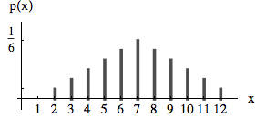
For continuous random variables the probability to get a specific value x is 0. But the probability to get a value out of a certain interval can be indicated by an area that corresponds to this probability. The function f(x) over these areas is called density function. With the following density the chance to get a number smaller than 0 is 0, to get a number between 0 and 0.5 is 0.5, to get a number between .5 and 1 is 0.5 etc. Density functions f(x) can reach values greater than 1 but the area under the function is 1.
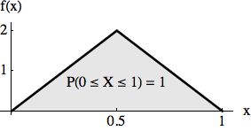

Generating Random Numbers With a Given Probability or Density
Csound provides opcodes for some specific densities but no means to produce random number with user defined probability or density functions. The opcodes rand_density and rand_probability (see below) generate random numbers with probabilities or densities given by tables. They are realized with the so-called rejection sampling method.

Rejection Sampling:
The principle of rejection sampling is first to generate uniformly distributed random numbers in the range required and then to accept these values corresponding to a given density function (otherwise to reject them). Let us demonstrate the method using the density function shown in the next figure. (Since the rejection sampling method only uses the "shape" of the function the area under the function need not be 1). We first generate uniformly distributed random numbers rnd1 over the interval [0, 1]. Of these we accept a proportion corresponding to f(rnd1). For example, the value 0.32 will only be accepted in the proportion of f(0.32) = 0.82. We do this by generating a new random number rand2 between 0 and 1 and accept rnd1 only if rand2 < f(rnd1) and reject it otherwise. (see Signals, Systems and Sound Synthesis chapter 10.1.4.4)
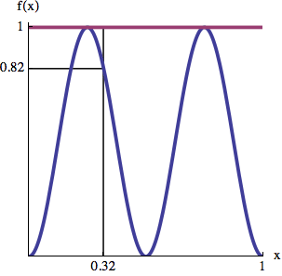
rejection sampling
EXAMPLE Appendix_Random01_Rejection_Sampling.csd
<CsoundSynthesizer>
<CsOptions>
-odac
</CsOptions>
<CsInstruments>
;example by martin neukom
sr = 44100
ksmps = 10
nchnls = 1
0dbfs = 1

; random number generator to a given density function
; kout random number; k_minimum,k_maximum,i_fn for a density function

opcode rand_density, k, kki

kmin,kmax,ifn xin
loop:
krnd1 random 0,1
krnd2 random 0,1
k2 table krnd1,ifn,1
if krnd2 > k2 kgoto loop
xout kmin+krnd1*(kmax-kmin)
endop

; random number generator to a given probability function
; kout random number
; in: i_nr number of possible values
; i_fn1 function for random values
; i_fn2 probability function

opcode rand_probability, k, iii

inr,ifn1,ifn2 xin
loop:
krnd1 random 0,inr
krnd2 random 0,1
k2 table int(krnd1),ifn2,0
if krnd2 > k2 kgoto loop
kout table krnd1,ifn1,0
xout kout
endop

instr 1

krnd rand_density 400,800,2
aout poscil .1,krnd,1
out aout

endin

instr 2

krnd rand_probability p4,p5,p6
aout poscil .1,krnd,1
out aout

endin

</CsInstruments>
<CsScore>
;sine
f1 0 32768 10 1
;density function
f2 0 1024 6 1 112 0 800 0 112 1
;random values and their relative probability (two dice)
f3 0 16 -2 2 3 4 5 6 7 8 9 10 11 12
f4 0 16 2 1 2 3 4 5 6 5 4 3 2 1
;random values and their relative probability
f5 0 8 -2 400 500 600 800
f6 0 8 2 .3 .8 .3 .1

i1 0 10

;i2 0 10 4 5 6
</CsScore>
</CsoundSynthesizer>

Random Walk
In a series of random numbers the single numbers are independent of each other. Parameter (left figure) or paths in the room (two-dimensional trajectory in the right figure) created by random numbers wildly jump around.
Example 1
Table[RandomReal[{-1, 1}], {100}];
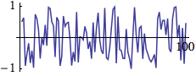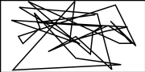
We get a smoother path, a so-called random walk, by adding at every time step a random number r to the actual position x (x += r).
Example 2
x = 0; walk = Table[x += RandomReal[{-.2, .2}], {300}];
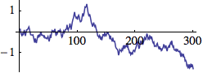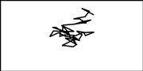
The path becomes even smoother by adding a random number r to the actual velocity v.
v += r
x += v

The path can by bounded to an area (figure to the right) by inverting the velocity if the path exceeds the limits (min, max):

vif(x < min || x > max) v *= -1

The movement can be damped by decreasing the velocity at every time step by a small factor d
v *= (1-d)
Example 3
x = 0; v = 0; walk = Table[x += v += RandomReal[{-.01, .01}], {300}];
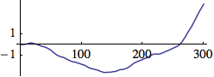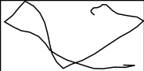
The path becomes again smoother by adding a random number r to the actual acelleration a, the change of the acelleration, etc.

a += r
v += a
x += v
Example 4
x = 0; v = 0; a = 0;
Table[x += v += a += RandomReal[{-.0001, .0001}], {300}];
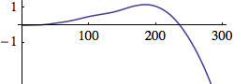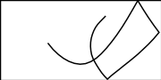
(see Signals, Systems and Sound Synthesis chapter 10.2.3.2)
EXAMPLE Appendix_random02_Random_Walk.csd
<CsoundSynthesizer>
<CsInstruments>
;example by martin neukom

sr = 44100
ksmps = 128
nchnls = 1
0dbfs = 1

; random frequency
instr 1

kx random -p6, p6
kfreq = p5*2^kx
aout oscil p4, kfreq, 1
out aout

endin

; random change of frequency
instr 2

kx init .5
kfreq = p5*2^kx
kv random -p6, p6
kv = kv*(1 - p7)
kx = kx + kv
aout oscil p4, kfreq, 1
out aout

endin

; random change of change of frequency
instr 3

kx init .5
kfreq = p5*2^kx
ka random -p7, p7
kv = kv + ka
kv = kv*(1 - p8)
kx = kx + kv
kv = (kx < -p6 || kx > p6?-kv : kv)
aout oscili p4, kfreq, 1
out aout

endin

<CsInstruments>
<CsScore>
; i1 p4 p5 p6
; i2 p4 p5 p6 p7
; amp c_fr rand damp
; i2 0 20 .1 600 0.01 0.001
; amp c_fr d_fr rand damp
; amp c_fr rand
; i1 0 20 .1 600 0.5
; i3 p4 p5 p6 p7 p8
i3 0 20 .1 600 1 0.001 0.001
<CsScore>
<CsoundSynthesizer>

73. BUILDING CSOUND
Currently (April 2012) a collection of build instructions has been started at the Csound Media Wiki at Sourceforge. Please have a look there if you have problems in building Csound.

Linux

Debian

On Wheezy with an amd64 architecture.
Download a copy of the Csound sources from the Sourceforge. To do so, in the terminal type:
git clone --depth 1 git://csound.git.sourceforge.net/gitroot/csound/csound5
Use aptitude to get (at least) the dependencies for a basic build, which are: libsndfile1-dev, python2.6-dev, scons. To do so, use the following command (with sudo or as root):
aptitude install libsndfile1-dev python2.6-dev scons
There are many more optional dependencies, which are recommended to get in most cases (some are already part of Debian), and which are documented here. I built with the following libraries installed: libportaudiocpp0, alsa, libportmidi0, libfltk1.1, swig2.0, libfluidsynth1 and liblo7. To install them (some might already be in your sistem), type:
aptitude install libportaudiocpp0 alsa libportmidi0 libfltk1.1 swig2.0 libfluidsynth1 liblo7
Go inside the csound5/ folder you downloaded from sourceforge, and edit build-linux-double.sh in order to meet your building needs, once again, read about the options in the Build Csound section of the manual.
On amd64 architectures, it is IMPORTANT to change gcc4opt=atom to gcc4opt=generic (otherwise it will build for single processor). I also used buildNewParser=0, since I could not get to compile with the new parser. To finally build, run the script:
./build-linux-double.sh
If the installation was successful, use the following command to install:
./install.py
Make sure that the following environment
variables are set:
OPCODEDIR64=/usr/local/lib/csound/plugins64
CSSTRNGS=/usr/local/share/locale
If you built the python interface, move the csnd.py and -csnd.so from /usr/lib/python2.6/site-packages/ to /usr/lib/python2.6/dist-packages/ (the standard place for external Python modules since version 2.6). You can do so with the following commands:
/usr/lib/python2.6/site-packages/csnd.py /usr/lib/python2.6/dist-packages/
/usr/lib/python2.6/site-packages/_csnd.so /usr/lib/python2.6/dist-packages/
If you want to un-install, you can do so by running the following command:
/usr/local/bin/uninstall-csound5
Good luck!

Ubuntu
1. Download the sources. Either the last stable release from http://sourceforge.net/projects/csound/files/csound5/ or the latest (possible unstable) sources from git (running the command git clone git://csound.git.sourceforge.net/gitroot/csound/csound5).
2. Open a Terminal window and run the command
sudo apt-get install csound
This should install all the dependencies which are needed to build Csound.
3. Change the directory to the folder you have downloaded in step 1, using the command cd.
4. Run the command scons. You can start with
scons -h
to check the configuration and choose your options. See the Build Csound section of the manual for more information about the options. If you want to build the standard configuration, just run scons without any options.
If you get an error, these are possible reasons:
- You must install bison and flex to use the new parser.
- If there is a complaint about not finding a file called custom.py, copy the file custom-linux-jpff.py and rename it as custom.py.
There is also a detailed instruction by Menno Knevel at csounds.com which may help.
5. Run
sudo python install.py
You should now be able to run csound by the command /usr/local/bin/csound, or simply by the command csound.

OSX
As mentioned above, have a look at http://sourceforge.net/apps/mediawiki/csound/index.php?title=Main_Page.

Windows
There is a detailed set of instructions by Michael Gogins, entitled How to Build Csound on Windows in the Csound Sources. The instructions are kept more or less up to date for each release of the Windows installer. You can either download the Csound Sources at http://sourceforge.net/projects/csound/files/csound5 or get the latest version at the Csound Git Repository.

74. GLOSSARY

control cycle, control period or k-loop is a pass during the performance of an instrument, in which all k- and a-variables are renewed. The time for one control cycle is measured in samples and determined by the ksmps constant in the orchestra header. If your sample rate is 44100 and your ksmps value is 10, the time for one control cycle is 1/4410 = 0.000227 seconds. See the chapter about Initialization And Performance Pass for more information.

control rate or k-rate (kr) is the number of control cycles per second. It can be calculated as the relationship of the sample rate sr and the number of samples in one control period ksmps. If your sample rate is 44100 and your ksmps value is 10, your control rate is 4410, so you have 4410 control cycles per second.

dummy f-statement see f-statement

f-statement or function table statement is a score line which starts with a "f" and generates a function table. See the chapter about function tables for more information. A dummy f-statement is a statement like "f 0 3600" which looks like a function table statement, but instead of generating any table, it serves just for running Csound for a certain time (here 3600 seconds = 1 hour).

FFT Fast Fourier Transform is a system whereby audio data is stored or represented in the frequency domain as opposed to the time domain as amplitude values as is more typical. Working with FFT data facilitates transformations and manipulations that are not possible, or are at least more difficult, with audio data stored in other formats.

GEN rountine a GEN (generation) routine is a mechanism within Csound used to create function tables of data that will be held in RAM for all or part of the performance. A GEN routine could be a waveform, a stored sound sample, a list of explicitly defined number such as tunings for a special musical scale or an amplitude envelope. In the past function tables could only be created only in the Csound score but now they can also be created (and deleted and over-written) within the orchestra.

GUI Graphical User Interface refers to a system of on-screen sliders, buttons etc. used to interact with Csound, normally in realtime.

i-time or init-time or i-rate signify the time in which all the variables starting with an "i" get their values. These values are just given once for an instrument call. See the chapter about Initialization And Performance Pass for more information.

k-loop see control cycle

k-time is the time during the performance of an instrument, after the initialization. Variables starting with a "k" can alter their values in each ->control cycle. See the chapter about Initialization And Performance Pass for more information.

k-rate see control rate

opcode the code word of a basic building block with which Csound code is written. As well as the opcode code word an opcode will commonly provide output arguments (variables), listed to the left of the opcode, and input arguments (variables). listed to the right of the opcode. An opcode is equivalent to a 'ugen' (unit generator) in other languages.

orchestra as in the Csound orchestra, is the section of Csound code where traditionally the instruments are written. In the past the 'orchestra' was one of two text files along with the 'score' that were needed to run Csound. Most people nowadays combine these two sections, along with other optional sections in a .csd (unified) Csound file. The orchestra will also normally contain header statements which will define global aspects of the Csound performance such as sampling rate.

p-field a 'p' (parameter) field normally refers to a value contained within the list of values after an event item with the Csound score.

performance pass see control cycle

score as in the Csound score, is the section of Csound code where note events are written that will instruct instruments within the Csound orchestra to play. The score can also contain function tables. In the past the 'score' was one of two text files along with the 'orchestra' that were needed to run Csound. Most people nowadays combine these two sections, along with other optional sections in a .csd (unified) Csound file.

time stretching can be done in various ways in Csound. See sndwarp, waveset, pvstanal mincer, pvsfread, pvsdiskin and the Granular Synthesis opcodes.

widget normally refers to some sort of standard GUI element such as a slider or a button. GUI widgets normally permit some user modifications such as size, positioning colours etc. A variety options are available for the creation of widgets usable by Csound, from it own built-in FLTK widgets to those provided by front-ends such as CsoundQT, Cabbage and Blue.

75. LINKS

Downloads
Csound FLOSS Manual Files: http://files.csound-tutorial.net/floss_manual/
Csound: http://sourceforge.net/projects/csound/files/
Csound's User Defined Opcodes: http://www.csounds.com/udo/
CsoundQt: http://sourceforge.net/projects/qutecsound/files/
WinXound:http://winxound.codeplex.com
Blue: http://sourceforge.net/projects/bluemusic/files/
Cabbage: http://code.google.com/p/cabbage

Community
Csound's info page on sourceforge is a good collection of links and basic infos.
csounds.com is the main page for the Csound community, including news, online tutorial, forums and many links.
The Csound Journal is a main source for different aspects of working with Csound.

Mailing Lists and Bug Tracker
To subscribe to the Csound User Discussion List, send a message with "subscribe csound <your name>" in the message body to sympa@lists.bath.ac.uk. To post, send messages to csound@lists.bath.ac.uk. You can search in the list archive at nabble.com.
To subscribe to the CsoundQt User Discussion List, go to https://lists.sourceforge.net/lists/listinfo/qutecsound-users. You can browse the list archive here.
Csound Developer Discussions: https://lists.sourceforge.net/lists/listinfo/csound-devel
Blue: http://sourceforge.net/mail/?group_id=74382
Please report any bug you experienced in Csound at http://sourceforge.net/tracker/?group_id=81968&atid=564599, and a CsoundQt related bug at http://sourceforge.net/tracker/?func=browse&group_id=227265&atid=1070588. Every bug report is an important contribution.

Tutorials
A Beginning Tutorial is a short introduction from Barry Vercoe, the "father of Csound".
An Instrument Design TOOTorial by Richard Boulanger (1991) is another classical introduction, still very worth to read.
Introduction to Sound Design in Csound also by Richard Boulanger, is the first chapter of the famous Csound Book (2000).
Virtual Sound by Alessandro Cipriani and Maurizio Giri (2000)
A Csound Tutorial by Michael Gogins (2009), one of the main Csound Developers.

Video Tutorials
A playlist as overview by Alex Hofmann:
http://www.youtube.com/view_play_list?p=3EE3219702D17FD3

CsoundQt (QuteCsound)
QuteCsound: Where to start?
http://www.youtube.com/watch?v=0XcQ3ReqJTM
First instrument:
http://www.youtube.com/watch?v=P5OOyFyNaCA
Using MIDI:
http://www.youtube.com/watch?v=8zszIN_N3bQ
About configuration:
http://www.youtube.com/watch?v=KgYea5s8tFs
Presets tutorial:
http://www.youtube.com/watch?v=KKlCTxmzcS0
http://www.youtube.com/watch?v=aES-ZfanF3c
Live Events tutorial:
http://www.youtube.com/watch?v=O9WU7DzdUmE
http://www.youtube.com/watch?v=Hs3eO7o349k
http://www.youtube.com/watch?v=yUMzp6556Kw
New editing features in 0.6.0:
http://www.youtube.com/watch?v=Hk1qPlnyv88
New features in 0.7.0:
https://www.youtube.com/watch?v=iytVlxMILyw

Csoundo (Csound and Processing)
http://csoundblog.com/2010/08/csound-processing-experiment-i/

Open Sound Control in Csound
http://www.youtube.com/watch?v=JX1C3TqP_9Y

Csound and Inscore
http://vimeo.com/54160283 (installation)
http://vimeo.com/54160405 (examples)
german versions:
http://vimeo.com/54159567 (installation)
http://vimeo.com/54159964 (beispiele)

The Csound Conference in Hannover (2011)
Web page with papers and program.
All Videos can be found via the YoutTube channel csconf2011.

Example Collections
Csound Realtime Examples by Iain McCurdy is one of the most inspiring and up-to-date collections.
The Amsterdam Catalog by John-Philipp Gather is particularily interesting because of the adaption of Jean-Claude Risset's famous "Introductory Catalogue of Computer Synthesized Sounds" from 1969.

Books
The Csound Book (2000) edited by Richard Boulanger is still the compendium for anyone who really wants to go in depth with Csound.
Virtual Sound by Alessandro Cipriani and Maurizio Giri (2000)
Signale, Systeme, und Klangsysteme by Martin Neukom (2003, german) has many interesting examples in Csound.
The Audio Programming Book edited by Richard Boulanger and Victor Lazzarini (2011) is a major source with many references to Csound.
Csound Power! by Jim Aikin (2012) is a perfect up-to-date introduction for beginners.

