1. Ran JPS command to check all Hadoop daemons are running.

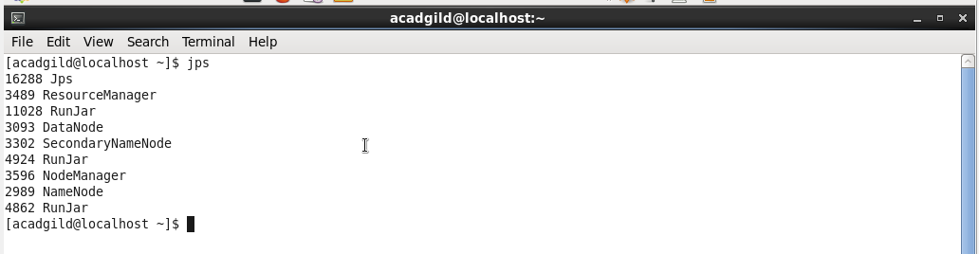

2)Ran sudo service sshd start command to invoke ssh server.



3)Command to invoke all deamons start-all.sh

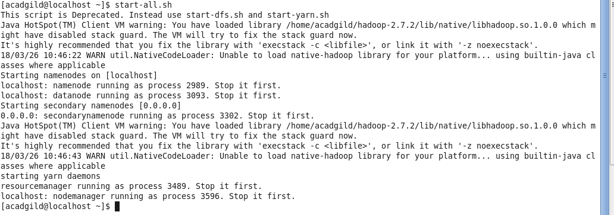

4) Created file test.txt with vi editor and inserted command. Used Cat to view the file. 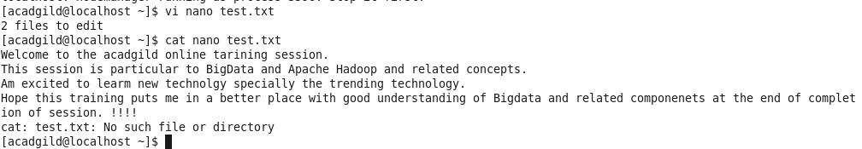

5)Some basic unix commands

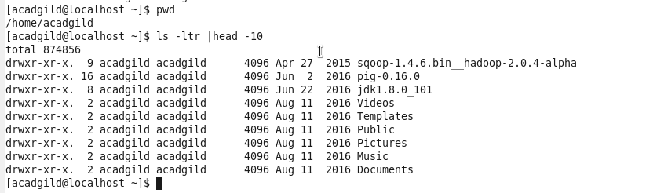

6)HDFS storage overview like data node, name nodes and some directories.

