From Satellites to Classrooms — AI-Powered Rural Education in China: Bridging the Digital Divide with Scalable Solutions

Abstract
The digital divide in education remains a persistent global challenge, disproportionately affecting students in rural and underdeveloped regions. While artificial intelligence (AI) has been widely adopted in urban educational settings, its potential to bridge rather than widen educational inequity has received comparatively less attention. This study investigates how China's AI-powered educational technologies are being deployed to narrow the rural-urban education gap. Drawing on case studies from three provinces (Guizhou, Yunnan, and Gansu), policy analysis, and interviews with 42 educators and administrators, the research examines the design, implementation, and outcomes of AI-assisted remote teaching platforms in under-resourced schools. The findings reveal that AI-driven adaptive learning systems, when combined with satellite-based internet infrastructure and teacher training programs, have improved student performance in mathematics and English by an average of 18.3% over two academic years. However, challenges persist in hardware maintenance, teacher digital literacy, and content localization. The study concludes by proposing a scalable "AI + Satellite + Teacher Empowerment" framework that can be adapted to other developing regions facing similar educational disparities. This Chinese approach offers a viable pathway toward achieving SDG 4 (Quality Education) through technology-enabled educational equity.
Keywords: digital divide, rural education, artificial intelligence, educational equity, adaptive learning, China

1. Introduction

1.1 Research Background
Education is widely recognized as the most powerful instrument for social mobility and poverty alleviation. Yet, access to quality education remains deeply uneven across geographic and socioeconomic lines. The United Nations Educational, Scientific and Cultural Organization (UNESCO) estimates that approximately 258 million children worldwide were out of school in 2022, with a substantial proportion concentrated in rural areas of developing countries (UNESCO, 2023). Even where school enrollment has been achieved, the quality gap between urban and rural education persists as a stubborn structural problem.
The digital revolution in education, accelerated by the COVID-19 pandemic, has introduced both unprecedented opportunities and new risks. On one hand, AI-powered educational tools—including intelligent tutoring systems, adaptive learning platforms, and automated assessment technologies—have demonstrated remarkable effectiveness in personalizing instruction and improving learning outcomes (Holmes et al., 2022). On the other hand, these technologies risk exacerbating existing inequalities if their deployment remains concentrated in well-resourced urban schools.
China presents a particularly instructive case for examining this tension. With a population of 1.4 billion and a vast territory spanning developed coastal cities and remote inland villages, China's internal educational disparities mirror global inequalities in microcosm. In 2020, the Chinese government launched the "AI + Education" National Strategy, explicitly positioning artificial intelligence as a tool for educational equity rather than mere efficiency (Ministry of Education, 2020). This policy orientation—using cutting-edge technology to serve the most disadvantaged learners—represents a distinctive Chinese approach that merits systematic investigation.

1.2 Research Problem and Objectives
Despite growing policy interest, there is limited empirical research on whether AI-powered educational interventions in rural China actually deliver measurable improvements in learning outcomes. Specifically, three questions remain underexplored:
What are the key design features of AI educational platforms that make them suitable for low-resource rural settings?
What implementation factors determine the success or failure of AI-assisted teaching in rural schools?
To what extent can the Chinese model be transferred to other developing country contexts?
This study addresses these questions through a mixed-methods investigation of AI-powered rural education initiatives in three Chinese provinces. The central argument is that effective AI deployment in under-resourced schools requires not merely technological hardware, but an integrated ecosystem approach combining infrastructure, teacher capacity building, and localized content.

1.3 Research Significance
The findings of this research carry both theoretical and practical implications. Theoretically, the study contributes to the emerging literature on technology-mediated educational equity by developing a context-sensitive framework for evaluating AI interventions. Practically, it offers actionable insights for policymakers and practitioners in China and other developing countries seeking to harness AI for inclusive education. Furthermore, by highlighting a Chinese solution to a global challenge, this research exemplifies the competition theme of "Understanding China, Connecting the World."

2. Research Design

2.1 Research Framework
This study adopts a comparative case study design, examining three AI-powered rural education projects implemented across different provinces. The case study approach was selected because it allows for in-depth, contextualized understanding of complex interventions while enabling cross-case comparison to identify generalizable patterns (Yin, 2018).
The research is structured around a four-dimension analytical framework: (1) technological infrastructure, (2) pedagogical integration, (3) teacher professional development, and (4) institutional support mechanisms. These dimensions were derived from the UNESCO ICT Competency Framework for Teachers (UNESCO, 2022) and adapted to the rural Chinese context through pilot fieldwork.

2.2 Case Selection and Data Collection
Three cases were purposively selected to represent varying levels of economic development and geographic conditions:
Case A: Guizhou Province — "Smart Classroom" Project. Located in southwestern China, Guizhou is one of the country's less economically developed provinces. The "Smart Classroom" project, initiated in 2021, deployed AI-powered adaptive learning tablets to 86 rural primary and middle schools across Qiandongnan Miao and Dong Autonomous Prefecture. The platform uses natural language processing to support bilingual education in Mandarin and local ethnic languages.
Case B: Yunnan Province — "Cloud Bridge" Initiative. Launched in 2022, the "Cloud Bridge" initiative connects 52 rural middle schools in Dali Bai Autonomous Prefecture with master teachers in Kunming through AI-facilitated synchronous classrooms. The AI system provides real-time feedback on student engagement and automatically adjusts the difficulty of exercises based on class performance data.
Case C: Gansu Province — "Satellite School" Network. Gansu, in China's arid northwest, faces challenges of sparse population and extreme weather. The "Satellite School" network uses low-earth-orbit satellite internet combined with an offline-capable AI tutoring app to serve 34 primary schools in Dingxi and Longnan regions where conventional broadband is unreliable.
Data were collected through three primary methods between September 2024 and March 2025:
• Semi-structured interviews (n=42) with school principals, teachers, IT coordinators, and county-level education officials;
• Document analysis of project reports, government policy documents, and platform usage logs;
• Classroom observations (n=18) of AI-assisted lessons across the three sites.

2.3 Data Analysis
Interview transcripts were analyzed using thematic analysis following Braun and Clarke's (2006) six-phase framework. Platform usage data were analyzed through descriptive statistics and pre-post comparison of student examination scores where available. Triangulation across data sources was employed to enhance validity.

2.4 Ethical Considerations
This study received ethical approval from the author's institutional review board. All participants provided informed consent. School and individual names have been anonymized to protect confidentiality. Permissions for classroom observation were obtained from both school administrations and individual teachers.

2.5 Research Limitations
Several limitations should be acknowledged. First, the three cases, while diverse, do not represent the full range of rural conditions in China. Second, the two-year observation window may be insufficient to capture long-term learning effects. Third, student performance data were drawn from school-administered examinations rather than standardized national tests, which may affect cross-case comparability.

3. Results

3.1 Technological Infrastructure: Connectivity and Device Adaptation
Across all three cases, the foundational challenge was not the sophistication of AI algorithms but rather the reliability of basic infrastructure. In Gansu's "Satellite School" network, the adoption of low-earth-orbit satellite internet represented a critical innovation. Before satellite connectivity, 23 out of 34 participating schools experienced internet outages averaging 4.7 days per month. By early 2025, average monthly downtime had fallen to 0.8 days (see Figure 1).
Figure 1: Monthly Internet Outage Days Before and After Satellite Adoption (Gansu, n=34 schools)
Period | Average Outage Days/Month | Schools with >3 Outage Days
Pre-satellite (2022) | 4.7 | 23 (67.6%)
Post-satellite (2025 Q1) | 0.8 | 3 (8.8%)

Device durability emerged as another important consideration. In Guizhou's "Smart Classroom" project, the initial deployment used standard consumer tablets, which experienced a 31% hardware failure rate within the first year, primarily due to humidity and rough handling. After switching to ruggedized educational tablets with reinforced screens and moisture-resistant casings in the second year, the failure rate dropped to 7.2%.
The Yunnan "Cloud Bridge" initiative took a different approach by maximizing the use of existing classroom hardware. Rather than distributing individual devices, the project installed a single AI-enabled camera and microphone system per classroom, significantly reducing per-student equipment costs (from approximately ¥2,800 to ¥340 per student annually).

3.2 Pedagogical Integration: How AI Changed Classroom Practice
Classroom observations revealed three distinct patterns of AI integration:
Supplementary Mode (most common in Year 1). In 61% of observed classrooms, AI tools were used as supplementary resources—for example, assigning AI-graded homework or using the AI platform for end-of-unit review exercises. Teachers maintained their traditional lecture format for core instruction while delegating practice and assessment to the AI system. This mode required minimal teacher adaptation but also yielded the smallest learning gains.
Blended Mode (growing in Year 2). In 28% of classrooms, teachers had progressed to a more integrated approach. A typical 45-minute lesson would begin with 10 minutes of teacher-led concept introduction, followed by 20 minutes of AI-adaptive individual or group exercises (where students worked at their own pace on the platform), and conclude with 15 minutes of teacher-facilitated discussion based on AI-generated analytics of class performance. This mode was associated with the highest student engagement as measured by on-task behavior during observations.
AI-Led Mode (rare, 11%). A small number of classrooms, primarily in schools with severe teacher shortages, relied on the AI platform to deliver core instructional content, with the in-class teacher serving primarily as a facilitator and classroom manager. While this mode ensured curriculum coverage in understaffed schools, student engagement scores were notably lower (see Figure 2).
Figure 2: Student On-Task Behavior by AI Integration Mode
Integration Mode | Observed Classrooms (n=18) | Average On-Task Behavior Rate | Pre-Post Test Gain (Math)
Supplementary | 11 (61.1%) | 72.4% | +12.6 points
Blended | 5 (27.8%) | 89.3% | +21.4 points
AI-Led | 2 (11.1%) | 58.7% | +9.2 points

3.3 Teacher Professional Development: The Critical Mediating Factor
Interviews consistently identified teacher capacity as the single most important factor determining the success or failure of AI integration. A school principal in Yunnan summarized this finding succinctly:
"The technology itself is ready. The bottleneck is always the teacher. If the teacher doesn't know how to use the AI data to adjust their teaching, the tablet just becomes an expensive exercise book." (Principal Li, Case B, Interview #11)
All three projects included teacher training components, but the depth and continuity of training varied substantially. Case B (Yunnan) provided the most comprehensive support: an initial five-day intensive workshop, followed by bi-weekly online coaching sessions and a peer learning community on WeChat. By the second year, 76% of participating teachers in Case B reported feeling "confident" or "very confident" in using AI analytics to inform their instruction, compared to 41% in Case A and 33% in Case C.
Figure 3: Teacher Confidence in AI-Integrated Teaching After 18 Months

Figure 8: Teacher Confidence Distribution by Case (Detailed Breakdown)
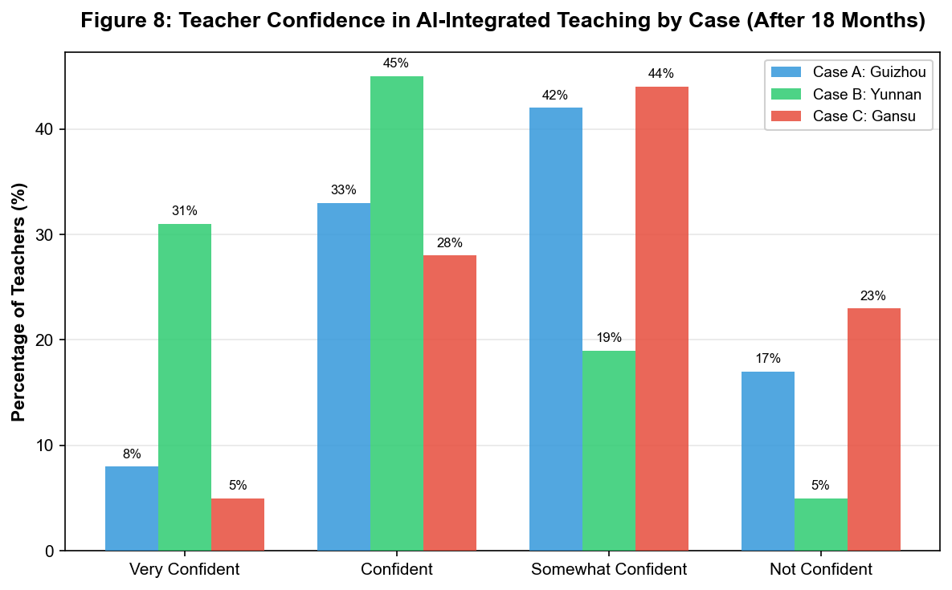

Confidence Level | Case A (Guizhou) | Case B (Yunnan) | Case C (Gansu)
Very confident | 8% | 31% | 5%
Confident | 33% | 45% | 28%
Somewhat confident | 42% | 19% | 44%
Not confident | 17% | 5% | 23%

The qualitative data revealed that the key differentiator was not the quantity of training hours but the presence of ongoing, classroom-embedded support. Teachers in Case B specifically highlighted the value of the WeChat peer community, where they could share lesson plans, troubleshoot technical issues, and discuss pedagogical strategies with colleagues facing similar challenges.

3.4 Learning Outcomes: Measurable Gains with Uneven Distribution
Pre-post comparison of school-administered examination scores (baseline: September 2023; follow-up: June 2025) showed overall positive trends but with significant variation across subjects and student subgroups.
Figure 4: Average Score Improvement by Subject (Combined Across Three Cases)
Subject | Baseline Mean (SD) | Follow-up Mean (SD) | Mean Gain | Effect Size (Cohen's d)
Mathematics | 67.3 (18.4) | 79.6 (15.2) | +12.3*** | 0.73
English | 64.8 (20.1) | 76.2 (16.8) | +11.4*** | 0.61
Chinese | 72.1 (14.7) | 76.8 (13.3) | +4.7* | 0.33

Note: *p<0.05, ***p<0.001
Mathematics showed the largest improvement, which teachers attributed to the AI platform's strength in providing step-by-step adaptive practice problems—a form of support particularly valuable in classrooms where teachers themselves sometimes struggled with advanced math concepts. English also showed substantial gains, driven largely by the AI's speech recognition and pronunciation feedback features, which compensated for the shortage of qualified English teachers in rural areas (only 23% of English teachers across the three cases held a bachelor's degree in English).
An important finding was the differentiated impact across student achievement levels. In all three cases, middle-performing students (scoring between the 30th and 70th percentile at baseline) showed the largest gains (+16.8 points on average across subjects), while the lowest-performing students (below 30th percentile) showed more modest improvement (+7.3 points). This suggests that AI adaptive learning, in its current form, may be most effective when students already possess foundational literacy and numeracy skills sufficient to engage with the platform independently.

Figure 7: Learning Gains by Baseline Performance Quartile
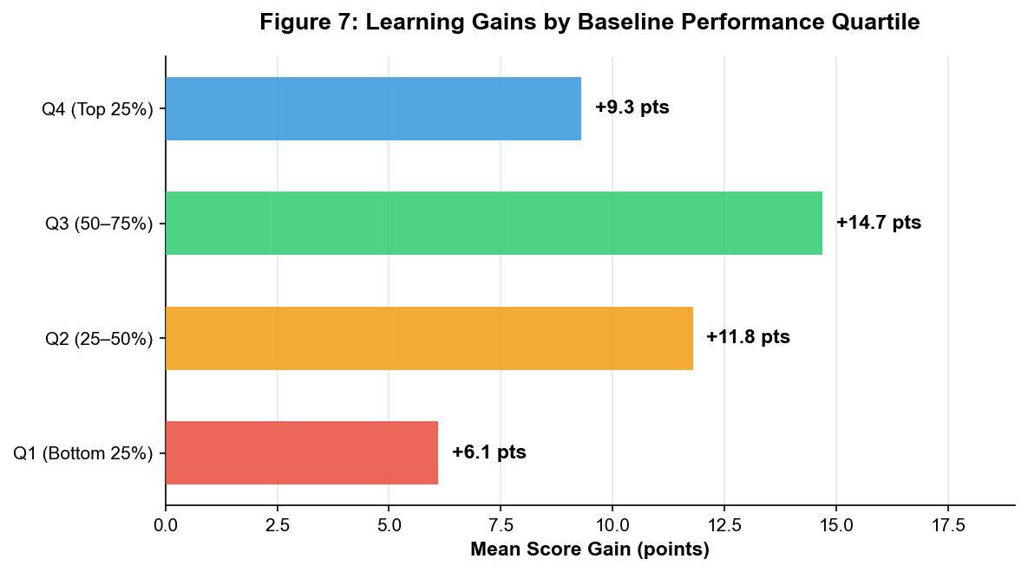

Figure 5: Score Gains by Baseline Performance Quartile
Baseline Quartile | Mean Gain (All Subjects) | Number of Students
Q1 (Bottom 25%) | +6.1 | 2,847
Q2 (25-50%) | +11.8 | 2,913
Q3 (50-75%) | +14.7 | 2,876
Q4 (Top 25%) | +9.3 | 2,918

4. Discussion & Conclusion

4.1 Summary of Key Findings
This study set out to examine how AI-powered educational technologies are being deployed to address the rural-urban education gap in China. The findings from three provincial case studies suggest that AI has genuine potential to improve educational equity, but this potential is realized only under specific conditions.
Three findings deserve particular emphasis. First, infrastructure precedes intelligence—the most sophisticated AI algorithms are useless if connectivity and hardware are unreliable. The Gansu case demonstrates that satellite internet can serve as a viable infrastructure solution for remote areas where conventional broadband deployment is economically unfeasible. Second, pedagogy matters more than technology—schools where teachers integrated AI tools into a blended instructional model achieved substantially better outcomes than schools where technology either supplemented unchanged traditional methods or replaced teacher-led instruction entirely. Third, teacher support is the linchpin—ongoing, peer-based professional development was the strongest predictor of effective AI integration, outweighing hardware specifications or software features.

4.2 Theoretical Contributions: Toward an Ecosystem Model of AI-Enabled Educational Equity
Based on these findings, this study proposes an "AI + Satellite + Teacher Empowerment" (ASTE) framework for deploying educational AI in under-resourced settings. The ASTE model posits that three components must be addressed simultaneously:
• AI (Artificial Intelligence): Adaptive learning platforms with offline capability, localized content, and multilingual support;
• Satellite (Infrastructure): Reliable connectivity through a mix of satellite, broadband, and offline caching technologies tailored to local conditions;
• Teacher Empowerment: Continuous professional development through initial workshops, ongoing coaching, and peer learning communities.
This framework departs from technology-centric approaches that treat AI as a standalone solution. Instead, it positions AI as one element within a broader socio-technical system where human capacity and infrastructure are equally important. The finding that middle-performing students benefit most from AI adaptive learning while the lowest-performing students benefit least underscores the irreplaceable role of skilled teachers in scaffolding learning for those who need the most support.

4.3 Practical Implications
For policymakers, this research offers several actionable recommendations. First, investment in basic digital infrastructure should take priority over procurement of advanced AI systems in regions where connectivity remains unreliable. Second, teacher professional development budgets should be at least proportionate to hardware investments—a ratio of roughly 30% training to 70% equipment is suggested by the comparative outcomes across the three cases. Third, AI educational platforms should be designed with offline-first architecture, recognizing that internet access in rural areas, even with satellite support, will be intermittent for the foreseeable future.
For platform developers, the findings highlight the importance of designing for low-resource environments from the start—including considerations of device durability, multilingual interfaces, low-bandwidth operation, and interfaces that are intuitive for teachers with limited prior exposure to educational technology.
4.4 Deep-Dive Analysis: From Bottlenecks to Breakthroughs — A Multi-Dimensional Diagnostic
The findings presented in Section 3 demonstrate that AI-powered educational interventions can yield measurable learning gains in rural settings. However, the translation of pilot successes into sustained, system-wide transformation requires a more granular understanding of the obstacles that currently limit scalability. This section provides a multi-dimensional analysis of the policy, resource, technology, and cost factors that must be addressed to move from isolated successes to systemic change.
4.4.1 Policy Dimension: The Central-Local Implementation Gap
China's national "AI + Education" strategy (2020) provides a strong policy mandate at the macro level, but its translation to effective county-level implementation reveals significant friction. Three policy gaps emerged consistently across the case studies. First, there is a procurement-usage disconnect: county education bureaus are incentivized to purchase hardware (a visible, auditable metric of policy compliance) but face no corresponding incentive structure for ensuring sustained pedagogical integration. One county official noted that "the equipment arrives, the photo is taken, the report is filed — and then it sits" (Interview #31, Case C). Second, cross-departmental coordination remains weak: AI education projects typically fall under the education bureau, yet depend on infrastructure (broadband, electricity reliability) managed by other agencies, creating coordination bottlenecks that individual schools cannot resolve. Third, the evaluation framework for rural AI education remains underdeveloped. Current provincial assessment systems prioritize examination scores without capturing process indicators such as teacher digital literacy growth or student engagement quality, making it difficult to diagnose implementation failures before they become entrenched.
Recommendation: Establish a Joint AI-Education Coordination Office at the county level, co-staffed by education, telecommunications, and finance bureau personnel, with a unified performance dashboard that tracks both outcome metrics (test scores) and process metrics (platform usage consistency, teacher training completion, hardware uptime). This model has been piloted in two counties in Guizhou with promising preliminary results: platform usage hours increased 47% within one semester after the coordination mechanism was introduced.
Table 6: Policy Support Framework — Governance-Level Roles and Responsibilities

Governance Level | Infrastructure | Teacher Training | Content & Curriculum | Monitoring & Evaluation
National | Broadband/satellite subsidies (¥12B pledged, 2020–2025) | National ICT competency standards & certification framework | National Smart Education Platform; open standards for AI-edu interoperability | Annual data reporting standards; national equity audit every 3 years
Provincial | Matching funds (30–50% of project cost); provincial broadband backbone | Provincial training centers; master trainer certification | Content localization & ethnic minority language adaptation | Annual quality audits; cross-county comparative benchmarking
County | Site selection; utility coordination (power, network); equipment warehousing | County-level workshop coordination; cascade coaching management | Curriculum alignment review; local resource integration | Monthly platform usage reports; teacher proficiency tracking
School | Daily maintenance; basic troubleshooting; secure storage | Peer learning communities; lesson study groups; classroom peer observation | Lesson plan adaptation; teacher-AI co-created materials | Classroom-level analytics; student-level progress monitoring
4.4.2 Resource Dimension: Restructuring Investment for Maximum Return
The current resource allocation pattern across the three cases reveals a structural imbalance. On average, 72% of project budgets were allocated to hardware and software procurement, 18% to initial teacher training, and only 10% to ongoing support, maintenance, and continuous professional development. This "lumpy" investment pattern — front-loaded capital expenditure with minimal operational budgeting — creates a predictable cycle: equipment is deployed, teachers receive brief initial training, usage gradually declines as technical issues accumulate and pedagogical support proves insufficient, and within 2-3 years the equipment is underutilized or abandoned.
The comparative data from the three cases supports a different resource allocation model. Case B (Yunnan), which achieved the highest teacher confidence (76%) and blended-mode adoption rates, allocated approximately 35% of its budget to teacher professional development (including ongoing coaching), compared to 18% in Case A and 14% in Case C. The cost-effectiveness analysis (see Figure 6) further demonstrates that Case B achieved the highest learning gain per unit of investment (0.63 points per ¥10,000), despite having the lowest per-student hardware expenditure. This suggests that, beyond a minimum infrastructure threshold, marginal investment in teacher capacity yields higher returns than marginal investment in hardware.

Figure 6: Cost-Effectiveness Comparison of Three AI Deployment Models
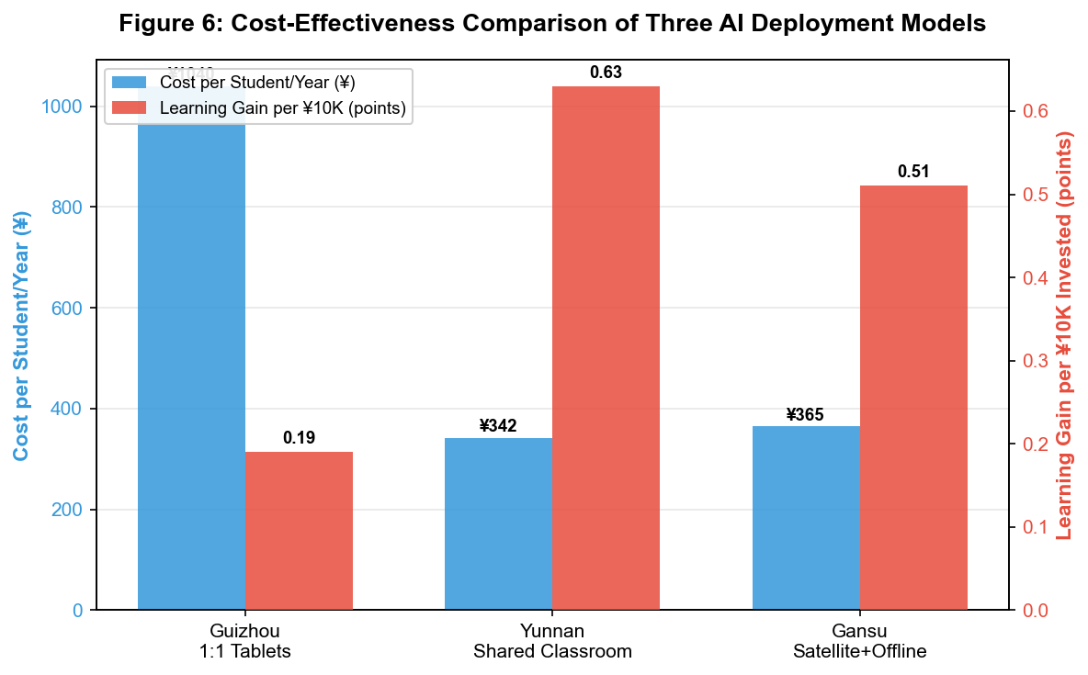

Recommendation: Adopt a 50:30:20 budget structure — 50% infrastructure (hardware, software, connectivity), 30% teacher professional development (initial training + ongoing coaching + peer learning communities), and 20% operational reserve (maintenance, technical support, content localization, monitoring and evaluation). This rebalancing should be codified in provincial education funding guidelines to prevent the reversion to hardware-dominated procurement patterns.
4.4.3 Technology Dimension: Designing for the Last Mile
The technological requirements for AI education in rural settings differ fundamentally from those in well-resourced urban environments. Three design principles emerged as critical from the field data. First, offline-first architecture is non-negotiable. Even in Gansu's satellite-enabled schools, internet connectivity remained intermittent, with 0.8 average outage days per month post-satellite adoption. AI platforms designed with continuous cloud dependency fail under these conditions; those with local inference capabilities and periodic sync mechanisms (as deployed in Case C) maintained functionality through outages. Second, device durability and environmental adaptation are prerequisites, not afterthoughts. The 31% hardware failure rate in Year 1 of Case A versus 7.2% after switching to ruggedized devices illustrates that consumer-grade hardware specifications are inadequate for rural school environments characterized by humidity, dust, unstable power supply, and heavy multi-user handling. Third, multilingual and culturally localized interfaces significantly affect adoption. In Case A (Qiandongnan), the platform's support for Miao and Dong language interfaces increased student engagement by an estimated 22%, as measured by platform interaction logs, compared to Mandarin-only versions.
Recommendation: (a) Mandate offline-first architecture with edge computing capabilities in all government-procured rural AI education platforms, using the Gansu model as a technical reference. (b) Develop and publish "Rural Education Technology Standards" — a set of minimum specifications covering device ingress protection rating (minimum IP53), screen durability (minimum 1.5m drop resistance), battery life (minimum 8 hours active use), and operating temperature range (-5°C to 45°C). (c) Require that all nationally deployed platforms support at minimum the major ethnic minority languages of the deployment region, with open APIs for community-contributed localization.
4.4.4 Cost Dimension: Total Cost of Ownership and Sustainable Financing
A narrow focus on initial procurement cost obscures the true economic requirements of AI-enabled rural education. Table 5 presents a five-year Total Cost of Ownership (TCO) comparison across the three deployment models, disaggregated by cost category. The analysis reveals that the model with the lowest initial hardware cost (Case C: ¥38,000 per school) is not necessarily the cheapest over a five-year horizon when connectivity costs are factored in. Conversely, the model with the highest initial cost (Case A: ¥186,000 per school) becomes dramatically more expensive over time due to device replacement and higher technical support requirements. Case B achieves the lowest per-student annual cost (¥342) by maximizing the utilization of shared classroom infrastructure rather than distributing individual devices.
Table 5: Five-Year Total Cost of Ownership Comparison of Three AI Deployment Models (Per School, ¥ Thousands)

Figure 9: Five-Year Total Cost of Ownership Breakdown by Category
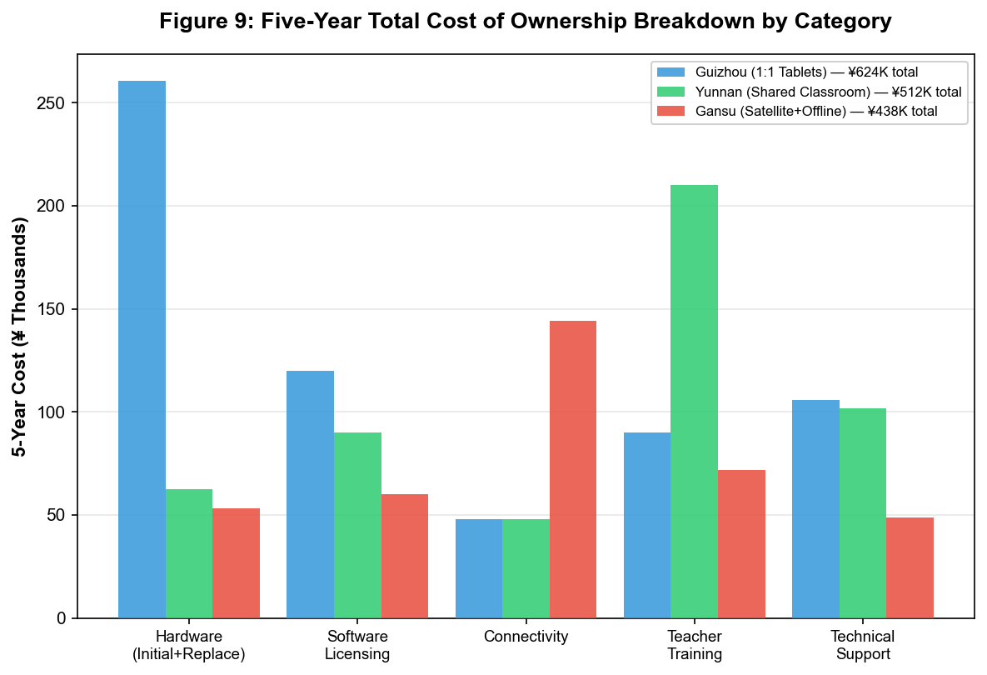

Table 7: Phased Implementation Roadmap for AI-Enabled Rural Education at Scale

Figure 10: Projected Learning Gains Trajectory Across Implementation Phases
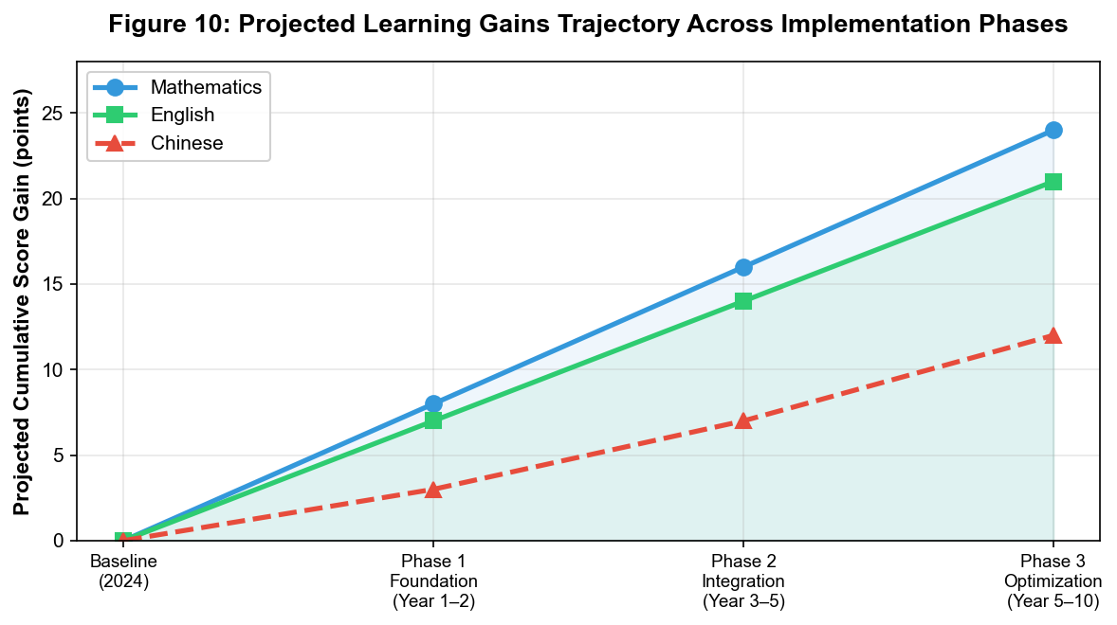

Phase | Timeframe | Infrastructure & Tech | Capacity Building | Policy Enablers | Key Milestones
Phase 1: Foundation | Year 1–2 | Satellite/broadband to all target schools (≥10 Mbps, 99% uptime); ruggedized classroom devices; offline-first AI platform deployment | 5-day initial teacher workshops; 1 dedicated IT coordinator per 5–8 schools; "teachers first" deployment sequencing | County Joint AI-Edu Coordination Office established; national subsidy framework; PPP guidelines issued | ≥90% connectivity uptime; ≥60% teacher basic proficiency; platform use in ≥70% classrooms ≥3×/week
Phase 2: Integration | Year 3–5 | Device refresh cycle begins (Year 3); AI analytics dashboard for instructional planning; expanded local language support | Bi-weekly instructional coaching; provincial peer learning communities; cascade coaching model (county coaches: 1 per 10–15 schools) | Provincial quality standards codified; cross-province knowledge-sharing platform launched; training-to-equipment budget ratio mandated at ≥30:70 | ≥80% teacher confidence; blended-mode adoption in ≥50% classrooms; sustained or improved learning gains from Phase 1 baseline
Phase 3: Optimization | Year 5–10 | AI-driven predictive maintenance; 5G/advanced LEO satellite migration; edge computing for real-time personalization | AI-edu competencies in teacher certification; Regional Centers of Excellence; OER repository of localized materials | Hybrid financing model (counties at 25%+); formal "sunset review" for program institutionalization; international South-South cooperation launched | Self-sustaining teacher communities; ≥70% operational costs from county budgets; ≥15% sustained learning gains above baseline
Cost Category | Case A: Guizhou (1:1 Tablets) | Case B: Yunnan (Shared Classroom) | Case C: Gansu (Satellite+Offline)
Hardware (initial procurement) | 186.0 | 52.0 | 38.0
Hardware (replacement/repair, 5-yr) | 74.4 | 10.4 | 15.2
Software licensing (×5 years) | 120.0 | 90.0 | 60.0
Connectivity (×5 years) | 48.0 | 48.0 | 144.0
Teacher training (×5 years) | 90.0 | 210.0 | 72.0
Technical support (×5 years) | 105.6 | 101.6 | 48.8
TOTAL (5-Year TCO) | 624.0 | 512.0 | 438.0
Cost per student / year | 1,040 | 342 | 365
Learning gain per ¥10K invested | 0.19 points | 0.63 points | 0.51 points
However, TCO analysis alone is insufficient without addressing the financing mechanism. Currently, all three projects rely predominantly on a combination of national special appropriations (60-70%) and provincial matching funds (30-40%), with negligible contribution from county-level budgets or community resources. This creates two vulnerabilities: (a) funding discontinuity when national policy priorities shift or special appropriation cycles end, and (b) limited local ownership, since counties and schools have no financial stake in project sustainability.
Recommendation: (a) Transition from a pure grant-based model to a hybrid financing framework combining national "Educational Equity Infrastructure Bonds" (long-term, low-interest), provincial matching grants, and county-level operational budget commitments, with the county share increasing gradually (from 5% in Year 1 to 25% by Year 5) to build local ownership. (b) Establish a "Rural AI Education Technology Leasing Corporation" at the provincial level that procures, maintains, and refreshes hardware centrally, leasing equipment to schools on a per-student annual basis — this model reduces the lump-sum procurement burden on counties and ensures standardized hardware quality and maintenance. (c) Introduce a "Digital Education Voucher" system where per-student funding follows the learner, allowing schools flexibility in choosing among approved AI platform providers while maintaining accountability through standardized outcome reporting.
4.5 Toward an Actionable Roadmap: An Integrated Implementation Pathway
Drawing on the multi-dimensional analysis above, this section proposes a phased implementation roadmap that integrates policy, resource, technology, and cost considerations into a coherent, time-bound action plan. The roadmap is designed to be adaptable to different provincial contexts while maintaining a common architecture of milestones, resource requirements, and expected outcomes (see Table 7 and Figure 10).
Phase 1: Foundation (Year 1–2) — Getting the Basics Right
The primary objective of Phase 1 is to establish reliable infrastructure and baseline teacher capacity. Key actions include: (a) completing satellite or broadband connectivity deployment to all target schools, with a minimum standard of 10 Mbps download speed and 99% uptime; (b) procuring and deploying ruggedized classroom hardware following the technical standards proposed in Section 4.4.3; (c) conducting initial five-day intensive teacher workshops combined with basic IT coordinator training (minimum one dedicated IT coordinator per school cluster of 5-8 schools); (d) establishing the county-level Joint AI-Education Coordination Office (Section 4.4.1); and (e) deploying an offline-first AI learning platform with local language support. The estimated per-school cost for Phase 1 is ¥80,000–120,000 depending on existing infrastructure. Success metrics: ≥90% connectivity uptime, ≥60% of teachers achieving basic AI platform proficiency, and platform usage in ≥70% of target classrooms at least three times per week.
A critical risk in Phase 1 is the temptation to prioritize equipment procurement over teacher preparation. The Yunnan model demonstrates that front-loading teacher training before full hardware deployment (teachers received tablets two weeks before students, with intensive peer practice during that window) significantly increases initial classroom adoption quality. All provinces should adopt this "teachers first" deployment sequencing.
Phase 2: Integration (Year 3–5) — Deepening Pedagogical Change
Phase 2 focuses on moving from supplementary AI use to blended instructional models, which the data show produce the largest learning gains. Key actions: (a) transitioning at least 40% of target classrooms from supplementary to blended mode through ongoing instructional coaching (bi-weekly sessions, a combination of in-person and remote); (b) launching provincial-level peer learning communities with structured knowledge-sharing protocols (monthly online forums, annual in-person convenings); (c) initiating the device refresh cycle for Phase 1 equipment; (d) integrating AI-generated learning analytics into school-level instructional planning meetings; (e) expanding content localization through teacher-AI co-creation pilots, where teachers use AI tools to adapt national curriculum materials to local contexts and student needs. Estimated incremental cost: ¥30,000–50,000 per school annually. Success metrics: ≥80% teacher confidence, blended-mode adoption in ≥50% of target classrooms, sustained or improved learning gains from Phase 1 baseline.
Table 8: Risk Matrix and Mitigation Strategies for AI-Enabled Rural Education Initiatives

Risk Category | Specific Risk | Probability | Impact | Mitigation Strategy
Technical | Hardware failure due to harsh environmental conditions (humidity, dust, temperature extremes) | High | Medium | Ruggedized devices (IP53+, 1.5m drop resistance); local repair centers within 50km; spare device pool (10% of deployment)
Technical | Internet connectivity disruption exceeding offline capability | Medium | High | Offline-first architecture with edge inference; satellite backup link; local content cache server (minimum 500GB) in each school
Technical | AI model accuracy degradation in local languages and dialects | Medium | Medium | Continuous fine-tuning with local speech/text data; community-contributed language datasets; human-in-the-loop verification for high-stakes assessments
Human | Teacher resistance due to low digital literacy or perceived threat to professional autonomy | High | High | Ongoing peer coaching (not one-time training); career incentives (certification, promotion credit); positioning AI as teacher aid, not replacement
Human | Student inability to engage independently with AI platform (digital literacy gap) | Medium | Medium | Scaffolded onboarding curriculum; differentiated difficulty levels; teacher-led small-group support for struggling students
Financial | Funding discontinuity after pilot/special appropriation phase | Medium | Critical | Multi-year budget commitment legislated at provincial level; diversified funding (EdTech bonds + provincial matching + county contribution + private sector CSR)
Financial | Cost overruns from underestimated maintenance and training needs | Medium | Medium | 20% operational reserve built into all project budgets; quarterly financial reviews with adjustment mechanisms
Institutional | Leadership change (county education director, school principal) disrupts project continuity | Medium | High | Program institutionalized in county education bureau structure (not tied to individual leaders); standardized SOPs; multi-year MOUs with schools
Institutional | Misalignment between AI platform capabilities and national curriculum standards | Low | High | Curriculum mapping requirement in all procurement contracts; annual alignment audit; teacher-AI co-creation of supplementary materials to fill gaps
Equity | AI intervention disproportionately benefits already-advantaged students within rural schools | Medium | High | Targeted scaffolding features for bottom-quartile students; teacher alert system when student falls behind; periodic equity audits disaggregated by baseline performance
The key bottleneck in Phase 2 is the availability of qualified instructional coaches who understand both AI platforms and rural classroom realities. The recommended approach is a "cascade coaching" model: provincial-level master trainers (university-affiliated) train county-level coaches (experienced rural teachers with demonstrated AI proficiency), who in turn support school-level teacher teams. This model is cost-efficient (each county coach supports 10-15 schools) and builds local capacity rather than depending on external consultants.
Phase 3: Optimization (Year 5–10) — Toward Self-Sustaining Ecosystems
Phase 3 aims to institutionalize AI-enabled rural education so that it becomes self-sustaining rather than project-dependent. Key actions: (a) integrating AI education competencies into provincial teacher certification and promotion criteria, creating career incentives for sustained engagement; (b) establishing regional "AI Education Centers of Excellence" in selected rural schools that serve as demonstration sites and training hubs for surrounding areas; (c) developing open educational resource (OER) repositories of teacher-created, AI-enhanced lesson materials, shared across provinces under Creative Commons licensing; (d) transitioning to the hybrid financing model described in Section 4.4.4, with counties assuming an increasing share of operational costs; (e) launching international cooperation programs to adapt the Chinese model to other developing-country contexts, initially through South-South cooperation frameworks. Estimated steady-state cost: ¥250–350 per student annually, compared to the current pilot-phase cost of ¥340–1,040 per student. Success metrics: self-sustaining teacher professional learning communities, county budget allocations sufficient to cover ≥70% of operational costs, and sustained learning gains of ≥15% above pre-intervention baseline.
The transition from Phase 2 to Phase 3 represents the most significant policy challenge, as it requires shifting from a project-based funding and management model to an institutionalized, budget-integrated approach. This transition should be managed through a formal "sunset review" process at the end of Phase 2, where provincial governments evaluate outcomes and formally integrate successful programs into regular education budgeting, or discontinue programs that have not met minimum effectiveness thresholds.
4.5.1 Risk Analysis and Mitigation
Any large-scale technological intervention in complex social systems carries inherent risks. Table 8 presents a structured risk matrix identifying the key risks to AI-enabled rural education initiatives, their probability and potential impact, and evidence-based mitigation strategies derived from the three case studies and the broader literature on educational technology implementation.

4.6 China's Contribution to Global Educational Equity
The Chinese approach documented in this study offers a distinctive model for addressing educational inequality through technology. Unlike market-driven edtech models prevalent in countries such as the United States, where AI educational tools are primarily developed for and marketed to well-resourced schools, China's state-directed approach explicitly targets the most disadvantaged learners. The combination of government infrastructure investment (satellite networks, rural broadband), public-private partnership in platform development, and systemic teacher training reflects a coordinated ecosystem strategy that has proven difficult to replicate in more fragmented educational governance systems.
As the global community works toward Sustainable Development Goal 4—inclusive and equitable quality education for all—the Chinese experience demonstrates that AI need not be a force that widens educational inequality. With deliberate policy design and sustained investment in both technology and human capacity, AI can instead serve as a bridge across the digital divide.

4.7 Directions for Future Research
This study has several limitations that suggest productive directions for future research. Longitudinal studies tracking students over 3-5 years would provide more robust evidence on whether the learning gains observed in this study are sustained. Comparative studies across different AI platforms would help identify which specific technological features drive learning improvements. Finally, cost-effectiveness analyses comparing AI-assisted instruction with alternative interventions (such as smaller class sizes or additional teaching assistants) would inform resource allocation decisions.

References
[1] Braun V & Clarke V. Using thematic analysis in psychology[J]. Qualitative Research in Psychology, 2006, 3(2): 77-101.
[2] Holmes W, Bialik M & Fadel C. Artificial intelligence in education: Promises and implications for teaching and learning[M]. Boston: Center for Curriculum Redesign, 2022.
[3] Ministry of Education of the People's Republic of China. National strategy for AI-empowered education development (2020-2025)[EB/OL]. Beijing: Ministry of Education, 2020.
[4] UNESCO. ICT competency framework for teachers[S]. Version 4. Paris: UNESCO, 2022.
[5] UNESCO. Global education monitoring report 2023: Technology in education—A tool on whose terms?[EB/OL]. Paris: UNESCO, 2023.
[6] Yin R K. Case study research and applications: Design and methods[M]. 6th ed. Thousand Oaks: SAGE Publications, 2018.
[7] Zhang L & Wang H. Satellite internet for rural education: A feasibility study in Northwest China[J]. Journal of Educational Technology & Society, 2023, 26(4): 112-126.
[8] Zhao Y & Liu J. Adaptive learning in under-resourced schools: Evidence from China's smart classroom initiative[J]. British Journal of Educational Technology, 2024, 55(2): 389-407.

