

Flexicon Installation

Version 0.1

This page intentionally left blank.

Table of Contents—Front Matter Heading Style

1 Overview 1-3

2 Installing MySQL 1

2.1 Windows 1

2.2 CentOS 10

3 Installing Rails 11

3.1 Windows Rails Installation 11

3.1.1 Windows Flexicon Startup 17

3.2 CentOS Install and Flexicon Startup 18

List of Figures

Figure 3‑1 MySQL Installation Welcome Screen 1

Figure 3‑2 Find Latest Products 2

Figure 3‑3 Choosing a Setup Type 2

Figure 3‑4 Check Requirements 3

Figure 3‑5 Installing Components 3

Figure 3‑6 Check Requirements Complete 4

Figure 3‑7 Installation List 4

Figure 3‑8 Installation in Progress 5

Figure 3‑9 Installation Completed 5

Figure 3‑10 Installation Configuration 6

Figure 3‑11 MySQL Server Configuration - Networking 6

Figure 3‑12 MySQL Server Configuration – Account Setup 7

Figure 3‑13 MySQL Server Configuration – Windows Service 7

Figure 3‑14 Configuration Overview Progress 8

Figure 3‑15 Configuration Overview - Samples and Examples 8

Figure 3‑16 Configuration Overview - Samples and Examples in Progress 9

Figure 3‑17 Installation Complete 9

Figure 4‑1 Rails Installer Welcome Screen 11

Figure 4‑2 RailsInstaller License Agreement 11

Figure 4‑3 Installation Destination and Optional Tasks 12

Figure 4‑4 Setup RailsInstaller 12

Figure 4‑5 Setup RailsInstaller Complete 13

Figure 4‑6 Rails Command Window 13

Figure 4‑7 bundle install 15

Figure 4‑8 rails s 15

Figure 4‑9 Ruby on Rails Welcome Screen 16

Figure 4‑10 Flexicon Home Screen -Windows 17

Figure 4‑11 Flexicon Home Screen - CentOS 18

# Overview

This installation guide for the Flexicon software is for system administrators of the Flexicon software. It describes the installation process for Flexicon as well as for the required support software. It illustrates installation for the Windows environment and for the CentOS Linux environment. Step by step instructions and screens shots are provided.

The Flexicon application needs the Ruby on Rails software package to be installed as well as the MySQL database software package.

The following sections describe the installation process for the Flexicon application, MySQL, and Ruby on Rails.

# Installing MySQL

## Windows

The MySQL installation file can be downloaded from MySQL from <http://www.mysql.com/>.

From the home screen select the “Downloads (GA)” tab from the MySQL home page.

There is a MySQL Installer for Windows available on the left hand side of the page. The MySQL installer is 32 bit but will install either the 32 bit binaries or the 64 bit binaries. Double click the link to bring up the “Download MySQL Installer” page. From this page select the “Windows” platform from the dropdown box and select the “Download” button to download the “Windows (x86, 32-bit), MSI Installer.

Login into the Oracle site (create an account if needed).

Fill out the required Oracle survey and select the “submit” button

Begin downloading by selecting the “Download Now” button. Save the file to your disk.

Double click the downloaded mysql-installer-community-5.6.10.1.msi file to launch the installation process.

The following are Installation Screen Shots captured during the installation process.

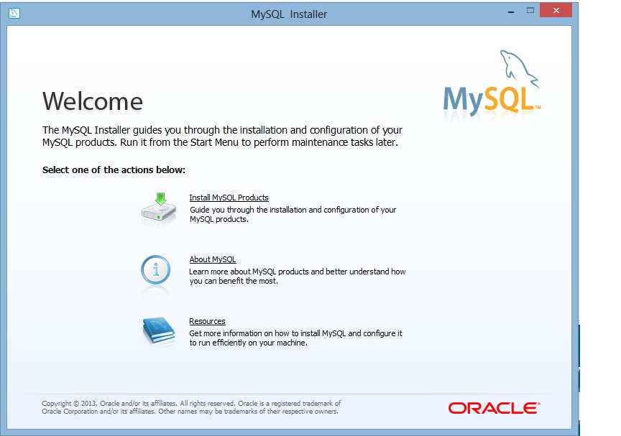

Figure ‑ MySQL Installation Welcome Screen

Select the “Install MySQL Products” link to begin the installation of MySQL.

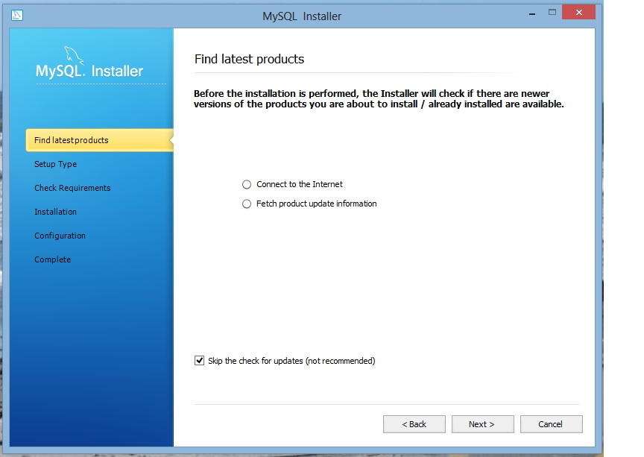

Figure ‑ Find Latest Products

Select the “Skip the check for updates (not recommended)” check box and then select the “Next >” button

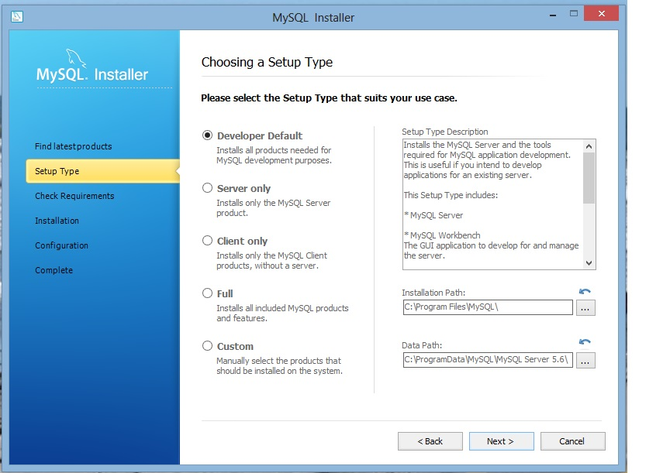

Figure ‑ Choosing a Setup Type

Accept the defaults and select the “Next >” button

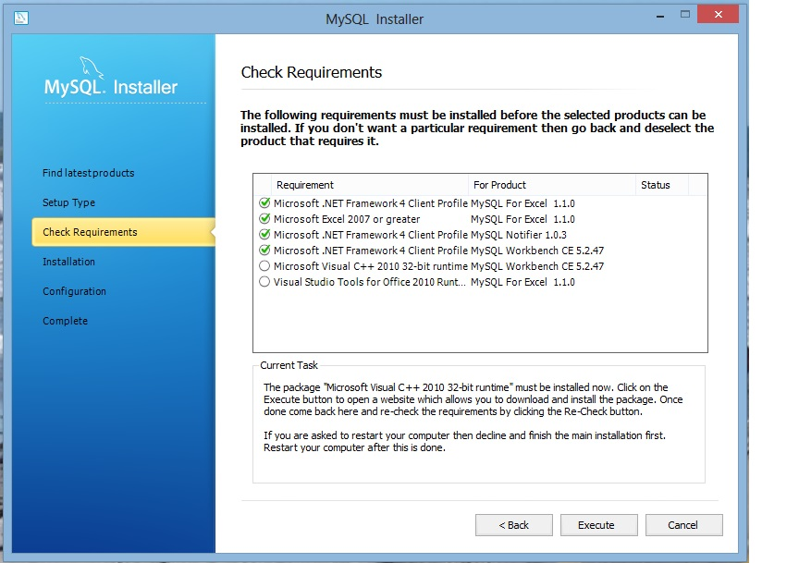

Figure ‑ Check Requirements

Select the “Execute” button

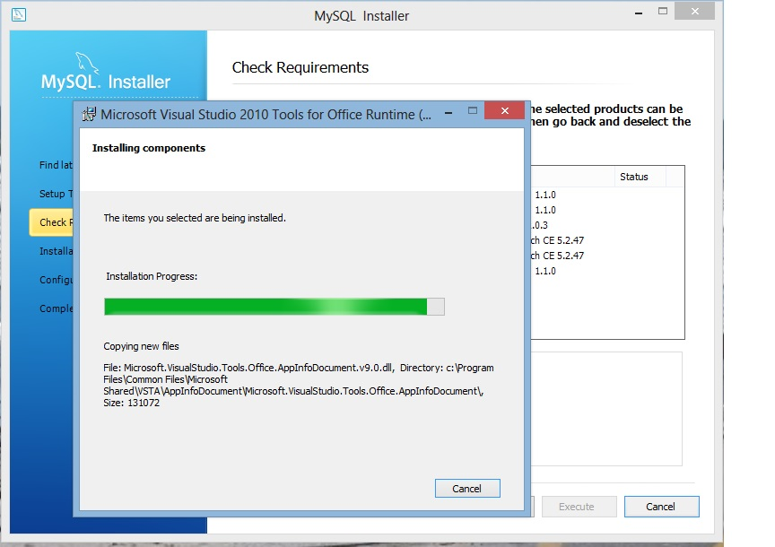

Figure ‑ Installing Components

Follow the onscreen prompts to install needed additional components. When finished select the “Finished” button.

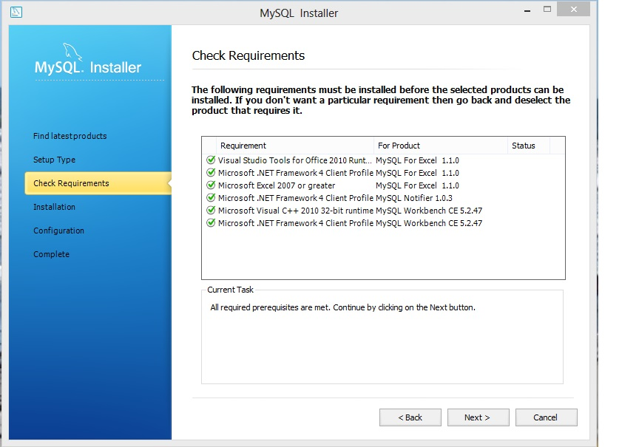

Figure ‑ Check Requirements Complete

Once all prerequisite components have been installed select the “Next >” button.

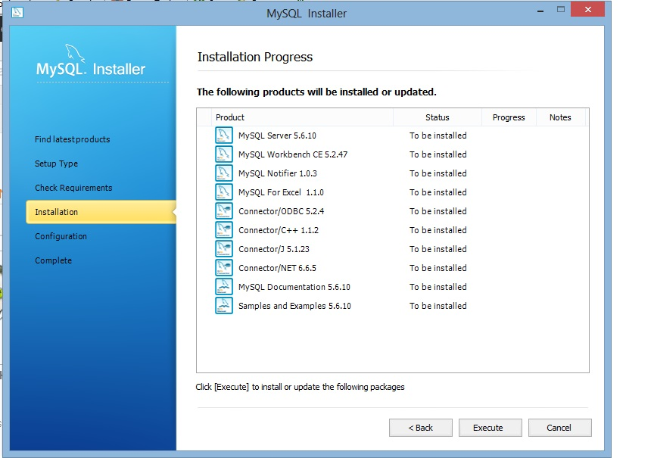

Figure ‑ Installation List

Select the “Execute” button

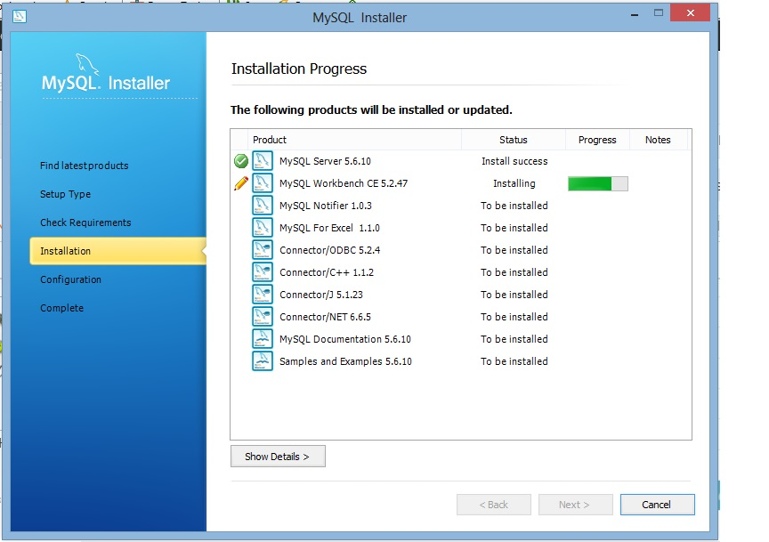

Figure ‑ Installation in Progress

Installation in progress

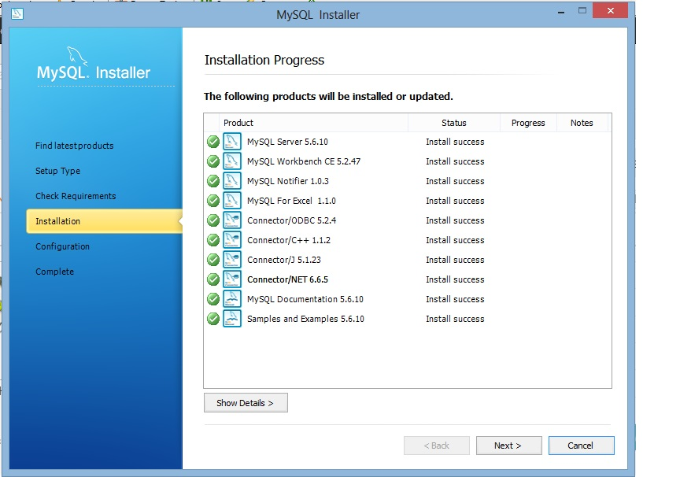

Figure ‑ Installation Completed

Installation of the components is complete. Select the “Next >” button.

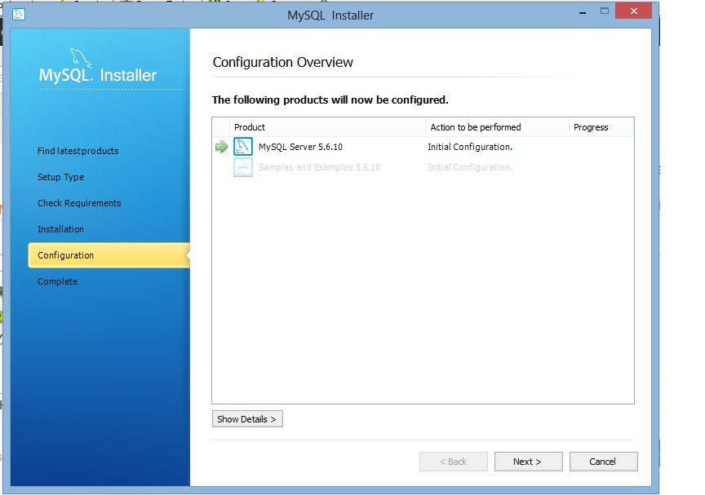

Figure ‑ Installation Configuration

Select the “Next >” button to continue with configuration.

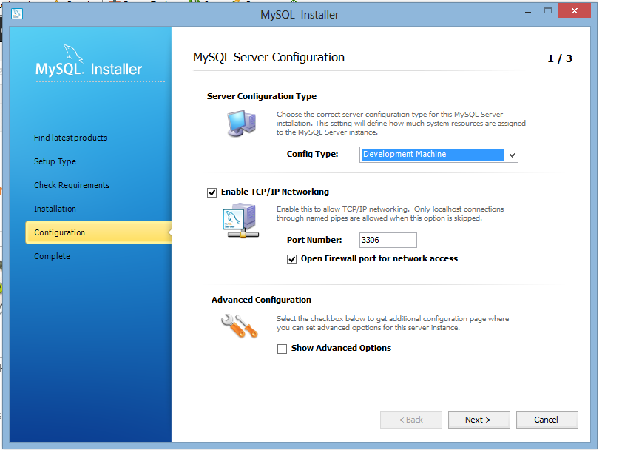

Figure ‑ MySQL Server Configuration - Networking

Select Development Machine from the drop down list to select the Server Configuration Type. Enable TCP/IP Networking and accept the default Port Number. Also select “Open Firewall port for network access”. Then select the “Next >” button.

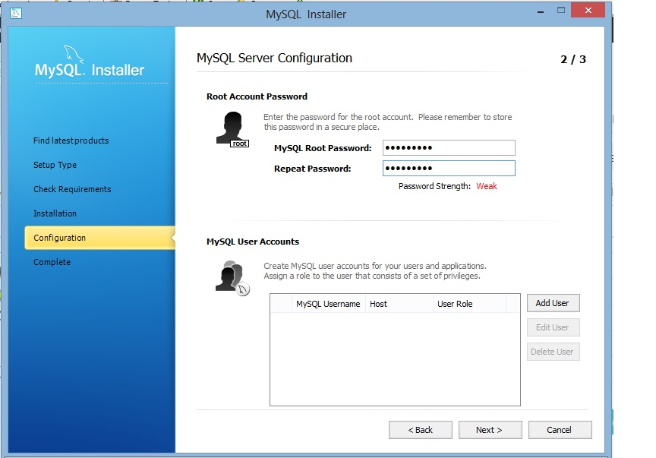

Figure ‑ MySQL Server Configuration – Account Setup

Enter in the MySQL Root Password. By default a MySQL User Account is not needed. Select the “Next >” button.

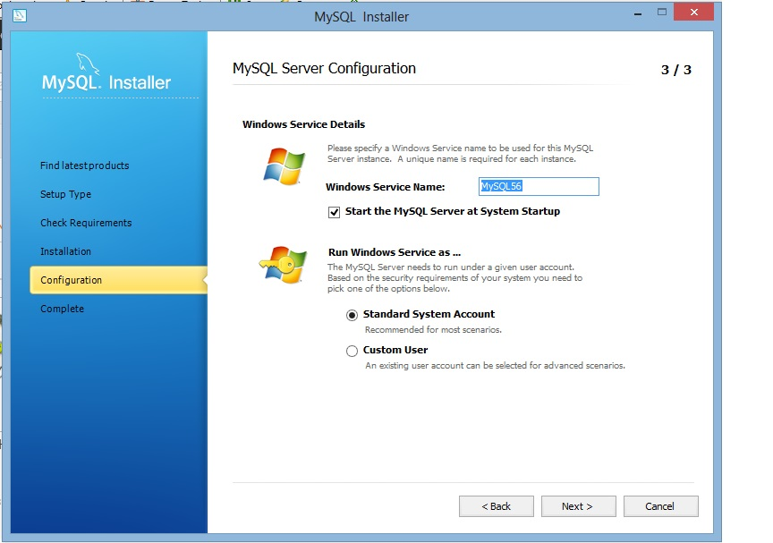

Figure ‑ MySQL Server Configuration – Windows Service

Accept the default Windows Service Details and select the “Next >” button.

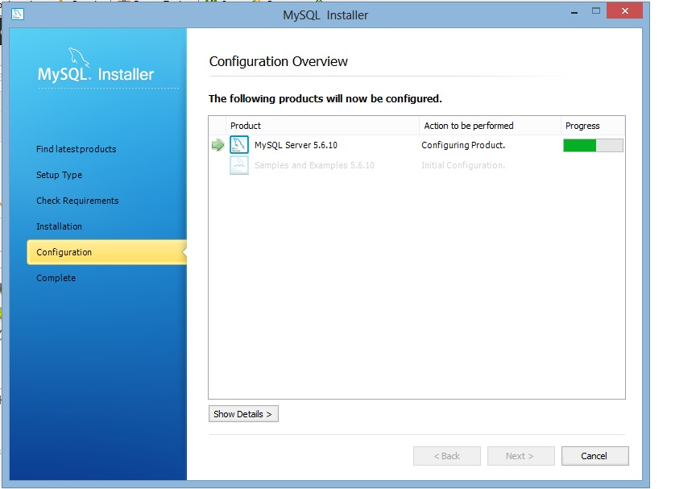

Figure ‑ Configuration Overview Progress

Select the “Next >” button to begin the configuration of the MySQL Server installation.

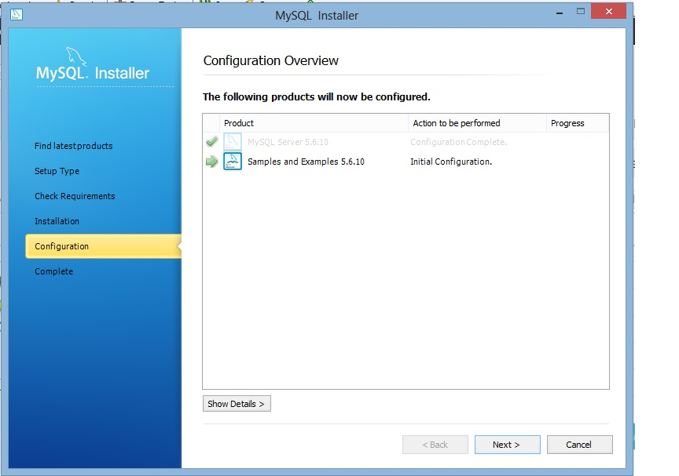

Figure ‑ Configuration Overview - Samples and Examples

Select the “Next >” button to begin the configuration of the Samples and Examples.

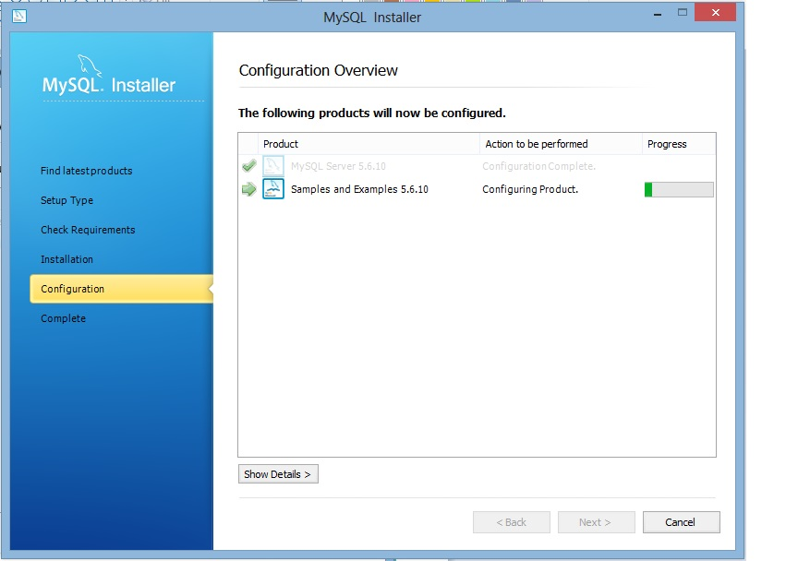

Figure ‑ Configuration Overview - Samples and Examples in Progress

Once the configuration of the Samples and Examples is complete select the “Next >” button.

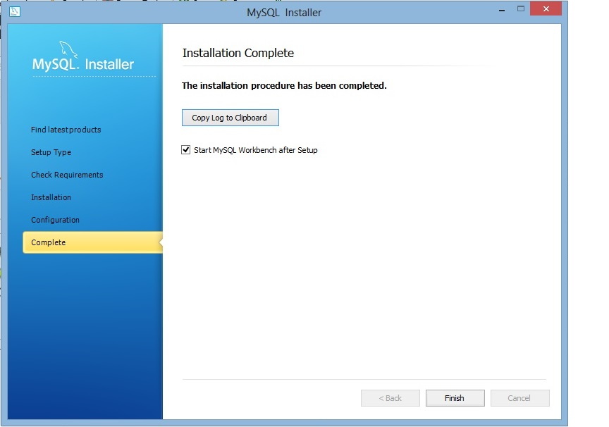

Figure ‑ Installation Complete

Installation and configuration of MySQL is complete. Select the “Finish” button.

## CentOS

To install MySQL on a CentOS workstation the user needs to enter in the following commands within a command line window. The login account on the CentOS operation system has to have sudo rights in order for the commands to succeed.

* sudo yum install mysql-server mysql php-mysql
* sudo chkconfig –levels 235 mysqld on
* sudo service mysqld start
* /usr/bin/mysqladmin –u root password *password*
* /usr/bin/mysqladmin –u root –h mm154938-pc.mitre.org password *password*
* mysql –u root –p
  + Enter mysql root password when prompted
  + mysql>SET PASSWORD for ‘root’@’localhost’ = PASSWORD(‘*password’*);
  + mysql>CREATE USER ‘taylor’@’localhost’ IDENTIFIED BY ‘*password’;*
  + mysql>GRANT ALL PRIVILEGES ON *.* TO ‘taylor’@’localhost’;
  + mysql>FLUSH PRIVILEGES;
  + mysql>SELECT * FROM mysql.user;
  + mysql>exit
* restart mysql
  + sudo /etc/init.d/mysqld restart

# Installing Rails

Ruby and Rails are installed together.

## Windows Rails Installation

To install Rails and Ruby on Windows, the first step is to download the Rails Installer (<http://railsinstaller.org/>) and save the executable to your local computer. This executable installs all the common packages needed for a full Rails stack. These include Ruby, Rails, Bundler, Git, among others.

From the download directory where the installer file is saved, click on the railsinstaller-x.y.z.exe file (where x.y.z reflects the version number). This will launch the Rails Installer which is pictured in Figure 4‑1 Rails Installer Welcome Screen.

The following are Installation Screen Shots captured during the installation process.

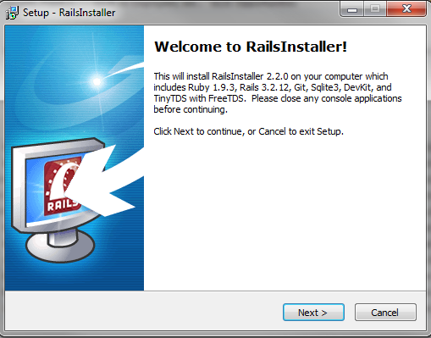

Figure ‑ Rails Installer Welcome Screen

Select the “Next >” button to launch the RailsInstaller License Agreement as shown in Figure 4‑2 RailsInstaller License Agreement.

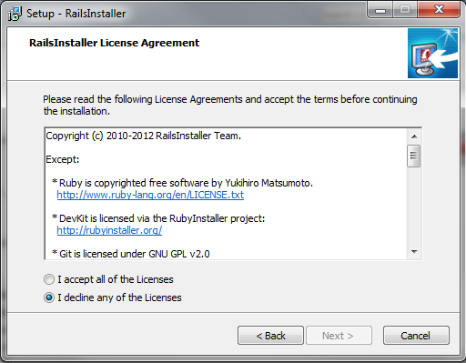

Figure ‑ RailsInstaller License Agreement

Indicate “I accept all of the licenses” and then select the “Next” button to select a destination directory as shown in Figure 4‑3 Installation Destination and Optional Tasks.

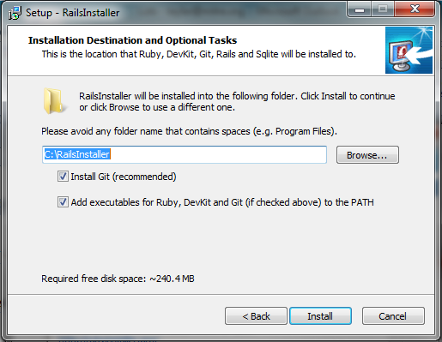

Figure ‑ Installation Destination and Optional Tasks

Accept the default location for the Rails Installer installation directory. Select the Git source code configuration management system if needed and also add the executable file locations to the PATH environment variable.

Select the “Install” button which will start installing the Rails software and launch the setup screen as shown in Figure 4‑4 Setup RailsInstaller.

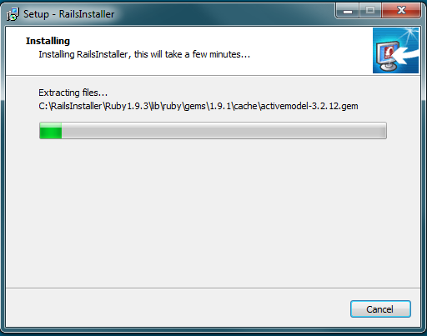

Figure ‑ Setup RailsInstaller

When the installation is complete the Rails Installer complete screen will appear as shown in Figure 4‑5 Setup RailsInstaller Complete.

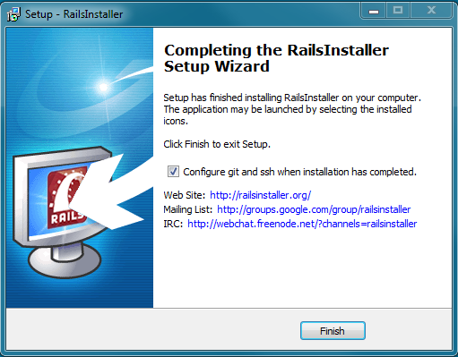

Figure ‑ Setup RailsInstaller Complete

Select the “Finish” button to complete the installation of the Rails Installer. A command window is automatically launched as shown in Figure 4‑6 Rails Command Window.

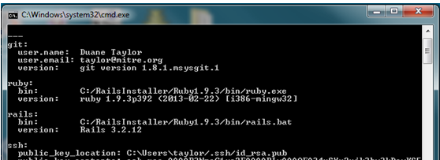

Figure ‑ Rails Command Window

On the Rails Installer web site (<http://railsinstaller.org/>) click on the “Step-By-Step Instructions” link to continue this installation. The steps from that site are repeated here:

* Once installation is complete it should bring up the Windows Command Line (DOS prompt) asking for your name and email address.

Once you enter both you should see your generated public SSH key which you will need later. See Figure 3‑6 Rails Command Window.

* Next you'll need to create a new rails application via the command line. This process may take up to a minute.
  + Create the following directory: C:\Sites and change to that directory in the command window
  + C:\Sites> rails new railsinstaller_demo
* Once it's complete we can now visit the application folder and start the Rails server to see the site in our browser.
  + Confirm that the HTTP_PROXY environment variable is set if you are behind a proxy
    - C:\Sites> printenv HTTP_PROXY
    - An example value: http://proxy.domain.com:80
    - If not set then set the HTTP_PROXY User Environment Variable to the appropriate proxy address and port number. Ask your System Administrator for these values.
  + C:\Sites> cd railsinstaller_demo
  + Install any missing bundles
    - C:\Sites> bundle install (see Figure 4‑7 bundle install)
  + C:\Sites\railsinstaller_demo> Rails s (see Figure 4‑8 rails s)
    - This command starts the railsinstaller_demo application
    - At this point you can visit <http://localhost:3000> in your web browser and see the default Rails welcome page. See Figure 4‑9 Ruby on Rails Welcome Screen.

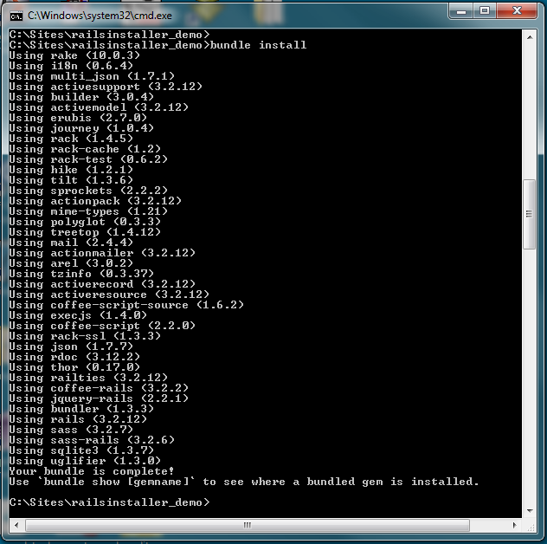

Figure 4‑7 bundle install

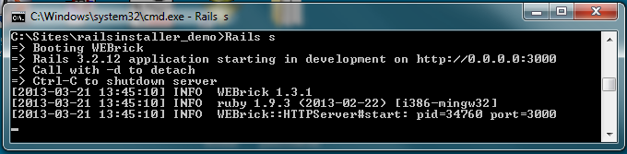

Figure 4‑8 rails s

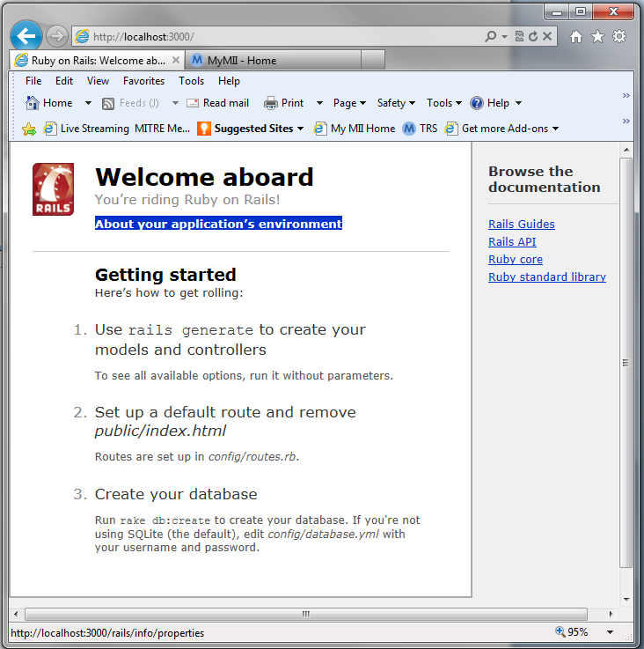

Figure ‑ Ruby on Rails Welcome Screen

### Windows Flexicon Startup

To start the Flexicon application, first open a command window and then change to the project directory.

* Change to the main directory for the Flexicon ruby application
  + For example, cd /home/taylor/code/flexicon
* Edit the Gemfile in the main directory of the Flexicon ruby application with wordpad and insert the following code:
  + gem ‘ember-rails’

gem ‘execjs’

* bundle install
* rake db:create
* rake db:reset
* rails s

At this point you can visit <http://localhost:3000> in your web browser and see the Flexicon welcome page. See Figure 3‑11 Flexicon Home Screen.

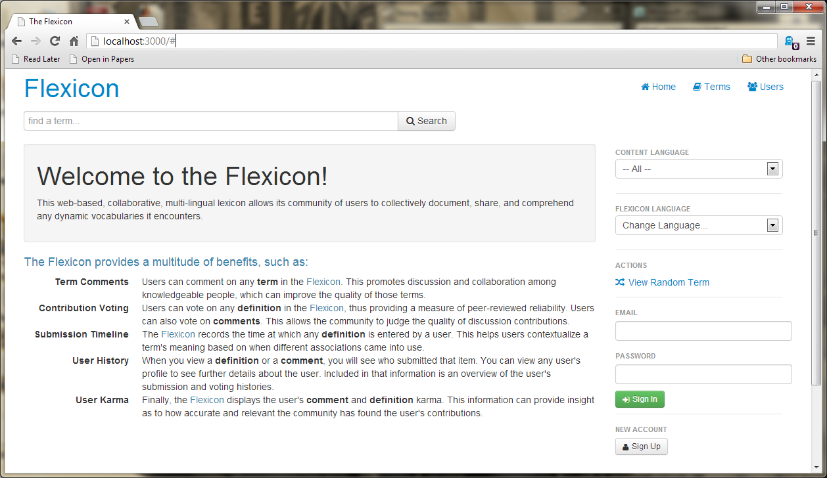

Figure ‑ Flexicon Home Screen -Windows

## CentOS Install and Flexicon Startup

To install Ruby on Rails on a CentOS workstation the user needs to enter in the following commands within a command line window. The login account on the CentOS operation system has to have sudo rights in order for the commands to succeed.

Flexicon requires Ruby 1.9 or greater to run. If the installed version of CentOS comes with an earlier version, either RVM (<http://rvm.io>) or rbenv (<http://rbenv.org>) can be used to manage multiple Ruby installations. Consult the documentation for these tools to set up your Ruby environment.

Additionally, a JavaScript runtime is required for the bootstrap-rails Gem to function. Flexicon was developed using node.js as the runtime, though others should work. Node.js can be downloaded at <http://nodejs.org/download>.

Once Ruby is installed and set up, make sure the bundler gem is installed. If not, install with “gem install bundler”. Once bundler is installed, run “bundle install” to install the gems the application depends on. Next, set up the database and test the installation, run the following commands

* rake db:create
* rake db:reset
* rails s

At this point you can visit <http://localhost:3000> in your web browser and see the Flexicon welcome page. See Figure 4‑11 Flexicon Home Screen.

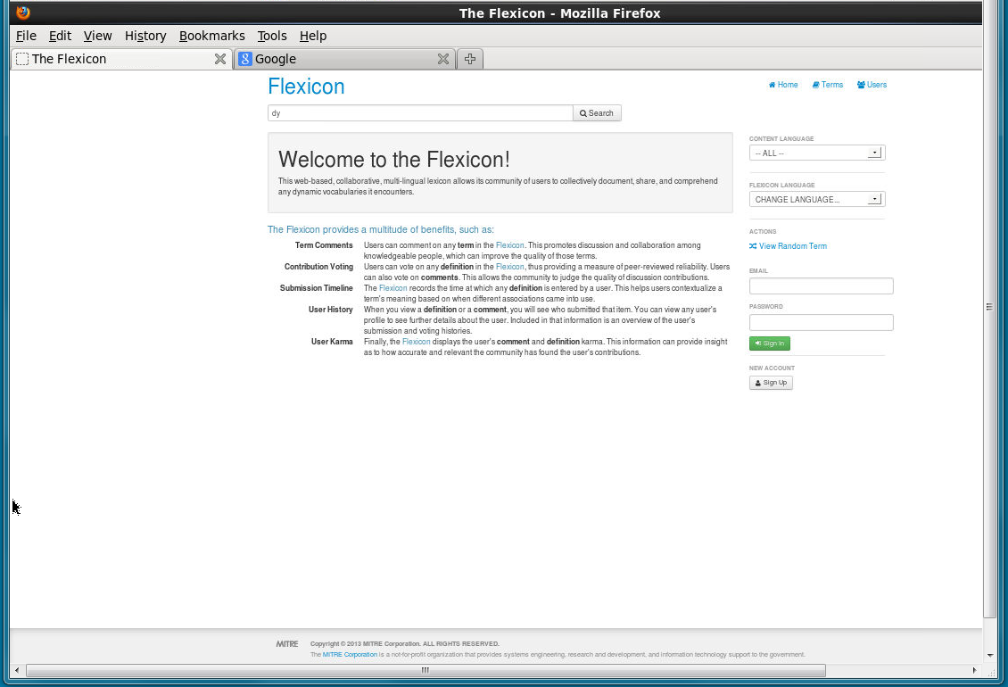

Figure ‑ Flexicon Home Screen - CentOS