Flexicon User Manual

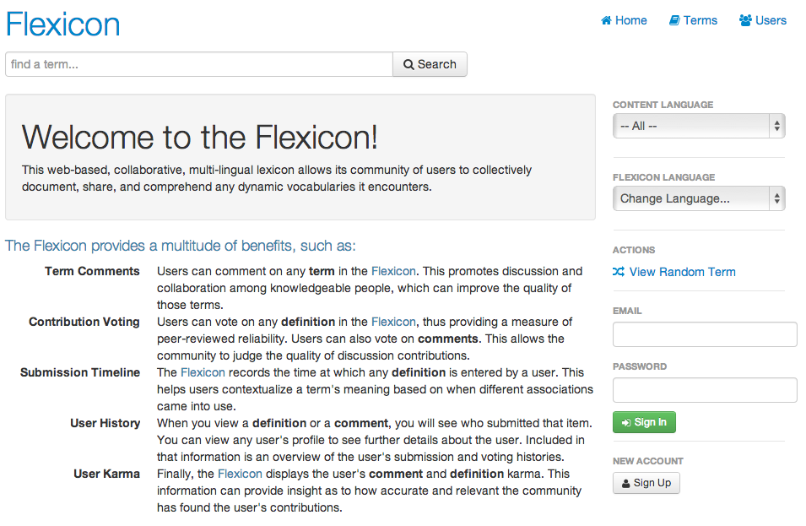

Figure - Flexicon Home Page

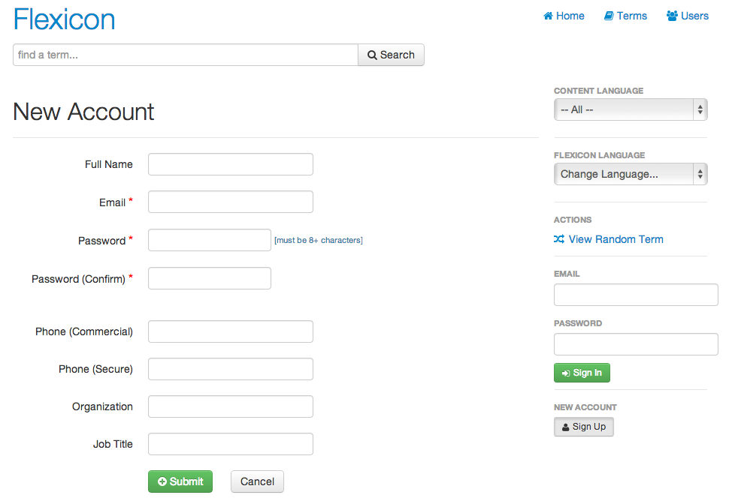

Figure - Flexicon Sign Up Form

A user can peruse portions of the Flexicon web application without having to be a registered user. However, to vote and contribute, the user needs to log in. A user selects the “Sign In” button to log in if the user is already registered. A user specified email address is the login string along with the password. To create a new login the user selects the “Sign Up” button. Selecting the “Sign Up” button displays the “New User” screen that has fields for user input. The data entered into the “New User” input fields will create the user profile. Required fields include Email, Password, and confirmation password. The “Submit” button is selected create the new user profile.

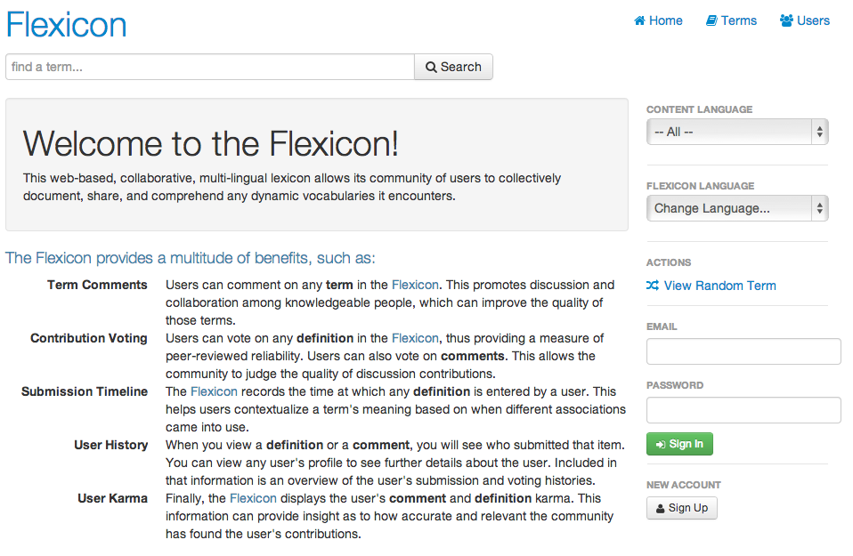

Figure - Sign In Form, Highlighted

The user is able to sign in via the sign in box. The user enters their email address and password and selects the “Sign In” button. Once the user supplies valid login credentials, the “Sign In” and “Sign Up” buttons disappear and the “Sign Out” button is displayed.

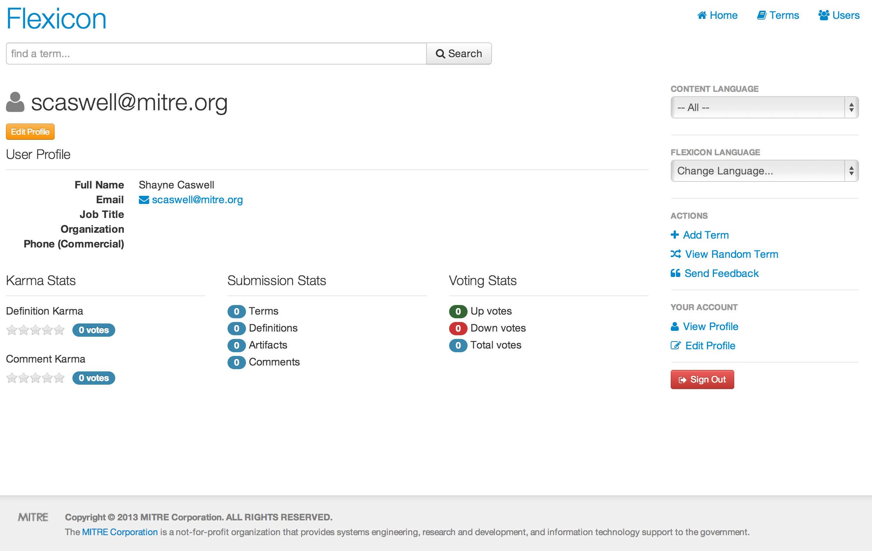

Figure - Flexicon User Profile Page

The user can view their profile by selecting the “View Profile” button and can edit their profile by selecting the “Edit Profile” button.

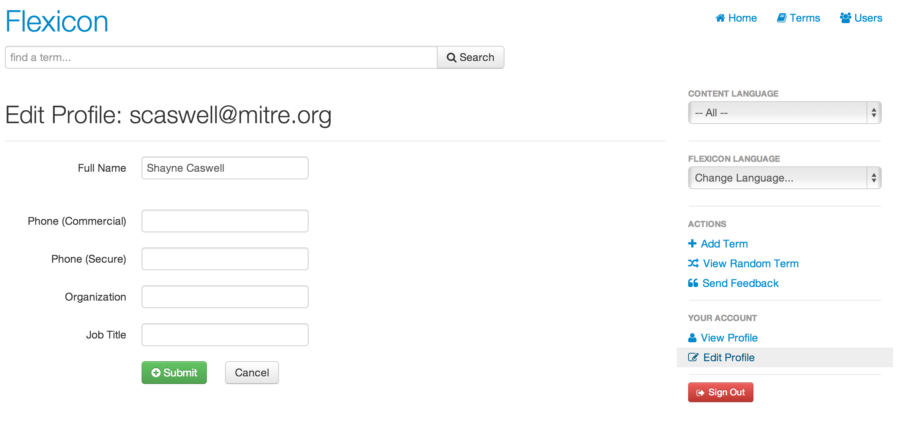

Figure - Flexicon User Profile Management

The user can edit his profile by selecting the “Edit Profile” link in the navigation bar. This takes the user to the profile management page, where he can edit his name and contact information.

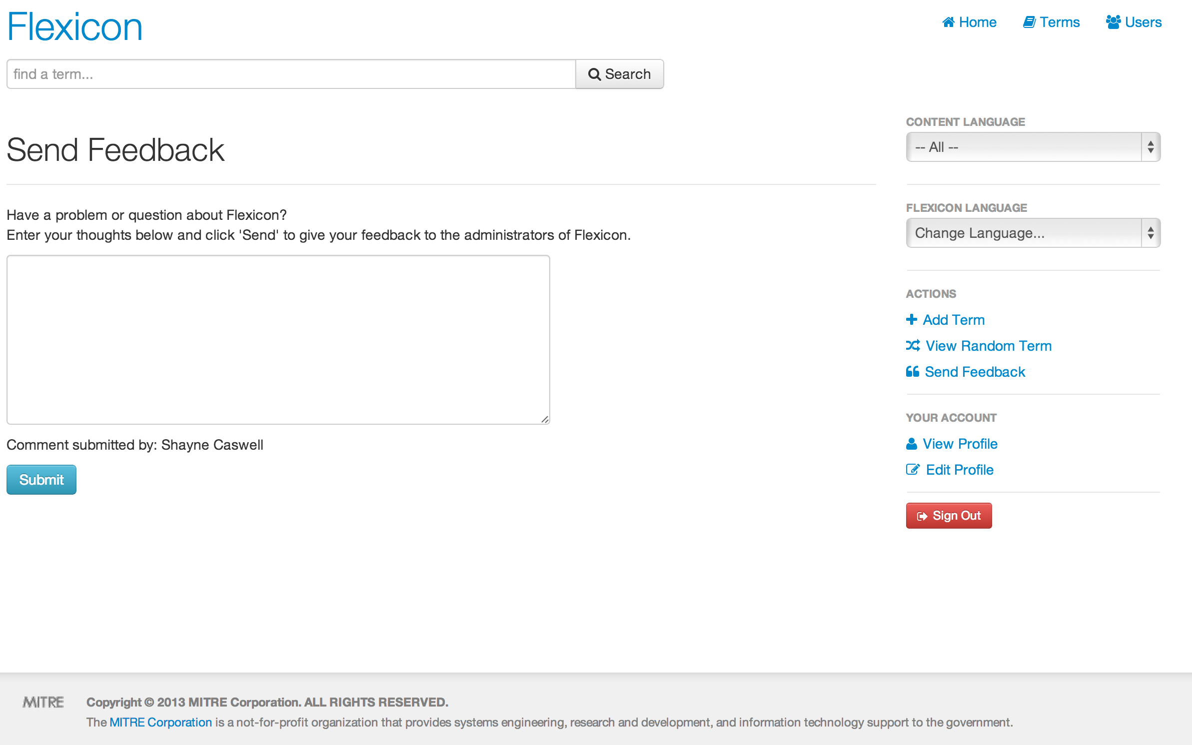

Figure - Flexicon Feedback Page

The developers of the Flexicon software always like to hear feedback on the usability of the Flexicon tool. Feedback can be sent by selecting the “Send Feedback” button, entering text in the text area and then selecting the “Send” button.

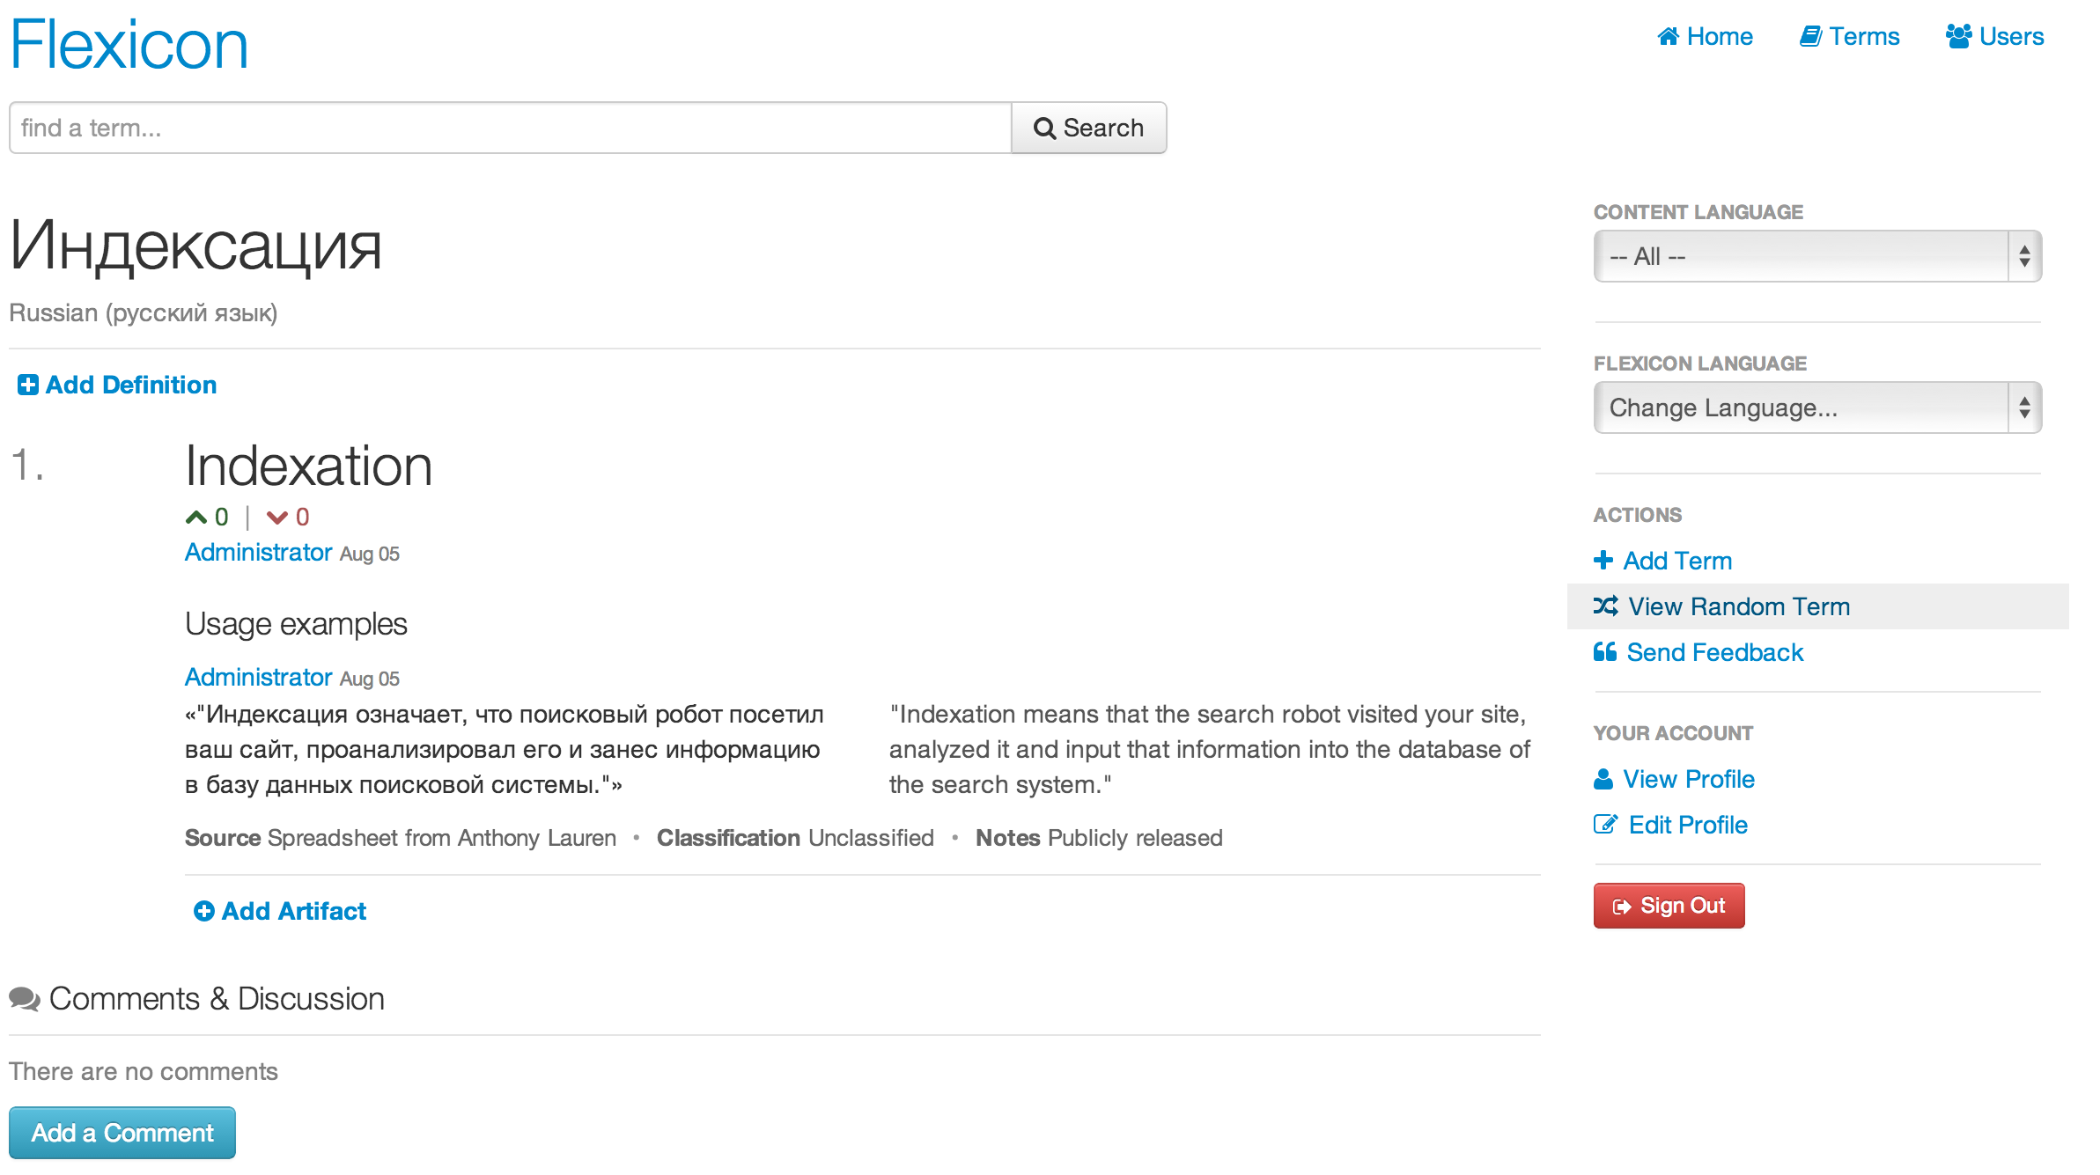

Figure - Flexicon Term Page

A user can view random terms stored in the database by select the “View Random Term” button on the left side of the application. The term then appears along with any previously entered comments and artifacts.

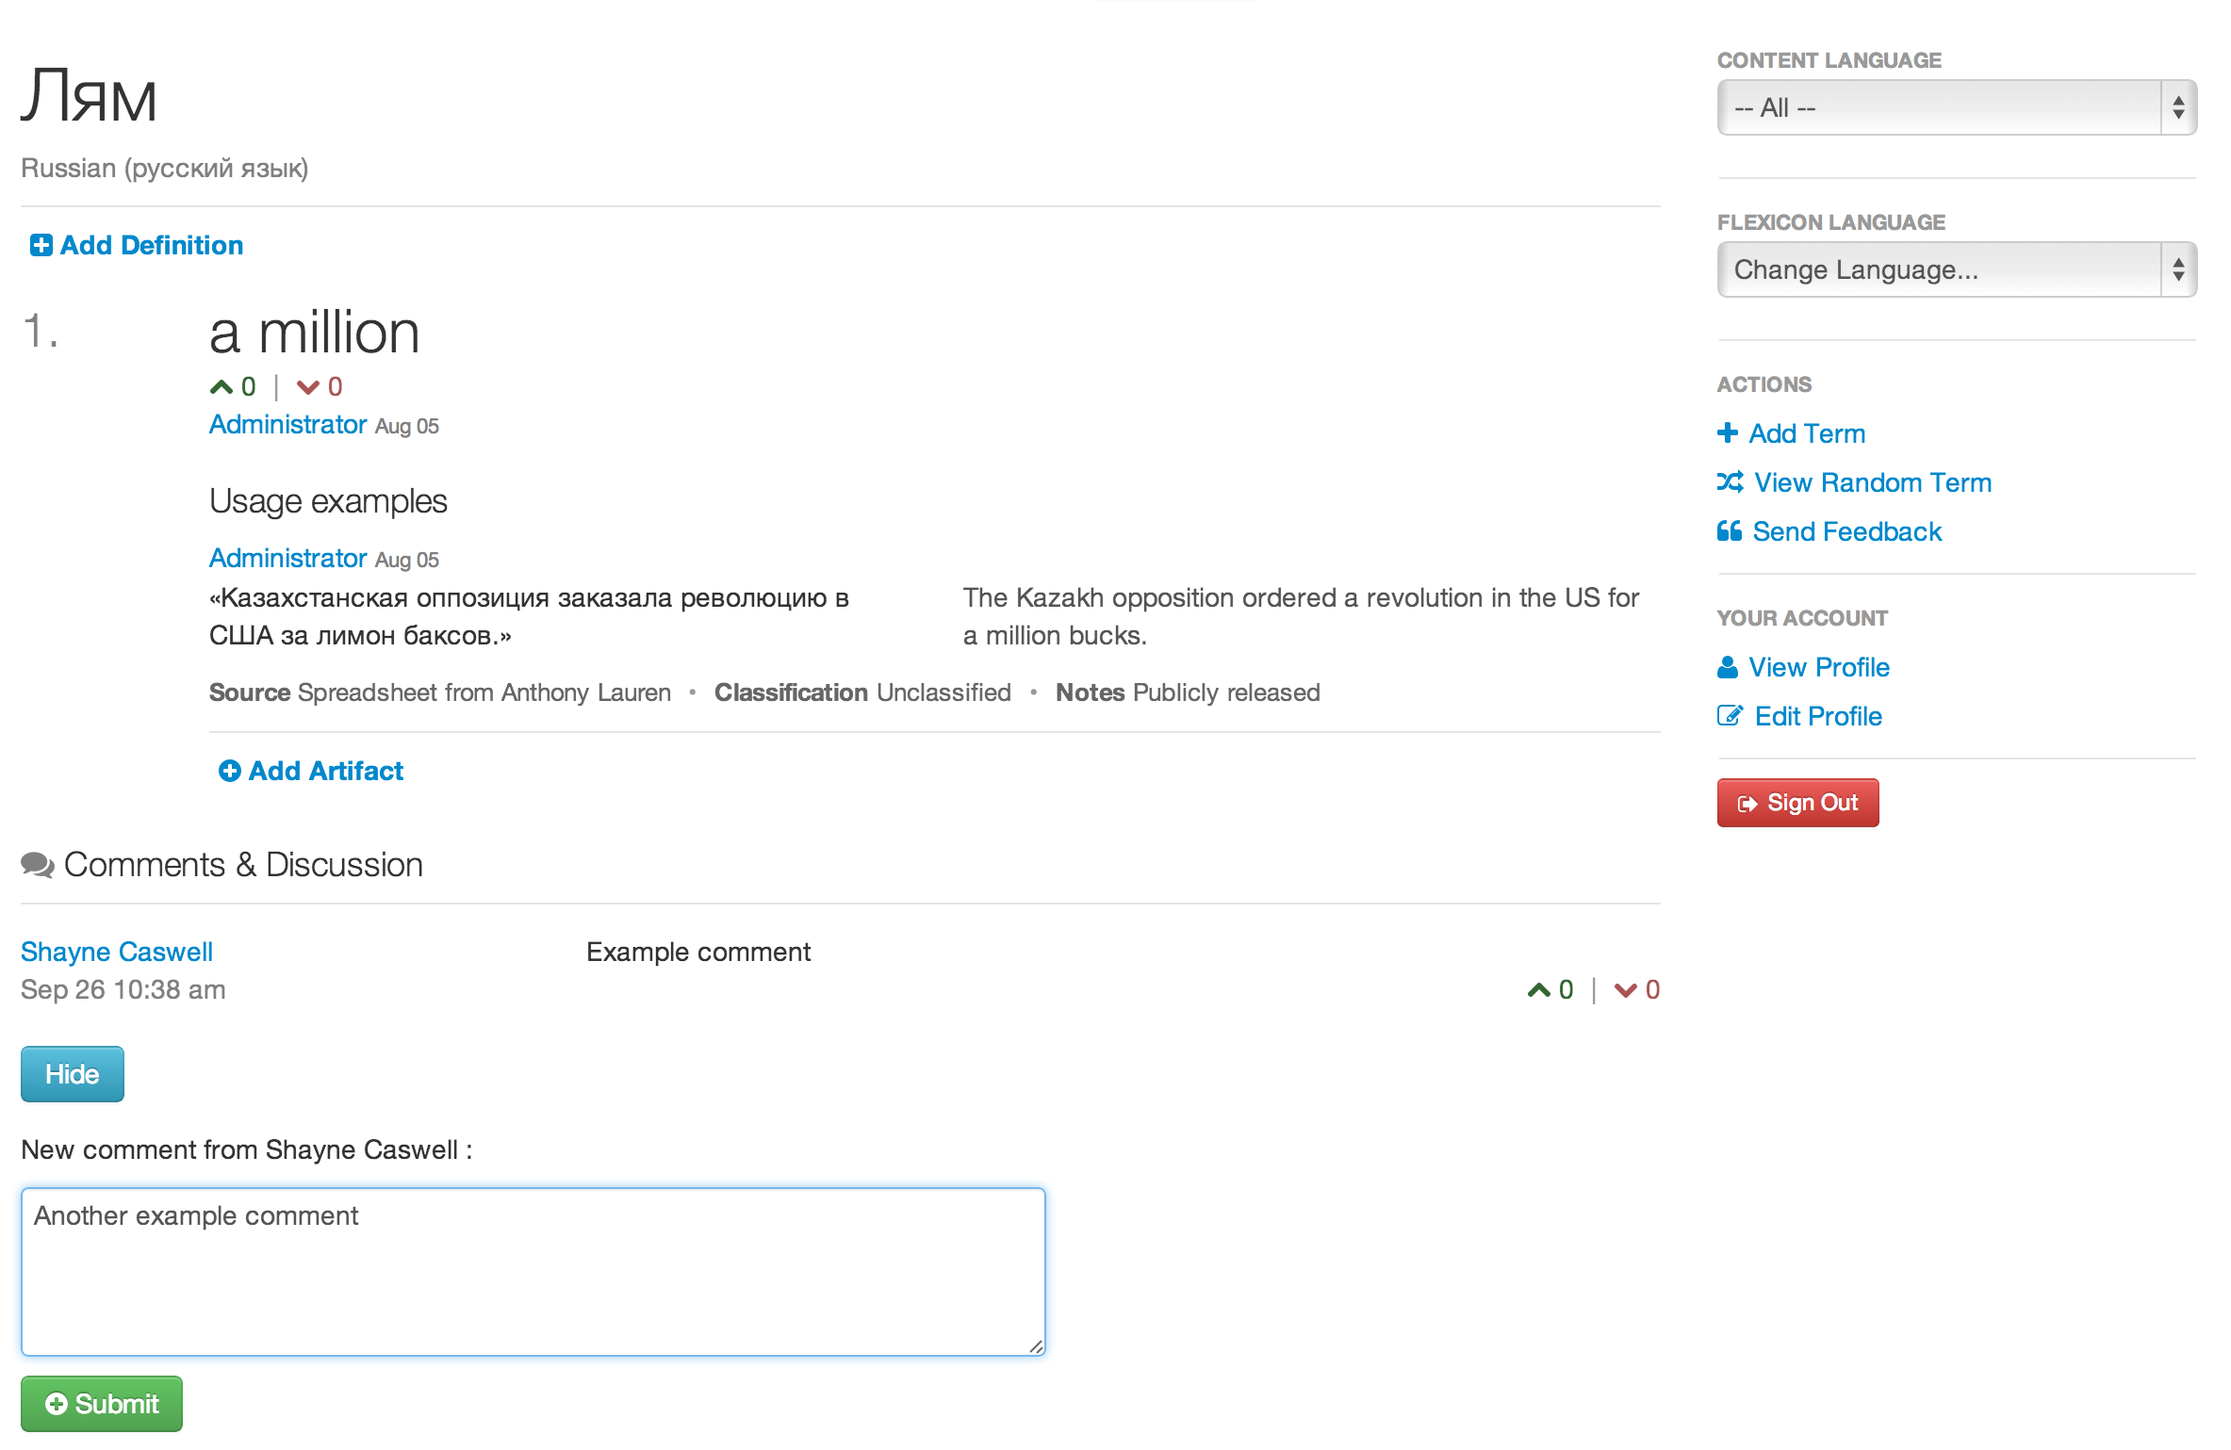

Figure - Flexicon User Entering Comment

The user enters a comment and selects the “Submit” button. The comment then appears along with the ability to vote up or down the comment.

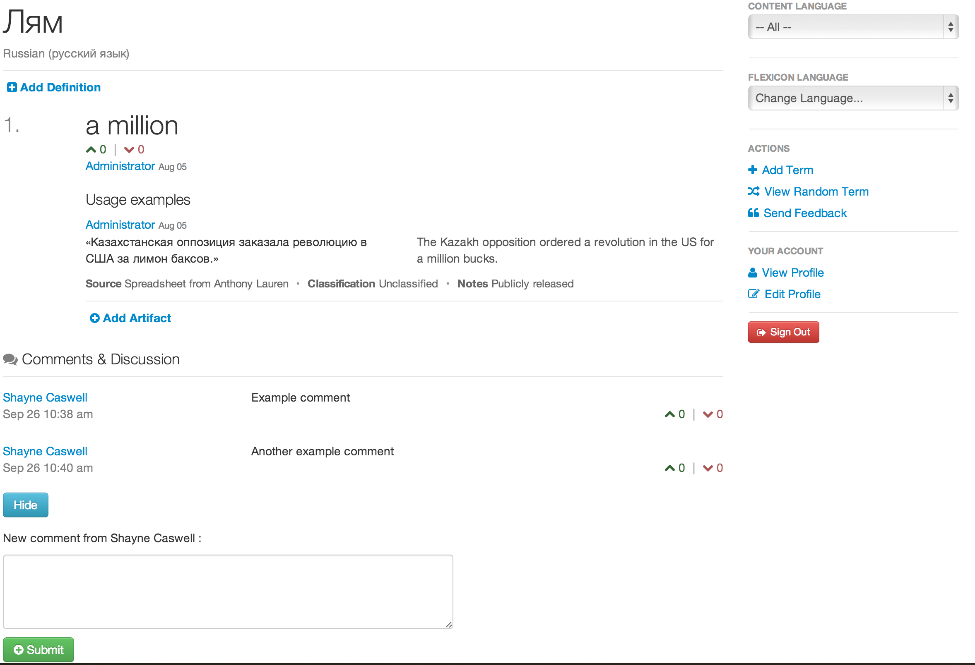

Figure - Flexicon Comment Added

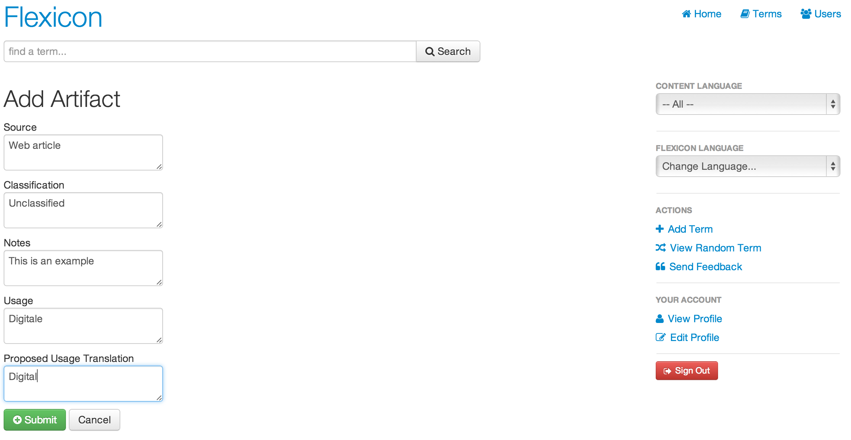

Figure - Flexicon Term Artifact Entry

To add an artifact the user selects the “Add Artifact” button, which loads the “Add Artifact” page. Once the information is entered the user selects the “Submit” button and returns to the terms page. To view all artifacts select the “View Artifacts” button and to hide the artifacts display select the subsequent “Hide Artifacts” button.

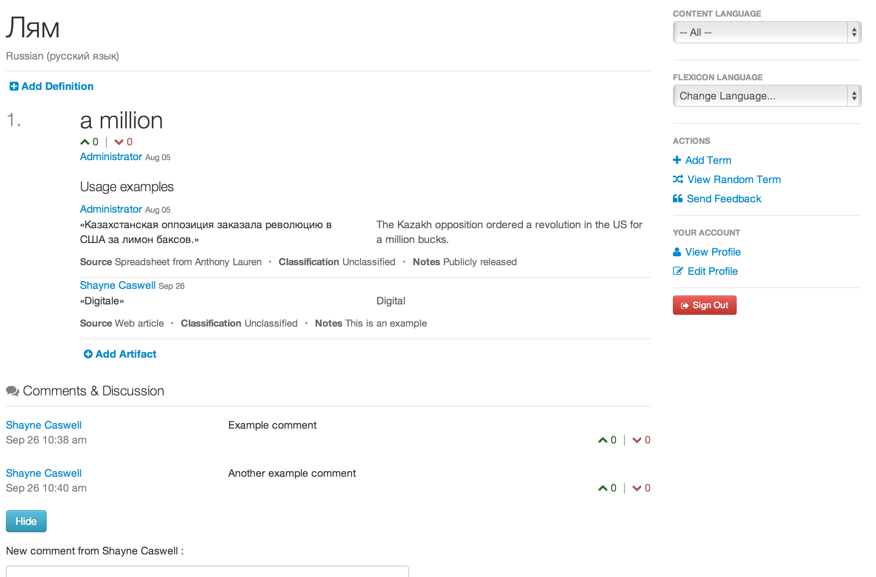

Figure - Artifact Has Been Added

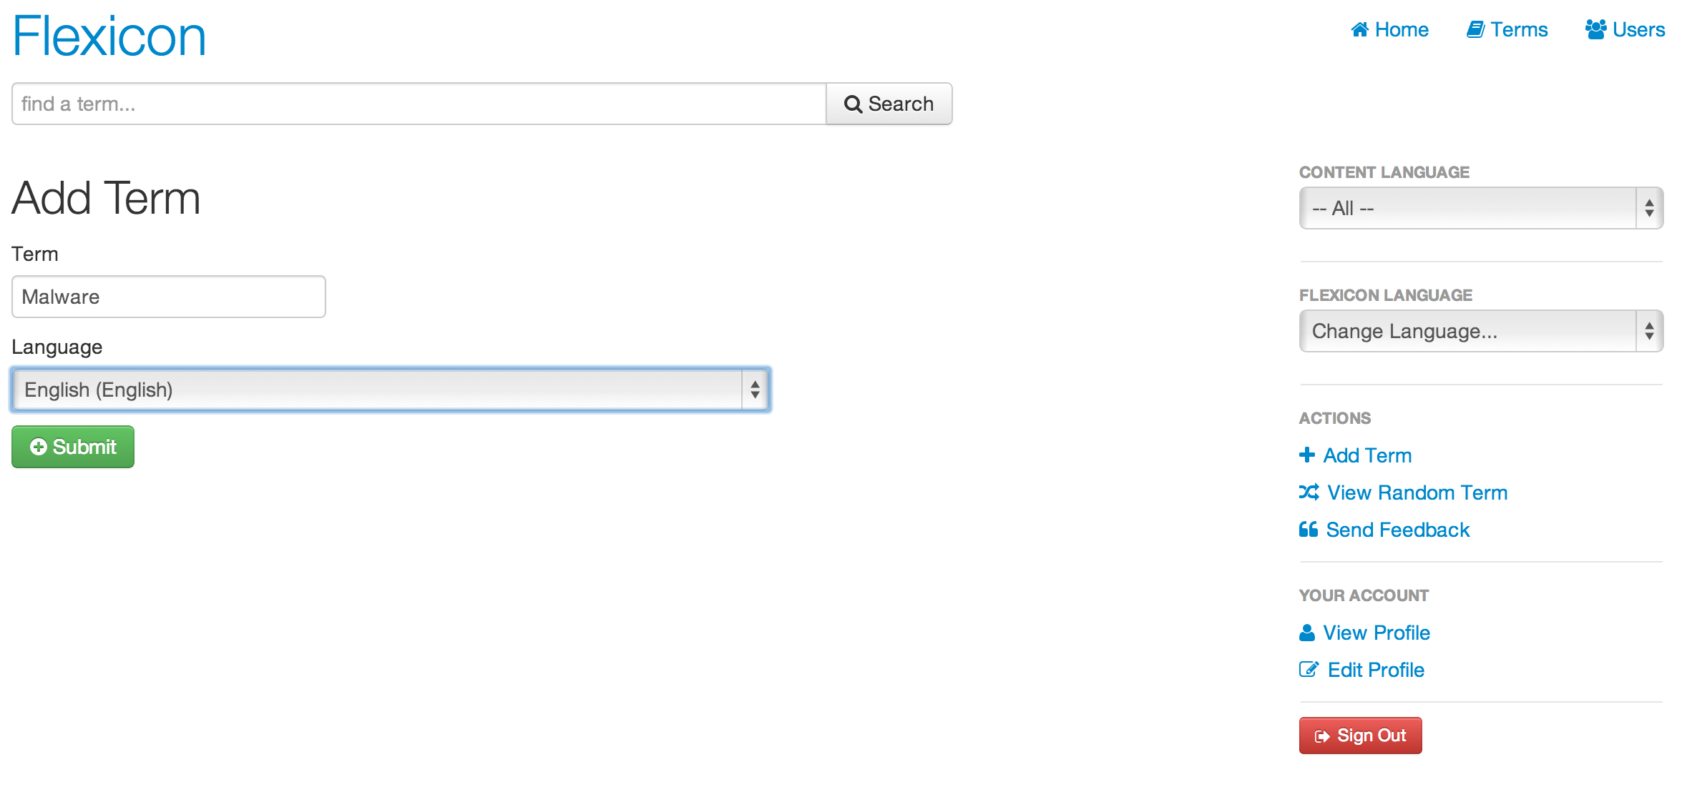

Figure - Flexicon New Term Page

To add a new term to Flexicon, the user should select the “New Term” button to load the “Add Term” page of the application. In the example shown here the term “Malware” is entered and the “English” language is selected from the drop down box.

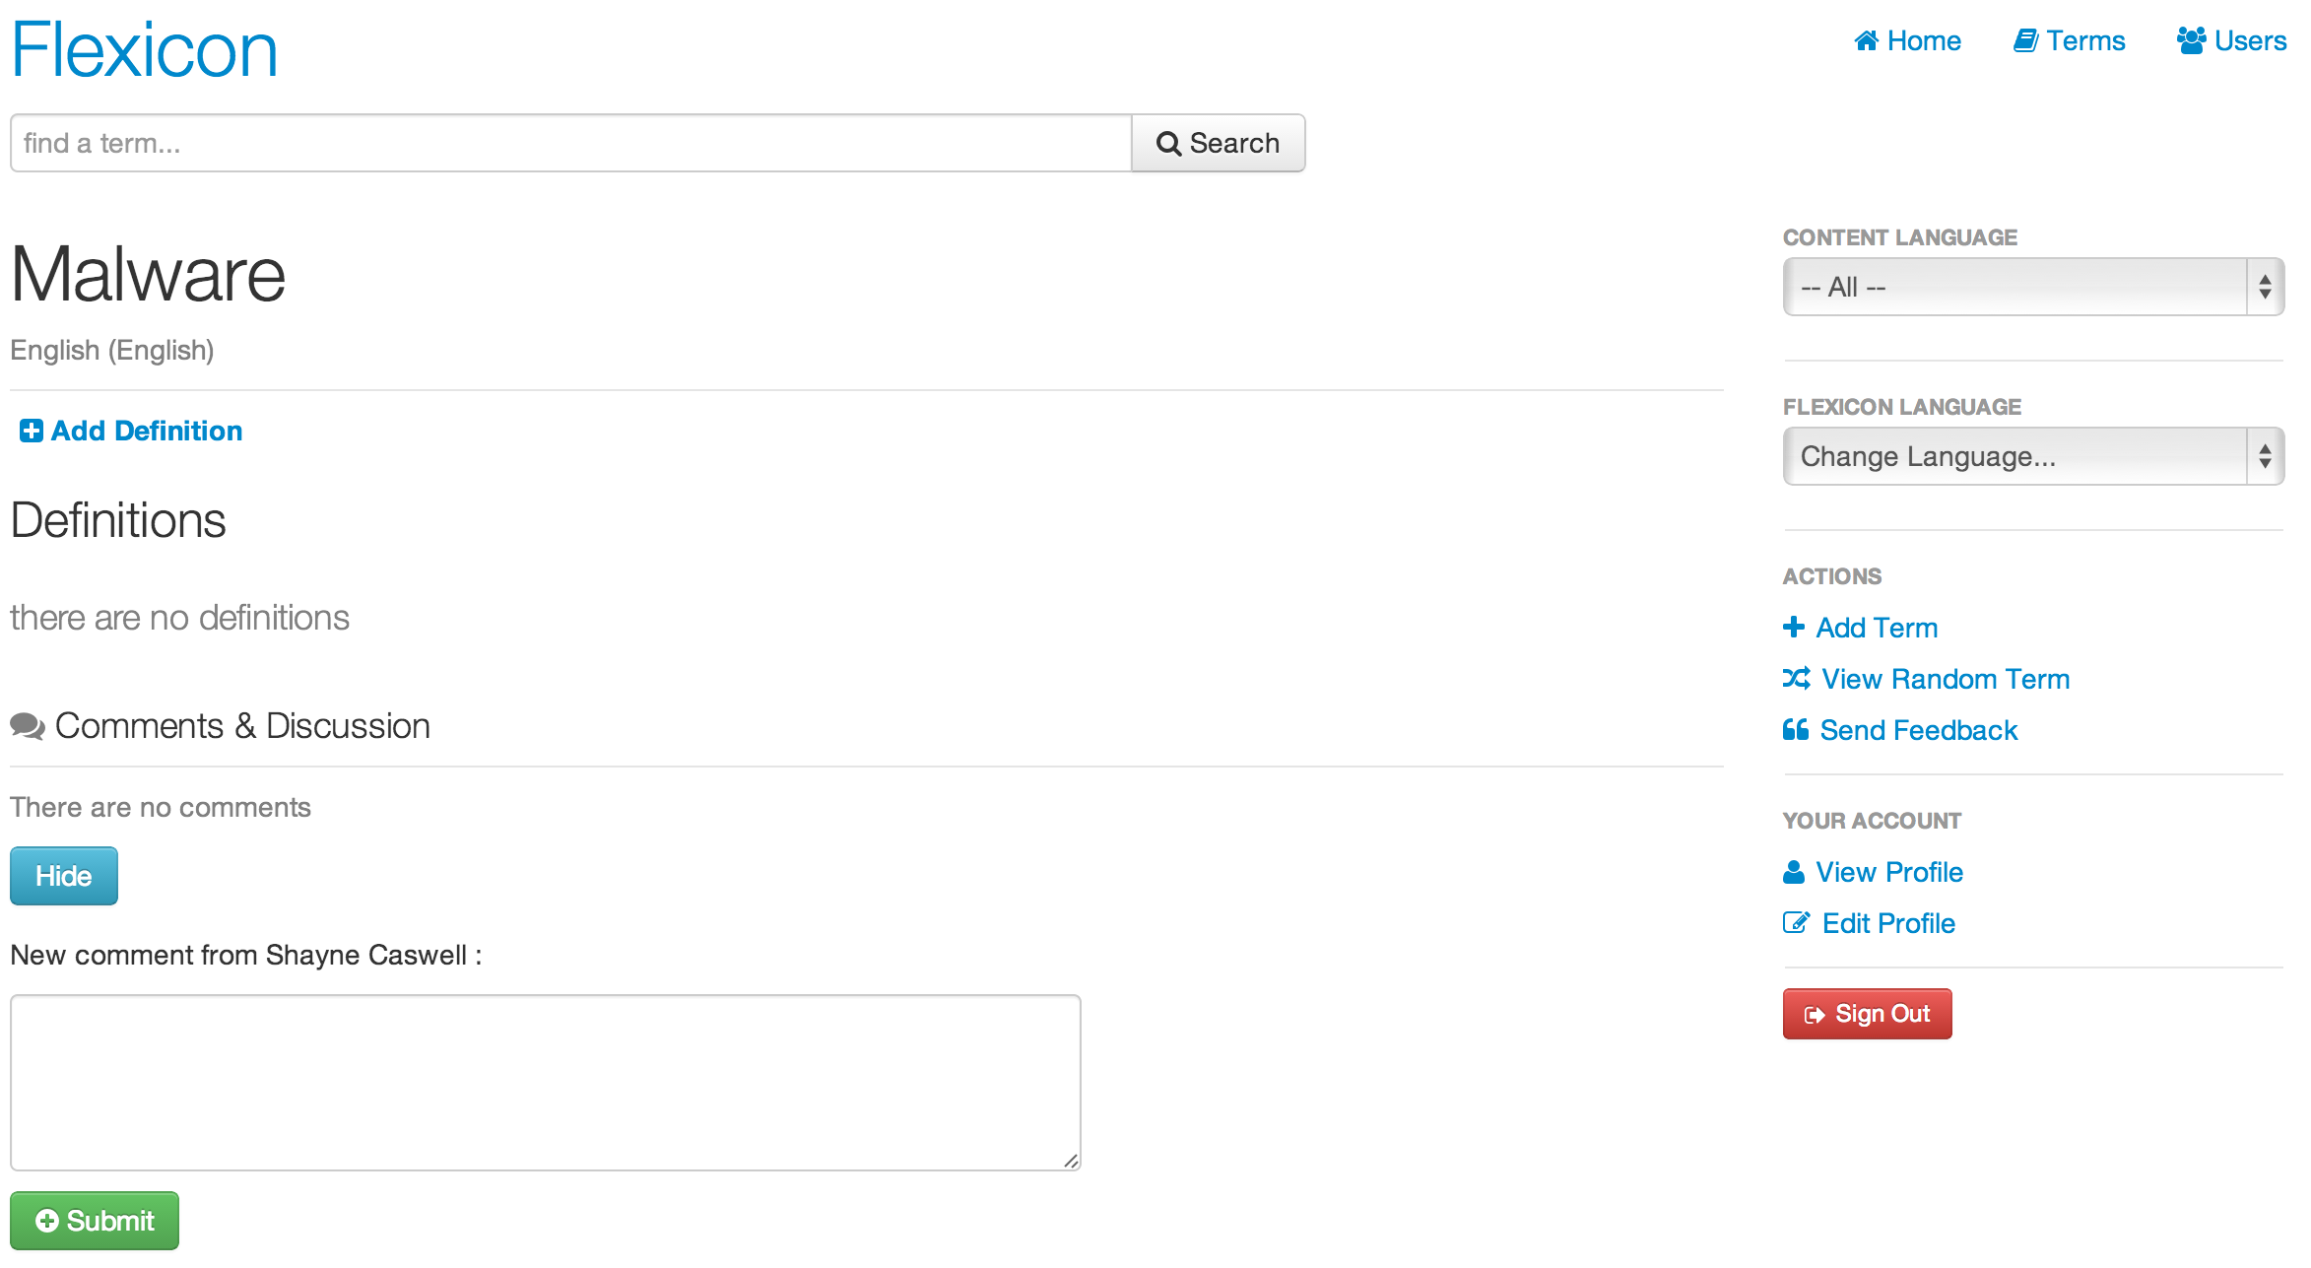

Figure - Flexicon Term Has Been Added

The definition of the term is also entered from this page by selecting the [Add Definition] link under the Definitions label on the page. This brings up the Add Definition page.

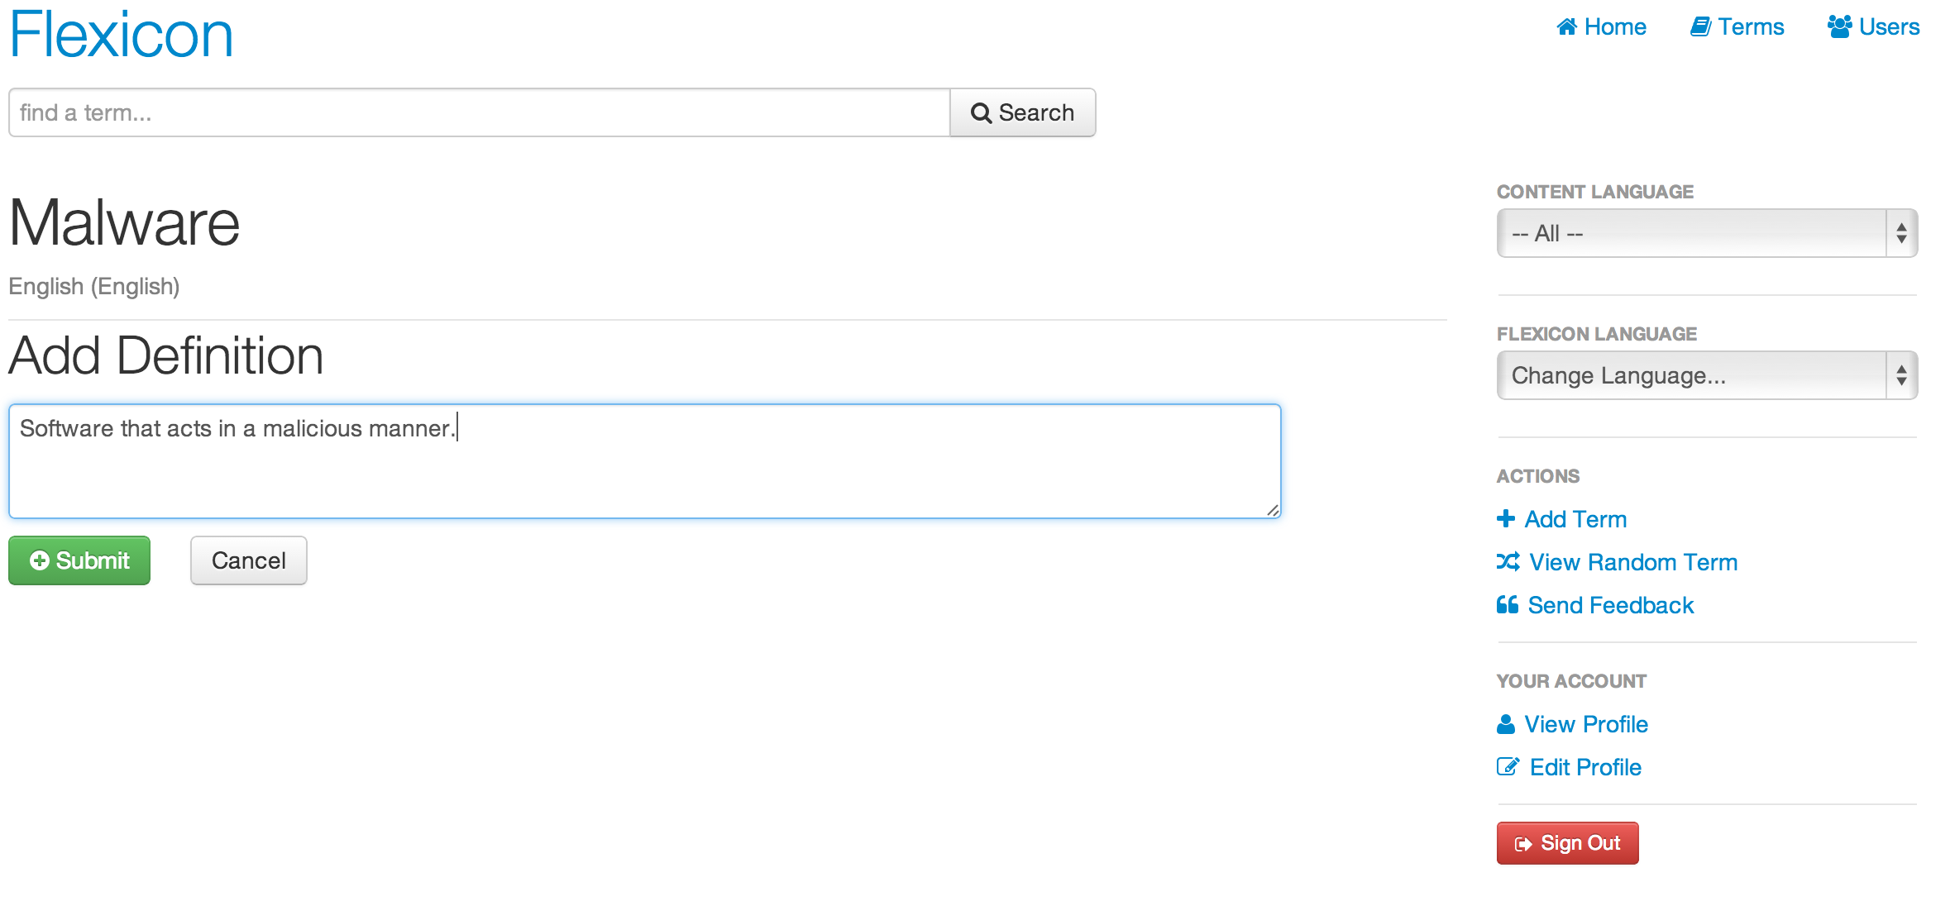

Figure - Flexicon Term Definition Creation

Enter the definition into the text box and select the “Submit” button. The Definition is then displayed as shown here and there can be multiple definitions for each term. An artifact can be added in a similar way. Just select the “Add Artifact” button and enter data is the resulting text boxes. Optional fields include Source, Classification, Notes, Usage, and proposed Usage Translation. When complete select the “Submit” button.

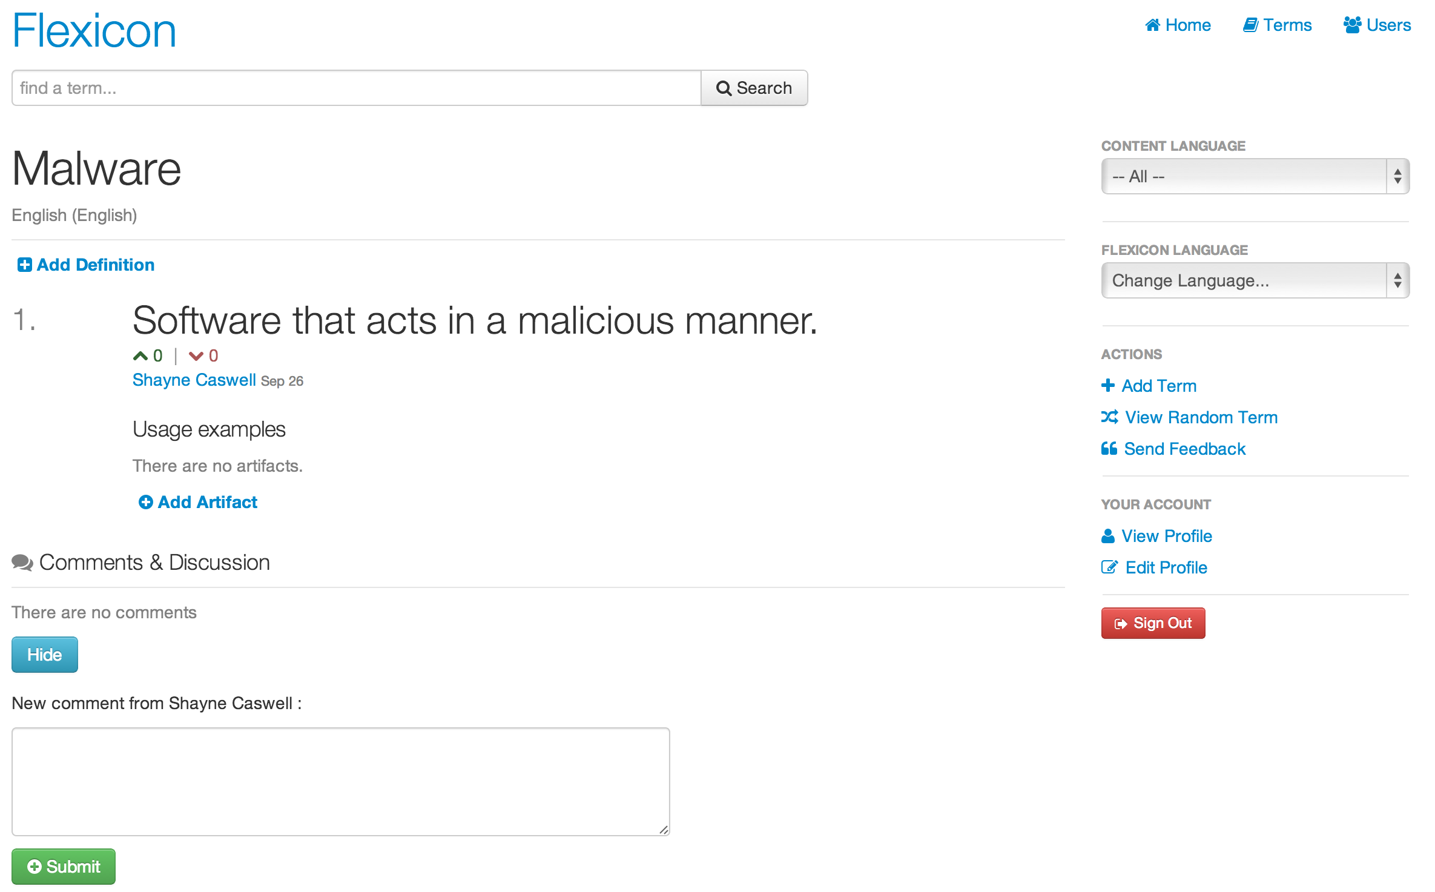

Figure - Definition Has Been Added

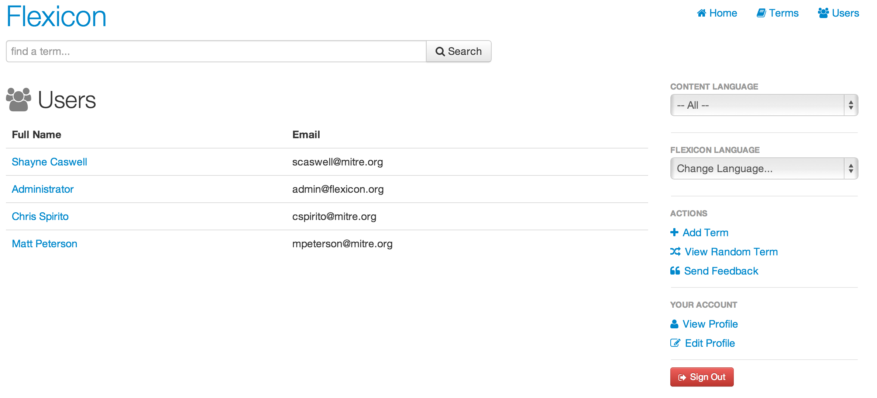

Figure - Flexicon User List

The user can view other users by selecting the “Users” button and then selecting the “Full Name” link of a user of interest.

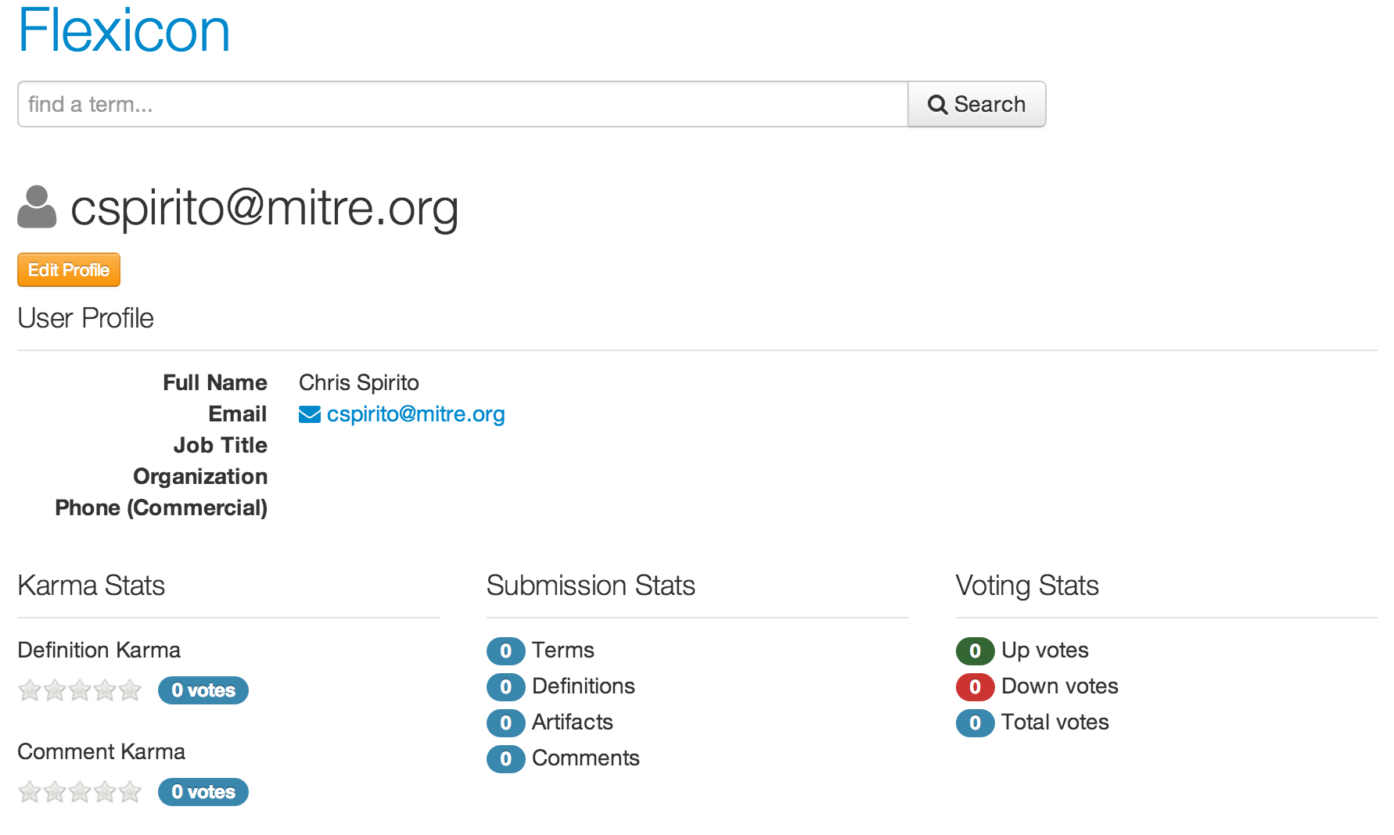

Information about that user is displayed as shown here. This includes the user email address which is also the login string. The “Edit” button is only displayed for the logged in user and a logged in user cannot change other user profile information.

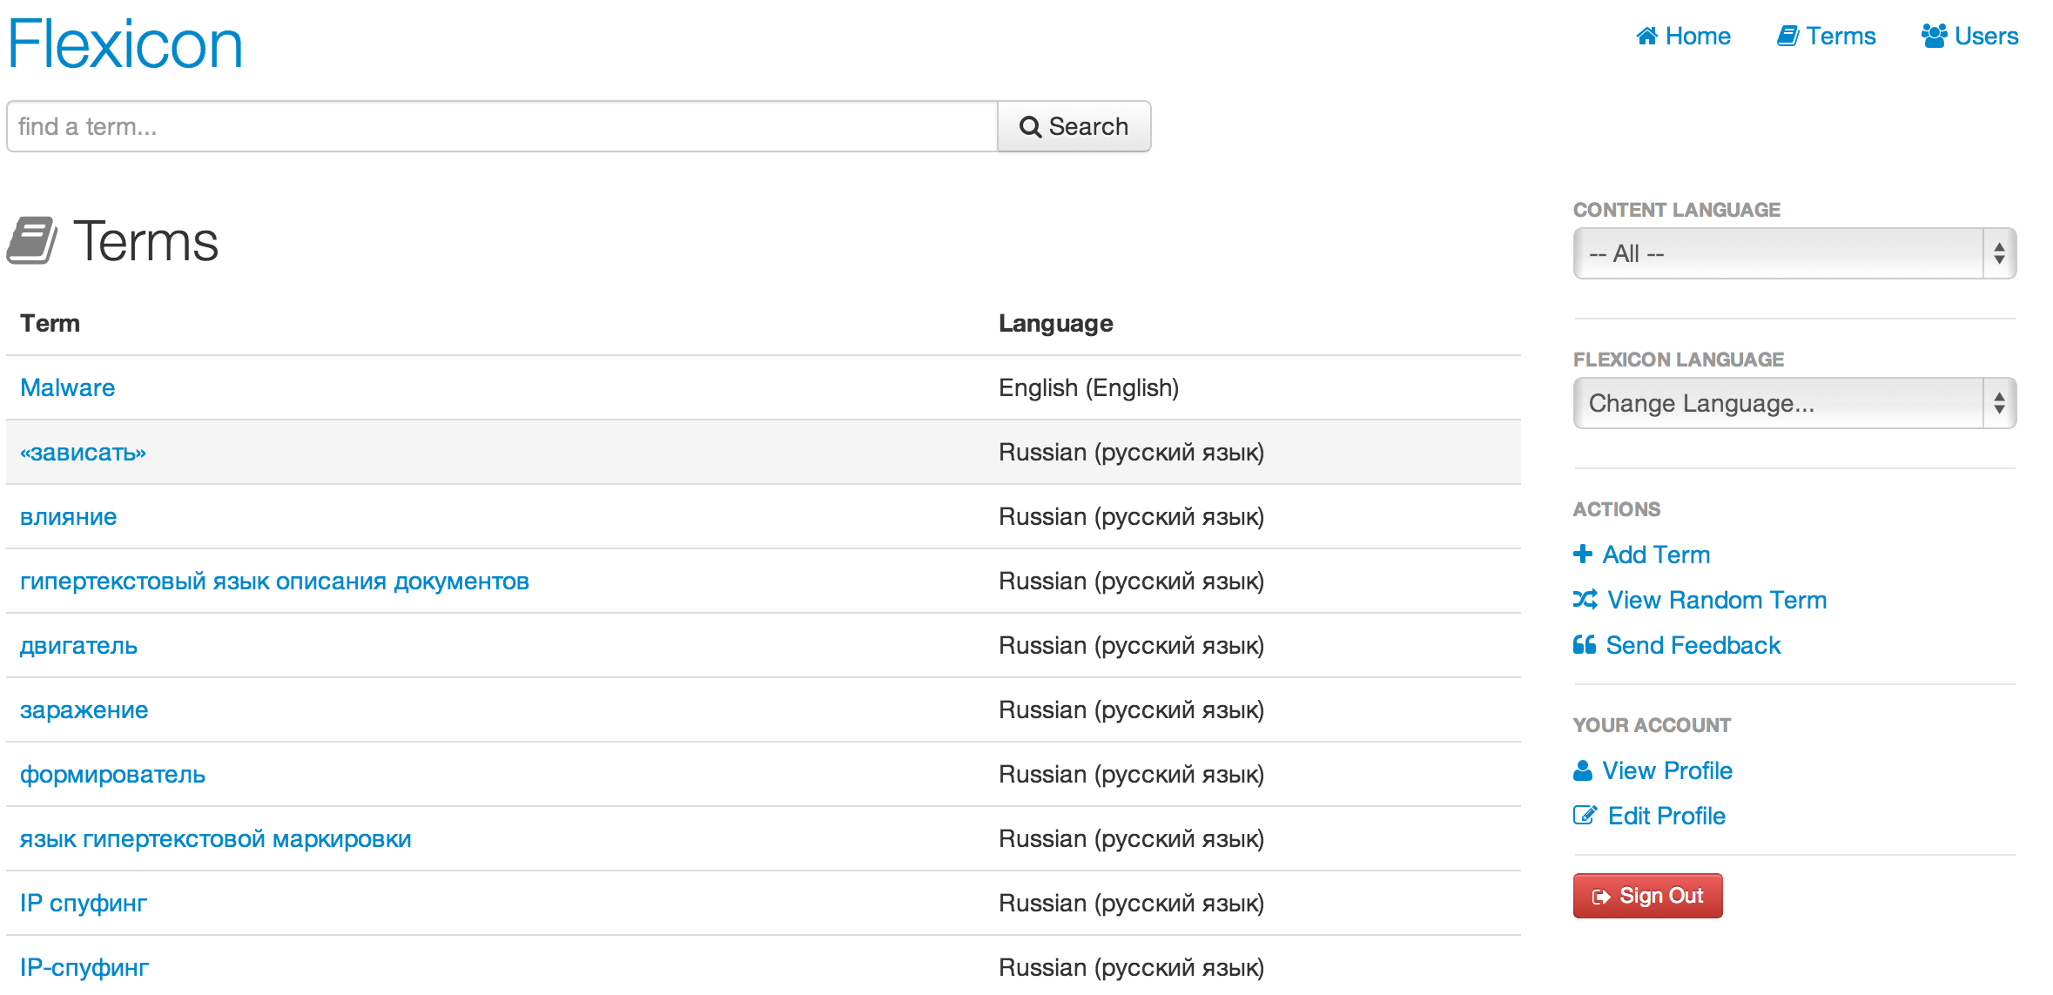

Figure - Flexicon Term List

Selecting the “Terms” button will generate a list of all the terms known by the Flexicon application.

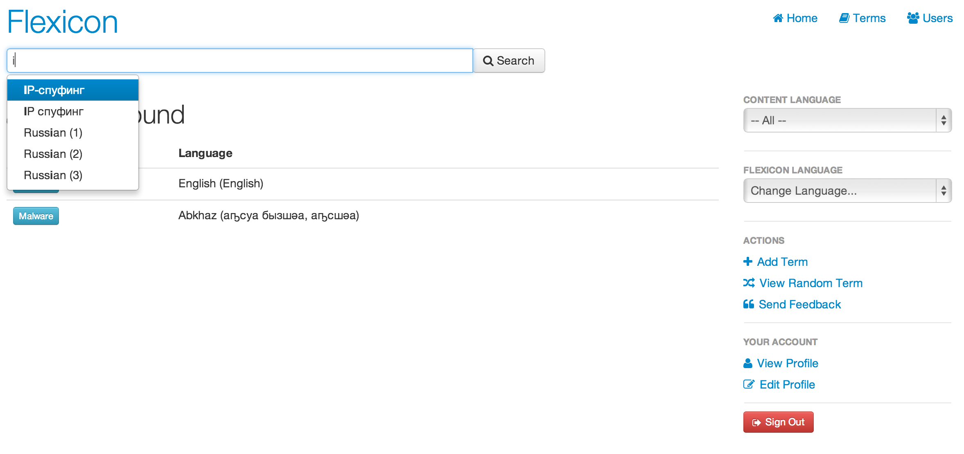

Figure - Flexicon Term Search

When the user starts to type in a term in the “Find A Term” search box, like terms will appear in a pop up and the user can select one of them. This is shown is the page illustrated here.

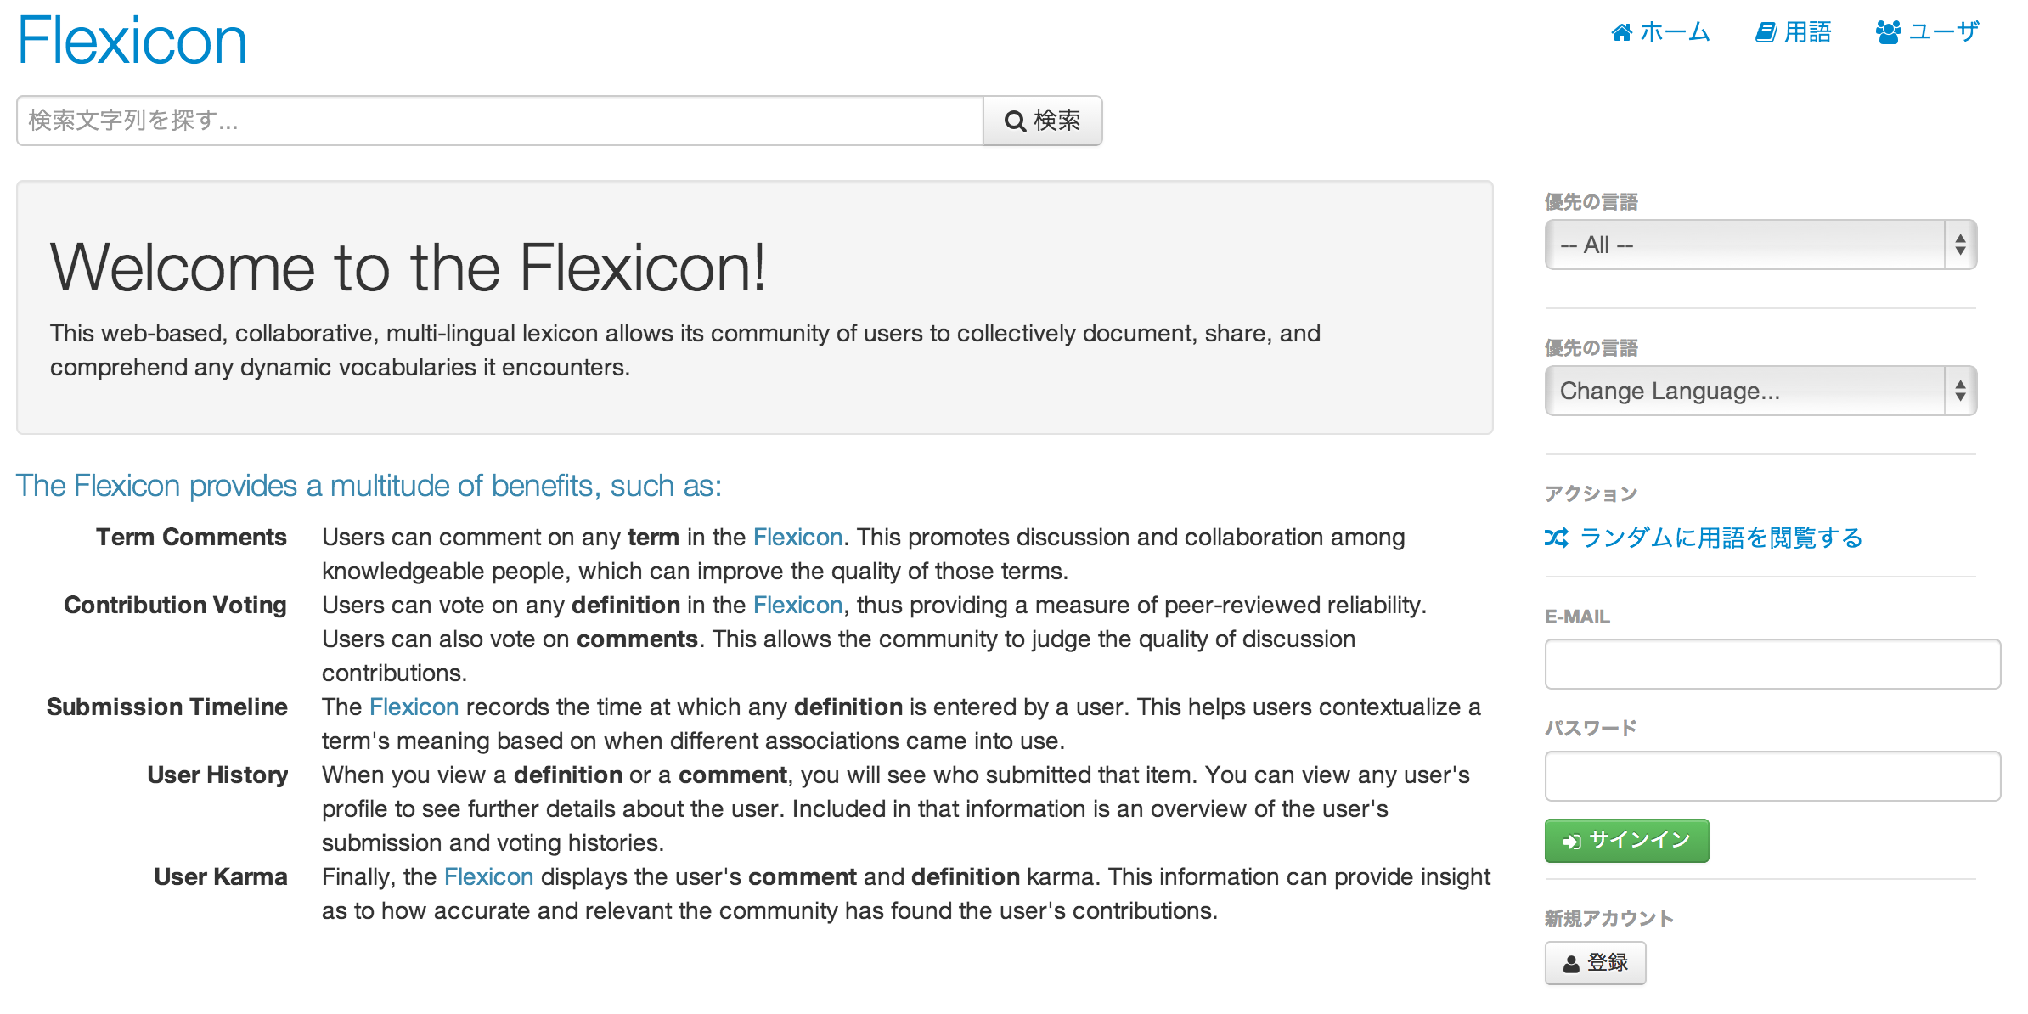

Figure - Flexicon Internationalization Support

The user can also select the Flexicon’s display language from a limited subset of available translations in the Flexicon Language box. Japanese is currently supported.