PROJECT DOCUMENTATION

Screening Project

SUMMARY

OVERVIEW 2

PROJECT REQUIREMENTS 2

CONCEPTUAL MODEL 3

LOGICAL MODEL 4

DATA DICTIONARY 5

|  |  |  |  |
| --- | --- | --- | --- |
| **Version** | **Date** | **Editor** | **Comments** |
| 1.0 | 08/23/2016 | CS | Creation of document |

OVERVIEW

You want to design a database to manage information for a B2B e-commerce site.

Users are companies which may have many subsidiaries, and each subsidiary has many end customers. The B2B platform allows them to buy products from qualified suppliers and sell them to end customers.

End customers are people who are identified by their document number, the full name, date of birth, home address, email and contact numbers (landline, mobile, fax, etc.).

Companies are identified by CUIT number (an unique identifier), date of commencement of its activities, website, email and telephones (landline, mobile, fax, etc.).

Subsidiaries are identified by SUIT number (an unique identifier), a nickname and an address

Suppliers are just a different type of company, and they expose a list of products and default prices.

Each user company can define its own price list using products from many suppliers. They can also place orders to the platform indicating which end customer has to receive the goods, orders among other things, should include a reference to the ordering subsidiary.

PROJECT REQUIREMENTS

1) Entity Relationship Model (ERM) diagram, including:

a. A description of the entities and their attributes.

b. Relationships

2) A database which implements the ERM.

3) SQL script that will create the whole database along with the constraints and relationships.

4) An SQL query or stored procedure for the following interactions with the database:

Getting how much products did a certain company order per month, broken down into subsidiaries.

Getting total orders paid from all companies coming from a specific end-customer.

Inserting a new company along with defining its subsidiaries.

5) Read - replica database on the same machine. Replication needs to be as real time as possible.

6) Automatic backups of the database every two hours.

CONCEPTUAL MODEL

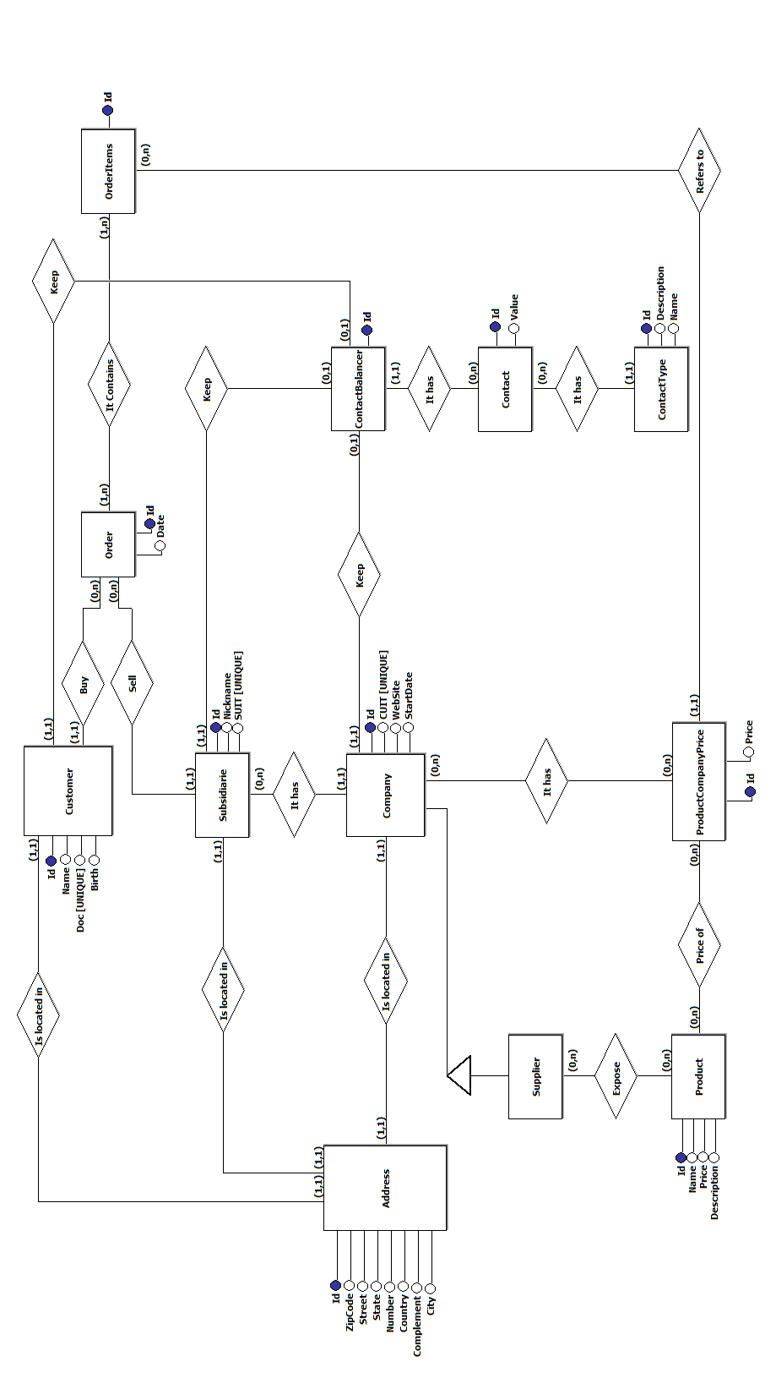

LOGICAL MODEL

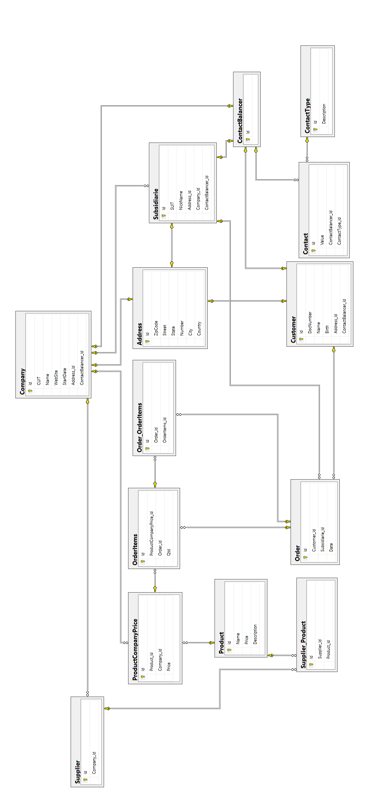

DATA DICTIONARY

|  |  |  |  |  |
| --- | --- | --- | --- | --- |
| **ENTITY: Address** | This entity stores the adress of active resources of system | | | |
| **PK / FK / UNIQUE** | **Field Name** | **Data Type** | **Field Length** | **Description** |
| PK | Id | int |  | For the unique and incremental identification of address records |
|  | ZipCode | int |  | Zip code of address |
|  | Street | varchar | 300 | Street of address |
|  | State | varchar | 100 | Complete name of state of address |
|  | Number | int |  | Number of the building or house of address |
|  | City | varchar | 100 | City of address |
|  | Country | varchar | 100 | Country of address |
|  |  |  |  |  |
| **ENTITY: Company** | This entity stores the data about companies | | | |
| **PK / FK / UNIQUE** | **Field Name** | **Data Type** | **Field Length** | **Description** |
| PK | Id | int |  | For the unique and incremental identification of company records |
| UNIQUE | CUIT | bigint |  | For the unique identification of company |
|  | Name | varchar | 300 | Name of company |
|  | WebSite | varchar | 100 | WebSite of company |
|  | StartDate | datetime |  | Date of commencement of company activities |
| FK | Address_Id | int |  | Current Address identification |
| FK | ContactBalancer_Id | int |  | Current ContactBalancert identification |
|  |  |  |  |  |
| **ENTITY: Contact** | This entity stores the contact of active resources of system | | | |
| **PK / FK / UNIQUE** | **Field Name** | **Data Type** | **Field Length** | **Description** |
| PK | Id | int |  | For the unique and incremental identification of contact records |
|  | Value | varchar | MAX | Value of this contact record |
| FK | ContactBalancer_Id | int |  | Current ContactBalancert identification |
| FK | ContactType_Id | int |  | Current ContactType identification |
|  |  |  |  |  |
| **ENTITY: ContactBalancer** | This entity stores the contact balancer to relate contact to an active resource of system | | | |
| **PK / FK / UNIQUE** | **Field Name** | **Data Type** | **Field Length** | **Description** |
| PK | Id | INT |  | For the unique and incremental identification of contact balancer records |

|  |  |  |  |  |
| --- | --- | --- | --- | --- |
|  |  |  |  |  |
| **ENTITY: ContactType** | This entity stores the contact type of a contact (Email, phone, cell, skype) | | | |
| **PK / FK / UNIQUE** | **Field Name** | **Data Type** | **Field Length** | **Description** |
|  | Id | INT |  | For the unique and incremental identification of contact type records |
|  | Description | VARCHAR | MAX | Description of contact type |
|  |  |  |  |  |
| **ENTITY: Customer** | This entity stores the data about customer | | | |
| **PK / FK / UNIQUE** | **Field Name** | **Data Type** | **Field Length** | **Description** |
| PK | Id | int |  | For the unique and incremental identification of customer records |
| UNIQUE | DocNumber | bigint |  | For the document number of customer |
|  | Name | varchar | 300 | Name of customer |
|  | Birth | datetime |  | Date of birth of customer |
| FK | Address_Id | int |  | Current Customer identification |
| FK | ContactBalancer_Id | int |  | Current ContactBalancer identification |
|  |  |  |  |  |
| **ENTITY: Order** | This entity stores the data about purchase order | | | |
| **PK / FK / UNIQUE** | **Field Name** | **Data Type** | **Field Length** | **Description** |
| PK | Id | int |  | For the unique and incremental identification of order records |
| FK | Customer_Id | int |  | Current Customer identification |
| FK | Subsidiarie_Id | int |  | Current Subsidiarie identification |
|  | Date | datetime |  | Date of issuance of the order |
|  |  |  |  |  |
| **ENTITY: Order_OrderItems** | This entity stores the relationship between order and order items | | | |
| **PK / FK / UNIQUE** | **Field Name** | **Data Type** | **Field Length** | **Description** |
| PK | Id | int |  | For the unique and incremental identification of Order_OrderItems records |
| FK | Order_Id | int |  | Current Order identification |
| FK | OrderItems_Id | int |  | Current OrderItems identification |
|  |  |  |  |  |
| **ENTITY: OrderItems** | This entity stores the items of a purchase order | | | |
| **PK / FK / UNIQUE** | **Field Name** | **Data Type** | **Field Length** | **Description** |
| PK | Id | int |  | For the unique and incremental identification of OrderItems records |
| FK | ProductCompanyPrice_Id | int |  | Current ProductConpanyPrice identification |
| FK | Order_Id | int |  | Current Order identification |
|  | Qtd | int |  | Quantity of this item in the current order |
|  |  |  |  |  |
| **ENTITY: Product** | This entity stores the data about products | | | |
| **PK / FK / UNIQUE** | **Field Name** | **Data Type** | **Field Length** | **Description** |
| PK | Id | int |  | For the unique and incremental identification of product records |
|  | Name | varchar | 300 | Name of product |
|  | Price | money |  | Original price of product |
|  | Description | varchar | MAX | Description of product |
|  |  |  |  |  |
| **ENTITY: ProductCompanyPrice** | This entity stores the price definition of products by companies | | | |
| **PK / FK / UNIQUE** | **Field Name** | **Data Type** | **Field Length** | **Description** |
| PK | Id | int |  | For the unique and incremental identification of ProductCompanyPrice records |
| FK | Product_Id | int |  | Current Product identification |
| FK | Company_Id | int |  | Current Company identification |
|  | Price | money |  | Company's price definition of product |
|  |  |  |  |  |
| **ENTITY: Subsidiarie** | This entity stores the data about subsidiaries | | | |
| **PK / FK / UNIQUE** | **Field Name** | **Data Type** | **Field Length** | **Description** |
| PK | Id | int |  | For the unique and incremental identification of subsidiarie records |
|  | SUIT | bigint |  | For the unique identification of subsidiarie |
|  | NickName | varchar | 300 | Nickname of subsidiarie |
| FK | Address_Id | int |  | Current Address identification |
| FK | Company_Id | int |  | Current Company identification |
| FK | ContactBalancer_Id | int |  | Current ContactBalancer identification |
|  |  |  |  |  |
| **ENTITY: Supplier** | This entity stores the data about supplier | | | |
| **PK / FK / UNIQUE** | **Field Name** | **Data Type** | **Field Length** | **Description** |
| PK | Id | int |  | For the unique and incremental identification of supplier records |
| FK | Company_Id | int |  | Current Company identification |
|  |  |  |  |  |
| **ENTITY: Supplier_Product** | This entity stores the relationship between supplier and product | | | |
| **PK / FK / UNIQUE** | **Field Name** | **Data Type** | **Field Length** | **Description** |
| PK | Id | int |  | For the unique and incremental identification of Address records |
| FK | Supplier_Id | int |  | Current Supplier identification |
| FK | Product_Id | int |  | Current Product identification |