Task 1:假定有四个进程 (P1 - P4)，到达时刻分别是0、10、20和40，优先级分别是1、2、3和4（假设4最高），执行时间分别是30、20、50和20毫秒， 这些进程在一个双CPU机器上被调度执行，系统中只有一个就绪队列（ready queue），假定上下文切换的开销为0。当分别采用以下可抢占调度算法时，画出按每种调度算法调度的甘特图，并计算其平均等待时间和平均周转时间。
(i) 优先级（Priority）调度；(ii) 轮转(Round Robin)调度，时间片为20ms； (iii) 最短作业优先 （Shortest Job First）。

Task 2: Consider a multi-level feedback queue in a single-CPU system. The first level (queue 0) is given a quantum of 8 ms, the second one a quantum of 16 ms, the third is scheduled FCFS. Assume jobs arrive all at time zero with the following job times (in ms): 4, 7, 12, 20, 25 and 30, respectively. Assume the context switch overhead is zero unless otherwise stated.
- Show the Gantt chart for this system.
- Compute the average waiting and turnaround time.
- Suppose the context switch overhead is 1 ms. Compute the average turnaround time.

Task 3: 下载并阅读论文《Simulation and Performance Evaluation of CPU Scheduling Algorithms》。编写C程序实现FCFS, SJF, SRTF, RR, Priorities Scheduling等常用算法，并在数据集上评估性能指标，包括Job Throughput、CPU Utilization、Average Turnaround Time、Average Response Time、Average Waiting Time。
参考项目：
- https://github.com/yousefkotp/CPU-Scheduling-Algorithms
- https://github.com/jasmarc/scheduler (too old)
用gnuplot或者python matplotlib把各个算法的性能比较图画出来。根据实验结果，陈述各个算法的优点和缺点。
注释：在clone仓库后，会发现verbose模式和非verbose模式下运行结果不一致，需按图示修改a2.h文件
原代码：
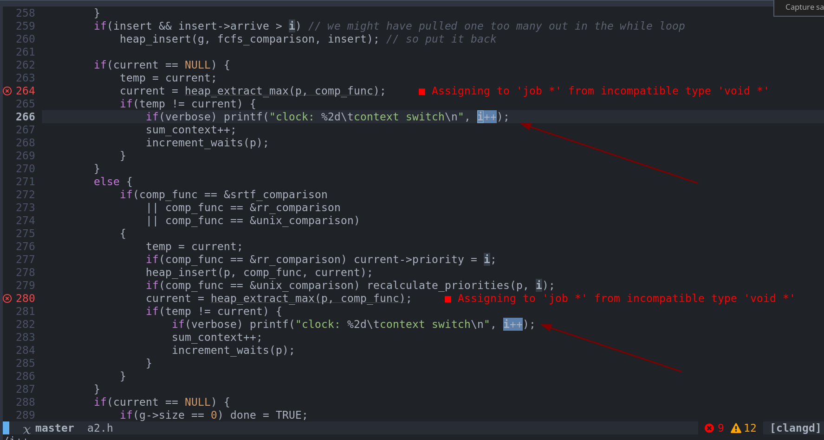
修改后的代码：
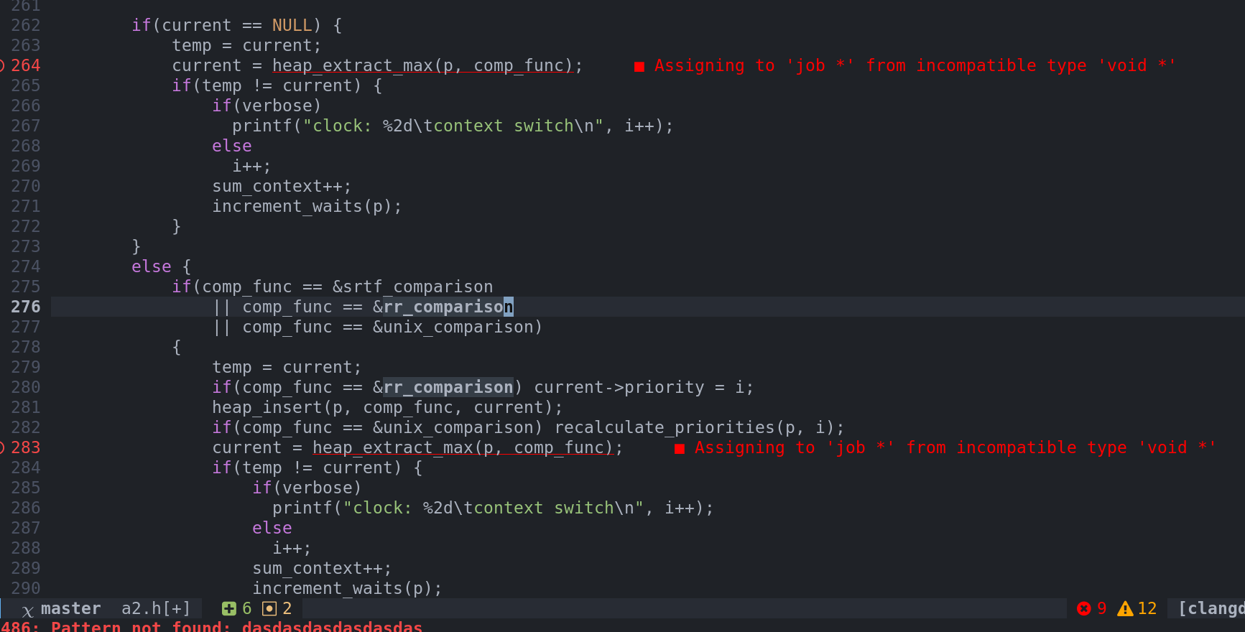

Abstract
This paper examines the factors that influence the performance of various CPU scheduling algorithms in order to evaluate each as determined by a set of common performance metrics.

1 Introduction
CPU scheduling is the process by which a computer's operating system determines how, in what order, and for how long individual processes in a queue of processes are allowed to access the CPU. Input factors such as the chosen scheduling algorithm, the length of processes, and frequency of processes will have an influence on performance factors such as CPU utilization, average job waiting time, average job response time, and average job turn-around time. Depending on the application, the importance of some factors may weigh more heavily than others. For instance, a system that is designed for heavier human-computer-interaction may require lower average job response time in order to make the system appear more responsive.
In this paper we will look at the following scheduling algorithms:
- First Come First Served
- Shortest Job First
- Shortest Remaining Time First
- Round Robin
- POSIX Dynamic Priorities Scheduling
We will observe the following output metrics:
- Job Throughput
- CPU Utilization
- Average Turnaround Time
- Average Response Time
- Average Waiting Time
We will also vary our random sample of data by altering certain factors which will be discussed later.

1.1 Scheduling Algorithms

1.1.1 First Come First Served (FCFS)
Jobs are processed in the order that they arrive [2]. For example, process P0 is the first to arrive at time t0 and no other processes are enqueued or are being serviced. P0 has a burst duration of 3. P0 is immediately serviced and continues to be serviced through to time t3. P1 showed up at time t1, but because the CPU was busy at the time, P1 is not serviced until time t3. Likewise, with any other processes that arrive while the CPU is busy, they are enqueued for later scheduling. Arrival does not guarantee immediate service, however earlier arrival does ensure higher priority for later scheduling.

1.1.2 Shortest Job First (SJF)
Jobs are prioritized by job burst duration [2]. For example, P0 and P1 arrive at the same time t0 and no other processes are enqueued or are being serviced. The CPU chooses the shorter of the two jobs, assume for example that the shorter job was P0, and leaves the other, P1, in the queue. While the CPU is servicing P0, other jobs may show up and join P1 in the queue. The fact that P1 arrived before those jobs has no bearing on their priority in this queue. If one of the jobs that has come along happens to be shorter than P1, it will jump to the front of the line and will be scheduled to receive service before P1. This scheduling algorithm allows for the possibility of starvation. It is possible that P1 may never get a turn at the CPU if a continuous stream of shorter jobs is in fresh supply to cut in front of P1.

1.1.3 Shortest Remaining Time First (SRTF)
Jobs are prioritized by job burst duration but allowing for preemption by shorter, newly-arriving processes [2]. For example, P0 and P1 arrive at the same time t0 and no other processes are enqueued or are being serviced. The CPU chooses the shorter of the two jobs, assume for example the shorter job was P0, and leaves the other, P1, in the queue. While the CPU is servicing P0, other jobs may show up and if they happen to be shorter in burst duration than the amount of remaining time left to finish servicing P0 as well as the burst duration of P1, then not only do they get to cut in front of P1, but also P0 is preempted. P0 is then shoved back into the queue unfinished and the shorter job is then serviced immediately. P0 will rise to the front of the queue again when its remaining burst duration is less than the remaining burst duration of any other process.

1.1.4 Round Robin (RR)
Jobs are time sliced and interleaved over time, allocating a certain quantum of time to each enqueued process [2]. For example, P0 and P1 arrive at the same time t0 and no other processes are enqueued or are being serviced. The CPU alternates between servicing P0 and P1 over equal quanta of times until both processes are completed. If other processes arrive while P0 and P1 are being serviced, they join the back of the queue and are rotated into the cycle. If the remaining burst duration of a particular process is less than the time chosen for the service quantum, the scheduler simply moves to the next item in the queue.

1.1.5 POSIX Dynamic Priorities Scheduling (POSIX)
POSIX Dynamic Priorities Scheduling algorithm is another preemptive scheduling algorithm that was designed to counter the starvation scenario presented in the SJF algorithm as well as assign different classes of priorities to different types of processes. Priorities are recalculated for all enqueued processes on a set schedule such that priority = (recent CPU usage/2) + base, where recent CPU usage is how much time the given process has spent at the CPU and base is a tunable, implementation-specific factor [2]. This algorithm ensures that processes that have seen the CPU but were preempted will not be starved out by incoming processes, and thus will eventually be allowed to finish.

1.2 Performance metrics

1.2.1 Job Throughput
This is simply the number of jobs per unit of time [2]. Throughout this report, time will always be measured in milliseconds.

1.2.2 CPU Utilization
This number, given as a percent, is an indication of the amount of time that the CPU has spent doing useful work as opposed to time spent context switching [2]. A context switch occurs when a process is preempted. The system must stop what it is doing, package up the current process's work environment, and move all of this safely to a storage area to be worked on later and to make room for the incoming process. This switching of tasks in and out is pure overhead and should be minimized in an efficient algorithm.

1.2.3 Average Turnaround Time
This is the amount of time it takes to service a process from arrival to completion [2].

1.2.4 Average Response Time
This is the amount of time it takes from the moment a process arrives to the moment we see the first response from the process, that is the first instant in which the process is being serviced [2].

1.2.5 Average Waiting Time
This is the total amount of time a scheduled process spends waiting, including time spent waiting for its first turn at the CPU as well as time spent waiting after being preempted by a higher priority process [2].

1.3 Input Data
The burst durations of real life CPU processes have been found to follow an exponential probability distribution such that shorter burst are more likely to occur, whereas longer burst durations are less likely to occur. Likewise interprocess arrival times have been similarly been found to follow an exponential probability distribution function such that shorter time intervals between processes are more likely to occur than larger time intervals between processes [2].

2. References
[1] T. H. Cormen, C. E. Leiserson, R. L. Rivest, and C. Stein. Introduction to Algorithms. MIT Press, Second Edition, 2001.
[2] A. Silberschatz and P. B. Galvin. Operating Systems Concepts. Addison Wesley, Reading, MA, Seventh Edition, 2004.
[3] Weisstein, Eric W. "Exponential Distribution." From MathWorld--A Wolfram Web Resource. http://mathworld.wolfram.com/ExponentialDistribution.html

