**INTRUSION DETECTION USING IMAGES AS A DATA SET AND MODELS LIKE VGG 16, RESET**

**ABSTRACT**

**Abstract**

This project introduces a Time-Based Attendance Management System that aims to streamline and modernize the traditional manual attendance tracking method, which is both time-consuming and challenging to maintain. The proposed system leverages advanced biometric technology, particularly Deep Learning (DL) based Face Recognition algorithms. Human faces serve as the primary dataset for training, employing the LBPH Face Recognizer. The user interface is developed through the Flask framework, providing a user-friendly web page. Notably, as an enhancement to this system, it offers the capability to store attendance data in a database, including timestamps.

The system is designed with two key modules:

Admin Module: The Admin has the ability to upload student data, view individual student profiles, and train the face recognition model on the student data. The Admin can also add marks details and view attendance statistics, such as total students, present students, and absent students. Additionally, the Admin can filter the attendance data by student name. An innovative feature automatically sends an email to parents regarding attendance condonation, based on the student’s attendance percentage.

Student Module: Students can mark their attendance using facial recognition, view their profile, and download their marks. The student dashboard provides easy access to attendance details and academic performance, enhancing the user experience.

In addition, the system includes a feature to notify parents about their children’s attendance, marks, and behavior through the Fast to SMS website, strengthening the communication between educational institutions and parents. This enhancement not only boosts the efficiency of attendance management but also fosters a more informed and engaged educational environment

**Keywords**: Attendance Management, Computer Vision, Deep Learning, Human Face Images, sending SMS.

**INTRODUCTION**

**1.1 MOTIVATION**

The motivation behind this project lies in revolutionizing attendance management within educational institutions by integrating cutting-edge Deep Learning technology. The system utilizes face recognition algorithms to accurately and efficiently track student attendance, reducing the reliance on traditional, time-consuming methods. This innovation not only streamlines administrative tasks but also encourages a culture of punctuality among students.

The system is designed with dual functionality: the **Admin Module** allows administrators to upload and manage student data, track attendance statistics, and send automated emails to parents regarding attendance condonation. The **Student Module**, on the other hand, empowers students to take attendance via facial recognition, view their profile, and download marks. This streamlined approach improves the overall user experience for both students and administrators.

An additional feature, the integration of real-time notifications through the Fast to SMS website, further enhances communication between schools and parents. Parents receive updates on their children's attendance, marks, and behavior, fostering greater parental involvement in their child's education.

Ultimately, this initiative aims to not only enhance student monitoring and administrative efficiency but also improve parental engagement and foster a more informed and connected educational environment.

**1.2 PROBLEM STATEMENT**

Traditional attendance management systems in educational institutions are often time-consuming, prone to errors, and inefficient. Manual tracking and record-keeping can lead to inaccuracies, administrative delays, and a lack of real-time monitoring. Additionally, communication between schools and parents regarding student attendance and performance is often limited, hindering effective parental involvement.

This project addresses these challenges by implementing a **Time-Based Attendance Management System** that leverages Deep Learning-based Face Recognition technology for accurate and efficient attendance tracking. The system allows admins to manage student data, monitor attendance in real time, and send automated notifications to parents regarding their child’s attendance and academic performance. Students can easily mark attendance using facial recognition and view their profiles and marks.

By automating attendance management and enhancing communication with parents, the system aims to improve administrative efficiency, foster punctuality among students, and create a more informed and engaged educational environment.

**1.3 OBJECTIVE OF THE PROJECT**

The primary objective of this project is to develop an efficient and automated **Time-Based Attendance Management System** using advanced **Deep Learning-based Face Recognition** technology. The system aims to replace traditional, manual attendance tracking methods, addressing the challenges of inaccuracies, time consumption, and administrative errors.

The key objectives of the system are:

1. **Accurate Attendance Tracking**: Utilize facial recognition for real-time, error-free attendance marking, ensuring efficiency and eliminating human error in attendance recording.
2. **Admin Control & Management**: Allow administrators to upload student data, track attendance statistics (total, present, and absent students), and add marks details. The system provides a streamlined platform for attendance management.
3. **Automated Parent Notifications**: Integrate a feature that sends automatic notifications to parents regarding their child’s attendance and performance, improving communication and increasing parental involvement in the educational process.
4. **Student Dashboard**: Enable students to take attendance via facial recognition, view their profiles, and download their marks, improving the overall student experience.
5. **Enhanced Administrative Efficiency**: Automate processes related to attendance tracking, reducing manual efforts, and saving valuable time for both students and administrators.

**1.4 SCOPE**

The scope of this **Time-Based Attendance Management System** includes the development and implementation of a fully automated solution for managing student attendance in educational institutions. The system will utilize **Deep Learning-based Face Recognition** technology to accurately mark attendance, minimizing human error and inefficiencies in traditional methods.

The system will have two main modules:

1. **Admin Module**: Admins can upload student data, track attendance, and generate reports. The system will provide real-time attendance statistics, including the number of present and absent students, and enable admin to send attendance notifications to parents based on attendance percentages.
2. **Student Module**: Students will be able to mark attendance using facial recognition, view their profile, and download their marks.

The system also integrates with external services like **Fast to SMS** for automated parent communication. The project focuses on improving attendance management efficiency, ensuring accurate tracking, and fostering better communication between schools and parents.

**1.5 PROJECT INTRODUCTION**

In educational institutions, managing attendance is a crucial but often cumbersome task. Traditional manual methods of attendance tracking are not only time-consuming but also prone to errors and inaccuracies. This inefficiency not only affects administrative tasks but also hampers the ability to monitor student punctuality and performance in real-time. The **Time-Based Attendance Management System** aims to address these challenges by introducing a cutting-edge solution based on **Deep Learning-based Face Recognition** technology.

The system replaces manual attendance recording with a more efficient, automated process where students mark their attendance using facial recognition. The face recognition algorithm ensures accuracy and prevents proxy attendance, a common issue with traditional methods. By integrating **LBPH (Local Binary Pattern Histogram) Face Recognizer**, the system learns and identifies student faces, offering seamless and error-free attendance tracking.

This project is divided into two main modules: the **Admin Module** and the **Student Module**. The **Admin Module** enables administrators to upload and manage student data, track attendance patterns, generate reports, and send automated notifications to parents regarding their child’s attendance status and academic performance. The **Student Module** allows students to mark attendance via facial recognition, view their profile, and download their marks.

In addition to enhancing attendance management, the system features real-time notifications to parents through **Fast to SMS**, ensuring improved communication between educational institutions and parents. This fosters greater parental involvement in a child’s education, creating a more engaged and supportive learning environment.

Ultimately, the **Time-Based Attendance Management System** not only aims to streamline administrative processes but also contributes to a more efficient, secure, and communicative educational system.

**3. SYSTEM ANALYSIS**

**3.1 Existing Method:**

The existing system for attendance management in educational institutions relies on manual methods, where educators manually mark and record students' attendance during each class. This manual process is time-consuming, prone to errors, and lacks real-time tracking capabilities. To address these challenges, our project introduces a modernized approach that leverages Face Recognition technology. By implementing Deep Learning-based Face Recognition, the system aims to automate the attendance tracking process. Students' faces are scanned, identified, and their attendance is recorded in real-time. This transition from the traditional manual system to automated Face Recognition offers a more efficient and accurate means of managing attendance, improving the overall educational experience.

**DISADVANTAGES**

Face recognition-based attendance tracking systems have disadvantages:

**1.Privacy Concerns:** These systems can raise privacy issues as they involve biometric data collection, which individuals may find invasive.

**2.Accuracy:** Accuracy may be compromised due to variations in lighting, facial expressions, or occlusions.

**3.Costly Implementation:** Setting up face recognition systems can be expensive due to the need for specialized hardware and software.

**4.Security Vulnerabilities:** Face recognition can be vulnerable to spoofing or hacking attempts.

**5.Ethical Concerns:** Concerns about consent and misuse of biometric data must be addressed.

**6.Dependency on Technology:** Technical failures or outages can disrupt attendance tracking.

**7.Cultural Sensitivity:** Different cultural norms may affect acceptance and usage.

**PROPOSED SYSTEM**

The proposed system aims to revolutionize attendance management in educational institutions by leveraging **Deep Learning-based Face Recognition** technology for automated and accurate attendance tracking. This modernized approach overcomes the limitations of traditional manual systems, ensuring efficiency, precision, and eliminating issues like proxy attendance. The system employs **LBPH Face Recognizer** to accurately identify students through facial recognition, offering a seamless user experience for both administrators and students.

Additionally, the system integrates two key modules: the **Admin Module** and the **Student Module**. The **Admin Module** allows administrators to upload student data, manage attendance, and track student performance. Admins can also send automated attendance notifications to parents based on attendance percentage, improving communication between the institution and parents. The **Student Module** provides students with the ability to mark attendance via facial recognition, view their profile, and download marks, enhancing their engagement with the system.

**ADVANTAGES**

Advantages of the Proposed Time-Based Attendance Management System:

1. Enhanced Accuracy: The Deep Learning-based Face Recognition system ensures precise attendance tracking, reducing the chances of errors in recording attendance data.

2. Real-time Monitoring: The system allows for real-time attendance updates, enabling educators to promptly address attendance-related issues and maintain class efficiency.

3. Improved Parental Engagement: Integration with the Fast to SMS website provides parents with timely notifications about attendance, marks, and behavior, fostering active parental involvement in their child's education.

4. Time Efficiency: Automation reduces the time spent on manual attendance-taking, allowing educators to allocate more time to instructional activities.

5. Data Security: The secure database infrastructure safeguards attendance records, ensuring the confidentiality and integrity of sensitive student data.

**3.5 Work Flow of Proposed System**

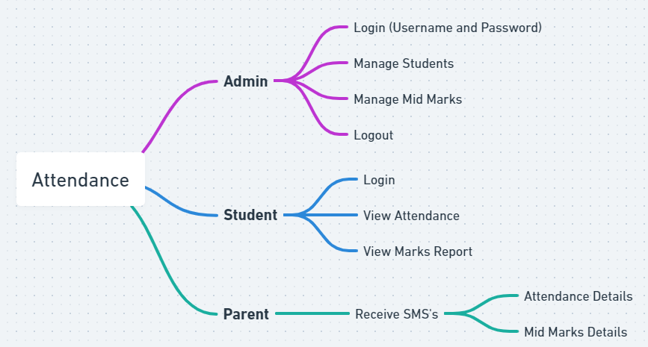

* 1. **Hardware Requirements**

# Processor - I3/Intel Processor

Hard Disk - 160GB

Key Board - Standard Windows Keyboard

Mouse - Two or Three Button Mouse

Monitor - SVGA

RAM - 8GB

* 1. **Software Requirements:**

Operating System : Windows 7/8/10

Server side Script : HTML, CSS, Bootstrap & JS

Programming Language : Python

Libraries : Flask, Pandas, Mysql.connector, Os, Smtplib, Numpy

IDE/Workbench : PyCharm

Technology : Python 3.6+

Server Deployment : Xampp Server

Database : MySQL

**SYSTEM DESIGN:**

## Input Design:

In an information system, input is the raw data that is processed to produce output. During the input design, the developers must consider the input devices such as PC, MICR, OMR, etc.

Therefore, the quality of system input determines the quality of system output. Well-designed input forms and screens have following properties −

* It should serve specific purpose effectively such as storing, recording, and retrieving the information.
* It ensures proper completion with accuracy.
* It should be easy to fill and straightforward.
* It should focus on user’s attention, consistency, and simplicity.
* All these objectives are obtained using the knowledge of basic design principles regarding −
  + What are the inputs needed for the system?
  + How end users respond to different elements of forms and screens.

### Objectives for Input Design:

The objectives of input design are −

* To design data entry and input procedures
* To reduce input volume
* To design source documents for data capture or devise other data capture methods
* To design input data records, data entry screens, user interface screens, etc.
* To use validation checks and develop effective input controls.

**Output Design:**

The design of output is the most important task of any system. During output design, developers identify the type of outputs needed, and consider the necessary output controls and prototype report layouts.

### Objectives of Output Design:

The objectives of input design are:

* To develop output design that serves the intended purpose and eliminates the production of unwanted output.
* To develop the output design that meets the end user’s requirements.
* To deliver the appropriate quantity of output.
* To form the output in appropriate format and direct it to the right person.
* To make the output available on time for making good decisions.
  1. **Architecture:**

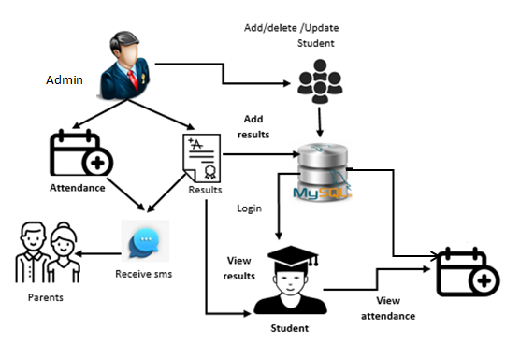

**SYSTEM DESIGN:**

## **Input Design:**

In an information system, input is the raw data that is processed to produce output. During the input design, the developers must consider the input devices such as PC, MICR, OMR, etc.

Therefore, the quality of system input determines the quality of system output. Well-designed input forms and screens have following properties −

* It should serve specific purpose effectively such as storing, recording, and retrieving the information.
* It ensures proper completion with accuracy.
* It should be easy to fill and straightforward.
* It should focus on user’s attention, consistency, and simplicity.
* All these objectives are obtained using the knowledge of basic design principles regarding
  + What are the inputs needed for the system?
  + How end users respond to different elements of forms and screens.

### Objectives for Input Design:

The objectives of input design are −

* To design data entry and input procedures
* To reduce input volume
* To design source documents for data capture or devise other data capture methods
* To design input data records, data entry screens, user interface screens, etc.
* To use validation checks and develop effective input controls.

**Output Design:**

The design of output is the most important task of any system. During output design, developers identify the type of outputs needed, and consider the necessary output controls and prototype report layouts.

### Objectives of Output Design:

The objectives of input design are:

* To develop output design that serves the intended purpose and eliminates the production of unwanted output.
* To develop the output design that meets the end user’s requirements.
* To deliver the appropriate quantity of output.
* To form the output in appropriate format and direct it to the right person.
* To make the output available on time for making good decisions.

**MODULES:**

### **1. Admin Module**

The **Admin Module** is the control center for managing the attendance system. It is designed for administrators and educational staff to monitor, update, and manage attendance data, student profiles, and communication with parents.

* **Upload and Manage Student Data**: The admin can upload student details, including names, class information, and photographs. This data is used to train the face recognition model and for accurate attendance tracking.
* **Train Face Recognition Model**: The admin can train the **Deep Learning-based Face Recognition** model using the facial images of students. This ensures that the system accurately recognizes the students' faces during attendance marking.
* **Mark Attendance**: Although the attendance is primarily automated through face recognition, the admin can manually update or adjust attendance records if needed. The system stores attendance data along with timestamps for every instance a student is marked present.
* **Track Attendance Statistics**: Admins can view key attendance metrics, including total number of students, present students, and absent students. These insights help in monitoring attendance trends.
* **Filter by Student Name**: The admin can filter attendance records by student names, which helps in generating specific reports for individual students or specific time periods.
* **View and Add Marks**: Admins can input or update students' academic marks in the system. This can be associated with attendance data for more detailed analysis of student performance.
* **Send Automated Parent Notifications**: Based on attendance percentage, the admin can automatically send email notifications to parents. These notifications inform parents about their child's attendance status, behavior, and marks, helping to increase parental involvement.
* **Generate Reports**: Admins can generate detailed attendance reports that summarize student attendance over a set period, making it easier for schools to analyze trends and identify students who may require further attention.

### **2. Student Module**

The **Student Module** provides an intuitive interface for students to interact with the attendance system. Students can easily mark their attendance using face recognition and access their academic details.

#### **Key Features & Actions:**

* **Facial Recognition for Attendance**: Students can mark their attendance by simply standing in front of the system, which uses facial recognition to automatically register their presence. This feature is fast, efficient, and eliminates the need for manual roll calls.
* **View Profile**: Each student has a personal profile where they can view and update their basic information (if required). This may include details like name, contact information, and photo.
* **Download Marks**: Students can access and download their academic marks directly from the dashboard. This feature makes it easy for students to track their academic progress and performance over time.
* **View Attendance History**: Students can also view their past attendance records, helping them keep track of their punctuality and attendance percentage. This transparency can encourage better attendance behavior.
* **Check Attendance Status**: Students can check if their attendance for the day has been recorded successfully. If any issues arise (like a missed recognition), they can notify the admin for corrections.