Project Plan
PILLAR
CSC 532: SOFTWARE ENGINERING
FALL 2016

Submitted by Pillar Team
Venkata Yedidi
Teja Kakulvar
Andrew Touchet
Hugh DeJarnette
Wennan Ma

Revision History
Name | Date | Reason For Changes | Version
 | 10/11/2016 | Drafted version of project plan | 1.0

A. Introduction
The purpose of this document is to provide information about Pillar platform project. It includes project timeline, potential difficulties, dependencies, assumptions, estimates, and project team.
B. Software Project Description
The main objective of this project is to build the dashboard that accomplishes the following:
- Connect to devices on a common network.
- Allow the user to see and control device states
- Track device state history relative to the user’s activities.
C. Team Members
- Venkata Yedidi
- Teja Kakulvar
- Andrew Touchet
- Hugh DeJarnett
- Wennan Ma
D. Deliverables
The deliverables for this project include:
Project Plan
Requirements Document
Design Document
Test plan
Demo of the final product.

E. Project Timeline
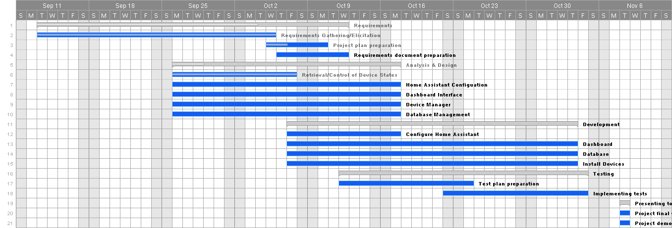
F. Responsibilities
Team Member | Responsibilities
Kiran Yedidi | Creating dashboard
Andrew Touchet | Device management, Database
Teja Kakulvar | Creating dashboard, Device management, Database
Wennan Ma | YAML configuration file, Testing
Hugh DeJarnette | YAML configuration file, Testing, Device installation

G. Potential Difficulties
- Configuring wink hub with other devices, getting/setting states of devices.
H. Resources:

- Home assistant
- Raspberry Pi
- Eclipse IDE

I. Dependencies:

- Python should be installed on device where home assistant is running.
- Bootstrap
- Device access token

J. Assumptions:

- Configuration files are already built.
- Devices are already installed and connected to Home assistant.

