**Evaluate offline alternatives**

“CodeIsFun” is the web application for programming community. There are several reasons why we need this web application instead of programming Language books and tutor courses. The digital population worldwide were active internet users around 3.81 billion and 2.91 billion were social media users as of April 2017 (Statista, 2017). The statistic show that people are trend to use more internet ,so this is the good way to create the web application.

Why we need this system ?

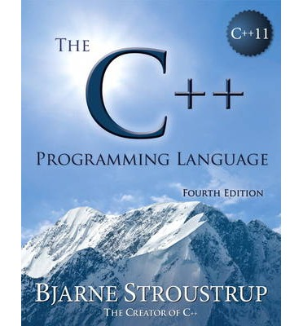

1. Programming Language Books are ineffective as a means of solving the problems. People can’t ask the author of this book about how to practice this solution or how to solve this error. All this thing can’t be done by the offline. Therefore, the web application for programming can solve all of this issues. People can chat each other about how to solve this problems. Also, people can share their idea about new questions and then let anyone come to join and solve it.
2. Tutor courses for teaching programming language are too expensive cost. People may be the expert after they learned from the tutor center. However, they can get only one language and few questions for practising. Web application have the tutorials and the problems. Therefore, people can learn and practice their programming skill at the same time. Moreover, it’s free.



The best feature is ranking people who can solve more questions in this week. Just like game on web board who will be the star in this week. This will attack more user to challenge and improve their programming skill. The winner of this week may get the gift from website.

**Evaluate online alternatives**

Six elements of sustainability

1. magnet content authored by experts
2. means of collaboration
3. powerful facilities for browsing and searching both magnet content and contributed content
4. means of delegation of moderation
5. means of identifying members who are imposing an undue burden on the community and ways of changing their behavior and/or excluding them from the community without them realizing it
6. means of software extension by community members themselves

“CodeisFun” provide the place for people ,who are the expert of programming, can share their questions. The number of questions are solved by users and they will rate about the questions are easy or difficult to solve. The admin can add, edit, delete the contents that are not appropriate in the community or some users who are imposing not polite. Also, the questions that are popular will present in the top of page and show the author of this questions. It can affect more expert members to show their skill in the community.

**The magnet content**

It will come from the users who interested in programming language community. They will share the questions that they made and invited some friends of them to join this community. If the problem is popular because it is hard to solve it. This will bring more expert to come to join the community. And the rank of people who can solve the problems are like the hall of fame in the community. 

Reference: <https://www.statista.com/statistics/617136/digital-population-worldwide/>