PS2
1. Create a database table to hold these
data:
– create new application mystocks.
– in database mystocks_development,create a table my_stocks

create table my_stocks (symbol varchar(20) not null,n_shares integer not null,date_acquired date not null);

--load the file mystocks.txt in the table in
mystocks_development=# copy my_stocks from '/home/neha/PS2_Quotation/mystocks/mystocks.txt';
COPY 5

mystocks_development=# select * from my_stocks;

symbol | n_shares | date_acquired
--------+----------+---------------
﻿MSFT | 200 | 2006-08-06
AAPL | 50 | 2000-07-25
GOOG | 250 | 1997-12-01
INTC | 100 | 1995-02-25
HSBC | 425 | 2015-05-30
(5 rows)

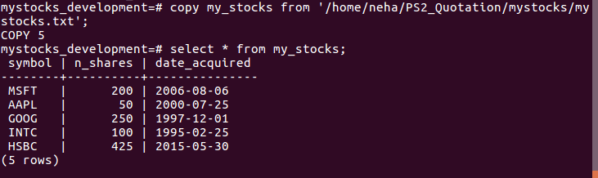
2. create a table called stock prices with three columns: symbol, quote date, and price.
>> create table stock_prices as select symbol,current_date as quote_date,31.415 as price from my_stocks ;
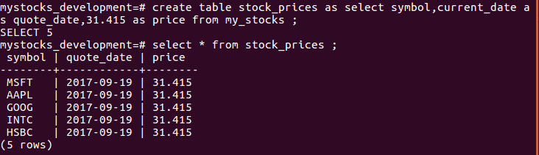
– Create a table newly_acquired_stocks
>> create table newly_acquired_stocks (symbol varchar(20) not null,n_shares integer not null,date_acquired date not null);

--insert the values from table my_stocks
>> insert into newly_acquired_stocks select * from my_stocks where n_shares > 150;

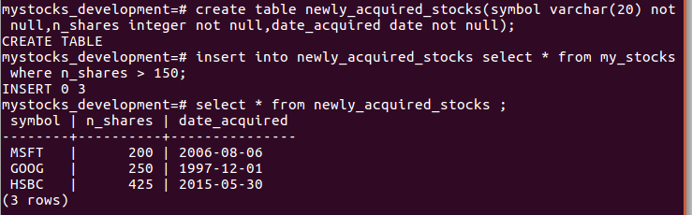
3.JOIN : joining my_stocks and stock_prices

>>create table joint_table as select stocks.symbol,stocks.n_shares,prices.price,(prices.price*10) as current from my_stocks stocks join stock_prices prices on stocks.symbol=prices.symbol;

SELECT 5

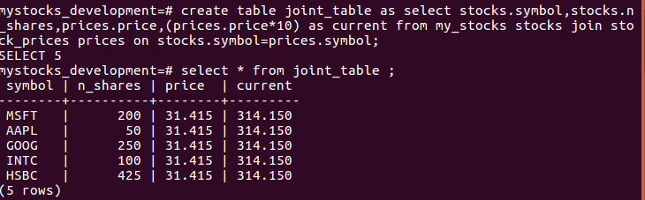
4. outer join: insert a row in my_stocks:
>>insert into my_stocks (symbol,n_shares,date_acquired) values('AMZN',125,'11/29/2005');

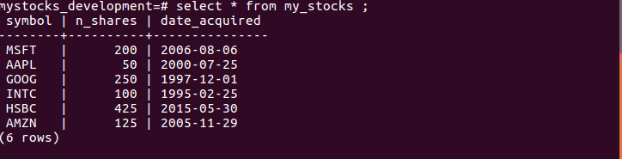
– After inserting new row and joining it again.
>> create table new_join as select stocks.symbol,stocks.n_shares,prices.price,(prices.price*10) as current from my_stocks stocks left outer join stock_prices prices on stocks.symbol=prices.symbol;

