SQL
Q 7. create table my_stocks

mystocks_development=# create table my_stocks (symbol varchar(20) not null,n_shares integer not null,date_acquired date not null);

– load the file mystocks.txt in the table in
mystocks_development=#
copy my_stocks from '/home/neha/PS2_Quotation/mystocks/mystocks.txt';

mystocks_development=# select * from my_stocks;
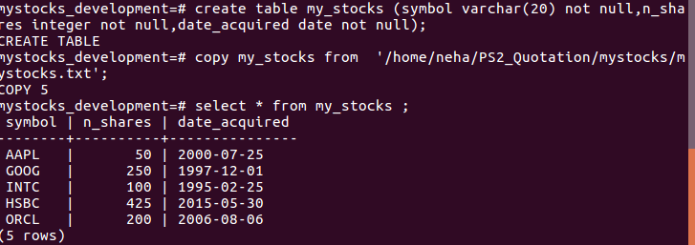

Q 8.
Part I: Create a table called stock prices with three columns: symbol, quote date, and price.

mystocks_development=# create table stock_prices as select symbol,current_date as
quote_date,31.415 as price from my_stocks ;

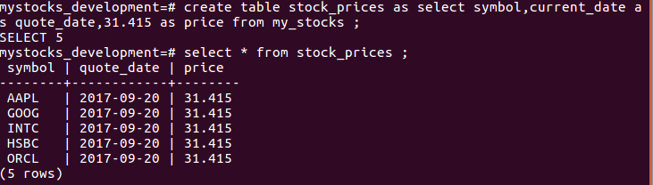
Part II : Create a table newly_acquired_stocks

mystocks_development=# create table newly_acquired_stocks (symbol varchar(20) not null,n_shares integer not null,date_acquired date not null);

mystocks_development=# insert into newly_acquired_stocks select * from my_stocks where n_shares > 150;

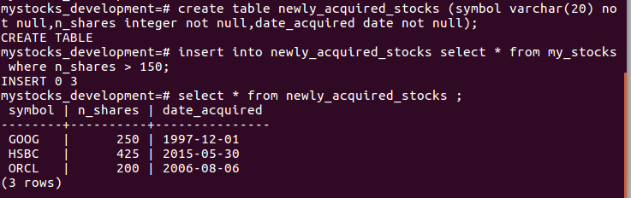

Q 9. JOIN : joining my_stocks and stock_prices

mystocks_development=# create table joint_table as select stocks.symbol,stocks.n_shares,prices.price,(prices.price*10) as current from my_stocks stocks join stock_prices prices on stocks.symbol=prices.symbol;

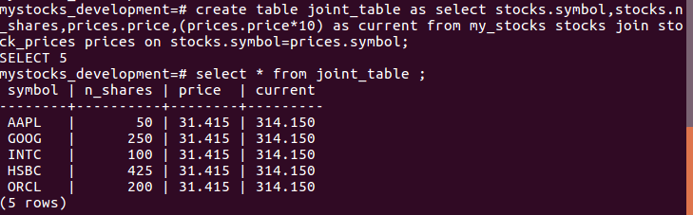

Q 10. OUTER JOIN:

mystocks_development=# insert into my_stocks (symbol,n_shares,date_acquired) values('AMZN',125,'11/29/2005');

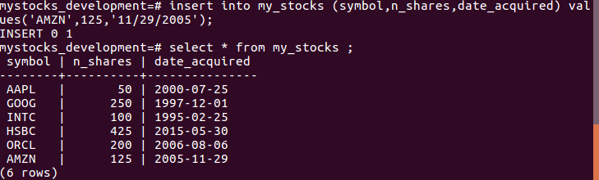
– After inserting new row and joining it again.

mystocks_development=# create table new_join as select stocks.symbol,stocks.n_shares,prices.price,(prices.price*10) as current from my_stocks stocks left outer join stock_prices prices on stocks.symbol=prices.symbol;

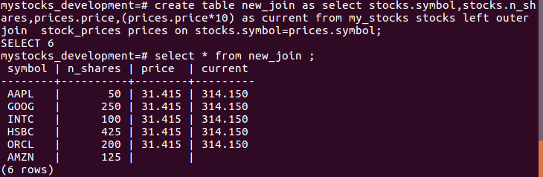

Q 11. PL/SQL :
Part I :

CREATE OR REPLACE FUNCTION stock_value(string varchar)
RETURNS integer as $$
DECLARE
ascii_value integer := 0;
BEGIN
for i in 1..length(string) loop
ascii_value:= ascii_value + ascii(substr(string,i,1));
END loop;
RETURN ascii_value;
END;
$$LANGUAGE plpgsql;

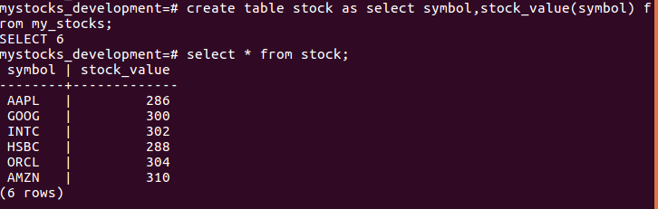

Part II :
– Update the stock_prices with the ascii value of symbol.

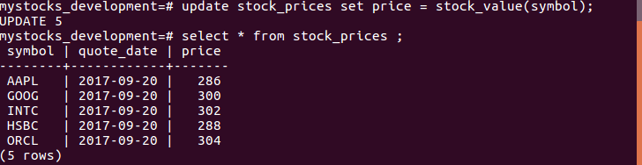

– Again joining the table my_stocks and stock_prices after updating the stock_prices table with stock_value function as price.

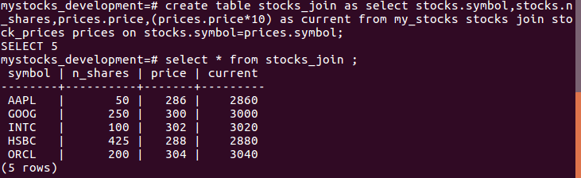

Part III:
CREATE OR REPLACE FUNCTION portfolio_value()
RETURNS double precision AS $$
DECLARE
aggregate_value double precision := 0;
rec_rows RECORD;
cur_portfolio CURSOR
FOR select stocks.symbol, stocks.n_shares,price, price*n_shares as current_value from my_stocks stocks join stock_prices price on stocks.symbol = price.symbol;
BEGIN
OPEN cur_portfolio;
LOOP
FETCH cur_portfolio INTO rec_rows;
EXIT WHEN NOT FOUND;
aggregate_value := aggregate_value + rec_rows.current_value;
END LOOP;
CLOSE cur_portfolio;
RETURN aggregate_value;
END;
$$ language plpgsql;

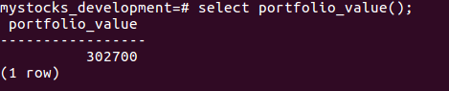

Q 12.
Part I : To calculate the average of price

mystocks_development=# select avg(price) from stock_prices;
avg
----------------------
296.0000000000000000
(1 row)

Part II:

mystocks_development=# insert into my_stocks (symbol,n_shares,date_acquired) select stocks.symbol,stocks.n_shares,current_date from my_stocks stocks join stock_prices price on stocks.symbol = price.symbol where price > (select avg(price) from stock_prices);

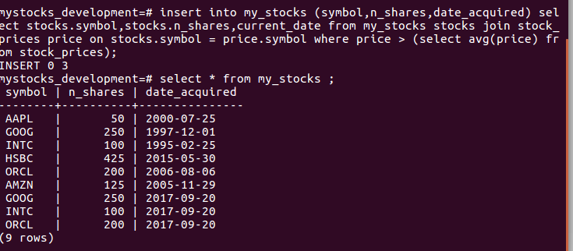

Part III:
mystocks_development=# select symbol,sum(n_shares) from my_stocks group by symbol;

symbol | sum
------------+-----
AAPL | 50
INTC | 200
HSBC | 425
ORCL | 400
GOOG | 500
AMZN | 125

Part IV:
mystocks_development=# select stocks.symbol, (sum(n_shares) * pri.price) as total_price from my_stocks stocks join stock_prices pri on stocks.symbol = pri.symbol group by stocks.symbol,price;

symbol | total_price
-------------+-------------
INTC | 60400
AAPL | 14300
GOOG | 150000
HSBC | 122400
ORCL | 121600

Part V:
mystocks_development=# select stocks.symbol,sum(n_shares), sum(n_shares) * price as total_price from my_stocks stocks join stock_prices pri on stocks.symbol = pri.symbol group by stocks.symbol,price having price > (select avg(price) from stock_prices);

symbol | sum | total_price
------------+-------+-------------
INTC | 200 | 60400
GOOG | 500 | 150000
ORCL | 400 | 121600

Q 13.
– to create a view stocks_i_like

mystocks_development=#create view stocks_i_like as select my_stocks.symbol, sum(n_shares), sum(n_shares) * price as total_value from my_stocks join stock_prices on my_stocks.symbol = stock_prices.symbol group by my_stocks.symbol, price having price > (select avg(price) from stock_prices);

mystocks_development=# select * from stocks_i_like ;

symbol | sum | total_price
------------+-------+-------------
INTC | 200 | 60400
GOOG | 500 | 150000
ORCL | 400 | 121600

References
https://stackoverflow.com/questions/24375773/replace-each-letter-with-its-ascii-code-in-a-string-in-pl-sql
https://www.w3resource.com/PostgreSQL/pl-pgsql-control-structures.php
http://www.postgresqltutorial.com/plpgsql-cursor/

