Book Info Application

Dear Viewer,
This Application has been Designed Keeping Responsive Web Design Approach In Mind.As there were no specificatios mentioned in terms od Resolutions .So the Resolutions that have been used are as follow:
**************Important Note ***********
Enviornment:HTML5,CSS3,Javascript,OOJS Concepts,RWD Approach,Ajax Call,IE9,10,Edge,Chrome,FireFox
I would request you to please run the application on a Node Server,local Server as I am using Ajax Call Methodolgy to retrieve the Json Data.
Also another request to the viewer is to please run the Application in the developer tool of Chrome,Mozilla and IE as running the application without the emulator may look differently due to difference in screen size..
This Application is supporting IE9,10,Edge
Please choose Potrait Mode for IE if viewing 320px ,480px resolution,lanscape mode for 1024,1280px resolution and do refresh the page after each resolution change for any browser…

***********************************

Default Mobile Resolution320px(I have kept this a default resolution ,as I have taken the mobile to Desktop approach) and then I have used the same properties and implemanted the different media queries for other speccific resolutions.
Resolution 2:480px as min-width
Resolution3:Desktop Approach:1024px,1280px as min-width
These are few of the screen Shots that would help you observe the application
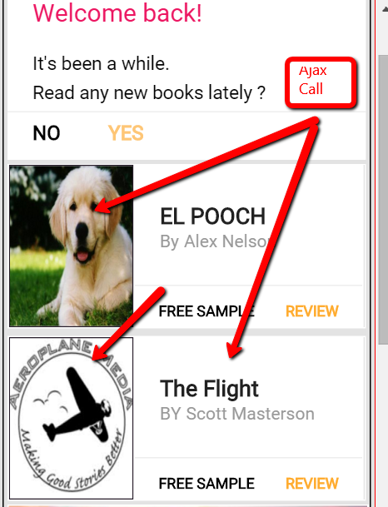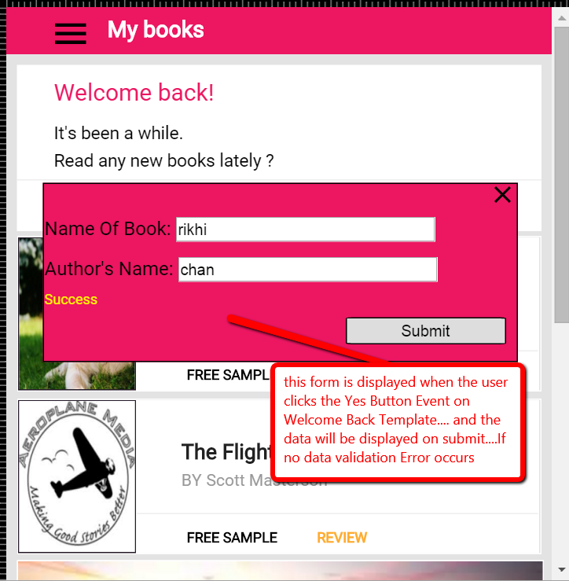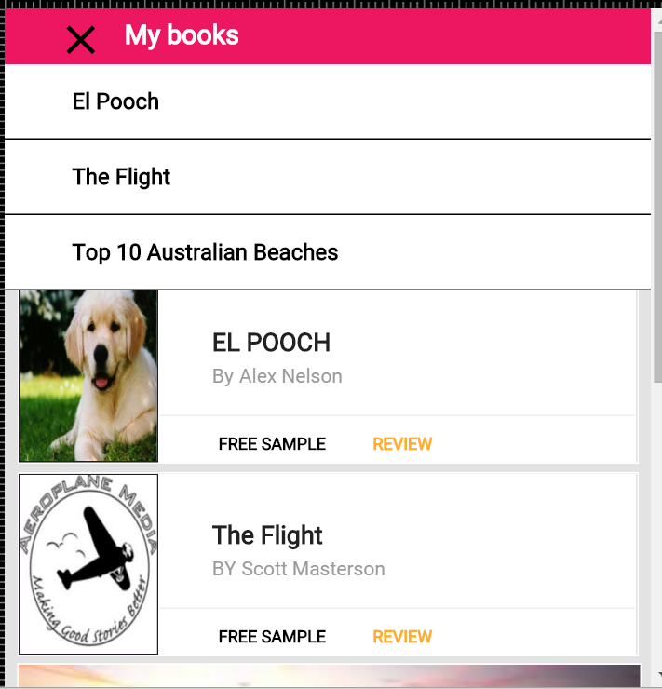

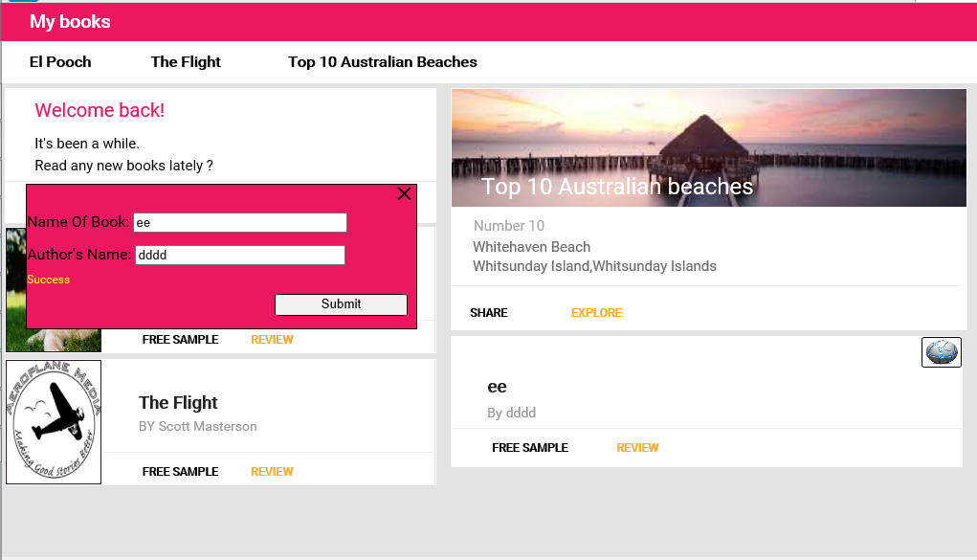
As per the above images:if you click bar Icon the menu would display and on clicking cross the menu would close.
When you click Yes in “Welcome Back Template ” form would be displayed and when the form is submitted without values an Error would Occur and if the form is submitted with values a layout will be displayed at the end of the page..

***************************The End************************************************

