AI Agent Patterns
Fundamentals to Advanced — with Framework Comparisons and Real Project Analysis

This document covers every major AI agent execution pattern — from the simplest REPL loop through production-grade stateful graph systems — alongside a detailed comparison of LangGraph, AutoGen, and CrewAI, and an analysis of how these patterns appear in real projects.

Part 0 — Graph Fundamentals
A graph is a data structure made of two things: nodes (the things) and edges (the connections between things). Understanding graph types is essential before exploring agent frameworks, because most modern agent runtimes are graph execution engines.
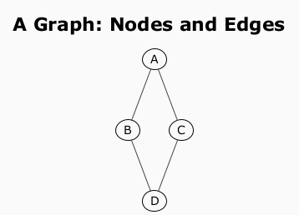
Figure 0.1 — Basic undirected graph

Types of Graphs
Directed graph — edges have a direction. 'A calls B' is not the same as 'B calls A'.
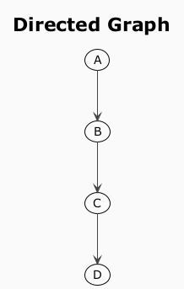
Figure 0.2 — Directed graph
DAG (Directed Acyclic Graph) — directed, no cycles. Used for pipelines where execution never goes back to a previous step.
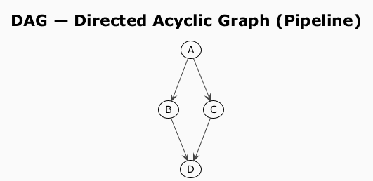
Figure 0.3 — DAG: parallel paths, no cycles
Cyclic directed graph — has loops. Used in agent frameworks for the ReAct tool loop: the agent node and tool node loop back to each other until a condition is met.
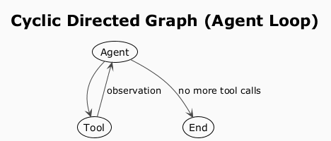
Figure 0.4 — Cyclic graph: agent loop

Why Graphs for Agents?
An agent workflow maps naturally onto a graph. Before graph-based frameworks, agent control flow was hidden inside LLM prompts or tangled if/else chains. Representing it as an explicit graph makes execution visible, testable, and modifiable without touching the LLM logic. The graph is the map of execution.
Graph Concept | Agent Equivalent
Node | Unit of work (LLM call, tool call, router, human approval)
Directed edge | After this, run that
Conditional edge | Go left if X, go right if Y
Cycle | Keep looping until condition is met
DAG | Linear pipeline, no re-execution

State Machines
A state machine is a system that can be in exactly one state at a time, with defined rules for transitioning between states. It has three core concepts:
- States — a finite set of conditions the system can be in.
- Transitions — events or conditions that move the system from one state to another.
- Current state — the state the system is in right now.

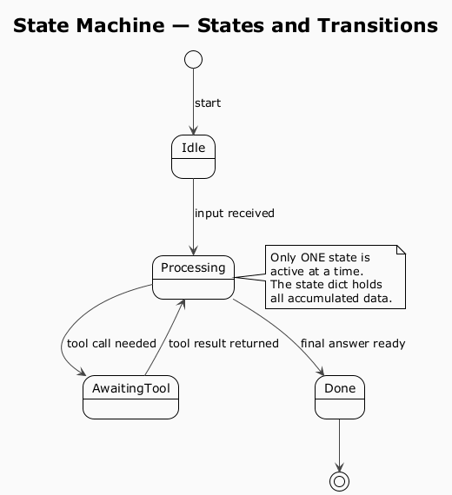
Figure 0.5 — State machine: one active state at a time
LangGraph is a state machine runtime. Its nodes are states, its edges are transitions, and its typed state dict is the current state — carrying all accumulated data as execution moves through the graph. The checkpointer snapshots the current state after every transition so it can be resumed or rewound.

MapReduce — Fan-Out and Fan-In
MapReduce is a programming model for processing large datasets in parallel, introduced by Google in 2004. It has two phases:
- Map — split the input into independent chunks and process each in parallel (fan-out).
- Reduce — collect all partial results and merge them into a single output (fan-in).

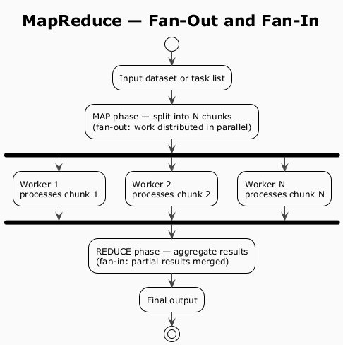
Figure 0.6 — MapReduce: parallel fan-out then fan-in aggregate
In agent frameworks this pattern appears whenever you have a list of independent work items that can be processed concurrently — document chunks, search queries, code files. LangGraph implements it via the Send API: the split node dispatches N parallel branches (fan-out), each runs independently, and an aggregate node merges the results (fan-in). Wall-clock time is bounded by the slowest worker, not the sum of all workers.

Vector Embeddings and Vector Databases
An embedding is a list of numbers (a vector) that represents the meaning of a piece of text. An embedding model reads text and outputs a vector — typically 768 to 1536 numbers. The key property: text with similar meaning produces vectors that point in similar directions in that high-dimensional space. This is measured with cosine similarity.
A vector database stores these vectors and answers the question: 'Given this query vector, which stored vectors are most similar?' This is semantic search — it finds relevant content even when the words don't match exactly.
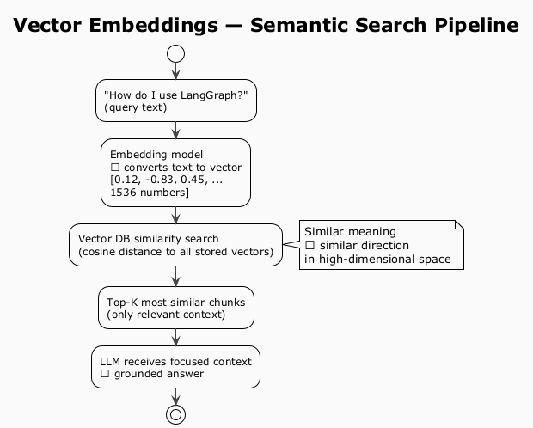
Figure 0.7 — Vector embeddings: text → vector → similarity search
Why this matters for agents: keyword search fails when the query uses different words than the document. Vector search finds conceptually related content regardless of exact wording. This is the foundation of RAG (Retrieval-Augmented Generation) and every memory-augmented agent pattern — inject only the relevant chunks into the prompt rather than the entire knowledge base, keeping context windows focused and token costs low.
Term | What it means
Embedding | A vector (list of numbers) representing the meaning of text
Cosine similarity | How similar two vectors are — 1.0 = identical direction, 0 = unrelated
Vector DB | Database optimised for nearest-neighbour search over embeddings (ChromaDB, Pinecone, pgvector)
Top-K | The K most similar chunks returned by the search — typically 3-5
RAG | Retrieval-Augmented Generation — fetch relevant chunks, inject into prompt, LLM reasons from them

Part 1 — Foundational Agent Patterns

1. REPL (Read-Eval-Print Loop)
The simplest pattern. The agent reads input, calls the LLM, outputs a response, and loops. No memory, no tool use, no planning. Essentially a chatbot loop.
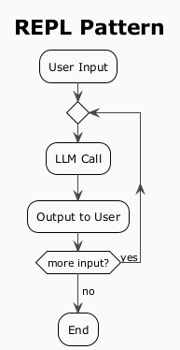
Figure 1.1 — REPL pattern

2. ReAct (Reasoning + Acting)
The dominant pattern for tool-using agents. The LLM alternates between Thought, Action, and Observation in a scratchpad loop until it reaches a final answer. Reasoning and acting are interleaved — each observation feeds back into the next thought, grounding the LLM in real results.
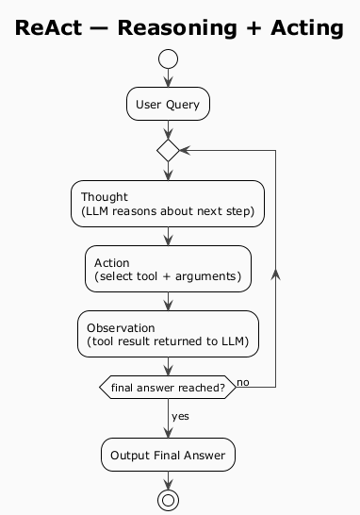
Figure 1.2 — ReAct: interleaved reasoning and acting

3. Plan-and-Execute
Separates planning from execution. A planner LLM generates a step-by-step plan upfront; an executor agent runs each step. Better for long-horizon tasks. A re-planner triggers if execution fails, which is the key differentiator from ReAct.
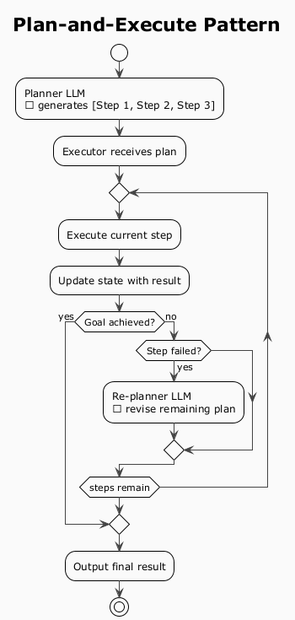
Figure 1.3 — Plan-and-Execute with re-planning

4. Reflection / Self-Critique
The agent generates output, then a second LLM call critiques it, and the agent revises. Loops until a quality gate is passed.
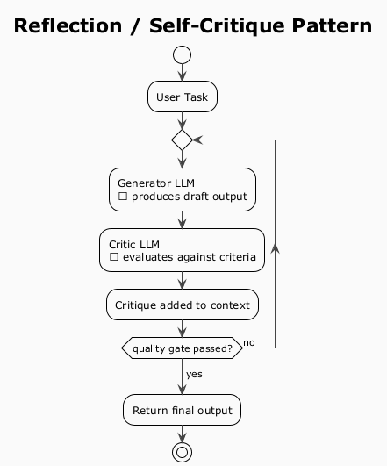
Figure 1.4 — Reflection loop
Variants:
- Reflexion — stores failed attempts in memory to avoid repeating mistakes.
- Constitutional AI — critique against a fixed set of principles.

5. Multi-Agent (Orchestrator + Subagents)
One orchestrator decomposes a task and delegates to specialist subagents. Subagents can run in parallel. The orchestrator maintains shared state and synthesizes results.
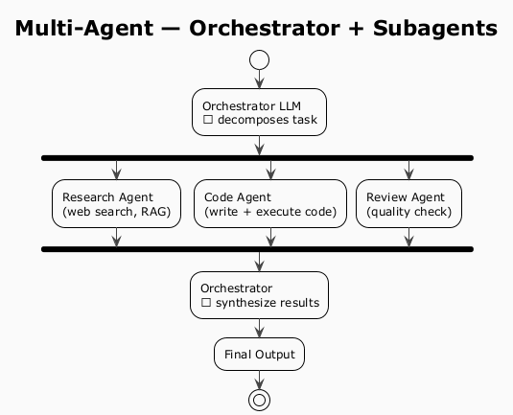
Figure 1.5 — Multi-Agent with parallel subagents

6. Tree of Thoughts (ToT)
Extends chain-of-thought by exploring a tree of reasoning paths rather than one linear chain. The model evaluates intermediate steps and prunes dead branches (BFS or DFS). Best for combinatorial search problems: puzzles, theorem proving, multi-step math.
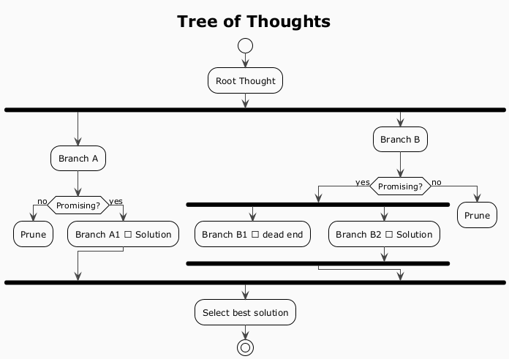
Figure 1.6 — Tree of Thoughts with pruning

7. Memory-Augmented Agent
Any pattern above extended with explicit memory stores. The agent reads from and writes to memory on each cycle, enabling long-term recall across sessions.
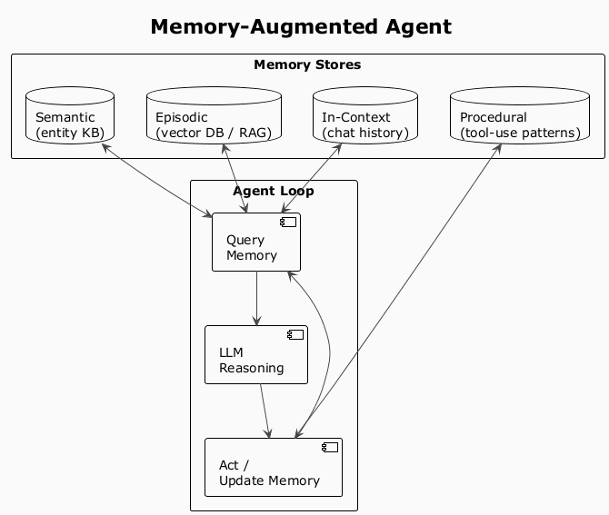
Figure 1.7 — Memory-Augmented Agent: four memory stores

8. Event-Driven Agentic Loop
The agent is triggered by external events (webhooks, file changes, cron, ETW telemetry) rather than user input. Runs autonomously, emits structured outputs to downstream systems.
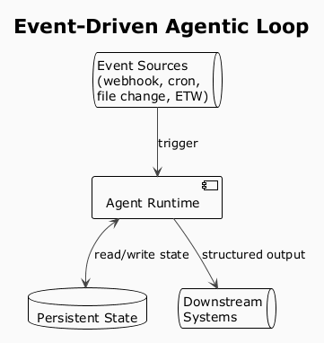
Figure 1.8 — Event-Driven loop

Pattern Selection Heuristic
Scenario | Best Pattern
Single-turn Q&A | REPL
Tool use, web search | ReAct
Long multi-step task | Plan-and-Execute
Quality-sensitive generation | Reflection
Parallelizable subtasks | Multi-Agent
Search / optimization problems | Tree of Thoughts
Long-term recall across sessions | Memory-Augmented
Persistent autonomous work | Event-Driven

Part 2 — LangGraph Patterns In Depth
LangGraph is built on one foundational abstraction — stateful directed graphs — and layers several agent patterns on top of it. The key design principle: control flow lives in your code, not in the LLM's output. This makes agent behavior explicit, inspectable, and testable.

Core Abstraction — State Machine
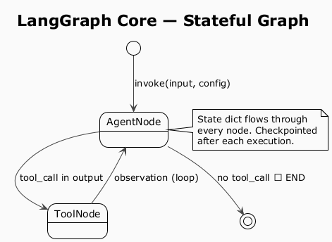
Figure 2.1 — LangGraph core: stateful graph with checkpointing
Nodes are Python functions (LLM calls, tool calls, logic). Edges are transitions (fixed or conditional). State is a typed dict that flows through every node and accumulates changes. It is checkpointed after each node execution.

Human-in-the-Loop via Interrupt + Checkpointer
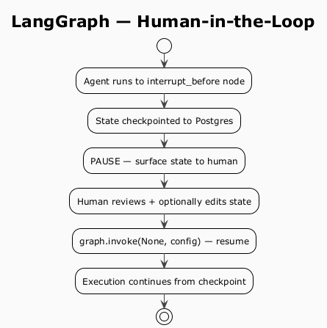
Figure 2.2 — LangGraph HITL: pause, edit, resume
graph = workflow.compile(
checkpointer=checkpointer,
interrupt_before=["approve_action"] # pause before this node
)
graph.update_state(config, {"approved": True}) # human edits state
graph.invoke(None, config) # resume

Map-Reduce via Send API
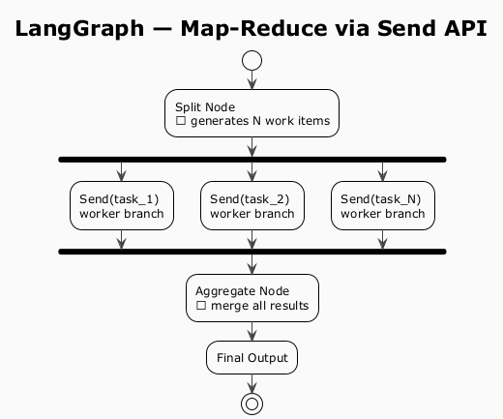
Figure 2.3 — LangGraph Map-Reduce: parallel fan-out / fan-in

LangGraph Pattern-to-Primitive Mapping
LangGraph Primitive | Agent Pattern Enabled
Cycles | ReAct, Reflection
Conditional edges | Plan-and-Execute, Supervisor
Send API (parallel) | Map-Reduce, Multi-Agent fan-out
Interrupt + Checkpointer | Human-in-the-Loop, Resume
Subgraphs | Multi-Agent composition

Part 3 — Framework Comparison: LangGraph vs AutoGen vs CrewAI
Framework | Core Abstraction | Mental Model
LangGraph | Stateful directed graph | You are the architect — explicit nodes, edges, state
AutoGen | Conversational agents | Agents are actors that talk to each other
CrewAI | Role-based crew | Agents are employees with job descriptions

Determinism vs Emergence Spectrum
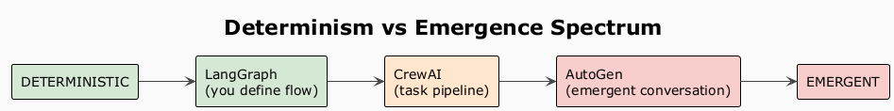
Figure 3.1 — Determinism spectrum: LangGraph → CrewAI → AutoGen

Multi-Agent Topology Support
Topology | LangGraph | AutoGen | CrewAI
Sequential pipeline | Graph edges | initiate_chat chain | Sequential process
Supervisor → workers | Supervisor subgraph | GroupChat with selector | Hierarchical process
Peer-to-peer conversation | Manual graph cycle | Native (core feature) | Not native
Parallel fan-out | Send API | Async agents | Partial (async tasks)
Nested subgraphs | Native | Nested GroupChat | Nested crews (v0.8+)

Human-in-the-Loop
Capability | LangGraph | AutoGen | CrewAI
Interrupt before node | Native (interrupt_before) | human_input_mode on agent | Limited
Approve tool call | Native | human_input_mode=ALWAYS | Not native
Resume from checkpoint | Native | Not built-in | Not built-in
Edit state mid-run | Native | Not built-in | Not built-in

When to Use Which Framework
Use Case | Best Fit | Why
Production workflow with approvals | LangGraph | Checkpointing, interrupt, audit trail
Data science / coding assistant | AutoGen | Native code execution sandbox
RAG pipeline, document processing | LangGraph | Map-reduce, parallel fan-out
Quick prototype multi-agent system | CrewAI | Minimal boilerplate, role-based intuition
Research / experimental agents | AutoGen | Emergent conversation, flexible
Long-running background automation | LangGraph | Persistent state, resume on failure
Regulated / auditable systems | LangGraph | Time-travel and state snapshots

Part 4 — LangGraph State Persistence in Production
LangGraph persists state via a checkpointer attached to the compiled graph. After every node execution, the full state dict is serialized and saved. The graph becomes resumable from any point. Every run is identified by a thread_id.

Production Checkpoint Architecture
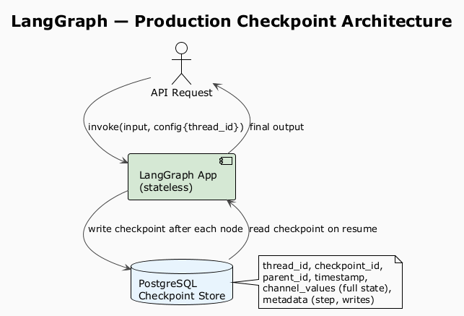
Figure 4.1 — Checkpoint architecture: stateless app + Postgres store

Checkpointer Backends
Backend | Use Case | Notes
MemorySaver | Dev / testing only | Lost on process restart
SqliteSaver | Single-process production | File-based, simple
PostgresSaver | Multi-process production | Recommended for scale
RedisSaver | High-throughput | TTL support
Custom | Any store | Implement BaseCheckpointSaver

Resume After Failure
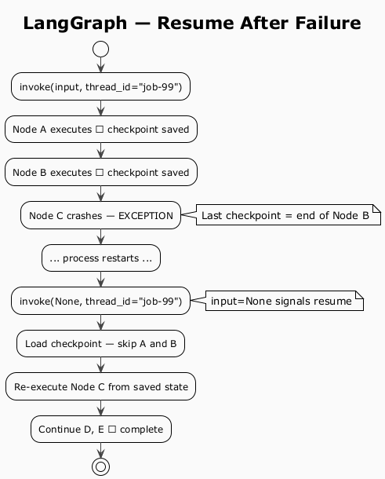
Figure 4.2 — Resume: nodes already completed are not re-run

Time-Travel and Branching
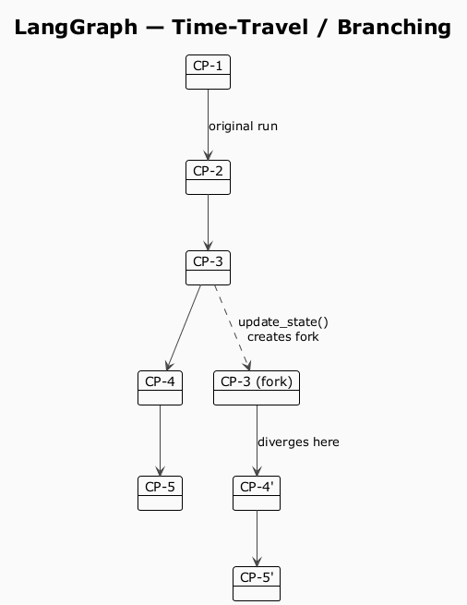
Figure 4.3 — Time-travel: fork from any past checkpoint
Use cases:
- Debug production failures by replaying with modified input.
- A/B test different agent decisions from a shared starting point.
- Recover from bad agent decisions without restarting from scratch.

Production Gotchas
Gotcha | Detail
State size bloat | Store S3 keys / DB IDs in state, not raw document content
Serialization | Everything in state must be JSON-serializable; Pydantic models work
Thread ID design | Use domain IDs (order-123) not random UUIDs for external lookups
Checkpoint retention | Checkpoints accumulate forever — add TTL policy or cleanup job
Idempotency | Re-run nodes must be idempotent; LLM calls are not naturally idempotent

Part 5 — Patterns in Practice: Real Projects
The following projects demonstrate how these patterns appear in real production and personal systems — from raw Claude API tool loops through LangGraph stateful graphs to fully deterministic Lua-scripted engines.
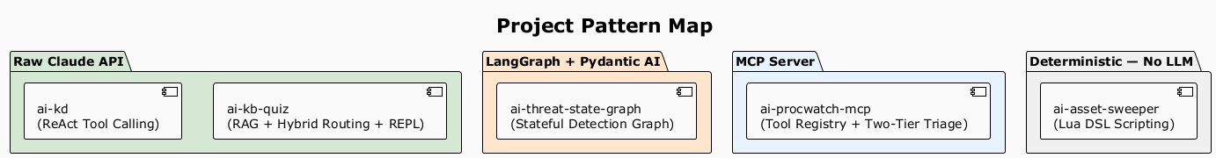
Figure 5.0 — Project pattern map

ai-kb-quiz — Hybrid Routing + PTC + RAG
Patterns: Hybrid model routing, Process-Then-Communicate (PTC), Vectorized RAG, Interactive REPL learning loop.
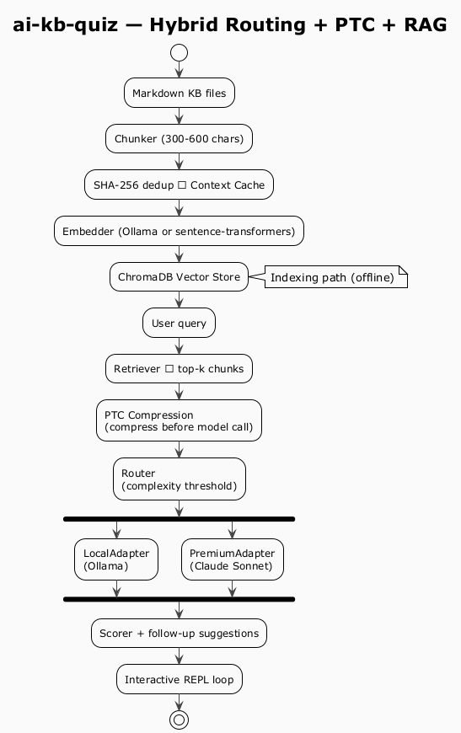
Figure 5.1 — ai-kb-quiz architecture
Key insight: The PTC pattern (Process-Then-Communicate) ensures raw KB content never hits the model — it is compressed first. The router avoids premium API calls for simple questions, routing them to a local Ollama model instead.

ai-kd — ReAct Tool Calling (Kernel Debugger)
Pattern: ReAct with a single tool (execute_windbg_action), plus a sanitization layer that strips kernel addresses before sending output to Claude.
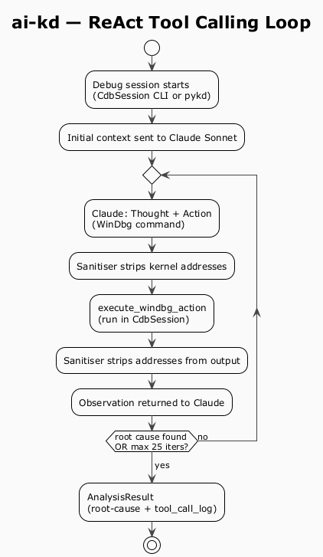
Figure 5.2 — ai-kd: ReAct loop with sanitization
Key insight: The sanitization layer is a security boundary — it prevents prompt injection via malicious kernel output and avoids leaking KASLR addresses to the external API.

ai-threat-state-graph — CAAD Loop + Five Detection Engines
Pattern: Stateful LangGraph graph with CAAD loop (Collect → Analyze → Act → Decide). Five deterministic detection engines: YARA-X, Sigma, Lua, PowerShell, Python. Claude is an advisory escalation in Phase 2, never on the critical path.
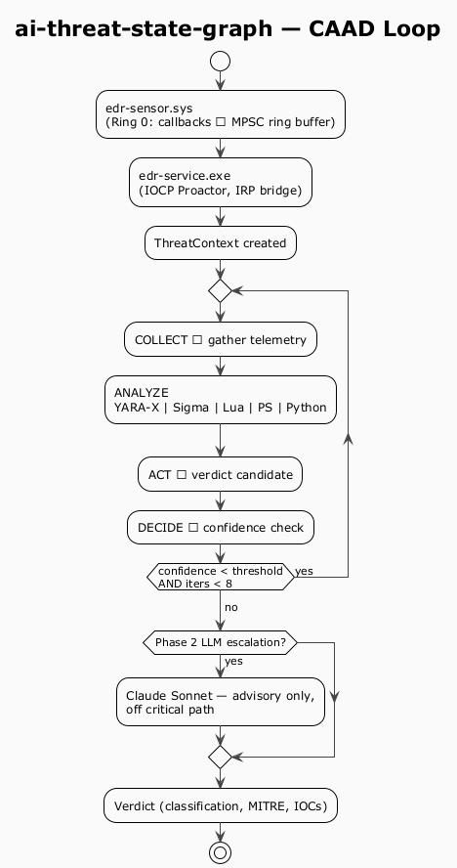
Figure 5.3 — ai-threat-state-graph: CAAD loop
Key insight: LLM is never on the critical detection path. This is the correct architecture for security-critical systems where latency and reliability matter more than AI flexibility.

ai-procwatch-mcp — MCP Tool Registry + Two-Tier Triage
Pattern: MCP server exposing 8 tools; behavioral genome tracked via ETW + eBPF; two-tier LLM classification (Ollama triage first → Claude escalation on high-confidence anomalies only).
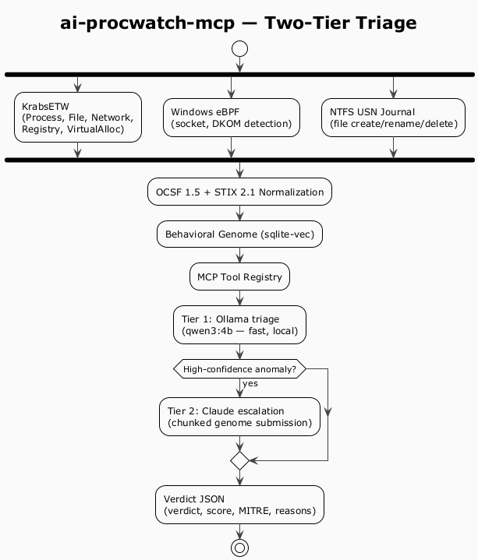
Figure 5.4 — ai-procwatch-mcp: two-tier triage
Key insight: The two-tier triage pattern keeps most inference local (low cost, low latency) and escalates to a premium model only when the local model flags high confidence. Server-initiated sampling means escalation happens mid-capture without waiting for the user.

ai-asset-sweeper — Sandboxed Lua DSL (No LLM)
Pattern: No LLM. Detection logic lives in Lua scripts; C++ orchestrator runs them in a sandboxed lua_State with whitelisted functions only. Hot-reloadable without recompiling the C++ host.
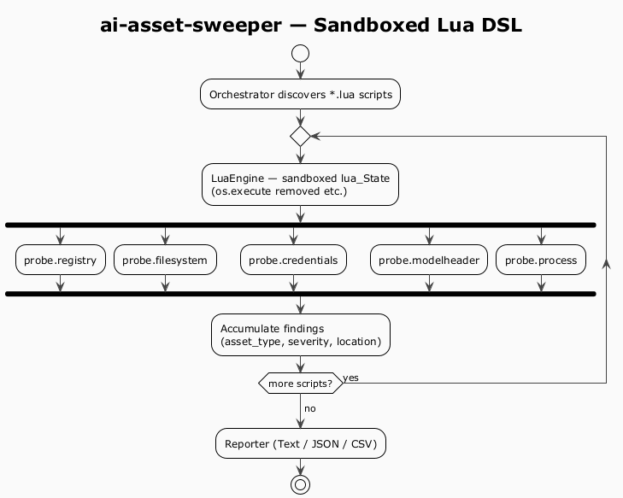
Figure 5.5 — ai-asset-sweeper: sandboxed Lua DSL
Key insight: The sandbox removes dangerous standard library functions — isolating the part that touches untrusted input (detector scripts) from the part that must not fail (the C++ host). This is the Error Kernel principle applied.

Part 6 — Quick Reference
Pattern | Control Flow | Memory | Best For
REPL | None | None | Simple chatbot
ReAct | LLM-driven loop | In-context | Tool use, search
Plan-and-Execute | Planner LLM | State dict | Long-horizon tasks
Reflection | Quality gate loop | In-context | Quality-sensitive generation
Multi-Agent | Orchestrator | Shared state | Parallelizable subtasks
Tree of Thoughts | BFS/DFS search | In-context | Optimization, proofs
Memory-Augmented | Any | Vector DB / KB | Long-term recall
Event-Driven | External event | Persistent | Background automation
LangGraph Graph | Code-defined | Checkpointer | Production workflows
AutoGen GroupChat | Emergent conv. | Chat history | Coding agents, research
CrewAI Process | Task pipeline | Embedding store | Role-based workflows

The Key Architectural Principle
LLM on the critical path = latency + reliability risk. Keep LLMs advisory or escalation-only for safety-critical, latency-sensitive, or regulated systems. Use deterministic engines as the primary layer; bring the LLM in only when confidence is low or human escalation is warranted.
This principle appears in ai-threat-state-graph (CAAD loop, LLM off critical path) and ai-procwatch-mcp (two-tier triage, Ollama first, Claude escalation only).

