Stop Burning Your AI Budget
An Engineer's Guide to Efficient Premium Model Usage

The debate is everywhere in enterprise right now: are we getting productivity returns that justify the token costs? Finance wants invoices justified. Engineering wants fewer restrictions on model access. Leadership wants both.
I'm an enterprise software engineer who also runs personal AI projects on my own Claude and Gemini subscriptions — a knowledge distillation pipeline, a KB quiz engine, and a process-monitoring MCP server. That combination gives me a useful vantage point: I feel the cost personally, I see the productivity question professionally, and I've had to find real answers for both. Here's what I've learned.

The Core Mental Model: Route by Difficulty
Stop treating your AI stack as a single model and start treating it as a fleet with a routing layer. Premium models (Claude Opus, Gemini Ultra) are best for complex multi-step reasoning, novel synthesis across sources, and high-stakes output where quality directly affects users. Everything else is a candidate for a cheaper or local alternative.

1. Multi-Agent Pipelines — Match the Model to the Step
Most workflows aren't a single task — they're a sequence of steps with very different complexity profiles. Assigning one premium model to the entire pipeline is like hiring a specialist surgeon to also do your hospital's paperwork. The better approach: decompose your workflow into steps, then assign the cheapest model capable of each step.
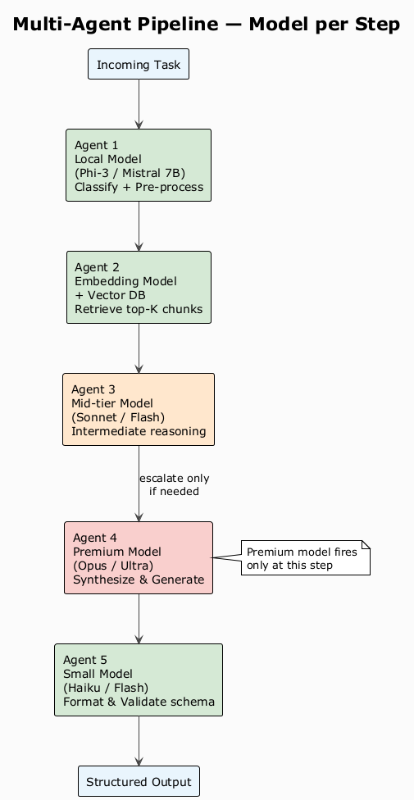
Figure 1 — Multi-Agent Pipeline: model assignment per step
Example — a document Q&A skill:
Step 1: Parse & clean raw input → local model (Phi-3, Mistral 7B)
Step 2: Classify intent / route query → small cloud model (Haiku, Flash)
Step 3: Retrieve relevant chunks (RAG) → embedding model only, no LLM
Step 4: Synthesize answer from chunks → premium model (Claude Sonnet/Opus)
Step 5: Format & validate output schema → small cloud model (Haiku, Flash)
Practical implementation tips:
- Schema contracts: Define a schema contract between agents — the output of each step is the structured input to the next.
- Single responsibility: Each agent should have a single responsibility. Agents that do too much become expensive and opaque.
- Confidence scoring: Build confidence scoring into classification steps — if the cheaper model isn't confident, escalate.
- MCP integration: With MCP support, wire different model-backed agents as distinct MCP servers, each domain-specialized.

2. Prompt/Token Caching — The Fastest Win
Claude's prompt caching lets you cache a prefix of your context (system prompt, documents, examples) and pay approximately 10% of the input token cost on repeated calls that share that prefix.
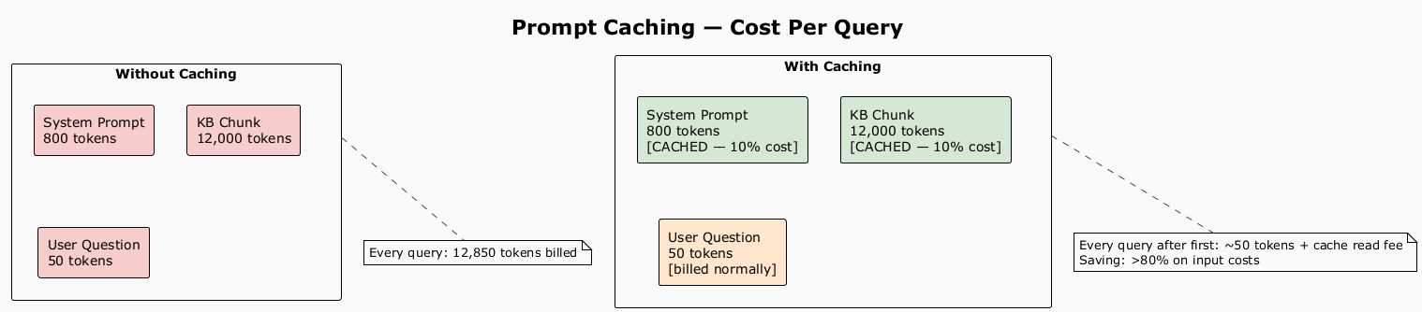
Figure 2 — Prompt Caching: cost comparison per query
Rules for getting cache hits:
- Put stable content first (system prompt, docs, few-shot examples).
- Put variable content last (the user's actual question).
- Use consistent cache_control breakpoints across requests in the same session.
- Cache TTL is 5 minutes on Anthropic's API — keep call cadence inside that window or re-warm explicitly.

In one of my personal projects — a knowledge base quiz engine that repeatedly queries the same document corpus — this single change reduced input token costs by over 80%.

3. Vector DBs — Ground the Model in What It Cannot Know
Before getting to the cost angle, it's worth understanding why a vector database is necessary in the first place. Large language models reason from their latent space — knowledge compressed into weights during training. That works well for general concepts, but it fails in predictable ways:
- Version-specific SDK and API references: The model was trained on docs from months ago. It will confidently describe a method signature that no longer exists.
- Deep domain knowledge: Windows kernel internals, IRQL rules, minifilter callback contracts. Models have surface-level familiarity, not the precision required when the details actually matter.
- Internal project context: Your component design, your team's architectural decisions, your internal APIs. The model has zero knowledge of these by definition.
The fix is RAG — injecting authoritative, current context into the prompt so the model reasons from your ground truth rather than its best guess.
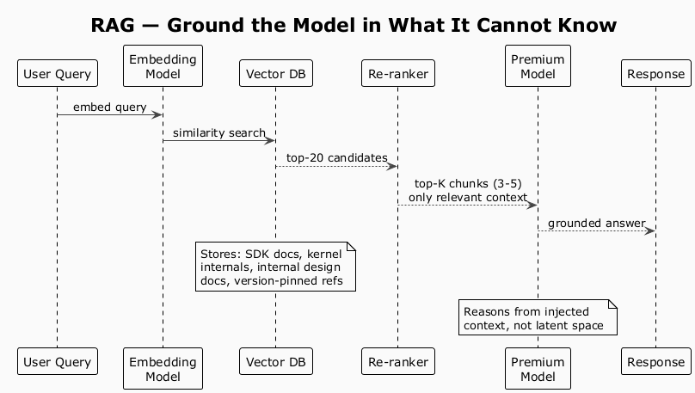
Figure 3 — RAG Flow: retrieval-augmented generation pipeline
Sizing guidance:
- Top-K = 3–5 chunks is usually enough. More is rarely better and always more expensive.
- Chunk size: 512–1024 tokens per chunk gives retrieval precision without truncating context.
- Re-rank before sending: use a lightweight cross-encoder or BM25 hybrid.

In my personal process-monitoring project, instead of sending full logs to Claude for every alert, I embed process events, retrieve only the anomalous window, and send that. Latency dropped, cost dropped — and critically, the model stopped hallucinating event fields that didn't exist in the actual log schema.
Key reframe: RAG isn't primarily a cost optimization — it's a correctness optimization that also happens to reduce cost. That's a much easier sell in an enterprise conversation where accuracy matters more than invoices.

4. Local Models — Free the Routine Work
Not every task needs a frontier model. Local models (Ollama + Llama 3, Mistral, Phi-3) running on your own hardware handle a surprising amount of routine work.
Task | Use Local | Use Premium
Intent classification | ✓
Entity extraction (structured schema) | ✓
Routing / triage | ✓
Summarization of well-structured input | ✓
Complex reasoning across multiple documents |  | ✓
Code generation with non-trivial logic |  | ✓
Novel synthesis, edge cases, ambiguity |  | ✓

My personal knowledge distillation pipeline uses a local 7B model to pre-process and structure raw input, then sends only the structured output to Claude for synthesis. Token input to Claude drops 60–70% because the local model did the cleanup first.

5. Context Window Discipline
Premium models have large context windows. That doesn't mean you should fill them. Cost scales linearly with input tokens. Quality does not.
- Compress before sending: Summarize prior conversation turns rather than appending them verbatim.
- Structured output contracts: Ask the model to return JSON with a defined schema — smaller, parseable outputs, no rambling preambles.
- Trim few-shot examples: Three high-quality examples beat ten mediocre ones — and cost 70% less.
- Strip metadata: Remove headers, footers, page numbers, and formatting artifacts from documents before sending.

6. Programmable Tool Calling — The Model as Orchestrator
Tool calling (function calling) is commonly seen as a way to connect models to external data. Its bigger value is architectural: it lets the premium model act as an orchestrator that decides what to invoke — and what not to invoke — rather than doing all reasoning inline.
Three efficiency patterns emerge from this:
- Parallel tool calls reduce round trips: The model can call vector_search() and classify_intent() in a single response. Instead of two sequential round trips — each paying full input token cost — you get one. For pipelines with multiple retrieval steps this compounds quickly.
- Tools as cheap-service wrappers: Define tools that wrap your local model, embedding service, or cache lookup. The premium model decides whether to invoke them based on the task. A high-confidence classification routes to run_local_model(); a complex synthesis stays in-model. The model becomes the router — no separate routing layer needed.
- Schema enforcement via tool definitions: Instead of prompt-engineering 'return valid JSON with fields X, Y, Z' and then parsing brittle free text, define a tool with a strict JSON schema. The model is constrained to call it correctly. Output token count drops, parsing reliability goes to near-100%, and you eliminate a whole class of retry logic.
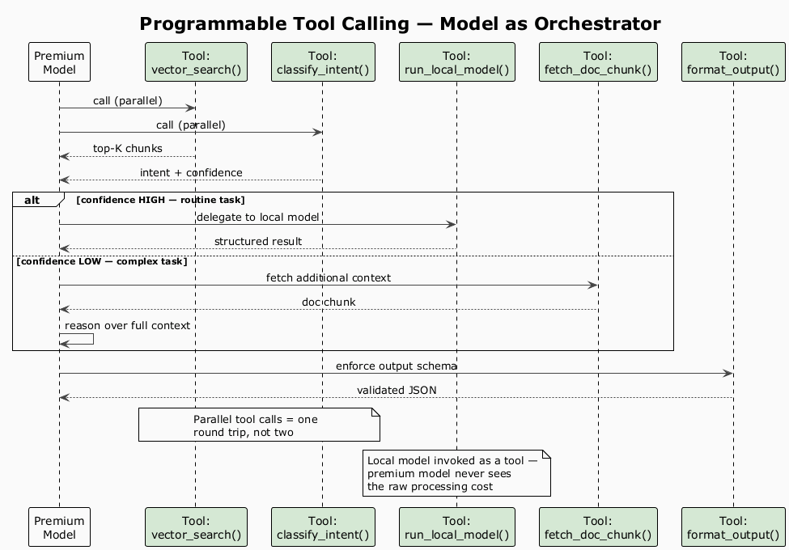
Figure 5 — Programmable Tool Calling: model as orchestrator
Practical tips:
- Keep tool descriptions concise — they count against your input tokens on every call.
- Group tools logically: retrieval tools, transformation tools, output tools. Fewer tools in scope = less decision overhead for the model.
- Use tool_choice: 'required' when you always need structured output — prevents the model from answering in prose instead.
- Log every tool invocation with latency and token counts. This is where you find the expensive surprises.

7. Async Batching — Don't Pay Rush Rates for Batch Work
Anthropic's Message Batches API gives you 50% off input and output tokens for non-real-time workloads with 24-hour turnaround. Nightly evaluations, bulk document processing, quiz generation pipelines — none of these should hit the synchronous API. Same principle applies across providers: identify workloads that can tolerate latency and route them to batch endpoints.

The Full Stack
Each layer below reduces what reaches the premium model. The premium model does what only it can do — and nothing else.
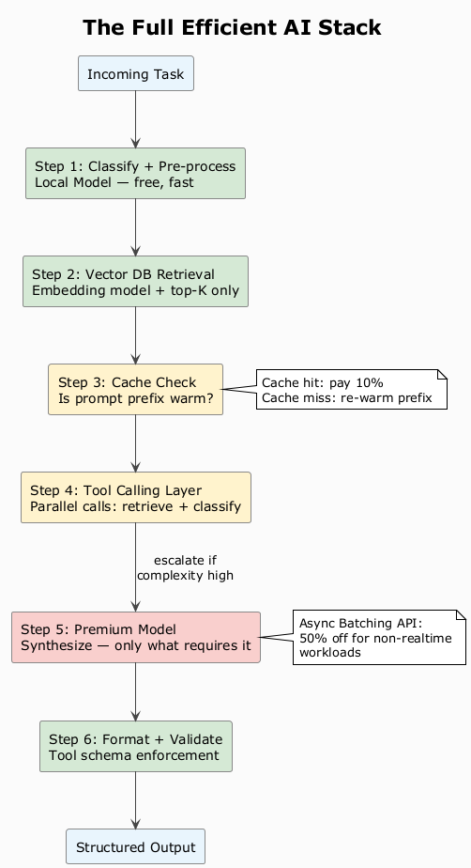
Figure 6 — Full Efficient AI Stack: combined pipeline

Answering the Enterprise Debate
When the cost-vs-productivity question comes up at work, the honest answer is: the question is usually posed too broadly to be useful. It's not 'is Claude worth it?' — it's 'which steps in our workflows justify the cost, and which are we routing there out of habit?'
Track these metrics per feature:
- Input tokens per task — primary cost driver
- Cache hit rate — target >70% for KB-heavy workloads
- Local/mid-tier deflection rate — % of steps resolved without a premium call
- Premium model invocation rate — how often does the expensive agent actually fire?
- Output token ratio — output/input; high ratios mean you're extracting value

The Mindset Shift
Premium models are exceptional tools. Routing every step of every workflow through them is like staffing a team entirely with principal engineers when juniors, mids, and seniors each have work suited to their level.
The engineers extracting real value from frontier AI are the ones who build agent pipelines with deliberate model assignment — so that when the premium model runs, it runs on exactly the right input, at exactly the right step, at exactly the right time.
Build the infrastructure. Make every premium token count.

I'm an enterprise software engineer who builds AI tooling and Windows systems as personal projects. Thoughts on the cost-vs-productivity debate or multi-agent patterns? I'd like to hear how others are approaching this.

