Consider an array of n distinct integers. What is the **time complexity** of an algorithm that returns a number from the array that is **not** the second largest?

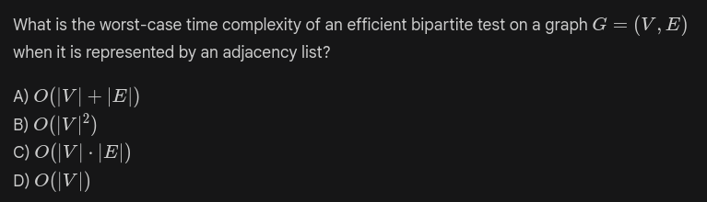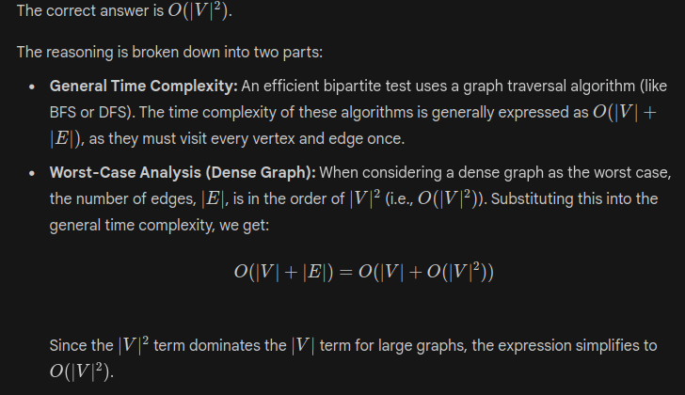

Q2. Given a simple undirected graph G that contains one or more vertices with an odd degree, what fundamental property will the new graph possess after adding a new vertex n and connecting it to every vertex in G that originally had an odd degree?

A) The resultant graph will always have an even number of vertices with odd degrees.

B) The resultant graph will have no vertices with odd degrees.

C) The resultant graph will have exactly one vertex with an odd degree.

D) The resultant graph will be bipartite.

**SOLUTION:**

In any simple undirected graph, the total degree of all vertices is even (since each edge contributes 2 degrees). So the number of vertices having odd degrees must be even, otherwise, their sum would have been odd, making the total degree also odd. Now single vertex n is connected to all these even numbers of vertices (which have odd degrees). So, the degree of n is also even. Moreover, now the degree of all vertices which are connected to v is increased by 1, hence earlier vertices which had odd degree now have even degree.

So now, all vertices in the graph have an even degree, which is a necessary and sufficient condition for the Euler graph.

Q1. Consider a **Ternary Search** algorithm implemented on a sorted array of size **n**. The algorithm maintains two mid-indices, m1​=⌊n/3⌋ and m2​=⌊2n/3⌋, dividing the array into three distinct parts. The search is conducted recursively in one of these three parts after a constant number of comparisons at each step.

Assuming the constant time for comparisons is c, which of the following expressions best represents the time complexity of this algorithm?

(A) O(n)

(B) O(log2​n)

(C) O(log3​n) (D) O(1)

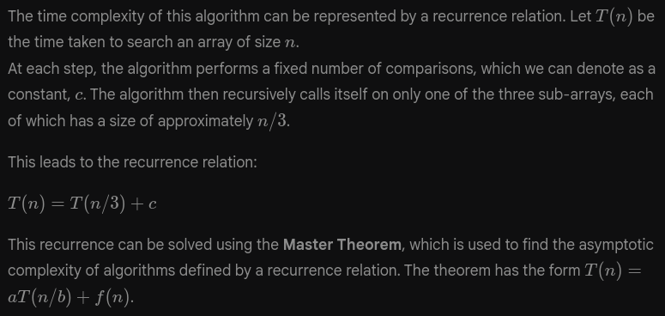

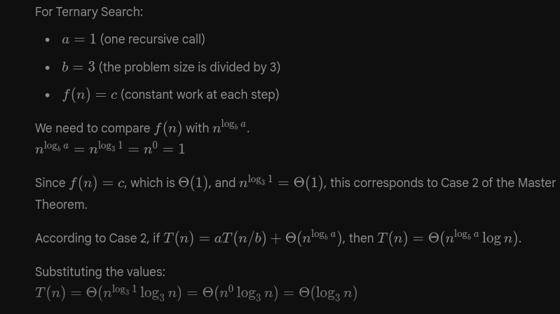

<https://faculty.iitr.ac.in/cs/bala/DSA/aid525.html>

https://cse.iitkgp.ac.in/~palash/Courses/2022Algorithms1-Theory/algo1-2022.html

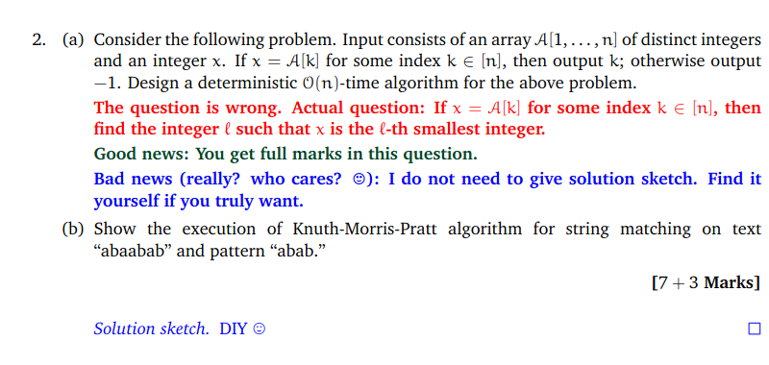

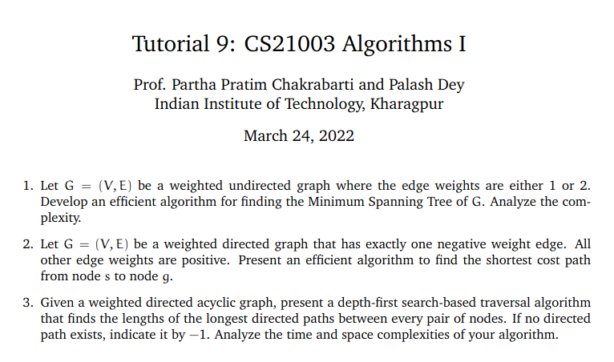





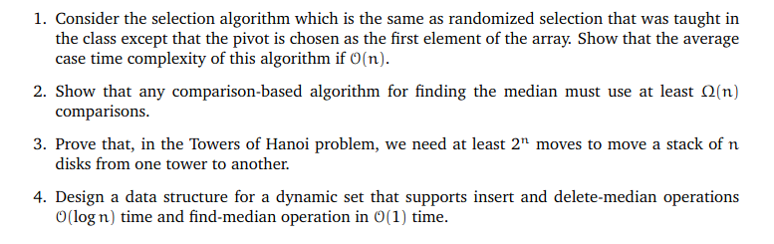

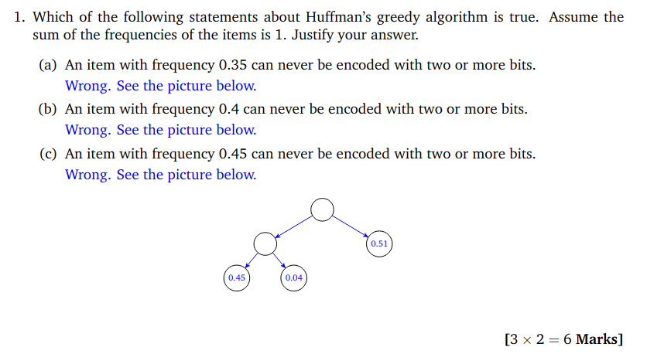

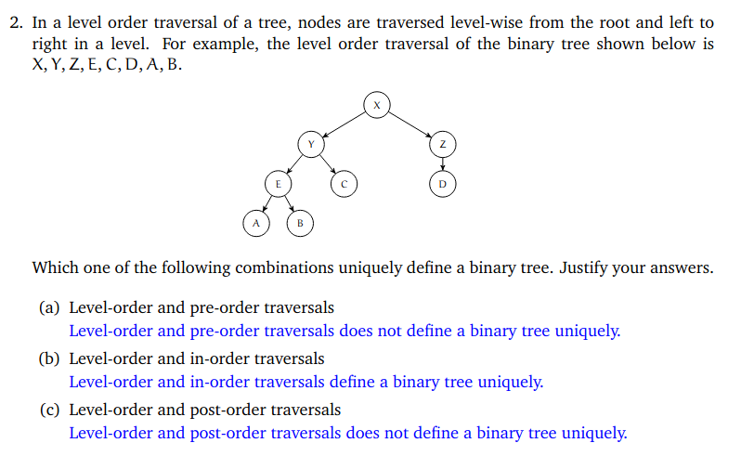

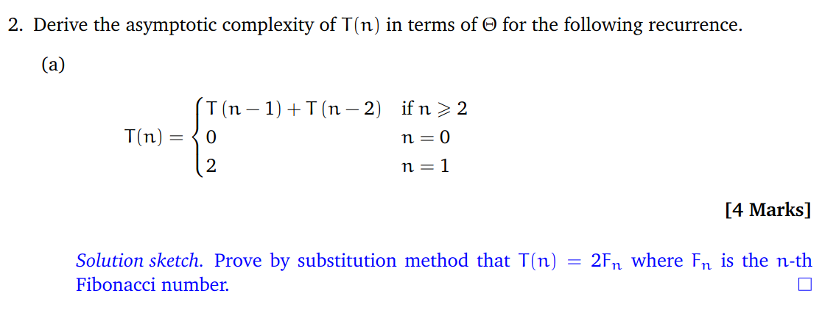

Q1.

