
UNIT 22: APPLICATION DEVELOPMENT
(MATH RUSH 3D REPORT)
VINCENT ESCANDALLO CASTILLO
TJ55730
REPORT SUBMITTED FOR THE
PEARSON BTEC HIGHER NATIONAL DIPLOMA IN COMPUTING
COSMOPOLITAN COLLEGE OF COMMERCE AND TECHNOLOGY

Report scope and evidence status
Evidence status: This report addresses the supplied project guideline and assignment brief using the inspected Math Rush 3D implementation. Missing peer-review, device-performance and administration evidence is stated explicitly and is not presented as completed work.

Revision record
Version | Date | Purpose | Status
0.1 | 21 July 2026 | Initial report based on currently supplied guidelines | Draft
0.2 | 29 July 2026 | Reformatted to the requested Times New Roman academic style and expanded traceability, performance and ethics sections | Revised draft
1.0 | 4 August 2026 | Final report review, current build verification and diagram layout correction | Final report

Table of contents
Table of contents will update in Microsoft Word.

Executive summary
Imaginé anaké Math Rush 3D is a type of video game where you control a character who has to run around in all directions. You also have to make quick math problems pop up on your screen and you have to solve them or do things will happen. A lot of people who do math exercises for the first time find them boring and don't see how they relate to real life. In Math Rush 3D, the four main types of basic math, adding, subtracting, multiplying and dividing, are part of the actual path that your character is on. If you answer a question correctly or do the right thing, it will make your group of followers get bigger.
Our finished project is available in two forms: as a web page that changes based on what you do and also as a program for the Android system. For the part of the show, we used several things: React to make the way it looks, Three.js and Three Fiber to work with 3D stuff, and Tailwind CSS. Zustand is used to keep track of the different parts of the app and when something on the screen needs to be updated. It does all of this without making React update the whole thing from top to bottom after every
A typical session begins with registration or login, followed by difficulty and level selection. The player steers a clustered crowd through ten pairs of arithmetic gates and difficulty-specific obstacles. Enemy crowds and hazards remove individual runners. Immediately before the boss, the player stops a timing meter to earn a crowd boost. The boss battle consumes crowd members according to the level balance. If successful, the survivors enter a multiplier lane, where each bonus stage exchanges crowd members for bonus points until the crowd is exhausted. The result screen awards a score, coins, stars, level progression and a next-level option.
The current implementation demonstrates a substantial functional baseline: four difficulty bands with five levels each, responsive controls, GPU-instanced crowds, collision tests based on movement-plane crossing, a balanced boss calculation, skins, persistent accounts and an online leaderboard. On 4 August 2026, all 30 automated tests passed, the browser and server TypeScript checks completed successfully, and Vite produced a production build. These checks support the internal consistency of the balancing, formation, level-progression, speed and boss-meter utilities, but they do not replace device testing, accessibility review, penetration testing or user acceptance testing.
There are still some things that need to be done to make sure our assignments are done correctly. Essentially, we've said that the main part of the back end will be built with either PHP, Python or Java, and that Node.js can only be used as a way to connect different parts together or to act as a middle man for our application's API. So, if we're currently using Node.js and Express to do our back end, then we'll need special permission from a tutor or we'll have to replace it with something that's on our approved list.
After this, we need to get a written OK on whether or not the back-end part of things follows the right rules. Next, you should After this, we need to get a written OK on whether or not the back-end part of things follows the right rules. Next, you should set up a special user with a set of tasks that an admin would do and how they do it.

1. Project context and scope

1.1 Scenario
Imagine you're part of a competition where you have to make a web based game. The goal of this game has to be about solving one of the actual problems we all face in our lives. Also, the game should show off your skills in building apps and how you handle & store related data, and finally, it has to be tested and improved using facts and numbers.

1.2 Aim
Our goal is to make an online math game that does well and can be played again and again. It will work like this: how good you are at doing the math and how well you can control your character will both affect whether or not you win.

1.3 Objectives
- Deliver a complete start-to-finish game loop with gates, hazards, enemy crowds, a boss and a finite bonus ending.
- Scale arithmetic content, obstacles and movement speed across four difficulty bands and five levels per band.
- Maintain fair level balance so that an optimal route remains achievable while poor choices have meaningful consequences.
- Provide account registration, login, saved progression, skins, statistics and leaderboards through PostgreSQL.
- Support touch, mouse and keyboard interaction on responsive web layouts and Android devices.
- Collect evidence through automated checks, manual tests, peer UAT and GitHub history.

1.4 Success measures
Measure | Target | Evidence method
Mathematical correctness | All generated expressions return the displayed integer result and update the crowd once. | Automated gate tests plus sampled gameplay evidence.
Level fairness | An optimal route can defeat the boss in every published difficulty and level. | Balance tests and documented perfect-route play tests.
Mobile usability | Core controls and authentication remain usable at 360x640 and larger supported viewports. | Responsive browser matrix and Android UAT.
Runtime performance | Gameplay should normally remain at or above 45 FPS on the selected mid-range Android test device. | Recorded frame-rate and frame-time test runs.
Persistence reliability | A completed authenticated run appears once in progress and leaderboard records after reconnection. | API/database integration test and offline queue test.
Security baseline | Invalid input is rejected, passwords are never stored in plain text and unauthorised admin access is denied. | Validation, database inspection and authorisation tests.

1.5 Scope boundaries
We've currently got one type of game where one person plays and a version that does 3D stuff in your area. It also keeps track of your progress so you can compete with others. But for now, we're not including online playing with others in real time, in-app purchases, ads, a way for users to send each other messages and the ability to create and add your own levels from your phone.

2. Software Design Document

2.1 Problem definition
Traditional math practice sheets are basically just for checking if you got the right or wrong answer, but they don't make you want to do them again on your own and, more importantly, they don't show you how your math is actually used in real life. Math Rush 3D changes that because it makes every calculation have a direct effect on what happens in the game, you enter two numbers, decide which one to pick and see how the scene around you changes as a result.

2.2 Stakeholder analysis
Stakeholder | Need or interest | Influence | Design response
Learner / player | Clear rules, fair challenge, responsive steering, visible rewards and saved progress. | High | Difficulty progression, readable gates, touch controls, feedback and next-level flow.
Lecturer / assessor | Evidence that the solution satisfies the brief and is evaluated honestly. | High | Traceable requirements, diagrams, testing records, references and explicit compliance gaps.
Game developer | Maintainable modules, reproducible builds and measurable defects. | High | TypeScript, separated game systems, shared rules, tests and GitHub workflow.
Administrator | Manage users/content and inspect reports. | Medium | Planned RBAC, administration dashboard, audit log and CRUD endpoints.
Hosting/database provider | Secure, efficient and correctly configured workloads. | Medium | Connection pooling, environment variables, rate limits and health checks.
Parent/educator | Age-appropriate play and evidence of mathematical value. | Low/medium | No chat or payments; arithmetic decisions and progression statistics.

2.3 User requirements
ID | Requirement | Acceptance measure | Status
UR-01 | A visitor can register and an existing player can log in. | Valid credentials create a persisted session; invalid input receives a clear error. | Implemented
UR-02 | A player can choose an unlocked difficulty and level. | Locked stages are visibly unavailable and completing a stage unlocks the next valid stage. | Implemented
UR-03 | A player can steer by touch, mouse or keyboard. | The crowd moves laterally within track boundaries without page scrolling during play. | Implemented
UR-04 | Gate content contains difficulty-appropriate arithmetic expressions. | Addition, subtraction, multiplication and division appear at suitable complexity and produce integer outcomes. | Implemented
UR-05 | Individual crowd members can be removed by hazards. | A hit reduces the crowd by the calculated amount and produces visible feedback. | Implemented
UR-06 | The level has a boss and a finite bonus ending. | A successful boss fight enters the multiplier lane and finishes at a visible end structure. | Implemented
UR-07 | A player can pause, restart, replay or continue to the next level. | Controls change the current run without requiring a browser refresh. | Implemented
UR-08 | Progress, scores, settings and skins remain available after sign-in on another client. | Server-backed profile values reload after authentication. | Implemented
UR-09 | Players can view rankings and personal statistics. | Leaderboard and statistics panels retrieve current stored data. | Implemented / verify UAT
UR-10 | An administrator can manage users, game content and reports. | Authorised admin screens support protected CRUD and reporting actions. | Planned

2.4 System requirements

Functional requirements
- FR-01: generate exactly ten arithmetic gate pairs for a standard level and retain the chosen and optimal values for run evidence.
- FR-02: calculate obstacle, enemy and boss outcomes from a deterministic level definition shared by all scene systems.
- FR-03: validate registration, login, player updates and run submissions at the API boundary.
- FR-04: use parameterised SQL to create and retrieve account, progression, run, event, skin and leaderboard records.
- FR-05: prevent duplicate run submission by treating the client run identifier as unique.
- FR-06: support offline/local play and queue a completed run for later synchronisation when the API is unavailable.
- FR-07: calculate rewards using a shared rule module so browser and API calculations cannot silently diverge.
- FR-08: provide protected administrator CRUD, RBAC, audit reporting, feedback collection and search/filter functions (planned requirement).

Non-functional requirements
- NFR-01 Performance: target smooth play on mainstream mobile devices by using instanced crowds, capped pixel ratio, reduced-effects settings and ref-based frame data.
- NFR-02 Usability: maintain readable arithmetic, large touch targets, safe-area spacing and scrollable authentication forms on small screens.
- NFR-03 Reliability: recover gracefully when the API is sleeping or temporarily unreachable; avoid losing a locally completed run.
- NFR-04 Security: hash passwords, store session tokens as hashes, use HTTPS in production, apply security headers, rate-limit authentication and keep secrets outside the repository.
- NFR-05 Maintainability: separate scene systems, pure game rules, API routes, validation, database access and shared reward logic.
- NFR-06 Compatibility: support current Chromium-based browsers and Android 7.0/API 24 or later through Capacitor.
- NFR-07 Accessibility: preserve keyboard operation outside gesture-only gameplay, meaningful labels, sufficient contrast and reduced-effects options; formal WCAG testing remains pending.

2.5 Assumptions and constraints
The design assumes an internet connection is available for account synchronisation, but the core run remains local and playable during an API outage. Render's free service may cold-start, so the first request can be slower than subsequent requests. The 3D scene is constrained by mobile GPU and memory limits, making instancing and bounded effects more important than photorealistic assets. The largest academic constraint is that the current Express API may not satisfy the brief's prescribed backend-language list; this must be resolved with the tutor before final submission.

2.6 Risk review and mitigation
Risk | Likelihood | Impact | Mitigation / contingency | Owner
Generated level is impossible even with optimal play | Medium | High | Balance from the same level definition; automated game-balance tests; play-test every difficulty/level seed policy. | Developer
Frame-rate drop with large crowds | Medium | High | GPU instancing, reusable geometry/materials, limited pixel ratio, reduced-effects mode and device profiling. | Developer
API cold start is interpreted as login failure | High | Medium | Visible connecting state, retry/backoff, health check and clearer timeout message; consider paid/always-on hosting later. | Developer
Credential or session compromise | Low/medium | High | bcrypt work factor, token hashing, secure HTTP-only cookie, short-scoped bearer storage, rate limits, HTTPS and session expiry. | Developer
Leaderboard score is manipulated | Medium | High | Server recalculation from submitted events, stricter plausibility validation, signed build/version policy and anomaly reports. | Developer/Admin
Database unavailable or migration fails | Low/medium | High | Connection pool health checks, repeatable migrations, Neon backups/branching and documented restore procedure. | Developer
Mobile form clips controls | Medium | Medium | Dynamic viewport units, safe-area padding, vertical scrolling and tests on short/narrow devices. | Developer/Tester
Third-party model licence is unclear | Low | High | Use CC0 assets where possible, retain attribution file and store source/licence metadata with each asset. | Developer
Backend stack does not meet brief | High | High | Obtain written tutor approval or reimplement the service in Python, Java or PHP before submission. | Student/Tutor
Peer feedback is unavailable before deadline | Medium | Medium | Book named testers early, use the UAT checklist, record device/browser and preserve dated evidence. | Student

2.7 Use cases
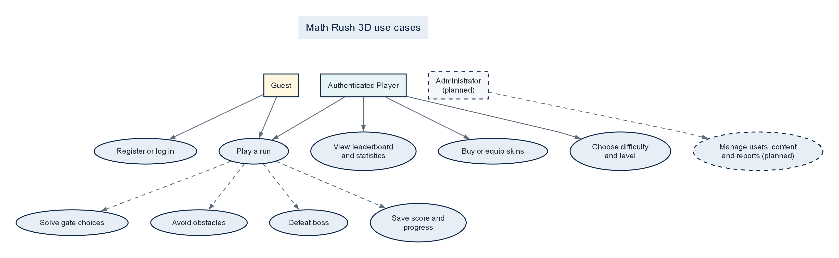
Figure 1. Use-case model; dashed administration functions are planned.

2.8 Data design
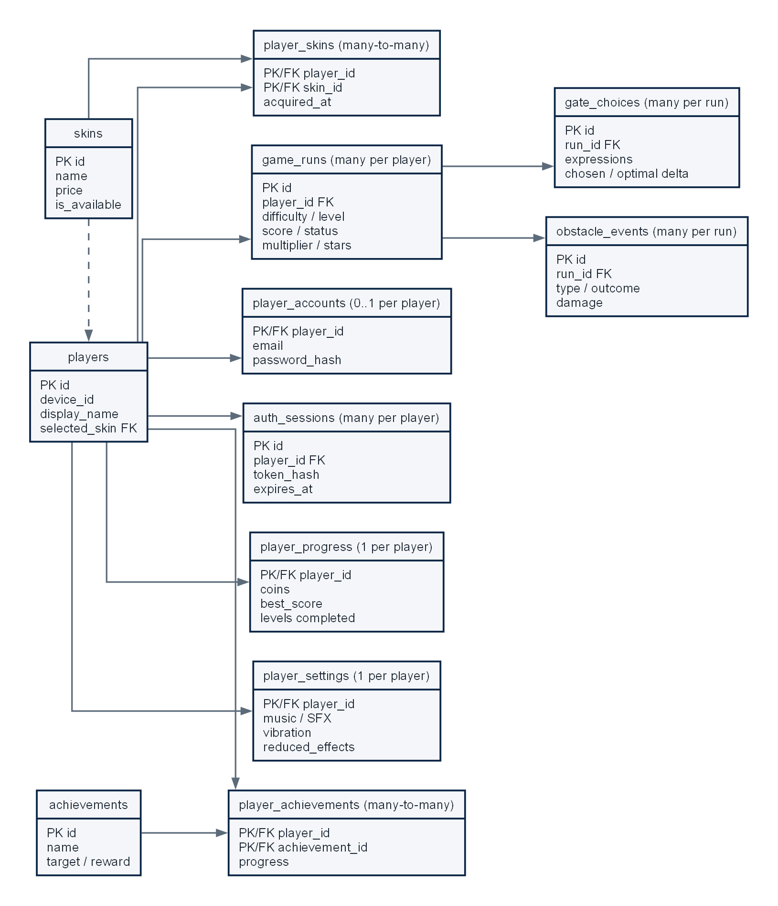
Figure 2. Current PostgreSQL entity-relationship model.
The schema normalises identity, credentials, mutable progression, settings and repeatable run/event records. Foreign keys and cascading deletes protect referential integrity, while checks constrain counts, difficulty values, outcomes and score-related fields. A leaderboard view joins player identity with progress data. The design currently lacks roles, permissions, administrative audit records and feedback entities; these should be added without overloading the existing gameplay event tables.

2.9 Three-tier architecture
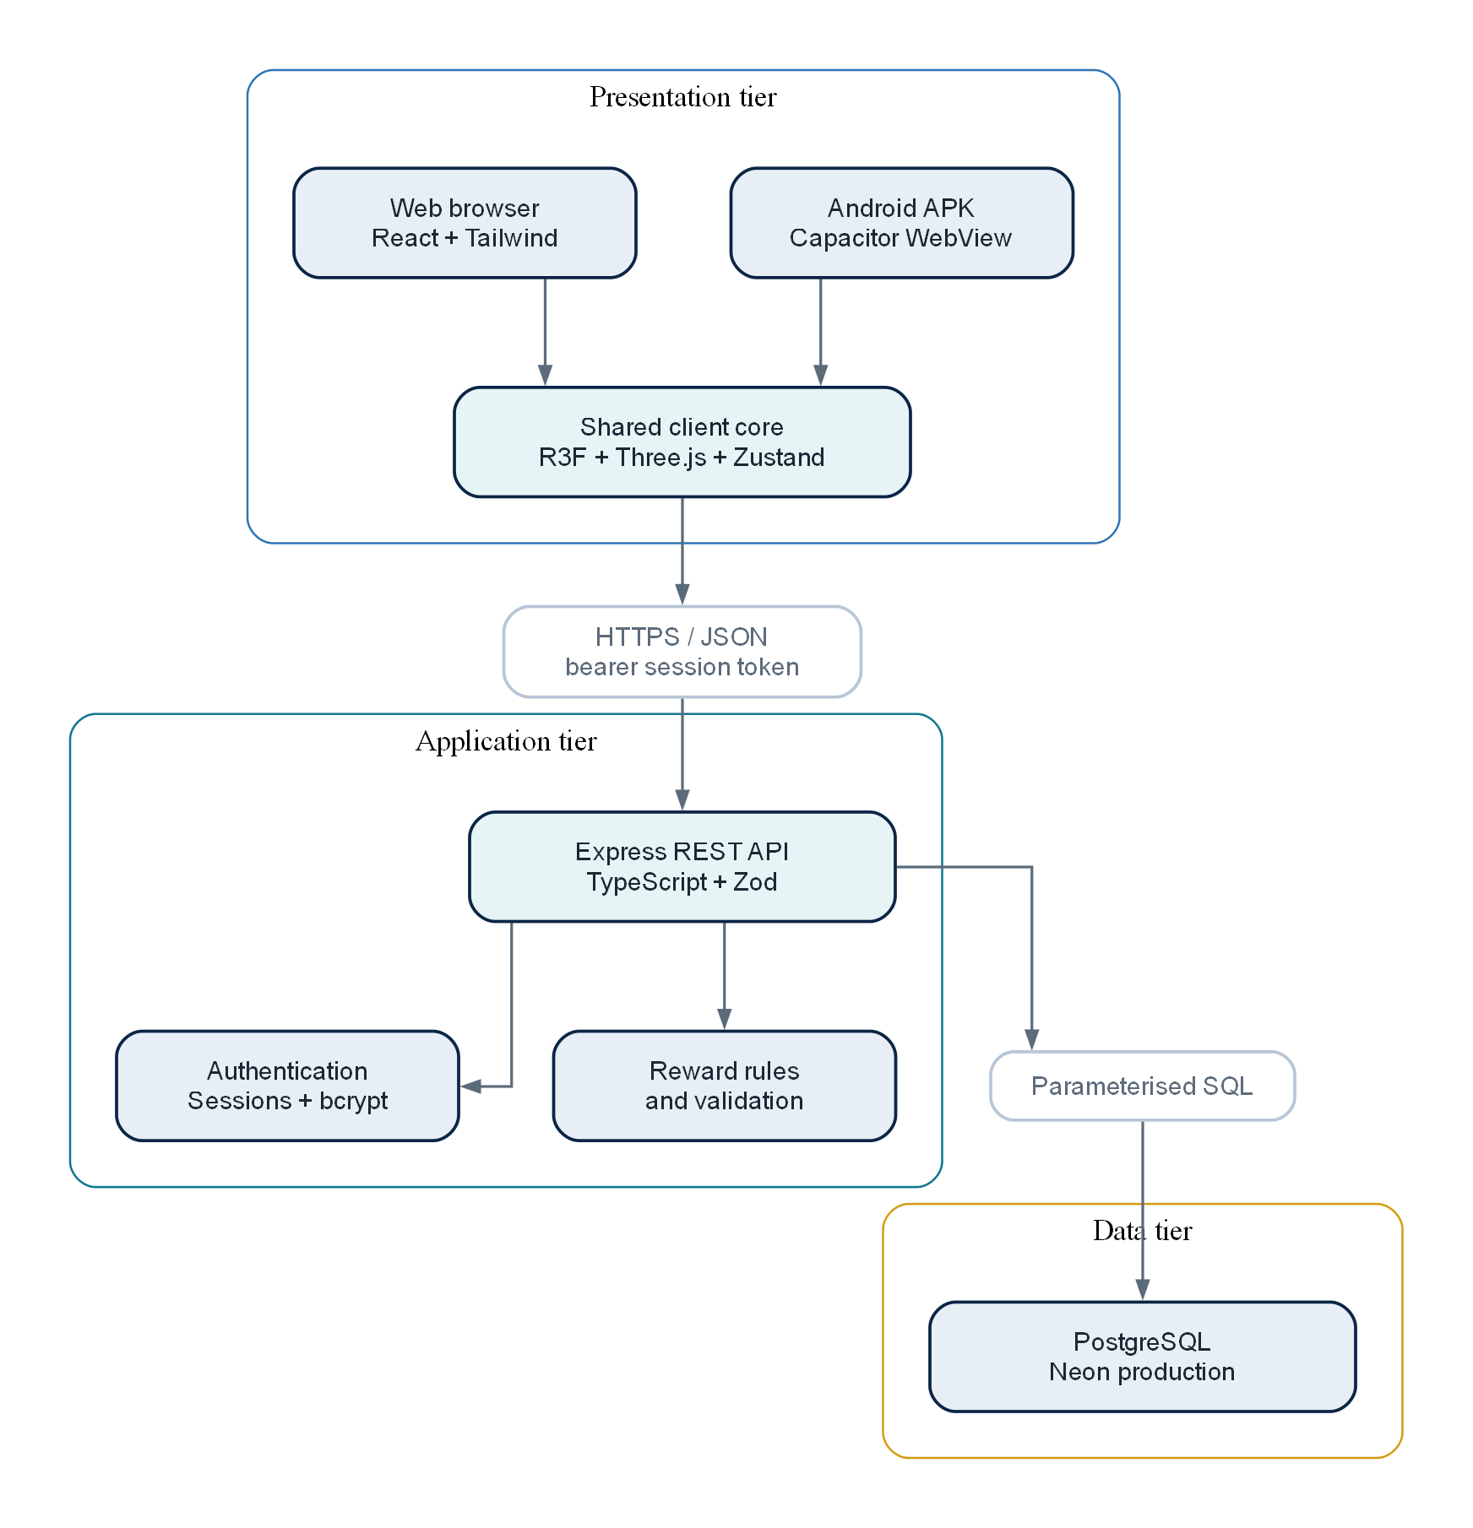
Figure 3. Three-tier deployment and runtime architecture.

2.10 Data-flow diagrams
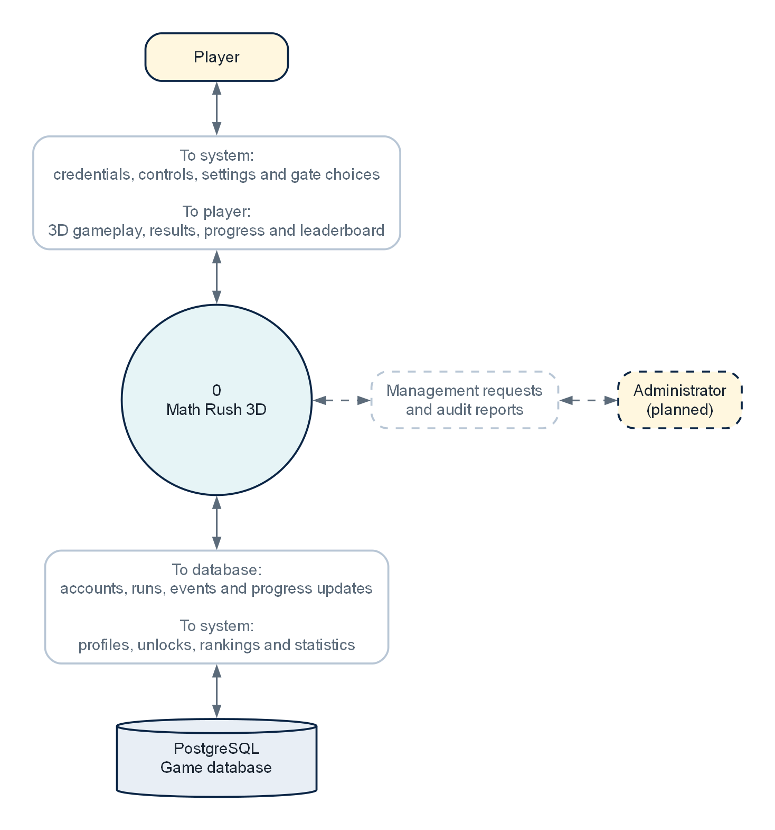
Figure 4. Level 0 context data-flow diagram.
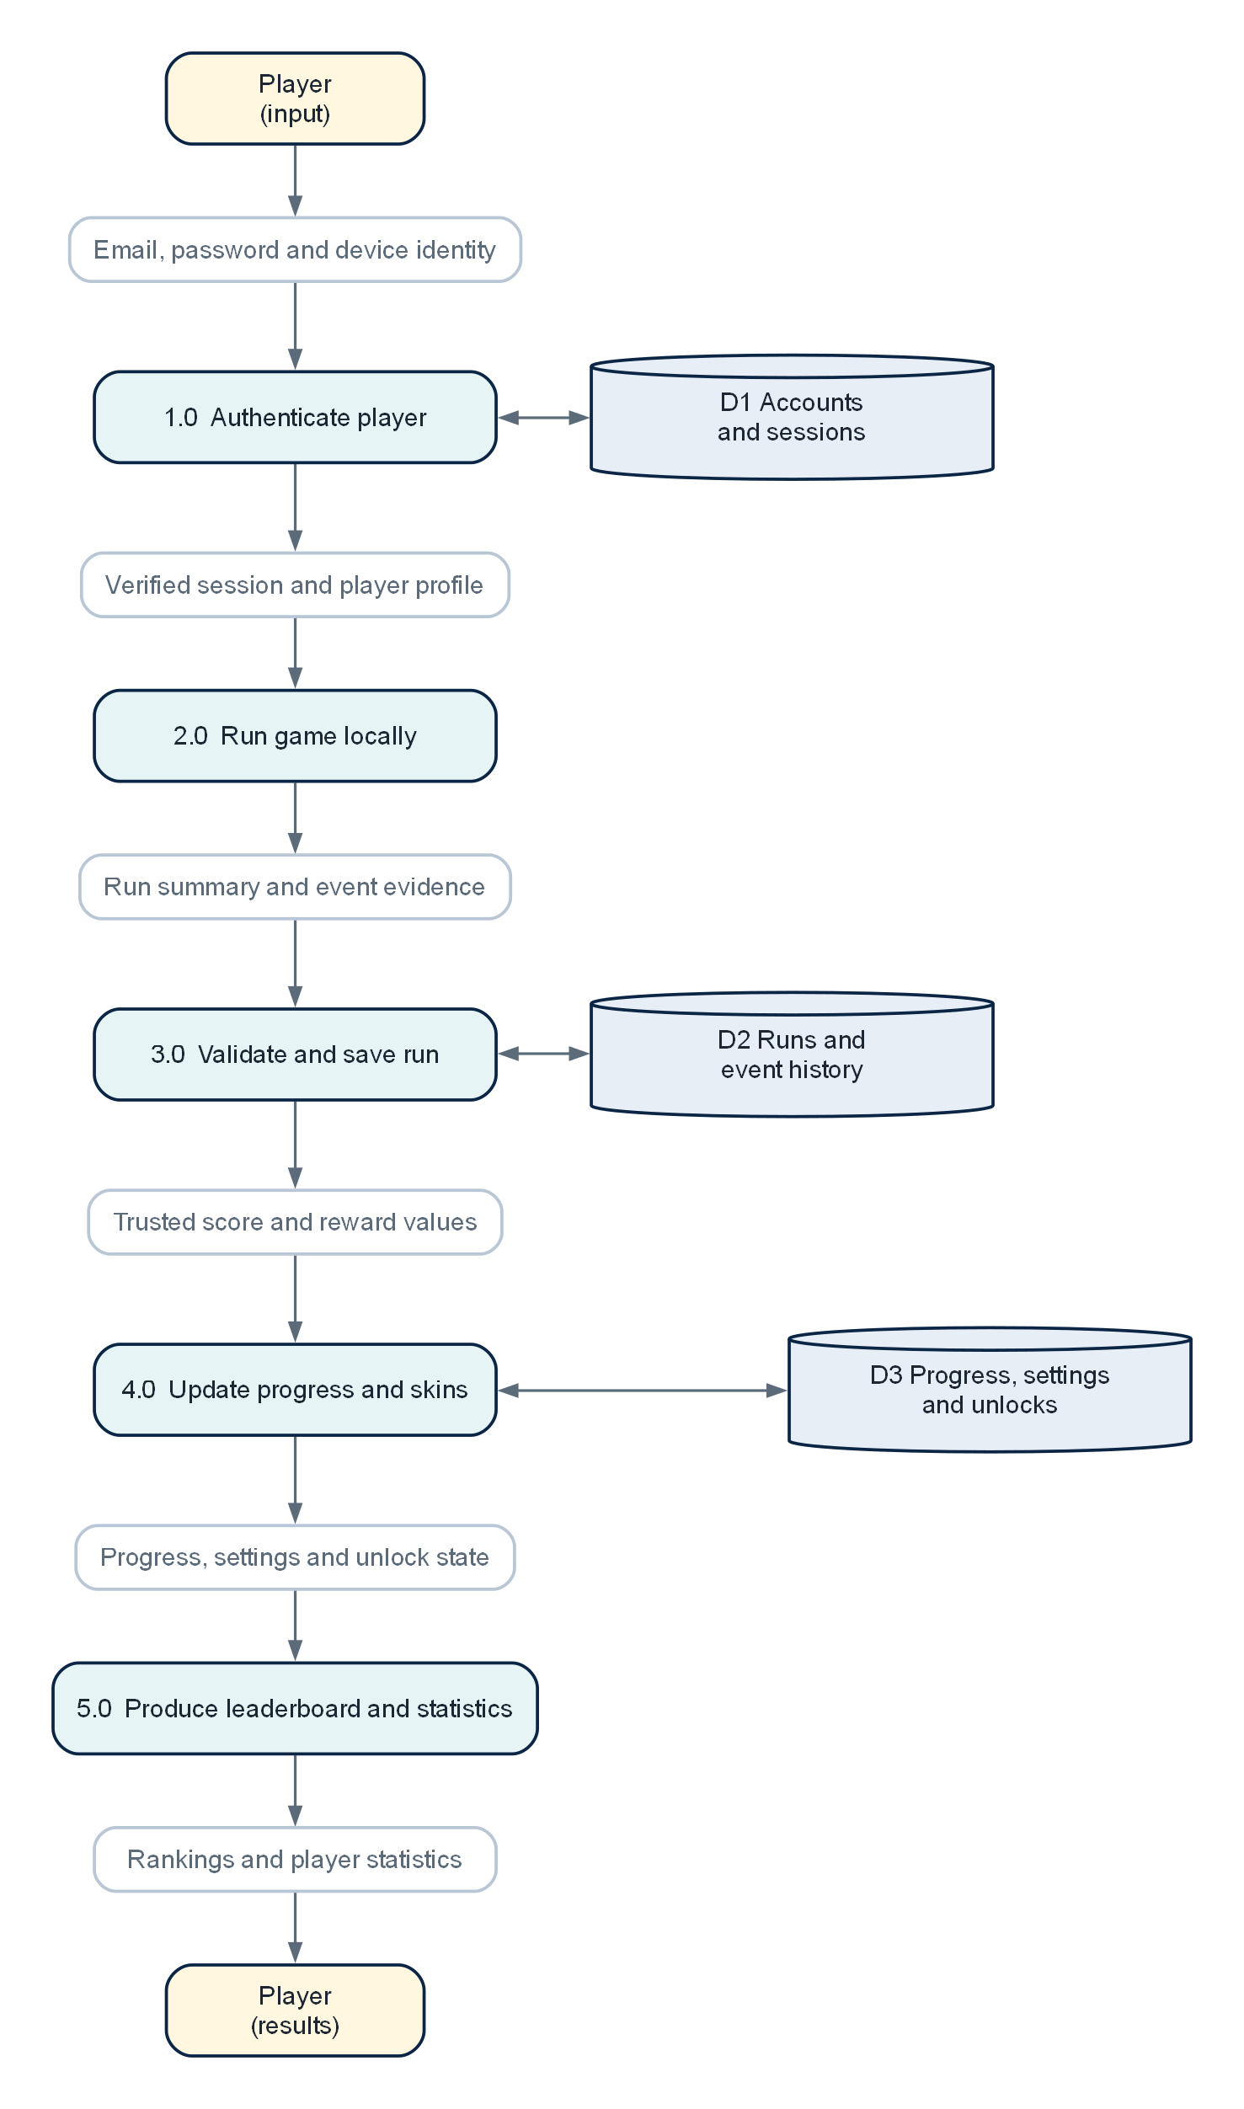
Figure 5. Level 1 data-flow diagram.

2.11 Gameplay flowchart
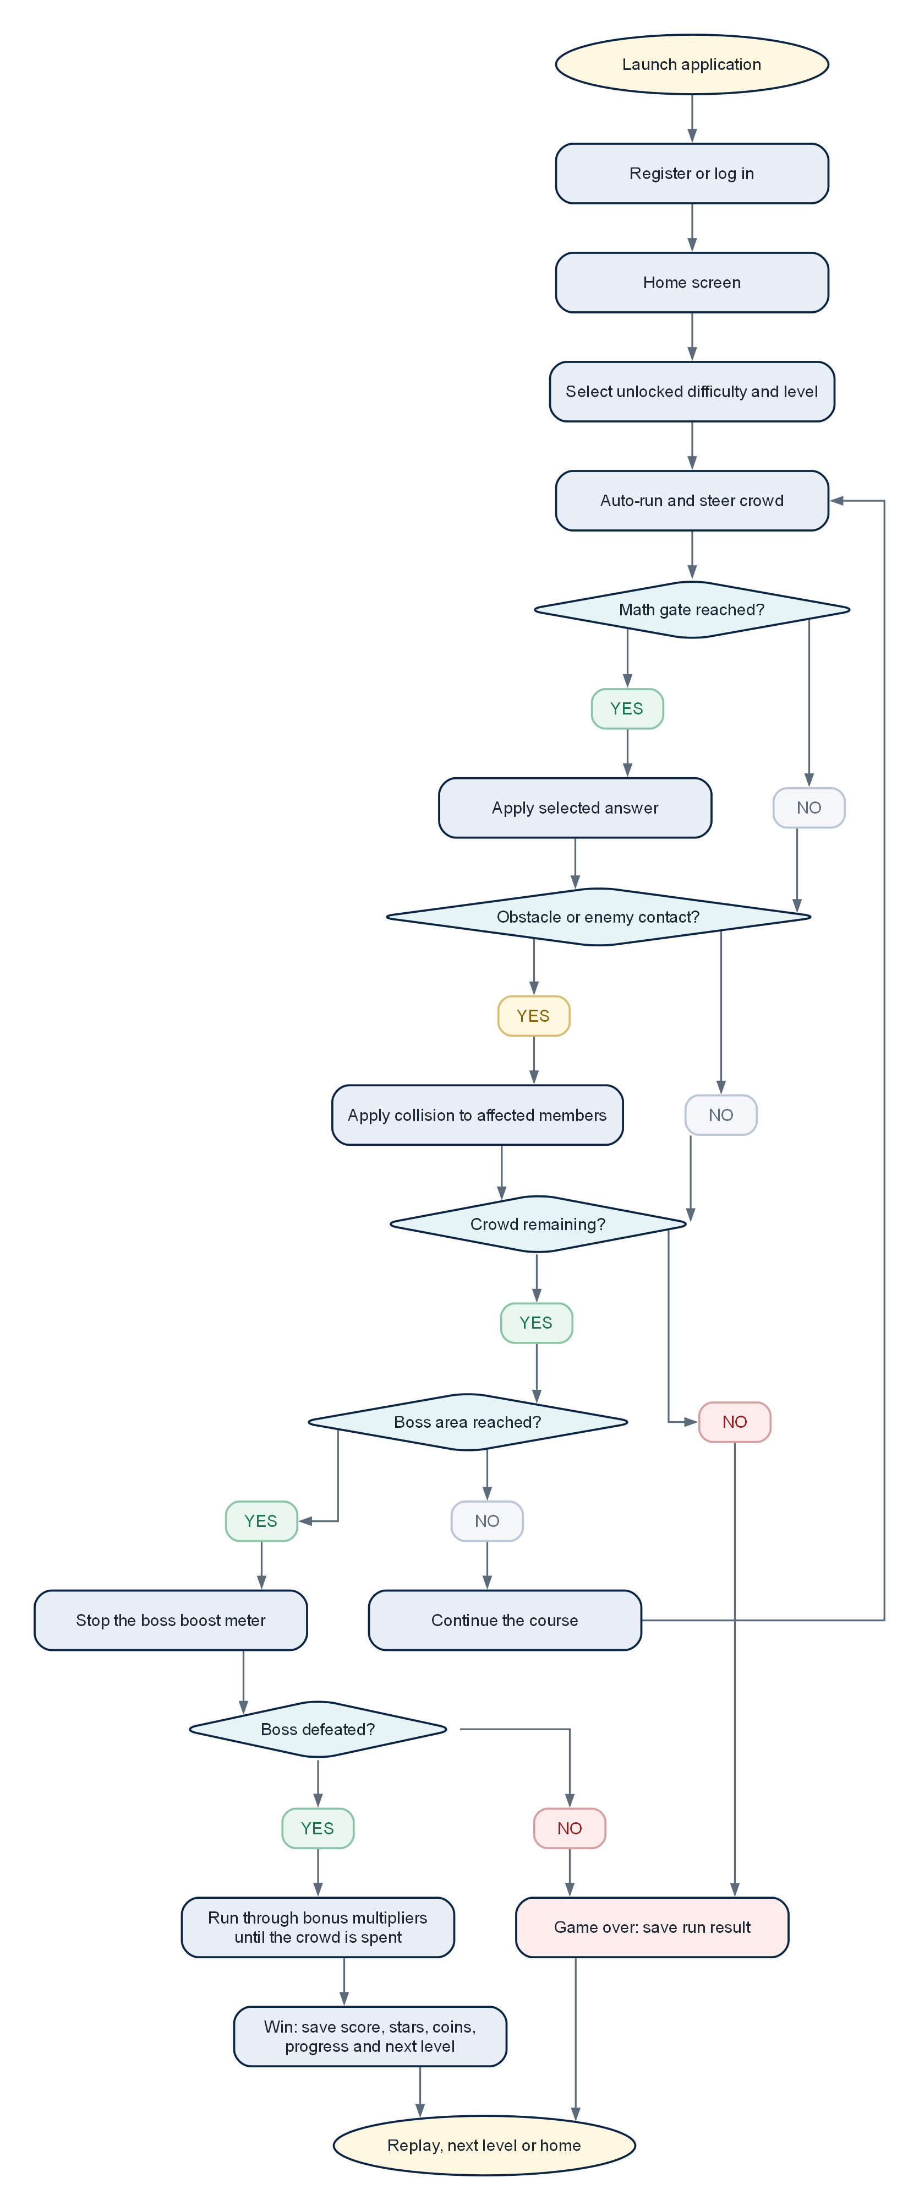
Figure 6. End-to-end gameplay flow.

2.12 Interface wireframes
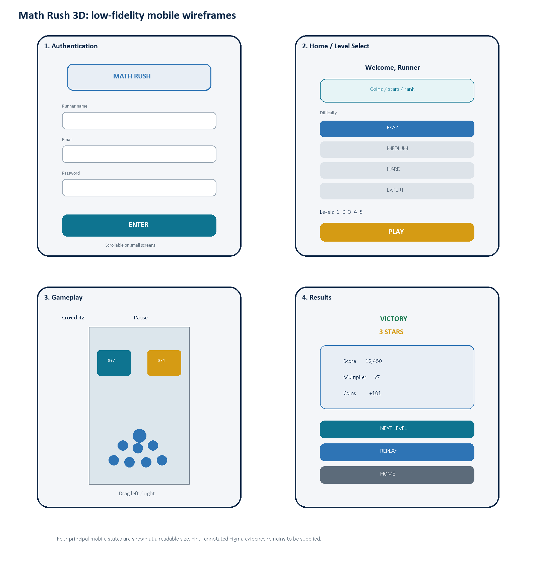
Figure 7. Low-fidelity mobile wireframes for the four principal interface states.

2.13 Requirements traceability
A table or chart called the "traceability matrix" is essentially a tool that shows which of the things that the users want (requirements) are currently being worked on and what proof or information is still required for each one.
Requirement | Implementation area | Verification | Current position
UR-01 Authentication | AuthScreen, authentication API routes, player_accounts and auth_sessions | Registration, login, invalid input and session-expiry integration tests | Implemented; formal integration evidence pending
UR-02 Progression | HomeScreen, levelProgress utilities and player_progress | Unlock-order unit tests and cross-device profile test | Implemented
UR-03 Steering | useInputController, CrowdRunner and track boundaries | Touch, mouse and keyboard device matrix | Implemented; UAT pending
UR-04 Arithmetic gates | mathGates utilities and GateManager | Expression correctness tests across all difficulties | Implemented
UR-05 Individual casualties | CrowdRuntime, ObstacleManager and obstacle events | Collision and crowd-loss regression tests | Implemented; animation UAT pending
UR-06 Boss and finish | BossManager, boss meter, GameTrack and bonus stages | Perfect-route balance test and end-state UAT | Implemented
UR-07 Run controls | Pause overlay, resetGame, replay and next-level actions | Pause, restart and duplicate-submission checks | Implemented
UR-08 Persistence | Zustand persistence, player API, run queue and PostgreSQL | Offline queue plus second-client login test | Implemented; integration evidence pending
UR-09 Rankings | Leaderboard route, view and statistics modal | Ordering, filtering and privacy tests | Partially verified
UR-10 Administration | No protected administrator module identified | RBAC denial and authorised CRUD tests | Not implemented

3. Development technologies and methodology

3.1 Software and tools used
Area | Selected technology | Purpose and justification
Interface | React 19 + React DOM | Component-based menus and overlays; React's state and composition model suits reusable screens and controls (Meta Platforms, 2026).
Language | TypeScript 6 | Static types across browser, server and shared rules reduce mismatched event and API structures (Microsoft, 2026).
Build | Vite 8 | Fast development server and optimised production bundling for a modern React application (Vite, 2026).
Styling | Tailwind CSS 4 + project CSS | Responsive utility classes support consistent spacing and breakpoints while custom CSS handles game-specific surfaces (Tailwind Labs, 2026).
3D | Three.js + React Three Fiber + Drei | WebGL rendering with a declarative React scene graph and reusable helpers; R3F is explicitly a React renderer for Three.js (Poimandres, 2026).
State | Zustand | Small central store with selective subscriptions and persistence; frame-critical transforms remain outside reactive state.
API | Node.js + Express 5 + Zod | REST endpoints, middleware, validation and shared TypeScript. Academically, this selection needs tutor approval because of the brief's language restriction.
Database | PostgreSQL 17/18 + pg | Relational constraints, foreign keys, views, transactions and parameterised SQL; PostgreSQL supports complex queries and transactional integrity (PostgreSQL Global Development Group, 2026).
Mobile | Capacitor 8 + Android/Gradle | Packages the web-first application in a native Android container and retains access to native platform APIs (Ionic, 2026).
Testing | Vitest + TypeScript + Oxlint | Fast rule-level regression tests, compile-time checks and static analysis.
Delivery | GitHub + GitHub Actions + Render + Neon | Version history, automated APK workflow, static/API hosting and managed PostgreSQL.
Design/evidence | Word, Graphviz and low-fidelity wireframes | Structured report, repeatable technical diagrams and an initial screen plan; editable Figma evidence remains pending.

3.2 Alternatives considered
Decision | Selected | Alternative | Reasoned comparison
3D integration | React Three Fiber | Plain Three.js | Plain Three.js gives direct control and fewer React concepts, but R3F keeps the scene declarative and componentised while still exposing Three.js objects. The current team skill set and React UI favour R3F.
State management | Zustand | React Context / Redux Toolkit | Context is sufficient for low-frequency UI state but can become awkward across many game consumers. Redux offers stronger conventions and tooling but adds ceremony. Zustand is compact; careful selectors are still required.
Server | Express/TypeScript | FastAPI/Python, Spring Boot/Java, Laravel/PHP | Express maximises type sharing and implementation speed. FastAPI would satisfy the brief and provide strong validation/OpenAPI; Spring Boot offers mature structure but higher complexity; Laravel offers rapid CRUD and RBAC patterns. Compliance may outweigh reuse.
Database access | Direct pg SQL | Prisma ORM | Direct SQL makes schema and queries visible for assessment and avoids ORM overhead. Prisma would improve generated types and migration ergonomics but can hide SQL learning and adds a generation layer.
Database | PostgreSQL | MySQL / SQLite | PostgreSQL is required by the brief and supports constraints, views and rich querying. SQLite is attractive offline but unsuitable as the shared production leaderboard store.
Mobile delivery | Capacitor | React Native / native Android | Capacitor reuses the deployed web client and is appropriate for the current project. React Native or native Android could improve device-specific optimisation but would duplicate rendering and interface work.
Methodology | Agile iterative | Waterfall | The game required repeated balancing and mobile feedback, which benefits from short build-test-review loops. Waterfall offers stable documentation gates but delays gameplay validation until too late.

3.3 Frontend implementation
In effect, the main part of what you see on the screen is made up of different React parts, but the game itself defines where everything is and then passes this info to some special managers like for the gates, the obstacles, and the boss. They all react to the same numbers that were already made by the game. There are also two more things: one that makes the characters move around and stay in their groups, and another that follows what's happening. Finally, there's something that draws the path and where the end of the run is.
The Zustand store models phase, run stage, difficulty, selected level, profile, settings, rewards and event summaries. Long-lived preferences are persisted locally and reconciled with the authenticated profile. Position and animation data that change every frame are kept in refs and runtime objects to avoid excessive component rerendering. The crowd uses instanced drawing so many bodies can share geometry and material data.
Capacitor offers features like touch simulation, mouse/ keyboard support, a "safe area" for the bottom of the screen where things don't go, and a way to keep the aspect ratio of your app in check. It also has an option to turn off some of the fancy graphics and you can even

3.4 Backend implementation
Express handles showing our website, checking that the info you send is correct and who you say you are. It also has rules for what parts of the site you can access based on what you've told us about yourself. If you're sending over a password, it's changed so it can't be reversed, we use a method called bcrypt with a strength of 12, which is the lowest suggested by OWASP, who actually recommend using Argon2 if possible (OWASP Foundation, 2020). When you log in, we give you a random code, but we just keep a special type of encrypted version of this on our end, not the actual code itself, so even if our database gets hacked, the code can't be used again.
For example, our application uses special kind of non-remember-me type of cookie when you're on the live site. On the other hand, the app on your phone uses a different way which is basically a single ticket that you can think of, because how that particular piece of information is handled by the built-in browser on your phone is a bit different from one phone to another. Our sessions will automatically time out after a month, and it's also possible for them to be cancelled.
To do this project, you'll need to use either PHP, Python, or Java for the part of the system that talks to the database and does the main business stuff. But you can only use Node.js to connect those two things together, or as a way to link them using an Application Programming Interface (API).

3.5 Database and SQL
We have 6 different instructions in our database that are used to make its current structure. We use special numbers called UUIDs and "bigserial" keys to label and keep track of things and events for sure. There are also lists where you can only put certain things (enums) which is like a list of allowed values, we use this for player's skill level, if a game is in progress or not and what kind of challenge is being done. We also have some rules (check constraints) that say you can't have a negative amount or an impossible score. To show who owns something we use another type of rule (foreign key).
Our current system does most of what we want it to, but we still need to finish making the full database that this project is about. To do that, we'll eventually have to add things like different types of users and their levels of access, who can do what and who gets to see what. We also want a way for an admin

3.6 Development methodology
Agile is the way to go because you can't really know for sure if your design will work or not, and if people will like it, by just reading about it. And also, what will take people a certain amount of time to do and how hard they'll find
- Discover: interpret the assignment, inspect comparable crowd runners, identify the learning problem and record constraints.
- Design: write requirements, model data and flow, plan mobile wireframes, define level-generation and reward rules.
- Build a vertical slice: home screen, one playable level, gates, crowd control, boss and result.
- Expand: add database accounts, progression, skins, leaderboard, difficulty bands, obstacles and Android packaging.
- Verify each iteration: automated rule tests, type checks, build checks, browser/device testing and database/API checks.
- Review and adapt: interpret peer feedback, prioritise defects, update the SDD and preserve evidence in GitHub.
In a real-world project that lasts about two weeks, you can basically use a list of things that need to be done which is prioritized, a clear idea of when it's ready to move on from each one, a relatively short time for getting things done, some tests that get run automatically, a

3.7 Version control and delivery
GITHUB is where our RUSH 3D project lives, it stores all the history of the changes made to the code. Every time you make a change, you should explain what that change was in a special comment called a "commit". If a change might have a high risk of going wrong, you should do it in a special branch or as a "pull request". When we release a
- Minimum evidence for the final appendix: repository URL, commit history screenshot, branch/pull-request example, passing test/build workflow and tagged release.
- The Android pipeline must use a supported Node version, Java 21, Android SDK 36 and the repository's Gradle wrapper.
- Render environment variables must separately configure DATABASE_URL, database SSL, NODE_ENV and the exact comma-separated client origins.

3.8 Data protection, ethics and asset licensing
The main thing this service should do is get the info it needs to tell if people are who they say they are, and how well they're doing compared to others. It should also tell us how well people have done in the past. Any information about people's email addresses and the way they have their passwords stored (which is like a secret code) can't come out when we show the ranking.
For now, our game doesn't have features like talking with others, ads, or it won't know where you are. This makes it less of a target for people who might try to take advantage of you, and it also helps keep your personal info private. However, the name you choose will still need to be approved because it will be seen by other players.
All the external and outside materials and their textures have to save their original and permission papers. Right now, we are using some stuff from Kenney and Quaternius and we keep track of who made them and under what agreement they were given out.

4. Testing and user acceptance

4.1 Testing strategy
We have a system where we first do some quick and simple tests that can tell us if there are any big problems with how the game works. These tests make sure things like scoring, the way groups of people play together, how players get from one level to the next and how their progress through the game gets faster or slower and the final boss fight works. We also use another type of test that checks if our game will work with all the different types of web browsers and the different kinds of servers.

4.2 Current automated evidence
Check | Command | Observed result | Date
Gameplay utility tests | npm test | 5 test files passed; 30 of 30 tests passed in Vitest. | 4 Aug 2026
Browser and server type checks | npm run typecheck | Completed successfully as part of the production build. | 4 Aug 2026
Production build | npm run build | Completed successfully. Vite reported a 1,275.81 kB JavaScript bundle before gzip and issued a large-chunk warning. | 4 Aug 2026
Database/API integration | Planned test script | No automated integration suite was identified in the inspected repository. | Pending
Android device matrix | Manual installation/UAT | Informal testing occurred, but a formal device matrix and signed evidence are still required. | Pending

4.3 Test data and environments
- Desktop web: current Chrome and Edge at 1366x768 and 1920x1080.
- Mobile web: 360x640, 390x844 and 412x915 responsive viewports, including on-screen keyboard behaviour.
- Android: at least one low/mid-range device and one newer device, recording OS version, memory and screen resolution.
- API/database: local PostgreSQL container and production Neon database with separate non-production test accounts.
- Adverse network: offline start, delayed first request, temporary API failure and retry after reconnection.

4.4 Peer tester plan
At least two people should each do a test. One person should check to see how easy it is for someone who is using your product for the first time and how clear the math in it is. The other person should look at the small screens (like those on a phone) and how hard or easy they are to use and if there are any mistakes in them. The person doing the test shouldn't be told by you what they should be looking for, they can only go by what they see in the product.
Tester | Profile | Device/environment | Session | Evidence
[Tester 1 name] | First-time player / learner | [Device, OS, browser] | Register, complete Easy 1-2, inspect result and leaderboard | Pending
[Tester 2 name] | Mobile/gameplay tester | [Device, OS, APK version] | Test squeeze control, obstacles, pause/restart and boss/bonus sequence | Pending

4.5 User acceptance checklist
ID | Test action | Expected result | Result
UAT-01 | Register with valid name, email and password. | Account is created and home screen loads. | Pending
UAT-02 | Enter invalid or duplicate credentials. | Specific, readable validation/error response; no account corruption. | Pending
UAT-03 | Reload and log in on another supported client. | Saved progression, coins, skin and statistics are restored. | Pending
UAT-04 | Select an unlocked and a locked level. | Unlocked level starts; locked level cannot start and explains prerequisite. | Pending
UAT-05 | Play using touch drag and keyboard. | Crowd follows input, remains in bounds and page does not scroll during play. | Pending
UAT-06 | Choose gates across all difficulties. | Expressions are legible, integer-valued and update the crowd correctly. | Pending
UAT-07 | Press fully against each track wall near hazards. | Crowd visibly compresses and skilled positioning reduces casualties. | Pending
UAT-08 | Collide with each obstacle type and an enemy crowd. | Correct individuals/damage are removed once; animation and sound match the event. | Pending
UAT-09 | Reach the boss with an optimal route. | Level is beatable; timing meter is readable and boss damage is understandable. | Pending
UAT-10 | Complete the bonus multiplier lane. | Crowd is consumed stage by stage, the track ends visibly and rewards match the result. | Pending
UAT-11 | Pause, restart, replay, next level and home. | Each action changes state once and does not duplicate a run submission. | Pending
UAT-12 | Disable sound/vibration and enable reduced effects. | Settings apply immediately and persist after restart/login. | Pending
UAT-13 | Disconnect the network, finish a run, then reconnect. | Game remains playable; run queues and later synchronises once. | Pending
UAT-14 | Use leaderboard difficulty filter/search function. | Results are correct and inputs cannot expose another player's private data. | Pending / feature gap
UAT-15 | Attempt administrator functions as player/admin. | Player is denied; authorised administrator can use audited CRUD. | Blocked: not implemented

4.6 Performance evaluation plan
It's better if the results of any performance claims can be backed up with some kind of numbers that can be repeated. Also, every test should note which app version was being used, what device it was on, whether a
Metric | Target | Method | Test point | Action if missed
Frame rate | At least 45 FPS on the selected mid-range Android device | Record a 60-second run with browser/Android profiling tools | Largest crowd, gate transition and boss battle | Reduce effects, profile allocations and review draw calls
Frame time | 95th percentile below 22 ms | Capture performance trace and inspect long frames | Gate application and crowd casualties | Remove synchronous work and repeated object creation
Initial load | Playable screen within 5 seconds on normal 4G after service wake-up | Cold-cache timed test | First visit and first APK launch | Compress assets, split bundles and improve loading feedback
API latency | Warm health/profile request below 500 ms | Twenty production requests with median and 95th percentile | Login and post-run synchronisation | Inspect database queries, indexes and hosting region
Memory stability | No continuing growth after three complete runs | Compare memory snapshots before and after repeated runs | Replay and next-level sequence | Dispose scene resources and remove stale listeners
Offline recovery | One eventual run record with no duplicates | Finish offline, reconnect and query run history | Queued submission | Fix idempotency and retry handling

4.7 Defect and feedback handling
Every time an automated test fails, it will be turned into a task and recorded with the steps you took to get the error, what was supposed to happen and what actually happened, what kind of computer and version of the program you were using, how serious it was and any pictures or videos that prove it didn't work right. We won't just copy the feedback from the tests, but make sense of it, and if there's more than one person who saw the same problem, or if the issue is very serious, or if it has to do with how something looks, that will take priority.

5. Current assignment coverage and gaps
This matrix compares the inspected project and this report with the supplied brief. 'Partial' means that some evidence or functionality exists but the criterion should not yet be claimed as achieved.
Criterion | Current evidence | Assessment | Next evidence/action
P1 Problem and requirements | Problem definition, stakeholders, user/system requirements and diagrams in this report. | Substantial draft | Validate requirements with named users and update after feedback.
P2 Risks | Risk register covers gameplay, performance, security, data, licensing, mobile and compliance. | Substantial draft | Add owner review dates and evidence of mitigations.
M1 SDD analysis | SDD connects the learning problem to architecture, data and game flow. | Partial | Add requirement traceability to implementation screenshots/commits.
P3 Tools and techniques | Selected stack, purpose and official research references documented. | Substantial draft | Add development screenshots and actual usage examples.
M2 Justification | Alternatives compared across 3D, state, backend, data, mobile and methodology. | Partial | Deepen comparison using measured build/performance evidence.
D1 Evaluation of solution/methodology | Only preliminary evaluation is possible at this stage. | Pending | Evaluate after UAT and compare outcomes against alternatives.
P4 Formal peer presentation | Tester plan exists; no presentation evidence supplied. | Pending | Deliver presentation and attach date, audience, slides and feedback.
P5 Functional app/support docs | Playable web/APK, README, database notes and this revised report exist. | Partial | Add user/admin guide, screenshots and backend compliance resolution.
M3 Interpret feedback | Feedback method is defined but no completed peer results exist. | Pending | Complete UAT, group themes and justify accepted/rejected changes.
M4 Develop against SDD | Modular implementation and passing rule/type checks exist. | Partial | Map requirements to commits, tests and screenshots.
P6 Review performance | Performance design choices are described. | Pending/partial | Capture FPS, load time, bundle size and device results.
M5 Critical review of stages/risks | Initial risks and lifecycle are documented. | Pending/partial | Compare estimated and actual risks after remaining iterations.
D2 Improvements and future work | Open gaps are prioritised below but not yet feedback-validated. | Pending | Link final recommendations to test and peer evidence.

5.1 Mandatory feature gap analysis
Brief requirement | Current state | Required action
PostgreSQL and SQL | Implemented through migrations, parameterised queries, constraints and a leaderboard view. | Add schema/query evidence and backup/restore test.
Frontend React + CSS framework | Implemented with React, Tailwind CSS and custom CSS. | Add responsive screenshots and accessibility evidence.
Backend PHP/Python/Java | Core backend currently uses Node.js/Express/TypeScript. | Obtain explicit approval or migrate to FastAPI, Spring Boot or PHP before submission.
CRUD | Account/profile, progress, skins and run creation/read paths exist; complete admin CRUD is absent. | Define core entities and implement protected create/read/update/delete workflows.
RBAC | No role/permission model or admin interface identified. | Add roles, authorisation middleware, admin UI and denial tests.
Validation/error handling | Zod, database constraints and central API error handling exist. | Add integration tests and user-friendly error mapping.
Search/filter | Leaderboard supports limited retrieval/filter behaviour; general search is incomplete. | Add documented server-side filters/search with pagination.
Dashboard/report | Player statistics and leaderboard exist. | Add administrator reporting and exportable summary if required.
Responsive UI | Mobile styles, safe areas, scroll fixes and touch controls exist. | Complete formal viewport/device matrix.
Audit logs | Gate and obstacle events are analytics, not administrator audit records. | Create separate audit_log entity and record protected changes.
Feedback | No persistent feedback entity or completed peer evidence identified. | Add feedback table/form if required and complete UAT records.

5.2 Prioritised next stage
- Resolve the backend-language compliance decision with the tutor before investing further in the existing service.
- Implement RBAC, administrator authentication/authorisation, protected CRUD, audit logs and denial tests.
- Add API/database integration tests, server-side reward plausibility checks and repeatable test data.
- Complete search/filter, administrator reports and a persistent feedback workflow where the full guideline requires them.
- Run peer UAT on web and Android, interpret results, implement justified changes and retest.
- Capture final evidence: diagrams, SQL, commits, CI, responsive screens, performance metrics and versioned deployment URLs.

6. Conclusion
Math Rush 3D essentially works. It has a 3D game that uses the React library, which is connected to a type of database called a PostgreSQL database. It also handles player accounts in a way that's secure. When you play on your phone, it will change the game to fit the size of the screen. Before the
This report covers the topics listed in the supplied project guideline: executive summary, SDD, problem and stakeholder analysis, requirements, measurable success criteria, risk review, use-case, ER, architecture, DFD, flowchart and wireframe designs, requirement traceability, software choices and alternatives, frontend, backend and database discussion, methodology, version control, ethics, performance evaluation and a peer UAT plan. The report does not claim completion of evidence that has not been supplied. Peer testing, measured device performance, administration functions and the backend-language decision remain necessary before the related higher-grade criteria can be evidenced confidently.

References
Beck, K. et al. (2001) Manifesto for Agile Software Development. Available at: Agile Manifesto (Accessed: 21 July 2026).
GitHub (2026) GitHub Actions documentation. Available at: GitHub Actions documentation (Accessed: 21 July 2026).
Ionic (2026) Capacitor: Cross-platform native runtime for web apps. Available at: Capacitor documentation (Accessed: 21 July 2026).
Meta Platforms (2026) React Quick Start. Available at: React Quick Start (Accessed: 21 July 2026).
Microsoft (2026) TypeScript documentation. Available at: TypeScript documentation (Accessed: 21 July 2026).
OpenJS Foundation (2026) Express 5: Installing and TypeScript. Available at: Express documentation (Accessed: 21 July 2026).
OWASP Foundation (2026a) Password Storage Cheat Sheet. Available at: OWASP Password Storage Cheat Sheet (Accessed: 21 July 2026).
OWASP Foundation (2026b) Session Management Cheat Sheet. Available at: OWASP Session Management Cheat Sheet (Accessed: 21 July 2026).
Poimandres (2026) React Three Fiber: Introduction. Available at: React Three Fiber introduction (Accessed: 21 July 2026).
PostgreSQL Global Development Group (2026) What is PostgreSQL? PostgreSQL 18 Documentation. Available at: PostgreSQL documentation (Accessed: 21 July 2026).
Schwaber, K. and Sutherland, J. (2020) The Scrum Guide. Available at: The Scrum Guide (Accessed: 21 July 2026).
Tailwind Labs (2026) Styling with utility classes. Available at: Tailwind CSS documentation (Accessed: 21 July 2026).
Three.js Authors (2026) Three.js manual. Available at: Three.js manual (Accessed: 21 July 2026).
Vitest (2026) Getting Started. Available at: Vitest guide (Accessed: 21 July 2026).
Vite (2026) Getting Started. Available at: Vite guide (Accessed: 21 July 2026).

Appendix A. Evidence still to insert
- The remaining tutor guideline and any revised section order.
- Figma project link or exported annotated wireframes if specifically required.
- Dated screenshots of registration, home/level select, gameplay, boss meter, bonus finish, results, skins, statistics and leaderboard.
- GitHub repository, commit history, pull request/branch and passing CI evidence.
- Database migration and representative SQL query evidence with sensitive values redacted.
- Named peer presentation and UAT evidence, feedback interpretation, implemented changes and retest results.
- Measured performance results on the specified desktop and Android device matrix.
- Written tutor decision on the Node.js/Express backend or evidence of migration to an accepted language.

Appendix B. Project technology snapshot
Layer | Current implementation
Web client | React 19.2, React DOM, TypeScript 6, Vite 8, Tailwind CSS 4, HTML/CSS
3D/game | Three.js 0.185, React Three Fiber 9.6, Drei 10.7, WebGL, GLB/GLTF, GPU instancing
State/audio | Zustand 5 with persistence; Web Audio API procedural effects
API/security | Node.js, Express 5.2, Zod 4, Helmet, CORS, rate limiting, bcryptjs, crypto session tokens
Data | PostgreSQL, pg connection pool, six SQL migrations, Neon production, Docker local development
Android | Capacitor 8.4, Java/AndroidX, Gradle, min SDK 24, target/compile SDK 36, immersive fullscreen
Quality | Vitest, TypeScript, Oxlint, Git/GitHub, GitHub Actions
Hosting | Render static web client, Render API service, Neon PostgreSQL
Assets | CC0 Kenney and Quaternius GLB assets with local attribution metadata

