**Structure of the Data**

The statistics below are calculated data from the Washington State Education Data and Research Center (ERDC, who supplied the data through DSA #K1600).[1] These files are merged to create a dataset with observations at the student-year level. For each student-year combination there is a free/reduced priced lunch (FRL) indicator which includes the reason why a student is eligible or not, a grade level field, a disability indicator, and enrollment fields (explained in the Grade Progression Metric section). For the FRL indicator, if a student has a reason code of 8 at any time throughout the year, he or she is considered to be in Foster Care for that year. If a student is receiving services for a diagnosed disability at any point during the year, he or she is considered to have a disability in that year.

In regards to the number of students in Foster Care each year, the ERDC data was most consistent with data obtained by Partners for Our Children for the academic years of 2006/07, 2007/08, and 2008/09. For this reason, the metrics presented below are limited to identifying students in Foster Care for these three years. The data can be combined with other sources to create longer panel datasets, however, identification of students in Foster Care is always done in these three years.

**Grade Progression**

Below are the 9th grade attainment rates stratified by disability status, Foster Care Status, and Free and Reduced Lunch status for the year that the individual was in 9th grade. Student age is not available, so cohorts are defined by grade in a particular year. The two cohorts are students enrolled as 9th graders in 2007 and students enrolled in 9th grade in 2008. I used a Kaplan Meier estimator to track grade attainment throughout high school. Grade attainment is used rather than year progression as the “time” component of the Kaplan Meier. This takes into account individuals who are held back. On the other hand, the panel (as determined by individual and grade) was “filled” for individuals who graduate in under four years. \**This is a change from the 10/30/14 version. Prior to this they were accidentally censored.*

Technical details are below:

* The ERDC-CSRS for years 2006/2007-2008/2009 contains monthly observations per student. In these datasets there is a field called Enrollment Status, which depicts how an individual is enrolled in that month or if they are leaving the school and for what reason. It contains the values Graduated(G), Transfer(T), Enrolled(E), Dropped Out(D), Unknown(U), and Deceased(Z). I used these codes to track dropouts, graduates, and those who ought to be censored.
* The ERDC-CEDARS data, used for the 2009/2010 and 2010/2011 years, contains yearly observations. The enrollment status field has been changed to withdrawal code and an individual is considered enrolled unless they have a withdrawal code during the year of G, T, U, Z, or D.
* To keep the data set manageable, for years 06/07-08/09 I trimmed these enrollment status down to two observations: their first non-missing enrollment status per year and their last.

Drop out coding

* A non-senior individual in year X was considered to have dropped out if either there first or last enrollment status was D or U in year X and the student was not observed to be enrolled in year X+1.
* Some individuals meet the above requirements for dropping out, but in years X+2 or X+3 have enrollment codes indicating that they graduated. They are now considered to have graduated rather than dropped out. \**This is a change from the 10/30/14 version.*
* A senior is considered a dropout if they do not have an enrollment status of G at the end of the year. Individuals with enrollment codes of E, T, or Z are censored.
* The Unknown status was considered to be a drop out coding because to be considered a drop out by the school a student must declare their intent to drop out. If on the other hand, they do not have a confirmed transfer and do not show up to school the next year they are considered unknown. This seems more likely that they dropped out.
* Individuals are censored in year X when they are not in the dataset in year X and in year X-1 they did not dropout e.g. in 2007 the student has an enrollment code of T, or transfer, and does not show up the next year.

Notes:

* Currently our ERDC-CEDARS data is only available for years 2009/2010 and 2010/2011. Thus, individuals in the second cohort who are held back will have their last year censored due to data limitations. This might explain why the graduation rates are higher in the Kaplan Meier estimator for the second cohort. It would seem that individuals who are held back are more likely to drop out than those who are not.

**9th Grade in 2006/2007 Cohort**

|  |  |  |  |  |  |
| --- | --- | --- | --- | --- | --- |
|  |  |  |  |  |  |
| Grade | Beg. Tot. | Dropout | Censored | % Retained | Std. Error |
|  |  |  |  |  |  |
| Non-Foster Non-FRL Non-Disability | | | |  |  |
| Freshmen | 55669 | 1970 | 2874 | 0.9646 | 0.0008 |
| Sophomore | 50825 | 1278 | 1827 | 0.9404 | 0.001 |
| Junior | 47720 | 1521 | 6816 | 0.9104 | 0.0012 |
| Senior | 39383 | 2417 | 36966 | 0.8545 | 0.0016 |
|  |  |  |  |  |  |
| Non-Foster FRL Non-Disability | | |  |  |  |
| Freshmen | 29478 | 1159 | 1819 | 0.9607 | 0.0011 |
| Sophomore | 26500 | 1398 | 1503 | 0.91 | 0.0017 |
| Junior | 23599 | 1780 | 5061 | 0.8414 | 0.0022 |
| Senior | 16758 | 2401 | 14357 | 0.7208 | 0.003 |
|  |  |  |  |  |  |
| Foster FRL Non-Disability | | |  |  |  |
| Freshmen | 324 | 13 | 21 | 0.9599 | 0.0109 |
| Sophomore | 290 | 16 | 21 | 0.9069 | 0.0165 |
| Junior | 253 | 32 | 66 | 0.7922 | 0.0238 |
| Senior | 155 | 38 | 117 | 0.598 | 0.0327 |
|  |  |  |  |  |  |
| Non-Foster Non-FRL Disability | | |  |  |  |
| Freshmen | 4586 | 124 | 239 | 0.973 | 0.0024 |
| Sophomore | 4223 | 133 | 178 | 0.9423 | 0.0035 |
| Junior | 3912 | 185 | 1076 | 0.8978 | 0.0046 |
| Senior | 2651 | 354 | 2297 | 0.7779 | 0.0072 |
|  |  |  |  |  |  |
| Non-Foster FRL Disability | | |  |  |  |
| Freshmen | 5685 | 203 | 335 | 0.9643 | 0.0025 |
| Sophomore | 5147 | 342 | 320 | 0.9002 | 0.0041 |
| Junior | 4485 | 510 | 1420 | 0.7979 | 0.0056 |
| Senior | 2555 | 607 | 1948 | 0.6083 | 0.008 |
|  |  |  |  |  |  |
| Foster FRL Disability | |  |  |  |  |
| Freshmen | 245 | 4 | 12 | 0.9837 | 0.0081 |
| Sophomore | 229 | 11 | 12 | 0.9364 | 0.0159 |
| Junior | 206 | 27 | 75 | 0.8137 | 0.026 |
| Senior | 104 | 43 | 61 | 0.4773 | 0.0421 |

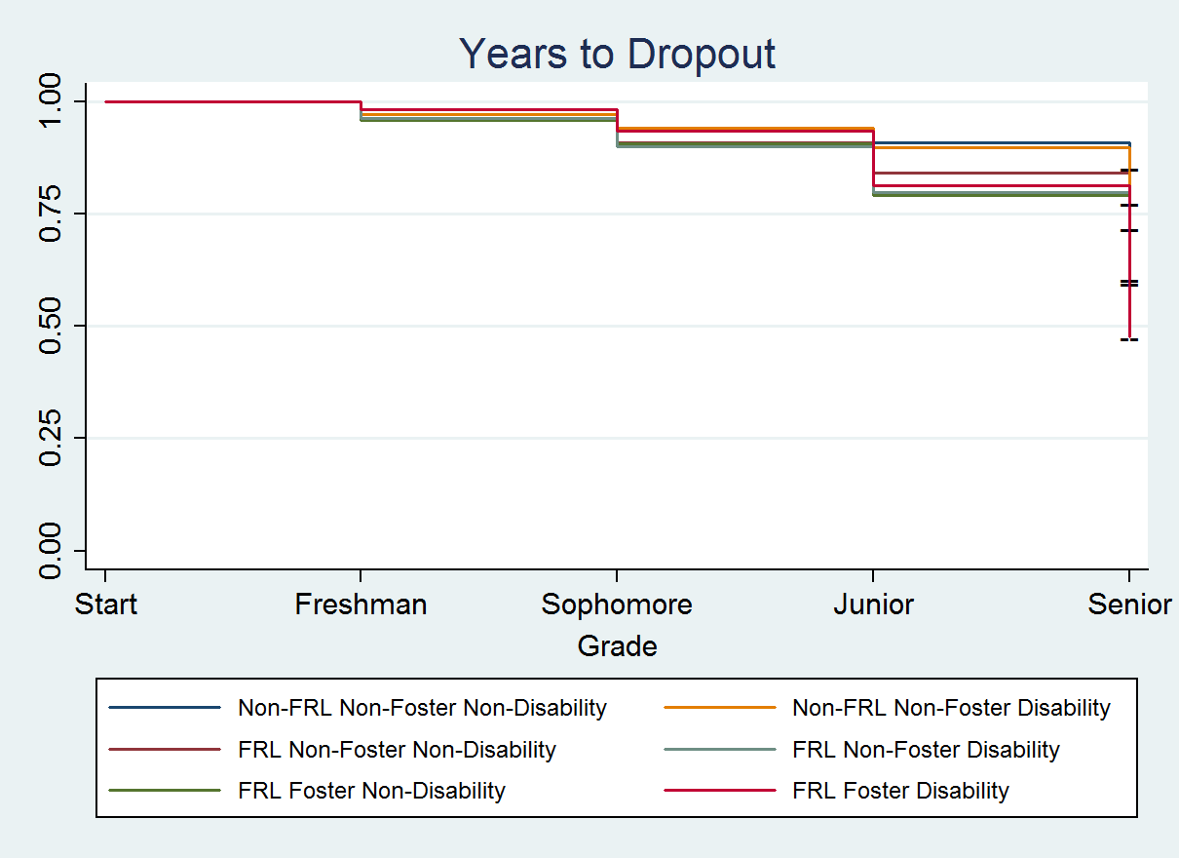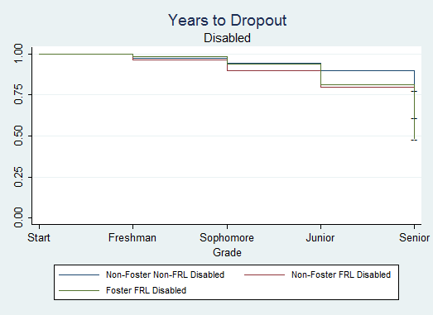

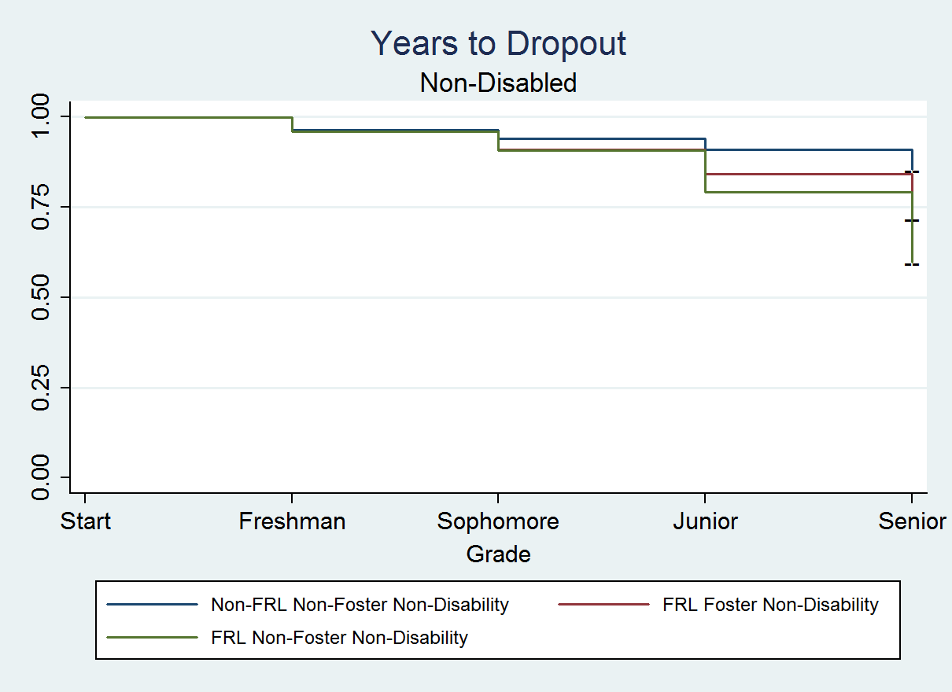

**9th Grade in 2007/2008 Cohort**

|  |  |  |  |  |  |
| --- | --- | --- | --- | --- | --- |
|  |  |  |  |  |  |
| Grade | Beg. Tot. | Dropout | Censored | % Retained | Std. Error |
|  |  |  |  |  |  |
| Non-Foster Non-FRL Non-Disability | | | |  |  |
| Freshmen | 55051 | 1840 | 3063 | 0.9666 | 0.0008 |
| Sophomore | 50148 | 1386 | 2293 | 0.9399 | 0.001 |
| Junior | 46469 | 1329 | 7054 | 0.913 | 0.0012 |
| Senior | 38086 | 1902 | 36184 | 0.8674 | 0.0016 |
|  |  |  |  |  |  |
| Non-Foster FRL Non-Disability | | |  |  |  |
| Freshmen | 28455 | 921 | 1497 | 0.9676 | 0.001 |
| Sophomore | 26037 | 1388 | 1629 | 0.916 | 0.0017 |
| Junior | 23020 | 1283 | 5575 | 0.865 | 0.0021 |
| Senior | 16162 | 1786 | 14376 | 0.7694 | 0.0028 |
|  |  |  |  |  |  |
| Foster FRL Non-Disability | | |  |  |  |
| Freshmen | 357 | 14 | 22 | 0.9608 | 0.0103 |
| Sophomore | 321 | 32 | 23 | 0.865 | 0.0185 |
| Junior | 266 | 21 | 71 | 0.7967 | 0.0223 |
| Senior | 174 | 40 | 134 | 0.6136 | 0.0307 |
|  |  |  |  |  |  |
| Non-Foster Non-FRL Disability | | |  |  |  |
| Freshmen | 4366 | 66 | 157 | 0.9849 | 0.0018 |
| Sophomore | 4143 | 107 | 217 | 0.9594 | 0.003 |
| Junior | 3819 | 132 | 1280 | 0.9263 | 0.0041 |
| Senior | 2407 | 229 | 2178 | 0.8382 | 0.0067 |
|  |  |  |  |  |  |
| Non-Foster FRL Disability | | |  |  |  |
| Freshmen | 5344 | 160 | 280 | 0.9701 | 0.0023 |
| Sophomore | 4904 | 334 | 358 | 0.904 | 0.0041 |
| Junior | 4212 | 323 | 1567 | 0.8347 | 0.0053 |
| Senior | 2322 | 435 | 1887 | 0.6783 | 0.008 |
|  |  |  |  |  |  |
| Foster FRL Disability | |  |  |  |  |
| Freshmen | 282 | 4 | 8 | 0.9858 | 0.007 |
| Sophomore | 270 | 15 | 16 | 0.931 | 0.0153 |
| Junior | 239 | 19 | 95 | 0.857 | 0.0215 |
| Senior | 125 | 40 | 85 | 0.5828 | 0.0386 |

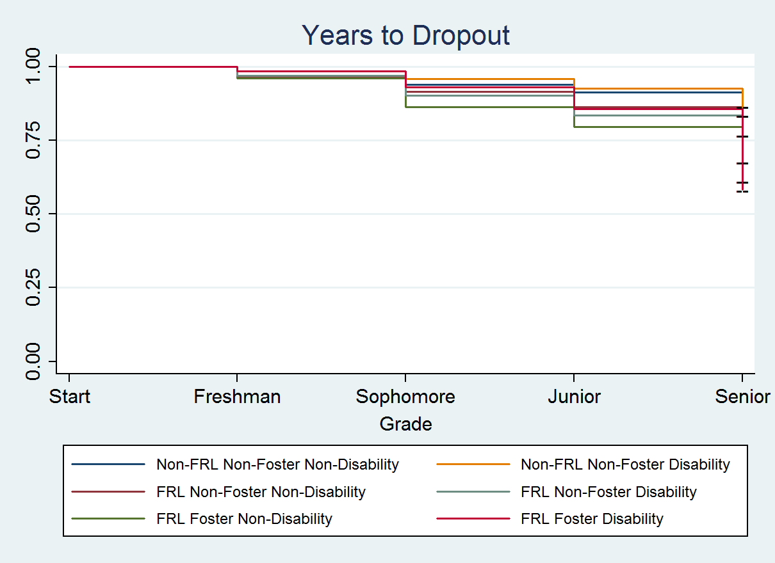

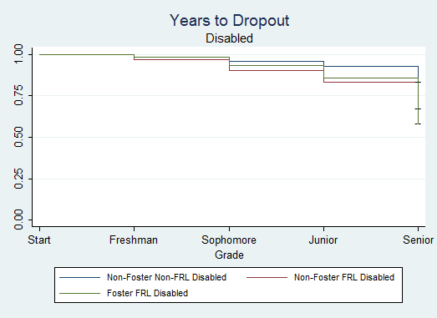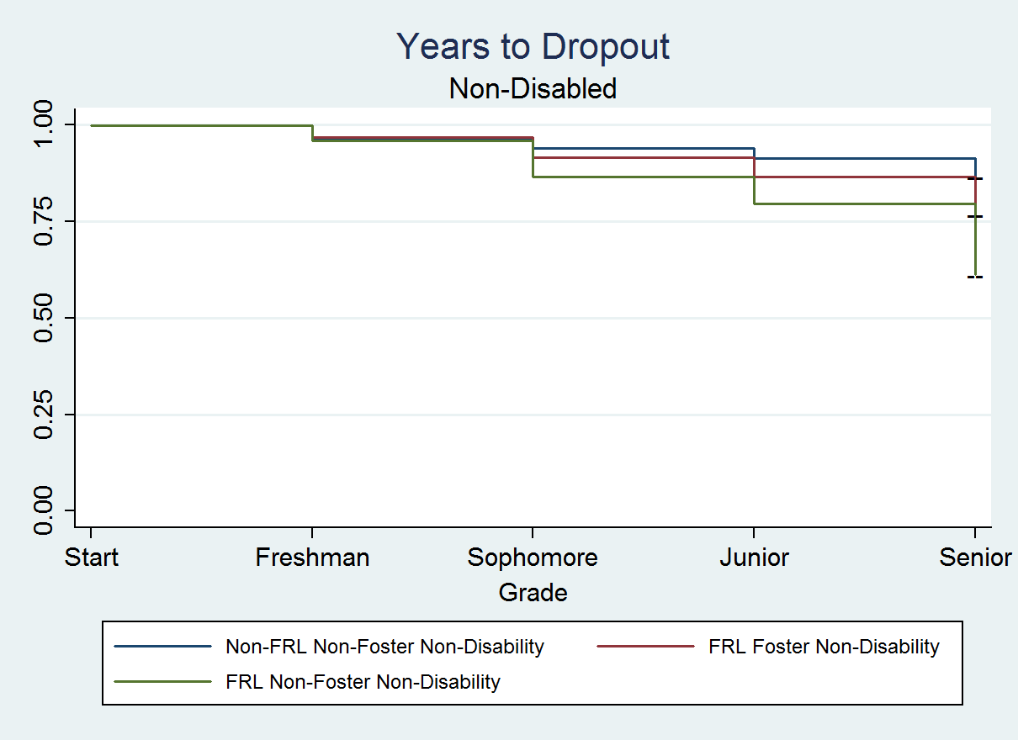

**College Enrollment**

To identify individuals who took college courses, registration files supplied to ERDC by the State Board of Community and Technical Colleges (SBCTC) and the Public Centralized Higher Education Enrollment System (PCHEES) were used. Both data set contains observations for individual classes of individual students. Importantly, these datasets only contain students in PUBLIC two- and four-year colleges and universities IN WASHINGTON STATE. So, results should be interpreted accordingly.

Classes in the SBCTC file are identified as a college-level course if the value in the field instit_intent_recat is “A” for academic.

All courses in the four year PCHEES data set were considered college level. Individuals must have received credit for these courses to be considered as having taken some college level classes, instead of just enrolled in them. The data contains enrollment information through summer quarter of 2011. As such, only one 9th grade cohort could be calculated; 9th graders in the 2006/2007 academic year. For this cohort, the enrollment rate represents those who have taken courses within one year after graduation. Three 12th grade cohorts were also tracked: 12th graders in the 2006/07, 2007/08, and 2008/09 academic years. The 9th grade cohort enrollment rate is lower than the 12th grade cohort’s enrollment rates because the 9th grade cohort has one year to enroll in college and be observed in this dataset, also the 9th grade enrollment count counts everyone enrolled in 9th grade, including those who will drop out in subsequent years.

**9th Grade Cohorts**

|  |  |  |  |
| --- | --- | --- | --- |
|  | Non-Disabled | | |
|  |  |  |  |
|  | Foster Care | FRL Non-Foster | Non-Foster Non-FRL |
| 2006-07 |  |  |  |
| 9th Grade Count | 324 | 29478 | 55669 |
| Enrollment Count | 94 | 8965 | 27890 |
| Proportion | 29.01% | 30.41% | 50.10% |
|  |  |  |  |
|  | Disabled | | |
|  |  |  |  |
|  | Foster Care | FRL Non-Foster | Non-Foster Non-FRL |
| 2006-07 |  |  |  |
| 9th Grade Count | 245 | 5685 | 4586 |
| Enrollment Count | 29 | 529 | 954 |
| Proportion | 11.84% | 9.31% | 20.80% |

**12th Grade Cohort**

|  |  |  |  |  |  |
| --- | --- | --- | --- | --- | --- |
| Non-Disabled | | | | | |
|  | |  | |  |  |
|  | | Foster Care | | FRL Non-Foster | Non-Foster Non-FRL |
| 2006-07 | |  | |  |  |
| 12th Grade Count | | 211 | | 20,265 | 56,131 |
| Enrollment Count | | 94 | | 8790 | 33796 |
| Proportion | | 44.55% | | 43.38% | 60.21% |
|  | |  | |  |  |
| 2007-08 | |  | |  |  |
| 12th Grade Count | | 232 | | 21,077 | 56,238 |
| Enrollment Count | | 103 | | 9432 | 35018 |
| Proportion | | 44.40% | | 44.75% | 62.27% |
|  | |  | |  |  |
| 2008-09 | |  | |  |  |
| 12th Grade Count | | 268 | | 23819 | 55,349 |
| Enrollment Count | | 119 | | 10281 | 33968 |
| Proportion | | 44.40% | | 43.16% | 61.37% |
| Disabled | | | | | |
|  |  | | |  |  |
|  | | | Foster Care | FRL Non-Foster | Non-Foster Non-FRL |
| 2006-07 | | |  |  |  |
| 12th Grade Count | | | 210 | 4,191 | 5,065 |
| Enrollment Count | | | 34 | 588 | 1246 |
| Proportion | | | 16.19% | 14.03% | 24.64% |
|  | | |  |  |  |
| 2007-08 | | |  |  |  |
| 12th Grade Count | | | 221 | 4,422 | 4,909 |
| Enrollment Count | | | 32 | 655 | 1216 |
| Proportion | | | 14.48% | 14.81% | 24.77% |
|  | | |  |  |  |
| 2008-09 | | |  |  |  |
| 12th Grade Count | | | 224 | 4221 | 4,850 |
| Enrollment Count | | | 26 | 628 | 1160 |
| Proportion | | | 11.61% | 14.88% | 23.92% |

**College Completion**

Individuals are considered post-secondary completers if they received either a Bachelor’s degree or an Associate’s degree. The data tables used to calculate these rates come from the ”completion” files provided by SBCTC and “completion” and “program” file from PCHEES. The PCHEES files contains data through summer quarter of 2011. The SBCTC file contains data through summer quarter of 2012. The PCHEES program file is used in conjunction with the PCHEES completion file to determine which type of degree was awarded. The SBTCT file contains two fields, exit_cd and award_type, that I use to determine the type of degree awarded.

Due to data limitations, completion rates can only be calculated for one cohort: high school seniors in the 2006/2007 academic year. This means the table below reflects completion rates of four year and two year programs in four years or less. To be consistent I limited the SBCTC file to contain data through the summer of 2011.

Note that there are other degrees awarded by Community Colleges not represented here (e.g. technical degrees or certificates). For a sanity check, the data appears to be consistent with this ERDC report: [www.erdc.wa.gov/briefs/pdf/201401.pdf](http://www.erdc.wa.gov/briefs/pdf/201401.pdf). According to the report, between 24% and 25% of Washington State high school seniors in the 2005/06 school year received either a Bachelor’s or an Associate’s degree by four years after graduation. This figure includes students who received their degree out of state or at private institutions (who are NOT included in these statistics).

Our DSA specifies that we are not to share statistics based off of less than 10 individuals. For this reason the Foster Care column contains the value of less than 10. There were a total of 11 post-secondary completers, across the disability field, who were in Foster Care in the 2006/2007 academic year.

|  |  |  |  |
| --- | --- | --- | --- |
| Post-Secondary Completion | | | |
| Seniors in the 2006/07 Academic Year | | | |
|  |  |  |  |
| Non-Disabled |  | | |
|  | Foster Care | FRL Non-Foster | Non-Foster Non-FRL |
| 12th Grade Count | 211 | 20,265 | 56,131 |
| Post-Secondary Completion | < 10 | 1566 | 9755 |
| Proportion | < 4.74% | 7.73% | 17.38% |
|  |  |  |  |
| Disabled |  | | |
|  | Foster Care | FRL Non-Foster | Non-Foster Non-FRL |
| 12th Grade Count | 210 | 4,191 | 5,065 |
| Post-Secondary Completion | < 10 | 20 | 86 |
| Proportion | < 4.76% | 4.77% | 1.70% |

**3rd Grade MSP Literacy Scores**

Below are the summary statistics for the 3rd grade MSP literacy proficiency rates for 2006-07 through 2008-09, stratified by Foster Care status, disability status, and FRL status.

An indicator, rlevel, in the testing data was used to determine whether or not an individual passed. On occasion individuals had multiple entries in the ERDC test score data. Since this should be an anomaly and there was no clear means to decide which score should be used, the first observation was taken.

Along with the summary statistics presented below, we have also conducted a two sided two sample T-test with unequal variances on the test scores between the two groups. In addition, we conducted a two sided binomial test of equal proportions for the passing rate between the two groups.

|  |  |  |  |
| --- | --- | --- | --- |
| Non-Disabled | | | |
|  |  |  |  |
|  | Foster Care | FRL Non-Foster | Non-Foster |
| 2006-07 | N=213 | N=27446 | N=35516 |
| Mean test score | 405.1455 | 404.4189 | 422.9007 |
| (23.84) | (27.06) | (25.43) |
| P-Values |  | 0.6585 | <0.001 |
| Proportion passed | 68.08% | 63.30% | 86.84% |
| P-values |  | 0.1499 | <0.001 |
|  | | | |
| 2007-08 | N=255 | N= 28281 | N=35020 |
| Mean test score | 405.2706 | 406.1347 | 424.3107 |
| (24.64) | (27.7) | (25.3) |
| P-Values |  | 0.5781 | <0.001 |
| Proportion passed | 63.92% | 63.89% | 87.13% |
| P-Values |  | 0.9919 | <0.001 |
|  | | | |
| 2008-09 | N=264 | N=29773 | N=34392 |
| Mean test score | 406.4773 | 406.7788 | 425.1648 |
| (23.9) | (25.54) | (25.71) |
| P - Values |  | 0.8385 | <0.001 |
| Proportion passed | 66.29% | 65.59% | 87.54% |
| P-Values |  | 0.8129 | <0.001 |

|  |  |  |  |
| --- | --- | --- | --- |
| Disabled | | | |
|  |  |  |  |
|  | Foster Care | FRL Non-Foster | Non-Foster |
| 2006-07 | N=125 | N=5694 | N=4901 |
| Mean test score | 375.736 | 376.862 | 398.2808 |
| (30.9) | (30.6) | (33.13) |
| P-Values |  | 0.6875 | <0.001 |
| Proportion passed | 32.80% | 31.19% | 56.95% |
| P-values |  | 0.7009 | <0.001 |
|  | | | |
| 2007-08 | N=127 | N=6178 | N=4840 |
| Mean test score | 377.063 | 374.805 | 396.839 |
| (32.75) | (32.43) | (34.49) |
| P-Values |  | 0.4431 | <0.001 |
| Proportion passed | 26.77% | 25.48% | 52.25% |
| P-Values |  | 0.7405 | <0.001 |
|  | | | |
| 2008-09 | N=123 | N=6514 | N=4676 |
| Mean test score | 378.8699 | 379.3812 | 399.4611 |
| (28.03) | (28.46) | (33.28) |
| P - Values |  | 0.8415 | <0.001 |
| Proportion passed | 26.02% | 26.33% | 52.72% |
| P-Values |  | 0.938 | <0.001 |

1. “…this DSA allows CALDER to use the data received to create aggregate reports that assist Partners for Our Children in fulfilling the reporting requirements of 2SHB 1566 (Chapter 182, Laws of 2013) that requires higher education data.” (p. 2)