
State of Washington

Statewide Automated Child Welfare Information System

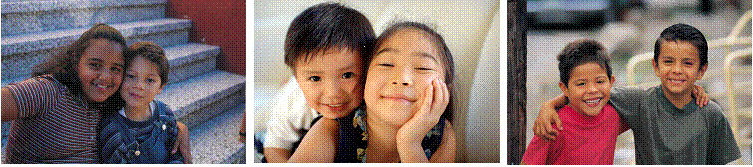

SSR01 RptPlacements

Version: 1.02

Revision History
Version | Date | Summary of Changes | Author | Reviewer/Approver
1.01 |  | Original Specifications | Lee Doran
1.02 | 7/26/2012 | Added report parameters | Lee Doran
Table of Contents
Revision History 2
1 Table Specifications 4
2 rptPLACEMENTS Report Parameters 4
3 Data Mapping Detail For rptPLACEMENTS Report 5
4 Data Mapping Detail For rptPLACEMENTS Table (not all elements are exposed in the report) 12

Table Specifications
The table base.placement_payment_services is created after loading all the data from Children’s Administration.
The purpose of this table is to provide payment information on services provided for a placement. The primary key of this table is id_payment_fact.

ref_service_category table (created by POC)
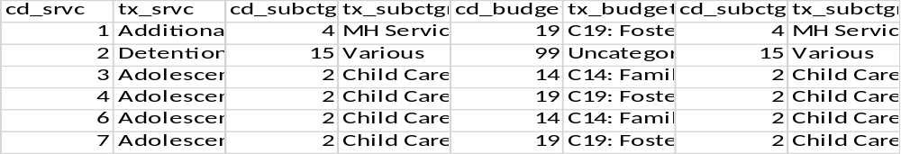

Base.placement_payment_services Table Definition
column name | data type | description
id_prsn_child | int | Famlink id
begin_date | datetime | Begin_date from rptPlacement_events
end_date | datetime | End_Date from rptPlacement_events
id_removal_episode_fact | int | from rptPlacement_events
id_placement_fact | int | from rptPlacement_events
id_provider_dim_caregiver | int | from provider_dim
id_case | int | from rptPlacement_events
dur_days | int | Days_to_dsch + 1
fl_close | smallint | if placement has an end date less than current date then set flag to 1 else 0.
id_payment_fact | int | From table payment_fact
svc_begin_date | date | From table payment_fact, column ID_CALENDAR_DIM_SERVICE_BEGIN  Converted to date.
svc_end_date | date | From table payment_fact, column ID_CALENDAR_DIM_SERVICE_END  Converted to date.
pymt_cd_srvc | int | cd_srvc from service_type_dim
pymt_tx_srvc | varchar (200) | tx_srvc from service_type_dim
fl_primary_srvc | Int | Base on table ref_service_category. If cd_srvc has fl_primary_srvc=1 then 1 else 0.
srvc_match | int | If the service paid matched the service in rptPlacement_Events then 1 else 0
prov_match | int | If the id_provider_dim_service matched the id_provider_dim_caregiver then 1 else 0
rate | decimal | am_rate from payment_fact
unit | decimal | am_units from payment_fact
total_paid | decimal | am_total_paid from payment_fact
cd_budget_poc_frc | int | Rolled up by poc cd_service_budget using ref_service_category table.
tx_budget_poc_frc | varchar (200) | Text description of cd_budget_poc_frc
cd_subctgry_poc_frc | int | Rolled up by poc cd_service_category using ref_service_category table.
tx_subctgry_poc_frc | varchar (200) | Text description of tx_budget_poc_frc
fl_plc_svc | int
fl_dup_payment | int
plcm_pymnt_sort_asc | int
fl_family_focused_services | int
fl_child_care | int
fl_therapeutic_services | int
fl_mh_services | int
fl_receiving_care | int
fl_family_home_placements | int
fl_behavioral_rehabiliation_services | int
fl_other_therapeutic_living_situations | int
fl_specialty_adolescent_services | int
fl_respite | int
fl_transportation | int
fl_clothing_incidentals | int
fl_sexually_aggressive_youth | int
fl_adoption_support | int
fl_various | int
fl_medical | int
filter_service_category_todate | decimal
fl_budget_C12 | int
fl_budget_C14 | int
fl_budget_C15 | int
fl_budget_C16 | int
fl_budget_C18 | int
fl_budget_C19 | int
fl_uncat_svc | int
filter_service_budget_todate | decimal

3 Data Mapping Detail For placement_payment_services Table
Row/Column Label | Description | Comments/Business Rules

