For all 3 tests, the unfilled circles should appear with a 0.5 second pause before each.

Test 2 (on the same window as Test 1):

* circle = the green circle
* n = 3

Test 1:

* circle = the blue circle
* n = 6

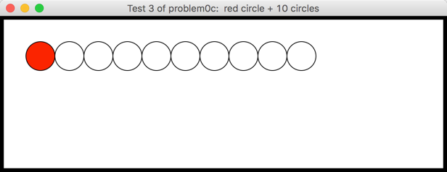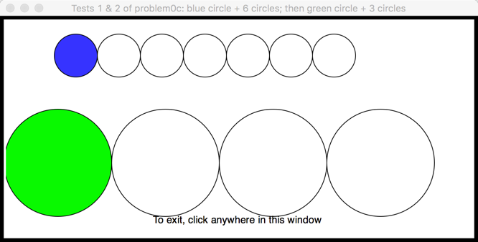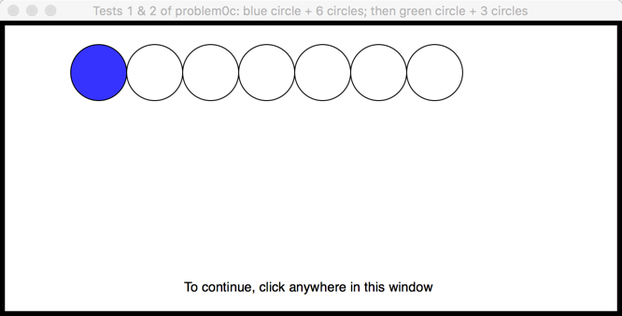

Test 3 (on a new window):

* circle = the red circle
* n = 10