For Test 1, the test begins by showing this:

Then, after the user clicks, this:

Then, after the user clicks again, this:

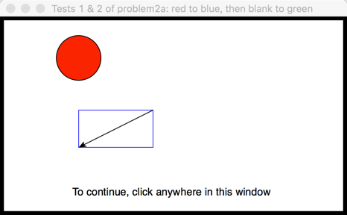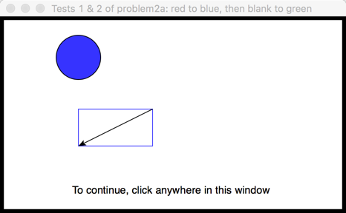

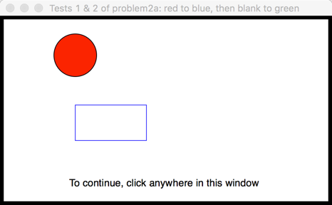

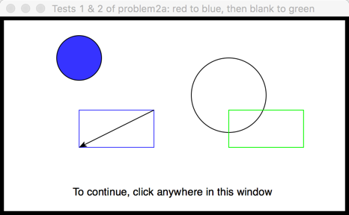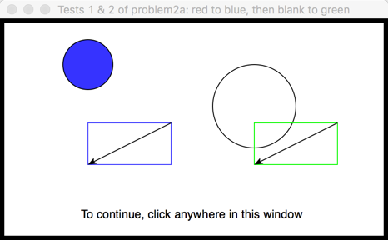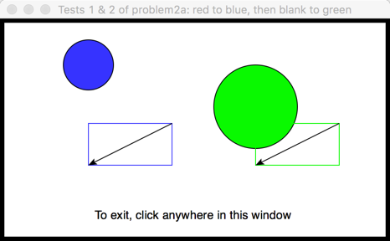

Then, after the user clicks, this:

Then, after the user clicks again, this:

Test 2 is in the same window and begins by showing this:

Test 3, which features a yellow-filled circle and a black-outlined rectangle, is not shown in this document.