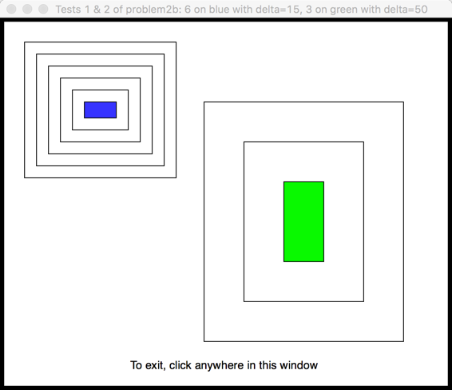

Test 1:

* The blue rectangle
* n = 6
* delta = 15

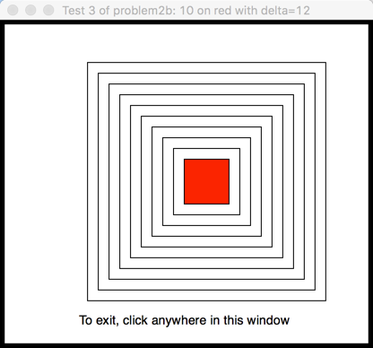

Test 3:

* The red rectangle
* n = 10
* delta = 12

Test 2 (on the same window as Test 1):

* The green rectangle
* n = 3
* delta = 50