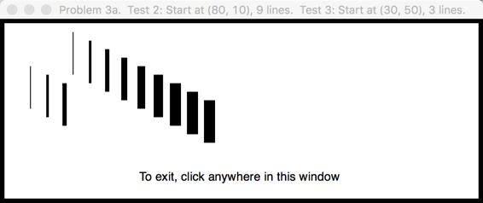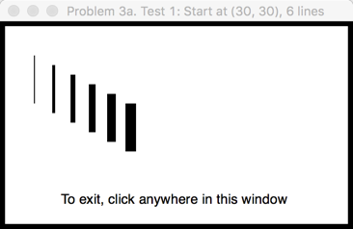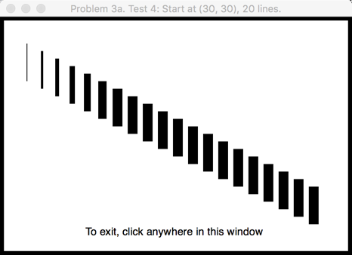

Tests 2 and 3 are two tests on one  
**550 x 200** window.

Test 2:

* The given starting point is at **(80, 10)**
* The number of lines to draw is **9**.
* The ***returned value*** should be ***75***.

Test 3:

* The given starting point is at **(30, 50)**
* The number of lines to draw is **3**.
* The ***returned value*** should be ***9***.

For Test 4, the picture should be like that shown above. For this test:

* The window size is **450 x 300**
* The given starting point is at **(30, 30)**
* The number of lines to draw is **20**.

The ***returned value*** should be ***218***. Note that the thicknesses max out at 13.

For Test 1, the picture should be like that shown immediately below. For this test:

* The window size is **350 x 200**
* The given starting point is at **(30, 30)**
* The number of lines to draw is **6**.

The ***returned value*** should be ***36***.