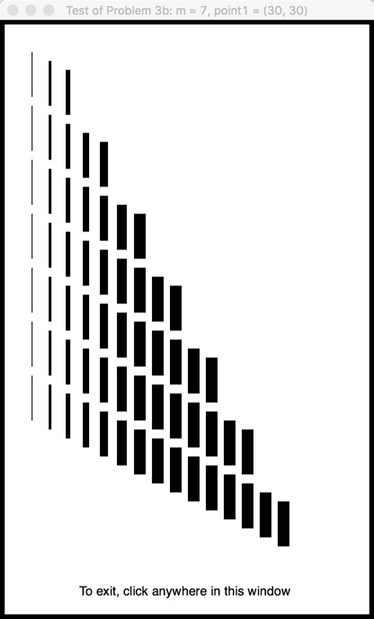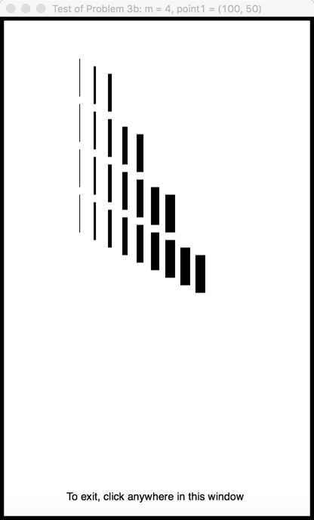

For Test 2, the picture should be like that shown immediately below. For this test:

* **m**  (the number of SETS of lines) is **7**
* **point1** (the starting point for the first set of lines) is at **(30, 30)**

The ***returned value*** should be ***539***.

For Test 1, the picture should be like that shown immediately below. For this test:

* **m**  (the number of SETS of lines) is **4**
* **point1** (the starting point for the first set of lines) is at **(100, 50)**

The ***returned value*** should be ***158***.