**Key Challenges**

**Challenge:** Team Coordination and Data Sharing.

**Solution**: A git repository was created for the team to coordinate and share work.

**Analysis**: The Git repository turned out to not be very useful. SQL server stored queries written, and documentation was mostly needed at the beginning and end of the project. During the project, a dozen ASCII file SQL queries were committed to the repository, which only cluttered it because SQL server stores the queries anyway. Some of these queries are out of date because functions defined on the database were altered at a later date and the queries on Git were never updated.

**Challenge**: Balancing Team Work Load

**Solution**: ???

**Analysis**: Overall this challenge was handled poorly. Members of the team had other time commitments related to other classes and did not balance their time well. Team meetings were often last minute, and poorly communicated by all three team members.

**Relational Schema**

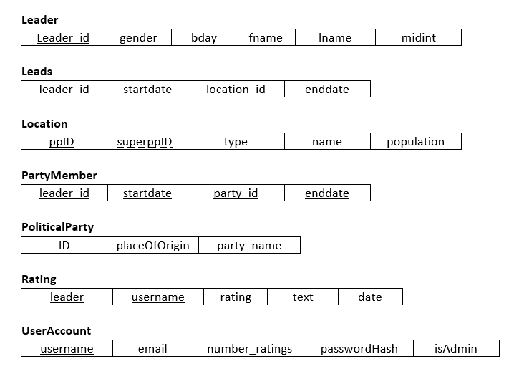

ER diagram

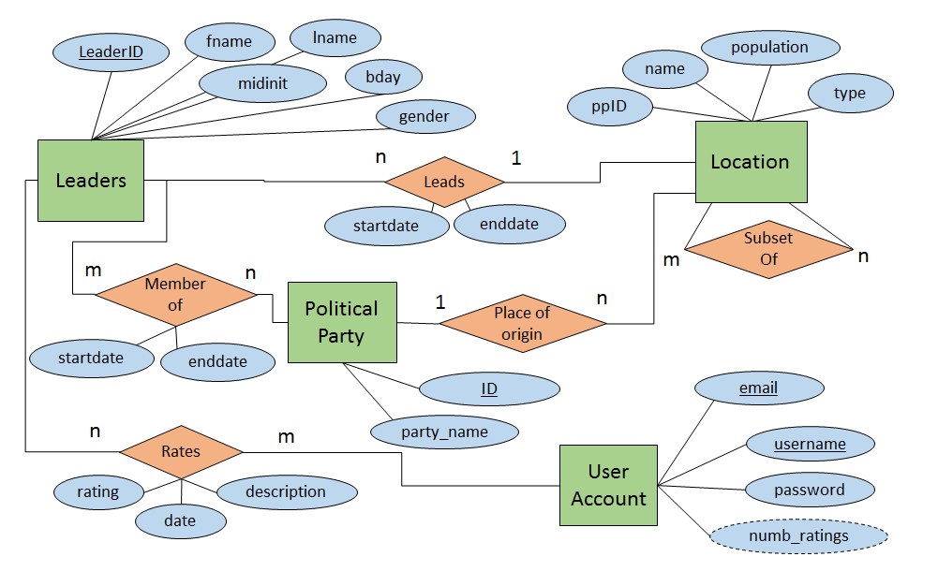

**Description of ER Diagram**

The Key points of the ER diagram are the user account and Leader Entity sets. Leaders, found in the upper left corrner are main focus of the porject, and they are what is rated by users in the database. The leader ID is a numerical identifier unique to each leader, and the leaders name, gender, and birthday are also stored. Equally important is the User Account entity set in the lower right corner. The User Accounds are important as a means for users to rate leaders, and to avoid having anyone place more than one rating on a leader, since they need an account to make ratings. User Account stores unique usernames and emails for each user, as well as the SHA1 hash of the user’s username and password concatinated together, to ensure the security of their account. The location and Political Party entity sets are provided to give users extra information by which they can filter the leaders they see.