**Information for Poster Session Participants**

The posters will need to be set up at the Atrium in the Arthur Weisberg Family Applied Engineering Complex between 8:30 a.m. and 9:00 a.m. on Thursday, April 20. Participants must be there from 9:00 a.m. to 12:00 p.m. on Thursday, April 20.

To ensure that the event runs smoothly, please read and follow the instructions below.

**Timeline:**

|  |  |
| --- | --- |
| April 20, Thursday | |
| 8:30 a.m. ~ 9:00 a.m. | Sign in, Poster Pickup and setup. |
| 10:00 a.m. ~ 11:30 a.m. | Poster Presentation, Judging |
| 11:45 a.m. ~ 12:00 p.m. | Award Ceremony, Closing Remark |

**Posters:**

Design

* Posters need to be 24-inches wide by 36-inch high.
* A template for a 24-inch wide by 36-inch-high poster can be downloaded here: [Poster_Template](https://csset.github.io/csset2023/assets/IEEE_Sample_Poster.ppt).
* The poster and all additional material (label, abstract, figures, charts, tables, summary, etc.) must fit within this 24-inch wide by 36-inch-high display area.

Printing

* Poster file must be in a .ppt, .pptx or .pdf format.
* Poster files MUST be sent to Poster Session Coordinator ([csset.marsahllu@gmail.com](mailto:csset.marsahllu@gmail.com)) no later than April 10. Only files initially sent by Poster Session Coordinator will be eligible for the single-copy and free printing.
* Participants are permitted ONE free printing. Any additional print jobs are the participants’ financial responsibility.
* Participants are responsible for picking up their printed poster from Poster Session Coordinator once they have been notified that their poster is ready.
* CONSULT PRINTING CHECKLIST BEFORE SENDING THE FILE TO THE COORDINATOR – See the included Printing Checklist for common errors to save yourself needing to pay for extra prints.

Setup

* A 24-inch wide by 36-inch-high display space will be provided to each participant.
* Participants will be provided with easel and foam board at setup.

Judging

* Participants need to be there between 10:00 a.m. and 11:30 a.m. in the area beside their posters to answer the judges’ questions.
* Judges will score participants’ posters and presentations according to a pre-set rubric (attached).

ShapeShape**Poster Printing Checklist**

Did I proofread my poster? (Note that all caps text is not always spellchecked in Microsoft products)

Shape Are all of my special symbols, tables, and mathematical equations correctly displayed?

Shape Is my name (and the names of the co-authors) listed?

Shape Is my division (or program) listed?

Shape Did I include my title?

Shape Is the document orientation for my poster set to “Portrait”?

Shape Make sure the poster size is correct (24-inch wide by 36-inch high).

Shape Is my file saved as a .ppt, .pptx or .pdf format?

ALSO REMEMBER:

* Send poster file to E-mail ([csset.marsahllu@gmail.com](mailto:csset.marsahllu@gmail.com)) BEFORE **April 10.**

The Poster Session Committee will send the posters for printing. The Poster Session Committee will notify the participants when it is time to pick up their posters.

* Bring your MU ID when you pick up your poster.
* The participant gets one free printing, if you send someone else to pick up your poster, make sure you contact the Poster Session Coordinator ahead of time.
* Check your poster when you pick it up.
* Pick it up as soon as possible when it is ready, to avoid having to wait in lines.
* If you find errors that you missed when you originally sent your file, you are responsible for paying for any additional printing.
* Plan ahead!
* Send poster file to Poster Session Coordinator BEFORE April 10.
* Posters not printed at the Print Bureau may be the wrong size, on the wrong paper.

**Poster Exhibition**

The exhibition location of the poster has been assigned. Please set up your poster at the assigned location at the Churchill Hodges Atrium from 8:00 a.m. and 9:00 a.m. on April 25.

**Poster Exhibition ID Assignment:**

**1.** Virtual Reality Drunk Driving Simulator

**2.** AI and Disease Diagnosing

**3.** Design and Construction of a Hybrid Electric Bike

**4.** Phishing Campaign Designed for Training

**5.** Harvesting Wind energy using Triboelectric Technology

**6.** Virtual Reality Museum Application for the Arts

**7.** Use of Machine Learning in Cybersecurity Education

**8.** Skyrim Alchemy

**9.** Simulation and Implementation of a Variable Frequency Drive for an Induction Motor Using MATLAB Simulink and Arduino

**10.** Database of Game Assets

**11.** Solar-Tacking Photovoltaic Panel

**12.** Website Development for Potters

**13.** Facial Recognition based Semi-autonomous Robots for Healthcare Industry

**14.** NSF STEM Website Renovation

**15.** Web Application for Marshall University GenCyber© Competition

**16.** Detecting Birds with Real Time Image Processing

**Poster Exhibition Map:**

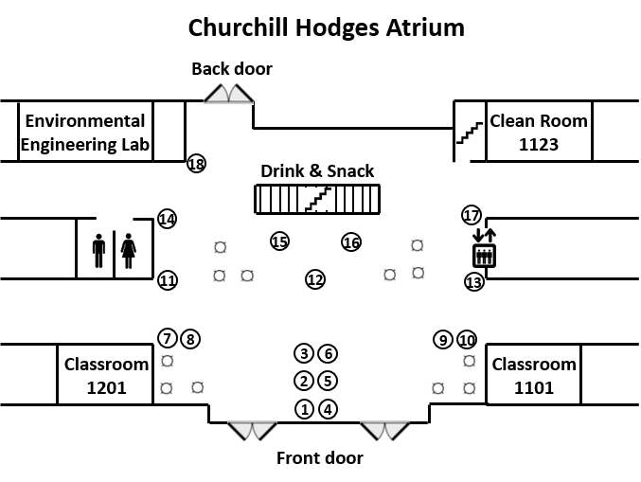

**Poster Presentation Judging Rubric**

**Presenter’s Name:_______________________ Poster Title:______________________________________ Evaluator:_______________________________**

Feel free to provide any constructive comments for participants. Your evaluation will remain anonymous.

|  |  |  |  |  |  |
| --- | --- | --- | --- | --- | --- |
|  | **0-1 points**  **(Unsatisfactory)** | **2-4 points**  **(Fair)** | **5-7 points**  **(Satisfactory)** | **8-10 points**  **(Excellent)** | **Score** |
| **Poster Content** | Connection not found between poster content and purpose of study, project, or research.  Conclusions and implications to bigger picture unclear or not present. | Content presented was difficult to understand and did not sufficiently convey a connection to the study, project, or research question.  Conclusions and implications were somewhat unclear. | The content was adequately presented, but support for the study, project, or research is somewhat general.  Conclusion and implications and reflections were reasonable and tied into the ‘big picture.’ | Strong material. Well summarized. Clearly shows development of study, project, or research. Material accurately supports the purpose of study, project, research question. Strong conclusion / analysis of experience presented. |  |
| **Poster**  **Appearance/Clarity** | Not visually effective.  Visually unappealing and difficult to interpret information presented. | Poster was acceptable but needs work to improve visual appeal through better utilization of fonts, colors, headings, and white space. | Poster was adequate but could improve effectiveness through better use of space through font size, colors, heading, and white space. | Visually appealing and strongly effective  presentation. Easy to read. Utilized creativity in the use of fonts, headings, colors, and white space. |  |
| **Poster Organization** | Unable to understand link between information presented and topic. | The topic is not clear.  Information presented is  somewhat confusing. | The topic is apparent. The  Presentation of information could use refining | The topic is clearly evident.  Layout of poster is logical and provides sequential  information from intro to  conclusions |  |
| **Presenter’s Oral Presentation** | The presenter was not prepared. Demonstrated problems in several areas (no eye contact, no clear discussion of topic, lack of professionalism). | Presenter did not convey a  sense of confidence or  ability to clearly discuss  the topic. Additional  practice would be helpful. | Presentation and demonstration of  understanding was acceptable. Demonstrated  some problems (speaking too softly, use of jargon, hesitation, inability to handle questions, etc.) | Presenter was confident  and professional.  Established eye contact.  Clearly conveyed topic.  Answered questions well.  Discussed in layman’s terms of appropriate to  judge. |  |
|  | | | | **Total Score (Max of 40):** |  |