**Exercise 3**

*Configuring a Load Balancer, Autoscaling and Stress Testing*

**Prior Knowledge**

Unix Command Line Shell

Exercise 2: Auto Scaling groups and Launch Configurations

**Learning Objectives**

Creating an elastically scaled system in the cloud

How to stress test using *wrk* command

**Software Requirements**

Browser and AWS account, previous configuration from Exercise 2

**Part A: Starting an instance to do a stress test from**

1. We are going to create a new instance in the same subnet to stress test the servers from. We could do it from our desktops, but we will take out network delays if we can do it within the Amazon EC2 network.
2. Because this takes a bit of time to start, we will get this running first and then come back and use it later.
3. Using the EC2 Launch wizard like before, start a new instance with the following settings:  
   1. **Ubuntu Server 18.04 LTS (HVM)**
   2. **t2.medium** (we want a beefier machine to be able to drive our nodes hard)
   3. User Data: please cut and paste from  
      <https://freo.me/wrk-userdata>
   4. This simply installs the latest version of *wrk* and sets correct parameters for the OS to handle this  
        
      (<https://github.com/wg/wrk>)
   5. Tag Name: *userid-*wrk
   6. Security Group: node-security-group
   7. Your existing SSH Key

**Part B: Setting up a Load Balancer and ELB Auto Scale Group**

1. Go to the AWS Console and then the EC2 Console.
2. Near the bottom of the left hand menu, find Load Balancers and Click on it. You will see something like this (although other students may have created load balancers that will show up).  
   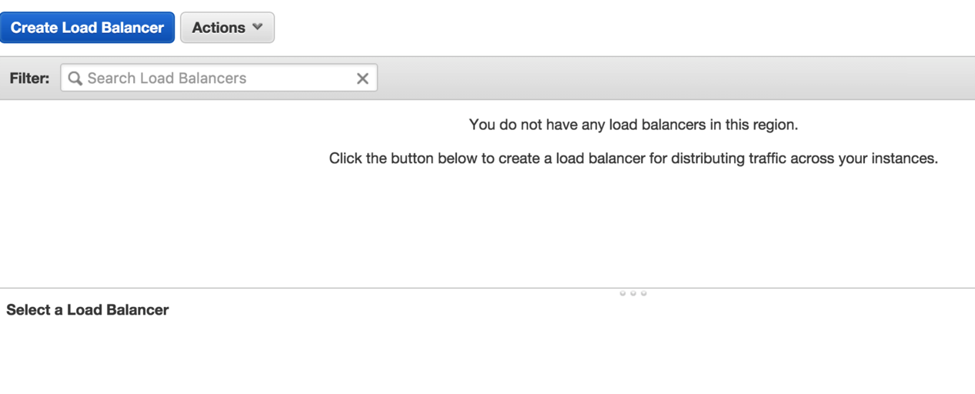
3. Click **Create Load Balancer**
4. Choose **Application Load Balancer**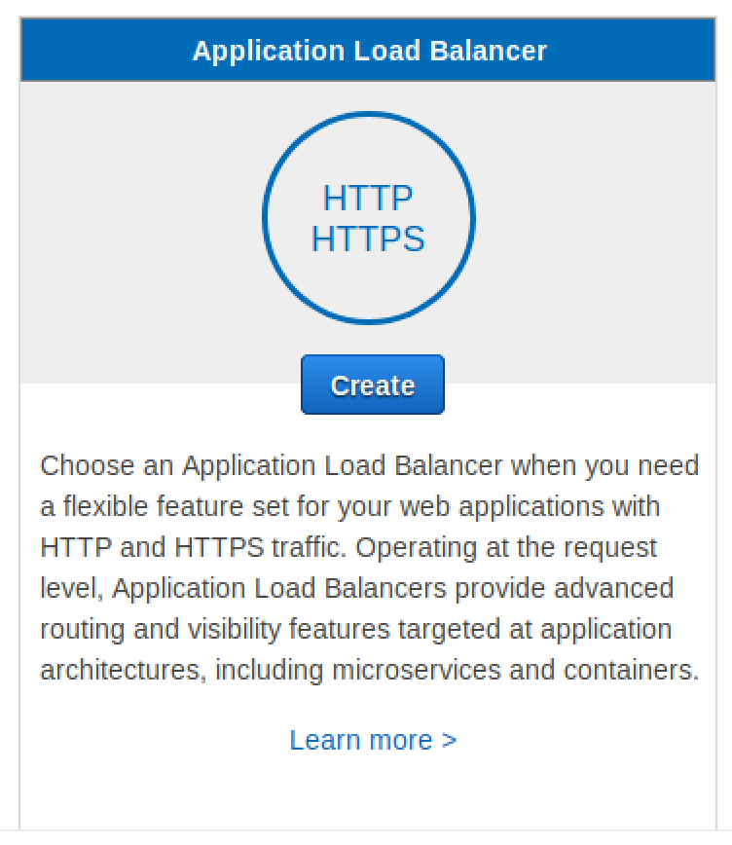
5. Set **Name** to *userid-*elb (e.g. oxclo02-elb), and leave the other fields the same.  
   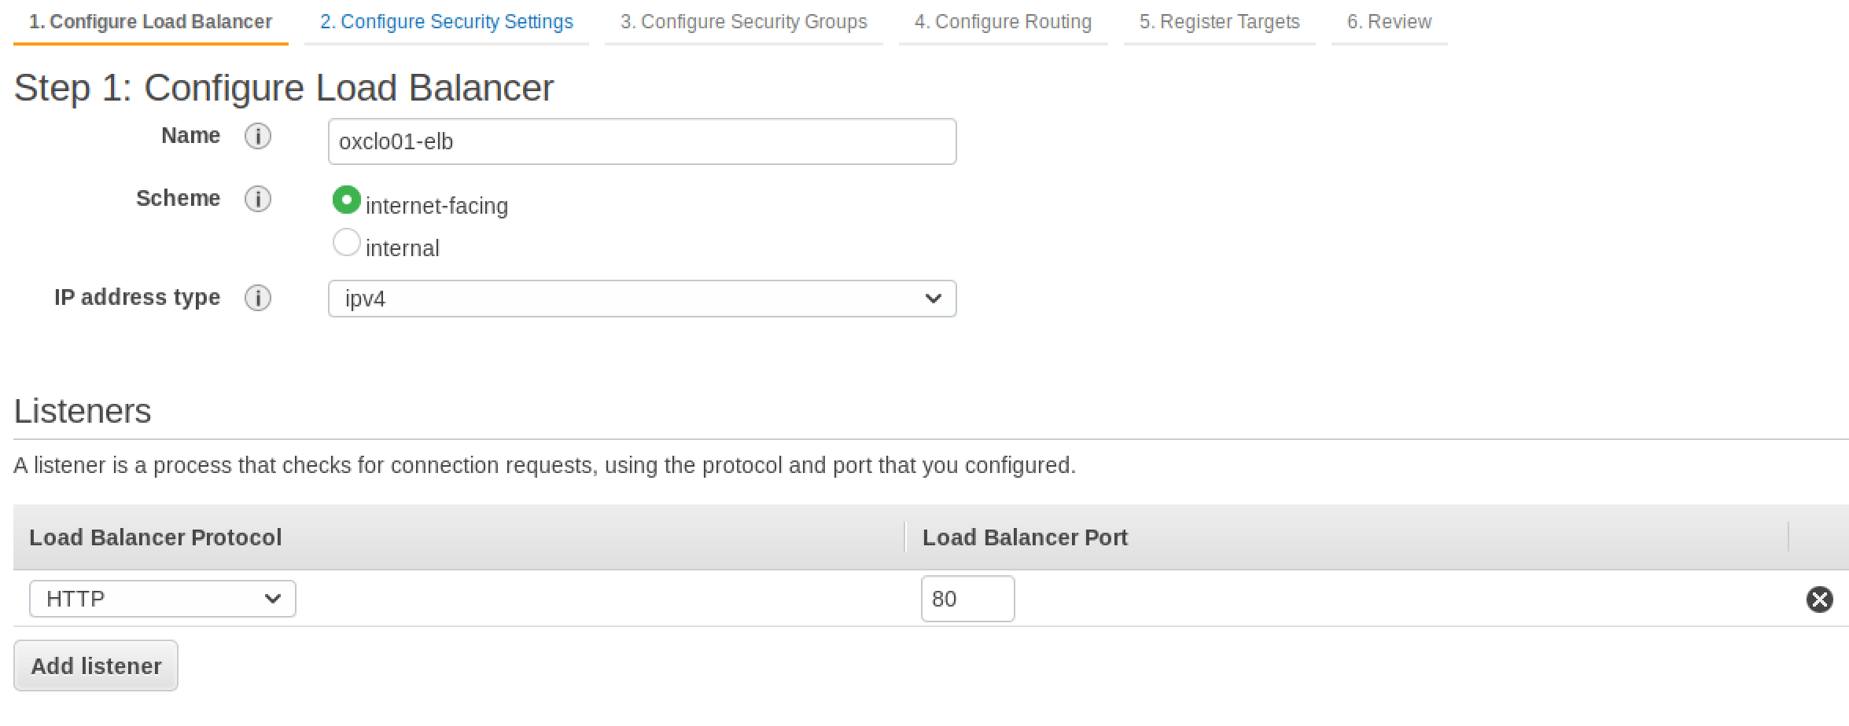
6. Click on all three of the **Availability Zones**:

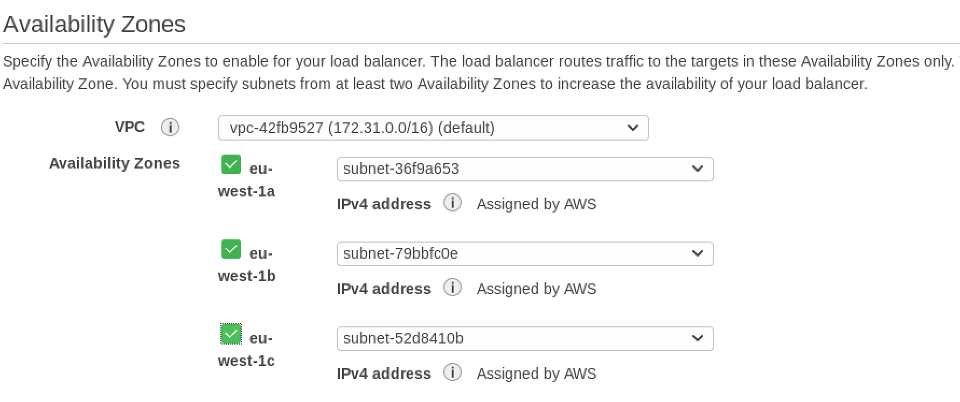

1. Click **Next: Configure Security Settings**  
   Ignore the warning!
2. Click **Next: Configure Security Groups**
3. Select **Create a New Security Group**
4. Give it the name *userid-*elb-sg (e.g. oxclo02-elb-sg)
5. Make sure the rule says:  
   Custom TCP 80 Anywhere 0.0.0.0/0  
     
   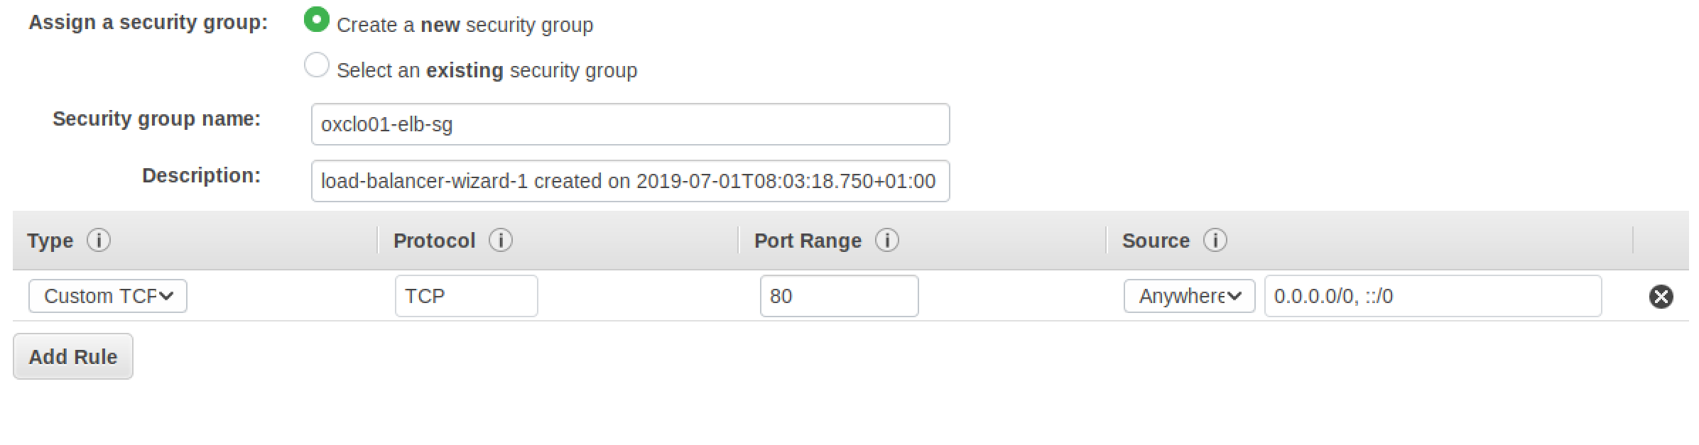
6. Click **Next: Configure Routing**

Make sure it says “New Target Group”, and then use  
  
*userid*-target (e.g. oxclo01-target)

Choose **instance**

Change the port to **8080**

Leave the rest as-is:  
  
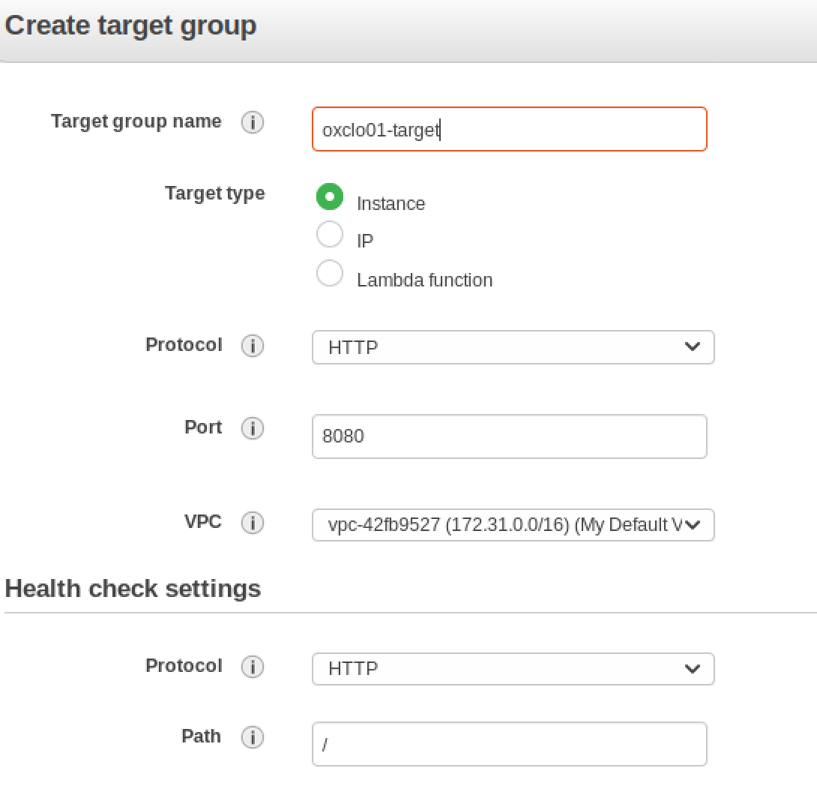

1. Ignore the warning and click: **Next: Register Targets**
2. Don’t add any instances yet. Just click **Review**
3. It should look like:  
   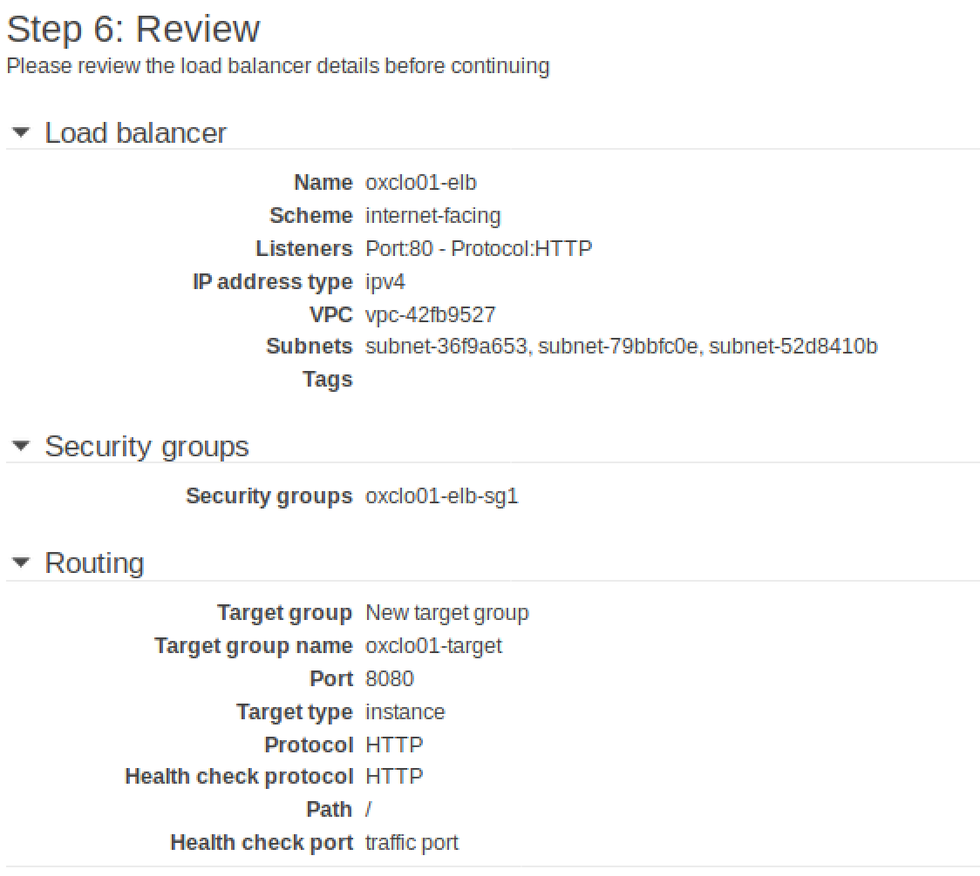
4. Click **Create**
5. You should see something like:

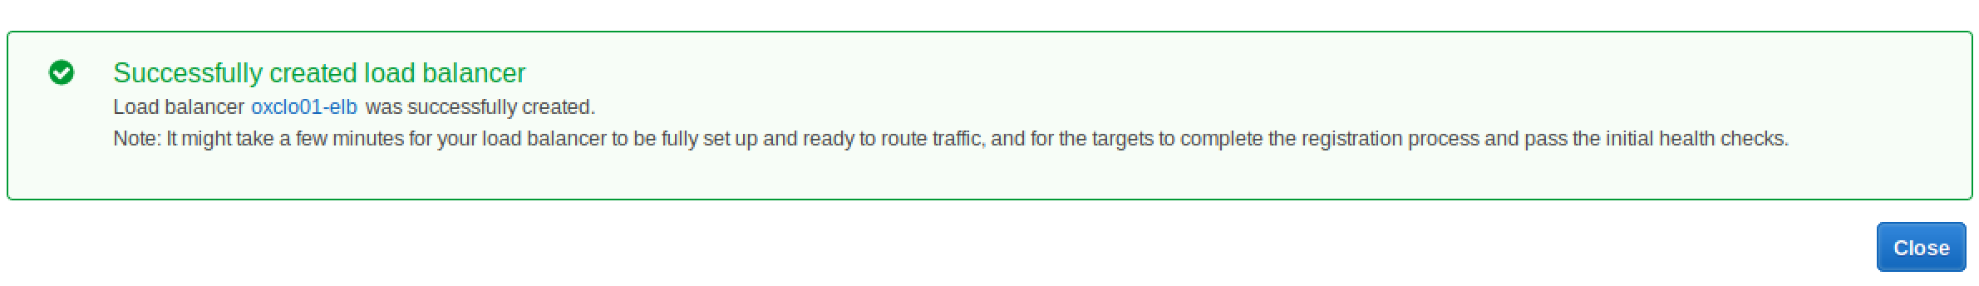

**Now let’s create our AutoScaling Group**

1. Go back to creating an Auto Scale Group like last time. **(Auto Scaling Groups -> Create Auto Scaling Group)**
2. Create from an existing Launch Configuration and choose your own launch config that you previously created. (Scroll down)  
   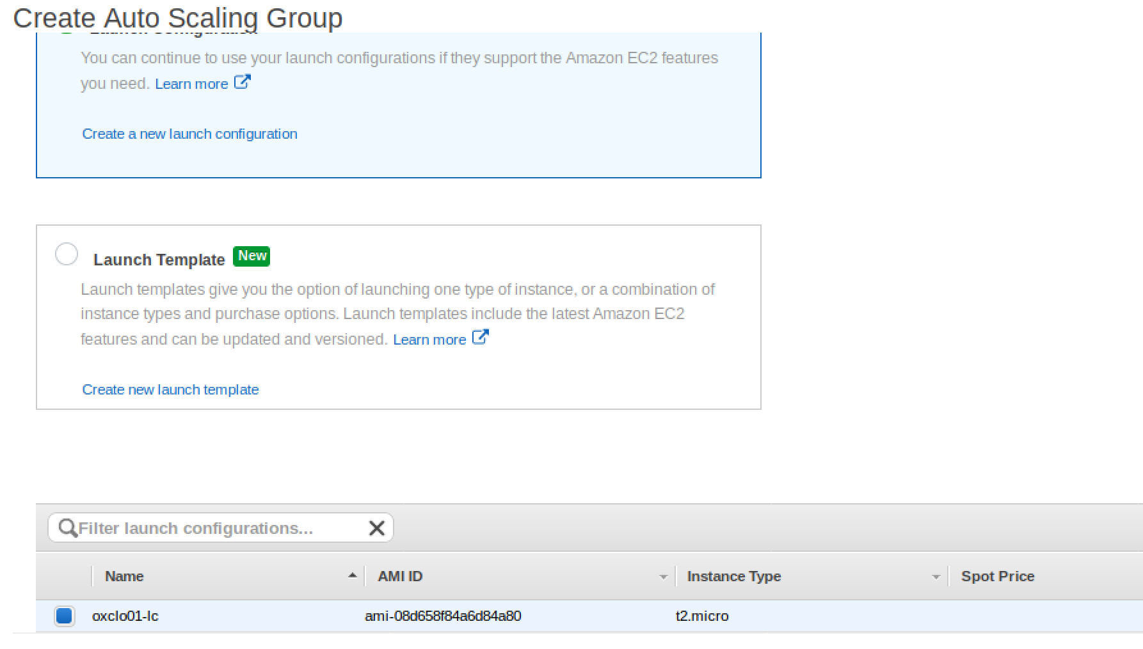  
   Click **Next Step**
3. On the following screen:  
   1. Give it a group name of *userid-*asg (e.g. oxclo01-asg)
   2. Add one or more subnets as before
   3. Expand the **Advanced Details**
   4. Click **Load Balancing**
   5. Select your own **Target Group**
   6. Change the Health Check type to ELB
   7. Leave the Grace period as 300 seconds  
        
      It should look like this:  
      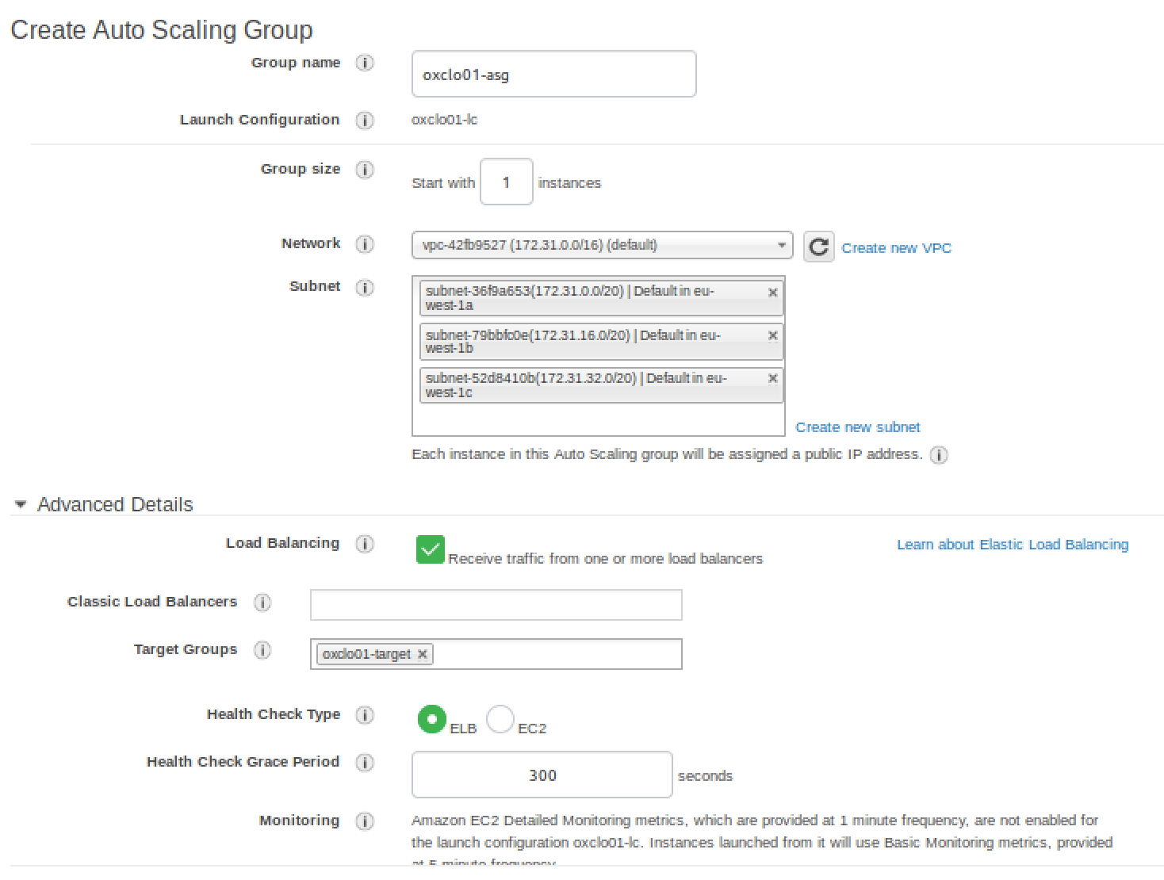
4. Click **Next: Configure Scaling Policies**
5. On the following screen   
   1. Select **Use scaling policies….**
   2. Change it to support scaling between **1** and **4** instances
   3. Set the target CPU value to be **30%**   
      (we want this low enough to see scaling happen)
6. It should look like:  
     
   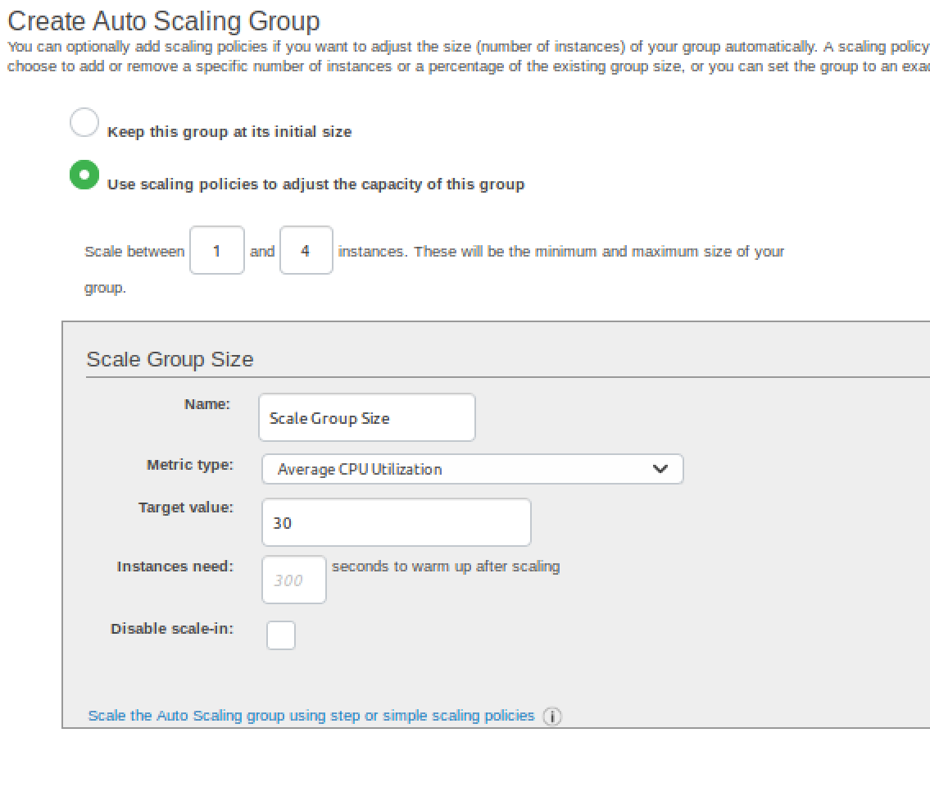
7. Click **Next: Configure Notifications**

If you want to configure notifications you can, but you have to figure it out yourself ☺

1. Click **Next: Configure Tags**
2. Add the tag: Name / *userid*-autoscaled  
   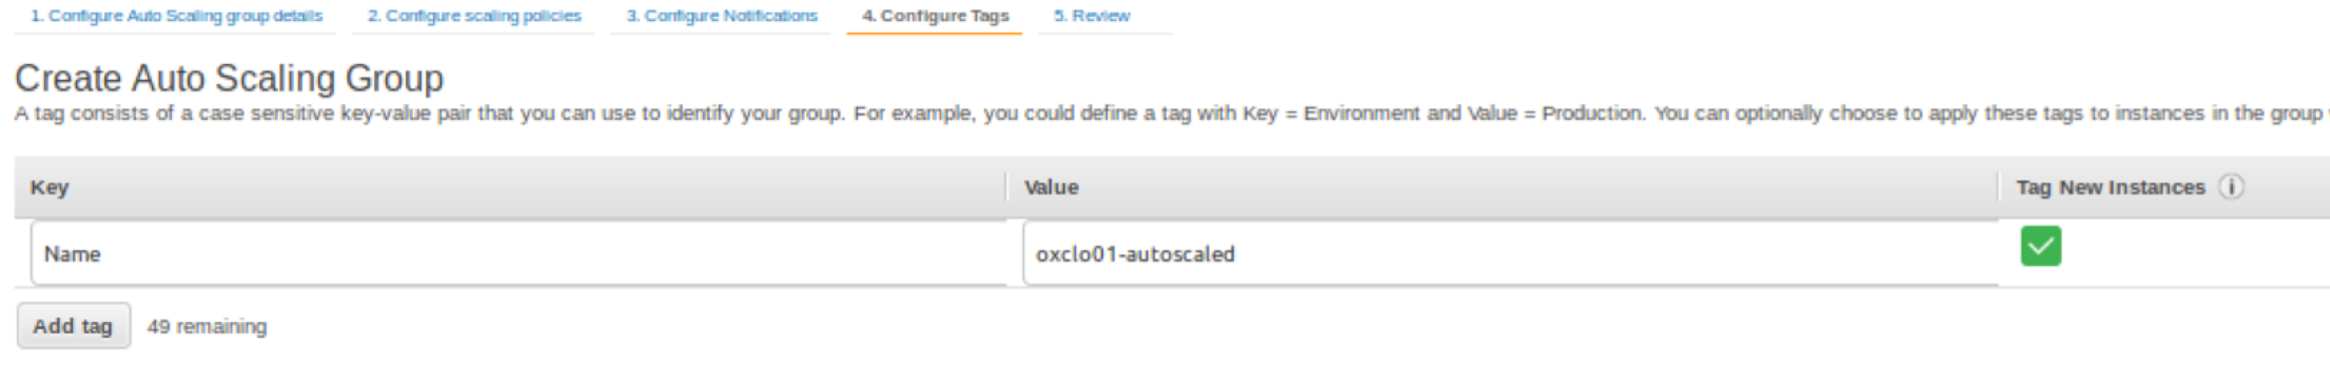
3. Click **Review**
4. Click **Create Autoscaling Group**
5. Go and see if an instance is being started. You should see something like:  
   
6. We need to give the new instance 300 seconds (5 minutes) before it is deemed healthy. This was a setting on a previous screen.
7. You can check the status of the instance in the target group.

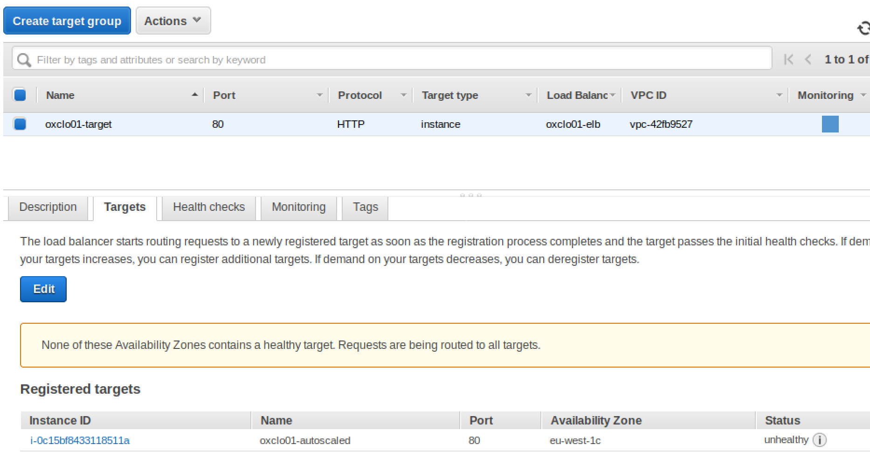

**Wait until the instance is healthy before the next step.PART C – Stress testing**

1. Navigate to view your ELB’s dashboard page. You can find the DNS address of your ELB this way:  
   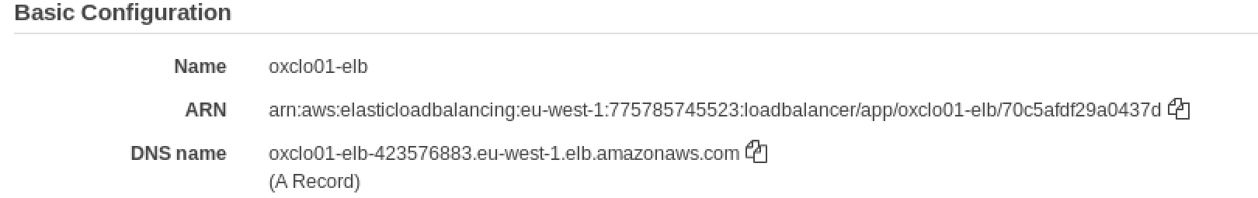
2. Copy and paste the DNS name into the address bar of your browser. You should see JSON returned from the node.js app.   
   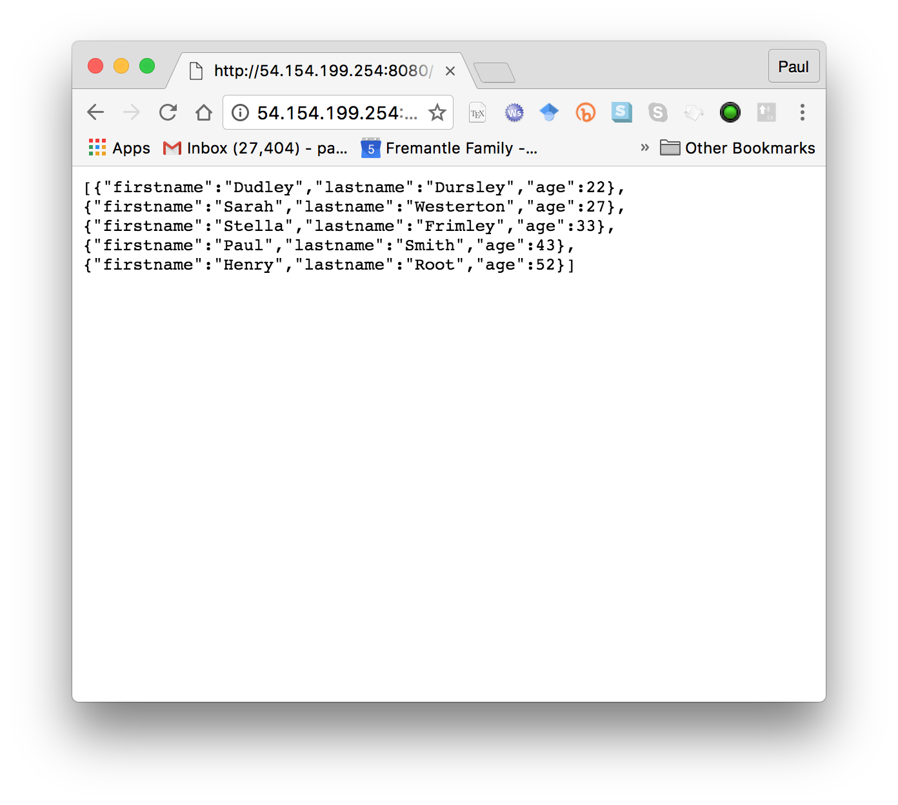  
     
   Notice this is now available on port 80 and no longer using 8080, because the load balancer listens on 80.
3. Remember the “wrk” instance you created earlier? Check the instance is running in the EC2 dashboard and then SSH into the instance as in Exercise 1.
4. Accept the fingerprint as before.
5. In the SSH session type: wrk  
     
   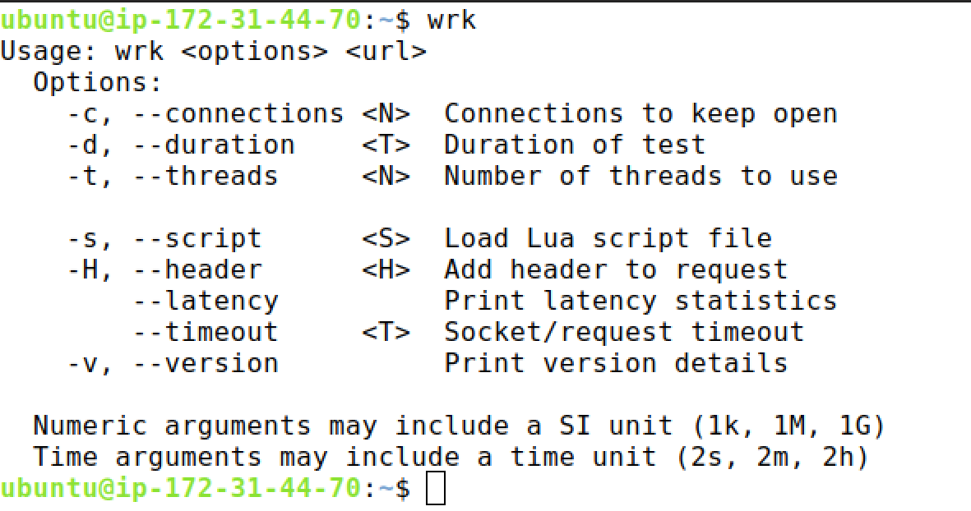

1. We want to call our load balancer with 100 concurrent connections, two threads, for around 15 minutes (enough time to see scaling).   
     
   e.g:   
   wrk -c 100 -t 2 -d 15m http://clo01-elb-1355165567.eu-west-1.elb.amazonaws.com

But with your ELB address

1. You should see something like:

Running 15m test @ http://oxclo01-elb-1355165567.eu-west-1.elb.amazonaws.com

2 threads and 100 connections

1. This is basically hitting your Load Balancer with a significant number of hits for 15 minutes. This should be long enough to see the behaviour we want.
2. Unless we run out of network bandwidth, this should push the instances’s average CPU above 30% and cause the Scaling Group to start another server. Ideally it will push it to 99% and we will see at least two instances created.
3. Assuming all is well you should see a new instance spawned in a few minutes when there is enough CPU history to capture.
4. You can also check the Auto Scaling Group’s Activity History  
   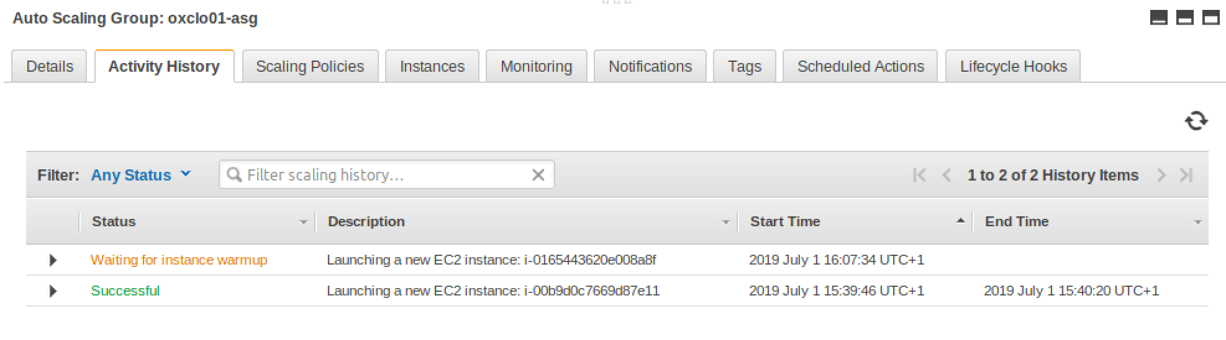

1. Once you have seen one or more new instances started, you can end the wrk if you like, by hitting Ctrl-C in the command line window:

Thread Stats Avg Stdev Max +/- Stdev

Latency 34.03ms 2.80ms 271.51ms 86.69%

Req/Sec 1.48k 60.62 1.72k 80.03%

339319 requests in 1.92m, 156.30MB read

Requests/sec: 2938.99

Transfer/sec: 1.35MB

1. Start wrk up again with the same parameters. Wait until the new server is in service and then stop/start wrk, so you get some new data with more instances running.
2. You should see the request count goes up a lot once the new server(s) are in service, compared to the data with only one server running.   
    *In my tests I saw around 3000 tps from one server, 6000 from 2 and 8500 from 4. Why might this dropoff in scaling happen?*
3. If you leave wrk running you may see even more servers launched over time.
4. Once the stress test has ended, you should see the spare instance removed after enough time.  
   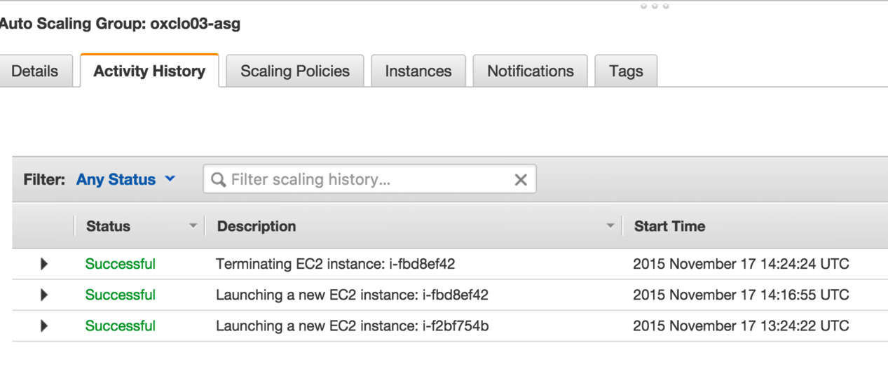
5. Once you have finished:
   1. Deletethe autoscaling group
   2. Delete the load balancer
   3. Delete the target.
   4. Terminatethe wrk instance.
   5. Make sure that you have no further instances running in your name!
6. You have completed the exercise. Well done.
7. As an **extension**, come up with a plan to secure the cloud instances better through improved configuration of the security groups. Identify which systems need to talk to which, and then suggest a set of security groups that would allow this.