**sExercise 11**

*Get started with Cassandra and import data*

**Prior Knowledge**

Unix Command Line Shell

HDFS

Simple Python

Spark Python  
Simple SQL syntax

**Learning Objectives**

Understand Cassandra’s CQL shell

Integrate Python, Cassandra and Spark

Load data from CSV into Cassandra using Spark Python

**Software Requirements**

(see separate document for installation of these)

* Apache Spark 2.0.0
* Python 2.7.x
* Apache Cassandra 3.0.8
* Nano text editor or other text editor

Part A

1. Make sure Cassandra is running
   1. In a Terminal window (Crtl-Alt-T) type:  
      service cassandra status
   2. You should see  
      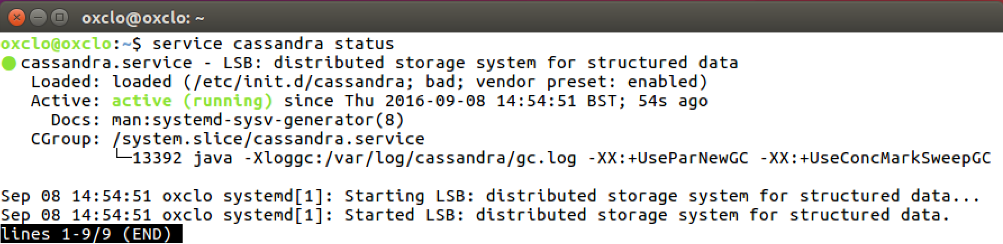
   3. Type q to get back to the command line
   4. If not, try   
      sudo service cassandra start  
      and then check the status again
2. Now you can ask Cassandra about its own situation:  
   nodetool status  
     
   You should see something like:  
   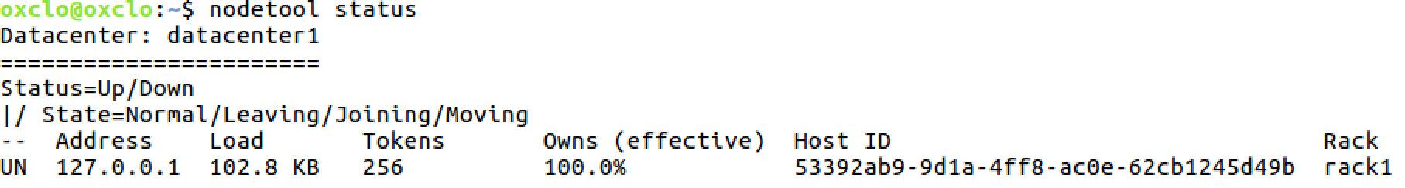

1. You can also try:  
   nodetool info  
   You should see something like:  
   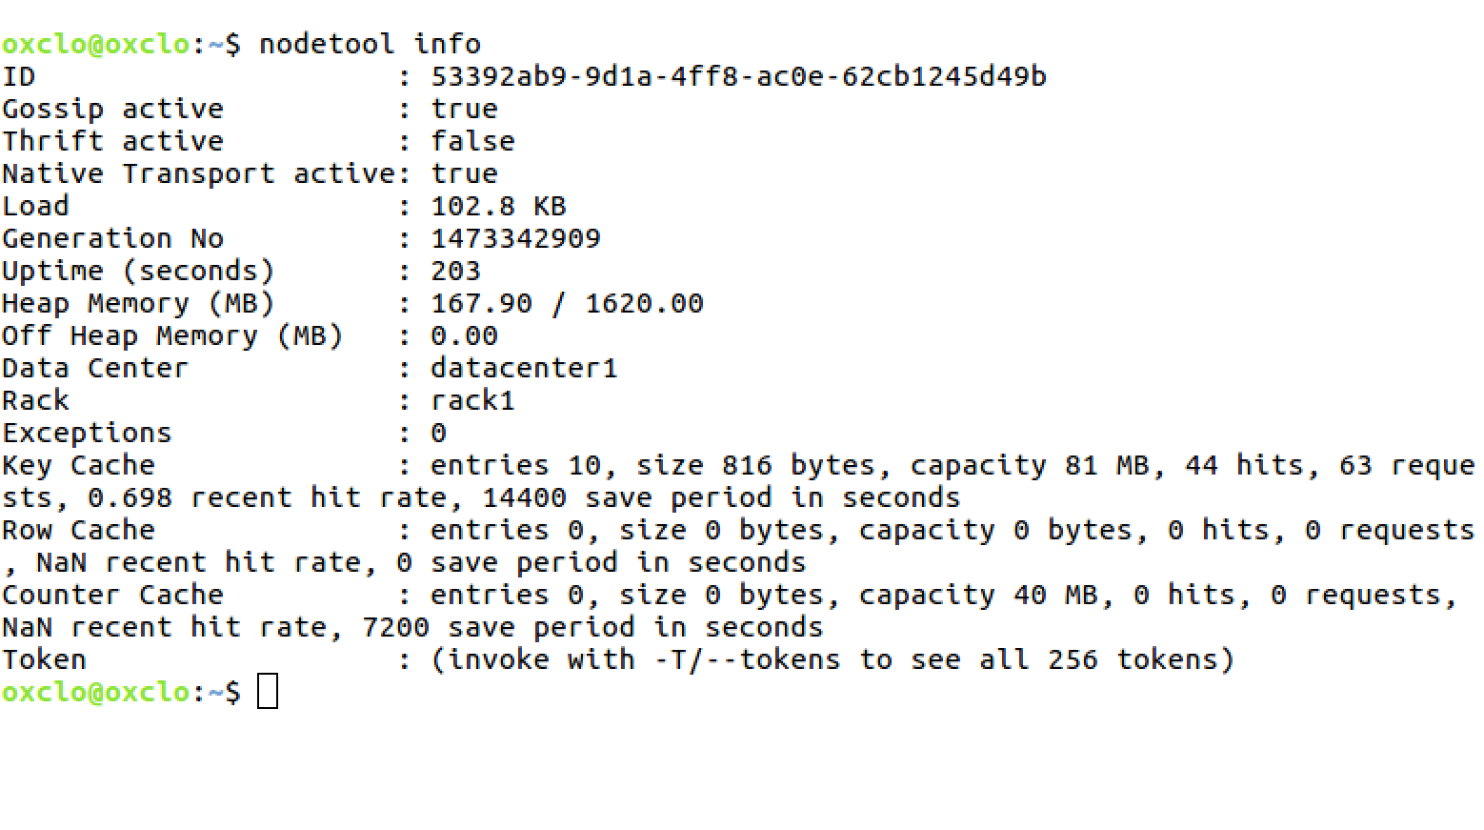
2. Now you can start the Cassandra Shell:  
   Type:

cqlsh  
  
You should see:  
Connected to Test Cluster at 127.0.0.1:9042.

[cqlsh 5.0.1 | Cassandra 2.2.3 | CQL spec 3.3.1 | Native protocol v4]

Use HELP for help.

cqlsh>

1. Let’s create a new database (Keyspace):
   1. Type (all on a single line)  
        
      d
   2. Check it worked:  
      Type:  
        
      desc keyspace test;
   3. You should see:  
        
      CREATE KEYSPACE test WITH replication = {'class': 'SimpleStrategy', 'replication_factor': '1'} AND durable_writes = true;
2. Now we need to select to use that keyspace:  
   use test;
3. The command prompt will change to:  
   cqlsh:test>
4. Let’s create a simple (key, value) table
   1. Type:  
      create table kv ( key text, value text, primary key (key));
   2. Now type  
      desc kv;
   3. You should see:

cqlsh:test> desc kv;

CREATE TABLE test.kv (

key text PRIMARY KEY,

value text

) WITH bloom_filter_fp_chance = 0.01

AND caching = '{"keys":"ALL", "rows_per_partition":"NONE"}'

AND comment = ''

AND compaction = {'class': 'org.apache.cassandra.db.compaction.SizeTieredCompactionStrategy'}

AND compression = {'sstable_compression': 'org.apache.cassandra.io.compress.LZ4Compressor'}

AND dclocal_read_repair_chance = 0.1

AND default_time_to_live = 0

AND gc_grace_seconds = 864000

AND max_index_interval = 2048

AND memtable_flush_period_in_ms = 0

AND min_index_interval = 128

AND read_repair_chance = 0.0

AND speculative_retry = '99.0PERCENTILE';

* 1. Add some simple values:  
     insert into kv (key, value) values ('a','1');

insert into kv (key, value) values ('b','2');

insert into kv (key, value) values ('c','3');

* 1. Now type:  
     select * from kv;  
       
     You should see:  
     key | value

-----+-------

a | 1

c | 3

b | 2

(3 rows)

1. You can also do other simple SQL of course

cqlsh:test> select * from kv where key='a' ;

key | value

-----+-------

a | 1

(1 rows)

1. Now exit the cqlsh:  
   exit
2. Congratulations! You have Cassandra running and working.

**PART B – Stress testing Cassandra**

1. Now let’s run a performance test on Cassandra.
   1. We will use the cassandra-stress tool which is part of the Cassandra distribution.
   2. First we need to write some data into Cassandra using the tool
   3. cassandra-stress write n=100000
   4. You should see:

Connected to cluster: Test Cluster, max pending requests per connection 128, max connections per host 8

Datatacenter: datacenter1; Host: localhost/127.0.0.1; Rack: rack1

Created keyspaces. Sleeping 1s for propagation.

Sleeping 2s...

Warming up WRITE with 25000 iterations...

Running WRITE with 200 threads for 100000 iteration

type total ops, op/s, pk/s, row/s, mean, med, .95, .99, .999, max, time, stderr, errors, gc: #, max ms, sum ms, sdv ms, mb

total, 5528, 5536, 5536, 5536, 26.2, 19.5, 80.8, 126.3, 160.8, 176.3, 1.0, 0.00000, 0, 0, 0, 0, 0, 0

total, 14266, 5488, 5488, 5488, 41.7, 22.0, 67.0, 843.2, 906.7, 966.9, 2.6, 0.00309, 0, 1, 85, 85, 0, 149

total, 25042, 9973, 9973, 9973, 20.1, 18.0, 39.6, 58.4, 88.4, 113.1, 3.7, 0.17349, 0, 0, 0, 0, 0, 0

total, 34623, 9166, 9166, 9166, 21.7, 19.6, 39.6, 95.7, 108.8, 134.4, 4.7, 0.14206, 0, 1, 67, 67, 0, 154

total, 41240, 7783, 7783, 7783, 25.7, 18.3, 73.5, 122.0, 172.8, 173.4, 5.6, 0.11341, 0, 0, 0, 0, 0, 0

total, 48536, 5775, 5775, 5775, 34.7, 17.7, 223.8, 246.2, 271.4, 358.3, 6.8, 0.10642, 0, 1, 219, 219, 0, 146

total, 58315, 10209, 10209, 10209, 19.2, 15.5, 47.1, 81.3, 134.9, 166.3, 7.8, 0.09884, 0, 1, 100, 100, 0, 146

total, 68423, 8514, 8514, 8514, 20.3, 13.6, 58.4, 150.9, 205.2, 480.6, 9.0, 0.08616, 0, 0, 0, 0, 0, 0

total, 80563, 7964, 7964, 7964, 27.4, 13.8, 66.5, 466.9, 735.6, 1128.5, 10.5, 0.07651, 0, 1, 58, 58, 0, 152

total, 87174, 6223, 6223, 6223, 31.4, 15.7, 87.3, 426.4, 623.0, 703.2, 11.6, 0.07327, 0, 0, 0, 0, 0, 0

total, 99424, 11794, 11794, 11794, 16.9, 13.8, 31.4, 132.7, 148.4, 160.2, 12.6, 0.08576, 0, 1, 118, 118, 0, 140

total, 100000, 9058, 9058, 9058, 22.1, 19.0, 49.8, 55.3, 55.7, 55.7, 12.7, 0.07836, 0, 0, 0, 0, 0, 0

Results:

Op rate : 7,896 op/s [WRITE: 7,896 op/s]

Partition rate : 7,896 pk/s [WRITE: 7,896 pk/s]

Row rate : 7,896 row/s [WRITE: 7,896 row/s]

Latency mean : 25.1 ms [WRITE: 25.1 ms]

Latency median : 16.4 ms [WRITE: 16.4 ms]

Latency 95th percentile : 55.1 ms [WRITE: 55.1 ms]

Latency 99th percentile : 167.1 ms [WRITE: 167.1 ms]

Latency 99.9th percentile : 766.6 ms [WRITE: 766.6 ms]

Latency max : 1128.5 ms [WRITE: 1,128.5 ms]

Total partitions : 100,000 [WRITE: 100,000]

Total errors : 0 [WRITE: 0]

Total GC count : 6

Total GC memory : 887.073 MiB

Total GC time : 0.6 seconds

Avg GC time : 107.8 ms

StdDev GC time : 53.5 ms

Total operation time : 00:00:12

END

1. Now you can try a full test:  
   cassandra-stress mixed n=100000
2. At what thread count did you get the highest throughput? And the lowest latency?

**PART C – Loading data from CSV files into Cassandra**

1. Firstly, we need to create a database and a table in which to store our data. Start up the **cqlsh** again and type the following commands:

CREATE KEYSPACE wind   
WITH replication = {'class': 'SimpleStrategy', 'replication_factor': '1'};  
  
USE wind;  
  
CREATE TABLE winddata (

stationid text,

time timestamp,

direction float,

temp float,

velocity float,

PRIMARY KEY (stationid, time)

);

1. In order to load the CSV files into Cassandra, we are going to use a Spark packages to help us: the Cassandra plugin for Spark.   
     
   *Please note, there are lots of ways of loading CSV data into Cassandra, including a built-in Cassandra utility, which might be easier to use for small datasets.  
     
   This exercise is designed to demonstrate how to integrate Cassandra with Spark. For a really large dataset, if this was loaded from HDFS into Cassandra, this Spark-based approach would have the major benefit of parallelizing the operation.*  
     
   1. To use these, we need to start Pyspark with the correct command line. Start a terminal window and start jupyter/spark with the right package:

cd ~

pyspark

--packages datastax:spark-cassandra-connector:2.4.0-s_2.11

1. Now we need to set up our imports:  
   In your Jupyter notebook type (or cut and paste from <http://freo.me/oxclo-spark-cass>)  
     
   import time  
   from datetime import datetime  
   from pyspark.sql import SQLContext, Row  
   sqlContext = SQLContext(sc)
2. Now lets load the CSV files into a SQL Dataframe:  
     
   df = sqlContext.read.format('com.databricks.spark.csv').\  
   options(header='true', inferschema='true').\  
   load('file:///home/oxclo/datafiles/wind/*')

1. Take a look at the data in df:  
   df.first()  
   After the log, you should see something like:  
     
   Row(Station_ID=u'SF04', Station_Name=u'Lincoln High School', Location_Label=u'2162 24th Ave', Interval_Minutes=5, Interval_End_Time=u'2015-01-5? 07:50', Wind_Velocity_Mtr_Sec=0.979, Wind_Direction_Variance_Deg=40.31, Wind_Direction_Deg=57.69, Ambient_Temperature_Deg_C=6.297, Global_Horizontal_Irradiance=0.706)
2. We can take advantage of Python to do any kind of Map/Reduce finagling of the data. In our case, we are just going to sort the dates into something Python understands and also change the names of the columns to match the Cassandra table.  
     
   Firstly we want to map the Interval_End_Time into something we can put in Cassandra. Cassandra expects a Python datetime.datetime object.

This chunk of python will convert the string date/time into that:  
  
convertTime = lambda t: \  
datetime.fromtimestamp( \  
time.mktime(time.strptime(t, "%Y-%m-%d? %H:%M")))

1. Secondly, we need to create a Python dictionary with the right names for our Cassandra Table. This function does that. I recommend you cut and paste!  
     
   toRow = lambda s: \

Row(stationid=s.Station_ID, \

time=convertTime(s.Interval_End_Time), \

direction=s.Wind_Direction_Deg, \

temp=s.Ambient_Temperature_Deg_C, \

velocity=s.Wind_Velocity_Mtr_Sec)

1. We need to map this function onto the data. We can convert RDD to/from DF in one line:  
     
   newDF = df.rdd.map(toRow).toDF()
2. Finally, we can do the work:  
     
   wThis will take a bit longer!
3. Browse to <http://localhost:4040>   
   It will look similar to:  
   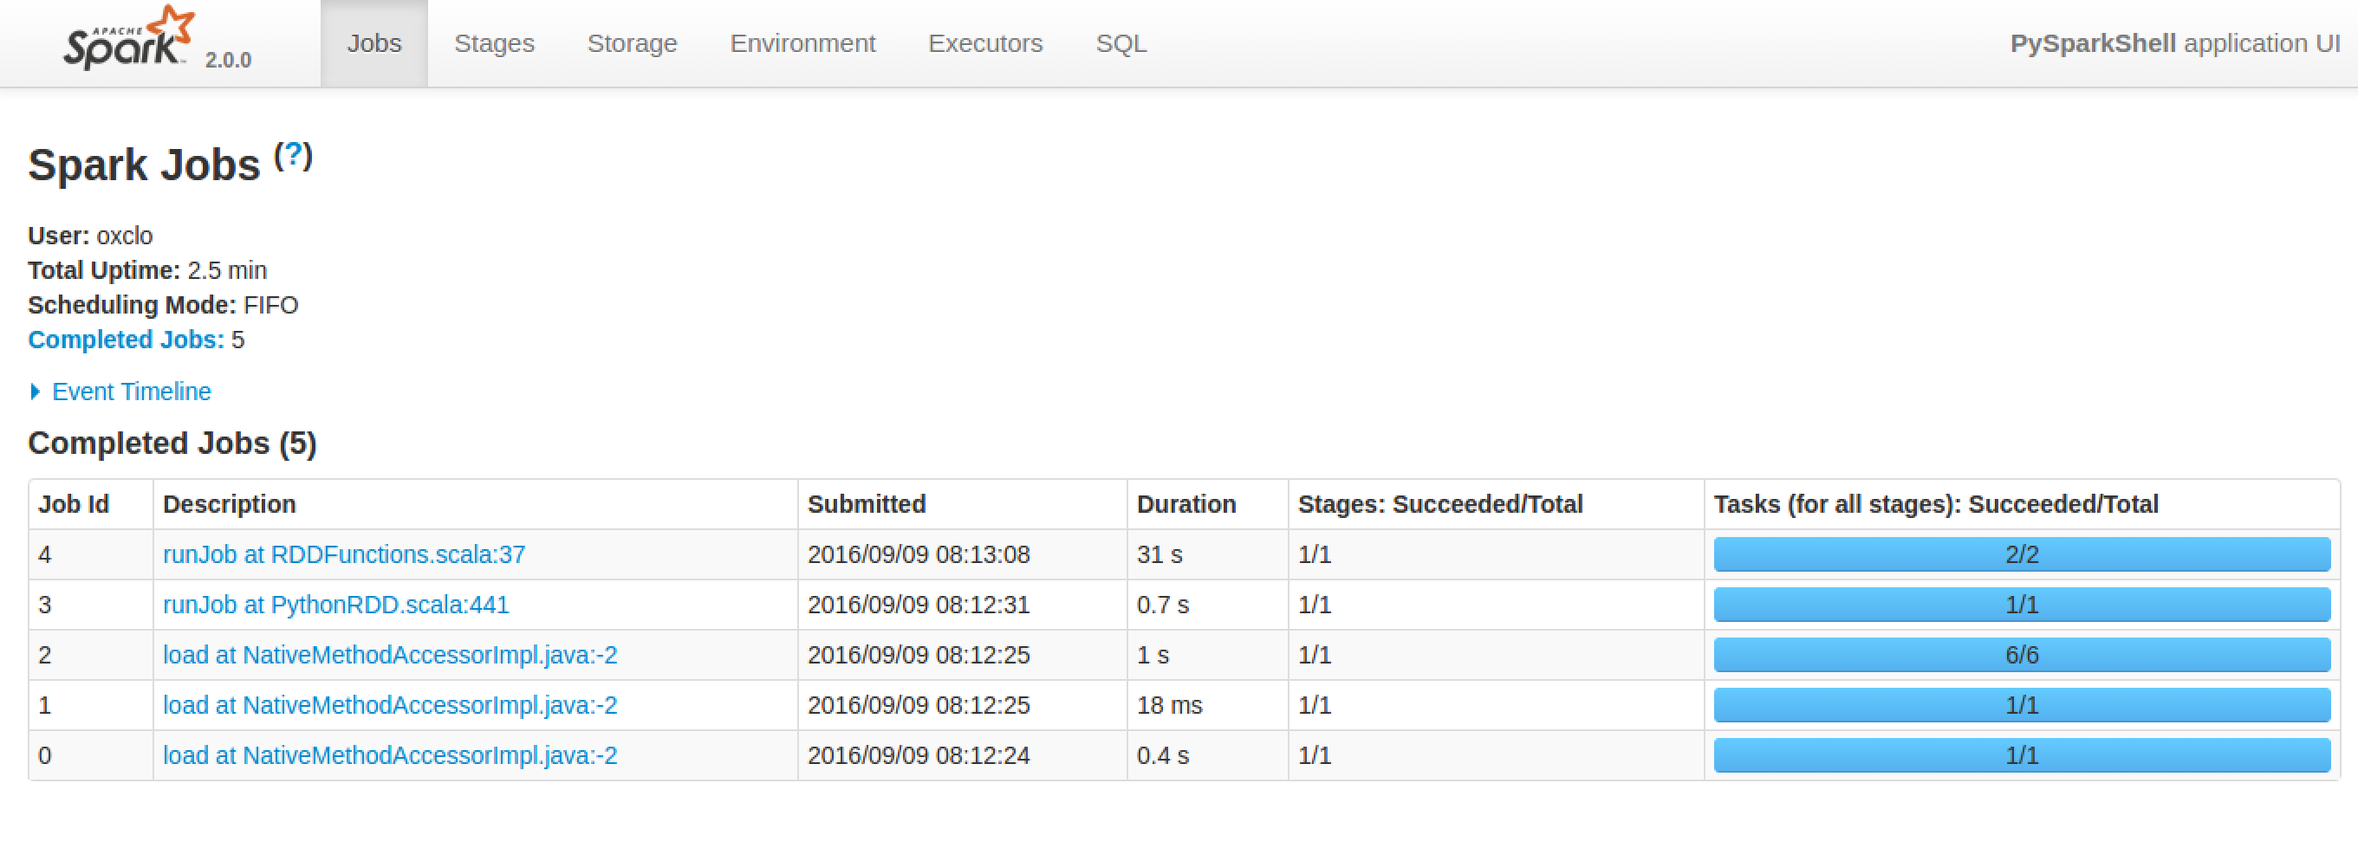
4. Click on the most recent job:   
   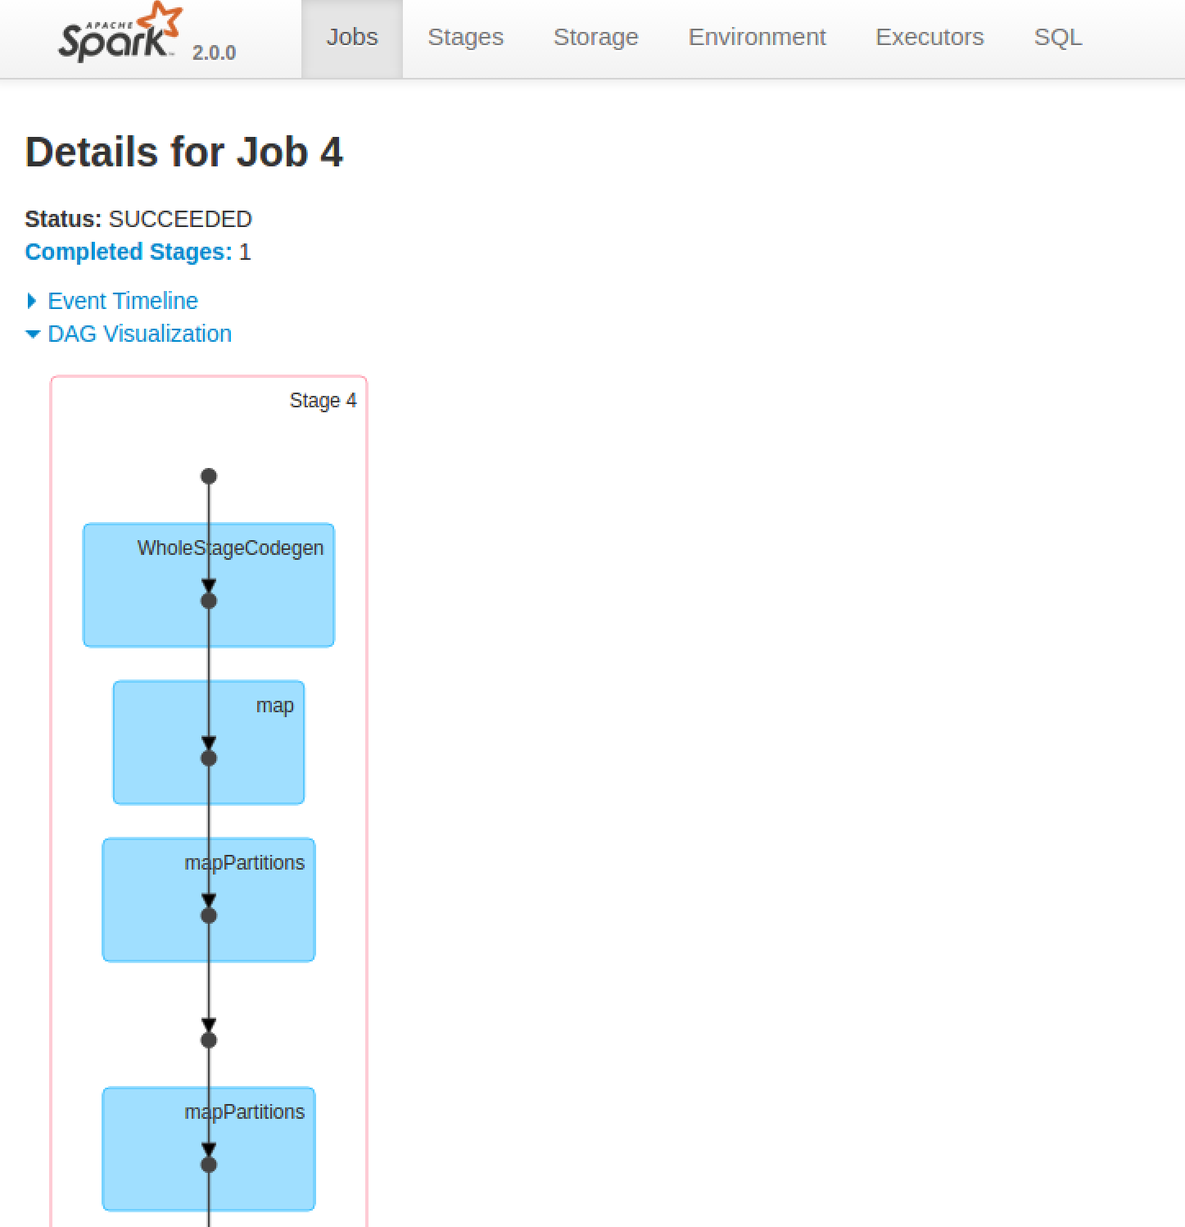
5. You can also get more details by clicking on a stage in the DAG (Directed Acyclic Graph) picture:  
   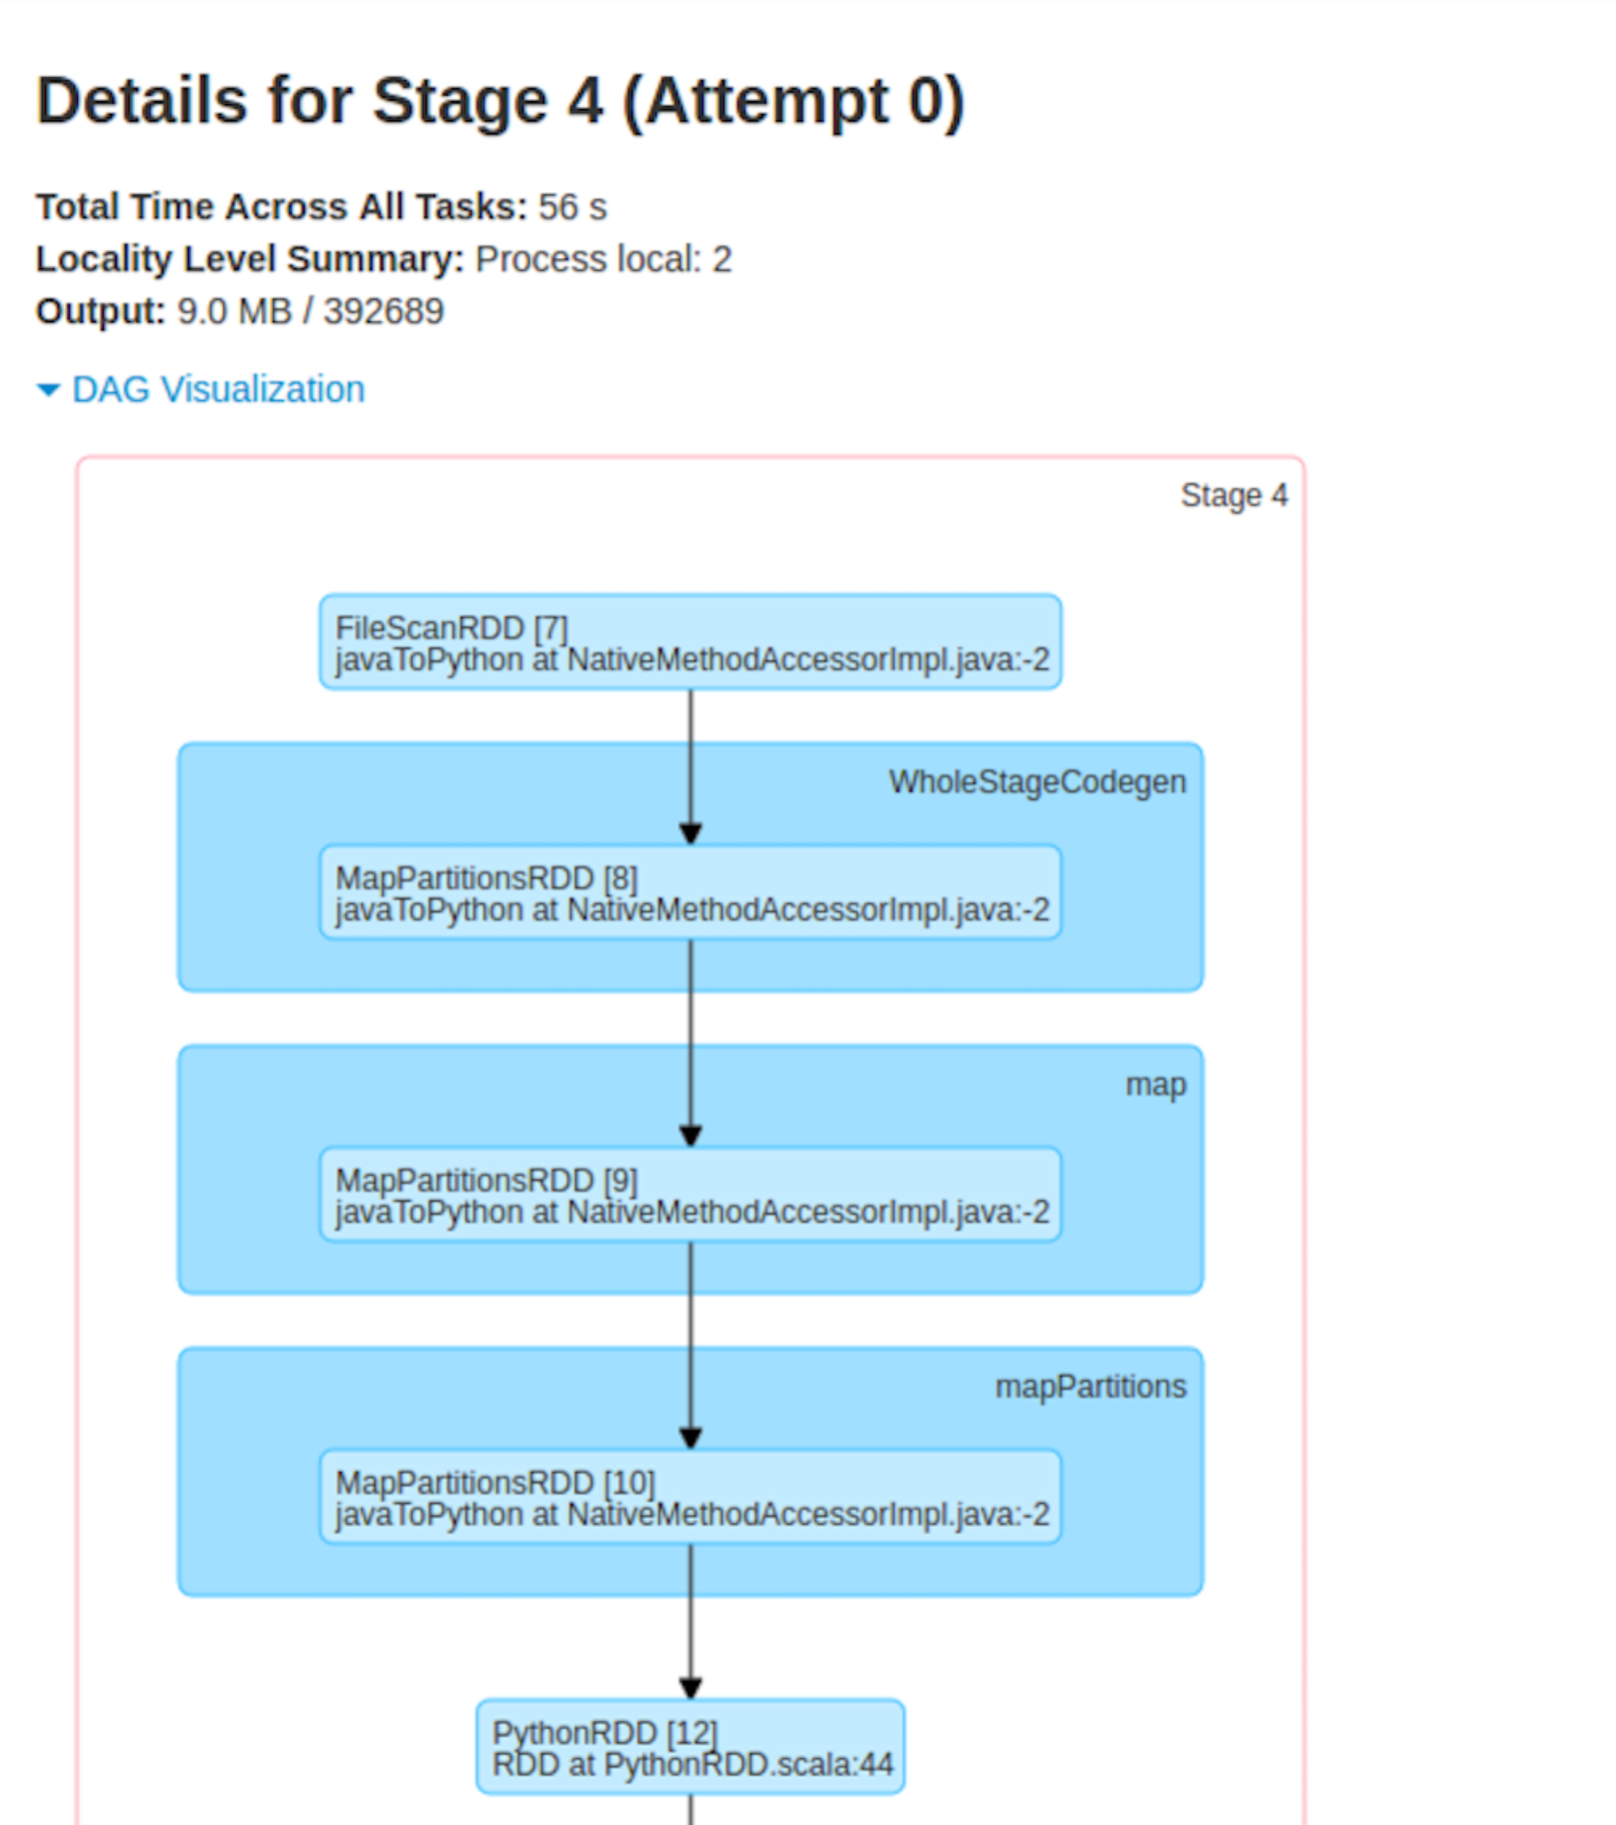
6. Check that the data has loaded. In your **cqlsh** window type:  
     
   select * from wind.winddata limit 15;
7. You should see something like:

stationid | time | direction | temp | velocity

-----------+--------------------------+-----------+-------+----------

SF36 | 2015-01-01 00:00:00+0000 | 116.9 | 11.33 | 2.727

SF36 | 2015-01-01 00:05:00+0000 | 108.5 | 11.25 | 1.814

SF36 | 2015-01-01 00:10:00+0000 | 113.7 | 11.2 | 2.621

SF36 | 2015-01-01 00:15:00+0000 | 117.8 | 11.11 | 3.678

SF36 | 2015-01-01 00:20:00+0000 | 117.3 | 11.07 | 2.842

SF36 | 2015-01-01 00:25:00+0000 | 117.3 | 11.07 | 2.629

SF36 | 2015-01-01 00:30:00+0000 | 117.3 | 11.09 | 2.235

SF36 | 2015-01-01 00:35:00+0000 | 117.2 | 11.09 | 2.043

SF36 | 2015-01-01 00:40:00+0000 | 117.2 | 11.05 | 1.635

SF36 | 2015-01-01 00:45:00+0000 | 117.3 | 10.93 | 2.224

SF36 | 2015-01-01 00:50:00+0000 | 112.5 | 10.86 | 1.822

SF36 | 2015-01-01 00:55:00+0000 | 108.7 | 10.8 | 0.866

SF36 | 2015-01-01 01:00:00+0000 | 108.7 | 10.67 | 1.068

SF36 | 2015-01-01 01:05:00+0000 | 108.6 | 10.54 | 1.393

SF36 | 2015-01-01 01:10:00+0000 | 108.7 | 10.44 | 1.468

(15 rows)

1. Congratulations, you have finished this lab.