**Exercise 13**

*Stream processing with Kafka and Siddhi*

**Prior Knowledge**

Unix Command Line Shell

JSON

**Learning Objectives**

Understanding Kafka

Siddhi SQL complex event processing

**Software Requirements**

* Kafkacat
* Nano text editor or other text editor
* Siddhi

1. I have started a system running on the Internet that is accessing TfL’s prediction API. This is publishing data onto a Kafka topic. This needs to be running for the lab to work. If you come back later and try, it may not happen.
2. You can look at those entries using a tool called **kafkacat**  
     
   kafkacat -b kafka.freo.me -t tfl -o end
3. You should see a lot of JSON scrolling past. Each line looks like this when pretty printed:  
   

*Take a good look at a few entries to understand what the data is.*

This is live data from the London Underground.

Hit Ctrl-C to stop. Since this is a stream it never ends :-)

1. If you want to see it in a more readable format, pipe the output through jq:

First install jq:

sudo apt install jq -y  
  
Now:

kafkacat -b kafka.freo.me -t tfl -o end | jq

1. The fields are mainly self-explanatory. The only non-self-explanatory field is **tts** which is the time to the next station. In general this should be equal to (expArrival - timestamp) and in the event above we can see that this is true.
2. Each train will have multiple entries, predicting its time of arrival at several stations ahead of its current position. Just to make it more complex, the trainnumbers are not unique (only unique to a line).
3. There are two files you need to proceed further. The first is a program I have provided that runs Siddhi queries against this event stream. The second is some SiddhiQL that will be run.
4. Make a new directory:  
   mkdir ~/stream  
   cd ~/stream
5. Download the two files:  
     
   wget https://freo.me/sk-jar-new -O sk.jar  
   wget https://freo.me/plan-siddhi -O plan.siddhi
6. If you want to look at the code, you can browse it here:  
   <https://github.com/pzfreo/siddhi-kafka/tree/master/sk/src/main/java/me/freo/sk>
7. There are instructions below for building the code, if you want to change or edit it.
8. Take a look at plan.siddhi  
     
   It is split into separate phases. The first phase is dead simple… it just outputs what is input.
9. The documentation for this language is available here:  
   <https://siddhi.io/>
10. Before modifying the plan, it is worth understanding what you can and can’t change.

There are a couple of points where the code is ‘hard-coded’ to this setup

and plan. Firstly, it is specifically looking to the broker (*kafka.freo.me*) and topic (*tfl*). Secondly, it is expecting a specific input stream called *tflstream*. Thirdly, it will take whatever output you send to a stream called *outstream* and print it as JSON to the console.   
  
*All of these could be improved easily, but they don’t affect our learning objectives.*

1. Firstly, let’s run the current plan, which simply copies the input stream to the output stream.  
     
   java -jar sk.jar plan.siddhi  
   

You may not see it because of scrolling, but the first output is a bunch of Kafka logging.

1. You should now see lots of log like:  
   
2. When you are happy with the output, hit Ctrl-C
3. Now comment the first query and uncomment the second. Re-run the code.
4. This will now show all the trains expected in the next 30 seconds
5. Re-comment this and uncomment the next phase (PHASE 2). This next query is a bit cleverer. It groups the trains by trainNumber and identifies the lowest expected time for that train. It then restricts the output to that event only. Effectively, these events tell you for each train, which station it is due at next and when. This outputs every 20 seconds.  
     
   In addition, this creates a new column called train, which joins the train and the line to give each train a unique identifier.  
     
   Rerun the code again.
6. Now comment phase 2 and uncomment phase 3. This now has two queries. The first query populates an intermediate stream (just the same as phase 2, but no longer named *outstream*).

The next query demonstrates three new things.  
  
1) Internal streams and using the output of one query as the input to another query.  
  
2) Partitioning. This lets us specify that we are only interested in what happens to a particular train. This is really important, because it cuts down the combinatorial problem for the engine. In addition, this is key for sharding and clustering.

3) Patterns and Sequences. We are now going to look at how the

current event compares to previous events. See

<https://siddhi.io/en/v5.1/docs/guides/patterns-and-trends/guide/>

The query now looks for trains where the current expected arrival time is

more than 30 seconds later than the previous expected arrival time.

Rerun the phase 3 code.

1. The code is actually not just finding late trains. It is also finding the cases where the train has changed destination station.
2. Fix the code so it only finds delayed trains.

**PHASE 4**

1. A key part of the Kappa architecture is using the same system to handle batch and real-time queries. Now comment out Phase 3 and uncomment Phase 4. This demonstrates aggregation by time periods. Basically this aggregates the average delay by line on a minute and hourly basis.

Effectively this is enabling doing “batch” like operations (Hourly, Monthly, Yearly averages, etc) with a real-time engine.

1. Run the plan and leave it running for a while. When you hit Ctrl-C to stop it you will see the aggregated numbers printed like this:

aggregate query

{

"AGG_TIMESTAMP": "2020-07-01 21:09:00 BST",

"avgDelay": 60,

"line": "Bakerloo",

"count": 1,

"totalDelay": 60

}

{

"AGG_TIMESTAMP": "2020-07-01 21:09:00 BST",

"avgDelay": 60,

"line": "Jubilee",

"count": 5,

"totalDelay": 303

}

1. Congrats, the lab is finished.

**Some extensions:**

1. Siddhi has an editor and runner that are pretty nice:

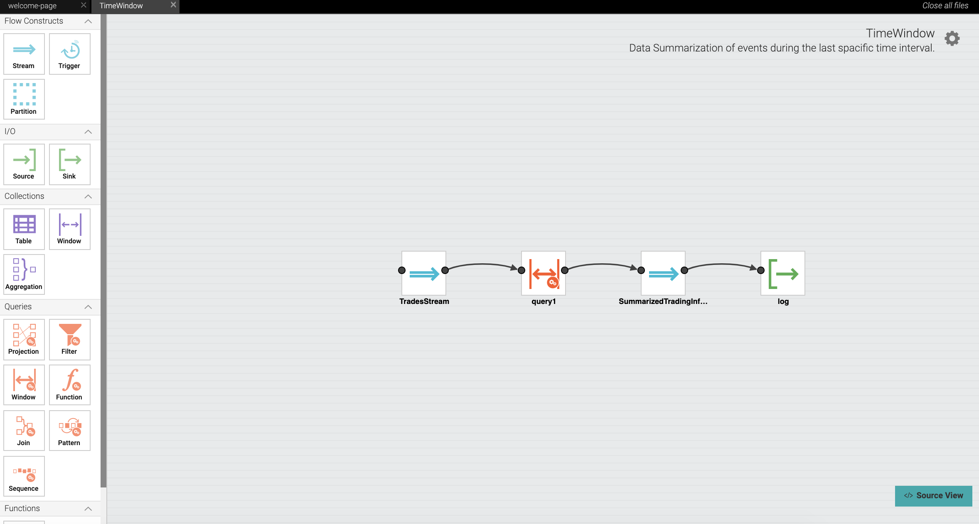

The editor keeps the SQL text syntax in sync with a graphical editor.

Unfortunately it is a little complex to get going with Kafka.

You can try the editor on Katacoda here:

<https://www.katacoda.com/siddhi/scenarios/siddhi-editor>

Try some of the samples.

1. If you want to, try installing the editor and follow the Quick Start:

<https://siddhi.io/en/v5.1/docs/quick-start/>

1. If you are really keen, you could try to rewrite the lab sample to use the Kafka Source. It’s a little tricky to get the Kafka extension running so feel free to ask me for help.