**Exercise KC**

*Creating a cluster of Cassandra nodes with Kubernetes*

**Prior Knowledge**

Unix Command Line Shell

**Learning Objectives**

Install Kubernetes cluster on EKS

Demonstrate scaling and rebalancing a Cassandra cluster

**Software Requirements**

Ubuntu

AWS credentials

**Overview**

Amazon EKS is Amazon’s Elastic Kubernetes Service. It is a pre-built Amazon deployment of Kubernetes, using Amazon’s Kubernetes Control Plane. At the time of writing, it is not available in Ireland, so we will use the US deployment. We will create a cluster of 3 nodes running Kubernetes.  
  
Helm is a “package manager” for Kubernetes that deploys pre-designed clusters of software. In this case, there is a

**Steps**

1. Install eksctl  
     
   Go to <https://github.com/weaveworks/eksctl> and copy and paste the lines that look like this, into an Ubuntu terminal window.  
     
   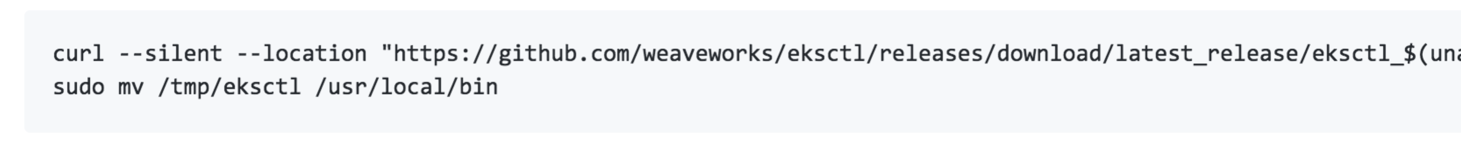
2. In the window type:  
     
   eksctl create cluster --name oxcloXX-eks --nodes 3  
     
   This will take a while..  
   You should see something like: