A Brief Introduction to Feed-Forward Neural Networks and Back-Propagation Algorithms

Chin-Shiuh Shieh (謝欽旭)
csshieh@cc.kuas.edu.tw

Department of Electronic Engineering
National Kaohsiung University of Applied Sciences

2015-05-26

Why and What Artificial Neural Networks?

- Human Brain vs. von Numann Machine
- Massive parallelism
- Distributed representation and computing
- Learning ability
- Generalization ability
- Adaptivity
- Inherent contextual information processing
- Fault tolerance
- Intended Challenging Domains
- Pattern recognition
- Clustering/categorization
- Function approximation
- Prediction/forecasting
- Optimization
- Content-addressable memory
- Control
- Brief History
- Pioneered by McCulloch and Pitts in the 1940s.
- Dampened by Minsky and Papert in the 1960s.
- Resurged by Hopfield (Hopfield network), Rumelhart (Back-propagation algorithm 1986)
- Biological Neurons and Computational Models

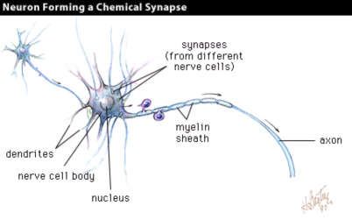
- Human brain has about 10¹¹ neurons, each having 10³ to 10⁴ connections to others. In total, there are around 10¹⁴ to 10¹⁵ interconnections.

- Artificial neuron (perceptron)
w₂
x₁
x₂
w₁
f (.)
Σ
x_{n}
w_{n}
y
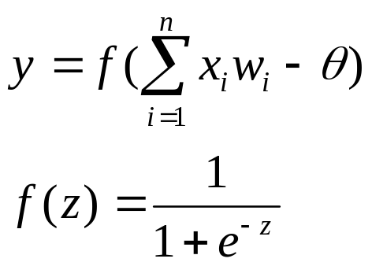
- Taxonomy of Neural Network Architectures

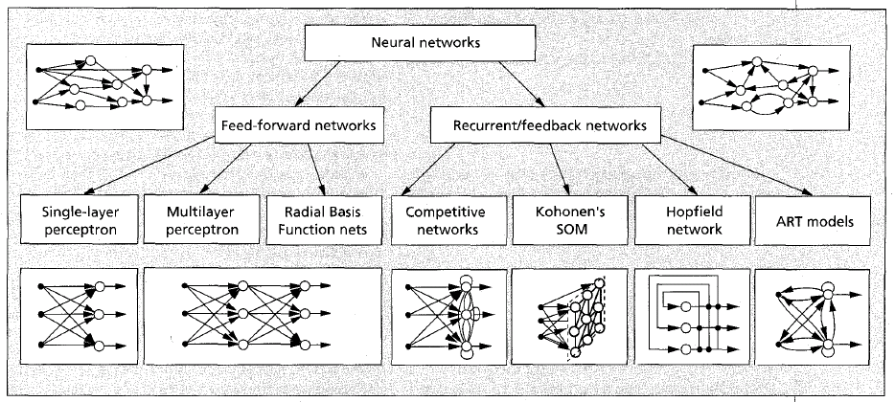
- Taxonomy of Learning Algorithms
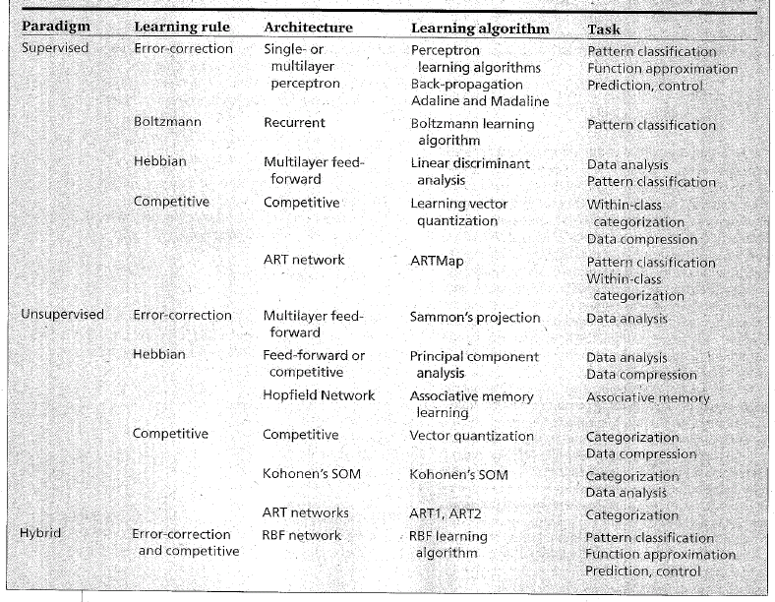

Feed-Forward Neural Networks
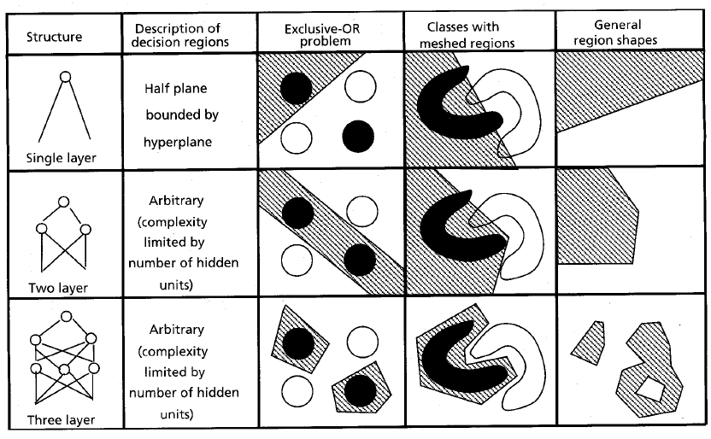
Also called Multi-Layer Perceptrons. Overcome the limitation of single-layer perceptrons

- Implement non-linear mapping between input, output data
- Function approximator
I₀
I₁
I₂
bias=’1’
H₀
H₁
H₂
H₃
O₀
O₁
I₃
H₄
w_{ih}
w_{ho}
- Controller
- Predictor
- Pattern classification

- Architecture

- Usage
- Train with known input-output data
- Apply to unknown input
- Learning (Training) Algorithm – Back Propagation

- Update connection weights to reduce approximation error (target output-actual output)
- Pseudo Code
while error _improvement> threshold
{
reset all 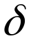w_{ih}, w_{ho} to 0
for every training data
{
// Forward Pass to evaluate O_{o}
// Reverse Pass to evaluate w_{ih}, w_{ho}
}
// Update Connection Weights
}
// Forward Pass
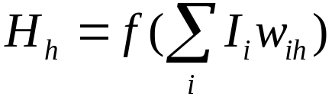
H_{h}: the output of h-th neuron in hidden layer
I_{i}: the value of i-th input
w_{ih}: the weight of the connection from i-th input to
h-th neuron in hidden layer
Threshold  was modeled by an extra connection weight
connected to fixed bias “1”.
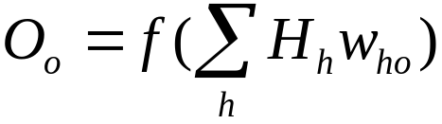
O_{o}: the output of o-th neuron in output layer
w_{ho}: the weight of the connection from h-th neuron
in hidden layer to o-th neuron in output layer
// Reverse Pass
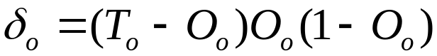
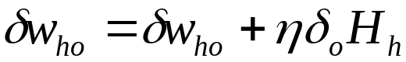
T_{o}: the o-th target output
δ_{o}: the error of o-th neuron in output layer
δw_{ho}: desired change on w_{ho} to reduce error
: learning rate
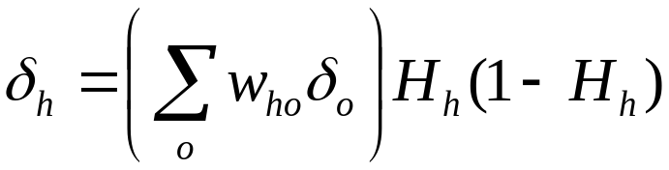 // this is why called back-propagation
δ_{h}: the error of h-th neuron in hidden layer
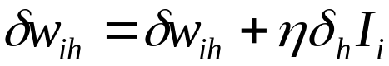
δw_{ih}: desired change on w_{ih} to reduce error
// Update Connection Weights
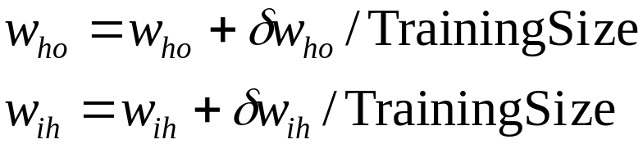

- A implementation in C at http://bit.kuas.edu.tw/~csshieh/research/program/bp.zip
- An Example

- Target Function
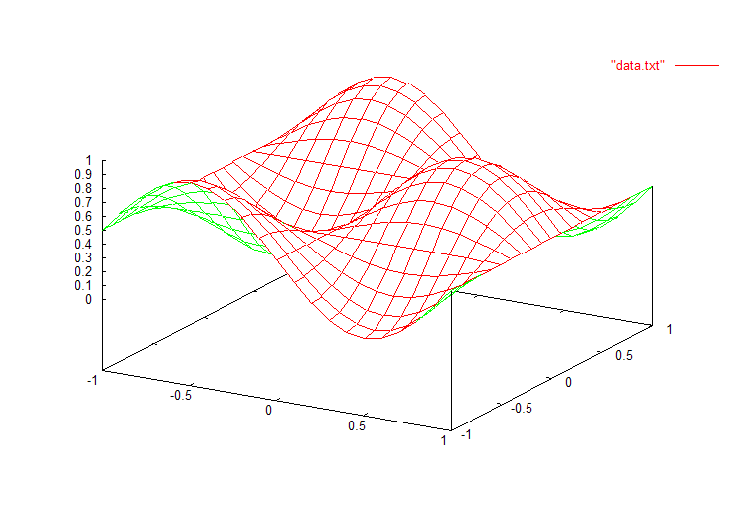
21x21=441 training data are sampled from the target functions.

- The Progress of Training
#define InputSize 2 /* Number of Nodes in Input Layer */
#define HiddenSize 16 /* Number of Nodes in Hidden Layer */
#define OutputSize 1 /* Number of Nodes in Output Layer */
#define TrainingSize 441 /* Number of Training Data */
#define eta 2.5 /* Learning Rate */
#define delta 1.0E-5 /* Threshold for Error Reducing Rate */

/* Connection Weight Initialization */
srand(1);
for(i=0;i<=InputSize;i++)
for(h=0;h<HiddenSize;h++)
w_ih[i][h]=RAND*10.0-5.0;
for(h=0;h<=HiddenSize;h++)
for(o=0;o<OutputSize;o++)
w_ho[h][o]=RAND*10.0-5.0;
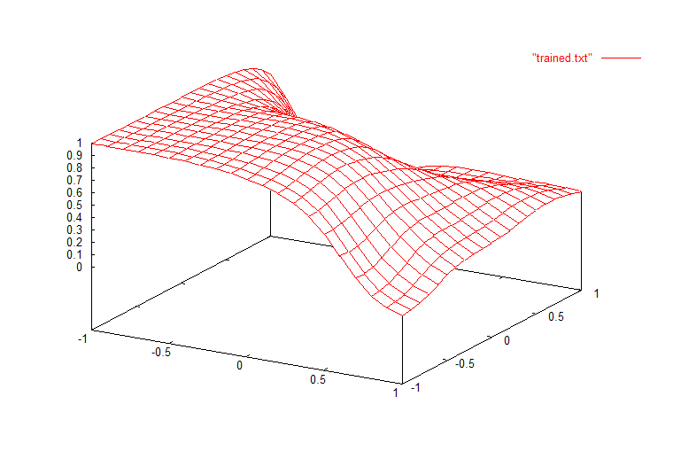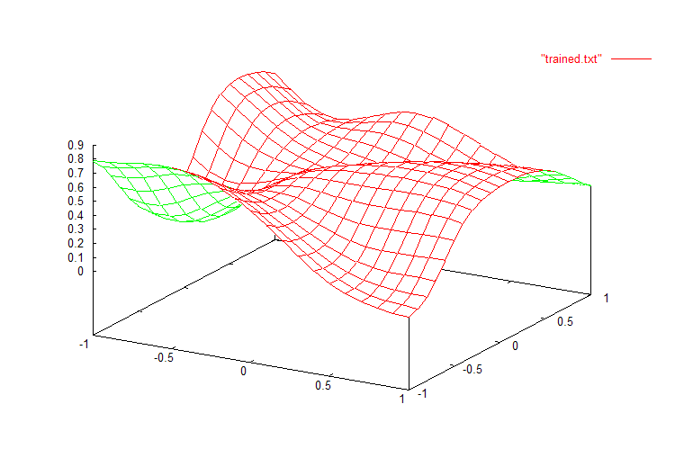
Figure 1 Output before training. Figure 2 Result of training after 100 iterations.
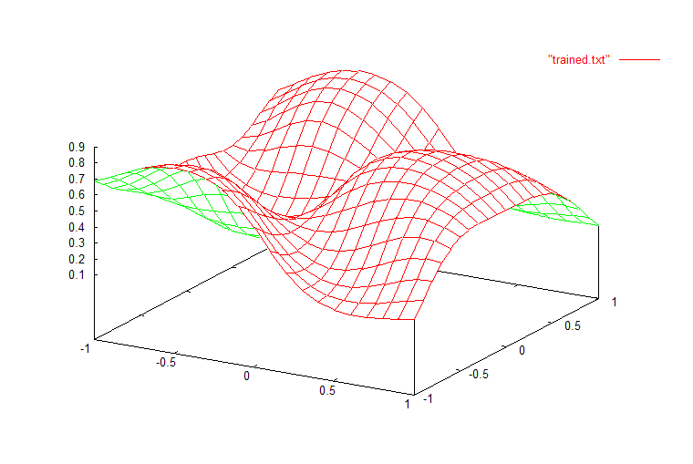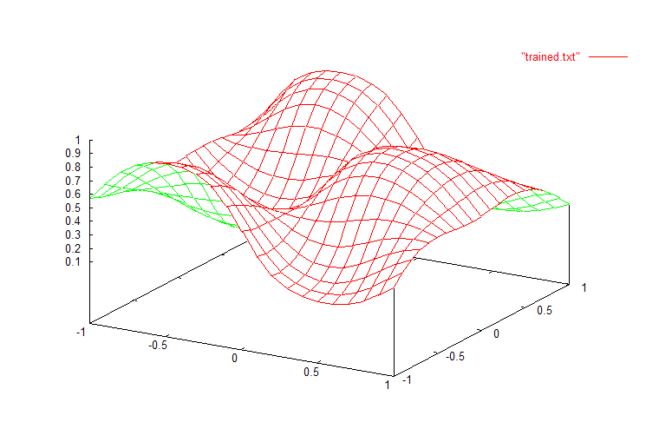
Figure 3 Result of training after 1000 iterations. Figure 4 Result of training after 10000 iterations.
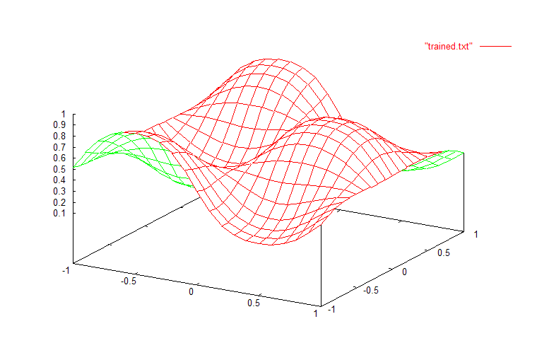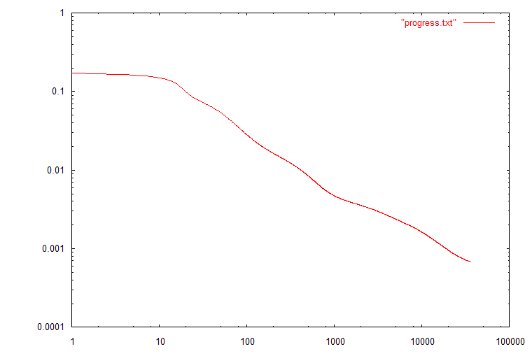
Figure 5 Result of training after 35748 iterations. Figure 6 Progress of approximation error.
- Effect of Initial Connection Weights

/* Connection Weight Initialization */
srand(1);
for(i=0;i<=InputSize;i++)
for(h=0;h<HiddenSize;h++)
w_ih[i][h]=RAND*1.0-0.5;
for(h=0;h<=HiddenSize;h++)
for(o=0;o<OutputSize;o++)
w_ho[h][o]=RAND*1.0-0.5;

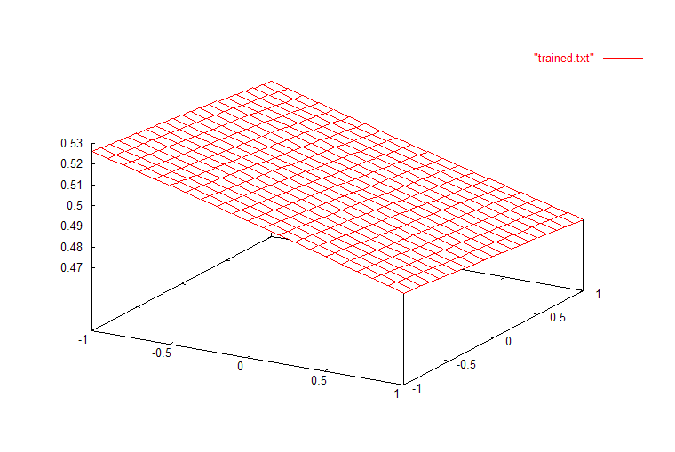
Figure 7 Failure for too small initial connection weights.
/* Connection Weight Initialization */
srand(1);
for(i=0;i<=InputSize;i++)
for(h=0;h<HiddenSize;h++)
w_ih[i][h]=RAND*100.0-50.0;
for(h=0;h<=HiddenSize;h++)
for(o=0;o<OutputSize;o++)
w_ho[h][o]=RAND*100.0-50.0;

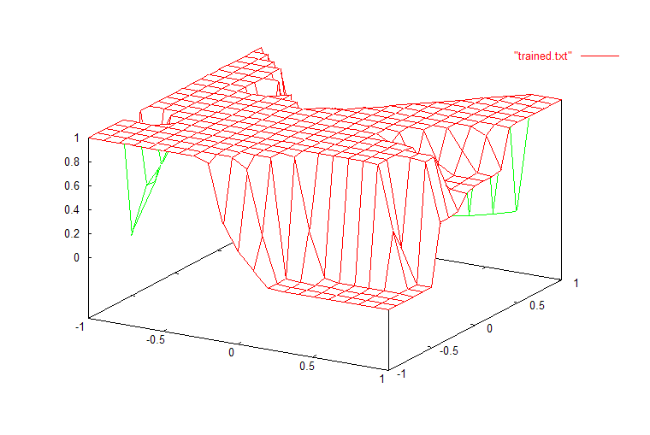
Figure 8 Failure for too large initial connection weights.
- Effect of Different Topology
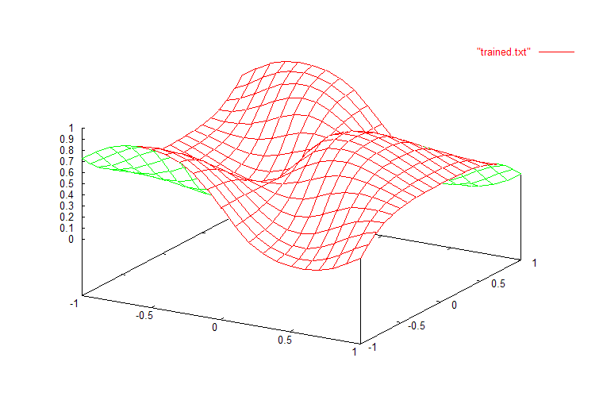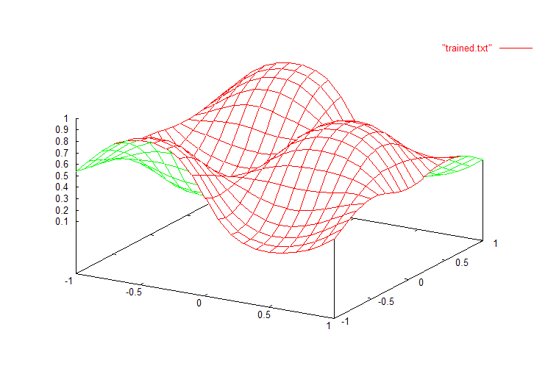
Figure 9 Result of 2x4x1 ANN; MSE=3.572772e-003 Figure 10 Result of 2x8x1 ANN; MSE=8.852724e-004.

- Practical Considerations
- Training Data
Internal test, external test; noisy data
- Network Size
Number of layers; neurons in each layer
Overlearning
- Initial Weights and Learning parameter
Momentum:
- Updating Policy
Batch, incremental

Reference
- Anil K. Jain, Jianchang Mao, and K.M. Mohiuddin, “Artificial neural networks: a tutorial,” IEEE Computer, March 1996, pp. 31-44, 1996.
- James A. Freeman and David M. Skapura, Neural Networks – Algorithms, Applications, and Programming Techniques, Addison-Wesley, 1991.
- 葉怡成, 應用類神經網路, 儒林, 1997.

