**Multi-objective Brain Storm Optimization Algorithm**

***Part I: Pareto Font***

1. *Schaﬀer’s Min-Min (SCH)* test function with convex Pareto front (which is used to test the effectiveness of algorithms in most multi objective optimization problems) [35]:

$$f_{1}=x^{2}, f_{2}={(x-2)}^{2}, x∈[-5,7]$$

|  |  |
| --- | --- |
| a | b |
| c  Figure 1: Pareto front of F1 with different number of iteration: a. N=20, b. N=100, c=200 | |

1. *Test function 2*

$$f_{1}\left(x,y\right)={\left(x^{2}+y^{2}\right)}^{\frac{1}{8}}, f_{2}\left(x,y\right)={\left({(x-0.5)}^{2}+{(y-05)}^{2}\right)}^{\frac{1}{4}}, x∈[-5,10]$$

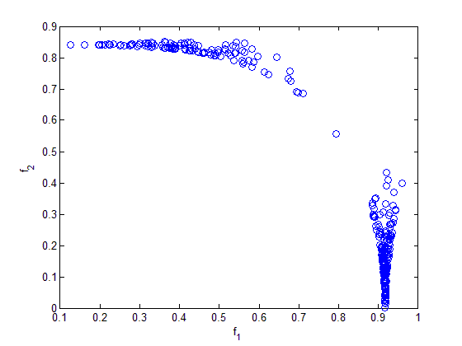

Figure 2: Pareto front of F2 with different number of iteration N=200

1. *Test function 3* has a non-convex front [34] [35]: F_04

$$f_{1}={x_{1}}^{2}, f_{2}={1-\left(\frac{f_{1}}{g}\right)}^{2}$$

$$g=1+\frac{9}{n-1}\sum_{i=2}^{n}{x_{i}}, x∈[-5,7]$$

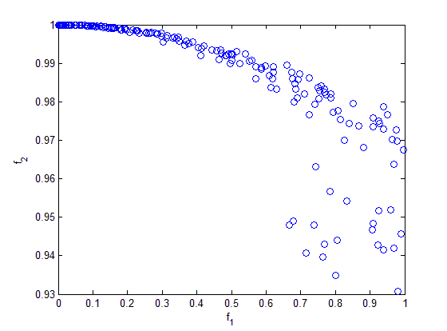

Figure 3: Pareto front of F3 with different number of iteration N=200

1. *Test function 4* has a convex Pareto-optimal front [34] [35]: F_05 $$f_{1}={x_{1}}^{2}, f_{2}=1-\sqrt{\frac{f_{1}}{g}}$$

$$g=1+\frac{9}{n-1}\sum_{i=2}^{n}{x_{i}}, x∈[-5,7]$$

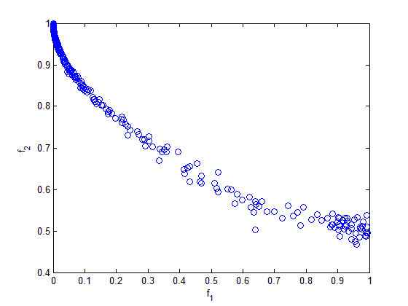

Figure 4: Pareto front of F4 with different number of iteration N=200

1. *Test function 5* represents the discreteness feature; its Pareto-optimal front consists of several noncontiguous convex parts: [34] : F_06

$$f_{1}={x_{1}}^{2}, f_{2}=1-\sqrt{\frac{f_{1}}{g}}-\frac{f_{1}}{g}sin⁡(10πf_{1})$$

$$g=1+\frac{9}{n-1}\sum_{i=2}^{n}{x_{i}}, x∈[-5,7]$$

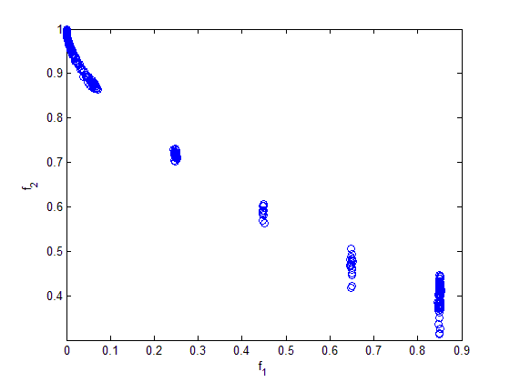

Figure 5: Pareto front of F5 with different number of iteration N=200

**Part II. Using MOBSO to find optimal solution**

1. Test function 6

$$F6: \left\{\begin{aligned}x_{1}^{2}+x_{2}^{2}+1=0 \\ x_{1}-x_{2}=0\end{aligned}\right., x_{1},x_{2}∈{[-1,1]}^{2}$$

|  |  |
| --- | --- |
| a | b |
| c  Figure 6: Convergence behavior in a typical run of F6 with different number of iteration: a. N=20, b. N=100, c=200 | |

1. *Test function 7*

$$F7: \left\{\begin{aligned}x_{1}+sin⁡(5*π*x_{2})=0 \\ x_{1}-x_{2}=0\end{aligned}\right., x_{1},x_{2}∈{[-1,1]}^{2}$$

|  |  |
| --- | --- |
| a | b |
| c  Figure 7: Convergence behavior in a typical run of F7 with different number of iteration: a. N=20, b. N=100, c=200 | |

1. *Test function 8*

$$F8: \left\{\begin{aligned}x_{1}-cos⁡(4*π*x_{2})=0 \\ x_{1}-x_{2}=0\end{aligned}\right., x_{1},x_{2}∈{[-1,1]}^{2}$$

|  |  |
| --- | --- |
| a | b |
| c  Figure 8: Convergence behavior in a typical run of F8 with different number of iteration: a. N=20, b. N=100, c=200 | |

1. *Test function 9*

$$F9: \left\{\begin{aligned}x_{1}+x_{2}+x_{3}-1=0 \\ x_{1}-x_{2}^{3}=0\end{aligned}\right., x_{1},x_{2}∈{[-1,1]}^{3}$$

|  |  |
| --- | --- |
| a | b |
| c  Figure 9: Convergence behavior in a typical run of F9 with different number of iteration: a. N=20, b. N=100, c=200 | |

1. *Test function 10:* Node localization application in WSNs

$$f_{1}=\sum_{i=m+1}^{n}{(\sum_{j∈N_{i}}{{(\hat{d_{ij}}-d_{ij})}^{2}})}$$

$$f_{2}=\sum_{i=m+1}^{n}{(\sum_{j∈N_{i}}{δ_{ij}}+\sum_{j∈\overline{N_{i}}}{(1-δ_{ij)}})}$$

D=3, R=4, number of iteration N=500

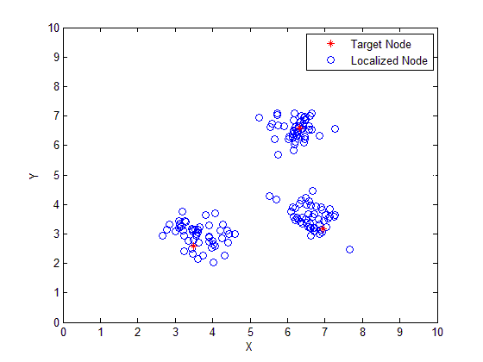

Figure 10: Convergence behavior in a typical run of F10 with number of iteration N=200

$$Average Localization error=\min_{Pareto font }{f_{1}}=\min_{Pareto font }{\frac{\sum_{i=1}^{n-m}{\sqrt{{({\hat{x}}_{i}-x_{i})}^{2}+{({\hat{y}}_{i}-y_{i})}^{2}}}}{\left(n-m\right)*R}*100\%}$$

Average Localization error (%) with 20 trial runs: 2.8154