**Title** /*Times New Roman 16pt, Bold*/

Author1, email1

Author2, email2

Author3, email3

**Abstract** **/*Times New Roman 12pt, Bold*/** Content Content Content Content Content Content Content Content Content Content Content Content Content Content Content… [An abstract should be 100 to 200 words and should clearly state the nature and significance of the paper. Abstract must not include mathematical expressions or bibliographic references.] /*Times New Roman 12pt */

**Keywords** /*Times New Roman 12pt, Bold*/ keyword, keyword, keyword, keyword, keyword [Keywords should closely reflect the topic and should optically characterize the paper. Please use about 3—5 keywords or phrases in alphabetical order separated by commas.] **/*Times New Roman 12pt*/**

1. **Introduction**

/*T imes New Roman 12pt, Bold*/

[Introduce the background of your project, why do you want to do your project? what's the goal for your project? and so on.]

* 1. **Subsection Title**

/*Times New Roman 12pt, Bold*/

Text Text Text Text Text Text Text Text Text Text Text Text Text Text Text Text…. /*Times New Roman 12pt */

1. **Project Design**

/*T imes New Roman 12pt, Bold*/

[Brief design of your project. Key data structures and algorithms. Possible technical challenges and your solutions.]

1. **Project Schedule**

[Brief introduce your project schedule and milestones.]

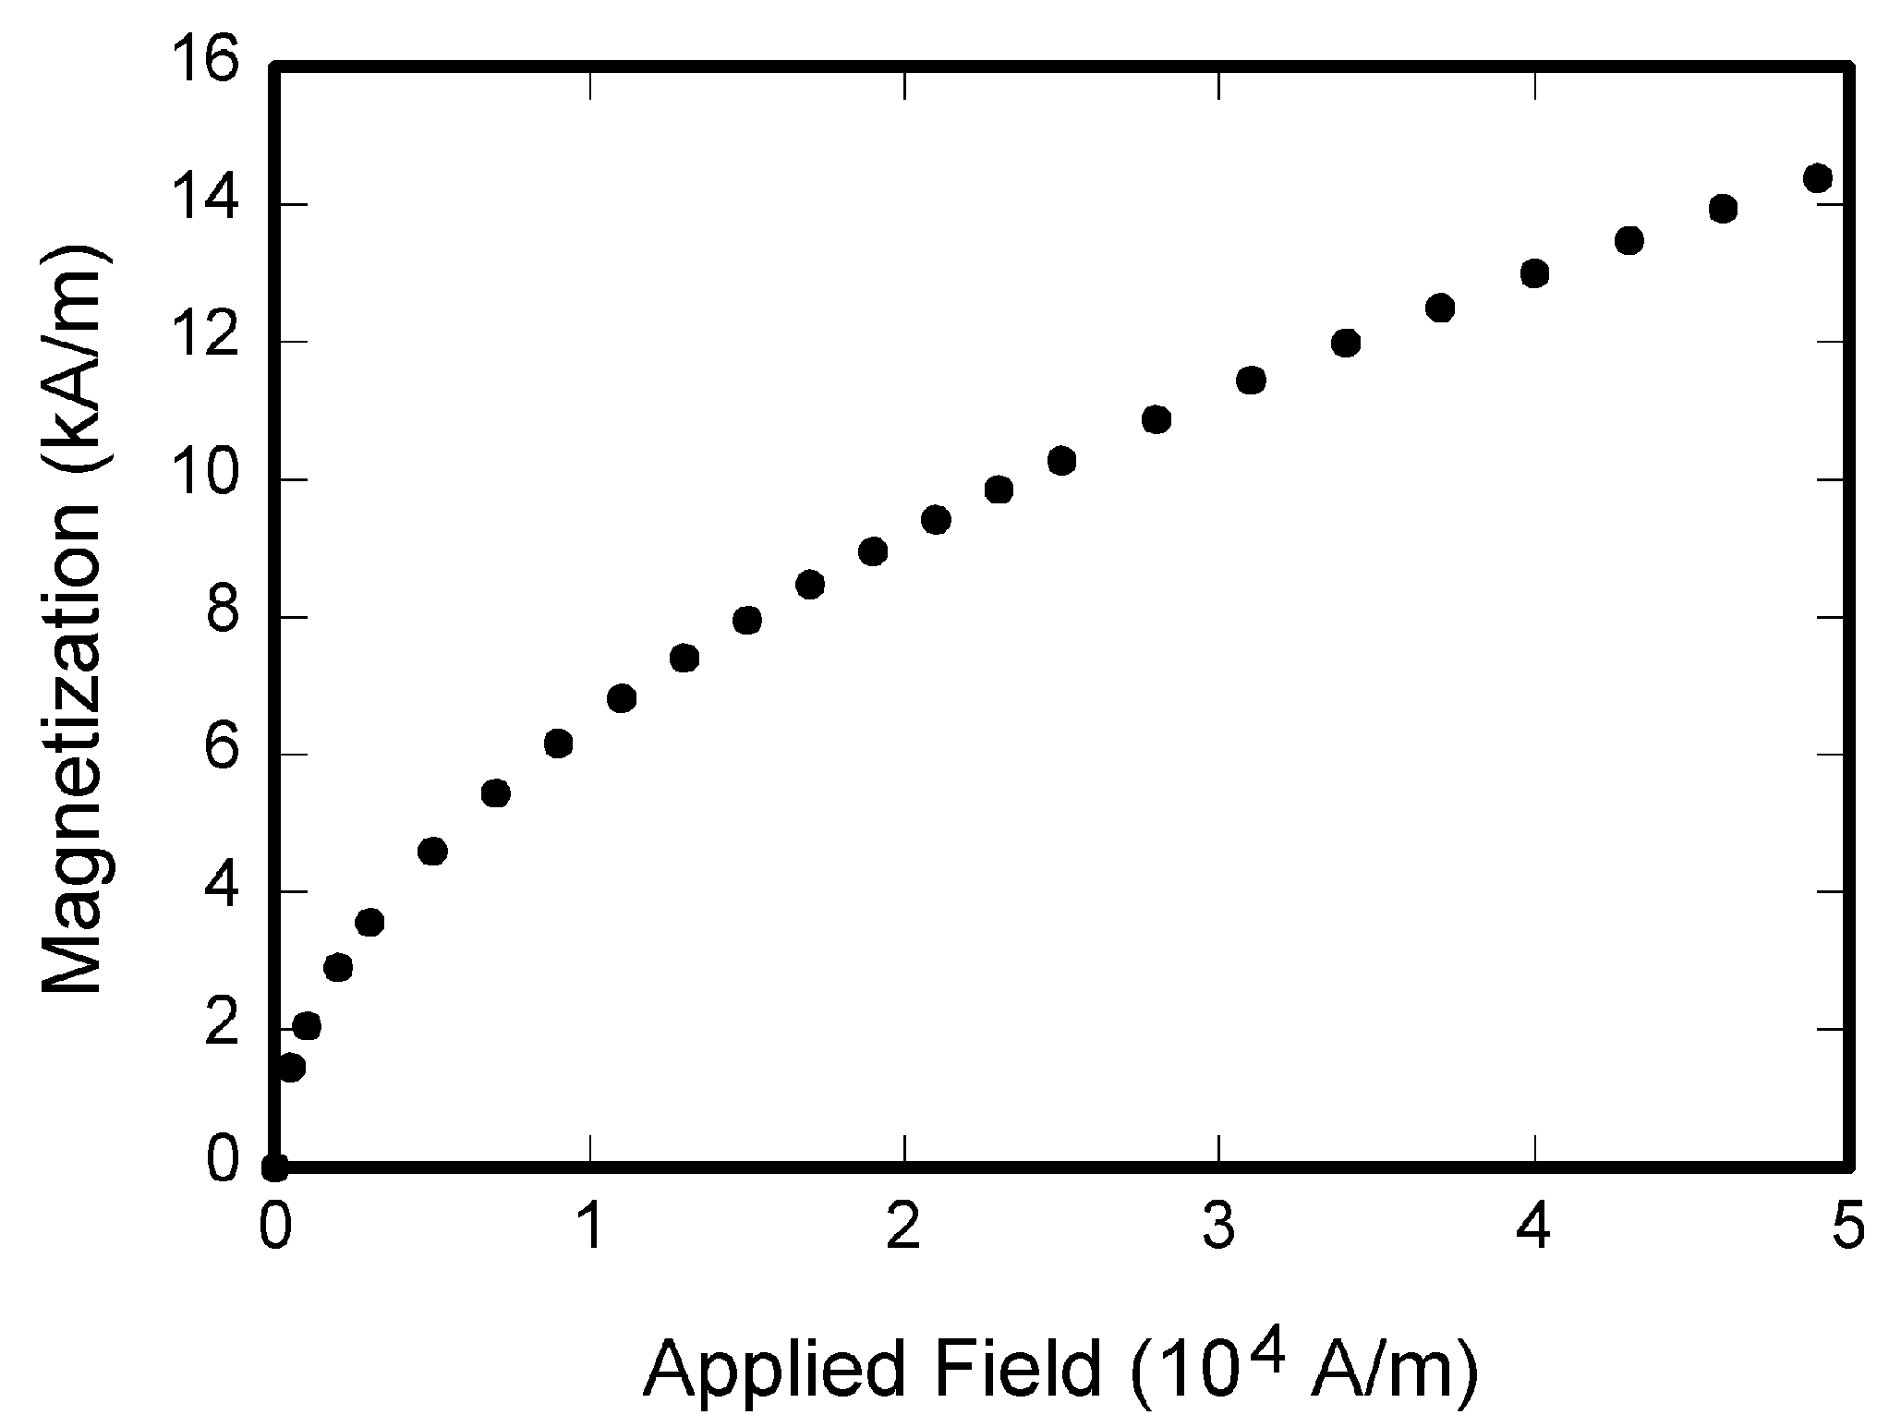

**Figure 1.** /*Times New Roman 10pt, Bold*/ Caption [briefly explain the significance of the figure in the caption]. /*Times New Roman 10pt */

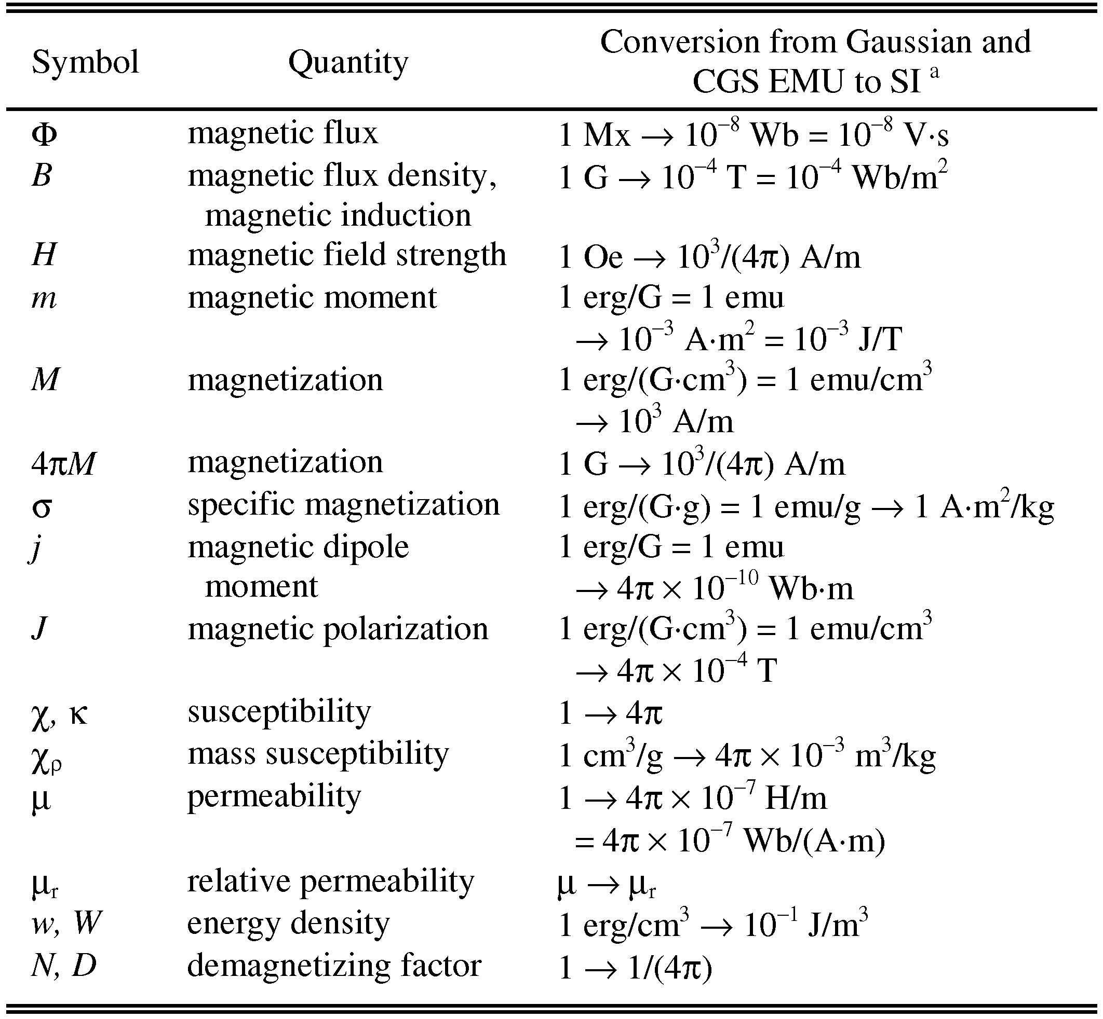

**Table 1．**/*Times New Roman 10pt, Bold*/ Caption[briefly explain the significance of the table in the caption] /*Times New Roman 10pt */

1. **Conclusion**

/*Times New Roman 12pt, Bold*/

Text Text Text Text Text Text Text Text Text TextText Text Text Text Text Text Text …[Although a conclusion may review the main points of the paper, do not replicate the abstract as the conclusion. A conclusion might elaborate on the importance of the work or suggest applications and extensions.] /*Times New Roman 12pt */

**References**/*Times New Roman 12pt, Bold*/

[The references should be listed at the end of the manuscript and numbered in the order they are referred to in the text.]

[1] Sayah J Y, Kime C R. Test scheduling in high performance VLSI system implementations. *IEEE Trans. Computers*, 1992, 41(1): 52-67.

[2] Gordon Plotkin. A semantics for type checking. In *Lecture Notes in Computer Science 526,* Ito T, Meyer A R (eds.), Springer-Verlag, 1991, pp.1-17.

[3] Kwan A W, Bic L. Distributed memory computers. In Proc. 6th Int. Parallel Processing Symp., March, 1992, pp.10-17.  /*Times New Roman 12pt */.