引起美国身份认证标准NIST SP800-63-2的修改

2016年8月，申请人下述代表性论文在网络公开，10月正式发表于信息安全顶级会议ACM CCS：
Ding Wang, Zijian Zhang, Ping Wang, Jeff Yan, Xinyi Huang. Targeted Online Password Guessing: An Underestimated Threat. Proc. of the 23nd ACM Conference on Computer and Communications Security (ACM CCS 2016), pp. 1242–1254. Oct 24, 2016 - Oct 28, 2016, Vienna, Austria.

该论文基于大规模真实的数据测试结果显示，在允许猜测100次的情况下，如果仅知道目标用户的一些常见个人信息，攻击者的猜测成功率可达20%；如果知道用户在其它网站曾经泄露的一个口令，成功率可达77%。这一结果大大超出了此前人们的预期，被福布斯、每日邮报、每日科学、Communications of the ACM、Naked Security等261国际媒体报道或转载（详见:
http://www.forbes.com/sites/leemathews/2016/11/10/100-guesses-is-enough-to-crack-your-password/#1f7e61c7e981
http://www.dailymail.co.uk/sciencetech/article-3907088/The-secret-password-using-Password-Researchers-warn-internet-users-making-easy-hackers-access-accounts.html
https://www.sciencedaily.com/releases/2016/11/161107112626.htm
http://cacm.acm.org/news/209702-online-password-guessing-threat-underestimated/fulltext
https://nakedsecurity.sophos.com/2016/11/09/would-your-password-withstand-100-guesses-from-a-hacker/
该论文引起了美国国家技术标准局（NIST）的关注。NIST在2013年8月发布的美国国家身份认证标准NIST SP800-63-2（https://nvlpubs.nist.gov/nistpubs/specialpublications/nist.sp.800-63-2.pdf）中，攻击者被允许在线猜测100次，并且认为口令在线猜测非常容易防御。在2017年6月新发布的标准NIST SP800-63-3（https://nvlpubs.nist.gov/nistpubs/SpecialPublications/NIST.SP.800-63-3.pdf）中，去除了旧版本NIST SP800-63-2中允许攻击者在线猜测100次的表述（“Attacker can make on the subscriber’s account to 100 or fewer in any 30-day period”）。
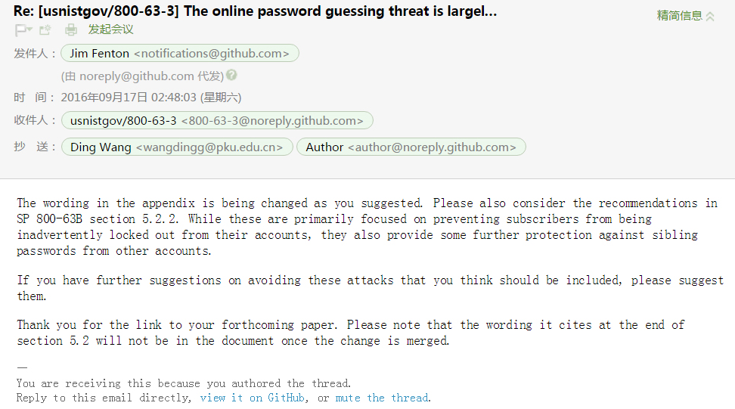
图1 NIST工作人员通过邮件征询申请人及合作者的防御建议
NIST工作人员进一步就如何防御口令在线猜测威胁，通过邮件（如图1）征询申请人及合作者的建议：“The wording in the appendix is being changed as you suggested. Please also consider the recommendations in SP 800-63B section 5.2.2. While these are primarily focused on preventing subscribers from being inadvertently locked out from their accounts, they also provide some further protection against sibling passwords from other accounts. If you have further suggestions on avoiding these attacks that you think should be included, please suggest them.”

最终，NIST SP-800-63-3新版标准在节“5.2.2 Rate Limiting (Throttling)”新增了4条针对定向在线口令猜测攻击的防御措施，详见 https://nvlpubs.nist.gov/nistpubs/SpecialPublications/NIST.SP.800-63-3.pdf
“申请人代表性论文引起NIST SP800-63-2修改”这一事件，得到多位美国学者（在他们公开发表的重要会议论文中）的佐证和肯定。2018年，俄亥俄州立大学的五位学者在论文【Proc. ACSAC’18, pp.89-100，https://doi.org/10.1145/3274694.3274714】中，明确指出申请人的前述ACM CCS 2016论文, 即下文中的“Wang et al. [43]”引起了NIST 标准的修改：

“Particularly, Wang et al. [43] have very recently developed efficient guessing algorithms for targeted online password attacks with the help of auxiliary information of the targeted accounts. The results were astonishing: Within 100 guesses, the algorithms could successfully crack 73% of the normal users’ accounts and 32% of the security-savvy users’ accounts (when evaluated against leaked password databases). These results have challenged NIST’s Digital Authentication Guideline [17] which suggested that “Online attacks where the attacker attempts to log in by guessing the password can be readily addressed by throttling the rate of login attempts permitted.” This remark has been hence removed from the document after the publication of [43].”

2017年，ACM Fellow、暗网Tor发明人、美国海军研究实验室Paul Syverson研究组在论文【HotPET 2017, https://petsymposium.org/2017/papers/hotpets/oft-target-1707.pdf】中，把申请人CCS 2016论文，即下文中的“[10]”作为定向攻击的典型代表，并指出申请人的工作迅速引起了美国身份认证标准的修订：
“Most research on security for widely-used systems follows the paradigm of assuming hoovering adversaries. Nonetheless, targeting has been shown to sometimes be much more effective than hoovering. For example, password guessing knowledge about the intended victim has been shown to be more effective than hovering in analyses of real data based on leaked datasets of passwords, and typically much more than twice as effective for security-savvy users [10]. And, NIST authentication guidelines, which had been created in consideration of hovering strategies, were quickly modified in light of these analyses.”

