Configure a Windows Server as a Static Agent
for a CloudBees CI Client Controller
Installation, validation, and troubleshooting runbook
Updated draft for onboarding labs and customer-safe Windows agent patterns
Key change: The recommended path is an inbound WebSocket agent running as a Windows service with WinSW. Cygwin SSH is intentionally excluded. Microsoft OpenSSH Server is the only SSH option documented, and only as an alternative path.

Contents
- 1. Purpose and scope
- 2. What changed from older Windows agent guidance
- 3. Connection method decision
- 4. Values to collect before starting
- 5. Prepare the Windows Server
- 6. Preferred path: WebSocket inbound agent as a Windows service
- 7. Alternative path: SSH-launched Windows agent with Microsoft OpenSSH
- 8. Client Controller validation checklist
- 9. Validation Pipeline
- 10. Troubleshooting
- 11. Evidence checklist
- 12. Sources and notes
- 13. Validation status and evidence

1. Purpose and scope
This runbook describes how to connect a Windows Server machine as a static build agent to a CloudBees CI Client Controller. It is intended for administrators or platform engineers who need a repeatable, copy/paste-friendly procedure for installing and validating a Windows agent.
The procedure covers two supported patterns:
- Preferred: inbound WebSocket agent running as a Windows service.
- Alternative: SSH-launched Windows agent using Microsoft OpenSSH Server.

2. What changed from older Windows agent guidance
- Cygwin SSH is removed from the recommended path. Many enterprise customers disallow it or do not support it operationally.
- WebSocket inbound agent is the default recommendation for new Windows static agents because it avoids inbound SSH to Windows and works better through HTTPS proxies and load balancers.
- Microsoft OpenSSH Server is documented only as the SSH alternative.
- Java guidance is updated for current Jenkins/CloudBees baselines: use Java 21 or Java 25 for the agent process when connecting to CloudBees CI based on Jenkins 2.555.x.
- Service installation uses WinSW with explicit warnings about secrets in service XML and service-account permissions.
- The runbook separates the browser/tunnel URL used by an administrator from the controller URL used by the agent process.

3. Connection method decision
Method | Pros | Cons | Use when
WebSocket inbound agent | Preferred for new Windows static agents. Uses controller HTTP(S), avoids inbound SSH to Windows, and is simpler through proxies/load balancers. | Requires persistent Windows service. Windows host must reach the Client Controller URL. | Default choice for a static Windows Server agent connected to a Client Controller.
SSH-launched agent | Controller starts the agent process over SSH. Useful where SSH is already standardized. | Requires Microsoft OpenSSH Server, TCP/22, host-key management, and SSH credentials. More moving parts. | Use only when WebSocket is unsuitable or when the controller must initiate the connection.

4. Values to collect before starting
- Client Controller URL used by agents. Do not use a local laptop tunnel URL such as http://localhost:18080 unless the Windows host is actually running on that same machine.
- Agent name, for example win-build-01.
- Agent labels, for example windows windows-server msbuild.
- Remote root directory, for example C:\ci-agent\work.
- Windows service account name, for example .\svc_cbci_agent, DOMAIN\svc_cbci_agent, or an approved gMSA.
- Required build tools such as Git for Windows, Visual Studio Build Tools, .NET SDK, MSBuild, NuGet, Node.js, Python, 7-Zip, or signing tools.
- Network path from Windows Server to the Client Controller over HTTPS for WebSocket, or from Client Controller to Windows Server over TCP/22 for SSH.
- TLS trust requirements, especially when the controller uses a private CA, self-signed cert, TLS inspection, or an internal certificate chain.
Java baseline: For current CloudBees CI / Jenkins 2.555.x based releases, use Java 21 or Java 25 for the agent JVM. Build jobs may use additional JDKs separately, but the agent process should use the supported JVM for the controller baseline.

5. Prepare the Windows Server

5.1 Create agent directories
$AgentRoot = 'C:\ci-agent'
$WorkRoot = 'C:\ci-agent\work'
$LogRoot = 'C:\ci-agent\logs'
$CacheRoot = 'C:\ci-agent\cache'
New-Item -ItemType Directory -Force $AgentRoot, $WorkRoot, $LogRoot, $CacheRoot | Out-Null

5.2 Create a least-privilege Windows service account
# Local account example. Use a domain account or gMSA if your build needs domain resources.
$Password = Read-Host 'Enter password for svc_cbci_agent' -AsSecureString
New-LocalUser -Name 'svc_cbci_agent' -Password $Password -Description 'CloudBees CI Windows agent service account'
icacls C:\ci-agent /inheritance:r
icacls C:\ci-agent /grant 'Administrators:(OI)(CI)(F)' 'SYSTEM:(OI)(CI)(F)' '.\svc_cbci_agent:(OI)(CI)(M)'
Service account guidance: Do not use a domain administrator, local administrator, or interactive human account for normal builds. Grant only the rights required by the build tools. Prefer gMSA or centrally managed service-account tooling when available.

5.3 Install Java and build tools
java -version
where java
# Optional machine-level cache locations.
[Environment]::SetEnvironmentVariable('NUGET_PACKAGES', 'C:\ci-agent\cache\nuget', 'Machine')
[Environment]::SetEnvironmentVariable('GRADLE_USER_HOME', 'C:\ci-agent\cache\gradle', 'Machine')
[Environment]::SetEnvironmentVariable('TMP', 'C:\ci-agent\work\tmp', 'Machine')
[Environment]::SetEnvironmentVariable('TEMP', 'C:\ci-agent\work\tmp', 'Machine')
New-Item -ItemType Directory -Force C:\ci-agent\work\tmp | Out-Null

6. Preferred path: WebSocket inbound agent as a Windows service
Use this path when the Windows Server can reach the Client Controller URL over HTTPS. The agent process calls back to the controller using WebSocket and is kept alive by a Windows service.

6.1 Create the static agent in the Client Controller
- Sign in to the CloudBees CI Client Controller.
- Go to Manage Jenkins > Nodes and create a new permanent/static agent.
- Set the node name, for example win-build-01.
- Set Remote root directory to C:\ci-agent\work.
- Set labels, for example windows windows-server msbuild.
- Set Usage to Only build jobs with label expressions matching this node unless this host is intended for general jobs.
- For the launch method, choose Launch agent by connecting it to the controller.
- Enable Use WebSocket.
- Save the node configuration.

6.2 Download agent.jar and copy the launch command
# Example download URL pattern. Use the actual Client Controller URL.
https://<CLIENT_CONTROLLER_URL>/jnlpJars/agent.jar
# Save to:
C:\ci-agent\agent.jar
Secret handling: The generated agent secret is sensitive. Do not paste it into tickets, public docs, chat, or screenshots. Restrict access to any service XML or script that contains the secret.

6.3 Test the WebSocket agent interactively
cd C:\ci-agent
& 'C:\Program Files\Java\jdk-21\bin\java.exe' `
-jar C:\ci-agent\agent.jar `
-url https://<CLIENT_CONTROLLER_URL>/ `
-secret <AGENT_SECRET> `
-name win-build-01 `
-webSocket `
-workDir C:\ci-agent\work

6.4 Install WinSW for the Windows service
# Example file layout
C:\ci-agent\jenkins-agent.exe
C:\ci-agent\jenkins-agent.xml
C:\ci-agent\agent.jar
C:\ci-agent\work\
C:\ci-agent\logs\

6.5 Create the WinSW service XML
<service>
<id>cloudbees-win-build-01</id>
<name>CloudBees CI Agent - win-build-01</name>
<description>Inbound WebSocket CloudBees CI agent for win-build-01</description>
<executable>C:\Program Files\Java\jdk-21\bin\java.exe</executable>
<arguments>-jar C:\ci-agent\agent.jar -url https://<CLIENT_CONTROLLER_URL>/ -secret <AGENT_SECRET> -name win-build-01 -webSocket -workDir C:\ci-agent\work</arguments>
<workingdirectory>C:\ci-agent</workingdirectory>
<logpath>C:\ci-agent\logs</logpath>
<log mode="roll-by-size-time" />
<onfailure action="restart" delay="10 sec" />
<onfailure action="restart" delay="30 sec" />
<!-- Prefer gMSA or service-management tooling when available. If using this block, restrict the XML file. -->
<!--
<serviceaccount>
<domain>.</domain>
<user>svc_cbci_agent</user>
<password>REPLACE_WITH_SERVICE_ACCOUNT_PASSWORD</password>
<allowservicelogon>true</allowservicelogon>
</serviceaccount>
-->
</service>

6.6 Install and start the service
cd C:\ci-agent
.\jenkins-agent.exe install
.\jenkins-agent.exe start
Get-Service 'cloudbees-win-build-01'

6.7 WebSocket network requirements
- The Windows Server must reach the Client Controller over the HTTP(S) URL in the launch command.
- No inbound TCP/22 rule is required for WebSocket unless the SSH alternative is also enabled.
- If a proxy is used, confirm it supports WebSocket upgrade connections.
- If TLS inspection or custom CAs are used, ensure the agent Java runtime trusts the controller certificate chain.
- Do not use a laptop-only tunnel URL as the agent URL unless the agent runs on that same laptop.

7. Alternative path: SSH-launched Windows agent with Microsoft OpenSSH
Important: Do not install or configure Cygwin SSH. Use Microsoft OpenSSH Server only when an SSH-launched Windows agent is required.

7.1 Install Microsoft OpenSSH Server
Get-WindowsCapability -Online | Where-Object Name -like 'OpenSSH*'
Add-WindowsCapability -Online -Name OpenSSH.Client~~~~0.0.1.0
Add-WindowsCapability -Online -Name OpenSSH.Server~~~~0.0.1.0
Start-Service sshd
Set-Service -Name sshd -StartupType Automatic
if (!(Get-NetFirewallRule -Name 'OpenSSH-Server-In-TCP' -ErrorAction SilentlyContinue)) {
New-NetFirewallRule -Name 'OpenSSH-Server-In-TCP' `
-DisplayName 'OpenSSH Server (sshd)' `
-Enabled True `
-Direction Inbound `
-Protocol TCP `
-Action Allow `
-LocalPort 22
}

7.2 Restrict SSH access
- Allow inbound TCP/22 only from the Client Controller or approved controller network range.
- Use a non-administrator service account for agent logon whenever possible.
- Prefer SSH key authentication and disable password login if required by policy.
- Configure host-key verification before production use.

7.3 Configure SSH keys for a non-administrator account
New-Item -ItemType Directory -Force C:\Users\svc_cbci_agent\.ssh | Out-Null
notepad C:\Users\svc_cbci_agent\.ssh\authorized_keys
icacls C:\Users\svc_cbci_agent\.ssh /inheritance:r
icacls C:\Users\svc_cbci_agent\.ssh /grant 'svc_cbci_agent:(OI)(CI)(F)' 'SYSTEM:(OI)(CI)(F)' 'Administrators:(OI)(CI)(F)'
icacls C:\Users\svc_cbci_agent\.ssh\authorized_keys /inheritance:r
icacls C:\Users\svc_cbci_agent\.ssh\authorized_keys /grant 'svc_cbci_agent:F' 'SYSTEM:F' 'Administrators:F'
Administrator account warning: If an administrator account is used for SSH, Windows OpenSSH uses C:\ProgramData\ssh\administrators_authorized_keys instead of the user profile authorized_keys file. Avoid administrator accounts for normal builds.

7.4 Create the SSH-launched agent in Client Controller
- Create a permanent/static agent.
- Set host to the Windows Server DNS name or IP.
- Choose Launch agents via SSH.
- Select SSH private key credential for the Windows agent account.
- Set JavaPath if PATH does not resolve the correct Java runtime.
- Use Manually provided or Known hosts verification; avoid Non verifying except for temporary troubleshooting.

8. Client Controller validation checklist
- Node appears in Manage Jenkins > Nodes.
- For WebSocket path, launch method is “Launch agent by connecting it to the controller” and Use WebSocket is enabled.
- Agent command from the node page includes -webSocket, -name, -secret, and -workDir.
- Agent is online after interactive test.
- Agent is online after service install and Windows reboot.
- Build label is specific enough, for example windows-server or win-build-01.
- Usage is set to only build jobs with matching label expressions unless general scheduling is intended.

9. Validation Pipeline
pipeline {
agent { label 'windows-server' }
stages {
stage('Validate Windows agent') {
steps {
echo 'CloudBees CI Windows agent is online.'
powershell(script: 'Write-Host "Computer: $env:COMPUTERNAME"; Write-Host "User: $env:USERNAME"; Write-Host "Workspace: $env:WORKSPACE"; java -version; Get-ChildItem Env: | Sort-Object Name')
}
}
}
}

10. Troubleshooting
Symptom | Likely cause | What to check
WebSocket agent does not connect | Agent cannot reach controller URL, WebSocket upgrade blocked, wrong secret/name, Java failure. | Run launch command interactively. Confirm HTTPS reachability, proxy, TLS trust, -name, -secret, -webSocket, and -workDir.
Windows service stops immediately | Bad Java path, XML error, wrong secret, missing directory, service-account permissions. | Check C:\ci-agent\logs. Run jenkins-agent.exe status. Test exact Java command outside service.
Service cannot log on | Missing “Log on as a service”, bad password, expired password. | Grant right through policy or WinSW allowservicelogon. Verify account format.
Tools not found during builds | Tools installed only for interactive admin or not machine-wide. | Run a shell as the service account. Check PATH, JAVA_HOME, MSBuild, Git, NuGet.
SSH connection refused | sshd not running, firewall closed, network path blocked. | Get-Service sshd, firewall rule, TCP/22 reachability.
SSH authentication fails | Wrong authorized_keys path/permissions, wrong private key, admin authorized_keys behavior. | Use non-admin account. Check user profile authorized_keys and permissions.
SSH host key failure | Missing/stale host-key verification. | Use manually provided or known-hosts verification; refresh after planned rebuilds.
Builds run on wrong node | Label too broad or Usage allows general jobs. | Use specific label and restrict project/node usage.

11. Evidence checklist
- Screenshot of Client Controller node configuration without exposing secrets.
- Interactive WebSocket command test output showing agent connected.
- Windows service state: Get-Service cloudbees-win-build-01.
- Windows service log path and sample log lines with secrets redacted.
- Node online screenshot.
- Validation Pipeline successful build console output.
- Reboot reconnect validation.
- Network/TLS notes, especially proxy, custom CA, and WebSocket support.

12. Sources and notes
- CloudBees CI — Connect inbound agents
- CloudBees CI — Set up agents on CloudBees CI
- CloudBees KB — How to install Windows agents as a service
- CloudBees CI — Test the SSH connection to an agent
- CloudBees KB — Host Key Verification for SSH Agents
- Microsoft — Get started with OpenSSH for Windows
- Microsoft — OpenSSH Server Configuration for Windows
- Jenkins — Managing Nodes
- Jenkins — Upgrading to Jenkins LTS 2.555.x
- WinSW releases
Client Controller lab test note: If no Windows host is available, validate the Client Controller side by creating the node, confirming the generated WebSocket launch command, and verifying agent.jar download. Full validation requires a Windows Server to run the interactive command and Windows service.

13. Validation status and evidence
Validation status: End-to-end validated on Windows 11 aarch64 using Java 21 and WebSocket inbound agent.
Validation item | Result
Client Controller node creation | Validated — win-build-01 created as a permanent/static agent.
WebSocket launch command | Validated — generated command includes -webSocket, -name, -secret, and -workDir.
agent.jar download | Validated — agent.jar downloaded from the Client Controller.
Windows Java 21 execution | Validated — Microsoft OpenJDK 21.0.11 detected and used.
Windows agent online state | Validated — win-build-01 connected and reported Windows 11 aarch64.
Pipeline execution on win-build-01 | Validated — windows-agent-smoke-test build #1 completed successfully.

Not required for the preferred WebSocket path
- Cygwin SSH
- Microsoft OpenSSH for the preferred path

Recommended next cleanup
- Delete and recreate win-build-01 to rotate the exposed lab secret before any real Windows host or client use.
- Keep this runbook as the onboarding baseline for WebSocket inbound Windows static agents.
- Add the evidence file to the onboarding evidence pack if evidence files are tracked outside Git.
- For production, replace laptop tunnel URLs with a Client Controller URL reachable from the Windows Server.

Security note
Important: The lab validation exposed a generated agent secret in the node page during testing. Treat the lab node secret as compromised. For real use, delete and recreate the node to generate a fresh secret, and avoid including secrets in screenshots, tickets, chat, or documentation.

Validation evidence screenshots
Figure 1 — Client Controller generated WebSocket inbound launch command for win-build-01. Secret redacted.
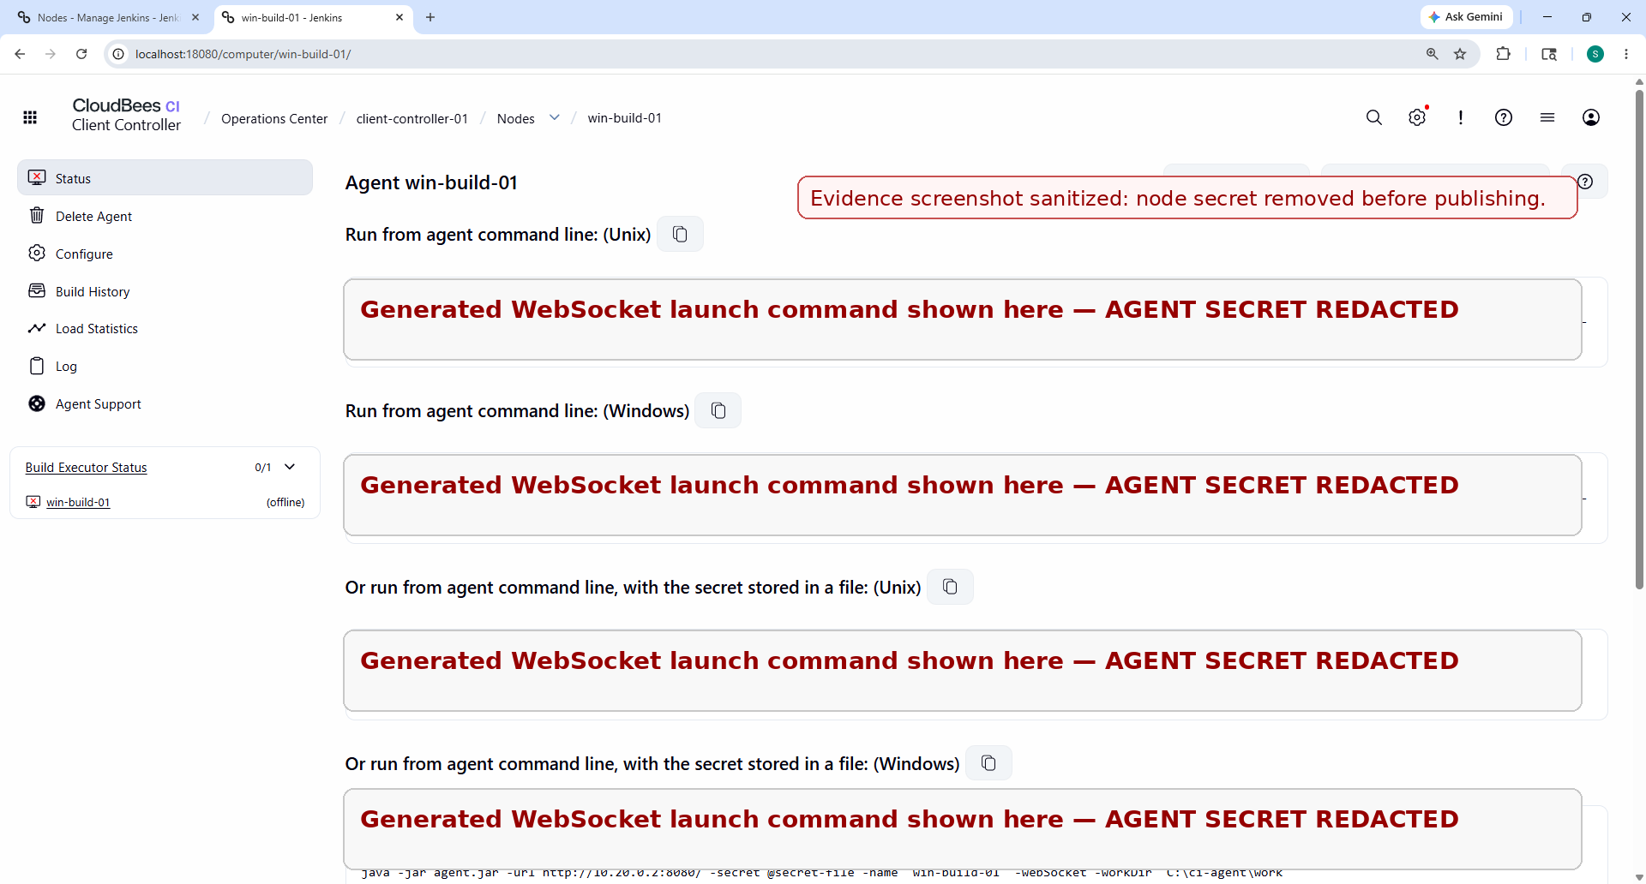
Figure 2 — Windows host validation: Java 21 detected and agent.jar downloaded to C:\ci-agent.
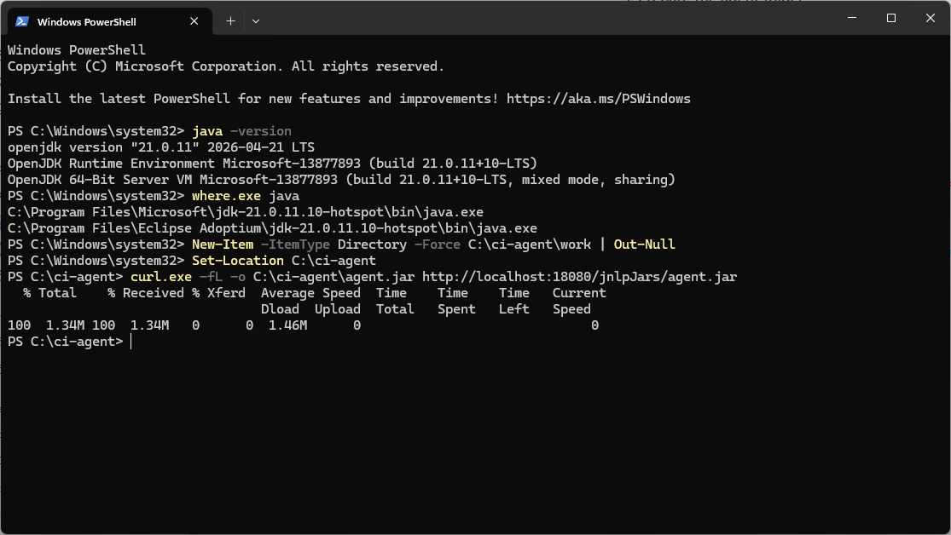
Figure 3 — win-build-01 online in Client Controller, reporting Windows 11 aarch64.
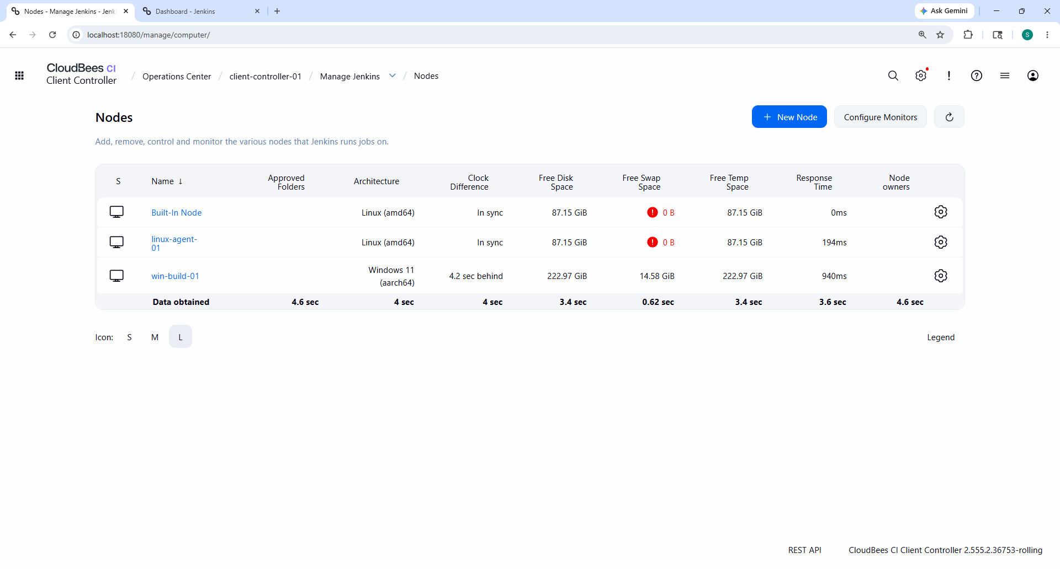
Figure 4 — windows-agent-smoke-test build #1 completed successfully.
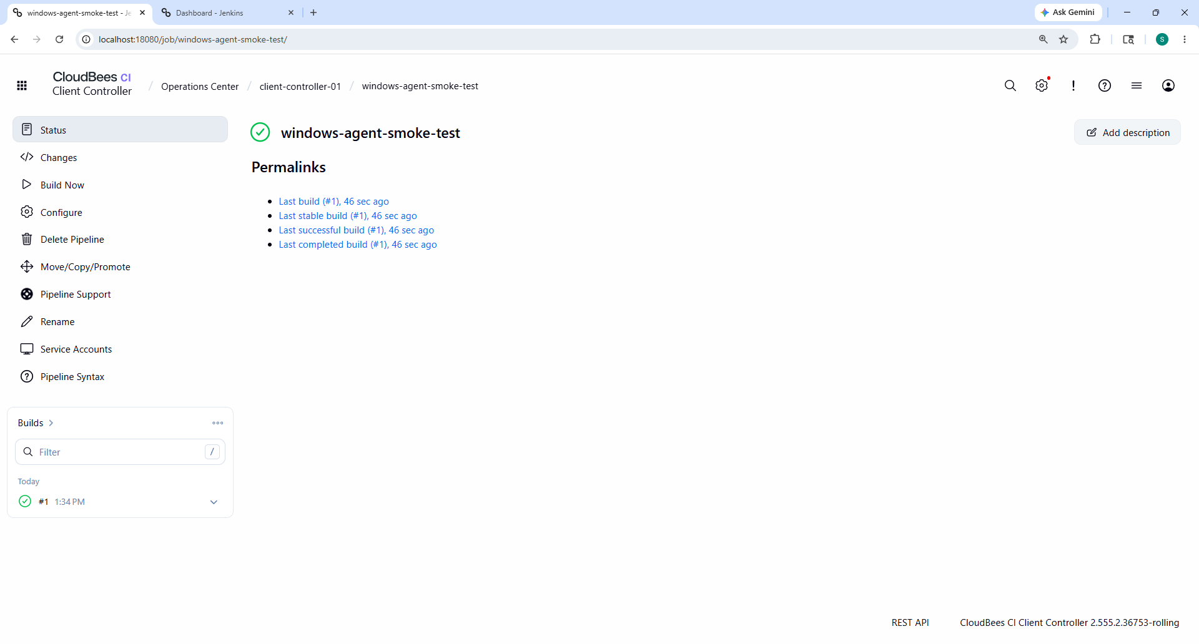

Conclusion
The preferred Windows static agent path is validated: WebSocket inbound agent, Java 21, agent.jar, online Windows node status, and Pipeline execution on win-build-01 all completed successfully. Cygwin SSH is not required, and Microsoft OpenSSH remains only an alternative path when WebSocket is not suitable.

