Library Management System

Design Specification
20-FEB-2022

VERSION HISTORY

Version  # | Implemented  By | Revision  Date | Approved  By | Approval  Date | Reason
1.0 | Anurag Chauhan | 20-feb-2022 |  |  | Initial Design Definition draft
 | Pradip Naliyadhara

TABLE OF CONTENTS
1 Introduction 5
1.1 Purpose of The Design Specification Document 5
2 Design specification 6
2.0 Use-Case………………………………………………………………………….. 6
2.1 Display Overview of Project 6
2.2 Application Program Interfaces 6

3 Product Design Specification Approval 7

Introduction

Purpose of The Product Design Specification Document
As the name suggest the Library Management System is a software which handles the entire data of library. It makes the work of librarian very easy instead of writing data in a notebook. In past the librarians were using notebooks to write the data of books along with students name who borrowed that book. So it was very difficult to keep track on each and every book.
If librarian want’s to search for a particular book then that task was very time consuming. So to make this task easy the programming languages were developed and C++ language is one of them.

Design specification

Use-Cases
- We have created separate logins for students and the librarian, in which the librarian is password protected.
- In this project, the librarian can add, update, delete and create books and can also assign the books to the students.
- The students can also view the list of the books available in the entire library database.
- The entire rights are given to the librarian to adding books, issuing books, and modify the book.
- This project uses file handling to store the data of books in a project.
- A Librarian can also be able to change the password.
- Reissuing and returning the books are the main features of this project.
- The student can also be able to see which student has already borrowed the book.

Display overview of project
- Main Screen Looks like below image:
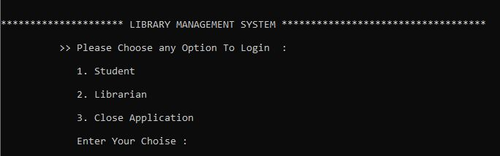
We have displayed the menu of Student, Librarian and close the application. If you’re a student then your choice will be 1 and if you are a librarian then your choice will be 2.

- When the student enter the choice as 1 then following screen will be appeared:
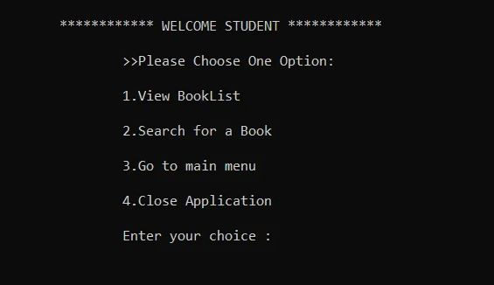

- The following menu will be visible to the Librarian, if they select the librarian as an option:
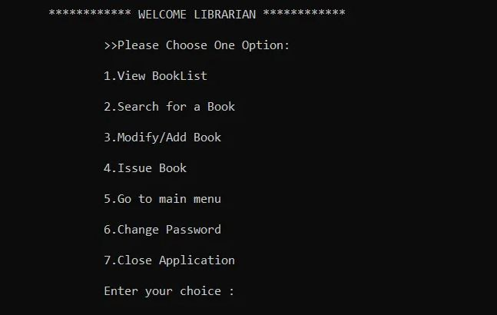

Application Program Interfaces
- The following Diagram is showing the actual design of Library management system roadmap.
- You can see the path of function call in this diagram.
- Currently we are planning to start with this but in future may be some of the function are added to add some extra functionality.
- Each function definition reflect to it’s function name so , you can get the idea of how we are going to approach this project by seeing this below diagram.

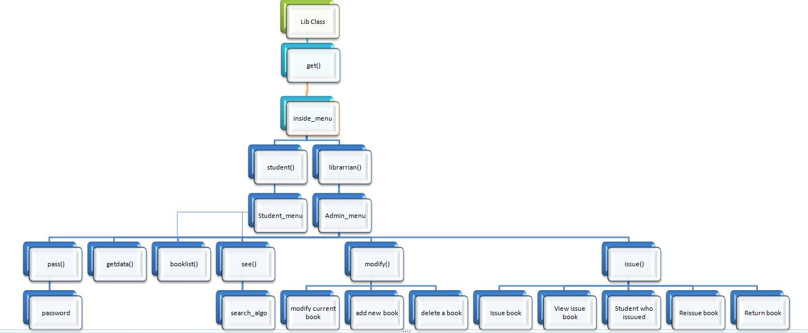

Product Design Specification Approval
The undersigned acknowledge they have reviewed the Library Management System Design Specification document and agree with the approach it presents. Any changes to this Requirements Definition will be coordinated with and approved by the undersigned or their designated representatives.

Signature: |  | Date:
Print Name:
Title:
Role:

Signature: |  | Date:
Print Name:
Title:
Role:

