financials - raw table (2019-2023, updated)
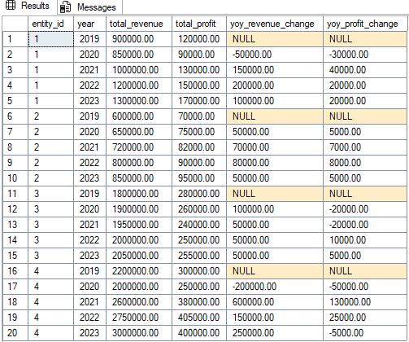

virtual table after ’with’ statement
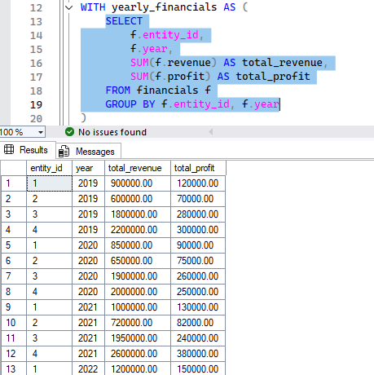
yearly_financials CTE (sum of change, YoY)
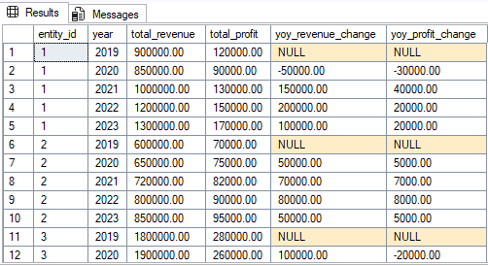

yearly_financials CTE (percentage change, YoY)
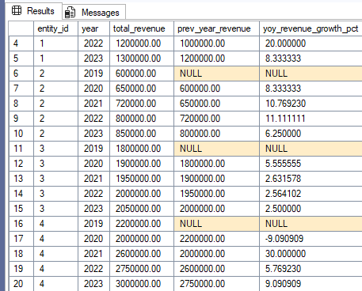

yearly_financials CTE (percentage change + trend labels, YoY)
