Base tables created
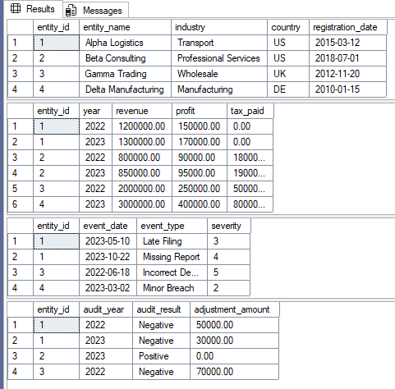

Virtual tables (as part of ‘with’ statement)
financial risk
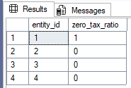
compliance risk
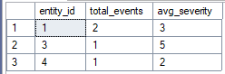

audit risk
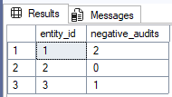
risk score
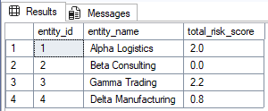

Ranking by overall risk score
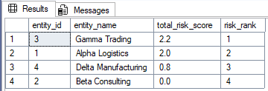
Ranking with modified risk wheightings (from 0.4, 0.4, 0.2 to 0.5, 0.3 , 0.2)
