Recipe for Blueberry Muffins

Introduction
This is a quick and easy recipe for Blueberry Muffins that the whole family can enjoy. I enjoy this recipe as they are delicious and I can make them easily whenever I want. This recipe is good for anytime of day as they can be eaten for breakfast, a snack or even dessert.
This recipe makes either 20 to 22 mini muffins, 8 large big top muffins or 10 standard muffins (which is what I usually use).

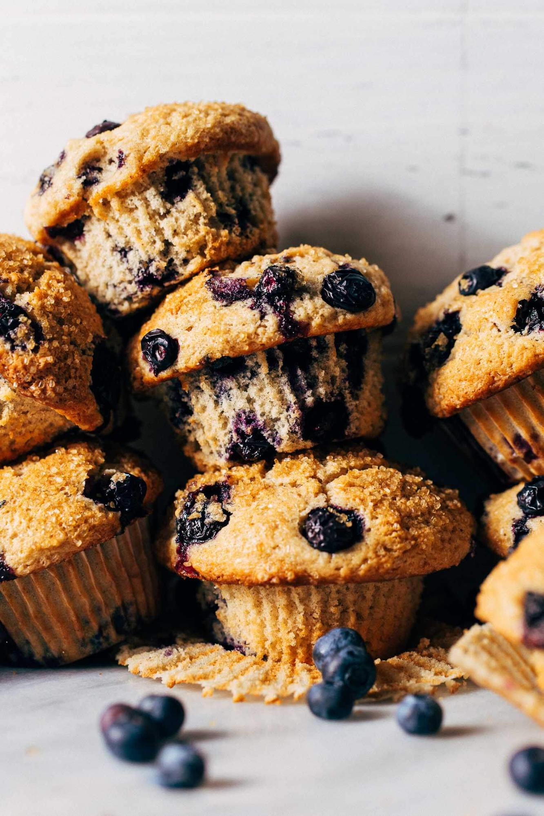INGREDIENTS
- 1½ cups of all purpose flour
- ¾ cup of granulated sugar
- ¼ tsp of fine salt
- 2 tsp of baking powder
- ⅓ cup of oil
- 1 large egg
- ⅓ to ½ a cup of milk
- 1½ tsps of vanilla extract
- 1 cup of fresh or frozen blueberries

COOKING INSTRUCTIONS
- First mix all the dry ingredients together
- In a seperate bowl mix all the wet ingredients together
- Put all of the dry and wet ingredients together in one bowl and mix
- Gently add and fold in the blueberries
- Bake muffins for 15-20 minutes at 400°f

ENJOY!

