Memoranda
Version 3.16
Team Newton Script
CST-316

Table of Contents
Memoranda Release Notes 1
Installation Instructions 2
Q&A 3
1) What are some of the new features in version 3.16? 3
2) How can I add/edit/remove phases for my project? 3
3) How can I add/edit/complete/remove defects for my project? 3
4) How can I add/edit/remove test cases for my project? 5
5) How can I Pass/Fail my test cases? 5
6) How can I add/edit/remove users to my project? 6
7) How can I enter my PSP time log into my project? 7
8) What statistics are available? 7
9) How do I save my project data, such as time sheets, phases, tests cases and defects? 7
10) How do I report a bug? 8
Hypothetical Upgrade 9
Gnu General Public License 10

Memoranda Release Notes

Additions:
- Added a back-end server.
- Added a Defect Log to track the defects in your program.
- Added a Timesheet Log to track the hours spent on the project.
- Added a Test Case Table to keep track of the test cases being used to test your program.
- Added a User’s page to keep track of the users working on your project and their contact information.
- Added a Statistics page that has graphs of your Projects information.

Changes:
- Tasks now belong to Phases and Phases are a group of Tasks.
- Resources are now streamlined. You no longer have to search for your program’s executable.

Fixes:
- Program no longer crashes when minimized.
- Entire program is now in English.
- The time in Event Creation is now in a 12 hour format.

Installation Instructions

1. To install go to: www.public.asu.edu/~hcho49/Memoranda.

2. Depending on which Operating System, go into the respective folder (Windows, Mac, Linux).

3. Click the Memoranda.zip to begin download.

4. Once completed extract the entire folder into any designated location.

5.
For Windows:
- Double click the exe to run the program.

For Mac:
- Double click the .dmg and drag application to /Applications.

For Linux (Ubuntu):
- Double click the .deb file to install the program.

Congratulations, Memoranda has now been installed!

Q&A
(For version 3.16)

1) What are some of the new features in version 3.16?
- Defect Log
- Task Phases
- Time Sheet
- Test Cases
- Streamlined Resources
- Users
- Visual Statistics

2) How can I add/edit/remove phases for my project?

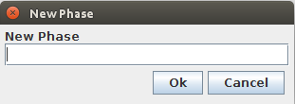
On the Tasks page, select the Add Phase button near the top of the window. The following dialog box will open:

Enter your new phase name into the text box and select 'Ok'. Your phase will then be added to the tasks table. To edit the phase title, simply double-click on the phase in your table. The following dialog will prompt you to change you phase name:
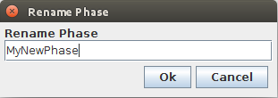

Edit your phase name in the text box and select 'Ok'. You phase will then be renamed in the task table. To remove a phase, highlight your phase in the table and select the Remove Phase button near the top.

3) How can I add/edit/complete/remove defects for my project?

On the Defects page, select the Add Defect  button on the right side of the page. This will prompt you with the following dialog:

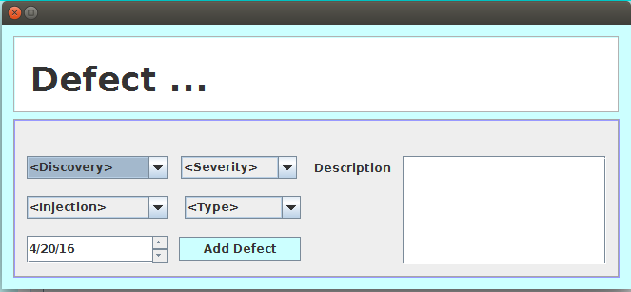

Fill out the appropriate boxes according to your defect, then select 'Add Defect'. Your new defect will be added to the defect table. To edit the defect, select the Edit Defect  button on the right side of the page. You will be prompted with a similar dialog box:

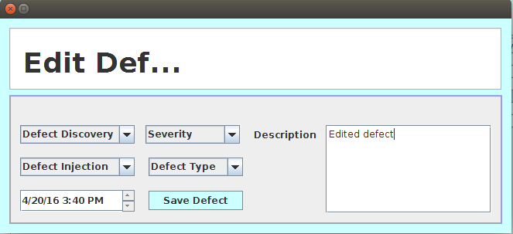

Edit your defect in the appropriate selection boxes and select 'Save Defect'. Your defects will be added to the defect table. To complete a defect, highlight a defect in the Open Defects table and select the Complete Defect  button on the right side of the window. This will provide you with the following dialog box:

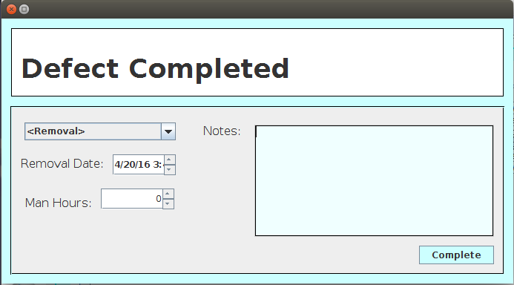

Fill in the appropriate boxes for your completed defect, and select 'Complete'. Your completed defect will move to the Closed Defects table, where it will be saved indefinitely until a user removes it. To remove a defect from either table, highlight the defect and select the Delete Defect button  on the right side of the screen. Your defect will now be removed from the table.

4) How can I add/edit/remove test cases for my project?

On the Test Case page, select the New button on the top left of the page. You will be met with the following dialog box:

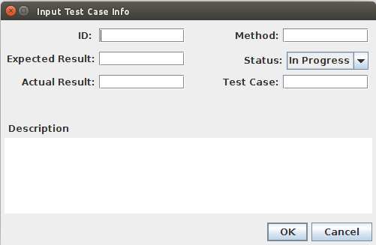

Fill in the test case information in the appropriately labeled text boxes. Once done, select 'OK'. Your new test case will be added to the table. To edit a test case, select your test case in the table, and click the Edit button in the top left. You will be met with a similar dialog as above. Edit the information in the appropriate fields and select 'OK'. Your test case changes will be applied to the table.

To remove a test case, select your test case in the table and click the Remove button at the top left of the window. Your test case will then be removed from the table.

5) How can I Pass/Fail my test cases?

There are three options on the top right of the Test case page. These options allow you to Reset, Pass and Fail test cases. The buttons appear as:



Reset – This will restore your test case to 'In Progress', changing the status column white.
Pass – This will pass your test case, changing the status column to green.
Fail – This will fail your test case, changing the status column to red.

To use any of these options, select the test case you wish to reset, pass or fail and select the appropriate option.

6) How can I add/edit/remove users to my project?

On the Users page, select the Add button in the bottom left corner of the window. You will be prompted with the following dialog box:

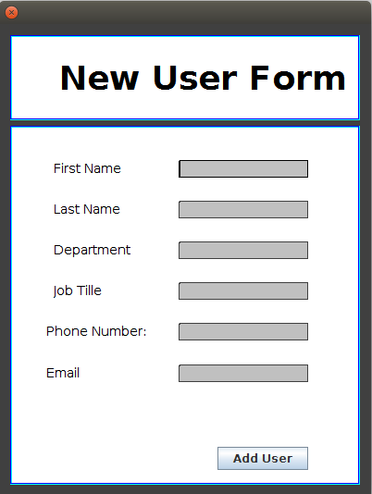

Fill out the information about the new user in the appropriate boxes. Select 'Add User'. The user will be added to the users table. To edit a users information, choose the user in the table and select the Edit button in the bottom left of the window. A similar dialog box will appear, edit the users information accordingly and select 'OK'. The table will be updated with the users new information.

To remove a user, highlight the user in the users table and select the Delete button in the bottom left corner. The highlighted user will be removed from the table.

7) How can I enter my PSP time log into my project?

On the Time Sheet  page you can input your Personal Software Process time log. The time sheet page includes a tab on top for every month of the year. Select your current month and fill out the Date, Start, Stop, Interrupt Time, Phase and comments for your current entry.

8) What statistics are available?

Currently, the statistics  page offers 3 different types of statistics. The three types available are Test cases, Defects, and Tasks.

Test cases can be viewed via a pie chart, this pie chart will give a visual representation of the overall status of all test cases. Defects are also displayed with a pie chart, though, much more detailed information is available. Defects can be views by type, discovery, injection, Severity and open/closed status.

For both pie charts, there are several options on the right hand side. The uppermost  button will continuously rotate the pie charts. The button directly under the rotate button is the Label  button. This button will toggle between different display types for the labels on the pie chart. The buttons below the two buttons toggle between the different available display types of the pie charts.

Tasks are seen with a Gantt chart. This chart will show the start/end dates of phases, and the overall progress of their combined tasks.

The statistics page also offers the option to export statistics as a PNG image file. To do so, select the tab which contains the chart you would like to export. Once selected, click the 'Export As..' option near the top of the page. The program will prompt you for a file name and location.

9) How do I save my project data, such as time sheets, phases, tests cases and defects?

Phases, test cases, defects and users are saved whenever a change has occurred within the respected table. An add, edit or remove of any kind will save your project information.

The time sheet panel will be hard saved when the program exits. If the program fails to exit properly, current time sheet session data will be lost.

All data within the program will be saved when the program is exited.

10) How do I report a bug?

To report a bug within the 3.16 version of Memoranda, please email one of the developers listed below. In the email, please provide any and all information about how the bug occurred, when it occurred and any steps that must be taken to reproduce the bug.

Jeb Johnson – jajohn64@asu.edu
Doug Carroll – dcarrol3@asu.edu
Seferino Fernandez – sferna12@asu.edu
Hancheol Cho – hcho49@asu.edu

Hypothetical Upgrade

The following is a step by step explanation of a hypothetical upgrade process. This test was performed to ensure that upgrading from an older version of Memoranda would not corrupt the users data in any way. The only data that is handled differently in the newest version of Memoranda is the Task data. This data will be the focus of the following test.

1) The new and old versions were setup to run separately in the same environment (in this case, a Linux desktop environment). The newest version was packaged into a runnable jar file for this test. The older version of Memoranda was compiled using the existing ant script and run with the provided shell executable file.

2) First, the old version was run and the following tasks were added to the program:
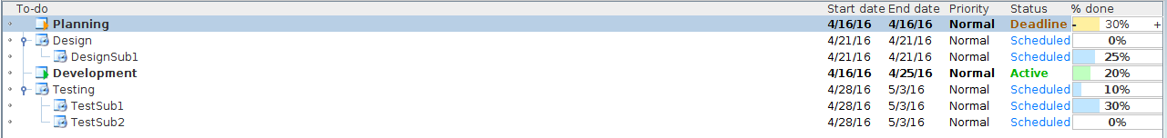
The program was then closed, which saved the tasks to the tasklist file.

3) The new version of Memoranda is run, with the old tasks loaded into the Default phase, all data intact:
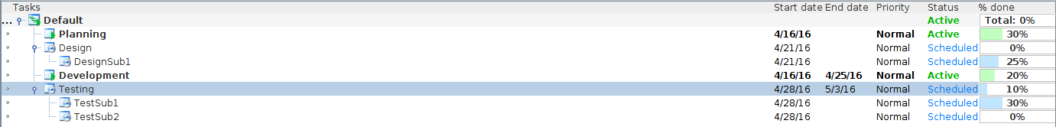

Gnu General Public License
TERMS AND CONDITIONS FOR COPYING, DISTRIBUTION AND MODIFICATION

0. This License applies to any program or other work which contains
a notice placed by the copyright holder saying it may be distributed
under the terms of this General Public License. The "Program", below,
refers to any such program or work, and a "work based on the Program"
means either the Program or any derivative work under copyright law:
that is to say, a work containing the Program or a portion of it,
either verbatim or with modifications and/or translated into another
language. (Hereinafter, translation is included without limitation in
the term "modification".) Each licensee is addressed as "you".

Activities other than copying, distribution and modification are not
covered by this License; they are outside its scope. The act of
running the Program is not restricted, and the output from the Program
is covered only if its contents constitute a work based on the
Program (independent of having been made by running the Program).
Whether that is true depends on what the Program does.

1. You may copy and distribute verbatim copies of the Program's
source code as you receive it, in any medium, provided that you
conspicuously and appropriately publish on each copy an appropriate
copyright notice and disclaimer of warranty; keep intact all the
notices that refer to this License and to the absence of any warranty;
and give any other recipients of the Program a copy of this License
along with the Program.

You may charge a fee for the physical act of transferring a copy, and
you may at your option offer warranty protection in exchange for a fee.

2. You may modify your copy or copies of the Program or any portion
of it, thus forming a work based on the Program, and copy and
distribute such modifications or work under the terms of Section 1
above, provided that you also meet all of these conditions:

a) You must cause the modified files to carry prominent notices
stating that you changed the files and the date of any change.

b) You must cause any work that you distribute or publish, that in
whole or in part contains or is derived from the Program or any
part thereof, to be licensed as a whole at no charge to all third
parties under the terms of this License.

c) If the modified program normally reads commands interactively
when run, you must cause it, when started running for such
interactive use in the most ordinary way, to print or display an
announcement including an appropriate copyright notice and a
notice that there is no warranty (or else, saying that you provide
a warranty) and that users may redistribute the program under
these conditions, and telling the user how to view a copy of this
License. (Exception: if the Program itself is interactive but
does not normally print such an announcement, your work based on
the Program is not required to print an announcement.)

These requirements apply to the modified work as a whole. If
identifiable sections of that work are not derived from the Program,
and can be reasonably considered independent and separate works in
themselves, then this License, and its terms, do not apply to those
sections when you distribute them as separate works. But when you
distribute the same sections as part of a whole which is a work based
on the Program, the distribution of the whole must be on the terms of
this License, whose permissions for other licensees extend to the
entire whole, and thus to each and every part regardless of who wrote it.

Thus, it is not the intent of this section to claim rights or contest
your rights to work written entirely by you; rather, the intent is to
exercise the right to control the distribution of derivative or
collective works based on the Program.

In addition, mere aggregation of another work not based on the Program
with the Program (or with a work based on the Program) on a volume of
a storage or distribution medium does not bring the other work under
the scope of this License.

3. You may copy and distribute the Program (or a work based on it,
under Section 2) in object code or executable form under the terms of
Sections 1 and 2 above provided that you also do one of the following:

a) Accompany it with the complete corresponding machine-readable
source code, which must be distributed under the terms of Sections
1 and 2 above on a medium customarily used for software interchange; or,

b) Accompany it with a written offer, valid for at least three
years, to give any third party, for a charge no more than your
cost of physically performing source distribution, a complete
machine-readable copy of the corresponding source code, to be
distributed under the terms of Sections 1 and 2 above on a medium
customarily used for software interchange; or,

c) Accompany it with the information you received as to the offer
to distribute corresponding source code. (This alternative is
allowed only for noncommercial distribution and only if you
received the program in object code or executable form with such
an offer, in accord with Subsection b above.)

The source code for a work means the preferred form of the work for
making modifications to it. For an executable work, complete source
code means all the source code for all modules it contains, plus any
associated interface definition files, plus the scripts used to
control compilation and installation of the executable. However, as a
special exception, the source code distributed need not include
anything that is normally distributed (in either source or binary
form) with the major components (compiler, kernel, and so on) of the
operating system on which the executable runs, unless that component
itself accompanies the executable.

If distribution of executable or object code is made by offering
access to copy from a designated place, then offering equivalent
access to copy the source code from the same place counts as
distribution of the source code, even though third parties are not
compelled to copy the source along with the object code.

4. You may not copy, modify, sublicense, or distribute the Program
except as expressly provided under this License. Any attempt
otherwise to copy, modify, sublicense or distribute the Program is
void, and will automatically terminate your rights under this License.
However, parties who have received copies, or rights, from you under
this License will not have their licenses terminated so long as such
parties remain in full compliance.

5. You are not required to accept this License, since you have not
signed it. However, nothing else grants you permission to modify or
distribute the Program or its derivative works. These actions are
prohibited by law if you do not accept this License. Therefore, by
modifying or distributing the Program (or any work based on the
Program), you indicate your acceptance of this License to do so, and
all its terms and conditions for copying, distributing or modifying
the Program or works based on it.

6. Each time you redistribute the Program (or any work based on the
Program), the recipient automatically receives a license from the
original licensor to copy, distribute or modify the Program subject to
these terms and conditions. You may not impose any further
restrictions on the recipients' exercise of the rights granted herein.
You are not responsible for enforcing compliance by third parties to
this License.

7. If, as a consequence of a court judgment or allegation of patent
infringement or for any other reason (not limited to patent issues),
conditions are imposed on you (whether by court order, agreement or
otherwise) that contradict the conditions of this License, they do not
excuse you from the conditions of this License. If you cannot
distribute so as to satisfy simultaneously your obligations under this
License and any other pertinent obligations, then as a consequence you
may not distribute the Program at all. For example, if a patent
license would not permit royalty-free redistribution of the Program by
all those who receive copies directly or indirectly through you, then
the only way you could satisfy both it and this License would be to
refrain entirely from distribution of the Program.

If any portion of this section is held invalid or unenforceable under
any particular circumstance, the balance of the section is intended to
apply and the section as a whole is intended to apply in other
circumstances.

It is not the purpose of this section to induce you to infringe any
patents or other property right claims or to contest validity of any
such claims; this section has the sole purpose of protecting the
integrity of the free software distribution system, which is
implemented by public license practices. Many people have made
generous contributions to the wide range of software distributed
through that system in reliance on consistent application of that
system; it is up to the author/donor to decide if he or she is willing
to distribute software through any other system and a licensee cannot
impose that choice.

This section is intended to make thoroughly clear what is believed to
be a consequence of the rest of this License.

8. If the distribution and/or use of the Program is restricted in
certain countries either by patents or by copyrighted interfaces, the
original copyright holder who places the Program under this License
may add an explicit geographical distribution limitation excluding
those countries, so that distribution is permitted only in or among
countries not thus excluded. In such case, this License incorporates
the limitation as if written in the body of this License.

9. The Free Software Foundation may publish revised and/or new versions
of the General Public License from time to time. Such new versions will
be similar in spirit to the present version, but may differ in detail to
address new problems or concerns.

Each version is given a distinguishing version number. If the Program
specifies a version number of this License which applies to it and "any
later version", you have the option of following the terms and conditions
either of that version or of any later version published by the Free
Software Foundation. If the Program does not specify a version number of
this License, you may choose any version ever published by the Free Software
Foundation.

10. If you wish to incorporate parts of the Program into other free
programs whose distribution conditions are different, write to the author
to ask for permission. For software which is copyrighted by the Free
Software Foundation, write to the Free Software Foundation; we sometimes
make exceptions for this. Our decision will be guided by the two goals
of preserving the free status of all derivatives of our free software and
of promoting the sharing and reuse of software generally.

NO WARRANTY

11. BECAUSE THE PROGRAM IS LICENSED FREE OF CHARGE, THERE IS NO WARRANTY
FOR THE PROGRAM, TO THE EXTENT PERMITTED BY APPLICABLE LAW. EXCEPT WHEN
OTHERWISE STATED IN WRITING THE COPYRIGHT HOLDERS AND/OR OTHER PARTIES
PROVIDE THE PROGRAM "AS IS" WITHOUT WARRANTY OF ANY KIND, EITHER EXPRESSED
OR IMPLIED, INCLUDING, BUT NOT LIMITED TO, THE IMPLIED WARRANTIES OF
MERCHANTABILITY AND FITNESS FOR A PARTICULAR PURPOSE. THE ENTIRE RISK AS
TO THE QUALITY AND PERFORMANCE OF THE PROGRAM IS WITH YOU. SHOULD THE
PROGRAM PROVE DEFECTIVE, YOU ASSUME THE COST OF ALL NECESSARY SERVICING,
REPAIR OR CORRECTION.

12. IN NO EVENT UNLESS REQUIRED BY APPLICABLE LAW OR AGREED TO IN WRITING
WILL ANY COPYRIGHT HOLDER, OR ANY OTHER PARTY WHO MAY MODIFY AND/OR
REDISTRIBUTE THE PROGRAM AS PERMITTED ABOVE, BE LIABLE TO YOU FOR DAMAGES,
INCLUDING ANY GENERAL, SPECIAL, INCIDENTAL OR CONSEQUENTIAL DAMAGES ARISING
OUT OF THE USE OR INABILITY TO USE THE PROGRAM (INCLUDING BUT NOT LIMITED
TO LOSS OF DATA OR DATA BEING RENDERED INACCURATE OR LOSSES SUSTAINED BY
YOU OR THIRD PARTIES OR A FAILURE OF THE PROGRAM TO OPERATE WITH ANY OTHER
PROGRAMS), EVEN IF SUCH HOLDER OR OTHER PARTY HAS BEEN ADVISED OF THE
POSSIBILITY OF SUCH DAMAGES.

END OF TERMS AND CONDITIONS

