[TABLE OF CONTENTS HERE]

Hypothetical Upgrade

The following is a step by step explanation of a hypothetical upgrade process. This test was performed to ensure that upgrading from an older version of Memoranda would not corrupt the users data in any way. The only data that is handled differently in the newest version of Memoranda is the Task data. This data will be the focus of the following test.

1) The new and old versions were setup to run separately in the same environment (in this case, a Linux desktop environment). The newest version was packaged into a runnable jar file for this test. The older version of Memoranda was compiled using the existing ant script and run with the provided shell executable file.

2) First, the old version was run and the following tasks were added to the program:
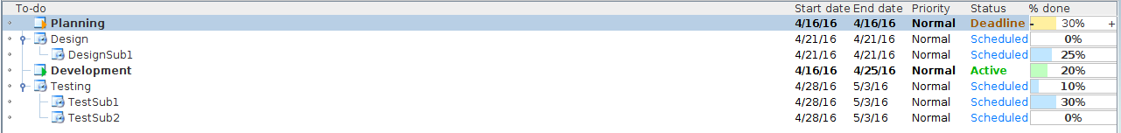
The program was then closed, which saved the tasks to the tasklist file.

3) The new version of Memoranda is run, with the old tasks loaded into the Default phase, all data intact:
