Q&A
(For version 3.16)

1) What are some of the new features in version 3.16?

2) How can I add/edit/remove phases for my project?

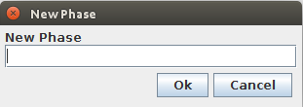
On the Tasks page, select the Add Phase button near the top of the window. The following dialog box will open:

Enter your new phase name into the text box and select 'Ok'. Your phase will then be added to the tasks table. To edit the phase title, simply double-click on the phase in your table. The following dialog will prompt you to change you phase name:
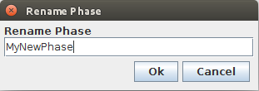

Edit your phase name in the text box and select 'Ok'. You phase will then be renamed in the task table. To remove a phase, highlight your phase in the table and select the Remove Phase button near the top.

3) How can I add/edit/complete/remove defects for my project?

On the Defects page, select the Add Defect 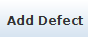 button on the right side of the page. This will prompt you with the following dialog:

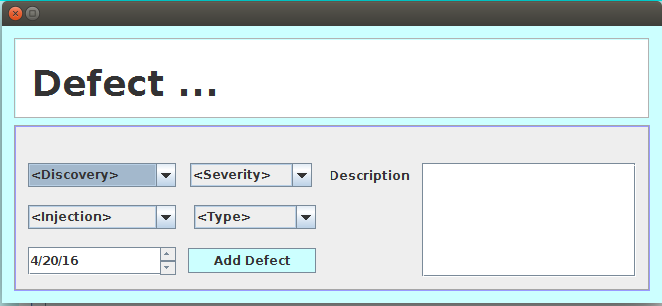

Fill out the appropriate boxes according to your defect, then select 'Add Defect'. Your new defect will be added to the defect table. To edit the defect, select the Edit Defect 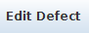 button on the right side of the page. You will be prompted with a similar dialog box:

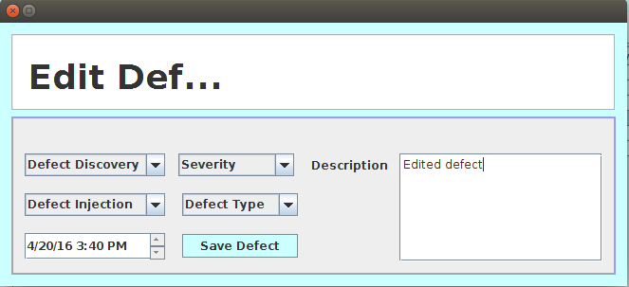

Edit your defect in the appropriate selection boxes and select 'Save Defect'. Your defects will be added to the defect table. To complete a defect, highlight a defect in the Open Defects table and select the Complete Defect 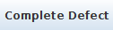 button on the right side of the window. This will provide you with the following dialog box:

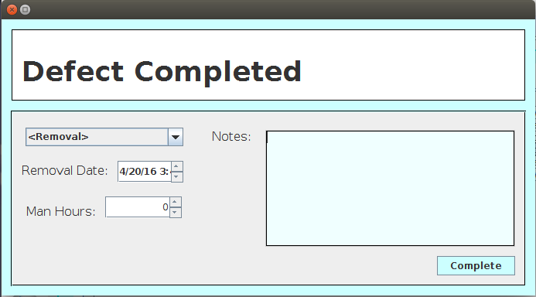

Fill in the appropriate boxes for your completed defect, and select 'Complete'. Your completed defect will move to the Closed Defects table, where it will be saved indefinitely until a user removes it. To remove a defect from either table, highlight the defect and select the Delete Defect button 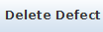 on the right side of the screen. Your defect will now be removed from the table.

4) How can I add/edit/remove test cases for my project?

On the Test Case page, select the New button on the top left of the page. You will be met with the following dialog box:

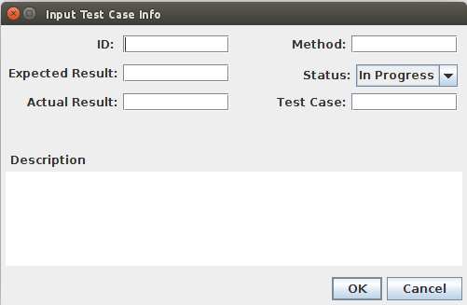

Fill in the test case information in the appropriately labeled text boxes. Once done, select 'OK'. Your new test case will be added to the table. To edit a test case, select your test case in the table, and click the Edit button in the top left. You will be met with a similar dialog as above. Edit the information in the appropriate fields and select 'OK'. Your test case changes will be applied to the table.

To remove a test case, select your test case in the table and click the Remove button at the top left of the window. Your test case will then be removed from the table.

5) How can I Pass/Fail my test cases?

There are three options on the top right of the Test case page. These options allow you to Reset, Pass and Fail test cases. The buttons appear as:

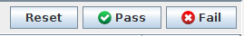

Reset – This will restore your test case to 'In Progress', changing the status column white.
Pass – This will pass your test case, changing the status column to green.
Fail – This will fail your test case, changing the status column to red.

To use any of these options, select the test case you wish to reset, pass or fail and select the appropriate option.

6) How can I add/edit/remove users to my project?

On the Users page, select the Add button in the bottom left corner of the window. You will be prompted with the following dialog box:

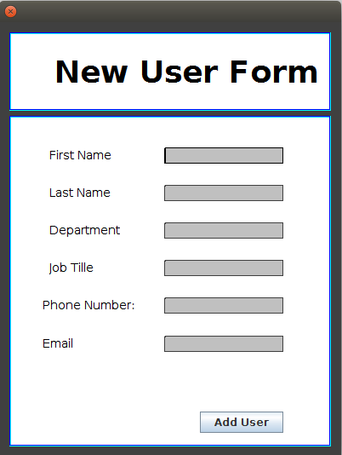

Fill out the information about the new user in the appropriate boxes. Select 'Add User'. The user will be added to the users table. To edit a users information, choose the user in the table and select the Edit button in the bottom left of the window. A similar dialog box will appear, edit the users information accordingly and select 'OK'. The table will be updated with the users new information.

To remove a user, highlight the user in the users table and select the Delete button in the bottom left corner. The highlighted user will be removed from the table.

7) How can I enter my PSP time log into my project?

On the Time Sheet  page you can input your Personal Software Process time log. The time sheet page includes a tab on top for every month of the year. Select your current month and fill out the Date, Start, Stop, Interrupt Time, Phase and comments for your current entry.

8) What statistics are available?

Currently, the statistics  page offers 3 different types of statistics. The three types available are Test cases, Defects, and Tasks.

Test cases can be viewed via a pie chart, this pie chart will give a visual representation of the overall status of all test cases. Defects are also displayed with a pie chart, though, much more detailed information is available. Defects can be views by type, discovery, injection, Severity and open/closed status.

For both pie charts, there are several options on the right hand side. The uppermost  button will continuously rotate the pie charts. The button directly under the rotate button is the Label  button. This button will toggle between different display types for the labels on the pie chart. The buttons below the two buttons toggle between the different available display types of the pie charts.

Tasks are seen with a Gantt chart. This chart will show the start/end dates of phases, and the overall progress of their combined tasks.

The statistics page also offers the option to export statistics as a PNG image file. To do so, select the tab which contains the chart you would like to export. Once selected, click the 'Export As..' option near the top of the page. The program will prompt you for a file name and location.

9) How do I save my project data, such as time sheets, phases, tests cases and defects?

Phases, test cases, defects and users are saved whenever a change has occurred within the respected table. An add, edit or remove of any kind will save your project information.

The time sheet panel will be hard saved when the program exits. If the program fails to exit properly, current time sheet session data will be lost.

All data within the program will be saved when the program is exited.

10) How do I report a bug?

To report a bug within the 3.16 version of Memoranda, please email one of the developers listed below. In the email, please provide any and all information about how the bug occurred, when it occurred and any steps that must be taken to reproduce the bug.

Jeb Johnson -
Doug Carroll – dcarrol3@asu.edu
Seferino Fernandez – sferna12@asu.edu
Hancheol Cho – hcho49@asu.edu

