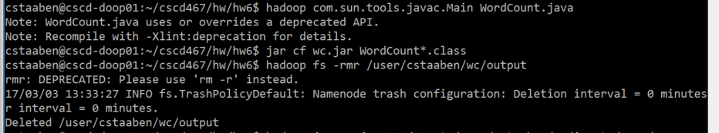

Figure - Compiles successfully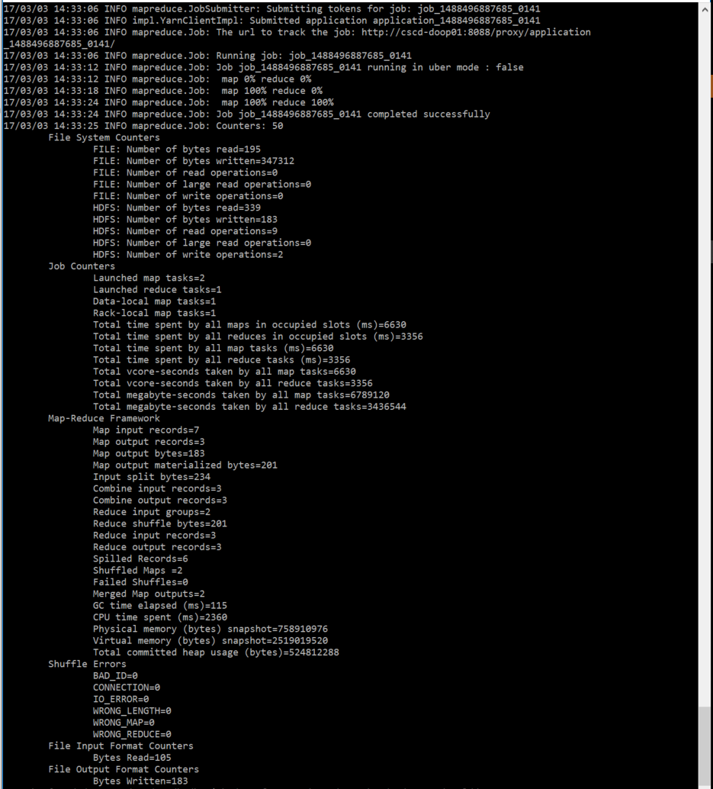

Figure - Runs successfully

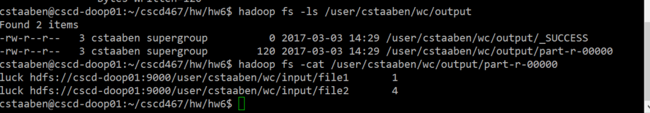

Figure - Search for "luck" output

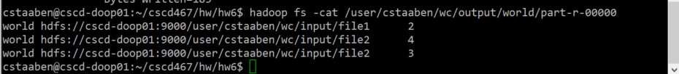

Figure - Search for "world" output