Setup Amazon AWS Java SDK and Credentials

**Please perform the following steps on your own personal desktop or your laptop. If you have a laptop available, please bring your laptop to the Lab for this lab session. If you do not, you can perform those steps on your desktop then show me the screenshot for the result of the step 7.**

1, Assumed you have already created an Amazon AWS account. If not yet, please see my previous tutorial regarding how to create an AWS account and redeem your AWS credits.

2, After step 1, you can log in the console of your account, you see the following interface,

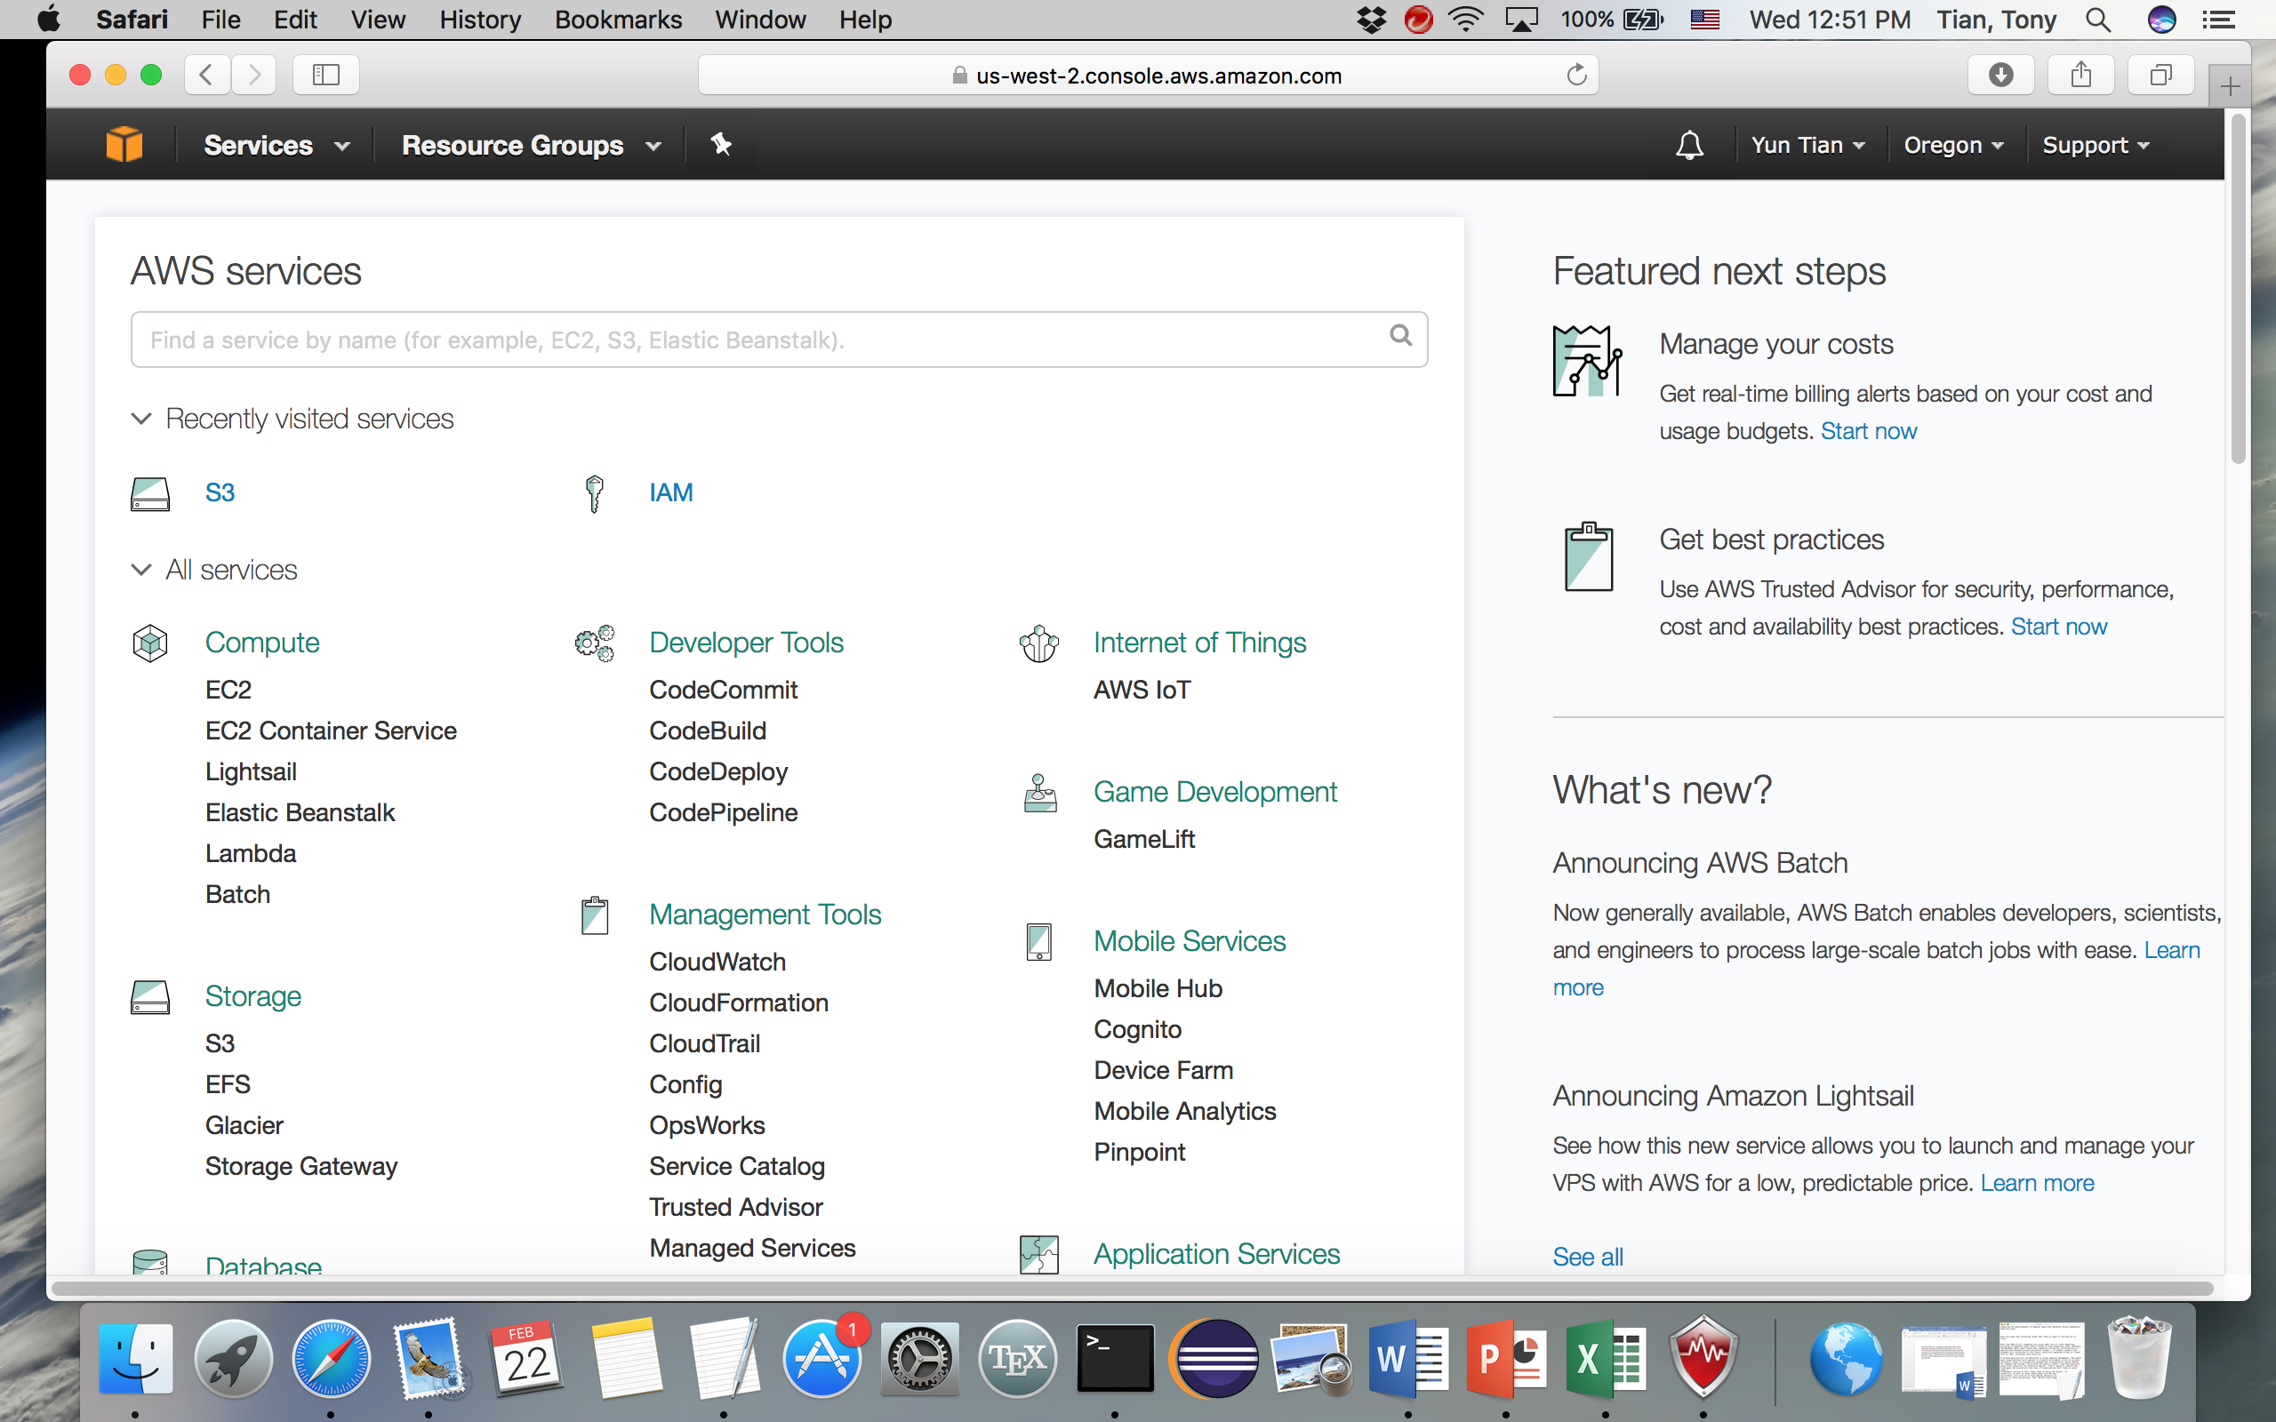

3) Click **Your Name** on the top right region of the window shown in the step 2,

then click **my Security Credentials,** then on a pop-up window click **continue with Security Credentials**.

4) on the Security Credentials page, click the ‘+’ sign of the third item labeled as “

**Access Keys (Access Key ID and Secret Access Key)”,** then clickthe button **Create New Access Key.** Please follow the on-screen prompt to create Access Key ID and Secret Access Key. You will need the Access Key ID and the Secret Access Key as you programmatically interact with the Amazon cloud.

5) Download Amazon AWS java SDK and set up by following the instructions here:

<https://aws.amazon.com/sdk-for-java/>

1. On the page above, you should click the SECOND button if you like to integrate AWS SDK Toolkit into an existing Eclipse that have been installed on your computer (**recommended**). In this case, please make sure you have installed Eclipse before this downloading. For example, I used Eclipse Java EE IDE for Web Developers, Version: Mars.2 Release (4.5.2). My Eclipse has no issues when working with AWS Java SDK toolkit.
2. Alternatively, on the page <https://aws.amazon.com/sdk-for-java/>, you can directly download the AWS SDK library by clicking the FIRST Button, if you like to develop and run your cloud program through command line tools. In this case, you have to following the instructions listed here: <http://docs.aws.amazon.com/sdk-for-java/v1/developer-guide/setup-install.html>. On the page above, please make sure you know how and why you have to do the following,

**“To use the SDK, add the full path to the lib and third-party directories to the dependencies in your build file, and add them to your java CLASSPATH to run your code.”**

6) After installed the java SDK in the step 5, you have to find a place to save(store) your Access ID and Access Keys that you have acquired in the step 4. Please follow the instructions listed here: <http://docs.aws.amazon.com/sdk-for-java/v1/developer-guide/setup-credentials.html>

7) Now please go to canvas course website and download **13_AmazonS3Demo.zip** under Files🡪DemoCode. Now you can compile and run that demonstration code without any error. You may get some warnings, which can be ignored.

8) Congratulations, after you successfully set up Amazon AWS SDK and your credentials, you can write a Java program to interact programmatically with Amazon Cloud services.

9) Turn in a PDF file that contains a screen shot showing your step 7 works perfectly.