Steps to do the indexing RDF file:

1. Create a new folder inside a rdf folder and copy the required rdf file there.
2. Make sure to have the sitemap.yml file in the rdf folder.
3. The content of the sitemap.yml file is like below,

archives: 0: "nypl": ["arc_rdf_nypl", 1000] "umich-lib": ["arc_rdf_umich-lib", 1000]

1. So add your folder information in the sitemap.yml file.

Eg: archives:

0:

"nypl": ["arc_rdf_nypl", 1000]

"umich-lib": ["arc_rdf_umich-lib", 1000]

"archivename": ["folder_name", 1000]

1. Create a new folder inside a rdf folder and copy the required rdf file there.
2. Run the below command to index the RDF file from the catalog project

C:\catalog\ rake solr_index:index archive=archive_name

1. Run the below command to merge the archive to the staging index

C:\catalog\ rake solr_index:merge_archive archive=archive_name

1. Go to the catalog page and click on ‘Manage archives’ and add the archives to the root

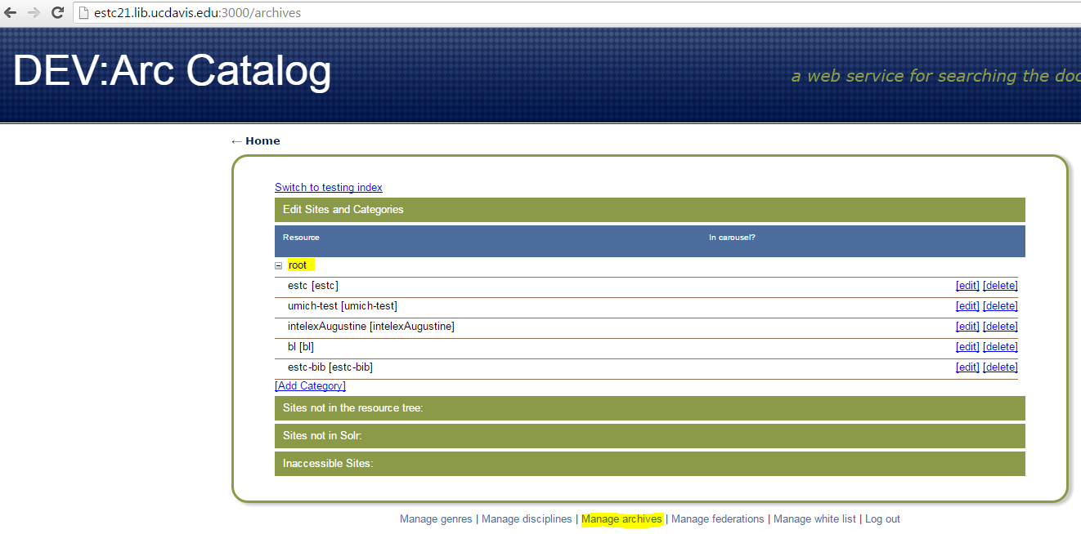

Note: You need to create ‘resources’ core manually inside the …/solr/server/solr/archives/

1. Load the collex page and go to Search page, there you should be able to see the added archive’s information.

