Radionuclide and Heavy Metal Concentrations in Australian Riverways

Preston Phillips

December 4, 2016

## Research Questions:

* How has the Ranger Mine contaminated the surrounding Alligators River Region with radionuclides and metals.
  + Where are the sample types of interest located in relation to the mine?
  + How does the concentration of radionuclides and metals change with distance from the mine?

## Problem

The Alligator Rivers Region is a province in the wet-dry tropics of northeastern Australia. The land in this region is rich in uranium, and since 1980 has been home to a large mine: The Ranger Uranium mine. An Australian government entity called the Environmental Research Institute of the Supervising Scientist (ERISS) has consistently collected animal and environmental samples from the land around the mine and the Alligator Rivers Watershed, since mine activity began. The samples have been measured for many different mine contaminants including the heavy metals Cu, As, Pb, Hg, and the radionuclides U238, U234, Th230, Ra226, Pb210, Po210, Th232, Ra228, Th228, Ac227, K40.

The location of the mine and the surrounding region is below. Locations of sample collection are indicated.

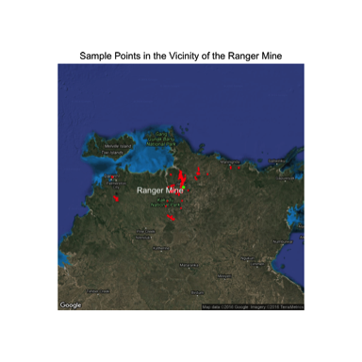

Samples from both flora and fauna have been gathered by the ERISS. The specific sample types can be clustered based on their ecological niche and purpose in the watershed, to contain the following groups: water, fish, molluscs, freshwater animals, freshwater plants, freshwater sediment, terrestrial animals, terrestrial plants, terrestrial soil. The following map shows the location of these different sample types, within the watershed.

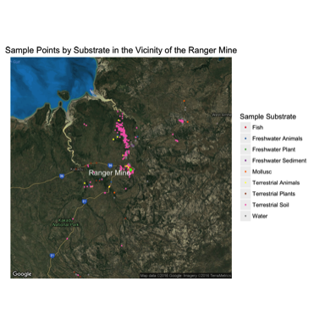

This sample data set has been continually gathered by the ERISS to keep track of mine contaminants in the region over space and time. The data set was recently published in the [Journal of Environmental Radioactivity] (<http://www.sciencedirect.com/science/article/pii/S0265931X16301928>).

Attempting to answer the research questions above using this dataset is important for many reasons. One reason is to better understand the overall impacts of uranium mining on water and fauna, as 2/3 of the land in the region is aboriginally owned. Because of this ownership, there are concerns about the contamination of bush foods and also the contamination of flora for wild animal consumption. Lastly, analyzing this data can help us better understand the impacts of the mine on Kakadu National Park, as the other 1/3 of the region is park land. The site is to be remediated by 2026 and incorporated into Kakadu, so knowing how and where contaminants are located is central to this goal.

Are the data that you chose to use reasonable for answering the question? Have you explained any caveats or limitations to the data that I should keep in mind when interpreting your results? As an example of how to do this for an analysis with secondary (imperfect) data, see how this post handles describing the data it uses, particularly in footnotes 1 and 3 and the sentences in the main text that correspond to them.

## Analysis

Have you explained the way you analyzed the data clearly enough that I think that I could reproduce your analysis if I had your data?

Have you explained a bit why your method of analyzing the data is appropriate for your question?

Have you let me know about major caveats or limitations related to the methods of analysis you’re using?

## Results

Below are the results for the radionuclide concentration (Bq/Kg) in Mulluscs as a function of the year sampled. The color of each point is scaled by it's proximity to the mine.

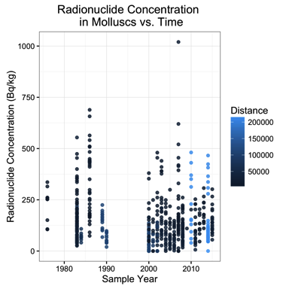

If the presence of the mine had a direct impact on the radionuclide concentrations in the environment, one would expect to see concentrations of radionuclides increase over time from the point before the mine was established to after. However, there is no apparent data to indicate an upward trend in radionuclide concentration over time, nor does the radionuclide concentration seem to depend on distance for a particular year.

The fluctuations in radionuclide content is most likely caused by naturally radionuclide concentrations in the local geology. There has been a presence of radionculides in the surrounding geology preceding any excavation from the mine.

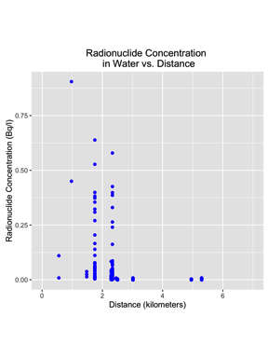

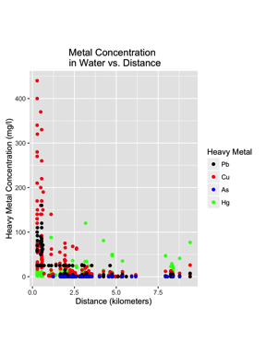

Is it clear what each is showing and how I should interpret it? (For a nice example of explaining how to interpret results, see footnote 4 here.) Have you explained and interpreted your main results in the text? Have you pointed out any particularly interesting observations (interesting outliers, for example)?

When I’m finished with your article, do I have more insight into your research question than when I started? ##Further Research