Reproduced Analysis of FARS data

## Results

**Percentages of drivers testing positive by drug type, sex, and year group**

|  |  |  |  |  |  |  |
| --- | --- | --- | --- | --- | --- | --- |
| Drug type | F 1999-2002 | F 2003-2006 | F 2007-2010 | M 1999-2002 | M 2003-2006 | M 2007-2010 |
| Alcohol | 26.4 | 24.3 | 27.1 | 43.2 | 42.9 | 43.3 |
| Cannabinoid | 2.8 | 5.8 | 7.4 | 6.0 | 10.7 | 12.2 |
| Depressant | 3.5 | 3.9 | 4.9 | 2.0 | 2.5 | 3.2 |
| Narcotic | 4.3 | 5.0 | 7.3 | 2.2 | 3.4 | 4.0 |
| Other | 5.8 | 6.8 | 7.5 | 4.4 | 4.6 | 4.3 |
| Stimulant | 7.3 | 9.3 | 8.9 | 10.7 | 12.3 | 9.5 |

**Figure 1: Prevalence of nonalcoholic drugs in fatally injured drivers by year and age group**

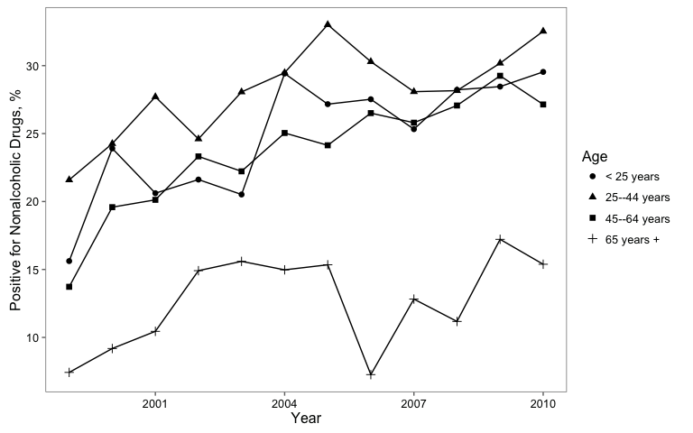

**Figure 2: Prevalence of nonalcoholic drugs in fatally injured drivers by year and drug type**

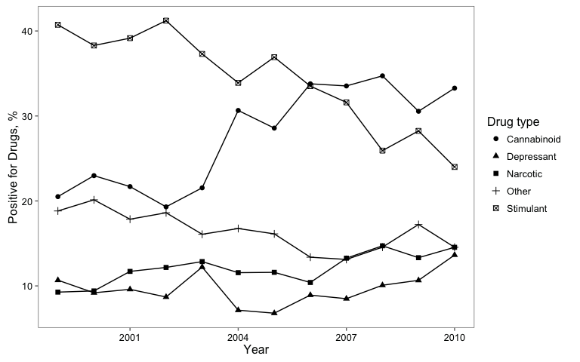

**Figure 3: Prevalence of nonalcoholic drugs in fatally injured drivers by year and age group**

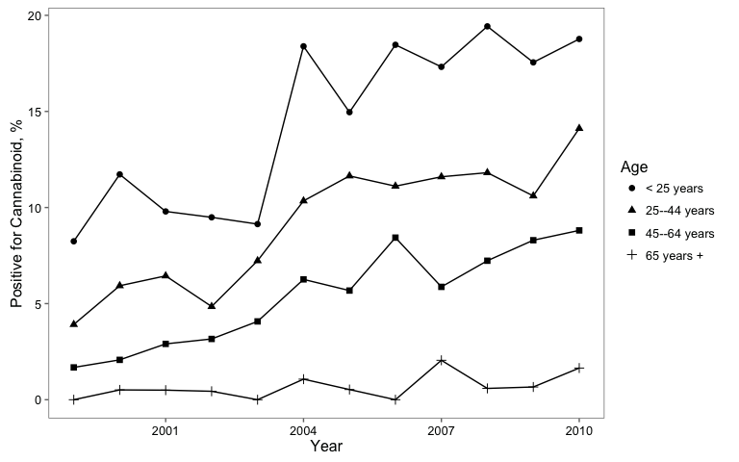

**Prevalence of drugs in fatally injured drivers for 1999 and 2010 by drug type**

|  |  |  |
| --- | --- | --- |
| Drug Type | 1999 | 2010 |
| Alcohol | 16.7 % ( 16.6 %, 16.8 %) | 16.7 % ( 16.5 %, 16.8 %) |
| Cannabinoid | 33.3 % ( 33.1 %, 33.6 %) | 33.3 % ( 33 %, 33.6 %) |
| Depressant | 50 % ( 49.5 %, 50.5 %) | 50 % ( 49.5 %, 50.5 %) |
| Narcotic | 66.7 % ( 66.1 %, 67.2 %) | 66.7 % ( 66 %, 67.3 %) |
| Other | 83.3 % ( 82.8 %, 83.9 %) | 83.3 % ( 82.7 %, 84 %) |
| Stimulant | 100 % ( 100 %, 100 %) | 100 % ( 100 %, 100 %) |

**Statistics for testing for trend in prevalence of drugs over study years by drug type using Cochran-Armitage trend test**

|  |  |  |
| --- | --- | --- |
| drug | Z | p.value |
| Alcohol | 1.2 | 0.228 |
| Cannabinoid | 13.7 | 0.000 |
| Depressant | 4.8 | 0.000 |
| Narcotic | 6.8 | 0.000 |
| Other | 1.5 | 0.146 |
| Stimulant | 0.4 | 0.720 |
| Nonalcohol | 11.5 | 0.000 |

**Statistics for testing for trend in prevalence of drugs over study years by drug type using Wald test of logistic regression coefficient for 'year'**

|  |  |  |
| --- | --- | --- |
| drug | Z | p.value |
| Alcohol | 1.2 | 0.228 |
| Nonalcohol | 11.5 | 0.000 |
| Narcotic | 6.8 | 0.000 |
| Depressant | 4.8 | 0.000 |
| Stimulant | -0.4 | 0.720 |
| Cannabinoid | 13.6 | 0.000 |
| Other | 1.5 | 0.146 |