Physical System Design of
BBBPM

(C) 2009, Csaba Tenkes, Brevissimus Co.

Physical System Design of BBBPM 1
1. Database model 3
2. Webservice model based on service model (SOA) 4
3. Resources 5

Database model

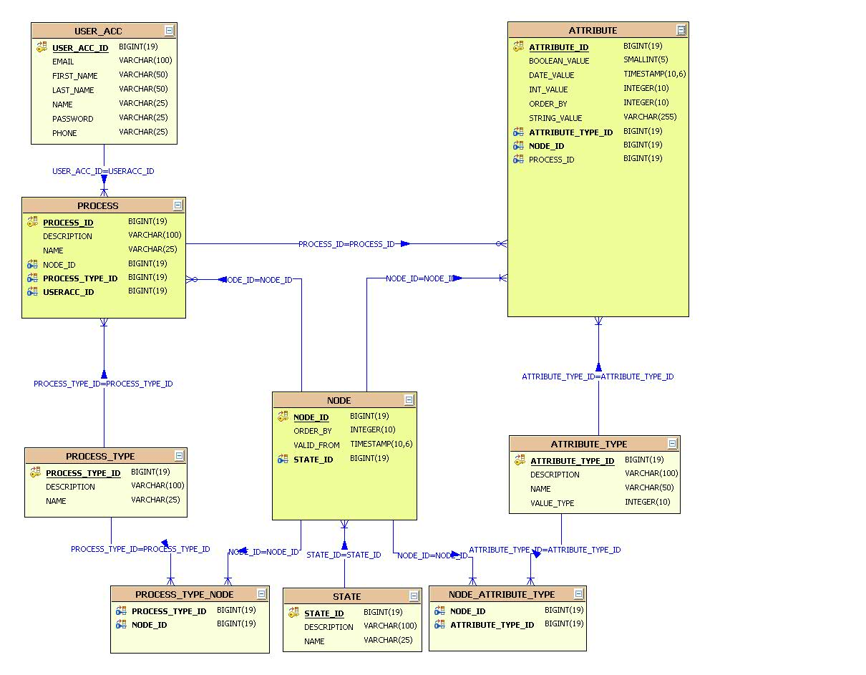

Description: (Using Java DB 10.2.x syntax)

ATTRIBUTE
ATTRIBUTE_ID | BIGINT | Own id of the table
ATTRIBUTE_TYPE_ID | BIGINT | Name of a state
NODE_ID | BIGINT | Description of a state
PROCESS_ID | BIGINT | Process
STRING_VALUE | VARCHAR(100) | String value of the attribute
BOOLEAN_VALUE | SMALLINT | Boolean value of the attribute
INT_VALUE | BIGINT | Integer value of the attribute
DATE_VALUE | TIMESTAMP | Date value of the attribute

NODE
NODE_ID | BIGINT | Own id of the table
ORDER_BY | VARCHAR2 | The process which the changes belongs to.
VALID_FROM_ID | TIMSTAMP | Start of the process
STATE_ID | BIGINT(19) | End of the process

PROCESS
PROCESS_ID | BIGINT | Own id of the table
DESCRIPTION | VARCHAR(100) | Description odf the process
NAME | VARCHAR(25) | Name of the process
NODE_ID | BIGINT | Actual node
PROCESS_TYPE_ID | BIGINT | Process Type of the process
USERACC_ID | BIGINT | User who owns the process

STATE
STATE_ID | BIGINT | Own id of the table
NAME | VARCHAR(25) | Name of a state
DESCRIPTION | VARCHAR(100) | Description of a state

ATTRIBUTE_TYPE
ATTRIBUTE_TYPE_ID | BIGINT | Own id of the table
DESCRIPTION | VARCHAR(100) | Name of a state
NAME | VARCHAR(25) | Description of a state

NODE_ATTRIBUTE_TYPE
NODE_ID | BIGINT | Node
ATTRIBUTE_TYPE_ID | BIGINT | Attribute_type

PROCESS_TYPE
PROCESS_TYPE_ID | BIGINT | Own id of the table
DESCRIPTION | VARCHAR(100) | Description odf the process
NAME | VARCHAR(25) | Name of the process

PROCESS_TYPE_NODE
PROCESS_TYPE_ID | BIGINT(19) | Process
NODE_ID | BIGINT(19) | Node

USER_ACC
USER_ID | BIGINT | Own id of the table
NAME | VARCHAR(50) | Username
PASSWORD | VARCHAR(25) | Password
FIST_NAME | VARCHAR(100) | First Name of the user
LAST_NAME | VARCHAR(100) | Last Name of the user
EMAIL | VARCHAR(100) | e-mail adderess
PHONE | VARCHAR(100) | Phone number
ADDRESS | VARCHAR(100) | Address

There is no admin user, and authorization level.
All user can do the same things, only his/her processes can be done.
After start he can stop the process.

When creating a process a start/end node is added by default.

Webservice model based on service model (SOA)

Basics: one service on a service level is published as a web service.

ProcessWS
getProcessState(Process Process): State
getProcessNextState(Process Process): State
isStarted(Process Process): boolean
isEnded(Process Process): boolean
setActualState(Process Process, State state)
startProcess(Process Process)
terminateProcess(Process Process)
createProcess(ProcessNodes[] processNodes, String name, User user)
deleteProcess(Process process)
modifyProcess(Process, User user): Process

UserWS
getProcesses(User user): Process[]
getActiveProcesses(User user): Process[]
getTerminatedProcesses(User user): Process[]
createUser(String userName, String password, String address, String eMail, String phone): User
deleteUser(String userName)
modifyUser(String userName, String address, String eMail, String phone): User
modifyUserPassword(String userName, String Password)

StateWS
getArributes(User user, State State): Attribute[]
createState(String name, String description, Attribute[] attributes)
deleteState(String name)
modifyStateDescription(String name, String description, Attribute[] attributes)
modifyStateAttributes(String name, Attribute[] attributes)
addStateAttributes(String name, Attribute[] attributes)

AttributeWS
createAttribute(String name, String description, Attribute[] attribute)
deleteAttribute(String name)
modifyAttribute(String name, String description, Attribute[] attribute)

Resources
Development Environment:

App server settings:
Developer uses her own app server by local with debug mode enabled

Jdbc settings:
Host
Port
Scheme
User
Password

Test Environment:
App server settings:
Host
Port
Url

Jdbc settings:
Host
Port
Scheme
User
Password

Integration Environment:

App server settings:
Host
Port
Url

Jdbc settings:
Host
Port
Scheme
User
Password

Production Environment:
App server settings:
Host
Port
Url

Jdbc settings:
Host
Port
Scheme
User
Password

Commit strategy:
One service call is a transaction
At the end one request is a transaction

